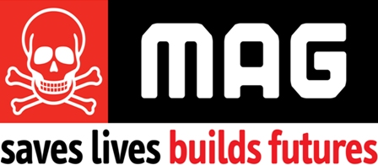

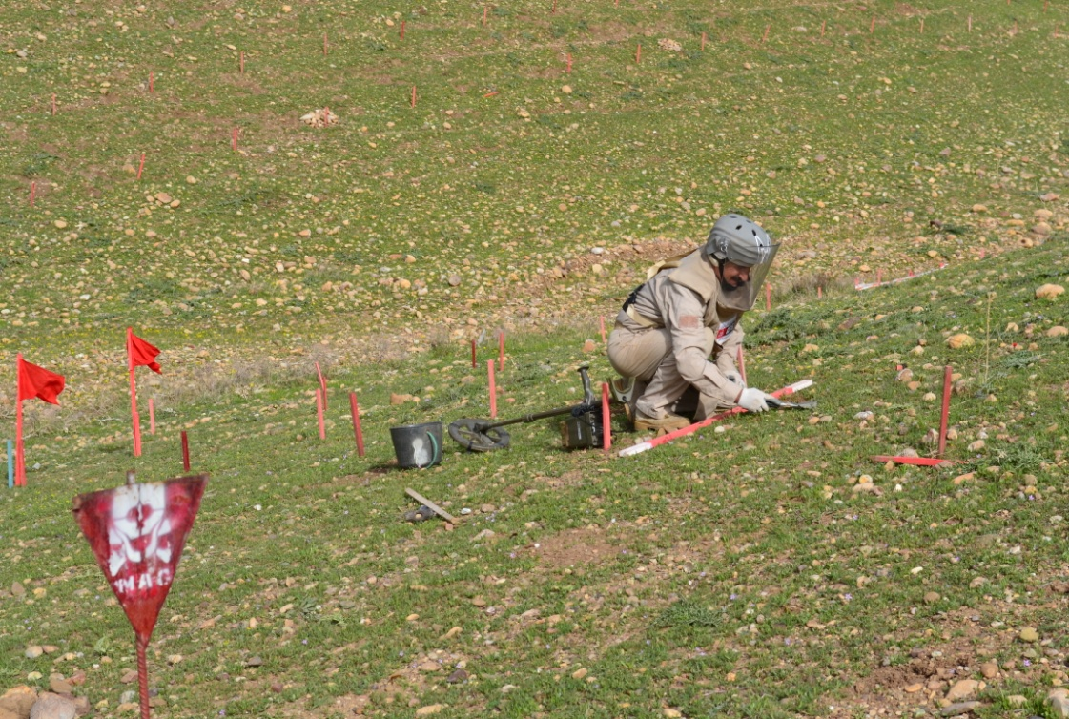

MAG deminer conducting clearance operations in Pirijan Village, Kirkuk Governorate

**Humanitarian Mine Action in Northern Iraq**

**MAG proposal to AusAID**

**May 2012**

MAG HQ: 68 Sackville Street, Manchester, M1 3NJ, United Kingdom

T: +44 (0)161 238 5464, F: +44 (0)161 236 6244

[www.maginternational.org](http://www.magclearsmines.org) [info@maginternational.org](mailto:info@maginternational.org)

UK Registered Charity No. 1083008 Company No. 4016409

Contents

2 Executive Summary 2

3 MAG Organisational Profile 3

3.1 MAG 3

3.2 MAG in Iraq 3

4 Country context and project background 4

5 Implementation and coordination 7

5.1 MAG Coordination and Support of National Capacity in Iraq 7

5.2 Implementation 8

5.3 Other Donors Contributing to the Programme 10

6 Anticipated outputs, outcomes and impact 11

6.1 Outputs 11

6.2 Outcomes 11

6.3 Impact 11

7 Monitoring and evaluation 11

7.1 Monitoring and Evaluation in country 12

7.2 HQ Support and Monitoring & Evaluation Procedures 12

8 Sustainability 12

9 Risks and Risk Management Strategy 13

10 Gender 13

11 Budget 14

# Executive Summary

**Organization:** MAG

**Date:** 28 May 2012

**Contact:**  Nina Seecharan, Regional Desk Officer

**Address:**  68 Sackville Street, Manchester, M1 3NJ, UK

**Tel:**  +44 161 236 4311

**Fax:** +44 161 236 6244

**E-Mail:**  [nina.seecharan@maginternational.org](mailto:nina.seecharan@maginternational.org)

**Project Title:** Humanitarian Mine Action in Northern Iraq

**Country/Region:** Iraq

**Nature of the Problem:** In Iraq the widespread presence of landmines and Explosive Remnants of War (ERW)[1], resulting from a number of conflicts over the last 30 years, continues to pose a direct threat to life and limb of the Iraqi population and, impede economic recovery by blocking access to land that could otherwise be used for agriculture, settlement and infrastructure.

**Period of Activity:** 1 July 2012 – 30 June 2014 (24 months)

**Amount Requested from AusAID:** AU$2,500,000

**Total Amount of Project:** AU$2,500,000

As a result of a number of conflicts over the last 30 years - including the Iraq-Iran war of the 1980s, conflicts between various religious and political parties, the large scale military actions of the 1991 Gulf War and, the allied forces invasion of 2003 - Iraq is littered with ERW. In addition, tactical minefields were laid along the borders with Syria, Turkey, Iran, Saudi Arabia and around former military positions and along the internal ‘Green Line’, the former defensive line set up by Saddam Hussein’s regime against the Kurdish after the first Gulf War in 1991.

Responding to the high level and varied nature of contamination in northern Iraq, MAG’s integrated use of clearance assets and technology enables the concurrent and complimentary use of manual, mechanical and Mine Detection Dog (MDD) assets on multiple tasks to reduce the average cost of task completion. To achieve this carefully considered approach using the full range of tools and techniques available, MAG will deploy the following teams within this project: MAG will deploy three Mine Action Teams (MATs), two for 24 months and one for 18 months (from Jan 2013); one Community Liaison (CL) Team for 18 months (from Jan 2013) and one Mechanical Support team for 19 months (Dec 2012 – June 2014).

# MAG Organisational Profile

## MAG

MAG is an international non-government organisation registered in the UK. It aims to address the threat posed by landmines, weapons and munitions to human security and development and implement comprehensive Conventional Weapons Management and Destruction programmes that support international and national conflict mitigation, recovery and wider development.

MAG was established in 1989 and is a specialist in conflict recovery through Humanitarian Mine Action (HMA). To date MAG has worked in 35 countries affected by remnants of conflict and is currently operational in 15 countries: Angola, Burundi, Cambodia, Chad, , Democratic Republic of Congo (DRC), Iraq, Lao PDR, Lebanon, Libya, Republic of Congo (RoC), Somalia, Sri Lanka, Sudan, South Sudan and Vietnam. MAG was a co-laureate of the Nobel Peace Prize due to its involvement in the International Campaign to Ban Landmines (ICBL) and the 1997 International Treaty to Ban Landmines. MAG responds to the needs of people affected by conflict by clearing the deadly legacy that often remains, including landmines, unexploded bombs, booby traps and other Explosive Remnants of War (ERW).

MAG’s programmes encompass a broad portfolio of conflict recovery activities which are continuously developed to provide better, safer and more cost-efficient ways to assist populations affected by conflict, and are conducted in support of broader relief, reconstruction and development efforts. Key activities include:

* Community Liaison (CL) and data gathering
* Pre- & Post-Clearance impact surveys
* Rapid survey and demarcation of landmine and UXO contaminated areas
* Technical survey of mined areas
* Clearance operations incorporating manual, Mine Detection Dogs (MDD) and mechanical methodologies
* Battle Area Clearance (BAC), Explosive Ordnance Disposal (EOD), Cluster Strike Clearance and Stockpile Clearance and Destruction
* Response to emergency tasks
* Building capacity of local and national mine action authorities
* Management and disposal of Small Arms and Light Weapons (SALW)
* Risk Education (MRE & SALW RE)

These activities are supported and complemented by central support from MAG’s UK Head Office in Manchester, including an International Development and Evaluation Team (IDET) responsible for the monitoring and evaluation of MAG’s programmes. The Head Office also coordinates the trialling of new technologies, together with coalition building and advocacy on international and national policy to achieve the aims of the International Treaty to Ban Landmines. [MAG implements Quality Management processes and is an ISO 9001:2008 accredited organisation.](http://www.maginternational.org/MAG/en/about/mag-an-iso-90012008-accredited-organisation/)

## MAG in Iraq

MAG has been continuously present in Iraq since arriving in 1992. MAG’s quality and impact driven operations have supported peace-building initiatives and armed violence reduction and supported Iraq in meeting its mine ban treaty obligations and supporting the implementation of the National Development Strategies toward achieving the Millennium Development Goals (MDGs). MAG has achieved this by mitigating the effects that the ERW have on livelihoods, infrastructure and socio-economic development.

MAG currently implements operations in parts of the five northern governorates of Iraq, including Dohuk, Sulimaniyah, Tamim (Kirkuk), Ninawa (Mosul), and Diyala. Substantial impact has been made in these areas to restore access to land in support of economic recovery and supporting overall national mine action capacity in Iraq. The table below summarises the physical outputs of the programme over the last 20 years:

Summary of Programme Outputs to Date

|  |  |
| --- | --- |
| **Activity** | **Jan 1993 – March 2012** |
| Land released (m2) | 67,993,006 |
| Areas demarcated (m2) | 154,941,471 |
| Tasks completed | 19,921 |
| Minefields cleared | 572 |
| Battle Area Clearance (BAC) tasks | 115 |
| Explosive Ordnance Disposal (EOD) tasks | 19,234 |
| Mines destroyed | 162,827 |
| Unexploded Ordnance (UXO) destroyed | 1,910,889 |
| Mine Risk Education (MRE) sessions delivered | 14,732 |

Central to the MAG Iraq’s programming is the assumption that targeted, impact driven ERW clearance enables reconstruction and regional security, reducing the risks posed by ERW to those living and working in contaminated areas and supporting economic recovery, stability and regional development strategies. In the programme’s 20 year history, MAG activities have cleared land predominantly for farming, grazing as well as infrastructure development including housing, irrigation systems, road widening, installation of telecommunication towers and development of tourist areas. In doing so MAG supports Iraq’s 2010-2014 National Development plan to reduce poverty through comprehensive rural development and diversify the country’s economic base by expanding Iraq’s agricultural and tourism sector.

MAG’s programme in Iraq contains a significant level of expertise and the operational systems and techniques employed by the programme, particularly the integrated use of mechanical clearance assets and technology, and Mine Detection Dog (MDD) teams, enables MAG to undertake operations which cannot be undertaken routinely by national and governmental implementers. Currently MAG Iraq’s operations make up approximately 30 per cent of the humanitarian mine action that is conducted in the country. MAG is the only humanitarian mine action operator in the highly contaminated, and contested, area of Kirkuk and the only organization clearing cluster munitions for humanitarian purposes in Iraq. MAG Iraq’s dedication to efficiency and operational innovation has also contributed to the enlargement of national capacity.

MAG is seeking further support from AusAID to enable MAG to continue to work in Iraq removing the threat of ERW, while supporting the development of regional and national mine action capacity and assist Iraq in meeting its obligations under the Mine Ban Treaty by February 2012 and 2018 respectively[2].

# Country context and project background

Over 30 years of conflict have resulted in the extensive presence of landmines and ERW in Iraq. The Iraq-Iran war of the 1980’s, conflicts between various religious and political parties and large scale military actions of the 1991 Gulf War have resulted in Iraq being littered with ERW and tactical minefields being laid along the borders with Syria, Turkey, Iran and Saudi Arabia. In addition, minefields were laid along the former military positions in the Iraqi Kurdistan region and the internal ‘Green Line’ which has separated the Kurdish region from areas under the control of the Ba'ath Government. Abandoned arms caches, air strikes and ground engagements during the 2003 conflict led to further contamination from ERW.

Despite considerable achievements, Iraq remains one of the most ERW contaminated countries in the world with millions of landmines and cluster bomblets contaminating Iraq’s oil fields and farmlands, impeding economic recovery. Coalition forces used large numbers of cluster munitions in Iraq in 1991 and 2003, with 61,000 cluster bombs containing some 20 million sub-munitions were dropped on Iraq and Kuwait in 1991. The number of cluster munitions delivered by surface-launched artillery and rocket systems is not known, but an estimated 30 million or more dual purpose improved conventional munitions (DPICM) sub-munitions were used in the conflict. In the 2003 invasion of Iraq, nearly 13,000 cluster munitions containing an estimated 1.8 to 2 million sub-munitions were used.[3] According to government figures it is estimated that more than 1,730 square kilometres of land in Iraq is contaminated; affecting more than 1.6 million Iraqis in approximately 4,000 communities across the country.

The utmost importance of ERW removal to reconstruction and development in Iraq was emphasised by David Shearer, Former Deputy Special Representative of the UN Secretary General and United Nations Development Program (UNDP) envoy to Iraq, "Landmine clearance is a key element within broader efforts to stimulate Iraq's economy.  Mines are limiting access of farmers to their lands, preventing increased oil production and putting the lives of Iraqi civilians at risk.” Furthermore, the role of international organisations in ERW removal in Iraq was stressed by Nouri Al-Maliki, Prime Minister of Iraq who, in a Mine Action Donor and Stakeholders meeting, said: "Removing mines from Iraq is difficult because there are no maps to indicate the mined areas, that is why we need the effort of donor countries and the experience of the international community. Iraq is losing the blood of its sons. We are responsible for the security of our people”.

The table below provides a summary of the landmine and UXO casualties recorded by MAG in its areas of operation during January – May 2012, underlining the continuing direct threat to life and limb due to landmines and UXO contamination in the prioritised areas. It is worth noting that these numbers do not reflect the true human impact of the problem as they only represent incidents reported to and recorded by MAG’s Community Liaison teams. Analysis of the incidents this year reveals all victims were male who had not previously received any MRE. A significant number were shepherds, often Arabs hired from the south of the country who were unfamiliar with the local area.

Landmine and UXO Accidents Recorded by MAG Community Liaison Teams: January – May 2012

|  |  |  |  |  |
| --- | --- | --- | --- | --- |
| **Sector** | **No. of incidents** | **Deaths** | **Injuries** | **Total victims** |
| Chamchamal | 4 | 5 | 1 | 6 |
| Dohuk | 6 | 2 | 8 | 10 |
| **Totals** | **10** | **7** | **9** | **16** |

**Project Goal**

To reduce the threat of death and injury from remnants of conflict and provide communities with access to cleared land to facilitate conflict recovery, poverty reduction and socio-economic development, in support of Iraq’s 2010 -2014 National Development Plan.

**Objectives**

1. To reduce the threat to life and limb to conflicted affected communities by removing landmines and ERW
2. To restore communities’ access to prioritised land for socio-economic development through integrated clearance operations
3. To support the national capacity in Iraq to manage and conduct HMA activities in a safe, effective and transparent manner.

**Geographic Focus of the Project**

The project will be implemented from MAG’s two sector locations of Dohuk and Chamchamal with oversight and support provided from the Erbil headquarters as indicated in the map below:

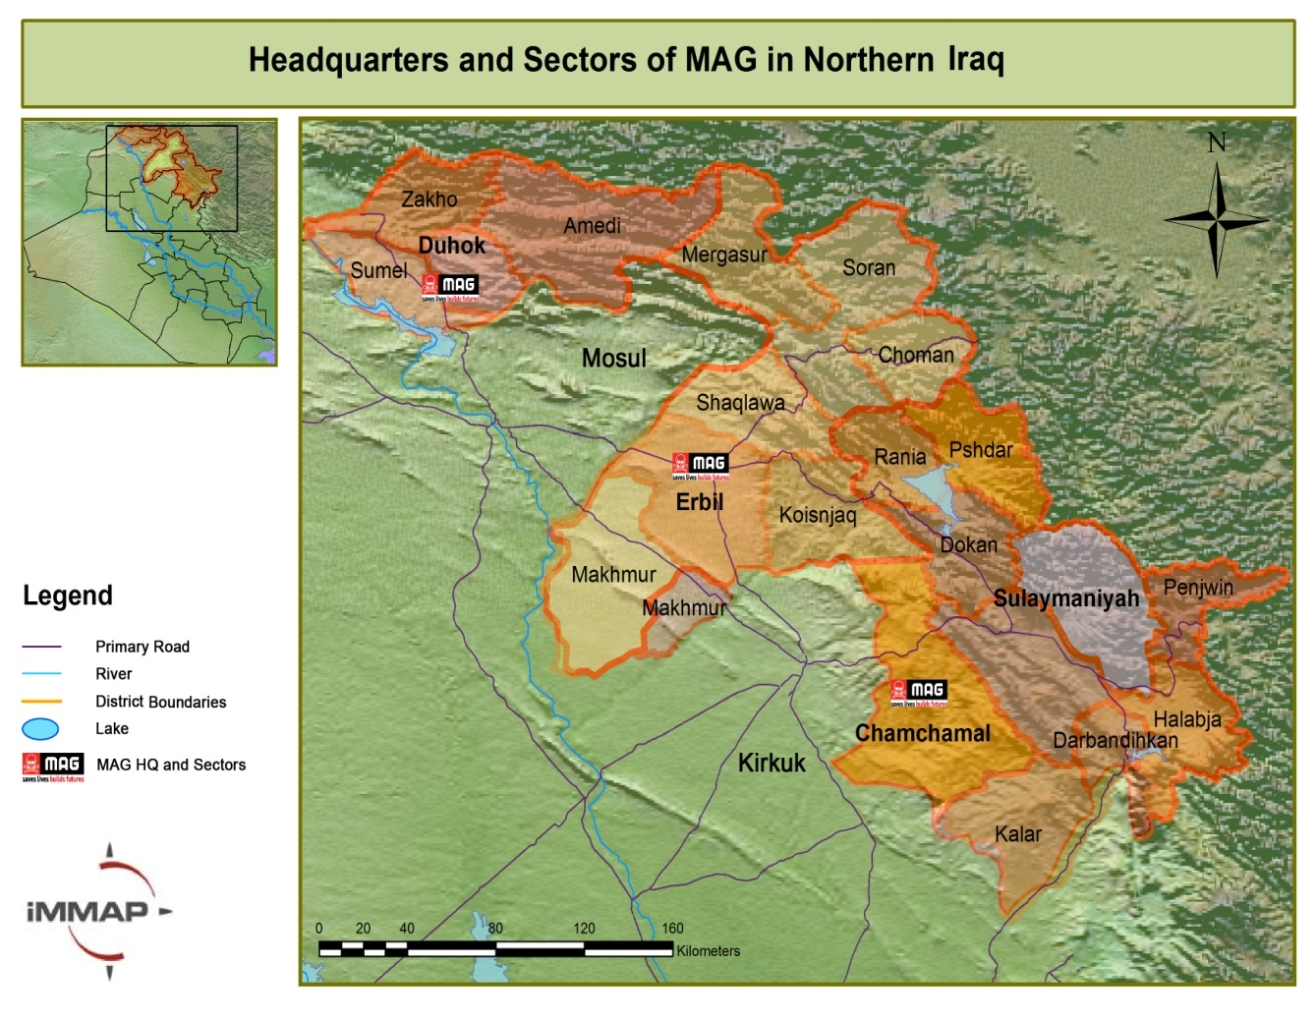

The selection of Dohuk (covering Dohuk and northern Ninawa/Mosul governorates) and Chamchamal (covering parts of Sulimaniyah and Kirkuk governorates) for MAGs sectors and operating bases reflects the following factors:

1. High proportion of affected communities: The north (including Kirkuk) accounted for 72 per cent of all affected communities surveyed in the Iraq Landmine Impact Survey[4]
2. The area of contamination in these areas represented 788 km2 (45.5 per cent) of the total 1,730 km2 estimated.
3. These areas represent 43 per cent of the total number of highly impacted communities identified during the survey.
4. The northern area accounted for 30 per cent of the total number of victims by region over the previous two years with Kirkuk suffering the highest victim rate per at risk population, being 34.5 per 100,000.

Many of the contaminated communities are near two very important former battle areas, the border of Iraq with Syria and Turkey, and the so-called ‘Green Line’ (southern boundary of de-facto Kurdish control established by the Coalition Forces during the early 1990s). The latter was an important area of confrontation between Saddam Hussein's forces and the Kurdish ‘Peshmerga’ and the scene of fighting and coalition air-strikes. Some of this area also saw the forced evacuation by Saddam Hussein’s forces of the original Kurdish inhabitants, and their subsequent replacement by Arab settlers from the south.

The selection of these operating areas is also a response to the development of other capacity in the Kurdistan Regional Government (KRG) area, both in the form of direct action by the regional mine action agency and the development of local commercial operators funded by the regional authorities, which have seen MAG move to less well served areas. For example MAG represents the only mine action capacity in Chamchamal.

## Implementation and coordination

MAG will continue to work closely with national and regional authorities and other relevant agencies to integrate mine action into development strategies and regional and national priorities, ensuring maximum impact on local communities.

## MAG Coordination and Support of National Capacity in Iraq

MAG Iraq has maintained a strong relationship with the mine action authorities, the Iraqi Kurdistan Mine Action Agency (IKMAA) since its creation in 2000 and assisted directly and indirectly in their capacity development to point where the regional authorities now exercise full control of accreditation and the maintenance of Quality Assurance (QA) and Quality Control (QC) against international IMAS standards. Through this project, MAG will continue to act as an exemplar to the authorities in the introduction of new techniques and approaches[5] to minefield clearance and the removal of unexploded ordnance.

The scope of the relationship with IKMAA encompasses the following areas:

* Coordination meetings: Weekly coordination meeting at the sector level, all implementer meetings with IKMAA every two months and senior management coordination meetings as required.
* Annual Planning: Annual plan, including details of all proposed tasks, submitted to the regional mine action authorities for their approval.
* Task Orders: Issued in advance of commencing any task.
* Reporting Operations: The following specific reports are submitted by MAG to IKMAA: Clearance Report (IKMAA form); Weekly Progress report (IKMAA form); Completion Survey (IKMAA form); Dangerous Area (DA) Report (IKMAA form); Copy of MAG clearance (MAG form); Area Reduction/Risk Assessment Form (MAG form); Monthly Explosive Report (MAG form) Ops Update in fortnightly meeting (IKMAA form).
* QA/QC/Sampling: In general IKMAA conducts QA/QC visits to all MAG tasks on a weekly basis. Sampling is conducted on all completed tasks prior to handover to the community, which is governed by a clearance certificate issued by IKMAA.
* Sharing facilities: Includes the sharing of MAG explosives storage and MDD training area in Chamchamal.

## Implementation

MAG employs local capacity, with all operational teams 100 per cent staffed by Iraq nationals. The programme currently employs around 470 national and nine international staff in its Iraq programme (a ratio of more than 50 national to 1 international staff member). Other than the international Technical Operations Manager (TOM) who is part of the senior management team, Technical Field Managers (TFM) work in support of national Field Operations Managers (FOM). Over the course of the last 10 years a number of Iraqi national staff have been internationalised in other MAG country programmes. The following assets will be deployed within this project:

Mine Action Teams

* Three Mine Action Teams (MATs): two for 24 months and one for 18 months (from Jan 2013)[6]. The procurement of two new 4x4 team vehicles is included in this project to replace older vehicles, in line with the fleet renewal policy.

The MATs have been trained and equipped to undertake the following activities: Emergency Survey and Demarcation[7]; minefield clearance; Battle Area Clearance (BAC); destruction of stockpiles and caches of Conventional Weapons (including SALW); and, Explosive Ordnance Disposal (EOD). Each team comprises of 10 deminers, two sub-team commanders and one team leader, together with a medic and two vehicles with drivers.

Operations will be ongoing throughout the project period with the exception of an annual closedown and refresher training period of three weeks timed to coincide with the height of summer and the Muslim fasting month of Ramadan. This project will also provide for the necessary support costs to deploy the assets in the target areas.

Community Liaison (CL) Team

* One Community Liaison (CL) Team for 18 months (from Jan 2013)[8] to conduct risk education, build the capacity of communities to live safely with the dangers posed by ERW and assist with the prioritization and assessment of operations. The team is comprised of one male and one female CL officer deployed with one vehicle and driver.

The CL team will deploy to affected areas to gather data on conventional weapons contamination and impact through the completion of community assessments, pre- and post-clearance impact surveys and landmine victim reports where necessary. The team will complete Dangerous Area (DA) reports to provide tasking information to MAG’s Conventional Weapons Destruction (CWD) teams[9] supported by the U.S. State Department’s Office for Weapons Removal and Abatement (U.S. State WRA) and complete Impact Survey and Mine Victim reports where necessary. CL teams will also provide training and support to teachers and community leaders in the delivery of Mine Risk Education (MRE). MRE will also be delivered to at-risk communities.

MAG CL has worked with the Ministry of Education for more than 15 years and has been instrumental in having risk education integrated into the school syllabus as well as in training teachers to carry it out using MAG RE materials. Currently MAG is acting as advisor to the MoE in developing its own specific risk education school materials and in the design of the MoE teacher training Risk Education curriculum.

MAG will continue to operate the dial ‘234’ number to facilitate reporting of contaminated areas. CL teams will be supported by an International Community Liaison Manager (CLM) who will be responsible for management, training, assessment and monitoring of Community Liaison (CL) staff. The CLM will also take responsibility for the implementation and continuing development of pre and post clearance impact evaluation tools, enabling MAG to record and report on the long term impact of its operations in Iraq on individual beneficiaries and their communities.

Mechanical Clearance

MAG Iraq deploys a wide range of mechanical assets and attachments in support of manual and MDD clearance operations as a critical element of an integrated and systematic approach to clearance. The mechanical team will conductg**round preparation through removal of vegetation and excavation of contaminated areas where manual and MDD clearance would be inefficient. The machines will also assist technical survey to obtain information rapidly and facilitate improved operational planning for the efficient use of other assets.** To support the efficient and effective use of these assets in the Dohuk sector of operations, this proposal includes funding for:

* One international Mechanical Technical Field Manager (TFM) funded for twelve months (Oct 2012 – Sep 2013)
* One Mechanical Support team for 19 months (Dec 2012 – June 2014), comprised of a team leader, sub-team commander, three deminers and one medic deployed with one vehicle and driver to work alongside the mechanical assets. A dedicated support team has been found to be more flexible and efficient than drawing deminers from an existing MAT.
* The procurement of a low loader (tractor unit and trailer) in year one to enable mechanical machines to operate in Dohuk sector

In addition to the directly funded teams and assets detailed above, where necessary, assets funded by other donors, including Mine Detection Dogs and mechanical assets will be deployed to maximize value for money through a complementary approach.

As the activities proposed represent the creation of new capacity, the exact tasking for this proposal is currently under development. However, for illustrative purposes, the following two examples of actual tasks already identified in operational planning are included to give an indication of the typical nature of tasks:

|  |
| --- |
| **Example 1: Kalak Shaty A minefield, Mord village, Shwan sub-distinct, Kirkuk district of Kirkuk governorate** |
| Kalak Shaty part A minefield stretches over 32,200m2 and was laid by the Iraqi army in 1991 to protect a military position and deny the Kurdish Peshmerga a resupply route. The minefield shows evidence of V69, TS50, VS50 and PMN anti-personnel mines. The proposed cleared land is earmarked for agriculture and grazing that should benefit 60 direct and 100 indirect beneficiaries. |

|  |
| --- |
| **Example 2: Razan Skreny BAC, Skrin village, Sarsink sub-district, Amedi district, Dohuk governorate** |
| The Razan Skreny BAC task covers 15,000m2 of land contaminated by a BLU97 air strike by coalition forces targeting the Iraqi army during the First Gulf War (1991). The proposed cleared land is intended for mixed use including agriculture and orchards and some housing. It is estimated the project will serve the needs of 130 direct and 400 indirect beneficiaries. |

Prioritisation

The prioritisation of MAG’s work is as a result of a two stage process as follows:

1. MAG bases its initial assessment on the existing data, which has been developed over the course of nearly 20 years of MAG’s presence in northern Iraq and, since 2003, in the adjoining areas. During this time MAG was the major source of survey and demarcation information for the region, until gradually handing over this information to the regional mine action agency, IKMAA (Iraqi Kurdistan Mine Action Agency) as their capacity improved. The survey information includes socio-economic data as well as technical information.
2. To complement existing data, MAG’s prioritisation is further enhanced through more up to date information gathered by its mixed-gender Community Liaison (CL) teams. These teams are responsible for data collection, pre-clearance assessments, Mine Risk Education (MRE) delivery and Small Arms and Light Weapons (SALW) risk education, as well as post-clearance evaluations. The CL teams are continually in the field and assessing communities with a view to determining their needs (both in terms of risk reduction and development opportunities) and generating reports which feed into the clearance planning process. Detailed discussions are held with community members to determine not only which communities may benefit most, but also gives communities conduct a self-assessment of the risks which pose the greatest danger or offer the greatest reward, since many communities are affected by more than one hazardous area. Formal pre-clearance reports are then prepared which form a baseline for later evaluation.

MAG remains responsive to development opportunities that may result from outside the communities by assessing requests that come from the local authorities.

Land Release

MAG Iraq has developed and implements land release processes which are designed specifically to use only the necessary required levels of intervention. Non-technical survey information gathered by CL teams forms the basis of operational prioritisation and planning through identifying Suspected Hazardous Areas (SHA) or Confirmed Hazardous Areas (CHA) depending on the level of evidence.

Through operational experience, the non-technical survey information has been found to be so reliable that almost all tasks in MAG’s area of responsibility are considered CHA, meaning that landmine contamination is certain. Following selection and approval of a specific task for implementation, a systematic technical survey (including systematic breaching of the area) takes place to further identify where the location of the contamination within the CHA. Through the information gathered during the technical survey areas within the CHA can then be categorised and designated as high, medium and low risk. High and medium risk areas are cleared by the most appropriate clearance assets, whereas low risk areas undergo a formal risk assessment process and should the low risk status be confirmed then the area will be released without clearance.

This risk assessment process is fully supported by the Iraqi Kurdistan Mine Action Agency (IKMAA) who are active participants during the process.

## Other Donors Contributing to the Programme

The following table indicated other donors currently supporting the programme and what their funding is supporting:

|  |  |  |  |
| --- | --- | --- | --- |
| **Donor** | **Period** | **Amount (US$)** | **Activities** |
| U.S. State Dept. WRA | Apr 2012 - Mar 2013 | $4,343,685 | MATs, CLTs, CWD Teams, MDD, Mechanical |
| Sida (Sweden) | Dec 2011 - Nov 2012 | $1,118,795 | MATs, CLT, Mechanical |
| Dutch Government | Jan - Jun 2012 | $793,755 | MATs, CLT |
| German Government | Mar - Dec 2012 | $264,585 | MAT |
| Irish Government | Jan - Dec 2012 | $264,585 | MAT, CLT |
| Stichting Vluchteling (Dutch refugee foundation) | Apr 2012 - Mar 2013 | $99,219 | CL local NGO partner on SALW RE |
| Act for Peace (Australia) | Apr - Jun 2012 | $41,736 | MAT |
| NVESD, U.S. Humanitarian Demining R&D | Jan - Dec 2012 | $93,946 | Operational Field Evaluation of mechanical assets |

# Anticipated outputs, outcomes and impact

## Outputs

* A minimum of 1,200,000m² of suspected hazardous land released, benefitting an estimated 1,500 individuals directly and 3,500 indirectly.
* 25 minefields and battle areas made safe for agriculture, grazing and other developmental use, such as housing and infrastructure[10].
* Demarcation of 20 minefields[11].
* 100% of ERW items identified, safely removed and destroyed.
* Deployment of mechanical assets in the Dohuk sector in support of the integrated approach to HMA.
* 375 sessions of MRE and SALW RE to an estimated 9,750 beneficiaries from identified high-risk populations.
* 45 train-the-trainer (ToT) sessions delivered to an estimated 450 beneficiaries, including teachers, health care workers and local leaders in landmine and UXO affected communities.

## Outcomes

* The clearance of known suspected hazardous areas reducing the physical risk posed to affected communities
* Safe land available for resettled communities to carry out livelihood activities
* Safe land available for construction of infrastructure which may include housing, including housing for refugees and displaced persons, irrigation projects, tourist areas and roads
* National capacity in Iraq supported to manage and conduct HMA activities in a safe, effective and transparent manner.

## Impact

At the end of the project targeted communities will:

* Have access to land for grazing animals and farming produce such as wheat, barley, and chick peas for both subsistence use and for sale.
* The national capacity in Iraq will benefit from MAG’s presence through the support given to their coordinating and tasking role, modelling of innovative approaches to mine action and sharing of resources, such as MAG’s Mechanical Assets and technical equipment.

**MDG 1 (Poverty and Hunger)**

The presence of ERW restricts community recovery and development. By removing ERW, it allows vital land to be utilized for agriculture and for communities to improve their food security and livelihoods as well as access to markets, in turn promoting sustainable employment, contributing to the reduction of poverty. Post-Clearance assessments indicate that beneficiaries use the additional income from cleared farming and grazing land on household expenses such as: health care, education and furniture.

**MDG 7 (Environmental Sustainability)**

ERW can cause environmental degradation, biodiversity loss and water pollution, which have a significant impact on Iraq’s ability to meet MDG 7[12]; clearance removes threats to environmental well being and allows for establishment of sustainable land use and safe water supplies.

**MDG 8 (Global Partnership)**

As a mine- affected country and signatory to international munitions treaties Iraq has commitments to global partnerships.

# Monitoring and evaluation

## Monitoring and Evaluation in Country

The project will be monitored through a structured reporting process. The reporting requirements ensure problems and potential risks are identified at the earliest opportunity so that, where necessary, timely action can be taken to rectify the situation.

Internal Quality Assurance (QA) and Quality Control (QC) will be conducted by expert international and national members of MAG Iraq's Training, Monitoring and Evaluation Unit (TMEU).

External QA and QC will be conducted by expert national members of IKMAA's QA/QC teams against MAG's SOPs. Quality control is an integral part of all MAG’s mine action operations and is laid out in each project’s SOPs and training. The emphasis on quality and safety is built into the implementation process in the form of direct monitoring of operations starting at the individual level.

The TFMs working on the project will report directly to the Technical Operations Manager (TOM), who in turn reports to the Country Director (CD). The CD will report to MAG HQ (UK). They are responsible for ensuring that all operations and plans are consistent with the agreed aims and objectives of the project. Reports will assess progress in relation to project timescales, expenditure, impacts and activities. The Programme Officer (PO) is responsible for the grant management, donor liaison and reporting.

Field accounts will be prepared on a monthly basis by the Finance Manager, checked by the CD, and submitted to MAG (UK) HQ’s Finance Department for final verification. Policies and procedures for finance and administration are subject to a written Finance and Administration Policy and Procedures Manual, which has been formulated for all MAG overseas programmes. The MAG PO and CD will monitor and support project staff in their compliance with these.

Clearance certification will be issued by the IKMAA and enclosed by MAG with the interim report or the statement of use.

## HQ Support and Monitoring & Evaluation Procedures

This project will receive remote support from MAG HQ, including by the following departments: Corporate Finance (covering logistics and systems support), Operations Department (overseeing programme management, donor liaison, contract management, administration support and donor reporting) and International Finance (monitoring project expenditure, financial reporting and audit support). MAG uses its International Development and Evaluation Team (IDET) to analyse and assess the progress of projects, and to provide advice, support and assistance in the implementation of their recommendations.

# Sustainability

MAG makes available its expertise and experience to assist the mine action authorities in developing regional and national standards, as well as prioritisation and quality monitoring frameworks. The following steps have been taken to ensure this project is sustainable and reinforces development processes in its working areas:

* MAG’s operations prioritise projects that enable implementation of development initiatives and which act in support of wider recovery and reconstruction projects
* Interviews of affected communities show that contamination is preventing socio-economic recovery plans; making land safe will directly enable these initiatives to occur
* By working in partnership with IKMAA, this project will form part of the longer term mine action strategy in the region
* The project will recruit and train local staff, thereby ensuring that affected communities are stakeholders in conflict recovery and the implementation of development initiatives
* MAG is working closely with partners in Iraq to build a sustainable local capacity to respond to contamination, including the Directorate of Mine Action in Baghdad
* The integration of risk education into the school system ensures that many adults and children will be made aware of the risk for years to come.

# Risks and Risk Management Strategy

|  |  |  |  |
| --- | --- | --- | --- |
| **Risks** | **Probability** | **Impact ranking** | **Mitigating Strategy** |
| Failure to retain Deminers to commercial entities in a very competitive sector | High | Medium | Continuous review of national staff salaries to ensure a competitive rate with the market. Close coordination with the regional mine action authorities and competitors. Run basic Demining courses frequently to minimise impact of loss of deminers on the grant and programme |
| Security environment in Dohuk and Mosul governorates deteriorates to the extent that operations cannot be implemented | Low | Medium | MAG undertakes operations in Iraq within strict security SOPs, which include a range of responses from reaction to localised security deterioration up to complete evacuation. In the event of localised incident, MAG will focus operations on accessible areas of Dohuk and Mosul governorates. The security dynamic in Iraq has not significantly impeded operational implementation and no operational days have been lost as a result of security issues in the last two years |
| MAG is no longer able to maintain accreditation with the local mine action authorities, IKMAA, which is required to successfully complete the project outlined above | Low | High | MAG will continue to work closely with IKMAA to ensure that accreditation is maintained |
| Outputs proposed change during the project implementation due to changing regional priorities | Medium | Low | MAG will work closely with IKMAA to ensure that all outputs are achieved |
| Current donor base decreases and shared costs required for the implementation of the project and deployment of teams cannot be covered | Medium | Medium | MAG will continue to seek funding from all programme donors to cover shared costs required for the successful implementation of the project. |

# Gender

While the nature of activities precludes community involvement in clearance operations, communities affected by remnants of conflict nevertheless play a central role in the planning and prioritization of MAG’s operations. As outlined above, MAG CL teams consult beneficiaries throughout project implementation. Gender dynamics and the distinctions in how these dynamics exhibit themselves in conflict and post conflict environments play a critical role in how MAG defines the scope and nature of its operations. Gender dynamics dictate particular patterns in behaviour that put individuals and communities at risk with women, men, girls and boys impacted differently by the threat posed by remnants of conflict in their communities. MAG also ensures that the concerns and experiences of individuals of both genders are taken into consideration in the design, implementation, monitoring and evaluation of programmes because gender differently impacts the likelihood of an individual becoming a victim of landmines, accessing MRE, accessing medical care and reintegrating into society after a disabling injury.

MAG’s CL teams comprise an equal proportion of women and men who deploy together to ensure a balanced approach and the full and active participation of women in MAG operations. Analysis of MAG’s projects show that beneficiaries typically comprise an equal proportion of male and female beneficiaries.

# Budget

**Total project budget AU$2,500,000**

**Personnel AU$1,385,182**

International Staff: AU$ 249,414

This budget line includes proportional costs for all international operational staff including: a Technical operations manager (TOM); 3 Technical Field Managers (TFMs) including the Mechanical TFM; and, a Community liaison manager (CLM). The project will also fund a contribution to the costs of the following in-country program management team: Country Director, Programme Officer, Country Finance Manager and Project Manager- Support Services).

National Staff: AU$1,135,768

This project will directly employ three MATs (two for 24 months and one for 18 months, from Jan 2013), one CL team for 18 months (from Jan 2013) and one Mechanical Support team for 19 months (Dec 2012 – June 2014. Also included is a proportion of the costs for support staff in MAG’s operational support bases (including workshops) in Chamchamal, Sulimaniyah, Dohuk and MAG Iraq HQ.

**Fringe Benefits AU$ 252,947**

The budget line includes international staff per diem, liability insurance, personal insurance and natural causes of death insurance, together with national staff insurance and other costs. Deployment and leave flights and associated travel accommodation costs for international staff are also included.

**Travel AU$ 5,367**

This budget line includes international flights.

**Equipment AU$ 415,901**

This budget line includes costs for the procurement of a low loader (tractor unit and trailer) to enable mechanical machines to operate in Dohuk sector and two new 4x4 team vehicles. Also included are vehicle running costs including fuel & lubricants, spare parts and insurance costs. The line also includes the cost of running generators in MAG HQ and two bases in Dohuk and Chamchamal and some provision of office and house equipment.

**Other AU$ 213,331**

This budget line includes office running costs, office consumables, freight, postage, communications costs including phones and internet, stationery costs, legal fees, audit costs, marketing costs, visibility costs, equipment repairs and maintenance, equipment insurance and the costs associated with the monitoring and evaluation of the project.

**Indirect Charges AU$ 227,272**

This budget line includes the organisational support costs at 10%.

1. ERW and munitions include, but are not limited to, unexploded ordnance (UXO), abandoned ordnance (AO), man portable air defense systems (MANPADS) and other small arms and light weapons (SALW) and ammunition.
2. Iraq’s treaty deadline for destruction of all stockpiled antipersonnel mines is 1 February 2012, and its deadline for destruction of all antipersonnel mines in mined areas under its jurisdiction or control is 1 February 2018. <http://lm.icbl.org/index.php/publications/display?act=submit&pqs_year=2008&pqs_type=lm&pqs_report=iraq&pqs_section>
3. Landmine Monitor Report 2009
4. Whilst the survey was incomplete due to the prevailing security concerns at the time it was conducted, this figure remains more than proportionate none the less.
5. Recent examples include GDMA’s introduction of MDDs and the use of mechanical assets to enhance their operations.
6. This MAT is currently being supported under a grant from the Irish Aid which ends in December 2012.
7. Whilst most confirmed hazardous areas (CHAs) in the proposed areas of operation have already been demarcated, a significant degree of disruption has occurred due to the long presence of the problem. Therefore it is often necessary to conduct re-demarcation activities either to replace missing marking or to re-mark sections following re-survey, The marking of new suspected or confirmed hazardous areas may also take place where survey makes it necessary.
8. This CL team is currently being supported under a grant from the Irish Aid which ends in December 2012
9. MAG CWD teams provide a mobile rapid response to reported dangerous areas.
10. The exact ratio of minefields to BAC tasks will be determined as a result of ongoing operational planning. As this stage, it is anticipated that 15 minefields and 10 BACs will be completed, although this may be subject to change, dependent upon conditions encountered.
11. As described in above in footnote 7, page 8.
12. <http://www.undp.org.lb/WhatWeDo/MDGs.cfm>