Managing Contractor Program Management
Australia Indonesia Basic Education Program

SUMMARY REPORT
AIBEP SCHOOL SURVEY
2010-2011

May 2011



PRELIMINARY INFORMATION

Program/Project ID
Program Name | Australia Indonesia Basic Education Program (AIBEP)  Program Extension Phase 1 – July to December 2010 and Extension Phase 2 – January to June 2011
Agreement Number | Partnership Loan Agreement (PLA) 37597
Implementing Agency | Ministry of National Education (MoNE)  Ministry of Religious Affairs (MoRA)
Commencement Date | Extension Phase 1 – 1st July 2010  Extension Phase 2 – 1st January 2011
Scheduled Completion Date | Extension Phase 1 – 31st December 2010  Extension Phase 2 – 30th June 2011
Report Type | Summary Report: AIBEP School Survey 2010-2011
Date of Submission to AusAID | May 2011
Managing Contractor Program Management (MCPM) | Cardno Emerging Markets (CEM)

TABLE OF CONTENTS

PRELIMINARY INFORMATION 1
TABLE OF CONTENTS 2
GLOSSARY 5
PREFACE 7
PART A 8
INTRODUCTION 8
1 AIBEP: AN OVERVIEW 9
1.1 AIBEP Program 9
1.2 BEP Monitoring and Evaluation 11
PART B 12
THE SCHOOL SURVEY 12
2 OVERVIEW OF THE 2011 SCHOOL SURVEY 14
2.1 Purpose and Scope of Survey 14
2.2 Methodology 14
2.3 Data Collection: Training and Implementation 15
2.4 Data Processing and Analysis 16
2.5 Validation Study 16
3 RESULTS OF THE SURVEY 18
3.1 Introduction 18
3.2 The Schools 21
3.2.1. Distribution of Schools 21
3.2.2. Classrooms and Other Facilities 21
3.2.3. School Accreditation and Supervision 24
3.3 The Teachers 27
3.3.1. Full-time or Part-time 27
3.3.2. The Teacher: Students Ratio 30
3.3.3. Gender and Age 30
3.3.4. Some Other Characteristics of BEP Teachers 31
3.3.5. Teacher Qualifications 32
3.3.6. Teacher Specialisation 34
3.3.7. Teaching Hours 34
3.3.8. Teacher Transfer and Absenteeism 35
3.3.9. Teachers’ Travel Time and Distance 35
3.4 The Students 37
3.4.1. Current Enrolment 37
3.4.2. Future Enrolment 40
3.4.3. Size of Schools 41
3.4.4. Age of Students, Gross and Net Enrolment Rates 43
3.4.5. Distance to School and Incidence of Boarders 44
3.4.6. Students’ Fees 44
3.4.7. Children from Poor Families 45
3.4.8. Students with Disabilities 49
3.4.9. National Examination and Transition to Senior High School 50
3.4.10. Promotion and Drop-out 51
3.4.11. Non Formal Education 52
3.4.12. Classroom Activity 52
3.4.13. Perceived Needs 53
3.5 BEP School Management and Evaluation 54
3.5.1. School Committees 54
3.5.2. Financial Resources Management 55
3.5.3. School Planning and Development Documents 56
3.5.4. Asset Management and Maintenance 56
3.5.5. Supported Self School Evaluation (SSSE) 57
3.5.6. Disaster Preparedness 57
3.6 Whole School Development (WSD) 58
3.6.1. Contribution of WSD Trainings 58
4 IN REVIEW 59
4.1 Lessons Learned 59
4.2 Recommendations 59
4.3 Conclusion 60

TABLES | PAGE
Table A: Structure of the 2010 BEP School Survey Instrument | 15
Table B: Level of Variance of BEP 2010 School Main Census to Validation Survey Results | 17
Table C: BEP Schools: Key Statistics (as at September 2010) | 19
Table D: BEP Students Who Do Not Own Their Own Textbooks | 23
Table E: Percentage of BEP Schools that Are Able to Provide Textbooks for Students | 23
Table F: BEP Teachers’ Profile | 26
Table G: EFT Teacher: Students Ratio in BEP Schools | 30
Table H: Number of BEP School Students by School Year | 37
Table I: Number of BEP School Students by Grade | 37
Table J: Average Number of Students per Each Type of BEP School by Year of Operation | 39
Table K: Five BEP Largest Schools (with over 500 students) | 41
Table L: Percentage of BEP Schools Generating Funds from Students’ Fees | 44
Table M: Average BEP Schools’ Funding per Type of Schools for 2010-2011 | 55
Table N: BEP Schools’ Funding by Sources for 2010-2011 | 55

FIGURES | PAGE
Figure 1: Map of BEP School Locations | 13
Figure 2: BEP Schools by Region | 21
Figure 3: Number of Rooms at BEP Schools | 21
Figure 4: Average Number of BEP Students per Classroom and per Science Laboratory | 22
Figure 5: BEP Teachers by Region | 27
Figure 6: Number of Teachers in BEP Schools | 28
Figure 7: Proportion of Full-time and Part-time BEP School Teachers | 28
Figure 8: EFT and Number of Students in BEP Schools | 29
Figure 9: Male and Female Teachers in BEP Schools | 31
Figure 10: BEP Teachers’ Employment Status and Level of Qualifications | 31
Figure 11: BEP Teachers’ Employment Status and Level of Qualifications (Percentage of MoNE and MoRA) | 32
Figure 12: Academic Qualifications of BEP Teachers (Full-time and Part-time) | 33
Figure 13: Percentage of Teachers in BEP Schools by Subject of Specialisation | 34
Figure 14: Average Teaching Hours per Week for BEP School Teachers (EFT) | 35
Figure 15: BEP Students by Region | 37
Figure 16: Number of BEP Students by Type of School | 38
Figure 17: Number of BEP Students by Grade Level | 38
Figure 18: Students Transferring to BEP Schools from other Junior Secondary Schools | 40
Figure 19: BEP Schools by Size of Enrolment | 41
Figure 20: BEP School Enrolments 2010-2011 | 42
Figure 21: Number of BEP Students by Age Group | 43
Figure 22: MTs Boarders | 44
Figure 23: BEP Students under GAKIN Scheme | 45
Figure 24: Proportion of BEP Students under GAKIN Scheme by Type of School | 45
Figure 25: BEP Students’ Economic Condition | 46
Figure 26: BEP Students’ Daily Transportation Expenses | 46
Figure 27: Distance BEP Students Travel to School | 47
Figure 28: BEP 2010-2011 Students with Intellectual Disabilities | 49
Figure 29: BEP 2010-2011 Students with Physical Disabilities | 49
Figure 30: BEP School Facilities for Students with Disabilities | 50
Figure 31: BEP Students Performance on 2010 National Examination | 50
Figure 32: Dropped-out and Not Promoted Students | 51
Figure 33: Demand for Non Formal Education in BEP School Communities | 52
Figure 34: BEP School Committees Review on Activities against Budget | 54
Figure 35: Received BEP Schools’ Funding by Type of School for 2010-2011 | 55
Figure 36: BOS Funds Allocation at BEP Schools for 2010-2011 | 56
Figure 37: BEP Schools with Repairs and Maintenance Budget for 2010-2011 | 57
Figure 38: Assessment on BEP Schools’ Disaster Preparedness | 57
Figure 39: Assessment of Value of WSD Training Modules | 58

GLOSSARY

Acronym | English | Bahasa Indonesia
ADB | Asian Development Bank | Bank Pembangunan Asia
ACDP | Analytical and Capacity Development Partnership | Kemitraan Pengembangan Analitik dan Kapasitas
AIBEP | Australia Indonesia Basic Education Program | Program Pendidikan Dasar Australia Indonesia
AusAID | Australian Agency for International Development | Badan Pemerintah Australia untuk Pembangunan Internasional
AUD | Australian Dollar | Dolar Australia
BEP | Basic Education Program | Program Pendidikan Dasar
BERMUTU | Better Education through Reformed Management and Universal Teacher Upgrading (a World Bank Program) | Pendidikan yang Lebih Baik melalui Reformasi Pengelolaan dan Perbaikan Guru secara Universal (suatu Program di bawah Bank Dunia)
BINDIKLAT | Education and Training | Pembinaan Pendidikan dan Latihan
BOS | School Operational Assistance | Bantuan Operasional Sekolah
CDC | Construction and Development Consultant | Konsultan Konstruksi dan Pembangunan
CEM | Cardno Emerging Markets | Cardno Emerging Markets
CPD | Continuing Professional Development | Pengembangan Profesi Berkelanjutan
DG | Directorate General | Direktorat Jenderal
DISDIK | Regional (Provincial / District) Education Office | Dinas Pendidikan Propinsi / Kabupaten/Kota
DSE / EDK | District Self Evaluation | Evaluasi Diri Kabupaten
EQAS | Education Quality Assurance System | Sistem Penjaminan Mutu Pendidikan
ESSP | Education Sector Support Program | Program Dukungan Sektor Pendidikan
FM | Field Monitor | Pengawas Lapangan
GoI | Government of Indonesia | Pemerintah Indonesia
ICT | Information, Communication, Technology | Teknologi, Informasi, Komunikasi
IDR | Indonesian Rupiah | Rupiah Indonesia
KTSP | School-based Education Unit Level Curriculum | Kurikulum Tingkat Satuan Pendidikan
LAN | State Administration Agency | Lembaga Administrasi Negara
LPMP | Provincial Education Quality Assurance Agency | Lembaga Penjaminan Mutu Pendidikan Propinsi
LPPKS | School Principal Development and Empowerment Agency | Lembaga Pengembangan dan Pemberdayaan Kepala Sekolah
LPTK | Training Centre for Educational Staff | Lembaga Pelatihan Tenaga Kependidikan
LU | Loan Underspend | Dana Sisa Pinjaman
MANDIKDASMEN | Management of Junior and Secondary Education | Manajemen Pendidikan Dasar dan Menengah
MAPENDA | Madrasah and Religious Education Office  ( at Provincial/District levels) | Kantor Madrasah dan Pendidikan Agama  (di tingkat Propinsi / Kabupaten/Kota)
M&E | Monitoring and Evaluation | Monitoring dan Evaluasi
MCPM | Managing Contractor Program Management | Kontraktor Pengelola Manajemen Program
MENPAN | Ministry of State Apparatus’ Empowerment | Kementerian Pendayagunaan Aparatur Negara
MIN | State Islamic Secondary School | Madrasah Ibtidaiyah Negeri
MoF / KEMKEU | Ministry of Finance | Kementerian Keuangan
MoHA / KEMDAGRI | Ministry of Home Affairs | Kementerian Dalam Negeri
MoNE / KEMDIKNAS | Ministry of National Education | Kementerian Pendidikan Nasional
MoRA / KEMENAG | Ministry of Religious Affairs | Kementerian Agama
MSS | Minimum Service Standards | Standar Pelayanan Minimal
MTs-SA | Islamic Junior Secondary School - One Roof | Madrasah Tsanawiyah – Satu Atap
MTR | Mid-Term Report | Laporan Paruh Periode
NT | National Trainer | Pelatih Nasional
PCMU | Program Coordination and Management Unit | Unit Koordinasi dan Pengelola Program
PD | Professional Development | Pengembangan Profesi
PDNA | Professional Development Needs Analysis | Analisa Kebutuhan Pengembangan Profesi
PEMDA | Local Government | Pemerintah Daerah
PIP | Presidential Instruction Program | Program Instruksi Presiden (INPRES)
PLA | Partnership Loan Agreement | Kesepakatan Pinjaman Kemitraan
PMU | Program Management Unit | Unit Pengelola Program
PMPTK | Quality Improvement for Teachers and Educational Personnel | Peningkatan Mutu Pendidik dan Tenaga Kependidikan
PPP / PPKS | Principals’ Preparation Program | Program Persiapan Kepala Sekolah
PSC | Program Steering Committee | Komite Pengarah Program
PSMP | Junior Secondary School Improvement | Pembinaan Sekolah Menengah Pertama
QA | Quality Assurance | Penjaminan Mutu
SATAP | One-roof School | Sekolah Satu Atap
SMD / MSPD | School Monitoring by Districts | Monitoring Sekolah oleh Pemerintah Daerah
SPP / PPPS | Supervisors’ Preparation Program | Program Persiapan Pengawas Sekolah
SSE / EDS/M | School Self Evaluation | Evaluasi Diri Sekolah/Madrasah
TA | Technical Assistance | Pendamping Teknis
TENDIK | Educational Personnel | Tenaga Kependidikan
USB | New School Unit | Unit Sekolah Baru
WDD | Whole District Development | Pengembangan Kabupaten Terpadu
WSD | Whole School Development | Pengembangan Sekolah Terpadu

PREFACE

As part of the Australia Indonesia Basic Education Program (AIBEP) Extension Phase 1, it was agreed by AusAID and the Government of Indonesia that MCPM should undertake a third annual survey of the schools constructed through the AIBEP program. The survey was designed to provide baselines for planning future ‘Australia Indonesia Partnership’ initiatives and evaluating past programs in both the Access and Participation domains.
This 2010-2011 School Survey report relates primarily to the Access and Participation component of the AIBEP and directly to the impact of the AIBEP supported school construction program 2006-2010.
The survey was conducted much as planned during the period from July to September 2010, but due to a parallel survey on district capacity and concurrent studies relating to the school construction program that were conducted at about the same time with the school survey, the final data analysis could not properly begin until the end of December 2010 and the final report presented until February 2011.
However, the findings of the survey are not time sensitive and should provide the reader with much valuable information and insight into two very significant aspects of the past and future development program for educational improvement in Indonesia.
The views expressed in this report are those of the authors and not necessarily those of the Australian Government. The Managing Contractor Program Management (MCPM) for AIBEP welcomes your feedback on the interpretations and analyses and also any comments on the methodology which may support improved surveys and research in the future.

Managing Contractor Program Management
for Australia Indonesia Basic Education Program (MCPM-AIBEP)
April 2011

PART A

INTRODUCTION

This Section provides an introduction to and an overview of the Australia Indonesia Basic Education Program (AIBEP or BEP) and to the role of Monitoring and Evaluation (M&E) within the BEP program. The introduction outlines some of the many achievements of the BEP since April 2006 and identifies the role of the 2010 BEP School Survey undertaken from mid-August through September 2010.

AIBEP: AN OVERVIEW
  - AIBEP Program
- The Australia-Indonesia Basic Education Program (AIBEP or BEP) commenced in 2006 to support and complement the priorities of the Government of Indonesia in improving the accessibility and quality of basic education services and strengthening education governance and accountability mechanisms.
- Through the course of this five-year program, AIBEP has successfully achieved its primary goals to improve equitable access to higher quality and better governed basic education services - especially in the poor and remote areas of eastern Indonesia – and has done so through its ongoing support for both implementing agencies – the Ministry of National Education (MoNE) and the Ministry of Religious Affairs (MoRA).
- The following are some of the major achievements in the access and participation area since April 2006 to December 2010:
- Construction of 2,074 junior secondary schools including 1,570 national public secondary schools (SMP) constructed through MoNE and 504 Madrasah Tsanawiyah (MTs) constructed through MoRA;
- Creation of more than 330,000 formal school places, which may be used also for non-formal enrolment;
- Increased Gross and Net Enrolment Rates (GER and NER) at junior secondary level nationally and especially increased participation of children from the poorest 20% of Indonesian households;
- Enhanced GoI capacity to manage day to day construction through the Construction Reporting System (CRS) and to deal effectively with complaints from stakeholders through the Complaints Handling System (CHS).
- In addition to supporting the provision of improved access and participation through school construction, BEP also gave substantial support to the other major pillars of the Government’s national education RENSTRA (Strategic Plan 2005-2009), namely: Quality Assurance and Governance. The approach throughout has been to help build the capacity of the various Directorates and Units and Departments of the Ministries of National Education and of Religious Affairs, provinces and districts, schools and school communities to better manage, implement and support an ever improving quality of basic education nationally, especially in the remote and poorer communities of eastern Indonesia and in ways which are systemic and yet consistent with the decentralised environment which has emerged in Indonesia over the past decade. Districts have a major responsibility for providing basic education but many - one in three - are newly formed since 2000 and face major challenges in providing the physical, human and organisational infrastructure and resources for high quality education at all levels from pre primary and primary through to and including higher secondary school.
- The following are some of the specific GoI achievements in the quality and governance areas that MCPM has supported throughout the period of AIBEP since April 2006:
- 2,014 school communities and the staff from more than 200 district offices were trained in Whole School Development (WSD) and in Whole District Development (WDD) during the period of April 2006 to June 2010, followed by trainings for the 60 school communities and their respective district office staff for schools constructed post June 2010. The capacity developed during the first phase of AIBEP enabled GoI master trainers to fully deliver both programs during the Extension Phase 1. This extension program was wholly funded by AusAID but managed and delivered by the GoI with only logistical and advisory support from MCPM.
- The national Government established through Ministerial Decree 63/2009 the ‘Education Quality Assurance System (EQAS)’ – a systemic change to ensure the continual movement to improved quality in the provision of basic education services and to make all individuals and all units within the system responsible and accountable for the improvement of quality.
- In the context of EQAS, the development of strategies and organisational capacity for School Self Evaluation (EDS/M), School Monitoring by Districts (SMD), District Self Evaluation (DSE) and Continuing Professional Development (CPD), all designed to encourage and facilitate the role and importance of the individual unit in quality assurance and strengthen the practice of decentralisation in Indonesian education.
- The MoRA RENSTRA 2010 – 2014, developed almost completely for the first time by Ministry personnel rather than by external consultants. This has been a major capacity building achievement which has ensured a high level of ownership within the Ministry and will impact planning within the Islamic education sub-sector for many years to come.
- Very significant capacity building also in other areas such as Financial Management where BEP has supported the development of the MoNE Financial Management Information System (FMIS) and the delivery of trainings in financial audit for personnel at several District Education Offices. These will be supportive of many of the elements which will be part of the next Australia Indonesia Education Partnership program.
- Ministerial Regulations providing the key cross-cutting areas of Gender Mainstreaming and Inclusive Education (IE) with national policy support backed by important regulatory changes which will ensure greater equity in the provision of basic education.
- By the 30th June 2010 AIBEP had achieved the great majority of its expected outputs with only a few activities relating to school construction and education quality assurance yet to reach expected targets. The program was then carried over into a six-month extension phase, as approved by the Governments of Indonesia and Australia in late June 2010.
- The AIBEP Extension Phase (July to December 2010) commenced therefore on 1st July 2010 with limited activities focused on two main Pillars of the AIBEP – Access and Participation and Quality Assurance. Again, the majority of the outputs proposed for the first extension were achieved or substantially achieved by 31st December 2010.
- The second extension phase commenced on 1st January 2011 and will conclude on 30th June 2011 when it is expected that the next program under the umbrella of the Australia Indonesia partnership will begin. To ensure a smooth transition from the activities of the previous five years to the new program, the second phase intensifies the support for continuing professional development (CPD) on a systemic and sustainable basis with the focus on principals and supervisors, provincial and district education officials and on the local government capacity to deliver such CPD.

  - BEP Monitoring and Evaluation
- In order to provide the most comprehensive evidence of good design, impact and change, each activity within the BEP has undertaken associated monitoring and evaluation activities. These activities have been both formal and informal and have been always jointly undertaken with the relevant GoI directorate or unit.
- For BEP, Monitoring and Evaluation (M&E) in the context of education development covers two main aspects, namely:
- Formative evaluation, as a tool to inform all stakeholders about the design, planning and implementation progress and about those factors supporting or working against successful development, implementation and completion, as well as to identify the need for any change in substance, focus and/or implementation strategy and the best way(s) to achieve such change(s).
- Summative evaluation which is conducted at the end of a program or activity, or at some other significant decision point, to enhance understanding among program developers, implementers and other stakeholders about what has been achieved and its immediate and possibly longer-term impact; and about what works, what does not work and why. This assessment will also assist in determining if the expenditures of the program have provided an appropriate level of economic return or ‘value added’, as well as showing whether the constituent elements have made a difference or not.
- The BEP M&E system manages these two aspects and creates the necessary space, time and resources for reflective analysis or `sense making’. BEP Quarterly and Annual reports submitted to the program management committees (PCMU and PSC) are essentially formative and are a part of this ‘sense making process’ which helps management and implementers to answer “What has worked and is working and what, if anything, should be changed as development and implementation moves forward?”
- The 2010 School Survey, coming as it does at a time when all the BEP funded schools are operational and being the third such annual survey, offers an evidence based and longitudinal dimension and is potentially more summative although, the lasting impact on access and participation will only become fully known and understood over the next three to five years. The conclusions arising from the analyses of these data must be at best tentative.
- This survey reflects the AusAID intention to use M&E to support evidence based decision making across crucial areas of the development program being managed under the Australia Indonesia partnership.

PART B

THE SCHOOL SURVEY

The three substantive sections of the School Survey report which follow, provide an overview of the 2010 BEP School Survey (Section 2), followed by a detailed discussion of the survey results and analyses (Section 3) with the findings summarised in Section 4 under lessons learned, recommendations and conclusions.
The reader seeking to obtain more information about the design of the overall program, its structure, development over time, organization, guidelines, achievements and recommendations, are referred to the material available in the various other documents (reports and manuals) which have been published previously. Much of this material is available on the AIBEP website at www.bep.or.id.

Figure 1: Map of BEP School Locations
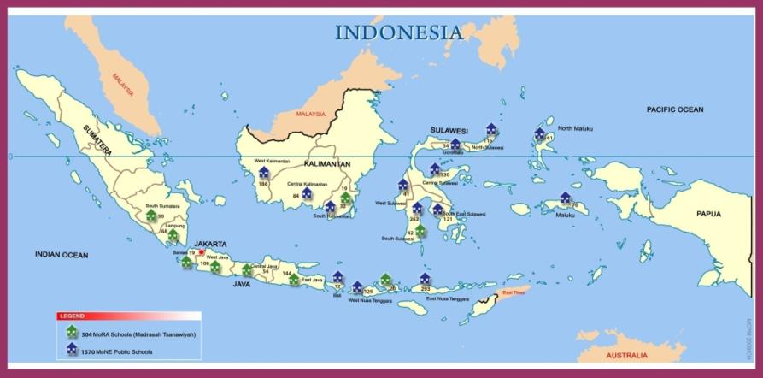

OVERVIEW OF THE 2011 SCHOOL SURVEY
  - Purpose and Scope of Survey
- The main purpose of the 2010 BEP School Survey was to provide an end of BEP benchmark for all 2,074 schools constructed with BEP support (including the 60 schools built through the use of funds saved by MoNE during the first phase of BEP generally known as “Loan Under-spend” or “LU” funds) and to provide:
- the third year of longitudinal data for the 906 schools that had completed a full three year cycle of operation by June 2010;
- the second year of longitudinal data for the 804 schools that had completed a full two year cycle of operation by June 2010; and
- the first year of data for 364 schools that either had completed their first year of operation or were in their first year of operation by June 2010.
- Within that broad purpose and scope, the survey was designed to enable:
- Aggregations or clusters of information about the changing and current status of the BEP schools for monitoring and evaluation purposes as well as for use as baseline data and ongoing comparison between BEP schools and non-BEP schools.
- A summary profile as at August/September 2010 of BEP national SMP schools and Madrasah (MTs).
- A comparison of BEP schools over time and, where appropriate, with data available nationally about SMP and MTs schools.
- A critical analysis of the data and an assessment of the extent to which key school-based BEP outputs relating to access and participation, quality and governance have been achieved through reference to the agreed performance indicators.
- Identification of key lessons learned through the survey and recommendations for future engagement with and further development of the basic education system whether at MoNE or MoRA.
  - Methodology
- Following the successful approach adopted for the two previous school surveys, the 2010 School Survey was conducted through a census of all 2,074 schools constructed through AIBEP funding using a similar School Survey Instrument (Annex 1) to those used previously.
- The majority of the questions in the 2010 Survey Instrument were in fact developed from the 2008 and 2009 Instruments. The development was based on a review of actual responses to the 2008 and 2009 instruments, personal reviews and previous reports provided by data collectors, and consultations with BEP counterparts at MoNE, MoRA, BAPPENAS and AusAID. This approach enabled most ambiguities and potential problems of interpretation to be discovered and corrected before the Survey Questionnaire was trialed and utilised in the field.
- Most of the questions were of the objective - multiple choice or Yes/No type - to reduce problems of interpretation and classification of responses both for data entry and for analytical purposes. The more objective style of question also reduces the time taken to complete a questionnaire and has been shown to improve the ‘within questionnaire’ response rate and the validity and reliability of responses.
- As this 2010 survey may well be the last survey of this specific group of schools and as it must serve as the final stage of the monitoring and evaluation of all 2,074 AIBEP schools, questions on each block of the 2010 Survey Instrument were carefully reviewed and refined to fit that purpose. In response to the incidence of natural disasters in different regions of Indonesia over the past several years - flooding, earthquakes, and volcanic eruptions - an additional block of questions was incorporated addressing an emerging concern with regard to schools’ level of disaster preparedness.
- Nine blocks of questions were included in the final 2010 Instrument giving a total of 97 questions in all. The sets of questions and each of the subjects are as shown in Table A:
Table A: Structure of the 2010 BEP School Survey Instrument
BLOCK NO. | SUBJECT | NUMBER OF QUESTIONS
I | Core Information | 13
II | School Facilities | 4
III | Teacher Data | 2
IV | Student Data | 20
V | School Management | 34
VI | Whole School Development | 5
VII | Support from School Supervisor | 3
VIII | Teaching and Learning | 10
IX | Disaster Preparedness | 6
 | TOTAL | 97
  - Data Collection: Training and Implementation
- The data collection for the 2010 School Survey was conducted by approximately 200 Data Collectors each of whom was given five-days of training in Bandung (20th-25th July 2010) or in Denpasar (26th-31st July 2010). Following the trainings, which included field visits to some non BEP schools to trial the questionnaires, the Data Collectors commenced their survey visits to the schools, with the Bandung group deployed to the field in the last week of July and the Denpasar group in the second week of August.
- The great majority of the data collectors were people who had been trained for and participated in at least one of the two previous annual surveys, others had been field monitors supporting the Pillar 1 school construction program. They were all well experienced in working with school stakeholders to obtain clear and detailed responses.
- All data from these survey visits were collected through interviews with School Principals, students, members of school committees, parents and/or other members of BEP school community at each of the visited schools, as well as through direct observation of classrooms, school registers, etc. Direct observation was particularly important for collecting information in relation to Block VIII of the Questionnaire (Annex 1) on Teaching and Learning.
- Within a period of approximately 12 weeks, completed questionnaires had been received from more than 90% of the schools and these were subsequently processed and data tabulated for further analysis and reporting.
- In spite of problems caused by remote locations and difficult weather which made travel to schools in some regions extremely difficult, only one school – in North Maluku – could not be visited. Apart from that one school, there were also a number of data sets (n = 7) that went missing in transit. Every effort was made to locate the missing questionnaires and to contact these schools by phone to access core information, however in the end there were eight schools (7 missing questionnaires + 1 school not visited) for which no data were available. The missing data related to 3 MoNE SATAPs, 2 MoNE USBs and to 3 MTs. Overall, the data from 2,066 schools or 99.6% of all the BEP funded schools were available for analysis.
  - Data Processing and Analysis
- The processing of the collected data involved an M&E Statistician with IT expertise and 15 data-entry personnel working through an online BEP School Survey Database System during the months of September and October. Additional work was required during November and in early December to enter data from school survey questionnaires submitted well after the expected final date as well as the data from the concurrent District Capacity Survey.
- Data entry accuracy was carefully monitored and only a very few systematic errors were identified and these were properly corrected before the final tabulation was completed and the information analysed. All individual responses to the open ended extended response type questions were entered into the database for subsequent categorisation by the M&E team at MCPM.
- As in previous years, the analyses focused on categories of schools – MoNE and MoRA and all BEP on the one hand and MoNE SATAP, MoNE USB and MTs on the other – to help identify significant comparisons, trends and changes in the data. While the data is available for each school, only in very exceptional instances is an individual school identified in the report.
- One problem that did emerge in the post data analysis period was that the 2008 BEP Survey had been collated using ‘excel’ whereas in 2009 and 2010 a web based database was created. It was not possible in the time available to convert the previous survey data to the new format. As a result comparisons took longer and were more unwieldy than might have been anticipated.
- As indicated in Para 25 above, the total number of schools for which data were processed and analysed was 2,066, including 732 SATAPs, 833 USBs and 501 MTs.
  - Validation Study
- A one-page Validation Survey was developed with questions focusing on (a) enrolment, (b) teachers and (c) classrooms (Annex 2). In order to minimise cost and ensure timely completion of the Validation Survey, a ‘convenience’ sampling approach was adopted, with the survey conducted only in the 128 schools to which MCPM Field Monitors were deployed in September and October 2010 as part of a follow-up visit to the LU schools. These 128 schools were located in 60 districts and 12 provinces. The sample was very adequate to test the reliability of the core School Survey instrument and also the reliability of the work undertaken by the data collectors. These Field Monitors had been trained in the data collection process for the School Survey alongside all other data collectors at the Bandung and Denpasar training workshops.
- If there was a weakness in this approach it was in the fact that the field monitors were not nearly so experienced as other data collectors in dealing with issues that might arise when collecting data about students, parents and teachers. However, the validation results are in line with the results from the 2009 validation study and indicate a high level of accuracy, consistency and reliability.
- The comparison of results on numbers of students’ enrolment, teachers and classrooms from the main survey and validation survey are outlined in the Table B below.

Table B: Level of Variance between BEP 2010 School Census and Validation Survey Results
DESCRIPTORS | CENSUS | VALIDATION | +/- VARIATION
Number of students in Grade 7 | 5,733 | 5,730 | -0.001%
Average number per school | 44.79 | 44.77 | 0.02%
Percentage female | 49.69% | 49.08% | 0.62%
Number of students in Grade 8 | 4,988 | 5,174 | +3.72%
Average number per school | 38.97 | 40.42 | -1.45%
Percentage female | 49.88% | 51.51% | -1.63%
Number of students in Grade 9 | 4,197 | 4,345 | +3.56%
Average number per school | 32.79 | 33.95 | -1.16
Percentage female | 49.42% | 49.46% | -0.04%
Number of students (all grades) | 14,918 | 15,249 | +2.21%
Average number per school | 116.55 | 119.13 | -2.59
Percentage female | 49.68% | 50.01% | -0.33%
Number of teachers | 1,699 | 1,576 | -7.02%
Average number per school | 13.27 | 12.31 | 0.96
Number of classrooms | 507 | 484 | -4.5%
Average number per school | 3.96 | 3.78 | 0.18

RESULTS OF THE SURVEY
  - Introduction
- In brief, the 2010 BEP School Survey covered 2,074 schools located in 240 districts across 20 provinces of Indonesia (see Figure 1, page 13) although, as noted in para 25, data are available for only 2,066 schools. The 2,074 schools comprised of 1,570 public junior secondary schools under MoNE (735 SATAPs and 835 USBs) and 504 Madrasah Tsanawiyah (MTs) under MoRA. At the time of the commencement of the survey the construction and fitting out of approximately 97% of all BEP Schools had been fully completed. All of the surveyed schools were found to be operational, including the 2%-3% approximately that were still incomplete at the time of the survey.
- For reference purposes, Table C overleaf shows the total number of BEP schools as at September 2010 and their enrolment and total number of teachers (Full and Part time). The sections which follow explore these and other statistics in depth and also provide some measure of change over the years of the program.
- In total more than 185,000 students are now enrolled in the 2,074 schools and these students are being taught by some 26,681 teachers many of whom are part-time. Some indication as to the scale of the BEP supported school construction program can be gathered from the fact that the total of 2,074 schools is almost the same as the total number of public schools in New South Wales in Australia. The following sections provide a picture of school environments which are often extremely varied reflecting the diversity of their geographical location and cultural and economic bases. Many schools face considerable challenges arising from their remote and difficult locations. The fact that so many of the BEP schools have grown to be viable educational units within only three years is a great indicator of community desire for improved educational opportunities and of their future aspirations for their children.
- The crucial point to be noted for the development and improvement of education is that school buildings need many inputs before they become effective learning spaces. They need students and teachers. They need leadership and organisation. They need teaching and learning resources. They need support from central and local governments and from community. A school needs these many inputs so that it can become a dynamic and living unit that is proactive, responsive, caring, guiding, listening, innovative and accountable.
- The following sections will help to show how the BEP supported schools are developing in relation to some of these key inputs – teachers, students, facilities, community support, etc. A brief summary of how the schools have evolved over the past three years and their basic characteristics is provided in section 3.2 which follows.

Table C: Key Statistics (as at September 2010)
for all BEP schools and BEP schools grouped by first year of operation
DESCRIPTORS | SCHOOLS GROUPED BY FIRST YEAR OF OPERATION | SMP |  |  | MTs | ALL BEP SCHOOLS
DESCRIPTORS | SCHOOLS GROUPED BY FIRST YEAR OF OPERATION | SATAP | USB | TOTAL SMP | MTs | ALL BEP SCHOOLS
Number of Schools Surveyed | ≤2007 to 2011 | 732 | 833 | 1,565 | 501 | 2,066
Number of Schools Surveyed | ≤2007-2008 | 341 | 325 | 666 | 74 | 740
Number of Schools Surveyed | 2008-2009 | 265 | 257 | 522 | 47 | 569
Number of Schools Surveyed | 2009-2010 | 106 | 202 | 308 | 223 | 531
Number of Schools Surveyed | 2010-2011 | 20 | 49 | 69 | 157 | 226
Enrolment, September 2010 | ≤2007 to 2011 | 46,273 | 104,387 | 150,660 | 34,832 | 185,492
Enrolment, September 2010 | ≤2007-2008 | 25,555 | 51,158 | 76,713 | 8,556 | 85,269
Enrolment, September 2010 | 2008-2009 | 14,560 | 32,787 | 47,347 | 3,753 | 51,100
Enrolment, September 2010 | 2009-2010 | 4,978 | 16,866 | 21,844 | 14,895 | 36,739
Enrolment, September 2010 | 2010-2011 | 1,180 | 3,576 | 4,756 | 7,628 | 12,384
Female Students (%) | ≤2007 to 2011 | 50.44 | 49.74 | 49.95 | 48.96 | 49.77
Female Students (%) | ≤2007-2008 | 50.16 | 50.12 | 50.13 | 48.24 | 49.94
Female Students (%) | 2008-2009 | 50.84 | 49.84 | 50.15 | 49.51 | 50.10
Female Students (%) | 2009-2010 | 50.26 | 48.75 | 49.10 | 48.72 | 48.95
Female Students (%) | 2010-2011 | 52.29 | 48.01 | 49.07 | 49.99 | 49.64
Average Enrolment per School | ≤2007 to 2011 | 63 | 125 | 96 | 70 | 90
Average Enrolment per School | ≤2007-2008 | 75 | 157 | 115 | 116 | 115
Average Enrolment per School | 2008-2009 | 55 | 128 | 91 | 80 | 90
Average Enrolment per School | 2009-2010 | 47 | 83 | 71 | 67 | 69
Average Enrolment per School | 2010-2011 | 59 | 73 | 69 | 49 | 55
Number of Teachers | ≤2007 to 2011 | 7,543 | 11,417 | 18,960 | 7,721 | 26,681
Number of Teachers | ≤2007-2008 | 3,834 | 5,154 | 8,988 | 1,294 | 10,282
Number of Teachers | 2008-2009 | 2,614 | 3,445 | 6,059 | 760 | 6,819
Number of Teachers | 2009-2010 | 915 | 2,275 | 3,190 | 3,430 | 6,620
Number of Teachers | 2010-2011 | 180 | 543 | 723 | 2,237 | 2,960
Number of Full-time Teachers | ≤2007 to 2011 | 3,992 | 6,592 | 10,584 | 3,112 | 13,696
Number of Full-time Teachers | ≤2007-2008 | 2,090 | 3,103 | 5,193 | 672 | 5,865
Number of Full-time Teachers | 2008-2009 | 1,402 | 2,039 | 3,441 | 301 | 3,742
Number of Full-time Teachers | 2009-2010 | 424 | 1,230 | 1,654 | 1,309 | 2,963
Number of Full-time Teachers | 2010-2011 | 76 | 220 | 296 | 830 | 1,126
Number of Part-time Teachers | ≤2007 to 2011 | 3,551 | 4,825 | 8,376 | 4,609 | 12,985
Number of Part-time Teachers | ≤2007-2008 | 1,744 | 2,051 | 3,795 | 622 | 4,417
Number of Part-time Teachers | 2008-2009 | 1,212 | 1,406 | 2,618 | 459 | 3,077
Number of Part-time Teachers | 2009-2010 | 491 | 1,045 | 1,536 | 2,121 | 3,657
Number of Part-time Teachers | 2010-2011 | 104 | 323 | 427 | 1,407 | 1,834
Teacher: Student Ratio (based on Effective Full Time Teachers) | ≤2007 to 2011 | 8.02 | 11.59 | 10.20 | 6.43 | 9.19
 | ≤2007-2008 | 8.63 | 12.39 | 10.82 | 8.70 | 10.56
 | 2008-2009 | 7.25 | 11.96 | 9.97 | 7.07 | 9.68
 | 2009-2010 | 7.44 | 9.62 | 9.02 | 6.29 | 7.67
 | 2010-2011 | 9.22 | 9.37 | 9.33 | 4.97 | 6.06
Number of Female Teachers | 2006 to 2010 | 3,464 | 5,711 | 9,175 | 2,999 | 12,174
Number of Female Teachers | 2006-2007 | 695 | 1,464 | 2,159 | 334 | 2,493
Number of Female Teachers | 2007-2008 | 1,349 | 2,213 | 3,562 | 0 | 3,562
Number of Female Teachers | 2008-2009 | 1,420 | 1,785 | 3,205 | 944 | 4,149
Number of Female Teachers | 2009-2010 | 0 | 249 | 249 | 1,721 | 1,970

BEP SCHOOLS
BEP SATAPs, USBs and MTs across Indonesia.
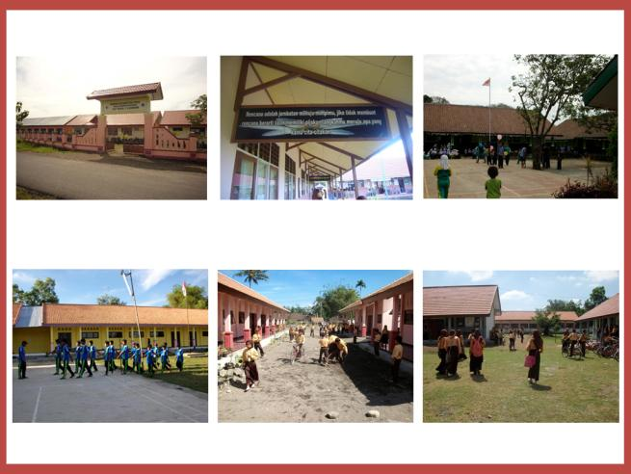

  - The Schools
    - Distribution of Schools
- By September 2010, 2,074 BEP schools were operational in seven regions of Indonesia, with the highest percentage of schools constructed on the island of Sulawesi (see Figure 1 on page 13 and Figure 2 below). The distribution also shows the way in which the program responded to the expressed government need to focus on improving access and participation levels in the more remote and isolated parts of the country and especially in eastern Indonesia.
Figure 2: BEP Schools by Region
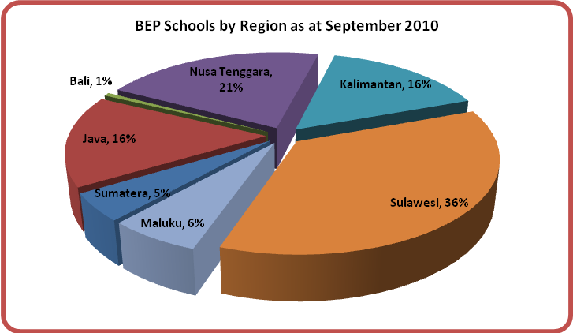
    - Classrooms and Other Facilities
- The total number of classrooms, laboratories, principals/teachers rooms, libraries and other rooms (classrooms used for other purposes such as prayer rooms and store rooms) across all 2,066 BEP schools included in the survey comes to 15,628 - details are shown in Figure 3.
Figure 3: Number of Rooms at BEP Schools
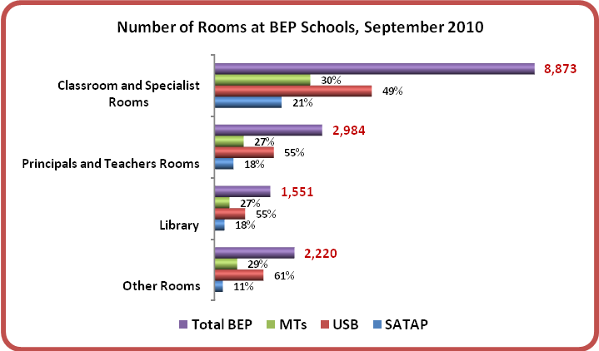
- The construction of a total 8,873 classrooms and specialist rooms (e.g. science labs, computer labs, arts and craft rooms, etc) during the four years of the program means that by the end of 2010 BEP had provided about 280,000 new student places based on the BSNP standard of 32 students per classroom. Should the maximum 36 students per classroom standard (as regulated by the PERMENDIKNAS 15/2010 on Minimum Service Standards) be used as the basis for calculation then about 320,000 new student places are available. Furthermore, if libraries are also treated as teaching spaces, as is common in many schools, then these numbers will be increased to more than 375,000 new student places. The original target of providing 330,000 new places has been well achieved.
- The number of BEP students per classroom varies across each type of school, being on average – 25 students at SATAPs, 28 at USBs and 18 at MTs. However, what is probably more important to note is the availability of science laboratories across the three types of BEP school. While 95% of BEP funded MTs have at least one science laboratory, only 59% of MoNE USBs and less than 4% of MoNE SATAPS have a science laboratory. As a result, the average number of students per science laboratory for USBs is quite high at 214 students per laboratory but can probably be managed through efficient timetabling provided that the total number of students in a school is not too great. MTs are much better off with only 73 students per laboratory. However, by comparison with both other types of BEP school, the SATAPs are much worse off with an average of 1,714 students per laboratory (see Figure 4 below).
- This reveals perhaps the greatest disadvantage faced by SATAPs when trying to deliver a high quality comprehensive national curriculum and certainly is one reason why parents in some areas are reported as bypassing the SATAP which is closest to home and sending their student children to a USB further away.
Figure 4: Average Number of BEP Students per Classroom and per Science Laboratory
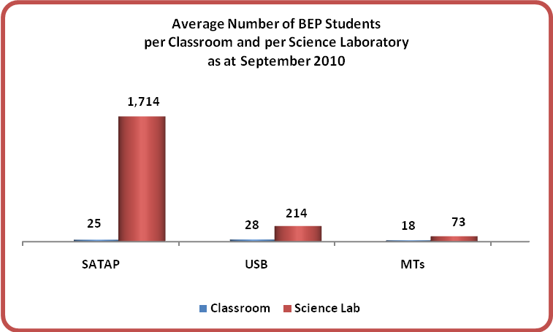
- 75% of BEP schools were reported to have electricity (54% from PLN, 21% from generators). There have not been any significant changes regarding electricity availability since 2009 and the largest number of schools without electricity is still USBs with 38% reporting no electricity supply.
- More than 55% of BEP schools get their supply of clean water from the storage tanks, while 16% get their daily supply provided by parents, teachers and the local community. 60% of BEP schools have sinks for students’ hand washing.
- The 2009 survey reported that 55% of BEP students did not have their own copies of required textbooks (curriculum books). The percentage had decreased by the 2010 survey, which recorded that about 65,000 students or about 35% out of the total number of BEP students do not have their own copies of all required textbooks. In those classes where there are insufficient books for students, common practice is for students to share. A comparison table of the 2009 and 2010 numbers of BEP students who do not own their textbooks, is as follows:
Table D: BEP Students Who Do Not Own Their Own Textbooks
TYPE OF SCHOOL | 2009-2010 RESULT  (Total BEP Students: 137,901) |  | 2010-2011 RESULT  (Total BEP Students: 185,492)
SATAP | 19,392 | 25.4% | 18,913 | 29.0%
USB | 49,809 | 65.2% | 34,708 | 53.2%
MTs | 7,144 | 9.4% | 11,645 | 17.8%
OVERALL BEP | 76,345 | 100% | 65,266 | 100%

- As compared to 2009, an increasing proportion of BEP schools are able to provide textbooks for students to use (refer to Table E below). However, this is only true for the SATAPs and MTs. The percentage of USBs reporting being able to provide textbooks actually declined slightly in 2010. This does not necessarily mean a problem as Table D above has shown that the number of students in USBs who do not own their own textbooks has declined by about 15,000 students or 30% since the 2009-2010 survey.
Table E: Percentage of BEP Schools that Are Able to Provide Textbooks for Students
TYPE OF SCHOOL | 2009-2010 RESULT | 2010-2011 RESULT
SATAP | 72% | 78%
USB | 74% | 68%
MTs | 43% | 58%
OVERALL BEP | 63% | 69%

- 69% of BEP school libraries have supplies of curriculum books, 73% of them have Supplementary Reading Materials (SRMs) and 51% have reference books.
- 50% of BEP schools have computers for school administration but only 13% have them for students’ use. The percentages of SATAPs and USBs that are able to provide computers for students significantly decreased over the past year from 13% to 3% this year for SATAPs and 22% to 14% for USBs. It is safe to assume that the last batch of USBs and SATAPs being completed and made operational during the past year may have not have had time to complete the provision of all facilities, such as computers for students.
- The number of BEP schools with internet facilities improved by about 3% over the year, but is still at a very low level given that a total of only 85 schools (4.3%) now have internet installed.
- There are only 69 (3%) BEP schools that have land line telephone facilities. Most schools conduct communications by using mobile phones.
    - School Accreditation and Supervision
- By September 2010, 9% or 186 BEP schools (7% SATAP, 11% USB and 9% MTs) were recorded as being accredited. 166 of those 186 schools or 8% of total BEP schools were able to confirm their accreditation status as follows - rank A (9%), B (54%) and C (37%). The remaining schools which are not accredited all indicated their intention to undergo school accreditation before 2013.
- School Supervisors’ visits to schools are viewed as highly useful support to most BEP schools (76%). Supervisors made between one and four visits to 80% of BEP schools in 2010.

BEP TEACHERS
BEP Teachers. Top: Teachers at a BEP MTs. Bottom: Teachers’ Room, Speed Boat – a mean of teachers’ transportations.
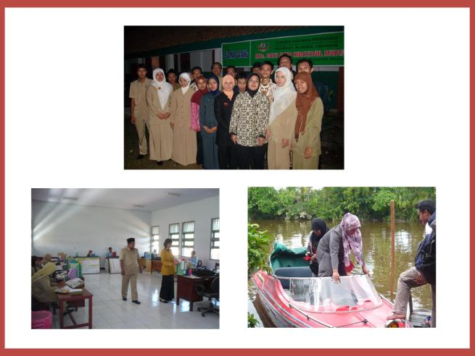
Table F: BEP Teachers’ Profile
Type of School | Age  (mean) |  | Gender |  |  |  | Civil Servant |  | Year Joined the School |  |  |  |  |  | Highest Academic Level
Type of School | M | F | M | % | F | % | Civil Servant | % | ≤2008 | % | 2009 | % | 2010 | % | ≤D3 | % | D4/S1 | % | ≥S2 | %
SATAP | 36 | 31 | 3,997 | 54% | 3,464 | 46% | 3,319 | 44% | 1,943 | 52% | 1,982 | 27% | 1,445 | 19% | 2,448 | 33% | 4,784 | 64% | 50 | 1%
USB | 35 | 31 | 5,625 | 50% | 5,711 | 50% | 5,849 | 52% | 2,570 | 45% | 3,524 | 31% | 2,255 | 20% | 2,031 | 18% | 9,010 | 79% | 120 | 1%
Total MoNE | 35 | 31 | 9,622 | 51% | 9,175 | 49% | 9,168 | 49% | 4,513 | 48% | 5,506 | 29% | 3,700 | 20% | 4,479 | 24% | 13,794 | 73% | 170 | 1%
MTs | 32 | 29 | 4,860 | 62% | 2,999 | 38% | 923 | 12% | 967 | 30% | 3,082 | 39% | 2,235 | 28% | 2,330 | 30% | 5,154 | 66% | 182 | 2%
Total BEP | 34 | 31 | 14,482 | 54% | 12,174 | 46% | 10,091 | 38% | 5,480 | 42% | 8,588 | 32% | 5,935 | 22% | 6,809 | 26% | 18,948 | 72% | 352 | 1%

Type of School | Pre-Service Pedagogic Training* |  | Years of Teaching Experience |  | Teacher Certification |  | Main Subject Specialisation |  |  |  |  |  |  | Teaching Hours per Week |  | Present on the Day of Survey
Type of School | Yes | % | M | F | Yes | % | Math | Natural Science | Bahasa Indonesia | English | Social Science | Religion | Others | M | F | F/T teacher absent | P/T teacher absent on work day | P/T teacher not present as not scheduled work day
SATAP | 5,182 | 69% | 8 | 5 | 995 | 13% | 753 | 922 | 764 | 750 | 1,086 | 828 | 2,186 | 11.2 | 11.8 | 9% | 5% | 15%
USB | 7,879 | 70% | 8 | 5 | 1,882 | 17% | 1,183 | 1,432 | 1,138 | 1,187 | 1,644 | 1,276 | 3,197 | 13.3 | 13.4 | 7% | 4% | 15%
Total MoNE | 13,061 | 69% | 8 | 5 | 2,877 | 15% | 1,936 | 2,354 | 1,902 | 1,937 | 2,730 | 2,104 | 5,383 | 12.4 | 12.8 | 8% | 4% | 15%
MTs | 4,919 | 63% | 7 | 5 | 1,014 | 13% | 587 | 592 | 554 | 601 | 667 | 2,110 | 2,502 | 7.9 | 8.8 | 6% | 6% | 29%
Total BEP | 17,980 | 67% | 8 | 5 | 3,891 | 15% | 2,523 | 2,946 | 2,456 | 2,538 | 3,397 | 4,214 | 7,885 | 10.9 | 11.8 | 7% | 5% | 19%

  - The Teachers
    - Full-time or Part-time
- There were 26,681 teachers in 2,074 BEP schools (see Figure 5 below for the distribution of BEP teachers by region) working full or part-time in 2010 - an increase of 7,256 or approximately 37% from total of BEP teachers in 2009. This represents approximately 4% of the total number of SMP teachers in Indonesia.
Figure 5: BEP Teachers by Region
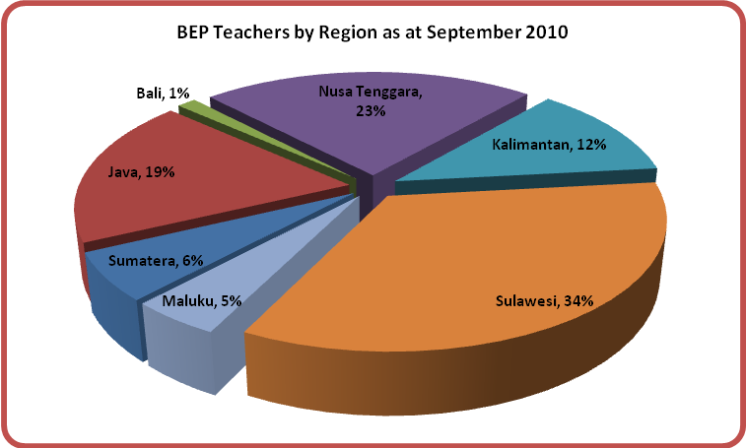
- On average, USB schools have 13.7 teachers per school, SATAPs have 10.3 teachers per school and Madrasah have 15.4 teachers per school. More than 50% of teachers have joined their current schools during the past two years as schools established in the early years of BEP show increased enrolment and new schools become operational.
- The teachers in the BEP schools are relatively young – an average 47% of them are below 30 years old – but are also quite experienced with male teachers having been teaching for eight years and female teachers having had on average five years’ experience. That experience factor should work positively to provide a better quality of education.
- In any education system teachers are one of, if not the main determinant of the quality of education which any one student will receive. Many children spend more time during an average day under the guidance of a teacher than they do under the guidance of their parents. Poor teaching is a crucial cause of poor learning.
- Of the total number of BEP teachers in SMP and MTs, nearly 13,696 (approximately 51% of them) are recorded as being full-time, teaching at least 15 hours a week in the BEP school in which they are employed (Figure 6).

Figure 6: Number of Teachers in BEP Schools
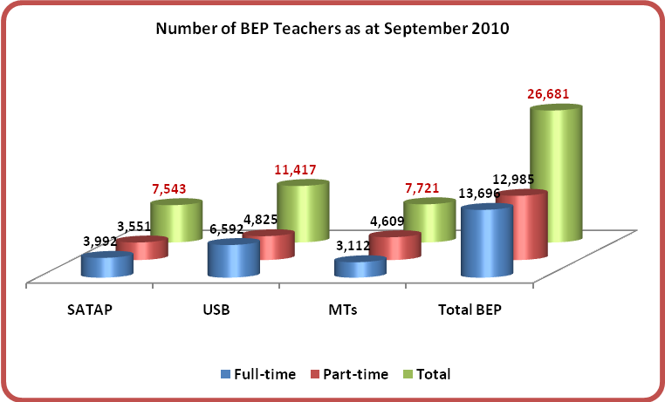
- Part-time teachers are in school for varying amounts of time – some for one or two days while others may be working for three or four days. If it is assumed that all part-time teachers are in the schools where they are working for 50% of the time or 0.5 of each week then effectively the number of 12,985 part-time teachers is the equivalent of 6,493 Effective Full-time teachers (EFT) – i.e. 12,985 x 0.5 = 6,493.
- Figure 7 shows the total Effective Full-time Teachers (EFT) against number of students in all BEP schools as at September 2010. The EFT, combined for SMP and MTs, is equal to 13,696 + 6,493 = 20,189.
Figure 7: EFT and Number of Students in BEP Schools
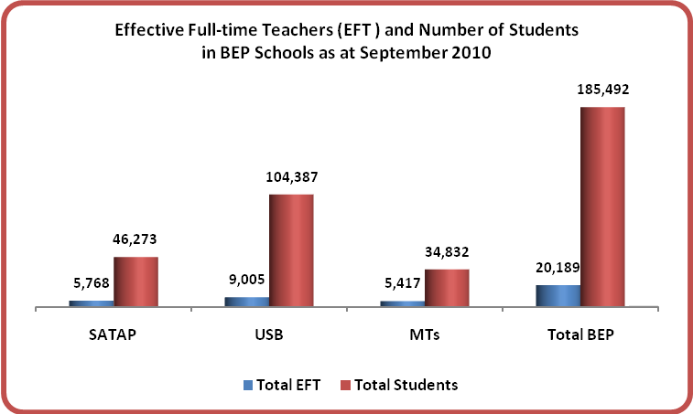

- The 51:49 ratio of full-time compared to part-time teachers at BEP schools is a serious challenge in achieving a sustainable and improved quality of education (Figure 8 below). It is even more challenging with more than 59% of the BEP part-time teachers dividing their teaching time and teaching responsibilities by teaching in more than one school.
Figure 8: Proportion of Full-time and Part-time BEP School Teachers
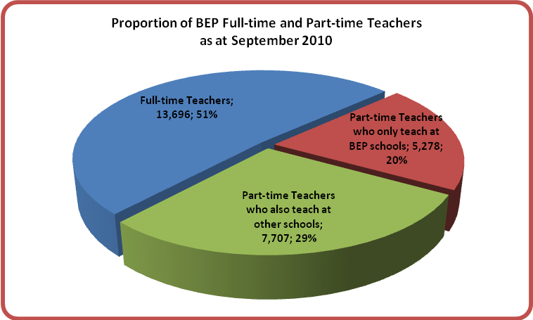
- These potential problems are perhaps more serious for the MTs where the proportion of part-time teachers is 59.7% and where the part-time teachers are often the specialist teachers of math and science.
- The high percentage of part-time teachers in all BEP schools does have implications for education quality and efficiency:
- Part-time teachers potentially can bring important efficiencies to a school’s education budget, including a lower unit cost per teacher and reduced costs for benefits and/or other incentives that are the entitlement of permanent teachers. Such efficiencies can allow for larger funding allocations for supplementary teaching and learning resources which can improve quality.
- Nevertheless, this apparent efficiency gain comes with potential quality consequences such as the limited time that part-time personnel have available to provide additional help to students who do not readily understand the material being taught and the limited time these teachers have to contribute more broadly to the life of the school and its extra-curricular activities. Dividing their time to teach at more than one school can require very good time management skills if the quality of lesson preparation, classroom teaching, and supervision of student work, is not to be diminished at both schools. There is also the potential negative impact from using BOS to pay for contract teachers (see para 64).
- The use of BOS (School Operational Assistance) funds for the payment of contract teachers in 74% of BEP schools also reduces funds available for the purchase of quality teaching and learning resources.

    - The Teacher: Students Ratio
- Based on the EFT assumption described in paragraph 59 above, which indicate a total EFT in BEP schools of 20,189, the teacher to student ratio is on average 1: 9.2 across all BEP schools. Table D below provides data on the teacher: student ratio for each type of junior secondary school.
Table G: EFT Teacher: Students Ratio in BEP Schools
TYPE OF SCHOOL | 2009 SURVEY | 2010 SURVEY
SATAP | 7.07 | 8.02
USB | 11.56 | 11.59
MTs | 8.33 | 6.43
AVERAGE RATIO | 8.98 | 9.19

- A favourable teacher: students ratio is one indicator of a potentially higher quality of education as it suggests that teachers have more time in class to support the learning of each individual student than is possible when ratios are say 1:30 or more. However, a higher quality of education is not a certain outcome because in the short term if the ratio is created by having a high percentage of part-time teachers then there may be reduced funds available at school level for the provision of quality supplementary teaching and learning materials. An excess reliance on part-time teachers may also reduce the teachers’ availability to support the broader school curriculum and the specific needs of children experiencing learning difficulties.
- Considered from a district government perspective, low teacher: student ratios may be indicative of a potentially higher average cost per student and ultimately be seen as a greater burden on district budgets.
- The teacher: students ratio has increased slightly for both types of BEP MoNE schools since the 2009 survey due to the increase in enrolments in existing schools. However, it is still viable for good educational practice and is less than the 1:21 ratio used as the national standard in Indonesia. The ratio for MTs has actually reduced from 1:8.3 to 1: 6.4 reflecting the additional madrasah in the database and the probability that their enrolments have yet to reach their maximum while staffing has already been increased to meet new expected demand levels.
    - Gender and Age
- The ratio of male to female teachers across all the BEP schools is 54:46 in comparison to the national figures of 49:51 for Indonesian teachers for the 2008-2009 School Year (as shown in Figure 9) and, even though the number of teachers has increased by more than 7,000, is identical to the 54:46 reported in the 2009 survey.
- As in previous years, male teachers (62%) are a far larger proportion as compared to female teachers (38%) in MTs than in MoNE schools and in schools nationally (see Figure 9 below).

Figure 9: Male and Female Teachers in BEP Schools
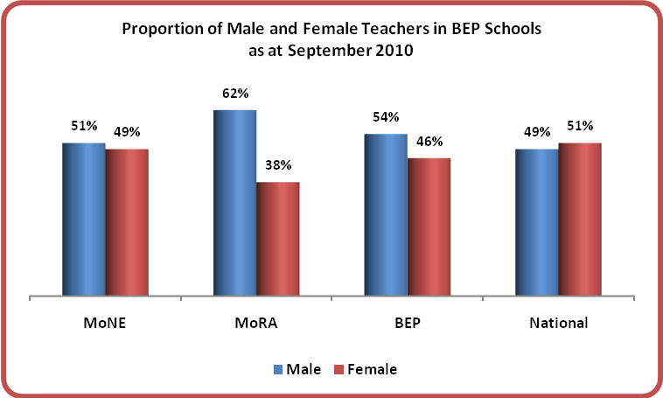
- The average age of 34 years for male teachers in the BEP schools is significantly older than the 31 years for female teachers in BEP schools probably reflecting the fact that, for men, teaching is a long-term career while women may leave to have children and to fulfill home duties.
- However, 47% of BEP teachers are younger than 30 years old in comparison to 18.5% of teachers on a national basis. The youthfulness of teachers is a positive characteristic as many young teachers have benefited from improved teacher education with its increased emphasis on the importance of different approaches to teaching and the need to recognise, understand and respond to students’ different learning styles.
    - Some Other Characteristics of BEP Teachers
- The Figures 10 and 11 provide both a visual and tabular representation of a number of other teacher characteristics.
Figure 10: BEP Teachers’ Employment Status and Level of Qualifications
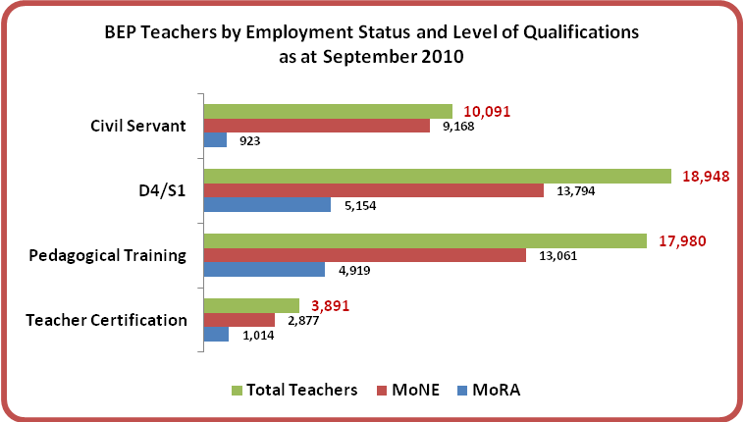
Figure 11: BEP Teachers’ Employment Status and Level of Qualifications
(Percentage of MoNE and MoRA)
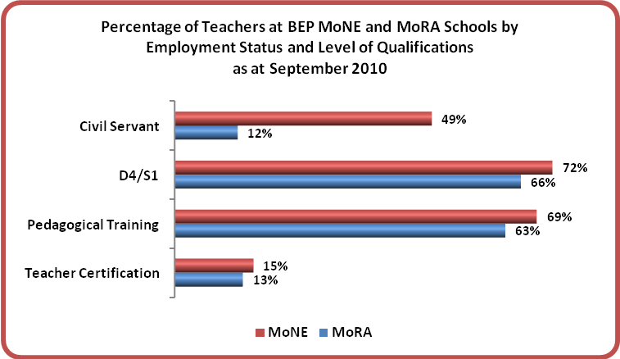
- More BEP teachers – 38% overall - were recorded as being Civil Servants in the 2010 survey in comparison to only 24% in 2009. The percentage of teachers with minimum D4/S1 degrees also has increased from 68% in 2009 to the current level of 72%. Likewise, more teachers (nearly 15%) are now reported to have completed teacher certification programs compared to only 11.5% in 2009.
- Whilst the BEP teachers’ profile in relation to the above mentioned characteristics has improved since the last BEP School Survey, the percentage of teachers who have undertaken pedagogical training decreased slightly from 69% in 2009 to 67% this year – most likely accounted for by the larger number of MTs teachers included in the survey this year. The proportion of MoRA teachers with pre-service pedagogical training has dropped from 65% in 2009 to 63% in 2010. The percentages for SATAP and USB teachers are virtually unchanged from 2009.
    - Teacher Qualifications
- Ministerial Regulation for National Education (SK MENDIKNAS) No. 16/2007 on Minimum Requirement of Teachers’ Academic Qualification, requires that all teachers of Kindergarten (TK/RA), Elementary (SD/MI), Middle School or Junior Secondary School (SMP/MTs) and High School (SMA/MA) have a minimum D4/S1 degree.
- At the national level, the 2007-2008 data showed that 26 out of 100 SMP teachers had not met the D4/S1 qualification requirement. The same measure currently for teachers in the BEP schools is directly comparable at 26% (see Figure 12 below). The lower level of qualification is much more noticeable in SATAPs and in MTs where there is certainly some crossover of teachers from Grades 1-6 to Grades 7-9 reflecting the close geographical linkage between the junior secondary school and the primary school.
- As expected, the level of qualification is higher in the USBs where nearly 80% of teachers have a D4/S1 qualification and only 18% have D3 or lower. Only a very small percentage of teachers at the junior secondary level have an S2 qualification.
Figure 12: Academic Qualifications of BEP Teachers (Full-time and Part-time)
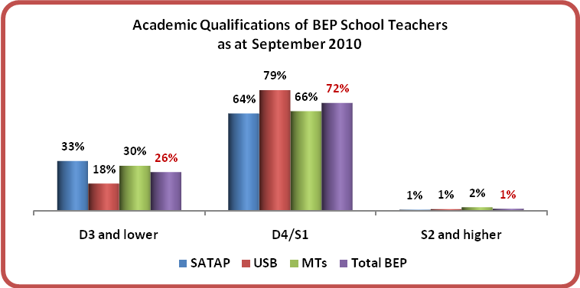
- Overall, while on the basis of national comparison the statistics for BEP teachers’ academic and pedagogical qualifications are relatively good, these two aspects do not guarantee a high quality of teaching as education delivery certainly takes more than just a proven academic level and pedagogical qualifications. As noted previously, many of the teachers in the BEP schools are young and much will depend on whether the school culture encourages and facilitates those young teachers to maximise their energy and enthusiasm as well as their use of the new approaches and ideas they have encountered during their pre-service training.
- One of the initiatives for quality improvement that the Government of Indonesia (GoI) has been encouraging is a Teacher Certification Program conducted by a number of MoNE appointed Training Centre for Educational Staff (LPTK) across the country. However, the successful implementation of this program requires concerted efforts from all stakeholders and especially from teachers in more remote rural locations.
- Currently, only 15% of the teachers in the BEP schools have received certification – 17% of USB teachers and 13% of SATAP and MTs teachers.
- Teacher certification is not an equivalent for those without D4/S1 degree. In fact, one of the program’s selection requirements regulates that each candidate must at least have a D4/S1 degree. Those without a D4/S1 degree are to be considered as eligible only if over 50 years old and having a minimum 20 years of teaching experience and IV-a level classification. Even teachers with a D4/S1 degree must have a minimum 5 years of teaching experience to be eligible to apply. Other teachers with D4/S1 but working in more remote areas may face difficulty in attending classes at the LPTK of which there are only 31 nationwide.
- On completion of the certification program the successful candidates are entitled to a professional incentive equal to as much as a 1-month salary promotion. The incentive ideally is expected to encourage higher quality of teaching performance. However, anecdotal evidence and reports from teachers suggest that this does not always happen as hoped.

    - Teacher Specialisation
- As described in Figure 13 overleaf, on average, 10% of teachers at BEP schools are specialist teachers of one of Mathematics, Natural Science, Bahasa Indonesia or English – the four main subjects of the National Examination. The percentages of specialist teachers who teach either Social Science or Religion are higher – 13% and 16% respectively. The percentage of specialist teachers of Social Science, Bahasa Indonesia, Natural Science and Math are significantly lower in the MTs than is the case at the MoNE SMPs.
- These data suggest that, on average, schools constructed under the BEP have one specialist teacher in each of the core subjects of the national curriculum with larger schools, generally USBs, having two specialists in one or more of these specialist areas.
- The fact that 30% of BEP teachers teach other than their main specialist subjects (see Figure 13 below) could be an indication that (a) these teachers are required to teach specialist classes in other areas because of staff shortages – a practice known widely as ‘mismatch’; (b) many teachers, especially in the SATAPs and Pesantren based MTs have been and continue to be more generalist primary level teachers who are required to meet teacher shortages in some areas; and (c) many teachers are teaching more than one subject.
- Although the practice of teachers teaching more than one subject at secondary school level is common in many countries, including Australia, it is not so common in Indonesia. Such multi-skilling is a reflection of the diversity of most undergraduate programs which generally require both a major and a sub-major or a double major. Being able to teach at least two subjects at school level – e.g. Math and Science – supports flexibility in staffing while increasing employment opportunities for teachers.
Figure 13: Percentage of Teachers in BEP Schools by Subject of Specialisation
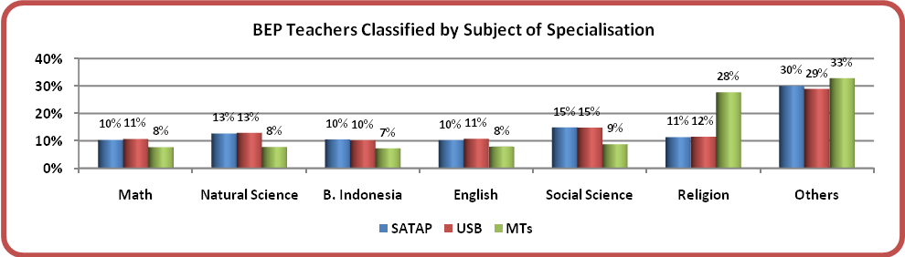
    - Teaching Hours
- Given the fact that more schools were constructed and became operational in 2010 and existing schools have grown in enrolment, the average teaching hours of BEP teachers per week as at September 2010 had increased not unexpectedly to 10.9 hours for male teachers and 11.8 hours for female teachers.
- As shown in Figure 14, the average teaching hours have increased from the 2009 survey by more than one hour per week at SATAPs and by closer to two hours per week at USBs. On average, and as in 2009, female teachers at BEP schools teach more hours than do male teachers. However, these figures are way below the 24 hours per week that the Ministry regards as the desirable norm and suggests inefficiency in the employment of many teachers. Core subject specialist teachers, especially in USBs, tend to teach more hours than do other teachers.
Figure 14: Average Teaching Hours per Week for BEP School Teachers (EFT)
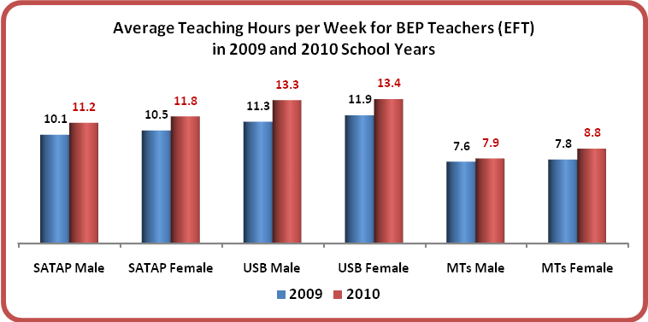
    - Teacher Transfer and Absenteeism
- 7% of teachers transferred out of the BEP schools during 2009-2010 school year; most of them relocated by Regional Education Office (DISDIK) to teach in other schools.
- The survey collected data relating to teacher absenteeism on the day the data collector visited the school. The results show that more than 6% of all teachers (full and part-time combined) were absent on that day. In addition nearly 20% of part-time teachers were not on duty because it was not a contract day.
- This absenteeism must impact negatively on the school’s ability to offer a consistently high quality of education. Likewise the fact that up to 20% of part-time teachers are not present on any day means that well in excess of 10% of all teachers are absent or will not attend on any one day and their contribution to the broader life of the school is fragmented and limited.
    - Teachers’ Travel Time and Distance
- Although there was not a specific survey question, there is a note on BEP teachers’ travel time and travel distance that should be taken into account for future reference. This refers to the many requests for provision of teachers’ dormitory that were recorded on this year’s survey and the possible need for schools and school communities to provide not only better access for students but also greater support for teachers who often travel long distances on a daily basis and often have to negotiate rivers and sea. Refer also to a story from one of BEP schools in Sulawesi on page 48.

BEP STUDENTS
Students in various BEP SATAPs, USBs and MTs. Top: In classrooms. Bottom: In craft room, library and computer laboratory.
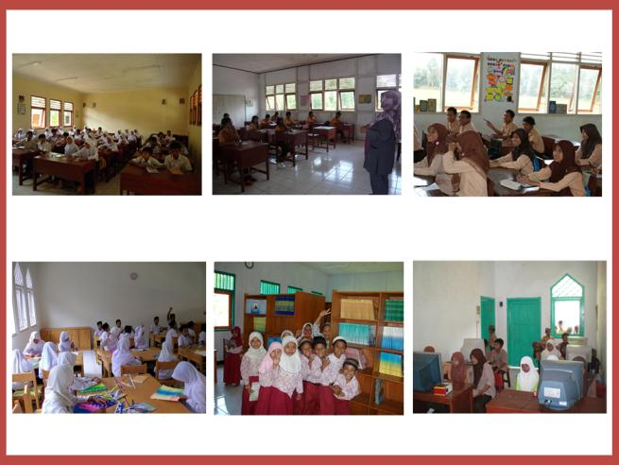

  - The Students
    - Current Enrolment
- Enrolment is probably the ultimate measure of the effectiveness of the program in providing improved access and increased levels of participation at the junior secondary level. The total number of students enrolled in the BEP schools for the 2010-2011 School Year is 185,492 distributed in 20 provinces in 7 regions (see Figure 15), with approximately equal numbers of male and female students (see Table H).
Figure 15: BEP Students by Region
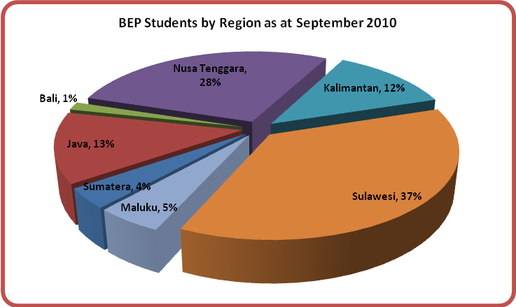
- Tables H and I below provide two perspectives on current enrolment. Table H presents the changing numbers by type of school over the three year period 2008-2009 to 2010-2011, while Table I shows the numbers of students at each grade level by type of school as at September 2010. Figures 16 and 17 present much the same information in graph format.
Table H: Number of BEP Students by School Year
TYPE OF SCHOOL | 2008-2009 |  |  | 2009-2010 |  |  | 2010-2011
TYPE OF SCHOOL | m | f | TOTAL | m | f | TOTAL | m | f | TOTAL
SATAP | 12,631 | 12,726 | 25,357 | 18,752 | 18,629 | 37,381 | 22,932 | 23,341 | 46,273
USB | 26,559 | 26,031 | 52,590 | 41,480 | 40,651 | 82,131 | 52,467 | 51,920 | 104,387
MTs | 4,605 | 4,600 | 9,205 | 11,496 | 10,007 | 21,503 | 17,777 | 17,055 | 34,832
TOTAL BEP | 43,795 | 43,357 | 87,152 | 71,728 | 69,287 | 141,015 | 93,176 | 92,316 | 185,492
Table I: Number of BEP Students by Grade
TYPE OF SCHOOL | GRADE 7 |  |  | GRADE 8 |  |  | GRADE 9 |  |  | GRAND TOTAL
TYPE OF SCHOOL | m | f | TOTAL | m | f | TOTAL | m | f | TOTAL | m | f | TOTAL
SATAP | 8,359 | 8,705 | 17,064 | 7,912 | 7,652 | 15,564 | 6,679 | 6,966 | 13,645 | 22,932 | 23,341 | 46,273
USB | 20,265 | 20,295 | 40,560 | 18,131 | 17,666 | 35,797 | 14,110 | 13,920 | 28,030 | 52,467 | 51,920 | 104,387
MTs | 9,687 | 9,287 | 18,974 | 5,721 | 5,478 | 11,199 | 2,361 | 2,298 | 4,659 | 17,777 | 17,055 | 34,832
TOTAL BEP | 38,311 | 38,287 | 76,598 | 31,764 | 30,796 | 62,560 | 23,150 | 23,184 | 46,334 | 93,176 | 92,316 | 185,492
Figure 16: Number of BEP Students by Type of School
2008-2009 to 2010-2011
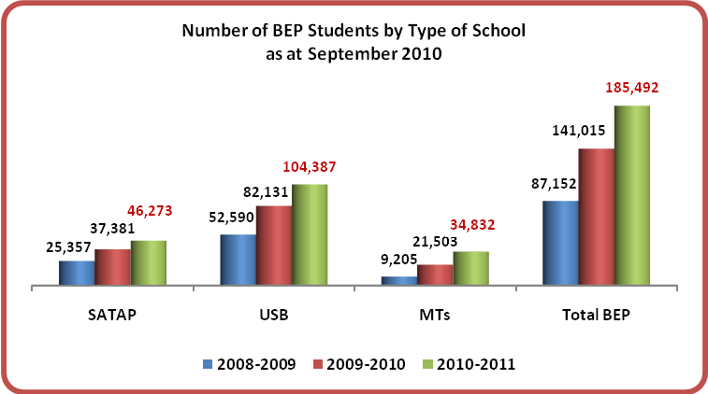
Figure 17: Number of BEP Students by Grade Level
2008-2009 to 2010-2011
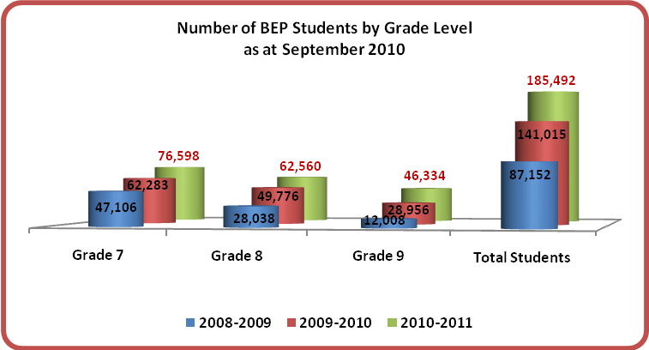
- As was expected given that these were all basically new schools, the total enrolments for each type of school and for each grade level have shown steady growth over the three years. SATAP enrolments have increased from 25,357 to 46,273 – an increase of 82.5%; USB enrolments have grown from 52,590 to 104,387 - an increase of 98.5%; and MTs enrolments nearly threefold (298%) from 9,205 to 34,832 as the number of MTs becoming operational increased rapidly during 2009 and 2010 reflecting the somewhat delayed construction cycle for MTs.
- The average number of students per school type in 2008-2009 was 80 for USBs and SATAPs combined and 120 for MTs. By school year 2010-2011, the average enrolment for all MoNE schools (USBs and SATAPs combined) had increased to 96 with the average for SATAPs being 63 and for USBs 125, while the average enrolment for MTs had dropped to 69 students per school. It is very clear and to be expected that the first schools constructed were those with the greatest potential to provide access for previously under-served areas. This was very much the case with the first pesantren based MTs which were constructed in large pesantren with high resident Madrasah Ibtidaiyah (MI) enrolments and in some cases even an existing enrolment at junior secondary level. Subsequent schools were always more likely to be constructed in more marginal areas with fewer potential students. This was also the case for the most recent MTs which were constructed in non pesantren environments and serve smaller, more isolated and poorer communities. This general picture of increasingly marginal locations is the picture revealed in Table J which shows data on average number of students at each Grade level per BEP school type by each opening year.
Table J: Average Number of Students per Each Type of BEP School by Year of Operation
YEAR | AVERAGE NUMBER | SATAP | USB | TOTAL MoNE | MTs | TOTAL BEP
2007 | Grade 7 Students per School | 27 | 56 | 41 | 44 | 42
2007 | Grade 8 Students per School | 24 | 52 | 38 | 38 | 38
2007 | Grade 9 Students per School | 23 | 49 | 36 | 33 | 35
2007 | Total Students per School | 75 | 157 | 115 | 116 | 115
2008 | Grade 7 Students per School | 20 | 47 | 33 | 36 | 34
2008 | Grade 8 Students per School | 18 | 42 | 30 | 26 | 30
2008 | Grade 9 Students per School | 17 | 38 | 27 | 18 | 26
2008 | Total Students per School | 55 | 128 | 91 | 80 | 90
2009 | Grade 7 Students per School | 20 | 39 | 32 | 36 | 34
2009 | Grade 8 Students per School | 19 | 35 | 30 | 27 | 29
2009 | Grade 9 Students per School | 8 | 9 | 9 | 3 | 6
2009 | Total Students per School | 47 | 83 | 71 | 67 | 69
2010 | Grade 7 Students per School | 22 | 43 | 37 | 38 | 38
2010 | Grade 8 Students per School | 20 | 16 | 17 | 7 | 10
2010 | Grade 9 Students per School | 17 | 14 | 15 | 4 | 7
2010 | Total Students per School | 59 | 73 | 69 | 49 | 55
2007-2010 | Grade 7 Students per School | 23 | 49 | 37 | 38 | 37
2007-2010 | Grade 8 Students per School | 21 | 43 | 33 | 22 | 30
2007-2010 | Grade 9 Students per School | 19 | 34 | 27 | 9 | 22
2007-2010 | Total Students per School | 63 | 125 | 96 | 70 | 90

- There were 3,059 or just under 2% of the enrolled students who transferred into BEP schools for the School Year 2010-2011 (as shown in Figure 18 below). Most of these students - generally more than 50% - enrolled in Grade 8 in their new school and mostly in USBs. A rather surprising number also made the move into a BEP school for Grade 9. One factor explaining the inflow to USBs at every grade level may well be their better level of resources, including laboratories, for the study of science as part of the national curriculum.
- The 2010 survey results showed that more than 8,000 students (4,043 males and 4,163 females) were reported as not continuing on to SMP in July 2010. About 50% were SD graduates in BEP USB localities.
- About 4% of BEP schools have refused applicants for Grade 7 this year, mostly due to the unavailability of seats. The total number of refused applicants is less than 1% of the total BEP students, 52% of them were female.
Figure 18: Students Transferring to BEP Schools from other Junior Secondary Schools
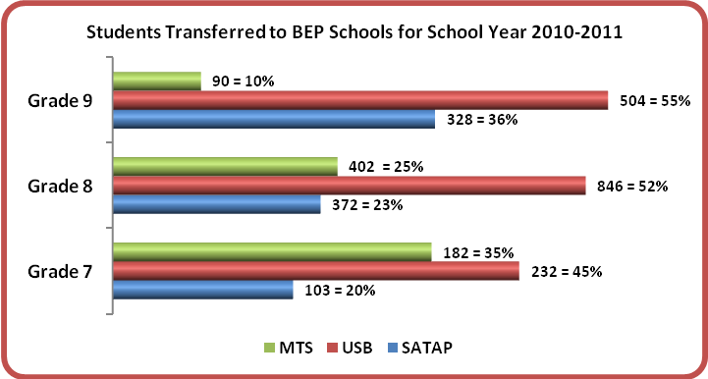
    - Future Enrolment
- Estimating the future level of enrolment is quite difficult because flow through rates, which are currently very high with high promotion rates, low drop-out rates and inflow from other schools, may well change and decline. Circumstances which may contribute to such a decline include the possible lack of senior high school places and poor economic conditions which might reduce employment opportunities and make further study less rewarding. These factors may ultimately undermine the aspirations of students and parents and turn people away from their pursuit even of junior secondary education and certainly their pursuit of higher secondary and university level education.
- Probably the easiest way to estimate the future level of enrolments is to assume that the Grade 7 enrolment level in BEP schools will not increase greatly in the immediate future as the schools generally serve well defined local areas. Between 2008-2009 and 2010-2011 the annual rate of increase of Grade 7 enrolments dropped from 32% to 22% with nearly 60% of the annual increase to September 2010 accounted for by new schools beginning operations in 2010. Without the impact of those new schools the rate of growth at Grade 7 would have been only 9.3%. Based on the trend data it is very likely that the Grade 7 growth rate will drop to 10% or less this coming year and then stabilize. This would give a Grade 7 enrolment increasing from 76,000+ in 2010-2011 to between 85,000 and 90,000 students in 2013-2014. If there was an effective 100% retention and promotion then this would lead in school year 2014-2015 to a total enrolment in the BEP schools of between 255,000 and 270,000 students. If the retention rate was only 95% each year then the enrolment might be closer to 255,000 students.
- In summary it is predicted that if current flow through rates continue then the enrolment in the BEP schools will increase from 185,000 approximately to between 255,000 and 270,000 by school year 2014-2015.

    - Size of Schools
- Enrolment growth is a very clear measure as to how well the program support is helping access and participation levels nationally and regionally. A review of the range in size of schools provides an indicator of the quality of the decision making as to where new schools should be built to meet the needs of ‘out of school’ children.
- In fact, 210 or about 10% of BEP schools reported having fewer than 20 students enrolled by September 2010, including 82 MTs (40%). 58% of these schools with less than 20 students are new or relatively new schools opening in 2010-2011 and 2009-2010 school years respectively. 30% of these small schools are located in Sulawesi with one school (SATAP 0088) in South Minahasa reported to have zero enrolment at the time of the survey. This school commenced operations in 2008 but the locals prefer to educate their children in the city. The classrooms are being used for library purposes and the principal’s room by the elementary school.
- Overall, 522 schools surveyed in September 2010 had not more than 40 students enrolled (see Figure 19 below). This represents more than 25% of the total number of BEP schools. These enrolments are potentially all marginal and the schools should be monitored over the next few years to determine if enrolments increase and if not, what are the reasons?
Figure 19: BEP Schools by Size of Enrolment
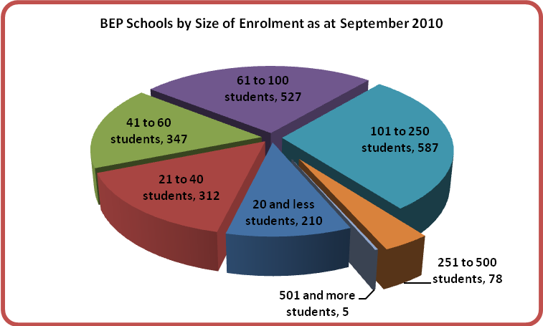
- Five schools were recorded as having student numbers between 535 (South Sulawesi) and 722 in West Nusa Tenggara. Table K details these schools which are the five largest BEP schools.
Table K: Five BEP Largest Schools (with over 500 students)
NO. | SCHOOL ID | SCHOOL NAME | PROVINCE | TOTAL STUDENTS
1. | USB 0360 | SMPN 4 Pallangga | South Sulawesi | 535
2. | USB 0196 | SMPN 3 Ubud | Bali | 614
3. | USB 0336 | SMPN 2 Barombong | South Sulawesi | 645
4. | USB 0276 | SMPN Kimbana | East Nusa Tenggara | 653
5. | USB 0089 | SMPN 4 Dompu | West Nusa Tenggara | 772

Figure 20: BEP School Enrolments 2010-2011
SATAPs, USBs and MTs – numbers in each size category
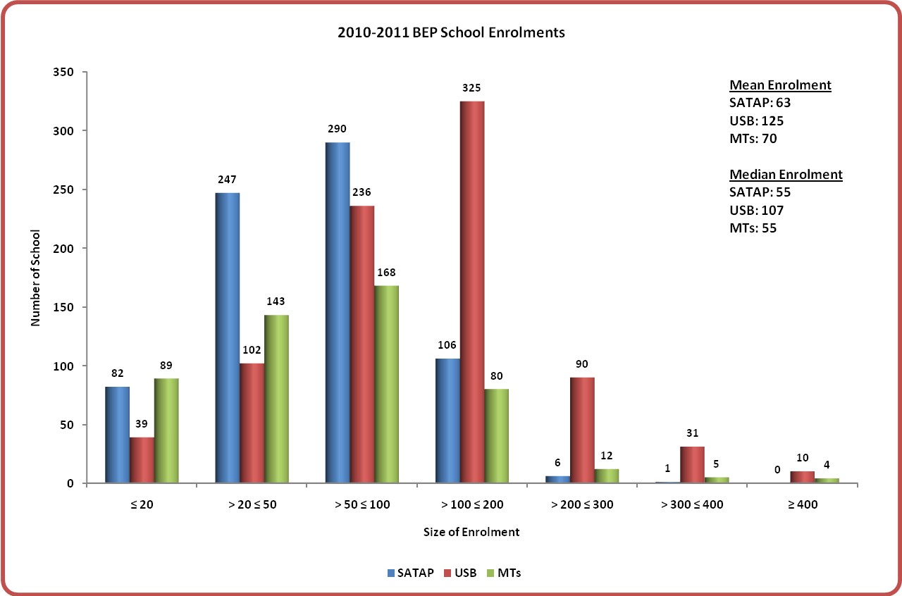

- Figure 20 shows the current distribution of BEP schools – MoNE SATAPs and MoNE USBs and MTs by size. The Median values for each of BEP school types are less than the Means indicating that more than 50% of the schools in each case have less than the mean enrolment.
- It was recorded that over 8,000 primary school graduate students (equally proportioned of male and female) in BEP school communities across the country did not continue their education on to junior secondary level. While, about 1,600 Grade 7 applicants were refused a place at BEP schools, mostly due to the unavailability of places.
    - Age of Students, Gross and Net Enrolment Rates
- Current age data (Figure 21) indicates that 78% of the students in the SMP and MTs are in their correct age cohort for their level of schooling. This distribution is unchanged since the first Survey in 2008-2009.
Figure 21: Number of BEP Students by Age Group
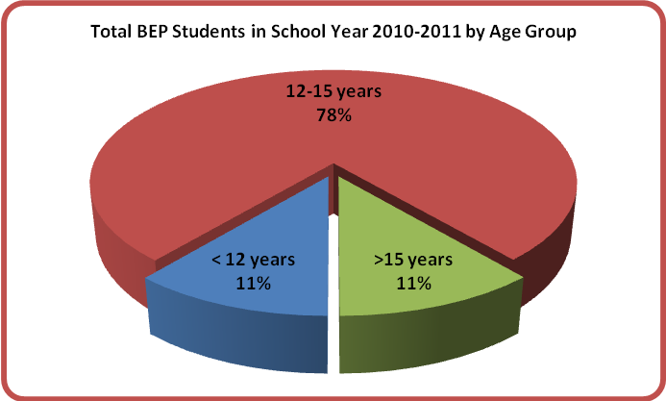
- Based on the official data for the 2005-2006 school year, the program had contributed by school year 2010-2011 an additional 170,000+ new students to the national total of SMP/MTS enrolments. This would be equal to a 1.5% increase in the GER and a 1.8% increase in the national NER over the 2005-2006 levels.
- However, if the additional enrolments are applied to only the 24 provinces in which SMP were constructed through MoNE – the more eastern and poorer provinces – the enrolment gains are much greater. The additional 131,000 new students represent an increase in GER of more than 6.8% and a 7.4% increase in NER over the 2005-2006 levels.
- The additional new enrolment (estimated at approximately 31,000 students) provided through the Madrasah in other provinces has added an estimated 0.43% to the GER and 0.58% to the NER in those nine provinces since 2005-2006.
    - Distance to School and Incidence of Boarders
- New students enrolled in Grade 7 at MoNE SATAPs and USBs mostly come, as expected given the locational criteria for new schools, from surrounding feeder primary schools (SD) within 1 to 3 km of the BEP Schools.
- The total percentage of MTs students living in the host Pesantren as boarders declined quite significantly from 78% in 2008-2009 to 25% last year and remained the same this year as the number of state and other madrasah constructed through BEP but without boarding facilities increased.
- The non boarders generally came from the immediate precincts of the MTs, also reflecting the location criteria for new schools.
- There are 8,061 MTs boarders in the 2010-2011, 46% of them female students. Of the total MTs students, the percentage of male boarders has increased from 26% in 2009-2010 to 28% in 2010-2011 whilst the percentage of female boarders has decreased from 24% to 22% (see Figure 22 below).
Figure 22: MTs Boarders
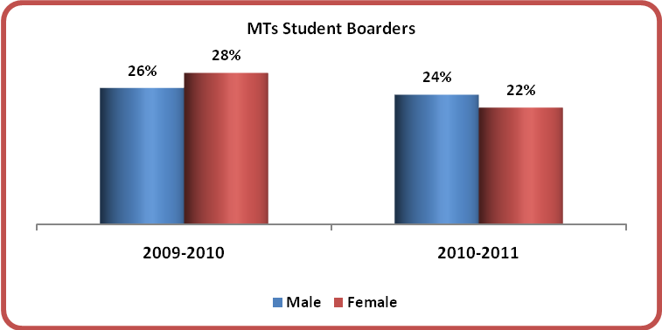
    - Students’ Fees
- Survey results show that students at 11% of BEP schools are still required to pay tuition fees, which are paid to the schools on a monthly basis (see Table L below). Apart from tuition fees, 9% of BEP schools are also generating funds from students’ non-tuition fees, which include extracurricular fees, field trip fees, etc. As shown in the following Table L, a greater percentage of BEP MTs charge tuition (15%) and non-tuition (13%) fees than do BEP MoNE schools.
Table L: Percentage of BEP Schools Generating Funds from Students’ Fees
TYPE OF SCHOOL | TUITION FEE | NON-TUITION FEE
SATAP | 9% | 8%
USB | 9% | 8%
MTs | 15% | 13%
TOTAL BEP | 11% | 9%

    - Children from Poor Families
- Some 99,132 children attending BEP schools are reported as being from poor families with family incomes of less than USD 2 per day and are listed under the Keluarga Miskin or GAKIN scheme (see Figure 23 below). This equals 53.4% of the total enrolment in BEP schools and represents an increase over the rates of 51% and 48% reported in the 2008 and 2009 surveys respectively.
Figure 23: BEP Students under GAKIN Scheme
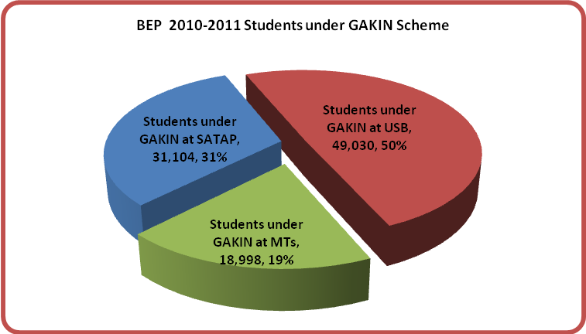
- The 2010 survey found that in the current school year 88,555 (48%) students across Grades 7 to 9 were given exemption from paying school fees – about 50% of them are USB students. An additional 38,608 students (21%) were given a reduced school fee payment, of which nearly 50% were students in Grade 7.
- The level of economic hardship (refer Paragraph 122) experienced by these children and their families and the fact that SATAPs are in more remote locations than MTs and USBs help to explain why they represent 67% of the enrolment at SATAPs and 55% of the enrolment at MTs but only 47% at USBs (refer to Figure 24 below).
Figure 24: Proportion of BEP Students under GAKIN Scheme by Type of School
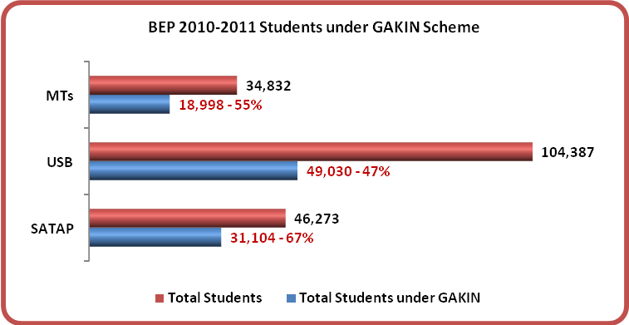
- Figure 25 describes several other indicators which may be used as a basis in assessing students’ economic condition. From the results of the survey conducted of BEP Grade 7 students, it appears that the over 50% of students indicated as coming from the middle level economy are USB students. USB students are much more likely than students attending SATAPs or MTs to have breakfast, have a complete school uniform, live in homes with electricity, have television at home, have a mobile phone and have pocket money greater than IDR 50,000 per month. To highlight the weaker economic condition of the SATAP students and their families is the facts that on all the above measures the SATAP students are clearly less well off than MTs students.
Figure 25: BEP Students’ Economic Condition
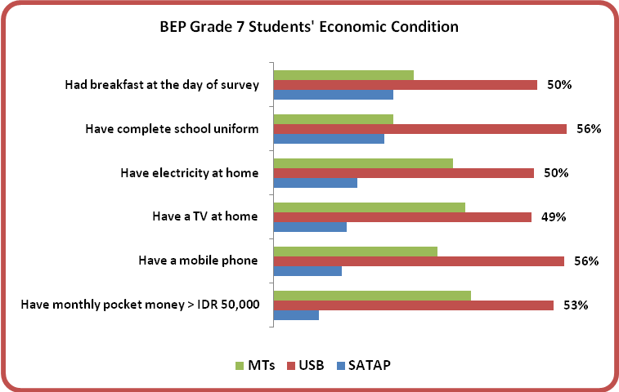
- Daily transportation costs (Figure 26) are much the same for both USB and SATAP students although about 49% of SATAP students report paying more than IDR 7,500 compared to 39% of USB students. Only 24% of MTs students pay more than IDR 7,500 reflecting the large number of students who board in the Pesantren and have no daily transportation costs.
Figure 26: BEP Students’ Daily Transportation Expenses
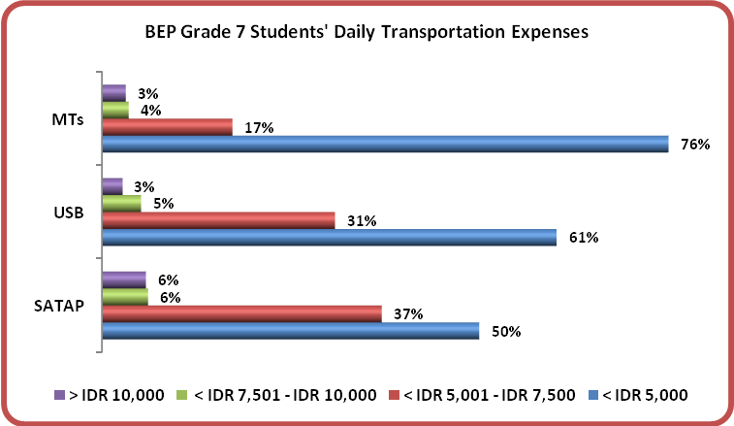
- Overall, about 45% of all BEP students travel less than 1 km to school with MTs students travelling the least distance as such a high percentage (more than 25%) are boarders and live in the Pesantren. The great majority of students (73%) travel to school on foot and fewer than 1% travel by boat or ferry.
Figure 27: Distance BEP Students Travel to School
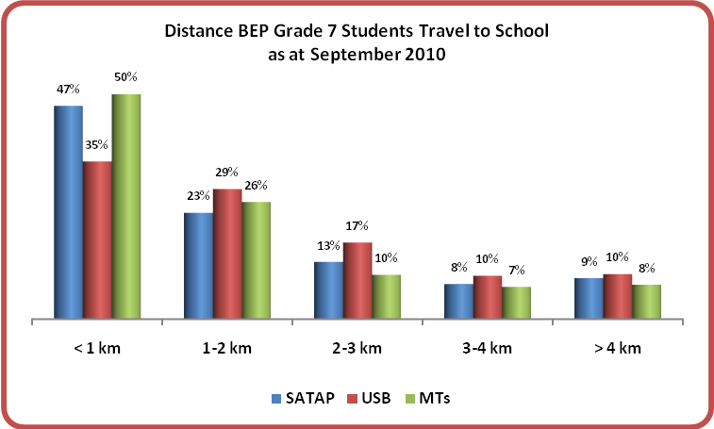

A BEP STORY
SMPN 3 Bontoharu*, Gusung Island, Selayar District, South Sulawesi
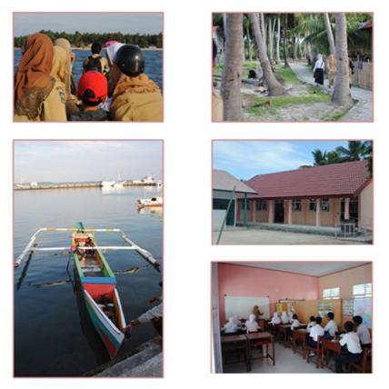
All teachers of this school reside in City of Benteng, the Capital City of Selayar District. These teachers have to travel to school on the Katinting (small outrigger boat as seen in left below picture) for 15-20 minutes each day under normal weather.
SMPN 3 Bontoharu is the first school built and the only one on the island for which the island community is very grateful for, as their children no longer have to travel on the outrigger boat to go to and from school in Benteng.
*BEP 2007 School

Report of MCPM Field Monitor,
Abdul Haq Abdullah,
September 2010

    - Students with Disabilities
- There is currently not a high number of students with disabilities enrolled at BEP schools. Last year’s survey recorded that less than 2% of enrolled students had either intellectual or physical disabilities. As shown in Figures 28 and 29, 671 students (0.4%) at BEP schools this year are recorded as having serious learning disabilities causing them difficulty in completing their current grade and 416 students (0.2%) have physical disabilities causing them to experience difficulties in learning.
- Given that an estimated minimum 3% of children in the school age cohort nationally do have major intellectual or physical disabilities then their low enrolment at junior secondary is either due to them failing to access the basic education system or dropping out at the completion of Grade 6 or earlier. Indonesia does have ‘special schools’ but these cannot cater for demand nationwide. One of the initiatives undertaken by the Government and supported by the AIBEP has been to encourage inclusive education and a special Ministerial Decree on Inclusive Education was prepared and approved and signed by the Minister with the support of the program.
- These low percentages could be one of the factors explaining why the provision of access ramps, (see Figure 30 overleaf) although encouraged and funded by the program in all BEP constructed schools, has not been adopted in 100% of the schools.
- The low incidence of disability may also explain why a topic such as Inclusive Education is not high on the priority list for school professional development training. (refer also to sub-section on WSD later in this report).
Figure 28: BEP 2010-2011 Students with Intellectual Disabilities
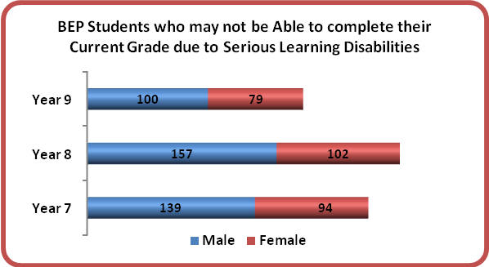
Figure 29: BEP 2010-2011 Students with Physical Disabilities
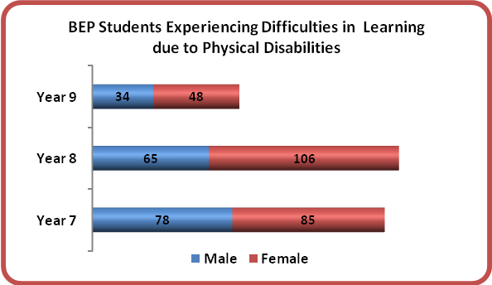
- More than 50% of MTs are equipped with access ramps while only about 18% of SATAP schools constructed under the BEP have access ramps.
- Another BEP initiative to support the attendance at school of disabled students has been the provision of special toilets.
- Some 20% of BEP schools have been constructed with toilets for disabled students. SATAPs have a smaller number of this type of facility in comparison to USBs and especially as compared to MTs that were found to have on average more than one disabled toilet per school.
- The availability of access ramps and toilets for students with disabilities at BEP schools is described in the figure below.
Figure 30: BEP School Facilities for Students with Disabilities
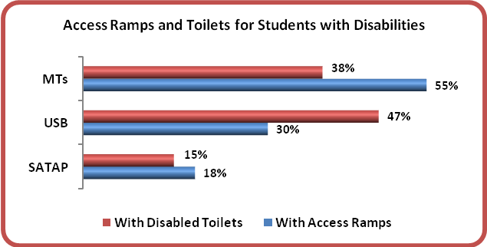
    - National Examination and Transition to Senior High School
- The 2010 National Examination was conducted through March and April 2010. A total of 29,221 (out of 29,381 Grade 9 BEP students) sat the examination and 93.11% of them (95% of SATAP and USB students and 90% of MTs) passed, with male and female students more or less in equal proportion (14,811 male and 14,410 female). This is 5.48% higher than the total percentage of BEP students passing the 2008-2009 examination and 2.84% higher than the total percentage of students passing the 2009-2010 examination nationally.
Figure 31: BEP Students Performance on 2010 National Examination
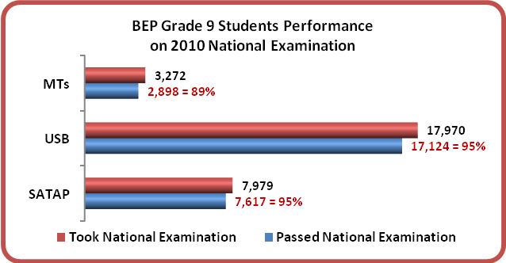
- A little over 50% of BEP schools reported insufficient access for their graduate students to continue on to senior high school. However, 53% of the responding schools preferred a new SATAP based on the SMP as the most suitable modality to allow their graduate students to access a higher level of education such as SMA, whilst 47% preferred a new USB-SMA.
- The 2010 survey recorded that for school year 2010-2011 more than 16,500 or 58% (approximately 50% male and 50% female) of Grade 9 graduate students went on to SMA/MA, about 5,000 or 18% (55% male and 45% female) went on to SMK and less than 2,000 or 6% (53% male to 47% female) did not continue to senior high school as they had to help their parents at home or went on to work. The remaining 18% are accounted for by the “others” response (e.g. marriage, doing nothing, etc) and by non-responses. The figures from the 2010-2011 survey results showed a 10% decrease of Grade 9 students who went on to SMA/MA in comparison to the 2009-2010 result. Whilst the percentage of those who went to SMK remains about the same, the percentage of those who discontinued schooling to work and/or help at home went down by 2.5% since the last survey.
    - Promotion and Drop-out
- The promotion and drop-out rates reported in September 2010 were satisfactory by international standards. The 2010-2011 survey recorded that 1,188 or 0.6% (out of 185,492) students (0.4% male and 0.2% female) were not promoted into the 2010-2011 school year. This 99.4% promotion rate was a slight improvement from the 98.4% reported at the time of 2009-2010 survey. At that time, 2,159 or 1.6% (out of 137,901) students were not promoted into the 2009-2010 school year.
- The 2010 survey results showed a 1.8% (1% male and 0.8% female) drop-out rate as compared to the 2.1% rate of the previous year. This reduced rate was fully accounted for by the 0.3% reduction at MoNE BEP schools. See Figure 32 below for the promotion and drop-out rates at each type of BEP school as at the end of the 2009-2010 school year.
Figure 32: Dropped-out and Not Promoted Students
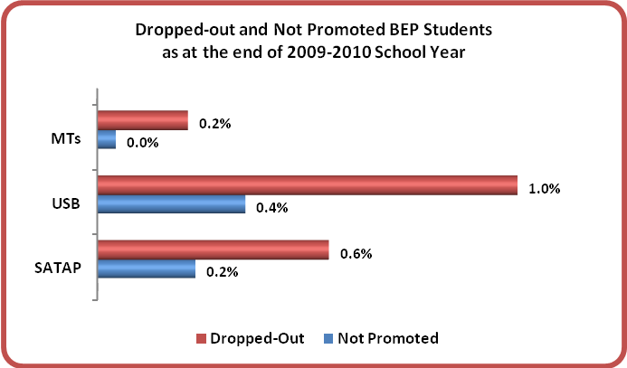
- The most common reasons reported for male students to drop out or discontinue schooling before completing Grade 9:
- Working to help out parents/the family’s economic condition (40%)
- Lack of parental or family support (25%)
- Distance to school (6%)
- Arranged marriage (3%)
- The most common reasons reported for female students to drop out or discontinue schooling before completing Grade 9:
- Working to help out parents/the family’s economic condition (40%)
- Arranged marriage (parents’ wish) (28%)
- Lack of parental or family support (25%)
- Distance to school (6%)
    - Non Formal Education
- 17,228 members of BEP school communities were reported as attending NFE classes at the time of survey, equally proportioned of male and female students. 40% of them were taking PAKET B, 30% PAKET C and the remaining were PAKET A and PKBM participants. Most of these NFE classes were being held in schools, either BEP schools or other schools in surrounding communities. 18% of BEP schools confirmed that they have teachers in their school teaching NFE classes outside of school hours.
- The demand for Non Formal Education in BEP school communities (Figure 33) has declined over the past year. This almost certainly reflects the new SMP/MTs provision in the local areas enabling potential students to complete junior secondary schooling in the formal system.
Figure 33: Demand for Non Formal Education in BEP School Communities
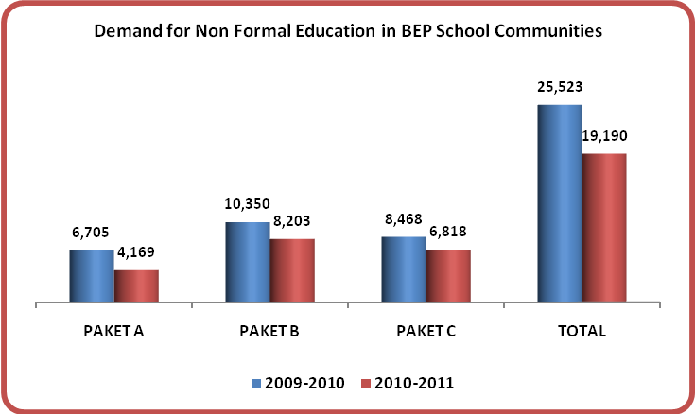
    - Classroom Activity
- The classroom observation was conducted on one Grade 8 classroom, selected at random if there was more than one such class, in each BEP school surveyed. 74% BEP grade 8 students (46,128 of 62,560) were present when the observations took place. The survey was conducted through the month of Ramadhan. As a result, many schools were having Ramadhan break and therefore, though the data collectors were able to collect other data, the classroom observation became one of the tasks that could not be comprehensively completed.
- Results showed that one third of the classes were being managed in a traditional manner with 35% of the teachers talking when the data collectors entered the classrooms and with 52% of the surveyed students working from texts. This classroom approach is appropriate for the meeting of knowledge objectives but less so for the development of concepts and of higher order intellectual abilities.
- Organisation of the students’ seating in rows seems to be most used in BEP schools (35% were in rows with boys and girls separated and the other 37% with boys and girls mixed), whilst u-shape, circle-shape and other seating arrangements that promote group activity, discussion and sharing of ideas were uncommon (less than 5% of each type).
- Over 50% of students were talking – some in subject focused discussion and others in non subject chatter – whilst about 40% were mainly answering questions asked by the teachers.
- Based on qualitative observation the classrooms appear to be places where teachers provide visual materials for students to study and where student work can also be displayed. 48% of the classrooms had maps, posters and other materials displayed and 48% also had the students’ work displayed.
    - Perceived Needs
- As per 2010-2011 School Survey results, 4,216 students were surveyed on key elements that they viewed as most needed by their schools. Results showed students’ perceived needs for school facilities such as science laboratories and computers (40%), textbook availability (30%) and lab equipment (16%). The remaining 14% gave priority to additional classrooms, libraries and teachers.
- Principals generally shared these priorities with many focused on the need for additional school facilities such as laboratories (41%), classrooms (21%) and lab equipment (17%). The other 21% gave high priority to textbook availability, additional libraries and teachers. In addition, principals also gave priority to training programs for teachers to ensure greater subject mastery and to improve their teaching methods as other important ways to improve student learning in BEP schools.
- Parents and communities reported through interviews that they see their greatest contribution to the schools as support through supervision when teachers are required on other duties, providing help to students with homework, and generally supporting with school maintenance and improvement through the provision of labour.

  - BEP School Management and Evaluation
    - School Committees
- Approximately 75% of BEP schools confirmed having active School Committees. From July 2009 to September 2010, nearly 60% School Committees held two to four regular meetings, 10% held more than four meetings, whilst 10% held no meetings.
- With the exception of a 16% ‘non-response’ recorded during the survey, about 60% of the active BEP School Committees review activities and expenditure against plans and budget quite regularly (see Figure 34 below).
Figure 34: BEP School Committees Review on Activities against Budget
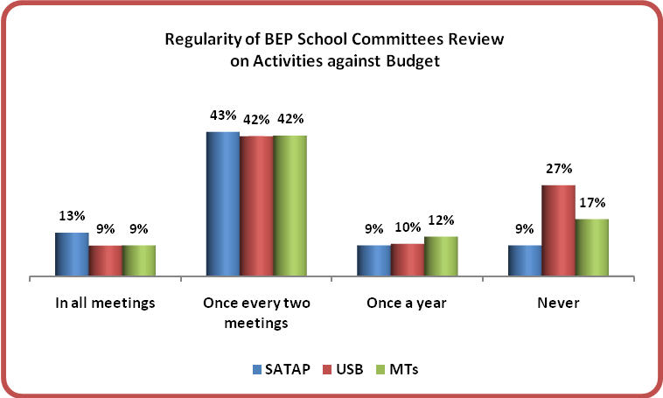
- Additional to the regular School Committees meeting more than 50% of schools reported having two to four ‘public’ meetings involving parents and communities during the period. These meetings were organised by the School Committees.
- In contrast to the results of the previous survey, School Committees report that Minutes of Meeting are now made more readily accessible to meeting participants and effectively more accessible to all parents at BEP SATAPs and USBs by posting them on school notice boards (29% in contrast to 12% based on the previous survey) rather than sending them out through newsletters.

    - Financial Resources Management
- 1,600 BEP schools provided data on school funding for the School Year 2010-2011. Information of the total funding received by 603 SATAPs, 673 USBs and 324 MTs and the sources of the funding are provided in the Tables M and N, and Figure 35 below.
Table M: Average BEP Schools’ Funding per Type of School for 2010-2011
TYPE OF SCHOOL | FUNDING PER SCHOOL (IDR) | FUNDING PER STUDENT (IDR)
SATAP | 44,979,246 | 586,141
USB | 85,516,107 | 551,336
MTs | 45,115,941 | 419,659
AVERAGE TOTAL | 62,057,744 | 535,292
Table N: BEP Schools’ Funding by Sources for 2010-2011
SOURCES | RECEIVED FUNDING (IDR) | FUNDING PER STUDENT (IDR)
BOS (School Operational Assistance) | 73,669,045,756 | 397,155
SPP (School Fee) | 3,163,718,560 | 17,056
PEMDA (Local Government) | 11,838,467,772 | 63,822
PARENTS DONATIONS | 2,608,888,644 | 14,065
OTHERS | 8,012,269,458 | 43,195
TOTAL | 99,292,390,190 | 535,292
Figure 35: BEP Schools’ Funding by Type of School for 2010-2011
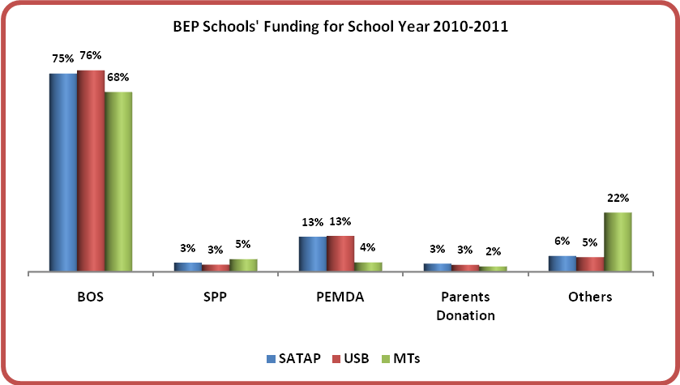

- The percentage of funding allocated through BOS and by District Governments (PEMDA) to BEP schools has been about the same each year since the first batch of BEP schools were opened in 2007. Possibly reflecting the higher poverty of more marginal areas the level of donation from parents which had reached 7% of funding in 2009-2010 is only 3% for this current year.
- In general, spending of BOS funds remained similar to last year (see Figure 36 below), although with a lower percentage of funds allocated to honoraria for contract teachers (-6%); school facilities (-8%); students’ textbooks (-1% ), assistance for poor students (-2% ). On the other hand, funds for teacher professional development have increased by 1% and those for other purposes by 13%.
Figure 36: BOS Funds Allocation at BEP Schools for 2010-2011
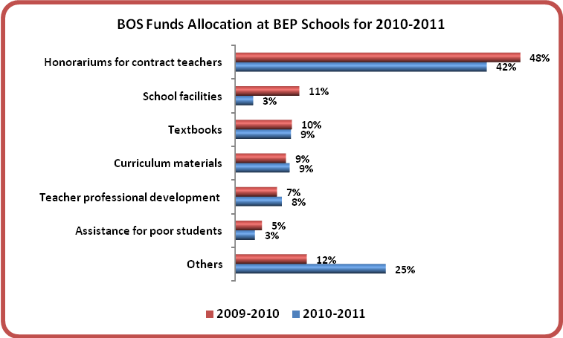
    - School Planning and Development Documents
- On average about 85% of BEP schools have the following documents:
- School mission or vision statement
- School development plan
- Annual budget
- School-based Education Unit Level Curriculum - I (KTSP-I)
- School-based Education Unit Level Curriculum - II (KTSP-II)
- Discipline policy for students
- Only 61% have an Asset Management Plan and about 40% have a Gender Mainstreaming and Inclusive Education Policy.
    - Asset Management and Maintenance
- BEP has included Asset Management and Maintenance as one of the training materials under WSD program delivered to all BEP schools. About 48% of the surveyed BEP schools include provision of funds in their annual budget for repairs and maintenance, only a 2% increase from the last time they were surveyed in 2009. Overall, 54% of USBs budget funds for maintenance but only 44% of SATAPs and MTs make such provision. The figures for 2010-2011 are shown in Figure 37 below.
Figure 37: BEP Schools with Repairs and Maintenance Budget for 2010-2011
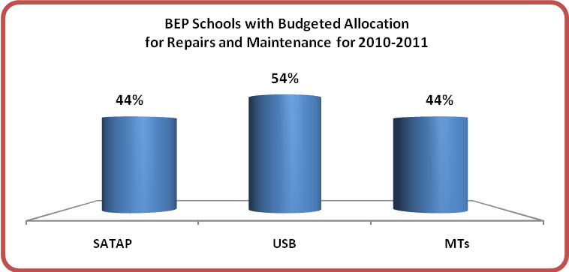
    - Supported Self School Evaluation (SSSE)
- 62% of BEP schools reported having used the SSSE approach for school evaluation this year. Improvement appeared across all categories of schools where the rates have increased as compared to the 2009-2010 survey results from 50% to 55% at SATAPs, 49% to 62% at USBs, and 62% to 71% at MTs.
    - Disaster Preparedness
- 90% of the surveyed BEP schools have a very low level of disaster preparedness. Less than 10% of the schools have appointed a specific person to be in charge for evacuations. Indeed, while 17% of the schools reported having evacuation plans, only 5.3% (1 in 3) have actually socialised them to students, teachers and parents.
Figure 38: Assessment on BEP Schools’ Disaster Preparedness
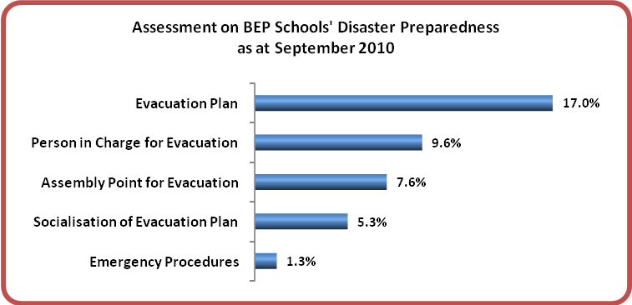
- Figure 38 above indicates a very low level of preparedness at most of BEP schools for disasters. This is a very important aspect to which every school must pay attention, especially schools in a country that is prone to the earthquake, volcanic, flood and tsunami type disasters which have been experienced frequently in Indonesia in the past decade.

  - Whole School Development (WSD)
    - Contribution of WSD Trainings
- The AIBEP WSD Program was first introduced in 2007. Though it had not been part of the initial design of the program, the WSD program has proven to become one of the program’s most important quality improvement initiatives. 72% of principals of BEP schools attended a professional training related to their role as head teacher in year 2009, and 46% did so in 2010.
- To June 2010, AIBEP had delivered trainings under the WSD Program to a total of 12,544 school representatives, of which about 5,000 representatives from over 1,000 schools constructed since July 2009 were given WSD trainings throughout the 2009-2010 School Year.
- 70% of the surveyed BEP schools rate WSD Program as the “most useful” strategy for improving quality of education, while 79% of the surveyed BEP schools view WSD as a better program than other quality improvement programs they have attended. The remaining schools think that it is equally as good as the other programs.
- All of the eight sets of WSD training modules are considered very useful with Educational Leadership and School Management viewed as being highly useful by 71% of respondents.
Figure 39: Assessment of Value of WSD Training Modules
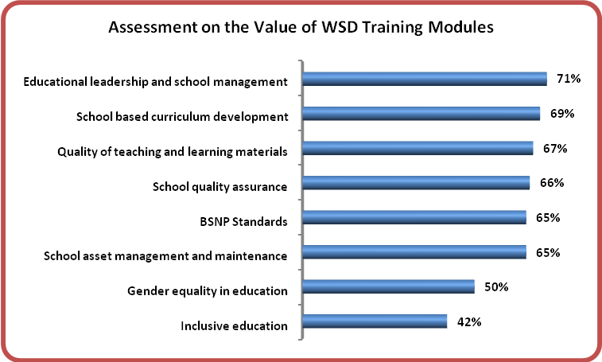

IN REVIEW
  - Lessons Learned
- The 2010 School Survey benefited from the experience of the previous three years in that the Questionnaire itself was more tightly constructed, produced fewer issues relating to interpretation and ambiguities and the survey was able to use some observational strategies to complement the generally quantitative and descriptive data obtained through the questionnaire.
- The major data collection problem encountered this year derived from the fact that the School Survey was conducted concurrently with surveys relating to the incomplete and Loan Underspend (LU) schools and this added to the work load and put pressure on the data collectors who were working to a very strict timetable. Fortunately, based on the Validation Study results there did not seem to be any significant impact on the quality or accuracy of the data but the data collectors did comment on the additional stress created by having to collect samples and data for the concurrent surveys.
- The three concurrent surveys also created problems in the handling of the packages when they were returned to Jakarta. The loss of 7 Questionnaires can most likely be attributed to the problems in handling somewhere between the schools and the return point at the MCPM office.
  - Recommendations
- The concept of multi-skilling of teachers (refer paragraph 84) at the junior secondary level should be evaluated for effectiveness and efficiency.
- The issue relating to possible poor decision making when determining whether to build a new junior secondary school is still an issue fuelled by the data from the 2010 survey. With 10% of the schools having fewer than 20 students enrolled and 25% with enrolments of 40 or below this is a serious issue if the return on the Australian investment is to be maximised. Increasingly, by design, the sites are more marginal but the problem is exacerbated by the fact that district education officers do not really know how many children of the relevant cohort are out of school and where they are to be found. As pointed out in the 2009 report, one of the effective strategies to get this information is by involving school leaders, district education officials and the wider public during the site selection process to triangulate and consolidate the enrolment information they have. Also there needs to be a new process at District level of integrated planning - planning where all new schools should be - including pre-school and senior secondary schools - building on the existing infrastructure distribution. Currently, the process is one of "infill" and that can lead, as BEP data suggests, to wastage of scarce resources. Such a process of integrated planning will require significant capacity building at all levels.
- While the time frame for BEP has allowed three consecutive surveys, three years is still not long enough to assess the true effectiveness and the long term sustainability of school infrastructure development. It is strongly recommended that continued monitoring takes place through follow-on surveys, especially monitoring of schools currently showing low enrolment.
- Greater provision needs to be made by the central government, district governments and/or the donor agencies, to ensure that all junior secondary schools and especially SATAPs have the laboratories and other resources necessary to allow the effective teaching of the curriculum.

  - Conclusion
- There are many achievements of the program which have been detailed in various reports over the past year. The focus in this section is on those achievements which have been highlighted through the various analyses of the data collected during the 2010 survey, but this is not an exhaustive list.
- At the time of finalising this report, all 2,074 schools are operational including 1,570 national junior secondary schools (SMP) and 504 Madrasah Tsanawiyah (MTs). The reported enrolment increase for the school year commencing in July 2010 was 44,477 or 31.5% over the level reported in the 2009 BEP school survey. Cautious projections based on current enrolment data on Grade 7 and a continuation of current promotion rates indicate that by the beginning of the school year 2013-2014 the enrolment in the BEP schools will be between 250,000 and 300,000.
- The survey clearly demonstrates that the program achieved its target of providing 330,000 additional student places and that overall there are more than sufficient places to accommodate the additional enrolment although there are a number of individual schools that are already at capacity and some that will reach capacity within two years.
- Based on the total enrolments at the BEP funded schools and the characteristics of the children enrolled it can be fairly concluded that the program:
- achieved its target to increase the level of participation at junior secondary level in the eastern regions of Indonesia with significant increases in both Gross and Net Enrolment Rates (GER and NER). Refer Section 3.4.4.
- has successfully improved access by bringing schools ‘closer to home’ for many thousands of students, the majority of whom come from low income families and who can now walk to junior secondary school without the burden of transportation costs. This ‘local’ access factor is also very evident with the decreasing proportion of MTs students now boarding.
- has successfully targeted the most economically disadvantaged children with more than 53% of students currently enrolled coming from families qualifying for Government support under the Keluarga Miskin (GAKIN) scheme which has a family income criterion of only IDR 600,000/month or about USD 60/month or USD 2/family/day. These really are the ‘poorest of the poor’ with their income level well below the World Bank’s poverty figure of USD 2/person/day.
- While the enrolment figures show no gender discrimination in terms of access or participation of girls or boys, it seems that much remains to ensure that children with learning and physical disabilities are accessing education at this level. The current level of enrolment of children with serious learning problems at less than 1%, which depending on the teacher’s frame of reference may include ‘slow’ learners, is well below the expected rate derived from the national estimates.
- On the quality side and reinforcing the findings of the 2009 survey, the BEP schools are exceptionally well staffed with a high percentage of teachers having the required S1 qualification and pedagogical training. All schools have access to at least one specialist teacher for each of the core subjects. The majorities of teachers are young and potentially bring with them the natural enthusiasm of youth and the lessons of their recent formal training. One result of these positive elements is that more than 93% of 29,221 students who sat the National Examinations at Grade 9 passed (refer to Figure 31 on page 50). In addition it is noteworthy that there are relatively few dropouts and that the very great majority of students are promoted each year. The fact that so many students complete Grade 9 also says much about their aspirations and those of their parents that they should take full advantage of the opportunity which the new schools are providing.
- The great majority of the BEP schools have active School Committees through which communities participate in decision making including financial decisions, but two areas that need to be significantly improved are (a) ensuring appropriate budget provisions for asset management and maintenance, and (b) developing plans for and training teachers and students in disaster response. On the other hand, information received during the survey indicates that the School Committees are fulfilling a vital role in ensuring both accountability and transparency in school decision making. Further and close engagement with the School Committees may be an important strategy in mainstreaming inclusive education and overcoming societal taboos, effective health education including HIV awareness, and disaster response education.

∞∞∞∞∞∞∞∞

All BEP SMP were constructed under MoNE systems with the loan funding channeled through the Indonesian Ministry of Finance (MoF). All BEP MTs were constructed under MoRA systems with the grant funding channeled through and managed by the Managing Contractor Program Management (MCPM). All BEP schools were built through a community-based approach using School Construction Committees supervised by Construction and Development Consultants (CDCs), who were contracted and monitored by the MCPM.
The 60 schools were constructed by MoNE through the use of funds saved by MoNE during the first phase of BEP in what is generally known as the “Loan Under-spend” or “LU” program.
It is important to note that while there were only two questions under the heading of ‘Teacher Data’ there were numerous parts to those questions providing an array of information about all teachers individually and allowing the aggregation of comprehensive school data. The true scope of the survey can only be fully gauged by a review of the questionnaire itself (refer Annex 1).
Due to the exclusion of eight datasets in the data processing (see previous Section 2.3) the number of BEP schools accounted for in this table is 2,066 or 99.6% of the total 2,074 BEP schools constructed within the period of BEP.
The total number of teachers at BEP schools included in various analyses varied by up to 0.1% from this figure, but these are negligible variations and with zero impact for analytical and interpretative purposes.
The figures of BEP female teachers presented in this table are based on school construction year and not on school operation year.
If the international norm of a maximum of 40 students per room is used as basis for calculation then more than 350,000 new places are available. If libraries are also included as teaching spaces then the number of students who could be readily accommodated in the BEP schools is close to 400,000.
The total number of teachers at BEP schools used in preparing this table is 26,656 – a variation of 0.1% from the actual figure. However, this had zero impact on the analyses and results.
Unless stated otherwise any reference to BEP teachers includes both Full-time and Part-time teachers.
AIBEP School and District Survey Report 2009-2010, P.58.
The 2009 Report on Education Statistics, National Statistic Agency (BPS), March 2010.
Data of Ministry of National Education for School Year 2007-2008
AIBEP School Survey Report 2008-2009, P.14
The analyses were based on our survey results from 2008-2009 and 2009-2010.
Data taken from the ‘Grand Design’, Accomplishment of the 9-Year Compulsory Basic Education 2006-2009, First Edition 2006, prepared and published jointly by the Ministry of National Education and the Ministry of Religious Affairs.
It is estimated that approximately 15,000 of the current enrollees have transferred in from other SMP although that number fell in 2009-2010 as compared to previous years.
It is estimated that of the 141,000 students enrolled in government SMP by the beginning of school year 2010, at least 131,000 were new enrollees who would be accessing SMP for the first time.
Results from the 2009-2010 survey showed 9,693 (4,877 male and 4,816 female) Grade 9 students took the national examination and 87.63% passed.
AIBEP School and District Survey Report 2009-2010, P.35.

