Australia’s Education Partnership with Indonesia –

Performance Oversight and Monitoring (POM)

**Annual Sector**

**Financial Report 2011**

December 2012

GRM International Pty Ltd

ABN 98 989 481 583 ACN 010 020 201

Level 6, 444 Queen Street  
Brisbane Queensland 4000 Australia

GPO Box 449

Brisbane Queensland 4001 Australia

Telephone: +617 3025 8500

Facsimile: +617 3025 8555

www.grminternational.com

Australia’s Education Partnership with Indonesia –

Performance Oversight and Monitoring (POM)

Annual Sector

Financial Report 2011

Adam Rorris

Managed on behalf of AusAID by GRM International Pty Ltd

# Preface

This report is intended to provide high level monitoring of national and district trends in education financing. The purpose of the monitoring is to inform AusAID and the GoI as they implement the Education Sector Support Program (ESSP) that commenced in 2011.

This is the fifth Annual Financial Performance Report and is a continuation of a series of three annual reports that were prepared by the same author for the Basic Education Program (BEP) and delivered through the Contractor for Strategic Advisory Services (CSAS). Copies of these reports are held by the AusAID Jakarta post. The fourth Annual Financial Performance Report (2011) was produced as part of the ESSP and is also available through the AusAID Jakarta post.

The author is Education Economist Mr. Adam Rorris who has worked with close collaboration and support from the Ministry of Finance. The consultant acknowledges the support and advice of the many people that contributed to the study. Data analysis support was provided by Mr. Ahmad Evandri. The views and opinions expressed in this report are those of the author and do not necessarily reflect those of MOEC, MoRA, Bappenas or AusAID.

# Abbreviations and Acronyms

| **Acronym** | **Bahasa Indonesia** | **English** |
| --- | --- | --- |
| **ACER** |  | Australian Council for Educational Research |
| **ADB** | Bank Pembangunan Asia | Asian Development Bank |
| **APK** | Angka Partisipasi Kasar | Gross Enrolment Rate |
| **APM** | Angka Partisipasi Murni | Net Enrolment Rate |
| **AusAID** | Badan Australia untuk Pembangunan Internasional | Australian Agency for International Development |
| **AWP** | Rencana Kerja Tahunan | Annual Work Plan |
| **Balitbang** | Badan Penelitian dan Pengembangan | Centre for Research and Development |
| **Bappenas** | Badan Perencanaan Pembangunan Nasional | National Development Planning Agency |
| **BEP** | Program Pendidikan Dasar Australia-Indonesia | Australia-Indonesia Basic Education Program |
| **BOS** | Biaya Operasional Sekolah | School Operational Fund |
| **BOS Buku** | Biaya Operasional Sekolah Buku | School Operation Funds for Textbooks |
| **BSNP** | Badan Standar Nasional Pendidikan | National Education Standards Board |
| **CCR** | Rasio Kelas-Ruang Kelas | Class-Classroom Ratio |
| **CSAS** | Kontraktor untuk Layanan Kepenasehatan Strategis | Contractor for Strategic Advisory Services |
| **DG** | Direktorat Jendral | Directorate General |
| **EC** | Komisi Eropa | European Commission |
| **EFA** | Pendidikan untuk Semua | Education for All |
| **ESP** | Rencana Strategis Pendidikan | Education Strategic Plan |
| **ESSP** | Education Sector Support Program | Education Sector Support Program |
| **ESWG** | Kelompok Kerja Sektor Pendidikan | Education Sector Working Group |
| **GDP** | Pendapatan Domestik Bruto | Gross Domestic Product |
| **GER** | Angka Pendaftaran Kasar | Gross Enrolment Rate |
| **GOI** | Pemerintah Indonesia | Government of Indonesia |
| **JSS** | Sekolah Menengah Pertama | Junior Secondary School |
| **KPI** | Indikator Kunci dari Kunci | Key Performance Indicator |
| **LAKIP** | Laporan Akuntabilitas Kinerja Publik | Public Performance Accountability Report |
| **MCPM** | Kontraktor Pelaksana untuk Pengelolaan Program | Managing Contractor Program Management |
| **MDA** | Kajian Tengah Dekade | Mid-Decade Assessment |
| **MoF** | Departemen Keuangan | Ministry of Finance |
| **MOEC** | Departemen Pendidikan Nasional | Ministry of Education and Culture |
| **MORA** | Departemen Agama | Ministry of Religious Affairs |
| **NER** | Angka Pendaftaran Murni | Net Enrolment Rate |
| **NFE** | Pendidikan Non-formal | Non-Formal Education |
| **PAM** | Matriks Aksi Kebijakan | Policy Action Matrix |
| **PCMU** | Unit Pengelola dan Koordinasi Program | Program Coordination and Management Unit |
| **PMPTK** | Peningkatan Mutu Pendidik dan Tenaga Kependidikan | Quality Improvement of Teachers and Education Personnel |
| **PSC** | Komite Pengarah Program | Program Steering Committee |
| **PTP Matrix** | Matriks Sasaran dan Kinerja Program | Program Targets and Performance Matrix |
| **PUSLIT** | Pusat Penelitian | Center for Research |
| **PUSPENDIK** | Pusat Pendidikan Statistik | Center for Education Statistics |
| **Renstra** | Rencana Strategis | Strategic Plan |
| **Rp.** | Rupiah | Rupiah |
| **SCR** | Rasio Siswa Ruang Kelas | Student Classroom Ratio |
| **SD** | Sekolah Dasar | Primary School |
| **SIKD** | Sistem Informasi Keuangan Daerah | Regional Finance Information system |
| **SMP** | Sekolah Menengah Pertama | Junior Secondary School |
| **SMA** | Sekolah Menengah Atas | Senior Secondary School |
| **SWAP** | Pendekatan Sektor secara Luas | Sector Wide Approach |
| **SPI** | Indikator Kinerja Tambahan | Supplementary Performance Indicator |
| **STR** | Rasio Siswa Guru | Student Teacher Ratio |
| **SUSENAS** | Survei Sosial Ekonomi Nasional | National Socio-Economic Survey |
| **TA** | Bantuan Teknis | Technical Assistance |
| **ToR** | Kerangka Acuan Kerja | Term of Reference |
| **UN** | Perserikatan Bangsa-Bangsa | United Nations |
| **USAID** | Badan Amerika Serikat untuk Pembangunan Internasional | United States Agency for International Development |

# Executive Summary

## Background

The Financial Performance Report 2011 monitors and reports on trends in education financing in Indonesia. This is the fifth Finance Performance Report and follows a series of reports produced by the same author for the AusAID supported Contractor Strategic Advisory Services (CSAS) team. The report is intended for the use of AusAID and high level government officials and education sector technical experts. It provides succinct analysis and is intended to be an accessible tool for operational planning. The objectives of this report are:

1. To identify trends in the quantum and distribution of education funding in relation to national policy and school needs.
2. To monitor education sector and school resourcing from the standpoint of the key RENSTRA themes of access, quality improvement and improved accountability.
3. To inform AusAID, GoI and other donors of the effectiveness and efficiency of current school funding mechanisms.
4. To support the capacity of GoI institutions to monitor and report on school financing.

The report has a particular focus on district level expenditures. Indonesian district level expenditure patterns are increasingly important as districts have increased responsibility for education management under the Indonesian government decentralisation policy. Monitoring patterns of expenditure by districts will become an increasingly important role for the Ministry of Education and Culture (MOEC) and the Ministry of Religious Affairs (MORA) to ensure that national funding norms and procedures are being implemented appropriately. Financial analysis of education allocations therefore needs to have a district level disaggregation to assess the variability in fiscal capacity and actual allocations for education resourcing.

A wide range in the poverty status of districts, and the importance of education in lifting district populations out of poverty, mean that vulnerable groups stand to benefit most from well-targeted education investment. Monitoring and evaluation of district level education financing provides the tools to do so.

### Key Performance Indicators and Analysis

The report analysis is framed by a set of Key Performance Indicators (KPI). These KPI focus attention on the main RENSTRA themes and government financial commitment to education. Most of these KPI are reported on at a national level by the GoI as part of its international Education for All (EFA) reporting obligations.

Each of the indicators proposed is described as being either a lead or lag indicator. Lag indicators are summative in nature. They describe the current state of progress toward an expected outcome. Lead indicators are those which capture the rate of movement towards an outcome or have a clear causal relationship to a desired outcome.

A summary of the results and findings for each of the indicators is presented in table format as part of this Executive Summary. This includes a summary assessment of the indicator result being positive, negative or uneven. A `Positive’ result indicates it is supportive of RENSTRA objectives; a ‘Negative’ result suggests it is contradictory to RENSTRA objectives; and an ‘Uneven’ result indicates large variation between districts.

This report has utilized the Enhanced Analytical Facility (EAF) as a database and warehousing tool. The EAF has brought together education, finance and socio-economic data sets from a very wide range of sources. Greater inter-relational analysis of these data sets and enhanced visualisation capacity from new software adds power and improves readability of the report. The EAF was again updated for this 2011 report with updates to financial and enrolment data for 2010 and the addition of new data for 2011.

## Key Findings

***Growth in national public expenditure for education in Indonesia is keeping up with price inflation.*** The GoI had particularly impressive growth in real and nominal terms in 2006 and 2009. Since 2009, the real increases in national funding for education have plateaued with growth in education expenditures only marginally outpacing inflation.

***The public expenditure for education (not accounting for price inflation) has increased by approximately 200% between 2006 and 2011.*** The nominal value of public expenditures for education increased from 123 trillion in 2001 to 243 trillion by 2011.

***The real value of public expenditure for education increased by 39% during the period 2006- 2011.*** In 2001 constant prices, national education expenditures increased more than 1.4 times their original 2006 value of Rp. 76 trillion to more than Rp. 110 trillion by 2011.

***Government commitment to meet a 20% target for education expenditure share of national budget has been met for the third year in a row.*** The national expenditures for education in 2011 met the 20% target, but this did not generate a large year on year increase in real funds available for education as the 20% target had already been reached in 2009. The growth in 2011 education expenditures was in line with growth in 2010, but more modest than 2009. This suggests that in future years the growth in national public education expenditures will continue to track the growth in the national public budget.

**There has been a decline in education expenditure as a proportion of GDP since 2009.** Education as a percentage of GDP rose from 2.5% in 2001 to 3.7% by 2009, but has declined to 3.3% in 2011. While education expenditure has been growing slightly faster than national public expenditure, it has been outpaced by a much faster growth of the economy as whole (as measured by GDP).

**In 2011 the salary share of expenditures had come down to 75% of total district level expenditures**. In the context of the additional salary costs associated with the teacher certification process, this is a very positive achievement. New budget allocations were especially strong for capital items which doubled from 7% of total district budgets in 2010 to 14% in 2011.

**Average district level education expenditures across Indonesia have increased from 27% of the total district budget (APBD) in 2006 to nearly 37% share in 2011**. The large increase in 2011 in the education share of district budgets has come in a year where both total district budgets and the education share of district budgets have grown strongly. However, while district budgets in 2011

grew at a national average of 16% on the year before, education budgets grew at an average 36% on 2010 allocations.

**Poorest districts (bottom quintile) recorded a staggering 40% average annual growth in their 2011 education budget on the previous year.** This follows a contraction in 2010, and annual growth of 10% and 5% between 2007-08 and 2008-09 budgets. This is a very positive result for the poorest districts as they have managed the highest average percentage increase in the education of all the poverty quintiles. The continued strong growth of education budgets within the poorest districts is far in excess of the annual inflation rate.

**Only 6 poorest quintile districts (all in Papua) experienced a decline in the dedicated 2011 district budget funds for education compared with the previous year**. This compares with 2010 when 37 poorest quintile districts recorded a contraction in their education allocations compared to the previous budget year.

**Average expenditure per student across the country grew very strongly in 2011**. This is a big change from the stalled expenditure growth that was experienced in 2010. Average education expenditure per student has grown to Rp. 2.8 million in 2011, from an average Rp. 2 million in 2010. Average per student expenditure is now considerably higher in rural districts and reached Rp. 2.8 million per student in 2011. This compares with Rp. 2.4 million per student in the urban areas.

**Highest budget allocations per student are found in the poorest districts**. Poorest districts (quintile 5) have an average budget allocation of Rp. 3.3 million per student. This compares with an average district allocation of Rp. 2.5 to 2.9 million for the other poverty quintiles. The allocation per student is greatly affected by the sparsity of population. More sparsely populated districts (such as those in the eastern region and many of those in the poorest quintile districts) have higher average salary costs. This is because of both lower student/teacher ratios and higher salary related costs associated with remote area allowances.

**Indonesia is moving towards a correct ‘equity slope’ in the distribution of funding to districts for schooling**. The ideal equity slope would show least public resources allocated per student for the wealthiest districts, and slope upwards towards those districts with the lowest socio-economic profile. These low socio-economic groups require the greatest public resources per student. By 2011, districts from the two poorest quintiles had grown their allocations at a faster rate than others and were receiving more per student than districts in other poverty quintiles

**There were only two districts in 2011 that meet *Critical Education Funding Status* (CEFS) criteria compared to 2009 (16 districts) and another 12 districts in 2010.** The CEFS diagnostic tool identifies districts that have (i) low expenditure per student, (ii) small education share of the district budget, and (iii) weak annual growth in their education budget. The turnaround in 2011 captures the widespread improvement in district allocations for education in 2011.

**Average BOS allocations to districts in 2011 were approximately 12% of average district expenditures on education.** The BOS funds represent a smaller share of total expenditure as teacher salaries and allowances increase. These salary and emolument increases are a flow on effect of the teacher certification process and will continue for a few more years (at least until 2015). It is possible that BOS allocations will have another spike in 2013 or 2014 if the GoI goes ahead with stated intentions to introduce a BOS allowance for the senior secondary level of schooling. If this were to happen, then BOS allocations are likely to equal more than 15% of total district expenditure for schooling.

## Recommendations

1. MOEC should consider undertaking a detailed study focused on the poorest districts in Papua and Maluku (poverty quintile 5 districts) to examine why some of these districts with high poverty rates are allocating significantly smaller share of resources for education than the national average. The study should look for comparisons with other districts in these island groups, to also understand why some districts (conversely) may be spending a higher proportion of their budget on education.
2. Undertake a short research project involving meetings with education officials of a targeted group of districts to explore (i) what has driven the strong increase in education spending of districts across the country, and (ii) what factors have been involved in those 22 districts which have reduced their education allocations in 2011.
3. For the AusAID funded ESSP, pay attention to (i) the eight districts identified in both 2010 and 2011 as having Critical Education Funding Status (CEFS), and (ii) the two districts with declining education allocations in 2011. ESSP disbursements managed through the districts should be reviewed and processed where the district does not reduce budget allocations for education in 2012. Where these districts are reverting to decreased per student funding in 2012 and beyond, policy dialogue with these districts should explore the reasons for the decrease before AusAID funds are committed to these districts.
4. AusAID support GoI in the formulation of a policy framework to (i) support a change in district education financing policy so that a greater volume and share of districts funds is diverted to education (where that is confirmed to be required), and (ii) mitigate the risk of the ESSP driving financial substitution effects at the district level which weaken existing local allocations for education.
5. The AusAID funded ESSP should review the strengths and weaknesses of the existing BOS training programs for school principals. The purpose of the review would be to signal changes and improvements in the delivery of training for district officers, principals and community members. It should lead to the improved capacity of school principals to better plan and manage their BOS funds and to help districts better monitor and support the schools in their disbursement activities. Ideally the analysis would obtain quantitative and qualitative evidence on differences in allocative choices and efficient use of BOS funds between different groups of principals e.g. those that identify as benefiting from the training and those that do not.

The highest priority studies are those of recommendations 1 and 2 presented above.

1. Table 1 Summary Findings – Financial Performance at National/District Levels

|  |  |  |  |  |  |  |
| --- | --- | --- | --- | --- | --- | --- |
| **Indicator** | | **Description** | | **Gov’t Level/ Related Goal** | **Comment** | |
| **KPI 1 Share of public expenditure** | | Public expenditure on education as  percentage of total public expenditure | | ***Nationa****l*  Gov’t commitment | **Result = Positive**  Significant growth in allocations as proportion of national expenditure since 2001 (12%) to 20% by 2011. | |
| **KPI 2 Share of GNP** | | Public expenditure on education as percentage of GDP | | ***National***  Gov’t commitment | **Result = Negative**  Education expenditure as a percentage of GDP declined to 3.3% in 2011, after reaching 3.5% in 2010.  Economy is growing faster than public expenditures, so future growth in allocations for education may become harder in the future. | |
| **KPI 3 Share of non-salary resources** | | % share of education budget spending on non-salary costs. | | ***National***  Quality | **Result = Positive**  Non-salary share of expenditures has increased to 25% of total district level expenditures. New budget allocations were especially strong for capital items. | |
| **KPI 4 National commitment for non-formal learning** | | Public expenditure on literacy and NFE as percentage of public expenditure on education | | ***National*** Equity/access | **Result= Negative**  NFE expenditure is approximately 1% of total expenditure for education.  Key advantage of NFE is its cost-effectiveness; increased levels of investment are needed to maximise possible economic and social returns. | |
| **KPI 5 Commitment to Basic education relative to national wealth** | | Public recurrent expenditure on basic education per pupil as percentage of GNP per capita | | ***National***  Equity/access | **Result = Positive**  In 2004 basic education accounts for approximately 70% of education expenditure. More recent analysis of central level expenditures shows basic education share to be maintaining high levels | |
| **KPI 6 District commitment to education** | Education as % of total public expenditures | | ***District***  Gov’t commitment Equity/access | | | **Result = Positive**  Average district level education expenditures in Indonesia increased from 31% of total district budget in 2010 to 37% share in 2011. |
| **KPI 7 Annual growth in spending for the poorest districts** | Annual % change in public expenditures for education in lowest quintile districts compared to national % change in public expenditure for education | | ***District***  Equity/access | | | **Result = Positive**  Poorest districts (bottom quintile) recorded a staggering 40% average annual growth in their 2011 education budget on the previous year |
| **KPI 8 Average District Expenditure per student** | Public expenditure from APBD divided by total number of school students | | ***District***  Gov’t commitment Quality | | | **Result = Positive**  Average expenditure per student across the country grew very strongly in 2011. This is a big change from the stalled expenditure growth that was experienced in 2010 |
| **KPI 9 Actual education expenditure as % of planned expenditure** | Realised APBD for education as % of planned APBD for education | | ***District***  Gov’t commitment | | | **Result = Positive**  Districts in 2007 managed to spend nearly 100% of their planned budget. This was a significant improvement on 2006 where only 91% of funds were spent nationally. |
| **SPI 1 Discretionary school funds as % of total district school expenditure** | Estimated BOS expenditure as % of total school expenditure | | ***District***  Quality | | | **Result = Positive**  From 2011, the BOS funds represent a slightly smaller share of total expenditure (12%) as teacher salaries and allowances increase. It is possible that BOS allocations will have another spike in 2013 or 2014 if the GoI goes ahead with stated intentions to introduce a BOS allowance for the senior secondary level of schooling. In this case, BOS allocations are likely to equal more than 15% of total district expenditure for schooling. |

* KPI – Key Performance Indicator, SPI – Supplementary Performance Indicator.

**Table of Contents**

Preface i

Abbreviations and Acronyms ii

Executive Summary iv

Background iv

Key Findings v

Recommendations vii

List of Tables ix

List of Figures ix

I. Introduction 1

A. Objectives of the Financial Performance Report 1

B. Scope of Analysis 1

C. Approach and Methodology 2

D. Report Structure 3

II. Financial Performance – National Level 4

A. Overview and National Data Sources 4

B. Trends in Education Funding 5

III. Trends in District Education Funding 12

IV. Annexes 44

A. DISTRICTS IN THE AUSTRALIAN EDUCATION PARTNERSHIP WITH INDONESIA 44

# List of Tables

Figure 1: Table 1 Summary Findings – Financial Performance at National/District Levels viii

Figure 2: Table 2 National Level Education Financing Data 2001-2011 4

# List of Figures

Figure 1: Table 1 Summary Findings – Financial Performance at National/District Levels viii

Figure 2: Table 2 National Level Education Financing Data 2001-2011 4

Figure 3: National Public Expenditure on Education, Rp. Trillion 2001-2011 5

Figure 4: Annual Growth in Education Expenditure(Rp. trillion), 2001-2011 6

Figure 5: Education Expenditure as Proportion of Total National Public Expenditure, 2001-2011 7

Figure 6: Education Expenditure as Proportion of GDP, 2001-2011 8

Figure 7: Composition of Aggregate District Education Expenditure, 2009-2011 9

Figure 8: Education Expenditure by Sub-Sector, 2004 10

Figure 9: Basic Education Share of Central Level Expenditures for MoNE and MoRA, 2006-2009 11

Figure 10: Number of Districts Included in FPR Analysis, (2006-2011) 12

Figure 11: Education Expenditure as % of Total District Budget (APBD 2006-2011) 14

Figure 12: Average District APBD and APBD for Education, 2006-2011 15

Figure 13: Rural and Urban District Education Expenditure as % of Total District Budget (APBD 2006-2011) 16

Figure 14: Education Expenditure as % of Total District Expenditure by Districts according to Poverty Quintile, (APBD 2006-2011) 16

Figure 15: Average District APBD and APBD for Education, by poverty quintile 2006-2011 17

Figure 16: Education Expenditure as % of Total District Expenditure by Island Grouping (APBD 2006-2011) 18

Figure 17: APBD Education Expenditure as % of Total district Expenditure in BEP and Non-BEP Supported Districts (APBD 2006-2011) 18

Figure 18: BEP Districts Only - Education Expenditure as % of Total District Expenditure by District Poverty Quintile (APBD 2006-2011) 19

Figure 19: BEP Districts with low financial share for education (less than 20% of APBD Expenditure) 2009 and 2011 20

Figure 20: Districts with very low financial share for education (less than 15% of APBD Expenditure) 2009 -2011 21

Figure 21: Poorest Districts with very low financial share for education (less than 15% of APBD Expenditure) 2011 22

Figure 22: Annual Growth in APBD Education Expenditure, 2007 -2011, by Poverty Quintile 24

Figure 23: Annual Growth in District Education Expenditure, (APBD 2007-2011) 25

Figure 24: Poorest Districts (Quintile 5), Negative Annual Growth in Education Expenditure, (APBD 2009-2011) 26

Figure 25: BEP and Non-BEP Districts - Annual Growth in District Education Expenditure, (APBD 2007-2011) 26

Figure 26: BEP Districts Only - Annual Growth in District Education Expenditure, (APBD 2007-2011) 27

Figure 27: Number of Districts, with Negative Annual Growth in APBD Education Expenditure (2007-2011) 27

Figure 28: Total Number of Districts, with Negative Annual Growth in APBD Education Expenditure, 2007 -2011 28

Figure 29: BEP Districts Only – Districts with Negative Annual Growth in District Education Expenditure, (APBD 2009/10-2010/11) 29

Figure 30: Average District Education Expenditure per all Students, 2006-2011 (Rp millions.) 30

Figure 31: Comparison - Expenditure per All Students vs. Expenditure per Public Students, (Rp. millions) 31

Figure 32: Average APBD Education Expenditure per Student (Rp), BEP and Non-BEP Districts 32

Figure 33: Average APBD Education Expenditure per Student (Rp. Million), by Poverty Quintile Districts 32

Figure 34: Average APBD Education Expenditure per Public Student (Rp. Million), by Poverty Quintile Districts 33

Figure 35: Average APBD Education Expenditure per Student (Rp), by Island 33

Figure 36: Equity Slope of Funding - Average APBD Education Expenditure per Public Student (Rp million), by Poverty Quintile, 34

Figure 37: Cost and Student Load Comparison - Average APBD Education Expenditure per Student (Rp million)and Numbers of Students, by Poverty Quintile, 2011 35

Figure 38: Critical Education Funding Status (CEFS) Districts – Districts with low growth in education budget, low share of district budget and low expenditure per student, 2009-2011 36

Figure 39: Realised Education Expenditure as % of Planned Expenditure 2006 and 2007 37

Figure 40: Realised Education Expenditure as % of Planned Expenditure 2006-07, BEP and Non-BEP districts 38

Figure 41: Realised Education Expenditure as % of Planned Expenditure 2006 and 2007, by Poverty Quintile 38

Figure 42: Poorest Quintile Districts that realised less than 90% of Education Budget 2007 39

Figure 43: BOS Grants as % of Education & Culture Budget 2006-2010 (public schools only) 40

Figure 44: BEP and Non-BEP Districts - BOS Grants as % of Education & Culture Budget 2006-2011 40

Figure 45: BOS Grants as % of Education & Culture Budget 2006-2011, by Poverty Quintile 42

# Introduction

This is the fifth Finance Performance Report and continues an analytical series begun by the CSAS team working for the AusAID funded BEP during the period 2006-2010. This report assesses the trends in education funding at national and district level in Indonesia between 2006 and 2011.

This report has been prepared for the attention of AusAID as well as the senior level officials within relevant GoI agencies and other donor agencies.

## Objectives of the Financial Performance Report

The objectives of the report are:

1. To identify trends in the quantum and distribution of education funding in relation to national policy and school needs
2. To monitor education sector and school resourcing addressing the key RENSTRA themes of access, quality improvement and improved accountability
3. To inform AusAID, GoI and other donors of the effectiveness and efficiency of current school funding mechanisms
4. To support the capacity of GoI institutions to monitor and report on school financing

## Scope of Analysis

### District Level Disaggregation

The district level of government has an increasing importance in education provision under the GoI decentralisation policy. Financial analysis of education allocations therefore needs to have a district level disaggregation to assess the variability in fiscal capacity and actual allocations for education resourcing.

### Key Performance Indicators

The Key Performance Indicators (KPI) focus on the three main RENSTRA themes and government financial commitment to education.

Two Supplementary Performance Indicators (SPI) sit below the KPI. The SPI offer a more nuanced perspective across the three RENSTRA themes assessing education expenditure at a district level. SPI have been chosen based on available data against the three RENSTRA themes.

### Lead and Lag Indicators

Each of the indicators proposed are described as being either a lead or lag indicator[1].

Lag indicators are summative in nature. They describe the current state of progress toward an expected outcome. For example, a lag indicator measuring government financial commitment towards education is the percentage of total public expenditure allocated towards education.

Lead indicators are those which capture the rate of movement towards an outcome or have a clear causal relationship to a desired outcome. For example, a lead indicator of government commitment towards financial commitment towards education might be annual percentage real increase in the education share of total public expenditure.

### Selection of Indicators

The indicators used have been drawn from a number of sources. One group of Key Performance Indicators is used by GoI as part of its EFA reporting obligations.

Another set of indicators focuses mainly on the district level of analysis. These have been selected to be of use for the Indonesian government and the Basic Education Program (BEP) in promoting development of the basic education sector across Indonesia. These indicators can be of use at the district level for planning and budgeting purposes.

## Approach and Methodology

### Phased Approach – Over 3 Years

The financial performance monitoring of the education sector began in 2007. The annual Financial Performance Report has built on each successive year as additional data becomes available and as the indicators become better known. Financial performance monitoring begins with what is available now and works towards future improvement.

### Data Sources and Collections: Financial Data

***National level financial data*** -This report has been able to update some of the historical data used in previous reports. Data for the period 2001-2005 remains unchanged but there have been revisions for the period 2006-2008. The government compiled comprehensive multi-year data on national and sub-national expenditures towards education in its submission to the Supreme Court case on its legal obligation to allocate at least 20% of the national budget towards education (Supreme Court Decision Number 13/PUU-VI/2008). This data has replaced the previous estimates generated by the World Bank 2006 and 2007 and CSAS for 2008.

Detailed financial data for 2009, 2010 and 2011 has been collected from Financial Note and Indonesian Revised Budget 2010, section III-2, (published by MoF, 2010).

***District level financial*** data has been collected from the Ministry of Finance (MoF) Regional Financial Information System (SIKD). The SIKD collects in hard copy format the budget and actual expenditures of all districts and provinces. The author worked with the Officers of the SIKD section to be given access to the available SIKD records. A painstaking process of manually sorting through the paper financial records of all districts and provinces was undertaken. Near complete financial records for all districts and provinces were obtained for 2007 and for approximately 78% of all districts in 2006. Data collection for 2008, 2009 and 2010 has been direct from the electronic records within the SIKD section of the MoF. There have been some changes in the records for years prior to 2011 and these have been incorporated into the database. In particular, there has been a considerable addition of 2010 data for districts that was not available in time for the previous report. There were also some revisions in the district budget data for that year which have led to some variations in results for that year.

### Data Sources and Collections: Non-Financial Data

***Education:*** The student, teacher and school facilities data is derived from the statistical collection of the Education Census conducted by MORA and MOEC. This education data has been collected and stored in the BEP Education Sector Database. This database has been built from available government statistical collections and represents authoritative government sanctioned data. The database includes population data collected from the Bureau of Central Statistics (BPS).

***Poverty:*** Poverty is an important analytical filter for the Financial Performance Report. Financial data analysis includes an examination of poverty by segregating districts into poverty quintiles. This analysis is consistent with the analysis applied in the CSAS Annual Sector Monitoring Report. The Poverty quintiles are based on the “P0” poverty scale developed by Survei Sosial Ekonomi Nasional (SUSENAS). This scale captures the incidence of poverty (the proportion of people living below the poverty line).

### Incorporate Into Existing Reporting Systems

The Financial Performance Report indicators and analysis are available to be used and incorporated within existing mandatory reports of MOEC and MORA.

The data underpinning most of the indicators at the district level is sourced from GoI statistical collections. This should mean the indicators will be able to be reported within other regular reports. At the district level, these indicators will be useful and could be incorporated within their reporting systems.

## Report Structure

### Financial Performance - National Level

The Financial Performance Statement presents an analysis of the nationally available financial performance indicators for education. These are presented according to the key RENSTRA themes of Access, Quality and Governance/Accountability.

### Financial Performance – District Level

Two additional Financial Performance KPIs and one SPI have been identified for the district level to assess district level allocations to basic education.

# Financial Performance – National Level

## Overview and National Data Sources

1. Table 2 National Level Education Financing Data 2001-2011

|  |  |  |  |  |  |  |  |  |  |  |  |
| --- | --- | --- | --- | --- | --- | --- | --- | --- | --- | --- | --- |
| **Item** | **2001** | **2002** | **2003** | **2004** | **2005** | **2006** | **2007** | **2008** | **2009** | **2010** | **2011** |
| Nominal National Education Expenditures (Rp trillion) (1) | 42.3 | 53.1 | 64.8 | 63.1 | 78.6 | 122.99 | 142.2 | 154 | 207.41 | 225.2 | 243.3 |
| Annual Inflation Rate (2) (3) | 100.0% | 10.0% | 5.1% | 6.4% | 17.1% | 6.6% | 6.6% | 11.1% | 0.2% | 5.3% | 7.0% |
| Annual Deflator | 1 | 0.8997 | 0.85418 | 0.79951 | 0.6627 | 0.61897 | 0.57818 | 0.5142 | 0.5131 | 0.4859 | 0.4518 |
| National Education Expenditures (Rp trillion 2001 prices) | 42.3 | 47.8 | 55.4 | 50.4 | 52.1 | 76.1 | 82.2 | 79.2 | 106.4 | 109.4 | 109.9 |
| Education Exp. As % of National Public Exp. (% Total National Exp.) | 12.0% | 15.8% | 16.0% | 14.2% | 13.9% | 17.6% | 18.9% | 15.6% | 20.0% | 20.0% | 20.2% |
| National Education  Exp. (% GDP) | 2.5% | 2.8% | 3.2% | 2.8% | 2.9% | 3.7% | 3.6% | 3.1% | 3.7% | 3.5% | 3.3% |
| Total Nominal National Expenditures (Rp trillion) | 352.8 | 336.5 | 405.4 | 445.3 | 565.1 | 699.1 | 752.4 | 989.5 | 1037.1 | 1126.2 | 1202.0 |
| GDP at Current Prices (4) (Rp trillion) | 1684.0 | 1897.8 | 2013.6 | 2273.1 | 2729.7 | 3339.2 | 3949.3 | 4954.0 | 5613.4 | 6436.3 | 7427.1 |
| Total Real National Expenditures (Rp. Trillion 2001 prices) | 352.8 | 302.7 | 346.3 | 356.0 | 374.5 | 432.7 | 435.0 | 508.8 | 532.2 | 547.3 | 543.1 |

* + 1. Financial data for 2005-2008 from (CC : Constitutional Court Decision PUU-13/2008) where Government of Indonesia provided a detailed breakdown of expenditure allocations. Data for 2001-2004 collected by World Bank and presented in its publication *Investing in Indonesia's Education* (WB, 2007).
    2. Inflation data for 2001-2006 from BPS Key Indicators of Indonesia Table 5.2 Inflation Rate Year on Year 2002-2007 Statistic <http://dds.bps.go.id/eng/download_file/Booklet_indikatorkunci.pdf>
    3. Inflation rate for 2007-2009 from BPS Statistical Yearbook 2009 Table 12.5 Composite Inflation Rate 2006-2009
    4. GDP at current prices from Bureau of Statistics 2001-2009, For 2010 and 2011, BPS Gross Domestic Product at Current Market Prices By Industrial Origin (Billion Rupiahs), 2004-2011 http://www.bps.go.id/eng/tab_sub/view.php?kat=2&tabel=1&daftar=1&id_subyek=11&notab=1
    5. For 2009 and 2010, education finance data is from *Financial Note and Indonesian Revised Budget 2010*, section III-2, (published by MoF, 2010) For 2011, education and national finance data is from Financial Note and Indonesian Proposed Budget 2011, section iv-100, MoF 2010

Public funding for education in Indonesia is provided mostly by the central and provincial levels of government with the provincial level providing a smaller share. National level analysis of aggregate public expenditure is complicated because of these different sources of funding and the subsidisation of salaries and services provided by the central level of government.

The national trends in the public financing of education are analysed in this section. Key Performance Indicators (KPI) provide a macro level assessment of government commitment towards education. Each KPI has been assigned a ranking that indicates (neutral, positive, negative).

This report has adopted the historical data presented in the 2009 FPR. For the period 2001-2005 this report relies on data collected by the World Bank and presented in its publication *Investing in Indonesia’s Education (*World Bank, 2007). For the period 2006-2008, the GoI compiled comprehensive multi-year data on national and sub-national expenditures towards education in its submission to the Supreme Court case on its legal obligation to allocate at least 20% of the national budget towards education (Supreme Court Decision Number 13/PUU-VI/2008).

Detailed finance data for 2009 and 2010 has been collected from *the Financial Note and Indonesian Revised Budget 2010*, section III-2, (published by MoF, 2010), and from from Financial Note and Indonesian Proposed Budget 2011, section iv-100, MoF 2010.

## Trends in Education Funding

***Growth in national public expenditure for education in Indonesia is keeping up with price inflation.*** The GoI had particularly impressive growth in real and nominal terms in 2006 and 2009. Since 2009, growth in education expenditures has marginally outpaced inflation, but there is a plateau in the real increase of national funding for education.

There has been a sustained upward trend in public expenditure for education. Consistent funding increases have been attained in nominal value terms for all years except for 2004. When accounting for the eroding impact of price inflation over time, the real increase in funding for education is more modest. The periods 2003-2005 and 2007-2008 saw a virtual pause (or even a slight decline) in real education expenditures. The year of 2005 was hit hard by a particularly high inflation rate of 17% that was driven by the removal of the oil price subsidy.

1. National Public Expenditure on Education, Rp. Trillion 2001-2011

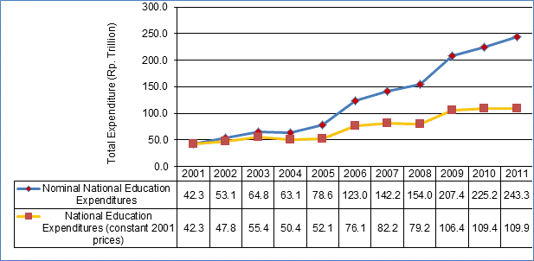

***The public expenditure for education (not accounting for price inflation) has increased by approximately 200% between 2006 and 2011.*** The nominal value of public expenditures for education increased from 123 trillion in 2001 to 243 trillion by 2011.

***The real value of public expenditure for education increased by 39% during the period 2006- 2011.*** In 2001 constant prices, national education expenditures increased more than 1.4 times their original 2006 value of Rp. 76 trillion to more than Rp. 110 trillion by 2011.

***Government commitment to meet a 20% target for education expenditure share of national budget has been met for the third year in a row.*** The national expenditures for education in 2011 met the 20% target, but this did not generate a large year on year increase in real funds available for education as the 20% target had already been reached in 2009. The growth in 2011 education expenditures was in line with growth in 2010, but more modest than 2009. This suggests that in future years the growth in national public education expenditures will continue to track the growth in the national public budget.

Adherence to a proportional budget allocation for education should enhance the ability of the education sector to anticipate future allocations and plan accordingly by creating a more stable financing framework. The proportional allocation approach toward education financing (i.e. 20% of available national public budget) will enhance predictability and steady growth of the education budget. The exception to this will be in the case of an economic downturn that depresses GoI revenues or where there is a change government fiscal policy settings leading to reduced public expenditure as a proportion gross domestic product.

***Annual increases in national education expenditure have been uneven.*** The growth in public expenditure (while still positive) has been uneven in its nominal value and 2001 constant prices. Sharp increases in public expenditure for education in the years 2003 and 2006 were followed by contractions in 2004 and 2008.

The 20% proportional allocation setting is now acting to moderate the changes in annual growth of the education budget towards the lower end of the growth spectrum.

1. Annual Growth in Education Expenditure(Rp. trillion), 2001-2011

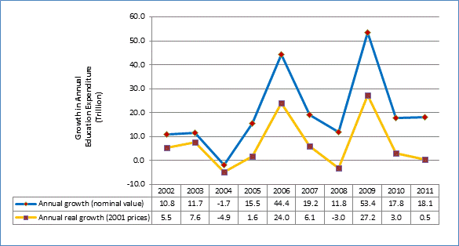

### KPI 1: Education Expenditure as Proportion of Total Public Expenditure

1. Education Expenditure as Proportion of Total National Public Expenditure, 2001-2011

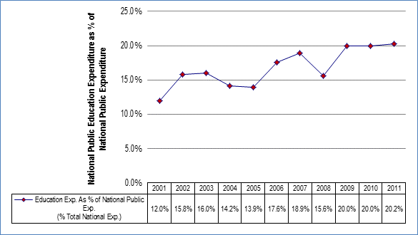

|  |  |
| --- | --- |
| **Result:** | Positive |
| **Data Availability:** | Full |
| **Comment:** | The GoI has now met its target of committing at least 20% of national public expenditure towards education for the last three years in a row (2009-2011).  Achieving this target has been made possible through significant growth in education expenditure allocations as a proportion of national expenditure since 2001. Education’s share has grown from 12% in 2001 to 20% for 2009-2011.  Declines in the share of education expenditures occurred in 2004, 2005 and 2008. The 2004 fall was related to the fuel subsidy crisis and the fiscal squeeze encountered by the central government.  The larger decline in budget share in 2008 reflects a faster rate of growth in the national budget than a decline in nominal value terms in the education budget. There was a substantial nominal growth in expenditure for education (see previous section), however particularly strong government revenues in 2008 facilitated a large growth in public expenditures.  In contrast, the relative decline in education expenditure during 2004 was affected through a decline in mostly development expenditures. |
| **Future Analysis:** | Annual. |

***Policy Implications:*** The 2010 and 2011 public expenditure figures and the Financial Notes for 2010 and 2011 released by the MoF make it clear there is now a continuing GoI commitment to meet the constitutionally mandated 20% target for education expenditure.

### KPI 2: Education Expenditure as Proportion of GDP

1. Education Expenditure as Proportion of GDP, 2001-2011

|  |  |
| --- | --- |
| **Result:** | Negative |
| **Data Availability:** | Full |
| **Comment:** | This indicator captures the national public commitment towards education in relation to the economic wealth being generated. By mapping education expenditure with GDP it avoids comparison problems with other countries (see table for UNESCO comparisons) which may have different sized public sectors. The indicator is also useful for comparing expenditure trends in a country which has altered the size of its public sector across time. Generally, this indicator is used in tandem with education share of public expenditure.  In Indonesia, there has been a decline in in education expenditure as a proportion of GDP since 2009. Education as a percentage of GDP rose from 2.5% in 2001 to 3.7% by 2009. In 2007 when the latest comparison figures are available, Indonesian education expenditure as a share of GDP (3.6%) was equal to the East Asia regional average.  While education expenditure has been growing slightly faster than national public expenditure, it has been outpaced by a much faster growth in GDP. |
| **Future Analysis:** | Annual. |

***Policy Implications:*** Expressed as a percentage of GDP, future growth in public allocations will become contingent on an increase in public expenditures as a proportion of GDP. Education expenditure as a percentage of GDP may decline if (i) fiscal settings reduce public expenditures as a proportion of GDP, and (ii) the government does not exceed the 20% target for education as a proportion of total public expenditure.

KPI 3: Education Non-salary Expenditure as Share of Total Expenditure

1. Composition of Aggregate District Education Expenditure, 2009-2011

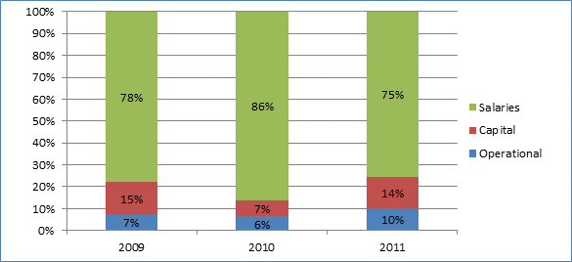

|  |  |
| --- | --- |
| **Result:** | Positive |
| **Data Availability:** | District supplied data from 2009 onwards. Data only refers to the district tier of government and does not include considerable non-salary payments likely to be flowing from central level government to districts and schools. |
| **Comment:** | School systems require a substantial share of non-salary related expenditures to (i) provide a full range of resources (apart from teachers) to schools, and (ii) maintain buildings and provide for additional capital and equipment needs.  In 2011 the salary share of expenditures had come down to 75% of total district level expenditures. In the context of the additional salary costs associated with the teacher certification process, this is a very positive achievement.  New budget allocations were especially strong for capital items which doubled from 7% of total district budgets in 2010 to 14% in 2011.  Budget allocations for operational costs also grew strongly from 6% in 2010 to 10% in 2011. |
| **Future Analysis:** | To be updated annually. |

***Policy Implications:*** In 2011 there was a significant year to year improvement in the share of resources being allocated for non-salary expenses within the education budget. Unfortunately there is little room for complacency in this respect due to the ongoing fiscal impact of remuneration for teachers attaining teacher certification. Certified teachers will garner at least 100% pay increases once they are certified. The cumulative impact of these increases will act to severely constrain future increases in non-salary expenditures. It will be increasingly important for districts and schools to ensure that non-salary expenditures are effective and efficiently distributed.

### KPI 4: Expenditure on Basic Education as % of All Education Expenditure &

### KPI 5: Expenditure on Non Formal Education as % of All Education Expenditure

1. Education Expenditure by Sub-Sector, 2004

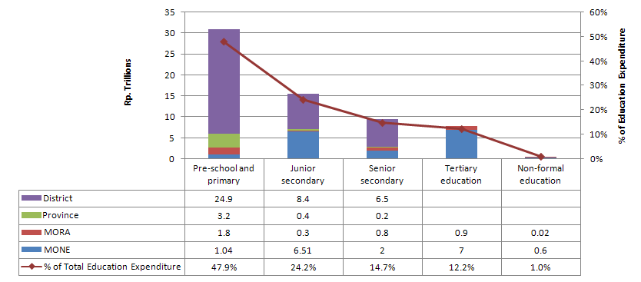

Source: World Bank, Investing in Indonesia’s Education, 2007

|  |  |
| --- | --- |
| **Result:** | Positive for Basic Education, Negative for Non Formal Education |
| **Data Availability:** | National analysis limited to 2004. Breakdown of data is difficult because of its composition from 3 tiers of government. Analysis of central level expenditures for basic education is provided to give some idea of resourcing trends since 2004. |
| **Comment:** | Basic education accounts for approximately 70% of total funding, with nearly 50% for pre-school and primary. Senior secondary will begin to make a stronger resource claim in future as universalisation policy expands access. Districts are carrying the bulk of expenditure for basic education and therefore remain a key site for interventions. The central share is likely to have increased since 2004 with the introduction of BOS grants that are paid directly to schools.  Analysis of central level expenditures for the period 2006-2009 shows commitment to Basic Education is holding firm within MoNE at around 50%. Within MoRA there was greater fluctuation with basic education dropping to as low as 17% of education expenditure in 2008 before climbing again in 2009 to 31%. It is unclear what has been driving the fluctuations in basic education share of MoRA expenditures.  The financial allocations for non-formal education are very low at 1% of total sector expenditure. |
| **Future Analysis:** | Uncertain. Current data collected at SIKD does not disaggregate between levels of education expenditure at the district level. Liaison with MONE, MORA, Bappenas and World Bank staff to see if periodic update is possible. |

1. Basic Education Share of Central Level Expenditures for MoNE and MoRA, 2006-2009

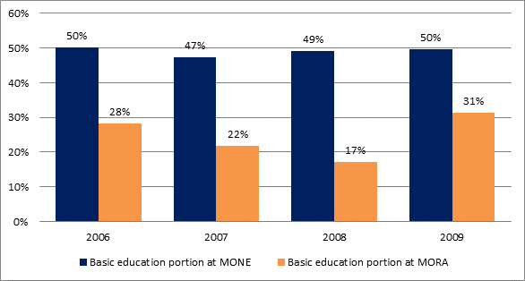

***Policy Implications:*** Maintaining the share of basic education will be important even as access to secondary education is expanded. Investment in basic education builds a strong base in literacy and numeracy and economic development suffers when basic education expenditure is neglected in favor of investment at higher levels.

NFE expenditure was approximately 1% of total expenditure for education in 2004. While a key advantage of NFE is its cost-effectiveness, increased levels of investment are needed to maximise the possible economic and social returns.

# Trends in District Education Funding

### Background

District level expenditure patterns are increasingly important as districts have increased responsibility for education management under decentralisation. Monitoring patterns of expenditure by districts will become an increasingly important role for MOEC and MORA to ensure that national funding norms and procedures are being implemented appropriately. The wide range of districts’ poverty status and the importance of education in lifting district populations out of poverty also mean that vulnerable groups stand to benefit most from well-targeted investments in education. Monitoring and evaluation of district level education financing provides the tools to do so.

This section provides - comparisons of district level education expenditures for 2006-2011. The year 2006 is a useful benchmark to identify the nature and extent of education spending at the district level before the commencement of the BEP expenditures.

The district level analysis provides comparisons in district expenditures between (i) rural and urban districts, (ii) BEP and non-BEP districts, (ii) districts sorted into poverty quintile rankings, (iv) provinces, and (v) island groups.

### Data availability

The Financial Performance Report 2011 is based on data collected electronically in 2010 and 2011. District data prior to this period, have been collected by CSAS directly from the SIKD section of MoF. The SIKD collected in hard copy format the budget and actual expenditures of all districts and provinces. CSAS arranged with the Officers of the SIKD section to be given access to the available SIKD records.

1. Number of Districts Included in FPR Analysis, (2006-2011)

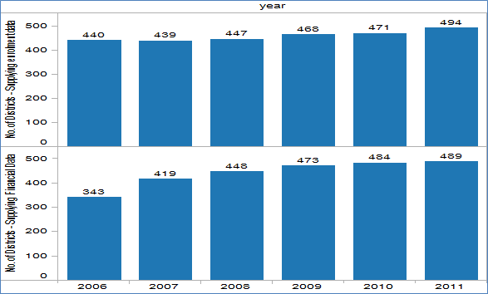

Since 2009, these data have been supplemented by data collected electronically from the MoF as and have contributed to the previous FPR 2008 and the FPR 2009.

The 2010 FPR was the first to have an entire year that was derived entirely from electronic records provided by SIKD MoF. The data provided by the MoF is subjected to logic tests and assessed for it completeness. The data provided by the MoF is seen to be improving in its completeness and in its quality.

At the time of the publication of the FPR 2010, it was only possible to access the financial data for 393 districts. The remaining districts had either not provided MoF with their financial reports, or the SIKD section was still in the process of data entry or validation and quality assurance. This report updated the 2010 year records for districts. It now contains the financial data of 484 districts as well as changes in the financial data of districts that had been previously reported. This has led to some changes in the trends for some indicators in the previous report. This report should be treated as the most accurate presentation and final presentation of data analysis for the years 2006-2010.

A detailed table in Annex 1 shows the status of data collected from all districts during the period 2006-11.

### KPI 6: District Financial Commitment to Education

1. Education Expenditure as % of Total District Budget (APBD 2006-2011)

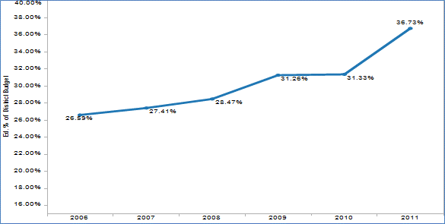

|  |  |
| --- | --- |
| **Result:** | Positive |
| **Data Quality and Availability:** | Financial data is for approximately 80% of all districts for 2006, more than 90% for the years 2007, 2008, 2009, 2010. Financial data for 2011 was available for 489 districts and enrolment data for 494 districts out of a total 497 districts. |
| **General Comment:** | Average district level education expenditures across Indonesia have increased from 27% of the total district budget (APBD) in 2006 to nearly 37% share in 2011.  The strong increase in 2011 in the education share of district budgets has come in a year where both total district budgets and the education share of district budgets have grown strongly. However, while district budgets in 2011 grew at a national average of 13% on the year before, education budgets grew 36% on 2010 average allocations.  The increased share of education expenditures at the district level demonstrates that districts on average strengthened their commitment toward education spending during the period 2006-2011.  The growth in share of allocations towards education is consistent for urban and rural areas. Rural areas on average allocate 37% of their district budgets towards education in 2011, compared with 35% in urban zones.  While these averages show maintenance of financial commitment to education, it does disguise some variation between districts. Comparison of the fluctuations of individual districts may not be useful as their expenditure may be significantly affected by one-off large annual investments.  The lowest average share of budget allocation for education was found in Papua (18%) and Maluku island group (25%). Both of these islands recorded less than 20% average share for education in 2010. While Maluku has shown strong growth since, Papua is still resting below the 20% government expenditure target set by government.  Nationally, there are 24 districts which have allocated less than 15% of their total district budget (APBD) on education every year during the period 2009-2011.  Analysis of districts by their poverty quintile, still shows that the poorest districts have consistently committed the lowest proportion of their budget (average 31% in 2011) towards education during the period 2006-2011. |
| **BEP Districts:** | The updated data show both BEP and non-BEP districts’ growing their education share of district budgets during the period 2006-2010. By 2011 BEP districts had increased their education expenditure to 34% of total district budgets. Non-BEP districts had a higher annual growth in district allocations for education, with 37% of budget allocations being for education.  The poorest BEP districts have increased their education share of expenditures from 23% in 2006 to 34% by 2011. Education expenditure shares in BEP districts in 2011 across all poverty quintiles stayed within a range of 32%-38%. |
| **Future Analysis:** | Annual update of 2012 data once available from MoF |

The average total district budget in 2011 (for all areas of expenditure, including education) grew by more than Rp. 100,000 million on 2010 allocations (16% growth). This was outpaced by the growth in the education expenditure which grew at more than 35% year to year 2010-2011.

In this report, additional financial data for 2010, has revised the findings of the 2010 FPR (this showed on average the total value of district budget has declined by 7% in 2010 from their previous average in 2009). This most recent financial data has been confirmed with the SIKD section of MoF.

1. Average District APBD and APBD for Education, 2006-2011

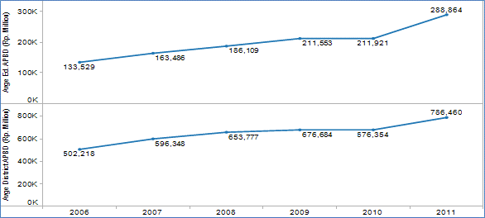

Both urban and rural districts have increased share of total district funds for education, although rural areas with a 37% commitment of district budgets for education have grown more strongly than the urban districts (35%).

1. Rural and Urban District Education Expenditure as % of Total District Budget (APBD 2006-2011)

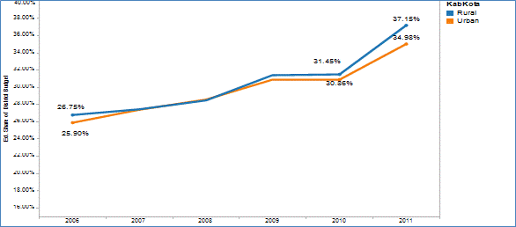

Districts in most poverty quintiles were increasing their average allocation share for education between 2006 and 2010, with the single major exception of quintile 3 which had a significant fall, and the smaller decrease of poorest districts (quintile 5) in 2010.

The year 2011 marks a change with significant increases in the education share of district budgets across districts from all poverty quintiles.

However, poverty quintile status still shows that the poorest districts have consistently committed the lowest proportion of their budget (average 31%) towards education during the period 2006-2011.

1. Education Expenditure as % of Total District Expenditure by Districts according to Poverty Quintile, (APBD 2006-2011)

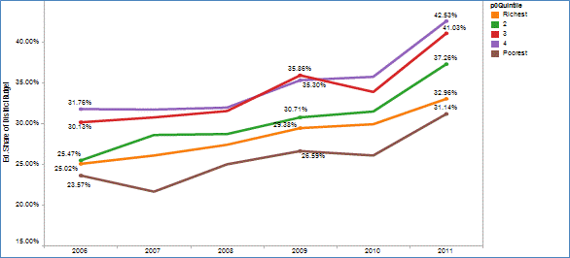

While districts in all poverty quintiles have shown growth in total district expenditure, the growth in education expenditure as a proportion of total district budget (APBD) within all quintile districts is due to stronger increases in education budgets.

1. Average District APBD and APBD for Education, by poverty quintile 2006-2011

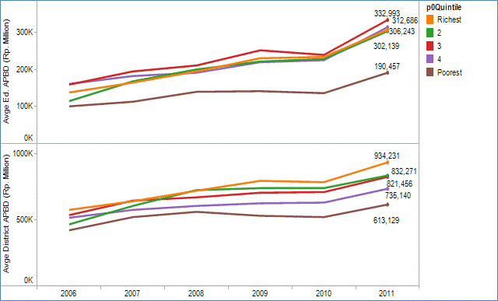

In 2011, the island group of Bali and Nusa Tengarra shows a big jump with education share of district budgets increasing from 33% in 2009 to 39% in 2011.

The lowest average share of budget allocation for education was found in Papua (18%) and Maluku island group (25%). Both of these islands recorded less than 20% average share for education in 2010, but Maluku has shown strong growth in 2011. However, Papua is still resting below the 20% government expenditure target for education set by government.

1. Education Expenditure as % of Total District Expenditure by Island Grouping (APBD 2006-2011)

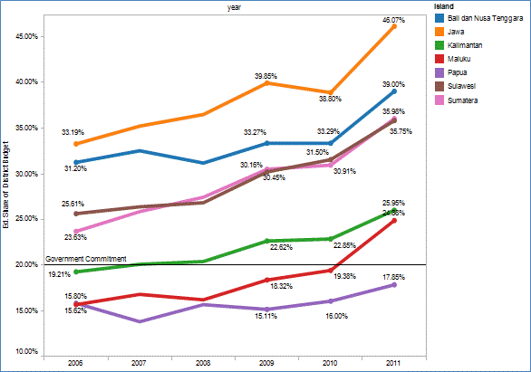

BEP districts increased their share of expenditure for education from 26% in 2006 to 34% in 2011. In 2011, the non-BEP districts (37%) had stronger growth in education expenditure than BEP districts.

1. APBD Education Expenditure as % of Total district Expenditure in BEP and Non-BEP Supported Districts (APBD 2006-2011)

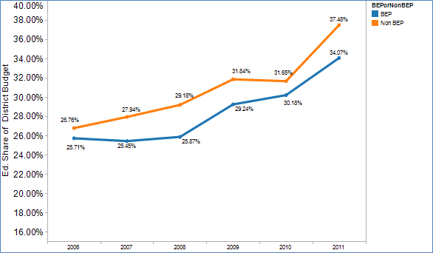

A more detailed analysis of education expenditure shares in BEP districts by their poverty quintile ranking reveals a continuing positive story of sustained improvement in the poorest quintile districts. The poorest BEP districts have increased their education share of expenditures from 23% in 2006 to 34% by 2011. The average poverty quintile education expenditure shares in BEP districts in 2011 was compressed to range between 32%-38%.

1. BEP Districts Only - Education Expenditure as % of Total District Expenditure by District Poverty Quintile (APBD 2006-2011)

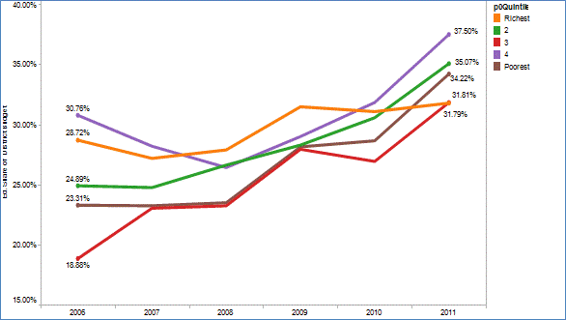

While BEP districts have committed a share of their district budget that is broadly in line with the national average, there are some BEP districts that have spent considerably less.

This report presents three years of results from 2009 to 2011 showing there have been 11 BEP districts which have dedicated less than 20% of their budget towards education in every year.

Most of the BEP districts that report spending less than 20% of their budget on education in both are located on Maluku. While some of the low figures may be due to poor reporting, the persistence of these low allocations shares in consecutive years suggest there are other factors involved.

1. BEP Districts with low financial share for education (less than 20% of APBD Expenditure) 2009 and 2011

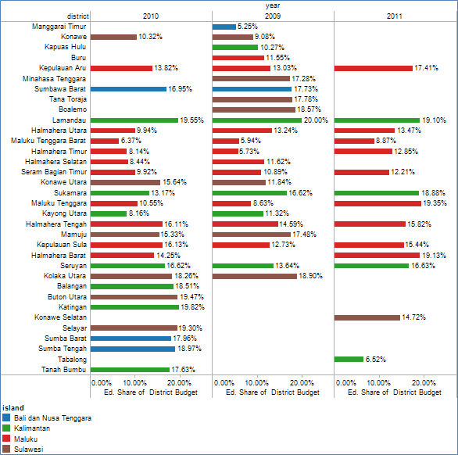

* Districts that are blank for one year have exceeded the benchmark for that year

Nationally, there are 23 districts which have allocated less than 15% of their total district budget (APBD) on education every year during the period 2009-2011. The chart below shows every district that allocated less than 15% of their district budget on education in any of the three budget years during 2009-2011. It would be useful to understand why education budget share is so low in these districts and to what extent they represent policy related or demand side factors as well as possible misreporting to the MoF.

1. Districts with very low financial share for education (less than 15% of APBD Expenditure) 2009 -2011

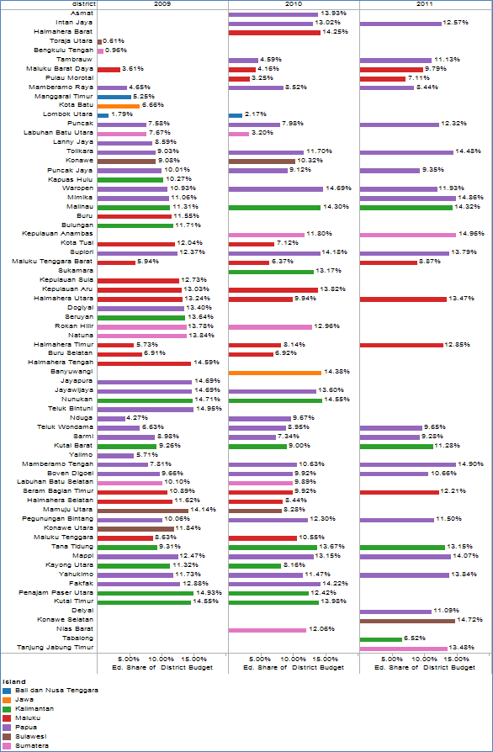

* Districts that are blank for one year have exceeded the benchmark for that year

Looking at the 30 districts which in 2011 committed less than 15% of their budget towards education, we find that 20 of these districts belong to the poorest quintile of districts. Of these 20 poorest quintile districts, seventeen (17) are found in Papua and three (3) are in Maluku.

1. Poorest Districts with very low financial share for education (less than 15% of APBD Expenditure) 2011

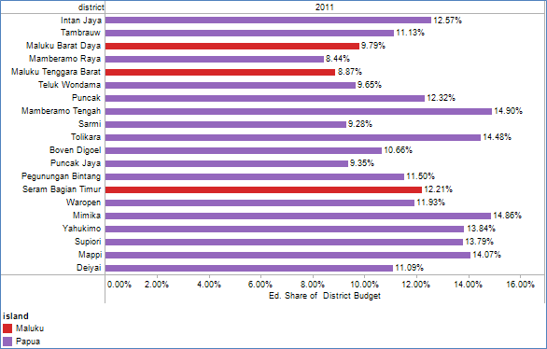

***Policy Implications:***

The 2011 report has found that on average, both total district budgets and their education components have shown strong annual growth in 2011. The report has also found that the average education component of district allocations grew at an even stronger rate than the total district budget. This has resulted in the average share of district funds allocated for education increasing to 37%.

Particularly interesting is that this strong increase in district allocations for education does not include BOS money which was distributed by districts in 2011. This is important, because there was the danger that district governments might be inclined to reduce their existing financial commitments as an offset to the ‘new’ BOS money that is channeled through the districts. The net effect for schools, would have been a reduction in total available government funding. In fact, the opposite appears to have occurred, and districts increased their education spending whilst becoming responsible for BOS distribution in 2011. There is a number of explanations for this effect. One is that districts retained their commitment as a deliberate policy setting. Another explanation is that the budget formulation process which granted the strong increases to education expenditure for operational and capital spending occurred prior to the receipt of BOS money. In that sense, the impact of the district mamanegment BOS funds on total district allocation of funds may have taken a year or more to be fully felt by the sector. A third explanation, is that the increased salary allocations for education are not decided by district but by the DAU allocations made by the centre and their upward variation reflects the costs of the teacher certification process (increases in salary and allowances).

Districts that have high poverty rates and are persistently allocating a significantly smaller share (less than 15%) of resources for education than the national average in 2011 are found in only two island groups - Papua and Maluku. This disadvantage is likely to be compounded each year as other, wealthier districts spend higher amounts on education.

This report finds that updated data provided by SIKD section of MoF for the year 2010 (data for an additional 88 districts and revisions for some districts) has reversed the finding from the 2010 FPR which found an average contraction in total district budgets in 2010. This reinforces the need for data analysis to be undertaken only when a sufficient number of districts have submitted their returns to MoF and this data has been properly validated by the SIKD section.

***Recommendation:***

MOEC should consider undertaking a detailed study focused on the poorest districts in Papua and Maluku (poverty quintile 5 districts) to examine why some of these districts with high poverty rates are allocating significantly smaller share of resources for education than the national average. The study should look for comparisons with other districts in these island groups, to also understand why some districts (conversely) may be spending a higher proportion of their budget on education.

KPI 7: Annual Growth in Education Spending for the Poorest Districts

1. Annual Growth in APBD Education Expenditure, 2007 -2011, by Poverty Quintile

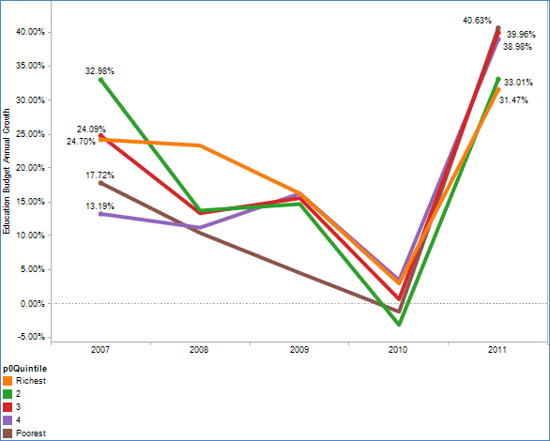

|  |  |
| --- | --- |
| **Result:** | Positive |
| **Data Quality and Availability:** | As per KPI 6 |
| **General Comment:** | Poorest districts (bottom quintile) recorded a staggering 40% average annual growth in their 2011 education budget on the previous year. This follows a contraction in 2010, and annual growth of 10% and 5% between 2007-08 and 2008-09 budgets. This is a very positive result for the poorest districts as they have managed the highest average percentage increase in the education of all the poverty quintiles.  The continued strong growth of education budgets within the poorest districts is far in excess of the annual inflation rate.  Only 6 **poorest quintile** districts (all in Papua) experienced a decline in the dedicated 2011 district budget funds for education compared with the previous year. This compares with 2010 when 37 poorest quintile districts recorded a contraction in their education allocations compared to the previous budget year.  In 2011 there were only 22 districts showing a decline in the education budget compared to the previous year.  Rural districts with an average annual growth of 38% in year to year allocations grew more strongly than urban districts (29%). |
| **BEP Districts:** | BEP districts showed strong positive commitment to education with 35% annual growth in education funds in 2010-11. The best annual growth rates in education expenditures were within the poorest BEP districts which expanded their budgets by an average 42% in 2011.  Non-BEP districts also displayed solid growth in their education expenditures in 2010-11 (36%) |
| **Future Analysis:** | Trend series can be updated beyond 2010-11. |

The average annual growth rate of district education budgets in 2011 was a remarkable 36%. This does come on the back of a very poor 2010 when annual growth was below inflation at 0.2%. The strongest growth was shown by the rural districts which had annual growth of 38% compared with a 29% annual growth of urban districts.

1. Annual Growth in District Education Expenditure, (APBD 2007-2011)

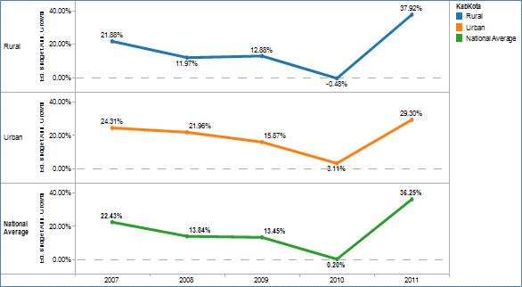

In 2011, only 6 of the poorest districts experienced a contraction in their education expenditure (not accounting for inflation) compared to the previous district annual budget. This is a big improvement on the previous year when 37 poorest quintile districts experienced a decline in the dedicated 2010 district budget funds for education (compared with the 2009 district budget allocations).

1. Poorest Districts (Quintile 5), Negative Annual Growth in Education Expenditure, (APBD 2009-2011)

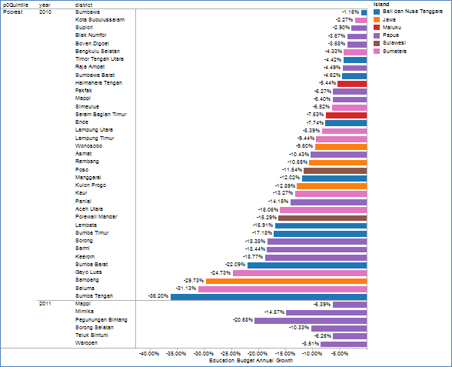

BEP districts had a strong growth in education expenditures with a national average of 35% that was only marginally below the national average of 36% growth.

1. BEP and Non-BEP Districts - Annual Growth in District Education Expenditure, (APBD 2007-2011)

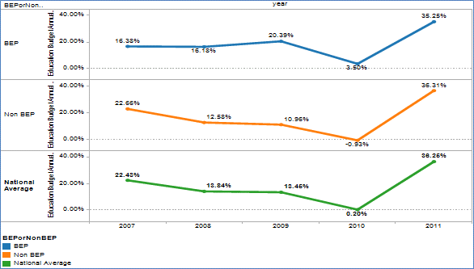

In 2011, BEP districts within all poverty quintiles showed strong annual growth in education expenditure. The best annual growth rates in education expenditures were within the poorest BEP districts which expanded their budgets by an average 42% in 2011. This was considerably higher than the 36% national average growth rate. The 2011 annual growth rates in district education spending were strong across all BEP poverty quintiles.

1. BEP Districts Only - Annual Growth in District Education Expenditure, (APBD 2007-2011)

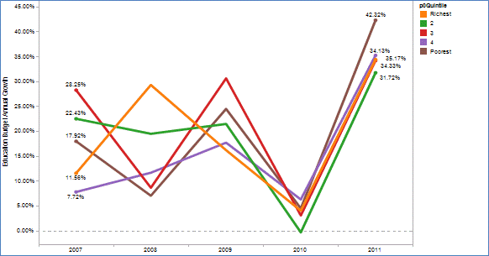

In 2011 there were only 22 districts showing a decline in the education budget compared to the previous year. This is a big improvement from the updated figures for 2010, which had 216 districts experiencing a decline in annual education budget allocation. This translated to more than 40% of districts showing a decline in budget commitment towards education. The year 2011 has seen a more consistently positive financial commitment from districts towards education, with less than 5% decreasing their allocations towards education.

1. Number of Districts, with Negative Annual Growth in APBD Education Expenditure (2007-2011)

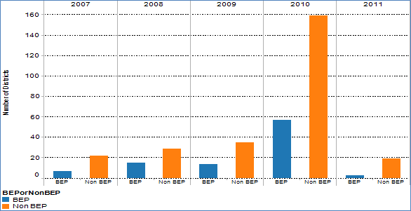

Poverty quintile analysis of districts with declining education budget allocations in 2011 shows them to be distributed across all quintiles although 6 of the 19 are from the poorest quintile.

1. Total Number of Districts, with Negative Annual Growth in APBD Education Expenditure, 2007 -2011

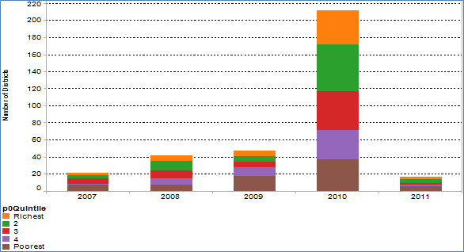

The BEP districts with negative annual growth in district expenditure are shown in the figure below.

***Policy Implications:*** A very positive result for the poorest districts which have the highest average percentage increase in budget allocations for education of all the poverty quintiles. Their growth of education budgets is far in excess of the annual inflation rate. Across the country in 2011, this meant there were only 22 districts showing a decline in the education budget compared to the previous year.

Looking specifically at the poorest quintile districts in 2011, the problem of contracting education budgets was confined to Papua. Six (6) poorest quintile districts of Papua experienced a decline in the dedicated 2011 district budget funds for education compared with the 2010 district budget allocations. This compares with 2010 when 37 poorest quintile districts recorded a contraction in their education allocations compared to the previous budget year.

***Recommendation:***

Undertake a short research project involving meetings with education officials of a targeted group of districts to explore (i) what has driven the strong increase in education spending of districts across the country, and (ii) what factors have been involved in those 22 districts which have reduced their education allocations in 2011.

1. BEP Districts Only – Districts with Negative Annual Growth in District Education Expenditure, (APBD 2009/10-2010/11)

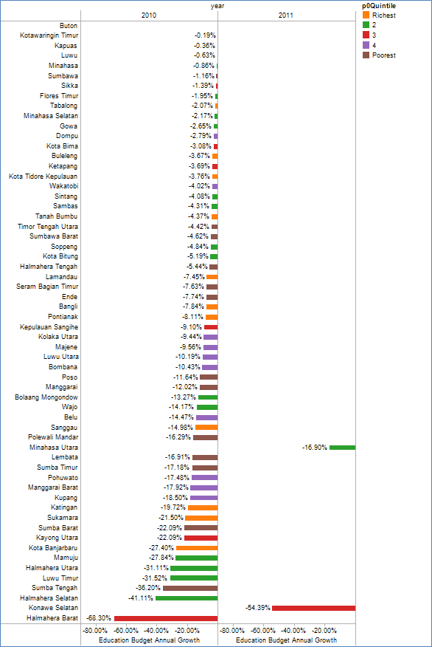

### KPI 8: Average District Expenditure per Student

1. Average District Education Expenditure per all Students, 2006-2011 (Rp millions.)

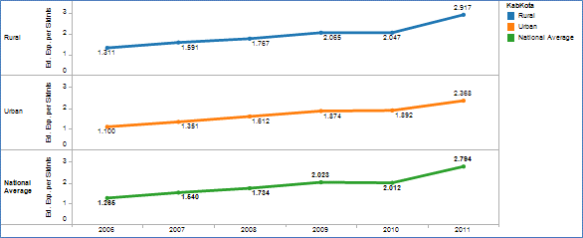

|  |  |
| --- | --- |
| **Result:** | Positive |
| **Data Quality and Availability:** | As per KPI 6 |
| **General Comment:** | Average expenditure per student across the country grew very strongly in 2011. This is a big change from the stalled expenditure growth that was experienced in 2010. Average education expenditure per student has grown to Rp. 2.8 million in 2011, from an average Rp. 2 million in 2010.  Average per student expenditure is now considerably higher in rural districts and reached Rp. 2.8 million per student in 2011. This compares with Rp. 2.4 million per student in the urban areas.  Highest allocations per student are found in the poorest districts (quintile 5) at an average Rp. 3.3 million per student. This compares with an average district allocation of Rp. 2.5 to 2.9 million for the other poverty quintiles.  The per student allocation is greatly affected by the sparsity of population. More sparsely populated districts (such as those in the eastern region and many of those in the poorest quintile districts) have higher average salary costs. This is because of both lower student/teacher ratios and higher salary related costs associated with remote area allowances. |
| **BEP Districts:** | In 2011, education expenditure per student in BEP districts reached Rp. 3.4 million, and continued to outspend the non-BEP districts which had an average allocation of Rp. 2.7 million per student.  BEP districts have a higher than national average per student allocation across all six years. The higher expenditure of BEP districts is in part related to the fact that 90% of BEP districts are located in the Eastern region of the country. Unit costs are higher in the eastern region due to sparsity factors. |
| **Future Analysis:** | Annual update |

A more nuanced analysis of per student education expenditure looks at district expenditures per public MOEC school students. This provides a more accurate measure because districts are only responsible for teacher salaries and other operational expenses of MoNE public schools. By excluding private school students from per student calculations it is possible to remove the bias of different rates of enrolment in private schools across districts.

The national average education expenditure per public students in 2011 was Rp. 4 million per student (from a previous year average of Rp. 3 million). Average expenditure per student for urban districts (Rp. 3.91 million) remains very close to rural districts (Rp. 3.98 million). Because there are proportionately greater numbers of private school students in urban areas, this indicator neutralizes the trend of the broader indicator *expenditure* *per all students.*

1. Comparison - Expenditure per All Students vs. Expenditure per Public Students, (Rp. millions)

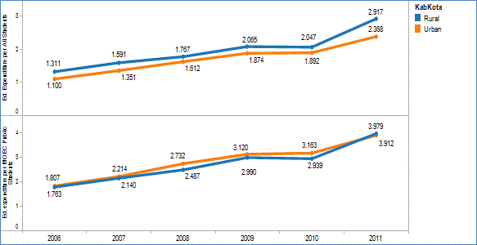

BEP districts reflect a similar trend to other districts with steady increases in per student allocations until 2009, a pause in 2010, and then sharp increase in allocations in 2011. In 2010, average per student expenditure showed no real growth on 2009, meaning that when taking into account the effects of price inflation, there was an average real decline expenditure per student in BEP and non-BEP districts.

In 2011, education allocations in BEP districts grew by Rp. 900,000 per student, to reach an average per student allocation of Rp. 3.4 million per all students. This compared to the other districts average of Rp 2.7 million.

1. Average APBD Education Expenditure per Student (Rp), BEP and Non-BEP Districts

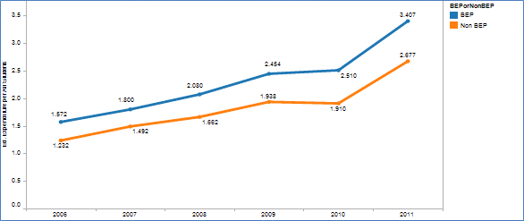

Poverty quintile analysis of average allocations per student shows the poorest districts in 2011 had the sharpest growth and by 2010 were allocating the greatest amount per student (Rp. 3.3 milllion). This compares with the richest districts which allocate the least of any quintile with Rp. 2.5 million. The poorest districts are on average allocating 28% more per student than the richest.

1. Average APBD Education Expenditure per Student (Rp. Million), by Poverty Quintile Districts

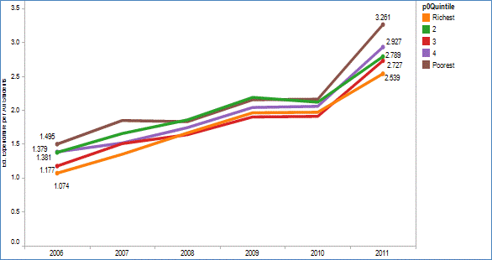

Average allocations per **public student** show the two richest quintile districts to be spending around Rp. 3.9 million per public student in 2011. The poorest quintile districts spend Rp. 4.8 million per public student. The per student allocation is greatly affected by the sparsity of population. More sparsely populated districts (such as those in the eastern region and many of those in the poorest quintile districts) have higher average salary costs. This is because of lower student/teacher ratios and higher salary related costs associated with remote area allowances. The relatively high per public student expenditure in the poorest districts is a positive indicator as it shows the government is making higher allocations towards those areas with higher costs for delivering services.

1. Average APBD Education Expenditure per Public Student (Rp. Million), by Poverty Quintile Districts

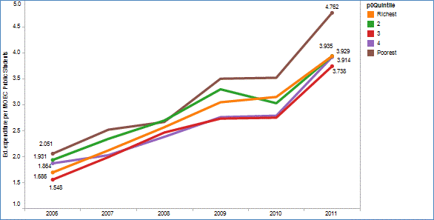

Districts in the far eastern regions of the country tend to have significantly higher costs per student than districts in the western region because of the lower density of populations. Average expenditure per student in 2011 was again highest in the island groups of Papua (Rp. 6.3 million) and Kalimantan (Rp. 4.4 million). Lowest expenditure by a considerable margin is found on Java with Rp. 2.3 million per student. To some extent the lower unit costs in java reflect the population density which makes it easier to run schools at maximum capacity and consistently high student:teacher ratios.

Education expenditure per public student shows Papua reaching Rp. 10.7 million in 2011 compared to the next highest Kalimantan (Rp. 5.7 million) and Java as the lowest island expenditure per public student (Rp. 3.5 million).

1. Average APBD Education Expenditure per Student (Rp), by Island

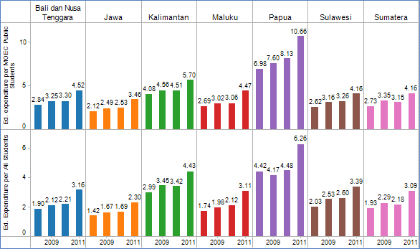

***Policy Implications:***

Unit cost calculations are greatly affected by the sparsity of populations and care needs to be taken when comparing districts. Care should be taken to compare like with like districts in order to get a true feel for the district government commitment and possible impact on quality.

Reasonable distribution of public education funds should generally provide greater funding per student to the poorest areas. This weighted distribution of government funds can enable the poorest communities to overcome a financial inability to pay for services. It also helps to cover the higher cost of servicing poor communities that are also in remote or difficult to reach areas.

1. Equity Slope of Funding - Average APBD Education Expenditure per Public Student (Rp million), by Poverty Quintile,

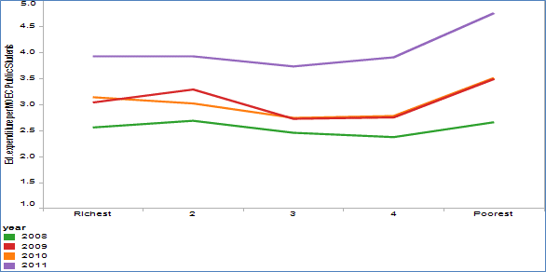

The chart above illustrates the ‘equity slope’ of district school funding. The ideal equity slope would begin low at the left hand corner (least public resources per student for the wealthiest districts) and slope upwards indicating that those districts with the lowest socio-economic profile and catering for the most remote communities have the greatest resources per student. The situation in Indonesia demonstrates a movement over time towards that kind of scenario. By 2011, districts from the two poorest quintiles had grown their allocations at a faster rate than others. This is a significant achievement and is beginning to move away from a relatively flat distribution of district education funding per student across poverty quintiles. It shows government policies have been successful in moving towards a greater share of public resources being directed towards education in poorer districts. To achieve better learning outcomes across the poorest districts, the government will need to continue to strengthen the ‘equity slope’ in its funding distribution.

There is good news for the government regarding the affordability of this approach. Analysis of the distribution of students across district poverty quintiles shows that there far fewer students in the poorest quintile than any other. In 2011, there were 5.7 million students in poverty quintile 5 compared to more than 12 million in the richest quintile. The cost of serving these districts is mitigated by reduced population density of these districts. Although of course, successful policies will solve access problems and push up enrolments, however the reduced population density means there will still be fewer students to service.

1. Cost and Student Load Comparison - Average APBD Education Expenditure per Student (Rp million)and Numbers of Students, by Poverty Quintile, 2011

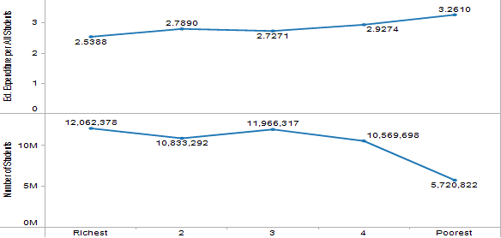

A *Critical Education Funding Status* (CEFS) diagnostic tool is based on three Key Performance Indicators from this District level analysis (KPI’s 6, 7, and 8). The CEFS diagnostic tool identifies critical districts that have:

* low expenditure per student (less than Rp. 2.1 million)
* small education share of the district budget (less than 20%)
* weak annual growth in their education budget (less than 20%).

The table below shows a dramatic reduction in the number of districts in 2011 (2) that are meeting these criteria compared to 2009 (16) and another 12 districts meeting the CEFS criteria in 2010. Eight (8) districts were identified in both 2009 and 2010. The turnaround in 2011 captures the widespread improvement in district allocations for education in 2011.

***Recommendations:***

* + - 1. For the AusAID funded ESSP, pay attention to (i) the eight districts identified in both 2010 and 2011 as having Critical Education Funding Status (CEFS), and (ii) the two districts with declining education allocations in 2011. ESSP disbursements managed through the districts should be reviewed and processed where the district does not reduce budget allocations for education in 2012. Where these districts are reverting to decreased per student funding in 2012 and beyond, policy dialogue with these districts should explore the reasons for the decrease before AusAID funds are committed to these districts.
      2. AusAID support GoI in the formulation of a policy framework to (i) support a change in district education financing policy so that a greater volume and share of districts funds is diverted to education (where that is confirmed to be required), and (ii) mitigate the risk of the ESSP driving financial substitution effects at the district level which further weaken existing local allocations for education.

1. Critical Education Funding Status (CEFS) Districts – Districts with low growth in education budget, low share of district budget and low expenditure per student, 2009-2011

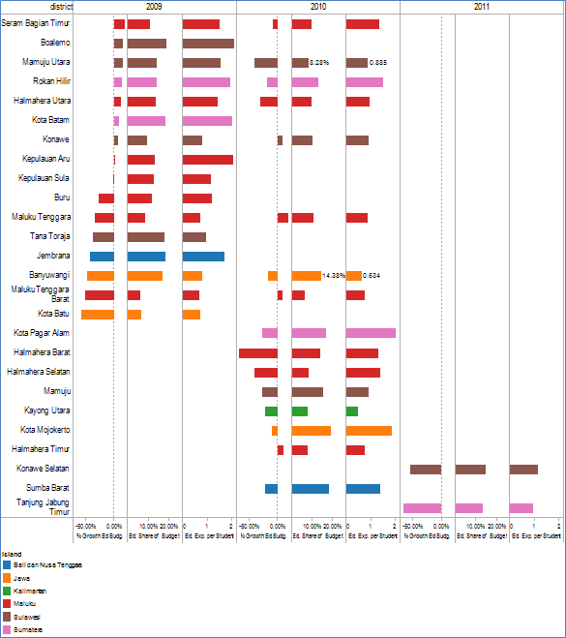

### KPI 9: Actual district education expenditure as % of planned education expenditure

1. Realised Education Expenditure as % of Planned Expenditure 2006 and 2007

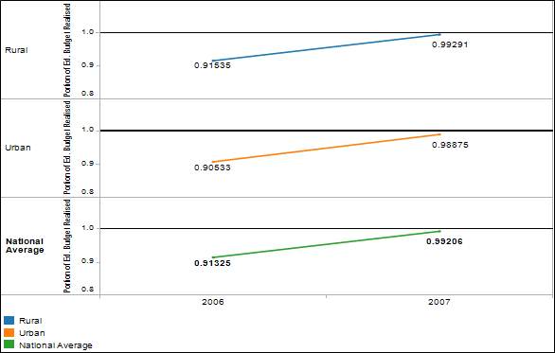

|  |  |
| --- | --- |
| **Result:** | Positive |
| **Data Quality and Availability:** | Budget data for 2006 is from the ‘final revised budget’ documents and reflect the final allocation. Revised budget data for 2007 was not available. Data collected is from the ‘planned budget’ documents which reflect a bid by the district education office for funds. This budget may then be revised downwards in the ‘revised final budget’. The 2007 financial data is therefore not from identical planning documents and may be responsible for an upwards shift in percentage of budget realized as actual expenditure. No new data was available for 2008 to update this analysis from previous report. |
| **General Comment:** | Districts in 2007 managed to spend nearly 100% of their planned budget. This was a significant improvement on 2006 where only 91% of funds were spent nationally. |
| **BEP Districts:** | The average BEP district increased its actual expenditure to 100% of budgeted allocations in 2007. This was up from a 92% expenditure in 2006. Non-BEP districts also increased their actual expenditure to nearly 100% of budgeted allocations in 2007. |
| **Future Analysis:** | Update 2008 data once collected.  Trend series to continue with realized budget data for 2007 to be collected |

1. Realised Education Expenditure as % of Planned Expenditure 2006-07, BEP and Non-BEP districts

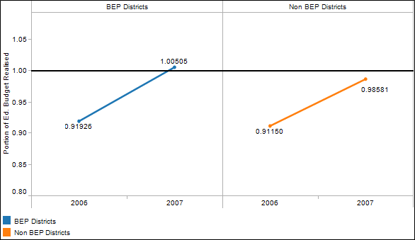

Poverty quintile analysis shows that the top two poverty quintile districts on average overspent their planned education budget in 2007. The lowest average rate of realisation was with the poorest quintile districts that only spent 91% of their planned budget.

1. Realised Education Expenditure as % of Planned Expenditure 2006 and 2007, by Poverty Quintile

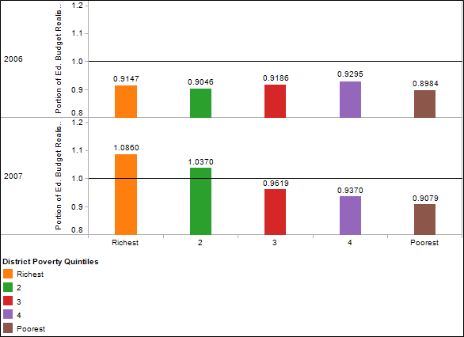

1. Poorest Quintile Districts that realised less than 90% of Education Budget 2007

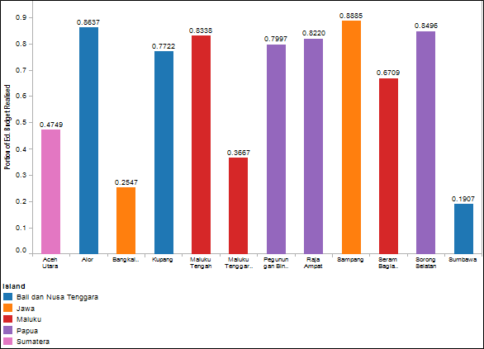

***Policy Implications:*** Too many districts may be failing to expend their allocated annual education budgets. The difficulty of the poorest districts in expending their budgets is of a particular concern given the access and quality problems in these districts. The quantum of funds may not be the greatest problem facing some districts, and/or there may be other problems related to disbursement restrictions and reporting or planning requirements.

***Recommendation:*** A study and policy dialogue with Dinas education offices is required to determine reasons for the under-expenditure of annual education budgets focused on the poorest districts. The study should propose options for improving the uptake of funds that can promote their efficient and effective use for education purposes at the district level.

### SPI: Discretionary School Expenditure as Percentage of Total Education Expenditure

1. BOS Grants as % of Education & Culture Budget 2006-2010 (public schools only)

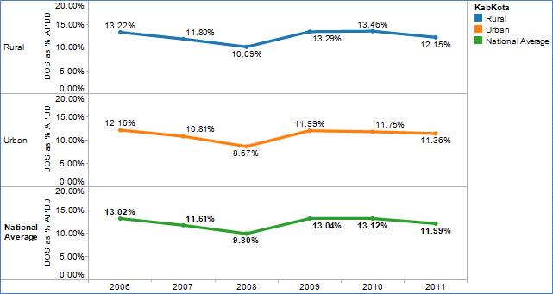

1. BEP and Non-BEP Districts - BOS Grants as % of Education & Culture Budget 2006-2011

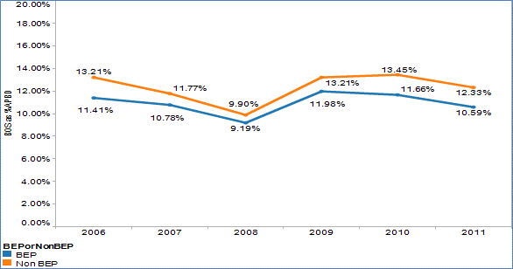

|  |  |
| --- | --- |
| **Meaning of the Indicator:** | Discretionary expenditure is a key variable at the school level to enable schools to provide materials for classrooms and other activities. |
| **Result:** | Positive |
| **Data Quality:** | BOS grants are used as a proxy variable for discretionary expenditure. The BOS funds are distributed directly to schools from the central government via MoNE. Schools will also collect other funds from parents and/or the district level of government. These other amounts are not reported on at a national level. The BOS grants indicate the average minimum discretionary funds available to schools.  This report (and the previous 2008, 2009, 2010 reports) calculate the value of BOS grants distributed to public schools. They do not include BOS grants distributed by MoRA to madrasah in the district. |
| **General Comment:** | The BOS grants distributed by districts provide a key source of discretionary funds available to schools under their own management. They have injected a dramatic new dimension to school resourcing. Direct payment to schools minimizes the opportunities for leakage before the funds reach the school.  BOS grants offer great potential for funding innovative and securely resourced interventions at schools that have an ongoing recurrent funding base. This allows school principals to plan around these allocations instead of pursuing submission based grant models.  In 2009 and 2010 BOS contributed funds directly to public schools equivalent to approximately 13% of total district level education expenditure for public schools.  From 2011, the BOS funds represent a slightly smaller share of total expenditure (12%) as teacher salaries and allowances increase. These salary and emolument increases are a flow on effect of the teacher certification process and will continue for a few more years (at least until 2015).  It is possible that BOS allocations will have another spike in 2013 or 2014 if the GoI goes ahead with stated intentions to introduce a BOS allowance for the senior secondary level of schooling. In this case, BOS allocations are likely to equal more than 15% of total district expenditure for schooling. |
| **BEP Districts:** | BOS grants in BEP districts total approximately 11% of the value of the average district budget in 2011. This compares with non-BEP districts where they amounted to 12% of the value of district budgets in 2011. |
| **Future Analysis:** | Update with 2012 data |

BOS grants as a percentage of total education expenditure are affected by the share of students progressing to secondary education. The per capita BOS grants for junior secondary students are 35% higher in value than grants for primary students. Districts with higher proportionate enrolment at secondary level have an increased proportionate weight in their BOS grants. As a consequence, inter-poverty quintile comparisons are distorted by differences in secondary level enrolment rates.

The significance of the BOS expenditures in comparison with total district expenditures declined for districts across all poverty quintiles between 2007 and 2008. This reflected the expanding outlays for education being made by the district levels of government during this period. However by 2009 and with the impact of the increase in the size of the per capita grants, the BOS had again risen in significance to 2006 levels.

From 2011, the BOS funds represent a smaller share of total expenditure as teacher salaries and allowances increase. These salary and emolument increases are a flow on effect of the teacher certification process and will continue for a few more years (at least until 2015). In addition to salary increases, 2011 saw increases in district allocations for capital expenditures and other operational expenses.

The BOS grants represent a smaller proportion of total expenditures for schooling in the poorest districts. This is because of the higher teacher costs (such as remote area allowances) and the lower student:teacher ratios which increase the per student teacher cost in these districts. As a consequence, the BOS funds represent a smaller contribution to the overall cost of delivering services to these districts. All other poverty quintile districts are more closely bunched together.

It is possible that BOS allocations will have another spike in 2013 or 2014 if the GoI goes ahead with stated intentions to introduce a BOS allowance for the senior secondary level of schooling. If this were to happen, then BOS allocations are likely to equal more than 15% of total district expenditure for schooling.

1. BOS Grants as % of Education & Culture Budget 2006-2011, by Poverty Quintile

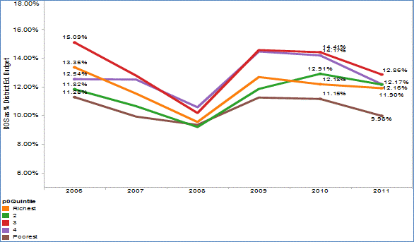

***Policy Implications:*** In 2011, the BOS grants were distributed to the district level of government which will then made payments to schools. This changed flow of funding was designed to reflect the function and responsibilities of local government towards education under the decentralization policy. It provided districts with significantly greater non-salary related resources to distribute amongst their schools. This was to help strengthen the relevance and importance of district monitoring and support teams for schools within their jurisdiction. However, the policy increased the pressure and expectations of schools that were relying upon the efficiency and effectiveness of the district offices.

The district management of the BOS distribution by district governments became a matter of national controversy during 2011. The widespread failure of many districts to manage these funds properly meant that delays and errors in the distribution of BOS funding were seen as a failure at the local rather than central level. By late 2011, the disbursement and general management of BOS funds by the district level was considered a gross failure. The program was subsequently brought back under the control of MOEC for the 2012 school year.

One significant risk that was identified in the 2010 FPR was that some district governments could be tempted to lower existing district budget allocations for education once they were given responsibility for disbursing BOS. This was because the additional flow of BOS grants for schools entering the district coffers and appearing as an education related budget line item could disguise cuts to existing allocations.

This has not happened, and in fact, district expenditures (not including BOS) have increased more strongly in 2011 than in the previous 5 years. While these increases were driven by teacher salary and allowance increases (which are not a district policy variable) there were also larger increases in operations and capital expenditures. It maybe, that if the BOS disbursements remained under the district level of government for a few more years, there would have been an impact on other district allocations for education. It is difficult to speculate on what would have been future impacts, but it seems that in 2011, districts were happy to continue increasing other education related allocations even as they were assuming responsibility for the BOS.

BOS grants provide a critical injection of funds at the school level. It is important that these funds are utilised as effectively as possible. Their importance is even greater in BEP districts where they stand as a greater than average proportion of total funds available to education. Planning and management of BOS funds should be a key planning priority for schools in BEP districts. Capacity building activities for principals and socialisation amongst parents are two obvious intervention points.

***Recommendation:*** The AusAID funded ESSP should review the strengths and weaknesses of the existing BOS training programs for school principals. The purpose of the review would be to signal changes and improvements in the delivery of training for district officers, principals and community members. It should lead to the improved capacity of school principals to better plan and manage their BOS funds and to help districts better monitor and support the schools in their disbursement activities. Ideally the analysis would obtain quantitative and qualitative evidence on differences in allocative choices and efficient use of BOS funds between different groups of principals e.g. those that identify as benefiting from the training and those that do not.

# Annexes

## DISTRICTS IN THE AUSTRALIAN EDUCATION PARTNERSHIP WITH INDONESIA

Component 1 Districts

| **Island** | **Component 1 Districts** | **Ed. Expenditure per  All Students  (Rp. Million)** | **Education APBD by District  (Rp. Million)** | **Education Share of  District Budget** | **Education Budget  Annual Growth** |
| --- | --- | --- | --- | --- | --- |
| Bali dan Nusa Tenggara | Alor | 3.82 | 188489.93 | 38% | 48% |
| Belu | 2.46 | 231241.52 | 40% | 30% |
| Bima | 3.00 | 365461.55 | 46% | 34% |
| Buleleng | 4.45 | 569326.08 | 55% | 60% |
| Ende | 3.28 | 225815.32 | 42% | 44% |
| Flores Timur | 3.85 | 224675.69 | 42% | 42% |
| Karang Asem | 5.12 | 402099.59 | 56% | 34% |
| Kupang | 3.55 | 258842.39 | 36% | 40% |
| Lembata | 4.11 | 127756.27 | 33% | 83% |
| Lombok Tengah | 2.44 | 507843.00 | 56% | 39% |
| Lombok Timur | 2.21 | 552455.37 | 49% | 33% |
| Lombok Utara | 2.72 | 115792.94 | 30% | 1474% |
| Manggarai | 2.18 | 184461.89 | 36% | 55% |
| Manggarai Timur | 1.91 | 134595.05 | 32% | 19% |
| Nagekeo | 3.54 | 104417.06 | 30% | 14% |
| Ngada | 3.48 | 123279.17 | 28% | 26% |
| Sabu Raijua | 5.07 | 93822.74 | 33% |  |
| Sikka | 2.71 | 196255.92 | 38% | 46% |
| Sumba Barat | 2.28 | 75603.70 | 22% | 30% |
| Sumba Barat Daya | 1.74 | 134675.69 | 36% | 60% |
| Sumba Timur | 3.56 | 202889.19 | 36% | 62% |
| Sumbawa Barat | 5.91 | 152610.45 | 24% | 71% |
| Tabanan | 5.43 | 385366.21 | 47% | 49% |
| Timor Tengah Selatan | 3.00 | 307809.08 | 43% | 37% |
| Timor Tengah Utara | 3.14 | 183005.67 | 35% | 46% |
| Jawa | Bandung | 2.14 | 1338622.86 | 57% | 41% |
| Bangkalan | 2.60 | 547552.09 | 47% | 71% |
| Batang | 2.75 | 372039.27 | 48% | 48% |
| Bekasi | 1.39 | 631127.42 | 33% | 15% |
| Bogor | 1.42 | 1293177.89 | 40% | 69% |
| Bondowoso | 2.74 | 345957.96 | 46% | 24% |
| Cianjur | 2.11 | 882868.88 | 55% | 35% |
| Garut | 2.04 | 1139984.19 | 56% | 75% |
| Grobogan | 2.41 | 639148.33 | 55% | 86% |
| Indramayu | 2.31 | 803740.80 | 51% | 81% |
| Kebumen | 2.53 | 707765.55 | 61% | 42% |
| Kota Banjar | 2.83 | 116430.46 | 29% | 43% |
| Kota Malang | 2.37 | 430310.49 | 43% | 51% |
| Lebak | 2.06 | 618038.50 | 53% | 56% |
| Lumajang | 3.16 | 561957.13 | 50% | 73% |
| Nganjuk | 2.91 | 561400.19 | 53% | 36% |
| Pandeglang | 1.89 | 567559.45 | 56% | 45% |
| Pasuruan | 2.46 | 676572.49 | 48% | 79% |
| Probolinggo | 2.49 | 488613.72 | 47% | 53% |
| Situbondo | 3.35 | 383581.04 | 44% | 46% |
| Sukabumi | 1.66 | 818061.98 | 46% | 43% |
| Tangerang | 1.30 | 776322.60 | 38% | 48% |
| Tasikmalaya | 2.31 | 769882.21 | 58% | 42% |
| Kalimantan | Balangan | 5.63 | 161976.16 | 26% | 70% |
| Barito Kuala | 4.18 | 235150.92 | 41% | 35% |
| Barito Timur | 5.93 | 132204.72 | 27% | 19% |
| Bengkayang | 3.31 | 190487.25 | 36% | 35% |
| Kapuas | 3.85 | 315987.45 | 38% | 29% |
| Katingan | 4.64 | 173362.25 | 24% | 31% |
| Ketapang | 3.22 | 311125.81 | 33% | 60% |
| Kota Singkawang | 3.69 | 180479.83 | 37% | 45% |
| Kotawaringin Barat | 2.83 | 157711.26 | 26% | 4% |
| Kubu Raya | 2.87 | 336578.17 | 44% | 56% |
| Lamandau | 5.51 | 86200.05 | 19% | 1% |
| Malinau | 11.01 | 189124.90 | 14% | 8% |
| Melawi | 3.56 | 152005.02 | 32% | 49% |
| Murung Raya | 6.07 | 166766.36 | 26% | 20% |
| Pasir | 6.09 | 305922.64 | 24% | 26% |
| Sambas | 3.35 | 388932.82 | 47% | 38% |
| Sanggau | 3.60 | 336043.39 | 43% | 67% |
| Sekadau | 3.34 | 147184.62 | 36% | 37% |
| Sintang | 3.25 | 298013.33 | 37% | 51% |
| Sukamara | 7.11 | 77595.76 | 19% | 37% |
| Tanah Bumbu | 3.64 | 217782.07 | 26% | 50% |
| Maluku | Buru | 4.19 | 141771.04 | 34% | 80% |
| Buru Selatan | 3.36 | 61792.35 | 20% | 185% |
| Maluku Tengah | 3.99 | 445407.10 | 54% | 57% |
| Sulawesi | Banggai Kepulauan | 3.32 | 143768.26 | 33% | 15% |
| Bantaeng | 2.35 | 165214.19 | 46% | 40% |
| Boalemo | 4.02 | 135448.21 | 36% | 32% |
| Bolaang Mongondow Timur | 6.55 | 89412.44 | 26% | 86% |
| Bone | 2.93 | 271992.08 | 30% | 17% |
| Buton | 2.75 | 203226.26 | 38% | 0% |
| Buton Utara | 2.78 | 75534.33 | 21% | 26% |
| Donggala | 3.80 | 253317.81 | 41% | 80% |
| Enrekang | 3.64 | 218096.64 | 43% | 49% |
| Jeneponto | 4.42 | 241568.79 | 44% | 9% |
| Kepulauan Sangihe | 6.89 | 170828.52 | 37% | 8% |
| Konawe Utara | 6.93 | 100258.08 | 21% | 55% |
| Luwu | 2.72 | 222132.90 | 41% | 27% |
| Majene | 4.23 | 168453.63 | 41% | 36% |
| Mamasa | 3.30 | 136066.91 | 33% | 46% |
| Mamuju | 1.89 | 168650.09 | 25% | 108% |
| Mamuju Utara | 2.17 | 65991.57 | 17% | 159% |
| Maros | 3.19 | 230469.01 | 40% | 44% |
| Morowali | 2.40 | 181546.32 | 31% | 10% |
| Muna | 4.34 | 341177.34 | 52% | 27% |
| Pangkajene dan Kepulauan | 4.87 | 298754.50 | 47% | 49% |
| Parigi Moutong | 4.34 | 188299.27 | 34% | 30% |
| Pinrang | 4.21 | 250907.82 | 40% | 23% |
| Polewali Mandar | 3.11 | 283605.10 | 47% | 66% |
| Poso | 4.48 | 203523.51 | 37% | 18% |
| Sigi | 3.97 | 171610.87 | 34% | 34% |
| Sinjai | 3.22 | 240432.87 | 45% | 41% |
| Tana Toraja | 2.31 | 150799.96 | 31% | 60% |
| Toraja Utara | 1.97 | 130456.91 | 30% | 35% |
| Wajo | 3.97 | 239787.53 | 32% | 67% |
| Sumatera | Aceh Barat | 4.67 | 199269.19 | 39% | 20% |
| Aceh Timur | 2.45 | 234084.48 | 33% | 34% |
| Aceh Utara | 2.80 | 388117.31 | 36% | 34% |
| Bangka Selatan | 3.78 | 125689.03 | 30% | 57% |
| Bangka Tengah | 2.88 | 87442.77 | 42% | -6% |
| Batu Bara | 2.46 | 227269.78 | 41% | 47% |
| Belitung Timur | 7.09 | 142997.84 | 28% | 23% |
| Bener Meriah | 4.52 | 156044.56 | 36% | 40% |
| Bengkulu Utara | 2.77 | 185084.37 | 35% |  |
| Bintan | 5.77 | 149442.32 | 21% | 51% |
| Deli Serdang | 2.04 | 747497.05 | 45% | 28% |
| Empat Lawang | 2.35 | 128791.66 | 25% | 47% |
| Indragiri Hulu | 3.61 | 305276.64 | 38% | 20% |
| Kampar | 4.12 | 610464.87 | 35% | 24% |
| Kaur | 3.84 | 107266.84 | 30% | 53% |
| Kerinci | 4.32 | 236617.95 | 38% | 38% |
| Kota Batam | 2.96 | 395167.97 | 28% | 21% |
| Labuhan Batu | 1.81 | 246700.09 | 39% | 37% |
| Lampung Utara | 2.56 | 388084.07 | 45% | 52% |
| Merangin | 3.09 | 234195.49 | 36% | 60% |
| Muara Enim | 2.80 | 460399.31 | 39% | 36% |
| Muaro Jambi | 3.78 | 259397.74 | 39% | 52% |
| Mukomuko | 3.58 | 134772.32 | 32% | 46% |
| Musi Banyuasin | 4.19 | 530656.17 | 27% | 23% |
| Nias | 1.79 | 101462.18 | 26% | 8% |
| Nias Selatan | 2.36 | 218531.33 | 42% | 99% |
| Ogan Komering Ilir | 2.75 | 416777.90 | 38% | 47% |
| Ogan Komering Ulu | 2.62 | 202575.00 | 29% | 24% |
| Pasaman Barat | 2.75 | 249800.49 | 43% | 57% |
| Pidie | 3.40 | 342620.20 | 46% | 43% |
| Pidie Jaya | 3.63 | 125471.64 | 36% | 37% |
| Rokan Hulu | 2.56 | 262181.93 | 28% | -2% |
| Seluma | 3.96 | 166266.14 | 33% | 91% |
| Serdang Bedagai | 2.55 | 349890.96 | 49% | 71% |
| Tanggamus | 2.30 | 324796.60 | 45% | 53% |
| Tanjung Jabung Barat | 3.35 | 210627.59 | 27% | 45% |
| Tapanuli Selatan | 3.02 | 236277.22 | 41% | 42% |
| Tapanuli Tengah | 3.16 | 264227.52 | 47% | 55% |
| Toba Samosir | 3.34 | 184381.81 | 44% | 3% |
| Tulang bawang | 1.58 | 150960.01 | 24% | 45% |

Component 2 Districts

| **Island** | **Component 2 Districts** | **Ed. Expenditure per  All Students  (Rp. Million)** | **Education APBD by District  (Rp. Million)** | **Education Share of  District Budget** | **Education Budget  Annual Growth** |
| --- | --- | --- | --- | --- | --- |
| Bali dan Nusa Tenggara | Alor | 3.82 | 188489.93 | 38% | 48% |
| Badung | 3.46 | 352074.09 | 23% | 5% |
| Bangli | 5.39 | 208801.93 | 37% | 46% |
| Bima | 3.00 | 365461.55 | 46% | 34% |
| Buleleng | 4.45 | 569326.08 | 55% | 60% |
| Ende | 3.28 | 225815.32 | 42% | 44% |
| Gianyar | 4.45 | 389601.69 | 45% | 38% |
| Jembrana | 2.89 | 156079.64 | 27% | 62% |
| Karang Asem | 5.12 | 402099.59 | 56% | 34% |
| Klungkung | 5.81 | 208564.15 | 41% | 26% |
| Kota Denpasar | 2.28 | 358140.13 | 35% | 29% |
| Kota Kupang | 2.72 | 219453.57 | 39% | 39% |
| Lembata | 4.11 | 127756.27 | 33% | 83% |
| Lombok Barat | 2.16 | 295746.25 | 36% | 22% |
| Lombok Timur | 2.21 | 552455.37 | 49% | 33% |
| Lombok Utara | 2.72 | 115792.94 | 30% | 1474% |
| Manggarai | 2.18 | 184461.89 | 36% | 55% |
| Manggarai Timur | 1.91 | 134595.05 | 32% | 19% |
| Nagekeo | 3.54 | 104417.06 | 30% | 14% |
| Ngada | 3.48 | 123279.17 | 28% | 26% |
| Rote Ndao | 4.05 | 123181.06 | 33% | 40% |
| Sikka | 2.71 | 196255.92 | 38% | 46% |
| Sumba Tengah | 3.73 | 76256.55 | 23% | 46% |
| Sumbawa Barat | 5.91 | 152610.45 | 24% | 71% |
| Tabanan | 5.43 | 385366.21 | 47% | 49% |
| Timor Tengah Selatan | 3.00 | 307809.08 | 43% | 37% |
| Timor Tengah Utara | 3.14 | 183005.67 | 35% | 46% |
| Jawa | Bantul | 3.01 | 432473.28 | 48% | 9% |
| Banyumas | 2.73 | 841648.90 | 55% | 52% |
| Banyuwangi | 1.15 | 344766.91 | 25% | 85% |
| Blitar | 3.68 | 670845.77 | 58% | 49% |
| Bogor | 1.42 | 1293177.89 | 40% | 69% |
| Bojonegoro | 2.98 | 682099.77 | 49% | 79% |
| Brebes | 2.09 | 750916.10 | 53% | 38% |
| Ciamis | 2.85 | 833036.87 | 61% | 42% |
| Cilacap | 1.72 | 615547.91 | 45% | 21% |
| Cirebon | 2.18 | 891055.04 | 51% | 39% |
| Gresik | 2.06 | 465901.05 | 38% | 56% |
| Gunung Kidul | 4.68 | 560276.69 | 60% | 30% |
| Jombang | 2.13 | 535398.11 | 49% | 36% |
| Karanganyar | 3.44 | 502938.77 | 56% | 34% |
| Kendal | 2.59 | 504170.88 | 50% | 48% |
| Kota Banjar | 2.83 | 116430.46 | 29% | 43% |
| Kota Batu | 3.69 | 134056.89 | 30% | 29% |
| Kota Bekasi | 1.70 | 737927.38 | 39% | 25% |
| Kota Cimahi | 2.39 | 268188.86 | 39% | 23% |
| Kota Depok | 1.32 | 380295.32 | 28% | 37% |
| Kota Jakarta Barat |  |  |  |  |
| Kota Jakarta Selatan |  |  |  |  |
| Kota Jakarta Timur |  |  |  |  |
| Kota Jakarta Utara |  |  |  |  |
| Kota Madiun | 3.79 | 215075.51 | 44% | 23% |
| Kota Magelang | 0.76 | 34215.31 | 40% | -76% |
| Kota Malang | 2.37 | 430310.49 | 43% | 51% |
| Kota Semarang | 2.12 | 667638.60 | 33% | 23% |
| Kota Sukabumi | 0.63 | 49526.64 | 30% | -64% |
| Kota Surakarta | 3.03 | 487615.97 | 46% | 71% |
| Kota Tangerang | 1.97 | 673266.59 | 39% | 31% |
| Kota Tasikmalaya | 2.13 | 304586.29 | 42% | 8% |
| Kota Yogyakarta | 2.85 | 312295.15 | 35% | 1% |
| Kulon Progo | 4.97 | 372505.02 | 55% | 37% |
| Lumajang | 3.16 | 561957.13 | 50% | 73% |
| Madiun | 4.31 | 476718.11 | 51% | 63% |
| Magelang | 3.00 | 647635.54 | 55% | 48% |
| Nganjuk | 2.91 | 561400.19 | 53% | 36% |
| Ngawi | 0.57 | 84924.64 | 39% | -75% |
| Pacitan | 4.28 | 416923.66 | 55% | 53% |
| Pandeglang | 1.89 | 567559.45 | 56% | 45% |
| Pasuruan | 2.46 | 676572.49 | 48% | 79% |
| Pati | 2.44 | 577163.38 | 49% | 21% |
| Pekalongan | 2.64 | 459797.74 | 51% | 41% |
| Purbalingga | 2.80 | 495613.41 | 55% | 44% |
| Purworejo | 3.69 | 548451.93 | 58% | 34% |
| Semarang | 2.56 | 437773.92 | 46% | 28% |
| Serang | 1.53 | 497236.39 | 40% | 44% |
| Sidoarjo | 1.96 | 710390.98 | 39% | 35% |
| Sleman | 2.75 | 473184.94 | 44% | 12% |
| Sragen | 3.25 | 583058.22 | 56% | 45% |
| Sukabumi | 1.66 | 818061.98 | 46% | 43% |
| Sukoharjo | 3.60 | 515132.06 | 56% | 37% |
| Sumedang | 2.99 | 616652.80 | 52% | 39% |
| Tasikmalaya | 2.31 | 769882.21 | 58% | 42% |
| Tegal | 2.11 | 624292.50 | 55% | 52% |
| Kalimantan | Banjar | 3.41 | 312381.76 | 37% | 26% |
| Berau | 7.95 | 289447.44 | 20% | -12% |
| Bulungan | 10.19 | 266323.02 | 20% | 39% |
| Hulu Sungai Selatan | 5.81 | 245781.94 | 42% | 30% |
| Hulu Sungai Utara | 5.50 | 256770.24 | 38% | 34% |
| Kapuas | 3.85 | 315987.45 | 38% | 29% |
| Katingan | 4.64 | 173362.25 | 24% | 31% |
| Kayong Utara | 4.85 | 109855.11 | 28% | 311% |
| Kota Balikpapan | 3.64 | 415965.59 | 23% | 6% |
| Kota Banjarbaru | 3.70 | 155071.53 | 35% | 49% |
| Kota Banjarmasin | 2.98 | 389261.23 | 42% | 49% |
| Kota Bontang | 11.81 | 396470.37 | 26% | 100% |
| Kota Palangka Raya | 5.24 | 278875.63 | 47% | 38% |
| Kota Pontianak | 2.49 | 342815.21 | 40% | 16% |
| Kota Samarinda | 4.16 | 623218.37 | 41% | 21% |
| Kota Singkawang | 3.69 | 180479.83 | 37% | 45% |
| Kota Tarakan | 3.87 | 149026.02 | 19% | -31% |
| Kotabaru | 3.67 | 235365.96 | 24% | 8% |
| Kotawaringin Barat | 2.83 | 157711.26 | 26% | 4% |
| Kotawaringin Timur | 2.64 | 236089.12 | 29% | 8% |
| Kubu Raya | 2.87 | 336578.17 | 44% | 56% |
| Kutai Barat | 4.40 | 170390.48 | 11% | 42% |
| Kutai Kartanegara | 7.93 | 1013978.22 | 22% | 29% |
| Kutai Timur | 7.64 | 387213.22 | 17% | 14% |
| Lamandau | 5.51 | 86200.05 | 19% | 1% |
| Melawi | 3.56 | 152005.02 | 32% | 49% |
| Murung Raya | 6.07 | 166766.36 | 26% | 20% |
| Pasir | 6.09 | 305922.64 | 24% | 26% |
| Penajam Paser Utara | 7.85 | 238306.12 | 16% | 64% |
| Pontianak | 3.19 | 186205.37 | 40% | 29% |
| Sambas | 3.35 | 388932.82 | 47% | 38% |
| Sanggau | 3.60 | 336043.39 | 43% | 67% |
| Seruyan | 4.01 | 116972.99 | 17% | 18% |
| Sintang | 3.25 | 298013.33 | 37% | 51% |
| Tabalong | 5.24 | 261473.67 | 7% | 22% |
| Tanah Bumbu | 3.64 | 217782.07 | 26% | 50% |
| Tanah Laut | 3.93 | 235361.71 | 35% | 18% |
| Tapin | 5.96 | 193846.18 | 29% | 31% |
| Maluku | Halmahera Barat | 2.30 | 69058.18 | 19% | 44% |
| Halmahera Utara | 1.51 | 69181.23 | 13% | 59% |
| Kepulauan Aru | 3.17 | 81289.62 | 17% | 37% |
| Kepulauan Sula | 2.13 | 92791.89 | 15% | 34% |
| Kota Ambon | 4.15 | 341730.96 | 57% | 31% |
| Kota Ternate | 4.52 | 189289.91 | 36% | 14% |
| Kota Tidore Kepulauan | 5.22 | 128198.18 | 34% | 26% |
| Kota Tual | 4.46 | 70919.42 | 21% | 245% |
| Maluku Tenggara | 2.27 | 77667.66 | 19% | 90% |
| Seram Bagian Barat | 2.96 | 162820.27 | 37% | 10% |
| Papua | Fakfak | 6.97 | 128028.78 | 19% | 43% |
| Kota Jayapura | 5.35 | 228223.55 | 34% | 13% |
| Manokwari | 4.99 | 239944.14 | 33% | 59% |
| Sorong | 6.08 | 134340.00 | 23% | 37% |
| Sorong Selatan | 6.97 | 92915.74 | 17% | -10% |
| Sulawesi | Bantaeng | 2.35 | 165214.19 | 46% | 40% |
| Barru | 2.03 | 215420.15 | 41% | 30% |
| Boalemo | 4.02 | 135448.21 | 36% | 32% |
| Bombana | 3.12 | 104702.16 | 29% | 50% |
| Bone | 2.93 | 271992.08 | 30% | 17% |
| Bone Bolango | 4.38 | 147656.27 | 38% | 24% |
| Buton Utara | 2.78 | 75534.33 | 21% | 26% |
| Donggala | 3.80 | 253317.81 | 41% | 80% |
| Enrekang | 3.64 | 218096.64 | 43% | 49% |
| Gorontalo | 3.28 | 290320.72 | 49% | 37% |
| Gowa | 2.47 | 334777.44 | 47% | 21% |
| Jeneponto | 4.42 | 241568.79 | 44% | 9% |
| Kepulauan Talaud | 6.70 | 132666.86 | 35% | 8% |
| Konawe Utara | 6.93 | 100258.08 | 21% | 55% |
| Kota Gorontalo | 4.33 | 201873.95 | 36% | 38% |
| Kota Kendari | 3.54 | 247277.91 | 34% | 23% |
| Kota Kotamobagu | 3.44 | 104769.88 | 31% | -15% |
| Kota Palu | 3.83 | 295732.46 | 46% | 39% |
| Kota Tomohon | 4.28 | 91393.00 | 26% | 18% |
| Luwu Timur | 3.91 | 157952.85 | 26% | 29% |
| Majene | 4.23 | 168453.63 | 41% | 36% |
| Mamuju | 1.89 | 168650.09 | 25% | 108% |
| Maros | 3.19 | 230469.01 | 40% | 44% |
| Minahasa Selatan | 3.51 | 160808.56 | 39% | 7% |
| Minahasa Utara | 3.47 | 125310.19 | 31% | -17% |
| Morowali | 2.40 | 181546.32 | 31% | 10% |
| Pangkajene dan Kepulauan | 4.87 | 298754.50 | 47% | 49% |
| Parigi Moutong | 4.34 | 188299.27 | 34% | 30% |
| Pohuwato | 3.46 | 115746.68 | 28% | 43% |
| Polewali Mandar | 3.11 | 283605.10 | 47% | 66% |
| Sidenreng Rappang | 3.67 | 264573.94 | 36% | 39% |
| Sigi | 3.97 | 171610.87 | 34% | 34% |
| Sinjai | 3.22 | 240432.87 | 45% | 41% |
| Tana Toraja | 2.31 | 150799.96 | 31% | 60% |
| toli-toli | 3.54 | 167265.06 | 34% | 37% |
| Wajo | 3.97 | 239787.53 | 32% | 67% |
| Wakatobi | 4.69 | 125909.65 | 32% | 29% |
| Sumatera | Aceh Barat | 4.67 | 199269.19 | 39% | 20% |
| Aceh Barat Daya | 3.31 | 124585.87 | 29% | 9% |
| Aceh Besar | 4.23 | 281907.00 | 41% | 29% |
| Aceh Jaya | 7.34 | 126403.92 | 30% | 60% |
| Aceh Selatan | 3.59 | 197491.73 | 36% | 25% |
| Aceh Tamiang | 3.03 | 202818.34 | 40% | 64% |
| Aceh Tengah | 4.11 | 194964.75 | 35% | 23% |
| Aceh Tenggara | 2.82 | 156324.36 | 33% | 18% |
| Aceh Timur | 2.45 | 234084.48 | 33% | 34% |
| Aceh Utara | 2.80 | 388117.31 | 36% | 34% |
| Bangka | 3.66 | 202518.27 | 35% | 8% |
| Bangka Barat | 3.79 | 129939.62 | 30% | 55% |
| Bangka Selatan | 3.78 | 125689.03 | 30% | 57% |
| Bangka Tengah | 2.88 | 87442.77 | 42% | -6% |
| Banyu Asin | 2.79 | 406448.24 | 39% | 40% |
| Belitung | 4.71 | 150878.38 | 29% | 16% |
| Belitung Timur | 7.09 | 142997.84 | 28% | 23% |
| Bener Meriah | 4.52 | 156044.56 | 36% | 40% |
| Bengkalis | 6.43 | 797633.29 | 25% | 38% |
| Bengkulu Selatan | 4.90 | 201606.94 | 44% | 56% |
| Bengkulu Utara | 2.77 | 185084.37 | 35% |  |
| Bireuen | 3.66 | 344147.51 | 46% | 34% |
| Deli Serdang | 2.04 | 747497.05 | 45% | 28% |
| Dharmas Raya | 3.94 | 171178.35 | 32% | 19% |
| Kampar | 4.12 | 610464.87 | 35% | 24% |
| Kaur | 3.84 | 107266.84 | 30% | 53% |
| Kerinci | 4.32 | 236617.95 | 38% | 38% |
| Kota Banda Aceh | 4.30 | 240128.64 | 41% | 20% |
| Kota Bengkulu | 3.13 | 251689.43 | 45% | 21% |
| Kota Dumai | 3.59 | 215016.80 | 27% | 20% |
| Kota Langsa | 3.48 | 144067.71 | 34% | 29% |
| Kota Lhokseumawe | 3.16 | 149700.70 | 33% | 25% |
| Kota Lubuklinggau | 2.99 | 154261.92 | 27% | 19% |
| Kota Medan | 1.53 | 878867.35 | 30% | 23% |
| Kota Metro | 2.97 | 175114.92 | 38% | 56% |
| Kota Padang | 2.93 | 586140.57 | 48% | 28% |
| Kota Palembang | 2.45 | 809678.58 | 48% | 37% |
| Kota Pangkal Pinang | 3.75 | 148783.20 | 32% | 5% |
| Kota Pariaman | 5.73 | 158499.40 | 37% | 46% |
| Kota Sabang | 15.15 | 100366.86 | 23% | 24% |
| Kota Subulussalam | 3.26 | 78206.24 | 28% | 69% |
| Kuantan Singingi | 4.88 | 303095.31 | 34% | 25% |
| Lampung Tengah | 2.84 | 713830.01 | 56% | 48% |
| Lima Puluh Koto | 4.74 | 357000.65 | 52% | 33% |
| Mukomuko | 3.58 | 134772.32 | 32% | 46% |
| Nagan Raya | 5.52 | 185611.72 | 37% | 17% |
| Ogan Ilir | 3.31 | 280079.33 | 46% | 25% |
| Ogan Komering Ulu | 2.62 | 202575.00 | 29% | 24% |
| Padang Pariaman | 4.28 | 427441.58 | 59% | 57% |
| Pelalawan | 3.69 | 222730.67 | 21% | 2% |
| Pesisir Selatan | 3.25 | 372864.18 | 50% | 36% |
| Pidie | 3.40 | 342620.20 | 46% | 43% |
| Pidie Jaya | 3.63 | 125471.64 | 36% | 37% |
| Pringsewu | 3.71 | 293708.70 | 51% | 64% |
| Rejang Lebong | 2.62 | 164153.35 | 51% | 18% |
| Rokan Hulu | 2.56 | 262181.93 | 28% | -2% |
| Sijunjung | 4.80 | 229967.53 | 41% | 49% |
| Simeulue | 4.04 | 102886.76 | 32% | 50% |
| Solok | 3.95 | 336979.82 | 52% | 40% |
| Tanah Datar | 3.98 | 308240.80 | 48% | 23% |
| Tapanuli Utara | 3.55 | 313966.78 | 48% | 41% |
| Tebo | 2.95 | 198072.38 | 35% | 56% |

1. Conceptually, “lead and lag indicators” have originated in the development of performance scorecards for use by business analysts. They are adapted here for use within the education sector.