

Australia Awards Alumni   
Longitudinal Global   
Tracer Survey 2023

Australia Awards Global Tracer Facility

The views expressed in this report are those of the authors and do not necessarily reflect the policy or position of the Australian Government, its agencies or representatives.

Australian Department of Foreign Affairs and Trade

With the exception of the Commonwealth Coat of Arms and where otherwise noted, all material presented is provided under a Creative Commons Attribution 3.0 Australia license.

**Acknowledgements:**

The Australian Council for Educational Research is the managing contractor for the Australia Awards Global Tracer Facility. The authors would like to thank DFAT’s Global Education and Scholarships Section for supporting this research.

Most importantly, thank you to the alumni, their colleagues, and the current and former Australian host organisation representatives who gave their time in participating in interviews in these surveys. Without your insight, feedback and accomplishments, the research we do would not be possible.

**Acknowledgement of Country:**

In the spirit of reconciliation, the authors would like to acknowledge the Traditional Custodians of Country throughout Australia, including the Wurundjeri People of the Kulin Nation, where this report was written, and their connections to land, sea and community. We pay our respect to their elders past and present and extend that respect to all Aboriginal and Torres Strait Islander peoples. We acknowledge the Aboriginal and Torres Strait Islander people who continue to contribute to our work to improve learning, education, and research.

**Recommended citation:**

Radloff, A., Haddow, A. & Edwards, D. (2024). Australia Awards Alumni Longitudinal Global Tracer Survey 2023. Australian Department of Foreign Affairs and Trade.

**Published Research Reports by the Australia Awards Global Tracer Facility**

**2016/17 – Year One**

* [Australia Awards Global Tracer Facility Tracer Survey: Alumni of 2006-2010](https://www.dfat.gov.au/people-to-people/australia-awards/Pages/australia-awards-global-tracer-facility-tracer-survey-alumni-of-2006-2010.aspx)
* [Fiji Alumni Case Study](https://www.dfat.gov.au/people-to-people/australia-awards/Pages/australia-awards-global-tracer-facility-fiji-alumni-case-study.aspx) - Education
* [Sri Lanka Alumni Case Study](https://www.dfat.gov.au/people-to-people/australia-awards/Pages/australia-awards-global-tracer-facility-sri-lanka-alumni-case-study.aspx) - Engineering
* [Kenya Alumni Case Study](https://www.dfat.gov.au/people-to-people/australia-awards/Pages/australia-awards-global-tracer-facility-kenya-alumni-case-study.aspx) – Agriculture & Environmental Management
* [Nepal Alumni Case Study](https://www.dfat.gov.au/people-to-people/australia-awards/Pages/australia-awards-global-tracer-facility-nepal-alumni-case-study.aspx) – Public Service

**2017/18 – Year Two**

* [Australia Awards Global Tracer Facility Survey: Alumni of 1996-2005](https://www.dfat.gov.au/people-to-people/australia-awards/Pages/australia-awards-global-tracer-facility-tracer-survey-alumni-of-1996-2005.aspx)
* [China Alumni Case Study](https://www.dfat.gov.au/people-to-people/australia-awards/Pages/australia-awards-global-tracer-facility-china-alumni-case-study.aspx) – Public Health & Environment
* [Indonesia Alumni Case Study](https://www.dfat.gov.au/people-to-people/australia-awards/Pages/australia-awards-global-tracer-facility-indonesia-alumni-case-study.aspx) - Education
* [Mongolia Alumni Case Study](https://www.dfat.gov.au/people-to-people/australia-awards/Pages/australia-awards-global-tracer-facility-mongolia-alumni-case-study.aspx) – Management & Commerce
* [Solomon Islands Alumni Case Study](https://www.dfat.gov.au/people-to-people/australia-awards/Pages/australia-awards-global-tracer-facility-solomon-islands-alumni-case-study.aspx) - Health
* [Vanuatu Alumni Case Study](https://www.dfat.gov.au/people-to-people/australia-awards/Pages/australia-awards-global-tracer-facility-vanuatu-alumni-case-study.aspx) – Law

**2018/19 – Year Three**

* [Australia Awards Global Tracer Facility Survey: Alumni of 2011-2016](https://www.dfat.gov.au/people-people/australia-awards-global-tracer-facility-tracer-survey-alumni-2011-2016)
* [Cambodia Alumni Case Study](https://www.dfat.gov.au/people-to-people/australia-awards/australia-awards-global-tracer-facility-cambodia-alumni-case-study) – Public Health
* [Mozambique Alumni Case Study](https://www.dfat.gov.au/people-to-people/australia-awards/Pages/australia-awards-global-tracer-facility-mozambique-alumni-case-study.aspx) – Food Security & Agriculture
* [Pakistan Alumni Case Study](https://www.dfat.gov.au/people-to-people/australia-awards/Pages/australia-awards-global-tracer-facility-pakistan-alumni-case-study.aspx) – NGOs and Public Service
* [PNG Alumni Case Study](https://www.dfat.gov.au/people-to-people/australia-awards/australia-awards-global-tracer-facility-papua-new-guinea-alumni-case-study) – Information Technology & Communications
* [Vietnam Alumni Case Study](https://www.dfat.gov.au/people-to-people/australia-awards/Pages/australia-awards-global-tracer-facility-vietnam-alumni-case-study.aspx) – Women in Finance

**2019/2020 – Year Four**

* [Bangladesh Case Study](https://www.dfat.gov.au/people-people/australia-awards/australia-awards-global-tracer-facility-case-study-bangladesh-economic-development) – Public Sector Finance
* [Costa Rica Case Study](https://www.dfat.gov.au/people-people/australia-awards/australia-awards-global-tracer-facility-costa-rica-alumni-case-study) – Environment & Agriculture
* [Samoa Case Study](https://www.dfat.gov.au/people-people/australia-awards/australia-awards-global-tracer-facility-samoa-alumni-case-study) – Engineering & ICT
* [Timor-Leste Case Study](https://www.dfat.gov.au/people-people/australia-awards/australia-awards-global-tracer-facility-timor-leste-case-study) – Disability & Development
* [Global Impact of Australian Aid Scholarships: Long-term Outcomes of Alumni](https://www.dfat.gov.au/sites/default/files/global-impact-australian-aid-scholarships-long-term-outcomes-alumni.pdf)

**2020/21 – Year Five**

* [Philippines Case Study](https://www.dfat.gov.au/people-to-people/australia-awards/australia-awards-global-tracer-facility-year-5-results/australia-awards-global-tracer-faciltiy-philippines-case-study-peace-security-and-inclusive-development) – Peace, Security and Inclusive Development
* [Kiribati Case Study](https://www.dfat.gov.au/publications/people-people/kiribati-case-study-mapping-alumni-networks-and-links-australia) – Social Network Analysis of alumni connections
* [Mobile Alumni Case Study](https://www.dfat.gov.au/publications/people-people/mobile-alumni-case-study) – Outcomes of alumni no longer in their home country
* [Alumni Contributions to COVID-19 Response](https://www.dfat.gov.au/people-to-people/australia-awards/australia-awards-global-tracer-facility-year-5-results/alumni-contributions-covid-19-response)
* [Global Tracer Survey Report 2020](https://www.dfat.gov.au/people-to-people/australia-awards/australia-awards-global-tracer-facility-year-5-results/australia-awards-alumni-global-tracer-survey-2020)

**2021/22 – Year Six**

* [Alumni Case Study – Insights into Short Course Capacity Building](https://www.dfat.gov.au/people-to-people/australia-awards/australia-awards-global-tracer-facility-year-6-results/alumni-case-study-insights-short-course-capacity-building)
* [Australia Awards Pacific Scholarships Alumni Survey 2021](https://www.dfat.gov.au/people-to-people/australia-awards/australia-awards-global-tracer-facility-year-6-results/australia-awards-pacific-scholarships-alumni-survey-2021)
* [Social Network Analysis of an Australia Awards Leadership Program Cohort](https://www.dfat.gov.au/people-people/social-network-analysis-australia-awards-leadership-program-cohort)
* [Australia Awards Exemplary Partnerships: The South Pacific Centre for Central Banking](https://www.dfat.gov.au/people-to-people/australia-awards/australia-awards-global-tracer-facility-year-6-results/australia-awards-exemplary-partnerships-south-pacific-centre-central-banking)
* [Alumni Growth: Tracking Australia Awards Alumni Over Five Years – Longitudinal Tracer Survey 2021](https://www.dfat.gov.au/people-to-people/australia-awards/australia-awards-global-tracer-facility-year-6-results/alumni-growth-tracking-australia-awards-alumni-over-five-years-longitudinal-tracer-survey-2021)

**2022/23 – Year Seven**

* [Australia Awards Alumni contributing to civil society: supporting development through volunteerism](https://www.dfat.gov.au/people-people/australia-awards-alumni-contributing-civil-society-supporting-development-through-volunteerism)
* [Women’s Leadership and Career Progression: Insights from Indonesian Australia Awards Alumnae](https://www.dfat.gov.au/publications/people-people/womens-leadership-and-career-progression-insights-indonesian-australia-awards-alumnae)
* [Outcomes of Australia Awards Fellowships: Sport for Development in Fiji](https://www.dfat.gov.au/publications/people-people/outcomes-australia-awards-fellowships-sport-development-fiji)
* [A Social Network Analysis of Australia Awards Alumni Workshops](https://www.dfat.gov.au/publications/people-people/social-network-analysis-australia-awards-alumni-workshops)
* [Australia Awards Alumni Global Tracer Survey 2022](https://www.dfat.gov.au/publications/people-people/australia-awards-alumni-global-tracer-survey-2022)

**2023/24 – Year Eight**

* [Longitudinal Alumni Case Study: Where are they now?](https://www.dfat.gov.au/publications/people-people/longitudinal-alumni-case-study-where-are-they-now)
* [Developmental leadership for women in the Pacific: Cultivating networks for change in Australia Awards WLI alumni](https://www.dfat.gov.au/publications/people-people/developmental-leadership-women-pacific-cultivating-networks-change-australia-award-wli-alumni)
* [Developmental leadership for women in the Pacific: WLI alumni reflections and insights](https://www.dfat.gov.au/people-to-people/australia-awards/australia-awards-global-tracer-facility/australia-awards-global-tracer-facility-year-8-results)

Further information and all research published by the Australia Awards Global Tracer Facility can be found on the DFAT website: [Australia Awards Global Tracer Facility](https://www.dfat.gov.au/people-to-people/australia-awards/australia-awards-global-tracer-facility).

Contents

Executive Summary 2

Career journeys 2

Contributions to long-term Australia Awards outcomes 2

Future plans 3

Implications for Australia Awards 3

1. Introduction 4

2. Scope, Approach and Alumni Participants 6

2.1. Scope 6

2.2. Approach 6

2.3. Survey instrument 6

2.4. Alumni population and participants 7

2.5. Characteristics of participants 7

3. Alumni Career Journeys: 2019 to 2023 9

3.1. Introduction 9

3.2. Alumni careers – changes over time 9

3.3. Examples of leadership 12

3.4. Long-term influence of Australia Awards on alumni careers 13

4. Alumni Contributions to Australia Awards Long-term Outcomes 15

4.1. Introduction 15

4.2. Outcome 1: alumni contributions to sustainable development over time 15

4.3. Outcome 2: alumni contributions to cooperation through networks over time 16

4.4. Factors influencing mid-career alumni long-term outcomes 19

5. Alumni future plans 21

5.1. Introduction 21

5.2. Future potential ongoing outcomes for the Australia Awards 21

6. Implications for the Australia Awards 23

6.1. Summary of findings 23

6.2. Implications for Australia Awards 23

Acronyms and Abbreviations 26

Appendix A: 2023 Longitudinal Global Tracer Survey Instrument 27

Appendix B: Survey Response Rates by Region and Gender 28

Executive Summary

**This report presents the findings from the 2023 Global Tracer Longitudinal Survey, completed by a cohort of Australian development scholarship alumni who participated in the 2019 Global Tracer Survey who had completed their Australian scholarship between 2013 and 2016. The survey was administered online in July and August 2023 and responses were secured from 1,388 alumni (a 61.5% response rate). The analyses presented in this report focus on the changes, progress, and long-term outcomes of this group of alumni nearing a decade post-award and focus on alumni career journeys, contributions to long-term program outcomes, and future plans. This research was conducted by the Australia Awards Global Tracer Facility for the Department of Foreign Affairs and Trade. This report complements** [**another longitudinal research project**](https://www.dfat.gov.au/publications/people-people/longitudinal-alumni-case-study-where-are-they-now) **by the GTF in 2023 involving in-depth interviews following up a group of alumni who were also interviewed in 2019. Together these reports provide a deep and broad understanding of the medium-to-long-term impact of the Australia Awards scholarships on alumni by providing both quantitative and qualitative insights.**

Career journeys

In this 2023 survey, alumni continued to report high levels of employment with more than 90 per cent of alumni currently working. When reflecting on changes to their employment in the close to five years since they last completed the survey, around two-thirds of alumni had changed jobs, more than 90 per cent reported an increase in their responsibilities and the complexity of their work, and almost all alumni had expanded their professional network. Almost all alumni also reported that they held a leadership position in their organisation or in their community.

Despite the many changes in their jobs, the qualifications alumni completed while on award continue to remain relevant. 95 per cent of alumni reported that they used the skills and knowledge gained from their qualification in their role, and around three-quarters reported that their qualification was a formal requirement for their current job. When asked about the most significant factor that has helped their career in the previous five years, the most common response was the skills and knowledge gained in their Australian scholarship qualification.

These findings highlight that close to a decade post-award, alumni continue to progress in their careers, deepen their influence, and grow their networks. In addition, despite the many changes alumni have experienced in their jobs, their Australian qualifications remain relevant and important for their careers.

Contributions to long-term Australia Awards outcomes

The survey explored the two long-term outcomes of the Australia Awards program. The first is that ‘alumni are using their skills, knowledge, and networks to contribute to sustainable development’. The results from the survey show that this outcome is clearly being met.

Almost all alumni had continued to pass on new skills and knowledge gained as part of their Australia Award to others, and indicated that their Award had enabled them to introduce improved practices and innovations, even around a decade post-award. Virtually all alumni had contributed to at least one United Nations Sustainable Development Goal (SDG) over the past five years. The most common SDGs that alumni had contributed to included Quality Education, Good Health and Well-being, and Gender Equality.

The second long-term program outcome is that ‘alumni contribute to cooperation between Australia and partner countries’. Again, the findings from the survey suggest that this outcome is being met.

More than half of alumni reported that they continued to have ongoing contact with individuals met while on award, such as fellow scholarship recipients, friends in Australia, and fellow Australian students, around a decade post-award. Although fewer alumni reported having professional connections with Australian organisations, there was some evidence that these continued to endure, and may even be growing. 58 per cent of alumni had developed a professional link with an Australian institution or organisation in the years since completing their award. For alumni who did not have these links, almost all indicated that they would like to develop links with Australian institutions or organisations.

Future plans

When asked about their plans for the coming five years, many alumni planned to continue their engagement with Australia Awards alumni and with Australia suggesting that there will be continuing cooperation between Australia and partner countries. More than 80 per cent said it was likely that they would attend alumni events, interact with other Australia Awards alumni professionally, and seek opportunities to partner with Australian organisations. Around 60 per cent of alumni felt it was likely that they would work in Australia or for an Australian organisation or would apply to do further study in Australia in the coming five years.

Implications for Australia Awards

Enduring importance of individual connections for developing professional links with Australia

The findings from the GTF Global Tracer Survey together with the Longitudinal Alumni Case Study highlight the enduring importance of the connections that alumni develop while on award. The outcomes of this research shows that many of connections, while starting off as personal or social connections, subsequently develop into opportunities to collaborate professionally with Australians and Australian organisations.

The GTF research has shown that among alumni who do not have professional connections, most are interested in creating links with Australia. Better understanding the types of professional connections that alumni have developed with Australia and how these have been developed may provide insights that could help support alumni who are keen to make these connections with Australia. One aspect that has been consistently identified to enable this to happen is providing further on-award opportunities to develop connections with Australian organisations.

Issue of ongoing gender gap in leadership

While female alumni have clearly made very significant contributions through their work, and most female alumni surveyed held a leadership role of some kind in their work or community, findings reported here and previously suggest there is an enduring gap in the proportion of female alumni who hold a formal leadership role at work. There would be value in exploring this gap with further research to better understand why this gap exists, and how female alumni could be better supported to move into formal leadership roles in the future.

Potential future research to strengthen longitudinal insights on the Australia Awards

The GTF has learnt much through its longitudinal survey research. However, there have been limitations in this. A future longitudinal study should be designed to track alumni from an earlier point – perhaps while on award – and could include multiple collections across a longer period of time.

# Introduction

**This report details the findings of the second wave of a longitudinal survey conducted by the Australia Awards Global Tracer Facility (GTF). The survey, conducted in mid-2023, explored the ongoing contributions of alumni who completed their Australian scholarship between 2013 and 2016. The cohort involved in this survey had responded to a GTF Global Survey in 2019, so close to five years later, this collection examined the changes, progress, and long-term outcomes of this group of alumni. This report complements the 2023 Longitudinal Alumni Case Study,[1] which involved in-depth follow-up interviews with alumni. Together they provide broad and deep findings relating to alumni outcomes post-award.**

The GTF is a research program established by the Department of Foreign Affairs and Trade (DFAT) and managed by the Australian Council for Educational Research (ACER). The focus of the GTF is to collect and analyse information from alumni to assist the Global Education and Scholarships section of DFAT to better understand the long-term outcomes of Australian development scholarship alumni. This survey is the seventh Global Tracer Survey undertaken by the GTF, and the second to include a longitudinal element in the data collection.

Given that this survey has involved re-visiting alumni of the 2013 to 2016 graduation cohorts who participated in the GTF Global Survey around five years ago, this research aims to provide:

* insight into the way alumni careers and opportunities have changed in the five years since they were last surveyed.
* understanding of the ongoing connections and new connections alumni have with Australia/Australians and across their other Australia Awards networks.
* detail of changes in the way these alumni have been contributing to development in their countries/regions in the period since completing their scholarship.
* new evidence relating to the way in which the Australia Awards continues to impact the careers, the networks and the development contributions of alumni.

The specific aims of this survey fit within the broader goals of the Australia Awards and the Monitoring and Evaluation Framework that underpin the program. The overarching aim of the Australia Awards is to ‘support partner countries to achieve their development goals through education and knowledge transfer and to build enduring relationships with Australia that advance mutual interests’. [2] The results of this survey are discussed in this report with reference to the long-term program outcomes of the Australia Awards:

**Program Outcome 1:** Alumni are using their skills, knowledge, and networks to contribute to sustainable development.

**Program Outcome 2:** Alumni contribute to cooperation between Australia and partner countries.

Alongside the program outcomes, there are three intermediate outcomes important in the context of this survey:

**Intermediate Outcome 1:** Alumni have the necessary skills and knowledge to contribute to development.

**Intermediate Outcome 2:** Alumni have relevant and useful networks and relationships.

**Intermediate Outcome 3:** Alumni view Australia, Australians, and Australian expertise positively.

With a focus on exploring the progress of alumni over the past five years, this report is structured around addressing the two long-term program outcomes of the Australia Awards, with reference to the intermediate outcomes and findings from in-depth interview-based 2023 Longitudinal Alumni Case Study where relevant. The following chapter provides insight into the longitudinal survey, the approach to fieldwork, and the alumni population included in the survey. The analysis chapters begin by exploring alumni career development in the close-to five years since they were last surveyed, then explores responses and insight from alumni in relation to the long-term outcomes of the Australia Awards. The report concludes with a summary of the findings.

# Scope, Approach and Alumni Participants

## Scope

The purpose of the GTF is to enable DFAT to assess the long-term development contributions and public diplomacy outcomes of Australia’s investment in the Australia Awards. The GTF does this through the collection of data from alumni of the Australia Awards and predecessor scholarship programs, colleagues and employers of alumni and stakeholders such as partner governments. Case studies and surveys are the mechanisms used by the GTF for the collection, analysis and publication of findings relating to alumni outcomes. Case studies of the GTF generally focus on a specific issue, field or context and are based around interviews with alumni and other relevant stakeholders. Surveys are either focussed on a specific issue or population or are broad and global in scope.[3]

This report is centred on the findings of the second Longitudinal Global Tracer Survey of the GTF. As such, there is an overall focus on understanding the way that alumni have progressed over the past five years (i.e., the period between responding to a GTF survey in 2019 and this survey in 2023). The cohort of focus in this report completed their scholarships between 2013 and 2016, so by the time this second data collection was finalised, all in this group had completed their scholarship more than seven years earlier. Further details about the [Australia Awards Global Tracer Facility Tracer Survey: Alumni of 2011-2016](https://www.dfat.gov.au/people-people/australia-awards/Pages/australia-awards-global-tracer-facility-tracer-survey-alumni-2011-2016). The findings from this report can be used either individually or in conjunction with the 2023 Longitudinal Alumni Case Study which focus on the findings from qualitative analysis of interviews conducted with six alumni from the Asia-Pacific and Latin America regions in 2019 and again in 2023.

## Approach

This survey was conducted online in July and August 2023. Fieldwork was administered by GTF partners, Wallis Social Research, using their online survey platform and their Computer Assisted Telephone Interview (CATI) processes. Each alum was emailed a unique link to the survey, and those with a phone number were also called and invited to participate in the survey. Responses were monitored in real-time, with reminder emails sent at appropriate intervals during fieldwork. Following the survey period, data was coded, cleaned, and prepared for analysis and reporting.

## Survey instrument

Questions in the survey were structured around the main aims of this research, and the program outcomes of the Australia Awards. Development of the survey focused on collecting data that was comparable to the GTF Global Survey conducted in 2019[4] and with reference to change for alumni in the period between 2019 and 2023. The core sections of the Longitudinal Global Tracer Survey are designed to develop understanding of:

* current employment – and any changes since the last survey around five years ago
* current leadership positions – and any changes since the last survey around five years ago
* the extent to which the Australia Awards play an ongoing role in career and leadership development
* contributions to development (at the local, national and international level, and mapped to the UN Sustainable Development Goals) – with a focus on most recent contributions made by this cohort
* ongoing connections with people met while on award
* partnerships alumni have established with Australians or Australian organisations – particularly recently made connections.

Download the full [Global Tracer Facility Longitudinal Global Tracer Survey 2023 (Year 8) - Survey Instrument](https://research.acer.edu.au/tracer/42/).

## Alumni population and participants

The survey was designed to follow up with a sub-set of respondents to the Year 3 GTF Global Tracer Survey undertaken around five years previously in 2019. Participants in the 2023 GTF Global Tracer Survey were those who had completed their Award between 2013 and 2016 and who had also participated in the 2019 GTF Global Tracer Survey. Two respondents who participated in the 2023 survey did not have any valid responses to the longitudinal items included in the 2019 survey and so their responses have been excluded from the analysis presented in this report.

In total, there were 2,617 alumni who fit this population and 1,388 of these alumni responded to the survey. Table 1 provides a summary of the target population and response to the 2023 survey.

Table 1: Sample for the Longitudinal Tracer Survey, target population, contactable alumni, respondents, and response rate

| Total Target Population (alumni who completed scholarship between 2013 and 2016, *and* responded to the GTF survey in 2019) | 2,617 |
| --- | --- |
| Contactable Target Population (alumni in target population who had a valid email address or telephone number) | 2,256 |
| Respondents to the Longitudinal survey | 1,388 |
| Response Rate | 61.5% |

## Characteristics of participants

Of the 1,388 alumni who responded to the survey, the vast majority had studied at a Master Degree or similar level (80.9%), with most others studying at either a Doctoral Degree (6.8%) a Bachelor degree (3.9%) or sub-Bachelor levels (7.4%). Most respondents had been awarded either an Australian Development Scholarship (41.8%) or an Australia Awards Scholarship (41.5%). Around a third of respondents (32.4%) had received another scholarship in addition to their Australia Award. Alumni were studying in many different fields of study in Australian universities.

The most common fields included society and culture (27.6%), management and commerce (16.2%), agriculture, environmental and related studies (15.0%), and health (13.5%).

Around half of responding alumni were female (50.6%) and less than one per cent reported having a disability (0.6%). Alumni were all aged between 30 and 79 at the time of the survey. 80 per cent of alumni were aged between 35 and 49 and responding alumni had a median age of 42.

Most alumni were currently living in an urban area (87.8%), with only small proportions in rural (10.4%) or remote (1.8%) areas. Alumni who responded to the survey were citizens of more than 80 different countries. Close to half of the secured sample are alumni from East Asia (46.7%), with the largest numbers of respondents from Indonesia (17.4%), Vietnam (12.2%) and the Philippines (6.0%). Close to one-in-five respondents came from South West Asia & Mongolia (19.2%) or from Sub-Saharan Africa (17.3%).

Population and response numbers and response rates by country are detailed in Table 2 and further detail on alumni population and response by gender, award completion year, and country is included in Appendix B.

Table 2: Population and response numbers by country

| **Country** | **Total respondents** | **Target population** | **Response rate** |
| --- | --- | --- | --- |
| Indonesia | 242 | 474 | 51.1% |
| Vietnam | 171 | 300 | 57.0% |
| Philippines | 83 | 139 | 59.7% |
| Papua New Guinea | 70 | 107 | 65.4% |
| Cambodia | 62 | 87 | 71.3% |
| Bhutan | 50 | 80 | 62.5% |
| Pakistan | 48 | 70 | 68.6% |
| Bangladesh | 44 | 74 | 59.5% |
| Myanmar | 42 | 55 | 76.4% |
| Nepal | 36 | 53 | 67.9% |
| Sri Lanka | 36 | 51 | 70.6% |
| Laos | 32 | 54 | 59.3% |
| Other countries | 469 | 708 | 66.2% |
| Total | 1,388 | 2,256 | 61.5% |

*’Other Countries’ are countries with alumni in the sample but fewer than 30 responses.

# Alumni Career Journeys: 2019 to 2023

## Introduction

This section focuses on the findings from the 2023 and 2019 GTF Global Tracer surveys that relate to alumni employment. This includes a discussion of employment status, sector of employment, a reflection on changes in their job and responsibilities over the previous five years, leadership status and the relationship between their Australia Award and their employment.

At the time of surveying, alumni had completed their Australian scholarship between seven and 10 years previously, and as such we would expect that many would begin to be well established in their careers, and many would likely be becoming – or already be – influential leaders in their organisations, industries, and countries.

## Alumni careers – changes over time

As shown in Table 3, almost all alumni surveyed in the 2023 GTF Global Survey were employed, with most employed full-time and smaller proportions employed part-time or self-employed. In 2023, 91 per cent of alumni reported that they were employed, compared with 93 per cent in 2019. Most of this very slight change in employment can be explained by a small uptick in the proportion of alumni who were undertaking further study at the time of the survey.

Alumni reported strong levels of employment, regardless of their gender or age. Male and female alumni reported similar levels of employment, however male alumni were more likely to report being employed full-time (85.5%) than female alumni (78.4%) and female alumni were more likely to report working part-time (6.0%) than male alumni (2.3%) although there were only small proportions of alumni in part-time work. As shown in Figure 1, alumni in their 30s reported slightly lower levels of employment than alumni in their 40s and 50s. Although we do not have information on alumni’s caregiving responsibilities, this may be due to many alumni in their 30s balancing work and the caregiving needs of young children.

Table 3: Employment status, 2019 and 2023

|  |  |  |
| --- | --- | --- |
| **Employment status** | **2019** | **2023** |
| Employed full-time | 88.3% | 81.9% |
| Employed part-time | 4.5% | 4.2% |
| Self-employed* | - | 4.8% |
| Studying | 3.5% | 5.4% |
| Retired | 0.1% | 0.6% |
| Not employed | 2.5% | 2.5% |
| Prefer not to say* | - | 0.6% |
| Other* | 1.1% | - |

*Note: ‘Self-employed’ and ‘Prefer not to say’ were not included as options in the 2019 survey instrument, and ‘Other’ was not included as an option in the 2023 survey instrument.

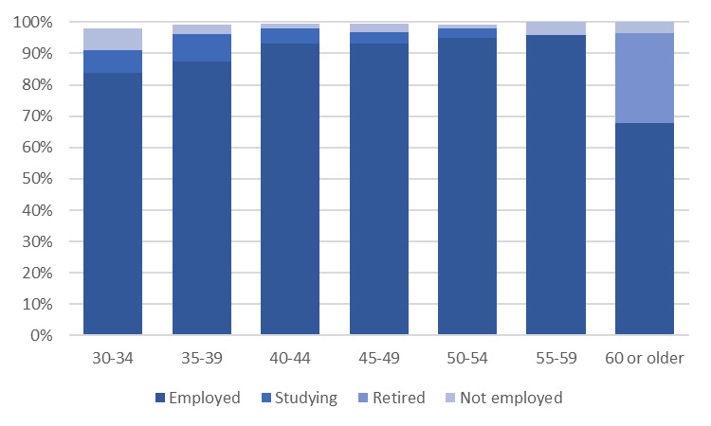

Figure 1: Employment status by age group, 2023

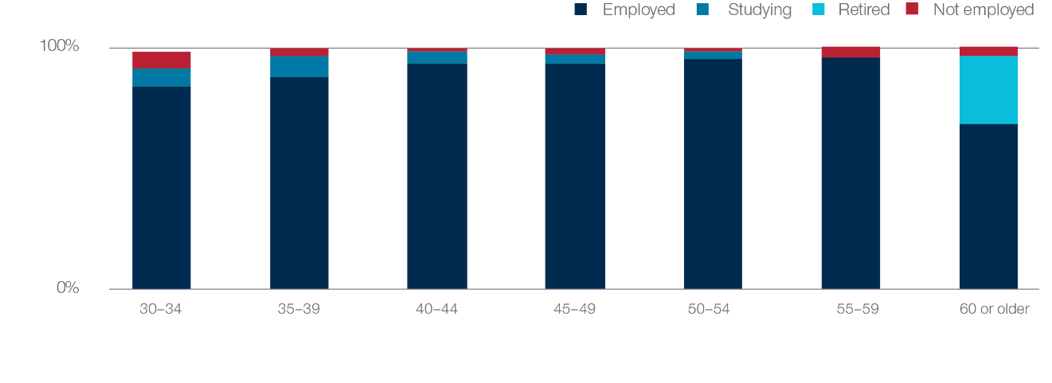

Alumni who were currently working were asked about several aspects of their employment, including their industry, sector, and occupation. The most common employers were the Public Administration and Safety (42.6%) and the Education and Training (21.8%) industries. Table 4 highlights that the largest sector of employment for alumni was the Public or Government sector with around half of all alumni employed in this sector. Alumni were more likely to be working in the private sectors and for NGOs or multilateral organisations than they were when surveyed around five years previously. Most alumni were employed as either managers or administrators (38.9%), as education professionals (16.9%), or as other professionals or associate professionals (25.9%).

Table 4: Sector of employment, 2019 and 2023

|  |  |  |
| --- | --- | --- |
| **Employment sector** | **2019** | **2023** |
| Private (Including independent/freelance contractors and consultants) | 9.5% | 16.1% |
| Public or Government | 52.3% | 45.1% |
| University or academia (public or private) | 20.3% | 17.8% |
| Non-Government Organisation or Multilateral organisation (including United Nations, development banks or agencies) | 17.0% | 20.3% |
| Other | - | 0.6% |
| Don't know | 0.9% | 0.2% |

Most alumni surveyed had experienced significant change in their employment over the previous five years mirroring the findings from the qualitative interviews, where all alumni had experienced changes in their careers, including to their positions, organisations, and industries.[5] Around two-thirds of surveyed alumni reported that they had changed jobs in the past five years. Male and female alumni were equally likely to have changed their job in the previous five years. As shown in Figure 2, 37 per cent of alumni had changed jobs and employer or organisation in the previous five years, and a further 28 per cent had changed jobs but had remained with the same employer. Figure 2 also shows that alumni working in the private sector or for an NGO or multilateral organisation were much more likely to have changed jobs in the previous five years than alumni working in the public sector or in academia.

Figure 2: Changed jobs or employer in previous five years, by current sector of employment, 2023

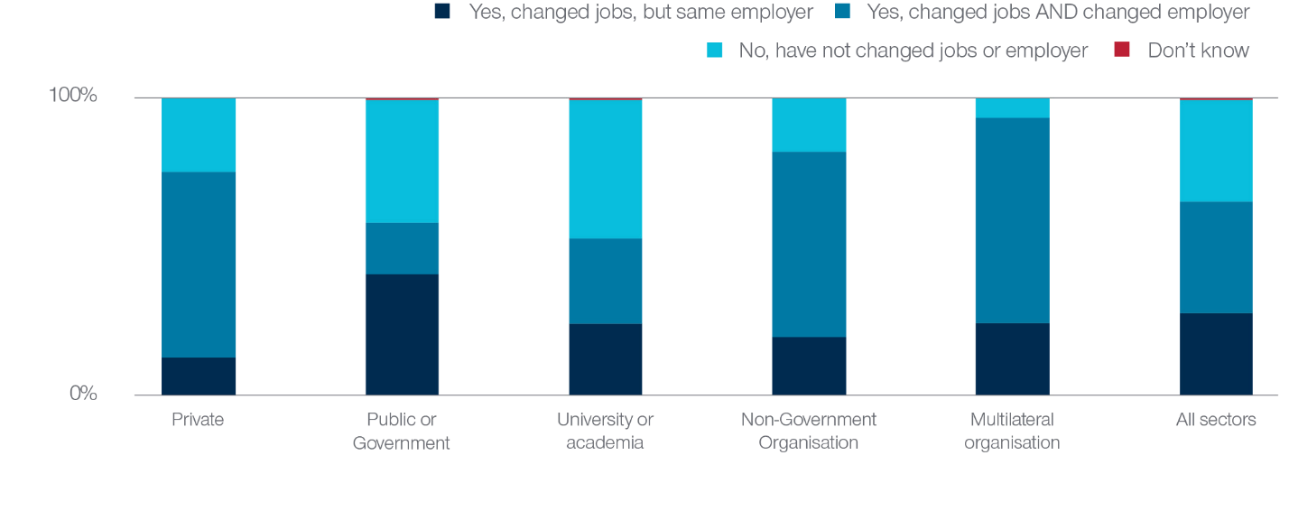

Alumni were also asked about changes to various aspects of their work in the previous five years. As shown in Table 5, more than 90 per cent of alumni have experienced an increase in the complexity of their work as well as an increase in their level of responsibility in their roles. Notably, given the importance of developing relevant and useful networks and relationships, almost all alumni reported that their professional network had grown in the previous five years. Most alumni also had experienced increases to their salary and had taken on more responsibilities in terms of management and supervision.

Table 5: Aspects of work that have *increased* in previous five years, 2023

| **Work aspect** | **2023** |
| --- | --- |
| Your professional networks | 93.9% |
| The complexity of tasks you are undertaking | 92.5% |
| The overall level of responsibility you have in your role | 92.5% |
| Your salary/remuneration package | 82.1% |
| The number of people you manage/supervise | 71.8% |

Male and female alumni both reported strong levels of career progression, however male alumni were slightly more likely to report that their work had increased in the previous five years than female alumni. This is most marked for the number of people that alumni reported managing where 75 per cent of male alumni and 69 per cent of female alumni indicated that this had increased over the past five years.

As shown in Figure 3, alumni continued to progress in their careers, regardless of whether they were in the same position or at the same organisation. It is interesting to note that alumni who had changed jobs but had remained at the same employer or organisation were even more likely to report career progression. These outcomes emphasise that alumni from the Australia Awards have continued to develop and grow in their careers post Award, and that importantly, their networks have continued to grow. This highlights that alumni have continued to develop relevant and useful networks and relationships following the completion of their Award.

Figure 3: Increases to aspects of work in previous five years, by change in employment, 2023

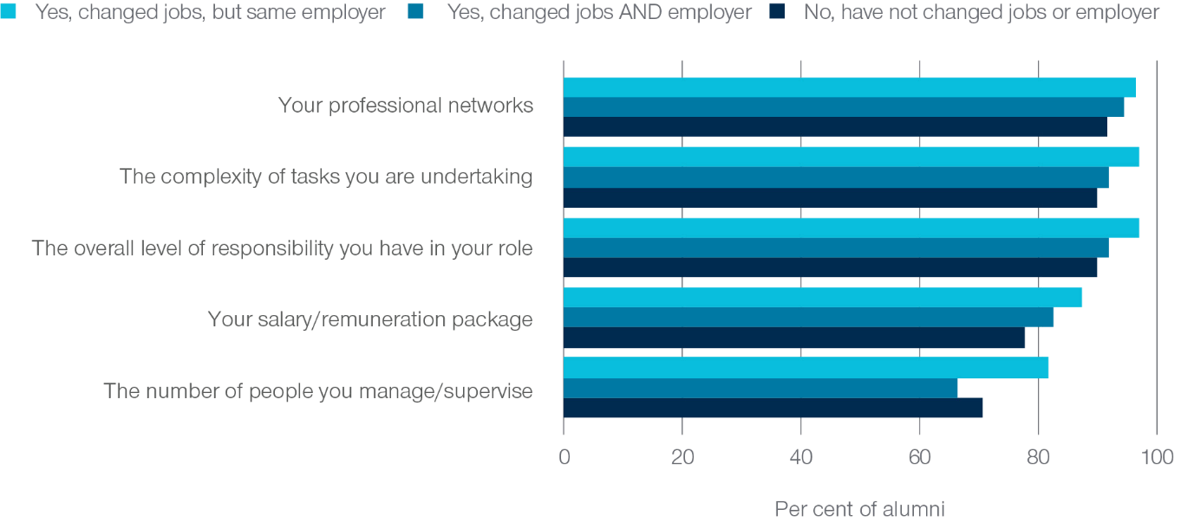

## Examples of leadership

**Alumni were also asked about their current leadership roles, including those held formally or informally in their employment, as well as leadership roles in their community. As shown in Table 6, around two-thirds of alumni held a formal leadership position when surveyed in 2023 and a further 20 per cent had an informal leadership role.**

Table 6: Held a leadership position in role, 2019 and 2023

|  |  |  |
| --- | --- | --- |
| **Leadership role** | **2019** | **2023** |
| A formal leadership role (e.g. manager, supervisor, executive) | 62.6% | 66.5% |
| An informal leadership role (e.g. mentor) | 29.6% | 20.3% |
| Do not have a leadership role | 6.1% | 11.5% |
| Prefer not to say | 1.8% | 1.8% |

In addition to having influence within their organisation or through their work, around a third of alumni reported having a leadership role in their community. The most common types of community leadership position included as religious leaders (27.6%) or in community or non-profit positions (24.5%).

There were some differences in leadership when looking at the rates for male and female alumni separately. As highlighted in Figure 4, male alumni (72.1%) were more likely to hold a formal leadership role in than female alumni (60.7%). Conversely, female alumni were more likely to hold an informal leadership role (23.2%) than male alumni (17.5%). These findings suggest that there may still be some gender-related barriers to leadership.

Findings from previous research conducted by the GTF that focused on women’s leadership and career progression among Indonesian alumni indicated that while alumni have a positive view of their leadership capabilities and felt that their experience on award had helped them with their career progression, they faced many challenges in moving into formal leadership positions post-award.[6] These included that many alumni worked in organisations with vertical style of leadership and very strict promotion policies, and in addition many cited that personal or family commitments had impacted their career progression, and around a fifth of alumni referred to gender bias in their workplace.

Around a third of both male and female alumni reported holding a leadership role in their communities. Overall, despite the gender differences in workplace leadership roles, very high proportions of both male and female alumni held either formal or informal leadership positions and in total, 89 per cent of alumni surveyed said that they were a leader either in their organisation or in the community, suggesting that almost all Australia Award alumni are in a position of influence.

Figure 4: Type of leadership role by gender, 2023

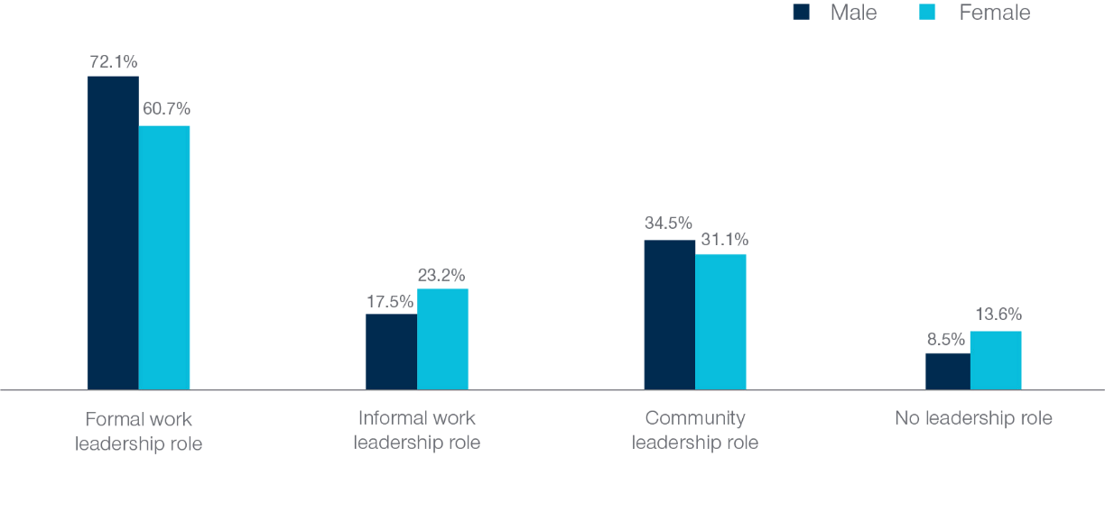

## Long-term influence of Australia Awards on alumni careers

**Despite many changes in alumni roles and responsibilities, the survey found that the qualification alumni gained in their Australia Award remains relevant and useful and that they have the skills and knowledge needed to contribute to development. As shown in Figure 5, 95 per cent of alumni reported using the skills and knowledge from their qualification in their current job. In addition, 77 per cent of alumni agreed that the qualification is a formal requirement for their current job. This reflects the findings from in-depth interviews conducted for the Longitudinal Alumni Case Study, which also found that the influence of the Australia Awards on alumni careers had been maintained, and for some alumni even increased, close to a decade post-award.[7]**

Figure 5: Relevance of Australian qualification to current job, 2023

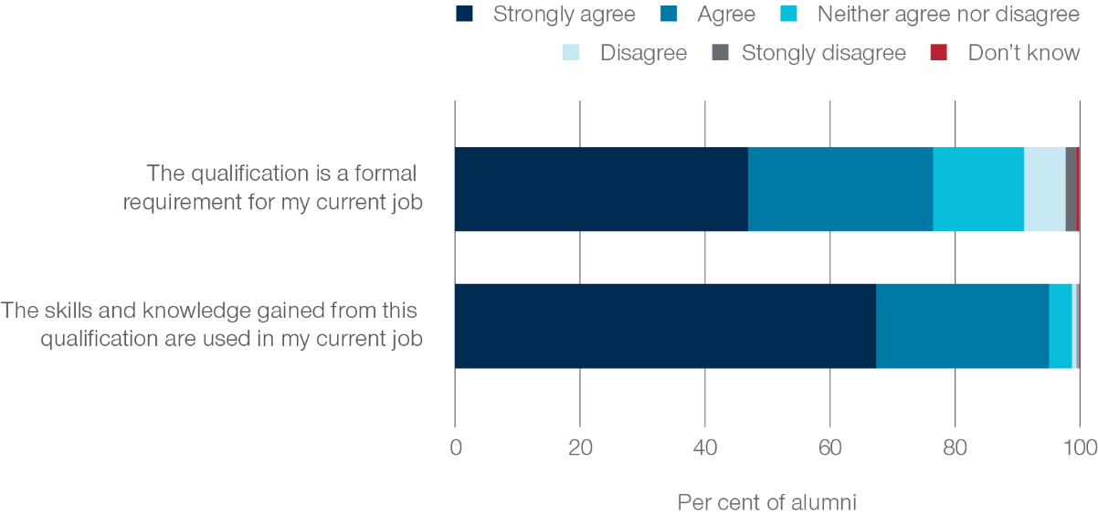

When asked about the most significant factor that has helped alumni with their career over the past five years, the most common answer given was ‘the skills and knowledge gained from my Australian scholarship qualification’. This again emphasises the ongoing value of the qualifications gained by alumni through their Award to their job and career.

Figure 6: Most significant factor that helped with career in previous five years, 2023

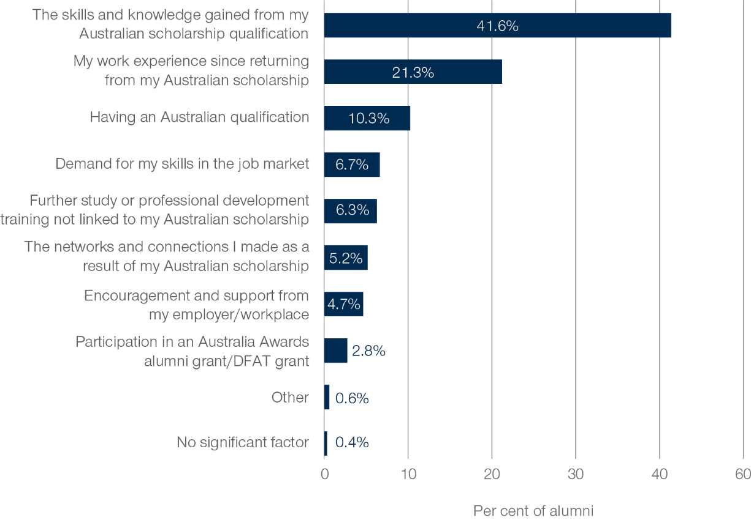

# Alumni Contributions to Australia Awards Long-term Outcomes

## Introduction

This section discusses findings from the 2023 and 2019 GTF Global Tracer survey that relate specifically to the two long-term program outcomes of the Australia Award. These include that ‘alumni are using their skills, knowledge, and networks to contribute to sustainable development’ and that ‘alumni contribute to cooperation between Australia and partner countries’.

## Outcome 1: alumni contributions to sustainable development over time

Alumni continue to agree that their Australia Award has not only benefited them directly but has also continued to positively impact others and their organisations through sharing skills, knowledge, and expertise. As shown in Figure 7, more than 90 per cent all alumni agreed that they had passed on new skills and knowledge gained as part of their Australia Award to others, and that they had been able to introduce improved practices and innovations through their work as a result of their Australia Award. This provides evidence of the enduring impact of the Australia Awards on alumni. Around a decade post Award, almost all alumni report that due to their Award, they can have a positive impact on others through sharing skills and knowledge and through their work.

Figure 7: Use of Australia Award in previous five years, 2019 and 2023

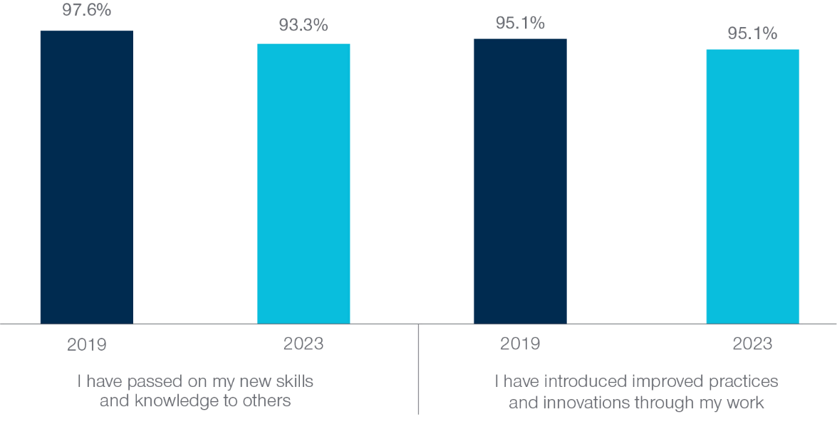

Alumni were also asked about which of the United Nations Sustainable Development Goals (SDG) that their work has supported over the past five years. Virtually all alumni (97.8%) had contributed to at least one of the SDG through their work, with most (79.2%) contributing to two or more of the SDG. The specific SDG that alumni have contributed to in the previous five years are shown in Figure 8. More than a third of alumni have contributed to the goals of Quality Education, Good Health and Well-being and Gender Equality reflecting findings from other alumni surveys. Again, these findings provide further evidence that alumni continue to contribute to sustainable development following their Australia Award. These findings also follow the pattern of other data collected and reported by the GTF, including large Global Tracer Surveys in 2020 and 2022[8] and the qualitative Longitudinal Alumni Case Study[9].

Figure 8: UN Sustainable Development Goals supported by work over previous five years, 2023

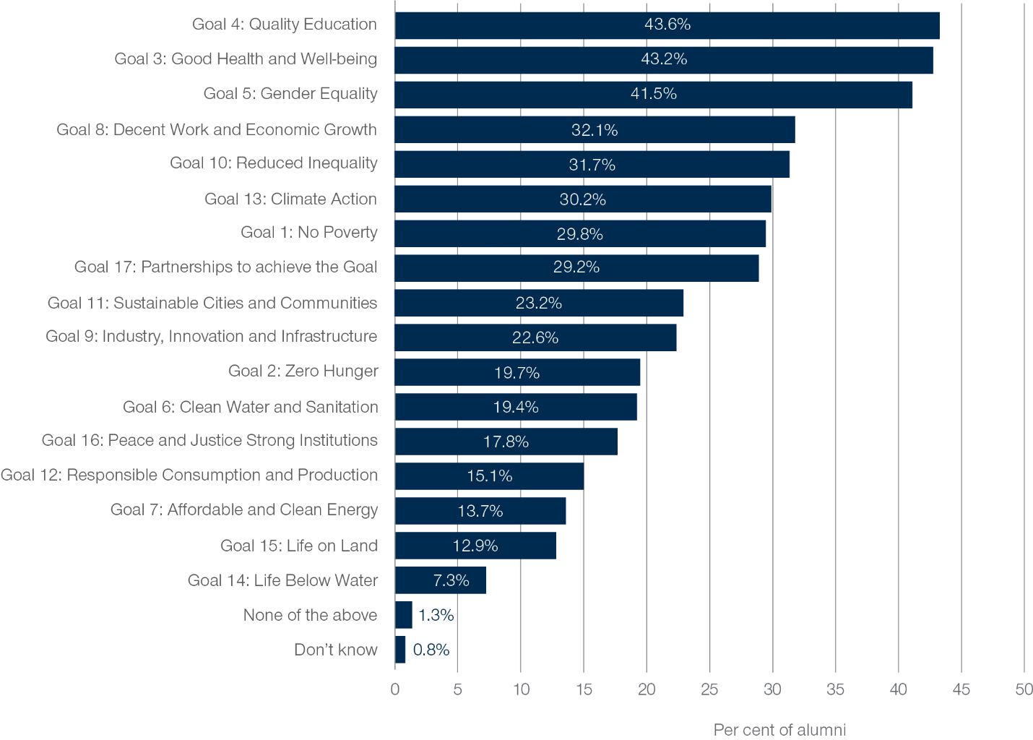

## Outcome 2: alumni contributions to cooperation through networks over time

**Another focus of the 2023 GTF Global Tracer Survey was to explore the long-term outcome that ‘alumni contribute to cooperation between Australia and partner countries’. This section focuses on the relationships, links, and networks that alumni have maintained and developed in the past five years.**

As seen in Figure 9, alumni are most likely to still be in frequent contact with their fellow scholarship recipients, their friends in Australia and with fellow Australian students. As might be expected given alumni had completed their Award around a decade ago, they were slightly less likely to report having frequent contact with their fellow scholarship recipients, friends, students, and institution when surveyed in 2023 than they were in 2019. However, as shown in Figure 10, more than half of alumni are still in touch with these groups at least ‘sometimes’ which suggests that many of these relationships are continuing and that these individual connections with Australia still endure. Alumni who were interviewed as part of the Longitudinal Alumni Case Study demonstrated that many of these connections gained as part of their involvement in the Australia Awards had grown into opportunities to work and collaborate on projects, emphasising the importance of these connections.

Notably, even as some connections may have waned slightly, professional connections with Australian organisations appear to be enduring. Alumni are slightly more likely to report ‘always’ or ‘often’ being in touch with Professional Associations or Australian businesses in 2023 (18.6%) than when they were surveyed in 2019 (14.8%), suggesting that these connections, although not as widespread, may possibly even be growing.

Figure 9: Frequency of contact with different groups in previous five years, 2023

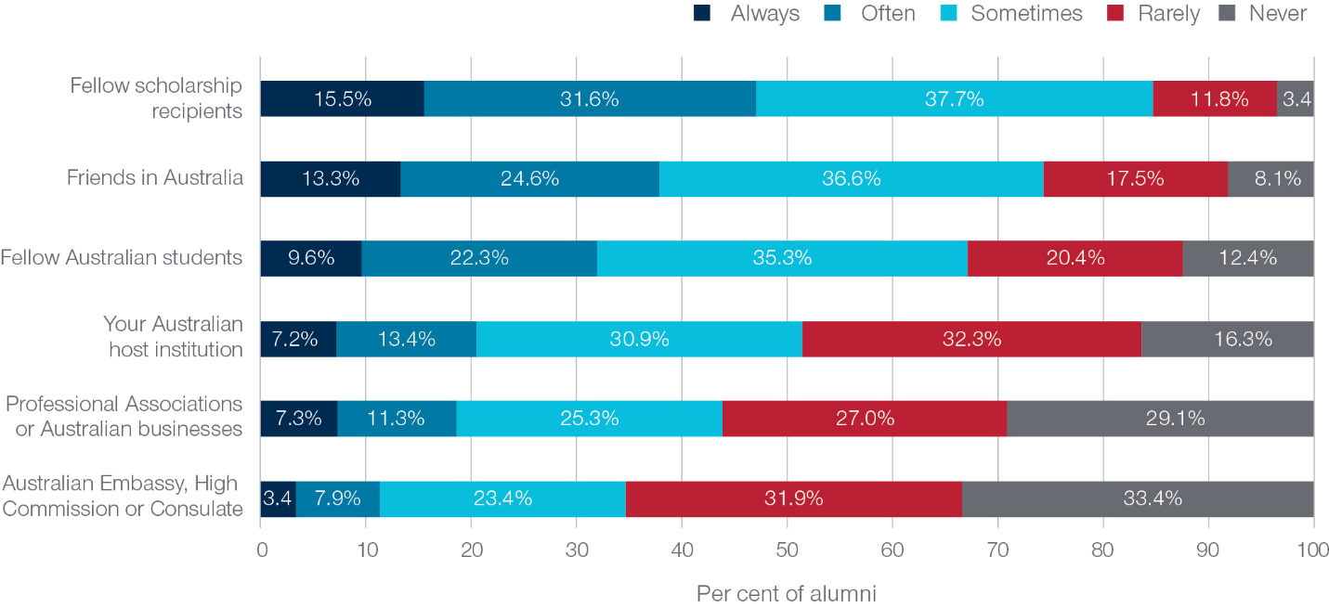

Figure 10: Alumni who were in contact with different groups in previous five years at least sometimes, 2019 and 2023

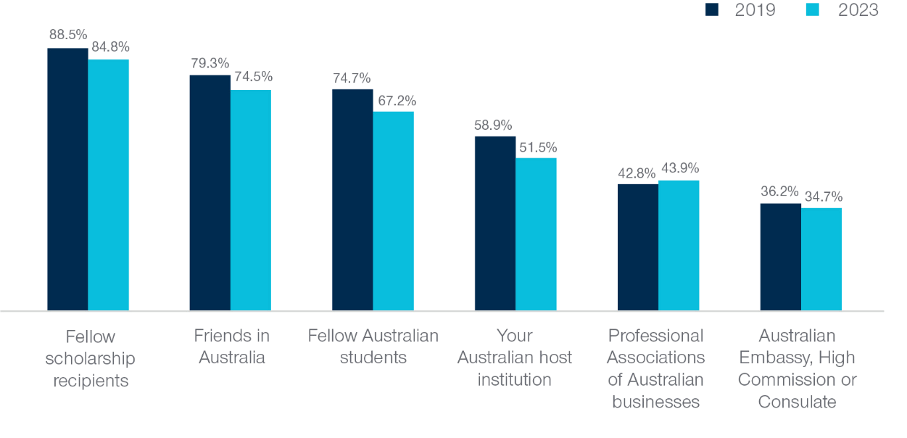

Further to this, when asked about whether, because of their Australia Award, alumni had developed professional links with an Australian institution or organisation in the previous five years, more than a third of alumni indicated that they had (35.6%). When combining responses from the 2023 and 2019 surveys, 58 per cent of alumni had developed a professional link with an Australian institution or organisation in the past decade since completing their Award.

Alumni working in universities or academia were more likely to report that they had developed links with an Australian institution or organisation in the past decade (68.5%) than alumni working in other sectors. As shown in Figure 11, alumni from Papua New Guinea (71.0%) were most likely to report that they had developed professional links with Australian institutions or organisations in the decade since completing their Award.

Figure 11: Alumni who developed professional links with Australia, by time period in which link was established

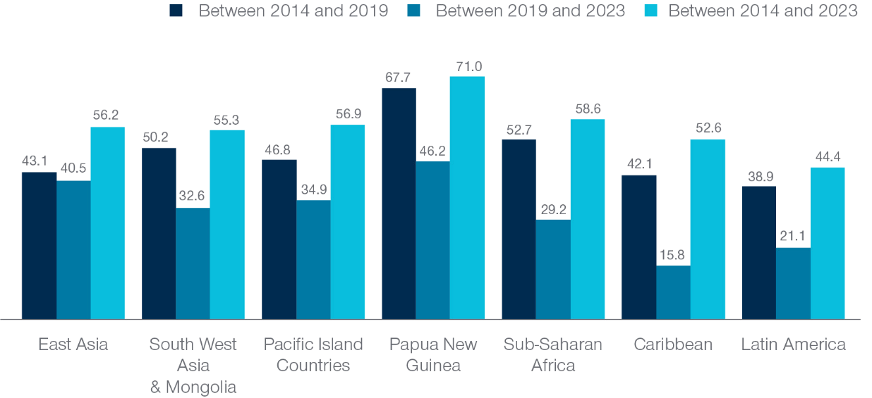

Note: This excludes alumni from North Africa and the Middle East because there were fewer than 10 respondents.

Alumni were also asked about the types of Australian institutions or organisations that they had developed professional links with. As shown in Table 8, the most common professional link alumni had developed was with Australian universities.

Table 8: Type of Australian organisation developed professional links with, 2019 and 2023

| **Organisation** | **2019** | **2023** |
| --- | --- | --- |
| National or State Government Departments | 20.0% | 25.5% |
| Private sector businesses | 14.9% | 18.5% |
| Universities | 66.4% | 59.6% |
| Non-Government Organisations | 23.3% | 25.3% |
| Other | 13.1% | 2.6% |

Alumni who had not developed professional links with Australian institutions or organisations in the past five years were asked about whether this was something they would like to develop. Almost all alumni surveyed were keen to develop such links. In 2023, 89 per cent of alumni indicated that they would like to develop professional links with Australia, and this was similarly high in 2019 with 90 per cent of alumni interested in developing professional links with Australian institutions or organisations.

## Factors influencing mid-career alumni long-term outcomes

To better understand what enables alumni to contribute to sustainable development and to developing professional links with Australia, alumni were asked to describe the most significant factor that has helped them in these areas. When asked about the factor that has helped them to contribute to sustainable development, as seen in Figure 12, the most commonly cited factors were the skills and knowledge that alumni had gained from their Australian qualification and the exposure to different values and ways of thinking gained from their scholarship experience. For 65 per cent of alumni, the most significant factor that has helped them to contribute to sustainable development is directly related to their experience while on Award.

Figure 12: Most significant factor in contributing to sustainable development, 2023

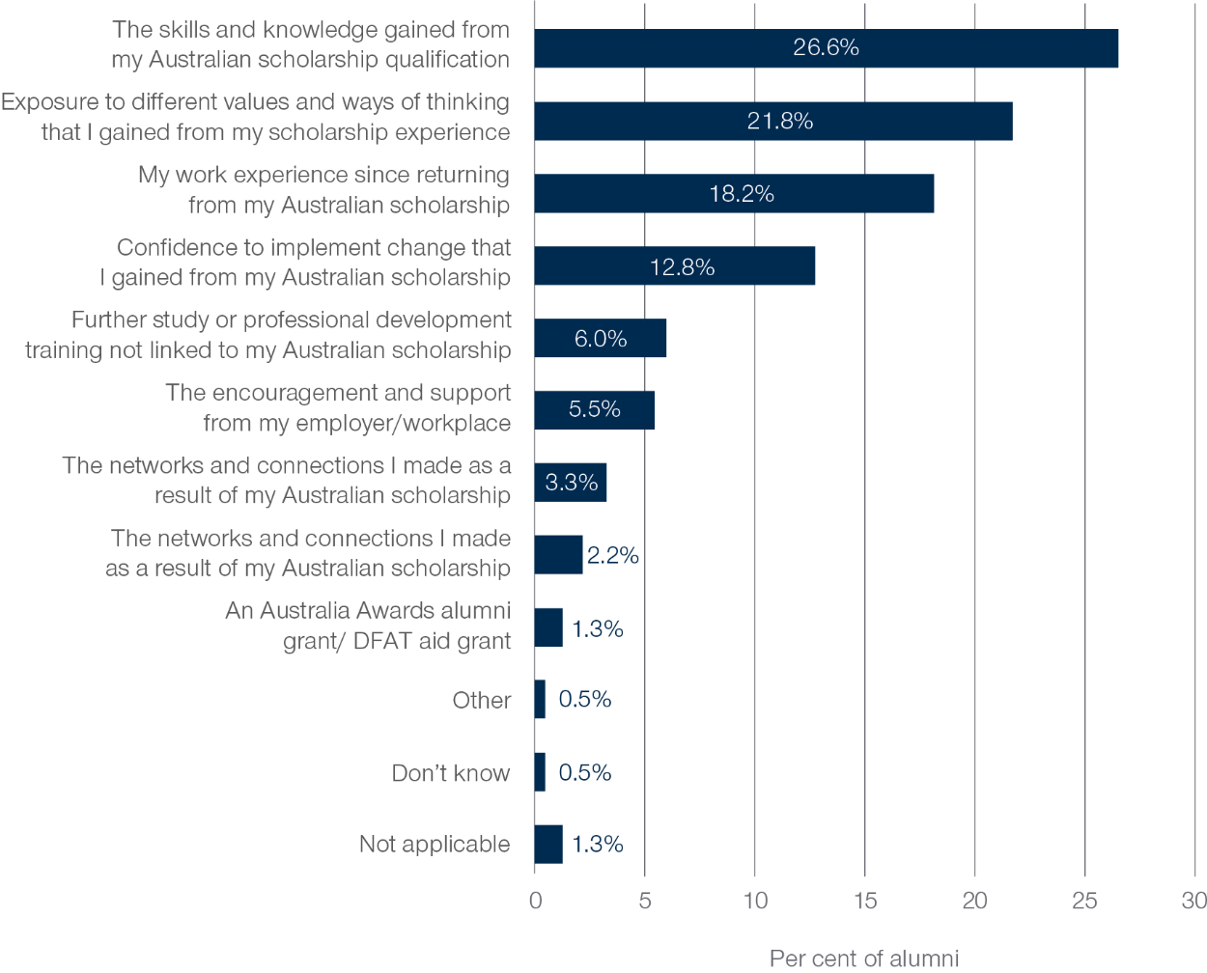

Figure 13: Most significant factor in building professional links with Australian organisations, 2023

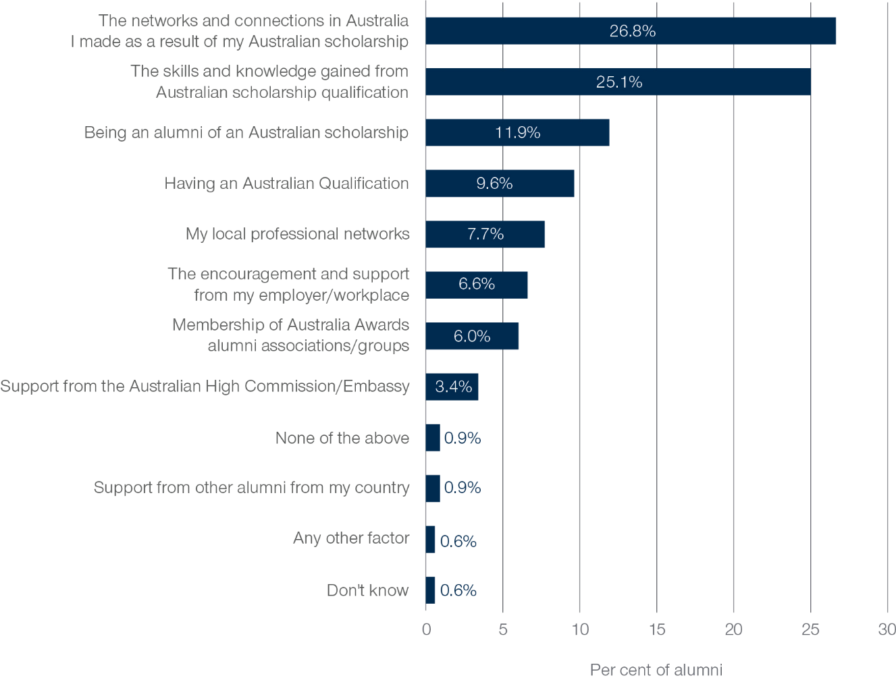

Alumni were also asked about the factor that has most helped them to develop professional links with Australian institutions and organisations. As shown in Figure 13, the most significant factors include the networks and connections in Australia made as a result of the Australian scholarship (26.8%) and the skills and knowledge gained from their Australian scholarship qualification (25.1%). Some alumni also indicated that being an alum of an Australian scholarship (11.9%) or having an Australian qualification (9.6%) were the most important factors in developing links with Australia. Again this highlights the importance of the Australia Award experience in facilitating and fostering these links.

# Alumni future plans

## Introduction

In the 2023 GTF Global Tracer survey, alumni were asked to think ahead to the next five years and their potential ongoing connections with the Australia Award alumni, Australians and Australian institutions and organisations. These findings highlight some of the ways in which alumni will continue to connect with Australia into the future, and potentially how these connections could be strengthened and supported.

## Future potential ongoing outcomes for the Australia Awards

Alumni were asked about how likely it was that they would continue to have connections with fellow Australia Award alumni, Australians, and Australian institutions and organisations. As shown in Figure 14, more than 80 per cent of alumni said that it was ‘likely’ or ‘very likely’ that they would attend alumni events, interact with fellow Australia Award alumni in their professional life, or seek opportunities to partner professionally with Australian organisations in the coming five years. Around 60 per cent of alumni indicated that they would be ‘likely’ or ‘very likely’ to seek to work in Australia or for an Australian organisation, or would apply to study in Australia in the next five years. This suggests that alumni are continuing to seek out connections with Australia into the future and provides evidence that alumni will continue to contribute to cooperation between Australia and partner countries.

Figure 14: Plans for next five years, 2023

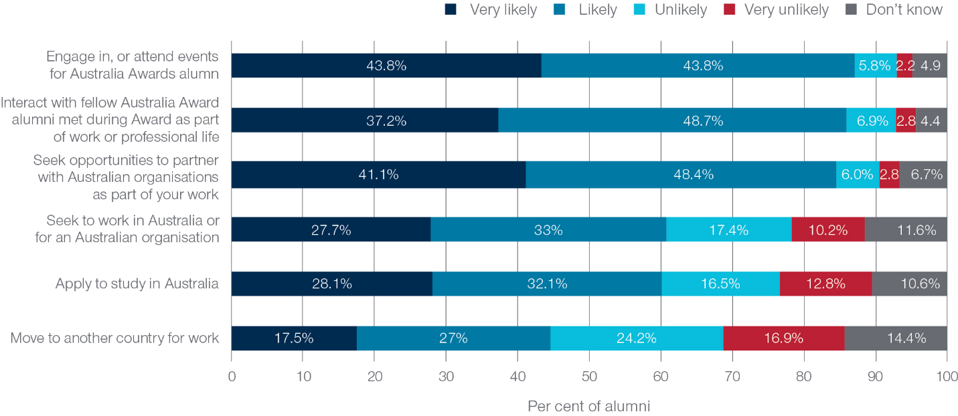

As shown in Figure 15, alumni plans for the coming five years vary quite substantially by their region. Looking at the level of the interest among alumni to engage in or attend events held for Australia Awards alumni, it appears that alumni from Papua New Guinea (93.4%), Sub-Saharan Africa (89.2%), East Asia (89.1%) and South West Asia (87.3%) were the most likely to engage in these events in the future. This suggests that it might be worthwhile to target these alumni for future networking events and alumni engagement.

Figure 15: Plans for next five years by region, 2023

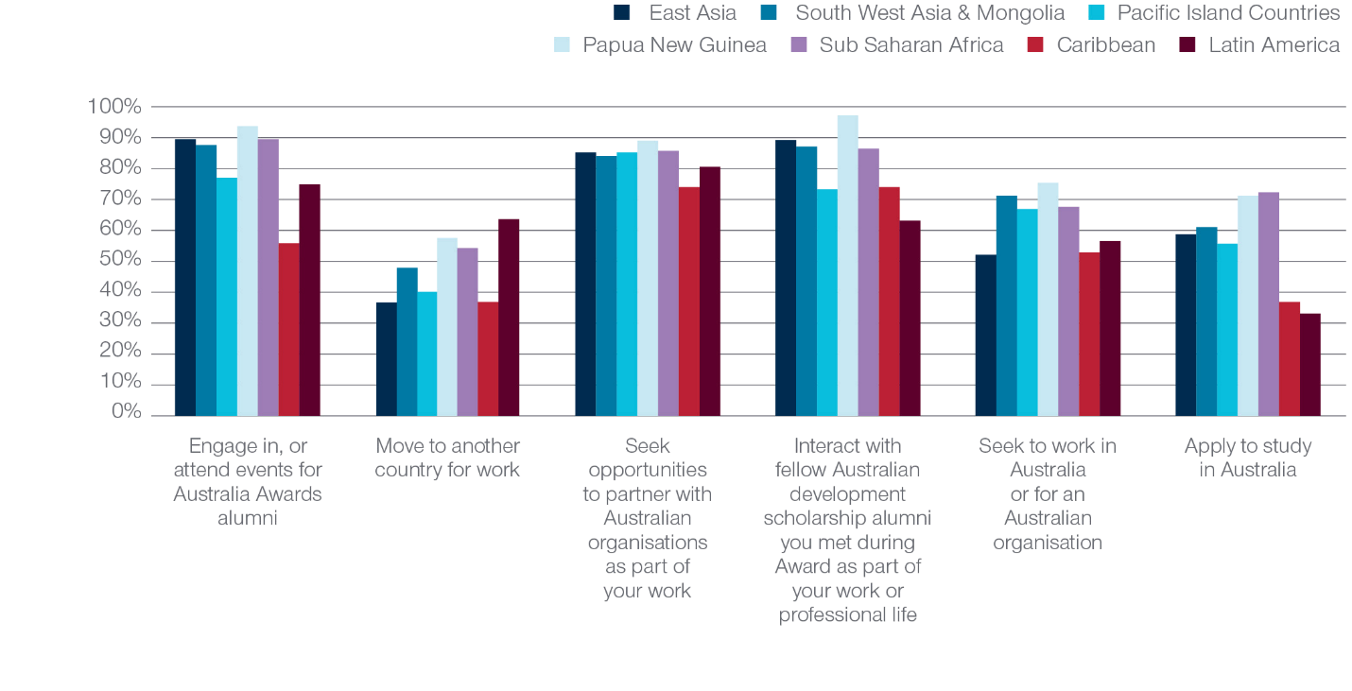

# Implications for the Australia Awards

## Summary of findings

This report summarises the longitudinal findings from more than 1,000 alumni who completed their Australia Award between 2013 and 2016 and who participated in the GTF Global Tracer Survey in both 2019 and 2023. The findings presented here complement the concurrent Longitudinal Alumni Case Study which provided deep insights into alumni careers and their contribution to the long-term outcomes of the Australia Awards through a series of interviews with alumni. Together, the findings provide further evidence that both the long-term and intermediate outcomes of the Australia Award program are being met.

Program Outcome 1: Alumni are using their skills, knowledge, and networks to contribute to sustainable development.

Alumni reported high levels of employment, and strong career progression over the past five years. Almost all alumni reported that their professional network had grown, and that the complexity of their work and level of responsibility they held had increased in this time. Close to 90 per cent of alumni held a leadership position in their role or in their community.

More than 90 per cent of alumni reported that as a result of their Australia Award, they were able to pass on new skills and knowledge to others, and had introduced improvements and innovations through their work. Almost all alumni had contributed to at least one of the SDGs in the past five years. This, along with findings from other research conducted by the GTF, again emphasises that alumni are contributing to sustainable development.

Program Outcome 2: Alumni contribute to cooperation between Australia and partner countries.

Most alumni reported that they had ongoing contact with fellow scholarship recipients, friends and students met in Australia while on award. This suggests that individual connections forged in Australia continue to be important to alumni, even close to a decade post-award.

Although fewer alumni had frequent contact with Australian businesses, more than half of alumni had developed a professional link with Australian institutions or organisations since completing their award. Almost all alumni who had not yet had the opportunity to develop professional links with Australian institutions or organisations would like to develop such links.

Alumni are keen to maintain ongoing connections with Australia, with more than 80 per cent interested in engaging in or attending events for Australia Awards alumni, interacting with fellow Australia Awards alumni as part of their professional life, or seeking opportunities to partner professionally with Australian organisations in the coming five years.

The survey contributes to the evidence-base being gathered by the GTF to help better understand the role that the Australia Awards have for the long-term outcomes of alumni. Overall, the findings show that alumni are using their skills, knowledge, and networks to contribute to sustainable development, and contributing to cooperation between Australia and partner countries.

## Implications for Australia Awards

Enduring importance of individual connections for developing professional links with Australia

The findings from the GTF Global Tracer Survey together with the Longitudinal Alumni Case Study highlight the enduring importance of the connections that alumni develop while on award. As discussed in this report, around half of alumni reported that they had continued to maintain contact with individuals they had met while on-award, around a decade since completing their studies in Australia. Findings from the Longitudinal Alumni Case Study suggest that **many of these connections, while starting off as personal or social connections, had subsequently developed into opportunities to collaborate professionally with Australians and Australian organisations**.

More than half of all alumni had developed professional connections with Australia in the time since completing their award, with most of these connections between alumni and Australian universities. Around 90 per cent of alumni who had not yet developed such a connection were keen to make these connections in future. **Better understanding the types of professional connections that alumni have developed with Australia and how these have been developed about may provide insights that could help support alumni who are keen to make these connections with Australia. Further research that explores the industries, occupations and projects where this collaboration and connection is occurring may help identify industry groups or professional associations who may be able to help foster these connections.**

As the most common significant factor in building professional links with Australian organisations was the networks and connections that alumni had built while on award, **providing further on-award opportunities to develop these connections with individuals may be beneficial both for developing individuals’ career opportunities and may also lead to greater connections post-award between alumni and Australia**.

Further to this, as **many alumni indicated they would be likely to attend alumni events in the future and are keen to make connections with other alumni and connections with Australia for work or study, this may provide an opportunity** to further foster these individual connections made while on-award and help alumni reconnect and maintain their relationships with other people and Australian organisations, which may in turn lead to deepening connections with Australia and increase the number of alumni who maintain these relationships.

Issue of ongoing gender gap in leadership

One of the Australia Awards’ Global Performance Targets is that the ‘Australia Awards contributes to a growing cohort of women leaders who are increasingly able to participate, influence and lead across a diversity of development sectors’.[10] While female alumni have clearly made very significant contributions through their work, and most female alumni surveyed held a leadership role of some kind in their work or community, findings reported here and previously[11] suggest **there is an enduring gap in the proportion of female alumni who hold a formal leadership role at work**.

Some work has already explored this issue in more depth with a cohort of Indonesian alumni[12] but **there would be potential value in exploring this gap with further research to better understand why this gap exists in other regions, and how female alumni could be better supported to move into formal leadership roles in the future**.

Potential future research to strengthen longitudinal insights on the Australia Awards

This longitudinal survey together with the longitudinal case studies provide valuable insights into the longer-term outcomes of alumni. One limitation of these longitudinal studies is that they focus solely on the post-award experiences of alumni at two specific points in time. **A future longitudinal study could be designed to track alumni from an earlier point – perhaps while on award – and could include multiple collections across a longer period of time**. Such a study would provide even broader and deeper insights into alumni experiences and contributions and could provide insights into causal relationships between alumni pre- and on-award contexts and experiences and their future outcomes post-award. Because of this, the information collected would likely have clearer policy implications that the findings from a standalone survey.

Potentially a longitudinal study could be designed that first surveys or interviews participants from when they accept a scholarship (pre-award), and then surveys them again during their studies (on-award), and then after they have completed their studies (post-award). This study could potentially continue following up with alumni over a significant period of time to provide further insights into the longer-term outcomes of the Australia Awards. **In addition to administering surveys to alumni before, during and after their award, there may be opportunities to complement these surveys with other data, such as responses from the national Student Experience Survey and Graduate Outcomes Survey, to create a richer, deeper and more informative source of data that can link alumni contributions and outcomes to their experiences and contexts before and during their award**.

# Acronyms and Abbreviations

| **Acronym** | **Meaning** |
| --- | --- |
| ACER | Australian Council for Educational Research |
| CATI | Computer Assisted Telephone Interview |
| DFAT | Australian Department of Foreign Affairs and Trade |
| GTF | Australia Awards Global Tracer Facility |
| NGO | Non-Governmental Organisation |
| OASIS | Online Australia Awards Scholarships Information System |

Appendix A: 2023 Longitudinal Global Tracer Survey Instrument

[2023 Longitudinal Global Tracer Survey Instrument](https://research.acer.edu.au/tracer/42/)

Appendix B: Survey Response Rates by Region and Gender

Table 9: Population, response numbers and response rates by gender

| **Gender** | **Total respondents** | **Target population** | **Response Rate** |
| --- | --- | --- | --- |
| Male | 687 | 1,185 | 58.0% |
| Female | 701 | 1,071 | 65.5% |
| Total | 1,388 | 2,256 | 61.5% |

Table 10: Population, response numbers and response rates by year of award completion

| **Year** | **Total respondents** | **Target population** | **Response Rate** |
| --- | --- | --- | --- |
| 2013 | 235 | 401 | 58.6% |
| 2014 | 335 | 536 | 62.5% |
| 2015 | 476 | 734 | 64.9% |
| 2016 | 342 | 585 | 58.5% |
| Total | 1,388 | 2,256 | 61.5% |

Table 11: Population, response numbers and response rates by region of citizenship

| **Country** | **Response** | **Population** | **Response Rate** |
| --- | --- | --- | --- |
| East Asia | 643 | 1135 | 56.7% |
| South-West Asia & Mongolia | 264 | 414 | 63.8% |
| Pacific Island Countries | 65 | 100 | 65.0% |
| Papua New Guinea | 70 | 107 | 65.4% |
| Sub-Saharan Africa | 239 | 366 | 65.3% |
| Caribbean | 19 | 23 | 82.6% |
| Latin America | 71 | 94 | 75.5% |
| North Africa and the Middle East | 7 | 11 | 63.6% |
| Other | - | 2 | 0.0% |
| Total | 1,388 | 2,256 | 61.5% |

Table 12: Population, response numbers and response rates by country of citizenship

| **Country** | **Total respondents** | **Target population** | **Response Rate** |
| --- | --- | --- | --- |
| Indonesia | 241 | 474 | 50.8% |
| Vietnam | 169 | 300 | 56.3% |
| Philippines | 83 | 139 | 59.7% |
| Papua New Guinea | 70 | 107 | 65.4% |
| Cambodia | 60 | 87 | 69.0% |
| Bhutan | 50 | 80 | 62.5% |
| Pakistan | 48 | 70 | 68.6% |
| Bangladesh | 44 | 74 | 59.5% |
| Myanmar | 42 | 55 | 76.4% |
| Nepal | 36 | 53 | 67.9% |
| Sri Lanka | 36 | 51 | 70.6% |
| Laos | 32 | 54 | 59.3% |
| Mongolia | 27 | 49 | 55.1% |
| Nigeria | 26 | 38 | 68.4% |
| Kenya | 26 | 41 | 63.4% |
| Zambia | 21 | 30 | 70.0% |
| Fiji | 19 | 27 | 70.4% |
| Malawi | 19 | 24 | 79.2% |
| Tanzania | 19 | 25 | 76.0% |
| Ghana | 16 | 25 | 64.0% |
| Maldives | 15 | 28 | 53.6% |
| Timor-Leste | 14 | 23 | 60.9% |
| Vanuatu | 13 | 20 | 65.0% |
| Botswana | 12 | 19 | 63.2% |
| Uganda | 12 | 24 | 50.0% |
| Solomon Islands | 11 | 16 | 68.8% |
| Mexico | 9 | 11 | 81.8% |
| Lesotho | 9 | 12 | 75.0% |
| India | 8 | 9 | 88.9% |
| Mozambique | 8 | 14 | 57.1% |
| Liberia | 7 | 10 | 70.0% |
| Mauritius | 7 | 12 | 58.3% |
| South Africa | 7 | 9 | 77.8% |
| Eswatini | 7 | 18 | 38.9% |
| Costa Rica | 6 | 8 | 75.0% |
| Guatemala | 6 | 8 | 75.0% |
| Jamaica | 6 | 6 | 100.0% |
| Kiribati | 5 | 9 | 55.6% |
| Tonga | 5 | 7 | 71.4% |
| Afghanistan | 5 | 7 | 71.4% |
| Argentina | 5 | 7 | 71.4% |
| Ecuador | 5 | 6 | 83.3% |
| Guyana | 5 | 5 | 100.0% |
| Paraguay | 5 | 6 | 83.3% |
| Peru | 5 | 7 | 71.4% |
| Cameroon | 5 | 8 | 62.5% |
| Gambia | 5 | 7 | 71.4% |
| Namibia | 5 | 8 | 62.5% |
| Rwanda | 5 | 8 | 62.5% |
| Chile | 4 | 7 | 57.1% |
| Belize | 4 | 4 | 100.0% |
| Nicaragua | 4 | 5 | 80.0% |
| Sierra Leone | 4 | 6 | 66.7% |
| Zimbabwe | 4 | 5 | 80.0% |
| Samoa | 3 | 6 | 50.0% |
| Bolivia | 3 | 3 | 100.0% |
| Brazil | 3 | 3 | 100.0% |
| Colombia | 3 | 3 | 100.0% |
| Uruguay | 3 | 5 | 60.0% |
| Honduras | 3 | 5 | 60.0% |
| St Lucia | 3 | 4 | 75.0% |
| Ethiopia | 3 | 5 | 60.0% |
| Madagascar | 3 | 3 | 100.0% |
| Seychelles | 3 | 7 | 42.9% |
| French Polynesia | 2 | 3 | 66.7% |
| Tuvalu | 2 | 5 | 40.0% |
| Egypt | 2 | 4 | 50.0% |
| Venezuela | 2 | 2 | 100.0% |
| Grenada | 2 | 2 | 100.0% |
| New Caledonia | 1 | 3 | 33.3% |
| Nauru | 1 | 1 | 100.0% |
| Palau | 1 | 1 | 100.0% |
| Cook Islands | 1 | 1 | 100.0% |
| Niue | 1 | 1 | 100.0% |
| South Sudan | 1 | 1 | 100.0% |
| Thailand | 1 | 1 | 100.0% |
| Malaysia | 1 | 1 | 100.0% |
| Panama | 1 | 1 | 100.0% |
| Dominican Republic | 1 | 1 | 100.0% |
| Haiti | 1 | 1 | 100.0% |
| St Vincent and the Grenadines | 1 | 2 | 50.0% |
| Congo, Democratic Republic of | 1 | 1 | 100.0% |
| Cote d'Ivoire | 1 | 1 | 100.0% |
| Guinea | 1 | 1 | 100.0% |
| Togo | 1 | 1 | 100.0% |
| Burundi | 1 | 1 | 100.0% |
| Total | 1,388 | 2,256 | 61.5% |

1. Haddow, A., & Hsien, M. (2023). *Longitudinal Alumni Case Study: Where are they now?*, Australia Awards Global Tracer Facility, Australian Department of Foreign Affairs and Trade, Canberra. Retrieved from: [Longitudinal Alumni Case Study: Where are they now?](https://www.dfat.gov.au/publications/people-people/longitudinal-alumni-case-study-where-are-they-now)
2. DFAT, (2022), Australia Awards Global Monitoring and Evaluation Framework, Department of Foreign Affairs and Trade.
3. All published GTF research reports can be found: [Australia Awards Global Tracer Facility](https://www.dfat.gov.au/people-to-people/australia-awards/australia-awards-global-tracer-facility)
4. [Australia Awards Global Tracer Facility Tracer Survey: Alumni of 2011-2016](https://www.dfat.gov.au/people-people/australia-awards/Pages/australia-awards-global-tracer-facility-tracer-survey-alumni-2011-2016)
5. Haddow, A., & Hsien, M. (2023). *Longitudinal Alumni Case Study: Where are they now?,* Australia Awards Global Tracer Facility, Australian Department of Foreign Affairs and Trade, Canberra. Retrieved from: [Longitudinal Alumni Case Study: Where are they now?](https://www.dfat.gov.au/publications/people-people/longitudinal-alumni-case-study-where-are-they-now).
6. Clarke, L. & Haddow, A. (2022). *Women’s Leadership and Career Progression: Insights from Australia Awards Indonesian Alumnae.* Australian Department of Foreign Affairs and Trade. [Women’s Leadership and Career Progression: Insights from Indonesian Australia Awards Alumnae](https://www.dfat.gov.au/publications/people-people/womens-leadership-and-career-progression-insights-indonesian-australia-awards-alumnae)
7. Haddow, A., & Hsien, M. (2023). *Longitudinal Alumni Case Study: Where are they now?,* Australia Awards Global Tracer Facility, Australian Department of Foreign Affairs and Trade, Canberra. Retrieved from: [Women’s Leadership and Career Progression: Insights from Indonesian Australia Awards Alumnae](https://www.dfat.gov.au/publications/people-people/longitudinal-alumni-case-study-where-are-they-now).
8. Edwards, D. & Radloff, A. (2021). [Australia Awards Alumni Global Tracer Survey, 2020](https://www.dfat.gov.au/people-to-people/australia-awards/australia-awards-global-tracer-facility-year-5-results/australia-awards-alumni-global-tracer-survey-2020), Australian Department of Foreign Affairs and Trade, Canberra; Hsien, M., & Edwards, D. (2023). [Australia Awards Alumni Global Tracer Survey 2022](https://www.dfat.gov.au/publications/people-people/australia-awards-alumni-global-tracer-survey-2022). Australia Awards Global Tracer Facility, Australian Department of Foreign Affairs and Trade.
9. Haddow, A., & Hsien, M. (2023). *Longitudinal Alumni Case Study: Where are they now?,* Australia Awards Global Tracer Facility, Australian Department of Foreign Affairs and Trade, Canberra. Retrieved from: [Longitudinal Alumni Case Study: Where are they now?](https://www.dfat.gov.au/publications/people-people/longitudinal-alumni-case-study-where-are-they-now).
10. Australia Department of Foreign Affairs and Trade, *Australia Awards Global Monitoring and Evaluation Framework, February 2022* (2022), Retrieved from: [Global Monitoring and Evaluation Framework February 2022](https://www.dfat.gov.au/sites/default/files/australia-awards-global-monitoring-and-evaluation-framework-2022.pdf)
11. Haddow, A., Edwards, D. & Clarke, L. (2022). Alumni Growth: Tracking Australia Awards Alumni Over Five Years, Longitudinal Tracer Survey 2021, Australian Department of Foreign Affairs and Trade. [Australia Awards Global Tracer Facility Year 6 Results](https://www.dfat.gov.au/people-to-people/australiaawards/australia-awards-global-tracer-facility-year-6-results)
12. Clarke, L. & Haddow, A. (2022). *Women’s Leadership and Career Progression: Insights from Australia Awards Indonesian Alumnae.* Australian Department of Foreign Affairs and Trade. [Women’s Leadership and Career Progression: Insights from Indonesian Australia Awards Alumnae](https://www.dfat.gov.au/publications/people-people/womens-leadership-and-career-progression-insights-indonesian-australia-awards-alumnae)