

# Australia Awards Alumni Global Tracer Survey 2020

Australia Awards Global Tracer Facility

The views expressed in this report are those of the authors and do not necessarily reflect the policy or position of the Australian Government, its agencies or representatives.

Australian Department of Foreign Affairs and Trade

With the exception of the Commonwealth Coat of Arms and where otherwise noted, all material presented is provided under a Creative Commons Attribution 3.0 Australia license.

**Acknowledgements**

The Australian Council for Educational Research is the managing contractor for the Australia Awards Global Tracer Facility, and staff from the GTF thank our colleagues at Wallis Social Research for managing the survey and data collection elements of this research. The authors would like to thank DFAT’s Scholarships and Alumni Branch, for supporting this research.

Most importantly, thank you to the thousands of alumni who gave their time in completing the GTF Global Tracer Survey, without your insight, feedback and accomplishments, the research we do would not be possible.

**Recommended citation**

Edwards, D. & Radloff, A. (2021). *Australia Awards Alumni Global Tracer Survey, 2020*, Australian Department of Foreign Affairs and Trade, Canberra. Retrieved from: https://www.dfat.gov.au/people-to-people/australia-awards/australia-awards-global-tracer-facility-year-5-results

## Contents

Abbreviations and Acronyms 4

Executive Summary 5

Outcome 1: Alumni are using their skills, knowledge and networks to contribute to sustainable development. 5

Outcome 2: Alumni are contributing to cooperation between Australia and partner countries. 5

Outcome 3: Effective, mutually advantageous partnerships between institutions and businesses in Australia and partner countries. 5

Outcome 4: Alumni view Australia, Australians, and Australian expertise positively. 6

1. Introduction 7

2. Scope, approach and alumni participants 8

2.1 Scope 8

2.2 Approach 8

2.3 Alumni participants 9

2.4 Characteristics of alumni respondents 10

3. Alumni contributions 13

3.1 Introduction 13

3.2 Sharing new skills and knowledge 13

3.3 Using new skills and knowledge 14

3.4 Examining the impact and reach of contributions 17

3.5 Enabling alumni to contribute 22

3.6 Factors inhibiting contributions 23

4. Cooperation with Australia 26

4.1 Introduction 26

4.2 Connections developed while on award 26

4.3 Connections maintained after returning from award 27

5. Partnerships 31

5.1 Introduction 31

5.2 Development of partnerships with Australians 31

5.3 Factors enabling and inhibiting partnerships with Australians 35

6. Views of Australia 37

6.1 Introduction 37

6.2 Experience of Australia and Australians 37

6.3 Promoting study and connections in Australia 38

7 Conclusion 40

7.1 Conditions for success 40

8 References 42

Appendix A: 2020 Global Tracer Survey instrument 43

Appendix B: Awards included in the GTF Global Tracer Survey population 44

Appendix C: Survey response rates by region and gender 45

## Abbreviations and Acronyms

COVAX COVID-19 Vaccines Global Access

AFoCOAsian Forest Cooperation Organisation

ANUThe Australian National University

AusChamAustralian Chamber of Commerce in Vietnam

CEO Chief Executive Officer

CIESComparative and International Education Society

CSIROCommonwealth Scientific and Industrial Research Organisation

ECCDEarly Childhood Care Development

GCBSGede College of Business Studies

ICT Information and Communications Technology

IT Information Technology

MBAMaster of Business Administration

NGONon-Governmental Organisation

OASISOnline Australia Awards Scholarships Information System

PNGPapua New Guinea

SCBScholarships and Alumni Branch

SDGSustainable Development Goals

SNIIndonesian National Standard

TBTuberculosis

UNUnited Nations

UNSWThe University of New South Wales

UTSUniversity of Technology Sydney

WIMRWoolcock Institute for Medical Research

## Executive Summary

This report details the findings of the 2020 Global Tracer Survey of alumni from the Australia Awards and predecessor development scholarships. The research was undertaken by the Australia Awards Global Tracer Facility (GTF), which is managed by the Australian Council for Educational Research (ACER). The survey was administered online in November and December 2020 to alumni from 106 countries who had studied in Australia as part of a scholarship or fellowship. More than 6,200 alumni participated (a 25.9 per cent response rate), and among this group were alumni who completed their award during the 1980s through to alumni who completed their award in the 2010s. These responses provide insight into contributions alumni have made using the knowledge and skills gained while on award in Australia, connections and partnerships with Australians, as well as their views of Australia and Australian expertise.

The results from the survey are discussed in this report with reference to the current long-term outcomes of the Australia Awards. Highlights from the findings are outlined in the summary below with reference to each outcome.

### Outcome 1: Alumni are using their skills, knowledge and networks to contribute to sustainable development.

Overwhelmingly, alumni are drawing on the knowledge and skills developed in Australia to contribute to development on their return home. The survey results show that the awards are benefitting individual alumni, and have equipped them to then pass on these benefits locally, nationally and globally. Almost all alumni (99 per cent) indicated they have shared their new knowledge and skills in their workplace, and the skills they are using and sharing used include both ‘technical’ and ‘soft’ skills developed on award.

Collectively, alumni of Australian development scholarships are contributing to each one of the UN Sustainable Development Goals. Further, in the past year, almost half of all alumni have been involved in their country or region’s COVID-19 response, and of those who studied health or work in a non-governmental organisation (NGO), more than 60 per cent have been involved in the response.

### Outcome 2: Alumni are contributing to cooperation between Australia and partner countries.

The findings of the survey help to show that alumni are developing people-to-people connections while on award and maintaining these connections with Australians after returning from award.

Since returning from award, alumni were most likely to have remained in contact with other Australia Awards students, other international students and other individuals in the Australian community they had met in Australia.

Around two-thirds of alumni who indicated that they had contact with Australian businesses or organisations while on award also reported having contact with individuals from Australia working in their field since returning from award.

### Outcome 3: Effective, mutually advantageous partnerships between institutions and businesses in Australia and partner countries.

Overall, just over one third of alumni indicated that they have developed partnerships with Australians or Australian organisations since completing their award. While this overall figure is relatively low, the survey found that the likelihood of having developed a partnership post award is significantly higher for alumni who were given opportunities to develop such partnerships while in Australia on award.

The survey found that among alumni who had opportunities to develop partnerships while on award, almost two-thirds have subsequently established a partnership with Australians or Australian organisations since completing their award. At the other end of the spectrum, only 21 per cent of alumni who said that they did not have opportunities to develop partnerships while on award had subsequently developed partnerships with Australians or Australian organisations.

### Outcome 4: Alumni view Australia, Australians, and Australian expertise positively.

Alumni overwhelmingly hold positive views of Australia, Australians and Australian education. The vast majority (95 per cent) have recommended and provided advice about Australia as a place to study, and more than half have provided help and advice to others about developing connections and partnerships with Australians and Australian organisations. Further, 98 per cent indicate that they agree that the Australian Government supports their country.

The findings of this large, global study consolidate previous work of the GTF, and offer comparable and consistent evidence relating to the long-term outcomes of alumni from Australian development scholarships. From an Australia Awards programming perspective, the outcomes here confirm that the experience, education and networks that alumni develop while on award in Australia are very much being utilised by alumni in order to contribute to sustainable development and human capital development on return to their home countries. The evidence relating to connections and partnerships post award strongly suggests that increased engagement with Australians and Australian organisations while on award is of utmost importance in enabling ongoing partnerships and networks in the years following completion of the award.

## Introduction

This report details the findings of the 2020 Global Tracer Survey of alumni from the Australia Awards and predecessor development scholarships. The survey was administered online in November and December 2020 to alumni from 106 countries who had studied in Australia as part of a scholarship or fellowship. More than 6,200 alumni participated and their responses provide insight into contributions to development using their new knowledge and skills, their connections and partnerships with Australians, and their views of Australia and Australian expertise.

The 2020 Global Tracer Survey was conducted by the Australia Awards Global Tracer Facility (GTF), a research program established by the Department of Foreign Affairs and Trade (DFAT) and managed by the Australian Council for Educational Research (ACER). The focus of the GTF is to collect and analyse information from alumni to assist the Scholarships and Alumni Branch (SCB) of DFAT to better understand the long-term outcomes of Australian development scholarship alumni. This survey is the fourth Global Tracer Survey undertaken by the GTF.

The overarching aim of the Australia Awards is to help ‘partner countries progress their development goals and have positive relationships with Australia that advance mutual interests’. The results of this survey are discussed in this report with reference to the long-term outcomes of the Australia Awards, which each contributing to the overarching aim. These long-term outcomes are:

* **Outcome 1:** Alumni are using their skills, knowledge and networks to contribute to sustainable development.
* **Outcome 2:** Alumni are contributing to cooperation between Australia and partner countries.
* **Outcome 3:** Effective, mutually advantageous partnerships between institutions and businesses in Australia and partner countries.
* **Outcome 4:** Alumni view Australia, Australians, and Australian expertise positively.[1]

The survey also captured information of particular relevance to current priorities and global contexts, as well as to supplement findings from previous research into alumni outcomes undertaken by the GTF. These features of the 2020 survey include:

* early insight into alumni contributions to their country’s COVID-19 pandemic response; and
* a focus on professional partnerships with Australian organisations to understand the extent to which these are occurring and identify ways of facilitating more opportunities for partnership among alumni.

This report is structured around addressing the four long-term outcomes of the Australia Awards, with further background and supplementary information included in relevant sections. The following chapter provides a brief insight into the survey itself, the approach to fieldwork and the alumni population included in the survey. The four analysis chapters that follow cover each of the long-term outcomes. Within these analysis chapters are additional boxes which explore outcomes in relation to the United Nation’s Sustainable Development Goals and contributions of alumni specific to the COVID-19 pandemic. The report concludes with a brief summary of findings.

## 2. Scope, approach and alumni participants

### 2.1 Scope

The purpose of the GTF is to enable DFAT to assess the long-term development contributions and public diplomacy outcomes of Australia’s investment in the Australia Awards. The GTF does this primarily through the collection of data from alumni of the Australia Awards and predecessor scholarship programs, from colleagues and employers of alumni and from stakeholders such as partner governments. The mechanisms used by the GTF for collection, analysis and publication of findings relating to alumni outcomes are case studies, and surveys. Case studies of the GTF generally focus on a specific issue, field or context and are based around interviews with alumni and other relevant stakeholders. Surveys are either focussed on a specific issue or population, or broad and global in scope.[2]

This report is centred on the findings of the fourth Global Tracer Survey of the GTF. The overall purpose of this survey is to capture high-level data from alumni across the world in relation to the outcomes, views and connections resulting from their experience gained through their scholarship or fellowship. The survey aims to collate data that is reliable, comparable across regions, and consistent. The data resulting from the survey offers a global perspective of the Australia Awards. The survey data is also used to generate Country Reports with data specific to individual countries that help supplement existing country-level monitoring and evaluation being undertaken by Australian Embassies and High Commissions, and by managing contractors of the administration and support for the Australia Awards.

### 2.2 Approach

The fourth Global Tracer Survey of the GTF was conducted online in November and December 2020. Fieldwork was administered by GTF partners, Wallis using their online survey platform. Each alumni was emailed a unique link to the survey and responses were monitored in real-time, with reminder emails sent at appropriate intervals during fieldwork. Following the survey period, data was coded, cleaned and prepared for analysis and reporting.

2.2.1 Survey instrument

Questions in the 2020 Global Tracer Survey were structured around the four long-term outcomes of the Australia Awards (listed in the Introduction chapter of this report). In developing the survey for 2020, the GTF team reviewed the previous global survey instrument used relatively consistently to survey different cohorts in 2016/17, 2017/18 and 2018/19. Following the review, and a reflection on purpose, outputs and relevance, the survey instrument was redrafted for the 2020 fieldwork. The survey was delivered online, and was structured as follows:

* **Alumni contributions to development (Outcome 1)**
* Use of new knowledge and skills
* Sharing of new knowledge and skills
* Examples of contributions (including specifics relating to COVID-19 responses)
* Factors enabling and challenging ability to contribute
* **Alumni contact and connections with Australians (Outcome 2)**
* Frequency of contact while on award
* Frequency of contact post award
* Examples of a connection/relationship
* **Professional partnerships with Australian organisations (Outcome 3)**
* Opportunities to develop partnerships while on award
* Extent to which alumni have formed a partnership post award
* Examples of partnerships
* Factors enabling and challenging the development of partnerships
* **Views of Australia and Australians (Outcome 4)**
* Extent to which views of Australia, Australians and Australian expertise are positive
* Extent to which alumni recommend Australia for study and professional relationships
* **Demographics and characteristics of alumni and their award.**

The GTF 2020 Global Tracer Survey instrument is available to download [here](https://research.acer.edu.au/cgi/viewcontent.cgi?article=1025&context=tracer) (full link in Appendix A).

### 2.3 Alumni participants

The population of focus for the 2020 GTF Global Tracer Survey was relatively large in comparison to prior surveys implemented by the GTF. The population was defined as: ***alumni of scholarship and fellowships funded by the Australian Government through development funding, who studied in Australia as part of their award.***

A full list of the relevant scholarships and fellowships that fit the population for the survey is included in Appendix B.

Alumni data was compiled by the GTF from a number of DFAT sources, this included databases developed by the GTF for surveys in 2016/17, 2017/18 and 2018/19; extracts from the DFAT Global Alumni database; and supplementary data provided by DFAT Canberra from the OASIS database and the DFAT Data Warehouse. All alumni for which the GTF had valid email details were invited to participate.

As outlined in Table 1, of an identified potential population of 47,228, a total of 24,009 alumni had a ‘valid’3 email address and were invited to participate in the survey in 2020. During the fieldwork period, 6,221 alumni responded to the Global Tracer Survey, giving a response rate of 25.9 per cent. This response rate is similar to that achieved in previous surveys of the GTF and is considered relatively strong given the breadth of the population being covered in this survey. Response rates across the main regions of the Australia Awards were relatively similar. Among the regions with at least 1,000 alumni in the population, the highest response rate was for Sub-Saharan Africa (31.8 per cent), while the Pacific Islands (20.3 per cent) and Papua New Guinea (PNG) (20.4 per cent) had the lowest response rates. Detail on response rates by region and by gender can be found in Appendix C.

Overall, the data collected for this report provides detailed and accurate representation of the alumni population at a global, regional and sub-group level. Specifically, analysis of the characteristics of the respondents in relation to the total target population suggest that at the global level, we are 95 per cent confident that the estimates are within +/-1 per cent of the reported figures. Confidence intervals are larger for sub-populations, but still maintain a relatively high level of accuracy. For example, at the global level, responses by gender are +/-1.5 per cent, the main regions of Australia Awards reported are at the largest +/-5 per cent within the reported figures, and for gender within regions the largest confidence interval is 7.5 per cent, but most are below +/-5 per cent (based on a 95 per cent confidence estimate).

Table 1: GTF Global Tracer Survey Year 5 population, fieldwork and response summary

| **Selection** | **Details** | **All alumni** |
| --- | --- | --- |
| Entire Population | All alumni of Australian development-funded scholarships or fellowships who studied in Australia and are identified in DFAT databases | 47,728 |
| Target Population | All alumni who fit the entire population definition and have a ‘valid’ email address[3] | 24,009 |
| Survey | Survey start date | 09/11/2020 |
| Survey end date | 11/12/2020 |
| Response | Number of alumni responding to the survey | 6,221 |
| Response rate[4] | 25.9% |

### 2.4 Characteristics of alumni respondents

The 6,221 alumni who responded to the 2020 Global Tracer Survey come from 106 different countries, and represent all of the regions in which the Australia Awards have operated. The data summaries in this section provide insight into the characteristics of these alumni, exploring demographics (Figure 1), course and award information (Figure 2) and employment characteristics (Figure 3). The figures highlight the diverse alumni population captured by the survey.

Figure 1: Demographic information for respondents to the Global Tracer Survey 2020 (n=6221)

This image is a data visualisation composed of a number of text boxes with data from the GTF Global Tracer Survey 2020

Title: Demographics of alumni respondents, GTF Global Tracer Survey 2020

Box 1, top left corner: Total alumni respondents: 6,221

Box 2, next to Box 1: Citizens of 106 countries

Box 3, top right corner: Age at time of survey (pie chart)
25 to 29: 1%
30 to 34: 10%
35 to 39: 26%
40 to 44: 26%
45 to 49: 18%
50 to 50: 16%
60 and above: 3%

Box 4, under Box 1, 2, and 3: Gender: 49.4% female 50.5% male (5 alumni, 0.1% chose not to identify as Female or Male)

Box 5, under Box 4: Region of origin (bar chart):
East Asia: 3,583
South and West Asia: 1,018
Pacific Island Countries: 271
Papua New Guinea: 288
Sub-Saharan Africa: 807
Caribbean: 51
Latin America:  138
North Africa and the Middle East: 47

Box 6, next to Box 5: Mobile alumni: 8.5% (those currently living away from country of origin)

Box 7, next to Box 6: Identify as having a disability: 3.5%

Figure 2: Course and award-related characteristics of alumni for respondents to the Global Tracer Survey 2020 (n=6,221)

This image is a data visualisation composed of a number of text boxes with data from the GTF Global Tracer Survey 2020

Title: Characteristics of alumni award and study, respondents of GTF Global Tracer Survey 2020

Box 1, top right corner: Level of Study (pie chart)
Masters: 77%
Doctorate: 8%
Short Course / Certificate / Fellowship: 7%
Diploma: 2%
Bachelors: 5%
Graduate Diploma / Graduate Certificate: 1%

Box 2, middle of page to the left: Time spent in Australia on Award (pie chart)
Less than 12 months: 7%
12 to 17 months: 12%
18 to 23 months: 31% 
24 months or more: 50%

Box 3, to the right of Box 2: Decade of completion of Award (horizontal column chart)
1980s: 0.3%
1990s: 6%
2000s: 25%
2010s: 68%

Box 4, under Box 2 and 3: Broad field of study on award (horizontal bar chart)
Natural and Physical Sciences: 413
Information Technology: 199
Engineering and Related Technologies: 406
Architecture and Building: 93
Agriculture, Environmental and Related Studies: 693
Health: 763
Education: 763
Management and Commerce: 1140
Society and Culture: 1541
Creative Arts: 88
Other: 44

Figure 3: Employment and leadership characteristics for respondents to the Global Tracer Survey 2020 (n=6,221)

This image is a data visualisation composed of a number of text boxes with data from the GTF Global Tracer Survey 2020

Title: Employment and leadership of alumni, GTF Global Tracer Survey 2020

Box 1, top left corner:
Employed full-time: 82.6%
Employed part-time: 5.1%
Studying: 6.5%

Box 2, right of Box 1: Type of organisation of employment (pie chart)
Private sector: 16% 
Multilateral organisation: 7%
Non-government organisation: 8%
University (public or private): 23%
Public / Government sector: 46%

Box 3, under Box 1 and 2: Alumni in leadership roles (bar chart)
Formal leadership role at work: 64%
Informal leadership role at work: 21%
Leadership role in the community: 27%

## 3. Alumni contributions

Overwhelmingly, alumni are drawing on the knowledge and skills developed in Australia to contribute to development on their return home. The awards are benefitting individual alumni, and have equipped them to then pass on these benefits locally, nationally and globally. Collectively, alumni of Australian development scholarships are contributing to each one of the UN Sustainable Development Goals. This large body of evidence suggests that Outcome 1 of the Australia Awards is being achieved.

### 3.1 Introduction

A significant outcome desired by the Australia Awards is that alumni **contribute to sustainable development** following their award. Outcome 1 of the Australia Awards specifies that in making contributions post award, alumni will use the skills and knowledge that they gained while on award. This chapter explores the responses of alumni to questions in the Global Tracer Survey that focussed on understanding the extent to which alumni are sharing their new skills with others, the types of contributions they are able to make, and the impact of these contributions. The chapter finishes by exploring the factors that alumni identified that have helped them make these contributions, as well as issues that have impeded their ability to contribute.

### 3.2 Sharing new skills and knowledge

Transfer of knowledge is a critical aspect for development contribution and capacity building within the countries the Australia Awards has supported. The Global Tracer Survey asked alumni about whom they have shared their new skills and knowledge with since returning from award. A range of potential groups of people that could benefit from such knowledge transfer were listed in the survey.

As shown in Figure 4, almost every alum involved in the survey indicated that they have shared these new skills with their colleagues, within their community, with their families and friends, and with people involved in projects and programs they work on. For alumni who are teaching professionals (working in either schools, vocational providers or universities), more than 99 per cent have transferred their new knowledge to their students, highlighting the power that these particular alumni have in helping to transfer this knowledge to the next generation in their country. Across all groups of alumni, these very strong positive findings were consistent regardless of alumni gender or region. This provides strong evidence of the contribution alumni are making in transferring knowledge within their country after returning from their award.

Figure 4: Knowledge and skills sharing – level of agreement that 'I have passed on my new skills and knowledge to' selected groups (n=6,093 (n=893 for ‘Students I teach’)

Figure 6

Factors that alumni identify as enabling them to contribute to development – per cent of alumni identifying each factor as important (n=5,394). Figure 6 is a bar graph which compares factors that alumni identify as enabling them to contribute to development. Factors are separated into three groups; award skills and experiences (broadened mindset from time on award, individual motivation to contribute to development, increased confidence to implement change in the workplace/community, new/improved relevant skills and knowledge from award), support networks (support from Australia Awards in your country, support from local Australian/Australia Awards alumni association in your country, support from fellow Australia Awards alumni, support from networks developed on award, support from your workplace), and university and award programs (a reintegration plan developed as part of your award, participation in on-award professional work experiences (internships, volunteering etc.), Australian university provided academic and welfare support to ensure success on award).

### 3.3 Using new skills and knowledge

Alumni were asked to provide an example of the kind of activities they have been doing that used the knowledge and skills they developed in Australia as part of their award. The descriptions provided in the survey were then analysed and coded to develop an understanding of the types of ways in which alumni are contributing. Overall, the responses from alumni demonstrate the variety of contributions that alumni have been able to make as a result of their award. As shown in the figures and examples below, these range from involvement in government reform initiatives, to scientific research and beyond.

More than three quarters of alumni surveyed provided specific examples of the contributions they have been able to make as a result of the skills and knowledge developed on award. Of these contributions:

* nearly 40 per cent of alumni specifically mentioned using new technical skills in their work (such skills were particularly noted by those who studied in science, engineering and health disciplines)
* almost one third noted their contribution was through teaching or education related activities
* more than one quarter specifically mentioned using leadership and management skills that they developed in Australia
* one in five have been able to publish and communicate about the information, knowledge and skills that they gained on award.

Examples of these four aspects of alumni contribution are outlined in the quotes provided by alumni below.

#### 3.3.1 Using new technical skills

The data presented in Figure 2 earlier showed that the alumni responding to the survey had studied in a broad range of fields of education. As such, the range of technical skills and knowledge that they have brought with them into their career on return from award is vast. The examples that follow offer a small insight into the variety of technical skills being applied by alumni in their work – these particular examples outline contributions in the areas of policy, health, organisational change, crime investigation, and water management. While these examples do not do justice to the wide range of application of skills by alumni, they supplement the more detailed case studies carried out by the GTF over the past five years, many of which specifically focus on individual industries or fields to highlight the technical skills being utilised.[5]

*Upon finishing my education from Flinders University, I've been working in an investigative unit. While serving in the investigative unit, we have solved some high-profile corruption cases. The skills gained the Australian education system have helped me to increase the critical thinking ability that has given me more opportunity to contribute more in solving the corruption cases.* ***Alumnus from Indonesia***

*After my study, I have worked as a Country Coordinator for a health initiative to strengthen the mortality statistics system in Myanmar with technical support provided by the University of Melbourne. I introduced the Verbal Autopsy method to ascertain the causes of death information for community deaths in Myanmar. Previously, the country had a lack of cause of death information for health planning and policy making. Now we have established a digitalised data collection system and integrated the Verbal Autopsy method into the existing health information management system.* ***Alumna from Myanmar***

*I used my new skills to lead the restructuring for Botswana Power Corporation in its endeavour to improve organisational effectiveness in order to drive the corporation forward to achieve its vision of being a leading power distributor in the region. This included the design and development of optimised organisational structures and related staffing level, as well as process re-engineering to ensure efficient service delivery.* ***Alumnus from Botswana***

*I completed Masters in International Public Health and Health Management at UNSW. I use the knowledge in my routine work as a Health Manager at the National Level. Currently, I am responsible for Human Resource Management of all the Consultants (medical specialists) working in the public health sector in the entire country.* ***Alumna from Sri Lanka***

*So far, I have introduced the concept of integrated water management at the local government level, emphasizing the importance of having alternative water resources and the need to start thinking about having a more sustainable water provision. I also started looking for an international aid organisation that focussed on water sensitive cities to help local government improving its water management. I recently spoke at an international forum to seek funding on behalf of my local government.* ***Alumna from Indonesia***

#### 3.3.2 Contributing through teaching

Alumni are working at all levels of the education systems in their countries, from early childhood settings through to higher and vocational education. The survey data suggests that about one in five alumni are specifically employed as ‘education professionals’. In addition to those specifically working in these roles, we know that other alumni are also contributing to education even if teaching is not their core job. As noted above, more than one third of respondents provided an example of a contribution that included some form of educating others. The quotes from alumni shown here offer an indication of the kinds of contributions that alumni are making across the spectrum of education.

*I am teaching Early Childhood Modules in Teacher Education College. I assisted in opening an Early Childhood Care Development (ECCD) centre in the college I work in and helped in developing academic programs of ECCD diploma in other Teacher Training College of Bhutan.* **Alumnus from Bhutan**

*I have resumed duties as primary school teacher trainer where I have directly been engaged in running peer ICT in-service training as well as student ICT crash courses for beginners with limited understanding in the use of Information Technology either in their studies or in their work* **Alumnus from PNG**

*I have been a school teacher since I graduated with my Masters from ANU. I have taught thousands of students at secondary schools. I was also a lecturer at the University of the South Pacific, through which I impacted lives of hundreds of regional students.* **Alumna from Tonga**

*I’m involved in a team selected by the Directorate of Vocational Schools to revise the National Curriculum for Vocational High Schools. The revision was then applied to all vocational high schools throughout Indonesia* **Alumna from Indonesia**

*As I am a lecturer, I have applied the skills from my Award into my career to instruct, nurture and support students in my faculty. I also conduct curriculum development.* **Alumna from Laos**

*With the knowledge I received from UTS under the Australia Awards Scholarships, I was able to assist to establish an Aircraft Maintenance Engineering School in my village which is now the only certified aviation training organisation in PNG approved by the Civil Aviation Safety Authority of PNG and the National Training Council of PNG.* **Alumnus from PNG**

*After graduating, I taught at one of the international schools in Dili for 8 months. Then, I got an opportunity to work with the Northern Territory Government partnership with Timorese Government to teach English for people who were listed to be seasonal workers.* **Alumna from Timor-Leste**

#### 3.3.3 Contributions through leadership

As shown earlier (Figure 3), almost one third of alumni surveyed hold a formal leadership position within their work, and a further one in five alumni hold an informal leadership role at work. In addition, a quarter of alumni are leaders within their community. In describing their contributions to leadership and management, the breadth of examples provided by alumni was considerable. The quotes that follow are from a small number of these leaders, and are intended to illustrate the work and community leadership roles filled by alumni after returning from award.

##### Leading at work

The experience I gained while studying in Australia, especially in the multi-cultural setting, has helped me in my people management skills. I am now leading teams with people from at least 12 nationalities **Alumna from Indonesia**

I have established Beautiful Hearts Against Sexual Violence, a community led NGO that aims to combat child sexual abuse in Mongolia. Beautiful Hearts is a member-based NGO, which has 30 members and 62 volunteers. **Alumna from Mongolia**

I became CEO of a leading management organisation in Nepal and later became General Secretary of that organisation. I used my knowledge and skills I gained in operating and running the organisation both in policy and operational levels. **Alumnus from Nepal**

I have directly utilised my acquired knowledge and skills from the Australian Awards to design and implement a women's economic empowerment program in Papua New Guinea. I manage a large project that is implemented by UN Women across 11 Provinces in Papua New Guinea. Under my leadership and resource mobilisation efforts this project is now reaching over 50,000 plus women across the country, to improve opportunities for them in markets and therefore their access and control over income. **Alumna from PNG**

I am currently working as a Chief Internal Auditor. In this position I demonstrate leadership in the unit as well as to the auditees. The interactions need delivery of coaching and consulting skills which I am offering as a result of my MBA skills obtained at the University of Western Australia. **Alumnus from Tanzania**

##### Leading in the community

I learnt a lot about teamwork and leadership during my award time and back in my community, I'm involved as head or member of the committee for social events. **Alumna from Indonesia**

I work as a Youth Leader in our church programme and am also mentoring youth within the church group. **Alumnus from Fiji**

I helped to incorporate and am currently on the board of two associations established in my parents’ respective villages to promote self-reliant and sustainable groups to improve standards of living. **Alumna from PNG**

Currently, I serve as Community Block leader and member of the Executive Committee. The Executive Committee is the highest body that makes all decisions on behalf of the community. **Alumnus from Liberia**

I am a leader among volunteers in sustainable agriculture and rural development especially in the scaling of the Integrated Rice-Duck Farming System in Mindanao among cooperative members and Local Government **Alumnus from Philippines**

I am currently the Leading Church Elder overseeing more than 500 people in a congregation. **Alumnus from PNG**

#### 3.3.4 Publications and communication of new knowledge

Alumni return to their home country with new knowledge that many then share through publishing research, giving speeches and workshops, or in other forms of large-scale communications. This helps alumni increase awareness of issues, share research findings, or lobby for reforms. Among the alumni who provided examples of their contributions since returning from award, about one in five mentioned something relating to communication or publication. A selection of examples from alumni are included here.

As a researcher, I have made contributions by writing scientific journal articles, semi popular articles, education books and seminars. I also promote environmentally friendly lifestyle with my families using social media platforms. **Alumnus from Indonesia**

I have collectively published books and journal articles on Vietnam higher education with my colleagues and have won the CIES Award to Distinguished Contribution to Educational Reforms and an award for Emergent Scholars. I have participated in national and international conferences, research projects, coaching and mentoring networks for young scholars and students and NGOs in Vietnam and Australia. **Alumna from Vietnam**

I have published a number of research articles in peer reviewed journals and led a project at the International Centre for Diarrhoeal Disease Research in my home country, Bangladesh. **Alumna from Bangladesh**

I facilitated academic workshops targeted to fellow lecturers with topics such as publishing in international journals and automatic referencing. These workshops were then deemed essential (as most of our lecturers are clinicians who work at the hospital) and is now held annually as a refresher by the Faculty Research Unit. **Alumna from Indonesia**

### 3.4 Examining the impact and reach of contributions

Large-scale surveys like the Global Tracer Survey are useful for understanding the broader picture of alumni contributions and building evidence about the extent to which strategic outcomes are being achieved. However, it is often difficult to objectively assess the overall impact of the contributions made by alumni by collecting information from a survey instrument and data from a large population with a vast range of backgrounds.

In order to develop greater insight into the relative impact of alumni contributions, the GTF has been using a ‘magnitude of impact’ approach to data collection, analysis and reporting. As detailed in previous work of the GTF (see Edwards et al., 2020) and elsewhere (Mawer, 2018), this approach has been used effectively to explore the outcomes of development scholarships. In the 2020 Global Tracer Survey instrument, specific questions were embedded as a means of building a measure of impact. Questions were developed to gain an understanding of the extent to which the alum is benefiting personally (micro impact), whether they are helping to improve the organisations and communities they work in (meso impact), and whether they are contributing to development at a national, regional or global level (macro impact). Each of these levels of impact are important – there is not a linear, values-based assumption that macro is ‘better’ than micro impact. In fact, the three levels are interdependent; an individual who has personally benefited from a scholarship can then be in a position to share, contribute and broaden their impact in their work or beyond, depending on the context and enabling environment in which they live (Boeren, 2018).

Alumni who participated in the survey were asked to respond to a set of statements exploring the impact and contributions they have had since returning from award. The proportion of alumni who responded as strongly agreeing, or agreeing with each of these statements is shown in Figure 5.

The three levels of impact used for analysis in this report are Micro, Meso and Macro.

The three levels of impact used for analysis in this report are Micro, Meso and Macro.
MICRO Impact of a scholarship/fellowship on an individual alumni and their family
MESOImpact of scholarship(s)/fellowship(s) on an organisation, institution or group of people
MACROImpact of scholarship(s)/fellowship(s) on a society, country, region or internationally.

Figure 5: Alumni outcomes and contributions, by perceived level of impact as a result of their award (n=6,181)

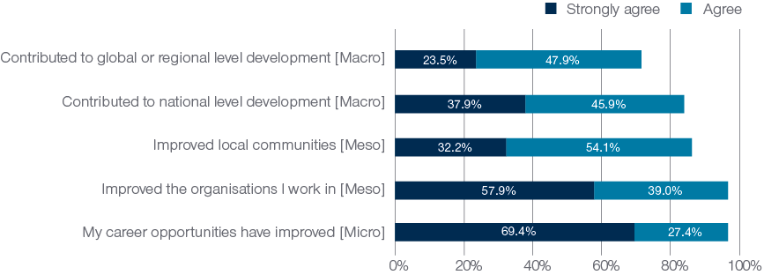

Almost all alumni (96.8 per cent) either strongly agreed (69.4 per cent) or agreed (27.4 per cent) that they have benefited from their award personally, through improved career opportunities. This highlights the micro-level impact of the Australian development scholarships. Broad examples of the **micro**-level impact of the awards are exemplified in the following alumni quotes from the survey.

My study in Australia gave me the confidence needed in strategic discussions, in English business writings, in formulating various frameworks used both in life and work. This helps me grow as both a person and a business executive. **Alumnus from Vietnam**

I have made two research publications from using my knowledge and skills. I have made a research network with my Australian friends and peer that helps me to further study (PhD) in Australia. **Alumnus from Bangladesh**

I have had two promotions after the Awards. My current grade is Deputy Director of Nursing Services. Many thanks to Australia Awards Africa for how far they have brought me. **Alumna from Ghana**

The knowledge I got from my study in Australia provides a strong foundation for my new job as Lecturer. **Alumnus from Indonesia**

At the **meso** level of impact, again nearly every alum indicated that they had been able to improve the organisations they work in as a result of their award (Figure 5). More than 85 per cent indicated they had also used the knowledge and skills they gained on award to improve the communities that they live or work in (32.2 per cent strongly agreed, 54.1 per cent agreed). Examples of work-based contributions have been extensively detailed in the sections above. As such, below are some of the ways alumni indicated they were improving communities.

The community development programmes and initiatives I have the opportunity to design, develop and implement in my current capacity is influenced by the knowledge and skills I developed while on the award. **Alumna from the Maldives**

Since returning I have mentored community based organisations project teams on development of project proposals for funding. **Alumnus from Uganda**

I have always tried to share the knowledge with people around me and never give up telling people, especially young ones, how learning in Australia improved my skills and knowledge and how it's influenced my life. **Alumna from Mongolia**

I was involved in successfully leading a community empowerment project funded by the Australian Government administered in Australia Awards Indonesia in 2018-2019. **Alumna from Indonesia**

At the **macro** level – impact at a global, regional or national level – the proportion of alumni indicating they had made such contributions is impressively high. In total, 83.9 per cent of alumni indicated that they had been able to use their new skills and knowledge to make contributions to development at the national level in their country. A high proportion of alumni (71.4 per cent) also indicated their contributions have been at a regional or global level.

The alumni quotes from the survey below provide insight into the broad range of contributions alumni are making to the benefit of their country as a whole:

Being an officer attached to my country's apex body for the Development Planning, the knowledge that I gained through the award has been a benefit in preparing the Country's Development Plan/ Public Investment Programme. **Alumna from Sri Lanka**

I have contributed to the development and implementation of the national tobacco control and alcohol control laws. **Alumnus from Vietnam**

After my Masters in Public Health I have worked in the field of HIV, mainly in capacity building. I have mentored and built the capacity of 5,000 health workers in two main regions of the country. **Alumna from Uganda**

I have contributed significantly to the development of a new (revised) Indonesian National Standard (SNI) for Land-cover/Land-use Classification with Indonesian Geospatial Information Agency – a reference for land-cover/land-use mapping nationwide. This work was mainly based on my PhD thesis at UQ. **Alumnus from Indonesia**

At an even broader level, the alumni featured in the quotes below are working in their fields to make an impact either within their region or across the globe:

Since I've finished study in Australia, my knowledge and skills have been applied in many investigations against cybercrimes such as child pornography, cyber scams, cyber-attacks...Currently, I am working as an Interpol Cybercrime Officer, my responsibility is coordinate cybercrime operations at regional as well as international level. **Alumnus from Vietnam**

Through the skills I gained, I have been able to link with other scientists regionally and internationally and won several research grants. The recent grant is on InnovAfrica project which is funded by European Union Horizon 2020 that we implementing in six countries in Africa including Kenya with a consortium of 16 partners, five from Europe and 11 from Africa **Alumnus from Kenya**

Recently, I have shown to the world the results of how I have use the new framework tools acquired during my masters. I was invited to be the ocean witness, it is an international initiative, from where, as senior marine officer at WWF-Mozambique, I showed how I work closely with coastal communities every day. This is a model that shows real potential to be applied at national and even regional scale. **Alumna from Mozambique**

At a regional/international level my knowledge and skills allowed me to understand and put into operation an online tool which allows Pacific people to validate and publish biodiversity data. This data can be used to inform field work, research, policy and legislation in the Pacific. **Alumnus from Samoa**

The exposure, experience, learning outcomes on award helped widen my horizon and perspective on many issues, sharpened critical and analytical skills, enhanced communication and leadership abilities. After my return, I continued serving, as an effective diplomat, later led governance team at UNDP Bhutan. I was honoured with award as outstanding diplomat, top global woman and have succeeded in sharing my views and ideas at numerous national and international forum. **Alumna from Bhutan**

| **Alumni contributing to the Sustainable Development Goals**  The survey asked alumni to indicate whether the example of their contribution following award was influencing one or more of the UN Sustainable Development Goals. This new data provides insight into the way in which alumni of Australian development scholarships are contributing to development. As the diagram below shows, alumni are making contributions in all 17 of the SDGs. In particular, almost half of all alumni indicated they have made a difference in SDG 4 – Quality Education, and one in five had contributed to Gender Equality (Goal 5) and to Good Health and Well-being (Goal 3). More than a third indicated they had made an impact in Goal 17 relating to partnerships, and more than one quarter in Decent Work and Economic Growth (Goal 8), Reduced Inequality (Goal 10), No Poverty (Goal 1) and Industry, Innovation and Infrastructure (Goal 9). |
| --- |

This image is an infographic of data from the GTF Global Tracer Survey 2020. It lists all of the UN Sustainable Development Goals and the percentage of all alumni contributing to the goal from largest percentage to smallest percentage.

Title: Australia Awards alumni contributing to the Sustainable Development Goals

Percent of all alumni who are contributing to each SDG 

(4) Quality Education (image of an open book and a pencil): 49.0%
(5) Gender Equality (image of the symbol for male and female with an equals sign inside the circle): 38.4%
(3) Good Health and Well-being (image of heart rate line and heart): 38.2%
(17) Partnerships for the Goals (image of a five circle Venn diagram): 34.5%
(8) Decent Work and Economic Growth (image of a bar graph with an arrow above it pointing upwards indicating growth): 29.6%
(10) Reducing Inequality (image of an equals sign with four triangles pointing out from each side): 28.6%
(1) No Poverty (image of five people holding hands. One person has a walking stick and two are children): 27.0%
(9) Industry, Innovation and Infrastructure (image of three blocks, stacked in a pyramid): 25.4%
(13) Climate Action (image of an eye with the earth as the iris): 23.3%
(11) Sustainable Cities and Communities (image of a house and skyscrapers): 23.1% 
(16) Peace, Justice, and Strong Institutions (image of a dove holding an olive branch standing on a gavel): 22.4%
(6) Clean Water and Sanitation (image of a glass of water with an arrow pointing down out of it): 18.9%
(2) Zero Hunger (image of bowl with steam rising from it): 16.8%
(12) Responsible Consumption and Production (image of an arrow in the shape of an infinity symbol): 13.6%
(7) Affordable and Clean Energy (image of the sun with a power icon inside it): 11.3%
(15) Life On Land (image of a tree and some birds): 11.1%
(14) Life Below Water (image of a fish under some waves): 5.8%

Source: Australia Awards Global Tracer Facility, Global Tracer Survey 2020

Bottom right corner: UN Sustainable Development Goals logo

### 3.5 Enabling alumni to contribute

The survey explored the issues and factors that alumni identified as helping them make the contributions described above. Alumni were asked about factors relating to the skills and experiences gained through their award, the networks that they have engaged in as a result of their award, and specific programs within their scholarship or degree that may have been influential factors in assisting on return to their home country. Responses relating to these enabling factors are detailed in Figure 6.

The responses show that overwhelmingly, the most critically important elements identified by alumni were to do with their own development while on award. New skills were identified by 84.6 per cent of alumni as enabling them to make contributions on return to their home country. Further, increased confidence (82.1 per cent), motivation to contribute (80.3 per cent) and a broadening of mindset (77.9 per cent) were all very strong influences that alumni have drawn on.

Among other enabling factors explored, the most commonly cited by alumni was support in the workplace; 65.9 per cent of alumni indicated this had helped them contribute on return from award. A notable proportion of alumni also highlighted the importance of different support networks that have stemmed from their award. Of particular interest here to Australia Awards country programs and DFAT Posts is the proportion of alumni that noted the support received from the Australia Awards in country (22.7 per cent) and local alumni associations (23.0 per cent) as being important in enabling their post-award contributions.

Specific programs or activities embedded in the course or the Australia Awards were also seen to be important by a substantial proportion of alumni. More than one quarter indicated their reintegration plan – a plan developed as part of their award to help in making a difference on return – had contributed to their ability to contribute to development. Almost one third of alumni mentioned on-award work experience within their course and the support provided by their university during award as elements contributing to their success.

Figure 6: Factors that alumni identify as enabling them to contribute to development – per cent of alumni identifying each factor as important (n=5,394)

Figure 6

Factors that alumni identify as enabling them to contribute to development – per cent of alumni identifying each factor as important (n=5,394). Figure 6 is a bar graph which compares factors that alumni identify as enabling them to contribute to development. Factors are separated into three groups; award skills and experiences (broadened mindset from time on award, individual motivation to contribute to development, increased confidence to implement change in the workplace/community, new/improved relevant skills and knowledge from award), support networks (support from Australia Awards in your country, support from local Australian/Australia Awards alumni association in your country, support from fellow Australia Awards alumni, support from networks developed on award, support from your workplace), and university and award programs (a reintegration plan developed as part of your award, participation in on-award professional work experiences (internships, volunteering etc.), Australian university provided academic and welfare support to ensure success on award).

A particularly interesting finding relating to the factors that enabled alumni to contribute to development after returning from award relates to alumni reintegration plans. Most country and regional programs have some kind of approach to reintegration. However, the understanding of the GTF through our case study work is that this is applied differently in different contexts. As Figure 7 shows, alumni from PNG and Sub-Saharan Africa were substantially more likely than alumni from other large Australia Awards regions to have mentioned the importance of these plans. It is clear from the findings above that such plans are important, but not the most important factor in enabling contributions of alumni. Perhaps this finding offers some potential for further thinking about reintegration plans, the way in which they are implemented, and whether there is benefit in further exploring best practice in this area of alumni support.

Figure 7: Reintegration plan seen as an enabling factor in post-award contributions, percentage of alumni indicating this is important, by region (n= 5,613)

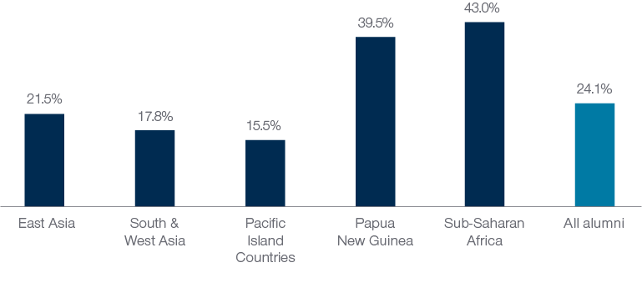

### 3.6 Factors inhibiting contributions

The survey also canvassed alumni perception of issues that have prevented or challenged their ability to make contributions since returning from award. In Figure 8, a range of factors, and the proportion of alumni who indicated these had inhibited their contributions are shown. The factors are grouped thematically into categories including factors relating to the workplace, labour market, broader societal issues and also, given the context in which the survey was being conducted, the impact of COVID-19.

Overall, there was a lower propensity among alumni to report inhibiting factors in comparison to the enabling factors discussed above. Of the issues that were experienced, a lack of workplace resources or funding (48.0 per cent of alumni), personal and family commitments (40.7 per cent) and issues relating to relevant labour market demand for their new skills (between 36 and 37 per cent) were those most commonly mentioned by alumni. As discussed in more detail in the feature box on this subject, about one in ten alumni indicated that they had been stood down, lost their job and/or made redundant as a result of the COVID-19 pandemic, and about a quarter noted that the pandemic had had a negative impact on their work.

From the perspective of Australia Awards programming and policies, many of the inhibiting factors listed here are highly context-dependent and therefore difficult to influence or change. As such, the fact that these are not impacting the majority of alumni is relatively good news. The most relevant thing to programming that this finding highlights is the importance of aligning labour market needs and projections with the choice of course by alumni during the selection processes for the Australia Awards. This is an important topic of discussion between Australian High Commissions/Embassies and partner governments in their annual planning cycles, and perhaps the findings here help to emphasise the importance of continuing to focus on development needs and future labour market opportunities in assigning priority areas for selection of future scholars.

Figure 8: Factors that alumni identify as inhibiting their contribution to development – per cent of alumni identifying each factor as inhibiting contributions (n=5,383)

Figure 8

Factors that alumni identify as inhibiting their contribution to development – per cent of alumni identifying each factor as inhibiting contributions (n=5,383). Figure 8 is a bar graph which compares the proportion of alumni who identified factors which are inhibiting their contribution to development. These factors were separated into five groups: Personal/family commitments, workplace related (Workplace resources and funding, Resistance to change, Limited opportunity for advancement/new work tasks, Change of leadership in my workplace, Limited influence in the workplace, Assigned to position unrelated to award), labour market (Securing relevant work post award, Limited opportunities/job market for award/new skills and knowledge), COVID-19 (COVID-19: change in workplace assignment/priorities/projects delayed, COVID-19: stood down from work/redundancy/job loss), and broader issues (Corruption/nepotism, Bias - other (i.e. apart from gender and disability), Connectivity - availability of internet and other communications resources, Bias - gender, Bias - people with disability).

**COVID-19 Responses – Alumni using skills and knowledge to make a difference**

Alumni have been using their skills and knowledge gained on award to contribute to the COVID-19 pandemic response. The virus was first detected in Wuhan, China in late December 2019 and rapidly spread around the globe in 2020. It was declared a pandemic by the World Health Organisation on 11 March 2020 and has caused significant economic and social disruption across the globe as countries struggled to control the spread of the virus, and deal with rising numbers of infections and deaths.

The Global Tracer Survey 2020 provided the GTF a unique opportunity to collect specific data relating to the initial impact of the COVID-19 pandemic on alumni, their workplaces and their contributions through several tailored questions. It found 46.8 per cent of alumni respondents had been involved in the response in some form. Of the types of alumni responding there were a large proportion of alumni who had studied in the field of health while on award who were involved in the response (60.9%). There were also large proportions of alumni who worked for an NGO (59.9%) or a multilateral organisation (57.5%) who had been involved in the COVID-19 response.

The survey also asked about the kinds of tasks alumni were involved in as part of the response. Of the alumni that responded:

* over a quarter of these tasks involved policy and planning or development work
* one quarter were providing education, awareness, or communication about COVID-19
* around one in seven alumni were contributing to the scientific or medical development or assistance to the COVID-19 response
* a small number of respondents also provided logistical and IT support during the COVID-19 response.

Alumni faced many challenges due to COVID-19. Of alumni surveyed, around a quarter had faced changes in their workplace assignment or priorities, or had projects delayed due to COVID-19. One in ten alumni reported having lost their job as a result of the pandemic.

Further analysis of the data, as well as detailed alumni interviews, are explored in the a case study undertaken by the GTF in early 2021 – *Australia Awards Global Tracer Facility: Alumni Case Study – alumni contributions to the COVID-19 pandemic response* (Doyle & Clarke, 2021). The case study focuses on the experiences of eight alumni from different countries and demonstrates how their skills and knowledge gained on award have been used in the response to the pandemic.

This image is a data visualisation of data from the GTF Global Tracer Survey 2020, focusing on alumni who have been involved in the COVID-19 response

Title: Snapshot of COVID-19 alumni responses  

46.8% of alumni responding to the 2020 Global Tracer Survey have been involved in the COVID-19 response efforts.  

Box 1: Left-hand side

COVID-19 Responders 
Two small images in the right corner of the box representing a male and female alumni.

Which alumni are making contributions to the COVID-19 response? 

52% of male alumni and 42% of female alumnae 
56 % of alumni in leadership positions  
61% of alumni who studied health  
60% of alumni who work in for an NGO  
58% of alumni who work in a multilateral organisation 
53% of alumni who work in the public sector 
46% of alumni who work in universities or academia  
35% of alumni who work in the private sector 

Right-hand side of Box 1

Types of Responders 
1 in 10 alumni are first responders (frontline workers) Image of a female nurse in uniform.
Over half of those involved in the COVID-19 response were considered secondary responders (those supporting COVID response efforts) Image of zoom meeting on a computer screen. 
One in six were policy and intergovernmental responders (high level decision makers and policy designers) Image of a clip board with a list and a large tick 

Box 2: Underneath box 1, in the middle of the page
The image is of a COVID virus with three text boxes coming out of three of the protein spikes.

Kind of tasks alumni undertook in the response to COVID in their workplaces: 
¼ of alumni tasks were policy and planning, or development work  
1 in 7 alumni were contributing to the scientific or medical development or assistance 
3% were supplying logistical and IT support 

## 4. Cooperation with Australia

Overall, most alumni develop connections with Australians while on award, including with Australian students, university lecturers and academics, individuals in the community and individuals working in their field. The survey demonstrates that alumni who developed these connections while on award are more likely to maintain links with individuals from Australia after returning from award. The findings discussed here indicate that Outcome 2 of the Australia Awards is being achieved.

### 4.1 Introduction

One of the outcomes sought by the Australia Awards is that the experience helps facilitate the development of ongoing relationships between individuals in Australia and other countries. Outcome 2 of the Australia Awards specifies that alumni are contributing to cooperation between Australia and partner countries. The focus of this outcome is on the **individual, professional and personal people-to-people connections** that are made while on award and continued after returning from award. This chapter explores the findings from the questions in the Global Tracer Survey that explored the networks, relationships and connections alumni developed while on award and the extent to which these continued post award.

### 4.2 Connections developed while on award

Alumni were asked to reflect on how frequently they had interacted with different individuals while on award in Australia. As shown in Figure 9, the groups with which alumni were most likely to report frequently interacting with while on award included other Australia Awards students and other international students. Alumni were least likely to report frequently interacting with individuals in Australian businesses, organisations or professional associations in their field. Around a third of alumni reported never interacting with businesses or professional associations while on award.

Figure 9: On-award frequency of contact with individuals met while in Australia – ‘While you were on award in Australia, how often were you in contact with…’ (n=5,519)

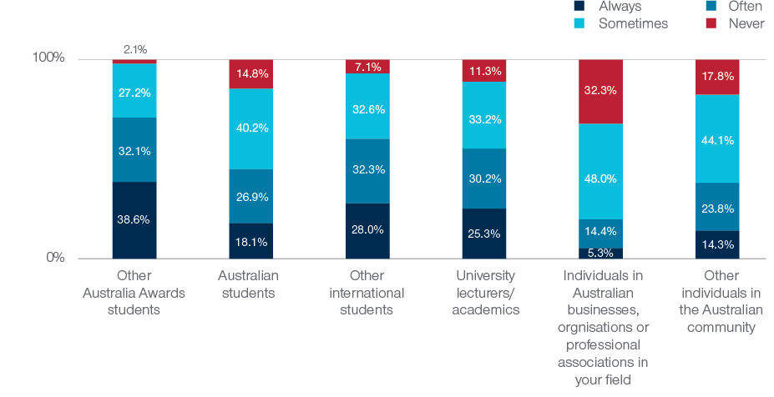

Alumni who were in Australia for a longer period of time tended to also report having more frequent contact with individuals in Australia. This is perhaps unsurprising, but nonetheless important to be able to document and confirm through the survey data. Figure 10 shows that the proportion of alumni who reported frequently being in contact with other students, academics and individuals in the Australian community increased with the length of time spent in Australia on award.

Figure 10: Proportion of alumni who reported often or always being in contact with individuals while on award by length of time in Australia as part of Award (n=5,519)

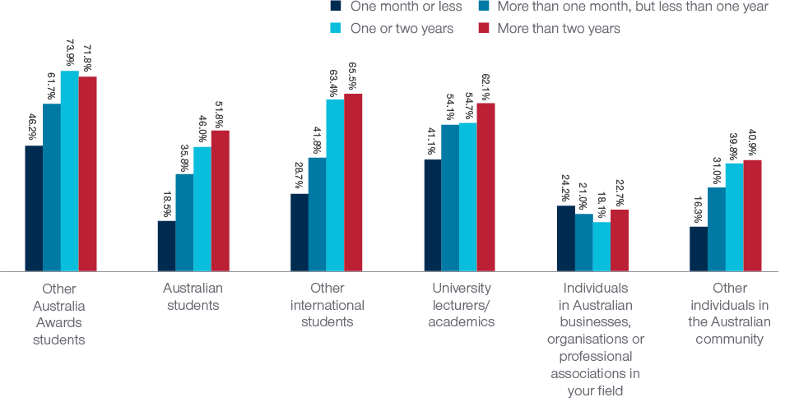

There did not appear to be a clear relationship between the time alumni spent in Australia and their frequency of contact with individuals in Australian businesses, organisations or professional associations in their field. This is perhaps because some of the shorter awards and fellowships under Australia Awards have specifically been focussed on a relationship within an industry or professional organisation in Australia.

Analysis of survey data was also explored in relation to the type of qualification completed by alumni. This showed that alumni who undertook a Doctorate while on award in Australia reported a greater frequency of contact with university lecturers or academics than other alumni. More than three quarters of Doctoral alumni said that they often or always had contact with university lecturers or academics, compared with only 54.1 per cent of other alumni. Alumni who undertook Doctoral studies while on award were also more than twice as likely to name university staff as the most important relationship or connection developed as a result of their Award (36.3%) than other alumni (17.2%). This finding is likely a reflection of the close supervisor-candidate relationship required in Doctoral studies, as well as the slightly longer duration of this qualification.

### 4.3 Connections maintained after returning from award

Alumni were also asked to indicate how frequently they interacted with people or groups they had met while on award in Australia since returning home. As seen in Figure 11, since returning from award, alumni were most likely to have remained in contact with other Australia Awards students, other international students and other individuals in the Australian community they had met in Australia.

Figure 11: Post-award frequency in contact with individuals met while in Australia – ‘Since returning from award, how often are you in contact with the following people you met while in Australia…’ (n=5,498)

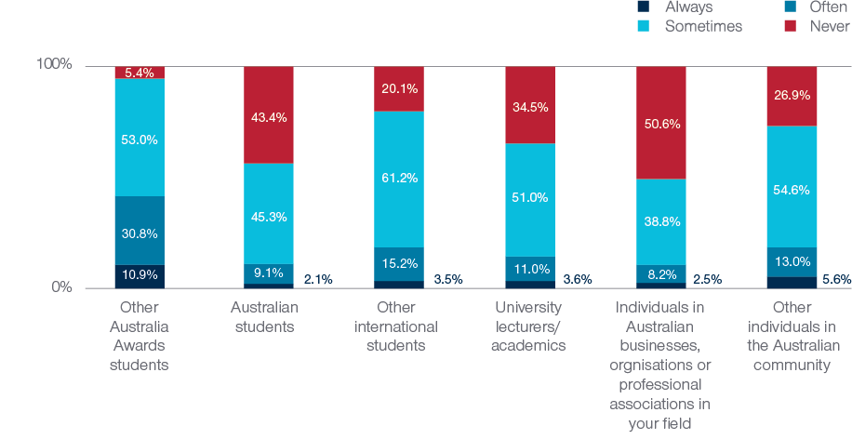

There was a moderate, positive and statistically significant correlation between frequency with which alumni have contact with others on award and their frequency of contact with others post award. This correlation was strongest for contact with individuals in Australian businesses, professional organisations or organisations in their field.[6] Around two-thirds of alumni who indicated that they had contact with Australian businesses or organisations at least sometimes while on award also reported having contact with individuals from Australia in their field since returning from award. Only 12.9 per cent of alumni who reported never having contact with Australians working in their field while on award had some contact with these Australians working in their field post award.

The following examples provided by alumni add some context to the way in which alumni relationships developed on award are fostered and continue well after the alumni have returned home:

Part of my personal support network includes people I met during my award, including other awardees. They are strong friendships that help me get through difficult personal times, as well as give perspective and new ideas when facing professional challenges. **Alumna from Mexico**

At the personal level, the people I studied with, lived with, and knew when I was in Australia are always considered close friends of mine as we share common memories from the experience. **Alumnus from Indonesia**

The relationship between alumni would be the most important connection I made on award. After a long time of communicating and connecting during the award, other alumni have become a stable multidisciplinary network and we support each other in work and lives. **Alumnus from Vietnam**

I have developed a close connection with a course mate in education who is an Australian and we still communicate. I also still communicate with other Australia Award alumni of other nationalities whom we were together with in the same batch. **Alumna from PNG**

I am still in contact with some lecturers from the Masters Program who offer opportunities for workshops online, seminars, academic publications etc. I am in contact with one specific lecturer from the University of Newcastle, she facilitated some recommendations letters for academic jobs in Bolivia. I value these relationships very much. **Alumna from Bolivia**

Alumni also reflected on how frequently they were in contact with key links to Australia and other alumni since returning from award – specifically the Australian High Commission, Embassy, Consulate or Australia Awards team in their country, and Australia Awards alumni associations. More than half of all alumni indicated that they had had at least some contact with the Australian High Commission, Embassy, Consulate or Australia Awards team in their country (64.2%) since returning from award. Furthermore, most alumni (83.8 per cent) have had some contact with an Australian alumni association following their return home. Most alumni (60.9%) also reported being in contact with Australians that they work with as part of their job.

As shown in Figure 12 , although most alumni reported having at least some contact with the Australian High Commission, Embassy or Consulate or Australia Awards team, or with an Australian alumni association in their country, the frequency with which alumni are interacting with these organisations differs greatly by region. Almost half of all alumni from Sub-Saharan Africa, and more than 30 per cent of those from PNG and South and West Asia reported having frequent contact (that is, they indicate they are often or always in contact) with an Australian alumni association or an Australia Awards alumni association since returning from award.

The value of relationships between alumni and High Commissions, or alumni associations is shown through a sample of cases provided by alumni in the survey. While each individual relationship is nuanced and different, the examples below are illustrative of the networks that alumni have been able to establish as a result of being an alumni of the Australia Awards – even with groups or individuals they did not specifically connect with while on award.

I maintain relationships with Australia Awards alumni, Australia Awards staff and the Embassy of Australia in Mongolia. Serving as an Executive Director of Mongolia Australia Society (Mozzies), I'm in constant contact with alumni and coordinate our work with Australia Awards and the Embassy of Australia in Mongolia. In addition, I regularly attend AusCham events, where I meet with the Australians working in Mongolia. **Alumna from Mongolia**

From a professional point of view the connection with the Australian Embassy in Argentina is really important in terms of collaboration and support. **Alumnus from Argentina**

At work, we Australia Awards alumni often cross paths as I am working in the Government sector and we always communicate and coordinate with other institutions which also have an extensive number of Australia Awards alumni. **Alumnus from Indonesia**

I am involved in Australia Award Alumni Sectoral Group in order to identify the activities which I together with other alumni contribute to the development of Timor-Leste. I chair the Infrastructure Sectoral group. We work with others to identify the ideas and activities that are useful for community, students and youth as part of development solutions for the country. **Alumnus from Timor-Leste**

Figure 12: Proportion of alumni who reported often or always being in contact with Australian organisations since returning from award (n=5,432)

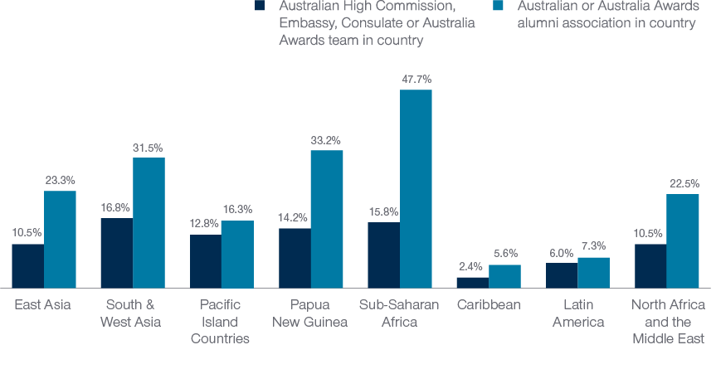

## 5. Partnerships

Around a third of alumni reported having opportunities to develop partnerships with Australian organisations or individuals while on award, and a similar proportion of alumni had developed partnerships with organisations or individuals in Australia after returning from award. The findings from the survey highlight that alumni who had opportunities to develop partnerships with Australians while on award were more likely to have established partnerships in the years following their award. The fact that some, although not the majority, of alumni have gone on to develop partnerships with organisations and individuals suggests that long-term Outcome 3 of the Australia Awards is being partially met.

### 5.1 Introduction

The third long-term outcomes sought by the Australia Awards program is that alumni are able to develop partnerships between Australia and partner countries. Specifically, Outcome 3 of the Australia Awards aims for the development of **‘effective, mutually advantageous partnerships between institutions and businesses in Australia and partner countries’**. This outcome is subtle in its difference from Outcome 2, discussed in the chapter above. Whereas Outcome 2 (discussed in the previous chapter) focuses on the development of person-to-person connections, Outcome 3 is focussed on the development of formalised professional partnerships developed between alumni and Australians or Australian organisations.

This chapter explores the findings from the questions in the Global Tracer Survey that focussed on the opportunities alumni had to develop partnerships with Australians or Australia while on award and the extent to which they have been able to establish partnerships since returning from award. Previous research by the GTF has shown that the area of professional partnerships between alumni and Australians was one aspect of the Australia Awards long-term outcomes that is less commonly ‘achieved’ by alumni than the other outcomes. As such, for the 2020 Global Tracer Survey, new questions and additional probing of alumni to gain greater insight into this long-term outcome were developed. In particular, the GTF were interested in understanding the extent to which alumni felt they had opportunities to begin to foster relationships *while on award* and whether this was a factor in the extent to which alumni developed partnerships after returning home.

This chapter looks at these outcomes for alumni. It also explores the factors that have enabled alumni to develop partnerships with Australians and Australian organisations and for alumni who have not yet had a partnership, the factors that have prevented them developing these partnerships.

### 5.2 Development of partnerships with Australians

#### 5.2.1 Opportunities on award, and outcomes post award

Alumni were asked about the opportunities they had while on award in Australia to develop partnerships with Australians or Australian organisations, and also whether they had developed any partnerships after completing their award. Overall, just over one third (36.4 per cent) of alumni indicated that they had had opportunities to develop partnerships with Australians or Australian organisations while on award in Australia and a similar proportion (36.3 per cent) of alumni had gone on to develop a partnership in the period since completing their award.

Importantly, the survey demonstrates that alumni who had opportunities to develop partnerships with Australians while on award were more likely to have developed partnerships following their award.[7] Almost two thirds (63.2 per cent) of alumni who had opportunities to develop partnerships while on award subsequently been able to establish a partnerships with Australians or Australian organisations after completing their award. At the other end of the spectrum, only 20.8 per cent of alumni who said that they did not have opportunities to develop partnerships while on award had subsequently developed partnerships with Australians or Australian organisations.

Figure 13: Relationship between having opportunities to develop partnerships while on award and post-award development of partnerships with Australians or Australian organisations (n=5,006)

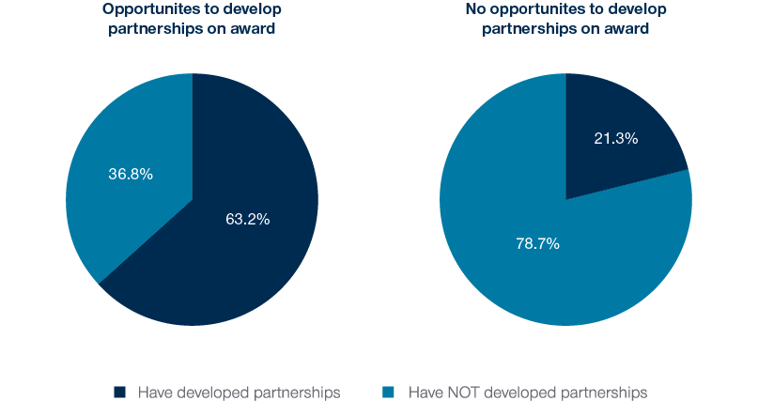

This is an important finding for the Australia Awards because it highlights the value of providing opportunities for scholars to build professional relationships and develop networks while on award. The survey results show that those who have this opportunity while in Australia have a significantly higher likelihood of developing professional partnerships with Australian organisations further down the track when they return home. Given this particular long-term outcome of the Australia Awards is one of the key areas where there is lower overall achievement, the evidence here helps to demonstrate the importance of fostering on-award professional relationships for Australia Awards scholars. The survey data explored below examines this finding in more detail, looking across degree types and regions.

Figure 14: Proportion of alumni by level of study who had opportunities to develop partnerships with Australians while on award and who have developed partnerships with Australians post award (n=5,049)

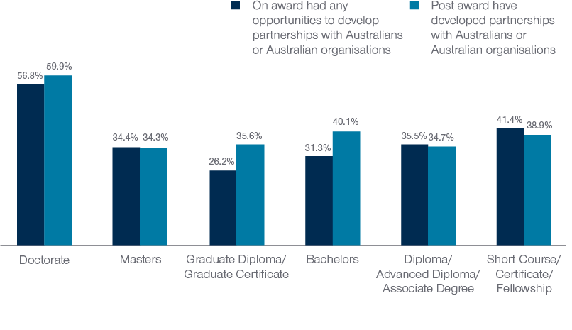

As shown in Figure 14, alumni who were doctoral candidates were the most likely to have had opportunities to develop partnerships while on award and to develop partnerships with Australians or Australian organisations after completing their award. Of the 56.8 per cent of alumni from doctoral programs who had opportunities to develop partnerships while on award, 75.6 per cent developed partnerships with Australians or Australian organisations after completing their award.

The proportion of alumni who reported having opportunities to develop partnerships and who subsequently developed partnerships with individuals or organisations from Australia also varied by region. Figure 15 shows that alumni from PNG were most likely to report having opportunities to develop partnerships while on award and to have subsequently established partnerships after completing their award. Alumni from Caribbean, Sub-Saharan Africa, and South and West Asia, were the least likely to have partnerships with Australians or Australian organisations. More than 60 per cent of alumni from these regions indicated that they neither had opportunities to develop partnerships while on award nor developed partnerships with Australians or Australian organisations since completing their award.

Interestingly, Figure 15 shows that alumni from the Pacific Island Countries, PNG and East Asia were more likely to report having developed a connection after their award, than they were to report having had the opportunity for developing these networks while on award. For the PNG and Pacific results here, perhaps this is indicative of the integration of Australia and Australian organisations in these regions.

Figure 15: Proportion of alumni by region who had opportunities to develop partnerships with Australians while on award and who have developed partnerships with Australians post award (n=5,197)

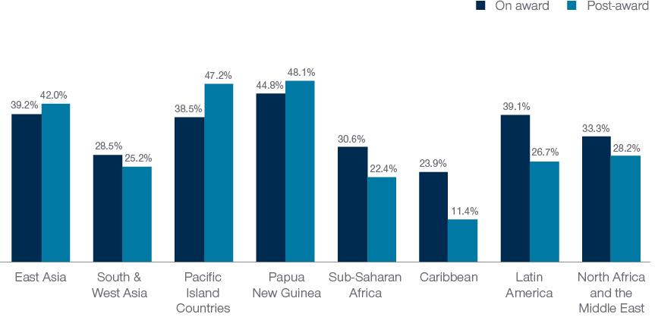

#### 5.2.2 Types of partnerships

Alumni who had developed partnerships with Australians or Australian organisations were asked to describe the sectors they had partnered with and also the type of partnerships that they had developed. As shown in Figure 16, the majority of alumni who had partnerships indicated that at least one of these connections was with an Australian university. Perhaps unsurprisingly, among alumni who completed a Doctorate while on award, 85.7 per cent of their partnerships were with Australian universities.

The survey asked alumni about the types of professional partnerships that they had formed since returning from award. As shown in Figure 17, the most common type of partnerships alumni had was a studying or mentoring relationship. In addition, alumni are partnering with Australians to undertake research, in their capacity as public servants, and through NGOs, private businesses and other organisations.

Figure 16: Sectors of partnerships alumni had post award with Australians or Australian organisations, percent of those who have a partnership by sector of partnership [note percentages do not sum to 100 because alumni could select multiple sectors for partners] (n=1,868)

Figure 16

Sectors of partnerships alumni had post award with Australians or Australian organisations, percent of those who have a partnership by sector of partnership [note percentages do not sum to 100 because alumni could select multiple sectors for partners] (n=1,868). Figure 16 is a bar graph which compares the types of sectors alumni have partnerships with. These sectors are Universities, National or State Government Departments, Non-Government or Community Organisations, Private sector businesses, Multilateral organisations, Disabled People's Organisations, and other sectors.

While the data above provides an overall perspective of the partnerships with Australians developed by alumni, the examples directly from alumni are provided below to offer insight into the nature of these relationships. The selected examples span a range of different organisations and types of relationships and are set out based on some of the categorisations in the figure above.

Figure 17: Type of partnerships alumni had post award with Australians or Australian organisations, percent of those who have a partnership by type of partnership [note percentages do not sum to 100 because alumni could select multiple types] (n=1,474)

Figure 17

Type of partnerships alumni had post award with Australians or Australian organisations, percent of those who have a partnership by type of partnership [note percentages do not sum to 100 because alumni could select multiple types] (n=1,474). Figure 17 is a bar graph which compares the type of partnerships alumni had post award with Australians or Australian organisations, of the alumni who stated they have a partnership. These partnership types are Studying or mentoring, Research or project collaboration, State or governmental organisations, NGO or community organisations, Business partnership or private business, Peak body or professional organisation, Funding or grants, and other

**Mentoring and study relationships** are broad ranging, the three examples below help demonstrate this:

I am providing mentorship to Masters in Public Health students at the University of Melbourne. **Alumna from Uganda**

I am involved in professional mentoring and partnership with colleagues from the Bureau of Meteorology and CSIRO on activities implemented in the Pacific. **Alumna from Samoa**

My organisation has received internship students from a few Australian universities several times. I was selected as the mentor for those students. This program has run under an agreement from my organisation. **Alumnus from Indonesia**

In **research work** and the funding for such work, examples of alumni who work closely with Australians include the following:

I am involved with collaboration on Tuberculosis (TB) research between the University of Sydney, the Woolcock Institute of Medical Research (WIMR), and the National Lung Hospital, National TB Programme and other institutions in Vietnam. **Alumnus from Vietnam**

I have been able to bring two experts from Griffith University’s Business School to develop the faculty capacity in research and research supervision at my university. They provided training to academics at Gede College of Business Studies (GCBS). **Alumna from Bhutan**

I have had collaborative projects with my Australian university supervisors. We won two grants from DFAT to enhance the pre-hospital care in Indonesia. The grants were organised by my supervisors and I on behalf of the two universities, Monash University and Universitas Brawijaya. **Alumnus from Indonesia**

While **partnerships within the private secto**r are less common, the two examples below provide insight into the sort of partnerships alumni are forging in the private sector – the first in ICT, the second in engineering:

*At Thimphu TechPark, we have two Foreign Direct Investment companies from Australia. My Australian connection has helped in fostering good relationship with them.* **Alumnus from Bhutan**

*I work with the contract department in my company who are responsible for formalising contractual agreement with third parties. I settled several Services Agreements with Australian based engineering consulting companies.* **Alumnus from Indonesia**

As Figure 17 shows, a small but important group of alumni are working with or within NGOs and other similar organisations where they have partnerships and professional links with Australian organisations. Specific examples from alumni responses to the survey are provided below to illustrate these kinds of partnerships.

During my studies I completed my practicum at the Bouverie Family Therapy Centre since then I have a regular contact with them. Through this relationship, practitioners from private practice came to Mongolia to conduct training for us. This became our regular activity, we try to organise it every other year. **Alumna from Mongolia**

I am volunteering with Engineers Without Borders (Australia) in my country. **Alumnus from Cambodia**

I am involved in a strategic partnership with CBM in Australia on disability-inclusive development. **Alumna from Indonesia**

I worked as a volunteer with Australian Doctors International and am still using that organisational contact in my current job to do programs during this COVID-19 pandemic. It's been an interesting journey so far with so many other contacts in Australia which I maintain. **Alumna from PNG**

### 5.3 Factors enabling and inhibiting partnerships with Australians

Alumni who had developed partnerships with individuals or organisations in Australia were asked about the factors that had enabled them to develop these partnerships. More than half of alumni who had developed a partnership with Australians indicated that developing these partnerships were part of their job (62.4%), that they had shared interests or priorities with their partner (60.1%), or had opportunities while on award to meet and network with Australians and Australian organisations (53.7%). The availability of financial and non-financial resources to commit to a partnership was an enabling factor indicated by 29.4 per cent of alumni who had partnerships with Australians.

Alumni working in the university sector were more likely than alumni in other sectors to indicate that having shared interests and priorities, and having opportunities to meet and network with Australians and Australian organisations while on award were factors that had enabled them to develop their partnerships. Alumni working in multilateral organisations were more likely to say that developing partnerships was part of their job and that they had resources available to commit to a partnership than alumni working in other sectors.

The vast majority of alumni who had not yet developed partnerships with individuals or organisations from Australia wanted to develop such partnerships (89.7 per cent). These alumni were asked about the factors that had prevented them from developing partnerships. As shown in Figure 18, the most common factor preventing alumni from developing partnerships with Australians or Australian organisations was not knowing whom to approach to develop a partnership.

Figure 18: Factors that have prevented alumni from developing partnerships with Australians or Australian organisations, proportion of alumni yet to develop a partnership by factors identified as inhibiting this (n=2,652)

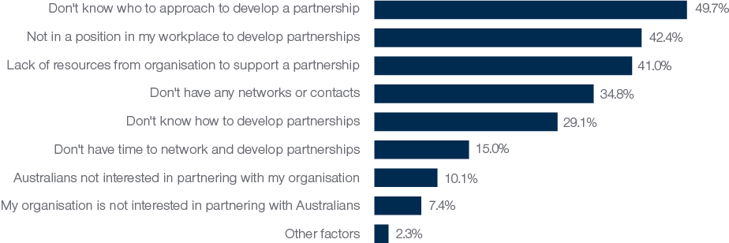

Alumni who had not had the opportunity to develop partnerships with Australians while on award were more likely to say that they did not have any networks or contacts, did not know whom to approach to develop partnerships, and did not know how to develop partnerships. Conversely alumni who had had opportunities to develop partnerships with Australians while in Australia on award but who had not yet developed partnerships post award were more likely to say that they had a lack of financial or non-financial resources to develop partnerships, or a lack of time to network and develop partnerships.

## 6. Views of Australia

Alumni overwhelmingly hold positive views of Australia, Australians and Australian education. They are promoting Australia through advice in relation to further study, and in order to help others develop connections and partnerships with Australians and Australian organisations. The evidence collected in this survey suggests that Australia Awards long-term Outcome 4 is being achieved.

### 6.1 Introduction

The fourth long-term outcome of the Australia Awards is that **‘Alumni view Australia, Australians, and Australian expertise positively’**. This outcome is important, because of the way it can resonate across, or contribute to all other outcomes of the Australia Awards. The implication being if an alum leaves Australia with strong, positive views of its people and expertise, then that person is far more likely to stay connected, refer to the skills they acquired and share their experiences more widely. As highlighted in prior research by the GTF (see in particular Edwards et al., 2020), there is very strong evidence to suggest this outcome is achieved through the Australia Awards. In the 2020 Global Tracer Survey, views about Australia and Australians were explored in relation to a number of statements presented to alumni. This chapter explores responses from alumni to these statements about their experience in Australia, and their involvement in encouraging others to pursue opportunities with Australia and Australians.

### 6.2 Experience of Australia and Australians

Alumni were very positive about their experiences of Australia. As shown in Figure 19, almost all respondents to the survey agreed with each of the four statements presented to them about their experience. Overall, 99.4 per cent of alumni indicated that their experience of Australia as a country and Australian education was positive, 99.4 per cent said that their experience of Australian people was positive and 98.2 per cent indicated that they feel the Australian Government supports their country.

Figure 19: Views of Australia, levels of agreement of alumni to selected statements (n=5,239)

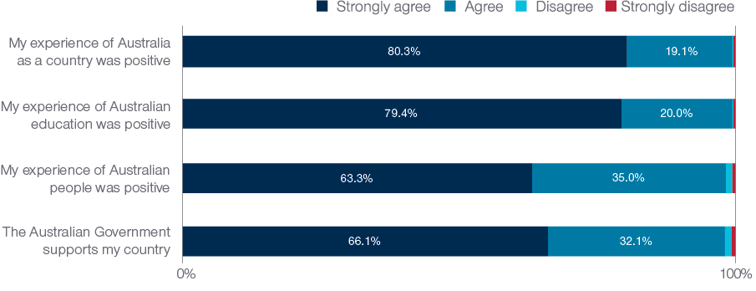

On the first three statements shown in Figure 19, there is almost no difference in the sentiment of alumni when examined by gender, field of study, region or country. However, for the last statement in the list, relating to perceptions of support by the Australian Government, there were interesting regional differences (Figure 20). In the regions closest to Australia – PNG and the Pacific Island Countries, a very high proportion of alumni strongly agreed that the Australian Government supports their country. However, in regions where Australia has reduced or finalised its support for development scholarships, the levels of disagreement with this statement was relatively high – Latin America and the Caribbean stand out in this regard. For these two regions, the agreement to the other statements relating to views of Australia were equally as high as other regions, the big difference was just in this statement relating to Government support.

Figure 20: Alumni agreement to the statement 'The Australian Government supports my country' by region of citizenship (n=5,239)

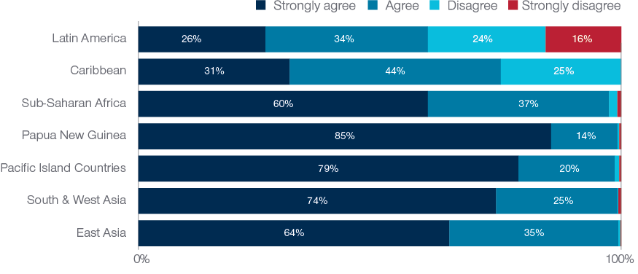

### 6.3 Promoting study and connections in Australia

Alumni across the globe are strong ambassadors for Australian education, with most alumni responding to the survey saying that they often or always recommend Australia as a place to study (Figure 21). Findings from previous research by the GTF have shown that alumni provide this advice to colleagues, friends and family (Edwards & Taylor, 2019), illustrating that the ongoing promotion of Australian education by alumni is broad and reaches across their networks.

While the vast majority of alumni indicated that they often or always recommend Australia as a place to study, alumni who interacted with other students, university lecturers, academics, and other Australians while on award were even more likely to recommend Australia as a study destination. This pattern was most marked for alumni interactions with other Australia Awards students. Alumni who reported that they had contact with other Australia Awards students while on award at least sometimes were more likely to recommend Australia as a place to study often or always (94.6%) than alumni who had no contact with fellow Australia Awards students while on award (84.7%).

As Figure 21 shows, a smaller overall percentage of alumni indicate they are engaged in providing advice about how to connect with Australia and Australians. This is not surprising given the discussion in the previous chapters in relation to the overall proportion of alumni who have been able to successfully develop professional partnerships with Australia. In exploring the responses in more detail, it is important to highlight that alumni who have established a partnership with Australians or Australian organisations were far more likely to have provided advice to others about developing partnerships (75.3 per cent often or always do this) than those who have not yet consolidated a professional link with Australia (among whom fewer than half indicate frequently providing advice). Alumni who had interactions with individuals working in their field while on award in Australia were also much more likely to provide advice to others about developing partnerships (65.1 per cent do this often or always) than alumni who did not interact with these individuals while on award (only 43.2 per cent do this often or always and 20.8 per cent never do this).

Figure 21: Proportion of alumni who say they always or often recommending Australian study and connections (n=5,117)

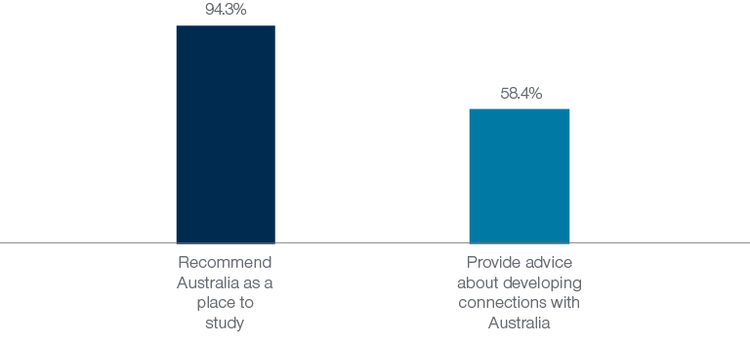

## 7 Conclusion

The findings of this large, global study consolidate previous work of the GTF, and offer comparable and consistent evidence relating to the long-term outcomes of alumni from Australian development scholarships.

In examining survey responses relating to the four long-term outcomes of the Australia Awards, the findings show very strong and positive achievement in Outcome 1, contributions to development, in Outcome 2, cooperation with Australians, and Outcome 4, views of Australia. For Outcome 3, partnerships with Australia, the overall proportion of alumni achieving this has been low relative to the other outcomes. However, in and of itself, this is the most challenging outcome to achieve, and the survey findings are able to point to areas of success in this regard, as discussed below.

From an Australia Awards programming perspective (and consolidating the outcomes-based analysis above), the findings presented in this report here confirm that the experience, education and networks that alumni develop while on award in Australia are very much being utilised in order to contribute to sustainable development and human capital development by alumni on return to their home countries. The evidence relating to connections and partnerships post award strongly suggests that increased engagement with Australians and Australian organisations while on award is of utmost importance in enabling ongoing partnerships and networks in the years following completion of the award.

Further work to promote the ongoing contributions of alumni – perhaps through exposure relating to the SDG-related findings in this survey, that alumni are contributing to all 17 SDGs – is integral to ensuring the importance and merit of this investment is recognised within Australia and internationally. In addition, using the data collected here to explore means for improving factors which alumni identify as enabling and facilitating their ongoing contributions and success is paramount. Potential future work could further analyse the data collected in this survey to explore specific outcomes or identify particular ‘touch points’ for individual region or country programs that may help in enhancing the already strong outcomes of Australia Awards alumni.

### 7.1 Conditions for success

In addition to the overall conclusions outlined above, the GTF have explored the survey findings from a perspective of identifying ‘conditions for success’. In essence, these are statements distilled from the analyses in this report that point to factors or issues for which there is survey evidence to suggest that if these conditions are satisfied, the likelihood of positive long-term outcomes is greater. This approach follows a similar distilling of findings in a report by the GTF that summarised the first four years of its research (Edwards et al., 2020).

The table below focuses on the findings from this survey and maps each identified ‘condition for success’ to its potential level of impact (micro, meso or macro), to the stage of the Australia Award, to the relevant long-term outcome/s and to Australia Awards delivery partners that can potentially influence or enable this particular condition for success (see DFAT, 2019, p. 3 for list of delivery partners). This is intended as a means of focussing the overall findings of this survey into specific avenues that delivery partners can potentially explore within their own program contexts.

Table 2: Conditions for success - factors identified in the survey that contribute to achieving Australia Awards long-term outcomes, by award stage, long-term outcome and delivery partner

| **Level of Impact** | **Award stage** | **Relevant AA long-term outcome** | **Delivery partner/s that can potentially influence this** |
| --- | --- | --- | --- |
| **Micro – individual-level factors** |  |  |  |
| Selected applicants for the awards are motivated to support sustainable development. | Selection | Outcome 1 | Posts, Managing Contractors (MCs) |
| Technical and soft skills are developed/enhanced as part of award. | On-award | Outcome 1 | Host Institutions |
| Positive and transformative learning experiences are provided on award. | On-award | Outcome 1 | Host Institutions |
| Skills and knowledge about how to effectively engage in professional networking are developed/enhanced as part of award. | On-award | Outcome 2 | Host Institutions, Posts, MCs. |
| Alumni have the time and resources to invest in partnership development. | On- &  Post-award | Outcome 3 | Host Institutions, Posts, MCs, employers* |
| Alumni are in a position within their organisation that enables them to engage with networks and partnerships established in Australia. | Post-award | Outcome 2&3 | Employers of alumni* |
| **Meso – organisational/program-level factors** |  |  |  |
| Opportunities to meet with Australian organisations and professional bodies are provided on award. | On-award | Outcome 3 | Host Institutions, Posts, MCs |
| Professional work experiences/internships are offered on award. | On-award | Outcome 2&3 | Host Institutions |
| Workplaces are supportive and enable alumni to apply new skills and knowledge. | Post-award | Outcome 1 | Employers*, Posts, MCs, Alumni] |
| Workplaces have the resources/funding to enable alumni to use skills and foster networks/partnerships. | Post-award | Outcome 1, 2 & 3 | Employers* |
| Alumni’s workplace/sector engages in collaboration or cooperation with Australian organisations or multilateral forums. | Post-award | Outcome 2&3 | Alumni, [employers*], Posts, MCs |
| Australia Awards reintegration programs/initiatives support alumni post award. | Post-award | Outcome 1 | Posts, Managing Contractors |
| **Macro – societal/government-level factors** |  |  |  |
| Local job market demand is identified/projected and selection decisions incorporate likelihood of post-award employment. | Planning & selection | Outcome 1 | Partner Countries, Posts |
| Positive experiences of Australia, Australians and Australian education are provided on award. | On-award | Outcome 4 | Post, Host Institutions |

*This group is not a defined Australia awards ‘delivery partner’ but included here due to the importance in relation to this condition for success.

## 8 References

Boeren, A. (2018). Relationships Between Scholarship Program and Institutional Capacity Development. In J. R. Dassin, R. R. Marsh, & M. Mawer (Eds.), *International Scholarships in Higher Education: Pathways to Social Change* (pp. 23–42). Palgrave MacMillan.

DFAT. (2019). *The Australia Awards Linkages Good Practice Guide: Enrichment support for delivery partners and scholars*. Department of Foreign Affairs and Trade. https://www.dfat.gov.au/sites/default/files/australia-awards-linkages-good-practice-guide.pdf

Doyle, J., & Clarke, L. (2021). *Australia Awards Global Tracer Facility: Alumni Case Study – alumni contributions to the COVID-19 pandemic response*. Australia Awards Global Tracer Facility, DFAT. https://www.dfat.gov.au/people-to-people/australia-awards/australia-awards-global-tracer-facility-year-5-results

Edwards, D., Doyle, J., Haddow, A., & Radloff, A. (2020). *Global Impact of Australian Aid Scholarships: Long-term outcomes of alumni*. Australia Awards Global Tracer Facility, DFAT. https://www.dfat.gov.au/sites/default/files/global-impact-australian-aid-scholarships-long-term-outcomes-alumni.pdf

Edwards, D., & Taylor, A. (2019). *Global Tracer Survey Report Year 3, Alumni of 2011 to 2016*. Australia Awards Global Tracer Facility, DFAT. https://www.dfat.gov.au/sites/default/files/australia-awards-global-tracer-facility-survery-alumni.pdf

Mawer, M. (2018). Magnitudes of Impact: A Three-Level Review of Evidence from Scholarship Evaluation. In J. R. Dassin, R. R. Marsh, & M. Mawer (Eds.), *International Scholarships in Higher Education: Pathways to Social Change*. Palgrave MacMillan. DOI 10.1007/978-3-319-62734-2_13

## Appendix A: 2020 Global Tracer Survey instrument

The full survey instrument is available via pdf at the following site:

<https://research.acer.edu.au/cgi/viewcontent.cgi?article=1025&context=tracer>

## Appendix B: Awards included in the GTF Global Tracer Survey population

Table 3: Scholarships, fellowships and other awards included in population for the 2020 GTF Global Tracer Survey

| Awards included in population scope |
| --- |
| Australian Development Scholarships |
| Australia Awards Scholarship |
| Australia Awards fellowship |
| Australian Leadership Awards |
| Australia Partnership Scholarships |
| Australian International Development Assistance Bureau |
| Australian Sponsored Training Assistance Scheme |
| Carnegie Mellon University AusAID Scholarships |
| Australia Pakistan Scholarships Program |
| Australia Iraq Agricultural Scholarships |
| Equity and Merit Scholarship Scheme |
| Colombo Plan Scholarships |
| Australian Development Cooperation Scholarships |
| United Nations Development Programme |
| Eduka Scholarships |
| International Monetary Fund |
| John Crawford Scholarship Scheme |
| Kiribati Australia Nursing Initiative |
| AusAID Private Sector Category |
| Australian Partnership Scholarship |
| Winrock |
| Commonwealth Scholarship and Fellowship Program |

**Note**: in addition to this list, alumni with the notation ‘Unspecified Development Award’ in DFAT records were also included in the population scope. Alumni who responded to the survey were asked to update the detail of their award where possible.

## Appendix C: Survey response rates by region and gender

Table 4: Target population, responses and response rates by region and gender, Australia Awards Alumni Global Tracer Survey 2020

| Region | Total Target Pop | Achieved responses | Response Rate all | Female target pop. | Male target pop. | Female achieved responses* | Male achieved responses* | Female Response Rate | Male Response Rate |
| --- | --- | --- | --- | --- | --- | --- | --- | --- | --- |
| East Asia | 14,455 | 3,583 | 24.8% | 7,477 | 6,978 | 1,826 | 1,754 | 24.4% | 25.1% |
| South & West Asia | 3,454 | 1,018 | 29.5% | 1,535 | 1,919 | 441 | 577 | 28.7% | 30.1% |
| Sub-Saharan Africa | 2,535 | 807 | 31.8% | 1,214 | 1,321 | 392 | 415 | 32.3% | 31.4% |
| Pacific Island Countries | 1,336 | 271 | 20.3% | 678 | 658 | 139 | 131 | 20.5% | 19.9% |
| Papua New Guinea | 1,409 | 288 | 20.4% | 747 | 662 | 153 | 135 | 20.5% | 20.4% |
| Latin America | 354 | 138 | 39.0% | 188 | 166 | 80 | 57 | 42.6% | 34.3% |
| North Africa and the Middle East | 201 | 47 | 23.4% | 44 | 157 | 11 | 36 | 25.0% | 22.9% |
| Caribbean | 134 | 51 | 38.1% | 78 | 56 | 27 | 24 | 34.6% | 42.9% |
| Other/unknown | 131 | 18 | 13.7% | 19 | 32 | 6 | 12 | 31.6% | 37.5% |
| *Global Total* | *24,009* | *6,221* | *25.9%* | *11,980* | *11,949* | *3,075* | *3,141* | *25.7%* | *26.3%* |

*five respondents chose not to identify as either male or female as such the total responses by Female and Male alumni do not sum to the Global Total.

1. See <https://www.dfat.gov.au/sites/default/files/australia-awards-global-strategy.pdf> and <https://www.dfat.gov.au/sites/default/files/australia-awards-global-monitoring-evaluation-framework.pdf> for detailed information about the long-term outcomes.
2. All published GTF research reports can be found here: https://www.dfat.gov.au/people-to-people/australia-awards/Pages/australia-awards-global-tracer-facility
3. Alumni with email addresses that were invalid (i.e. the GTF received a ‘bounce-back’ message when invitation for survey was sent) are excluded from this number. It is possible some of these ‘valid’ emails are unmonitored email accounts, but verifying this is not possible. As a result the actual *contactable* alumni population for this survey is probably lower than the number listed here and used to calculate response rates.
4. The response rate is calculated as the number of responses divided by the total number of alumni in the target population, expressed as a percentage.
5. All GTF publications can be found here: <https://www.dfat.gov.au/people-to-people/australia-awards/australia-awards-global-tracer-facility>
6. (*τ*b = .513, *p* < .01)
7. Opportunities for partnerships during award is moderately and significantly correlated with development of partnerships post award (*τ*b = .418, *p* < .01).