Australia-Cambodia Cooperation for Equitable Sustainable Services (ACCESS) End of program evaluation
FINAL Report

Report prepared by:
Alinea International – Mia Urbano, Kim Vesely, Phoebe Hardefeldt, Sereyroth Lim, Georgia Naughton-Watt
alineainternational.com

Front Cover Image: Kaheng Community Hall, in Kampong Speu
Accessible image caption: A small community hall with tiled floors, cream walls, and a pitched roof. There is a table with some chairs, a whiteboard, and some banners inside. Tiled steps lead to the wide entrance, and there is an access ramp to the right side. There are plants and small trees beside the entrance to the hall.
Contents
- ACRONYMS 4
- ACKNOWLEDGEMENTS 5
- Executive summary 6
Introduction 6
Findings 7
Lessons learned and implications for future programming 10
- Introduction and methodology 14
Purpose and scope of the evaluation 14
Methodology 14
Limitations 15
- program overview 16
Context 16
Program overview 17
- findings 20
Relevance 20
Effectiveness 24
Efficiency 35
Sustainability 40
- Annexes 44
Annex 1 Terms of Reference 44
Annex 2 ACCESS Program Logic Version 2 46
Annex 3 ACCESS Program Logic Version 3 47
Annex 4 Stakeholder Interview List 48
Annex 5 ACCESS Geographic Coverage 51
Annex 6 ACCESS Implementing Partners 52
Annex 7 DFAT Disbursements 54
Annex 8 ACCESS Organisational Chart 55

ACRONYMS
ACCESS | Australia-Cambodia Cooperation for Equitable Sustainable Services | IP | Implementing Partner
ADD | Action on Disability and Development International | JPAs | Judicial Police Agents
AHRC | Australian Human Rights Commission | JPOs | Judicial Police Officers
ASC | ACCESS Steering Committee | LAC | Legal Aid Cambodia
ASEAN | Association of Southeast Asian Nations | MEF | Ministry of Economy and Finance
AWP | Annual Work Plan | MoH | Ministry of Health
CCHR | Cambodia Centre for Human Rights | MoI | Ministry of Interior
CCWC | Commune Committee for Women and Children | MoSVY | Ministry of Social Affairs, Veterans and Youth Rehabilitation
CDHS | Cambodia Demographic and Health Survey | MoWA | Ministry of Women’s Affairs
CDPO | Cambodian Disabled People’s Organisation | NAPVAW | National Action Plan to Prevent Violence Against Women
CIMP | Competitive Investment Mechanism Panel | NDSP | National Disability Strategic Plan
CIP | Commune Investment Plan | NGO | Non-Governmental Organisation
CNCW | Cambodia National Committee for Women | OPD | Organisation of Persons with Disabilities
CWCC | Cambodian Women's Crisis Centre | PDoWA | Provincial Department for Women’s Affairs
DAC | Disability Action Council | PFM | Public Financial Management
DAC-SG | Disability Action Council-Secretariat General | PRC | Physical Rehabilitation Centre
DFAT | Department of Foreign Affairs and Trade | PWDF | Persons with Disabilities Foundation
DSA | Daily Subsistence Allowance | RGC | Royal Government of Cambodia
DWPD | Department of Welfare for Persons with Disabilities | SAQUS | Service Access Quality Uptake Study
GBV | Gender-Based Violence | TPO | Transcultural Psychosocial Organisation
GDA | General Department of Administration | TWG | Technical Working Group
GD-SNAF | General Directorate for Sub-national Administration Finance | TWGG-GBV | Technical Working Group on Gender- Subcommittee for GBV
GEDI | Gender Equality and Disability Inclusion | UN Women | United Nations Entity for Gender Equality and the Empowerment of Women
GRB | Gender-Responsive Budgeting | UNFPA | United Nations Population Fund
HI | Humanity & Inclusion | UNICEF | United Nations Children’s Fund
IDPoor | Identification of Poor Households | WDC | Women’s Development Centre
ACKNOWLEDGEMENTS
The evaluation team would like to express their appreciation for the support by DFAT, the Royal Government of Cambodia and the ACCESS program team who gave their time to support the evaluation and share their honest reflections on the ACCESS program. Special thanks are owed to the team at the Australian Embassy in Cambodia, and to ACCESS management and the GBV and disability workstream leads. They have been highly engaged in the process over the course of months and brought wonder powers to coordinating the moving feast that was the fieldwork schedule. Thanks, are also due to Jodie Nguy from CBM International who has provided review and advice on this report.
Finally, thank you to the ACCESS implementing partners and many local and international experts and organisations who provided the vital bridge to understanding the contexts and service gaps for people with disabilities and women survivors of violence across Cambodia. Your perspectives grounded our understanding of ACCESS and what to illuminate through this report.
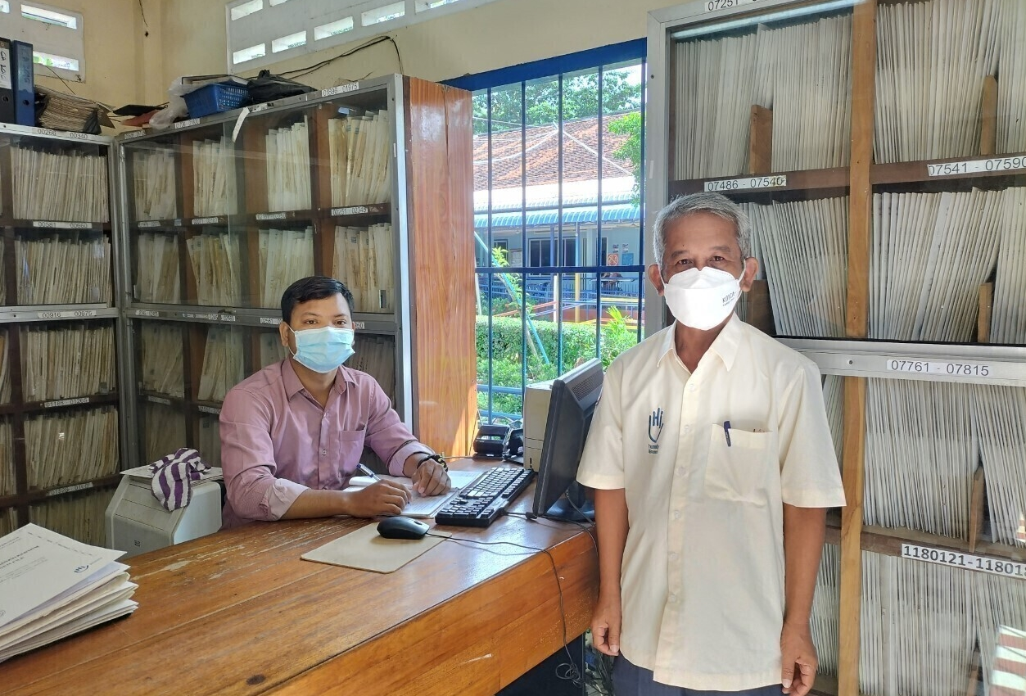
Image: Mr Duong Cheatha, PRC Manager and Mr Uka Tola in the administration office of the Kampong Cham Physical Rehabilitation Centre.

Executive summary

Introduction
Advancing gender equality and disability inclusion are central tenets of Australia’s development partnership with Cambodia. Cambodia is estimated to have one of the highest disability prevalence rates of any developing country, and people with disabilities face compounding inequalities and discrimination if they are women, young, or indigenous people, that limit their full and equal access to services. Gender inequalities persist across many domains of Cambodian life, underpinned by cultural norms that manifest in barriers to women’s participation, voice and access to services and in their most extreme form have led to high rates of gender-based violence (GBV), especially among women with disabilities. Barriers to equality and inclusion are exacerbated by underlying poverty and geographic isolation in rural areas. While relatively recent policy and regulatory frameworks provide a foundation for action, financing and implementing these frameworks remains a challenge. Women and girls, LGBTQI+ people, indigenous people, people with disabilities and marginalised groups face increased vulnerabilities in the context of COVID-19, heightening the need for inclusive service delivery.
Australia-Cambodia Cooperation for Equitable Sustainable Services (ACCESS) is a five-year AUD 25 million investment by the Australian Government to develop sustainable, quality, and inclusive services for gender-based violence (GBV) survivors and people with disabilities in Cambodia. ACCESS seeks to strengthen service delivery links between the Royal Government of Cambodia (RGC), international and local NGOs and multilateral agencies at national and sub-national levels, to support collaboration and coordination in both the disability and GBV sectors. Recognising Cambodia’s transition to a lower middle-income country, it also has a focus on strengthening the financial sustainability of quality services relating to gender-based violence (GBV) and disability inclusion. These objectives are encapsulated in ACCESS’s two end-of-program outcomes (EOPOs), noting that discussion of the shifts in these outcomes is included at multiple points in this evaluation:
- Ministry of Social Affairs, Veterans and Youth Rehabilitation (MoSVY), Disability Action Council (DAC) and Ministry of Women’s Affairs (MoWA) better mobilise RGC resources for GBV and disability services, with support from Ministry of Economics and Finance (MEF).
- RGC, civil society organisations and the private sector sustainably provide better quality, more inclusive and more accessible services for people with disability and women affected by GBV.
To achieve this, the program contributes to the formulation and implementation of the National Action Plan to Prevent Violence Against Women (NAPVAW) and the National Disability Strategic Plan (NDSP) via both direct technical assistance to government institutions and the provision of grants to 14 implementing partners. The program had a wide geographic footprint with interventions at a national level and across 15 provinces, with a particular focus on the three priority provinces of Kampong Speu, Kampong Cham and Siem Reap.
ACCESS was implemented in a rapidly evolving operating context, with the onset of the Covid-19 pandemic overlayed on a backdrop of decentralisation and deconcentration imperatives, institutional change in relevant RGC ministries, and during Cambodia’s transition to low-middle income status. Responding to these changes and working to build and maintain strong Government partnerships required an adaptive and flexible approach by the ACCESS team, particularly as the policy of not systematically providing daily subsistence allowances (DSAs) was a challenge for building buy-in to program activities.

Findings
This evaluation was commissioned by DFAT to assess the relevance, effectiveness, efficiency and sustainability of the ACCESS program over its five-year duration; and to answer the question as to whether ACCESS’s focus and approach to improving service delivery for victims of GBV and people with disabilities is a relevant and effective route to advancing gender equality and social inclusion in Cambodia. The evaluation was also sought to identify lessons learned and best practices generated through ACCESS; and to provide an evidence base to support the shaping of Australia’s future support for gender equality, disability and social inclusion in Cambodia. A summary of the top line findings against the key evaluation questions is as follows:
Relevance: Is ACCESS’s focus and approach to improving service delivery for victims of gender-based violence and people with disabilities a relevant and effective route to advancing gender equality and social inclusion in Cambodia? Are there other types of programs that could be more effective in advancing social inclusion in Cambodia going forward?
ACCESS was found to be highly relevant and aligned with the development policy and thematic priorities of the RGC and Australia on support to survivors of GBV and people with disabilities. The program has played a formative role in the refinement and updating of policies and national standards as one of the single largest donor-contributors to the implementation of RGC commitments in these sectors. ACCESS maintained its relevance by working adaptively and proactively to seize opportunities to promote inclusion within the changing delivery context of COVID-19, which emerged early in the program’s lifecycle and continues to impact on all aspects of the Cambodian context. This is well evidenced by the identification of people with disabilities as eligible for enrolment in the IDPoor scheme, and by the recovery of client caseloads after the drop in client numbers during lockdowns in 2021.
Access to services is an essential need for survivors of violence and for people with disabilities, a priority under respective sectoral plans for RGC and Australia, and it is an ongoing gap in public service provision in many countries, including Cambodia. Hence, it is a relevant and well substantiated area for ACCESS to have focused upon. Working with RGC on systems strengthening is also warranted in terms of increasing the visibility and sustainability of these public services, although it dictates a slower, more incremental pace of progress. Complementing this with support to implementing partners (IPs), who work with clients at the subnational level, was a sound choice to support ‘supply’ and ‘demand’ sides, even if the breadth of scope has ultimately overextended staff.
Where relevance is less strong is in terms of the ACCESS delivery modality. Although attributable to the design rather than delivery strategies, ACCESS was not strongly aligned to the political economy landscape and the realities of budgetary processes. Initial program outcomes on public financial management set unrealistic expectations, specifically an increase in fiscal allocations by MEF on the basis of improved line ministry budget submissions - for the two underfunded, advocacy areas of disability and GBV services. The pursuit of a competitive investment mechanism (CIM) which initially set up rivalry and silos between partners is also counter to the collective action that is needed for progress on GBV and disability responses. A second area where relevance is questionable is ACCESS support to mediation or ‘counselling’ to respond to GBV. While mediation is inscribed in law, it is not survivor-centred, and it does not align with international guidance on responding to GBV. As part of the ACCESS program, The Asia Foundation (TAF) engaged Women Peace Makers (via sub-granting arrangement) to develop guidelines on the ‘limited use’ of mediation. However, mediation accounts for a high proportion of GBV services by ACCESS IPs, and so a consultative process with IPs is needed to guide ACCESS’s discontinuation of these services, with avoidance of harm as the paramount consideration.
Lastly, the question about whether other types of programs could be more effective in advancing social inclusion in Cambodia sits above evaluation of the ACCESS program. The evaluation did not include a counterfactual or undertake a benchmarking exercise. Beyond ACCESS, interventions such as labour market and vocational education programs, access to land title and finance initiatives can play a fundamental role in closing socio-economic gaps for certain population groups, if well targeted and tailored. They could conceivably reach more people. However, this evaluation concludes that those areas – i.e., labour market, education – will be a natural focus for RGC as the country graduates to higher income levels. There are also other DFAT programs with the capacity to contribute expertise here. Whereas services for two population groups who are typically hidden or stigmatised, world over, needs advocates. Building upon ACCESS’s results and ecosystem of partners to create more integrated and inclusive services, with associated social protection and advocacy elements, remains a well justified and worthy focus for advancing social inclusion and gender equality. That notwithstanding, three conclusions can be drawn from the consultations undertaken: 1) that there was consensus among IPs that the program should have had more focus on clients, and supporting actual service utilisation and demand; 2) that the voice of both service users or organisations representing them was marginal in the program, when this is often key to progress on social inclusion; and 3) that financial security through employment or access to livelihoods is a priority for people with disabilities to secure their independence and for survivors of GBV to have the option to leave a violent relationship.
Effectiveness: Was ACCESS effective in achieving its intended outcomes?
Multiple changes to the ACCESS Theory of Change (ToC) mean it is not straightforward to measure effectiveness. There were three ToCs in three years, not including the version in the Design Document, removal of the PFM-related end of program outcome (EOPO), and rewording of the new sole EOPO. Changes were also made to the wording and orientation of intermediate outcomes. While these changes were endorsed by DFAT and convey the team’s adaptiveness, the changing of goals posts poses a challenge for measuring performance against outcomes. The evaluation concludes that it would have been preferable to change strategies and workplans, rather than change the EOPOs to this degree.
On the original PFM-related EOPO, despite efforts, ACCESS was ultimately not effective. On the best available evidence, ACCESS made only minor progress against the original PFM EOPO. Securing an agreement in Year 1 for MEF to cover the DSA of RGC official participation in ACCESS is a prominent achievement. In the face of setbacks, ACCESS has also elevated the agenda within the two line ministries, MEF and subnational officials about the need to finance disability and GBV services. However, a strategy more focused on working with MEF, than supporting MoSVY and MoWA in the preparation and defences of their own budgets, was required. The gradual shift to exploring options for financing at the subnational level demonstrates the program’s awareness of financing as key to sustainable service delivery. However, the social affairs budget lines managed by the subnational level are limited in value and are in demand from many services including health and education.
On the EOPO relating to services, ACCESS was effective in improving the coverage and quality of services, while effectiveness was limited in terms of inclusiveness. The program exceeded its own client target numbers, and it quickly re-established case numbers after lockdowns. ACCESS technical leads and IPs for disability and GBV led and facilitated partner input into the development of sectoral and facility-based guidelines and standards, such as for PRC management and for GBV essential service standards – thus making a major contribution to quality. The combination of ACCESS’s technical assistance to the RGC on the enabling environment, complemented by IP work on subnational service delivery has been an effective strategy for advancing the coverage and quality.
Inclusiveness in service delivery was most significant in the work of CARE Cambodia with Indigenous populations in Ratanakiri province. LAC and CWCC supported women with disabilities who were experiencing violence in their service outreach. Inclusiveness in terms of gender responsiveness (beyond GBV) and disability inclusiveness, and attention to diversity in disabilities has been more limited, albeit increasing over time, with examples such as the commissioning of the study on autism. The initiative taken by IPs Action on Disability and Development International (ADD) and the Cambodian Women and Children’s Crisis Centre (CWCC) to collaborate on the development of a training package and integration of gender-responsiveness and disability inclusiveness is notable. Other IPs that paid attention to inclusiveness in their work include: HI and CDPO both partnered with Banteay Srey to conduct gender equality training to PRC staff/OPD members; TAF consulted the ACCESS disability team to ensure that their communication materials were accessible to persons with disabilities. The Internal Rapid Review (2020) recommended that ACCESS invest in support to services for women with disabilities. ACCESS then commissioned PAfID to conduct a study exploring women’s access to rehabilitation services. This was published in July 2022.
More on inclusiveness could have been done earlier in the program, but this was somewhat hampered by a lack of specialist resourcing on staff from the outset. ACCESS commissioned a consultant to develop a GESI strategy early in the program, which was followed by two gender equality and social inclusion (GESI) reviews of the program. A Senior GESI Officer was appointed in the final year of Phase 1, with a workplan in place by January 2021.
On a supplementary note, ACCESS has been effective in forging linkages with the RGC. ACCESS’s high profile as an inclusion program and DFAT’s strong engagement has supported relationships to be built with RGC counterparts. ACCESS has worked effectively with MoSVY and MoWA, adapting to changes in structures and personnel (in the case of MoSVY), being reformed-minded (such as on the draft Disability Law and limited use of mediation for GBV) while maintaining good working relationships, and working at a pace that is compatible for the two ministries. Progress has also been good in governments’ engagement in the ACCESS Steering Committee, and in the evolution of its membership to include Ministry of Interior (MoI), Persons with Disabilities Foundation (PWDF) and Deputy Provincial Governors.
Beyond government, a more collaborative, partnerships-based approach to IPs and adviser engagement could have better harnessed their expertise and increased ACCESS’s collective impact. ACCESS’s work with the private sector is marginal, and mostly confined to the IPs in the disability workstream working on economic opportunities.
Efficiency: To what extent has ACCESS been an efficient and effective program model to deliver outcomes?
Overall, the ACCESS delivery modality has not proven to be an efficient implementation approach. The competitive investment mechanism is the primary vehicle for the achievement of service-related outcomes. However, this has resulted in the dispersal of relatively small grants (between AUD 200,000-600,000) to 14 partners who vary in strategic influence and capability, across 15 provinces. Some management and human resourcing efficiencies may have been anticipated in having a centralised grants window, rather than a broader programmatic approach for achieving outcomes. However, the model more resembles a ‘small bets’ approach working with a range of partners who, while vetted, have differing capability. This has undermined coherence, and ultimately, impact.
This judgement is not, however, a criticism of the ACCESS management and technical leads. This small team has managed to deliver an immense number of outputs – providing advice to RGC, leading training, events, meetings with national and subnational authorities, and coordinating the work of implementing partners. It has met and exceeded almost all targets set by the program. Despite being overstretched, staff have maintained their responsiveness to RGC and the program is regarded positively by government stakeholders.
Sustainability: Are program achievements and impacts sustainable?
As one IP remarked, “What is ACCESS? A good start.” Three dimensions were considered in measuring sustainability. The first was financial sustainability, and on this aspect – particularly service delivery – sustainability has not been achieved. In some cases, the sustainability of elements such as the GBV working groups was even questioned by more than one stakeholder, if funding for UN Women was removed. The second dimension considered by the evaluation was the sustainability of quality elements that were introduced as part of system strengthening efforts. This includes guidelines, standards and revision to laws and plans, a number of which have been endorsed by line ministry entities and submitted for RGC approval and adoption. This official uptake of ACCESS products is likely to be sustainable and paves the way for their ongoing impact. The last aspect of sustainability relates to human resources and organisational capacity. At this stage, ACCESS’s achievements – such as quality standards for managing PRCs – will be undermined by the lack of a public sector workforce or cadre of physiotherapists, prosthetic and orthotic specialists, and social workers to maintain these services. ACCESS was aware that these staffing shortages were a barrier to service delivery, as well as to sustainability. It also recognised that the Ministry of Health (MoH) was critical to the resolution of staffing issues, especially for disability service providers. However, since MoH is not a formal partner, ACCESS was not well positioned to engage with the line ministry. ACCESS support to partners was oriented to activities and outputs aligned with ACCESS outcomes. It was not focused on organisational development, nor on IP engagement with government, outside of some interaction by OPDs on the revised Disability Law. The way of working with partners through the CIM meant that a focus on their enduring role on the demand side of services was under-emphasised.

Lessons learned and implications for future programming
The lessons below are high level reflections by the evaluation team drawing upon the findings discussed above and in the main report. This is then followed by some recommended future directions for DFAT and other development partners in their support for gender equality, disability and social inclusion outcomes in Cambodia:
Focus area | Lessons learned
Relevance | - ACCESS is unique in scale and scope in giving effect to Cambodia’s national plans and Australia’s core commitments to people with disabilities and addressing gender-based violence.  - The political economy of resource allocation and influence on strategic priorities is shifting in the context of decentralisation and deconcentration, and Covid-19 fiscal constraints, and needs to underpin efforts to support change in this space.  - A balanced approach to engagement at the national and sub-national level, and in strengthening the capacity of service providers to then support service delivery is required if changes in the services are to be realised  - The limited engagement of Ministry of Health (MoH) poses constraints for service delivery, staffing and functioning referral systems for both people with disabilities and survivors of violence.
Effectiveness | - Consolidating and building on gains from predecessor programs and investing time in developing strong relationships with RGC counterparts was central to ACCESS’s success in advancing its outcomes, including in challenging areas.  - Strengthening coordination and emerging referral processes has been a strength of ACCESS, which is critical in underpinning integrated service delivery for survivors of GBV and people with disabilities.  - The assumption in the design, that improvements in the quality of budget preparation processes and supporting MoSVY and MoWA on ‘arguing the case’ would lead to increased budget allocations did not hold.  - Initiatives that seek to advance economic empowerment of survivors of GBV and people with disabilities need to be conscious of safeguarding to ensure they are likely to fulfill their empowerment objectives and mitigate risks.  - Critical GBV services are missing in the context such as a national hotline with connections to province level frontline services, state co-financed shelters and emergency accommodation. This means there is still much to build up in the system.  - GESI skills were required to support an intersectional approach to activities between the workstreams.
Efficiency | - Design choices including the decision to work across multiple ministries and sectors, levels of government, and inclusive of NGO sector have meant that ACCESS is a resource-intensive model to implement, in terms of geographic, technical and partner breadth, and working at national and subnational levels. Also, the decision for the ACCESS team to be implementers on top of supporting IPs impacted what the program could deliver.  - In terms of ACCESS team resourcing, technical staffing was lean – including limited STA inputs by international advisers and the lack of GESI staff until late in the program. Ensuring technical staff are not drawn into administrative and logistical matters also needs to be better bounded.  - DFAT resourcing was adequate however, the geographic and institutional footprint and number of partners engaged in the ACCESS program were highly ambitious and necessitated a high volume of management oversight and resourcing. DFAT was highly engaged and made efforts to be present and support as many ACCESS events, as possible. However, with the high volume of ACCESS activities, this was time-consuming and DFAT engagement would be best concentrated on policy and RGC level dialogue in future.  - Better use of the program and RGC assets, for example using the program office or ministry spaces for meetings, or co-locating the technical leads within related ministries, would reduce costs while increasing the quality of the engagement.  - DFAT was highly engaged and made efforts to be present and support as many ACCESS events, as possible. However, with the high volume of ACCESS activities, this was time-consuming and DFAT engagement would be best concentrated on policy and RGC level dialogue in future.  - Approaches to engaging IPs and ACCESS advisors was inefficient and should be designed to harness their expertise, and promote collaboration and two-way learning to support program decision making. In addition, the lack of GEDSI advisers early in the program’s implementation meant that opportunities for a more intersectional approach were missed.  - Cost consciousness could be improved, especially in better use of the office space through to a more modest approach to ACCESS branding and branded products.
Sustainability | - Choosing to work closely with RGC has been critical to some of ACCESS’s strongest outcomes. This technical assistance strand of work has been important in the context of no budget support.  - The competitive mechanism for engaging IPs and decision not to fund DSAs created further hurdles to building government engagement and sustainable partnerships for long-term improvements to service delivery.  - There are diverging views about the program’s sphere of influence and who holds the responsibility and influence for achieving the end of program outcomes – RGC, ACCESS or IPs?

Implications for future programming:
- A new program should increase involvement and the voice of GBV survivors or responders and of people with disabilities. This is to inform prioritisation and strategic directions and to guide ongoing programming – on the grounds of principle and effectiveness.
- The geographic footprint should be carefully considered in future programs with a view to the specific outcomes sought to be achieved in each province. Concentrating on fewer provinces would enable the further refinement of service delivery models as demonstration sites for RGC. However, risks related to the withdrawal of support to particular IPs and locations / local government relationships need to be managed.
- A new design should look to support new financing mechanisms that have political buy-in to be taken forward, alongside considering options for the self-reliance of services.
- It is important to more closely engage with the MoH in future programming since women survivors and people with disabilities are likely to need ongoing referrals for complex needs within the public health and hospital system.
- Staffing and workforce issues will have a major bearing on the sustainability of services. This includes for PRCs where public sector terms and conditions undermine staff retention in the transition from NGO to government management. Social workers are also needed for both disability and GBV service provision – including case management, referral and continuity of care - in the long term.
- When GBV survivors do seek assistance, police, alongside health services, are key points of first contact. GBV sensitisation workshops need to be offered to more police stations. There is also a recognised need to socialise ministries such as MEF and MoI to the specific elements in GBV and disability service provision, and their costs.
- There is a need to increase skill and expertise in child protection within PRCs given the high client volume of children under 18 years in these centres as well as contact with children through PRC community outreach activities.
- The CIM is contrary to the very coordination of partners that is needed for GBV and disability service delivery. An alternative, more strategic approach to partnership is advisable.
- Greater exchange with and exposure to international and Australian expertise and approaches to GBV and disability service delivery would be valuable for the GBV and Disability Leads, IPs and RGC.
- Australia should continually re-assess its engagement in mediation services as mediation is not survivor centred, does not treat violence as a criminal offense and it is inconsistent with international guidance.
- Consideration should be given to co-location arrangements of ACCESS’s GBV and Disability Leads to deepen relationships with RGC.
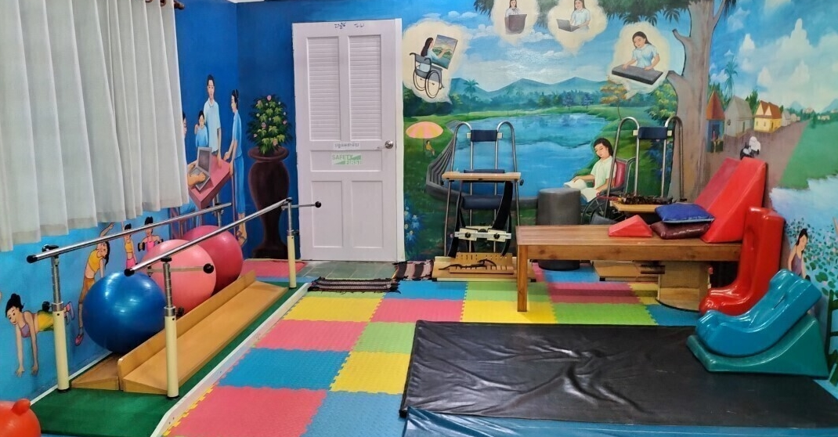
Image: The child friendly room at the Kampong Cham PRC.

Introduction and methodology

Purpose and scope of the evaluation
The purpose of the evaluation was to:
- Assess the relevance, effectiveness, efficiency and sustainability of the ACCESS program over its five-year duration, evaluating the extent to which it has achieved its intended outcomes, its impact on Cambodia’s disability and GBV services, and the quality of support provided to people with disabilities or experiencing GBV.
- Identify lessons learned and best practices from the ACCESS program. These findings will interrogate whether the focus and approach of ACCESS is the most appropriate and effective way for Australia to advance GEDSI outcomes, and the implications of Phase 1 lessons for future programming.
This evaluation assessed ACCESS’s performance and results since its inception in 2018, responding to four high-level key evaluation questions (KEQs):

Key Evaluation Questions
Relevance: Is ACCESS’s focus and approach to improving service delivery for victims of gender-based violence and people with disabilities a relevant and effective route to advancing gender equality and social inclusion in Cambodia? Are there other types of programs that could be more effective in advancing social inclusion in Cambodia going forward?
Effectiveness: Was ACCESS effective in achieving its intended outcomes?
Sustainability: Are program achievements and impacts sustainable?
Efficiency: To what extent has ACCESS been an efficient and effective program model to deliver outcomes?

Methodology
A convergent mixed methods design was used for triangulation of data during and after the evaluation field mission conducted in August 2022. Primary data was collected in Phnom Penh, Kampong Speu and Kampong Cham. Evidence was collected through the following methods:
- Document review. Review of 100+ program documents, including the ACCESS MIS system and M&E database (‘Amelia’), activity reports and financial data. Reviewed international literature on GBV and disability-related service delivery.
- Key informant interviews. Semi-structured interviews included program managers from both ACCESS and DFAT, as well as RGC partners from MoWA, MoSVY, MEF, and MoI at both the national and sub-national (provincial, district and commune) levels. Other interviews were conducted with IPs, independent context and sectoral experts, NGOs and development partners.
- Focus group discussions. With the GBV and Disability Workstream IPs, and beneficiaries reached through organisations supported by IPs.
- Site visits / observation. The team visited one Physical Rehabilitation Centre (PRC) in Kampong Cham, and the MoWA-supported Women’s Development Centre (WDC) in Kampong Speu.
- Continuous reflection and triangulation of data. The team recorded and regularly processed findings while on mission. This process enabled a quick distillation of conclusions that was able to be checked in subsequent interviews and through the quantitative data, using contribution analysis.
The Evaluation Team conducted 55 interviews and focus group discussions with approximately 200 stakeholders (80 male, 119 female) between August and October 2022.
The Evaluation Team used rubrics for synthesis and to form judgements on the evidence to answer the four KEQs. These rubrics draw on the implicit values in the sub-questions and are an adaptation of DFAT’s Annual Investment Monitoring Review (IMR) ratings matrix.

Limitations
There were three key limitations that had a bearing on the scope and findings of this evaluation. The first were logistical in nature. The two-week duration of the mission meant that consultations and data collection were limited to three of the 15 provinces involved in the program (Phnom Penh, Kampong Speu and Kampong Cham). As these represented target provinces and the strong national focus of ACCESS, these provinces are likely to reflect the most significant examples of change achieved by ACCESS. In addition, the mission coincided with 2023 Budget Week and subsequently access to finance officials was limited.
Secondly, due to ethical considerations the evaluation team did not meet with any survivors of violence nor visit any of the GBV shelters. So, the evaluation was not able to elicit women’s perspectives on the ACCESS-supported GBV services beyond that available in existing reports - especially the Service Use Quality Uptake Study ‘SAQUS’ (2019-20) which surveys users to understand the quality of the GBV and disability services being provided and the barriers that service users face in trying to access services. The follow up SAQUS was due in late 2022, but it was not yet available while this report was being finalised.
Thirdly, multiple changes to ACCESS’s program logic over the program’s duration meant it was difficult to formulate a coherent and consistent performance assessment for the program. In part, the onset of the COVID-19 pandemic and subsequent budgetary constraints of RGC explain this iterative approach. It also demonstrates the ACCESS team’s interrogation of the context and adaption of the design to implementation conditions and learning. However, it has resulted in the lack of a clear line of sight from ACCESS’s baseline conditions in Year 1 to results achieved in later years of the program, as well as shifting performance expectations which make a robust assessment challenging to undertake.
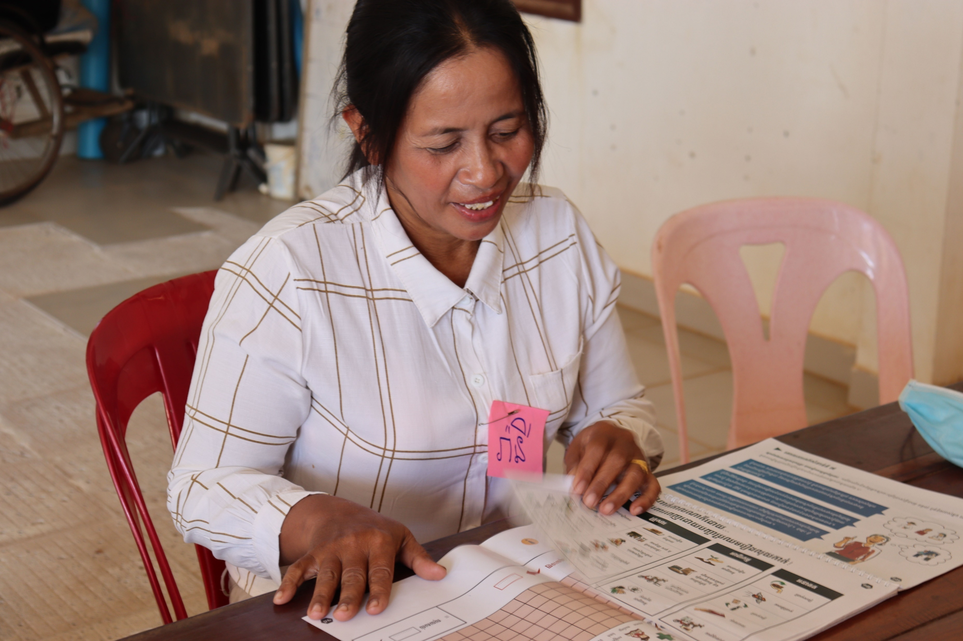
Image: Mrs Nop Rany, elected member of village committee, Kampong Speu Province (from ACCESS website – case study).
program overview

Context
ACCESS was delivered in a rapidly changing context, characterised by shifts in the operating environment in Cambodia and institutional change. The onset of the Covid-19 pandemic in early 2020 had devastating impacts on business and the livelihoods of people in Cambodia and caused severe fiscal constraints that saw funding commitments by the national government retracted as budgets were reconciled at the national level. RGC counterparts and sub-national authorities prioritized Covid-19 response plans and faced limitations in their ability to allocate sufficient budget to disability and GBV specific service delivery.
ACCESS beneficiaries and partners faced significant implementation barriers and pivoted to new ways of working towards achievement of ACCESS program outcomes. Government and non-government partners shifted to online meetings, training, and remote service delivery, consequently enabling the program to progress its outcomes, despite a significantly challenging environment.
The decentralisation and deconcentration agenda continued to unfold over the life of the ACCESS program, impacting on the mandates and responsibilities for service delivery for target Ministries and different levels of government. Most importantly for ACCESS was the increasing separation of funding for District and Commune level administrations (funded through MoI) from the National and Provincial administrations (funded through line ministries) which required an increasing two-pronged approach to public financial management engagement. In parallel, internal restructuring within MoSVY and the transition of PRCs from NGOs to MoSVY management changed the nature of support required by these organisations. PWDF, established in 2010 by the RGC, is a public administration institution with one of its mandates being to provide physical rehabilitation services.
These contextual shifts were coupled with challenges implicit in the program resourcing profile and funding decisions that impacted on manageability and buy-in to ACCESS’s activities. DFAT’s decision not to provide DSAs for RGC counterparts participating in ACCESS activities was problematic in the context of a program that does not contribute budget support and created significant challenges fostering ownership of program outcomes. Insufficient resourcing in the ACCESS program leadership team for the first 18 months of the program also caused limitations for the team’s capacity to engage with the breadth of stakeholders implicit in a program with this scope and geographic footprint.
Daily Subsistence Allowance (DSA): DFAT’s decision to seek the RGC to fund the cost of DSAs under the ACCESS program was, unsurprisingly, a topic raised in the majority of consultations by RGC, IPs and the ACCESS team alike. DSAs cover the costs of officials participating in ODA-funded program activities such as meetings and trainings. They are a supplement to salaries, and an incentive to participation. At the commencement of ACCESS, the MEF agreed to cover the cost of DSAs and an allocation of 50 million riels each was earmarked for the MOWA and MoSVY budgets. However, ministry views differed on the ease of accessing those funds. The lack of project-managed DSA meant that official participation in ACCESS was challenging to secure. Pragmatically and to be flexible, ACCESS moved to determining DSA payment on a case-by-case basis. This was a reasonable compromise to make, however it resulted in the need for much ‘micro’ liaison between IPs, ACCESS and RGC. It also complicated the planning and scheduling of activities, until DSA determinations were made and official participation were confirmed or not. Feedback from the IPs indicated that the decision to not pay DSA to RGC trainees affected the number of attendees at workshops. Some RGC staff could simply not afford to attend workshops, or they were further disincentivised from attending if they were not interested in the topic. Australia does not provide direct budget support to RGC. It is also notable that ACCESS was the pilot for this DSA policy – a somewhat surprising choice given the program is working to support two highly marginalised populations where advocacy is needed with governments for adequate attention, including for the funding of services.

Program overview
The Australia-Cambodia Cooperation for Equitable Sustainable Services (ACCESS) is a five-year AUD 25 million investment by the Australian Government to develop sustainable, quality, and inclusive services for gender-based violence (GBV) survivors and people with disabilities in Cambodia. ACCESS was implemented as a ‘3+2 year’ program, meaning a three-year program was implemented from 2018-2021 (Stage 1) which was then extended for an additional two years from 2022-2023 (Stage 2).
The Goal of ACCESS is that persons with disabilities and women affected by GBV benefit from access to sustainable, quality and inclusive services.
ACCESS program logic and end of program outcomes (EOPOs) have changed multiple times over the duration of the program. The program logic included in the investment design was updated in 2019 and it is this version, illustrated in Figure 1 below and in Annex 2, that was used for the majority of program implementation. Notably, Figure 1 includes two EOPOs, one of which pertains to planning and utilisation of resources. In late 2021, the ACCESS team made further revisions to the program logic, in response to the Internal Rapid Review (2020) and produced a third logic model, see Annex 3. This third iteration contains only one EOPO that ‘RGC, CSOs and private sector sustainably improve the coverage, quality and inclusiveness of services, economic opportunities, and social protection for persons with disabilities and women affected by GBV, responding appropriately to COVID-19 impacts’, the second EOPO relating to planning and utilisation of resources having been removed. These revisions were undertaken with the full consultation and approval by DFAT, and it was later endorsed by the ACCESS Steering Committee. However, changing the EOPOs in particular (as compared with the IOs), fundamentally changed the basis for measuring the program over its lifespan.
The program logic used to assess ACCESS’s performance for this evaluation is version 2, as this guided majority of the program’s implementation duration. The two EOPOs under this program logic were that:
- Relevant RGC entities plan and utilise their resources more effectively for GBV and disability-related services, in accordance with MEF guidelines; and
- RGC, CSOs and private sector sustainably improve the coverage, quality and inclusiveness of services for persons with disabilities and women affected by GBV.
In line with this program logic, ACCESS has nine Intermediate Outcomes (IOs) which include improving the quality, coverage, and sustainability of GBV and disability services, improving economic opportunities through social protection, and responding to pandemic impacts in Cambodia.
Figure 1: Version 2 of the ACCESS program logic
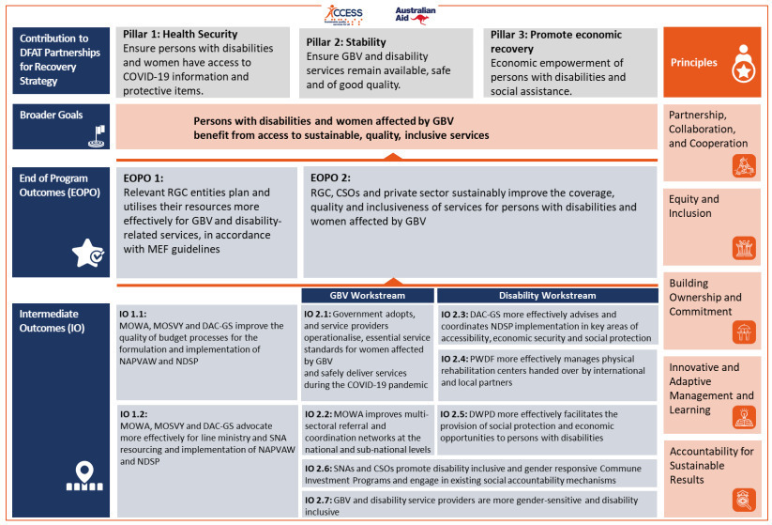
ACCESS works in partnership with targeted Royal Government of Cambodia Ministries that are responsible for law and policy, plans, budgets and the workforce for service delivery relating to women survivors of violence and people with disabilities. These are: Ministry of Women Affairs (MoWA); Ministry of Social Affairs, Veterans and Youth Rehabilitation (MoSVY); Disability Action Group Secretary General (DAC-SG); and Ministry of Economics and Finance (MEF).

Gender-based violence Workstream IPs
- CARE Cambodia
- Cambodia Women and Children’s Crisis Centre (CWCC)
- Legal Aid Cambodia (LAC)
- The Asia Foundation (TAF)
- Transcultural Psychosocial Organisation (TPO)
- UN Women
- UNFPA (Stage 1 only)

Disability Workstream IPs
- Action on Disability and Development International (ADD)
- Agile
- Cambodia Disabled People’s Organisation (CDPO)
- Chamroeun Finance / Good Return
- Humanity & Inclusion (HI)
- People’s Action for Inclusive Development (PAfID) (formerly Light for the World – LFTW)
- UNDP

ACCESS is implemented for DFAT by an international managing contractor, Cowater Sogema (Cowater). Support is provided through two channels: Firstly, a Competitive Investment Mechanism (CIM) that provides grants to multilateral and non-government implementing partners (IPs) to support service delivery strengthening, and secondly, technical assistance to RGC to support service delivery including through policy dialogue, technical advice, capacity building, and research and analysis. The CIM has provided a total of 26 grants to 14 IPs over the four years, in line with its gender-based violence and disability workstreams (see Annex 4 for further details). A list of IPs receiving grant funding under each workstream is provided in the table above.
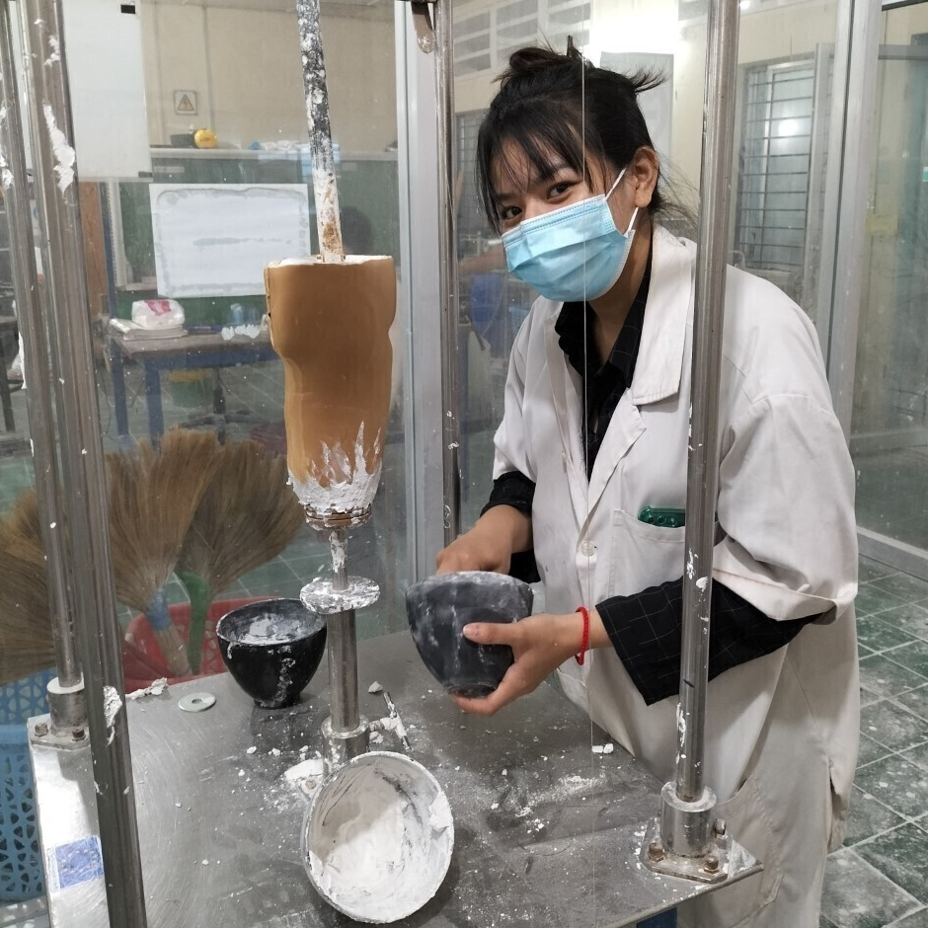
Image: Prosthetics technician Ms Nguon Reaksmeymutta making a prosthetic leg in the prosthetics and orthotics workshop in Kampong Cham PRC.
findings
This section summarises the evaluation findings and lessons learned against each of the four key evaluation questions included in the evaluation Terms of Reference. It is guided by the KEQ sub-questions and includes cross-referencing where pertinent.

Relevance

Is ACCESS’s focus and approach to improving service delivery for victims of gender-based violence and people with disabilities a relevant and effective route to advancing gender equality and social inclusion in Cambodia?
Cambodia and Australia’s Policy Priorities
ACCESS aligns directly with priorities outlined in Cambodia’s National Disability Strategic Plan (NDSP) and the National Action Plan on Violence Against Women (NAPVAW) and addressed key service delivery challenges faced by MoWA and MoSVY in implementing these plans. ACCESS is aligned with key capacity challenges identified in the design including coordination, budget processes, management, and technical supervision. The program also set out to support the two ministries (MoWA and MoSVY) to develop and defend their budgets for NDSP and NAPVAW III, underlining the centrality of the national plans to ACCESS (the results are further discussed under the effectiveness section). Against a backdrop of significant multi-sectoral need for improved service delivery for people with disabilities and survivors of GBV, the broad scope of priorities encompassed in these two policies presents a challenge in defining programmatic priorities, which is discussed in more detail in the effectiveness section of this report.
Technical assistance provided by ACCESS contributed both to development of NAPVAW III, as well as achievement in multiple strategic priority areas. NAPVAW III was endorsed in October 2020 and continues to set out a plan for addressing the needs of survivors of violence, including those from vulnerable groups. ACCESS contributed to achievements in:
- Strategic Area 2: Legal Protection and Multi-Sectoral Services, through ACCESS’s focus on increasing coordination at and between national and sub-national levels and improving access to quality services.
- Strategic Area 3: Laws and Policies, through ACCESSs’ focus on strengthening the legal framework through the development of Guidelines on the Limited Use of Mediation (now endorsed by the MoWA Technical Working Group on Gender – Sub-Committee on GBV (TWGG-GBV), with a joint ministerial prakas pending), and training service providers on the five essential service standards that were developed under DFAT’s predecessor EVAW program.
- Strategic Area 4: Monitoring and Evaluation, through ACCESS’s funding to UN Women to support the mid-term review of NAPVAW III which is currently underway.
ACCESS aligns with the NDSP goal of improving the livelihood, independence and equality of people with disabilities, including women and girls with disabilities, as well as contributing to all three NDSP objectives:
- Objective 1 to provide services to people with disabilities, including social protection and vocational training, through ACCESS’s provision of technical assistance to the IDPoor scheme, a commissioned study and advice to MoSVY on reforms to a disability benefit, and through IP activities by Agile and PAfID to provide business and employment-oriented training and coaching.
- Objective 2 to empower persons with disabilities to participate in decision making and political life, through ACCESS’s support for facilitating the involvement of ACCESS IPs and OPDs in consultations on the development of the new Disability Law.
- Objective 3 to improve access to the physical environment and facilities, as well as information, through ACCESS supporting the implementation of national technical standards on the physical accessibility of infrastructure, and installation of 22 accessible ramps for commune halls.
ACCESS gives effect to core policy priorities for Australia’s development assistance to Cambodia, and as a dedicated, significant-value investment in people with disabilities and women survivors of GBV is unique in Australia’s programming portfolio in Southeast Asia. The program explicitly supports DFAT’s Gender Equality and Women’s Empowerment Strategy (2016) whereby ending violence against women and girls is one of its three priorities, and the heightened GBV risk for women and girls with disabilities is explicitly acknowledged. The Strategy specifically commits to supporting countries and organisations to increase women survivors’ access to support services, including counselling, housing, and legal services. ACCESS also supports realisation of Australia’s international commitment to people with disabilities under the Development for All 2015-2020: Strategy for strengthening disability inclusive development in Australia’s aid program (extended until end 2021). One of three objectives of the Strategy is to improve equality for people with disabilities in all areas of public life, including service provision, education and employment. The services focus of ACCESS is well aligned with these policies, as is the twin-track support to government and representative organisations.
‘Other countries no longer support us, but Australia does’
Stakeholder interviewee from an Organisation of People with Disabilities
Adaptiveness to changes in the context
ACCESS demonstrated its ability and positioning to pivot to support key priorities in Australia’s COVID-19 response and to embed new ways of working required by the Covid-19 context. DFAT’s Partnerships for Recovery: Australia’s COVID-19 Development Response (2020) prioritised the response to violence against women and girls as part of efforts towards stability, and it includes a focus on people with disabilities, acknowledging the multiple layers of exclusion faced by these individuals. ACCESS’s response to Covid-19 has also contributed to the RGC’s Strategic framework for programs and economic recovery for living in the new normal of COVID-19 (2021-2023). Significantly, during the emergency context, ACCESS and its partners supported UNICEF in identifying 230,000 people with disabilities to be registered for an IDPoor card - the national, poverty-registration scheme which enables access to a range of social protection schemes, including free health care and the COVID-19 cash transfer. ACCESS also sourced Personal Protective Equipment (PPE) for IPs for onward distribution to service providers, people with disabilities and survivors of violence. ACCESS transitioned swiftly to online communication and outreach to maintain contact with partners during periods of travel restrictions, and it also commissioned several rapid assessments to gauge the effect of the pandemic on access to services and experience of GBV.
Appropriateness for the development context and needs
The complexity and the scope of ACCESS’s outcomes and of the context in which it was seeking to improve capacity for service delivery cannot be overstated. The design brought together two spheres of public sector service delivery that are both at an incipient stage of development in Cambodia. For example, Cambodia has only three active shelters for survivors of violence serving Phnom Penh, Siem Reap and Banteay Meanchey (all managed by ACCESS IP - CWCC), and the country has 11 Physical Rehabilitation Centres (PRCs) (with five recently transitioned from NGO to RGC-management). The levers or building blocks for system development are multi-sectoral and span the national level enabling environment such as the legal framework, workforce development and budgets, to sub-national service delivery. Considering GBV, the conduct of training in the GBV service standards has been a major focus of the ACCESS-staff led activity (as distinct from IP activities), with 4,791 service providers trained in Year 4 alone.
Supporting the national and sub-national coordination mechanisms – the backbone of the referral system for survivors - has also been a priority. Training participants have self-reported increased confidence and capacity to respond to survivors, and working group members could cite examples of improved information sharing (see further detail in effectiveness). Without undermining these achievements, the scope and breadth of ACCESS’s activities and the focus on national level ‘systems strengthening’ meant that downstream service delivery itself was carried by individual IPs. While the ACCESS team made efforts to ensure that partner activities were complementary and avoided overlap in a given location, service delivery support was ultimately piecemeal rather than driven by an overriding workstream or program-level strategy. To a large extent, the impacts of many ACCESS activities on beneficiaries is unknown. A more balanced program design which had a narrower geographic footprint but sought to extend results through to the beneficiary level could have addressed this gap.
On balance, ACCESS has concentrated significant effort at the national level, with an increased focus on the sub-national level from Year 2 onwards. The program design was ambitious given it required working across multiple sectors, systems, and delivery partners, in a changing operational context. This has meant a tendency to focus on the national level. For example, the ACCESS disability team has been engaged in foundational system strengthening work at the national level. This includes input on the new disability law, the production and dissemination of national PRC guidelines, and engagement on dialogue with the National Social Protection Council-General Secretariat relating to disability-inclusive measures. ACCESS advocacy also contributed to MEF including a reference to budgeting for people with disabilities in the Circular on Technical Procedures for Preparation of the 2023 Budget Proposal of Sub-national Administrations. These are landmark achievements that stand to beneficially impact on service delivery in the long term. However, at this stage, their translation to improvements in service delivery cannot yet be claimed.
ACCESS worked to adapt its approach to the decentralisation and deconcentration process that is unfolding in Cambodia, noting the uneven and contested nature of this process. Technical assistance shifted to include a greater focus on the sub-national level and MoI and Provincial Deputy Governors were invited to join the ACCESS Steering Committee (ASC) given their importance in administration and funding of SNAs.
ACCESS has been acknowledged by stakeholders for working closely with RGC, with some lessons to be drawn on the engagement with MEF, MoI and MoH in particular. The relevance of working with MEF for the RGC to increase funds for service delivery, as per EOPO 1, is indisputable, however difficulties in moving this work forward – including alternative budgetary priorities such as COVID-19 response and the usual competition for funds from more powerful ministries - led to the removal of EOPO 1 in version 3.0 of the ACCESS program logic. Furthermore, EOPO 1 had no specific performance expectations relating to budget allocation because it was viewed as a potentially sensitive government issue.
Several RGC stakeholders questioned the approach of the program in how it supported the two line ministries to prepare and advocate for budgets. This included working with technical staff rather than the decision-making level, and comment that the line ministries did not have the power to set increased budgets. They well understood the requirements and budget ceiling communicated by MEF, and so the expectation of advocating for increased budgets was misplaced – i.e. a point on understanding the political economy. In reply, ACCESS cited instances of RGC requests for supporting the budgeting process, and development partners such as UNICEF are working on exactly this process too, so views diverge on this point.
The limited engagement with the Ministry of Health is a key constraint. Interaction with the health sector, including access to and referral from clinical care, therapy and rehabilitation, is relevant to both survivors of violence and people with disabilities. Both disability and GBV are also public health issues that require a multisectoral approach. For violence survivors, the health sector is one of the first and few services that women will seek out, often on account of injury. Indeed, the SAQUS (2020) found ‘84.2% of GBV survivors who accessed health services went for care for injuries and medical treatment’. ACCESS IP UNFPA was an important connection to the MoH including for implementation of the Essential Services Package for survivors (co-financed by DFAT global funding). UNFPA trained cohorts of clinicians on responding to GBV and produced related guidelines. However, this link was lost when UNFPA involvement concluded at the end of Stage 1. Representatives from the provincial health department and district health office are trained as part of the ACCESS training of the GBV Response Working Group, but the link is not one of formal partner. Furthermore, for people with disabilities, hospitals are referral points to the PRCs and the MoH oversights the PRC workforce development. Interviewees agreed that it was important to more closely engage with the MoH in future programming since women survivors and people with disabilities are likely to need ongoing referrals for complex needs within the public health and hospital system. The shifting population health needs linked to Non-Communicable Diseases (NCDs) such as diabetes, stroke, and mental health will also lead to chronic and complex disability needs as a result.
Success Snapshot
A Women’s Support Group in a district in Kampong Speu, established in 2020, received training by the Commune Council for Women and Children focal point through ACCESS. The Group carries out awareness raising on women’s rights and gender-based violence and plays a role in grassroots frontline response to GBV in their community, including referring women to support services, liaising with local authorities on GBV cases, and identifying safe accommodation and support to respond to women’s needs.
Members of the group report that ACCESS’ support has seen them gain greater knowledge on GBV, which has served improvements in their own lives as well as the lives of others. Group members see themselves as filling a critical gap in GBV response at the grassroots level, now able to refer women to appropriate services and with self-confidence in their knowledge and skills in handling GBV cases. The Group feels there is now a greater level of awareness among women and men of women’s rights and options for non-violent problem resolutions.

Lessons Learned
- ACCESS is unique in scale and scope in giving effect to Cambodia’s national plans and Australia’s core commitments to people with disabilities and addressing gender-based violence.
- The political economy of resource allocation and influence on strategic priorities is shifting in the context of decentralisation and deconcentration, and Covid-19 fiscal constraints, and needs to underpin efforts to support change in this space.
- A balanced approach to engagement at the national and sub-national level, and in strengthening the capacity of service providers to then support service delivery is required if changes in the services are to be realised.

Effectiveness
Was ACCESS effective in achieving its intended outcomes?
There are a number of factors that had a significant bearing on the operating context for ACCESS and need to be considered in discussion of effectiveness:
  - The requirement for RGC payment of DSAs. ACCESS was the first program to implement DFAT’s new policy on the payment of the Daily Subsistence Allowance (DSA) (i.e. per diem). It is a long-standing tradition in Cambodia for development project budgets to cover the cost of DSA when RGC officials participate in project activities. DFAT, as a number of other donors did at the time, decided that it would request RGC to pay for the DSA for official participation in ODA-funded development programs. This was a bold stance, and the issue of DSA came up in virtually every RGC and IP meeting for this evaluation. Notably, ACCESS was chosen by DFAT to be the ‘pilot’ for the DSA stance, and the only DFAT program to do so. Being a large-value program, DSA costs under ACCESS would have been considerable. It is questionable why the program focused on equity issues and vulnerable groups was chosen as the pilot, with presumably less political capital with RGC than other kinds of ‘hard’ sector investments.
Remarkably, and a credit to the ACCESS and DFAT teams in Year 1, ACCESS was successful in negotiating for RGC to cover DSA expenses (which amounted to a block grant of 50 millon riels). While this commitment was maintained throughout, and reaffirmed at the ACCESS Steering Committee meeting in December 2021, there was a view expressed by one of the line ministries that they were not able to access the full DSA allocation, due to the onset of COVID-19 in 2020 and with the reconsolidation of budgets to cover emergency assistance budgets. Due to the project’s position on DSA, the ACCESS team and IPs expended much time negotiating with RGC counterparts on a case-by-case basis about who would pay. This ultimately led to delays in the planning of activities.
  - The onset of COVID-19 immediately after Year 1 of the program. COVID-19 was universally disruptive and unprecedented in its effects. However, it coincided with Year 2 of ACCESS – a time when most complex and large programs first hit their strides. ACCESS deserves much credit for how it pivoted to COVID-19 conditions – including the distribution of Personal Protective Equipment (PPE) to IPs to enable them to maintain some service provision and outreach, and onward distribution of PPE to people with disabilities and women survivors of violence. ACCESS also provided support to UNICEF to register 230,000 people with disabilities on the IDPoor card scheme so that they would be entitled to emergency and ongoing social assistance transfers and poverty-targeted subsidies and services. As the client data provided later in this section shows, COVID-19 waves and related lockdowns had a major impact on GBV and disability service utilisation.
  - The development of three program logic frameworks in four years. The last factor of note in gauging effectiveness is that ACCESS has had three different results frameworks in four years. The program logic included in the design document was revised early in implementation. The Internal Rapid Review of ACCESS (April 2020) and onset of COVID-19 led to further modifications. As a 3+2 year program and implemented in two phases (Phase 1 – 2018-20, and Phase 2 – 2021-23), refinement of outcomes is also to be expected. Notably, though, it has led to three sets of End of Program Outcomes. In light of this, and with the rephrasing and addition/removal of several Intermediate Outcomes (IOs), there is not a continuous line of sight on performance across the life of the program. As noted in the methodology, this evaluation assesses against the Stage II program logic (see figure 2 below).

Figure 2: Overview of the three ACCESS program logic frameworks
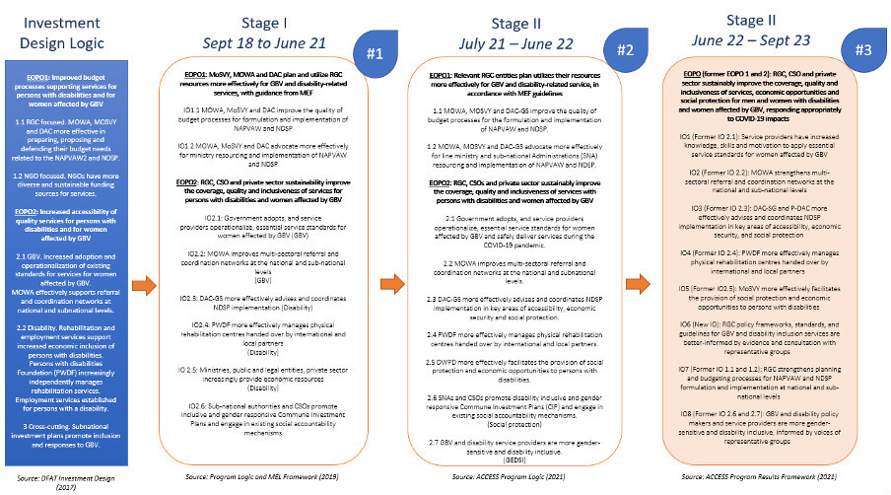

Performance Against End of Program Outcomes

1. EOPO relating to RGC, CSO and private sector sustainably improving the coverage, quality and inclusiveness of GBV and disability services.
This EOPO formed part of the ACCESS program logic, with slight variations, for the entire program duration.
ACCESS has made substantial progress in the continuous EOPO focus area of sustainably improving the coverage, quality and, to a lesser extent, the inclusiveness of services. The combination of ACCESS’s technical assistance to the RGC on the enabling environment, complemented by IP work on subnational service delivery has been effective for advancing the coverage and quality (as defined by the SAQUS) of services, in particular. It has also served to support achievements in social protection specific to people with disabilities. Inclusiveness in terms of gender responsiveness and disability inclusiveness, and attention to factors such as ethnicity and diversity in disabilities was belated, but it has increased over time. In terms of the sustainability of services, the gauge of effectiveness is more challenging.
A summary of selected ACCESS results on coverage, quality and inclusiveness are provided in Table 1.
Table 1: Key achievements of ACCESS in the three focus areas for improving service delivery capacity
Focus area | Key achievements
Coverage | - Exceeded targets to increase the number of people with disabilities accessing ACCESS-supported PRCs.  - Increased the number of GBV survivors receiving support.  - GBV Response Working Groups now in place in 6 provinces and 33 districts.  - Exceeded the number of disability stakeholders trained in developing skills to facilitate access to economic opportunities.
Quality | - Development of standards for PRCs. Endorsement and training package on five essential GBV service standards.  - Development of a range of training packages including gender equality and disability inclusion (GEDI) ToT training rolled for 27 master trainers from RGC; gender equality and social inclusion training for district level GBV Response Working Groups; and Gender Equality training including for disability service providers.  - Modelled accessible ramps at 22 communes.  - Modelled private GBV counselling rooms.
Inclusiveness | - Development of technical standards on physical accessibility for people with disabilities.  - CARE’s integration of a GBV response in its multisectoral work with ethnic minority people in Ratanakiri.  - CWCC and ADD consultancy on ‘intersectionality’ to provide training on gender responsiveness and disability inclusion.  - Registration of people with disabilities from poor households in the IDPoor card scheme.

Quality
Building on the strong foundations of predecessor investments, ACCESS made strong progress on quality, supporting the development, adoption, and operationalisation of service standards for women affected by GBV. This included using essential service standards guidelines developed and endorsed through the predecessor EVAW program in training and planning. ACCESS also built on existing efforts to improve functioning and institutionalisation of the national-level Technical Working Group on Gender-Sub Committee on GBV (TWGG-GBV) and subnational GBV Response Working Groups. Importantly, the program was able to make headway on the sensitive issue of the use of mediation in ‘resolving’ GBV cases because of foundational work that had been done in this space. The Guidelines on the Limited Use of Mediation have just been approved and a training package is being developed. There was anecdotal evidence of positive attitudinal change with district policing being better equipped to manage GBV interviews and more willing to share information on cases. This needs to be understood in a context where traditional attitudes persist that in GBV victim-blaming and that disability is a result of sin in a previous life. In the case of disability services, support to the PRCs had been challenging for the DRIC program, and so ACCESS had the benefit of the DRIC mid-term review recommendations to guide its work. ACCESS also supported disability coordination at DAC.
Coordinated, referral networks have been the backbone of the ACCESS response to GBV at national and sub-national levels. Data indicates that GBV coordination and referral networks have been strengthened, with GBV Response Working Groups now in place in 6 provinces and 33 districts. Feedback on the program reinforced the substantial work that the program did to improve stakeholder coordination. For example, CDPO and CCWC were satisfied with the support they received from ACCESS as primary coordinating bodies. ACCESS also supported disability coordination at DAC and improved functional coordination of the Technical Working Group on Gender-Sub Committee on GBV (TWGG-GBV) and GBV Response Working Groups supporting the development of referral networks in the provinces and implementation of Annual Operating Plans (AOP). The MoWA coordination groups have become further institutionalised. However, the governance structure of the referral networks and lack of RGC budget means they are not yet financially sustainable or fully functional. They require a network of volunteers using their own funds to cover victim accommodation and transport costs. ACCESS has also supported private, furnished, women and children-friendly counselling rooms in some PDoWA offices. However, there are critical elements of GBV services that are not available. Cambodia does not yet have a national hotline service with connections to province-level frontline responders, nor any state co-/financed shelters or emergency accommodation for survivors.
ACCESS made notable contributions to progressing disability inclusive employment. According to Disability Rights Administration (DRA), as of December 2021, a total of 3,621 (23% female) were employed by 37 government entities, an increase of 17% compared to 2020 (3,091). In the same period, 5,235 (65% female) were employed by private institutions, an increase of 35% compared to 2020 (3,891). This was made possible with ACCESS’s direct support to sector coordination mechanism, capacity development of key stakeholders, implementation of inclusive TVET-employment guidelines, finalisation, and introduction of ‘Oakas’, and documentation and sharing of good practices on inclusive employment. A new rubric-based indicator¹⁵ to measure the functionality of the coordination mechanism has been finalised and an assessment is planned for September 2022.
In terms of strengthening the legal framework underpinning services, ACCESS coordinated with CDPO and its 75 member organisations to facilitate a dialogue for people’s input into the draft Disability Law, while also liaising between DAC-SG and the Australian Human Rights Commission (approached by the Embassy) to support greater alignment with the Convention on the Rights of Persons with Disabilities (CRPD). Although one of many actors involved, it was a priority engagement for ACCESS. The program also supported the production of plain language, explanatory notes for the Law on Domestic Violence. A shift in focus to supporting the implementation or monitoring of these laws will be important, once passed. In terms of evidence-based inputs, program invested in developing the internal Amelia database to improve the programs’ MEL data capture and visualisation. It may well constitute an important supplement to the current gaps in administrative data on disability and GBV.
ACCESS’s work with the private sector is marginal, and mostly confined to the IPs in the disability workstream working on economic livelihoods, jobs, entrepreneur training and business incubation, and access to finance. (Notably, the GBV workstream does not have economic livelihood partners). The evaluation found the programs by Agile and PAfID to be interesting and well rated technically in the ACCESS Partner Performance Rating for Stage 1, albeit small in value. The Chamroeun / Good Return program on access to finance raised some concerns for the evaluation team about practices that carry a high risk of exploitation, such as doorstop banking. The economic livelihoods of people with disabilities is essential to independence, however the ACCESS approach to working on economic opportunities warrants further strategizing. In addition, support for the pilot of MoWA’s Women’s Development Centre (WDC) for women at risk of (not defined) or experiencing GBV in Kampong Speu sits aside from a focus on improving GBV services. The evaluation visit to the WDC found that it is a vocational centre teaching skills in garment making, as a way for survivors to gain employment. Teaching garment making is not negative in itself, even if gender stereotypical, as compared with skills for the digital economy. The issue is that the industry is highly feminised and exploitative, it usually does not provide a living wage and gains to employers outweigh gains to employees. Countries are moving away from garment manufacturing, in general. The WDC visited was close to the garment factories in the industrial zone in Kampong Speu which raises the risk of ACCESS potentially preparing women for transition to these low income jobs, with high levels of exploitation.
Performance against selected IO targets:
- ACCESS exceeded the number of disability stakeholders trained in developing skills to facilitate access to economic opportunities from 1307 to 1541.
- DPWD launched the ‘Oakas’ employment app which has directly supported economic inclusion of 1,541 persons with disabilities (47% female).
- ACCESS reported that it had contributed in part to a 17 per cent and a 35 per cent increase in public and private sector employment, respectively between 2020 and 2021.
- ACCESS did not meet the target of 100 employers sensitised about disability inclusion policies, reaching 45 instead. This was due to delays in finalising the DI E-learning tool relevant to this work.
- ACCESS met the targeted number of 8 OPDs engaging with RGC to improve social protection for disability inclusion. For example, OPDs supported 838 members to access social protection payments.
- ACCESS met its targets on to ensure that 10 CIPs were better aligned with NDSP and NAPVAW, and in fact exceeded its target in relation to inclusion of disability services (a 57% rating above the 35 % target).

Coverage
ACCESS has exceeded its targets on service coverage. By its own measures, ACCESS and its IPs have steadily increased client utilisation of GBV and disability services over the four years. This is more than a mere technical achievement and represents the program’s ability to address the multi-faceted barriers and discouragements for people with disabilities and survivors of violence to seek assistance.
Disability
ACCESS supported six PRCs between September 2019 to June 2022, assisting 16,998 people with disabilities (clients). The two top PRCs in terms of client volume in this period were the ACCESS target province of Kampong Cham (5,251 clients) and Kien Kleang (4,003 clients). The busiest six-monthly period was between January to June 2022 (3,587 clients), and July to December 2020 (3,504 clients). Visits to the PRCs decreased from 3,504 between July to December 2020, to 1,682 visits the following January to June 2021. This coincides with COVID-19 lockdowns that occurred across Cambodia over March to May 2021, particularly in parts of Phnom Penh and Siem Reap. This demonstrates how the PRCs being supported by ACCESS were able to resume service provision, and in the majority of PRCs steadily increased client numbers.
Analysis of PRC visits reveal that the PRCs that served the largest numbers of women were Kampong Cham (1,894 clients / 31.9 per cent of total clients), and Kien Kleang (31 per cent of clients were women/ 1,520 clients) between September 2019 to June 2022. The PRCs located in Kratie and ACCESS target province Siem Reap saw the lowest numbers of women, at 7 and 3 per cent, respectively, of their total clients over the period September 2019 to June 2022. It would be instructive for ACCESS (including the disability and GESI teams) to look into the 2022 SAQUS data and better understand the reason for this low coverage of women. PRC visits by children under 18 years of age with a disability was highest in Kien Kleang (2,487 clients or 42 per cent of total clients) and Kampong Cham (1,944 clients / 33 per cent of clients) between September 2019 to June 2022. Kratie (162 clients, 3%) and Siem Reap (79 clients, 1 per cent) again were the PRCs reporting the lowest number of visits by children to date (September 2019 to June 2022 data). This highlights the relatively high demand for disability services for children. It did not represent a focus of this evaluation but child-sensitive service provision and child protection advice may be pertinent to any ongoing support to disability services.
Figure 3: Client numbers over time, by province
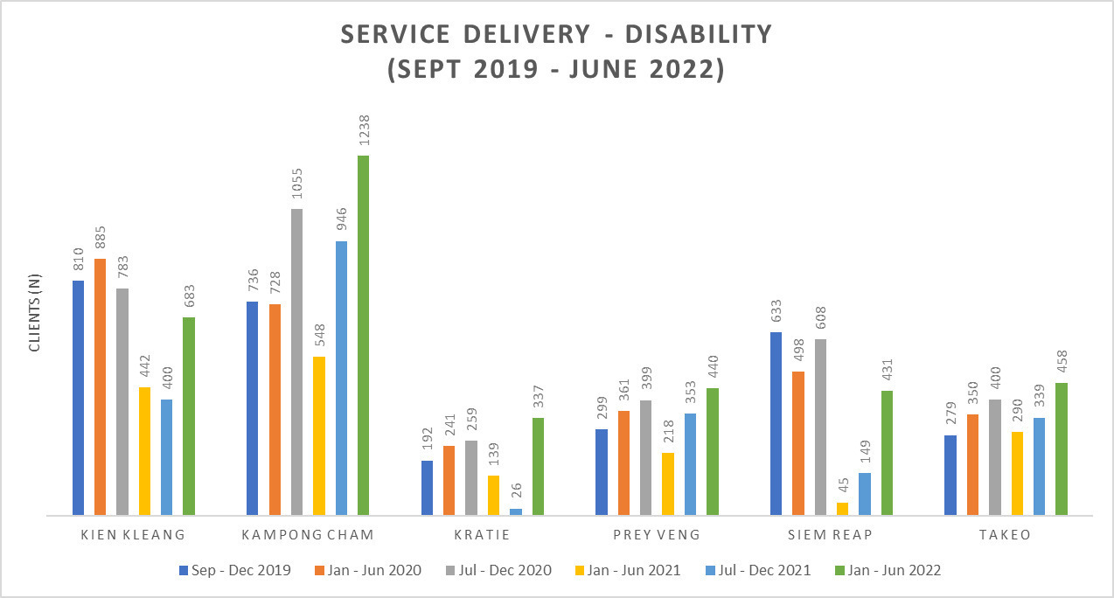
Gender-based violence
ACCESS IPs provided GBV services to a total of 4,831 clients between September 2019 and June 2022. Of the four main GBV IP service providers, CWCC assisted the highest number of clients (57 per cent of total clients served by ACCESS / 2,558 clients) followed by TPO (24 per cent / 1,094 clients), LAC (13 per cent / 593 clients) and CARE (6 per cent / 265 clients). Cambodia’s national prevalence study on violence against women (2015) found that only one in four women experiencing violence seek out supportive services. ACCESS’s client numbers need to be read in that light.
IPs provided eight types of services to clients including: physical treatments, forensic exams, legal consultations, legal representations, mediation, mental health (psychosocial) counselling, shelter, and economic empowerment (presumably livelihood) options. Legal consultation was the most requested service and CWCC provided 1,117 legal consultations in the period (equivalent to 67 per cent of total legal advice cases), followed by LAC (21 per cent / 344 clients), CARE (6 per cent / 93 clients) and TPO (4 per cent / 72 clients).
In the same period, ACCESS partners provided 773 clients with mediation services. TPO, which has counselling rooms at government health sites, provided the highest number of mediation services at 56 per cent of the total number of ACCESS client (429 clients), followed by LAC (22 per cent / 173 clients), CWCC (15 per cent / 114 clients) and CARE (7 per cent / 57). It is important to highlight that mediation is a formal dispute resolution process. It is enshrined in law in Cambodia and a highly promoted practice, but it is contrary to international guidelines. More background information is needed to understand whether these cases were referred from local authorities and the police, and whether these clients received other GBV services alongside mediation (which is presumably so in the case of these ACCESS IPs, but not verified by this evaluation), and the proportion of time that IPs spend on this service provision. In summary, this data represents the clients who perhaps underwent a more skilled and compassionate mediation experience, but for a service that is not regarded as an advisable GBV response. ACCESS recognises this moral quandary, and both the EVAW and ACCESS programs elected to take a harm reduction approach by trying to improve the counselling skills of the providers involved in these high frequency referrals. The development of guidelines on its limited use by Women Peace Makers – a sub-grantee of ACCESS IP TAF - also highlights attempts to progressively reduce the practice. The evaluation team recognise that Cambodia has a tradition of mediation and that the current program has sought to improve, namely restrict, the implementation of this practice – based on the ACCESS management assessment that it would not be possible to eliminate the practice in the short term. Any withdrawal of ODA support to this area should be done in full consultation with IPs and other advisers or women’s groups to ensure that it is sequenced in a way that avoids risk or harm for survivors.
Figure 4: GBV services data summary
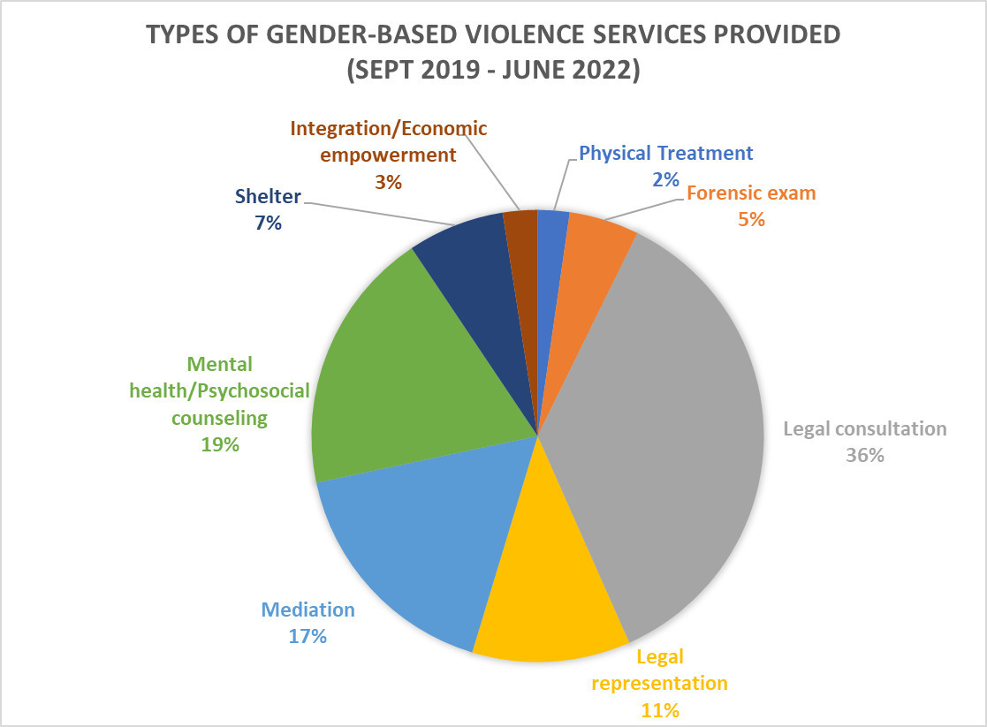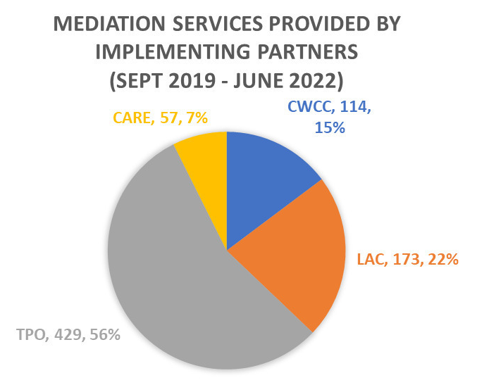

Inclusiveness and intersectionality
ACCESS is taking increasing account of inclusiveness and ‘intersectionality’ but it is uneven across IPs, with CARE’s work being a standout. It needs to be acknowledged that ACCESS is fundamentally about inclusion in the first place. The primary purpose of the program is to overcome the physical, institutional, attitudinal and service barriers that prevent people from accessing GBV and disability services. Greater inclusiveness is therefore understood here as ensuring that ACCESS is conscious of reaching the full diversity of users of GBV and disability services – with attention to gender, ethnicity, residence and socio-economic means. Certainly, consideration of outreach and cross referral of people with disabilities experiencing violence and of survivors of violence with disabilities would be an important starting point.
In Phase 1, evidence of inclusiveness was limited and GEDSI advice was not sufficiently resourced. ACCESS established separate disability and GBV workstreams with IPs, which makes sense from a coordination perspective, however, stakeholders reported that it had the unintended effect of creating silos. This meant that opportunities for promoting the gender responsiveness or disability inclusiveness of services were missed. Notably, the ACCESS design provided for the recruitment of GBV and disability inclusion advisors (long term, but on a consultant basis up to a certain number of days per year) but it did not include recruitment of a separate Gender Equality and Social Inclusion advisor – despite having a GESI strategy. It has been a learning for the program, as acknowledged by the Team Leader, that GESI skills were needed to better support the interaction or joint activities between the workstreams, and to take an intersectional and holistic lens to the program and consider intersecting forms of discrimination and disadvantage. ACCESS did commission two GESI reviews (2020, 2022). Additional to the above points, key findings of these reviews included ACCESS having a ‘narrow’ definition of intersectionality - understood as joint work between disability and GBV IPs; situating GBV in a broader discussion of gender inequality, women’s rights and the do no harm principle; and taking simple, practical actions to promote and monitor GESI.
The main example of an inclusive approach in Phase 1 was CARE International’s support to multi-sectoral services in Ratanakiri Province, working with ethnic minority communities. ACCESS funding enabled CARE to extend its work into GBV service provision. CARE has had a long -standing presence in the province, with staff fluent in local languages and experienced in culturally appropriate ways to support community development. Their understanding of local conditions and customs is important to note when pursuing greater inclusion of ethnic minority people. Aside from this, examples of inclusion in phase one were limited. Data from disability service providers interviewed in the 2019-20 SAQUS highlighted that only one quarter of people seeking services were women. This was acknowledged by the ACCESS team.
By Phase 2, there was evidence of ACCESS and IPs taking a more intentional approach to inclusion. In this phase, ACCESS appointed a full time national GESI advisor and an international advisor on an STA-basis. ACCESS has now developed a Gender Equality and Disability Inclusion (GEDI) training package which it has rolled out to ACCESS stakeholders. Two IPs – CWCC and ADD International – have submitted a proposal to ACESS to support integrated training on disability-inclusive GBV service provision and GBV-responsive disability service provision. CWCC noted that it is starting to support women with disabilities experiencing violence and is interested in further reach and support to this community of women.
The evaluation noted that the PRCs, the core of ACCESS’s disability service provision, only focus on physical and mobility-related disabilities. While PRCs have deaf and low vision clients who come for physiotherapy and prosthetic and orthotic (P&O) services, they do not provide hearing or vision services, not cater for people with more ‘invisible’ disabilities, such as cognitive or communication-related disabilities. ACCESS has taken some steps to expand the inclusiveness of its disability work. This includes the commissioning of a study on autism, and several initiatives focussed on support for blind people.

Social protection
ACCESS had strong achievements on social protection for people with disabilities, but not for GBV survivors. The onset of COVID-19 put social protection firmly on the agenda for many countries where it had not yet been a priority. ACCESS has been extremely effective in taking advantage of this increased political interest and openness to social protection by RGC, particularly for people with disabilities. Key results include the ACCESS team working with IPs such as CDPO to successfully identify 230,000 people with disabilities (figure noted in interviews) to be registered with the IDPoor Card scheme – an initiative led by UNICEF. This registration work is ongoing with MoSVY. CDPO and its OPD members has also identified 838 members with disabilities to immediately access social assistance payments. ACCESS also funded a study on disability inclusive social protection by Development Pathways to contribute to the development of a national disability benefit, which ACCESS is using as the basis of planning with MoSVY and MEF. Additionally, ACCESS is in dialogue with MoSVY for innovative financing options for PRCs, such as performance-based payments for PRCs on the basis of service provision, and an insurance model. While not strictly a social protection measure, it will assist in expanding the coverage and quality of free disability services. With this window of opportunity for social protection in Cambodia, it is notable that ACCESS does not appear to have pursued social protection dialogue or policy change for the survivors of violence. Acknowledging that influencing social protection as regards GBV was not a priority target of ACCESS from the outset, and that a gender lens on social protection and GBV-responsive social protection is still gaining traction internationally, measures such as emergency social assistance payments for women who access shelters or access to subsidised medical and legal care for non-poor women experiencing violence would align well with ACCESS’s objectives.
The final word on effectiveness is on the point that people with disabilities and women survivors of violence are the ultimate beneficiaries of ACCESS. ACCESS was not designed to focus on movement building with representative organisations of people with disabilities and survivors of violence or women’s rights groups - or the demand side of service delivery. However, there would be value in better foregrounding the voice of OPDs and supporting the Nothing Without Us principle. On GBV, the evaluation noted that local women’s rights organisations and gender equality advocates were not part of the GBV workstream. It is not known whether GBV survivors work within IPs, although experience or exposure to GBV is one driver for people to work on the GBV response. Supporting all of these organisations in their advocacy work and organisational capacity is needed, and worth considering. Women’s organisations have been regarded as the single most important factor in achieving progress on a national GBV response.^{[1]} There is also a new generation of disability and gender/feminist advocates emerging in Cambodia, including among the Australia Awards alumni cohort. The greater involvement of these groups is vital.

2. EOPO relating to public financial management (PFM), and RGC improving planning and utilising their resources more effectively in accordance with MEF guidelines.
On the best available evidence, accounting for complexities in measurement and the political economy, ACCESS only made partial progress against this end of program outcome. Public investment in GBV and disability services is the ultimate basis for their sustainability. It makes sense that this was an explicit area of engagement for ACCESS. However, it is also unsurprising that this was the most challenging and uncertain undertaking for the program. Measuring the effectiveness of the ACCESS’s PFM efforts is not straightforward, for several reasons. Firstly, the PFM EOPO was demoted to being an IO in the current version of the program logic, with the more limited scope that ‘RGC strengthens planning and budget processes’. Subsequently, routine monitoring data is no longer collected to measure the EOPO. The Internal Rapid Review had recommended prioritising PFM by identifying areas ‘where engagement was most needed and most likely to have success’. However, the Review is silent on the EOPO. Secondly, the indicator used for the original EOPO monitored whether budget strategic plans and program budgets were completed. It did not specifically monitor budget allocation changes, or aspects such as the inclusion of new budget lines for GBV and disability. The Stage 1 Results Matrix (October 2019) explains why, noting ‘no specific performance expectation has been defined relating to budget allocation, as this is a sovereign decision of RGC.’ ACCESS did however prepare Annual Budget Monitoring Reports, to supplement.
ACCESS’s approach was to build the capacity of MoWA and MoSVY to improve the preparation of their annual budgets to MEF, and equip them to advocate to MEF for increased allocations. Politically speaking, ACCESS noted the following in its Story of Significant Change: Building the Royal Government of Cambodia Capacity in Developing the Annual Budget Documentation:
‘There is also a lack of transparency or explanation for how or why specific decisions are made by MEF and amongst MoSVY senior management responsible for budget finances. Many factors influence the final budget resource allocations/decisions, most of which ACCESS cannot (easily) directly influence or reach. This was acknowledged by RGC staff as well. Successes will most likely involve incremental changes representing the results of long-term capacity building, but improved budget outcomes must also have clear political backing and policy commitment/prioritisation from MEF.’
ACCESS effort did not translate to any increase in budget allocations at the national level, towards implementation of the NDSP and NAPVAW. The evaluation has found that the assumption in the program logic about budget allocation processes that quality of budget proposals was a significant influencing factor in funding allocation by MEF did not hold. Stakeholders’ feedback on ACCESS’s approach was mixed. Some stakeholders appreciated ACCESS support, others felt that efforts should have been directed to more senior government officials and that the quality of budgets proposals was not the determining factor in the volume of funding allocated to them. ACCESS itself has highlighted that MEF officials need to actually visit a PRC or GBV counselling service to understand that there is a material need for financing, and that it meets a need of citizens. Support is still needed to socialise RGC counterparts about the needs of persons with a disability and survivors of violence.
That said, the program did have some PFM ‘wins’. Securing an agreement in Year 1 for MEF to cover the DSA of RGC official participation in ACCESS is a prominent achievement. ACCESS advocacy contributed to MEF including a reference to budgeting for people with disabilities in the abovementioned Circular on Technical Procedures for Preparation of the 2023 Budget Proposal of Sub-national Administrations. ACCESS reported that this stemmed from the conclusions to an ACCESS-funded workshop in 2022 where the key priorities of the NDSP were presented to MEF, DAC-GS and GD-SNAF. Another positive result was that ACCESS funded an in-depth study on Gender Responsive Budgeting (GRB). The findings of this study on GRB processes were shared with MOWA and MEF and the General Secretariat for the PFM Reform Program, and they have been integrated within a GRB Roadmap being developed for MOWA by UNDP.
More financing progress has been evident at the subnational level. ACCESS directly supported MOWA to socialise the Annual Operational Plan and budgeting process at provincial and district level. These AOPs demonstrated better adherence to the NAPVAW than was the case with line ministries at the national level, and ACCESS’s analysis of the 2022 budget found that PDoWA budgets for GBV legal protection had increased in five provinces that ACCESS has supported. ACCESS had identified but not properly embarked upon support to the sub-national level to plan and utilise CIP budgets, especially the 20 per cent social affairs budget line which could be applied to disability and GBV services. The evaluation found that sub-national authorities were uncertain as to how to utilise the social affairs budget line in the CIP budget template. This was in part due to due concerns about complying with procurement regulations for ‘soft’ services, and remains an area for support. On disability services, ACCESS supported UNDP to strengthen commitment to funding services at the provincial level. One province allocated budget for P-DAC meetings, which has been attributed to ACCESS inviting MEF and General Directorate for Subnational Administration Finance (GD-SNAF) to P-DAC meetings to promote the need for funding. More substantially, the Provincial Administration in Siem Reap allocated 57 million riels towards the disability sector in its 2022 budget, including first time funding of P-DAC meetings (10 million riels).

Lessons Learned
- Consolidating and building on gains from predecessor programs and investing time in developing strong relationships with RGC counterparts was central to ACCESS’s success in advancing its outcomes, including in challenging areas.
- Strengthening coordination and emerging referral processes has been a strength of ACCESS, which is critical in underpinning integrated service delivery for survivors of GBV and people with disabilities.
- The assumption in the design, that improvements in the quality of budget preparation processes and supporting MoSVY and MoWA on ‘arguing the case’ would lead to increased budget allocations did not hold.
- Initiatives that seek to advance economic empowerment of survivors of GBV and people with disabilities need to be designed to ensure they are likely to fulfill their empowerment objectives and mitigate risks.
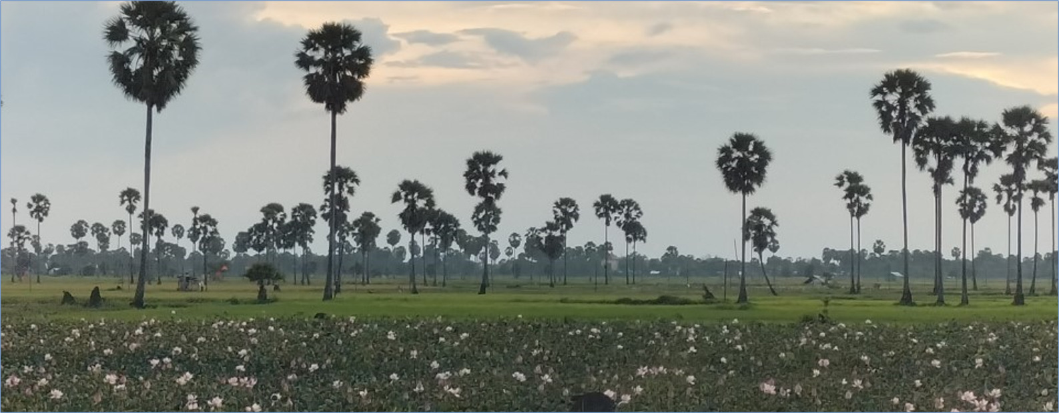
Image: A landscape of sugar palms at sunset near Kampong Speu PRC.

Efficiency
To what extent has ACCESS been an efficient and effective program model to deliver outcomes?
The discussion of efficiency in this section is in relation to the ACCESS model as designed; the efficiency in how the ACCESS model has been implemented; and expenditure and value for money considerations.
ACCESS is on track to fully expense its program budget by September 2023. At the end of Year 4 (June 2022), ACCESS had disbursed approximately AUD20 million, or around 80% of its total approved AUD 25 million budget. Variance between annual budgets and actual expenditure has been negligible in dollar terms according to the financial data provided by ACCESS. However, when comparing budget and actuals by IOs, it is significant in percentage terms for a number of IOs such as IO 1.1 and IO 1.2 relating to budgeting preparation and sub-national resourcing (see Figure 6). As shown in Figure 5, almost one quarter of the budget (24 per cent) has been applied to IO 2.1 on the adoption and operationalisation of essential service standards for women experiencing GBV and also to IO 2.2 on MoWA’s support to coordination and referral networks at the national and sub-national levels. The lowest spend (3 per cent) has been on IO 1.1 on improving the quality of budget processes for the NDSP and NAPVAW, and on IO 2.6 (5 per cent) for sub-national authorities and CSOs to promote disability inclusive and gender responsive Commune Investment Plans.
Figure 5: Activity spend by IO, July 2019 – June 2022
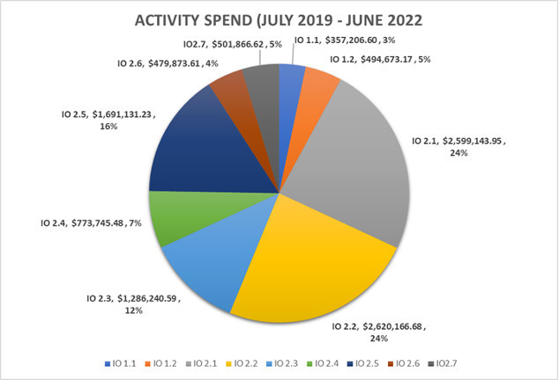
The ACCESS team has been proactive in adapting the program model and being responsive to change. A key example is in relation to COVID-19. Not only did the ACCESS program distribute PPE, but ACCESS recognised that the pandemic crisis would acutely increase the hardship and isolation faced by survivors of violence and people with disabilities. Program funds were diverted to meet challenges of COVID-19 to support IPs in their service delivery, and regular workshops were held to support their COVID response and adaptation. ACCESS pivoted to use new technologies such as zoom to increase number of participants in online training workshops to improve service delivery. Significantly, it also seized the opportunity to register people with disabilities for IDPoor cards so that they could receive emergency assistance. The COVID-19 response accelerated the program’s relationship with RGC, was commended by RGC stakeholders and seemingly gained valuable high-level support for GBV and disability in the process. The team has been unflaggingly responsive, over the course of many years.
Figure 6: Budget variance by IO, September 2018 – June 2022
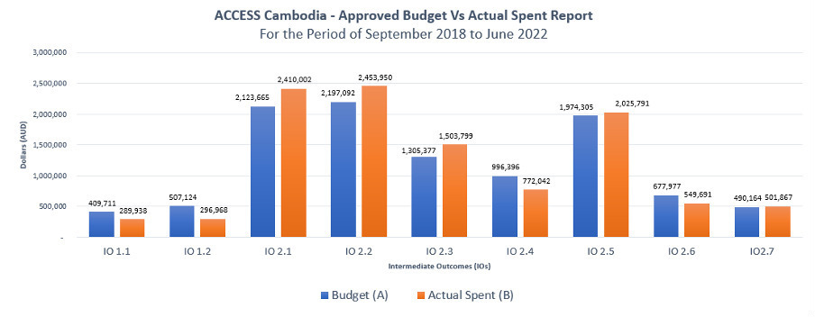

Partnerships and stakeholder relations
Investing in strong stakeholder relations was central to ACCESS’s ability to facilitate efficient activity delivery by IPs and rapidly adapt to changes in context. ACCESS and IPs described how the year spent identifying and forging relationships with relevant RGC officials at the commencement of ACCESS has underpinned many of the program’s achievements.
ACCESS has worked effectively with MoSVY and MoWA, adapting to changes in structures and personnel (in the case of MoSVY), being reform-minded while maintaining good working relationships, and working at a pace that is compatible for the two ministries. The ACCESS team reports that there was solid engagement of the RGC in the co-design process of the CIM Panel, and the ultimate selection of the IPs. There was anecdotal data on this point only. Key examples in the case of ACCESS include navigating the DSA policy position in a way that did not impair relations or that avoided the disengagement of RGC officials. IPs in the GBV workstream commended ACCESS on their extensive government relations work in the first 18 months of the program, so that IPs knew exactly which counterparts to approach relevant to their activities.
With the restructuring at MoSVY, ACCESS has demonstrated its good upkeep of relations with the key government officials. It has also made astute decisions in terms of pursuing new financing options, such as dialogue with the National Social Assistance Framework-Directorate General on a potential insurance or performance-based assessment model for the PRCs, and shifting to a focus on supporting utilisation of the (albeit modest) social affairs line item in commune investment budgets. ACCESS was successful in inviting the MoI, PWDF and Provincial Deputy Governors onto the ASC. The program also held its first ASC outside of Phnom Penh in mid-2022, in Kampong Speu, to foster stronger engagement with provincial leadership and partners.
With Australia’s encouragement, ACCESS also responded to requests from MoWA to support its priority on women’s economic empowerment, leading to the pilot project with the Women’s Development Centre in Kampong Speu. Opportunities and platforms for advocacy will arise from the 12th ASEAN Para Games and the Asia Pacific Community Based Inclusive Development Conference being held in Cambodia in 2023. It is expected that ACCESS responds, based on the record to date.
A more collaborative, partnerships-based approach to IPs and adviser engagement could have better harnessed their expertise and increased ACCESS’s collective impact. The Phase 1 Implementing Partner Performance Assessment Report highlights the comprehensive management of IPs by the ACCESS team, ranging from project results to risks. However, a number of IPs expressed that their relationship with ACCESS is more akin to sub-contractors or NGO service providers, rather than being regarded as strategic partners who are brought into decisions on priority setting and approaches. Under the CIM, IPs described not being fully aware of the activities of the ACCESS team and noted there was perceived competition in the IP grants portfolio and the technical advisory services provided by ACCESS. The evaluation team felt this could also apply to the international strategic advisers in the ACCESS program. Engaged on an STA basis, the advisers are contracted to undertake discrete, assigned tasks and do not appear to be part of the management group or involved in overarching strategy. While the advisers do not compete with each other, they are uninformed of what each is doing.
On the governance of the program between RGC and Australia/ACCESS, progress has been good in terms of both governments being willing to engage in the ACCESS Steering Committee. Evidence of its satisfactory functioning is in the endorsement of changes to its membership, and of issues discussed. Adding MoI, PWDF and Deputy Provincial Governors, in charge of social sectors to the membership was a sound move, as was the recent hosting of the ASC in the target province of Kampong Speu to deepen subnational engagement. MoH’s inclusion on the ASC is worth revisiting, as would the membership of a GBV survivors or support group in keeping with the current representation by people with disabilities. It is notable that in addition to predictable discussion of DSA, that some other more contentious issues have been tabled at this forum such as seeking further explanation of the interest rates being charged by Chamroeun/Good Return for their tailored loan product.
ACCESS’s profile and DFAT’s strong engagement with the program has supported strong relationships to be built with RGC counterparts. There is a high level of interaction between DFAT and the ACCESS team, and with ACCESS counterparts in the RGC. DFAT reported having a pretext to visit MoSVY weekly on ACCESS matters, with less frequent contact with MoWA, in part due to the distance to their office. While MoWA has been a longstanding DFAT partner since the predecessor EVAW program, the relationship with MoSVY has primarily been developed through the ACCESS program. In a future phase, it would be worth considering whether ACCESS technical staff should be co-located with MoWA and MoSVY for some part of their time to further deepen these relationships. There is scope for greater DFAT policy engagement with MEF on gender equality, disability and social inclusion initiatives (i.e., mooted new social assistance schemes and gender-responsive budgeting) by leveraging relationships built through other DFAT-funded initiatives. Similarly, exploring opportunities for DFAT engagement with MoH on GBV and disability service delivery would be valuable.
There is scope to shift from public diplomacy to more policy-oriented engagement. It is clear that DFAT takes its representational role seriously on ACCESS, endeavouring to be a regular presence at program events and reiterate Australia’s support to GBV and disability services. The high volume of activities, though, mean that much time is consumed on attending events such as training launches with less time available for substantive policy engagement. This would be an area to rebalance in the final year, utilising long run program learnings and insights to support policy dialogue.

Delivery Approach
Design choices have meant that ACCESS is a resource-intensive model to implement. ACCESS management and staff have managed an impressive scope of work with motivation and enthusiasm to make a difference for people with disabilities and survivors of violence. However, key staff are over-stretched by unrealistic scopes of work. The program was designed with a minimal management and technical layer, including with the Team Leader as the sole management personnel for the first 14 months of the program, until a Deputy Team Leader position was created. Core technical teams were small (three for the disability workstream and two for GBV), with international advisers working on an STA basis. This was inadequate for an AUD 25 million program, working at national and sub-national levels, across 15 provinces and 14 partners. The rationale for this breadth of geographic engagement should be reconsidered in future designs.
In addition, for a program of its size, spanning technical assistance to RGC and IP programming and workstream management, the GBV and disability teams are under resourced. GBV has two staff members, and the disability team has three. The two national leads are incredibly dedicated, and each bring a great degree of skill, experience and insight to their roles. However, they are overstretched. This is not a reflection on their capacity, but on the arguably impossible scope of the role for one person. Secondly, the international GBV and disability advisors engage as consultant advisors, with a limited number of days per year rather than an FTE amount. They are assigned to work on discrete tasks and do not appear to engage with the program on priority setting and strategy. It is fitting that the full time national GBV and disability leads are part of the management team for ACCESS, however in a program of this complexity with its need for nuanced strategizing with RGC, it would be advisable that these international roles are better integrated into the program. In the case of disability, the Team Leader’s disability work background means ACCESS has an in-house source of expertise on international approaches to disability. However, the evaluation team felt that this was a gap for GBV, simply due to how the international advisor role is structured. In the absence of such links, the GBV and disability leads are potentially technically isolated, and certainly with limited time to pursue information on new international approaches and guidance. There were plans for a study visit to Australia before COVID-19 arose. The evaluation team has concluded that this exchange with Australian and international expertise and institutions is an important aspect to deepen in future.
The separation of workstreams for GBV and disability is understandable given the Cambodian context in which these services were delivered, but meant that intersectionalities and potential opportunities for integration of activities were not explored until later in the program. Having two workstreams meant that lessons and potential synergies across programs were not sufficiently harnessed. This included how to ensure both GBV and disability services are more gender sensitive and disability inclusive. The joint training of IPs conducted by ADD International and the Cambodian Women’s Crisis Centre (CWCC) from 2021, is one of the first examples of integrated work, initiated by the IPs themselves. This is a promising direction. The GBV IPs consulted for the evaluation were united in support for joint workstream meetings and communications.
The competitive investment mechanism (CIM) has had unintended effects. The CIM was included in the ACCESS design as complementary to the RGC budget and intended to ‘fund TA and activities (delivered by activity implementers) to fill government GBV and disability service provision gaps’. This rationale makes sense from an efficiency point of view, and it did achieve the dispersal of funds to civil society, multilateral organisations and the private sector. However, the efficiency the CIM model can be questioned on five counts. The first is that the CIM was a lengthy process. The process took 6 – 7 months after the call for EOIs was launched in March 2019, taking the ACCESS team close to 13 months overall from the development of the documents for the grant window and the signing of the agreement with all 14 original partners. The process also entailed investigating the tax implications for private sector partners which the relevant IPs noted was a long limbo period. Secondly, rather than promoting coordination of IPs’ GBV and disability activities, the CIM created a competitive environment where IPs were vying for resources. The ACCESS team have tried to address this in their facilitation of workstreams. Thirdly, by disbursing a large number of small-value grants, the activities supported through ACCESS were piecemeal, and did not have a sufficient standalone or collective impact to support durable change. Fourthly, the original three target provinces extended to fifteen, reflecting the IPs pre-existing networks in those locations. Finally, the model was not fit for purpose for UN partners which saw UNFPA discontinue involvement in the program in the second grants round. In addition, financial processes associated with the CIM such as quarterly reporting were reported to be burdensome for all parties.
Table 2: ACCESS Implementing Partner Grants Phase 1
No. | Partner | Total Budget ACCESS (AUD) | Co-funding (AUD) | Project Start Date | Project End Date | Workstream
1 | CWCC | 480,445.14 | 497,378.97 | 13/09/2019 | 30/06/2021 | GBV
2 | TAF | 422,738.85 | 25,094.59 | 13/09/2019 | 30/06/2021 | GBV
3 | TPO | 350,904.24 | 91,271.06 | 13/09/2019 | 30/06/2021 | GBV
4 | LAC | 444,425.91 | 58,102.17 | 13/09/2019 | 30/06/2021 | GBV
5 | CARE Cambodia | 385,001.00 | 70,000.00 | 20/09/2019 | 30/06/2021 | GBV
6 | UNFPA | 499,639.50 | 275,800.00 | 29/11/2019 | 30/06/2021 | GBV
7 | UN Women | 426,588.00 | 87,800.00 | 29/11/2019 | 30/06/2021 | GBV
8 | CDPO | 545,861.00 | 21,139.00 | 6/09/2019 | 30/06/2021 | Disability
9 | LFTW | 363,866.00 | 84,774.00 | 12/09/2019 | 30/06/2021 | Disability
10 | HI | 641,750.00 | 66,058.00 | 13/09/2019 | 30/06/2021 | Disability
11 | Agile | 202,158.81 | 5,560.17 | 3/10/2019 | 31/03/2021 | Disability
12 | Chamroeun / Good Return | 233,174.00 | 96,347.00 | 8/11/2019 | 31/12/2021 | Disability
13 | ADD | 363,962.73 | 87,958.00 | 27/05/2019 | 30/06/2021 | Disability
14 | UNDP | 585,000.00 | 169,515.00 | 29/11/2019 | 30/06/2021 | Disability
That notwithstanding, the CIM process has allowed ACCESS to deliver on the outcome of supporting CSO partners, with some caveats. It appears there has been a tendency towards a more transactional approach to these partnerships – based on ACCESS provision of funding, and CSOs meeting ACCESS’s program delivery, MEL and reporting requirements. This is an understandable result of a busy program, small and overstretched workstream teams. However, there is scope and certainly mutual interest in a more strategic, two-way engagement for the sake of improved services for GBV survivors and people with disabilities. This could include engagement and voice of IPs in ACCESS’s workplan priorities, especially with RGC; forums for sharing lessons learned from partners across workstreams; and more opportunities for the voice and representation of people with disabilities and GBV survivors - where personally willing – to input into understanding of general and service-specific needs and preferences. It should be noted that the ACCESS team has noted that the ‘high’ due diligence requirements largely excluded small and grassroots CSOs from becoming IPs. While the ACCESS team have proposed the potential for a small grants window for such groups, the evaluation team recommends that a broader approach to CSO engagement – especially with OPDs and GBV survivor / supporter groups – should be reconsidered; not limiting CSOs to being ‘grantees’. This could include devising an overarching engagement or program strategy to guide civil society involvement, including support to strengthen organisational development, advocacy capacity and networks.
The expenditure profile of ACCESS, both in terms of cost-consciousness and the proportion of funding allocated to management fees were raised by stakeholders through the evaluation. There was a widely held perception that 50 per cent of the AUD 25 million ACCESS budget was ‘taken by the managing contractor’ (suggesting in management fees or profit) and only 50 per cent was provided to ‘the people’ it is meant to benefit. Analysis of the financial data provided to the evaluation team confirmed that the budget profile of ACCESS is reasonable and that management fees were within standard expectations. While 50 per cent of the program budget was provided to IPs, approximately 30 per cent of the program budget was dedicated to technical assistance, and beyond that were operational costs and dedicated gender equality funding. The perceptions around the program budget reflect the conflation of adviser costs with the ‘managing contractor’ fee income, and greater communication of the budget breakdown is required to clarify these concerns. It is notable, however, that IP grants would also comprise a management fee, meaning the CIM process did culminate in higher levels of management costs than some other modalities may. A connected observation is that ACCESS has embraced profiling the program through monogrammed merchandise, extending even to less standard items such as umbrellas. While the promotion of the ACCESS identity and of the GBV and disability service access that it advances is a positive, there may be prudence in rationalising merchandise designed to raise visibility to ensure the program is perceived to be cost-conscious.

Lessons Learned
- Design choices have meant that ACCESS is a resource-intensive model to implement, in terms of geographic, technical and partner breadth, and working at national and subnational levels.
- The geographic and institutional footprint and number of partners engaged in the ACCESS program were highly ambitious and necessitated a high volume of management oversight and resourcing from both ACCESS and DFAT.
- Approaches to engaging implementing partners and ACCESS advisors should be designed to harness their expertise and promote collaboration and two-way learning.
- It is important that cost consciousness is embedded in all program decision-making, from program operations through to visibility and branding.

Sustainability
The program’s strategic focus on partnership with RGC has been advantageous towards ensuring the sustainability of ACCESS outcomes. The discussion in this section highlights evidence on changes in financing, capacity development and political commitment to GBV and disability services that would sustain ACCESS’s impacts, and identification of ACCESS’s contribution.

Government resource allocation
The ACCESS team itself has characterised progress on PFM outcomes as ‘challenging’ to achieve (Year 4 Report), especially at the national level. This is not unexpected, given that GBV and disability services typically require long-term advocacy and sensitisation of decision makers, fiscal constraints from COVID-19, and that budget processes are political. During the evaluation, MoWA and MOSVY each referred to themselves as being perceived as ‘spending’ rather than ‘income generating’ ministries, and so the challenges are considerable. ACCESS’s Story of Significant Change highlights the complexity of budgetary processes within RGC, and the bias towards tangible, economic sector line items such as infrastructure. Advice from line ministries concurred that support is still needed to socialise RGC counterparts about the needs of persons with a disability and survivors of violence. In the face of setbacks, ACCESS plays a vital role in working with RGC to address funding shortfalls for disability and GBV services for the improved health and livelihood of all Cambodians.
At the national level, a positive result for disability inclusion is that MEF included reference to people with disabilities and vulnerable groups in its Circular on Technical Procedures for Preparation of the 2023 Budget Proposal of SNAs. ACCESS reported that this stemmed from the conclusions to an ACCESS-funded workshop in 2022 where the key priorities of the NDSP were presented to MEF, DAC-GS and GD-SNAF. However, MEF did not ultimately provide any increase in budgets towards NDSP implementation, or the PRCs in particular. Improvement in the preparation of budgets is still an achievement. In the ACCESS Story of Significant Change on building RGC capacity in developing the national budget, one DAC official noted that ACCESS advice to MOSVY had enabled senior officials to ‘argue’ in support of increased funding with MEF. A second MoSVY official credited ACCESS with supporting the ministry to improve communications with MEF and the quality of the budget – which augurs well for closer cooperation.
Another positive result was an in-depth study on Gender Responsive Budgeting (GRB) funded by ACCESS has been integrated within a GRB Roadmap being developed for MoWA by UNDP. While GRB targets all-sector budgets and is broader than GBV, it could result in increased allocations to the GBV response. MoWA has expressed appreciation for ACCESS GRB efforts, and this should be followed up. Less fruitful was MoWA’s work with line ministries/agencies to develop Annual Operational Plans (AOPs) with costed activities relevant to NAPVAW. Of the 15 agencies that responded, the AOPs did not entail as many NAPVAW-aligned activities as anticipated. ACCESS plans to support MoWA in Year 5 to focus its support on 5 – 6 agencies to improve NAPVAW activity integration into AOPs, but the success of these efforts is uncertain.
More progress has been evident at the sub-national level. ACCESS directly supported MoWA to socialise the AOP process at provincial and district level. These AOPs demonstrated better adherence to MoWA’s advice, and ACCESS’s analysis of the 2022 budget found that PDoWA budgets for GBV legal protection had increased in five provinces that ACCESS has supported. While a credit to ACCESS, this is ultimately one dimension of the multi-sectoral response needed. On disability services, ACCESS supported UNDP to strengthen some provincial governments’ commitment to funding services. The Provincial Administration in Siem Reap allocated 57 million riels towards the disability sector in its 2022 budget, including first time funding of P-DAC meetings (10 million riels). One province also allocated budget for P-DAC meetings, which has been attributed to ACCESS inviting MEF and General Directorate for Sub-national Administration Finance (GD-SNAF) to P-DAC meetings to promote the need for funding. The new focus on commune level investment plans is worthwhile but ultimately modest in value.

Raising awareness of GBV and disability service delivery
ACCESS has increased political awareness dynamically through the course of its work with RGC. ACCESS was described as the only program working with and through RGC on disability, and the only one on GBV services to this scale. The work of ACCESS has fundamentally centred on raising political awareness and a sense of accountability of the need for and right to quality disability and GBV services. This is evidenced by the training of RGC officials, engagement in strengthening of the national legal framework such as the draft Law on Disability and the disability benefit, the facilitation of workshops on financing, and radio-based campaigns. These results are well documented in ACCESS’s narrative reporting, and they are captured to some extent in Stories of Significant Change (against IO 6 which measures instances of improved quality of GBV/ disability policy frameworks through ACCESS technical support). However, the indicator does not measure changes in the awareness and attitudes of policy makers, as such. The program documents and interviews revealed much conversational data on relationships, but this is not clearly documented as part of normal data capture. Some of ACCESS’s influence on RGC may not be adequately captured in the MEL framework at this time.
COVID-19 opened the door for conversations with RGC regarding IDPoor and social protection, which is a good start to addressing vulnerable people’s access to services, especially disability. This conversation is opening the way for further discussion on how the government can shift away from the social welfare model towards right-based initiatives to services.
There are a number of examples of ACCESS influencing other organisations’ policies and practice. Starting with DFAT, ACCESS provided disability inclusion training to focal points within the Embassy, and it has delivered disability inclusive training to other investment partners. ACCESS sees this as a value-add contribution, and would like to expand upon this with DFAT. ACCESS also advised the concept note for the forthcoming program on assistive devices led by the Clinton Health Access Initiative (CHAI) (see annexure on alignment for more details). Funded by US, UK and Demark, at this stage, ACCESS expertise has guided the design of this complementary program. Regarding the IPs themselves, partners such as CDPO and CWCC have enhanced the inclusiveness of their services on account of the exposure to GBV, GESI and disability, respectively. Another major institutional change is of course MoSVY embracing the recommendation to include people with disabilities within the national IDPoor card scheme. With finite funds available for poverty-targeted schemes, securing agreement to extend benefits to new groups reflects that ACCESS has influenced the settings of the organisation also. On GBV, MoWA’s approach to GBV is slowly being transformed with the increased evidence base presented by ACCESS. We can see shifts towards a multisectoral and case management approach. Several RGC officials noted that 115 police at sub-national level involved in sub-national GBV Response Working Groups were participating in ACCESS GBV sensitisation training, and individual police officers reported adopting safer practices when interviewing GBV survivors. ACCESS inputs to strengthening the legal framework will also have a downstream effect on institutional practices and culture. Key examples include Guidelines on the Limited Use of Mediation and Guidelines for management of PRCs.
Success Snapshot
As a result of training provided through ACCESS, staff at the Kampong Cham Physical Rehabilitation Center have greater knowledge on center management, governance, leadership and planning. The overall management of the Center is reported to have improved, with staff having a greater understanding of their roles and procedures, and improved services being provided to clients. Clients of the PRC report the center stands out in comparison to others, feeling that staff give clients greater attention at Kampong Cham PRC and treat clients with more respect and kindness.

Sustainability of improvements to service delivery
ACCESS has taken a comprehensive and staged approach to the capacity building of RGC and service providers. Building capacity for service delivery is a natural pre-requisite to improving service delivery, but the crux of the sustainability issue is whether ACCESS training has developed lasting service delivery competencies among those trained. Anecdotal evidence from this evaluation – across stakeholders ranging from police, PDoWA and CCWC officials to IP partners - attest to having increased confidence and knowledge on people with disabilities and survivors of violence and their service needs. However, the forthcoming SAQUS report with results from service providers will be an important source of verification about sustainable improvements to service delivery. ACCESS has been astute in training a cohort of master or ToT trainers so that expertise resides in more than one individual. However, one word of qualification is that training has used a cascade model – whereby one training graduate goes on to train another. There are debates about whether the quality of the training and the skill in imparting knowledge diminishes with each wave of cascade training. There may be merit in follow up or spot checks at the end of ACCESS.
When considering people with disability and survivors of violence as vulnerable groups, there are examples where change in IP practice mean that some improvements in service delivery will endure beyond ACCESS. These include CWCC and ADD taking an intersectional lens to their activities and services, and changes reported by referral network members, as noted above. When considering groups such as ethnic minorities, CARE’s work in Ratanakiri may endure in part. If funding ceased this may risk some of the gains made, however CARE is effectively building a pool of local staff who will be able to provide GBV services long after CARE completes its project. Local staff with extensive training from ACCESS and years of experience in the Ratanakiri program will be well-placed to practice their skills in government hospitals and clinics. Staff may also be equipped to run GBV sensitisation courses which may benefit government-run clinics. Included in the CARE pilot is the work to reach Indigenous people, and although this is only one province, this work is incredibly important as a pilot that demonstrates how GBV multisectoral services can be responsive and respectful to this community.
There were conflicting views between stakeholders about who owns and drives the ACCESS program and is responsible for achievement of its outcomes. Cultivating ownership is not straightforward in donor-designed projects, without budget support. While described by ACCESS as an RGC program, the evaluation found that RGC stakeholders referred to the program as belonging to Australia or the managing contractor. (This contrasts with findings of the Rapid Internal Review in 2020). ACCESS engagement with RGC has been extensive however this evaluation found limitations relating to ACCESS’s sphere of influence which hindered the program’s ability to achieve outcomes, especially on financial sustainability. A clear understanding of ACCESS’s role as a supporter to the RGC’s implementation of NDSP and NAPVAW is critical to the success and sustainability of the program. It appears ACCESS continues to hold responsibility for achieving these goals, when the onus for achieving them is best placed with RGC.
Ultimately, the major impediment to service delivery being sustainable is the allocation of finances. State services supported by IPs will remain unsustainable until core funding is embedded within recurrent government budgets. Unfortunately, the changed focus from PFM to CIPs is unlikely to improve the probability of ministries adding budget lines to cover GBV and disability services.
Success Snapshot
In Kampong Speu, training delivered by the Legal Aid of Cambodia is reportedly contributing to improved capacity among service providers to respond effectively and appropriately to cases of GBV and has supported better coordination between GBV responders. Notably, CCWC focal points report increased confidence in their knowledge of different types of violence and ways of responding and feel better equipped to undertake mediation and assist women seeking support, including through counselling with survivors. Relationships between CCWC and Police have reportedly improved, with Police participation in the LAC training credited as supporting improved collaboration, stronger networks between service providers, and shared understandings of how to respond to cases. Increasingly, mediation is only being used in cases involving verbal abuse or quarrels, with more serious cases of violence, including any cases involving aspects of physical violence, being reported to police to manage.

Lessons Learned
- Choosing to work closely with RGC has been critical to some of ACCESS’s strongest outcomes. This technical assistance strand of work has been important in the context of no-budget support.
- The competitive mechanism for engaging IPs and decision not to fund DSAs created further hurdles to building government engagement and sustainable partnerships for long-term improvements to service delivery.
- There are diverging views about the program’s sphere of influence and who holds the responsibility and influence for achieving the end of program outcomes – RGC, ACCESS or IPs?
^{[1]} S. Laurel Weldon & Mala Htun (2013) Feminist mobilisation and progressive policy change: why governments take action to combat violence against women, Gender & Development, 21:2, 231-247
Annexes

Annex 1 Terms of Reference

Key deliverables
The Review team will provide DFAT Phnom Penh Embassy with the following reports:
- Review and Design plan – articulating key review questions, methodologies to collect data, a timeline linked to key milestones, identification of key review informants, proposed schedule for remote field work and a detailed breakdown of responsibilities between team members. The review/design plan should meet the relevant DFAT M&E and design standards and be submitted at least 10 calendar days prior to a meeting for stakeholders’ consideration (up to 20 pages).
- Presentation of findings upon completion of first in-country mission:
- Part I: An Aide Memoire power point and 1 hour presentation to DFAT, summarising key findings of both part II and part III.
- Part II: ACCESS End of Program Evaluation which includes findings of the review and highlights critical lessons that can help improve the relevance and effectiveness of Australia’s ongoing support for GEDSI. The report should meet DFAT’s accessibility guidelines and be fit for publication on DFAT’s website (up to 24 pages plus annexes).
- Part III: Social Inclusion preliminary design (up to 10 pages), to include:
  - A social inclusion needs assessment, sector mapping, and identification of priority areas (drawn from the desk review and consultations)
  - Preliminary recommendations for DFAT’s social inclusion programming. The presentation of findings is to be delivered to Phnom Penh Embassy and other agreed stakeholders for comment within the agreed timeframe after completing the review mission.
- Development of an Investment Concept Note in close consultation with DFAT’s Phnom Penh Embassy.
- Delivery of a full Investment Design Document incorporating any agreed changes to be submitted within 10 days of receipt of feedback. The final report should provide a succinct and clear presentation of key findings and lessons learned. It should include a draft scope of services as an annex.
Timeframes for all deliverables are dependent upon the provision of timely feedback to the review team as specified in the review/design timetable (below).

Key end of program review questions
Key review questions to be confirmed with the team during the development of an evaluation plan.
- Is ACCESS’s focus and approach to improving service delivery for victims of gender-based violence and people with disabilities a relevant and effective route to advancing gender equality and social inclusion in Cambodia? Are there other types of programs that could be more effective in advancing social inclusion in Cambodia going forward?
- Have the overall objectives of the program and implementation approaches been an effective way for Australia to support progress on gender, disability, and social inclusion in Cambodia given both priority GEDSI needs in Cambodia, and Australia’s experience and comparative strengths?
- To what extent is ACCESS integrated with and used to amplify/strengthen the broader goals of the Australia’s development program in Cambodia?
- In assessing strengths and weaknesses of the current focus and approach, are there other areas of GEDSI programming, and/or other approaches that are likely to have greater impact on advancing GEDSI in Cambodia as part of Australia’s broader development portfolio that should be incorporated into subsequent programming?
- Was ACCESS effective in achieving its intended outcomes?
- To what extent has ACCESS supported RGC, CSOs and the private sector to sustainably improve the coverage, quality and inclusiveness of services and social protection for persons with disabilities and women affected by GBV?
- To what extent has ACCESS support enabled relevant RGC entities to plan and utilise their resources more effectively for GBV and disability-related services, in accordance with MEF guidelines?
- To what extent did ACCESS deliver its projected outcomes for vulnerable people in target provinces?
- What were the contributions of ACCESS to RGC policy dialogues, consultations with relevant groups, evidence-based policymaking, and the development/strengthening of policy frameworks, standards, and guidelines?
- Did ACCESS sufficiently consult with and then respond to the needs of women and people with disability? Did ACCESS employ an effective strategy for engaging women and enabling them to contribute fully to increased GBV and disability services?
- Did ACCESS successfully influence Cambodian government policy, financial management reforms, budgeting, or other systemic improvements, to improve social inclusion?
- Are program achievements and impacts sustainable?
- Has ACCESS supported improvements in service delivery for vulnerable groups which are likely to be sustainable after the program ends?
- Have there been improvements to government budgeting for disability and GBV services? Why did this occur or not, and what could increase the likelihood of sustainability in future programs?
- To what extent has ACCESS increased political awareness/ policy attention on support for victims of GBV and/or people with disabilities? (And has this impact been effectively tracked by the program’s MEL framework?)
- Has the program improved the capability of government and partners to deliver inclusive services and policy outcomes for people with disability and survivors of GBV?
- Is there any indication that aspects of the ACCESS program model have been adopted or adapted by other organisations (including government agencies, service providers, and civil society organisations)?
- To what extent has ACCESS been an efficient and effective program model to deliver outcomes?
- To what extent has ACCESS’s program model and management structure enabled it to adapt and respond to changing circumstances (including COVID-19, but also other political developments)?
- How effective has DFAT engagement been in maximising the outcomes of the ACCESS program (including leveraging DFAT/Embassy relationships and access to maximise policy influence)? How could this support be further leveraged/strengthened in successor programs (if at all)?

Annex 2 ACCESS Program Logic Version 2

Annex 3 ACCESS Program Logic Version 3
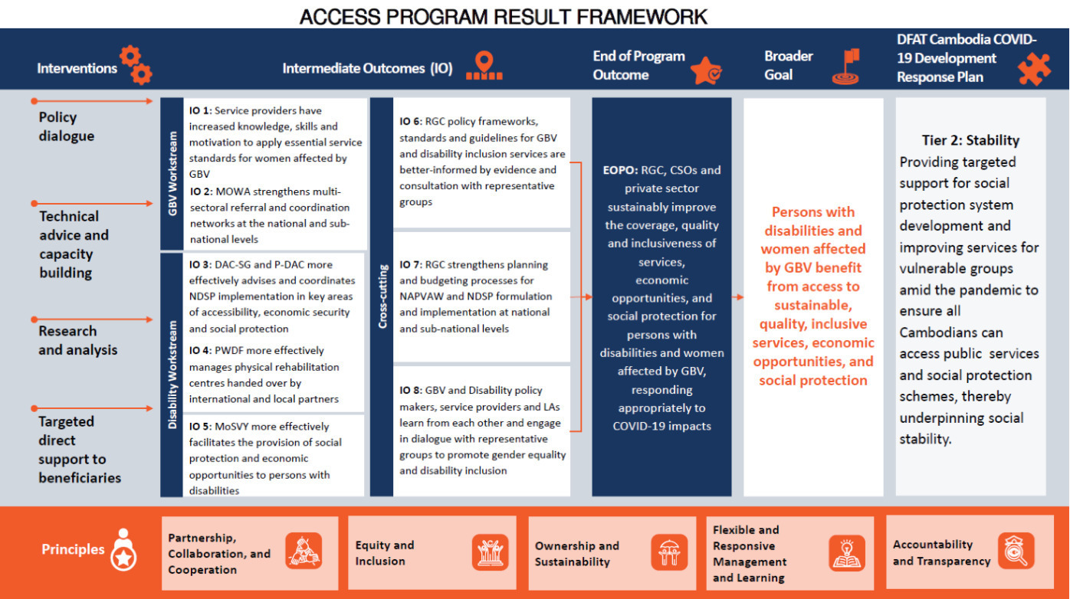

Annex 4 Stakeholder Interview List
Stakeholder Category | Location | Details | M | F
DFAT | Phnom Penh | DFAT Management / ACCESS Program Management | 3 | 3
DFAT | Phnom Penh | DFAT Human Development Team | 3 | 3
ACCESS | Phnom Penh | Management Team / Contractor | 3 | 4
ACCESS | Phnom Penh | Monitoring, Evaluation and Learning Team | 2 | 1
ACCESS | Phnom Penh | PFM Technical Advisors | 1 | 1
ACCESS | Phnom Penh | Disability Workstream Team | 3
ACCESS | Phnom Penh | GBV Workstream Team |  | 2
ACCESS | Phnom Penh | International GBV Advisor |  | 1
ACCESS | Phnom Penh | International Disability Advisor |  | 1
ACCESS Disability Workstream IPs | Phnom Penh | CDPO, Agile, PAfID, Chamroeun/GR, HI, UNDP, ADD | 5 | 3
ACCESS GBV Workstream IPs | Phnom Penh | UN Women, LAC, TAF, CWCC, TPO, CARE and UNFPA | 7 | 10
RGC-MoSVY | Phnom Penh | ACCESS Steering Committee (ASC) and Competitive Investment Mechanism (CIM) Panel Members:  HE Sem Sokha, Secretary of State, MOSVY  HE. Yeap Malyno, General Director of General Department of Social Policy and ACCESS CIMP member  Mr Sann Ratana, Director of Department of Welfare for People with Disabiltiies  Three other accompanying colleagues | 5 | 1
RGC-MoSVY DAC | Phnom Penh | HE Em Chan Makara, Secretary of State (MoSVY) and General Secretary (DAC)  HE Prak Thavak Pheary, Deputy General Secretary (DAC)  HE Ung Sambath, Deputy General Secretary (DAC) | 3
RGC-MoSVY PWDF | Phnom Penh | HE Sim Sothun,  Mr Mom Sothara  Two other team members | 4
RGC-MoSVY | Phnom Penh | HE Samheng Boros, Secretary of State of MoSVY  HE Chuor Sophana, Deputy Director General | 2
RGC-MoSVY | Phnom Penh | HE Yeap Malyno, DG Social Policy at MoSVY (former Director of the DWPD).
RGC-MEF | Phnom Penh | Mrs Hav Phirum, Deputy Director of Budget Formulation Department of General Directorate of Budget  Mr Chhum Socheat, Chief of Budget Formulation Office  Mrs Sar Sakina, Deputy chief of office, in charge of Social Affairs Sector | 1 | 2
RGC-MEF DG-SNAF | Phnom Penh | HE Bou Vongsokha, Deputy Director General of General Department of Sub-national Administrative Finance  Ms. Ty Lumey  Mr. Vann Chakriya | 2 | 1
RGC-MEF | Phnom Penh | Mrs. Uy Channimol, Deputy Secretary General of the National Social Protection Council, MEF  Ms. Dalinna  Mr. Sivutha Say  Two accompanying colleagues | 2 | 3
RGC-MoWA | Phnom Penh | HE Hou Samith, Secretary of State (MoWA) (ASC member)  HE Nhean Sochetra, General Director, General Department of Social Development  Ms Sar Sineth, DDG and ACCESS focal point  Ms. Pok Saren |  | 4
RGC-MoWA WEE | Phnom Penh | HE The Chhun Hak General Director of Gender Equality and Economic Empowerment  Ms Thoeun Sarkmakna, Director of Department of WEE  Accompanying colleague | 1 | 2
RGC-MoWA Finance | Phnom Penh | HE Chea Fung |  | 1
RGC-MoI NCDD | Phnom Penh | HE Chan Sothea, Undersecretary of State and Deputy Head of NCDD Secretariat, MoI  Three accompanying colleagues | 4 | 1
RGC-MoI GDA | Phnom Penh | HE Prak Sam Ouen  Mr Chhun Hieng, ACCESS Focal Point | 2
Development Partner | Phnom Penh | Giselle Hardley, Deputy Country Director, Clinton Health Access Initiative and three accompanying colleagues | 1 | 3
Development Partner | Phnom Penh | Dr Ly Nareth, World Bank HEQIP Contact |  | 1
Development Partner | Phnom Penh | Sokroeun Ain, Programme Analyst, UNFPA |  | 1
Development Partner | Phnom Penh | Erna Ribar, Social Policy Chief, UNICEF  Accompanying colleague | 1 | 1
Civil society | Phnom Penh | Cambodia-based CBM consultants |  | 2
Civil society | Phnom Penh | Australia Awards Alumni | 2 | 3
Civil society | Phnom Penh | Eng Chandy, Executive Director, Gender and Development for Cambodia (GADC) |  | 1
Civil society | Phnom Penh | Eng Netra, Director, Cambodia Development Resource Institute, CDRI and two accompanying colleagues |  | 3
RGC-PDAC | Kampong Speu | Mr Ou Sam Bo, P-DAC member | 1
RGC-PDoWA | Kampong Speu | Ms Davy, Director  Ms Phun Phin, Deputy Director  Head of Administration |  | 3
RGC-PDoWA-WDC | Kampong Speu | Head of WDC | 1
RGC-CCWC  (Kaheng commune) | Kampong Speu | Ms Prun Ny, Commune Chief  Ms Sy Lany, CCWC  Other Commune members |  | 8
RGC-CCWC  (Borseth district) | Kampong Speu | CCWC members |  | 8
RGC-PoSVY | Kampong Speu | Ms Srey Lina, Director (also P-DAC member)  Accompanying staff members (P-DAC, P-CWCC) | 2 | 1
RGC | Kampong Speu | HE Long Bonareth, Deputy Provincial Governor and Chair of P-DAC |  | 1
Civil society | Kampong Speu | Mr Som Som Eng, Head of Samrong Tong Disability Development Federation  Ms Min Sophal, Head of Women and Children with Disability Federation | 1 | 1
Civil society | Kampong Speu | - Women’s support group member |  | 12
Civil society | Kampong Speu | - Woman who received economic support |  | 1
RGC-PWDF and PoSVY | Kampong Cham | - Mr Hout Sothea, Branch Manager PWDF and Deputy Director of PoSVY  - Mrs Samouen, Head of Finance | 1 | 1
RGC  (Chamkar Leu District) | Kampong Cham | - Police and CWCC members | 2 | 2
RGC-MoH  (Chamkar Leu District) | Kampong Cham | - Referral Hospital | 2 | 3
RGC  (Stung Treng District) | Kampong Cham | - GBV Response Working Group Members – Deputy Governor, Police, Health, Women’s Affairs | 1 | 4
RGC | Kampong Cham | - HE Pang Dany, Deputy Governor and Chair of GBV Response Working Group  - Chair of Provincial CWC, Health, P-DoWA | 0 | 4
Civil society / IP | Kampong Cham | - Mr Doung Chethea, PRC Manager (HI managed)  - Mr Uk Tola, Database Officer  - Ms Nguon Reaksmeymutta, P&O | 2 | 1
Civil society / IP | Kampong Cham | - PRC clients | 3 | 4
Civil society / IP | Kampong Cham | - Chamroeun Branch Manager | 1
Civil society / IP | Kampong Cham | - Focus group meeting with OPD and WWDF beneficiaries | 3 | 4
Civil society / IP | Kampong Cham | - OPD staff - Mr Soi Sokorn  - Women with Disabilities Federation staff | 3 | 2
Total number of stakeholders consulted: 80 male, 119 female.

Annex 5 ACCESS Geographic Coverage

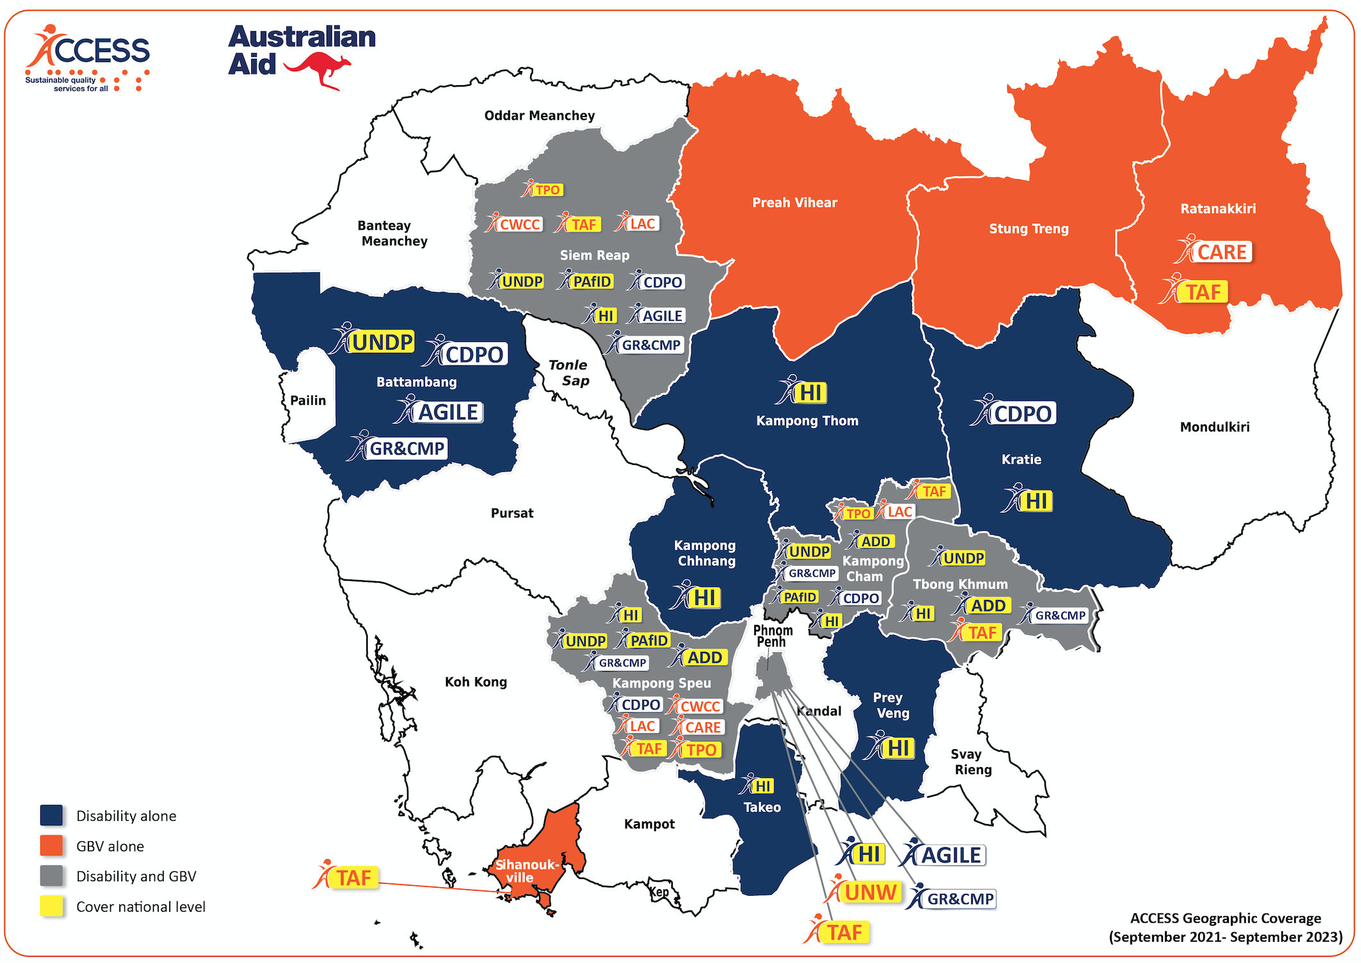

Annex 6 ACCESS Implementing Partners
Organisation | Focus of activities under ACCESS – Gender-based Violence Workstream
UN Women  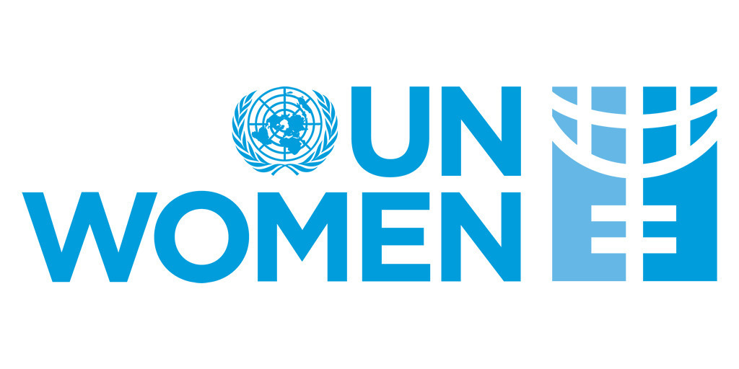 | UN Women supports the Ministry of Women’s Affairs (MoWA) to implement the third National Action Plan to Prevent Violence Against Women. This includes strengthening MoWA capacity to implement minimum service standards, effectively coordinate the GBV response coordination and NAPVAW implementation at national and sub-national levels through the Technical Working Group on Gender – Gender-Based Violence, and inform laws that better prevent, respond to, and prosecute all forms of GBV.
Care  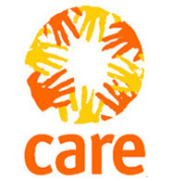 | CARE supports women affected by GBV from minority groups, predominantly ethnic minorities, and women with disability to access quality health care, legal protection, and other coordinated social services. This includes through strengthening capacity of service providers and GBV working groups through training on topics including sexual harassment, national guidelines for managing violence against women in the health system, basic counselling, and referrals.
Legal Aid Cambodia  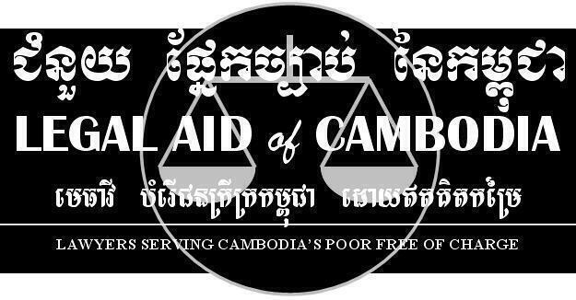 | Legal Aid of Cambodia is supporting capacity building of government service providers and strengthening stakeholder coordination to enhance access to survivor-centred legal protection and justice for survivors of GBV. LAC provides direct legal aid services to GBV survivors, and supports training and coaching to MoWA, judicial police agents and officers, and district-level GBV working groups on service packages including basic counselling, mediation, and legal services.
Transcultural Psychosocial Organisation  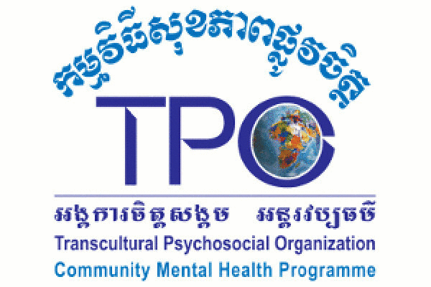 | TPO supports improved psychological well-being of women affected by GBV by providing counselling to women affected by violence and developing local service providers’ knowledge and skills on mental health and psychosocial support for violence survivors. This includes through providing training on minimum standards for basic counselling, psychological first-aid, and referral guidelines, and raising awareness of GBV services.
Cambodian Women’s Crisis Centre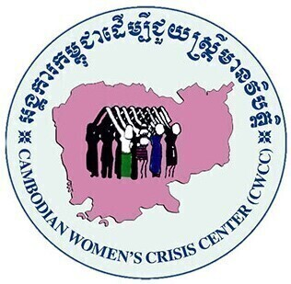 | Cambodian Women’s Crisis Center supports women and girls survivors of GBV, including women and girls with disabilities, to access essential services. CWCC provides safe accommodation to GBV survivors, economic support to recover from violence, psychological and legal counselling to survivors and referrals to other services. CWCC also supports capacity development of GBV working group members through training on women’s rights, GBV, policies and guidelines/standards.
The Asia Foundation  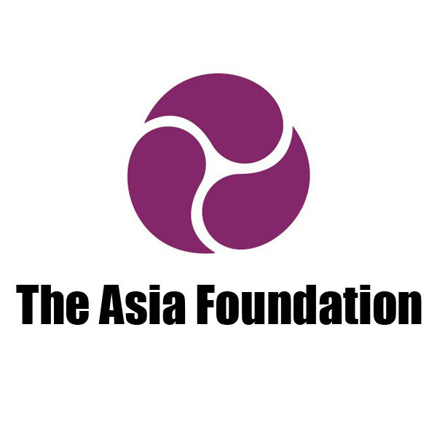 | The Asia Foundation supports research on court and mediation practices to build evidence and recommendations for amendments to the Law on the Prevention of Domestic Violence and Protection of Victims. TAF supports improved digital case management systems at the provincial level, court case monitoring, training on GBV for members of the Bar Association and legal stakeholders, and supporting capacity of MoWA and PDoWA to improve access of women survivors of GBV to legal aid.
UNFPA  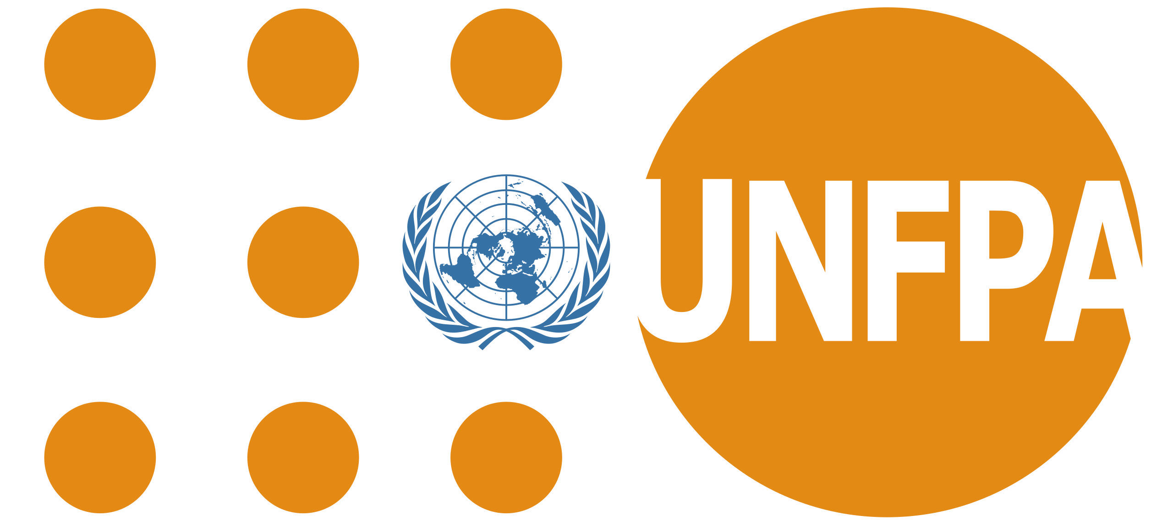 | UNFPA supported improved access to quality GBV and sexual and reproductive health services for women affected by violence, through supporting implementation of national guidelines for the management of GBV in the health sector and capacity building of health service providers. This included adapting the WHO manual for healthcare managers, integrating GBV into midwife curriculum, and developing a GBV toolkit for new health sector civil servants’ induction.
Organisation | Focus of activities under ACCESS – Disability Inclusion Workstream
ADD  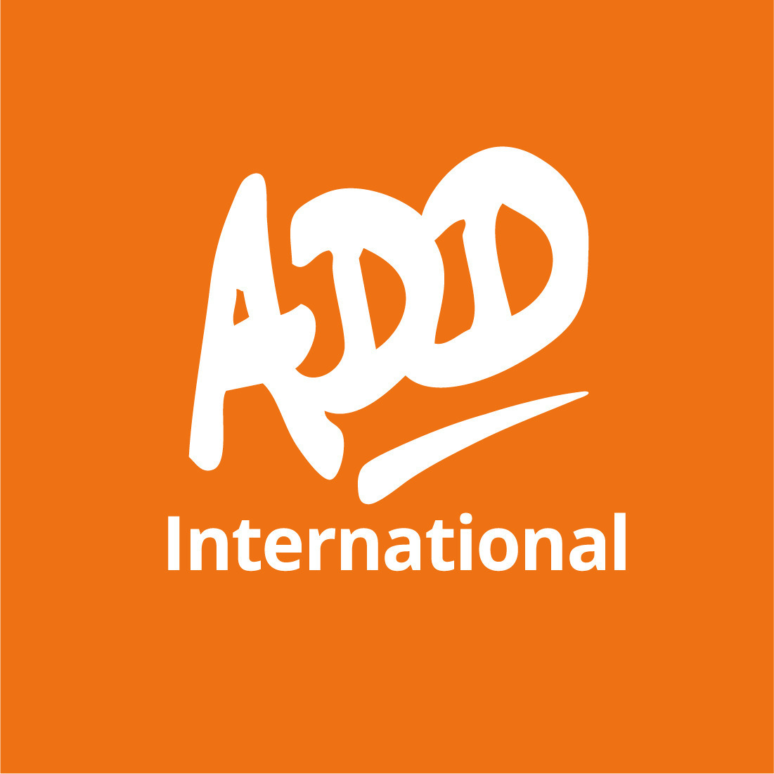 | ADD International works with government agencies, donors, Organisations of Persons with Disabilities, service providers, business networks, and people with disabilities to implement the National Disability Strategic Plan 2019-2023 and NAPVAW III. ADD supports women and girls with disabilities to speak directly about their experiences of violence and exclusion from services and facilitates Learning and Exchange Platforms between stakeholders to promote disability inclusive GBV services.
Agile  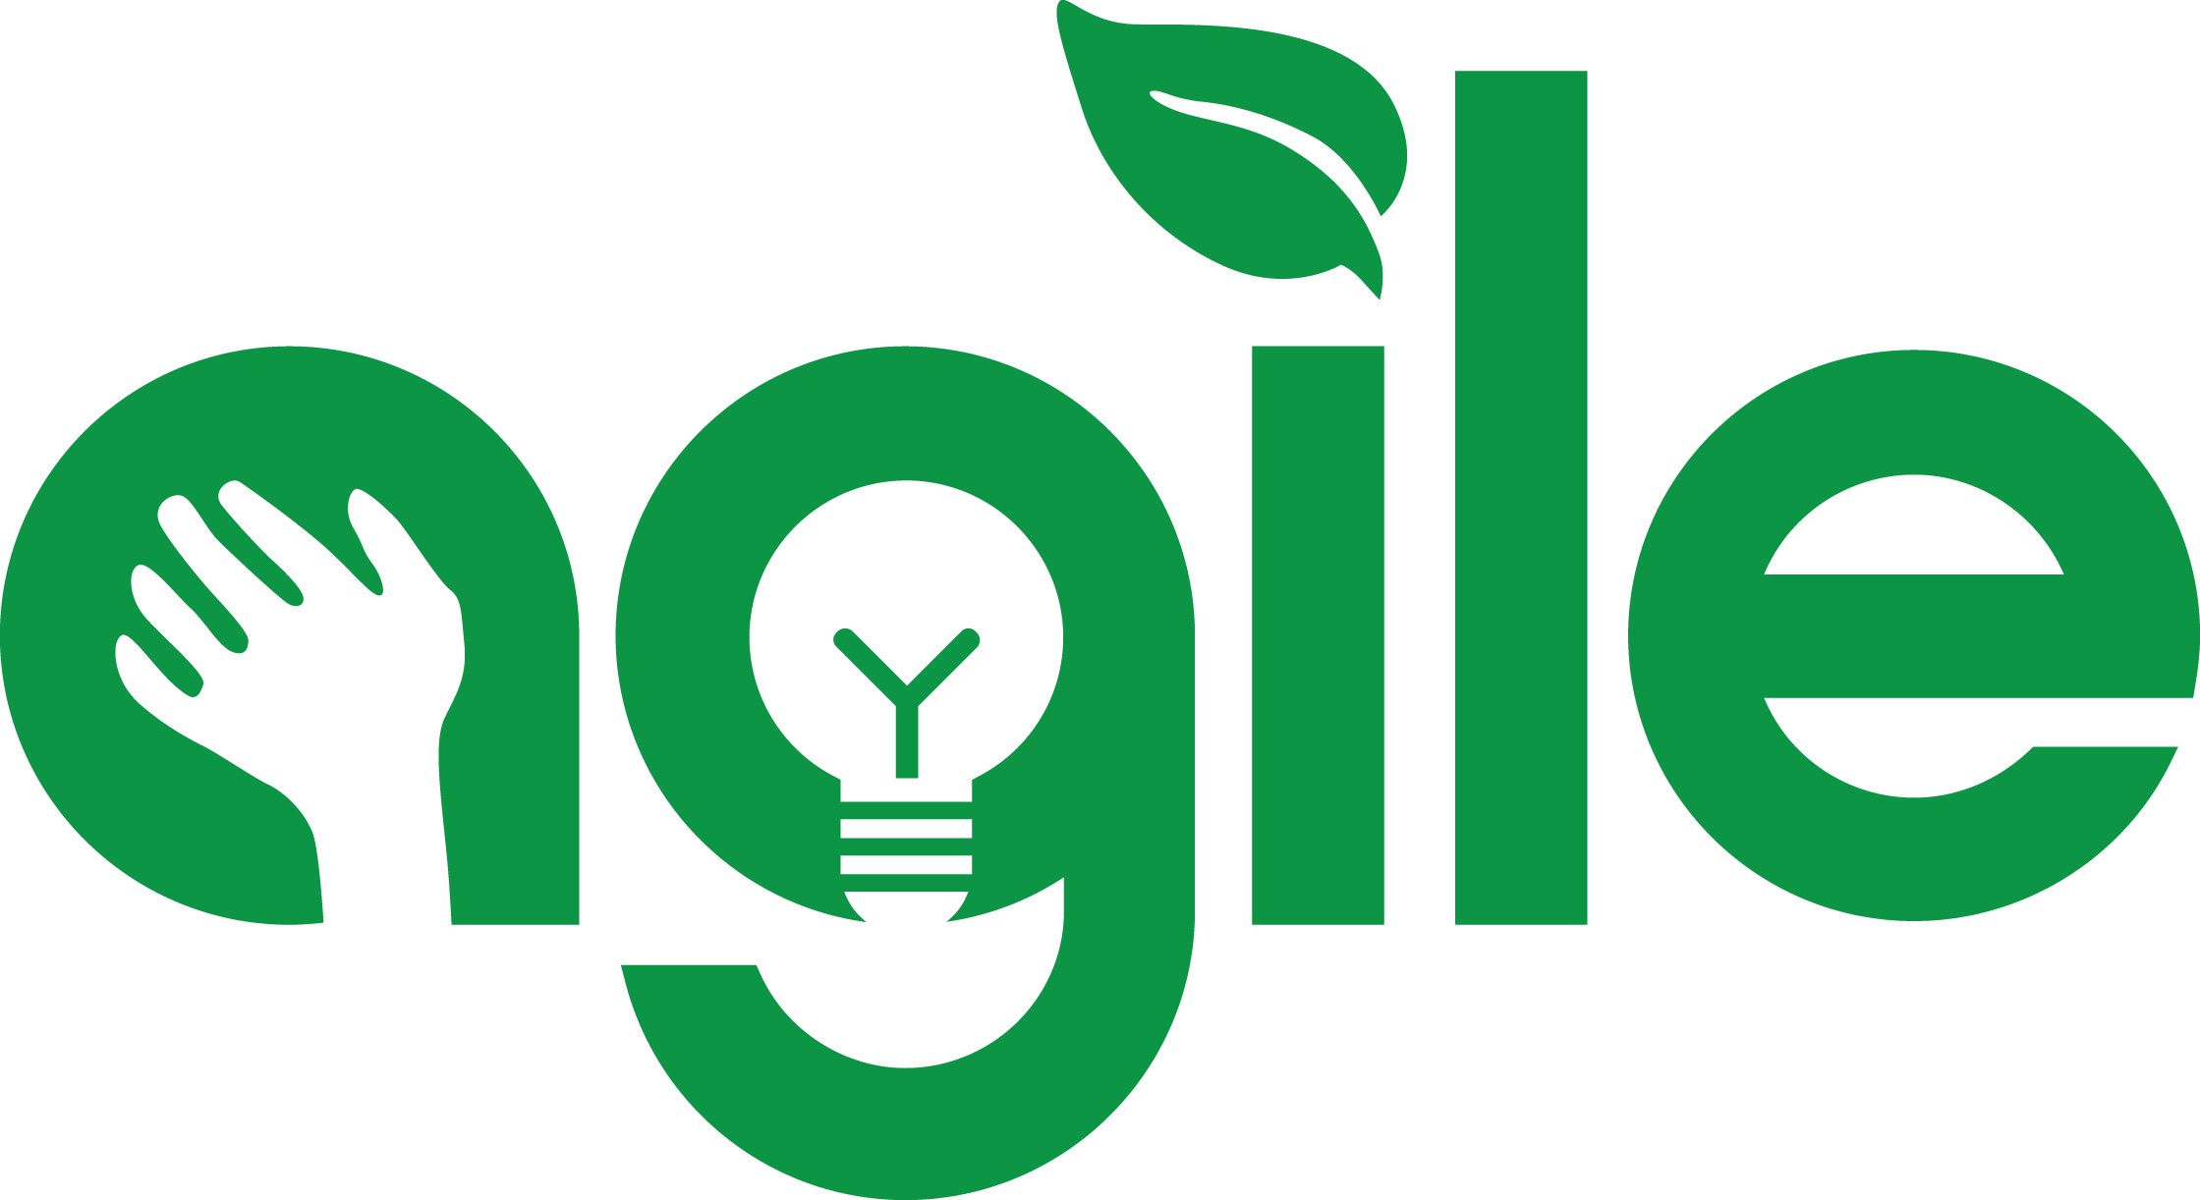 | Agile works to enhance entrepreneurship capacities of women with disabilities, through delivering business incubation training programs for women, creating and sustaining networks of women entrepreneurs with disabilities, undertaken research on access to financial services for women with disabilities, and documenting success stories and lessons to inform and influence policy.
HI  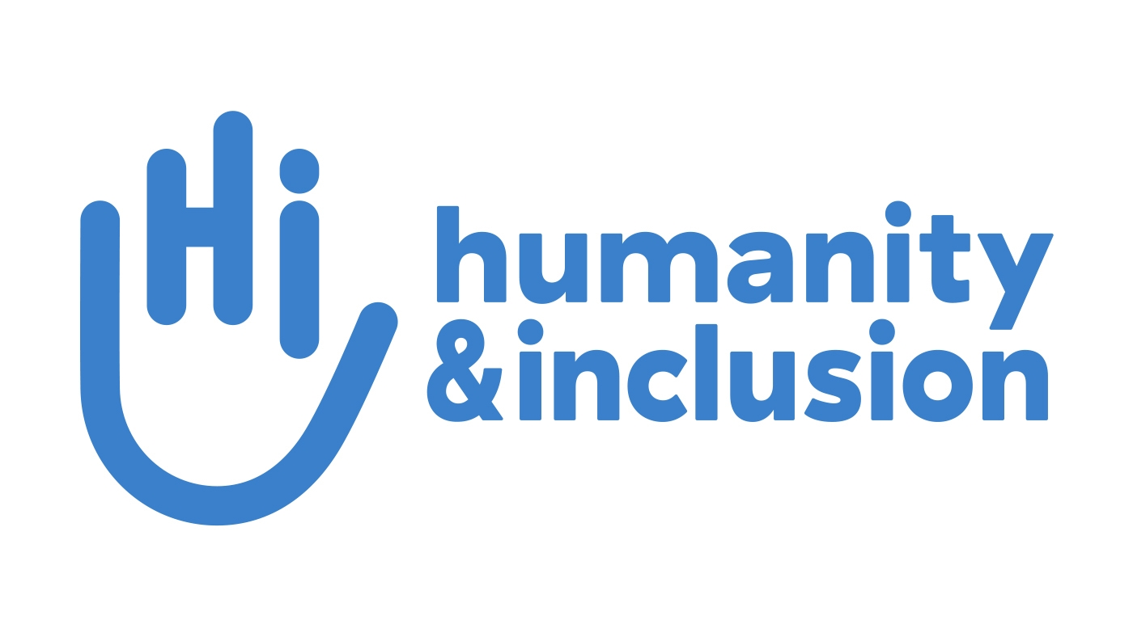 | Humanity & Inclusion works in partnership with the Royal Government of Cambodia, OPDs, PRCs, and health facilities to improve quality and inclusive services for all, including women and men with disabilities. H&I supports implementation of technical standards on physical accessibility-infrastructure, accessible transport, and professional standards in 6 PRCS, and supporting training and coaching of PRC managers and PWDF staff including on GBV.
PAFID  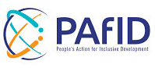 | People’s Action for Inclusive Development (formerly Light for the World) supports increased sectoral knowledge on disability inclusion and access for people with disabilities to employment and vocational training. This includes supporting a national curriculum and guidance on inclusive vocational training and employment, job coaching, inclusive employment networks and forums, and establishing employment service desks in PRCs in collaboration with OPDs.
CDPO  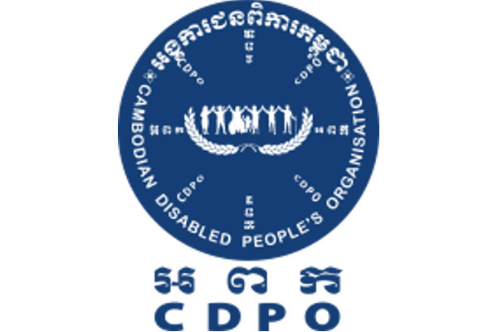 | Cambodian Disabled People’s Organisations (CDPO) supports access to inclusive employment opportunities for women and men with disabilities and promoting disability-inclusive, gender-responsive Commune Investment Plans. CDPO supports training on disability inclusion and GBV with partners, builds capacity of OPDs and Women with Disabilities Forums to identify jobseekers with disabilities and support linkages with employment opportunities, and to access ID-Poor, disability identification cards, and other social protection interventions.
UNDP  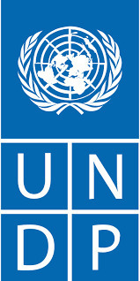 | UNDP is supporting DAC to effectively develop, coordinate, and monitor the implementation of the NDSP 2019-2023 and relevant national level frameworks such as the new disability law, accessible digital monitoring platforms and Disability Inclusive Social Protection guidelines. This includes supporting training on disability inclusion and coordination and resources mobilisation for NDSP implementation at national and sub-national levels.
Chamroeun & Good Return   | Chamroeun Microfinance in partnership with Good Return support increased inclusion and accessibility of financing products for people with disabilities. This includes providing financial literacy training for people with disabilities, creating a pipeline of accessible finance and ensuring financial products meet the needs of people with disabilities, and supporting more inclusive attitudes and physical accessibility of financial service providers.

Annex 7 DFAT Disbursements
ACCESS Cambodia - Total Drawdown & Activities Drawdown Comparison
Table 1: Total Drawdown (AUD) (September 2018 – June 2022)
Fiscal Year | Approved Budget | Actual Spent | Variance ($)
Year 1 (Sep 18-Jun 19) | 1,869,497 | 1,869,497 | 0
Year 2 (Jul 19-Jun 20) | 6,725,522 | 6,726,000 | 478
Year 3 (Jul 20-Jun 21) | 5,402,983 | 5,402,988 | 5
Year 4 (Jul 21-Jun 22) | 5,991,674 | 5,991,674 | 0
Total | 19,989,675.50 | 19,990,158.50 | 483.00
Table 2: Activities Drawdown Comparison (AUD) (September 2018 – June 2022)
Fiscal Year | Approved Budget | Actual Spent | Variance ($)
Year 1 (Sep 18-Jun 19) | 140,945.54 | 140,945.54 | 0
Year 2 (Jul 19-Jun 20) | 4,476,119.81 | 4,464,213.17 | 11,906.64
Year 3 (Jul 20-Jun 21) | 2,997,831.94 | 2,809,958.16 | 187,873.79
Year 4 (Jul 21-Jun 22) | 3,252,233.29 | 3,388,931.06 | (136,697.77)
Total | 10,867,130.59 | 10,804,047.93 | 63,082.66
Table 3: ACCESS Cambodia - Budget Vs Actual Spent Report (a) (September 2018 – June 2022)
EOPO | Sector | IO | Budget (A) | Actual Spent (B) | Variance (C=A-B) | % under / (over)
EOPO 1 | PFM | IO 1.1 | 363,907 | 357,207 | $6,700.45 | 1.88% (b)
EOPO1 | PFM | IO 1.2 | 502,225 | 494,673 | $7,551.59 | 1.53% (b)
EOPO2 | GBV | IO 2.1 | 2,605,499 | 2,599,144 | $6,355.50 | 0.24% (c)
EOPO2 | GBV | IO 2.2 | 2,630,408 | 2,620,167 | $10,241.11 | 0.39% (c)
EOPO2 | Disability | IO 2.3 | 1,278,916 | 1,286,241 | -$7,324.62 | -0.57% (d)
EOPO2 | Disability | IO 2.4 | 810,215 | 773,745 | $36,469.72 | 4.71% (e)
EOPO2 | Disability | IO 2.5 | 1,701,953 | 1,691,131 | $10,821.35 | 0.64% (f)
EOPO2 | CIP | IO 2.6 | 483,844 | 479,874 | $3,970.53 | 0.83% (g)
EOPO2 | GESI / Cross-cutting | IO2.7 | 490,164 | 501,867 | -$11,702.97 | -2.33% (h)
- | - | TOTAL | 10,867,131 | 10,804,048 | $63,082.66 | 0.58%

Annex 8 ACCESS Organisational Chart
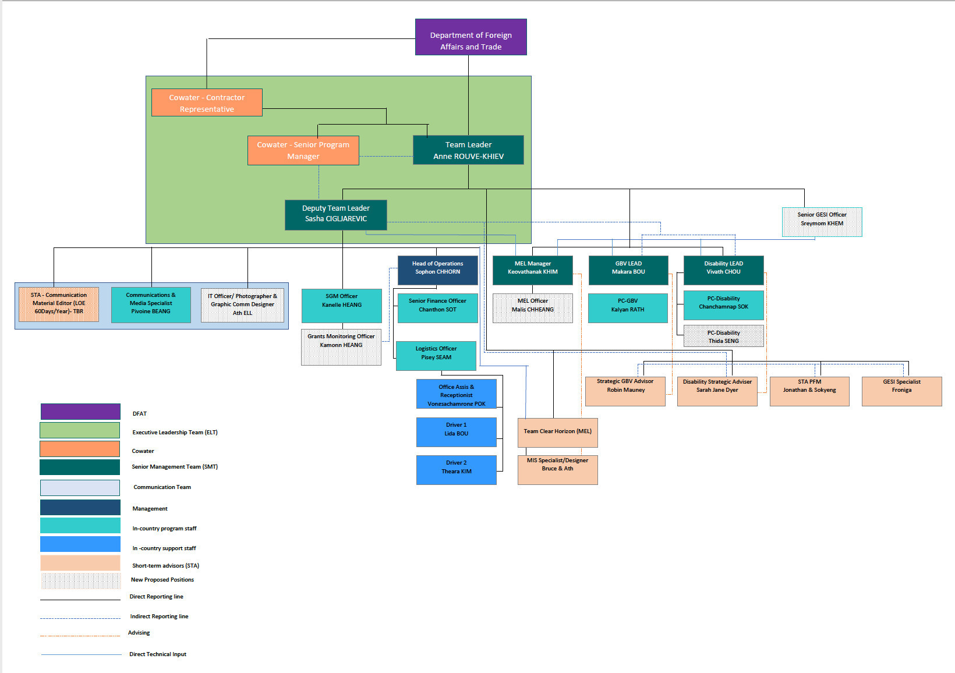

Source: Australia Cambodia COVID-19 Development Response Plan
https://www.cbm.org/news/news/news-2015/putting-disability-on-the-agenda-in-cambodia/#:~:text=Disability%20in%20Cambodia,whom%20have%20amputations%20%5B3%5D.
https://cambodia.un.org/sites/default/files/2022-03/Gender%20Deep%20Dive%20-%20CCA%20Cambodia_V6_010322_LQ.pdf; https://gsdrc.org/document-library/triple-jeopardy-gender-based-violence-and-human-rights-violations-experienced-by-women-with-disabilities-in-cambodia/
The restructure was in line with Sub-Decree 94 which restructured a former General Technical Department into three General Departments.
This insight may be modified after the results of the second ACCESS SAQUS, with a sample size of 538 people. The results from the first SAQUS offer a baseline picture only.

