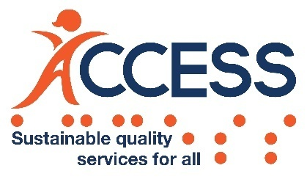 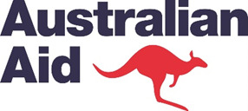

**Stage 1 Impact Report**

**(September 2018-June 2021)**

***Australia-Cambodia Cooperation for***

***Equitable Sustainable Services (ACCESS)***



Submitted to:

Department of Foreign Affairs and Trade (DFAT) - Australia

Prepared by:

Cowater International Inc., in association with Clear Horizon

November 2021

****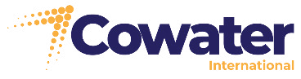

Table of Contents

List of Acronyms ii

1 INTRODUCTION 1

2 THE DEVELOPMENT CHALLENGE 1

2.1 Gender-based violence (GBV) and disability are highly prevalent and access to quality support services is low 1

2.2 Service delivery constraints for both disability and GBV are complex, inter-related, and require systemic responses. 3

3 ACCESS RESULTS 3

3.1 Enhanced policies and laws 4

3.2 Predictable and sufficient budget 7

3.3 Improved Standards, Guidelines, and Monitoring 8

3.4 Improved Coordination 12

3.5 Improved Representation and Empowerment 16

4 FUTURE DIRECTIONS 19

Annex 1: Updated Program Logic 22

Annex 2: Key Achievements Indicators-Stage 1 23

Annex 3: Story of Significant Change 25

# List of Acronyms

ACCESS Australia-Cambodia Cooperation for Equitable Sustainable Services

AOP Annual Operational Plan

ASC ACCESS Steering Committee

BAKC Bar Association of the Kingdom of Cambodia

CDHS Cambodia Demographic and Health Survey

CDPO Cambodian Disabled People’s Organisation

CIMP Competitive Investment Mechanism Panel

CIP Commune Investment Programs

CMP Chamroeun Micro-finance Plc

CNCW Cambodian National Committee for Women

CCHR Cambodian Centre for Human Rights

COVID-19 Coronavirus Disease 2019

CSL Cambodian Sign Language

CSO Civil Society Organisation

CWCC Cambodian Women’s Crisis Centre

DAC Disability Action Council

DAC-SG Disability Action Council- Secretariat General

DFAT Australian Department of Foreign Affairs and Trade

DV Law Law on Prevention of Domestic Violence and Protection of Victims

DSA Daily Subsistence Allowance

DWPD Department of Welfare for Persons with Disabilities

EPC Essential Personnel Cambodia

GBV Gender Based Violence

GESI Gender Equality and Social Inclusion

GD-SNAF General Department for Sub-national Administration Finance

GPCC General Population Census of Cambodia

GRB Bender responsive Budgeting

HI Humanity and Inclusion

IP Implementing Partners

KHR Khmer Riel

LAC Legal Aid Cambodia

LFTW Light for the World

LM Line Ministry

M&E Monitoring and Evaluation

MEF Ministry of Economy and Finance

MEL Monitoring, Evaluation and Learning

MIS Management Information System

MoI Ministry of Interior

MoP Ministry of Planning

MoSVY Ministry of Social Affairs, Veterans and Youth Rehabilitation

MoWA Ministry of Women’s Affairs

NAPVAW National Action Plan to Prevent Violence Against Women

NCDD National Committee for Sub-national Democratic Development

NDSP National Disability Strategic Plan

NEA National Employment Agency

NGO Non-Governmental Organisation

NSPPF National Social Protection Policy Framework

NSPC-GS National Social Protection Council-General Secretariat

OPD Organisations of Persons with Disabilities

PDoWA Provincial Department for Women’s Affairs

PFM Public Financial Management

PFMRP Public Financial Management Reform Program

PFMRP-GSC PFMRP General Secretariat-Steering Committee

PRC Physical rehabilitation centre

PWDF Persons with Disabilities Foundation

RGC Royal Government of Cambodia

RMS Rehabilitation Management System

TA Technical Assistance

TAF The Asia Foundation

TPO [Transcultural](https://www.devex.com/organizations/transcultural-psychosocial-organization-tpo-cambodia-117430) Psychosocial Organisation

ToT Training of Trainers

TVET Technical and Vocational Education and Training

TWGG-GBV Technical Working Group on Gender- Sub Committee on GBV

UN United Nations

UNDP United Nations Development Program

UNFPA United Nations Population Fund

UNICEF United Nations International Children’s Emergency Fund

UN Women United Nations Entity for Gender Equality and the Empowerment of Women

WG Working Group

WSG Women’s Support group

|  |  |  |  |
| --- | --- | --- | --- |
| **Version** | **Date** | **Author** | **Detail** |
| 1.0 | 16/11/21 | Co-water/Clear Horizon | Submitted to DFAT for review and approval |
| 2.0 | 25/11/21 | DFAT comments | Responded to ACCESS for completion |
| 3.0 | 22/12/21 | Cowater/Clear Horizon | Revised version addressing DFAT comments |
| 4.0 | 03/01/22 | Cowater/Clear Horizon | Final version approved by DFAT |

# INTRODUCTION

The Australia-Cambodia Cooperation for Equitable Sustainable Services (ACCESS) is a five-year (2018 – 2023) initiative to improve social, economic, and health outcomes for persons with disabilities and women affected by gender-based violence (GBV) through improvements in the sustainability, quality, and inclusiveness of relevant services. Over the last three years (Stage 1), the Government of Australia, through the Department of Foreign Affairs and Trade (DFAT), committed AUD 15 million to the Program. In February 2021, a contract amendment was signed to extend the Program for two more years, with an additional budget of AUD 10 million (Stage 2). Stage 1 of the Program involved a coordinated design process for the ACCESS implementing partners during the first year followed by two years of implementation.

This report distills key results achieved during ACCESS Stage 1. The purposes of this are to inform DFAT and the ACCESS Steering Committee of the strategic direction of the Program during Stage 2 and to share lessons for other development programs. The report is divided into three sections:

1. the development challenge,
2. ACCESS results, and
3. future directions.

The primary audience of this full report is DFAT. A separate summary version of this report will be distributed to ASC.

# THE DEVELOPMENT CHALLENGE

## Gender-based violence (GBV) and disability are highly prevalent and access to quality support services is low

**Cambodia continues to experience high rates of GBV.[1]** According to a 2015 survey conducted by the Ministry of Women’s Affairs (MoWA),[2] 20% of Cambodian women (aged 15-64) reported physical and/or sexual violence by an intimate partner, and 8% had experienced it in the past 12 months.[3] Social norms and attitudes about women and girls contribute to widespread tolerance and acceptability of GBV across the country. Almost half of the female respondents in the MoWA study, for example, felt that beatings by a husband are justifiable under specific circumstances.[4]

**Yet, critical gaps remain in the availability of quality health, legal, and social services for women affected by GBV.** The MoWA study, for example, found that 90% of women who had experienced violence were hurt badly enough to require healthcare, though only 53% ever accessed it. These women also pursued legal recourse and social service support at similarly low rates. A 2014 study found that only about two in five women sought assistance to stop the violence they experienced.[5] Furthermore, only 24% of women who experienced GBV reported seeking help from a formal service.

**The situation for persons with disabilities is similar**. In 2014, 9.5% of the Cambodian population over the age of five reported any form of disability, with slightly higher rates for females (10.5%) than males (8.5%).[6] A study by UNICEF found that 10% of children have a disability, with speech and cognitive impairments being the most common. Additionally, accidental detonations of landmines have led to approximately 45,000 injuries since 1980, resulting in Cambodia having the highest number of amputees per capita in the world.

**A primary concern remains the lack of economic opportunity for persons with disabilities**. In 2019, 35% of Cambodian households in which a member had a disability were living on less than KHR10,100 (US$2.50) per day, while 78% were living on less than KHR18,000 (US$4.50).[7] Their financial situation is exacerbated by few employment opportunities. The 2019 General Population Census of Cambodia (GPCC) found that only 48% of children with disabilities aged 6-17 attend school. Also, 76% of adults with disabilities have no more than primary education, while 41% have never attended school. Consequently, persons with disabilities can struggle to access steady work – the GPCC reported an employment rate of 52.9% across adult persons with disabilities, with lower rates for women (45.9%) than men (62.7%). Only 32% of persons with severe disabilities reported employment.

**Persons with disabilities also experience limited access to necessary physical rehabilitation services.** There are currently eleven physical rehabilitation centres (PRCs), a spinal cord injury centre, and an orthopaedical component factory active across Cambodia. In 2019, the Persons with Disabilities Foundation (PWDF) recorded 28,606 PRC clients across all of Cambodia, only 25% (7,281) of which were female.[8]. A study conducted by ACCESS in 2020 identified several demand-side constraints to accessing services for persons with disabilities, such as service costs, travel time, distance from home and transportation costs. It also identified female-specific barriers such as lack of childcare options and safety concerns, which have created a distinctive gender gap in the rates of PRC service provision.[9]

**The COVID-19 pandemic has exacerbated challenges that survivors of GBV and persons with disabilities face and made it harder to access services.** The pandemic and associated restrictions have increased the number of women experiencing violence globally and most likely in Cambodia[10]. Home isolation and increased economic strain due to income disruptions has been proven to exacerbate mental health concerns and increase the level of risk for women experiencing violence. During the COVID-19 pandemic, home isolation meant that persons with disabilities were unable to leave their homes to access services and they were also impacted by job losses. Women experiencing violence have also found it more challenging to access services. Furthermore, the Cambodian Government’s COVID-19 response has diverted national budget resources from some GBV and disability-related initiatives[11].

## Service delivery constraints for both disability and GBV are complex, inter-related, and require systemic responses.

A core premise of the ACCESS design is that the causes of inadequate services for persons with disabilities and survivors of GBV are complex, inter-related, and require whole-of-system responses, working at multiple levels. ACCESS was designed to address the following key systemic areas:

* **Laws and policies**: Both the second National Action Plan to Prevent Violence Against Women (NAPVAW II) and the first National Disability Strategic Plan (NDSP I) were due for renewal during ACCESS Stage 1, with work also required to develop or apply related laws, including the Disability Law and the Law on Prevention of Domestic Violence and Protection of Victims (DV Law).
* **Budgeting**: The Royal Government of Cambodia’s (RGC) budget allocation for GBV and disability sectors has been limited, due to competing budget priorities, limited understanding of budget needs, and lack of awareness / sensitivity among officials about disability and GBV. This has led NGOs to fill gaps in financing for frontline services and creates sustainability and alignment issues.
* **Standards, guidelines, and monitoring:** Progress has been made in both sectors to define service standards and guidelines, but more work is needed to build understanding of these requirements, and the capacity of service providers to implement them. This is critical to addressing hesitation among women affected by GBV and persons with disabilities to seek health, legal, and social support.[12] Strengthening the availability and quality of data on both prevalence and services is also essential.
* **Coordination:** MoWA and Disability Action Council- Secretariat General (DAC-SG) have faced challenges coordinating and building commitment to NAPVAW and NDSP implementation by Line Ministries, sub-national administrations, and civil society[13]. This has been compounded by complicated and inefficient institutional structures in the disability sector, with unclear roles and responsibilities. Coordination of service provision at the provincial and district levels has also beeninadequate, leading to duplication of effort and inefficient or inequitable resource allocation.
* **Representation and empowerment:** The participation and voice of representative groups in both policy and service delivery processes are fundamental to the relevance, accountability, and effectiveness of service delivery responses. Persons with disabilities and women affected by violence often struggle to access information on available services and economic opportunities. They also have fewer opportunities to dialogue with service providers, local authorities and decision-makers about their needs.

# ACCESS RESULTS

During Stage 1, ACCESS worked across all five systemic areas listed above. The pace of change has not been linear, and ACCESS has had to adapt its focus as new opportunities and constraints emerged. However, there has been a range of significant results, which are summarised below. This section also explores four core features of the ACCESS implementation approach, which help to explain its effectiveness. See Figure 1 below.

Figure 1: ACCESS’s model to achieving improved GBV and disability related services

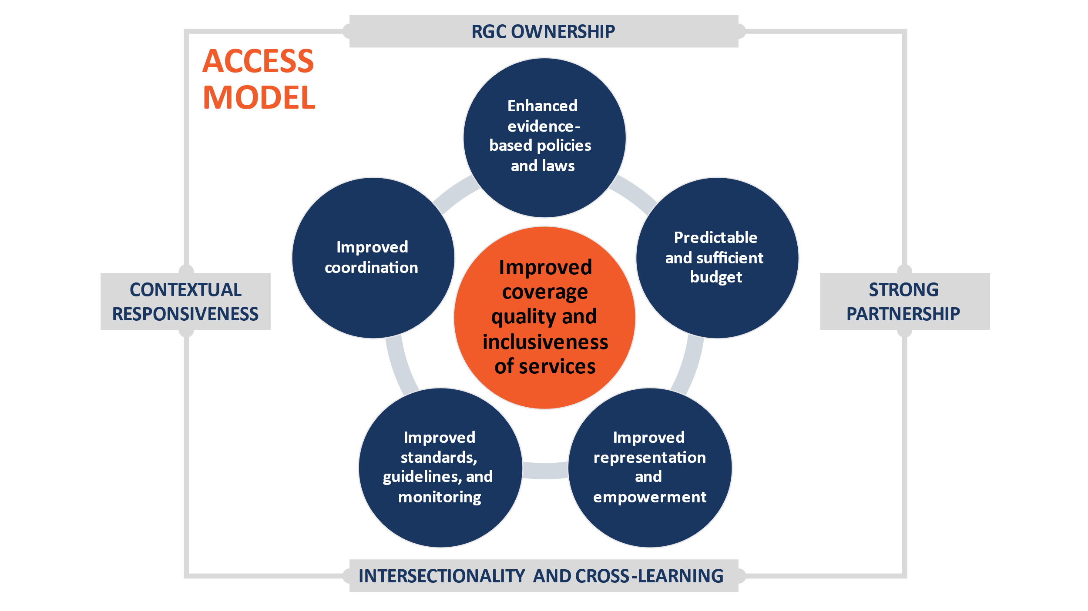

## Enhanced policies and laws

### Laws and Sub-Decrees

**ACCESS’s support to the Disability Action Council -Secretariat General (DAC-SG) on the Disability Law resulted in a draft[14] that will provide critical protections for the rights of persons with disabilities.** The draft law responds to the diverse experiences across disability groups and commits to awareness-raising, resource mobilisation and capacity building, based on key principles of social inclusion and CRPD conventions. As part of a technical working group, ACCESS and its partner UNDP helped draft the law, informed by a rights-based perspective and social model of disability. ACCESS' support, through UNDP ensured the drafting process benefited from intensive consultation with wider relevant stakeholders, including disability-focused Civil Society Organisations (CSOs), Organisations of Persons with Disabilities (OPDs) and all relevant ministries. ACCESS was instrumental to engage Cambodia based Development Stakeholders to combine their technical inputs and recommendations in a single document that was presented to DAC-SG management for consideration. This included mobilising inputs from the Australian Human Rights Commission, and DFAT disability inclusion specialists and facilitating a dialogue between DAC Secretary General and the Australia High Commissioner for Disability Rights. RGC has also recently endorsedanInter-Ministerial Prakas enabling persons with disabilities to access a driving license.

*"Thanks to ACCESS for organising consultation workshops on the law, persons with disability were able to join, and this is a great acknowledgement of the voices and concerns of persons with disabilities, resulting in improved contents of the law better aligned with the UN Convention on The Rights of Persons with Disabilities (CRPD)."* Ms. Mak Monika, Executive Director of the Cambodian Disabled People’s Organisation (CDPO)

**ACCESS supported MoWA to lead the implementation of the Law on Prevention of Domestic Violence and Protection of Victims (DV Law)** – by updating the Explanatory Note on the DV Law and training MoWA officials on the law. Eighty MoWA management staff and 34 technical MoWA officials are now better equipped to provide accurate advice on DV Law implementation to provincial judicial police agents and officers.

“Following the ACCESS intervention, MoWA Legal Protection Department officials are more knowledgeable and skilled to facilitate access to GBV services in partnership and cooperation with the judicial police of the Ministry of Interior (MoI), courts and lawyers. Especially, they have shared their legal knowledge and have facilitated policy discussions during consultation processes such as in the Technical Working Group for Gender- GBV sub-committee (TWGG GBV)” said Mr Phorn Putborey, Director of Legal Protection Department, MoWA

### Sector Policies and Plans

The RGC launched NDSP II in December 2019 and NAPVAW III in January 2021. Both documents define clear national priorities and responsibilities and are a key reference point for RGC and development stakeholders.

**ACCESS technical advice informed improvements in the content of NAPVAW III compared to previous versions.** For the first time, OPDs participated in consultations that ACCESS facilitated, resulting in NAPVAW’s acknowledgment of the needs of women with disabilities in the final draft. NAPVAW III also recognises the critical role of GBV response working groups whose functioning has been significantly improved, with ACCESS' support. Because of the improvement, MoI recognised the benefits of WGs in addressing GBV issues and has committed to supporting the expansion of these nationwide (see Section 3.4.1 below on subnational coordination). Lastly, NAPVAW III includes a stronger M&E framework with indicators owned by Line Ministries and an embedded capacity building plan supported by ACCESS-funded Monitoring and Evaluation (M&E) experts.

"It is important that this policy document has an M&E component which helps us to track progress in implementation accurately. I'd like to thank ACCESS for supporting this work, as well as for participating and supporting in the development and dissemination of the NAPVAW itself as it's a reference guide for multisectoral GBV responses". Ms. Nhean Sochetra, Director General of the Social Development General Directorate, MoWA

**ACCESS is helping to build awareness and buy-in to NAPVAW III, which will bolster its implementation.** ACCESS funded the printing of NAPVAW documents and NAPVAW launch, and dissemination events attended by members of 25 provincial authorities, Ministries,[15] OPDs, and the Women’s Federation Forum. With expert advice provided by UN Women, ACCESS funds helped to broaden government and non-government awareness of the plan and its content, which contributed to an increased budget for sub-national implementation (see section 3.2) and increased commitment to implementation by Line Ministries (see section 3.4.1).

1. **In the disability sector, ACCESS advice and OPD representation informed improvements in the content of NDSP II compared to NDSP I.** Crucially – especially given COVID-19 impacts – the document emphasises the need to better include persons with disabilities in the National Social Protection Policy Framework (NSPPF). ACCESS achieved this by engaging in direct policy dialogue and facilitating the participation of OPDs in key discussions. NDSP II is also much stronger from a data perspective: it calls for the establishment of a national commission on disability data and commits to the use of internationally comparable data collection methods (e.g. the Washington Group Questions). With support from UNDP, the Disability Action Council (DAC) has also developed an Action Plan and Monitoring and Evaluation Framework for NDSP II, which aim to guide RGC annual planning entities at the national and sub-national levels.
2. **ACCESS Ways of Working #1: A governance model fostering RGC ownership**

ACCESS works in a highly collaborative way with RGC counterparts to promote alignment and ownership. The ACCESS Steering Committee (ASC) and Competitive Investment Mechanism Panel (CIMP) is constituted by various RGC agencies, including MoWA, Ministry of Social Affairs, Veterans and Youth Rehabilitation (MoSVY), Ministry of Economy and Finance (MEF), and DAC.

Figure 2: ACCESS governance arrangements

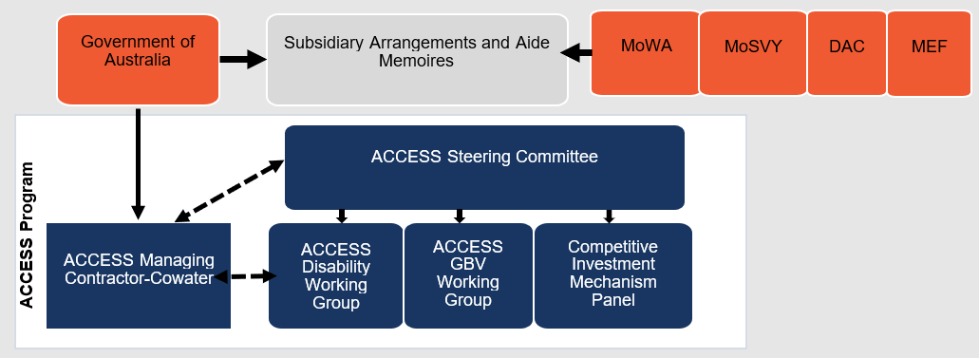

During ACCESS’ design phase, the team engaged with RGC at length. **ACCESS and RGC technical teams collaboratively defined the Program’s strategic priorities, which the ASC endorsed at the first meeting in March 2019.** These priorities constituted the basis for the call for expressions of interest to implementing partners. This process, combined with the involvement of RGC focal points in the review of submitted proposals, has ensured that implementing partners’ interventions align fully with RGC sectoral priorities. RGC technical teams participated and guided the Program’s collaborative planning process with selected implementing partners.

During implementation, **RGC counterparts actively took part in program decision-making during ASC meetings and reflection workshops**. For example, the presence of MEF at the ASC was crucial in building commitment from MoWA and MoSVY to contribute to program activity costs. Similarly, ASC members have guided the Program to strengthen its support at the sub-national level and to consider more direct support to beneficiaries when the COVID-19 pandemic started impacting the livelihoods of our target groups.

Given the strategic importance of ACCESS governance discussions, ASC membership has been extended to the Ministry of Interior (MoI) and Persons with Disabilities Foundation (PDWF) (as non-voting members), as well as provincial deputy governors of three target provinces (Kampong Cham, Kampong Speu and Siem Reap).[16] This reflects ACCESS’ growing engagement at the sub-national level (See Section 4).

Provincial dissemination workshops conducted in ACCESS’ three target provinces in late 2019 and led by members of the ASC provided a strong demonstration of the extent to which ACCESS enjoys high levels of leadership and ownership by its four government counterparts.

## Predictable and sufficient budget

**ACCESS is contributing to the Public Financial Management Reform Program (PFMRP) to enable better allocation of resources for GBV and disability-related services.**Cambodia's recent reclassification as a lower middle-income country along with PFMRP's focus on strengthening policy linkages have opened the door for ACCESS to influence and support MEF's reform agenda. However, external factors, such as COVID-19, continue to affect budget prioritisation and allocation. It is also difficult to draw a clear line of sight between ACCESS advice and budget outcomes. Nevertheless, the Program achieved progress as described below.

**ACCESS helped build momentum around gender-responsive budgeting (GRB)**. MoWA is willing to integrate ACCESS technical recommendations in its upcoming GRB roadmap and the PFMRP General Steering Committee (PFMRP-GSC) has indicated its support to advance this important agenda. Progress in GRB may in turn support MoWA's efforts to increase RGC budget allocation to GBV services.

“MoWA GRB/Gender Equality team will use ACCESS’ developed material as the foundation of our GRB roadmap” HE Chhun Hak, General Director of the Gender Equality and Economic Empowerment Department at MoWA

**ACCESS also encouraged MoWA to improve resource coordination functions that are important for NAPVAW III implementation.** Examples include the provision of Daily Subsistence Allowances (DSA) for MoWA staff, increased funding for national TWG-G-GBV meetings, and additional human resources for GBV coordination mechanisms.

**Enhanced budget submissions by MoSVY and DAC have improved resourcing prospects for disability-related services.**ACCESS advisory support strengthened MoSVY’s budget submissions, highlighting its disability-related program activities. Intensive technical assistance to MoSVY and DAC-SG during their budget submission process also resulted in observable improvements, such as stronger assessments of progress against policy objectives and expected results. Over the medium term, the improvements resulting from ACCESS' support are likely to improve the predictability and sufficiency of budget allocation.

**ACCESS is also increasingly engaging with sub-national agencies on planning and budgeting of GBV and disability services**. For example, ACCESS assisted five provincial DAC offices to develop an action plan for NDSP coinciding with MEF's budget cycle. ACCESS also helped MoWA organise virtual meetings with eight Provincial Department for Women’s Affairs (PDoWAs) to discuss key NAPVAW priorities and prepare FY2022 program budget proposals. As a result, all six PDoWAs of ACCESS-supported provinces submitted budget proposals to MoWA and MEF that incorporated resources for legal protection services. ACCESS also helped MoWA prepare for planning and budgeting workshops with key Provincial Departments and Provincial and District Administrations across the eight provinces.

“The District Administration will integrate the domestic violence-related activities including domestic violence and case intervention in 2022 [referring to the next 3-year Investment Program].” Ms. Hou Chanthoeurn, Deputy Governor of Odong District, Online Consultative Meeting on Budget Monitoring Study, 23 April 2021

**DAC-SG and MoWA’s efforts to improve line ministry budget commitments for GBV and disability** has been impacted by COVID-19-related budget reallocations. However, impressively, MoWA’s budget for the protection of women with disabilities has increased by 48% between 2019 and 2021.[17] ACCESS hopes to see increases in other key budget line items in the next two years as Covid situation improves.

**ACCESS also directly engages with MEF to help bolster consideration of disability and GBV issues in RGC budget processes.** ACCESS has regularly engagedMEF in GBV and disability related workshops and inter-ministerial discussions, and the MEF team is now more aware of the budget implications of NAPVAW and NDSP. In line with RGC’s COVID-19 response, MEF has prioritized investments in social protection. Separately, the National Social Protection Council- General Secretariat (NSPC-GS) sought advice from ACCESS and has since adopted disability inclusion objectives within its social protection schemes.

## Improved Standards, Guidelines, and Monitoring

### Service Standards, Guidelines, and Training

#### GBV services

**Five GBV essential service guidelines[18] were finalised, officially endorsed, and rolled out, providing a necessary and practical framework for policy implementation.**

Figure 2 displays results from a rubric-based assessment[19] that measures how well these guidelines have been integrated and operationalised across ACCESS-supported provinces. Baseline scores in 2019 found that there was no systematic process to monitor adherence to the GBV service standards or monitoring processes occurred in an ad hoc manner. Additionally, service providers had not yet received sufficient training about the standards. ACCESS has addressed these issues through targeted technical advisory and capacity building, which has helped to further integrate and operationalise the guidelines.[20]

Figure 3: Average annual assessment scores across ACCESS-supported provinces for integration and operationalisation of service guidelines

"MoWA, with support of ACCESS, has all the five essential GBV service guidelines developed and endorsed, and is strengthening capacity of providers in these guidelines. The training is essential so that GBV services conform to the guidelines and are provided with high quality and in a timely manner. In the meantime, we've observed that service coordination and referral mechanisms have improved, and more women come to seek assistance on GBV cases".   
Ms. Sar Sineth, Deputy Director General of Social Development General Directorate, MoWA

**ACCESS is supporting MoWA to ensure service providers are trained in these service standards.** ACCESS supported the development and delivery of training modules on legal protection guidelines and mediation guidelines and is currently working on a training module for the essential service package. ACCESS partners have trained service providers on the Minimum Standards of Basic Service Delivery, Legal Protection Guidelines, Guidelines for Managing GBV in the Health System and the Referral Guidelines. By June 2021, 5,132 GBV service providers at different levels were trained through ACCESS’ support. Service providers report that this training had improved their understanding of how to provide effective services.

“After attending training on Minimum Standards for Basic Counseling for Women and Girl Survivors of GBV, and Basic Counseling Skills for Women and Girl Survivor of GBV, I realized I better understood how to provide mental health support to survivors. I know how to use basic counseling skills like observing and coordinating with the local services. Accessing skills has allowed me to understand the needs of survivors through questioning.”   
Local service provider trained by ACCESS partner TPO

**ACCESS is helping to more directly expand access to quality GBV related services through targeted service delivery by implementing partners.** During Stage 1, ACCESS IPs, including CWCC, TPO and LAC, provided a total of 2,667 GBV related services, which included support provided to 1399 females, 50 persons with disabilities, and 177 children.[21]To ensure continued service availability throughout the COVID-19 related restrictions, ACCESS supported GBV IPs to deliver phone-based services where appropriate and applicable. Figure 2 disaggregates the services by service type, with legal consultation as the most common support provided.[22]

**Figure 4: Number of GBV related services provided by ACCESS IPs between September 2019 – June 2021**

#### Disability services

**In the disability sector, ACCESS supported similar work to enable PWDF to fulfil its mandate to effectively manage PRCs by collaboratively establishing defined standards for PRC services.** National guidelines for the PRCs are being finalised based on ACCESS technical advice, and ACCESS-facilitated consultations with the government, NGOs and OPDs. These guidelines will better define and promote improved service standards across PRCs and justify RGC budget allocation to support PRC delivery of essential services to persons with disabilities.

**PWDF has also increased its readiness to assume full PRC management responsibilities from NGOs.** ACCESS engaged its implementing partner Humanity and Inclusion (HI) to train PWDF representatives and PRCs on diseases management[23] (directly and in partnership with professional associations). Managerial training was also provided to improve leadership, management, and governance. These efforts led to improved quality management and application of new techniques and initiatives to better support PWDF and PRCs. ACCESS strategically involved professional associations[24] to facilitate the establishment of longer-term support networks for PWDF and increase awareness of professional associations about standards and guidelines.

"With support of ACCESS funding, and technical support of HI, PWDF staff have received training in professional clinical standards, such as in torticollis management, stroke management, diabetic foot lesion management so that we can better support PRCs. Along with this, we have also been trained in the management of rehabilitation services." Mr. Teav Sam Ol, Senior Official of PWDF

**There are positive signs that these investments are helping to improve the quality of PRC service delivery.** ACCESS worked with PWDF and the six ACCESS supported PRCs to conduct assessments of PRC service quality in 2019, 2020 and 2021 using a PWDF-owned tool, the Rehabilitation Management System (RMS).[25] As shown in Figure 5, the aggregate average quality standard score has increased annually since 2019 and exceeded the 2021 program target of 74%.

Figure 5: Average RMS quality standard scores in ACCESS-supported PRCs

**ACCESS is also funding a range of other efforts to improve disability inclusion and physical accessibility.** ACCESS’ implementing partner LFTW supported DAC-SG to finalise disability inclusion awareness training and accompanying toolkit. Master trainers have been taught and the training will be rolled out in years 4 and 5 of ACCESS to widely promote a rights-based disability approach and the meaningful participation of persons with disabilities. Separately, the DAC-SG team received training and guidance from HI to improve their technical knowledge and confidence to roll out the national standards for physical accessibility. 36 Master Trainers from DAC-SG were trained, and Training of Trainers (ToT) was delivered to 157 individuals across eight provinces. A series of physical accessibility awareness-raising video clips are ready for wide dissemination and “model” accessible ramps were built in 22 communes in close collaboration with RGC and OPDs at national and local levels. Finally, ACCESS supported 1,731 disability service providers to receive disability inclusion awareness training.

### Monitoring Service Delivery

**Aligned with monitoring frameworks for NAPVAW III and NDSP II (see Section 3.1.2), ACCESS is assisting RGC to track adherence of GBV and disability services to agreed standards**. For example, with ACCESS funds, UN Women is helping MoWA develop and pilot service provider monitoring tools for the GBV Minimum Standards of Essential Services. ACCESS implementing partners the Asia Foundation (TAF) and the Cambodia Centre for Human Rights (CCHR) also developed and applied a monitoring tool to track gender sensitivity of court proceedings in two provinces. Results will be reviewed by MoWA and potentially used to recommend improved GBV case management by legal professionals. In the disability sector, as noted in Section 3.3.1 above, PRC managers and staff have been trained in the use of the RMS, an assessment tool which identifies shortcomings in PRC management and facilitates discussion on identifying solutions (see above).

**ACCESS is also supporting broader efforts to strengthen the evidence base for service improvement.** For example, with UNFPA and HI, ACCESS issupporting the inclusion of GBV and disability modules in the Cambodia Demographic and Health Survey (CDHS) (questionnaire design, enumerator training, etc.). This will provide valuable evidence on the impact of COVID-19 on the incidence of GBV in Cambodia[26], complementing a rapid assessment of COVID-19 impacts on GBV service provision that ACCESS is currently conducting. In the disability sector, ACCESS supported **the establishment of a disability Management Information System (MIS)** and MoSVY-led disability identification process, through the provision of a server and machines for printing disability card. This constitutes an important tool for social protection schemes, connected to ID-Poor.

" We have run policy dialogues three times with participation of MoSVY's Department of Social Welfare, Ministry of Planning's ID Poor Department and the General Secretariate of the National Social Protection Council and several other relevant ministries to raise awareness about disability and the need to include persons with disabilities in social protection mechanisms. Thanks to ACCESS for making that happen and for also supporting generation of evidence and data systems which improve MoSVY's capacity to further advocate for disability inclusion in social protection." Mr. Yeab Malino, Director of Dept. of Welfare for Persons with Disability, MoSVY

## Improved Coordination

### National Level

**At the national level, DAC-SG has improved sector coordination with ACCESS financial and technical support.** ACCESS worked closely with officials to support their leadership role in the sector.[27]

“ACCESS brought significant changes in the disability sector in Cambodia. I found that governments are taking the lead and it is also interesting to have the involvement of the MEF. I also saw that the ACCESS program design brought improved cost-effectiveness to the whole sector”.  
 Senior Program Manager, ACCESS implementing Partner

ACCESS’ joint planning process with implementing partners and RGC in the first year of the program was strongly aligned to NDSP II and helped streamline planning in the disability sector. This process enabled stakeholders to agree on respective responsibilities and resolve gaps or overlaps in scope.[28] ACCESS also helped DAC-SG lead consultative meetings on the Disability Law with all 25 Line Ministries.

**ACCESS also assisted MoSVY and PWDF to play stronger sector coordination functions**. ACCESS facilitated the establishment of a coordination platform on inclusive employment, led by Department of Welfare in MoSVY and launched in September 2021. This platform gathers Line Ministries, the National Employment Agency, NGOs, OPDs and private sector stakeholders to coordinate interventions promoting employment of persons with disabilities. ACCESS also helped PWDF revive their coordination platform whereby PWDF, non-government service providers and user representatives can discuss physical rehabilitation issues, identify possible solutions and promote consistent PRC service delivery standards. For example, solutions to maintain rehabilitation services open during the COVID-19 pandemic was discussed in this platform.

**With ACCESS funding, UN Women helped strengthen the** **Technical Working Group on Gender- Sub-Committee for GBV (TWGG- GBV)** through a review of its terms of reference and membership, and technical assistance to prepare and facilitate meetings. This working group is an inter-ministerial national coordination body and has been effective in leading consultations for NAPVAW III. For the first time, MoWA is now allocating budget for TWGG-GBV meetings and is ably leading and coordinating meetings. Technical assistance has also guided a consistent approach to Annual Operational Plans (AOPs), which will frame NAPVAW III implementation and monitoring. In 2021, 11 Line Ministries, and 4 CSO partners submitted their AOPs. ACCESS also helped engage MEF and MoI in these meetings, given their important roles in budget allocations. Furthermore, ACCESS has supported the inclusion of two additional representatives from CSOs into the TWGG-GBV.

1. **ACCESS Ways of Working #2: Strong partnerships within and beyond RGC**

ACCESS maintains a strong partnership approach, **forming connections with different entities to achieve sustainable relationships, greater understanding and alignment of objectives, and productive policy dialogue.**

ACCESS invested much time and energy **building strong relationships with relevant RGC counterparts**. A crucial step was the identification of focal points within MoWA, MoSVY and MEF working closely with the ACCESS program team.

MoWA quickly demonstrated strong ownership in leading the work of the GBV workstream.

Building strong foundational common understanding of each other’s role took a bit more time in the disability sector due to more complex coordination mechanisms and the overlapping roles of DAC, Department of Welfare for Persons with Disabilities (DWPD) and PWDF. The identification of clear areas of collaboration with each entity and the mobilisation of dedicated technical support from Year 3 onward has helped consolidate greater trust between these entities.

**Collaboration was extended to MoI and the National Committee for Sub-national Democratic Development** **(NCDD) in Year 2 of the Program**, realising the need to invest more on coordination mechanisms, service provision and resource mobilisation at the sub-national level. The partnership within MEF was also extended to the General Department for Sub-national Administration Finance (GD-SNAF) and more recently with the National Social Protection Council Secretariat (NSPC-GS). For example, in 2021, MoI and GD-SNAF both took an active role in a series of sub-national level workshops on NAPVAW and NDSP to share information on local planning process and subnational budget formulation cycle.

Through policy dissemination, capacity building efforts, and targeted facilitation, ACCESS strengthened **policy dialogue between national and sub-national level officials**. Governors now fully participate and support the implementation of the GBV service system and receive relevant support from MoWA. DAC-SG is providing guidance to Provincial DAC (P-DAC) in establishing and facilitating provincial-level coordination mechanisms and transferred technical knowledge on the implementation of the national accessibility guidelines.

“*Involvement of PDoWA in joint planning process* *gave them opportunities to voice concerns and inputs to improve feasibility in implementation*". MoWA Official

Another significant contribution of the Program is **fostering positive relationships between governmental and non-governmental partners through collaborative coordination**. For example, recognising misalignment between CSOs and the RGC, ACCESS used its workstream coordination mechanism to encourage CSOs to collaborate and align with government-led initiatives. For instance, ACCESS IPs, Legal Aid Cambodia (LAC) and CCHR, have advised MoWA on the development of a mediation training curriculum and on the provision of training on legal service provision to MoWA officials.

“*ACCESS approach is a very unique one which enables a single streamline for disability sector in Cambodia to avoid overlap in planning and intervention, reduce redundancy, and optimize resources”* Disability workstream IP

ACCESS also helped initiate a workshop between the Cambodia National Council for Women (CNCW) and the Bar Association of the Kingdom of Cambodia (BAKC) to discuss the division of funding and delivery responsibilities related to essential GBV services. Ultimately the parties signed an MoU establishing CNCW as the administrator of finances and BAKC as the implementer through its lawyers. This not only enhanced their working relationship and collaboration but also reduced procedural and administrative inefficiencies.

This positive partnership spirit is evidenced by the latest Partnership Survey conducted in December 2020, which documented a **clear improvement in the quality of partnerships among ACCESS stakeholders**. Perceptions among the program stakeholders on the quality of partnerships improved significantly among disability stakeholders (from 74% at baseline to 82% in Year 3) and remained high among GBV stakeholders (81% to 83%).[29]

### Sub-National Level

**There have also been improvements in disability sub-national coordination, with ACCESS helping to restart and improve the effectiveness of P-DACs.** Increases in the effectiveness of these bodies were identified during a reflection workshop involving five P-DACs, facilitated by   
DAC-SG. For example, official terms of reference are in place and P-DAC members received orientation on the role and functions of the P-DAC. OPDs are members of P-DAC across the five provinces. P-DACs are led by the Deputy Provincial Governors, and since they have restarted, all relevant provincial departments are participating in their meetings. In Kampong Cham, one OPD is appointed as the P-DAC co-chair and all five P-DACs developed their 2021 and 2022 annual work plans to support the implementation of the NDSP.

“In 2018, Disability Coordination was progressing slowly, but since the third quarter of 2019, Disability Coordination has improved significantly and many facilitation mechanisms have been created to improve the disability sector response for within the province” Deputy Director, Kampong Cham PoSVY[30]

**ACCESS also helped establish and strengthen six provincial and 21 district GBV response working groups, which are the backbone of Cambodia’s GBV service delivery system.** These groups bring together state and non-state service providers in health care, justice, safe accommodation, and other services/sectors to improve coordination and quality of their responses to survivors of GBV. At the start of the Program, only three working groups had been established at the provincial level and there were none at the district level. ACCESS has also supported the strengthening of these groups. An assessment against a rubric measuring working group effectiveness found the aggregate score of district-level GBV WG effectiveness increased from 52% in 2019, to 79% in 2021.[31] ACCESS helped MoWA to clarify responsibilities of working groups and their members, as well as the frequency of meetings and budget implications. Representatives of persons with disabilities have been integrated into three sub-national working groups to support the disability inclusiveness of GBV services in that province. ACCESS IPs are also training working group members in minimum service standards (see section 3.3.1). ACCESS team members have observed during monitoring visits that these groups are more effectively discussing and conducting referrals. ACCESS has also received anecdotal reports from GBV survivors of service quality improvement during these visits.

"Thanks to ACCESS and partners for helping to improve the functioning of district GBV WGs in the six districts. These groups are essential to ensure services are provided to GBV survivors, i.e., coordinating between health services, legal and psychosocial support. I also expect and encourage ACCESS to consider supporting GBV WGs in other 6 districts in the province". Ms. Krang Si Thavy, Director, PDoWA, Siem Reap

**Figure 6: Average province and district level annual assessment scores of GBV WG effectiveness**

**Story of Significant Change: Improving Sub-national GBV Services**

**With ACCESS support, the Cambodian Women’s Crisis Center (CWCC) is increasing the availability of support services to women survivors of GBV in target communes.**

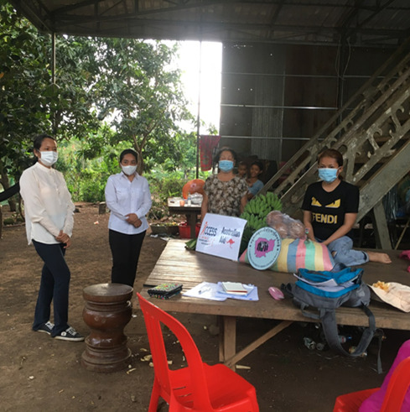

Before CWCC started working in these communities, limited knowledge about gender and GBV amongst officials, low availability of services, and lack of safe spaces for survivors deterred GBV survivors from seeking services and support.

With ACCESS support, CWCC established eight commune-level Women’s Support Groups (WSGs), which bring together officials from district to village levels to promote local service provision. WSG members were trained in GBV concepts, women’s rights, disability inclusion, advocacy, and how to report GBV cases to ensure quality services and effective awareness-raising for GBV survivors.

Since their establishment, the WSGs have transformed the lives of many GBV survivors by providing preliminary counseling and guidance on options available for women in an abusive relationship. For example, Mrs. P.T, who is a GBV survivor and person with a disability, has become a local change agent with support from CWCC. She is thankful for the opportunities offered by CWCC that allowed her to gain knowledge, skills, and the confidence to overcome her problems and be part of the WSGs. She notes, *“Unlike before, I now have the courage and confidence to discuss equally any matters with my family [with my husband]. I also feel confident enough to disseminate what I had learned from the training by CWCC to other community members”.*

So far, the eight WSGs have dealt with a total of 72 domestic violence cases and have improved the knowledge and understanding on GBV and case reporting of at least 1,080 individuals across the target areas through providing support, counselling and referral services to GBV survivors and raising awareness of GBV amongst their communities.

## Improved Representation and Empowerment

### Increased Economic Opportunities for Persons with Disabilities

**ACCESS IPs LFTW, CDPO, Agile, and Chamroeun Microfinance (CMP)** **helped 4,170 persons with disabilities improve their access to economic opportunities, including providing** targeted support to women with disabilities. Fifty-seven female entrepreneurs with disabilities graduated from an “Incubation Entrepreneurship” training delivered by Agile, that included topics to improve business skills, financial skills, digital skills, self-confidence, and access to capital. Course assessments reported a 90.5% satisfaction rate amongst participants. In addition, ACCESS partners LFTW and CDPO continued to provide job readiness and coaching support to persons with disabilities and developed tools and training targeting employers and Technical and Vocational Education and Training (TVET) institutions to support them on their journey to becoming more inclusive. ACCESS hopes to see evidence of employment outcomes during Stage 2 of the Program. Figure 7 below displays the distribution of support services provided by ACCESS IPs during stage 1.

Figure 7: Distribution of support received by persons with disabilities to improve access to economic opportunities

**ACCESS is also supporting better identification of employment opportunities for persons with disabilities**. ACCESS provided financial and technical support to the development of a DWPD-managed Employment App (AOKAS) which matches registered persons with disabilities with private sector employers. In addition to e-registrations from job seekers and employers, this system aims to cross-reference data from the National Employment Agency (NEA) for better job-matching opportunities.

### Engagement of OPDs in policy processes to improve disability inclusion

**ACCESS convened greater involvement by OPDs in key policy processes to promote disability inclusion**. To support OPDs to meaningfully engage in social protection policy dialogue, ACCESS provided training and information to 75 OPDs on social protection schemes in Cambodia. ACCESS also facilitated two national dialogues between social protection policy makers (including NSPC-Gs, MoSVY, MoP and Development Partners) and OPDs on access of persons with disabilities to ID-Poor, disability cash transfer and other social protection interventions. OPDs were given an opportunity to voice their concerns and challenges and make recommendations. In parallel, ACCESS worked with Development Pathways to document evidence on disability inclusion issues within current social protection schemes and recommended practical policy responses. Findings have been taken into consideration in the RGC design of the new social allowance Family Package. ACCESS also facilitated OPD engagement at the sub-national level to improve the implementation of the social protection scheme. As a result, 1,508 (54% women) persons with disabilities received ID-Poor cards; and 2,582 (47% women) persons with disabilities accessed the national social protection cash transfer programme from local authorities.

**ACCESS also supported OPDs to advocate during commune discussions for disability inclusive Commune Investment Programs (CIPs).** Three ACCESS partners (CARE, HI and joint UNDP/CDPO) conducted this work in partnership with 20 commune councils to support CIPs to align with NAPVAW/NDSP. ACCESS also collaborated with CARE to enhance the capacity of commune representatives in disability inclusion. Results of these efforts are shown in Figure 8 below, which scores the extent to which CIPs in 20 communes prioritise GBV and disability inclusion[32]. The improvement between the two years reflects an increased awareness among commune officials about GBV and disability issues in their communities and a commitment to advocate for their inclusion in policy and program efforts. This is a positive sign that NDSP II and NAPVAW III are being reflected in commune-level decisions. ACCESS will continue to strengthen its support at this level during Stage 2 (see Section 4).[33]

Figure 8: Average assessment scores of CIP alignment with NAPVAW / NDSP (20 CIPs)

1. **ACCESS WAYS OF WORKING #3: Contextual** **responsiveness**
2. **ACCESS developed systems and processes to enable it to remain responsive and flexible to the dynamic disability and GBV sectors, especially during the COVID-19 pandemic**. Constant monitoring of context, close communication with RGC and IPs, monitoring and research activities, and feedback during regular reflection workshops all provided ACCESS with early evidence of emerging challenges or opportunities to inform early and strategic responses.
3. The most significant example of this was **ACCESS’ COVID-19 response pivot, which helped to mitigate the negative impacts of the pandemic** and mobility restrictions on women experiencing GBV and persons with disabilities. Working closely with RGC counterparts and IPs, ACCESS:
   * **Supported the immediate response**. Procured and delivered Personal Protective Equipment (PPE) supplies (including 18,267 bottles of disinfecting alcohol, 29,456 fabric masks, 333,000 surgical masks, 144,620 soap bars, and 16,435 hand fans), to GBV service providers and women at risk of GBV in ACCESS target provinces. Additionally, ACCESS supported the procurement and distribution of 9,425 boxes of surgical masks, 7,400 fabric masks, 26,800 bottles of disinfecting alcohol and hand sanitisers, and 30 thermometers to PRCs and OPDs across five provinces to ensure adherence to safety measures to protect against COVID-19.
   * **Promoted ongoing availability of services.** ACCESS successfully advocated for the incorporation of GBV- and disability-sensitive considerations into RGC COVID-19 response at national and sub-national levels. This includes much stronger engagement in the social protection sector (see Section 3.5.2 above). ACCESS engaged with diverse stakeholders to ensure continued accessibility to essential GBV-related services during the strict lockdowns, including through the delivery of online counselling services to survivors. Remote rehabilitation service provision was piloted in Kampong Cham and extended to the five PRCs supported by PWDF.
   * **Targeted communications strategies to increase awareness of service availability.** Various digital campaigns to provide information about GBV services through MoWA’s website and Facebook pages. In collaboration with OPDs and other relevant stakeholders, ACCESS also successfully advocated for the incorporation of Cambodian Sign Language (CSL) in COVID-19-related communications including RGC-broadcasted press conferences, improving awareness on available services for persons with hearing impairment. ACCESS also funded DWPD, in collaboration with UNICEF, to develop and distribute 4,200 posters to facilitate access of persons with disabilities to COVID-19 vaccination. As reported by DWPD in early November, 118,284 persons with disabilities were registered for vaccination, out of which 75,542 received a first dose, and 57,783 were fully vaccinated.

# FUTURE DIRECTIONS

Stage 2 of ACCESS runs to September 2023 and is driven by a renewed set of priorities, as described in Figure 9, below. These are informed by lessons from Stage 1, findings from the DFAT Rapid Review, and the policy priorities of RGC and the Australian Development Program.

Figure 9: Stage 2 priorities

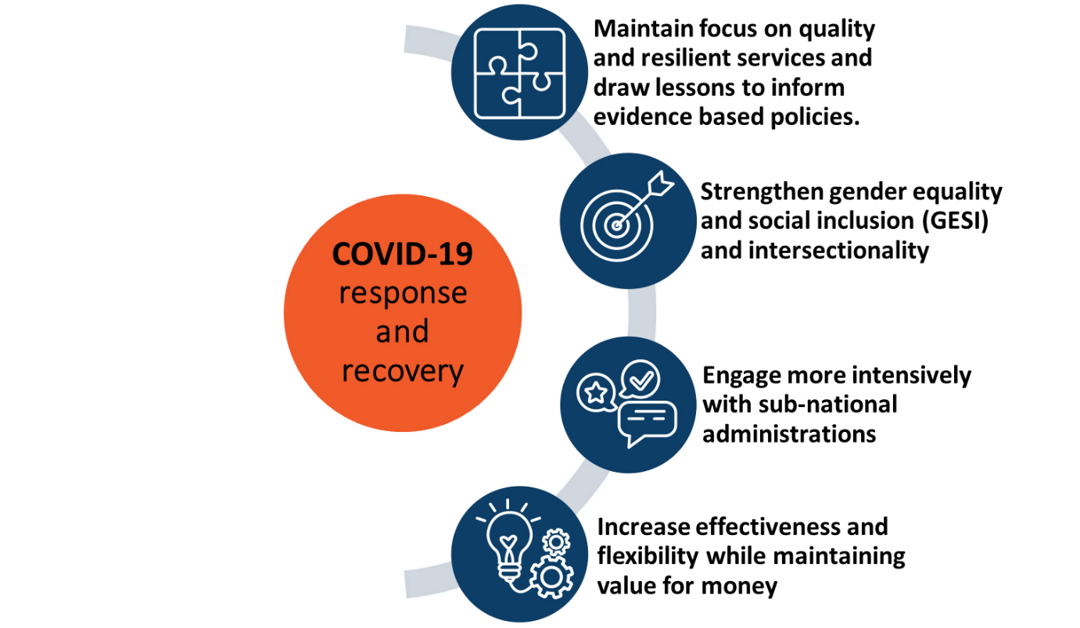

At the centre of these priorities lies the need to keep **strengthening Cambodia’s COVID-19 response, recovery, and resilience strategies** in the disability and GBV sectors. We expect this to include even deeper engagement on social protection reform and a growing focus on economic inclusion.

ACCESS will **maintain its focus on the provision of sustainable, quality, and inclusive services** by continuing to work on the five systemic factors discussed in this report. Within the disability sector, this will include reduced and more targeted support to overall coordination functions and additional investments in the rehabilitation sector. More work will also occur on RGC monitoring systems to help drive NAPVAW and NDSP implementation.

ACCESS will **strengthen** **Gender Equality and Social Inclusion (GESI) across the Program and will promote** **intersectionality[34] between gender and disability,** with new intermediate outcomes andadditional human and financial resources to help drive this agenda. The Program will focus even more attention on women with disabilities and will consult more regularly with persons with disabilities and women affected by violence to ensure ACCESS’ work addresses their priority needs.

Following recommendations from the ASC and the DFAT Rapid Review, ACCESS will **engage more intensively with sub-national administrations,** based on existing support from the General Department of Administration (GDA), MoI and the recent engagement with MEF GD-SNAF.

Finally, to increase our **effectiveness and flexibility**, we will continue nurturing a common vision and adhesion to ACCESS’ core values and principles across all partners. We will invest additional resources in the most promising areas, and we will ensure that the ACCESS team responds to the needs of our partners and DFAT.

1. **ACCESS WAYS OF WORKING #4: Intersectionality and Cross-learning**
2. **ACCESS is paving the way towards stronger intersectionality between Gender Equality and Disability Inclusion.**
3. Some signs of effective collaboration and cross-learning are starting to emerge between MoWA and the DAC-SG teams that resulted in the finalisation in September 2021 of a joint plan to **promote gender equality and disability in their respective sectors.**
4. With the support from ACCESS, MoWA provided inputs to ensure that the new Disability Law incorporated adequate language and commitments to protect the rights of women and girls with disability in the context of a dedicated article.

Capacity building to five OPDs and self-help groups in three provinces with the support our partner ADD resulted in women with disabilities engaging in a series of dialogues with GBV service providers and provincial decision makers with final learning documented in a **policy brief endorsed by both MoWA and DAC and providing recommendations on integrating disability inclusion into GBV services.**

1. *"After I have collaborated with disability stakeholders, it makes me to always consider persons with disabilities. Before I did not pay attention to this, but now the work on disability is in my heart and where I go, I always pay attention to persons with disabilities"* HE Pang Davy, Deputy Provincial Governor of Kampong Cham and Chair of GBV Response working group, stated in her opening remarks at the Disability Inclusive training for GBV response WG members on 23 Aug 2021.

As of end of September 2021, 263 disability stakeholders received training on gender equality and 360 GBV stakeholders and service providers received training on disability inclusion through the Program.

Other examples of ACCESS facilitated intersectionality included:

* Integration of representatives of persons with disabilities into national and sub-national GBV Response Working Groups
* Active inclusion of persons with disabilities in training and meetings that are provided by GBV partners and stakeholders – 136 persons with disabilities, of which 77 were women, participated in trainings conducted by CWCC and ADD.
* Facilitation of three provincial “Learning and Exchange Meetings” between GBV and disability service providers, OPDs, local NGOs, and representatives of women with disabilities by ACCESS partner ADD International (ADD). MoWA’s representative confirmed that the Learning and Exchange Meetings provided opportunities to better integrate disability and GBV policy objectives.

# Annex 1: Updated Program Logic [35]

Pillar 1: Health and Security. - Ensure persons with disabilities and women have access to COVID-19 information and protective items.
Pillar 2: Stability - Ensure GBV and disability services remain available, safe and of good quality.
Pillar 3: Promote empowerment of persons with disabilities and social assistance.

# Annex 2: Key Achievements Indicators-Stage 1

|  |  |  |  |
| --- | --- | --- | --- |
|  | **Tier 2 ADR indicators (Sep 2019 - Jun 2021)** | **Total** | **Women** |
| 1 | Number of poor women and men who increase their access to financial services | 88 | 62 |
| 2 | Number of police and law and justice officials trained (women and men) | 115 | 101 |
| 3 | Number of vulnerable women, men, girls and boys provided with life-saving assistance in conflict and crisis situations | 37,609 | 28,745  (<18 girls 95) |
| 4 | Number of women survivors of violence receiving services such as counselling | -- | 1399 |

**Chart 1: Number of GBV survivors who were provided with services between Sep 2019 and Jun 2021**

**Chart 2: Number of GBV services provided to survivors** **between Sep 2019 and Jun 2021**

**Chart 3: Number of clients accessing services of the six ACCESS-supported PRCs between Sep 2019 and Jun 2021**

**Chart 4: Number of persons with disabilities who received support to access economic opportunities (between Sep 2019 - Jun 2021)**

**Chart 5: Number of service providers who received training by area between Sep 2019 and Jun 2021**

# Annex 3: Story of Significant Change

**Improving Access to Employment for People with Disabilities**

This story highlights a significant change in improving access to employment opportunities for persons with disabilities by Light for the World (LFTW) and its partner, Essential Personnel Cambodia (EPC), in three target provinces – Siem Reap, Kampong Cham, and Kampong Speu.

Before collaborating with LFTW, EPC started activities in these provinces in 2015, with the aim of supporting young people with disabilities to gain access to vocational training and employment opportunities. Previously, EPC’s approaches were less systematic as it relied primarily on its immediate connections and networks coupled with internet-based job searching. This meant that EPC could only introduce to its beneficiaries a limited number and diversity of job opportunities.

With ACCESS funding through LFTW, EPC developed a Job Coach Manual and established vocational training courses with its partners to provide beneficiaries with appropriate skills and to prepare them for job hunting. Secondly, EPC established a National Employment Forum Committee chaired by the Ministry of Social Affairs, Veterans and Youth Rehabilitation (MoSVY) with members representing local and international NGOs, employers, and relevant ministries and stakeholders. Guided by a clear work plan with clearly defined terms of reference, the committee was established as a platform to link persons with disabilities with employers who are committed to disability inclusion in their businesses. This committee also plays an important role in providing soft and hard skills through coordinating with partnered service providers to refer the unskilled job seekers to access required training courses and prepare them for job placement processes. EPC are advocating for the Job Coach Manual and Committee to be made official by the national government so that persons with disabilities from across the country can sustainably benefit from these initiatives.

With these two complementary approaches, EPC has now supported 216 persons with disabilities across the three target provinces to attend and complete job coaching, which has enabled 30 persons with disabilities to be officially employed by the certified employers, 4 to be referred to vocational training courses with full allowance support, and the rest to be put on the waiting list to be matched with potential employers.

For many persons with disabilities, being officially employed is a life-changing experience. For example, Sina was trained in sewing at the Japan- Cambodia Interactive Association Training Center in 2019 but could not find a job she wanted since. Sina was introduced to EPC to join the job search training program and was coached by a job coach. Before long, she found a job at the Fair Weave business shop in Phnom Penh. She was excited and highly appreciated the opportunity to be employed. She said that “my dream came true because I can earn a living."

*Sina at the Fair Weave business shop in Phnom Penh*

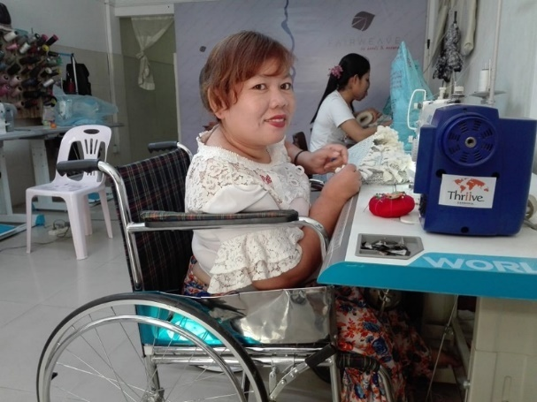 A person sitting in a wheelchair
under the improving access to employment for persons with disabilities 

1. GBV refers to any physical, emotional, and sexual violence, and includes both intimate partner violence (IPV) as well as non-partner violence.
2. MoWA (2015) National survey on women’s health and life experiences in Cambodia.
3. This is based on reported cases of GBV. Actual rates may be higher.
4. The most commonly cited reasons for justifying violence in the 2014 Cambodia Demographic and Health Survey (CDHS) were for neglecting children, arguing with her partner, or going out without telling her partner. (Fulu, Emma 2015).
5. 2014 Cambodia Demographic and Health Survey (CDHS)
6. Cambodian Demographic and Health Survey- CDHS 2014
7. Source: CSES 2019– Cambodian Socio-economic survey.
8. Source: PWDF database.
9. In 2019 according to PWDF data, 28,606 people attended PRCs across all of Cambodia, with only 25% (7,281) female
10. Measuring the shadow pandemic: violence against women during COVID-19, UNW: https://data.unwomen.org/sites/default/files/documents/Publications/Measuring-shadow-pandemic.pdf ; The UNFPA recently analysed Google search trends by Cambodians and found a 71% increase in searches for physical violence after the onset of COVID-19. Search terms which suggest use by a survivor or victim (such as, boyfriend is violent” or “my husband beats me”, increased by 25%.
11. MEF directives (numbers 003 and 010) on budget measures.
12. According to a recent study conducted by ACCESS in 2020, around 50% of beneficiaries who sought out health, legal, or social services mentioned that they did not receive care in an independent room, which raises privacy concerns. Also concerning were low levels of sensitivity - more than half of the service providers (55%) felt they should enquire into what the woman did to cause the violence. In addition, regular reports surface about gender-insensitive courts proceedings including of women being blamed, ridiculed or re-traumatized by justice professionals, which creates disincentives for pursuing legal recourse against abusers.
13. Civil society organisations include NGOs and other associations representing professional or population groups, i.e. lawyer association (BACK), organisations of persons with disabilities (OPD) .
14. The current draft is awaiting RGC’s review and endorsement.
15. Ministry of Women’s Affairs (MoWA), Ministry of Planning (MoP), Ministry of Social Affairs, Veterans and Youth Rehabilitation (MoSVY), Ministry of Culture and Fine Arts (MCFA), Ministry of Economy and Finance (MEF), Ministry of Education, Youth, and Sports (MoEYS), Ministry of Labour and Vocational Training (MoLVT), Ministry of Post and Telecommunications (MoPT), Ministry of Religions & Cults (MoRC), Ministry of Rural Development (MoRD), Ministry of Tourism (MoT)
16. These are the three provinces in which ACCESS GBV and disability related interventions are the most comprehensive..
17. Budget Monitoring Survey
18. The five essential services are related to health, counselling, legal, referral and mediation.
19. Progress is measured based on a rubric based assessment of ACCESS-supported provincial GBV response WGs against the following criteria: 1) guideline development 2) training provision 3) monitoring guideline implementation 4) client feedback mechanism (by service type). Data was gathered during a point-in-time annual assessment conducted by ACCESS and IPs in November 2019, December 2020 (year 2) and July 2021 (year 3); the score for each year is averaged across the five service standards and the six ACCESS supported target provinces; each service score for each province is based on a three-point scale (1, 3 or 5) and four criteria. The score is then converted to a percentage.
20. ACCESS set a year three target for achieving an average score of 92%. The program did not achieve the target, primarily due to the absence of a service monitoring and client feedback system (critical for criteria #3) and the delayed approval of the Guidelines for a Limited Use of Mediation.
21. A total of 1491 GBV related cases were recorded during this time period. Data collected by ACCESS IPs does not disaggregate persons with disabilities and children by sex.
22. After a GBV incident, a legal consultation is often the first course of action and can help determine the path to other services.
23. These were torticollis management, stroke management, diabetic foot lesion management.
24. Cambodian Physiotherapist Association (CPTA) and the Khmer Association of Prosthetist and Orthotists (KHAPO)
25. The assessment scores PRCs against 54 criteria (across six areas) of PRC management on a scale of 0 (critical problem) to 3 (exceeds expectations). A PRC achieves a 100% overall score if all 54 aspects are given a score of 3. Results and follow-up actions are discussed and agreed with PRC management.
26. The results of CDHS 2021 will be compared with CDHS 2014 to try and understand trends in the incidence of GBV.
27. Story of Significant Change, Improving Coordination and efficiency of the disability sector, supporting implementation of the National Disability Strategic Plan, 2020
28. Story of Significant Change, Improving Coordination and efficiency of the disability sector, supporting implementation of the National Disability Strategic Plan, 2020
29. ACCESS Partnership Survey, December 2020. The Partnership Survey involves the ACCESS Team, RGC and other IPs rating their partnership with nominated partners. The survey asks partners to rate various elements of the partnership, including how clear the goals of the partnership are, whether all partners are committing resources, whether there are clear processes to resolve issues and how effective communication between partners is. The survey includes a total of consisting 5 dimensions and 14 elements. Scores are segmented into: poor (<55%); good (55%-65%); very good (66% - 80%); and Excellent (>80%).
30. Story of Significant Change, Improving coordination and efficiency of the disability sector, supporting implementation of the National Disability Strategic Plan, 2020
31. These scores are based on a rubric style assessment using six criteria to determine level of functioning: 1- WG officially established; 2- WG members oriented on roles and duties; 3- Approved plans for WG meetings; 4- Approved budget for WG meetings; 5- Regularity of meeting held; and 6- Effectiveness of WG meetings. Based on an annual point-in-time annual assessment conducted by ACCESS and IPs, each criterion is measured on a three-point scale (1,3, 5), and then converted to a percentage. A final score of 100% is possible if all criteria are assigned a mark of 5. The drop in average district scores in year two were due to an anomaly in the implementation of the scoring methodology.
32. These scores are based on document appraisal of final CIPs against six criteria by ACCESS and IPs. The criteria relate to 1) inclusion of GBV and disability inclusion data 2) broader situation analysis of GBV and disability inclusion issues and needs 3) proposing unbudgeted GBV and disability inclusion activities 4) proposing budgeted GBV and disability inclusion activities 5) clear links between proposed activities and situation analysis and 6) participation of target populations in the CIP process. Each criterion is measured on a three-point scale (1,3, 5), and then converted to a percentage. A final score of 100% is possible if all criteria are assigned a mark of 5.
33. The target for year three was set at 93%, which reflects room for improvement across five of the six criteria included in the assessment.
34. In the context of ACCESS, intersectionality refers to areas where disability and GBV are crossing or influencing each other. Relevant interventions will for example consider how to ensure women with disabilities affected by violence can effectively access GBV services and how disability service providers and decision makers take more into account gender dimension in their work and actions. ACCESS will also consider the multiple dimensions of discrimination and look at particularly marginalized or at-risk groups such as LGBTQ, women from ethnic communities and persons with less visible forms of disabilities.
35. As approved by ASC in October 2020. Note that IO 2.7 will only be reported against in Stage II.