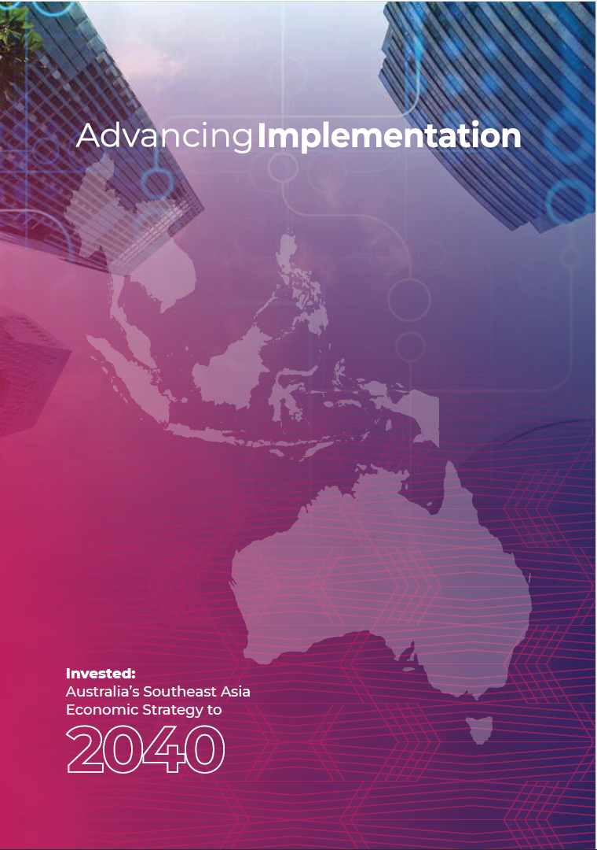

**Creative Commons**

The Commonwealth of Australia’s Advancing Implementation (this publication) is protected by copyright.

The material in this publication is licensed under the Creative Commons Attribution – NonCommercial – NoDerivatives 4.0 International licence (CC BY-NC-ND 4.0),

available at [creativecommons.org/licenses/by-](https://creativecommons.org/licenses/by-nc-nd/4.0/) [nc-nd/4.0](https://creativecommons.org/licenses/by-nc-nd/4.0/)), with the exception of:

* the Commonwealth Coat of Arms
* the Department of Foreign Affairs and Trade logo
* any material protected by a trademark
* any images that are identified as being licensed under another source in the image credits.

CC BY-NC-ND 4.0 is a standard form licence agreement that allows users to copy and redistribute this publication in any medium or format provided the user attributes the Commonwealth of Australia as the licensor of the publication. The licence provides that this publication may not be used for commercial

purposes, and cannot be remixed, transformed or built upon for the purpose of distribution.

The licence and relevant licensing conditions are available on the Creative Commons website at [creativecommons.org/licenses/by-nc-nd/4.0/](https://creativecommons.org/licenses/by-nc-nd/4.0/legalcode) [legalcode](https://creativecommons.org/licenses/by-nc-nd/4.0/legalcode).

Users should attribute this publication (and any material sourced from it) using the following wording: ‘Source: Licensed from the Commonwealth of Australia under a Creative Commons CC BY-NC-ND 4.0 licence. The Commonwealth of Australia does not necessarily endorse the content of this publication.’

**Image credits**

Images used in this publication are sourced from the Department of Foreign Affairs and Trade or from third parties with their permission.

**Use of Coat of Arms**

The terms under which the Commonwealth Coat of Arms can be used are detailed on the Department of the Prime Minister and

Cabinet’s website at [pmc.gov.au/honours-and-](https://www.pmc.gov.au/honours-and-symbols/commonwealth-coat-arms) [symbols/commonwealth-coat-arms](https://www.pmc.gov.au/honours-and-symbols/commonwealth-coat-arms).

**Publication enquiries**

Economic Strategy Section  
Southeast Asia Economic, Communications and Analytics Branch  
Office of Southeast Asia  
Department of Foreign Affairs and Trade RG Casey Building, John McEwen Crescent BARTON ACT 0221

**Email**

[SoutheastAsiaEconomicStrategy@dfat.gov.au](mailto:SoutheastAsiaEconomicStrategy@dfat.gov.au)

**Website**

[dfat.gov.au/southeastasiaeconomicstrategy](https://www.dfat.gov.au/southeastasiaeconomicstrategy)

Printed by CanPrint Communications Published in October 2024

Contents

Foreword iii

Summary of Invested iv

Implementing Invested vi

RAISING AWARENESS 8

Australia-Southeast Asia Business Exchange and outbound investment missions 8

Business Champions for Southeast Asia 8

Helping more Australian businesses trade with Southeast Asia 12

Engaging with Southeast Asian communities in Australia 13

First Nations trade and investment 13

REMOVING BLOCKAGES 14

Free trade agreements review 14

Enhanced visa access 14

BUILDING CAPABILITY 15

Placements and Internships Pilot Program 15

Mekong-Australia Partnership 15

AUS4ASEAN Scholarships and Fellowships 16

ASEAN-Australia Centre 17

DEEPENING INVESTMENT 19

Enabling Australian tech scale-ups to grow 19

Southeast Asia Investment Financing Facility 20

Investment Deal Teams 20

Simplifying investment into Australia 23

Partnerships for Infrastructure 23

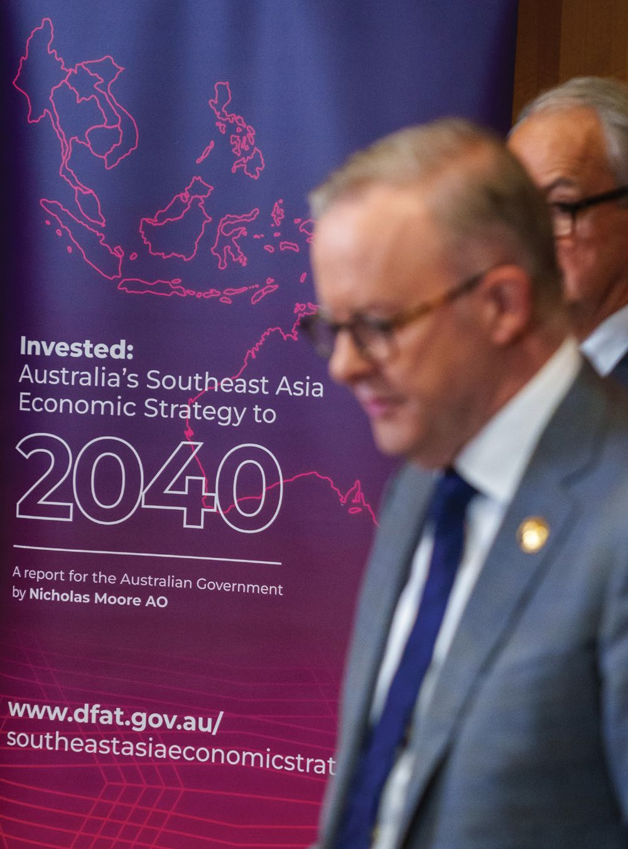

## Foreword

Australia’s security and our economic future are closely linked to Southeast Asia. We are a strong and reliable partner in the region, and are playing a key role in its dynamic economic transformation.

Taken together, Southeast Asia is Australia’s second largest two-way trading partner and it is on track to grow to the world’s fourth largest economy by 2040.

When I launched *Invested: Australia’s Southeast Asia Economic Strategy to 2040* in Jakarta in September 2023, it was a demonstration of Australia’s determination to seize the vast opportunities of this diverse and vibrant region and to maximise our economic ties.

The Strategy, authored by Special Envoy for Southeast Asia Nicholas Moore AO, sets out a practical roadmap to increase two-way trade and investment between Australia and the region.

I am proud of the steps we have taken over the last year to act on the strategy’s recommendations.

We have deployed new Deal Teams across the region to identify pipeline opportunities for Australian investors. We have established an Investment Financing Facility to catalyse more private sector investment links between Australia and Southeast Asia.

Our targeted program of trade and investment missions are connecting exporters and investors with customers, and our new private sector Business Champions are lending their experience and influence. We are rolling up our sleeves and getting things done.

We are making it easier for Southeast Asia to do business in Australia through a new ‘Front Door’ to provide a single point of entry for investors, as well as enhanced visa access for the region’s businesspeople.

We are working together on our most pressing challenges – the shift to clean energy, rapid digital transformation – to make a real difference to the future of our region and the lives of our citizens.

The work of shoring up our partnership matters to our region – and it also matters in Australia. Our cultural and economic ties open up jobs and opportunities for Australians, and will grow and strengthen our economy.

The economic transformation ahead of us will be powerful and profound. We know there is more to do, so let us work together to embrace this transformation – and to shape it.

Australia is committed to working with our Southeast Asian partners to build the next generation of prosperity, for our shared future and for our people.

The Hon Anthony Albanese MP

Prime Minister of Australia October 2024

## Summary of Invested

*Invested: Australia’s Southeast Asia Economic Strategy to 2040,* developed by Special Envoy for Southeast Asia, Nicholas Moore AO, provides a practical pathway to significantly increase two-way trade and investment, to ensure we are jointly positioned to maximise the potential of our economic growth.

*Invested* presents a total of 75 general and sector-specific recommendations.

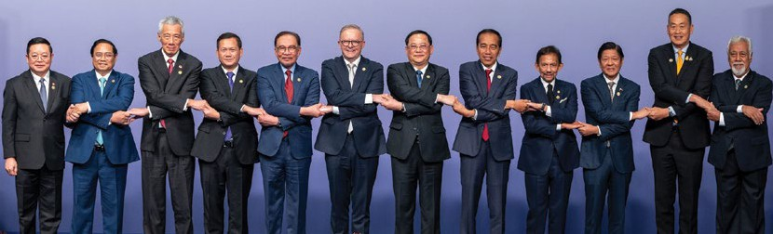Australia’s Prime Minister, the Hon Anthony Albanese MP, with the ASEAN Secretary-General and Leaders from ASEAN Member States and Timor-Leste during the ASEAN-Australia Special Summit in Melbourne, Australia, on 5 March 2024.

*Invested* outlines 4 categories of actions that are necessary to realise the commercial potential between Australia and Southeast Asia.

* Raise awareness – to address a lack of knowledge of markets, sectors, and understanding of the region.
* Remove blockages – to address tariff and non-tariff barriers, including through mutual recognition of qualifications and standards harmonisation, managing risks and enhancing mobility.
* Build capability – to ensure Australia and the region have the skills and capability to pursue opportunities and address economic challenges.
* Deepen investment – to promote economic growth and prosperity.

*Invested* has 10 priority sectors regarded as offering the most potential for growth.

* Agriculture and food
* Resources
* Green energy transition
* Infrastructure
* Education and skills
* Visitor economy
* Healthcare
* Digital economy
* Professional and financial services
* Creative industries

## We are building momentum on implementation

The Australian Government is implementing a broad range of initiatives to deliver on the recommendations of *Invested*.

**Raising awareness**

* Australia-Southeast Asia Business Exchange and outbound investment missions
  + 220 + businesses participated
  + 10 missions
  + 7 countries.
* Austrade have had their best ever client results in Southeast Asia, with $1 billion+ in commercial outcomes since the beginning of 2024.
* First Nations Southeast Asia Economic Strategy Dialogue
  + 120+ representatives attended.
* Business Champions for Southeast Asia are leading business missions and promoting opportunities.
* Engaging Australia’s Southeast Asia communities 1 million Australians linked by ancestry.
* Raising Australian business awareness in Southeast Asia.

**Removing blockages**

* Extended Business Visitor Visa from 3 to 5 years and introducing Frequent Traveller Scheme.
* Strengthening free trade agreements with the region.

**Building capability**

* Placements and Internships Pilot Program to start in 2025.
* 130+ new Aus4ASEAN Scholarships and 55 new Fellowships.
* $33 million to establish the ASEAN-Australia Centre.
* $222.5 million Mekong-Australia Partnership to work on shared challenges.

**Deepening investment**

* Southeast Asia Landing Pads launched June 2024
  + 44 services to businesses
  + 30 new clients.
* Established a $2 billion Investment Financing Facility.
* $140 million Partnerships for Infrastructure program.
* Simplifying investment from Southeast Asia.
* 9 Deal Teams established in the region.
  + 150+ Australian companies, institutions and partners across the region engaged to discuss investment opportunities
  + Facilitated the largest ever investment mission by value representing $2.5 trillion of assets under management.

## Implementing Invested

**Laos**

* The Special Envoy visited a Business Assistance Facility under the Lao PDR Competitiveness & Trade Project in July 2023.
* Business Champion Charles Olsson co-led with the Special Envoy an investment mission in October 2024.

**Thailand**

* A business mission on digital technology visited in July 2024.
* Business Champion Peter Fox co-led with the Special Envoy an investment mission in October 2024.

**Cambodia**

* The Special Envoy jointly launched the Handbook on Investing in Cambodia in July 2023.
* The Special Envoy visited Lyly Food Factory in July 2024.

**Malaysia**

* Assistant Minister for Trade, Senator the Hon Tim Ayres, led a business mission on maritime decarbonisation in April 2024.
* Business Champion Tony Lombardo co-led a business mission on the digital economy in October 2024.

**Indonesia**

* Business Champion Jennifer Westacott AO co-led with the Special Envoy a business mission on digital technology in June 2024, including to celebrate the new Landing Pad in Jakarta, and led a business mission on education and skills in September 2024.
* Australian Ambassador Penny Williams PSM, accompanied by the Special Envoy and Jennifer Westacott AO, signed a Memorandum of Understanding with the Indonesian Investment Authority in June 2024.

**Vietnam**

* An investment mission visited in June 2024, meeting with four of Vietnam’s leading business groups – VinGroup, VinCapital, FinGroup and Dragon Capital.
* A business mission on education and skills visited in September 2024.
* Business Champion Louise Adams co-led with the Special Envoy a business mission on digital technology in June 2024, including to celebrate the new Landing Pad in Ho Chi Minh City.

**Philippines**

* A business mission on transnational education visited in May 2024.
* Business Champion Shemara Wikramanayake led an investment mission in September 2024.

**Brunei**

* The Special Envoy visited and met with entrepreneurs in May 2023.
* Business Champion Nur Rahman visited with a focus on agribusiness in May 2024.

**Singapore**

* Assistant Minister for Trade, Senator the Hon Tim Ayres, led a business mission on maritime decarbonisation in April 2024.
* Minister for Trade and Tourism, Senator the Hon Don Farrell, led an investment mission in June 2024, including to attend the Indo-Pacific Economic Framework Clean Economy Investor Forum.
* A business mission on the digital economy visited in October 2024.

**Timor-Leste**

* Timor-Leste–Australia Economic and Business Conference was held in June 2024.
* The Timor-Leste Australi a Business Council was launched in July 2024.

## RAISING AWARENESS

### Australia-Southeast Asia Business Exchange and outbound investment missions

**Australia-Southeast Asia Business Exchange** **missions** are supporting Australian exporters and investors to build lasting connections with customers, suppliers and partners in Southeast Asia.

Business Exchange missions focus on priority sectors – including green energy transition, transnational education, and digital transformation – to grow two-way trade and investment between Australia and Southeast Asia.

The Business Exchange program provides support for Australian companies to enter, compete and grow in Southeast Asian markets.

**Outbound investment missions** are raising awareness of investment opportunities, connecting potential Australian investors to regional business leaders and project proponents, and supporting Australian companies to expand into the region.

* 10 missions
* 7 countries
* 220+ businesses

### Business Champions for Southeast Asia

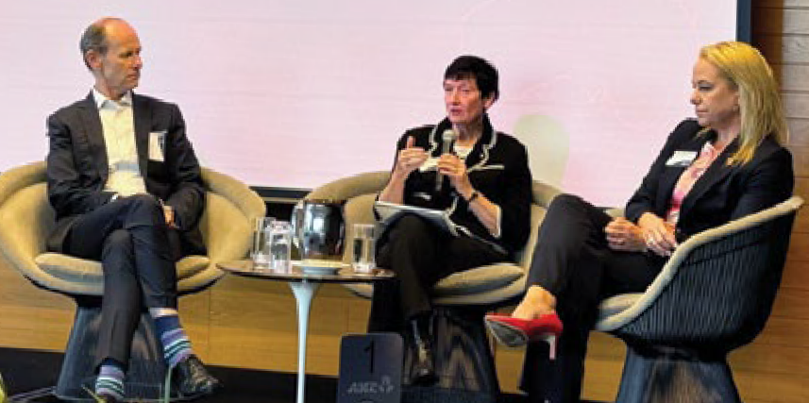  
Business Champions Shayne Elliott, Jennifer Westacott AO, and Louise Adams, in Melbourne, Australia, on 19 August 2024.

Australian senior private sector Business Champions are leveraging their experience and influence to build commercial links between Australia and Southeast Asia.

Business Champions are raising awareness of opportunities in Southeast Asia and have led and participated in high-profile business and investor missions to the region, including to Indonesia, Laos, Malaysia, the Philippines, Thailand and Vietnam.

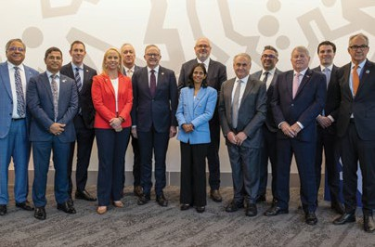  
Business Champions at the ASEAN-Australia Special Summit in Melbourne, Australia, in March 2024.

Business Champion for Singapore and ANZ Chief Executive Officer, Shayne Elliott, hosted a roundtable with institutional investors to hear their insights on opportunities to deepen Australian investment in Southeast Asia. Business Champions for Indonesia, Jennifer Westacott AO, and Vietnam, Louise Adams, participated.

The event highlighted that the implementation of Invested is generating significant conversations within Australia’s business community about the substantial opportunities for trade and investment presented by the dynamic economies of our region.

### SINGAPORE & MALAYSIA

#### Supporting de-carbonisation in the maritime domain

**April 2024**

Assistant Minister for Trade, Senator the Hon Tim Ayres, led the inaugural Australia-Southeast Asia Business Exchange mission, focused on green energy transition in the maritime industry.

Australian companies, research institutions and industry organisations across the maritime supply chain showcased green technologies and services suitable for deployment across the region. In Singapore, delegates saw progress towards ammonia fuel deployment, methanol and a range of electrification opportunities. In Malaysia, delegates visited the Port of Tanjong Pelepas, ranked among the world’s top 15 major ports.

The mission generated strong interest from ports and investors in fuel and electrification solutions.

‘The SEABX mission presented industry-specific opportunities that we were keen to explore, potentially opening doors for collaborations and partnerships that could significantly benefit our business in the long run.’ David Stribley, Commercial Director, HAMR Energy

### PHILIPPINES

#### Building education ties to meet workforce demands

**May 2024**

As part of a business mission, Australian universities, vocational education and training providers, and the Australia Philippines Business Council explored transnational education opportunities in the Philippines through site visits, business-matching, networking and roundtable discussions.

Australia is working with Philippine institutions to identify programs that meet local needs and align with anticipated workforce demands. Key Philippine industries with skills in demand include IT and business management; construction; agriculture; health; tourism; hospitality; and education.

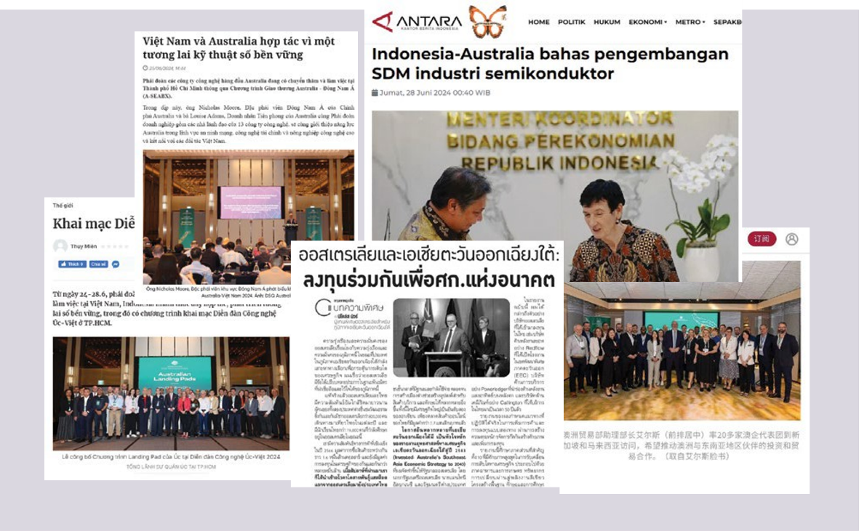

Regional media coverage of *Invested*, including business and outbound investment missions.

### SINGAPORE & VIETNAM

#### Supporting more Australian investment in our region

**June 2024**

Minister for Trade and Tourism, Senator the Hon Don Farrell, led a mission of Australia’s leading institutional investors and fund managers to Singapore. This was the largest-ever outbound Australian business mission by value, representing a combined A$2.5 trillion of assets under management.

In Singapore, the delegation attended the Indo-Pacific Economic Framework Clean Energy Investor Forum – a significant regional investment event. The delegation also met local experts who shared insights on regional opportunities and boosted delegates’ understanding of how Southeast Asia’s growth rates, energy transition, digitalisation and rapid urbanisation are driving opportunities for Australian investors.

In Vietnam, the delegation met key government departments and leading business groups VinGroup, VinaCapital, FiinGroup and Dragon Capital.

‘Greater engagement with Southeast Asia is a priority for the Australian Government. We are determined to leverage the enormous opportunities for Australian businesses in the region.’ Senator the Hon Don Farrell, Minister for Trade and Tourism

### VIETNAM & INDONESIA

#### Forging digital connections for the future

**June 2024**

Australian technology companies showcased their capabilities on a business mission focused on fintech, cyber security and agricultural technology, co-led by the Special Envoy, the Business Champion for Indonesia, Jennifer Westacott AO and the Business Champion for Vietnam, Louise Adams.

In Vietnam, the delegation received market, sector and regulatory updates and insights from key government departments and Vietnam’s leading business groups.

In Indonesia, the delegation met business leaders and government to understand Indonesia’s high- growth sectors of financial technology, cyber security, artificial intelligence (AI), agricultural technology, cleantech and smart city solutions.

Delegates celebrated new regional Landing Pads in Ho Chi Minh City and Jakarta, which are promoting Australia’s digital technology capabilities and building new partnerships.

### Case study: Partnering on financial innovation

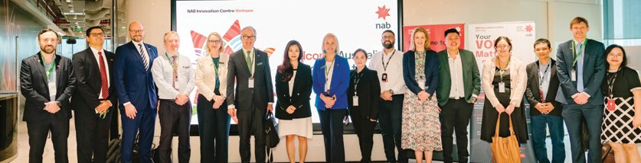  
A development chemist at Callington’s laboratory in Thailand. Source: Callington

The National Australian Bank (NAB) Vietnam’s Innovation Centre is helping to deliver innovative technology to improve customer experience, connect local talent to NAB and nurture young people to develop the skills of the next generation of technology leaders.

NAB Vietnam has grown over the past four years and is dedicated to innovation and strengthening the Australia-Vietnam partnership.

The Special Envoy and Business Champion, Louise Adams, visited the Innovation Centre as part of an Australia-Southeast Asia Business Exchange mission

### THAILAND

#### Driving digital economy links

**August 2024**

Australian technology companies across AI, digital health, regulatory technology, agricultural technology and technologies for business innovation met Thailand-based businesses and heard from in-market experts about trends, the technology ecosystem and Thailand’s digital economy.

The mission included targeted business-matching and pitching sessions, site visits and participation in the Australian Pavillion at the Techsauce Global Summit, one of Asia’s leading tech events.

### PHILIPPINES

#### Connecting key Australian investors to the region

**September 2024**

Business Champion for the Philippines and CEO of Macquarie Group, Shemara Wikramanayake, led a delegation of institutional investors and corporate leaders from Australia’s agribusiness, resources, infrastructure and

digital sectors, representing Australia’s key investment funds and corporations.

In Manila, experts from the Philippines’ major conglomerates shared their insights with delegates on the major trends that will drive investment and trade opportunities for Australia.

### Helping more Australian businesses trade with Southeast Asia

Austrade is working to boost long-term awareness of opportunities for Australian businesses to do business with Southeast Asia to strengthen and diversify supply chains. It is also highlighting the opportunities and benefits of investing in Southeast Asia.

In addition, Austrade is increasing its marketing and communications activities to include new website content, regular email marketing, case studies shared through social media and promoting Southeast Asia on its Go Global Toolkit website (www.export.business.gov.au).

As of 31 July 2024, these activities have generated over 19,430 new users of the Go Global Toolkit, 15,000 views of the case studies and news stories and

7,700 subscribers to the Southeast Asia newsletter.

This forms part of the Australian Government’s commitment to ensure Australian businesses are aware of the vast two-way trade and investment opportunities in the region.

To find out more, visit www.austrade.gov.au

### Engaging with Southeast Asian communities in Australia

More than one million Australians have existing or historical family links to Southeast Asia, and are at the heart of our strong people-to-people links with the region.

The Australian Government is actively engaging with Southeast Asian communities across Australia to connect them with opportunities in Invested.

Building on our already strong connections between our communities, businesses and leaders has been a key part of implementation of the recommendations.

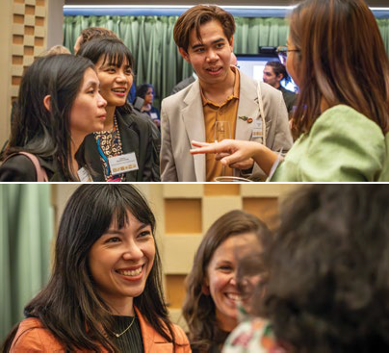  
Attendees at the Emerging Leaders Networking Reception and RMIT’s ASEAN Artistic Collaboration Showcase at the ASEAN-Australia Special Summit in Melbourne, Australia, in March 2024.

### First Nations trade and investment

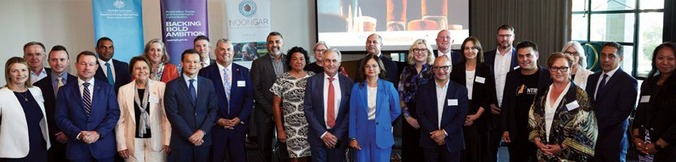  
The Minister for Trade and Tourism, Senator the Hon Don Farrell, with attendees at the First Nations Southeast Asia Economic Strategy Dialogue in Boorloo/Perth, Australia, in April 2024

Australia’s First Nations business sector is expanding exponentially and has never been in a more competitive position to take advantage of opportunities in Southeast Asia.

In April 2024, representatives from the First Nations business sector with experience

in Southeast Asia, together with academia and the Australian Government, held a First Nations Southeast Asia Economic Strategy Dialogue co-hosted with the Noongar Chamber of Commerce and Industry in Boorloo/Perth. The Dialogue was the first major engagement with the First Nations business sector on Invested and explored the sector’s priorities and ideas to increase their participation and success in the region.

In response to advice from the Dialogue, the Australian Government, in line with its First Nations economic empowerment agenda, is working to embed First Nations interests across the implementation of Invested. The Australian Government welcomes continuing engagement with First Nations business through the Trade 2040 Taskforce, the Ministerial Council for Trade and Investment, and the planned pilot First Nations Trade and Investment Advisory Group.

## REMOVING BLOCKAGES

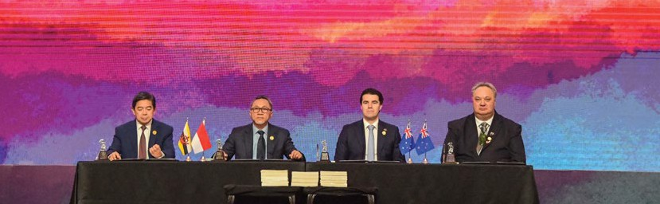  
The Assistant Minister for Foreign Affairs, the Hon Tim Watts MP, at the signing of the Second Protocol to Amend the Agreement Establishing the ASEAN-Australia-New Zealand FTA in Semarang, Indonesia, in August 2023.

### Free trade agreements review

Australia’s longstanding trade and investment links and our bilateral and regional free trade agreements (FTAs) with Southeast Asia have strengthened our regional relationships, improved supply chains, and supported the region’s economic development and resilience.

There are opportunities to modernise and build on the existing FTAs to further boost economic engagement with Southeast Asia. Department of Foreign Affairs and Trade (DFAT) will review Australia’s Southeast Asian FTAs to identify enhancement opportunities and ensure the benefits of trade and investment are maximised.

Further information on the Southeast Asia FTA modernisation review, including how to participate, will be made available on the DFAT website (www.dfat.gov.au).

### Enhanced visa access

Australia grants around 34,000 business visas each year to travellers from ASEAN Member States and Timor-Leste. We are enhancing opportunities to increase trade and investment, build people-to-people connections, and grow jobs by providing enhanced visa access to conduct business.

The Business Visitor Visa (subclass 600) is now valid for up to five years for Southeast Asian business people. Business Visitor Visa holders can stay in Australia for up to three months at a time, during multiple visits, to negotiate contracts, make general business or employment enquiries, participate in conferences or trade fairs, or as part of official government visits. Australia will extend the 10-year Visitor Visa Frequent traveller stream to ASEAN Member States and Timor-Leste in late 2024.

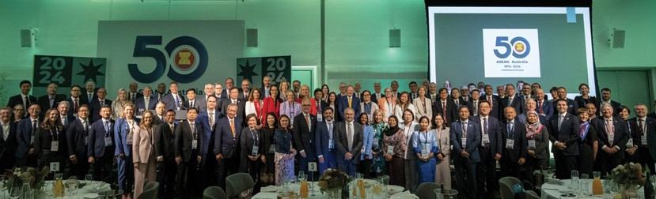  
Delegates pose for a photo during the CEO Forum at the ASEAN-Australia Special Summit in Melbourne, Australia, in March 2024.

## BUILDING CAPABILITY

### Placements and Internships Pilot Program

The Placements and Internships Pilot Program will place young professionals from Australia in businesses in Southeast Asia and vice versa. The program will facilitate connections between young professionals and businesses across Australia and Southeast Asia, as well as build commercial understanding and capability across markets. Placements and internships will focus on priority sectors, including clean energy and the digital economy. The program is being developed in consultation with business and the first placements will take place in 2025.

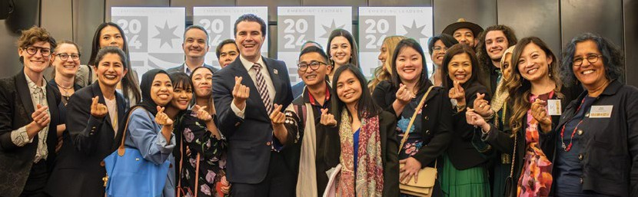  
The Assistant Minister for Foreign Affairs, the Hon Tim Watts MP, with emerging leaders during the ASEAN-Australia Special Summit, Melbourne, Australia, in March 2024.

### Mekong-Australia Partnership

Australia and the Mekong subregion have a strong history of cooperation and deep connections through government and people.

The Mekong-Australia Partnership (MAP) is a flexible program that responds to emerging needs and shared regional and transboundary challenges.

At the ASEAN-Australia Special Summit in March 2024, Australian Minister for Foreign Affairs, Senator the Hon Penny Wong, announced a A$222.5 million second phase of MAP.

This will aim to strengthen institutions and partnerships, and work to enhance economic resilience, improve water security, respond to climate change, and combat transnational crime.

### Case study: Supporting women’s economic empowerment

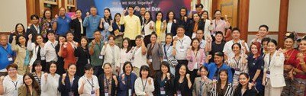

The MAP is working with Thailand and Vietnam to advance supplier diversity through gender-responsive procurement. WE Rise Together, implemented by UN Women, has worked with companies to build awareness of the benefits of inclusive procurement. Several Thai businesses have pledged their commitment to women’s economic principles, including creating equal market opportunities. In 2023, Thailand and Vietnam adopted policy mechanisms that targeted support for women-owned businesses to engage better in supply chains.

### AUS4ASEAN Scholarships and Fellowships

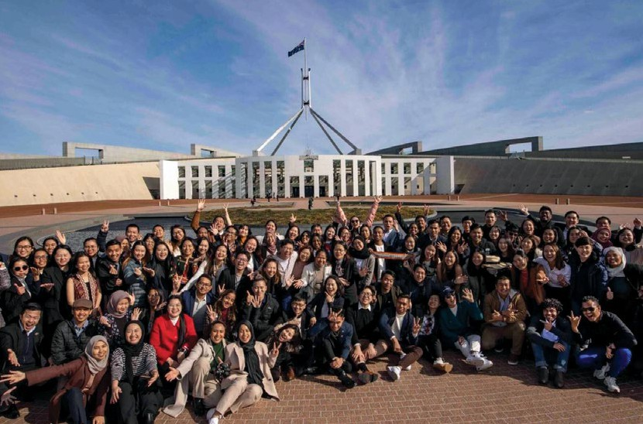  
Aus4ASEAN scholars visit Australia’s Parliament House in Canberra, Australia, in August 2023.

Australia and Southeast Asia have a long history of fostering relations through education, while addressing our region’s pressing challenges.

Aus4ASEAN Scholarships are prestigious master’s degree scholarships for emerging leaders from ASEAN Member States and Timor-Leste, in areas that reinforce the ASEAN Outlook on the Indo-Pacific – maritime, connectivity, economic development and the 2030 Agenda for Sustainable Development.

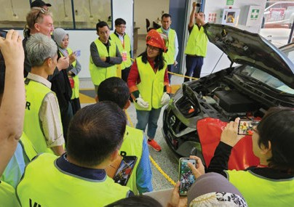  
Aus4ASEAN Digital Transformation and Future Skills Initiative cohorts learning about the Australian electronic vehicle sector during a visit to the Royal Melbourne Institute of Technology’s Centre for Digital Innovation.

Aus4ASEAN scholars have the opportunity to participate in the ASEAN Scholars Leadership Program, which includes a Women’s Developmental Leadership component.

The first 100 Aus4ASEAN scholars are due to complete their master’s degree by mid-2025 and over 130 new Aus4ASEAN scholars – many of whom are co-funded by Australian universities – will commence their studies in 2025.

Fifty-five new Aus4ASEAN Fellowships will provide mid-career officials and professionals the opportunity to participate in professional development activities, including short courses, from 2025.

### ASEAN-Australia Centre

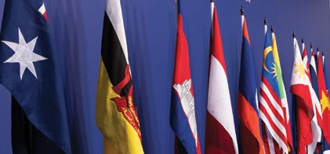  
The Australian flag and flags of ASEAN Member States at the ASEAN-Australia Special Summit in Melbourne, Australia, in March 2024.

The Australian Government has invested A$33.1 million to establish the ASEAN- Australia Centre as a focal point for people-to-people engagement and to promote greater Southeast Asia cultural literacy in Australia.

Established on 1 July 2024, the Centre will strengthen business, education, cultural and community connections between Australia, ASEAN Member States and Timor-Leste to support implementation of Invested.

The Centre will also deliver opportunities for young entrepreneurs and emerging leaders to connect and contribute their energy and potential, aimed at underpinning deeper business engagement in the future.

It will support partnerships between national cultural institutions and peak bodies, and work with Southeast Asian Australians to reflect our contemporary diversity in our engagement with the region.

Grants will be awarded on a competitive basis to projects including joint academic research on Southeast Asia literacy, exchanges in the creative industries, tourism, and business initiatives.

### Scholar profiles

‘Studying in Australia, especially as part of the ASEAN Scholars Leadership Program, not only elevates my academic insights but also provides a platform to collaborate with distinguished professors and peers. This synergy of knowledge, I believe, is invaluable for my mission to contribute meaningfully to Laos’ economic growth.’ – Lounglavanh Vongxay

Lounglavanh Vongxay, a scholar from Laos, is pursuing a Master of International Trade and Development at the University of Adelaide. She aims to refine and enhance economic policies back home in Laos, to foster a vibrant business ecosystem.

Shakgantan M Balakrishnan, from Malaysia, is studying a Master of International Business at the University of Melbourne’s Melbourne Business School. He wants to redesign business processes and enrich the international outlook of corporations operating in Malaysia to boost their success.

‘I appreciate the opportunity to be in Australia for my studies and to take part in the ASEAN Scholars Leadership Program because I get to engage with future ASEAN leaders in Australia and reinforce our collaboration while understanding our objectives to improve our nations together.’ – Shakgantan M Balakrishnan

### Case study: Co-investing in Philippine agriculture

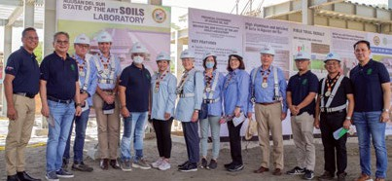

The Australian Centre for International Agricultural Research (ACIAR) is deepening collaboration in Southeast Asia’s agrifood systems through co-investing in research, innovation and capacity development.

In the Philippines, ACIAR’s partnership with the Department of Science and Technology – Philippine Council for Agriculture, Aquatic and Natural Resources Research and Development (DOST- PCAARRD) continues to grow.

Australia and the Philippines are co- investing in research to develop soil knowledge, a soil information system and capacity through improved soil management and health in the Philippines. As part of the co-investment, the Provincial Government of Agusan

del Sur is building a state-of-the-art soil laboratory to support farming communities improve productivity, sustainability and resilience of key cropping systems.

A new Philippines Country Strategy guides these co-investments in collaborative research, capacity development and effective distribution and uptake of research outcomes to improve productivity, competitiveness and sustainability of agrifood systems, for human, environmental, and economic resilience.

‘The partnership is a role model for international cooperation. Our collaboration is not just about shared resources and research results but about building a robust and sustainable partnership. It exemplifies how mutual accountability and dedication to delivering high-quality science can foster significant advancements in agriculture.’ – Dr Reynaldo Ebora, Executive Director, DOST-PCAARRD

### Case study: Working with ASEAN on biosecurity

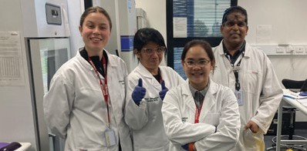

The ASEAN-Australia-New Zealand Free Trade Area (AANZFTA) is unlocking trade opportunities.

Australia is known for its excellence in biosecurity and is working with ASEAN Member States to increase biosecurity cooperation.

On 21 August 2023, Ministers from Australia, New Zealand and ASEAN signed an upgrade to AANZFTA, signalling their agreement to new and enhanced commitments.

The ASEAN Regional Diagnostic Network Project – funded through the Regional Trade for Development initiative – sees the Australian Department of Agriculture, Fisheries and Forestry work with Southeast Asian countries to enhance their capacity to diagnose plant pests and diseases; promote regional networking; and stimulate adoption of new diagnostic techniques.

The next phase aims to ensure ASEAN Member States have the skills and resources they need, prioritising training opportunities and professional networks.

## DEEPENING INVESTMENT

### Enabling Australian tech scale-ups to grow

Australia is leveraging its expertise to partner with Southeast Asia on fast-growing digital and technology opportunities.

New Landing Pads in Indonesia and Vietnam, building on the success of the Landing Pad in Singapore, are giving on- the-ground support to Australian tech services companies seeking to break into Southeast Asia’s dynamic markets.

Landing Pads are building capacity for Australia-Southeast Asia partnerships now and into the future.

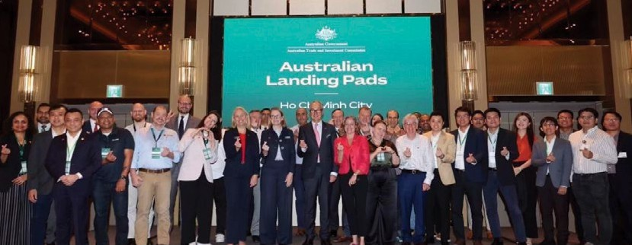  
The Special Envoy and Business Champion for Vietnam, Louise Adams, celebrate the new Landing Pad in Ho Chi Minh City, Vietnam, in June 2024.

They are enabling Australian tech scale- ups to raise brand profile, develop market entry plans, connect with opportunities, customers, partners and funding, and expand and grow sales internationally.

### Case study: Fostering tech connections in Singapore

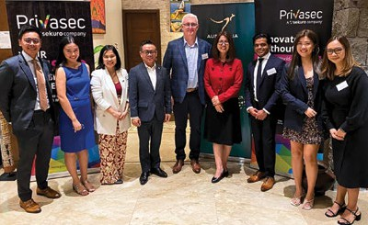

Australian cyber security company Privasec (a Sekuro company) is just one of many success stories from the Singapore Landing Pad.

Founded in 2014, Privasec is a governance, risk compliance, offensive security and digital transformation firm. It works with its clients to develop strategies to secure systems, applications and data.

Through the Landing Pad, Privasec formed long-term partnerships with banks, financial services institutions, hospitality groups, universities, insurance companies and investment funds.

Since joining the Landing Pad program in 2019, Privasec’s revenue has almost doubled year-on-year with clients including the Asian Development Bank, CIMB, Circles.Life and SingTel.

Building on its success, Privasec has expanded into Malaysia and the Philippines, and is exploring opportunities in Thailand, Vietnam and Indonesia.

### Southeast Asia Investment Financing Facility

The Australian Government is supporting Australian businesses to expand and thrive in Southeast Asia through the new

A$2 billion Southeast Asia Investment Financing Facility, which provides loans, guarantees, equity and insurance.

The Facility is up and running and a pipeline of projects is being developed. It is focused on enhancing trade and investment and supporting infrastructure development

in Brunei, Cambodia, Indonesia, Laos, Malaysia, Philippines, Singapore, Thailand, Timor-Leste and Vietnam.

A range of factors will be considered for transactions under the Facility, such as commercial viability, environmental and social standards and mobilising Australian investment into Southeast Asia.

The Facility is managed by Export Finance Australia (EFA), which has a strong track record of providing finance solutions to support Southeast Asian infrastructure development and Australian businesses investing in or expanding into Southeast Asia.

To find out more about the Facility and how EFA could work with you, visit [www.exportfinance.gov.au](http://www.exportfinance.gov.au)

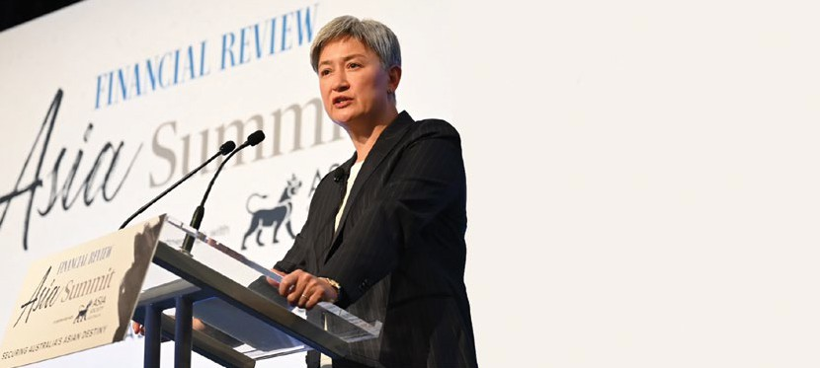  
The Minister for Foreign Affairs, Senator the Hon Penny Wong, addresses the Australian Financial Review Asia Summit in Melbourne, Australia, on 3 September 2024.

“Our government’s initiatives are designed to make it easier for Australian business to get established in new markets. It is up to business, smart business to take the opportunities we have created through this strategy.” – Senator the Hon Penny Wong, Minister for Foreign Affairs

### Investment Deal Teams

New Investment Deal Teams have been deployed across Southeast Asia and are connecting Australian investors to opportunities in the region. They are

working to bring investment and finance into strategic projects, including through the Facility.

Deal Teams work with Southeast Asian business and government project proponents to understand project pipelines and identify opportunities for Australian investors.

Deal Team Hubs in Ho Chi Minh City, Jakarta and Singapore – supported by representatives across Southeast Asia – are promoting Australian investment in priority areas of infrastructure, net zero transition, agrifood, health, digital economy, and advanced manufacturing.

To contact the Deal Teams, visit [www.austrade.gov.au/asea/seaidt-contact](http://www.austrade.gov.au/asea/seaidt-contact)

### Case study: Building investment ties with Indonesia

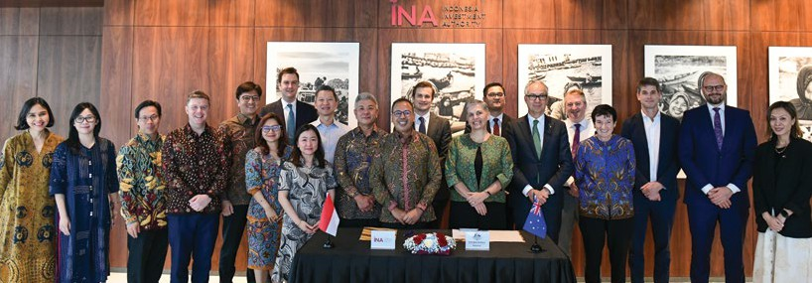

In June 2024, the Australian Embassy Deal Team in Indonesia and the Indonesia Investment Authority (INA) – a sovereign wealth fund mandated to increase foreign investment – signed a Memorandum of Understanding to connect Indonesian projects to Australian investors, creating opportunities for both countries. Through the Memorandum of Understanding, the Deal Team is working with INA to identify investor-ready opportunities for Australian participants.

The partnership is growing our strategic economic engagement with Indonesia, one of our closest partners.

Purple map marked with Deal Team Hub, geographical locations Ho Chi Minh City, Vietnam, Jakarta, Indonesia, Singapore And
The Deal Team locations
Hanoi, Bangkok, manila, Phnom Penh, Kuala Lumpur and Bandar Seri Begawan.

### Simplifying investment into Australia

Australia is investing A$22.7 billion over the next decade to maximise the economic and industrial benefits of the move to net zero, through the Future Made in Australia agenda.

A Future Made in Australia is not a future made alone.

Australia will establish a new ‘Front Door’ for investors with major, transformational investment proposals to make it simpler to invest in Australia and attract more global and domestic capital.

The Front Door forms an integral part of the Future Made in Australia agenda and will provide a single point of entry for investors and companies with major investment proposals. It will deliver a joined-up approach to investment attraction and facilitation, identify priority projects related to the Future Made in Australia agenda, support strengthened and streamlined approval decisions, and connect investors with Australia’s specialist investment vehicles.

Consultation on the design and timing of the establishment of the Front Door will take place over 2024.

### Partnerships for Infrastructure

Australia is partnering with Southeast Asia to meet shared challenges including climate change with reliable, sustainable infrastructure.

Through Partnerships for Infrastructure’s (P4I) flexible, innovative tools and diverse expertise, we are working with Southeast Asian countries on their specific needs.

P4I is helping to accelerate the policy and regulatory reforms needed to develop quality infrastructure projects and attract diverse infrastructure finance.

Australia is extending P4I to enhance our partnerships with Southeast Asian governments and address infrastructure challenges in the region.

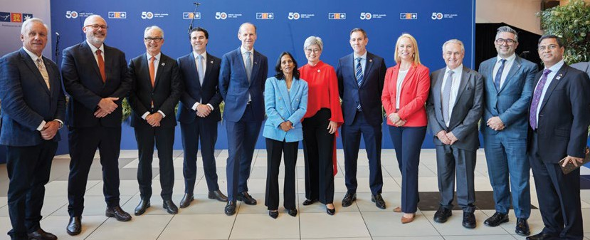  
Ministers, the Special Envoy and Business Champions at the welcome reception during the ASEAN-Australia Special Summit in Melbourne, Australia, on 5 March 2024.

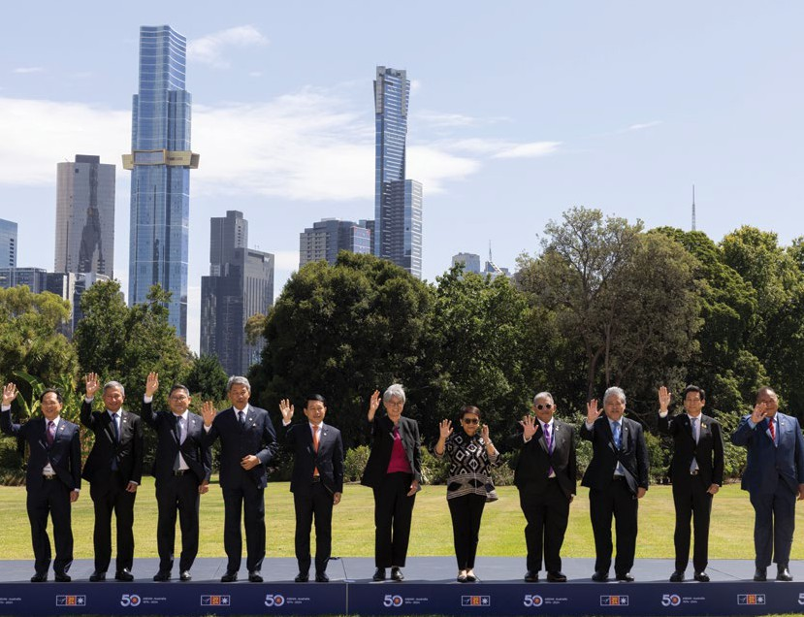  
The Minister for Foreign Affairs, Senator the Hon Penny Wong, with her ASEAN and Timor-Leste counterparts at the ASEAN-Australia Special Summit in Melbourne, Australia, on 5 March 2024.

### Case study: Supporting the green energy transition

The transition to net zero offers great two- way trade and investment opportunities for Australia and the region.

Laos has made significant investments in hydropower and aims to be a key exporter of renewable energy in Southeast Asia. Australia is pleased to be part of that journey.

The Laos-Australia Sustainable Energy Partnership is helping strengthen Laos’ energy planning and enhance understanding of renewable energy technology. Australia is sharing our world leading expertise and research on issues like green hydrogen, solar and pumped hydro energy storage.

To further Laos’ renewable energy ambitions, the Australian Commonwealth Scientific and Industrial Research Organisation (CSIRO) and Mekong Region Futures Institute conducted a joint study with the Laos Government on potential production and use of green hydrogen.

This has led to work on a National Hydrogen and Ammonia Roadmap for Laos.

