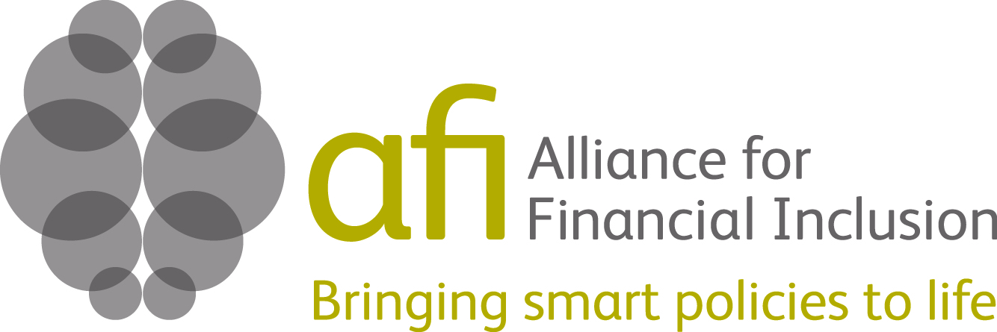

Report to the Australian Agency for International Development (AusAID) about the use of funding received

In support of:
AFI’s activities on the G20 Global Partnership for Financial Inclusion (GPFI)
and
the management of the Pacific Island Working Group
--- July 2011 – June 2012 ---

Date of Report: July 2012

EXECUTIVE SUMMARY

Since its nomination at the Seoul Summit in December 2010, the Alliance for Financial Inclusion (AFI) has played a substantial role as a key implementing partner of the G20’s Global Partnership for Financial Inclusion (GPFI) assisting with the successful launch of the initiative. Building on the strength of the AFI membership network as a platform for knowledge exchange among developing countries, AFI’s role is to foster the participation of non-G20 developing countries in the GPFI. The Australian Agency for International Development (AusAID) has co-funded AFI’s activities under this new mandate for the period from July 2011 until June 2012. The AusAID funding was a contribution to the core fund provided by the Bill & Melinda Gates Foundation.
AusAID’s support has enabled AFI to contribute effectively as a key implementing partner of the GPFI through part-funding the administrative and managerial support for overseeing and coordinating AFI’s activities across the range of topics addressed by the GPFI; providing the resources to prepare and publish 16 country case studies on the application of the G20 Principles and developing country experiences of working with the standard setting bodies; enabling an effective contribution to the development of a core set of Financial Inclusion Key Performance Indicators by the GPFI; and facilitating the organization of the GPFI’s first ever forum with stakeholders.
In addition to the contribution to AFI’s activities under the GPFI, AusAID funding further supported the work of the Pacific Island Working Group (PIWG). AFI facilitated the formation of the Pacific Island Working Group in December 2009 upon the request of the Governor of the Reserve Bank of Vanuatu on behalf of six Pacific Island Central Banks. The group’s objective was to identify key issues relating to financial inclusion applicable to all countries and utilize the AFI platform to help advance knowledge and strategic responses to increase access and use of financial services in the islands.
The funding from AusAID was used to cover AFI’s administrative support to manage the Working Group’s activities, and ensure continued dialogue and consultation with AusAID in the region. AusAID’s support enabled AFI to scale up and meet the demands of group members for deeper and more frequent engagement, integration into AFI’s global network, and the development of several knowledge products and tools that support the work of the group and allow them to share their lessons globally.
By contributing to the funding for AFI’s activities under these two initiatives, AusAID and the Australian Government also support AFI’s overall goal of facilitating innovative policy changes in developing and emerging countries with the objective of promoting financial inclusion of the poor. More specifically, AFI’s work on the GPFI provides exposure to existing effective solutions in developing countries, thereby empowering non-G20 countries and bringing their concerns and challenges onto the global agenda. AFI’s work in the Pacific Region contributes to removing obstacles and challenges on financial inclusion policy and creating an enabling regulatory framework that promotes greater access to financial services and leads to the financial empowerment of Pacific Islanders in the short to medium term.
AFI believes that facilitating knowledge exchange and peer learning as well as providing financial support to develop and implement effective policy initiatives will contribute to increased access to and use of financial services for the unbanked.
AFI’s approach is thereby in line with the strategy for the Australian aid program 2010-15 on ‘Financial Services for the Poor’ contributing in particular to outcome 1 (a policy and regulatory environment that allows institutions offering financial services for the poor to enter the market and grow) and outcome 4 (increased client capacity to understand and utilize financial services effectively).
AFI’s focus on evidence-based policies that increase access and use of financial services also complements the Australian Government’s new policy on aid effectiveness as introduced in July 2011: ‘An Effective Aid Program for Australia: Making a real difference—Delivering real results.’ Incidentally, the theme for the 2012 AFI Global Policy Forum to be held in Cape Town, South Africa in September is ‘Making financial inclusion real.’
AFI thus values the support received from AusAID, which directly contributes to helping our members achieve their financial inclusion objectives – and by extension AFI’s goal – in line with the Paris Declaration on Aid Effectiveness and Busan Global Partnership for Effective Development Cooperation.
INTRODUCTION
The Alliance for Financial Inclusion (AFI) is a global network of Central Banks and leading financial regulatory bodies in developing and emerging countries that provides its members with the tools and resources to share, develop, and implement their knowledge of cutting-edge financial inclusion policies that work.

AFI’s approach, supported by the Bill & Melinda Gates Foundation, is based on the assumption that effective policy solutions exist in, and mostly originated from, developing countries and that knowledge exchange, peer learning and providing financial resources will enable countries to bring about policy reforms which lead to greater financial inclusion for the poor. More specifically, AFI believes that:

- Policymakers want to implement effective financial inclusion policies and will do so if they have access to additional resources, experts, and knowledge;
- A policy network, with modalities such as an online platform, exchange visits, working groups, regional and global events, peer reviews, and a policy champions program, is an effective mechanism for “unlocking” the existing knowledge of policymakers;
- The policy solutions developed as a result of policymakers’ participation in AFI are effective solutions for reaching the poor; and
- The policy areas in which AFI works are areas through which greater financial inclusion can be achieved (quality of services, greater outreach, etc.).

By co-financing the activities below together with the Bill & Melinda Gates Foundation, AusAID has contributed to AFI’s goal of facilitating innovative policy changes in developing and emerging countries with the objective of promoting financial inclusion for the poor.

AFI’s overall progress update
AFI’s strategic emphasis shifted in 2011, following two years of building a strong membership network, to focusing on enhancing the value of the network. This was achieved by consolidating services to meet members’ key demands for developing and implementing effective policy solutions for financial inclusion.
Since the beginning of 2011, AFI strengthened its engagement with existing members and welcomed 18 new members, including the People’s Bank of China, Banco de Moçambique and the National Bank of Tajikistan. AFI also bolstered its profile as a global network, counting 88 member institutions representing 80 countries among its members by the end of June 2012. This represents a substantial increase in AFI’s geographical reach and population coverage, indicating healthy growth in the AFI network and a strengthened global presence.
Figure 1: Number of AFI members by region
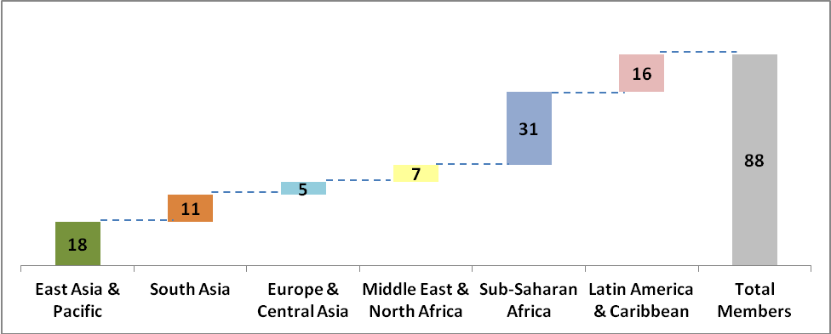

Demand for peer-to-peer learning platforms grew in 2011. AFI’s working groups, one of AFI’s key modes of knowledge exchange, were driven by members. More than half of the institutions in the AFI network are now members of one or more working groups. The efforts of the working groups gained prominence as outputs such as the Financial Data Working Group’s (FIDWG) Core Set of Financial Inclusion Indicators were acknowledged by global data initiatives led by the GPFI, the World Bank, and the UNCDF.
A higher number of long-term grants were approved in 2011, marking a shift from knowledge and short-term grants, which had been more popular in the first two years of AFI’s existence. This shift is in line with AFI’s grant-making cycle that anticipates members’ needs for support will mirror the stages of their policy formulation and implementation.
The third annual Global Policy Forum (GPF), a signature AFI event, had another successful year. Co-hosted by CNBV Mexico and SBS Peru in Riviera Maya, Mexico, in September 2011 the event drew high-level representatives from various corners of the world, including the President of Mexico and H.R.H. Princess Máxima of the Netherlands.
The GPF concluded with an announcement of the Maya Declaration on Financial Inclusion, the first global, measurable set of financial inclusion commitments led by developing and emerging countries. Since the announcement of the Declaration, 24 countries have made concrete financial inclusion commitments with the agreement that they will share knowledge with the AFI network and jointly review progress.
AFI also played a substantial role as a key implementing partner of the G20’s Global Partnership for Financial Inclusion (GPFI) helping the initiative to launch successfully. AFI leveraged the GPF in Mexico in coordinating the first GPFI Forum, which was held immediately after the GPF.
2012 holds several key milestones for AFI. AFI’s first project phase concludes at the end of August — a phase in which AFI is expected to deliver concrete evidence of success to substantiate its ‘proof of concept’ as a member-driven policy network. With the strong sense of ownership and active participation of its members, AFI is well-equipped to step into this next phase. Strategic options for AFI’s future, such as the timeline for AFI’s independence, will be carefully considered and decided upon based on members’ needs. AFI looks forward to continuing to catalyze positive impacts on financial inclusion around the world through the smart and successful policy initiatives of its members.
AFI’s strategic focus and outcomes of 2011
To achieve its strategic objective for 2011 of increasing the value of the network by consolidating services and meeting identified policy demands, AFI identified and focused on five key priorities aimed at responding to member needs with quality services, strengthening existing services that are in high demand such as the working groups, and capturing and showcasing tangible results from these activities:
- Strengthen and broaden member participation and ownership in the AFI network
AFI focused its efforts on strengthening its engagement with existing members while at the same time expanding the number of members actively participating in the AFI network. As a result of these efforts, more than 80% of AFI members have participated in one or more AFI services, including the GPF, member zone, working groups, knowledge production and grants. More than half of AFI members are now active in one or more of AFI’s 5 working groups and more than 70% of AFI members participated at the 2011 Global Policy Forum. In addition, AFI services are regarded as very useful by AFI members. 100 policymakers from 58 member institutions responded to the 2011 Member Needs Assessment survey. All of the respondents rated AFI’s services highly (with an average score of at least 4 out of 5, see graph below).
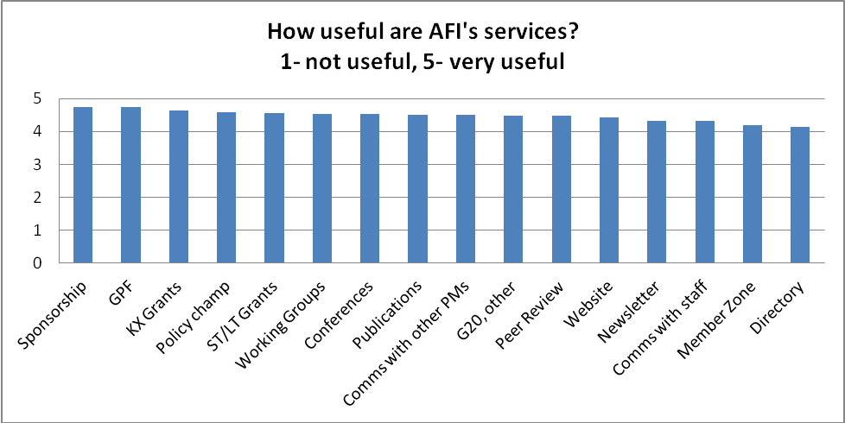
Source: AFI Member Needs Assessment 2011
Through this active participation in AFI services, more than 30 members have implemented or improved financial inclusion policy in their countries (a direct result of the working groups, grants, and other activities). According to the AFI 2011 Member Needs Assessment, 31 countries (of the 53 countries that responded) indicated that AFI had a direct impact on their policy reform. Most respondents gave concrete examples. Some were more high-level changes in the national priorities, whereas others were very specific changes, such as new regulation.
In September 2011, AFI members officially endorsed the Maya Declaration on Financial Inclusion. Through the Declaration, members agreed to improve financial inclusion through setting their own concrete objectives and developing implementation plan as well as sharing knowledge and experiences with their peers through the AFI network. 25 members had made concrete commitments under the Maya Declaration by the end of June 2012. AFI members will report back their progress against their commitments at the 2012 AFI Global Policy Forum in Cape Town, South Africa.
- Leverage the potential of AFI communities of practice
AFI has experimented with a variety of peer exchange programs over the years and many have proven very successful. Based on the 2011 Member Needs Assessment, 84% of respondents strongly agreed that AFI’s peer learning approach is an effective learning methodology. In 2011, AFI focused specifically on the work and outputs of the working groups, whose key achievements included developing knowledge products on financial inclusion data, financial integrity, and mobile financial services. A new working group was also established to respond to member demands for consumer empowerment and market conduct policy issues. Other channels were used to complement and support the working groups, including the online Member Zone and positioning the working groups at the heart of the GPF agenda.
- Maximize the long-term impact of grant-supported projects on financial inclusion
By the end of 2010, AFI had disseminated 21 grants to its members. In 2011, AFI focused on monitoring and implementing these grants and approving an additional 13 grants. Through these grant support, 17 members showed concrete policy results. A number of knowledge exchange activities led to specific policy changes or improvements, and short-term and long-term grants provided practical support to a number of members’ policy implementation activities.
- Capture policy insights from AFI members and promote these insights through the network and global platforms
With the expansion of the network and more than two years of interaction, new knowledge and emerging trends on financial inclusion policy started to become apparent. The goal for 2011 was to capture the individual or aggregate experiences of AFI members in a variety of knowledge products and disseminate these widely across the network. AFI achieved this through its knowledge management (publications) program and added the use of video and short executive-style briefs to its portfolio. Importantly, AFI was able to channel its members’ views and experiences into influential global policy dialogues such as the GPFI.
- Capturing the lessons learned and planning ahead for the policy-driving network
Since AFI’s first phase concludes in August 2012, AFI spent part of 2011 designing the second phase of the network. The main strategic direction was defined — becoming a policy-driving network — and key outcomes for the next phase were brainstormed and agreed upon in various meetings and discussions with members from AFI’s Steering Committee and others from the network.

Lessons learned
- Policy observations
Creating transformational processes that will build more inclusive financial sectors in developing countries is an enormous task, but one that will be achieved through a wide variety of innovations and partnerships. There are three key approaches that leading policymakers have taken on this road. The first is to move beyond microfinance and embrace financial inclusion as a broader financial sector agenda that contributes to financial stability, while taking a proportional approach to providing financial products and services for the poor. The second is to improve the regulatory environment in order to enhance innovative solutions that utilize new information and communication technology. The third is to understand that financial inclusion can be achieved more quickly through committed leadership and partnerships across ministries and agencies and the private sector and civil society.
Moving beyond microfinance: Over the past year we have seen a steady shift in policymakers broadening their perspective on financial inclusion beyond microfinance to payments, savings, insurance, consumer protection and empowerment, and other areas that create a more balanced system that is better suited to the needs of the poor. In the AFI network, this is happening mainly through exposure to peer institutions that are innovating with new channels such as mobile financial services, or those that have taken the initiative to put key financial inclusion enablers in place (such as consumer protection). However, microfinance, and microcredit in particular, is still the primary concern of regulators in a number of countries, especially in the Middle East, Eastern Europe, and Central Asia.
Improving the regulatory environment to enhance technology-enabled solutions: Policymakers and regulators are demonstrating a profound openness to innovative financial inclusion solutions and experimentation. Within the AFI network, the topic of digital payment systems and financial services has consistently been a priority for members’ policy work, which is reflected in the focus of the grants made and the growing number of members in the AFI Mobile Financial Services Working Group as well as in the Financial Integrity Working Group. This focus was also further emphasized through the commitments made by leading AFI members under the 2011 Maya Declaration, in which the majority of commitments made were along the lines of advancing financial inclusion by harnessing the potential of technological innovations such as mobile financial services. In addition, the first regional initiative on mobile finanicial services (MFS) was formed at the conclusion of a regional forum held in Zanzibar, Tanzania on 1-2 March 2012, when the Governors the Bank of Tanzania (BOT) and the Central Bank of Kenya (CBK) called for the formation of a regional policy and regulatory effort to promote and expand the use of Mobile Financial Services (MFS) throughout Africa. The Africa Mobile Financial Services Policy Initiative (AMPI) was founded in response to this need. We therefore have evidence to conclude that the learning, the leadership, and the commitment to technology-enabled financial inclusion is going to continue to spur further innovations and break new ground for the poor.
Leadership and partnerships: Leadership and partnership for financial inclusion stand out as the AFI network’s theme of 2011. A trend toward organizing for financial inclusion was clearly evident in the network, where members see high-level political support, intra-country coordination, setting clear objectives and developing and implementing financial inclusion strategies as key to meeting commitments. Policymakers are championing financial inclusion and engaging with other government and private sector partners to advance the issue on all fronts. This trend is possibly best illustrated by the adoption of the Maya Declaration by AFI members in 2011—a concrete commitment to advancing financial inclusion at national levels.
AFI members have reported that ongoing dialogue with the private sector, especially the various market players and service providers, is central to developing successful financial inclusion initiatives. By creating inclusive forums where providers and other relevant stakeholders can share experiences, regulators can ensure that policies enable the private sector to achieve goals related to financial inclusion. In order to ensure buy-in from stakeholder groups for a national strategy, it is also important that the coordinating body continuously motivates the various actors.
Trends have been observed in several AFI policy areas as well, such as:
- Financial inclusion data: There is a greater emphasis on evidence-based policy decisions, clearly demonstrated in the Maya Declaration commitments — more than half include a commitment to collect data. Countries are at different stages in this process, with some just beginning to conduct demand side surveys, while others have comprehensive demand and supply side surveys in place, and others are ready to measure the quality of financial inclusion, such as consumer protection and literacy indicators. What is clear is that every country needs to have a core set of indicators as a starting point and that enables comparisons between countries. In the pilot, 13 AFI member institutions collected data using AFI’s Core Set of Financial Inclusion Indicators. The second phase focuses on expanding the core set of data collected. Emerging trends include collecting data using indicators that measure quality. The AFI core set of indicators has also formed the best of the G20 Financial Inclusion Indicators (which additionally include SME indicators), expected to be endorsed by G20 Leaders at the Los Cabos Summit. With improved data and information on the needs and demands of various socio-economic groups, appropriate and effective products can be provided include more people in the formal financial sector.
- Mobile financial services: Innovative models like mobile financial services continue to be popular as a means to reach large numbers of people in a short space of time, and at lower cost. There are still several challenges in clearly identifying the risks these products bring to the system and formulating sound and enabling regulatory and supervisory responses. Key topics include approaches to interoperability and interconnectivity, coordination between banking supervisors and telecommunication supervisors, proportional regulation and, for those members who have moved beyond access, the quality and sustainability of products and consumer protection and market conduct.
- Consumer empowerment: Since the global financial crisis, regulators have prioritized consumer protection and market conduct, which is especially important when dealing with vulnerable and low-income consumers. The focus has been on financial literacy and education, which should ultimately produce financially capable consumers. However, consumer empowerment is a new and complex topic and goes beyond education to ensuring greater transparency and disclosure, as well as redress mechanisms for consumers. AFI members are also looking at best practices and suitable supervisory approaches in dealing with market conduct issues. The link to financial stability and integrity needs further research to convince global Standard Setting Bodies that these issues are interconnected and that standards should include a consumer protection element.
- Financial integrity and financial inclusion: There is growing understanding within the AFI network that a proportional approach to regulation that balances financial stability, integrity, and inclusion is important. However, the key to proportional regulation is understanding the risk of money laundering and terrorist financing. The lower the risk, the greater the case for tiered proportional regulation e.g. tiered KYC requirements. Policymakers are recognizing the connection between a more inclusive financial sector and an effective AML/CFT regime, so the question now is how to assess risks and implement proportionality regulations. Some countries have had success with this, and sharing these success stories is an important part of peer learning, not only for AFI member countries, but also for the Standard Setting Bodies when they apply and assess standards for these countries.
AFI has identified priority policy areas and responded to increased demand for certain topics. For example, financial inclusion strategy has became one of the most popular topics in the network, with more than 25 member countries expressing interest in developing strategy or sharing experience and learning from others. Financial inclusion strategy includes both the process of developing and implementing the strategy (“the how”) and the content of the strategy (“the what”). To respond to this growing demand, AFI is currently developing a concept and implementation plan for a financial inclusion strategy peer learning and review program.
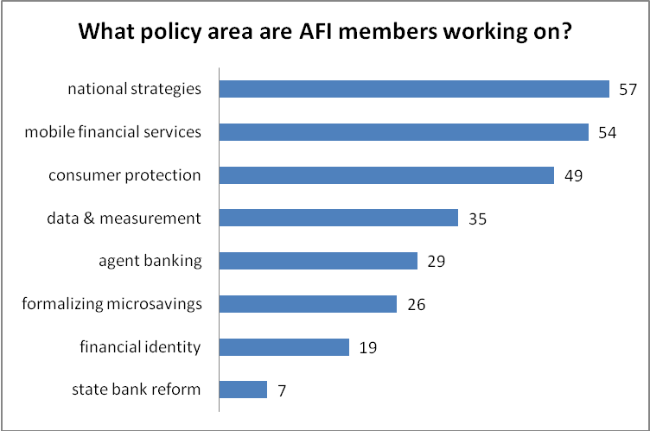
Source: AFI Member Needs Assessment 2011
There are a number of policy areas that AFI does not currently cover, but for which members have been seeking support and requesting AFI to include on their agenda. These include remittances, access to payments, G2P and financial inclusion, financial services infrastructure, Islamic finance, and microinsurance. AFI is currently seeking to address some of these topics through partnerships with other institutions (i.e. microinsurance) and some should be added as policy areas in AFI’s second phase, based on the priorities and demands of the members.
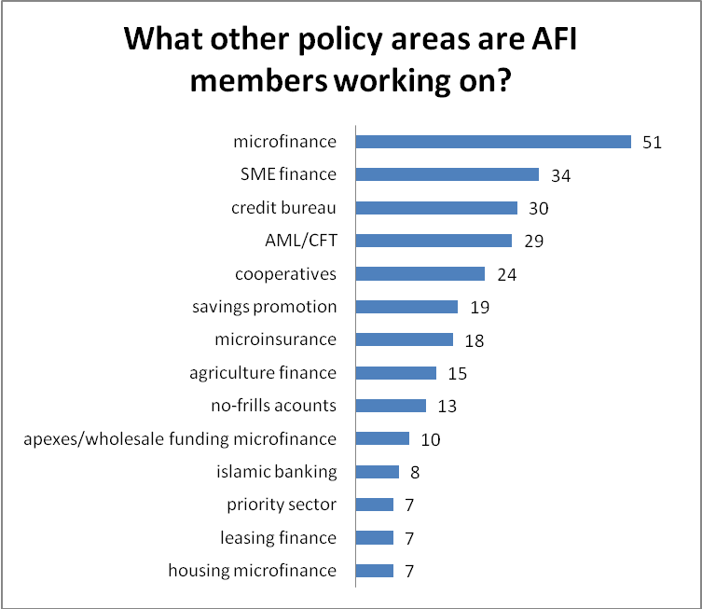
Source: AFI Member Needs Assessment 2011

- Organizational lessons learned
AFI is committed to being a learning organization that continually reflects on what is working well and actively seeks opportunities for improvement.
AFI has had great success in establishing itself as a platform for peer learning and exchange. AFI has focused on providing online and in-person opportunities for members to connect with one another and share information and knowledge.
As the network grows however, and knowledge and experience about financial inclusion policy deepens, members are looking to AFI to spot emerging trends, highlight new innovations, cluster information, and help to connect members with the right experience to members who are seeking solutions. Members are also seeking a stamp of approval from the AFI network. AFI is often asked whether it has endorsed a particular policy approach and hears comments such as, “It would be easier to pass policy recommendations or proposals internally if we had an AFI stamp of quality or agreement.” As AFI is a network of policymakers and regulators with specific expertise on financial inclusion policies, the network as a whole is naturally assuming the role of quality assurance and policy clearing function.
Given this natural evolution of the organization, in its second phase AFI will build on its standard knowledge exchanges and bolster its programs with stronger services such as peer reviews, policy dialogues, quality review committees for knowledge products by members, the secondment program and other forms of knowledge sharing in order to develop its role as a policy clearinghouse for its members. The network will therefore be even further leveraged based on knowledge generated and delivered “by policymakers for policymakers”.
There is a growing sense of ownership and leadership among AFI member countries. Early leaders in the network were primarily countries represented by the members of the Steering Committee, but now more than 14 member countries (16% of the membership) are taking concrete leadership role in the AFI network. In addition more than 65% of the AFI membership is actively participating in the network activities.With growing ownership comes higher expectations. To give stronger ownership and leadership roles to members in driving network activities and developing and vetting the quality of policy content, AFI needs to build the right systems and mechanisms and put appropriate support functions in place.
Stronger ownership also has implications for organizational independence. To be truly member driven, the financial sustainability of the network is key and AFI needs to build an independent institution that is able to absorb member subscriptions from policymaking bodies and allow its members to participate in the governance structure (i.e. the Board).

SUMMARY: Outcomes and Outputs in 2011/12
The table below provides an overview of the program outputs and outcomes achieved for AFI’s GPFI and the PIWG activities, which the AusAID funding contributed to, and how they aligned with Australia’s approach as articulated in the Financial Services for the Poor: A strategy for the Australian aid program 2010–15 launched in March 2010. Further details will be elaborated in the following sections Part I: GPFI and Part II: PIWG.
Outputs | Contributed to the Following Outcomes | Alignment with AUSAID FSP Outcomes
- GPFI: Development, publication and distribution of a guidance note on what the “application of the Principles for Innovative Financial Inclusion in practice” means.  - A comprehensive G20 Principles Report, which included:  - Eleven country case studies on the application of the Principles;  - Analysis of how the Principles had been applied in each of these country case studies, and the challenges faced; and  - Concrete recommendations and next steps towards advancing the application of the Principles globally.  - Showcasing of country case studies at a plenary session in the first annual GPFI forum in Mexico, together with a discussion with stakeholders on the next steps in application of the Principles. | - Principles have taken into consideration developing country realities and context  - Principles adopted at a country level  - Developing countries play a strong role in the GPFI Forum  - AFI Data Working Group’s Core Set of Financial Inclusion Indicators adopted by GPFI  - AFI Peer-Learning approach recognized by GPFI as an optimal methodology of developing effective Financial Inclusion Strategies  - Implementation of the Maya Declaration incorporated into the workplan of the GPFI subgroup on Principles & SSBs | Outcome 1: A policy and regulatory environment that allows institutions offering financial services to the poor to enter the market and grow  Outcome 4: Increased capacity of clients to understand and utilise financial services effectively.
- Five case studies completed with examples of concrete country-level challenges applying SSB standards & guidance, cross-cutting challenges, innovative approaches and best practices of implementing the Standards in line with financial inclusion commitments;  - AFI participation in key discussion with the SSBs, including the second annual high-level meeting among on SSBs on financial inclusion convened on 19 March 2012 by Her Royal Highness Princess Maxima of the Netherlands in her capacity as Honorary Patron of the GPFI, together with BCBS Chair Stefan Ingves. | - FATF and other SSBs recognised the vital contributions developing countries make by inviting policymakers to present their views and provide recommendations on the SSB standards and principles  - Provisions made in the guidelines which are non prescriptive and specific to developing country contexts  - FATF standard on proportional regulations have been implemented in number of developing countries  - Implementation of the Maya Declaration incorporated into the workplan of the GPFI subgroup on Principles & SSBs | Outcome 1: A policy and regulatory environment that allows institutions offering financial services to the poor to enter the market and grow  Outcome 4: Increased capacity of clients to understand and utilise financial services effectively.
PIWG workplan accomplishments 2011-2012:  - Three successful working group meetings hosted by group members in the region  - Workshop on national strategies learning from Fiji and Solomons, and the publishing of results in “Lessons learned for National Financial Inclusion Strategy Development”  - Training (International Finance Cooperation, Pacific Financial Inclusion Program) and field visit to Papua New Guinea (PNG) on non-bank deposit taking entity supervision, and publication of “Techniques for supervising depository microfinance institutions”  - Updated “Mobile Financial Services: Regulatory Action Planning Tool” during workshop (regulatory status, vision for the future)  - Workshop on consumer protection, development of survey on existing legal framework for consumer, pilot completed by Reserve Bank of Fiji (RB Fiji)  - Central Bank of Samoa (CB Samoa), with group inputs, drafted concept note and full proposal for regional data project – grant awarded in May 2011.  - Re-drafted group Terms of Reference to reflect greater ownership and commitment of the group, position the group to report to Governors and Ministers at their annual meeting, and expand PIWG remit to be an clearinghouse for all policy activities in the region  - Data Project Knowledge Exchange visit was undertaken to Bank Negara Malaysia from 27-29 June 2012. Five of the seven member institutions participated.  Integration of PIWG into the AFI global platform 2011-2012:  - Two Pacific region governors in speaking roles at the GPF 2011 on important topics: G2P and national strategies  - One group member (Fiji) among the first 17 AFI members to make their commitments under the Maya Declaration  - RB Fiji attended AFI’s FINTWG meeting to bring the Pacific experience with AML/CFT  - CB Samoa joined the AFI FIDWG to provide a two-way conduit on data  - Bank of PNG engaged with leaders from the MFSWG to gain feedback on their mobile money regulations  - Four PIWG members completed the AFI CEMCWG survey on consumer protection  - Participation of RB Fiji at the Financial Inclusion event in Los Cabos during the G20 meeting to highlight the commitments under Maya Declaration and also to discuss the G20 peer learning programme.  - Submission to the World Bank Global Findex on cooperation with Pacific Islands countries to be included in the data survey. | - Central Banks of Vanuatu, Papua New Guinea, and Samoa have developed processes towards formulating national financial inclusion strategies  - All members updated their non-bank regulation and supervision approaches to reflect a risk-based approach  - Nine non-bank entities have started MFS deployments in the Pacific  - Financial Inclusion is a permanent agenda item at the Oceanic roundtable  - Strengthened and deepened the connections between governors of the Pacific Islands in the area of Financial Inclusion  - Improved coordination between the Pacific Island Working Group and other AFI technical working groups | Outcome 1: A policy and regulatory environment that allows institutions offering financial services to the poor to enter the market and grow  Outcome 4: Increased capacity of clients to understand and utilise financial services effectively.

PART I: AFI’s work in the G20 Global Partnership for Financial Inclusion (GPFI)

Background
The Global Partnership for Financial Inclusion (GPFI) is the main platform for implementing the G20 Financial Inclusion Action Plan. The group engages partners from G20 and non-G20 countries, private sector, civil society, and others. In 2011 it was chaired by the G20 troika countries, Korea, France, and Mexico. In December 2011, Korea left the troika to be replaced by Russia (who will have the G20 Presidency in 2013).
The GPFI builds on the work of the G20 Financial Inclusion Experts Group (FIEG) in 2009–2010, to which AFI also contributed the perspectives and voices of developing country policymakers, especially to the development of the G20 Principles for Innovative Financial Inclusion.
AFI’s role in the GPFI
Building on the strength of the AFI membership network as a platform for knowledge exchange among developing countries, AFI has been given a special mandate to foster the participation of non-G20 developing countries in the GPFI. AFI members are directly contributing to two of the three GPFI subgroups: G20 Principles and Standard Setting Bodies (SSBs) and Financial Inclusion Data and Measurement.
AusAID’s support has enabled AFI to contribute effectively as a key implementing partner of the GPFI through part-funding a staff position focussed on overseeing and coordinating AFI’s activities across the range of topics addressed by the GPFI; providing the resources to prepare and publish 16 country case studies on the application of the G20 Principles and developing country experiences of working with the standard setting bodies; enabling an effective contribution to the development of a core set of Financial Inclusion Key Performance Indicators by the GPFI; and facilitating organization of the GPFI’s first ever forum with stakeholders.
Key Outputs & Outcomes from GPFI activities in the period July 2011 to June 2012:
- 11 Country Case Study document “Bringing the Principles to Life” produced and disseminated via AFI & GPFI websites and events;
- G20 Principles incorporated into the AFI network’s Maya Declaration, individual countries national financial inclusion strategies, and stakeholder initiatives, contribution of Maya Declaration to implementing G20 Principles recognized in Los Cabos Leaders’ Declaration;
- 5 Country Case Studies on Financial Inclusion and the Global Standard Setting Bodies produced and disseminated;
- Planning initiated for first GPFI Standard Setting Bodies conference to take place in October 2012, AFI leading on non-G20 country participation;
- AFI Data Working Group’s Core Set of Financial Inclusion Indicators adopted by GPFI and utilized as foundation for the G20 Basic Set of Key Performance Indicators, endorsed by G20 Leaders at Los Cabos Summit;
- First Annual GPFI Forum organized in Riviera Maya Mexico, and Forum Report produced, planning underway for second annual forum in Cape Town, Sept 2012;
- AFI invited as key implementing partner of the G20 Financial Inclusion Peer Learning Program following announcement by Finance Ministers (April 2012), with 8 AFI member institutions participating in launch of the Peer Learning Program at the Los Cabos Summit.
Subgroup on the G20 Principles and Standard Setting Bodies (SSBs)
This subgroup supports putting the G20 Principles for Innovative Financial Inclusion into practice by showcasing how each of the nine principles have been put into action and the challenges countries have faced in implementing them. The group also works to embed financial inclusion in the work of SSBs through dialogue and highlighting how countries have sought to balance the requirements of the SSBs with a commitment to promoting financial inclusion.
- G20 Principles for Innovative Financial Inclusion
AFI produced a comprehensive report on how 11 countries have implemented financial inclusion policies in line with the G20 Principles. Case studies were produced documenting the financial inclusion stories of seven G20 countries (South Korea, Brazil, Russia, United Kingdom, Mexico, Indonesia, and Turkey) and four non-G20 countries (Nigeria, Kenya, Peru, and the Philippines).
The report, “The G20 Principles for Innovative Financial Inclusion: Bringing the Principles to Life”, was published in hard copy and on the GPFI’s website on 1 October 2011 alongside the GPFI Forum in Riviera Maya, Mexico, and was launched the same day. Four of the countries showcased in this report — the United Kingdom, Russia, Nigeria and Indonesia— participated in a panel discussion at the GPFI Forum to share their experiences in person and to discuss next steps in implementing the G20 Principles by developed and developing countries.
The report made a series of policy recommendations in four key areas encompassing the nine Principles. These recommendations have been endorsed by the GPFI in their report to G20 leaders and included the following topics and principles:
- Organizing for financial inclusion: leadership and cooperation
- Promoting financial inclusion, integrity, and stability in conjunction: proportionality and framework
- Safeguarding consumers: empowerment and protection
- Learning for financial inclusion: building knowledge in new areas such as technological innovation and new business models
The report and its recommendations have been widely disseminated at GPFI and AFI events – such as the African Financial Inclusion Policy Forum held in Zanzibar in March 2012, and the G24/AFI Policymakers’ Roundtable in Washington, D.C. in April 2012, in addition to the AFI and GPFI websites.
In 2012 the focus has been on implementation of the G20 Principles, for which a key platform is the AFI network’s Maya Declaration. The Maya Declaration, and the individual country commitments made under it, are fully consistent with the G20 Principles and provide a practical mechanism to help the Principles a reality in developing and emerging countries. Implementation of the Maya Declaration has therefore been incorporated into the workplan of the GPFI subgroup on Principles & SSBs.
In April 2012, 4th Annual G24/AFI Policymakers Roundtable was held. This year’s roundtable focused on discussions between policymakers from AFI member institutions committing to the Maya Declaration, and the G20 Presidency and GPFI co-chairs on the roles they could play in supporting countries to meet their commitments.
At the G20 Leaders Summit in June 2012, the Leaders’ Declaration recognized the contribution of the Maya Declaration to implementation of the G20 Principles:
[We] “encourage […] efforts to advance effective implementation of the G20 Principles for Innovative Financial Inclusion such as the commitments to concrete actions to promote financial inclusion made by developing and emerging countries under the Maya Declaration”
The successful dissemination and awareness-raising of the G20 Principles has additionally led to a number of individual countries making explicit links to the Principles in their published financial inclusion strategies and action plans in this period. Examples include Indonesia’s National Strategy for Financial Inclusion (June 2012) and the action plan of Brazil’s National Partnership for Financial Inclusion (April 2012). Stakeholders – such as the United Nations Capital Development Fund (UNCDF) through the “Making Access Possible” financial inclusion diagnostic tool – have also utilized the G20 Principles in their work programs.
- Standard Setting Bodies (SSBs)
Financial inclusion can complement the goals of SSBs, which are to maintain integrity and stability in financial systems. AFI’s Financial Integrity Working Group (FINTWG), which is closely involved in developing countries’ efforts to implement standards of the Financial Action Task Force (FATF), contributes to this GPFI work stream by sharing lessons learned by developing country policymakers implementing FATF standards and knowledge gained from its dialogue with the SSBs.
Five AFI member institutions contributed case studies which together demonstrate that financial inclusion contributes to a stronger framework overall for financial regulation, and that the goals of financial stability, financial integrity, and financial inclusion can be mutually reinforcing. The case studies from Brazil, Mexico, Kenya, the Philippines, and South Africa, together with a synthesis report, were published on 1 October alongside the GPFI Forum and have been widely distributed.
As part of the dissemination of key messages from these case studies, AFI worked with CGAP and the GPFI co-chairs on preparations for the Basel Consultative Group Meeting in Hong Kong in November 2011. AFI Steering Committee member and Deputy Governor of Bangko Sentral ng Pilipinas, Nestor Espenilla Jr., presented these messages to the Committee. Earlier, AFI members provided comments on the revision of the core principles to the Basel Committee on Banking Supervision (BCBS).
In the first half of 2012, AFI – working together with CGAP and the GPFI co-chairs – has assisted the GPFI in developing the concept for a combined high-level conference and technical meeting with the Standard Setting Bodies, which will take place in Basel in October 2012. AFI has been leading particularly on identifying and reaching out to key non-G20 developing countries to ensure they have a strong voice in this important event.
Subgroup on Financial Inclusion Data and Target-Setting
This subgroup engages various GPFI stakeholders in order to create general consensus on data and measurement issues, including setting common definitions of the components of financial inclusion and consistent methodologies to inform, measure, and set targets. The group also facilitates actions to support countries in implementing data initiatives and setting their own targets.
AFI’s Financial Inclusion Data Working Group (FIDWG) has made strong and effective contributions to help the GPFI meet its objectives for Data & Measurement. FIDWG’s first contribution to the subgroup was a core set of five key performance indicators to advance better measurement of financial inclusion and standardization of data across countries. AFI contributed a chapter on the “Core Set” to the GPFI Data Subgroup’s document “Measuring the Data Landscape”. The importance of the FIDWG’s Core Set in taking forwards global data collection efforts was highlighted in the GPFI’s November 2011 report to G20 Leaders.
In 2012, the GPFI developed – using the foundations of the AFI Core Set – the G20 Basic Set of Financial Inclusion Indicators. These include 3 of the 5 original FIDWG Core Set Indicators, with the addition of two Key Performance Indicators to measure access to finance for SMEs. In June at Los Cabos, the G20 Core Set was endorsed by the G20 Leaders.
FIDWG will continue to submit indicators and methodologies to the GPFI subgroup that meet the needs of policymakers in developing countries.

- Organization of the GPFI Forum in Riviera Maya, 1 October 2011
AFI supported the co-chairs of the GPFI in organizing the first forum meeting of the GPFI, which took place in Riviera Maya immediately following the AFI Global Policy Forum. The GPFI meeting was opened by President Felipe Calderon as he closed the GPF.
This first forum served as an important milestone for the GPFI and provided the opportunity to engage a wider audience in its work, especially the private sector and civil society. AFI prepared a report of the first GPFI forum, capturing the discussions and with recommendations for the GPFI’s work moving forwards (a copy of the forum report has been submitted together with this paper).
Following the successful organization of the first GPFI forum, AFI has again been invited to support the co-chairs in organizing the second annual forum back-to-back with the AFI GPF in Cape Town, South Africa, 26-28 September 2012. The report of the first GPFI forum will be printed and distributed ahead of the second forum taking place in Cape Town, September 2012.

- Cannes G20 Summit and the transition to the Mexican Presidency
AFI, along with the other implementing partners and co-chairs, contributed to the preparation of the GPFI’s Report to G20 Leaders ahead of the Cannes Summit in November 2011, which outlined the achievements of the GPFI to date and made five recommendations for moving its work forward. The report was endorsed by the leaders and published on 5 November 2011. Three of the recommendations were particularly relevant to AFI’s work:
- Developed and developing countries commit to further implementation of the nine Principles for Innovative Financial Inclusion, building on lessons learned and the policy recommendations from the case studies;
- The main SSBs jointly explore complementarities between their work and that of the GPFI and consider the lessons learned as well as recommendations from the five country case studies and the white paper; and
- Countries should develop and use data sources that are relevant for informing and monitoring policy success, leveraging other complementary supply-side and demand-side data.

- AFI’s role in supporting the Mexican G20 Presidency Agenda and the Los Cabos Summit
Mexico has made promotion of financial inclusion one of its top five priorities for its G20 Presidency. In particular, the Mexican presidency has highlighted the importance of coordinating bodies for financial inclusion policy at the national level (e.g. Councils or Taskforces) together with national financial inclusion strategies. To this end, the G20 has endorsed the Mexican proposal to establish a G20 Financial Inclusion Peer Learning Program focused on these aspects.
AFI has been invited to support the Mexican G20 agenda as a key implementing partner of the G20 Financial Inclusion Peer Learning Program, designed to encourage country commitments to develop national financial inclusion strategies and national coordination mechanisms, and to share their experiences as they make progress. 15 of the 17 countries initially taking part in the program are AFI members, many invited specifically because of the commitments they have made already under the Maya Declaration. At a side event at the Los Cabos Summit to accompany the official launch of the program, 8 AFI member institutions attended in person to present on their Maya Declaration commitments and declare their interest in participating in the Peer Learning Program.
Moving forwards, AFI will support the implementation of the G20 Peer Learning Program through offering its services to all participating countries and establishing a specific peer learning group focused on financial inclusion strategies.

PART II: Support for the management of the Pacific Island Working Group (PIWG)

Background
The Pacific region has one of the highest unbanked rates globally due to factors such as geographically dispersed islands with low density populations and challenges related to physical and banking infrastructure. Policymakers in the region are working together to advance innovative solutions that help more Pacific Islanders access the formal financial system.
The Pacific Island Working Group (PIWG) was formally established and endorsed by the governors of the Central Banks during the annual Forum Economic Ministers' Meeting (FEMM) and South Pacific Central Bank Governors meeting in December 2009. The Central Banks of Papua New Guinea, Fiji, Samoa, Solomon Islands and Vanuatu are among the founding members, along with the Banco Central Timor-Leste. The Federal Reserve Bank of Tonga joined in 2012. PIWG now comprises of member institutions representing 7 countries. All institutions are members of the Alliance for Financial Inclusion, and it is upon this platform that the group is administrated and networked into the global membership of 89 financial regulatory and policymaking bodies working on financial inclusion.
The general motivation for the working group was to build a collaborative dynamic between peers in the region, exchange knowledge and information on key issues relating to financial inclusion, discuss and share the current situation and priorities in their countries, and finally to identify activities that the group could do together to advance financial inclusion in the region. AusAID’s support enabled AFI to scale up and meet the demands of group members for deeper and more frequent engagement, integration into AFI’s global network, and the development of several knowledge products and tools that support the work of the group and allow them to share their lessons globally.

Focus areas and key outputs in 2011/2012
The Pacific Islands Financial Inclusion Working Group (PIWG) completed its second full year of activities in 2011 and is currently in its third year. PIWG is co-chaired by the Reserve Bank of Fiji and the Central Bank of Samoa. The group focused on the following policy areas during the 2011/12 period:
- Financial inclusion strategy
The working group shared their experiences, challenges, and approaches in formulating national financial inclusion strategies. These findings were captured in its publication, “Lessons Learned for National Financial Inclusion Strategy Development”.
Within the PIWG and at AFI’s Global Policy Forum (GPF) in Mexico in September 2011, regulators from the Central Banks of Fiji and Solomon Islands shared their experiences in formulating and implementing financial inclusion strategies in their countries, including the formation of national financial inclusion task forces. Central Banks of Vanuatu, Papua New Guinea, and Samoa have now developed their own processes based on these lessons learned.

- Formalizing microsavings
Building on a three-day training session on how to regulate and supervise non-bank deposit taking entities held in April 2011, PIWG members visited Papua New Guinea in January 2012 in order to gain early insights into its future regulatory framework. The Bank of Papua New Guinea is embarking on reforms of its large multi-player microfinance sector using a balanced and risk-based approach.
By the end of February 2012, all members already had or were currently updating their non-bank regulation and supervision approaches to reflect a risk-based approach to balance the importance of small deposit taking services with financial system integrity and consumer protection.

- Mobile financial services (MFS)
Since June 2010, five out of seven PIWG members deployed mobile financial services using various regulatory risk-based approaches. The lessons learned assisted countries in moving from being regulators to enablers of financial inclusion. At the working group meeting in January 2012, members were able to share their progress on MFS deployment and initial emerging reflections and lessons learned as more customers engaged with the services. In using a balanced and more flexible approach, regulatory barriers have lowered so that Mobile Network Operators (MNOs) can provide services to geographically dispersed populations. In total, nine non-bank entities have started MFS deployments in the Pacific to date.

- Data and measurement
Led by the Central Bank of Samoa, the group has submitted a long-term data and measurement grant proposal. This will support survey development and implementation in three countries and define a core set of indicators and data for use across the region. The project kicked off with the Knowledge Exchange visit to Bank Negara Malaysia that took place from 27-29 June 2012.

- Consumer empowerment
Led by the Reserve Bank of Vanuatu, the group added consumer protection, literacy, and transparency to its learning agenda. This was in response to a commitment made at the South Pacific Central Bank Governors Annual Meeting. The Group is currently working on a survey which would assess the current consumer protection legal framework in each country. This is expected to be finalised by the end of August 2012 with the results to be reported at the next working group meeting during the 2012 Global Policy Forum (GPF) in Cape Town, South Africa in September 2012.

Meetings and activities:
- July 2011: Working group meeting hosted by the Reserve Bank of Vanuatu on the sidelines of the biannual Pacific Microfinance Week, where members also participated with other regional stakeholders.
- September 2011: PIWG met at the AFI GPF in Riviera Maya, Mexico.
- January 2012: PIWG embarked on a knowledge exchange to Papua New Guinea.
- June 2012: Knowledge exchange visit to Bank Negara Malaysia (BNM) on the Data project.

Knowledge products
- Policy note on Microsavings and Non-Bank Supervision

Financial Report
The following budget summarizes the costs for activities from July 2011 to June 2012 in support of AFI’s activities related to the Global Partnership on Financial Inclusion (GPFI) and the management of the Pacific Island Working Group (PIWG).
Sub-totals per activity | Budget |  | expenses Total |  | in %
AusAID contribution to GPFI | 439,230 |  | 441,439 |  | 88.43%
AusAID contribution to PIWG | 60,770 |  | 57,760 |  | 11.57%
AusAID contribution Total | 500,000 |  | 499,199 |  | 99.84%
Specific activities/outputs AusAID’s contribution was used for:
GPFI
Organization and Implementation of 1st GPFI Forum
feeding into GPFI workplan
Coordinating and facilitating AFI members contribution to the GPFI process
Concept note for the G20 Peer-Learning Program
Writing, editing, designing and printing of the G20 Principles for Innovative Financial Inclusion "Bringing the principles to life; eleven country case studies"
Writing, editing, designing and printing of 5 Standard Setting Bodies case studies from
- Mexico
- Kenya
- Philippines
- Peru
- South Africa
Pacific Island Working Group (PIWG)
Overall management support to PIWG
Participation at two working group meetings (Papua New Guinea and Vanuatu)
Participation at workshop on Microfinance at Fiji

ANNEX 1: AFI Official Member List (30 June 2012)
Total countries | 80
Total institutions | 89
Principal Members | 76
Associate Members | 13
Country | Principal Members | Associate Members
Afghanistan | Da Afghanistan Bank
Angola | Banco Nacional de Angola
Armenia | Central Bank of Armenia
Bangladesh | Bangladesh Bank | Microcredit Regulatory Authority
Bangladesh |  | Ministry of Finance
Belarus | National Bank of the Republic of Belarus
Bhutan | Royal Monetary Authority of Bhutan
Brazil | Banco Central do Brasil
Burkina Faso | Ministere de l’Economie et des Finances
Burundi | Banque de la République du Burundi
Burundi | Ministère des Finances et de la Planification du Développement Economique
Cambodia |  | Securities and Exchange Commission of Cambodia
Chile | Ministerio de Desarrollo Social
China | People's Bank of China
China | China Banking Regulatory Commission (CBRC)
Colombia | Superintendencia Financiera de Colombia
Colombia | Ministerio de Hacienda y Crédito Público | Banca de las Oportunidades
Congo (Democratic Republic) | Banque Centrale du Congo
Côte d'Ivoire | Ministère de l’économie et des finances de Côte d'Ivoire
Ecuador | Banco Central del Ecuador | Ministerio de Inclusión Económica y Social (MIES)
Egypt |  | Ministry of Investment
El Salvador | Superintendencia del Sistema Financiero de El Salvador
El Salvador | Banco Central de Reserva de El Salvador
Ethiopia | National Bank of Ethiopia
Fiji | Reserve Bank of Fiji
Ghana | Bank of Ghana
Guatemala | Superintendencia de Bancos de Guatemala
Guinea | Banque Centrale de la République de Guinée
Haiti | Banque de la République d'Haiti
India |  | Union Bank of India
India |  | National Bank for Agriculture and Rural Devt (NABARD)
Indonesia | Bank Indonesia
Jamaica | Ministry of Finance and the Public Service
Jordan | Ministry of Planning and International Cooperation
Kenya | Central Bank of Kenya
Kyrgyz Republic | National Bank of the Kyrgyz Republic
Liberia | Central Bank of Liberia
Madagascar | Banque Centrale de Madagascar
Malawi | Reserve Bank of Malawi
Malaysia | Bank Negara Malaysia
Maldives | Maldives Monetary Authority
Mexico | Comisión Nacional Bancaria y de Valores (CNBV)
Mongolia | The Bank of Mongolia
 | Financial Regulatory Commission
Morocco | Bank Al-Maghrib | Ministère des Affaires Economiques et Générales
Mozambique | Banco de Moçambique
Namibia | Bank of Namibia
Nepal | Nepal Rastra Bank
Niger | Ministere de l’Economie et des Finances
Nigeria | Central Bank of Nigeria
Pakistan | State Bank of Pakistan
Paraguay | Central Bank of Paraguay
Palestine Authority | Palestine Monetary Authority
Panama | Superintendencia de Bancos de Panamá
Papua New Guinea | Bank of Papua New Guinea
Peru | Superintendencia de Banca, Seguros y AFP (SBS) del Peru
Philippines | Bangko Sentral ng Pilipinas | People's Credit and Finance Corporation
Philippines |  | Cooperative Development Authority
Russia | Ministry of Economic Development of the Russian Federation
Rwanda | National Bank of Rwanda
Samoa | Central Bank of Samoa
Senegal | Ministère de l'Economie et des Finances du Sénégal
Sierra Leone | Bank of Sierra Leone
Solomon Islands | Central Bank of Solomon Islands
South Africa | National Treasury | National Credit Regulator
 |  | Financial Services Board
Sri Lanka | Central Bank of Sri Lanka
Sudan | Central Bank of Sudan
Syria | Central Bank of Syria
Tanzania | Bank of Tanzania
Tajikistan | National Bank of Tajikistan
Thailand | Bank of Thailand
Timor-Leste | Banco Central de Timor-Leste
Togo | Ministère de l'Economie et des finances du Togo
Tonga | National Reserve Bank of Tonga
Uganda | Bank of Uganda
Vanuatu | Reserve Bank of Vanuatu
Yemen | Central Bank of Yemen
Zambia | Bank of Zambia
Zimbabwe | Reserve Bank of Zimbabwe
Regional Bodies
Central African States (Republic of the Congo, Cameroun, Gabon, Equatorial Guinea, Central African Republic, Chad) | Banque des Etats de l'Afrique Centrale (BEAC), La Commission Bancaire de Afrique Centrale (COBAC)
Union Monétaire de l'Afrique de l'Ouest (Bénin, Burkina Faso, Côte d'Ivoire, Guinea Buisseau, Mali, Niger, Senegal, Togo) | Banque Centrale des Etats de l'Afrique de l'Ouest (BCEAO)

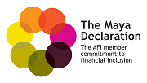
ANNEX 2: Maya Declaration on Financial Inclusion
We, the Members of the Alliance for Financial Inclusion, a network of central banks, supervisors and other financial regulatory authorities met in Riviera Maya, Mexico, 28 to 30 September 2011, on the occasion of the Third AFI Global Policy Forum,
Recognize the critical importance of financial inclusion to empowering and transforming the lives of all our people, especially the poor, its role in improving national and global financial stability and integrity and its essential contribution to strong and inclusive growth in developing and emerging market countries;
Reaffirm the value of peer-to-peer knowledge exchange and learning among financial regulators and policymakers for the design and implementation of innovative financial inclusion policy solutions relevant to the developing world;
Recall our efforts over the last two years to strengthen and expand the AFI network and to identify and explore high-priority areas for financial inclusion policy in the developing world through AFI’s working groups;
Commit as a network of developing and emerging market financial regulators and policymakers to:
- Putting in place a financial inclusion policy that creates an enabling environment for cost-effective access to financial services that makes full use of appropriate innovative technology and substantially lowers the unit cost of financial services;
- Implementing a sound and proportional regulatory framework that achieves the complementary goals of financial inclusion, financial stability, and financial integrity;
- Recognizing consumer protection and empowerment as key pillars of financial inclusion efforts to ensure that all people are included in their country’s financial sector;
- Making evidence-based financial inclusion policy a priority by collecting and analyzing comprehensive data, tracking the changing profile of financial inclusion, and producing comparable indicators in the network.

We remain dedicated to making financial inclusion a reality through concerted domestic and global actions, and actively sharing our knowledge and experience through the AFI network. We commit to delivering concrete financial inclusion outcomes for the developing world to provide sustainable, relevant, cost-effective, and meaningful financial services for the world’s financially unserved populations.
---------------------------------------------------------------------------------------------------------
The Maya Declaration was announced at the 2011 AFI Global Policy Forum. 25 AFI member institutions followed up on the Declaration with specific commitments for their national efforts. These can be found at http://www.afi-global.org/gpf/maya-declaration

ANNEX 3: Maya Declaration Institutional Commitments

AFI Member Institution | Areas of Commitments
Central Bank of the Republic of Armenia | - Mobile financial services  - Consumer protection  - Financial literacy
Microcredit Regulatory Authority, Bangladesh | - Mobile financial services  - Consumer protection  - Financial literacy  - Microinsurance  - Agent banking
Banco Central do Brasil | - Consumer protection  - Data and measurement  - National Strategy  - Regulatory framework  - Financial literacy
Banque de la Republique du Burundi | - Data and measurement
Banque Centrale du Congo | - Mobile financial services  - Consumer protection  - Financial literacy  - National payments system framework  - Agent banking  - National strategy
Banco Central del Ecuador | - Mobile financial services  - Financial literacy
National Bank of Ethiopia | - National strategy
Reserve Bank of Fiji | - Mobile financial services  - Data and measurement  - National strategy  - Financial literacy  - Microsavings  - Payment systems framework
Bank of Ghana | - Mobile financial services  - Consumer protection  - Regulatory framework for branchless banking  - Payment system strategy  - Financial literacy
Banque Centrale de la Republique de Guinée | - Consumer protection  - Financial literacy  - Regulatory framework for MFIs
Bank Indonesia | - Financial identity  - Financial literacy  - Microsavings  - Regulatory framework for branchless banking  - Financial inclusion strategy
Central Bank of Kenya | - Data and measurement  - Agent banking  - Consumer protection  - Regulatory framework
Reserve Bank of Malawi | - Mobile financial services  - Agent banking  - Consumer protection  - Data and measurement  - Financial literacy
Comisión Nacional Bancaria y de Valores Mexico | - Mobile financial services  - Agent banking  - Data and measurement  - National strategy
Bank of Namibia | - Consumer protection  - Data and measurement  - National strategy  - Financial literacy
Central Bank of Nigeria | - National strategy
Central Bank of Pakistan | - Develop concrete steps for financial inclusion
Banco Central del Paraguay | - National strategy
Superintendencia de Banca, Seguros Y AFP de Peru | - Agent banking  - Consumer protection  - Microsavings  - E-money framework
Bangko Sentral ng Pilipinas | - Agent banking  - Consumer protection  - Financial literacy  - Microsavings  - Data and measurement  - Microinsurance  - E-money regulations
National Bank of Rwanda | - Data and measurement  - National strategy  - Financial literacy
Ministère de l'Economie et des finances du Sénégal | - Data and measurement  - Mobile financial services
Bank of Tanzania | - Mobile financial services  - Agent banking  - Consumer protection  - Data and measurement
Bank of Uganda | - Consumer protection  - Data and measurement  - National strategy  - Financial literacy
Bank of Zambia | - Data and measurement  - Financial literacy

ANNEX 4: GPFI and PIWG Publications
GPFI publications in the period July 2011 to June 2012:
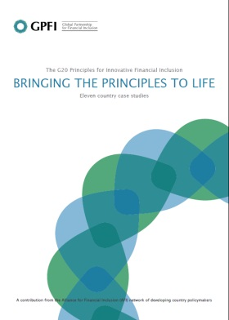 |  | 11 Country Case Study document “Bringing the Principles to Life”
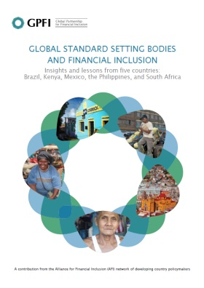 |  | 5 Country Case Studies on Financial Inclusion and the Global Standard Setting Bodies
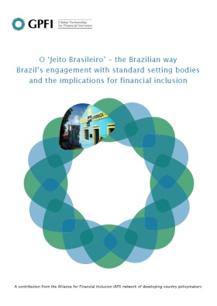 | 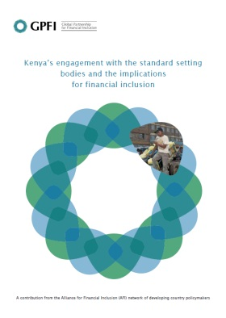 |  | 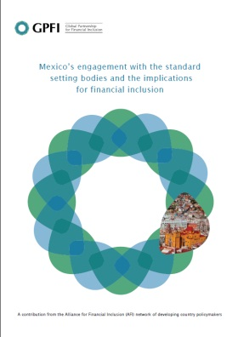
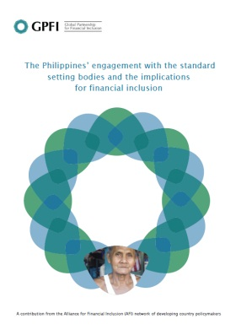 | 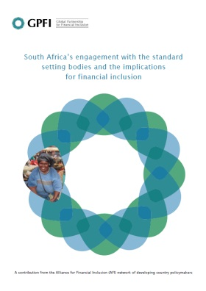
PIWG publications in the period July 2011 to June 2012:
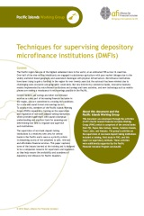 |  | Policy note on Microsavings and Non-Bank Supervision

Established in September 2008, AFI is managed on behalf of its members by GIZ (Deutsche Gesellschaft für Internationale Zusammenarbeit GmbH - German International Cooperation) with funding from the Bill & Melinda Gates Foundation.
AFI focuses on the following financial inclusion policy areas: Agent Banking, Consumer Protection, Data & Measurement, Financial Identity, Formalizing Microsavings, Mobile Financial Services, and National Strategies
Refer to Annex 1 for a complete list of AFI members.
AFI has 4 thematic working groups – the Consumer Empowerment and Market Conduct Working Group (CEMCWG), the Financial Inclusion Data Working Group (FIDWG), the Financial Integrity Working Group (FINTWG), and the Mobile Financial Services Working Group (MFSWG) – and one regional working group, the Pacific Islands Working Group (PIWG)
Countries that endorse the Maya Declaration agree to make measurable commitments and jointly work on four broad areas including: enabling environment and new technology; proportionate regulatory framework; consumer protection and empowerment; and data and diagnostics. The four areas closely mirror the nine G20 Principles for Innovative Financial Inclusion.
Refer to Annex 2 for the text of the Maya Declaration and Annex 3 for a list of country commitments.
Leadership role includes chairing a working group, hosting AFI events, being a Policy Champion, a member of the Steering Committee etc.
Participating in or utilizing more than one of AFI’s services.
For a list of publications please see Annex 4.
http://www.gpfi.org/knowledge-bank/case-studies/g20-principles-innovative-financial-inclusion-bringing-principles-life
http://www.afi-global.org/library/publications/quick-guide-maya-declaration-financial-inclusion
http://www.gpfi.org/featured/afi-member-countries-make-financial-inclusion-commitments-line-g20-principles
http://195.43.53.105/news-and-events/news/maya-declaration-showcased-4th-annual-g24afi-policymakers%E2%80%99-roundtable
www.afi-global.org/library/publications/g20-summit-communiqu-full-text-g20-leaders-declaration
http://www.gpfi.org/knowledge-bank/case-studies/global-standard-setting-bodies-and-financial-inclusion
http://www.gpfi.org/knowledge-bank/publications/financial-inclusion-data-assessing-landscape-and-country-level-target-approaches
http://www.gpfi.org/featured/g20-leaders-welcome-progress-endorse-gpfi-financial-inclusion-indicators
http://www.afi-global.org/news-events/press-releases/g20-leaders-embrace-alliance-financial-inclusion-afi-peer-learning-model
Reserve Bank of Fiji, Central Bank of Samoa, Central Bank of Solomon Islands, Bank of Papua New Guinea, Reserve Bank of Vanuatu, National Reserve Bank of Tonga, Banco Central Timor-Leste
For a list of publications please see Annex 4.

