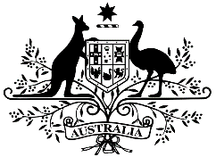

N° 17/190

The Department of Foreign Affairs and Trade presents its compliments to the High Commission of the Republic of Singapore and has the honour to refer to the Agreement to Amend the Singapore-Australia Free Trade Agreement (“the Agreement”) done at Canberra on 13 October 2016.

The Department of Foreign Affairs and Trade has the further honour to refer to the review undertaken by both the Government of Australia and Government of the Republic of Singapore, in which both parties identified clerical errors in the Agreement.

The Department of Foreign Affairs and Trade has the honour to propose that the Government of Australia make the following corrections in its original copy of the Agreement signed on 13 October 2016 and that the Government of the Republic of Singapore make the following corrections in its original copy of the Agreement signed on 13 October 2016, and that the Agreement be published as so corrected:

1. In the fourth line of paragraph 2, Article 10 (Import Licensing) of Chapter 2 (Trade in Goods), insert a line space after “6.” and before “3.”.
2. In paragraph 6 of Section A (Introductory Notes), Annex 2 (Product-Specific Rules of Origin) replace “RVC(BD30/BU40)” with “RVC(BU30/BD40)”.
3. In the 'List of Entities' in Section A (Central Government Entities) of Annex 3A (Schedule of Australia) on line 59 delete “Productivity Commission”. Underneath this, create a new line and insert “60. Productivity Commission”. Replace “60. Professional Services Review Scheme” with “61. Professional Services Review Scheme”, replace “61. Royal Australian Mint” with “62. Royal Australian Mint”, replace “62. Safe Work Australia” with “63. Safe Work Australia”, replace “63. Seafarers, Safety, Rehabilitation and Compensation Authority (Seacare Authority)” with “64. Seafarers, Safety, Rehabilitation and Compensation Authority (Seacare Authority)” and replace “64. Workplace Gender Equality Agency” with “65. Workplace Gender Equality Agency”.
4. In paragraph 1, Annex 3-A (Minimum Data Requirements) of Chapter 3 (Rules of Origin) replace the heading “l. Importer, Exporter or Producer Certification

of Origin” with “1. Importer, Exporter, Producer or Authorised Representative Certification of Origin”. In the paragraph text, after “exporter, producer, or importer” insert “or an authorised representative of the exporter, producer or importer”.

The Department of Foreign Affairs and Trade has the further honour to advise that the Government of Australia has completed its domestic requirements for entry into force of the Agreement. In accordance with the provisions of the Agreement, the Agreement shall enter into force on the date of the latest note of an exchange of notes confirming that each Party has completed its respective domestic requirements for entry into force of this Agreement.

The Department of Foreign Affairs and Trade avails itself of this opportunity to renew to the High Commission of the Republic of Singapore the assurances of its highest consideration.

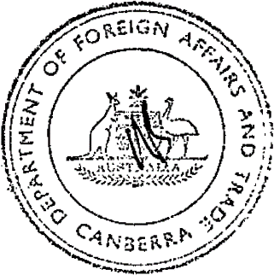

CANBERRA

1 December 2017