Australia – Indonesia Basic Education Program
INDONESIA REALITY CHECK
MAIN STUDY FINDINGS
Listening to Poor People’s Realities about Basic Education

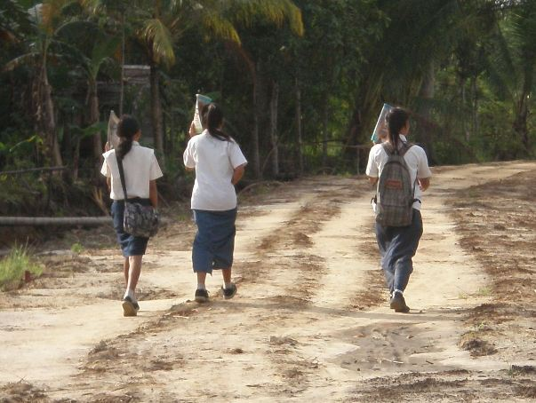
May 2010

Preface
The Reality Check has been made possible by the commitment, enthusiasm and teamwork of many. We would like to express our gratitude and to give credit to those who have been directly involved in developing the Reality Check and making it successful.
The Reality Check is an initiative of the Swedish Embassy in Bangladesh and SIDA (Swedish International Development Agency) which was initiated in 2007. The approach and methodology was developed by Helena Thorfinn (SIDA Head Office), Esse Nilsson (SIDA Head Office) and Dee Jupp. AusAID acknowledges this initiative and has supported its introduction to Indonesia. GRM International is the implementer on behalf of AusAID.
The Reality Check study was carried out by an international team comprising Dr. Dee Jupp (overall team leader, UK), Enamul Huda (sub team leader, Bangladesh) and Dr. Syed Rukanuddin (sub team leader, Bangladesh) with field team members from Indonesia; Revy Sjahrial, Sherria Puteri Ayuandini, Peter Riddell-Carre, Rivandra Royono, Harining Marojuki, Rida Jesti Ratnasari, Madekhan with Paul Mahesa, Tirza Reinata, Dewi Arilaha and Annisa Ridzkynoor Beta, as translators/field team members. Sherria Puteri Ayuandini and Peter Riddell-Carre also assisted the Team Leader in writing the final report. Professor David Lewis (London School of Economics) was our peer reviewer and Peter Riddell-Carre (GRM International) was the Project Manager. CARE International Indonesia was subcontracted to provide in-country logistical, administration and procurement support.
Hetty Cislowski (team leader CSAS) provided valuable on-going support and direction for the Reality Check team.
The Reality Check study was only possible thanks to the many families who opened their doors to the study team. We thank these families in all ten locations for contributing their valuable time and allowing the team members to live with them and share their day to day experiences.
Reality Check does not attempt to make any conclusive statements about the Basic Education Program and generalisations cannot be made from the study sample to the whole Basic Education Program or to education in Indonesia overall. However, there are many observations from Reality Check that shed light on important issues facing policy-makers at this current time concerning both the quality and relevance of junior secondary education. It is hoped that by providing an insight into the daily reality of some of the poorest segments of the population this study will contribute improving the understanding of policy makers so that education policy and practice in education continues its pro-poor focus.
The intention of this report is to reflect accurately the views of the families and community members involved. Any opinions or conclusions made in this report are those of the research team and do not necessarily reflect those of the Government of Indonesia or AusAID.

Acronyms & glossary
Acronyms | Bahasa Indonesia | English
ADB | Bank Pembangunan Asia | Asian Development Bank
AIBEP / BEP | Program Pendidikan Dasar Australia-  Indonesia | Australia Indonesia Basic Education  Program
AusAID | Badan Australia untuk Pembangunan  Internasional | Australian Agency for International  Development
BOS | Biaya Operasional Sekolah | School Operational Fund
BOS Buku | Biaya Operasional Sekolah Buku | School Operation Fund for textbooks
CSAS | Kontraktor untuk Layanan  Kepenasehatan Strategis | Contractor for Strategic Advisory Services
DINAS | Dinas Pendidikan di Tingkat Distrik | District Office of Education
 | Dusun | Sub Village
FHH | Rumah Tangga (pokok) | Focal Households
GoI | Pemerintah Indonesia | Government of Indonesia
GER | Angka Partisipasi Kotor | Gross enrolment rate
 | Guru Honor | Locally employed casual teacher, usually not fully qualified.  under-qualified and paid a small honorarium
HHH | Rumah Tangga (yang menjadi tuan  rumah) | Host Households
ICT | Teknologi Komunikasi dan Informasi | Information and Communication  Technology
MCPM | Kontraktor Pelaksana untuk  Pengelolaan Program | Managing Contractor Program  Management
MI | Madrasah Ibtidaiyah | Islamic Primary School
MoNE | Departemen Pendidikan Nasional Kemendiknas | Ministry of National Education
MoRA | Departemen Agama | Ministry of Religious Affairs
MT | Madrasah Tsanawiyah | Islamic Junior High School
NTB | Nusa Tenggara Barat | West Nusa Tenggara
OSIS | Organisasi Siswa Intra Sekolah | Student Organization
PNS | Pegawai Negeri Sipil | Permanent Civil Servant (teacher)
PNPM | Program Nasional Pemberdayaan  Masyarakat Mandiri | National Community Empowerment  Program
PRA | Pendekatan Riset yang Partisipatif | Participatory Research Approach
SATAP | Sekolah Satu Atap | One Roof School, including primary and junior secondary grades  junior secondary grades
ST | Sekolah Terbuka | Open school
SD | Sekolah Dasar | Primary school
SIDA | Lembaga Bantuan Internasional  Pemerintah Swedia | Swedish International Development  Agency
SMA | Sekolah Menengah Atas | Senior high school (academic)
SMK | Sekolah Menengah Kejuruan | Senior high school (vocational)
SMP | Sekolah Menengah Pertama | Junior high school
TK | Taman Kanak-kanak | Kindergarten
UN | Ujuan nasional | National exams

Table of Contents

Preface i
Acronyms & glossary ii
1. Executive Summary 1
2. Methodology 9
2.1 Background to the Reality Check Initiative 9
2.2 Methodology in Brief 10
3. Context 13
3.1 National Context 13
3.2 Local Context 14
4. Main Findings 19
4.1 Access 19
4.1.1 Cost of Education as an Access Issue 25
4.1.2 Student Drop-Out 30
4.1.3 Student Absenteeism 36
4.1.4 Hindrances 38
4.2 Quality 41
4.2.1 Quality in School Construction 49
4.3 Governance 50
Conclusions and Recommendations 55
References 58
Annexes 59
Annex 1: Methodology 60
Annex 2: Poverty Map 64
Annex 3: Village Profiles 65
Annex 4: Descriptions of Host Households 75
Annex 5: Categories of people met (across all locations) 87

Executive Summary

Background
The Contractor Strategic Advisory Services (CSAS) to the Australia-Indonesia Basic Education Program (BEP) commissioned this Reality Check Study to gain insights into the on the ground realities resulting from its investment in basic education.
The goal of the BEP is to improve equitable access to higher quality and better governed basic education services, especially in targeted and disadvantaged areas in Indonesia. It comprises four pillars:
- Pillar 1 - improved equitable access to basic education services through the construction and equipping of 2000 new or expanded schools;
- Pillar 2 - improved basic education quality and internal efficiency involving improved school maintenance, teacher quality, learning and teaching materials, curriculum development and standards, whole school development and enhanced gender and inclusive education;
- Pillar 3 - improved governance of basic education services involving support to strategic planning and budgeting, statistical data generation and enhanced use of ICT;
- Pillar 4 - assured resource mobilisation in the education sector to direct resources towards poorer and under-served districts.
The Monitoring and Evaluation Framework for the BEP includes a comprehensive array of monitoring activities and end-of-program school surveys and evaluation studies, mainly of a quantitative nature. To complement these studies, CSAS agreed to undertake an in-depth qualitative study of the perspectives and observations of people living in rural poverty as well as those of their local service providers on the expanded provision of basic education through BEP supported schools. These voices were gathered during three weeks in February, 2010 by a team of researchers who spent several nights living with people in their own houses and sharing many conversations supplemented with first-hand experience of the issues discussed.

Reality Check Methodology
The Reality Check initiative was established by the Embassy of Sweden in Bangladesh in 2007 as an important contribution to their Country Strategy for Cooperation with Bangladesh (2008-12). The underlying principles for the Reality Check highlight two key perspectives which are to permeate all of Swedish development co-operation. These are the rights perspective and poor people’s perspectives on development. They remind us that ‘poor people should not be viewed as a homogenous group; that poor women, men and children must be seen as individuals’ and, in order to ensure that ‘the problems, needs and interests of poor people are given a genuine and undistorted impact on development cooperation....... there must be more possibilities (for) poor people to express their needs and advance their interests’ (Reference 1).
The Reality Check builds on the traditions of listening studies, which have the purpose of ‘listening to, trying to understand and convey poor people’s reality’ (Reference 4). Listening studies differ from other forms of study in that they give more voice to people than conventional research, thus creating the potential for citizens’ voices to be more directly linked with policy makers. Every effort is made in the report therefore to present these voices and experiences as accurately as possible.
The Reality Check focuses on basic education in Indonesia and provides insights into how activities under the AusAID-Indonesia Basic Education Program (BEP) have been translated into experienced reality of people living in poverty. It is hoped that the Reality Check will become a longitudinal study over the next 5 years where the research team members interact with the same communities and households at the same time every year in order to identify changes, and to build an in-depth understanding of lived realities. In Bangladesh the Reality Check study has just completed its 3rd year of the 5 year program and rich insights have been gathered on how families and conditions have changed and adapted over time.
The Indonesian main study was undertaken in three locations: West (Lampung/West Kalimantan), Central (South Sulawesi) and East (West Nusa Tenggara) Indonesia and in ten villages. Study team members stayed in the homes of a total of 29 households living in poverty. Each team member spent a minimum of two nights and three days staying in the homes of three families (one in each of three villages). This immersion by the research team members enabled the best possible conditions for building trust and interacting with all members of the host family and their neighbours, for building on conversations over several days and for complementing conversations with direct observation and experience.
The study both complements and supplements other forms of evaluation undertaken by the Basic Education Program, but the Reality Check has its own special characteristics. Some findings may be new, while others may simply confirm those already indicated by other forms of evaluation. Nevertheless, the Reality Check may confer on these existing findings another dimension of credibility, since they are revealed by in-depth conversations. The study may also be expected to supplement other forms of evaluation by generating information that is less readily obtainable through conventional studies, and by offering nuanced interpretations of quantitative data.
This report presents the findings from the first year of study, which coincides with the final year of BEP. These findings have emerged from field work carried out during February 2010, and from subsequent inter-team analysis and discussion. An initial pilot study was also conducted in August 2009 in West Java to contextualise the methodology and to build the capacity of the Indonesian team members. A separate report is available which documents the findings from the Pilot Study (Reference 2).

Sample households
Three areas of Indonesia were selected as representative of different geographical regions of Indonesia with a cross-section of social, ethnic and geographical characteristics. The selection was made in consultation with AusAID and the BEP Managing Contractor Program Management (MCPM) to ensure priority regions were targeted. A random selection of schools supported by the BEP, where the construction had commenced before 2007 was made from each of the regions (three from the West and Central areas and four from the East region providing a total of ten schools). The sub-villages included in the catchment area of each school were identified as the study focus from within which households were identified as host families. This identification was based on discussions with a range of community members and was intended to identify the poorer families of the area. A total of twenty nine households were included in the study and all included children of basic education age.
The manifestation of poverty within the ten selected villages was diverse. However, high levels of indebtedness were prevalent in all locations. Three of the villages were within thirty minutes motorised access of large urban centres and shared some important characteristics; wide range of employment opportunities in addition to farming and fishing (particularly in the transport and construction sectors), choice of service providers for basic education, a high level of connectedness to the town and beyond and consequently access to markets and technology. We refer to these three villages as peri-urban. By contrast, the households in the rural villages were largely subsistence farmers and the poorest depended on a single rain-fed crop per year.
These latter are also remote mountain locations with poor connectivity to growth centres. In one village the families had enjoyed former relative wealth from the now illegal timber industry and their assets masked their current very poor economic status with little alternative income earning opportunities. Regardless of the different manifestations of poverty, all our study households took frugal meals, usually consisting of rice and vegetables only twice per day. Some houses had access to piped or well water, some relied on natural water sources and nearly all had very poor sanitary arrangements.

Findings
Access to Education
Generally, there was a sense of pride among parents, children and teachers regarding the new BEP schools constructed in all the study villages and many told us that the numbers transitioning from primary to junior secondary education has increased since the school has catered to this age group. In the past, children of this age group had been required to travel long distances to school or to board in towns some way from home in order to attend junior secondary school. People told us that time and cost savings had resulted from the provision of a more local option. Families who formerly had been unable or unwilling to send their children to these more distant schools because of the costs, lack of networks to draw on to provide boarding facilities or children's own disinterest, indicated that their children were now more likely to attend the local school.
For poor families, there are still high costs associated with basic education despite the Government's intention that this level of education is free. Low income households often spend as much as 85% of their cash income on basic education expenses. Most schools require children to have a minimum of four different school uniforms (national, scouts, sports and batik) and this was frequently noted as a major burden for poor families. Although some children have been given some free uniforms from the BOS allocations, many families were confused about why some received this and other families, who were as poor, or more poor, did not.
Parents are also expected to buy exercise books and other stationary. The severe shortage of textbooks has led to some teachers expecting their students to photocopy text books at considerable expense. There is wide variation in the number and type of costs levied by schools, some of which continue to charge annual registration fees and exam fees.
In all but one remote mountainous village, children make demands for daily pocket money which ranges from Rp. 1,000 - 5,000 during term time. This is normally used to buy “snacks”. Parents told us that they have to comply with their children's demands and some children threaten that they will not go to school if the pocket money is not forthcoming. This adds up to a considerable amount of money for impoverished parents.
Drop-out rates may be higher in these schools than officially recorded as schools appear to have a number of incentives to maintain their numbers: for example, to justify BOS allocations, to ensure sufficient enrolment for public exams take place in situ, and to support parents to keep children in school for the entire nine years of compulsory education. Children drop-out, not usually because of family economic pressures, but for their own decisions based on peer pressure and lifestyle choices as characterised on TV and the attractions of mobile phones, motorbikes, increasingly early sexualisation and pop music. Where there are jobs available locally which do not require completion of Year 9, the desire to have an independent income to support this kind of lifestyle is a major pull factor to leave school. Where there are clear links between certification and better income prospects e.g. clerical work in plantation offices, then the motivation to remain in SMP is greater. Where an SMK is available in the area, this exerts a strong pull factor for completion of junior secondary education as the minimum qualification. The desire to remain in the village is often very high and this limits motivation to complete school as job prospects, even with education, are very limited: there is simply not the capacity to absorb the number of children wanting to be teachers and nurses in their own area. A further disincentive for continuing education is the high cost of further education beyond SMP. Families living in poverty tend to select one or two children who demonstrate potential and determination for further education. They cut-back the education of less able siblings in order both to save money and to keep their 'less school minded' children happy.
Student absenteeism is high in many areas particularly during certain farming seasons. Although teachers claim that children are expected to help on the farm, our observations and conversations indicated that while children often chose to be with their families on the farm, they did not actually contribute much to economic activities although some older siblings were needed to mind the younger ones. Communities felt that more flexible timetabling would allow for periods of necessary absence at harvest times and rains, particularly as teachers are affected in just the same way as students. Teacher absenteeism during the farming cycle or for attendance at workshops also impacts on days lost and students are often sent home when there are insufficient teachers.
Villagers noted a number of social hindrances to children's education which were confirmed by the research team's direct observation. Children are frequently absent from school and expect their classmates to cover for them by informing the school that they are sick. Many accompany their parents to their farms (often overnight), not for economic reasons but because they choose to stay with the family. TV is a hindrance to completion of homework and many children stay up very late watching communal TV. In many of our study communities, junior secondary school children are highly sexually aware and their preoccupation with ‘dating’ interferes with their regular and/or on- time attendance at school.
Quality of Education
Some of these new schools have yet to provide the quality of education perceived to be provided in the schools previously accessed by older siblings prior to the provision of the new school. Although there are many teachers in all the new or expanded schools and, in theory, very high teacher to student ratios, few of these teachers are fully accredited public service appointees and there is high reliance on honorarium teachers (guru honor). Whilst children and parents often say they prefer these teachers who are typically regarded as 'young', 'energetic' and 'fun', they are casual employees, servicing several schools (particularly in peri-urban areas) and spending little time with individual classes each week. These teachers tend not to be integrated into the day to day operation of the school, work long hours in order to maximise their meagre honorariums and are often required to teach outside their specialisations. Furthermore, teacher absenteeism and lateness, particularly among the tenured teachers, is widespread and this limits contact time with students and severely impacts on the continuity of learning programs. Resources such as text books, library books, computers and other teaching and learning aids are still very limited. Children share text books and cannot take them home. Even when teaching resource kits are provided to schools, these are often not utilised. Teachers and students indicated that they felt that much of the curriculum is unnecessary or irrelevant to their experience and aspirations.
The establishment phase of new schools clearly brings many challenges, including establishing credibility and confidence in the face of inadequate teacher provision. In remote areas, the lack of quality teaching input appears to be at crisis point. In one of the schools in our study, the Principal was so concerned about the non-provision of trained teachers that he arranged for the SMP Year 9 students to join another school in town for the period leading up to the national exam. In another school which initially started with much optimism and local support, new enrolment is now declining and parents are transferring their children to the former SMP option which is regarded as providing better quality education. In one sub-village, children continue to attend the former option partly because it is an easier journey (by boat rather than long rocky path) but also because the quality is considered better.
Adults and children in the study mostly equate quality of education with the physical aspects of the school, such as its buildings and physical resources. For children, there is a strong emphasis on having fun at school and it being a place for peer friendships. Comments on teachers or teaching quality, teaching aids, learning for interest and enjoyment or learning to achieve education outcomes are rare.
The schools still lack significant resources however many of the un-met resource requirements for these schools are very simple. There are very limited stationary supplies including paper, pens, coloured pencils, stickers and other materials one would expect in classrooms. There appears to be little systemic encouragement or motivation to use BOS funds for these kinds of consumables.

Governance
Although schools were intended to be constructed within six months, local conditions have meant that very few schools in the sample had actually reached final completion at the time of this study and some parents were concerned that even at this stage, maintenance problems were already emerging.
Despite efforts to foster interaction between the community and the school, or parents and the school, the interaction was limited. The traditions of hierarchy and deference are difficult to overcome and decision making is still seen to be largely the responsibility of village leaders and school Principals. In the BEP-supported school where community participation was high, the immediate tangible and social benefits to the school were obvious.

Conclusions
This first Reality Check has built on the findings gathered earlier during the pilot study. The further material we have gathered through the main study shows that important insights can be gained by this approach. We found that people shared their opinions and perspectives with openness and candour. Direct observation and experience, as well as the accumulation of perspectives from many different stakeholders, helped to provide significant opportunities for triangulation of our findings, and this gave us additional confidence in the credibility and validity of our findings.
A number of key general issues have emerged from the study however it must be recognised that these conclusions cannot be generalised to the whole of the BEP or to the whole of Indonesian education.
- The targeting of the BEP towards poorer and underserved villages has been largely successful. Poverty has many manifestations, and a relatively high level of visible asset ownership can often conceal the reality of chronic indebtedness and severe cash flow problems.
- People displayed a real sense of pride in having schools in their own community, and are generally committed to sending their children to school, but they face a range of prohibitive ‘hidden costs’ if they do so.
- People have really appreciated the provision of local schools for the age group 12-15 years, because it has increased the likelihood of transition from primary school and has reduced the costs associated with the previous option of sending children to distant schools. The physical provision of schools is only a starting point for the provision of education, since a range of quality issues now needs greater consideration.
- The poor distribution of adequately trained teachers and teething problems in setting up effective school management committees, has impacted heavily on the perceived quality as well as the capacity of principals to actually deliver quality education in these new schools.
- There are few parents involved in participatory management of education services, and most do not yet have the organisation or knowledge to begin to do this.
- Many social and cultural factors contribute to non-attendance and non-participation at school, including the need to assist or at least be with the family at key points of the farming cycle. It appears however that the strongest factors in impacting on poor attendance and drop- out are peer related: peer pressure to truant, the distraction and growing social influence of TV, increasing use of mobile phones, and an emphasis on adolescent ‘dating’ that distracts children from schooling.
- Despite cost savings through the localisation of schools, accessing school for the junior secondary years still incurs considerable costs for families particularly for the many school uniforms required, the continued practice of charging fees (in some schools) and the seemingly non- negotiable demands for pocket money. Where resources are scarce, these costs force parents to make choices about which of their children can continue with schooling reserved for those with potential and those who are 'school minded'. Unless the costs of senior secondary and tertiary education can be reduced drastically, and reliably gainful employment options are available, the motivation to complete the nine years of basic education will continue to be low.
- Education quality is strongly associated in these people's minds with physical facilities and social benefits (companionship and 'fun') and there is little concern among students, parents or even teachers regarding the quality of the education process and the learning outcomes. This is in part exacerbated by the assumption that children will automatically pass the UN exam. The study provided some insight into the ineffectiveness of these exams in assessing quality in education outcomes or acting as a mechanism to raise standards.
- Quality assurance and supervision of schools is weak. Teachers are frequently late, absent and lacking the skills to use whatever teaching resources are available. The study suggests that the BEP schools that are doing better than others in engaging students in learning have benefitted from two influences - a critical mass of young and energetic teachers who can make change happen even where there are older teachers who are often resistant to change; and having a link with a tertiary education institution which encourages innovation and having better schools in the area which people regard as a benchmark for quality.
- The study indicates that children have the strongest voice in decisions about continuation of their schooling. Where there are employment opportunities which do not require school certification their motivation to remain in school tends to be low. Their level of interest in schooling is heavily influenced by many factors outside of the schools' jurisdiction - including distractions such as TV, mobile phones, family and social conventions (such as accompanying the family to the farm, expectations to look after younger siblings), and a growing emphasis on dating. In many ways, teenagers in these isolated and poor villages have similar interests and pre-occupations to teenagers anywhere.
- Community participation in school decision-making is low despite the “community construction model”. Decisions continue to be made mainly by the Principals and village leadership suggesting that traditional patterns of dependency and hierarchy are proving hard to break. Lack of information and community school interaction results in disinterest at best, and high levels of suspicion at worst. Consequently there are frequent allegations of misappropriation of resources and unfair allocation of resources (particularly scholarships and BOS awards). An active and representative school committee operates in only one of the study schools. This school also regularly holds parent teacher meetings. This success of this school in this regard seems to be the result of a long history of sustained external support from an INGO that has helped with developing leadership, community participation and mutual accountability.
- There is general acceptance of the status quo in schools because teachers are highly respected members of the community. Many parents themselves have little or no education and feel it is not their place to comment on education. The study describes a few isolated examples of complaints being raised by parents or children some of which have been addressed. However, more often than not little is done and when teachers try to raise their voices with their authorities they are regarded as trouble makers or told that they will have to 'live with it'.
Recommendations
While the Reality Check is primarily concerned with documenting the experiences and concerns of people in the poorest areas, the findings do lend themselves to some tentative recommendations:
- Consideration must be given to how to better attract and retain qualified and committed teachers in rural schools;
- Better provision of simple, appropriate and relevant educational materials and more interactive teaching strategies are needed so that children become more engaged and are more motivated, by their enjoyment of learning, to complete the nine years of compulsory education;
- Despite the BOS, the cost of education continues to be an ongoing financial burden for parents and targeted affirmative action from government is required for highly disadvantaged areas. In addition, it must be recognised that many of the “obligatory costs” are only tangentially related to teaching and learning (eg. costs of pocket-money and snacks at school, cost of multiple uniforms) and this is an area where truly empowered school management committees could begin to have an influence;
- School Lunch Programs in these very poor areas should be considered as a way of both improving students’ nutrition and reducing pressure on parents for providing cash each day for snacks.
- Development partners and government should continue, and maintain for the long term, efforts to strengthen community participation in decision-making across all contexts at village and district level as a necessary foundation for community involvement in school management.

While there is overall optimism and progress towards effective school operations, there are many challenges, chief of which are the lack of qualified staff and the poor teaching practices and professionalism of existing staff. Ongoing studies in the same locations with the same households over the next few years will provide insights into the way people perceive the new schools and will provide a more valid opportunity to observe full operation of the schools and gauge the impact of BEP on the current students as they graduate and their younger siblings up to SMP level.

Methodology

2.1 Background to the Reality Check Initiative
The Reality Check initiative was established by the Embassy of Sweden in Bangladesh in 2007 as an important contribution to their Country Strategy for Cooperation with Bangladesh (2008-12). The underlying principles for the Reality Check are drawn from Sweden’s Policy for Global Development adopted by the Swedish Parliament in 2003, which highlights two key perspectives which are to permeate all of Swedish development co-operation. These are the rights perspective and poor people’s perspectives on development. They remind us that ‘poor people should not be viewed as a homogenous group; that poor women, men and children must be seen as individuals’ and, in order to ensure that ‘the problems, needs and interests of poor people are given a genuine and undistorted impact on development cooperation....... there must be more ‘possibilities (for) poor people to express their needs and advance their interests’ (Reference 1).
The Reality Check builds on the traditions of listening studies, which have the purpose of ‘listening to, trying to understand and convey poor people’s reality’ (Reference 4). Listening studies differ from other forms of study in that they give more voice to people than conventional research, thus creating the potential for creating opportunities for citizens’ voices to be more directly linked with policy makers. Every effort is made in the report therefore to present these voices and experiences as accurately as possible.
The Reality Check focuses on basic education in Indonesia and provides insights into how activities under the AusAID-Indonesia Basic Education Program (BEP) have been translated into experienced reality of people living in poverty. It is hoped that the Reality Check will become a longitudinal study over the next 5 years where the research team members interact with the same communities and households at the same time every year in order to identify changes, and to build an in-depth understanding of lived realities. In Bangladesh the Reality Check study has just completed its 3rd year of the 5 year program and rich insights have been gathered on how families and conditions have changed and adapted over time.
The study was undertaken in three locations: West (Lampung/West Kalimantan), Central (South Sulawesi) and East (West Nusa Tenggara) Indonesia and in ten villages. Study team members stayed in the homes of a total of 29 households living in poverty. Each team member spends a minimum of two nights and three days staying in the homes of three families (one in each of three villages). This immersion by the research team members enabled the best possible conditions for building trust and interacting with all members of the host family and their neighbours, for building on conversations over several days and for complementing conversations with direct observation and experience.
The study both complements and supplements other forms of study undertaken within the basic Education program, but the Reality Check has its own special characteristics (see Box 1). Some findings may be new, while others may simply confirm those already indicated by other forms of study. Nevertheless, the Reality Check may confer on these existing findings another dimension of credibility, since they are revealed by in-depth conversations. The study may also be expected to supplement other forms of study by generating information that is less readily obtainable through conventional studies, and by offering nuanced interpretations of quantitative data.
This report presents the findings from the first year of study, which coincides with the final year of BEP. These findings have emerged from field work carried out during February 2010, and from subsequent inter-team analysis and discussion.
The following section briefly explains the methodology, and indicates what makes this study different from other participatory investigative and evaluative approaches. This is followed by the presentation of the main findings arranged under the main strategic pillars of the BEP; access, quality and governance.
Box 1. What Makes the Reality Check Approach Different from other Studies?
The Reality Check both complements and supplements other forms of study but has its own characteristics as follows:
- It is qualitative (seeking answers to ‘how?’ and ‘why?’ questions rather than to ‘what?’, ‘when?’ and ‘how many?’) and it deliberately tries to explore a range of experiences;
- It uses informal conversations rather than interviews, which helps to put people at ease and enables greater openness;
- It includes participants whose voices are less often heard (elderly, infirm, young, persons with disabilities) because it focuses on the whole household and not on an artificial subset such as a focus group;
- It uses ‘immersions’ (staying overnight with families living in poverty) so that the researchers can better understand the context in which conversations are held;
- It involves ‘shadowing’ members of the family as they interact with formal and informal service providers, and/or following up on their comments about service providers by having informal chats with providers so that their voices too can be heard;
- It is intended to be longitudinal and will track change over time.

2.2 Methodology in Brief
A full description of the methodology can be found in Annex 1.
A Pilot Study was conducted in August 2009 over 10 days to adapt the approach for the Indonesian context and the needs of BEP and to build the capacity of the Indonesian field team members. The pilot study consisted of workshops in Jakarta and a 2 night village immersion exercise in three locations in West Java. 10 households were included in the pilot study, each one having a child at the local BEP supported school. A separate report is available which documents the findings from the pilot study (Reference 2).
The main study was conducted in February 2010 and is the first in what is hoped to be a series of annual studies for the next 5 years. Study team members stayed with families living in poverty and conducted conversations with different family members, their neighbours and different local service providers, particularly those engaged in education service provision. The host family is referred to as the host household (HHH) and neighbours are referred to as focal households (FHH). Each team members interacts with their HHH and at least one FHH. In total 29 HHH were included in the study (and conversations held with more than 600 people).

2.2.1 Site selection
The three study areas (West, Central and East) were selected in different geographical regions of Indonesia to provide a cross-section of social, ethnic and geographical characteristics, and also in consultation with AusAID /BEP to ensure priority regions were targeted. The villages within these three regions were selected based on the following criteria:
- the location must be categorised as being in poverty map quintiles 4 or 5 (see Annex 2 for poverty map)
- the location must have a BEP supported school which was constructed in 2006 or 2007 so that it has been operational for at least two years
- one location must have a madrasah (MoRA)
- 90% of the sample must be public schools
- locations must include a mix of BEP supported SATAP ( 'one roof schools' ) and USB junior high schools
- villages within each locations logistically must be within one day travel from one another.
The HHH were mostly identified a fortnight in advance of the study by one team member from each team during a pre-visit. During this half day visit, they talked with people in the village and gathered recommendations for households and families to stay with during the main study, based on our need to stay with poorer households with school-going children. This information was collected from sub-village leaders, motor taxi and ojek drivers, students and shop keepers. The team member walked round the village to get a sense of the socio-economic mix and visited the recommended households. More often than not, different households were eventually chosen as those recommended were either too close together, the household was relatively better-off or there were no BEP school students in that particular house. Attempts were made to include one HHH close to the school, another at the furthest point of the catchment area and a third somewhere between these two. The team also tried to ensure that the HHH selected were representative of the majority and were not those which villagers considered to be well-off or well-connected.
Despite the careful pre-visits, several HHH had to be changed when the team arrived for the main study. In some cases the previously identified family said they did not feel like having someone living with them or they had to go outside of their village leaving their house empty (see Box 2). Finding a substitute family did not prove to be a problem with help from neighbours.
In Indonesia, it is expected for visitors staying more than 24 hours in a village to meet with the village authority to clarify their intention of spending the night. Accordingly, team members met with sub-village leaders but these visits were made in a more casual, low key way rather than through a formal meeting so as to avoid too much fuss being made of the visitors.
In order to try to understand the criteria used by families to choose schools, and to understand how they perceive school quality, wherever possible the teams interacted with everyone involved: school-age children and their parents, teachers and administrators from all schools in the catchment area (and not just BEP-supported schools) and then also visited these schools. The team also engaged other village-based service providers in conversations: e.g. teachers from BEP-supported and non-BEP schools, school administrators, village administration and leadership, kiosk owners, midwives, school supervisors among others (see Annex 5 for details). Each team member stayed with their own HHH for a period of at least two nights and three days in each location. Details of the HHH can be found in Annex 4.
The Reality Check is therefore not a conventional evaluation, where achievements are assessed against a set of normative programme intentions, but rather, an appreciation of the day to day reality as experienced by people living in poverty. The Reality Check Team was acutely aware that to be able to do this well, they needed to suspend judgement and reduce the influence of external bias on their conversations.
Box 2. HHH selection - building confidence of poorer households to host RC teams
The HHH had agreed to host two team members during discussions in the pre-visit. However, when we arrived the family was staying in the mountains at their farm. A message was sent to them that we had arrived and that we could meet them whenever it was convenient. Meanwhile we chatted with the neighbour (a MI teacher) and she prepared a simple lunch of rice and leaves. When the HHH arrived, it became very clear that they felt awkward about hosting us. Their children stayed in the house alone at night, they said, and they had little space. The neighbour intervened and suggested we stayed there. We agreed.
Next day we talked with the original HHH family again. They had observed that we slept on the floor, ate simply and were comfortable with the basic sanitary arrangements and they now wanted us to stay. So we stayed the second night with them. In the morning, the mother brought us a cup of coffee. ‘Do you like coffee? we asked her. 'I have never taken coffee in my life - we cannot afford the coffee or the sugar', she told us. The coffee may not have been quite as we expected but we appreciated it all the more. Her neighbour had supplied the coffee and the mother had tried to make it. We explained again that we did not want her to treat us like a guest as we would learn little. She grinned and happily shared the rice with instant noodles that she prepared for breakfast for her family. As we left after the stay, both the father and mother hugged us and asked us to stay both nights if we came back next year. (East 2)

3. Context

National Context
Education is the responsibility of the Ministry of National Education of Indonesia (Departemen Pendidikan Nasional Republik Indonesia/Depdiknas (MONE). According to the Constitution, citizens must undertake nine years of compulsory education comprising six years at elementary level and three in middle school (junior secondary). Education is also provided by private institutions, mainly Islamic religious organisations. (See Table 1).

Table 1.Types of Government Schools in Indonesia
Levels of Education | Age | Grades | Public (general) School | Religious School
Pre-school education | 5 – 6 years |  | Taman Kanak-Kanak (TK) | Raudhatul Athfal (RA)
Primary Education | 7 – 12 years | 1 – 6 | Sekolah Dasar (SD) | Madrasah Ibtidayah (MI)
Junior Secondary Education | 13 – 15 years | 7 – 9 | Sekolah Menengah Pertama (SMP) | Madrasah Tsanawiyah (MTs)
Senior Secondary Education | 16 – 18 years | 10 - 12 | Sekolah Menengah Atas/Kejuruan (SMA/SMK) | Madrasah Aliyah (MA)

Since 1994, the Government of Indonesia (GOI) has been working to achieve Nine Years Universal Basic Education, through an emphasis on a massive school construction program. Between 1996 and 2004, the World Bank and the Asian Development Bank (ADB) supported the construction of 923 new schools and 2153 new classrooms in existing schools. The GOI subsequently funded the Junior Secondary School Expansion project (Proyek Perluasan SMP) between 2004-7 and built 631 new junior secondary schools, 40,500 extra classrooms for existing schools and 2,155 one-roof schools, increasing the number of places available at this level by an estimated 25%. The private sector has also expanded junior secondary education, especially through madrasahs, approximately 90% of which are privately owned. Under the Australia Indonesia partnership, the basic Education Program (BEP) has just completed construction of over 2,000 junior secondary schools, including 500 MTs.
To increase access in rural areas, ‘one roof schools’ (satu atap, abbreviated to SATAP) are being established, where the junior secondary school of three classrooms is built on the same site as the primary school. Some SATAPs use the primary school buildings in the afternoons (shift system) and many use the primary school’s teachers to teach the junior secondary students.
The GOI national gross enrolment rate (GER) target is 95%. In the 2007-8, school year the GER had reached 92.52% but enrolment is uneven across the country and varies from 110% in Yogyakarta to 63% in Papua. The minimum GER target at district level is 80%. 111 out of 440 districts remain below the 80% target rate and future school building will concentrate on these districts.
Participation rates vary significantly according to economic circumstances. Only about 50% of the poorest quintile of children complete junior secondary education, compared to over 80% of the richest quintile. Enrolment by gender is fairly even in both state and religious schools. A slightly higher proportion of male students are enrolled in state schools (SMP), while a slightly higher proportion of female students are enrolled in religious schools (MTs).

Local Context
All study locations are in districts categorised as Quintile 4. However the experience of poverty differs significantly between locations. Table 2 illustrates our assessment of relative poverty in each of the locations

Table 2. Our Assessment of Relative Poverty of the Locations
Assessment of Poverty | West  (Lampung/W.Kalimantan) | Central  (S.Sulawesi) | East  (NTB)
poorest |  | Central 1  (remote, mountain rainfed agriculture) | East 3  (remote mountain rainfed agriculture)
 | West 1  (remote, irrigated mixed agriculture & temp work in plantation/ construction) |  | East 2  (remote but rainfed agriculture supplemented by sea-fishing)
 | West 2  (regular plantation work) | Central 3  (rainfed agriculture but with crop diversification, some migrant workers) | East 4  (well organised mountain village, rain fed agriculture, migrant workers)
Least Poor | West 3 ( peri urban)  (regular plantation work, former illegal timber wealth, alternative income options) | Central 2 (peri- urban)  irrigated agriculture supports two crops. Construction and transportation work in town | East 1 (peri urban)  irrigated agriculture supports three crops. Many migrant workers. Construction and transportation work in town

The poorest two locations (East 3 and Central 1) share similar characteristics in that they are both remote mountain villages. East 3 can only be reached by motorbike along a very hazardous rocky road. The farm land is within the national forests where there is no opportunity for expansion. It is rain-fed and supports only one crop per year. There is little alternative employment available, and the remote nature of the village inhibits peoples’ interaction with the wider district community. Income earning in Central 1 is severely constrained by its remoteness and, like East 3, the farmland is located within the State forest where there is no possibility of expansion. Households in both these villages are acutely short of cash, since their farming is primarily for family consumption with very little surplus for sale.
Year-long income earning opportunities seem to be key differentiating factor in the villages which are slightly less poor. In East 2, fishing is an alternative to farming which only supports one crop and although unpredictable nevertheless cushions periods of cash insecurity (e.g. during parts of the dry season). Where there is a greater diversity of job opportunities, people tell us that that they are better off and we observe that there is also arguably greater interaction with other communities and networks contributing to greater stocks of ‘social capital’. Where there is plentiful, regular and relatively well-paid work (Rp 30,000 per day) on oil palm plantations for men, women and teenagers, as the case in two of our West study villages, poverty is less acute. A tradition of seeking work overseas in some villages has impacted the community as returning workers often invest in house improvements and high status consumption goods (TV, mobile phones, rice warmers etc). However, people told us that migrant work is unpredictable and many remain out of work for many months at a time. Others find it very difficult to be away from their families for extended periods and may only complete one contract term. In other villages (e.g. West 3), visible assets belie the extent of actual poverty. Families acquired assets from the illegal timber trade which has been banned since 2007. They now live in well built and furnished houses but are cash constrained as many remain unemployed and they service very high debts.
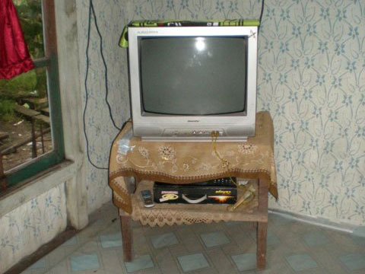
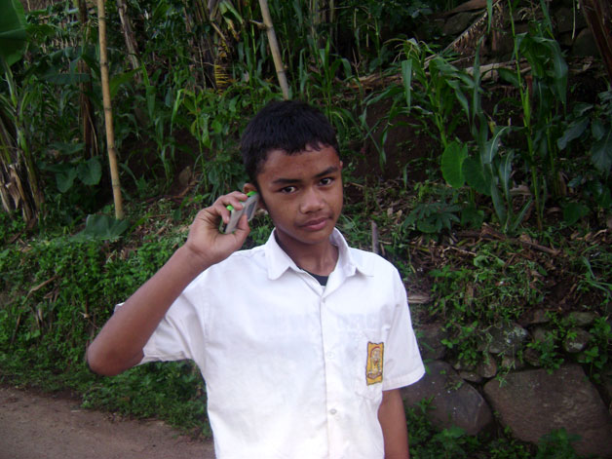
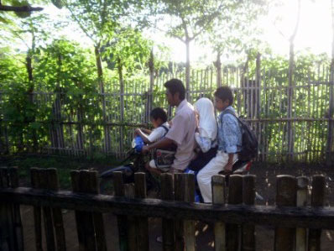
In fact in many of our villages, asset ownership can appear to contradict normative perceptions of poverty. TVs, mobile phones and motorbikes, whether new or second-hand, are all purchased on credit (see Picture Box 1). The result is that there are very high levels of household indebtedness across all our study villages, through institutional and informal credit provision. Those who are slightly better-off face pressure to lend to others (see Box 3). Luxury goods are prioritised by families in our study areas over basic sanitation provision. Very few of our study households had any form of sanitary latrine, and bathing was generally in the open using a standpipe or the river (see Box 4). Kitchens either incorporated in the house or in outside sheds were very basic, and all our HHH relied on the use of firewood for cooking (see Picture Box 2). In the central villages, there is a strong culture of ‘bride price’ practiced which exacerbates family indebtedness (see Picture Box 3).
Picture Box 1. Asset ownership can mask the family's real poverty as most assets are bought on credit and many struggle to keep up with their credit repayments. The motorbike, TV and mobile phone were all bought on credit
Box 3. More income leads to more demands from relatives
Ibu Suro is a widow and makes a good living selling snacks at the oil palm plantation. She indicated that she was almost always able to put aside some savings at the end of the month. Sometimes she could even save as much as half a million IDR. Yet, we observed her living condition was far from comfortable. She sometimes was barely able to put food on the table and often when she could, she only fried some leftover rice and served only that for her children.
She explained that her savings was often 'lent' to her relatives. Whenever one of her relatives needed some money, whether it was to throw a wedding or to renovate their house, they came to her and asked her to lend them some. Unfortunately, the possibility of getting that money back is remote so even though she earned quite well, she still lives in a very constrained condition due to the demands of others.
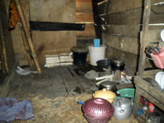
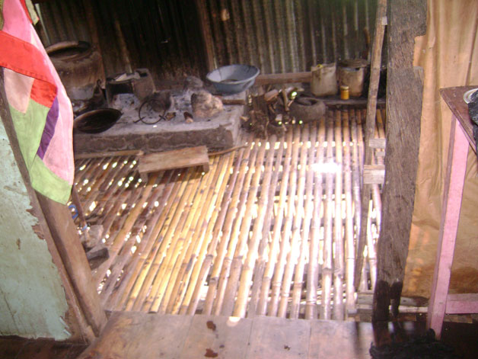
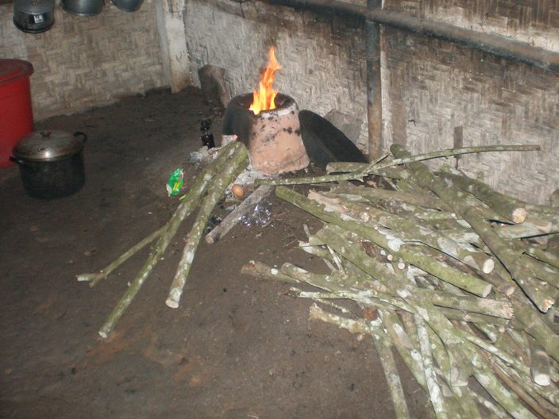
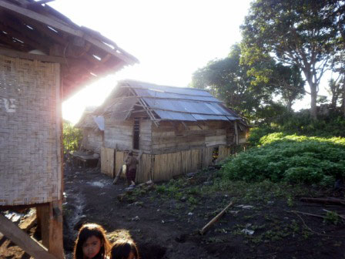
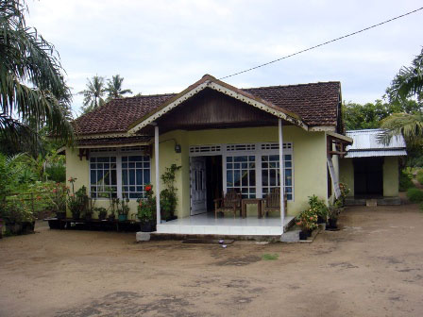
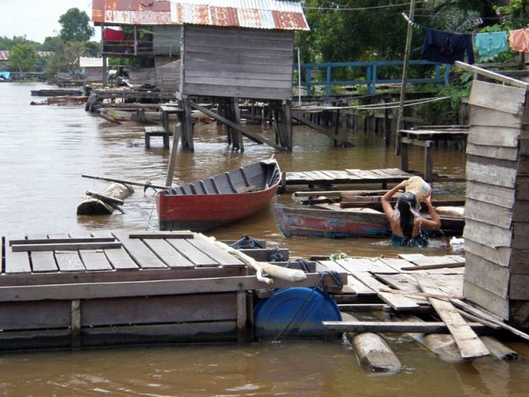
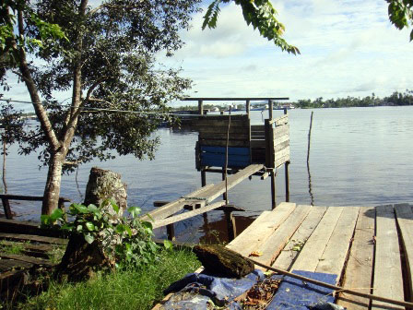
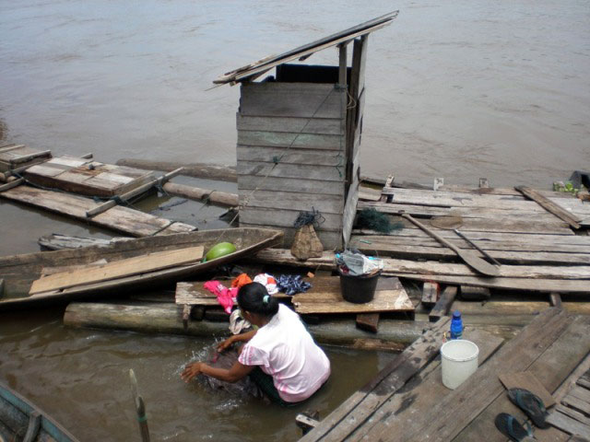
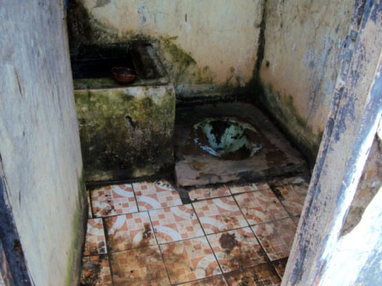
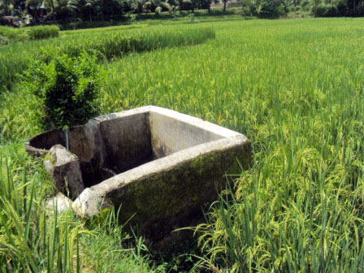
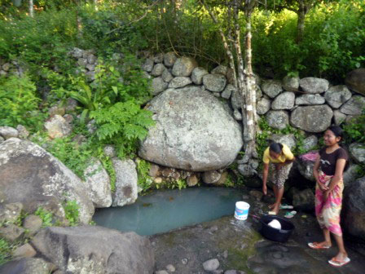
Picture Box 2. These photos show typical HHH kitchens, the first shows the kitchen- washing area which is also where the family urinates, the second is demonstrates the basic utensils and simple cooking arrangement and the third shows the typical use of firewood for cooking
Picture Box 3. Poverty can be unseen.
The contrast between these two host households is stark and indeed the one on the left is much poorer. However, the look of the house in the picture on the right belies the fact the family is highly indebted and the father is unemployed. The house was built from proceeds from the now illegal timber industry

Box 4. Toilets are a low priority
We rarely came across any H/FHH with water sealed latrines. The following are extracts from field notes and demonstrate the low priority given to having toilets.
Most of the houses we stayed in (West 3) were without any toilet facilities. People had built attractive houses and have assets such as TV, DVD player and satellite dishes but no toilet. They tell us they prefer to go the bush or river bank for toilet purposes.
The BEP supported SMP has constructed two toilets for the boys and girls with all facilities including water, but the students generally prefer to use the nearby bush. People say that they do not like to defecate in a confined place as it is not good for health and creates a bad smell all the time. They prefer the river for bathing too.
Houses in West 2 are also mostly without latrines. For defecation, people go to the river or to a relatives’ house while they used a platform at the back of their house where they also cook and wash dishes to urinate.
Despite having various assets in the house and a good income running a small shop, my family have no latrine and explained that I needed to dig a hole if I needed to defecate (East 1).

Washing and toilet
Bathing in the toilet area
Hanging toilet of HHH
Public toilet
Washing hole
Public washroom
In each region, one of the villages selected was within 30 minutes drive from the district town. We refer to these as ‘peri-urban’ locations. These were all relatively better off and shared many characteristics. Although families continue to farm, this is primarily for their own consumption. The land is irrigated and so supports two to three cropping seasons. Diets tended to be more varied, as a result of both this irrigation and the ready availability of a greater variety of supplementary foods due to the proximity of the town. In each of these peri-urban locations there is a greater variety of permanent and day basis jobs which supports year round employment. Day labour in the construction industry for both men and women is particularly important in supplementing lean periods of employment.
The number and quality of meals consumed each day by our study families also points to conditions of relative poverty. Most families took either two or three meals of rice with small amounts of vegetables. The poorer families collected leaves from the forest and less poor supplemented this with bamboo, papaya, coconut, pumpkin (see Picture Box 4). None of our families took fish more than about three times a week and very few ever ate meat, even though they may rear chickens, ducks, goats and cows. These animals (and horses in the central area) are regarded as asset stocks which can be sold in times of cash crisis and are therefore not consumed (see Picture Box 5).
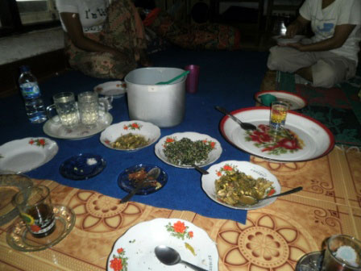
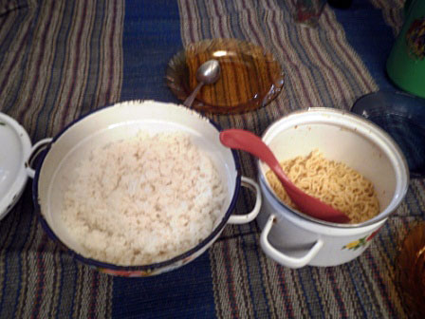
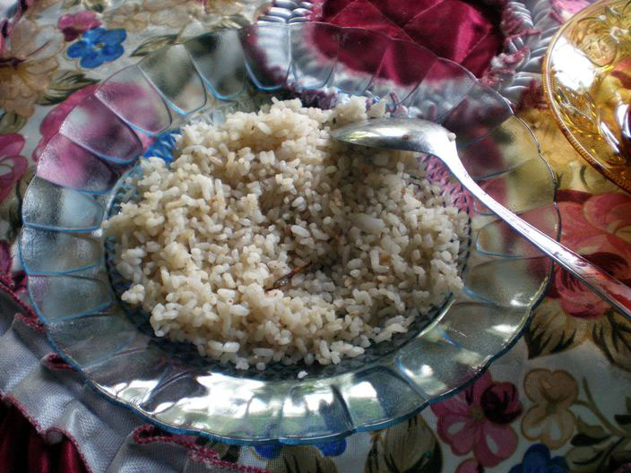
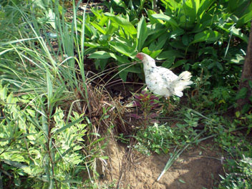
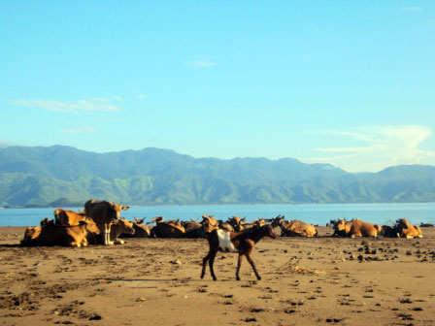
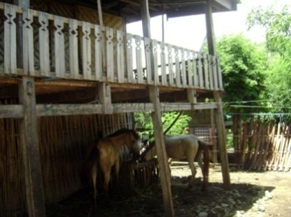
In the peri-urban locations and those villages which are more connected to the outside world, younger parents told us that they are keen to keep their family size small mainly, because of the high cost of education. In the remote areas, family size may be much higher, for example two households in East 3 comprised very young parents with five children each. These ten children all showed signs of malnutrition including poor teeth and stunting and wasting. Two have been registered as malnourished.
Picture Box 4. HHH meals are taken twice a day and are generally simple- the first shows that this HHH only ate rice with nothing else for some of their meals; the second demonstrates a peri-urban diet which is more varied and the third picture shows a meagre breakfast of rice with instant noodles for the entire family.
Just rice
Varied diet using different vegetables
Basic breakfast
Picture Box 5. Animals as assets that can be converted into cash when needed - In different locations, different livestock (cows, poultry, horses) are treated as savings that can be sold for educational needs
Table 3 presents a summary of the BEP supported schools located in our study villages. As explained in the methodology section above, we felt it essential to maintain anonymity and confidentiality of their identities to honour the trust invested in the research team by villagers in sharing their opinions and perceptions openly. This is also essential if a longitudinal study is envisaged. As a consequence, only the barest details are given about these schools.

Table 3. The BEP Supported Schools
Location | Type | Description
West 1 | Madrasah (MI and MT) | Constructed in 2006, Privately owned, mostly caters for fee-paying boarders from other locations with only a handful of boys from the locality
West 2 | SMP | Constructed in 2007
West 3 peri urban | SMP | Constructed in 2007
Central 1 | SATAP | Constructed in 2007. Grade 1 SMP only functioning at present
Central 2 peri urban | SMP | Constructed in 2007
Central 3 | SMP | Constructed in 2007
East 1 peri urban | SATAP | Constructed in 2006. All three grades operating.
East 2 | SMP | Constructed in 2006
East 3 | SATAP | Constructed in 2007. All three grades operating
East 4 | SATAP | Constructed in 2006. All three grades operating

Main Findings

The main findings are organised under three relevant pillars of the four used by the BEP to organise its activities. These are access, quality and governance. We have used ‘access’ to refer to issues associated with accessing education including costs, hindrances, attendance and drop out as well as physical access created by construction of new school buildings. ‘Quality’ includes opinions on what makes a good school, teacher and teaching issues and resources as well as views on construction quality. ‘Governance’ refers to school supervision and management, community participation and voice.

4.1 Access
The discussion of poverty in the section 'District Context' above suggests that the BEP has successfully targeted areas which can be regarded as relatively poor and are representative of the poorer pockets within Quintile 4. Villagers and teachers confirmed that the schools have been built where there is clear need. With the exception of the peri-urban locations, people shared with us the difficulties of accessing SMP education before the BEP School was built. Table 4 summarises comments typical of many we spoke to about what it was like before the school was built.
Table 4. Typical Comments Regarding the situation before the construction of the BEP Schools
Location  (Poorest first) | Before BEP school
East 3 | Previously had to stay with relatives in town 15 km at bottom of a hazardous mountain road 'Only a few went there because it is too far away and it cost too much'.
Central 1 | Nearest SMP was an hour walk away and 'only three of four used to go' 'Mainly the rich went because they could go by motorbike’. At present only Grade 7 operating and they have 10 students
East 2 | Tradition of travelling across the sea bay to the SMP- some daily (Rp 15,000 return) but most stayed with relatives Children say they like having the new local SMP, 'we like living here better as there is free fresh fish... beautiful environment... lots of friends to play with ... and a beach'. 'We get treated as servants when we stay with relatives'; 'It is much better that we can stay with our parents'
West 1 | Only 3 local students attend the boys only MT, which is residential and costly. Other students in the village attend a SMP 2km away (there are two other SMP 2km and 5km away)
West 2 | Used to have to cross the river to the nearest SMP (Rp 4000 round trip). Village leaders say that they 'are not allowed to go across the river now to school' , as it is outside the catchment area. Very high tradition of drop out to work in plantation continues even with new school
Central 3 | Used to live with relatives and attend the SMP in another town. Although only a 30 minute motorbike ride, only the better off children could attend. Over the three years of operation, the community has shown increasing confidence in the new SMP which now has 114 students.
East 4 | Used to attend the SMP in town, a hazardous mountain road journey away. Higher numbers now attend the new SMP
Central 2  (peri urban) | Formerly students attended the SMP 3 km from the village, accessed by a good road. The ojek cost was Rp8000 per day. The new school caters to 101 students and villagers say that before only about 20% of SD graduates continued to SMP whereas now this has risen to 80-85%.
West 3  (peri ruban) | Poor record of transition previously to SMPs 5 and 7km away, so SMP originally started under a private local initiative. After initial enthusiasm, students appear to be returning to the old SMPs which are perceived as better quality.
East 1  ( peri urban) | There are three other SMPs within a 3km radius of the new school and also a Sekolah Terbuka (open school). There is tension between the latter and the new school as they have 'poached students'. Villagers say more children continue their education because the SMP is in their community now.
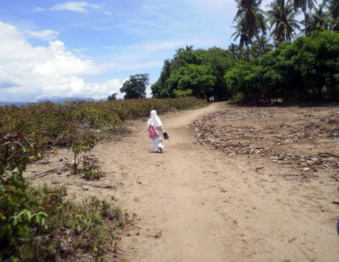
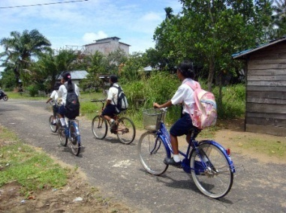
Picture Box 6. Journeys to school are often better than they were but for many they are still long.

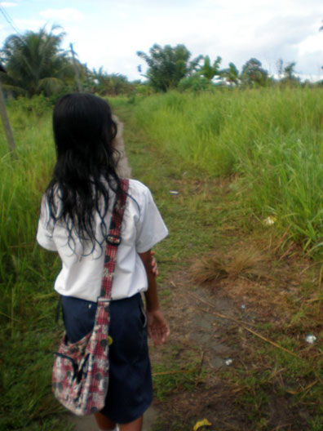

Walking home for over an hour, this girl sets off for the next sub village
Girls riding bikes to school
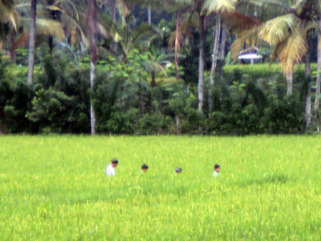
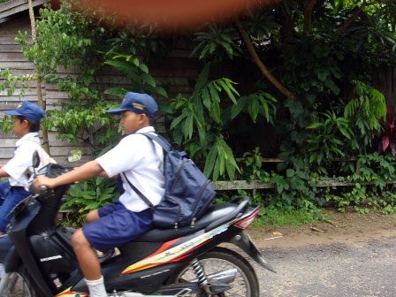
Long walk through the paddy fields to school
Young boys driving motor bike to school

Going to school via a long and very muddy road

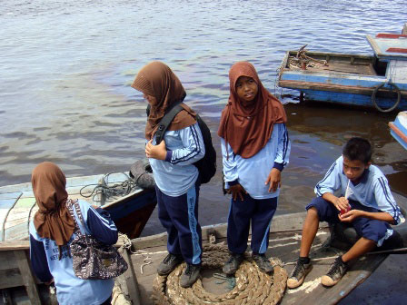
Time and travel cost savings are noted among the benefits of having a school in the community. Boat and ojek fares saved ranged between Rp2000-10,000 per day. Walking times were said have been reduced by between 2 hours and 1 hour although many still have very long walks to school (e.g. 1-2 hours in East 2 and East 3). However, outweighing the time and travel cost benefits is a sense of pride that the school is in 'our village' which also appears to stimulate a social pressure to attend school.
Non BEP Madrasah students are still taking the boat to cross the river to go to school. BEP-SMP students don’t have to do this any longer

Student attitudes
Children tell us that they go to school mainly for 'friendship'. There is therefore a strong sense of peer inclusion in conforming to the norm of school attendance. Some students said ‘The only reason we go to school is for friendship’ (girls, Central 2). When children talk about what they like about school, there is always a priority given to 'having fun'. They say the best teachers are those they can have 'fun with', 'joke with' and the best classes are the ones where they can 'have fun with the teacher', 'have group discussions which are fun' or 'work together in groups'. Some children told us of ‘study circles’ they have after school, mostly self–initiated (see Box 5).
Box 5. Self-organised study and friendship circles
A group of boys in Grade 2 SMP boys tell us that they meet up several times a week to study together after school. They make themselves a snack of biscuits crushed in coconut milk and sugar and sit under the trees. They chat a bit and then 'because we are not smart enough we ask the one who is smart and understands the homework to explain it to the others'. Then as a reward they watch TV together. But they do not get homework more than a couple of times per week.
Another group of girls likes to meet in the house belonging to one of them at night usually after the Friday prayer. The four of them are 2nd graders of a BEP supported SATAP. They discuss the homework and tests for the next day. But bonds of friendship are very strong and they like to chat about girls’ issues too. They meet even though the light from the solar powered lamp is very dim. They crave for the teen magazine widely circulated in the city and are keen followers of some popular television soap opera shows. All of them wish to pursue higher education. One particularly aspires to become a teacher and another wishes to be a medical doctor. They love their school but do not enjoy the tiring daily walk to school. They sometimes sleep together keeping each other company because their parents are away at sea or farms. In fact two of them are living with relatives as their parents are migrant workers. (East 2)
Friends take snacks together after school, known as 'nongkrong' (chill out), and may do a bit of homework and, if available, watch TV together. Children and parents further reinforce the idea of school being for fun and friendships in their preference for mixed classes. They tell us that they want classes to be mixed gender 'because it is more fun' than they imagine single sex schools would be. 'We can joke with the girls' (boys East 2) 'it would be very quiet without boys' (girls East 2). Big classes are preferred over small classes again because 'it is more lively' or 'it is more fun’. See Table 5 for examples of these preferences.
Different groups were shown pairs of pictures and asked to choose their preference. In each case, the preference is highlighted in the table. Comments justifying their choice are noted in the third column.
Table 5. Which Do You Prefer?
This | Or this? | Comments
Women teachers | Men teachers | 'men will protect the school from thieves' (mothers E2)  'women teachers can cook for events' ( mothers E2)  'women teachers are kind', ' Don't hit so hard' ,'have more patience'  (SATAP boys E1)  'we can have more fun with women teachers' (SMP girls E2)  'we want just one male teacher for sports' girls E3
Young teachers | Old teachers | 'young teachers joke with us more' (E2 and E3)  'young teachers talk to us in break and after school' (E2)  'young teachers are not so angry all the time' (E2)  'young teachers speak louder' ' Are more energetic' 'Give more  homework but we like them' 'Old teachers get angry easily...they hit  us' (E 3 girls and boys)
Mixed classes | Single sex classes | 'it is best to have girls and boys together. Life is not complete without  boys and girls' ( mothers E2)  'It would be very quiet without boys ' (SMP girls E2)  'It would be no fun without boys' (SMP girls E2)  'More fun' (SATAP boys E1).  'Can joke more' (boys and girls E3)  But when conversations turned to the possibility of being able to concentrate more, learn more without the 'irritations' of the opposite sex (teasing, joking, fighting, dating etc) then there was unanimous agreement on the advantage of single sex classes.
Small classes | Big classes | 'Big classes are merrier' (mothers E2)  All children asked said big classes were better because it was more fun. (E1,2 and 3)
Computers | More text books | Peri-urban (E1) children said ‘computers’ whereas rural children mostly told us ' more books' (E2). In E3 children did not recognise the picture of a computer.
Computers | More sports facilities | 'We have never used computers but think this would be better for us' (SMP girls E2)
More sports facilities | More text books | SMP Girls, mothers (E2) unanimously agreed that more text books were needed
More trees | More classrooms | Emphasis on trees in dream school drawings, shade & attractiveness.

Choice of school

For many children the prospect of living away from home for SMP education is mostly unappealing as they will have to 'live with strangers', 'be treated like servants' and not be able to stay with their own families and friends. Parents more often expressed concerns about the associated costs. When a child boards, even with family, they are expected to contribute to their food costs, soap and detergent, electricity and water and there are often daily transport costs from the relatives' house to school. Parents expect to have to pay more pocket money to those who live away from home.
Other reasons cited for liking the new SMP schools is that teachers are likely to be local. Most of these locally hired teachers are guru honor and are often young. Because they are familiar with the children and their families, children feel they can relax more with them 'they know us’, 'we feel shy with teachers from outside' (Central 1). Again the idea of ‘having fun’ was paramount. These teachers also tend not to use Bahasa Indonesia language as a medium of instruction and use local language predominantly. For example, in East 2 and East 3, children are not taught Bahasa Indonesia until grade 4 SD and in Central 1 children are not introduced to Bahasa Indonesia until SMP level so only local languages are used.
In a few cases, the alternative SMP charged registration fees and the BEP-supported schools generally do not although there are some in our sample that do. This has been a factor in choice of schools where choice is available. In Central 1, however, even very poor households (including one of our HHH) have to pay Rp 30,000 per month which they say is 'monthly fees' and Rp 300,000 per year which is 'promotion fee' to ensure promotion to the next grade. In West 3 an annual re-registration fee of Rp 30,000 is charged.
The communities often express their pride in having a new school as typified by these comments 'our building is the best, the most beautiful in the area. It is new, has new floors, tables and is painted green' (Children, Central 1). The children in West 2 said 'why ask us to draw our dream school? We already have it'. Indeed, when we asked children to draw their dream schools, many drew pictures of their existing new BEP supported school (see Picture Box 7).
However, there are issues associated with the localisation of schools and the problems raised may be a function of the fact that construction of a new school building is only the beginning of a process of ensuring quality education. The issues highlighted could be regarded in the main as teething troubles.
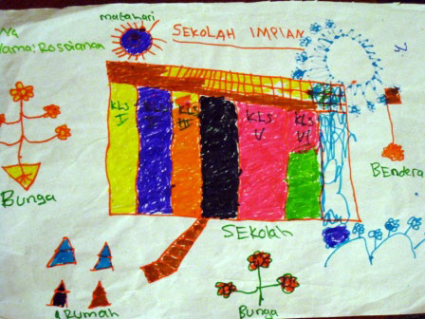
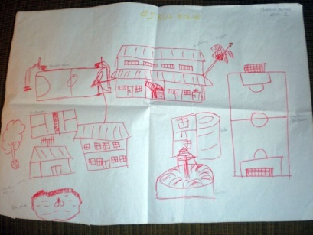
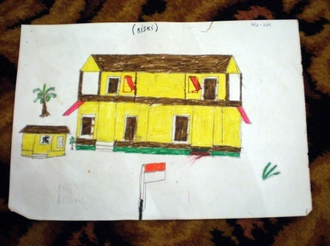
Picture Box 7. Dream School Drawings

Early problems experienced in the new schools
In the East locations, staffing of the schools is a problem. The school in East 2 has only one PNS teacher, who is the school principal. In East 1 there are only two PNS teachers. In the Central locations there are more PNS teachers but at least 50% of staff are guru honor. The reliance on guru honor has implications which are discussed more fully below under Quality. In peri-urban situations, these honor teachers teach in several schools in the area. This means that they are travelling between schools making them, in their own words, frequently late, tired and stressed. Their contact with a particular class of children may only be one 'study hour' per week. Children say that they don't remember the names of some of these teachers and that they change frequently. In rural areas, the honor teachers do not have the opportunity to accumulate many teaching hours and therefore have to supplement the very low honorarium paid to them with additional work, for example ojek driving or farming. Balancing the need for earning an income and fulfilling the requisite school hours means that the latter sometimes suffer and absenteeism or lateness are common. Many honor teachers have little or no training and are often required to work outside their subject specialisation.
Box 6. Declining student numbers at SATAP
The first enrollment of the BEP-supported SMP extension of the SD was three years ago and resulted from an intensive motivation effort by the head. After a cautious start the subsequent year intake saw a massive increase and four classes had to be created.
However, enrollment for the current school year has declined to half of last year's intake. So currently, there is one class at Grade 3 SMP, four at Grade 2 SMP and two classes at grade 1 SMP. A teacher explained that parents are choosing to send their children to two other SMPs (4-6 km away). ‘They probably think that because the school is new, it’s not as good as the other SMPs. But of course it is not necessarily true.’ Our observation suggested other reasons for this disaffection.
Because of the 'bulge' in Grade 2 SMP and the need for four classrooms just to accommodate them, other rooms are being used as classrooms e.g. teacher’s room, student council’s room and musholla. The student council’s room is so little that the desks and chairs are crammed together, while students studying in the musholla have to sit on the floor without chairs and the white board has to be placed on the floor. (West 3)
The inadequate provision of qualified teachers means that the quality of education offered in many schools, including some of the BEP schools, is limited. The situation has become so critical in 2 BEP schools that children are being taken out of the new school and enrolled in the former more established school (e.g. West 3 and Central 1). In West 3, the school opened three years ago with much local anticipation. After a modest first year intake, the second intake was so large that four classes had to be created (requiring the teachers’ room, musholla ((prayer room) and library to be pressed into service as classrooms) but the numbers have halved in the third year intake (see Box 6). In Central 1, the absence of teachers is so chronic (see Box 7), coupled with a rumour that the school has yet to be accredited means that parents are sending their children to the SMP an hour's walk away. There are now only 10 children studying in the SMP section of this SATAP. In East 3 the head has taken the decision to send all the 3rd grade SMP students to the school at the bottom of the mountain for a period of three months leading up to the national exams. For some this extra cost has meant that they have had to curtail their schooling and will not sit the national exam (see Box 8).
Box 7. Difficulties of the honorarium teacher
‘I am a locally recruited teacher. Teaching is my dream job. For six years I have been teaching in the school in my own village. I want to be a good teacher, so I put my best efforts and sincerity into teaching. But I don’t know how long I will be able to keep this up in this school where the management is so poor. Sometimes, I become frustrated about the unfairness here. Most of the teachers come from outside and all of them are highly paid compared to me [all PNS]. As per the government rules, each teacher is required to teach 24 hours per week. But they are often absent from the school. It frequently happens that I am the only the teacher to manage the whole school. I have to work continuously, setting assignments for different classes and as a result I often lose my voice. This absence of teachers is very common in my school, but the school management completely overlooks this and does not recognise what a big workload I am bearing. Then on top of everything else, I have not received my salary. I want to ask the management, ‘why am I not getting salary for the last one year?’’ (female teacher , SATAP, Central 1)
In general, the children in our sample are less likely to be going out of their community for SMP schooling since the construction of the BEP supported school. The downside of this may be that such children may have less exposure and less connectedness to the outside world. Some community members hinted at this as a possible problem. Older siblings whom we met who had been away to school were often more fluent in Bahasa Indonesia and more aware of current events and modern technology. For example, in East 2, there was a sense among older siblings that their schooling in the SMP across the sea had been better, and that it had required them to be fluent in Bahasa Indonesia as the language of instruction, and that had been introduced to computers and used laboratories. The combination of the increased likelihood of teaching in local languages and dialect, with a higher chance of the school being less well resourced, less qualified teachers and limited teaching resources (see 4.2 Quality below), potentially limits the educational outcomes for children in these local SMPs.
Box 8. Moving the grade 3 SMP because of lack of resources
Most of the grade 3 SMP students have gone for three months to attend the school in the town at the bottom of the mountain. Parents say it is because the teachers were always absent and 'could not be bothered to come up the mountain in the rainy season' but the Head says it is 'because the facilities for these children are limited and we do not have a laboratory'. This means that each family has to pay transport and boarding costs for their children amounting to about Rp 1.2 million. Pak Rahmad (47) and Bu Ida (45) each have a child in 3rd grade SMP. Pak Rahmad said the transfer was because the SMP lacked laboratory equipment, has insufficient supplemental text books, and low quality of teachers at the BEP school so the school decided to send all their 3rd graders to the longer established, better quality SMP in the nearby district town for about three months in the second semester leading to the national examination.
Bu Ida did not seem to know why this decision had been made. It was not clear whether parents were consulted about the school's decision. Students are unable to commute between their homes and the temporary school as it requires a round trip (3-hour ojek ride on a hazardous path, costing Rp 30,000). So children spend the week in the district town and funds have to be found to cover their living expenses there. While typically the annual direct cost for education, which covers notebooks, shoes and uniforms, for a SMP student here is about Rp 450,000, this three-month window incurs additional cost of Rp 1,200,000 for living expenses (contribution to food (Rp 250,000) even though they are living with relatives and transportation between their lodging and school (Rp4000 per day) and return visits home (Rp 30,000 per round trip). Pak Rahmud tells us he is able to afford this additional cost (despite his indebtedness) but Bu Ida, a widow with five children, is not as fortunate and her daughter has no choice but to stay out of school during the three months, which effectively diminishes her chance of graduating SMP (East 3).
School location
Even though there are some significant transport and time savings associated with the location of the new school, there are some concerns in some villages that the school has not been located in the most appropriate place. In West 2, the land for the school has been donated by three families and is far from the dusun (sub-village) where fishing families live. As a result it caters to only 52 students. In East 2 the school is located a 30 minute, muddy walk from the centre of the village and on the outskirts. It is a 2 ½ hour walk from the furthest sub-village and children here continue to cross the sea bay to access SMP as it is slightly easier than walking over the rocky terrain to the new school. In West 1 the school is located close to the two dusuns with very low populations rather than the more populated villages and this could not be explained. Contrary to this, in East 4, a deliberate decision was made through extensive community consultation to site the new school at the dusun located at the lower part of the mountainous village even though most students live in the dusun higher up the mountain. This was to facilitate access for teachers from town and to ensure that 'better quality teachers would be able to attend regularly' (teacher).
In West 2, children's education is delayed by several years because of their parents work on the plantations. They tell us that they do not want to leave their children unsupervised during the day and so take them to the plantation until they are at least 8 or 9 years old. Since there is available work for young teens on the plantation, this also contributes to the drop-out rate (see 4.1.2 below). This means some children may have only 4 to 5 years effective access to education (see Box 9).
Box 9. Delaying school in plantation communities
In this village, most people (men, women and adolescents) work in the palm oil plantation. The company provides a motor launch to transport them to the plantation very early each morning, 6 days per week. They have to leave home by 3.30am and are expected to work 12 - 13 hours. They take younger children with them and tell us they would worry ‘they may lose their way or will go elsewhere with the friends', if they left them behind Consequently, they delay the start of school until the child is at least 8 or 9 years old. In one of our FHH, the mother gets up at around 2am to prepare food and sets out the uniform for her eight year old son before leaving for the plantation. He gets himself up in the morning, takes breakfast, bathes at neighbour's house and goes to school. He doesn't like to wear shoes even though his friends says 'he has shoes’ and goes off to school barefoot with no parent to tell him otherwise. (West 2)
Another study team member noted: ‘it was only 8 o’clock in the morning and there were around 7 school age children playing around in an open space, a mutual front yard of 4 to 5 houses in the village. The parents of these children watched closely from behind the windows of their own homes. The youngest was only 4 but most were 7 and 8 years old. Their parents said openly that the 7 and the 8 years old were not in school because they were not in fact enrolled because they did not have the heart to leave their kids behind to go to school while they themselves have to be away working at the palm oil plantation. Working at the plantation only allowed them to come home at 3 in the afternoon, leaving the children to fend for themselves for as long as 6 hours each day. 7 and 8 year old were considered too young to do this; therefore plenty of children only started SD when they were already 9.’ (West 2)
These issues highlight the need for improved demographic and school planning at the district office.

Where there is a choice of a SATAP or SMP, we met boys, in particular, who told us that they preferred the SMP because 'we do not like to mix with little kids' and 'we wanted to mix with new friends, meet new kids outside our village’. When we visited one SATAP, the SMP boys hid behind the pillars during morning exercises conducted with the entire school. When we talked with them, they told us they felt 'stupid' and 'weird' having to do these kinds of things with the small children. Young SD level children in the SATAP shared with us that the SMP boys tease them and 'hit us'.

4.1.1 Cost of Education as an Access Issue
Although the GOI stipulates that the nine years of basic education should be free, costs associated with schooling continue to be a major burden for families living in poverty. In a few cases, the BEP- supported school does charge fees as mentioned above. (Central 1: Rp 30,000/month; Central 3: Rp 300,000/ year; and West 3 annual registration fee Rp 30,000). The following typifies comments that we heard in all locations: ‘My neighbours are often complaining along with me about the amount of money we have to pay, particularly for uniforms’ (FHH mother, East 2); 'Uniform costs are a real hardship' (mother, East 1); 'as our children get bigger, the costs get higher - uniforms for SMP cost more than SD ' (mother, West 2). In all locations except East 3, students are expected to have at least four sets of uniforms: the national (blue and white for SMP level), school- specific batik, sports and scouts uniforms. In some schools, they are expected to have a fifth set which is muslim dress.
Box 10. Strict uniform regulation
BEP-SMP in Central 3 still uses corporal punishment to discipline their students: they beat them using a ruler. The teachers of the school also punish students by telling them to stand in the middle of the school yard, or by telling them to memorize multiplication tables. Violations considered to be punishable by these measures are mostly related to uniform wearing and appearance.
Students can get punished because they wear white shoes, sport long hair (boys) or for not wearing a ‘jilbab’ for girls. They also get punished for being late for the weekly flag ceremony or for not completing their homework.

Enforcement of uniform dress code is quite strict in many schools (see Box 10) and children are punished for not conforming. In most of the schools located in the poorer villages, the enforcement of dress code tended to be more relaxed: children wore flip-flops, a few were barefoot and some wore their own clothes from time to time (when the uniform was being washed or had got wet in the rains). In East 3, children only had two sets (national dress and sports) and the school enforced no code regarding footwear. Some families told us that they received some free uniforms from schools, but generally this was only one per year (equivalent to Rp 60,000-75,000). Some indicated that these allocations were made from BOS (direct Government grants made to schools on a per capita basis which can be allocated according to the priorities of the school). Uniforms were distributed to all potential SMP students in East 1 as a way to encourage them to enrol but this has not been continued since then.
Poorer families tell us that they try to buy 'very large sizes so the uniform can last for more than one year'. Others rely on handed down uniforms from older siblings and neighbours. This way many told us they are able to limit the purchase of uniforms to two sets a year (about Rp 120,000- 150,000). But even with these economies, the cost of uniform is still considered a burden. In the Central study villages, there is a provincial directive that girls must wear jilbab (veil). This adds a further cost of a minimum of Rp 20,000 (for two).
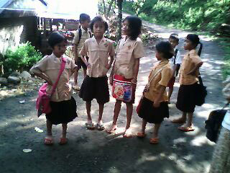
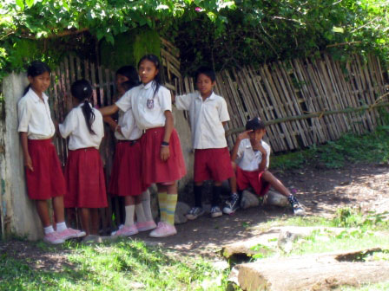
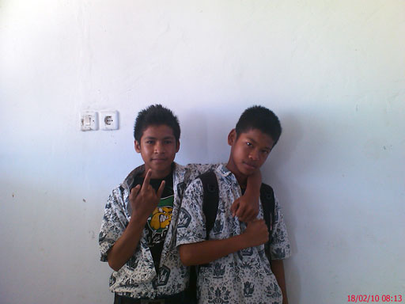
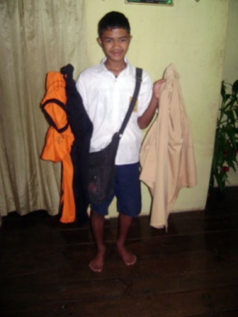
Picture Box 8. Uniforms are a major cost for students’ families but some schools are more lenient about dress code than others. In the first photo a boy shows all the uniforms he needs, the second shows boys who are always in trouble about their failure to conform to the dress code, children attending the 'model school' in East 4 even wear matching pink shoes and in the fourth photo there is less concern about the uniform regulations.

b. SMP level annual comparative costs of education in Rp
 | HHH  (East 2) BEP school | HHH  West 2  BEP school | HHH  (Central 3)  BEP school | HHH (East 4) BEP school | FHH  (Central 3)  BEP school | HHH  (Central 2)  BEP school | HHH  Central 2) BEP school | HHH  (East 2 )  town  NON-BEP | HHH  (East 3) town  NON-BEP
Uniform ( 4 sets but buy every 2 years | 100000 | 200000 | 100000 | 220000 | 75000 | 100000 | 150000 | 100000 | 200000
Exercise books | 40000 | 15000 | 125000 | 50000 | 25000 | 200000  (includes photocopy text books) | 125000 | 20000 | 200000
Shoes | 50000 | 100000 |  | 30000 | 60000 | 45000 | 80000 | 30000 | 100000
Pocket money | 80000 | 700000 | 100000 | 600000 | 100000 | 100000 | 45000 | Can't afford | See below
OSIS | 14000 |  |  | 60000 |  |  |  | 6000 | 35000
Tuition fee | none |  |  | none |  |  |  | 960000 | none
Transportation | walks | none | none | none | none | none | none | 400000 | none
School bag |  |  |  |  | 40000 | 25000 | 30000
Extra costs | 150.000  One off registrat-ion fee |  | 24000 |  |  |  |  |  | 1,200,000 boarding,  pocket money and transport
Total | 284000 | 1015000 | 349000 | 960000 | 300000 | 470000 | 430000 | 1,516000 | 1,735000
* Excluding pocket money costs, education costs at BEP supported schools range from Rp 200,000-315,000. Boarding or transport costs at the non BEP schools as well as fees are between Rp 1,200,000 and 1,360,000 in addition.

Box 11. Comparative costs for schooling
a. SD level (all BEP schools) annual comparative costs of education in Rp
 | HHH (East 2) | HHH (East 2) | HHH (East 4) | HHH (Central1) | HHH (West 1)
Uniform ( 4 sets but buy every 2 years) | 90,000 (2 sets) | 70,000 | 240,000 | 50,000 | 1000,00
Exercise books & stationery | 24,000 | 20,000 | 50,000 | 30,000 | 30,000
Shoes | 30,000 | Does not have | 30,000 | 25,000 | 50,000
Pocket money* | Can't afford | Can't afford | 400,000 | 100,000 | 360,000
Admission fee | - | - | - | - | 50,000
Total | 144,000 | 90,000 | 720,000 | 205,000 | 590,000
* Excluding pocket money and cost of snacks, education costs range from Rp 100,000-320,000.

Pocket Money and School Snacks
c. Annual comparative costs of education; SMA level-no BEP schools at this level
 | FHH  East 3 | HHH  East 2 | HHH  East 2
Uniform ( 4 sets but buy every 2 years | 150,000 | 100,000 | 100,000
Exercise books |  | 20,000 | 20,000
Shoes | 100,000 | 60,000 | 80,000
Pocket money | 150,000 | Can't afford
OSIS | 14,000 | 6,000 | 120,000
Tuition fee | 250,000 | 960,000 | 900,000
Registration | 470,000 |  | 660,000
Transportation | 300,000 | 400,000 | 400,000
Lodging & food | 1,200,000
Fashion clothes | 300,000
Total | 2,934,000 | 1,540,000 | 2,280,000

As raised in the pilot study, the provision of pocket money is another major cost concern of parents. In only one of our study villages (and one remote sub-village), pocket money is not expected by children. The former is the poorest village in our study and there is one small kiosk serving the entire village which is owned by a teacher's wife. Very few children use this and there is no peer pressure for taking snacks to school. In the small sub-village, children go home if they are hungry. However, in all the other villages in our study the picture is quite different. Even in very poor families, children demand Rp 1,000 per day. Parents told us that their children may 'refuse to go to school if we do not give in to them'. One said: 'You have met my daughter, she seems very quiet and nice doesn't she? But you should see her if I say I have no money for pocket money. She screams and screams and I have to give in to her' (HHH father East 2). Another said: 'Ira's parents work outside (the country) so Ira will go round all her relatives asking for pocket money every day (Ira's grandfather, East 1). A third: 'The neighbours' children throw a tantrum and refuse to go to school (West 2) if the parents do not give them pocket money’.
One HHH child refused to brush his teeth unless his parents gave him more pocket money (West 2). Boys in Central 3 resented the fact that 'if we don't get pocket money we have to drink the water from the school toilet’. Parents in West 2 said 'children used to get Rp 4,000 per day for the boat fare to school but now (they no longer have a boat trip to school) they demand Rp 3,000 for pocket money'. Here, some children protest if they do not get pocket money and play truant from school. Some children in the better-off villages demand up to Rp 10,000 and we observed them helping themselves from parents’ pockets.
In East 1 children complained that one of the biggest problems they faced at school was that 'bigger boys steal pocket money'. They said that those who do not get pocket money get teased (see Box 12). Although mostly used to buy snacks from the kiosks which are either inside the school grounds or line the entrance to the school, some children spend only part of their pocket money and make savings towards the purchase of a mobile phone, mobile phone credit or cigarettes. Kiosk vendors tell us that most children buy snacks daily. Children like to buy sweets, crackers and syrup drinks. A few contribute to the cost of after school coaching or exercise books from their pocket money.
Box 12. Pocket money demands
A boy of 3rd grade of the BEP supported-SMP refuses to live with his father, who is the village leader because he says he is too strict. He lives with his grandparents about 15 minutes walk from school. His grandfather is a retired teacher and the boy takes notice of him and, according to his father, his behaviour has improved since living with his grandparents. The grandparents do not eat breakfast and they give the boy Rp. 3,000-5,000 pocket money per day for snacks during break. If the grandparents cannot manage pocket money or it is less than expected, the boy gets angry and goes off in a huff pretending to go to school but actually does not. Instead, he crosses the river and passes time with other friends in the urban centre. He comes back home at 12:30 same as the end of school hour. His grandfather thinks that the boy is just coming from the school. (West 2)

All children need to buy exercise books. This ranges from Rp 15,000 to Rp 125,000 per year at SMP level. In some villages, the teachers have been photocopying the text books and work books for their students and charging them for this. In Central 2 this amounts to a weekly cost of Rp 5,000-10,000. Computer classes using the school administration computer and teacher's own laptops are available only to students who can afford it in West 3 (Rp 50,000 for seven classes).
The following are some of the other periodic cost demands that people shared with us:
- contribution to repair of school fence (Rp 5,000 per student Central 1);
- periodic requests ('whatever you can afford' but strong social pressure to contribute at least Rp 5,000 each time) for maintenance, cleaning and 'helping the poor'. This last request was particularly puzzling for one of our very poor FHH families 'teacher told me we have to give money for the poor' (student, Central 2) and they felt obliged to give Rp 5,000 ('all we could afford');
- we had to make cakes for science class (extra expense and one child got into trouble for 'stealing' live eggs from her home); mothers complained to the school about these extra costs (Central 2);
- purchase of decorations for Independence Day ( Central 2);
- camping trips (e.g. Central 1 Rp 40,000 cost which meant that some children did not go, parents have complained and in subsequent years this is free), study tour to the beach (West 3);
- weekly 'cleaning contribution' (Rp 2,000 per week) to purchase brooms and other cleaning materials (West 3);
Access for children with disabilities is rare. Some schools were not accessible for children with mobility difficulties as footpaths were rocky or hazardous. Parents of children with profound hearing disability told us that they do not send their children to school as there is no special provision for them. Some teachers seemed confused during conversations about disabilities and indicated that they had never thought that children with disabilities could be included in school.

4.1.2 Student Drop-Out
Discussion on drop out at SMP level needs to be placed in the context of the perceived value of the difference the qualification makes for children's income earning prospects in the future as this is seen as the key reason for continuing schooling. A grandmother (HHH West 2) said to her daughter 'why do you have to put her (her granddaughter) to SMP? SD is enough’. But her daughter replies, 'nowadays you cannot get a job without certification'. Box 13 describes how an uneducated father wants a better education for his daughter.
Box 13. Uneducated father with high aspirations for his daughters
The father (in his early thirties) never went to school because his parents did not encourage it, there was no village school and peer pressure promoted, in his words, reckless youth. He looks back on his youth as a wild time. He has two daughters and the elder one is studying in 4th grade. He moved her from the SD to the MI because he was concerned about the free-mixing of the girls with the boys and the lack of teacher discipline. He feels the MI has more discipline and engages the students better. For someone who once led a free life he has very high ambitions for his daughters and is very protective of them. He wants his daughters to be educated so they can earn their own living and not be dependent on their husbands. The mother completed 3rd grade SMP and on the instructions of her husband ‘takes care of education of their daughters.' She helps the elder daughter with her homework and prepares her for school every day. The father shared with us that he regrets that his lack of schooling means he is not able to help her with homework. He has no regular earning and only has a small farm of his own. However, he has managed to purchase a TV mainly to 'keep my daughters at home ...and not mix with the other village children ' (whom he regards as a bad influence). He hopes the elder daughter will be teacher and the younger one (only a toddler at present) will be a doctor, 'these occupations will help them serving poor people like us'. In his view, quality education means “teachers will teach and explain lessons clearly so that the students will not face any problem in performing homework” (West 1).
Labour market influence
In our West study locations (2 and 3) jobs for men and women which do not require certification are regarded as plentiful in the oil palm plantations. Girls who are considered ‘smart’, however, feel there are opportunities for them to become cashiers and secretaries in the plantation and will continue to SMP certification so they can enter higher education. In East (2 and 3) there is a strong sense of home and roots as exemplified in the stories in Box 14.
People explained that even those who have left the villages for work outside, return soon and their experiences are mainly regarded as negative. The only work 'at home' is farming and, additionally in East 2, sea fishing or as indicated in Box 14 limited opportunities for teaching. The desire for completing Year 9 and gaining the certification is therefore low except for those few considered to be 'smart' (and by implication potential teachers). Typical of similar comments we heard in the remote and less connected villages is ' this village is peaceful because we do not have many educated people here' (East 2) and 'most people are farming and we have no bad influences for youth here. It is a tranquil place' (East 3 village leader).
Box 14. Contrasting paths but similar aspirations to stay at “home”
Norman (21) is the eldest son of the wealthiest family in the village as his father is the only PNS teacher in the village. Norman completed his schooling in the nearby town and is now enrolled in his first year in the teaching college in the provincial town. He is one of the only three people in the village who have made it to this college. He aspires to follow in his father's footsteps and be a qualified teacher in the village.
Harun (22) went to the SD in the village and his family gave him the opportunity to continue his junior and senior high school education in Jakarta in Madrasah schools. He enjoyed his six years in Jakarta but chose to come back to the same teaching college as Norman and plans to remain in the area. He told us he used to describe with great affection the village where he grew up to his friends in Jakarta as 'having not only beautiful beaches but also beautiful mountains', and has decided to return because “no matter how modern Jakarta is, this will always be my home” (East 2).
Those who do aspire beyond SMP in these villages, mostly say they want to be teachers with a handful indicating they want to be village doctors or nurses. But this involves further education and children often add to their aspirations comments such as ‘but it all depends on whether my parents can afford this'. Aspirations expressed by parents and children alike in Central 3 are typical of other areas too, 'if we finish SMP we will be farmers, if we go to SMA or SMK we will enter the army or police and if we get to university we will be teachers’ .
Picture Box 9. Drawings depicting aspirations to be a teacher which most girls and many boys told us was their goal.

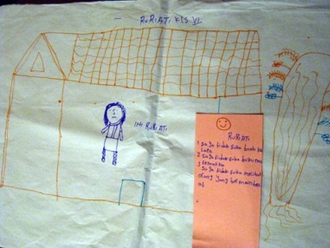
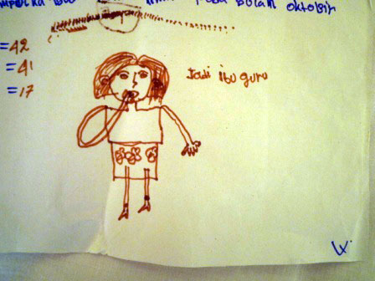

In East 1, there is a tradition of unskilled migrant work for boys where only primary education is required. But girls here are more likely to continue their education and because of the peri-urban location of East 1 have aspirations to work in the provincial town. In West 1, girls get married early but this is usually after they have left school and this is not the reason for leaving school. They say ‘there is nothing else to do here'.
Motivation to attend SMK
Where an SMK has been established new opportunities act as a pull factor for completion of SMP. For example in West 3, the SMK provides vocational training geared to the Japanese fishing industry and mechanics training (which is a route to employment for boys) as well as training in accounting and computing (which is a route to employment in plantation offices for girls). Boys in Central 2 expressed frustration that there was no SMK in the area. Box 15 describes how this has changed the aspirations of a former drop out boy. Sekolah Terbuka (West 3) is also offering students a second chance to get certification. 'In the past you could forge a certificate to get a job, now employers want to see the original' (girls in their 20’s who dropped out of school and now want to get work in shops).
Box 15. Opportunity to attend SMK motivates some students to complete SMP
One boy of the West 3 village just got back from Japan, he spent 3 years there working on a large fishing ship, apprenticed to a Japanese company. He got the chance to do the apprenticeship because of his enrolment at the SMK, majoring in fisheries. He was very happy to get this opportunity because he had always wanted to work in the fisheries industry. He told us that he had dropped out of schooling until he got an opportunity to enroll in the SMK. He said that it was quite common for his peers to choose the type of school based on what work they hope to do in the future. ‘Some of my friends went to accounting or computer SMK because they wanted to work in the plantation [to do desk jobs]. Some were like me, went on to fisheries or mechanical SMK.’
His experience over the last 3 years has given him a number of options. Since he now speaks Japanese and has a good relationship with the Company he is being sponsored to attend a particular university in Yogyakarta with whom the Company has links. He could enroll in Japanese language studies and graduate in only one and a half years. He also has the option of going back to work, seeking opportunities with other fishery companies. A girl who was with me when I talked with the boy was very impressed by the boy’s achievement. ‘He was not like that before,’ she said. She noted how he spoke more fluently, had a healthy glow about him, and looked 'more plump' than before the apprenticeship. She interpreted this as evidence of doing really well in life.
Box 16 describes how some schools adopt a flexible enrolment policy which enables children to get a second chance.
Box 16. Second chances for drop outs
The eldest son (of the FHH) is 2nd year (SMP) age but just before the first semester exam of the 1st year SMP at the BEP supported school, he stopped showing up at school. The mother said he was eager to join his father in the palm plantation. Things had been tough for the family after the father’s lucrative income from illegal timber business dried up and his mother was pregnant with their third son. Regular day work in the plantation (Rp 30,000/ day the same rate as adults) seemed very tempting. But he did not realise that this would also mean the same responsibility and workload as adult workers. ‘After only a couple of weeks, he couldn’t handle it any longer. Because it was such hard work, to carry those heavy plants all day long,’ his mother said. So he quit. The school did not have a policy to re-admit students so an alternative had to be found. ‘Luckily my cousin, his uncle, works in the market selling iced coconut. He saw a mini market had a vacancy for a shop attendant. He informed me and my son, he even took my son to meet with the owner. Now my son has been working there for almost a month, quite happily’ (West 3).
Had this been West 2, the boy would have been accepted back in school without reservation. Realizing that plenty of children only started SD when they were 9, instead of 7, and many others often missed class for months because their parents brought them to the plantation area, schools in the village, including the BEP-supported SMP, were very flexible about the age of the students. It was quite common to see older students sitting side by side with their younger counterparts in the same grade. One girl, who missed many months of school because she was ill, was already 14 years old when she went back to school and attended 2nd grade of SD. Another girl told us that in her class, 7th grade of SMP, she has friends who were as old as 16. Her older brother, who was 18, was in fact still finishing junior secondary.

Maintaining children at school – perverse incentives?
Schools have an interest in maintaining their student numbers as explained below. 'Our only concern is to keep children in school', say teachers in West 2. In Central 2 it was said that illiterate children are admitted to grade 1 SMP in order to keep numbers high. Apart from the need to demonstrate to the Education Authorities that nine years of compulsory education is being provided, other reasons cited for this are:
i) that there is a requirement to have 20 students in Grade 3 SMP for the national exam to be conducted at the school. Teachers and students favour this arrangement because students do not have to bear the cost of staying away from home for the period of the exams and do not have to sit the exam in an unfamiliar environment. Teachers also indicated that they could not 'help the children' who had to go away and it was clear that they were talking about providing direct assistance during the exam;
ii) the BOS allocation (Reference 3) which is calculated on a per capita basis. Some schools do not officially notify when students have dropped out. For example, in Central 3 only six of the ten boys enrolled in grade 3 SMP attend school; one has gone to Malaysia for work and the others have either gone to the city to work or permanently rear horses. The teacher explained that their names are still there 'for the BOS';
iii) some new school are anxious to retain children ' at all costs’ to motivate families in the area to keep their children at these schools and improve their life chances.

Peer pressures and teenage sex

The West 2 School has seen a 50% drop out since the start of the school year in Grade 3 SMP. This is largely because of teen pregnancies which result in ‘socially enforced' marriages. Since some of the fathers are also in the SMP, they too have dropped out to earn for the baby. In this village and West 3, as mentioned above, the lure of what is regarded as relatively well paid work in the plantation which does not require certification is very strong. Young boys can expect to earn Rp 900,000 per month and they are not expected to contribute to costs at home. This means they have disposable income for motorbikes, fuel, mobile phones and cigarettes. Consequently, girls prefer these young men to their classmates as potential boyfriends and several in our F/HHH had been given mobiles by their plantation worker boyfriends to maintain contact. In Central 3, the midwife explained why teenage pregnancy was prevalent here ' it is dangerous here - it is cool, women are fertile and there are regular electricity blackouts'. Many girls here appear to have few aspirations beyond marriage. Though this is a rural village, there is nevertheless a strong urban culture pervading teenage behaviour. Kiosk vendors say it is the 'bad influence of the city' - the girls wear tight jeans and tight shirts and the boys wear 'hoodies'.
Older mothers in East 1 shared their concern that their girls might get too old for marriage and children if they stay on at school and complete SD. But parents in their twenties and thirties here were adamant about having small families and the importance of independence of their daughters. Frequent absence gradually increases the likelihood of the child dropping out.
Although there is a level of drop out in SMP, people told us in all locations that more children now extend their education beyond primary after a BEP-supported school is constructed. A much bigger challenge lies in facilitating transition from SMP to senior high school education, because this stage inevitably requires considerable expense (See Box 11). Many people told us they felt that feel if this hurdle cannot be crossed, there is little incentive to continue sending a child to SMP. Teenage boys in East 3 were asked why they had not gone on to SMA or SMK, 'Well you know, look at our houses, you can tell we do not have the money at all’.
Box 17 Children's voice in decision making
The following stories show how children have the strongest influence in decisions on their education and how peer influence strongly affects that decision making.
Rudi is a boy of 14years old. After graduating from the BEP-supported SD, Rudi decided he wanted to try going to a different school and so he followed a good friend to attend a religious boarding school in a nearby town. He only stayed there for five months since he said he couldn't stand being beaten by his teachers 'almost every single day.' He then moved, following another good friend, to a nearby private madrasah. He stayed there until Class 2, at the end of which the good friend dropped out. By this time, Rudi's father came to the conclusion that it would be better for Rudi to finish his junior secondary education at a public school, since it could take up to a whole year for private school or madrasah students to receive their diploma from the local Education Office (Dinas) after they graduate. Rudi's moved to the BEP supported SMP at the start of Class 3 and as far as he was concerned, he moved because his good friend was no longer in the madrasah and he missed his old friends who were then studying at the SMP (East 1).
Ratna is only five but she has already taken the lead in the choice of school. She was shown several TK by her father and said she did not want to go to any of them. One day she was out with her father on his motorbike and they passed the Government TK some 5 km from home. She demanded to go there because ' it has space to play'. It is more expensive than other schools (Rp 20,000 per month plus a Rp 350,000 enrollment fee (not charged in other schools) and is located further away than others but the parents 'want her to be happy'. So even though her father is out of work at the moment they have sent her to this school. She has already announced which SD she intends to go to. Her mother told us 'She gets what she wants and has expectations... perhaps we will not be able to meet these ourselves in the future so she must be economically independent and able to meet her own needs'. On another occasion she told us 'I cannot even afford to replace my broken shoes and I know if I do Ratna will demand a new pair too, so I go without '( East 1).
Box 18. Peer pressure to stay and peer pressure to leave
‘I wasn’t planning to go to college. But all my friends said they will go, so I decided to go to,’ claimed Linda who is currently in her final year of university study. She then went on to explain that in the final year of SMA, she was given a questionnaire to fill in, asking about her plans after high school. She was not planning to continue her study at that point. But she realized all of her friends answered the question intending to continue their study at college. Not wanting to be different, she wrote the same. And that was how she then ended up in college.
By contrast, her brother dropped out of SMK because his friends were all out of school and they often asked him to hang out with them during school hours. So at the end, the boy just decided to drop out entirely to have more time to hang around with his friends.
Families living in poverty have to make choices between their children in who can proceed to senior high school and higher education. In these circumstances limited investments are channelled towards just one child who is perceived to have potential and ambition. This is also done to ensure that the less 'school minded' children or ones who are 'not the school type' are happy, a very important factor for parents in general and mothers in particular. Box 19 describes some examples of how siblings have given up their chances to continue their education for the sake of another:' I am not so smart so I do not want my parents to waste their money on my education (girl, West 1). Box 20 describes how parents try to reduce the risk involved in education costs by favouring their brightest child.

Box 19. Elder sister gives up her chance of education for her younger sister
The elder sister (18) of HHH did not continue her education after SMP. In conversations with her and her father it was clear that continuation to SMA would have been costly. They would have needed to purchase a motorbike for transportation to school and SMA is not free. At the time when the decision about continuation was being made, the younger sister was just about to enter the SMP. The father told us about the younger sister, ‘Oh, she has been a very smart student since SD. Very diligent, we don’t need to encourage her, let alone force her to do homework or go to school, she is always enthusiastic to do them. ’ The elder sister added, ‘Yeah, it’s better if she continues schooling until whichever level she can go to, because she’s the smartest one. I’m just too lazy and not right for schooling.’ (West 3 )
Mini is 20 and dropped out from school years ago after completing primary school. She is an attractive and bright girl with ambitions. She used to dream that she would have a profession one day, perhaps in teaching. She told us that her academic achievement was much better than any of her five brothers and sisters and she felt she had the capacity to continue to university. But while she was in Grade 6 SD, one of her elder brothers was studying in Grade 10 in the senior high school located far away from their home. Since her parents were poor, they were facing enormous hardships to support this older boy. Mini assumed she would continue to junior high school like her elder brother but her mother told her that they were unable to meet the education costs both for her and her elder brother at the same time. She was told she should give up her hopes for further education and should work to contribute to the education costs of her elder brother. She was angry and refused food for days. Her brother visited home during this time and she finally sympathized with him and reluctantly agreed to her parents’ wishes. She started to work by making artificial flowers and earned money for her elder brother. This brother has now secured a good job, got married and is living in the city. Mini says she has lost the opportunity for schooling but she still yearns for this. The regret has been fueled by the construction of the 'beautiful new SMP school building' by BEP and she is acutely aware that had it been there when she was younger, she might have been able to continue her education. (Central 1)
Box 20. “Privileging” the most promising child
The young parents (early thirties) have five children ranging in age from 5 years to about 16 years. The eldest boy is at the BEP supported SMP and is currently preparing for the national examinations. The head of the SATAP was worried that these Grade 3 children were not getting adequate education facilities at the SMP (e.g. 'there is no laboratory here') and has insisted that they all stay in town and attend another SMP for the last three months prior to the exam (see Box 8). This is exceedingly costly for the parents whose yearly cash income is currently around Rp 1million but they have somehow managed to send him. When we left and gave the mother some surplus stationery materials she hid them away from her other children and said she would 'keep them for Ismail' (her eldest boy). We never met Ismail but we saw his exercise books which the mother had kept. They were written in neat handwriting and showed scholarship. By comparison, her other three boys were at the farm when we arrived and the youngest (Grade 2 SD) stayed there all three days of our stay. The middle two (Grade 6 SD and Grade 5 SD) came back on the second day to go to school but were very late for school. In the course of playing and chatting to us we asked them to write various things. Their writing skills were very basic (writing in awkward capital letters) and they were barely literate. After struggling for a while the older one vanished into the kitchen to write and emerged with a piece of writing which his friend had done for him and he could not read back to us. The gulf between the abilities of these two sons and her eldest son was extraordinary. The parents are pinning their hopes on the first son and have basically given up on the others who will be farmers when they are older. (East 3)
In another family, the fourth of five sons, Yadi (14) is currently in Grade 1^{1th} grade BEP-SMP and is very likely to continue his education to senior high school and beyond. All of Yadi’s elder brothers either dropped out of or did not continue to SMP. When asked why he dropped out of SMP, one of Yadi’s brothers claimed that his family could not afford it. This claim, however, was refuted by Yadi’s own father and the family’s neighbours, who are also their relatives. According to them, Yadi’s family was fully able to cover the costs of education, yet Yadi’s elder brothers were simply “not the school type”—a euphemism for a combination of what they perceive as laziness and lack of academic aptitude. Yadi, however, has relatively higher academic achievement and is considered as the brightest among his siblings. His father is determined to send him to college and is willing to spend as much money as he can afford for supplementary books and resources for him to ensure that. (East 2)

4.1.3 Student Absenteeism
'Children skip school every other day' (teacher, West 2). Absenteeism is high in several of our village schools. In East 3, teachers said 'it is very difficult at this time of year to get the children to come’ referring to the weather (rainy season) and their work on the farm. Indeed many of our H/FHH children had joined their parents in the farms, some of which were more than two hours walk from the village though more were only 20-30 minutes away and the children could have attended school. The families stay in makeshift shelters to take turns to scare monkeys, dogs and cows from the ripening harvest. We spent time in the farms and noted that there is little manual agricultural work to do at this time - what weeding is done is accomplished by the parents in a couple of hours at most. Children often refuse to help with weeding and spend time at the farm playing and 'lazing around'. This implies they are not contributing to the household economy but are, at best, reducing the workload for the family. Their absence from school is not an economic necessity as implied by the teachers who try to explain absence. Talking to children in the schools in villages where this practice is prevalent about why their friends drop out, they say they have 'no money 'but the parents say they are 'not the school type' or are 'lazy'. By contrast, in Central 3 and East 4 there is a very strong motivation to go to school and parents do not let their children help in the farm during school hours. But we also heard that the village leader in Central 3 has reportedly told parents that they 'will go to jail if they don't send their children to school'. In East 4, parents said that their children never miss school not even in the rain ' they are strong, they can handle it’.

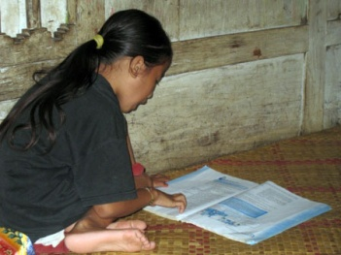
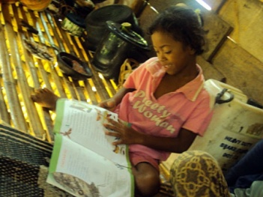
Picture Box 10. Absenteeism impacts on attainment
2nd Grader fluently reading 4th Grader material
2nd grader looking at book but can’t read

Nevertheless, children are genuinely required to help for short periods of work (a few days) on the farm at key points in the season, such as planting and harvesting and or to help with nutmeg harvesting. In several villages it is well known as to when these needs arise, and teachers and parents alike wondered why schools could not be closed during these peak labour periods (particularly as teachers too have to take care of their farms). The rainy season creates enormous access problems in some areas. In East 3, the mountain road become treacherous and teachers refuse to come from the town, so school is effectively closed. In West 2, the access road to the BEP-supported school is exceptionally muddy and so students do not go when it is wet 'as teachers will not be there anyway'. Again, villagers say they can often predict rain time, and that school openings could be more flexible to accommodate this.
It is very easy for children to skip school by saying they are sick. For example, on one of our visits to a school (East 2) more than half the children were absent from classes and the teachers told us they were all sick. We were staying in or near the homes of some of these children, and we knew that they were not sick. Children who are class 'captains' are expected to mark children who are not in school as 'sick' in attendance registers and some children complained to us about captains who had marked them as 'absent without notification' instead.
Some children have to look after their siblings while their parents are away working (e.g. in plantations or on their own farms). This may affect their attendance. For example, the children of one HHH (East 2) are usually looked after by the 15 year old brother, while his parents stay at the farm shelter overnight. However in the course of chats with him, his friends and neighbours, it transpired that the youngsters often stay watching the neighbours' TV until 1 or 2am and the children either skip school or are very late. Another young HHH girl (Central 3) misses at least 2-3 days of school every month when her parents leave her in charge of her pre-school siblings while her parents attend the farm. One girl from grade 2 SMP has now missed two months of school because she is required to help her mother who has recently given birth (see Box 21). In Central 2, parents are very relaxed about school attendance and readily accept it if children tell them that 'the teacher has given permission for me to take the day off’. Box 22 describes some of the problems faced by children whose parents work away.
Box 21. Long term absence makes returning to school hard
Cinta is 16 and studies in grade 2 SMP. She is a proven bright student according to her mother and neighbours. Two months ago, her mother gave birth to her sixth child. Her mother told us that with the new baby, she cannot take care of the other members of the family and feels unable to do the household chores. Cinta's parents asked her not to go to school until her mother is totally fit again. Cinta was unhappy about this decision because she loves school and enjoys academic study, but she had no choice. She has been running the household during the day and trying to continue studying at night. After fifteen days at home she expected that her parents would suggest she returned to school but they wanted her to wait some more days. After some time Cinta gradually lost interest in school work because she had no access to school notes or knowledge of the new topics covered in her absence. This was exacerbated by the fact that her school does not allow students to bring home text books .She has now spent two months at home and is unwilling to return to school because she feels she is 'far behind her class mates' and cannot cope with lessons. She told us gloomily, ‘I thought at least after the first two weeks my parents would tell me to go to school but now I am absent for two months. How will I face my teachers? So it is better not to go to school any more’. (Central 2)
Box 22. Schooling for a child left behind by migrant worker parents
Indah is 8 years old and lives with her elderly grandfather (widower) as both her parents are migrant workers in the construction industry in Malaysia. She is in Grade 2 SD and is bright. She spends a lot of time practicing her writing and drawing at home but does not share her school books with her family or ask them for help with her homework. She spends most of her time when not in school with her younger cousins and watches TV in the evenings and on Sundays as long as there is electricity. She rarely has to do chores. She has not seen her elder brother who has gone to live with relatives in Sulawesi for such a long time she has forgotten his name. She hardly knows her baby brother who stays with his parents in Malaysia.
Indah's costs are supported by profits from the paddy field which Indah's parents own, supplemented by very small profits from a small electric mill also owned by her parents but which her uncles who live nearby, operate. In emergencies the family will SMS for money from the parents. Indah is one of few children who does not have all the uniforms needed to go to school. On the school day we were there she wore a non -uniform muslim dress which was several sizes too small for her. Her grandfather tells us that it costs at least Rp 500,000 per year to keep Indah in school. This calculation excludes the daily requests for pocket money (Rp 2,000 per day) which she uses to buy sweets and fruits at school because she never takes breakfast before school; at times she could spend as much as Rp 10,000 in a day for snacks. Although close to her grandfather, he gets easily irritated by her and his own failing health means she spends a lot of time on her own and misses out on the kind of family affection her cousins enjoy. (East 1)

Some children skip the whole day or part of the day from school for dating or play. There is always much to-ing and fro-ing from school so absences can be disguised as official. The pre-occupation with dating in some villages (e.g. Central 3), without doubt inhibits education. Children spend time on mobile phones (even into the early hours of the morning), arrive late at school having organised assignations and are absent during the day. Even when children attend school regularly, there are many distractions throughout the day which are condoned by the teachers e.g. when a fight breaks out in the street and children rush out of their classrooms to see what is happening (West 1), or when a funeral passes and the children pile out of classes to observe (East 2), or when visitors arrive and classes stop or teachers leave the class to gossip. (West 3)
Girls tell us that they go to school to avoid chores such as sweeping and clothes washing. They are also denied pocket money if they don't go. (Central 3)

4.1.4 Hindrances
Provision of domestic electricity is both a hindering and enabling factor for education. Where there is electricity, there are TVs. In some villages there may only be four or five TVs but nightly neighbours pour into these houses to watch TV. Sometimes people are expected to pay to watch TV (Rp 500 per evening). In some villages these sessions are tightly controlled and the TV is switched off at around 9 pm (‘so that the children can go to bed’ (Central 2) but in others, children stay watching TV until late at night, sometimes as late as 1 or 2 am. Although some families seem unconcerned about this including the teacher who hosts late night TV sessions in her house (East 2), others felt that children are watching too much TV and too late into the night.
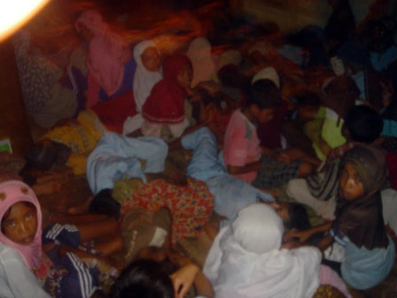
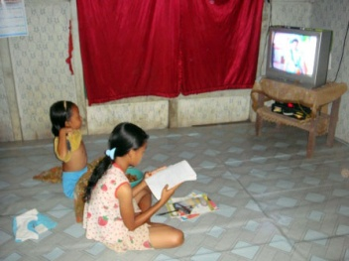
The lack of electric or other reliable light in the evenings can inhibit study. In one HHH (East 2) the children were constantly being berated to study by their parents but the parents will not pay for the kerosene for the lamps. They tell us they can only afford half a litre of kerosene every five days and there is no homework habit here. In Central 2, the electricity is off for two hours every evening. Although this inhibits homework, the habit is a little better than found in Central 1.
Picture Box 11. Watching TV
Students prepare homework while watching the TV
Falling asleep in front of the TV

The expectation to do household chores varies widely from location to location. In Central 3 girls help their families by collecting water, cleaning the house, cooking and washing whereas boys are expected to look after the horses. They have opportunities to earn by weeding the farms of wealthier villagers. Sometimes this earning is used as a reason for parents to withhold pocket money. The emphasis on helping in horse rearing may be related to the custom here of paying bride prices. Considerable dowry payments have to be made by prospective bridegrooms and horses are often regarded as the investments required to service these costs (see Box 24). These dowry payments increase depending on the education level of the bride and may act as an incentive for further education for girls. Girls in West 2 may spend as much as three hours a day doing household chores (preparing food, washing clothes and dishes) and seem accepting of this even though boys are out playing. Some teachers (East 3) ask children to help them in their farms. However, overall our observations suggest that many children (mostly boys but some girls too) are not required to do chores and may refuse to do chores. These children spend a lot of time playing and loitering.
Box 23. Watching TV
In one village (West 2) households get electricity supply for only 12 hours from 17:30. As soon as the power is on, the TV is switched on for the entire evening. The following is our experience in our respective HHH
In HHH1 the grandson (Grade 3 SMP) does not want to watch TV with his elderly grandfather who prefers to watch the news. So he leaves the house everyday at around 5 pm to watch TV with his friends, returning home around 11 pm. Meanwhile the grandfather watches TV and talks with his old friends until midnight.
In HHH2, as soon as the electricity was on, the TV would be blaring from the living room. Children and adults alike were glued to the screen following soap opera programs. Relatives would come over and watch the shows together with the host family. The adults would chat and gossip while the children did their homework while simultaneously watching their favourite shows. The TV was still at its loudest hours after the children went to bed at 9 pm.
In HHH3, the married sister is quite disciplined in keeping their father’s rule regarding watching TV. It is on only after 6:30 p.m. until around 9-ish, which is the children’s (four aged between 5-13 years) bed time. Female neighbours who usually visit together with their children to watch have to follow the same rule, so there is a strong understanding among them. After seeing the children of the house preparing for bed, the neighbours immediately say goodnight to one another and leave the house without the host having to tell them to.
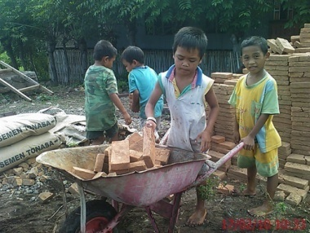
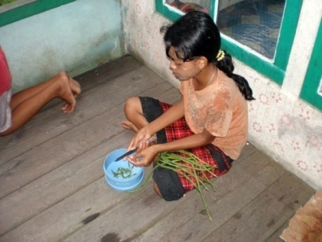
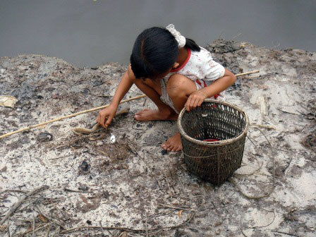
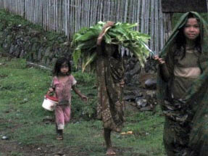
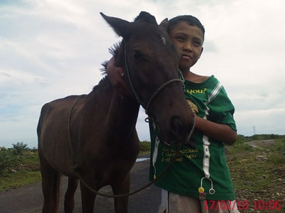
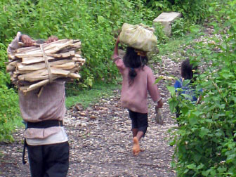
Picture Box 12. Doing chores
Box 24. In Debt for Paying Cost for Wedding
Many poor families have a huge amount of debt in the Central 2 village. The debt results from local traditional customs in which people are obligated to contribute to the wedding being held by their relatives. The tradition is a symbol of solidarity, but nowadays it has become a long term investment amongst relatives with each family keeping a record of money or goods they received from a particular relative and therefore what should be their obligation in return, ensuring that their contribution will be equal to or more than the amount received. The Wedding contributions are part of the bride price (uang naik) in which the groom’s immediate and extended family and friends must pay an agreed amount dependent on the social status and education level of the bride. The higher the education of the girl, the more money she will receive from the groom’s family. A girl that is only an SD graduate will receive a bride price around 10 million IDR while a university graduate can receive more than 30 Million IDR.
When poor people do not have any savings, they get a loan from a middleman in order to meet their obligations which are often up to 5 million IDR. There is huge pressure to make the contributions as failure to do so can lead to tensions and possible exclusion from the family.
The pre-occupation with dating, as mentioned above, not only increases school absences but affects sleep as mobile phones are used throughout the night to contact boyfriends and girlfriends.
Teachers are frequently absent or late (see below in 4.2. Quality). In Central 1 students are sent home regularly and particularly on Fridays and Saturdays. Some of these absences are to enable teachers to attend training. Sub- cluster training is provided once per month and many schools close all day to enable teachers to attend this training. In West 3 several teachers are currently taking Master degrees and are absent, rarely arranging substitute teachers to take their classes.
4.2 Quality
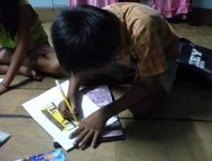
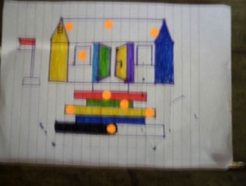
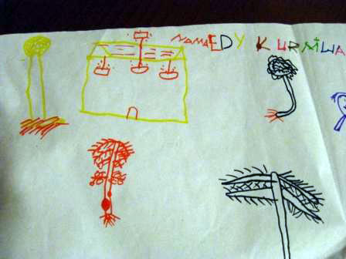
In all our study villages, people initially describe a 'good school' in terms of the quality of the buildings and physical facilities. The following are typical remarks; 'a good school has a nice building' (mothers East 2), 'it is big and new... that's why we prefer to send our children here' (parent East 1). Very rarely when children drew pictures of their dream school did they include anything going on inside the classrooms (see Picture Box 13). Instead showed the classrooms, (sometimes libraries and laboratories) but concentrated on beautification: the more trees, flowers, fountains, fish ponds and colourful paint, the better. One child had drawn his dream school and was encouraged by the study team member, 'You can draw anything you want’. ' yes ', he said, ' I want the walls to be yellow’. Peri-urban school students suggested computers ('like city schools' (Central 2) and TVs ('so we can watch sport' or 'we can watch TV in the canteen' (East 1) while libraries with books, electricity connections and sports facilities feature among rural dreams. A few parents suggested that teachers should be 'good' but could not explain what qualities were associated with this. As indicated in the section on Access above, “good schools” are also those where children are happy and have fun and forge friendships.
Picture Box 13. Dream Schools: Children draw dream schools which always emphasise the physical appearance rather than what might change inside

Interacting with children, it was clear that children in some areas are struggling. For example, in East 2, those attending the new BEP-supported school only understood the simplest Bahasa Indonesia, and virtually no English. Those attending the SMP on the mainland could converse more easily in Bahasa Indonesia and had slightly improved English skills.
In many areas, parents have little or no experience of school themselves. While many tell us that they want their children to do better than they have (educationally and income-wise), they know very little about how to judge the quality of an education. Teachers tend to be regarded with high respect in the village, and parents do not feel it is appropriate to question their skills or competence. Few of our F/HHH follow-up on their children's progress at school. At best, they may read the report cards brought home and tell us 'we encourage them to do well but don't punish them if they don't ' (East 2 father). The following typifies answers given when asked what parents want from the school. 'I want my children to be well behaved and with some knowledge' (East 3 mother).
Teacher attendance is irregular in most of our study schools. Lateness in the morning is endemic although the degree of 'acceptable' lateness varies from half an hour to two hours (e.g. in East 3 children told us school starts at 7am, we observed them on two consecutive days -they mostly arrived by 7.30 am but no teachers arrived before 8.30 am and the school finally started at around 9 am when the Head arrived). Teachers told us themselves that it was alright if they took time off or arrived late 'it doesn't matter' ,' I have permission to be late' and 'the honor teachers will cover for me'. In one school, the teachers had claimed to parents that there was a two day government holiday the previous week when there was not, but still the school was closed anyway. In others, children were regularly sent home or remained on their own (e.g. teachers left school to attend a village funeral with no one to cover for their absence (East 2).
Box 25. Long journeys to school for what?
Three Grade 1 MI students walk for an hour and a half from their sub village to school every day. On Friday we chatted to them as they sat outside the classroom around 10am. They had spent the first part of the morning helping to clear the cemetery. In the course of talking to the Grade 2 teacher she told us that Grade 1 teacher had not come to school that day. There were thus no classes that day and the girls walked one and half hours back home (East 2).
On day 1 , 19 (out of 34) students at the BEP supported SMP were at school, arriving between 8 and 8.30 am although several told us that school should start at 7am. Assembly was finally run in front of the SD at 9-ish when the head teacher arrived. The SMP students filed out to their classes at about 9.30 but there were no teachers. They loitered around the building for an hour until there was an official break when they played volley ball. School was dismissed at 12.45 and we saw only one teacher sitting for a while in the teacher's room but not in class. On day 2, only 12 SMP students came to school, which again started late (8.30 am ) and the Head did not arrive until 9 am . The sports teacher took them for a volley ball session but no other lessons were held. We talked with a group of SMP students returning home after school and they told us they had at least an hour's walk through the forest to go home and then they would be working on their parents’ farms (East 3).
Even when teachers are at school, we observed many sitting outside their classrooms or in the teachers’ room smoking, chewing betel nut, using mobile phones and chatting. Children wandered in and out of classrooms without any apparent discipline. There were noticeable exceptions to this, and we met and observed some highly committed teachers. These teachers were often picked out by the students as their favourites. These teachers were described as 'fun', 'joke a lot', 'have good sense of humour' , 'friendly', 'rarely punish', 'explain things clearly' , and 'give examples when explaining'. More often than not these were young teachers and it was the older teachers who tended to be associated with 'giving punishments', 'getting angry', 'not having energy' or ' only reciting things from the book and don't explain things' (see Table 5 above) . For example, children told us how the maths teacher sets assignments on the board, and then retires to the teachers’ room to take rest and smoke (Central 3). Some teachers belittle children: ' learn this by yourself, I cannot be bothered to teach it to you' or 'how come you do not know a simple thing like this?’ (Central 2). Teachers who 'don't give homework', 'look clean’, 'attend regularly’, 'speak clearly' and 'are easy on scores' are also preferred. Students also told us they do not like teachers who expect them to do chores for them. In one school, the teacher brings her baby and gets a student to look after it for her (Central 2). More children expressed a preference for female teachers over men, saying they are 'more friendly’, 'it is easier to joke with them’, 'they are clearer', 'they are more patient’, 'they don't get angry' and 'show more affection'.
Although there were always many teachers employed at all our study schools and very low student-teacher ratios, teachers told us they were often expected to teach outside of their subject competence. One honor teacher who has been required to teach English because he is the only one who can speak it at all, pleaded to us: 'if you have any way you can tell the authorities that this school needs a proper English teacher, please tell them, as I feel my capability is not good for students'. Another, who is trained to teach religious studies, is teaching English because she has completed a private one year English language course. We observed basic errors in the work she marked. SD teachers are currently expected to teach in the SMP section of SATAPs.
The discussions on the position and role of guru honor were mixed. All schools have many guru honor teachers, sometimes hugely outnumbering the PNS staff (e.g in the SMP in East 1 there was only one PNS teacher). Guru honor themselves seemed confused about their status and many had been contracted locally on this basis for many years. The honorarium they get is very low (around Rp 5,000 per hour) but they tell us that they are prepared to put up with this in the hope of being able to become PNS one day. They also know that being a guru honor confers status in the village and they may be approached for other work (e.g. government or NGO project work) on the basis of their demonstrated commitment as teachers. However, they are treated as junior staff in schools, are less likely to attend training than certified teachers and quite likely to be exploited by PNS teachers (‘We can relax a bit now' a young PNS teacher (East 1) told us because there are more honor teachers. ‘He (the PNS teacher) told you that he is the guardian of grade 4 but he doesn't do any teaching. He makes me do it all for him (honor teacher, East 2). Box 7 describes an extreme example of exploitation. Because honor teachers may service several schools (particularly in peri-urban locations), they have high travel costs, complain of being tired and stressed. Those who travel between schools are less likely to give homework, less likely to use school resources if they are available and may see a particular cohort of students for only one session a week. Nevertheless, the flexibility for schools to employ honor teachers at local level is critical to ensuring that these schools operate at all. Local teachers are often preferred by students and parents and the loss of these once they are certified (as they rarely get posted in their own locality) is felt acutely. Box 26 describes the difficulties guru honor face trying to get certification.

Teaching resources
Box 26: determination to become a certified teacher
Sinta told us of her struggle to be a teacher in an SD. 'I never imagined I would ever be a PNS teacher as I had heard that one has to pay a Rp 55 million bribe to get such a job... but I have done it without a bribe' . She is very hard working and resourceful. She has had many jobs; she did a sewing course to get a job in a garment factory but could not get a job, she has made handicrafts including baskets made of coconut leaves, has taken in tailoring work, worked in construction and for a while in an NGO project. She got her first teaching honorarium job in the madrasah in 2003 working there for 2 years, followed by three years in the SD.
Finally, she managed to get a place in college and a new job in the local 'model' SD where she currently works. With a young baby whom she still breast feeds, full time teaching job and traveling to University on weekends to complete her 5-year under graduate program, she has finally decided to give up taking in tailoring jobs. She feels very happy that she now makes Rps 1.9 million per month but told us she feels very tired and often feels perhaps she does too much (East 1).
There is a shortage of textbooks in all our study schools and teachers always mentioned this to us as a major problem. The problem is particularly associated with SMP level. This, they say, is exacerbated by the frequent changes in curriculum so books go out of date quickly. In the worst case scenario, students in all grades use the same textbook (just thirty five copies of a science text book) so it is used to teach reading skills in the lower grades and subject content in the higher grades. Children in SMP levels told us that they share textbooks and we observed this for ourselves (see Table 6). All schools insist that the text books remain at school. In only one area are text books occasionally allowed to be taken out, but children are fined if they bring them back damaged. Here the children 'on-lend' the books to friends at another SMP for them to photocopy (East 1).

Table 6. Some Observations on Presence and Use of School Resources
Location | Computer for Student Use | Textbooks for Students Use | Supplementary Teaching Aids
Location | Computer for Student Use | Textbooks for Students Use | Have | Use
E3 | No computer | 1 : 3 | Y | N
C1 | No computer | 1 : 10 | N | N
E2 | Computer but not for students | 1 : 2 | N | N
C3 | Yes, but students use it 3 minutes each per week | 1 : 3 | N | N
E4 | Computer but not for students | 1 : 1 (outdated) | Y | Y (some)
W2 | No computer | Teachers only | N | N
E1 | Yes, but broken | 1 : 2 (can take home) | N | N
C2 | No computer | 1 : 3 | N | N
W3 | Yes but for private tutoring, not use in class | 1 : 4 | N | N

In discussions about what would makes schools better, teachers, parents and children indicated that more library books and reading materials are needed (see Picture Box 14). Rather than expensive reference books which can only be accessed in supervised class time, children want to be able to take small 'readers' home to practice reading skills and to enjoy: 'We should be able to read extra books other than text books' (Central 2 students).
Box 27. The school I dream of
The following is a direct translation of a prayer written by a girl (13)
Dear ALLAH, I feel sad for my school because I think that the school is lacking facilities such as computer, electricity, and musical instruments. So we can study with facilities.
Dear Allah, Is this our fate since SD until SMP we’ve always been short of school facilities.
Dear Allah I pray that the people in high positions like the president and others can give help to our poor school.
Central 2
There appears to be a mismatch between the kinds of learning resources needed and provision. Many of the BEP schools simply do not have much in the way of learning resources. This may be a function of their relative newness and teachers spoke about expecting this situation to get better. Where the schools have other teaching resources, these are often not used. There seems to be several reasons for this:

- the resources are perceived to be too complicated:-'children won't understand;
- the resources are not relevant e.g. ICT resources (CDs etc) where there are no computers and no electricity;
- teachers are reluctant use resources if that means more time and effort;
- teachers are reluctant to use because they do not want the materials to get spoilt;
- honor teachers working in more than one school have little time to look out for resources materials;
- usually only one teacher has the only key to the store cupboard and others cannot access the materials in her absence.
Picture Box 14. Library conditions
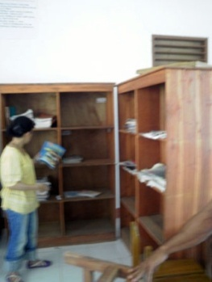
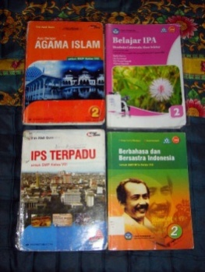
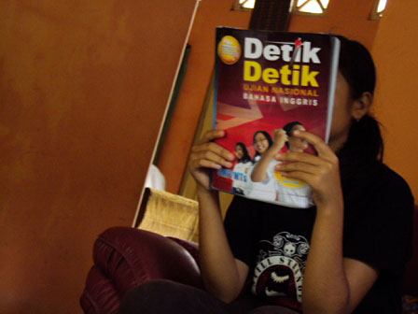

Schools have very few books in their libraries

Non BEP student borrowing book from BEP school friend

Books received by BEP SMP

1
2
3
4

Picture Box 15. ICT teaching resources to a school which lacks electricity and has no computer

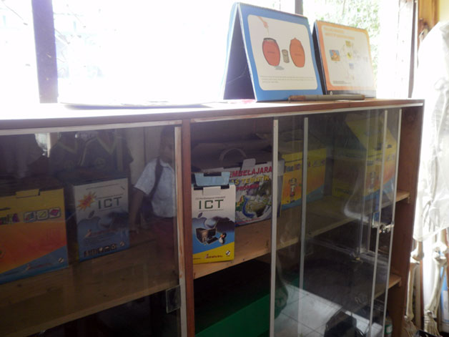

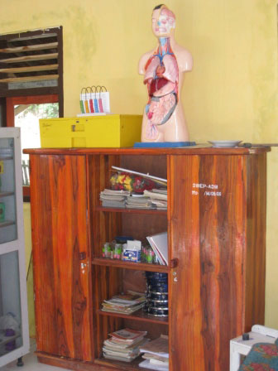
Learning resource kits were stacked haphazardly in the corner of one teacher's room (SATAP East 3). They have been there for some time and never opened. In another school these same kits were collecting dust unopened, and other materials supplied some years ago have also not been opened yet. One school (East 4) had extensive learning materials which were kept neatly away in locked cupboards. This school had benefited greatly from the support of an NGO. Nevertheless, there was little evidence that the materials were much in use. Another SD had a collection of brand new hard back reading and reference books which were still in their cellophane packages stored in the teachers' room. They have been there for six months and the teachers said that they were too complicated for the students. Our observations concurred with this - it was hard to see the relevance of these books to the children's experience and lives.
Picture Box 16. Although there are resources in the teacher's room they are very rarely used
Children told us how hard it was to study ICT when they have never even seen a computer. In one school, they have tried hard to introduce all the children to the one computer provided to the administration, but this means each student only gets to use the computer for three minutes per week.
Picture Box 17. Children and adults drawing
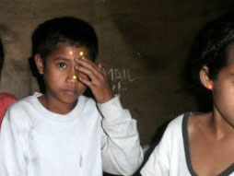
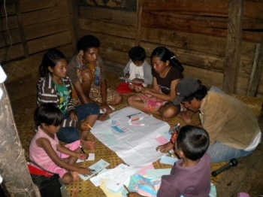
Children pounced on the sheets of paper, coloured marker pens and sticky dots we brought with us whenever we produced them. Parents and older siblings also wanted to draw and play with the materials. One HHH is a teacher and he asked if he could have the pens we brought with us ‘for my children at school, as they never have anything like this'. Some children had never seen an eraser or pair of scissors before. We asked why BOS allocations were not used for paper, pens and art materials if these were so short, and received equivocal answers. It seems that there is little encouragement to spend BOS money on consumable items which cannot be demonstrated as investments to supervisors.

Teaching and learning practices
There were many comments on the lack of relevance of education materials. English teachers (East 1 and 2) showed us examples of questions from the national exam test papers which their students could not comprehend (see Box 28). Teachers told us that they had to teach about 'planets' ‘transportation' 'climate change' which are hard for children to understand. Children from one class complained to us that the teacher had told them to make newspaper cuttings for homework, but the village never has any newspapers. Favourite classes were the ones which the children could relate to more directly from experience. IPA (natural science) was often selected as a favourite, because ' we can see the things the teacher is talking about’ and ‘we collected frogs and watched them grow'.
Students told us that teaching style is largely one-way and emphasises rote learning. Children always told us that they like the teachers who organised group discussions, and that they found the ‘one way’ teaching boring. Creativeness among students does not seem to be encouraged and when we asked children to do drawings and writing during our study, we noticed a reticence based on lack of confidence and the fear that they might ‘get it wrong’. Their schooling and exams (which are largely multiple choice format) emphasise getting 'right answers' rather than analysis or creative thinking. Drawing, children say, involves copying drawings done by teachers. No classrooms in any of the schools had any materials displayed on the walls, except some faded posters of Indonesian heroes. In no case did we see any children's work displayed in classrooms. There were some quality improvements mentioned by children in Central 3 mainly attributed to the placement of student teachers from the University for Teaching Practice. These young teachers are 'close to the students’, bring in innovations and are 'lively'. They clearly had motivated students.

Examinations
Despite the concerns about the quality of teachers and teaching and our observations of low capability, students preparing for the upcoming national examination each expressed confidence about their ability to pass. Teachers confirmed that students 'always pass the exam' and 'whether they study or not, they will all get through (East 1 teachers) and the occasional failure was due to non appearance at the exam or exceptional problems. This optimism may be a legacy of entrenched systemic cheating practices. Although teachers expressed concern about the appropriateness of the questions in the UN exam (see Box 28 and 29), they all concurred that their students would pass.
In some SMP schools the curriculum, particularly for grade 3 SMP, has been reduced to only the four subjects required for the national exam (Mathematics, Bahasa Indonesia, English and Natural Science). Extra classes are being provided in all the schools and in some cases additional fees are being charged for this. Some children have purchased student guides to help explain the answers in the practice exam papers. Some schools have charged fees for organising practice exams.

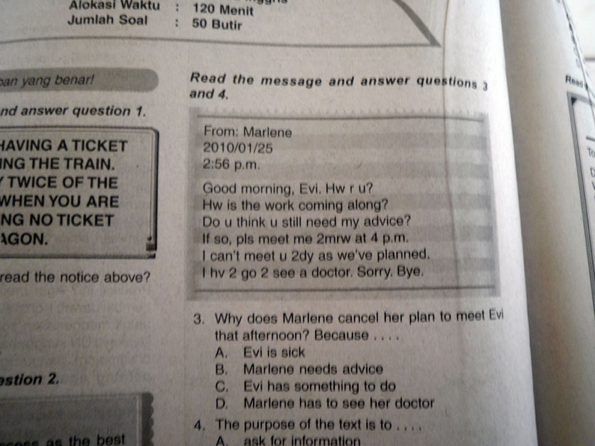
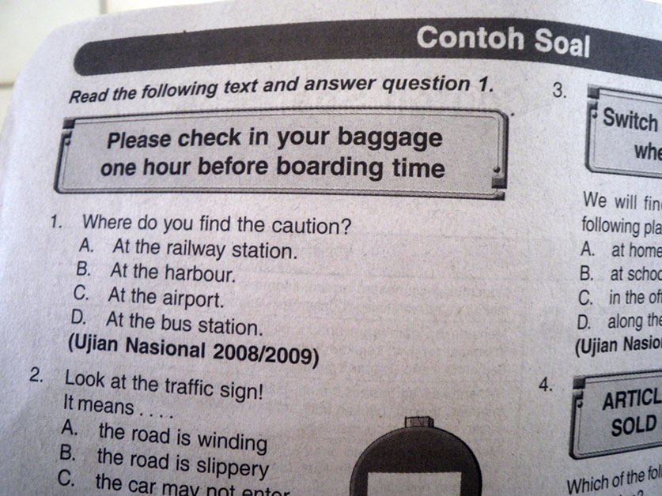
Picture Box 18. Examples of some national exam questions

Box 28: Appropriateness of exam questions?
Teachers showed us several pages of the past test papers for the UN exam practice book that they were currently working trough with Grade 9 students. Teachers said that it was hard for their students to understand English let alone the abbreviated English used in texts. Many students have no knowledge of transportation and questions which requires some knowledge of boarding lounge at the airport very difficult. An English teacher told us that one question was related to buying a stamp. 'My students have never seen a stamp before. I had to draw it on the board and explain what it was for. Then I had to explain what a post office is. How will they manage if they get a question like this in the exam?' As we sat at the back of a English after school coaching session, the teacher appealed to us to explain what was a “Charity Bazaar”.

Box 29. 'To be honest, the only way they will pass is by cheating' teacher
The young English language teacher invited me (the English team leader) to her first class of the morning (Grade 3 BEP supported SMP, East 1) ' please come and motivate them. Their English is so bad. It will be good if they talk to you'. But they could not. They struggled with basic questions such as What is your name. Where do you live? And what is your hobby? (All covered in first year Bahasa Inggris text). The task in this class was to go through a sample national test paper. Amazingly, they mostly got the multiple choice answers right and I asked them to explain to me how they did this even though they did not read the texts and could not understand them. It was an exercise in pattern recognition and guesswork. 'So will they pass the UN exam in March? I asked the teacher in private. 'Yes they will pass, but to be honest the only way they will pass is by cheating'.
Another teacher from a different but local school what she believes happens in this area. ‘It is the teachers who take the exams otherwise every student will fail! The teacher whose subject is to be examined that day is not allowed to be in school on that day, but they can falsify the names so that in fact he stays there. The outside invigilator has to cover several classrooms so when he is out of the exam room the subject teacher gives the students all the answers. This is an open secret. Everyone knows this happens- the teachers are afraid they will lose their jobs if their students fail, the sub district Education office and the district office both want their area to do well nationally. So everyone knows'.
In another SMP (East 2) the Head told us that all the students passed the UN last year except one, yet we could not converse in English with this year's grade 3 students even though the Head has insisted that the six hours a week devoted to 'Local Content’ will be English language tuition and is making the students attend extra coaching twice a week for an hour. We were invited to sit in the after school English language coaching session. The students with the supplementary student guide hidden under their desks shouted out the correct answers while the beleaguered teacher struggled himself with the vocabulary and trying to select the right answers, frequently referring to us for explanations. At the end of the session he said to us ' please, if there is any way to tell the authorities to assign a proper English teacher here, please tell them, I feel my capability is not good for the students'.
School discipline
Children often indicated that their preference for teachers was based on whether they gave punishments or not. The nature of these punishments has changed over recent years from beatings to punishments such as cleaning toilets, cleaning classrooms and grounds, physical exercise such as push-ups and running laps round the school grounds and memorising multiplication tables. Some children did tell us about corporal punishment still being meted out by some teachers and demonstrated what teachers did. This usually involved pinching (ears, waists) or slapping arms/wrists or hitting with a rod and 'rolling on the wet field' or 'standing on one leg in the full sun '. This was for misdemeanours such as lateness and 'being noisy in the classroom and, in schools which impose a strict uniform code, the failure to adhere to this code. Some peri-urban teachers lamented the GOI decision to endorse the Rights of the Child: 'we have no way to discipline children now’, 'children report us to the police for the slightest thing' (East 1) and 'we cannot do anything about the very bad behaviour of children here. One boy was violent towards a teacher but there is nothing we can do because we are not allowed to use corporal punishment. The students know that they can get away with anything. We need to keep these children at school no matter what because we have to have 20 for the exam' (school administrator, West 3).

4.2.1 Quality in School Construction
All the BEP supported schools in our study were completed in 2006 or 2007. Most have ongoing construction of libraries and laboratories and grounds- work as evidenced by building materials on site. In some cases, building materials are stored in classrooms. In all but one school, people told us that construction was delayed. The reasons were generally attributed to 'outside contractors' who did not supervise properly, or to outside workers who did not come to the site in the rainy weather and only spent short days on site. By contrast, one school in East 4, where there is a high level of community empowerment, was completed in three months.
Generally people we spoke to liked the design of the buildings and were very proud of their school. Classrooms are designed to be airy and large, but in one school with very high ceilings, teachers and students complained that they could not hear very well in class and when children were engaged in group work, the noise was deafening. There were a few other minor complaints shared: the quality of wood used in construction or furniture was poor, there was no consultation on the tiles to be used for the floors.
Maintenance of newly-built school buildings is already becoming a problem, particularly ceiling and roof condition. The use of white tiles for the flooring of schools is much criticised as it is difficult to keep clean. The walls of many schools are already scuffed and plaster is falling off partly because of poor workmanship, but also because the students do not 'take care'. Several Principals shared concerns about the huge cost of annual maintenance and worries that school premises were not adequately fenced.

4.3 Governance
Teachers told us that supervisors come to the school at best once per month. The visit is always pre-arranged, and the school receives a letter to indicate when the visit is due. Teachers told us that the supervisors check some of the teacher’s lesson plans and sometimes observe some of the teachers. When one teacher was asked what sort of feedback was provided, she found it very hard to remember any. Finally she said 'yes, I do recall one male teacher being told to speak slower once' (East 2). We were told that the external school auditor spends only a few hours in schools when the provision is for six days (East 1).
School Committees in all our study areas except East 4 appeared to be minimally effective, if indeed they functioned at all. In some cases neither teachers nor parents could name members of the school committee. In some other cases, the school data boards supplied to all schools have not been filled in with this information. Where the composition was known, the membership comprised people with status in the community and was not dependent on them having children attending the school. (In West 3 all the members are political appointees). If these Committees have any function at all, it is to meet annually to decide the allocation of BOS, but more often this is decided by the teachers or the Head alone. The difficulties experienced in village involvement in the school committee are highlighted in Box 30. In Central 2, parents told us that if one opposed decisions or tried to raise concerns in meetings, one might lose the benefits the school provided and would then not be invited to subsequent meetings.
In some villages the leadership or administration is very powerful and does not encourage participation. For example in Central 2, the village administrator has held this position for more than 30 years, and intends to pass it on to his daughter. He takes the credit for all the development in the village including the BEP-supported school. In Central 1 the village leader is also very powerful and makes all the decisions.
In one village, the School Committee (which was equated with the temporary Construction Committee formed during the construction period) was dubbed a local dialect name which sounds very like the word 'committee' but instead also implies that members are 'looking for money'. There is mutual distrust expressed in several locations where the community has assumed that there has been misappropriation of money and the school administration accuses the community of theft of materials. (See Table 7).
Box 30. Community involvement; intention versus reality
Despite the intention to involve communities in education through the establishment of project and school committees this has rarely seemed to occur in reality in our study sites. Even where residents understand and support these principles there are obstacles to their optimal functioning. Pak Joni (45) explained in detail some of the problems he faces. He is a very active member of his community and is serving or has served on various local committees. He had been a member of the BEP school building committee, which oversaw the construction of the SMP building, and is currently a member of both SD and BEP-SMP school committees. (His youngest child is in the SD and his eldest in the SMP). Pak Joni was not a typical member of his community, in the sense that he was relatively much better educated and more exposed to outside ideas. He had graduated at senior secondary-level and had worked as a teacher, a fisherman, a worker for a service company in Kalimantan for over eight years, a village administration staff and a farmer.
Pak Joni told us that during decision making in the various local committees, the community representatives on the committees barely had anything to say and tended to just acquiesce to the opinions of government officers from outside the village or external facilitators ( project staff). A typical local committee member would not have the confidence to have—let alone openly state— his own opinion, feeling that they did not have adequate knowledge to make a point. Pak Joni, an ardent supporter of self governance and the principle that the locals know what is best for them, would usually speak up, sometimes arguing against the opinions of the outsiders, but then found his own people not supporting him and even criticised him for 'not knowing his place'. They felt that a local person should 'defer to the wisdom of the outsiders'. (East 2)

Table 7. Perceptions of the Quality of Education
Perceptions Of… | W1 | W2 | W3 | C1 | C2 | C3 | E1 | E2 | E3 | E4
Teachers Commitment | H | M | M | L | M | H | H | M | M | H
Level of transparency in allocation of resources | L | M | L | H | L | L | H | H | L | H
Interaction of school with community / parents | L | L | M | L | L | L | M | L | L | H
Inclusion of poorer children | L | H | M | L | M | M | M | M | H | M
Key: H=high; M=Medium; L=Low

In East 4, where there has been a history of community empowerment initiatives supported by an INGO and Government programmes, the School Committee meets regularly. Community members including poor parents are said to actively participate in decisions. Here parent teacher meetings are held each semester and are well attended. But in other villages, people tend to go to the school for celebrations only.
BOS was mentioned in many study sites, but not always with much clarity. Families expressed confusion over the allocations made, e.g. one poor HHH (Central 2) does not receive an allowance they say because they are 'not native to the village', another HHH (West 2) complained that the school has said they are going to spend the BOS money on uniforms but she knows from relatives that in some areas poor children get cash allowances of Rp 650,000. In East 2 and 3, parents could not explain the rationale for the schools providing assistance to students and said the Head made the decisions. But in East 3, the Head teacher was very confused and evasive about how BOS was spent. He said that there were cash transfers for poor students but none of our poor F/HHH received these. In Central 2, villagers believe the school has 'cut the scholarships in half'. They have been told that they will get Rp 265,000 and the rest of the allocation will go towards sports uniform and the computer laboratory. This appears to be a problem of miscommunication rather than misappropriation but has resulted in the parents feeling as though their rights have been denied. Other heads indicated that because there are so many poor children, they 'pool the money and distribute fairly. (Box 32).

The recent directive requiring all PNS teachers to teach for a minimum of 24 hours per week has led some schools to indicate that they will be retrenching their honor teachers. This is in an effort to 'save BOS money. (Central 3)
Box 31. Money required at school
The following was written by a girl (13) - it is translated but unedited.
At school we are told to pay for the copy of our school certificate and we have to buy pens, books, shoes, and clothes. And we also collect money for exam practice books and snack money and collect money for group work for example to buy brooms for classrooms, coloured papers to decorate the classroom and if we go to school sometimes we cannot buy snacks because of poverty. I’m usually late to school because I help my parents including cleaning the house, collecting water, washing the dishes, cooking and lastly bathing my little brother. (Central 3)
Box 32. Poor but no subsidy
‘I only sold 1kg of fish that I caught for 35,000 rupiah,’ said Sobirin. He was a fisherman and his only source of income of the day, which was also the only source of income for his family, was the fish that he caught for that particular day. Some days he caught no fish. As a consequence, the family lived very minimally. Their staple was just plain rice and 2 or 3 small river fishes caught by Sobirin. Their living conditions would be considered extreme poverty.
The family was well aware of the government subsidies to which they were entitled for education costs such as uniforms and books for their two boys. Unfortunately, the family was somehow overlooked when it came to the distribution of subsidies. ‘Oh some kids did get the subsidy. But not us. The more affluent ones got it.’ They claimed they had no idea how decisions were made about who would receive financial support. All they knew was that they were entitled to it, but somehow they did not get it.
As a result, the family had to scrape to afford the additional money needed to cover their sons’ school uniforms, books and stationery. They were even required to pay monthly “contributions” to the school. They also had to dig deeper into their pocket every exam time as well as at the beginning of the year as more payment was expected of them to cover the administration cost.
Since the family was not entitled to any subsidy, their boy who went to SMP had no access to text books. Not being able to pay for the original print, the family decided to photo copy some of the required books. Each copy cost them around 20 thousand IDR. Still, even with this arrangement, the family could only afford 3 out of 5 text books needed by the boy.
The following is a list of some ways in which BOS has been spent:
- Payments for guru honor (regular employment, usually about Rp100,000 per month);
- Purchase of text books;
- Provision of cash for shoes for five children who wore sandals , but 'we have no control over how the money is actually spent once we have given it' (teachers);
- After school coaching payments made to guru honor (e.g. Rp 10,000 per month for 2 sessions per week);
- Individual student fees for school student committee (e.g. Rp 7500/month);
- Small amounts of cash for buying breakfast;
- Large cash grants (rp700,000 per year paid four times per year) to a few students (e.g. 20 get this in East 2 'parents buy goats with this money but sometimes these are taken by wild dogs' (teacher);
- Assistance to sick children unable to go to school;
- Provision of uniforms (batik and sports- school specific) directly to students;
- Provision of sports clothes for the school to retain;
- one free pen and one free exercise book per student at the start of each semester (West 2);
- transportation allowance for students ( although they walk);
- cash for buying breakfast at school;
- contribution to computer equipment (though no electricity provision yet).

There is some suspicion in some areas about perceived malpractice (see Table 7). Some Heads told us they were very well aware that communities will be quick to assume malpractice and that it was important to quell rumours. However, it seems a few of these suspicions are well founded. The Head in one school was also the contractor for the school construction and used no local workers. This same Head has had a legal file lodged against him for malpractice in the use of BOS money. There is little knowledge of the circumstances of this among the villagers as they are actively kept in the dark as all decisions are captured by the village leader and the Head Teacher. Even the village secretary told us that 'we are happy a good building has been built here - if you ask me to say something more I cannot'. In another school, the Head has been fired over improper allocation of BOS scholarships after this was leaked to the local press. The community feels that allocations were made on the basis of relationship with the Head and not on whether students were 'bright or not bright, rich or poor'. In this same school, an ex-student who worked on the construction is sure that there is a difference between the school design plans and what was built. He has spread this concern around and schoolboys have stolen books from the library in protest.
Generally parents feel that they have no right or place to complain about anything that goes on in the school. This is related to the respect held for teachers and to their lack of confidence as they are less well educated. Many parents told us they never get invited to the school for any purpose. This passiveness is exemplified by the case of Central 1 where children have been promoted or held down to 'balance the size of classes’. One parent has been told that her child is being kept down because 'she is too small’ but the parents do not feel they can query any of these decisions. They themselves have only SD education and feel it is inappropriate to raise questions.
Box 33: Suspicions fuelled by lack of information
The following comments are typical of concerns raised by several villagers.
'A few years ago some people came to this village and started purchasing land. We did not know anything about it. They started construction and we came to know that there will be a madrasah. We were inspired that our children will be able to get religious education and be able to continue education. Most families of this village enrolled their children in this madrasah. But then we found that the authority is charging very high fees for admission and other fees. Soon it became difficult for the poor to send their children to the madrasah. Three years ago, the madrasah started construction of a few new buildings. The contractor came with his own workers from outside village. Although we indicated our interest to work as labourers, the contractor refused us with the comment that “the local labour will steal the materials to construct their house”. The madrasah formed a student’s brigade which provides a round the clock night watch to stop trespassing in the madrasah compound. This made us more suspicious- why the authority feels so insecure in this remote village. We were never invited to participate in any activities of the madrasah. We do not know who runs it? Who are in the management committee? From where did they get funds to construct new buildings? Some people told us the fund was given by Australia but we are not sure why Australia, being a Christian country, is giving funds for a madrasah? (Father, West 1.)

Teachers feel they have no channels either, for raising issues or problems. When they are called for training and cluster meetings, it is only to receive information from trainers and authorities, rather than to have an opportunity to discuss problems. The exception to this is Head Teachers who told us that they are constantly asking about distribution of resources for the school as well as teacher salary and condition of employment issues. They told us that they are usually told 'you will have to live with it' and there is little attention given to their grievances. Guru honor we met feel particularly unable to raise complaints about low pay, delayed payment and difficulties they face travelling round different schools as 'we would just get sacked’ (guru honor), 'there are so many honor teachers that we would just lose our jobs if we complained about anything' (guru honor). In Central 1, the honor teachers decided to mount joint action as they had not been paid for many months. They boycotted classes on the Saturday we were there and school was closed.
The student body (OSIS) if it exists, generally organises trips, camping and events. It is not perceived as an organisation which can represent student voice. 'OSIS does nothing in my school. I pay Rp 6,000 per year but I don't know what they do with it ' (East 2). In West 3, students we talked with were surprised: 'we are allowed to complain?' Most simply confine their concerns to grumbling amongst themselves. Only in Central 3 has the OSIS been involved in student protest, and this was to protest the sacking of a much loved honor teacher (following the directive that PNS teachers would have to work a minimum of 24 hours). The protest was spear-headed by the girls, and apparently succeeded in having the decision revoked.

Conclusions and Recommendations

This first Reality Check has built on the findings gathered earlier during the pilot study. The further material we have gathered through the main study shows that important insights can be gained by this approach. We found that people shared their opinions and perspectives with openness and candour. Direct observation and experience, as well as the accumulation of perspectives from many different stakeholders, helped to provide significant opportunities for triangulation of our findings, and this gave us additional confidence in the credibility and validity of our findings.
A number of key general issues have emerged from the study however it must be recognised that these conclusions cannot be generalised to the whole of the BEP or to the whole of Indonesian education.

- The targeting of the BEP towards poorer and underserved villages has been largely successful. Poverty has many manifestations, and a relatively high level of visible asset ownership can often conceal the reality of chronic indebtedness and severe cash flow problems.
- People displayed a real sense of pride in having schools in their own community, and are generally committed to sending their children to school, but they face a range of prohibitive ‘hidden costs’ if they do so.
- People have really appreciated the provision of local schools for the age group 12-15 years, because it has increased the likelihood of transition from primary school and has reduced the costs associated with the previous option of sending children to distant schools. The physical provision of schools is only a starting point for the provision of education, since a range of quality issues now needs greater consideration.
- The poor distribution of adequately trained teachers and teething problems in setting up effective school management committees, has impacted heavily on the perceived quality as well as the capacity of principals to actually deliver quality education in these new schools.
- There are few parents involved in participatory management of education services, and most do not yet have the organisation or knowledge to begin to do this.
- Many social and cultural factors contribute to non-attendance and non-participation at school, including the need to assist or at least be with the family at key points of the farming cycle. It appears however that the strongest factors in impacting on poor attendance and drop- out are peer related: peer pressure to truant, the distraction and growing social influence of TV, increasing use of mobile phones, and an emphasis on adolescent ‘dating’ that distracts children from schooling.
- Despite cost savings through the localisation of schools, accessing school for the junior secondary years still incurs considerable costs for families particularly for the many school uniforms required, the continued practice of charging fees (in some schools) and the seemingly non- negotiable demands for pocket money. Where resources are scarce, these costs force parents to make choices about which of their children can continue with schooling reserved for those with potential and those who are 'school minded'. Unless the costs of senior secondary and tertiary education can be reduced drastically, and reliably gainful employment options are available, the motivation to complete the nine years of basic education will continue to be low.
- Education quality is strongly associated in these people's minds with physical facilities and social benefits (companionship and 'fun') and there is little concern among students, parents or even teachers regarding the quality of the education process and the learning outcomes. This is in part exacerbated by the assumption that children will automatically pass the UN exam. The study provided some insight into the ineffectiveness of these exams in assessing quality in education outcomes or acting as a mechanism to raise standards.
- Quality assurance and supervision of schools is weak. Teachers are frequently late, absent and lacking the skills to use whatever teaching resources are available. The study suggests that the BEP schools that are doing better than others in engaging students in learning schools have benefitted from two influences - a critical mass of young and energetic teachers who can make change happen even where there are older teachers who are often resistant to change; and having a link with a tertiary education institution which encourages innovation and having better schools in the area which people regard as a benchmark for quality.
- The study indicates that children have the strongest voice in decisions about continuation of their schooling. Where there are employment opportunities which do not require school certification their motivation to remain in school tends to be low. Their level of interest in schooling is heavily influenced by many factors outside of the schools' jurisdiction - including distractions such as TV, mobile phones, family and social conventions (such as accompanying the family to the farm, expectations to look after younger siblings), and a growing emphasis on dating. In many ways, teenagers in these isolated and poor villages have similar interests and pre-occupations to teenagers anywhere.
- Community participation in school decision-making is low despite the “community construction model”. Decisions continue to be made mainly by the Principals and village leadership suggesting that traditional patterns of dependency and hierarchy are proving hard to break. Lack of information and community school interaction results in disinterest at best, and high levels of suspicion at worst. Consequently there are frequent allegations of misappropriation of resources and unfair allocation of resources (particularly scholarships and BOS awards). An active and representative school committee operates in only one of the study schools. This school also regularly holds parent teacher meetings. This success of this school in this regard seems to be the result of a long history of sustained external support from an INGO that has helped with developing leadership, community participation and mutual accountability.
- There is general acceptance of the status quo in schools because teachers are highly respected members of the community. Many parents themselves have little or no education and feel it is not their place to comment on education. The study describes a few isolated examples of complaints being raised by parents or children some of which have been addressed. However, more often than not little is done and when teachers try to raise their voices with their authorities they are regarded as trouble makers or told that they will have to 'live with it'.

Recommendations
While the Reality Check is primarily concerned with documenting the experiences and concerns of people in the poorest areas, the findings do lend themselves to some tentative recommendations:
- Consideration must be given to how to better attract and retain qualified and committed teachers in rural schools;
- Better provision of simple, appropriate and relevant educational materials and more interactive teaching strategies are needed so that children become more engaged and are more motivated, by their enjoyment of learning, to complete the nine years of compulsory education;
- Despite the BOS, the cost of education continues to be an ongoing financial burden for parents and targeted affirmative action from government is required for highly disadvantaged areas. In addition, it must be recognised that many of the “obligatory costs” are only tangentially related to teaching and learning (eg. costs of pocket-money and snacks at school, cost of multiple uniforms) and this is an area where truly empowered school management committees could begin to have an influence;
- School Lunch Programs in these very poor areas should be considered as a way of both improving students’ nutrition and reducing pressure on parents for providing cash each day for snacks.
- Development partners and government should continue, and maintain for the long term, efforts to strengthen community participation in decision-making across all contexts at village and district level as a necessary foundation for community involvement in school management.

While there is overall optimism and progress towards effective school operations, there are many challenges, chief of which are the lack of qualified staff and the poor teaching practices and professionalism of existing staff. Ongoing studies in the same locations with the same households over the next few years will provide insights into the way people perceive the new schools and will provide a more valid opportunity to observe full operation of the schools and gauge the impact of BEP on the current students as they graduate and their younger siblings up to SMP level.

References
- Current Thinking on the two perspectives of the PGD, Sida November 2006, Development for Policy and Methodology, POM Working Paper, 2006, 4.

- Indonesia Basic Education Program Reality Check Study; Findings from the Pilot Study, August 2009, Contractor Strategic Advisory Services, Australia Indonesia Partnership.

- Education Financing Review: Evaluation on the Effectiveness of BOS. Center for Educational Policy and Innovation Research, Research and Development Agency, Ministry of National Education, 2009.

- Bangladesh Reality Check Report 2008.

Currency exchange rates (February 2010)
Rp 8305 : Aus $1
Rp 9325 : US $1
(rate on February 26th, 2010 Currency Converter, internet)

Annexes

Annex 1: Methodology
Annex 2: Poverty Map
Annex 3: Village profiles
Annex 4: Descriptions of Host Households
Annex 5: List of people met (across all locations)

Annex 1: Methodology

Reality Check is a method of study first developed by Dr Dee Jupp and Helena Thorfinn from the Swedish Embassy in Bangladesh in collaboration with Esse Nilsson from Sida’s Policy and Methodology Department. This study was first put into practice in Bangladesh in 2007 as an initiative of the Swedish Embassy in Bangladesh and Sida (Swedish International Development Agency). Bangladesh is now at its 3rd year of Reality Check and the initiative is planned to be conducted annually for another 2 years (2007-2012).
In Indonesia, the Reality Check was piloted in August 2009. The main study was completed in February 2010. During these periods, the Reality Check team stayed with families living in poverty and conducted conversations with different family members, their neighbours and different local service providers.
The Reality Check has been undertaken in the tradition of a ‘listening study’. This is a term that covers a range of techniques that have been used by policy researchers, activists, and market researchers to engage in depth with the views of service users and clients. Listening studies have three main strengths: a) engaging in more depth than conventional consultation exercises normally allow; b) representing a wide range of diverse views on complex issues, and c) creating an arena in which frequently ignored voices can be better heard.
It is primarily a qualitative study with focus on ‘how’ and ‘why’ rather than ‘what’, ‘when’ and ‘how many’. It is not intended to provide statistically representative or consensus views but deliberately seeks to explore the range of experiences concerning health and education of people living in poverty. It complements other forms of research by providing valid, up to date, people-centred information.
Reality Check as a method is intended to be a longitudinal study and it is expected to track changes and people’s perceptions and experience of these changes, in the case of Indonesia with regard to education. Repeating the study in the same locations, at approximately the same time each year and, as far as possible, with the same households it will be possible to find out what change occurs over time.
The study team members live with host households for two nights and three days in each location. The focal unit of the study is the household, rather than individuals or wider groups. A household focus provides insights into household dynamics including those constructed by gender and age. It enables a better understanding of how information is shared and how decisions are made and acted upon.
While living with these households, team members adopt an approach which draws on the ideology of participatory processes which encourages non extractive forms of engagement. The emphasis is on a number of characteristics which differentiate Reality Checks from many other qualitative studies such as a strong focus on two-way conversations, shared and visualised analysis, listening and observation.

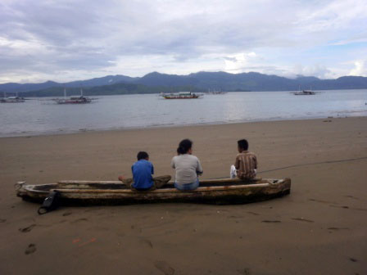
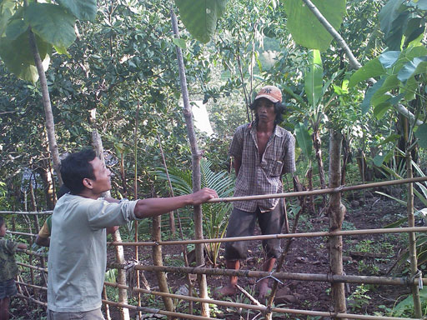
Picture Box 19. Chatting with gardener and SMP students

Conversations are conducted at different times of the day/evening and with different constellations of household members throughout the period of the study member's stay. Conversations have the advantage over interviews and some other participatory approaches of being two-way, relaxed and informal, and can be conducted as people continue with their chores and other activities (with the study member helping were appropriate) and so keeping disturbance to normal routine to a minimum. The study adopts the principle of sensitivity to people’s routines and flexibility in relation to timing of conversations.
In the field, as well as conversations, the teams use a range of visual approaches which emphasise the use of diagrams, dramatisation, and illustrations (drawings and photographs). These tools, many derived from the PRA family of tools are used to assist with the conversations, rather than as a goal in itself, often serving as an ice breaker as well as a useful means to provide easier and more comfortable ways for the families to share ideas.
Picture Box 20. Sometimes diagrams were used to aid conversations

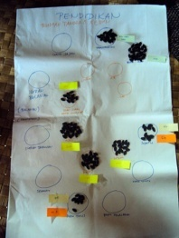
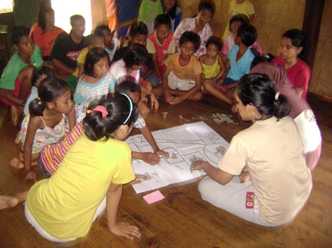
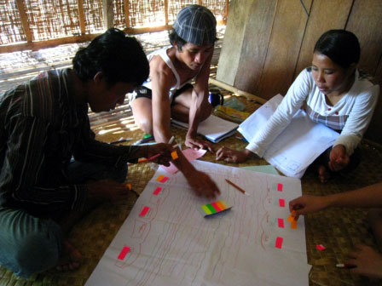

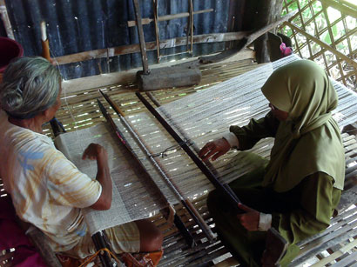
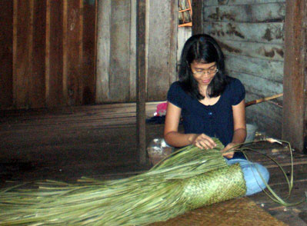
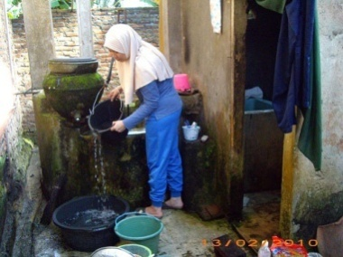
Picture Box 21. Researchers got involved in day to day activities

Conversations are complemented by observation. As the team members spend several days with their host families, there is ample opportunity to observe and experience day to day life. Inter and intra household dynamics can be understood and provide important contextual information for interpreting conversations. Living with host families builds trust and informality is promoted providing the best possible conditions for open communication.
Reality Check also uses the participant observation approach. It draws on the recent ideas about ‘immersions’ as a way for ‘outsiders’ to live with households living in poverty and, to some extent, experience their day to day life. It provides the team with opportunities to understand the context, live (to some extent) other people’s reality, experience the community dynamic both in the day and the night, observe coping strategies and witness unintended interpretations of programmes and the difference between knowing and doing.
Furthermore, in order to put the conversations with household and community members in context, the study team members observe informal and formal local education service provision and engage in conversations with service providers. This includes, for example, accompanying students travelling to schools as well as conversing with teachers, administration officers and snack vendors alike in informal settings. This type of triangulation (i.e. seeking multiple perspectives) is not only used to verify information but rather to explore the range of multiple realities among poor people.
The study also uses a cross-sectoral approach by examining experiences of the families not only in terms of education but also in terms of other sectors as well. Family decision-making does not follow sectoral lines but rather but rather involves weighing up the ability to meet needs based on consideration of a range of economic and social dimensions. Hence, taking all factors into consideration provide further insights into how households meet social needs as a whole.
Living with the poor for two nights also allows team member to insure inclusion by including ‘small voices’ and engaging with family members who rarely participate in other forms of participatory studies, in particular the elderly, young, persons with disabilities, religious and other minorities. And unlike many other studies, Reality Check also involves interaction with non-users (those that actively opt out as well as those who feel excluded).
Reality check must ensure the confidentiality of the host households as well as of the community where the study is conducted. This confidentiality is paramount to maintain trust from the people the team interacts with. Confidentiality is also a crucial aspect in a longitudinal study as it will prevent the unwanted attention for the families and the communities the team stays and spend their time with.
There are, of course, challenges to the Reality Check method of study. Reality Check never aims to cover a large sample size for information collection. It also never aims to collect information against a pre-determined and fixed check list since the method used is more conversational, flexible, circumstantial and opportunistic. As a result, the information gathered may not lend itself to comparison across households and across locations. It may be more detailed in some areas and less so in others. Individual stories are anecdotal, yet put together they represent multiple realities rather than consensus based realities which result from most forms of qualitative study. Furthermore despite interacting in depth with 29 host households the team study members also interact with the neighbours and other people in that community. As each team members usually has conservations with at least 20 people in any given location (excluding the member of the host family), we estimate that the views of over 600 people have been gathered in the course of the 2010 Reality Check.
In addition, Reality Check never claims to be the substitute for other forms of study such as the quantitative or the conventional qualitative methods. In fact, Reality Check is a complement and a supplement for these, providing a more in depth insights into the findings from other approaches and it can 'flag up' issues for further exploration using the other two methods.
The team recognises that there is a danger of distortion of information collected and jointly exercised caution not to overlay their own interpretation onto statements provided by people. The team takes time to reflect on information gathered and ensure that our own normative values do not impinge on analysis. We are also always circumspect about who provides what information, realizing that people they talk to might have their own agenda and interest in sharing information. The team emphasises triangulation as a means to reduce the risk of being taken in by such vested interest. Statements are verified by talking to many and observing and experiencing things for ourselves (e.g. if we are told the road is hazardous and difficult to walk to the school, we take the route ourselves, if we are told teachers are late we go to school and wait).
Reality Check is not a conventional evaluation where achievements are assessed against a set of normative programme intentions. Rather it is an appreciation of the day to day reality as experienced by people living in poverty and the Reality Check Team is acutely aware that to be able to do this well, they must suspend judgment and reduce influence of external bias on their conversations. There is thus a need to let the study participants take the lead in directing conversations while the team needs to maintain this ideal with a careful balance of external expectations.
In sum, the Reality Check approach, where the team stays with the community for several days, allows researchers to be particularly attentive in recording multiple perspectives and relating these to actual life conditions (immersion and observation) and to following up earlier conversations (rarely possible in other forms of study).

Annex 2: Poverty Map

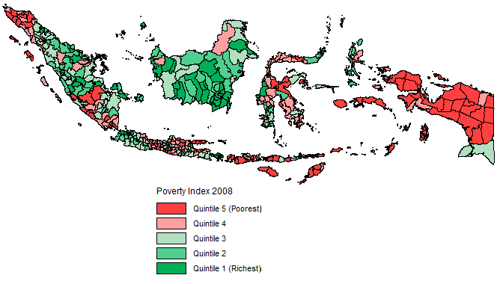

Annex 3: Village Profiles

Table 2: Our assessment of relative poverty of the locations
Assessment of poverty | West | Central | East
Poorest |  | Central 1  (remote, mountain rainfed agriculture) | East 3  (remote mountain rainfed agriculture)
 | West 1  (remote, irrigated mixed agriculture & temp work in plantation/ construction) |  | East 2  (remote but agriculture supplemented by sea-fishing)
 | West 2  (regular plantation work) | Central 3  (rainfed agriculture but with crop diversification, some migrant workers | East 4  (well organised mountain village, rain fed agriculture, migrant workers)
Least poor | West 3 ( peri urban)  (regular plantation work, former illegal timber wealth, alternative income options) | Central 2 (peri- urban)  irrigated agriculture supports two crops. Construction and transportation work in town | East 1 (peri urban)  irrigated agriculture supports three crops. Many migrant workers. Construction and transportation work in town
West (Lampung /W.Kalimantan):
Location 1:
The village of about 500 households is situated in hilly land interspersed with plains about two and half hours by road from the district town. The market is about 5km away. Our sub village comprises 170 houses, scattered over about 1 km². The main village road is a cement road in poor condition but all other roads are mud. The main occupation is farming (paddy, maize and cassava) on owned and other's land (Rp 30,000 per day). The land is irrigated and supports three crop seasons. The harvest from paddy lasts families about six months and they have to buy rice for the other six months. They grow cocoa and coffee for sale but the former is not well organised. They do not have work throughout the year and supplement their income by picking up work as day labourers on the rubber plantations (Feb- April) and construction jobs in nearby towns amounting to about one week per month of paid work. Many households keep cows, sometimes on shared basis, for fattening. The majority of households keep chickens for sale.
The community comprises local inhabitants (35%) who speak their own language and Javanese migrants (65%). There is some recent tension between these ethnic groups and no inter- marriage. The village has a reputation as the 'thieves village' (cattle thieves) which means that the village itself is crime free.
Most houses are brick and some are plastered with tiled roofs and cement floors. They have their own water wells with plentiful water. Toilets with water sealed latrines are also well built and attached to most houses. Some houses do not have latrines and these families use neighbours and relatives toilets. Every household has metered electrical connection or extension from neighbours for which they pay monthly. All houses have a colour TV and mobiles phones are very prevalent (minimum two per household). Most use firewood for cooking although some have gas stoves provided by the Government. Families take two meals per day (early in the afternoon and evening) comprising rice and leaf vegetables, tofu and cassava, rarely supplementing this with fresh fish and meat. Most households own their own motorbikes.
There is a community health centre with a permanent village doctor and resident midwife. There is an effective family planning programme here and younger parents prefer small families (two children). There is a government SD, a private early childhood education centre and BEP-supported MT. Most children do not go to the MT but to a SMP about 4 km away, using bikes and motorbikes. The SMA is about 2 km away from the village.

Location 2:
The village is about 3 hours from the district capital, a journey including a river crossing (Rp2000 pp). It is long village situated along the river. It is bound by forest and hills with the sea 2km to northwest. It is divided into four sub villages and we worked in two of these. There is one main road which is cement and internal roads are narrow and red mud. Houses are arranged in an organised grid. (The fourth sub village comprises well off families involved in the sea fishing industry).
Main occupation is working as day labourer in a new palm oil plantation. (Rp 30,000 per day for temporary workers, Rp 30,000 plus 1 kg rice per day and on site housing facility for permanent workers). The plantation site is a company sponsored boat ride away and both women and men are employed here. They leave early in the morning (3 am) and return around 4pm. Their children take care of younger siblings in their absence. Previously their main source of income was from illegal timber but this was banned in 2006. Some work in construction (on day basis), river boat driving and portering. A few are involved in petty business. Most households keep chickens to consume themselves and to sell. Despite abundant pasture land, they do not keep cows.
Their first language is a local dialect (a variant of Malay) but people speak Bahasa Indonesia. There is a problem of early pre-marital pregnancy which results in boys having to marry young and high indebtedness to support dowry demands. There are strong social connections and social interaction with people spending evenings together.
Houses are mostly built of cement, with wood plank floors (covered with vinyl) and tiled roofs but without toilets or bathrooms. Many families living close to the river share hanging toilets constructed along the river bank and use river water collected in buckets below the toilet. Those households further away from the river, have a simple toilet constructed of a wooden platform with a hole. Some use a wooden platform at the back of the house for urination and bathing. This area is also used for cooking and washing dishes. Others bathe in the open around shared wells or in the river (which is heavily polluted by the upstream bauxite mine and is saline due to sea water intrusion during the dry season). Rainwater is collected for drinking and cooking purposes. All houses have electricity supplied by the government but it is only available for 12 hours overnight. Every house has a colour TV, CD and parabola (set costs Rp700,000). Every family has a mobile phone and young people use them constantly.
Most families take food twice a day (the plantation workers take food with them and their children eat after school and the family eats together in the evening)
There is a community health post close by and a midwife clinic. Younger parents prefer small families and use pill, IUD and injectibles for birth control. There are two private early childhood education centre, one SD and BEP-funded SMP 15 minutes away from the village (along a muddy road).

Location 3: peri urban
This village is about 15-30 minutes from the district town. It comprises five sub villages with 720 families. It is located beside a river and is on the main district road. All the roads are asphalted. The land is a river plain and has sandy soil.
Earlier this was the main export centre for (illegal) timber but this has all been prohibited since 2007. Many people are still in jail. So families which used to earn very high incomes (reportedly Rp10 million per day) are now involved as day labourers in the palm oil plantations (same as location 2) earning Rp 30,000 per day. They commute weekly, living in dormitories at the plantations. Some 30% are said to bribe the police and forest rangers and continue in illegal timber trading. Others fish in the river for sale locally. A small number are involved in paddy cultivation mainly for their own consumption. Some work as construction workers in the district town.
There are two ethnic groups – one indigenous and one migrant (approximately 50:50). Both speak Bahasa Indonesia although their main language is a local dialect (variant of Malay). These communities live side by side but there are two SD schools in the same compound which cater to the different ethnic groups.
Houses are well built of high quality wood with carved ornamentation. Floors are wood and covered with vinyl or have woven palm leaf carpets. All houses have electricity, TVs and mobile phones. The houses mostly have proper toilets attached to the house but some use their neighbour’s toilet and others use hanging toilets above the river. Most bathe in the river. Filtered rain water and river water is used for drinking.
Families take two meals; one after the children come back from school (rice, vegetables (eggplant, potato and cassava) and fish or chicken) and the evening meal which is similar to the lunch. Most take tea and coffee with cassava chips or fruits after dinner. Most children do not take breakfast before school.
There is one community health facility with a midwife and village doctor who are permanently posted here. Malaria is prevalent. Many use oral pill and family sizes are mostly small (two children).
There is one government TK, two SD and one BEP funded SMP (originally a school founded by a local initiative to cater to drop out children). Two other SMPs are 1.5 and 3km away respectively. Children commute to the district town for SMA by motorbike.
Central (S.Sulawesi)
Location1.
The village is situated in the mountains and is remote. It comprises four sub villages with a population of around 1,700 (446 households). We worked in two sub villages which comprise 199 households. The village is situated about 2 hours away from the district town on a poor road with a bridge which was severely damaged two years ago by flood water and has not yet been repaired. The houses are clustered along the main road in the valley surrounded by mountains and the village is regarded as a remote area in this province.
The land surrounding the village is protected State forest and villagers illegally cleared this for farming. This was condoned on payment of a bribe to the resident forest ranger who holds enormous power in the village. They cultivate one crop of rain-fed paddy or maize (with some rainy season leaf vegetables) as sharecroppers and day labourers (Rp 20,000 per day for men and women) as most of the poor families are landless. The paddy harvest is not enough for poor families to live on and they need to purchase rice for about 6 months of the year. Farms are all within 15 minutes walking distance up the mountain. Some people provide night security in the fields of better off people. They scare off wild pigs or hunt them for sale (outside traders will buy these).
The community is an ethnic group with their own language and only educated people can speak Bahasa Indonesia. The households are arranged in family clusters with close family networks.
The houses are mostly made of wood planks with wooden floors and on stilts. The roofs are zinc sheet. Horses and chickens are kept beneath the house. Some houses have bamboo or wood slat fences. Very few houses have toilets, those that do are the more wealthy families. Poor families use the forest for defecation and urinate through the bamboo slats in the area next to the kitchen. Water is pumped from the mountain source by private individual households and surplus is then shared with neighbours. They bath in their own yards. 50% of households have electricity, half of which have their own diesel generators or solar power with only a limited number having public electricity connections (Rp 5millon required for a connection). Those with electricity mostly have TVs. There is no mobile phone coverage here. Motorbike and ojeks are the main means of transportation. One richer man owns a car which he rents out as the only means to go to the district town.
They usually take two meals per day (late morning and early evening) comprising maize or rice (very poor quality) with leafy vegetables. They occasionally supplement this with salt fish.
Poor families borrow from richer families through intermediaries at an interest rate of 50% for a 10 month loan. Although the interest rate increases if the loan repayment time is exceeded there is considerable leniency shown. There are no institutional credit facilities. Most of the poor are experiencing high levels of indebtedness.
The village has a new Community Health Clinic but there is no doctor or nurse yet posted there (one midwife was there for a short time but disappeared). This community uses traditional healers. Family size is high with 5-6 children and family planning is limited.
There is a new private TK which has not yet started, a BEP-funded SATAP in the village.

Location 2: ( peri -urban)
The village comprises 8 sub-villages (total 986 households with a population of over 3,500) and we worked in three of these sub-villages with about 100 households in each. It is on plain land about 30 mins drive on a metalled road to the district town. There is no market in the village and the nearest is 1 ½ km away (Mon and Fri) and they also go to the district town.
Main occupation is farming on own land (10% own most farmland and the rest have very little or work as day labour (70% are landless) on other's land (paddy and some vegetable cultivation further away in the hills). There are two crop seasons as the land is irrigated. Families are more or less self sufficient in rice although poorer families who are dependent on sharecropping have to buy rice for about 7 months of the year. They rear horses and goats and some keep chickens. Several men are soldiers. Some rented rickshaws in the district town and other offer ojek services. There is also construction work available in the district town and people live there for several weeks. People also break stones for construction purposes.
Houses are made of wooden planks with wooden floors and on stilts. The roofs are zinc. Families urinate through the bamboo slats off the kitchen area. They use river water which is piped to the households for bathing and drinking. Some use the supply of neighbours and some have to pay Rp2000/month. There are very few toilets in the village. One person told us there were only four toilets and that these all belong to well off people, the rest practice open defecation. All houses have electricity connections. Many have TVs and mobile phones. Many own motorbikes.
Families take three meals a day; breakfast comprises cakes and coffee and children take their breakfast with them to school or buy from snack vendors at the school, lunch is taken mid afternoon and comprises rice and leaf vegetables grown or collected from trees, evening meal is generally left-overs from lunch. Fresh sea fish is eaten frequently.
Many families take 10 month loans from Koperasi intended for business but used mostly for marriages and marriage gifts (estimated at interest rate 40%). The national programme for community empowerment runs three programmes in this village; irrigation, sanitation and credit, but there is concern in the village that funds have been misappropriated.
There is a community health clinic providing primary health care only. It opens daily but has no permanent doctor. A village doctor runs consultations once per month and fees are charged although there is a Government health card system for the poor. For more serious health problems they have to go to the district hospital which is 7 km away. There is also monthly clinic for babies. Births are mostly attended by traditional birth attendants (payment Rp 250,000 and 20 kg rice). Family size is large and the family planning programme appears to be weak here.
There are many schools; two private playschools, (which receive Government and international support), two private TK, three SD, one MI/MT, BEP funded SMP. Children stay in the district town for SMA education.

Location 3
This village is high in the mountains, on a good road about 1 hour drive from the district town. There are 632 households.
Main occupation is farming (maize, some paddy and cassava) on own farmland nearby. The maize is for consumption only. There is one crop only as it is rain fed. They also grow bananas, cucumber, tomato, chilli and leaf vegetables which they share and sell excess if the harvest is good. At this time of year there is plentiful food and varied diet. There are some farm commodity traders (fertiliser/pesticides, middlemen for crops). Some work in a private sawmill. Some people are working in Malaysia as day labourers. Others are government employees (including teachers) and ojek drivers. Many families rear cows and chickens.
Houses are constructed of poor quality wood, some portion of the floor is bamboo and some wooden planks. Houses are on stilts with zinc roofs. There are no toilets and people bathe in a separate cemented bathing area inside their yard with a standpipe. Drinking water is piped and is supposed to be paid for but they do not pay their bills. 25% have electricity connections from the State electricity supply and the poorer families all take sub-lines from their neighbours. Most have TVs and mobile phones.
They are an ethnic group with their own language and only the educated have any knowledge of Bahasa Indonesia. There are strong social bonds and families spend much time in each others houses.
They eat three times a day; light breakfast of fried cassava with coffee, lunch and dinner is rice, maize or cassava with leafy vegetables which is supplemented with fresh or salt fish twice a week.
There is no institutional credit but they take loans from well off villagers with high interest rates.
There is a community health clinic close to the village leader's house and it is claimed it opens daily but we did not see it open. The midwife lives here but services other villages so is not regularly attending this clinic.
There is a SD and BEP- funded SMP in the village.

East (NTB)
Location 1: ( peri-urban)
The village is located about ½ km off the main road to the district town on plains land. There are good transportation links to town and it takes less than 45 minutes to reach town. We worked in two sub- villages; one of 170 households and the other.
Occupations are mixed as might be expected in a peri-urban setting. Although many have small farmland this is primarily for growing paddy for own consumption as well as vegetables and fruit. They have three crops per year and are largely self sufficient in rice and some sell surplus. Men and women travel out of the village for farming and construction day labouring work. They may stay away for several days. There is a clay extraction operation near the village and people earn by loading trucks with this clay (earning approximately Rp 25,000/day) There are many migrant workers working in Malaysia (palm oil plantation), Saudi Arabia (driving/gardeners) and Bali (construction). Although this earns well the work is irregular (and some are vulnerable because they work illegally abroad) and is punctuated by periods of unemployment when the families rely heavily on their relatives, loans and food stocks they accumulate when earning. Many own chickens. A few households own small mills for grinding rice, coffee and coconut at a small profit.
There are strong family ties and many live in family units comprising several house s belonging to siblings built on inherited land. Although there is a local language, everyone speaks Bahasa Indonesian. There is a high level of divorce in the community. Young wives have their first child early, perhaps as an insurance against being abandoned by their migrant worker husbands.
The houses are mostly brick built with tiled roofs although a few are still bamboo. We were told that people put a lot of stock in appearances and that migrant workers in particular like to impress by making improvements to their houses even though they may not be able to make ends meet. Some have toilets in separate roofless partitioned areas in the yard but others have no toilet and dig holes for defecation. One sub village has piped water but there are problems with irregular supply. There are still public wells when water shortages are experienced. In the other sub-village they rely on wells which never run out. There is a public washing area beside a well which is also used for urination. Firewood is used for cooking. All houses have an electricity supply and many have TVs. Mobile phones are prevalent and in continuous use. Many household have motorbikes. There is a very high level of indebtedness and monthly repayments are burdensome.
Families take two-three meals per day. Children skip breakfast but demand pocket money (Rp 2000) for snacks which they buy at school. Meals comprise rice with a wide variety of vegetables in the rainy season. Rarely dried fish or chicken is taken.
Many households have dogs for security as theft is not uncommon.

Location 2:
In 1987 the army resettled families living in the mountains in this village in order to be able to provide services. It comprises five sub villages strung along the coast but it takes more than five hours to walk between the furthest villages. We worked in three sub villages. The two central ones are laid out in an organised grid with cement and mud internal roads. Recently built cement bridges are all broken by flood water. The village is 3hours from the district town , a journey involving a 40 min boat journey and boats depart only once per day.
The main occupations are farming (mixed paddy and maize) and sea fishing. Some farms are situated very far away in the hills. Families have to stay overnight during the growing season to protect their crops from pigs, cows and wild dogs and for those with farms a long way from the village to avoid daily commutes. There is only one crop per year as it is rain fed and the harvest is all for own consumption. Nothing will grow in the dry season and villagers complain of boredom Night fishing sometimes yields huge catches and these are traded at sea before returning in the morning. Excess fish are sold in our central sub village or dried for cattle and taken for sale in the district town. Fishermen reportedly earn Rp 200,000 /month but the livelihood is very unpredictable and is work for the young and fit. Some men have taken illegal workers in Malaysia but several have returned with bad stories and no money so this does not seem to be an occupation to aspire to. Many have relatives in East Java and have visited for work or education but are not drawn to relocating. Many keep cattle as a financial investment (can be sold in emergencies). These roam freely in the village and a vet visits only once per year.
There are strong family bonds in the village and reportedly no crime although tensions between two sub villages led to one being burned down some years ago.
Houses are almost all built of wood in a traditional design on stilts. Roofs are mostly tile and floors are a mix of wood planks and bamboo (the latter being cheaper). Most houses have metered water supplies. About 50% of houses have recently installed toilets with their own septic tanks and neighbours share these. Only a few houses have TVs (powered by diesel generators) and reception is poor so a parabola is required. People pile into one house to watch TV each evening. Every household has a mobile phone. A company distributed a few solar panels in the village.
Most families take two- three meals per day comprising rice and some fish and kelor leaves , banana flower and cassava leaves. There is little in the way of sauce or seasoning as shallots, chillies etc have to be purchased from the market a boat ride away.
There is a pustu in the village. Each sub village has its own SD but there is only one SMP. The central village also has a MI.
One of our sub villages was at the outer margins- a 2 ½ hour walk from the central village. It comprised 70 households. Following a conflict with the neighbouring village which resulted in them burning their houses down, the Government provided zinc sheets for roofing. Inhabitants refer to the central village as 'the city'! They are considered by other villagers to be lucky as they have a natural spring well and will always have good harvests whereas other experience crop failure and they also have fruit trees. Unicef has provided water taps for most of these households although some continue to prefer to wash in the river. Unicef also provided as toilet for the school but children 'go home' rather than use it and others said they did not feel it right to use someone else's toilet and actually use the river. Two households have TV and charge Rp500 for neighbours to come and watch in the evenings. Ten households have solar panels provided by the government. The children from this village do not go to the SMP in the central village but travel across the sea to the one in the small town there.

Location 3
This village comprises two sub-villages (central one is 157 households and the second is 16 households) is situated up a mountain with a treacherous rocky road barely accessible by ojek. It takes at least one hour to reach the main road (13 km) from the village and much longer in rain. The road is muddy and hazardous in the rains and extremely dusty in the dry season. The lack of access makes this community very remote. There are some cemented internal roads built through a community work programme recently.
The main occupation is farming, most farms are within about an hour from homes but some are located very far away (3hours or more). It seems that the Government allocated mountain land to poor people who wanted to settle here in the 70s so farms are scattered. The villages were developed later so people did not have to return to the original lowland village in the dry season. The Government established a nutmeg plantation which appears communally owned but families can make Rp400,000 from gathering the nutmegs. Several (including teachers) offer ojek service which is relatively lucrative (Rp 30,000 return journey). They grow paddy (only for own consumption) and maize. The latter is a relatively new introduction and for some of our households this was the first year that they have planted it and do not know how successful it will be. There are a few migrant workers working in Jakarta in factories.
Perhaps because of the re-settlement ,the family connections are less deep rooted than in other locations but they live in peer family groups. The village has a number of security posts because crime is reportedly high.
The houses are built of wood and are on stilts with wood and bamboo floors. Most roofs are zinc sheet, partly because this is cheaper to transport up the mountain than tiles but also because the Government distributed some of the zinc sheets. There is a big variation in quality of housing with the poor living in very dilapidated houses. The Government recently distributed solar panels and batteries to about 2/3rd of the central sub village which are sufficient to power house lights at night. There were no toilets in the houses we stayed in, in one sub village there was a public toilet (not water sealed) and open wash room and in the central village some people used to use the school toilet until it broke and now practice open defecation. IN the central sub village bathing took place in the stream and waterhole. Drinking water is collected from mountain streams or tanks which store this water. Only five houses have TVs in the central village and others go there to watch it in the evenings, there were two in the smaller sub village.
Families eat three times a day mostly comprising rice with a small amount of kelor leaves and other leaves collected from the forest. Dry fish sellers come daily from the coastal town (4 hours walk away) and families occasionally supplement with small quantities of dried fish.
There is a community health clinic which was never open while we were there but a midwife is said to run monthly child monitoring sessions and will assist with home deliveries if called and collected. The only school is the BEP supported SATAP (actually two separate buildings).

Location 4
This village is a 30 minutes ojek ride up the mountain with 671 households in three sub villages. The only access is by ojek and the road is rocky and hazardous.
The main occupation is farming (paddy, maize in rainy season and peanuts and garlic in the dry season) but there are some people who are migrant workers in Saudi (maids and baby sitters), in Malaysia (oil palm industry) and Jakarta (factories).
This community have had a lot of external assistance- the National Community Empowerment Programme (PMPM) (World Bank/GOI) has supported since 2002 and Plan International worked there for 6 years ( since 1999) and the impact is obvious with well organised village committees and obvious village development (water and sanitation, hygiene training, teacher training, roads etc).
There is a community health clinic and BEP-supported SATAP in the lower village and a MI and SD in the upper village.

Annex 4: Descriptions of Host Households
HHH information- WEST Location

Site 1 | Photo | Description
HHH 1 | 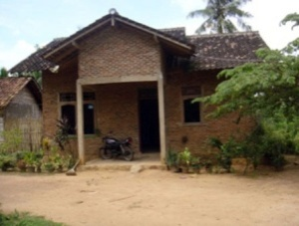 | The family consists of four members; father (31), mother (28) and two daughters (10 and 3 years). Grandfather migrated from East Java and settled in this village. Father never went to school and mother studied up to grade 9. They married in 1998. Elder daughter is a student of grade-4 in the private MT. The family inherited 20 sq. meters land from the grandfather. Father is a casual day labourer working as a farmer for Rp. 15,000 per day. However, he works only for 7 days per month as work is scarce. He also looks after his 4 cows (2 calves). His wife works as cook at the MT and elder daughter helps in cooking. She receives three full meals for all the family members and Rp. 300,000 per month as salary. Most of the family income goes for loan repayments (house, motor cycle, electronic goods). In 2005 the father joined a savings group formed by 10 members of extended family, and saves Rp. 700,000 per year. Two years ago he borrowed Rp. 3,000,000 interest free from the group for the construction of a brick house which is brick with a latrine. He repays Rp. 700,000 per year until 2012. Father never went to school but he wants to ensure his daughters are educated. His wife also dreams that their first daughter would be teacher and the second will be a doctor. The family uses well water for washing and cooking and purchases bottled water for drinking.
HHH 2 | 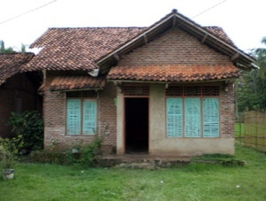 | Father, construction worker, late 30s, completed junior high education. Mother, a member of the local birth control program cadre, (33), also completed junior high. Son (13) is 8th grade student at MT. Second son, baby 2 months old. Size of house: 5x15 m², brick walls without plaster for the main part of the house and bamboo walls for the kitchen, cement floor. There are 6 rooms in the house: 1 bedroom for head of household, wife and the youngest child, a bedroom for the son, a prayer room, living room, storage room and kitchen. In the bamboo-fenced backyard are chickens and their well for drinking and other domestic purposes. There is no latrine in the house. The family takes a bath beside the well in the open. The family owns a TV set. The house has access to electricity. The house was built using credit to buy the building materials and by exchanging help with neighbours. The father earns about Rp. 250,000 per week, riding a bicycle to work, sometimes commuting for more than 1 hour to the city. As a freelancer there are times when he cannot find work. The mother sells birth control pills, for Rp. 500 profit for every pack sold. The family is a devout Muslim family, with the mother participating in regular local Koran recitation meetings and the older son sometimes giving sermons in youth Koran recitation meetings.
HHH 3 | 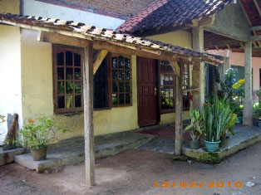 | The family is Javanese in origin but have lived in the sub-village for more than ten years. Father, 47 years old, SPG (vocational school for teachers) graduate, bachelor degree student, working as primary school teacher in another village about 4 km away. Mother, 45 years old, primary school graduate, house wife, helps the madrasah buy food supplies in the market everyday. The eldest daughter, 20 years old, 3rd semester in Islamic University, Solo (Central Java). The second daughter, 17 years old, 10th grader in Islamic high school at Metro city (2-3 hrs drive), where she boards. Son, 15.5 years old, 9th grader in BEP-supported boarding Madrasah (Pesantren). A cement-built house with plastered walls and cemented floor has a living room, TV room, 3 bedrooms, dining room, kitchen, and washing/laundry area at the back. An extension is linked to the dining room; a two-storey building with 1 bedroom upstairs and 1 living room downstairs. They own a large piece of idle land on the northern side of the house. In total, main house + idle land, is around 400 – 500 m2. The family has 1 motorcycle. Water supply comes from the well, which used to have a working pump. They cook with gas-stove provided for free by the State. The family’s sole income is the teaching salary; daily-meals are provided from bonus of provisions bought for the madrasah. “To tell you the truth, though I am a bit embarrassed… but you’ve asked, so here it is: most of my income is sucked by the children’s schooling needs. I almost have nothing left, even to buy my wife new clothing. But that’s OK, it is a sacrifice for a better future for all of us,” the father confided. Income-expenditure portions are as follows (by seeds exercise): “After the children enter their teenage years, we don’t have sufficient knowledge in religion to guide them at home and protect them from peer/environmental influence. At the pesantren, there are people who are just right to give such guidance. At home, our children would only be spending their time in front of TV or just hanging out outside with who knows whom,” the mother said.

Site 2 | Photo | Description
HHH 1 | 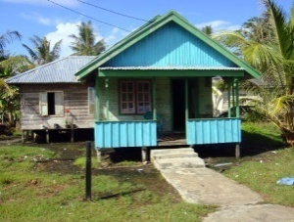 | This is an extended family with elderly parents, a married daughter, an unmarried son and a grandson. The father (70) is a retired primary school teacher and mother (65) is a housewife. The married daughter lives in the same house with her husband and children but they eat separately. The unmarried son works on a mercantile ship and stays only during holidays. The grandson is the son of the elder son and is in 9th grade in SMP BEP. The pension money of the father and contribution of unmarried son are the two main income sources for the family. The education expenditure for the grandson is provided by his father who lives nearby in a separate house. Because of limited income, the family cannot afford to eat three meals a day. They mostly eat rice with leafy vegetables and sometime fish. The homestead land is 20x35 m²; the four room timber house with kitchen has a wooden floor. They use rain water for drinking and river water for other domestic purposes. No toilet facilities exist in the house and they use a relative’s toilet hanging above the river. A colour TV, DVD player, a few chairs and a very old model radio are the only assets.
HHH 2 | 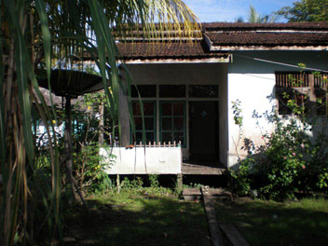 | The family consists of 5 members. The mother is in her early 40s, has been divorced from her husband for 10 years now. She divorced her husband because he had a gambling problem. He now works in a gold mine and they seldom speak to one another. The mother works as a snack vendor at palm oil plantation from 3 am to 3 pm. The snacks that she makes are mostly rice based snacks and cakes. In a month, she can earn up to Rp. 2 million. She only completed SD. She also owns a small patch of land, harvests once a year and yields up to 56kg of rice. She usually sells some of the harvest and keeps the rest for her snacks. She manages to save up to Rp. 500,000 a month but she frequently lends money to her relatives which is rarely repaid. Her oldest boy (21) dropped out of school after finishing 5th grade of elementary, following his parents’ divorce. He initially worked to help his mother; now he finds whatever work he can but mostly he cuts and shape wood for sale. Her second son, (18), is still studying in a MT across the river. He plans to go to MA to study information technology and to then find a desk job using computers. For this son’s education, the mother spends Rp. 250,000 monthly. Her 3rd child is a girl, currently studying on the 7th grade of BEP-SMP. Her favourite subject is English and math and she aspires to be an English teacher. D helps her mom by doing chores like cutting vegetables for dinner and washing dishes and looking after her younger sister. Bu S’ youngest is a 10 year old girl, studying at 4th grade elementary school. The family owns a 30x10m piece of land with 16x7 meters wooden two bedroom house. The floor is covered with plastic carpet. One bedroom is used by the oldest son, and the other is shared between the mother and the two daughters. At the back of the house there’s a semi open platform where the family cook with fire wood. The same platform is also used to wash dishes and bathe. As the family does not own a latrine, they either use the same platform or a relative’s latrine. The family owns a TV set that is switched on from 6 in the afternoon until around 11 in the evening. They also have access to electricity but it is only on from 6pm to 6 am. They eat meals twice a day, excluding breakfast and they drink sweetened tea a lot. The family uses well water for bathing but collects rain water for drinking.
HH3 | 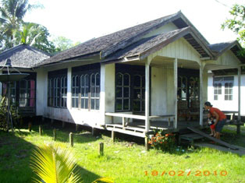 | The family has 11 members although only six reside here on a daily basis. Father, in his 50s, a 3rd grade drop-out, owns a food-stall/shop in the palm plantation; Mother, 40-ish, a 3rd grade drop-out supports him everyday in the food stall. Daughter 1 (26) educated to 6th grade has 3 children, taking care of the house when other adult members are away from home. Her husband educated to 6th grade, works in gold mine, comes home once a month. Their children are a son 1, (9) (from her first marriage), 2nd grade in village SD, who is repeating this year, daughter (6) has just joined village ECED and son (1). Eldest son (20) SD graduate, supplies timber for construction at the same palm plantation, is home once a week. Daughter 2 (18) works in the canteen at a bauxite mine also returning home once a week. Daughter 3 (14) 7th grade in BEP-SMP. Daughter 4 (11) is repeating 3rd grade in the village SD. The wooden house has plastered walls and wooden floor covered with plastic. There is a living room without furniture, a TV room without furniture except the TV & DVD set, a room dedicated for ironing, a big kitchen without dining room (eating is always done on the floor), 3 bed rooms, and a washing area at the back of the house without latrine. Father has to prepare Rp.7 million per month for the stall’s working capital, but could profit as much as Rp.17 million at the end of the month from all the customers who are buying from his stall on high price credit scheme – “Just wait until a couple of years more, everything will be like when it used to be when the timber business was still on,” he said. While the son earns about Rp. 5 million per month and daughter 2 earns about Rp 1.5 million, they don’t contribute to the household expenditure.

Site 3 | Photo | Description
HHH 1 | 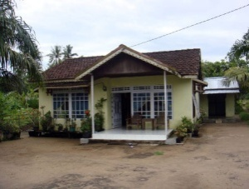 | The family consists of four members. Father (35) is a casual agricultural labourer, sometimes fishing from the nearby river for others or working at the plantation in the hills. On average he earns Rp. 30,000 per day but the income is not regular. Mother (32) runs a morning snack shop opposite the house. She earns Rp. 20,000/ 30,000 a day by selling snacks in the shop. The father has a half-hectare of cultivable land for paddy and cassava. Until 2007 father sold timber in the now illegal timber industry. He regarded these times as his golden era. Before 2007, he built a beautiful house with very good quality wood and purchased furniture, TV, DVD players, freezer, motorbike and utensils. The land for constructing the house was a gift from his father-in-law. The house consists of a living room, two bedrooms, dining room and kitchen. Elder son is in grade-8 in SMP BEP and younger daughter in grade 5 in SDN. Son bicycles to school and father drops the daughter to school with his motorbike. The family spends most of their earning for purchasing food followed by phone cards and electricity bills. Both father and son use mobile phones costing Rp. 70,000 a week. They use well water for household activities and rain water for drinking. Illness is rare for the family except fever. Father is the member of an informal savings group and saves Rp. 30,000- 50,000 per week. The group distribute the saved money to the member through lottery which they can use for house construction, motorbike purchase and other purposes.
HHH 2 | 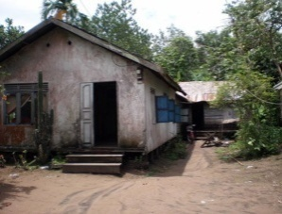 | There are 5 people in the household: father, mother and their three youngest boys (5th, 6th and 7th children). The father (early 50s) is a river fisherman: this is the family's only source of income and his customers are usually the neighbours or other villagers. He can catch up to 5 kg a day but it is not rare for him to come home empty handed. He did not complete SD. The mother cares for the family. She also weaves palm leaf carpets for the house or 'gossiping' (her own words) with relatives and neighbours. The 5th son (18 yrs) completed SD, but did not continue on to SMP and is now also working as a fisherman. He hangs around with his friends a lot in the evening at the house. They usually smoke and chat in his room which he shares with his younger brothers. The 6th son is in 8th grade of the local BEP-SMP and the youngest (9) goes to SD, 3rd grade. The family eats meals twice a day. The wooden stilt house is 10m x 5 m with a small backyard for palm and guava trees. In the front yard, there is a small gazebo where the men of the family and their neighbours send time in the evening. The family owns no latrine or bathroom. They bath in the river and use a floating toilet at the back of the 2nd daughter’s house across the street. They also wash clothes and do dishes in the same river. The family owns an old black and white TV. The father owns a bicycle which the youngest son uses to go to school every day. Food accounts for more than 70% of their expenses with 10% for education costs.
HHH 3 | 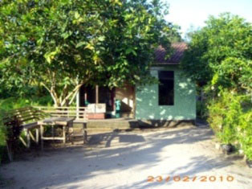 | A family of 5 members, comprising father (40s) SD graduate, who works in construction and with additional income source from fishing; mother (40s) SD graduate, housewife; daughter 1 (18) SMP graduate, at home without any further schooling or job; daughter 2 (13) 8th grader at BEP-SMP; daughter 3 (5) about to enter KG this year. The wooden house has a cement floor covered with plastic with a living room with proper furniture , a TV room with TV + DVD sets without furniture, 3 bedrooms, kitchen with wooden and kerosene stoves, and a roofless washing area at the back. They own two bicycles.“If I bought a motorcycle, I would not be able afford gasoline anyway… so why push myself to have one although almost everybody else has it,” father said. The main income comes from his irregular construction work. Expenditure is mostly on schooling, milk and pocket money for the youngest child. The mother also does irregular seasonal work as land worker, either in planting season or harvest time.

Central HHH information
Site 1 | Photo | Description
HHH 1 | 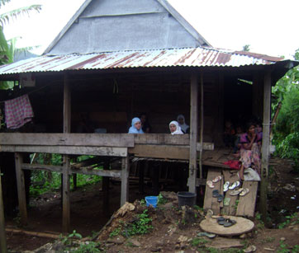 | This family comprises of 7 members. The male head of the family (70) provides manual labour to a local rich farmer. His wife (60) does casual agricultural work in addition to her household work. They have one daughter who studies in 6th grade and lives with a relative since her parents can’t manage her schooling and living costs. The elder son is 10 years old studies in 3rd grade in SD school. Their 2nd son of age 7 is waiting to admit in first grade. The married sister of 40 years of the mother also lives with them along with her husband and takes meal together. This couple also work as day labourers. The stilt tin shed house has a wooden and bamboo floor. The house has two small rooms separated with hanging fabric. They have no other land or assets. All of the HH contents (mattress, cupboard and a few utensils) look very old. They use a certain part within the kitchen as urinal without having any protection around and they defecate in open space in the jungle. They usually take meal twice a day with rice, maize, leaf vegetable or cassava. Income from manual labour: 20,000 Rp./day X 2 persons (husband & wife) x 200 days in a year provides an annual income of Rp. 8 million. They say “We never calculate earning and expenditure”. However education and household expenditure is higher than their earning and they depend on loans to cover this deficit.
HHH 2 | 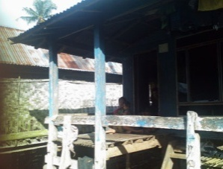 | The household consists of father (29), his wife (26), their first son (9) in the third grade of SD and their second son (11) in second grade. The father is illiterate having dropped out from school at first grade: he cannot speak Indonesian. The mother graduated from SD and can speak some Indonesian. The parents, especially the wife, is strongly motivated for the children to get better education, and they want their first son to be a teacher. The family eats 3 times a day of the same thing: salt fish, green leaves, and rice. The father earns money from farm production, planting in their own land (about 0.25 ha), earning Rp. 300,000 per month. They use all the vegetable harvest but share the rice harvest to pay their debt with the money lender. They didn’t access credit from bank or other micro credit facility from local government. The house is made from wood and bamboo with one main room and a kitchen. There is no latrine and they use the neighbour’s latrine or the small rivers nearby. The house is near the village main road but the health facility and market is far from house. The children walk 10 minutes to school through farmland and rough roads. They own few assets; only an old mattress and a simple wooden bed. They don’t have electricity using a kerosene lamp.
HH3 | 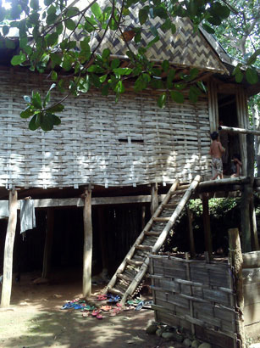 | The father (30) and his wife (26) have two sons; R (10) is a 2nd grade student in SATAP and their second son is 4 years old. The father is illiterate, never having gone to school, and cannot speak Indonesian. The mother graduated from SD but also can’t speak Indonesian. The parents, especially the wife, hopes that they will get job as a teachers, but their father wants his son to work as farm labourer or feeding horses to save income for marriage. The house is wood and bamboo without any rooms, except one for kitchen. There is no latrine. The only assets include only an old mattress and a simple wooden bed. They use kerosene lamps. Water is piped from the mountain, to the house but only runs twice a day. They have 7 chickens and some farming tools. They have farmland but this land is allocated for forest conservation, so they pay the village forest police (jagawana) Rp. 2 million to continue to farm there. This was provided as a loan by a wealthier villager at 50% interest over 6 months. They also take loans for agricultural inputs such as fertiliser and herbicide. The family eats twice a day.

Site 2 | Photo | Description
HHH 1 | 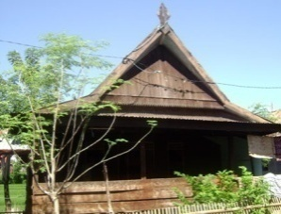 | This house is owned by woman who shares it with her elder daughter, her husband and four children. The daughter’s husband (40) is a share cropper and rickshaw rider. They use food from the share cropping for 4-5 months of the year. The elder daughter (36) is a house wife and looks after the four children including their education. The elder son studies in SMP in 8th grade while the 2nd son (12) is in SD in grade 4. The 3rd son (7) and the younger daughter (3) are going to Kindergarten and play group respectively. A good education climate exists in this family. The stilt tin-shed house with wooden and bamboo floor has incomplete windows and leaks. They have no farmland. The house consists of 3 rooms with a common space and a kitchen cum urinal close to the main house. Two cupboards, one old record player and other common house hold utensils are the only visible assets. Besides share cropping, they rear two horses on a share basis. They rarely visit doctors because it is costly; instead, they use the traditional healer. They say that every year their family expenditure is always higher than their income but they manage by taking loans.
HHH 2 | 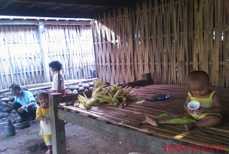 | This household has five members; husband (45), wife (40), son (15) in grade 9 in the BEP- SMP, daughter (10) in grade 3 in SD, and daughter (17 months). The house is 7 x 6m wood and bamboo house or “rumah panggung”. They have an old sofa, cupboard, and two beds but no phone, television, or radio. The road has not been sealed. The family have some farmland, but it is occupied by relatives because the family still cannot pay outstanding debts. Joint earnings amount to about Rp. 300,000 per month. In the planting or harvest season, the husband and wife work on a neighbour’s land and are paid 3-4 kg rice each per day. When there is no work in village, he goes to the main town to drive rickshaw for several months. While waiting for his return the wife sometimes has to borrow money from the neighbour to cover consumption and school costs. The house has a simple latrine, and they use electricity from their neighbour. For three electric lamps, they pay about Rp. 25,000 per month.
HHH 3 | 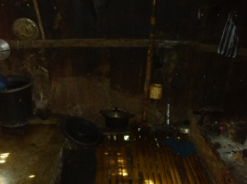 | Grandmother (70), and mother (40) spin cotton for funeral shrouds earning about Rp. 30,000 per item which they can produce in a month. Daughter 1 (18), daughter 2 (15) and son-in-law (20) all work as temporary farm labours. The granddaughter (5 months) is often sick but is not taken to the clinic. The son-in-law sometimes works as rickshaw driver in the town. The house is a temporary structure made of bamboo and wood and built on loaned land. It is not divided into rooms and there is no latrine. They own a simple wood bed and old mattresses well as a hen with 10 small chicken, 5 ducks, And very simple traditional spinning tools. Electricity is provided by the neighbour for which they pay Rp. 10,000 per month for 2 lamps. Water comes from a hand well. They have no farmland. The grandmother and mother are illiterate, never having gone to school, and cannot speak Indonesian. The first daughter and her husband dropped out of SD because of marriage. The family eats twice a day, comprising salt fish, green leaves and rice. They drink unboiled water.

Site 3 | Photo | Description
HHH 1 | 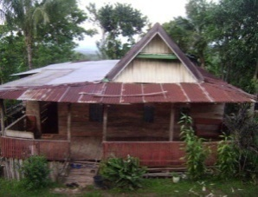 | This family consists of 10 members. The father is now 80+ and is not able to work for the family so they don’t use the 1 hectare land effectively. As a result the family is suffering economically. Out of four daughters, 2 are married and now live in the district town. Another daughter lives and works in the town. The elder daughter is not yet married and still lives at home. One son (20) is studying in town in a vocational school. The younger son is studying in the 9th grade in SMP. The elder daughter was a dropout student but managed to get her SD certificate at 28. The mother (60) is taking care of her one grandson who is 4 years old but he is extremely malnourished and looks more like a child of 1 year. The wood, bamboo and tin house on the top of wooden pillars has 5 rooms including a kitchen and urinal in the same room. They defecate in the open space in the jungle. They eat three times a day usually comprising rice, maize, cassava, and leafy vegetables. Income is less than their annual expenditure but the married daughter and son help them to make up their deficit. They have a TV, 3-4 mattresses, one old sofa, two cupboards and few household utensils.
HHH 2 | 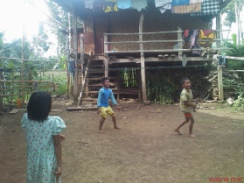 | The family comprises 7 people. The oldest is the grandmother (68). The oldest son (28) who is unmarried controls the family resources. He distributes farm works to the first son–in-law (30) and second son who is married (25). Home chores are done by the married daughter (25) and the second daughter-in-law (21). The grandson in the first grade of BEP SMP (13) helps his uncle looking after the cows. The sheet metal house is 8x15 m², with a wooden floor and has three bedrooms with wood partition for each couple. The assets include TV, a cow and a horse, 2 cupboards, old sofa in guestroom, with 0.5 ha garden and 0.5 ha farmland. Their income is mainly from the harvest of farmland, garden and profit sharing from cow rearing. The family eats the rice and corn from their farmland 3 times per day. This comprises rice and vegetables, with occasionally fish bought from daily mobile trader.
HHH 3 | 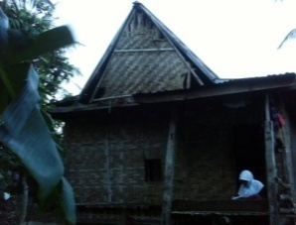 | Mother (30) and her daughter (13) live here. The other sons and daughter are married and are working in the other town. They have a temporary bamboo house with electricity from neighbour and pay Rp. 5000/month for one lamp only. They use a hand well for water. The daughter is SMP in 3rd grade. She has a hand phone. The mother is illiterate, never having gone to school, and cannot speak Indonesian. The mother earns an income from working as farm labourer at earning Rp. 20.000/day, or payment in the form of rice (2 ‘buckets’ per day, 2 ‘sacks’ for 10 days). The mother has strong motivation to send her children to school so they can earn more income with a better job. The daughter does not help her mother with housework or farming. The family eats 2 times a day, comprising salt fish, green leaves, and rice and they drink boiled water.

East HHH information
Site 1 | Photo | Description
HHH 1 | 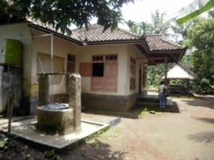 | The household comprises an elderly widower (85) and his granddaughter (8) who is in Grade 2 SD at the BEP supported SATAP. Her parents are both construction workers in Malaysia and she has not seen them for years. Her elder brother lives in Sulawesi with relatives and a baby brother lives with her parents. The one storey brick house with a tiled roof belongs to the granddaughters' parents. It comprises four rooms (three bedrooms and living room) with an attached storeroom and outside bathroom with water- sealed latrine. They have a small colour TV, electricity connection, beds and mats but few other assets. The grandfather used to be relatively wealthy but has split his land between nine children (from two wives although he actually had 7 consecutive wives). He keeps about 50 chickens which pay for his incidental expenses while the provision for the grand daughter is made through profit from a paddy field owned by her parents and offering milling services (coffee, coconut and rice). The daughter in law who lives next door cooks for them.
HHH 2 | 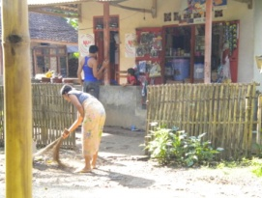 | This female headed household with son (15), student of Grade 2 BEP supported SATAP, owns a dynamic grocery kiosk which generates their own income as well as income for the family of her daughter. The daughter graduated from SD and has an unemployed husband and son (6) who refuses to go to school. The kiosk is run by the mother and daughter while the eldest son goes to the sub-district office everyday as local government honorary employee. The family also own a small cassava farm. The modest house construction is a permanent building with electricity and water supply from local water company. Just next to the main house which also serves as kiosk, there is a semi permanent smaller building functioning as a kitchen and the bedroom of the grandfather. Cooking depends on the fire wood collected from their farm. They don’t have a latrine for the family but use the public well surrounded by paddy field for washing and taking bath.
HHH 3 |  | The household is made up of a middle age couple (both in their late 40s) and their son (15) who is in Grade 3 SMP at the BEP supported SATAP. He has two older sisters; the eldest is married with a 3 year old son and lives with her family in a house opposite, while the other one is studying economics in college in nearest provincial town. The father works as an administrator in the BEP supported SATAP. The mother provides grinding services for rice, coconut and coffee. The land where the host household, the eldest daughter's house and the father's brother's house stand used to belong collectively to the father and his siblings but now he personally owns most of it. The house is a one-story brick house with tiled roof and cement floor with three bedrooms, a sitting area, a living room, and a storage room. There is a separate kitchen at the back of the house, next to a bathroom and a separate outhouse with water-sealed latrine. Firewood for cooking is stored next to the outhouse. The household owns a small colour TV, a DVD player, a sofa in the sitting area, a bed in each bedroom, and not much else.

Site 2 | Photo | Description
HHH 1 | 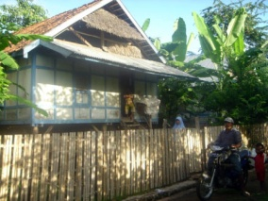 | The family has five children but the eldest son (17) is currently studying at the SMA and is living away from home. The second son (16) is in Grade 3 BEP supported SMP, third son (11) in Grade 4 SD, only daughter (9) in Grade 3 SD and youngest son (5) is not in school. The father is a farmer growing paddy and maize. He suffers internal bleeding if he does strenuous work and so has been advised by the doctor not to work on the fishing boat any more. He runs his father-in-law's motor launch three times a week to supplement his income. His wife helps on the farm. Their weekly income is about Rp. 60,000. Their house is wood and on stilts with a tiled roof with bamboo flooring as it was cheaper than wooden flooring. The house is divided by old damaged plywood to separate off a bedroom area. The kitchen is at the back of the house and has a simple firewood stove and few utensils. They have one bed, some bedding, a new wardrobe (made with wood from the mountains but costing Rp. 300,000 for carpentry work), old motorbike, old mobile phone, old karaoke set and 2 plastic chairs. They have two cows. Although they have a water tap, they use the neighbours’ water as they cannot afford metered water. They get RASKIN and BOS support as well as support from neighbours.
HHH 2 | 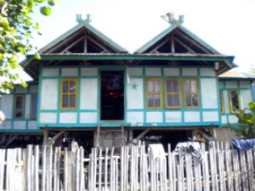 | This wooden stilt house is home for a family of 5. Living here are a community organizer father, hard working mother, Grade 2 BEP SMP daughter, Grade 2 SD son and a grandmother who mostly spends her time staying in the farm hut during this rainy season. In the evening till morning the father goes fishing together with a group of his friends. The family collects running water from the spring well in the next sub-village. There is a latrine available for the family. They keep livestock such as goats and ducks. The electricity comes from the solar panel installed on the roof. They cook with firewood collected around the hills close to the area. While the father graduated from SMP, the mother graduated from SMA level. The daughter is a member of a ‘learning circle’ consists of 4 female students from the same school at the same grade. After school hours the son plays with friends and makes constant demands for pocket money before leaving the house.
HHH 3 | 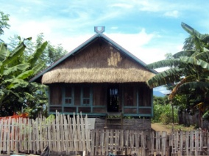 | The family of six lives in a typical stilt wooden house with zinc sheet roof. The family is the father (45), mother (37), son (14), daughter (7), the grandfather and grandmother (age unconfirmed). The father currently works exclusively as a farmer but has worked as a teacher, a fisherman, a labourer in Kalimantan, and a village administration staff in the past. The mother works as a 3rd grade teacher at the BEP SD and is pursuing her S1 degree. The second son is in 2nd grade SMP and daughter is in 2nd grade SD. The main area of the house is used as the living room; a smaller area, partitioned by a small cupboard and a large piece of cloth, is where the men sleep. Beyond the main area, separated by a thin sheet of wood, is a small storage room, adjacent to the women’s bedroom. Everyone sleeps on a mat on the floor. A semi open-air kitchen lies at the back of the house, separated by another thin sheet of wood from the storage room and the women's bedroom. Firewood is used as fuel. A small solar panel is installed on the roof to provide electricity, but the battery is broken and the household finds no compelling reason to fix it or buy a new battery. Aside from the small cupboard in the living room, a small desk and chair, and a standing shelf in the storage room, there is no other furniture. The household’s small front yard houses a public well, a public washroom, and a public toilet.
HHH 4 | 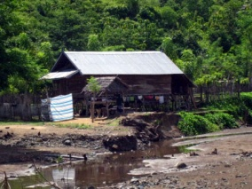 | The family consists of 7 people, the elderly grandmother (80ish), 4 grandchildren children and their parents in their late 40s. Both parents are uneducated and speak very limited Indonesian. They are farmers and in the rainy season usually spend the whole day working on the farm, a 2 hours walk from home. The eldest son (24) goes to an Islamic teaching college on Saturday and Sunday in a district town about 2 hours by boat from home. The college fee is Rp 500,000 per semester. The eldest daughter (20) is in Grade 3 SMA (Rp 960,000 per year) in the nearest sub-provincial city, where she lives with her relatives. She failed last year and now is retaking her 3rd grade. She only returns home during holidays or when she needs to get more food. The second son (14) chose to drop out of Grade 2 SMP in protest because ”my parents would not buy me new trousers” (not for school!). Now he lives and works on his uncle's farm which is “less than a day away” (probably 4 -5 hours walk). The youngest son (8) is in Grade 3 SD in their village. The house is on stilts with a wooden frame and floor and walls of bamboo. They have a tin roof which was provided by the government after the village was burned down during an inter-village conflict. The family all sleep in one large room which has two plywood walls dividing the room. The kitchen is at the back of the house. There is no electricity or furniture in the house, they only have several pillows. They do not have a toilet, but they have a tap with clean running water just outside the house provided by UNICEF. They own one goat, several chickens, and some paddy fields which enable them to be more or less self-sufficient in rice.

Site 3 | Photo | Description
HHH 1 | 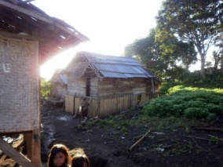 | The family comprises seven members. Mother (30) and father (early 30s) are farmers, growing paddy and maize on land allocated by the government many years ago, about a three hour walk from home. This is the first year they have grown maize and so they are not sure how much profit they will make. The rice is not enough for the family to be self sufficient. They also work on other people's farms, occasionally cut trees into planks and collect and sell nutmeg in September. Their eldest son (16) is at the BEP- supported SMP in grade 3 but on the suggestion of the headmaster is studying in the nearest town (15km away) in the run up to the national exams. The three younger boys (14, 12 and 10) all go to the SD which is next to the SMP. The fifth child is a girl (5). The family spends most of the rainy season at their farm and the three younger boys go to school irregularly and are struggling. The stilt house is small and made of rough hewn wooden planks, with a zinc roof provided by the Government. It also has a small solar panel which powers two light strips also provided by the Government. There is no running water or toilet. They wash in the stream and defecate in the forest. They have no animals except a cat to catch rats. The kitchen is part of the house. They have few utensils and use firewood for cooking. They have very few assets (blanket, mosquito net, palm matting and no furniture). They eat three meals a day but this is only rice and leaves collected from the forest or pumpkin leaves.
HHH 2 | 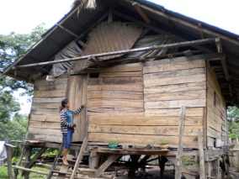 | This is a female headed family of 5 children of which the two older ones are no longer in school. The mother has been a traditional birth attendant for the last three years, while the father died from a snake bite five years ago. The third child is a Grade 2 student at the BEP supported SATAP. The house is a stilt wooden house with solar panel installed on the roof supplying limited electricity enough for light during some hours only at night. There is a kitchen at the back of the house without any latrine and water facility. They get water for cooking through a channel from the spring well. The mother works hard maintaining two farms as well as working two days a week as a farm labourer to earn cash for the family. The 2 older children help her once every three days. The two youngest siblings still in Grade 1 of SD and kindergarten enjoy playing with friends around the area.
HHH 3 | 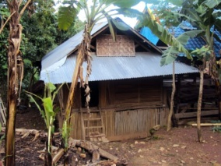 | The household comprises of the father (mid 40s), his wife (mid 40s) and his aging mother (age unknown). They have two children; both are living with their grandmother away for senior secondary schooling in the nearby district town, about 1.5 hours by motorbike on a treacherous mountain road. The wooden stilt house has a zinc sheet roof. The front area is about 2 x 3 meters and serves as the living room and a place for guests to sleep; a mattress and mosquito net is always ready in the corner of the room. Beyond the front area are two small rooms; one where the mother and father sleep, while the other is where the grandmother sleeps. The grandmother's bedroom opens to the semi open-air kitchen at the back of the house. The household uses firewood as fuel for cooking. The household is one of the only two in the sub-village with a working TV set. A solar panel installed on the rooftop provides electricity. The open-air public washroom, where a large brick tub collects water coming from a stream in the nearby woods, is situated right next to the house. The public toilet is right across the street from the house. Like everyone in the village, the father and mother work their own farm, where they plant rice (for the household’s consumption) and maize (to be sold). However, both have jobs that bring in a steady monthly income; the father works as an SD teacher, while mother works as an administration staff with the village office. For the last several years, father has to work the farm alone since mother has to stay home to take care of her mother-in-law, who finds difficulties walking. Both aspire for their children to continue to college.
HHH 4 | 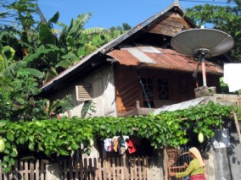 | The father (35) and the mother (32) are both teachers at the local school. The father is a PNS qualified teacher and is in his last semester studying at teacher college in a nearby sub-district town on Saturday and Sunday to be a qualified geography teacher. The mother is a kindergarten teacher and is studying at the same college three days a week to become a qualified PNS teacher. They have 5 children; a 5-month old baby, 2-year old daughter, and three school-aged children who go to the BEP-SATAP school (Grade 5 elementary school, Grade 1 junior high school, and Grade 3 junior high school). The family is one of the most well-off (monthly income of approximately Rp 2,200,000) and active families in the community. They own a farm and a kiosk attached to the house. The grandfather (who lives next door and is the tribal leader) manages the farm on a daily basis while the father and some of the children help after school hours (after 1 pm). They farm paddy and corn in the rainy season and peanuts in the dry season. The house is two-storey and made of wood with a tin roof and glass windows with many assets including: TV, DVD player, satellite, fan, kerosene stove, a wooden framed bed, bookshelf, plastic wardrobe, lots of beddings, and a motorcycle. They have electricity and have built their own water sealed latrine and three large concrete water containers.

Annex 5: Categories of people met (across all locations)

- Members of HHH
- Neighbours/members of FHH
- Members of HHH extended relatives
- BEP-school students (SMP, MTs or SATAP)
- Other school students (TK, SD, SMP, SMA, SMK, MI, MTs)
- University students
- Graduates of the school
- Dropouts from school
- Young pre-school children
- Working young people
- Stay- home mothers
- Senior villagers
- Teachers (PNS, guru honor, volunteers and contract)
- School administration officers
- School supervisors
- Principals
- Construction workers
- Snack vendors
- Warung (small store) keepers
- Village leaders
- Sub village leaders
- Neighbourhood leaders
- Village administration officers
- Village police officers
- Midwives
- Boatmen
- Motor taxi/ojek drivers
- Plantation workers
- Timber collectors

Some even have a fifth uniform - ‘muslim wear’.
A pilot Reality Check which was carried out in August 2009 included two madrasahs. The pilot findings were published in August 2009, and complement this report [Reference 2)
Clearly there are problems with the way enrolment data is collected leading to likely overstatements of achievement.
Badan Pusat Statistik, (BPS) 2007-8 –National Bureau of Statistics
The school was instead more interested in targeting just the engagement of families with Year 9 children to motivate them to ensure their child continues with their education.

