AN INDIA ECONOMIC STRATEGY TO 2035

NAVIGATING FROM POTENTIAL TO DELIVERY

# FINANCIAL SERVICES sector snapshot

## OVERVIEW

* India’s financial services sector will grow rapidly out to 2035, driven by rising incomes, heightened government focus on financial inclusion, the increasing pace of digital adoption and a large unbanked and underserved population.
* Fast digital adoption from consumers and skilled IT clusters, such as those in Hyderabad and Bengaluru, will continue driving the expansion of India’s fintech industry, which is expected to double between 2016 and 2020 to $3.2 billion.
* India’s mutual funds segment is sizeable, equivalent to approximately one-tenth of the country’s GDP. Growth prospects are good, given India’s high savings rate and its well-developed equity market.
* Despite India’s high savings rate, the country will be an importer of capital to meet its growth ambitions.
* Digital payments in India could pass the $1 trillion mark by 2030.
* Out to 2035, technological change will have a transformational effect on this sector. India is set to benefit and could leapfrog Australia while our industry struggles with legacy systems.
* Technology leapfrogging in telecommunications, rapidly expanding mobile phone penetration, the roll out of the Aadhaar card (a national biometric identification system), the United Payments Interface (a safe instant payment system) and the financial inclusion program Jan-Dhan (aiming to ensure every household has a bank account) are crucial to the future development of India’s booming fintech sector.
* Indian fintech start-ups are already encroaching on established financial services markets, developing targeted product offerings, a greater focus on customer choice and experience, and sophisticated use of data analytics. The most successful Indian fintech player Paytm has over 200 million users.

FORECAST: DIGITAL FINANCE

$950 billion boost to India’s GDP by 2025

21 million new jobs created by 2025

## OPPORTUNITIES FOR PARTNERSHIP

Australian industry can benefit from India’s financial inclusion drive by investing in segments of the financial services sector that are open to foreign participation, such as general insurance (expected to grow 13-19 per cent out to 2025), or providing services to enable investment in other sectors, such as infrastructure. Partnership opportunities will be niche, targeting the economically advanced parts of India and in segments not dominated by state-owned enterprises.

As the Indian market matures in the medium term, Australian businesses could partner with Indian financial services companies in sectors that align with our competitive strengths in asset management, general insurance and fintech. This will depend on a steep change in financial literacy in India as well as an increase in pension fund and insurance subscription.

India’s pension system is at a nascent stage, dealing with challenges related to customer awareness, penetration and regulation, but the demand for pensions is expected to rise considerably out to 2035 on the back of an increase in the elderly population and a higher life expectancy. While Australian expertise may not be transferable on a large scale to an Indian context, India’s financial services sector will become more globally connected.

Although the financial services sector and investment decisions are commercially led, government can play a role in bridging knowledge and expectations gaps. Sharing Australia’s regulatory experience and work on setting standards with Indian policy makers could also facilitate commercial engagement. Both countries would benefit from robust international standards in the blockchain industry.

There is also potential for Australian financial institutions to source fintech capabilities and skills from India.

EXPECTED ROI IN FINTECH PROJECTS

Global: 20% average expected ROI

India: 29% expected ROI (not risk adjusted)

## CONSTRAINTS AND CHALLENGES

* India’s financial services sector is heavily regulated and dominated by state-owned enterprises. Though foreign investment caps are likely to be relaxed out to 2035, structural inefficiencies and red tape will linger.
* The constraints to growth in this sector are not one sided. Australia’s institutional investment industry is, by and large, preoccupied by short term wins and incentives that work against India’s value proposition.
* Success in India will require strong local knowledge and a willingness to operate on longer time horizons than Australian financial services firms are used to, and for India to have made progress in regulatory clarity and investor protections.
* While the long-term fundamentals of the financial services sector are sound, the Indian Government’s openness to private players and foreign participation is likely to remain patchy.
* Australian expertise in financial services may not be transferable on a large scale to an Indian context because of misalignment in target markets and goal orientation. Australian industry is primarily focused on making a profit and products are geared to a sophisticated investor base, whereas India’s financial ecosystem has a marked social undertone.

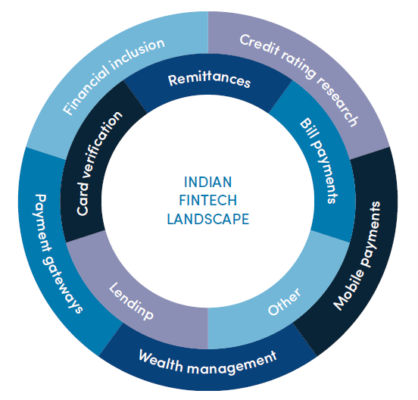

An image depicting the Indian Fintech Landscape in the centre, with two concentric circles around it. The inner circle shows Remittances, Bill payments, Card verification, Lending, and Other. The outer circle shows Financial inclusion, Credit rating research, Mobile payments, Wealth management, and Payment gateways.

## WHERE TO FOCUS

Unlike many other industries, the financial services market in India is a national market in which businesses are shaped less by the settings of state governments. Nevertheless, India does have well-formed financial services and fintech clusters.

These cities should be the entry point for Australian companies seeking to establish a presence in the market. In the medium term, Indian cities with the greatest unmet demand for capital and insurance are unlikely to offer the best prospects for the types of financial services in which Australia specialises. Australian efforts should also focus on the Central Government to bridge knowledge and expectation gaps and share regulatory expertise.

Much like other parts of the world, India’s financial services sector has a high spatial concentration in one city. **Mumbai (Maharashtra)** is India’s financial and corporate capital, housing the headquarters of regulators, including Securities and Exchange Board of India and the Reserve Bank of India.

The clustering of IT firms in **Hyderabad (Telangana)** and start-up culture in **Bengaluru (Karnataka)** has led to the emergence of a strong fintech ecosystem in both cities. Telangana is also home to T-Hub, India’s largest start-up incubator.

**Andhra Pradesh** and **Karnataka** are key states for fintech partnerships given the development of fintech hubs and strong IT ecosystems.

Recognising its wide-ranging potential to modernise the economy, **New Delhi, Kerala** and **Rajasthan** are committing to develop blockchain specialisation hubs.



An image of the Australian Coat of Arms above the words Australian Government, next to it the logo of the Australia-India Council, under both the text “Produced by the Australia-India Council”