AN INDIA ECONOMIC STRATEGY TO 2035

NAVIGATING FROM POTENTIAL TO DELIVERY

# RESOURCES AND MINING SECTOR SNAPSHOT

## OVERVIEW

* Out to 2035, India’s urbanisation, rising incomes and industrial activity will drive strong demand for greater volumes of key Australian resource commodities.
* India’s steel intensity, below a third of the global average, indicates the scale of catch-up growth in resource-use India is likely to experience as its economy grows out to 2035.
* India has significant resource endowments of its own and the Indian Government is seeking to modernise its underdeveloped mining sector and improve efficiency.
* Demand for Australian resources will be strongest where domestic Indian reserves are limited, including in metallurgical coal, copper and gold. These Australian resource exports to India will continue to make up the bulk of our merchandise trade.
* India’s demand for both metallurgical coal and copper is forecast to grow at around 5 per cent per year to 2035; over 90 per cent of this is expected to be met by imports.
* India is one of the most important future markets for Australian METS companies. As India grows and seeks to modernise its mining sector, METS demand will increase across the board. Australian equipment and services that deliver more productive, cleaner, safer mining and resources extraction are particularly of interest to India.

### AUSTRALIA’S GOODS AND SERVICES EXPORTS TO INDIA 2016-17 ($ MILLION)

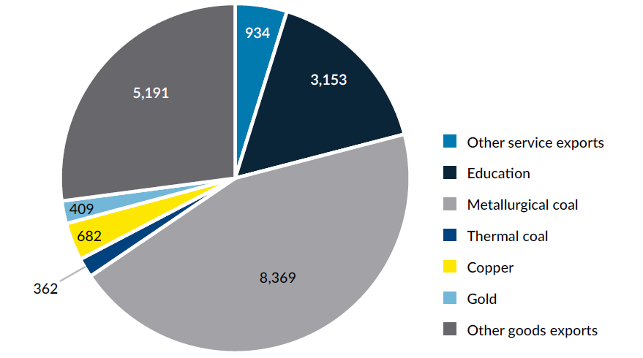

An image of a pie graph showing the following export figures: Metallurgical coal: $8,369 m, Other goods exports: $5,191 m, Education: $3,153 m, Other service exports: $934 m, Copper: $682 m, Gold: $409 m, Thermal coal: $362 m.

Source: Department of Foreign Affairs and Trade (AU). Services Trade Access Requirements Database. Canberra: The Commonwealth of Australia; 2017.

## OPPORTUNITIES FOR PARTNERSHIP

Our mineral resources relationship will continue to be dominated by exports, rather than outbound Australian investment.

Australia already dominates India’s metallurgical coal imports due to its low landed cost. While India is looking to diversify its import sources, Australia will remain well-positioned in this market given the high quality of our metallurgical coal and that we are India’s top supplier by a considerable margin.

India has limited copper ore reserves, constituting just 2 per cent globally, and imports around 95 per cent of its copper requirements as concentrates. Future demand growth is expected to be in the range of 5-6 per cent annum, which presents opportunities for Australia to increase its 12 per cent market share.

India is one of the world’s largest consumers of gold and has the largest private gold holdings globally. Reflecting deeply entrenched cultural preferences, almost 80 per cent of demand consists end-use in jewellery and household investments.

Although India has around 30 billion tonnes of iron ore reserves, limited domestic production owing to product quality, land acquisition and environmental challenges means it has become a net importer. Opportunities will continue for Australian iron ore exporters in the short to medium term, but long-term Indian iron ore import growth is uncertain.

As part of spreading risk, Australia should continue to seek Indian investment in Australian resource assets including through sustained messaging on Australian investment settings and business culture. Attracting Indian investment can bring in capital and create jobs. For India, vertically integrated investments into Australia can help smooth commodity price volatility. But inwards investment will need to be managed in light of the problematic experience of Indian companies investing in the coal sector.

Australian METS companies have a competitive edge, particularly in the coal value chain and beneficiation. However, the well-trodden path for Australian METS companies to follow Australian resource majors into markets is unlikely to eventuate in the Indian market.

The opportunities for market entry for Australian METS companies include research and development collaboration, leading to joint commercialisation and METS exports. Collaboration on education could include industry-embedded courses and research degrees.

There will be opportunities in advanced Indian mining projects for exporters of mining IT, planning software, safety, health and risk management technologies and methods, and training in all its forms.

### RESOURCES AND METS KEY COMMODITIES OUT TO 2030

|  |  |  |  |  |  |  |  |
| --- | --- | --- | --- | --- | --- | --- | --- |
| Resources | Units | Indian Demand 2016 | Indian Demand 2030 | Indian Domestic Supply 2016 | Indian Domestic Supply 2030 | Indian Imports 2016 | Indian Imports 2030 |
| **Metallurgical Coal** | Million tonnes | 52 | 90-100 | 15 | 6-8 | 87% | 90-95% |
| **Iron ore** | Million tonnes | 154 | 290-300 | 156 | 290-300 | 5% | 0-3% |
| **Copper** | Thousand tonnes | 511 | 1,000-1,200 | 26 | 70-100 | 95% | 91-94% |
| **Gold** | Tonnes | 735 | 1,000-1,100 | 1 | 2-3 | ~100% | ~100% |

## CONSTRAINTS AND CHALLENGES

* India will continue prioritising price over quality and product life-cycle costs, creating some unpredictability for resource commodity exports to India. As a result, the extent of our market share in these key commodities will depend primarily on the competitiveness of our exports against others.
* While making up the bulk of our merchandise exports, the government-dominated resources sector in India brings with it a range of regulatory barriers, which constrain commercial activity.
* Despite an apparently open FDI regime for resources, the costs associated with domestic regulatory compliance remain a hurdle to foreign investment.
* A lack of investment in exploration, and inadequate information about proven reserves, are also key issues impeding India’s mining industry with India having explored only 10 per cent of its mineral resources to date.
* For METS especially, behind the border restrictions on licencing and permits inhibits the delivery of professional services into the Indian market. Corruption, poor contract enforcement, and uncertainty over land tenure adds to this complexity and cost.
* In terms of commodity exports, a key challenge for Australian firms is the increasing global competition from emerging economies where the cost of production is significantly lower.

### INDIA’S RELIANCE ON COPPER IMPORTS

India’s limited domestic copper ore reserves means its import reliance is likely to remain above 90%

## WHERE TO FOCUS

West Bengal and the eastern states of India (Jharkhand, Chhattisgarh, Bihar and Odisha) are home to the majority of India’s resource deposits and mining activity. This critical mass of Indian and Australian interest makes these eastern states natural targets for increased political investment in support of our long-term export and investment relationship with India.

### WEST BENGAL

A regional hub for engagement on mining and METS, including as the gateway to the mineral-rich states of Jharkhand, Chhattisgarh and Odisha, West Bengal will likely remain the most significant METS market for Australian companies in India. The state’s capital Kolkata is re-emerging as a growth centre:

* Coal India, the world’s largest coal company, is headquartered in Kolkata
* the Australian Government has established a Consulate in Kolkata, Austrade has maintained a presence for over 15 years, as have more than a dozen METS businesses.

### JHARKHAND

Around one-quarter of India’s total steel production comes from Jharkhand. With the proposed expansion of a number of integrated steel plants, Jharkhand is a steel hub of India.

Australia’s engagement with IIT-ISM is based in Jharkhand.

### ODISHA

Odisha accounted for 21.6 per cent of India’s coal production in 2015–16, and the state ranks first in India in the production of chromite, manganese, iron ore and bauxite.

The state accounts for a third of India’s iron ore reserves, a quarter of coal reserves, half of bauxite reserves, and almost all chromite and nickel reserves.

A number of Australian METS suppliers are based or working in Odisha.

### CHHATTISGARH

Resource-rich Chhattisgarh produces 27 per cent of India’s iron and steel, 20 per cent of iron ore and 15 per cent of aluminium, presenting opportunities in METS.

Some of the best quality iron ore deposits in the world are located in the south of Chhattisgarh.

### ANDHRA PRADESH

There is also mining activity in south India, focussed around Andhra Pradesh including the world’s largest deposit of baryte, India‘s largest bauxite deposit, major ilmenite deposits, and largest off shore gas field. Australian mining and extractives companies already have a presence in Andhra Pradesh.

### METALLURGICAL COAL DEMAND

By 2030 over 90% of India’s demand is expected to be met by imports



An image of the Australian Coat of Arms above the words Australian Government, next to it the logo of the Australia-India Council, under both the text “Produced by the Australia-India Council”