AN INDIA ECONOMIC STRATEGY TO 2035

NAVIGATING FROM POTENTIAL TO DELIVERY

A report to the Australian Government by Mr Peter N Varghese AO.

AN INDIA ECONOMIC STRATEGY TO 2035

NAVIGATING FROM POTENTIAL TO DELIVERY

# A PLAN TO TRANSFORM AUSTRALIA’S ECONOMIC PARTNERSHIP WITH INDIA

Over the next 20 years, a growing India will need many of Australia’s goods and services – including in education, agriculture, energy, resources, tourism, healthcare, financial services, infrastructure, science and innovation, and sport.

There’s no single major market out to 2035 with more growth opportunities for Australian business than India.

Australia’s ties with India are long-standing and strong. What’s now needed is a step change in the economic partnership, led at the highest levels of government and business.

The India Economic Strategy is an ambitious plan to transform Australia’s economic partnership with India out to 2035. Getting the Strategy right will strengthen the resilience of the Australian economy and help realise India’s aspirations.

India is already the world’s third largest economy and by 2035 its share of global GDP could be on par with the United States (in PPP terms).

India will also be the world’s most populous country by 2035, with 1.6 billion people across 29 diverse states. Around 640 million Indians will live in cities.

India is a remarkably young country – **its 440 million millennials, the largest number globally, are tech savvy and spurring consumption.**

Doing business in India can be challenging, but significant reforms are under way and the trajectory is clear.

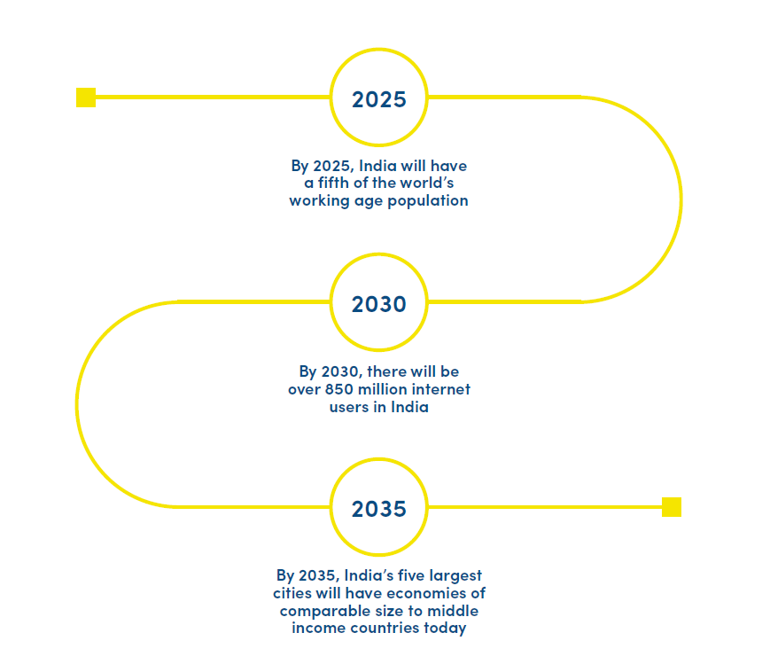

An image showing that by 2025, India will have a fifth of the world’s working age population; by 2030, there will be over 850 million internet users in India; by 2035, India’s five largest cities will have economies of comparable size to middle income countries today.

## SHARE OF WORLD GDP PROJECTIONS (PPP)

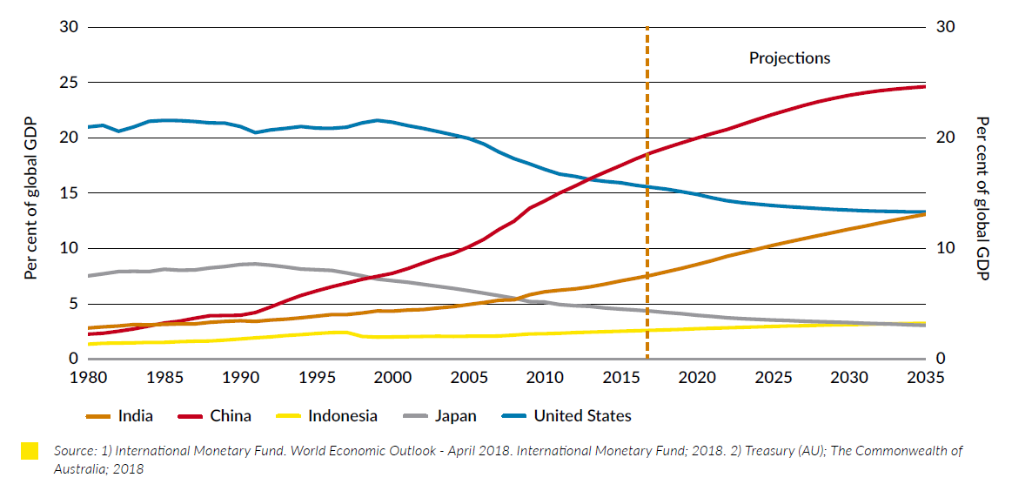

A graph showing current and projected shares of world GDP by country: India, China, Indonesia, Japan, United States. By 2035, India’s share would equal USA’s.

Source: 1) International Monetary Fund. World Economic Outlook - April 2018. International Monetary Fund; 2018, 2) Treasury (AU); The Commonwealth of Australia; 2018

## STRATEGIC OPPORTUNITIES

* The India Economic Strategy maps opportunities **in India across 10 sectors and 10 states**.
* The Strategy is designed to plug Australian business into India’s growth story to 2035, **matching Australian strengths with Indian priorities.**
* It sets out a road map to navigate the macro trends that will shape the Indian economy, its business environment and its most promising markets.
* People to people links will be a crucial enabler. The Indian diaspora in Australia – **now 700,000 strong or almost 3 per cent of Australia’s population** – is the fastest growing large diaspora.
* The Strategy recommends that Australia strive by 2035 to lift India into its **top three export markets and make India the third largest destination in Asia for outward Australian investment.**
* This would see Australian exports to India **treble to around $45 billion, and investment to India rise 10 times to over the $100 billion mark**, a genuine transformation of the relationship.

## ECONOMIC OPPORTUNITIES OF INDIA’S KEY SECTORS AND STATES

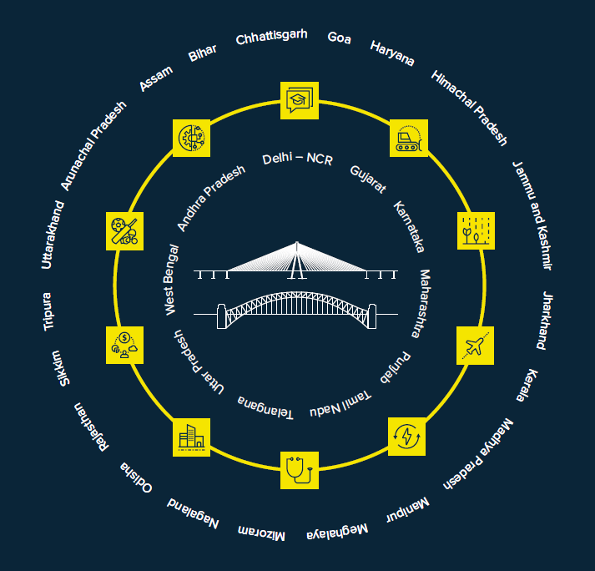

An image showing three concentric circles with the two bridges - Bandra-Worli Sea Link and Sydney Harbour Bridge - in the centre.

The first, inner circle shows the names of the ten priority states: Delhi-NCR, Gujarat, Karnataka, Maharashtra, Punjab, Telangana, Uttar Pradesh, West Bengal and Andhra Pradesh.

The second circle is made up of icons denoting the ten priority sectors: education, resources, agribusiness, tourism, energy, health, financial services, infrastructure, sport, science & innovation.

The third, outer circle is made up of the names of a further twenty Indian states.

#### The inner circle identifies the 10 priority states where Australia should focus. The yellow icons symbolise the 10 key sectors where Australia has competitive advantages.

## KEY SECTORAL OPPORTUNITIES

### FLAGSHIP SECTOR

#### EDUCATION

India hopes to upskill 400 million people by 2022.

India has the largest tertiary age (18-22) population globally. Demand for education spans every sector of India’s economy. Research and development collaboration will help transform both our economies.

### LEAD SECTORS

#### AGRIBUSINESS

India’s food demand will grow at 2-3 per cent, outpacing supply.

India has an appetite for Australian commodities (pulses, grains, oilseeds and horticulture), premium products, as well as services and technology to boost its productivity, including cold-chain supply, logistics and food processing.

#### RESOURCES

India’s steel intensity, below a third of the global average, indicates the scale of catch-up ahead.

Urbanisation, rising incomes and industrial activity will drive strong resources demand, including for Australian metallurgical coal, copper and gold. India will be a promising market for mining equipment, technology and services (METS) as it modernises its mining sector.

#### TOURISM

By 2035 Indian tourism could be worth over $9 billion to Australia each year.

By 2035, the number of Indian tourists visiting Australia will grow four-fold to nearly 1.2 million. Business and luxury travel offer strong potential.

### PROMISING SECTORS

#### ENERGY

India’s demand for energy is set to outpace domestic supply, providing the largest contribution (30 per cent) to growth in global energy demand to 2035.

#### HEALTH

India’s medical device market is growing at 15 per cent annually and 77 per cent is imported. Demand for healthcare will continue to dwarf domestic supply.

#### FINANCIAL SERVICES

By 2025, digital finance is forecast to boost India’s GDP by $950 billion and create 21 million new jobs. Digital payments in India could pass the $1 trillion mark by 2030.

#### INFRASTRUCTURE

India will require infrastructure investments of USD4.5 trillion by 2040.

#### SPORT

India’s consumer class is spurring demand for sports training, goods and sponsorship. Besides the Indian Premier League for cricket, nine professional sporting leagues were established between 2013 and 2016.

### SCIENCE & INNOVATION

India has been ranked the top innovation destination in Asia and is the world’s third largest destination for imported research and development.



An image of the Australian Coat of Arms, next to it the logo of the Australia-India Council, below both the words “Produced by the Australia-India Council”