AN INDIA ECONOMIC STRATEGY TO 2035

NAVIGATING FROM POTENTIAL TO DELIVERY

# UNDERSTANDING INDIA’S BUSINESS ENVIRONMENT

## OVERVIEW

* Opportunities exceed difficulties in the Indian market for Australian business. There is no single market offering greater growth opportunities out to 2035 than India.
* But success in this market requires a clear-eyed understanding of the business environment, including challenges posed by the regulatory environment, limited state capacity, corruption and differences in business culture; in particular, the prevalence of family-owned businesses.
* Clean-sheet thinking about product development, having a local office, credible local partners with established networks and high-profile champions can all play a critical role in success.

## EASE OF DOING BUSINESS

India is committed to improving the ease of doing business. India’s improvement in international ease of doing business rankings reflects a series of business-friendly reforms and the streamlining of regulatory procedures. One example is the introduction of a GST, which has provided a common indirect tax structure and common market, albeit with a level of complexity in implementation.

There is wide variation in the ease of doing business across states and sectors. As the dynamic of cooperative and competitive federalism takes root, states are being exposed to more competition, driving them to progress reforms to attract investment.

Australian businesses need to identify the right local sources of expert market advice, understand how legislation and regulations are practically applied, recognise the value of a targeted approach to the most competitive states or sub-national markets and tailor their business and investment decisions accordingly.

## TRANSPARENCY AND CORRUPTION

The indications are that high-level political corruption at the Centre has declined in recent years, although this is less evident at the official level and in the states.

Combating corruption remains a high political priority and voter tolerance of corruption is wearing thin. A range of recent policy initiatives of the Indian Government have been aimed at reducing the opportunities for corruption and crony capitalism, including:

* the demonetisation of 500- and 1,000-rupee notes in November 2016
* the push for digital payments to formalise one of the world’s most cash-intensive economies
* the transition to directly transferring welfare to beneficiaries’ bank accounts
* the new bankruptcy code passed in 2016
* and incremental political finance reforms.

The legal framework for combating both public sector and private sector corruption is making progress. The courts have acted to correct irregularities, as in the high-profile Supreme Court cases quashing the irregular allocation of India’s 2G telecommunications spectrum and coal mining blocks. There are also high-profile cases of India pursuing private sector firms and individuals abroad.

Australian companies need to prioritise an in-depth, forensic approach to due diligence before embarking on new business relationships in India. Australian companies can minimise the risks by being careful about their choice of local partner, by taking steps to ensure they have the appropriate market entry strategies and maintaining clear policies on corporate conduct including a strict ‘no corrupt payments’ policy. It is essential that Australian businesses seek their own legal advice in relation to these issues.

### OPERATIONAL CHALLENGES FOR FOREIGN COMPANIES IN INDIA

#### **MOST DIFFICULT AREAS**

Starting a business, obtaining permits, enforcing contracts

#### **DIFFICULT AREAS**

Bureaucratic inefficiencies, inadequate infrastructure, restrictive land acquisition, retrospective and seemingly arbitrary tax liabilities, difficult regulatory procedures, restrictive labour laws, inconsistently applied and frequently shifting regulation

## BUSINESS CULTURE AND STRUCTURE

The similarities in federal, legal and parliamentary systems and a shared use of the English language can often assist relationships between Australia and India, but companies can be caught unprepared for the divergent business norms that sit behind these formal structures.

In general terms, the business cultures of Australia and India differ with respect to the levels of comfort with uncertainty, the process and length of decision-making and the relative importance of hierarchy and seniority. Differences in business culture extend to different approaches to contract negotiation and enforcement, dispute resolution and the expected role of government in securing commercial outcomes.

Large, diversified company groups owned by families dominate India’s corporate landscape. Indian entities may be more likely to expect that agreements are open to reinterpretation or renegotiation, and that building strong business relationships will create flexibility in commercial terms and conditions.

Australian companies need to inform themselves about the differences between Australian and Indian business culture and values and adopt corresponding strategies to market entry, strategic planning, contract negotiation and dispute resolution. Business planning will need to manage the different time horizons Australian shareholders and Indian partners may expect. The performance of individual elements of family-owned businesses can vary significantly, so due diligence on partners should reflect not only the operations of the family group and overall management, but also the commercial performance of the specific arm being considered.

### INDIAN FAMILY-OWNED CONGLOMERATES

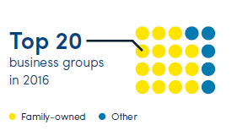

The top 20 Indian business groups in 2016, of which 15 were family-owned

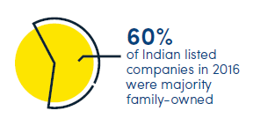

60% of Indian listed companies were majority family-owned

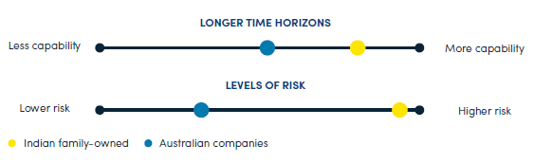

Linear depictions of capability and risk: over longer time horizons, Indian family-owned companies have more capability than Australian companies, but have much higher levels of risk.

## STATE CAPACITY

All levels of government in India remain stretched on resourcing but still heavy on bureaucratic processes. Recent national public sector reform initiatives have included technology-enabled monitoring of the attendance of public servants, e-governance to streamline public service delivery and reduce corruption, as well as tentative moves to adopt lateral recruitment at lower levels of the bureaucracy.

The paradox of the Indian public service is not that there are too many bureaucrats but that there are too few at the levels that matter. It is a top-light and bottom-heavy system.

Australian business needs to consider the impact of limited state capacity in India on their investments. In some cases, local advocates, agents or business partners can be powerful in helping to understand and shape regulatory processes. Limited state capacity also means that Australian companies need to be prepared to dedicate resources to India for the long haul and demonstrate commitment to the market.

### INDIAN GOVERNMENT POLICY INITIATIVES

#### POLICY GOALS

**Reduce opportunities for corruption**

**Reduce opportunities for crony capitalism**

#### POLICY INITIATIVES

Demonetisation of 500- and 1,000-rupee notes

Push for digital payments

Directly transferring welfare to beneficiaries’ bank accounts

New bankruptcy code

Incremental political finance reforms.



An image of the Australian Coat of Arms above the words Australian Government, next to it the logo of the Australia-India Council, under both the text “Produced by the Australia-India Council”