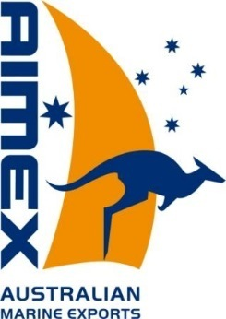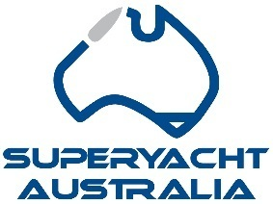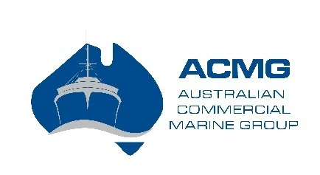

Suite 4401

4 Daydream Street

Warriewood

NSW. Australia. 2102

t: +61 (0)2 9956 8906

e: info@aimex.asn.au

[www.aimex.asn.au](http://www.aimex.asn.au)

[www.superyachtaustralia.com](http://www.superyachtaustralia.com)

www.commercialmarine.com.au

The Australian International Marine Export Group (AIMEX) is the peak body for the marine export industry. The objective of AIMEX is to develop and promote Australia’s international competitiveness in the marine sector. AIMEX arranges Australian pavilions and exhibitions at key international trade shows, including the Dubai International Boat Show.

AIMEX represents Australia’s most successful international brands, emerging companies and firms that showcase exciting innovation and technological development.

AIMEX members offer a broad range of marine services and products including:

* Design, manufacture and repair of powerboats, sailboats, superyachts and commercial vessels
* Boatbuilding equipment; research and development; technology and innovation
* Marine construction materials
* Ancillary equipment and fittings
* Marina construction and development

AIMEX strongly supports the establishment of a Free Trade Agreement (FTA) with the United Arab Emirates (UAE) as it will increase Australian exports and create jobs in highly skilled and well paid advanced marine manufacturing.

Australian companies have a proven track record of delivering competitive and high-quality vessels and will become more competitive to sell into the growing UAE boating market such as:

* Riviera,
* Maritimo,
* Steber Craft,
* Ausships,
* Echo Yachts, and
* Silver Yachts.

Additionally, our marina manufacturers are already sought after for marina developments in the UAE, however will become more competitive to win contracts because of the FTA including:

* GC Marine,
* Bellingham Australia, and
* Superior Jetties.

Marine component manufacturers:

* Muir Winches,
* Veem Propellers,
* Ayres Composites,
* Evercor,
* Marine Windows Services,
* Hydrive,
* Savwinch,
* Greencorp,
* Marine Airflow,
* Polyflex, and
* Ronstan.

As a result of this announced FTA negotiation the above have all been invited to tender to supply Gulf Craft, manufacturer of Majesty Yachts, Nomad Yachts, Oryx Sports Cruisers, Silver Craft and Silver Cat.

These companies listed are proud Australian vessel builders, advanced manufacturers, and component suppliers. Their commitment to manufacturing, development of their skilled tradespeople through apprenticeships and the jobs created from their exports are important to the economic benefit of Australia.

AIMEX strongly endorses this FTA as it will lead to increased exports and jobs in the Australian Marine Industry.

Yours sincerely

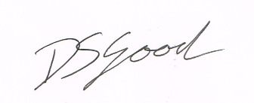

David Good

Chief Executive Officer

Australian International Marine Export Group