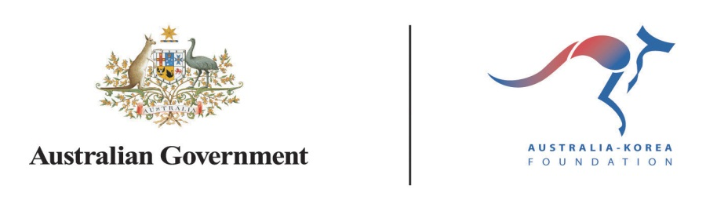

**2014-2015 Grants and Scholarships**

Applications for AKF grants and scholarships close at 5pm 11 April.

Information and application forms are available at:

<http://www.dfat.gov.au/akf/>

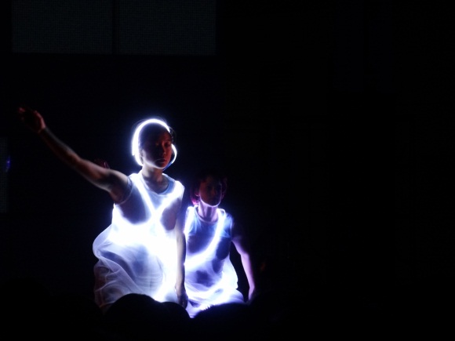

Pixel Mountain, Stalker Theatre Inc

Gwacheon and Hi Seoul Festivals

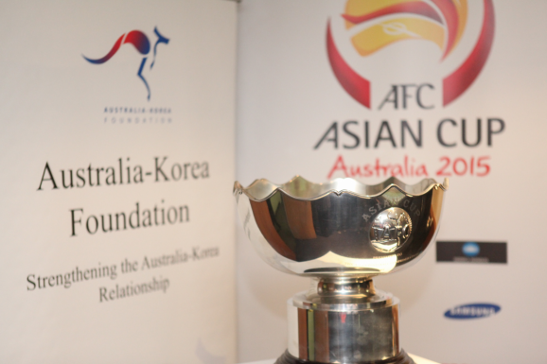

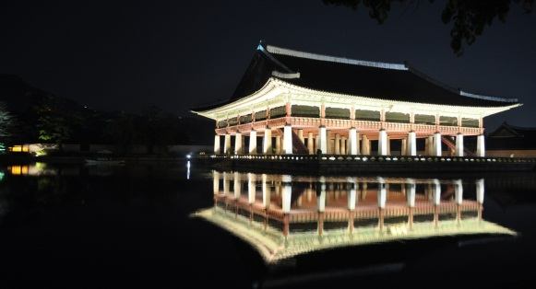

Photo taken by AKF Scholarship awardee, Jason Mitchenson, Korea University

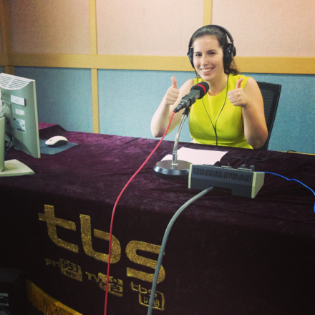

Media Intern Lara Pearce on air at tbs

Local Organising Committee, Asian Cup

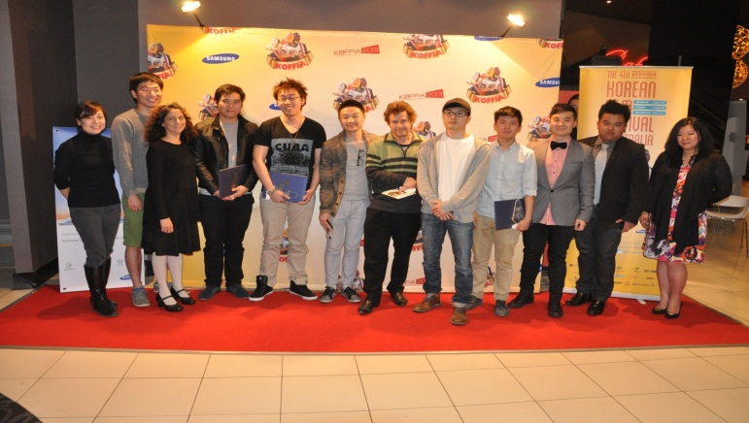

**What could you do with Korea in 2014-15?**

Fourth Korean Film Festival in Australia



**Australia-Korea Foundation**

**Grants and Scholarships**

Applications which seek to advance Australia’s engagement with Korea through cultural and academic pursuits, business and community exchanges and partnerships and collaborations are welcome.

Current priorities are:

Korea language and literacy: Developing the language and literacy skills of Australians to effectively engage with Korea and build a deeper understanding of Korean society, politics and the economy, including language studies and student/professional exchanges.

Science innovation: Establishment of new partnerships or strengthening of existing collaborations between institutions and peak bodies and their counterparts in Korea, particularly in emerging fields of research and development. Health, aging and social change projects are of interest.

Sports diplomacy: Projects harnessing major sporting events, such as the Asian Cup and Winter Olympics, to develop ties between the sports and business communities of Korea and Australia.

AKF grants (typically $20-30,000) contribute to projects with clear goals and committed partners. Scholarships support language studies (up to $5,000), research (up to $15,000) and internships (up to $10,000).

Contact Details

**Email:** [australia.korea@dfat.gov.au](mailto:australia.korea@dfat.gov.au)

**Phone:** +61 2 6261 3869

**Australia**  
Australia-Korea Foundation,

North Asia Division   
Department of Foreign Affairs and Trade   
R G Casey Building, John McEwen Crescent

Barton ACT 0221 Australia

**Web:** <http://www.dfat.gov.au/akf/>

**Korea**  
Australia-Korea Foundation   
Australian Embassy  
19th Fl, Kyobo Building  
1 Jongno 1-Ga, Jongno-Gu   
Seoul, Korea