Australian NGO Cooperation Program (ANCP)

Partnerships for recovery and

2020-21 Highlights

The ANCP is a unique global program that supports trusted Australian-based international development NGOs (ANGOs) through flexible annual grants for effective development projects overseas. The ANCP contributes to Australian Government and partner country priorities to reduce poverty and promote sustainable and inclusive development. This 2020-21 snapshot provides aggregated data on program performance, primarily against agreed and common indicators[1], as well as how ANCP was implemented including by partner-type, sector focus and capacity building focus.

## **ANCP COVID-19 Development Response**

ANGOs work directly with local partners to deliver programs that are responding to the social and economic impact of the pandemic, in line with the Australian Government’s development policy [*Partnerships for Recovery*](https://www.dfat.gov.au/publications/aid/partnerships-recovery-australias-covid-19-development-response)*: Australia’s COVID-19 Development Response*. ANGOs’ established relationships with local partners support adaptive programming to COVID-19. With restrictions to international travel and resource mobilisation ongoing in 2020-21, the long‑standing partnerships between ANGOs and local partners allowed the program to react quickly to evolving local needs and contexts.

At the start of the pandemic, the inherently flexible ANCP model supported the timely adaptation of existing projects to focus on *Partnerships for Recovery* and COVID-19 activities. This flexibility and support have continued into the second year of *Partnerships for Recovery*. For example, in 2020-21 59.4% of all projects specifically responded to the challenges of COVID‑19. More broadly, all ANCP projects aligned with at least one of the three pillars of *Partnerships for Recovery* with 39% supporting health security, 31% supporting stability and 30% supporting economic recovery.

The top five countries for ANCP expenditure on COVID-19 specific activities were Timor-Leste, Laos, Bangladesh, Indonesia and Nepal. $7.9 million of Australian Government ANCP funding was used to support COVID-19 activities, reaching over 4 million people.

In 2020-21, ANCP supported:



$132.9 million in grants to NGOs + additional $21.44 million from NGO contributions +  
$21.47 million in leveraged funds

57 Accredited Australian NGOs worked with over 2500 local partners

Nine million project participants. 52.4% women and girls and 5.8% people with disability

 406 projects in 50 countries. 75.3% expenditure in Indo-Pacific

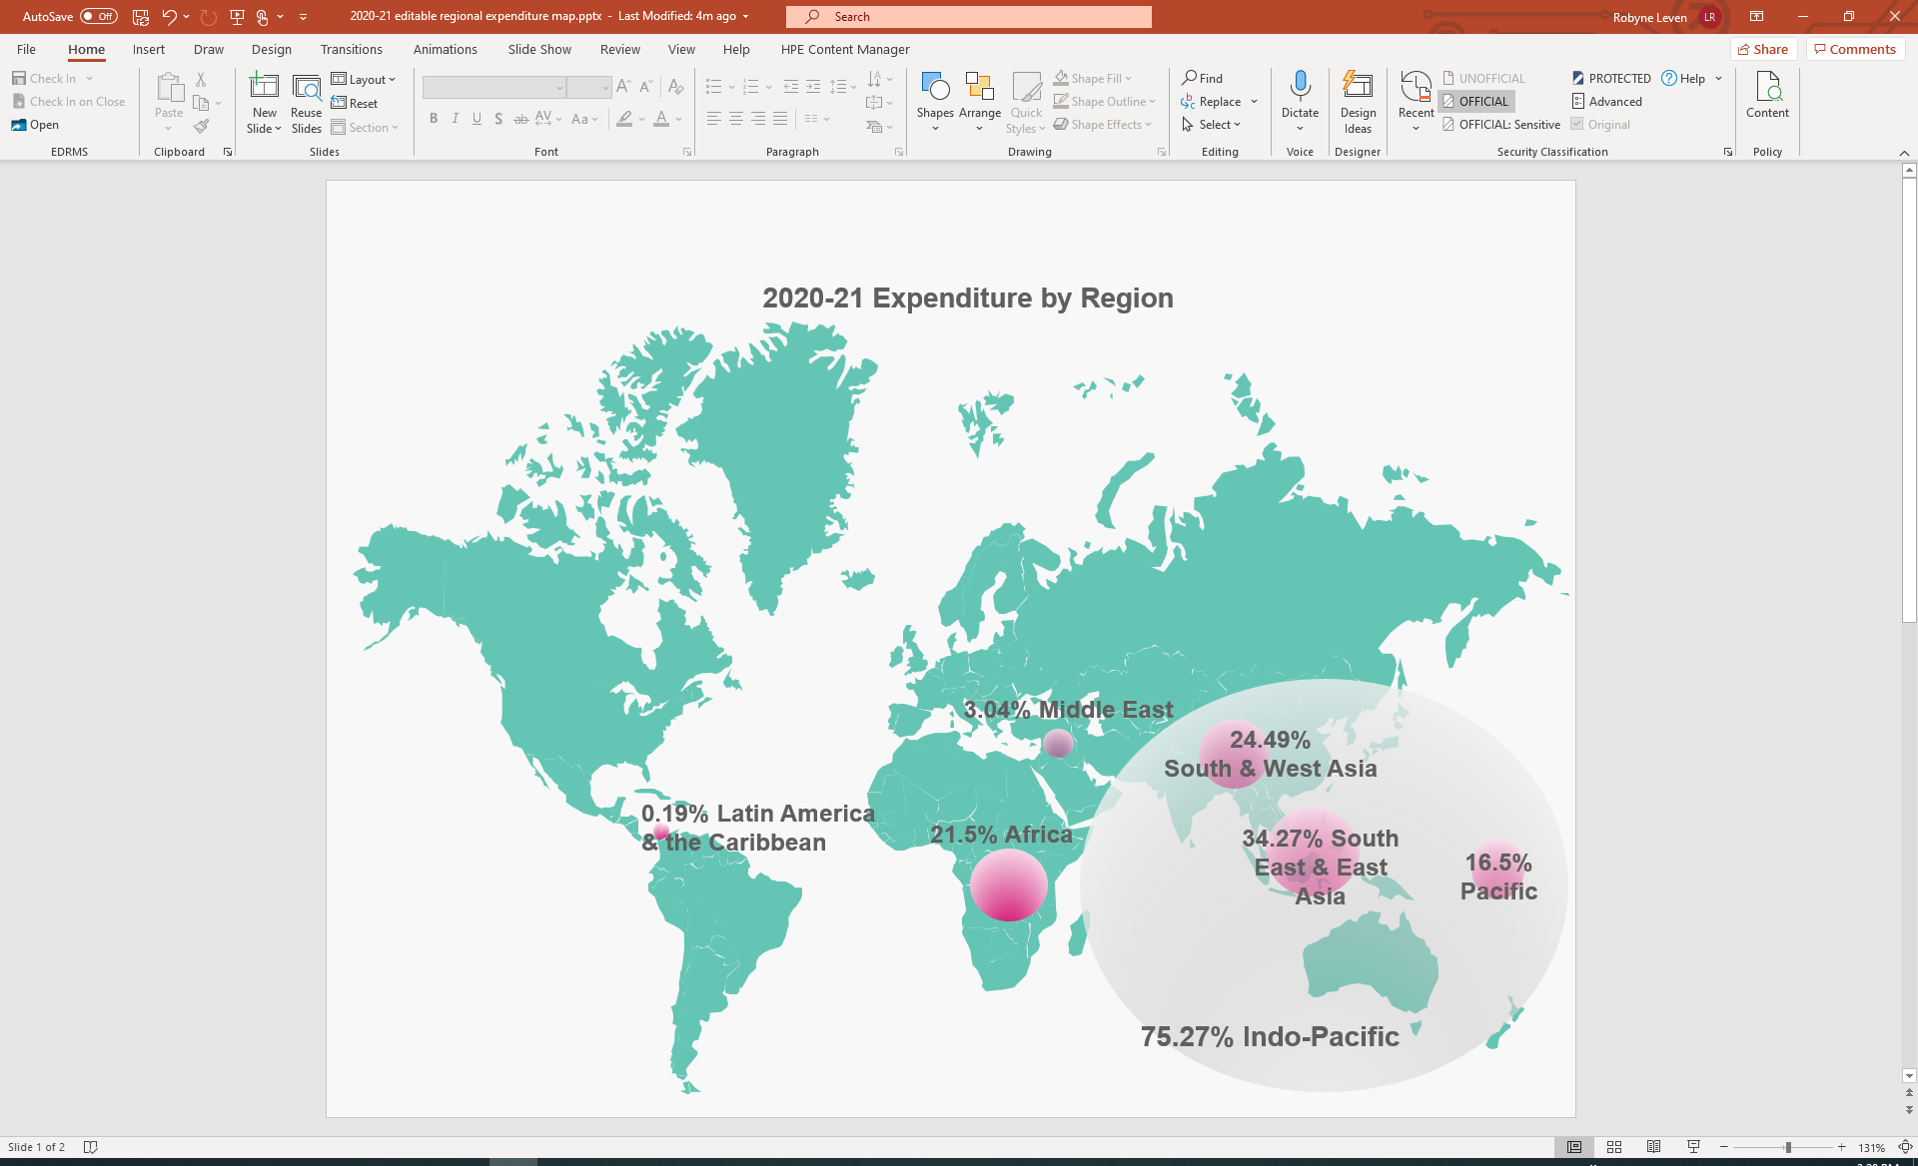

### Partnerships for Recovery Pillar 1: Health Security

In 2020-21, 156 ANCP projects supported communities and leaders to address health security risks and impacts of COVID-19. Common COVID-19 response activities included the delivery of one-way messaging on COVID-19, the provision of Personal Protective Equipment (PPE) and the supply of handwashing facilities to households.

In 2020-21 ANCP supported the following:

* 6,979,396 people were targeted through one-way messaging on COVID-19 prevention and access to services (32.8% women and girls and 0.6% people with disabilities) up from 4,171,431 in 2019-20 (ANCP Indicator H.08, Tier 2 Indicator)
* 438,065 people were reached through interactive events or sessions related to COVID-19 public health measures (63.7% women and girls and 3.7% people with disabilities) down from 1,048,423 in 2019-20 (ANCP Indicator H.09, Tier 2 Indicator)
* 1,175,725 items of PPE were distributed, up from 630,948 in 2019-20 (ANCP Indicator H.10, Tier 2 Indicator)
* 309,295 people were provided household access to handwashing facilities (58.8% women and girls, 1.9% people with disabilities) up from 267,601 in 2019-20 (ANCP Indicator W.03)
* 1,061 public buildings were provided with hand washing facilities (including 480 schools, 306 health care facilities and 90 places of worship) down from 1,769 in 2019-20 (ANCP Indicator W.05)

COVID-19 heath security activities, however, were generally less inclusive than in the previous year. For example, women and girls and people with disabilities made up lower proportions of participants for all ANCP-AHP COVID-19 indicators where inclusion was measured: the number of people targeted with one-way COVID-19 messaging; the number of people participating in COVID-19 events; and the number of people who received mental health and psychosocial support.

##### Case Study: Improving health outcomes

Cases of waterborne diseases, such as cholera, were high in Malawi’s Karonga District. Poor sanitation, unprotected water sources and frequent flooding, forced communities to use contaminated water sources. With support from ANCP, The Salvation Army is working with communities to improve health outcomes through the Karonga Integrated WASH and Food Security Project. This project is improving access to clean water through the construction of 25 boreholes. Project staff are also raising awareness in communities on COVID-19 and how to prevent transmission as part of its hygiene awareness efforts.

Access to safe water for approximately 10,000 households has contributed to reduced cases of cholera. The increased availability of water is also enabling more regular hand washing, which is crucial in COVID-19 prevention efforts.

### Partnerships for Recovery Pillar 2: Stability

In 2020-21, ANCP NGOs continued to help minimise the social impacts of COVID-19 through activities that supported social cohesion, social protection, improved food security, education and resilience to threats such as climate change with a particular focus on protecting the most vulnerable.

In 2020-21 ANCP supported the following:

* 660,028 people participated in sessions on prevention, reduction and response to violence, abuse and exploitation of children (60.3% women and girls, 2.2% people with disabilities), up from 442,749 the previous year (ANCP Indicator CP.01)
* 128,918 participated in sessions on climate related hazards and disasters (climate change mitigation, adaptation, preparedness, resilience and early warning) (59.6% women and girls, 2.1% people with disabilities), a small decline from 151,635 the previous year (ANCP Indicator C.01)
* 215,075 people had improved access to sufficient food (55.5% women and girls, 3.9% people with disabilities), down from 321,174 people the previous year (ANCP Indicator F.01)
* 4,249 women survivors of violence receiving services such as counselling (6.7% women and girls with disabilities), up from 3,196 the previous year (ANCP Indicator G.03, Tier 2 Indicator)

##### Case Study: Challenging anti-social behaviours and social norms

The Kokoda Track Foundation’s Project Zero aims to challenge and change anti-social behaviours and norms that place women and children at risk in their homes and communities. It also supports Oro Province’s first safe house, helping women access the support they need to start new life chapters. Project Zero brings together Friends of Femili PNG, the Family and Sexual Violence Action Committee and Department of Community Development.

‍COVID-19 lockdowns and travel restrictions didn’t stop Project Zero undertaking vital awareness activities and training across Oro. To June 2021, Friends of Femili PNG’s outreach team delivered 26 family and sexual violence awareness-raising sessions to schools, business, communities and health facilities in rural Oro, reaching 3,133 participants.

### Partnerships for Recovery Pillar 3: Economic Recovery

In 2020-21, economic recovery efforts were supported through training and support for improved livelihoods and rural development and improved access to financial services and social transfers. The number of participants across the economic recovery indicators was generally greater than for the previous year, reflecting additional focus on livelihoods and income generation activities.

In 2020-21 ANCP supported the following:

* 140,222 people reached with livelihoods support interventions (58.45% women and girls, 2.23% people with disabilities) up from 95,335 the previous year (ANCP Indicator L.05)
* 133,503 people increased their incomes (55.3% women and girls, 5.6% people with disabilities), up from 108,746 people in the previous year (ANCP Indicator L.02)
* 117,256 people were provided with financial services (74.7% women and girls, 4.8% people with disabilities, down from 192,165 people with previous year (ANCP Indicator L.03)
* 39,585 people accessed social transfers (such as cash & voucher assistance) (56.5% women and girls, 7.1% people with disabilities) up from 35,887 people with previous year (ANCP Indicator L.04)
* 114,928 people adopted improved agricultural and fisheries practices (55.9% women and girls, 5.3% people with disabilities), up from 103,348 people the previous year (ANCP Indicator L.01)

##### Case Study: Social security recognition for domestic workers

Australian People for Health Education and Development Abroad (APHEDA) supports the Working Women's Centre of Timor-Leste (WWCTL) to advocate on behalf of Timorese domestic workers. Domestic workers, often with limited school education, are at high risk of exploitation and poor working conditions including low wages, long working hours and exposure to sexual and physical harassment from employers. WWCTL delivers training to domestic workers in employment rights, job skills, health and safety, COVID-19 prevention, child protection, Preventing Sexual Exploitation, Abuse and Harassment and advocacy.

‍The COVID-19 pandemic has highlighted the wage and employment precarity of many domestic workers. In 2020-21, WWCTL was able to rapidly assess the financial and housing situation for vulnerable domestic workers, identify those most at risk and provide accurate data to the Government. WWCTL's efforts led to the Government endorsing eligibility for domestic workers to receive social security payments during state lockdowns. WWCTL's impact was recognised with the Prime Minister's Award for Strong Advocacy.

## ANCP 2020-21 program Highlights

In 2020-21 ANCP projects were impacted not only by COVID-19, but also other significant events including the humanitarian crisis in Myanmar and recovery from Tropical Cyclone Harold in the Pacific. The ANCP continued to support projects in a variety of contexts, with results reported against all 42 ANCP indicators and all *Partnerships for Recovery* Tier 2 indicators. Although many projects directly implemented COVID-19 specific response and recovery activities, other projects adopted longer-term support in areas such as immunisation, education and training and agricultural development. For example, nearly 17,000 children were immunised through GAVI support and over 63,000 additional children were enrolled in school.

The objective of the ANCP is to progress Sustainable Development Goals through supporting inclusive development, and open and transparent civil society. Graph 1 shows ANCP expenditure (percentage) in 2020-21 against SDGs. Expenditure under Goal 3 increased from 21.6% the previous year, reflecting the ANCP’s pivot to supporting additional COVID-19 response activities.

### Financial Contributions

In addition to the $21.44 million in ANCP NGO contributions, 34 projects received funding from other institutional donors, including:

* $8.6 million from International NGOs & CSOs
* $3.1 million from Government sources (including local governments in-country and other Government donors such as Ireland, EC, MFAT, Canada etc).
* $2.6 million from faith-based organisations
* $3.9 million from multilateral organisations
* $2.3 million from the private sector

ANCP NGOs have strong links with local implementing partners, the majority of which are government agencies, local NGOs and international NGOs, stakeholder groups and the private sector (see Graph 2).

### In 2020-21 there was a slight rise in partnering with local NGOs/CSOs, perhaps reflecting the greater emphasis on localisation in response to COVID-19 travel and resourcing restrictions.

### Capacity Building

A strength of the ANCP is a commitment to building the capacity of in-country implementing partners and communities, as reflected in the [ANCP Program Logic](https://www.dfat.gov.au/about-us/publications/Pages/ancp-program-logic). This has become a cornerstone of ANCP’s effective response to the challenges of COVID-19. Investing long-term in the capacity of local partners has enabled ANGOs to continue supporting communities and leaders in their response to COVID-19.

Graph 3 reflects the strong focus on capacity building across the ANCP, with the most reported development outcome (under Pathway 2 of the ANCP Program Logic) focussed on strengthening the capacity of in-country partners and the civil sector more broadly. Graph 4 outlines the number and type of capacity building activities in the ANCP. Disability inclusion capacity building activities were less commonly reported than other foci. Disability inclusion has been identified as an area for further capacity support in the ANCP forward learning agenda.

### 2020-21 ANCP Gender Equality and Disability Inclusion

ANCP NGOs have inclusive practices to ensure response activities address the needs of women, children and people with disability reaching 9.0 million project participants, of which 52.4% were women and girls, 5.8% were people with disabilities. Overall inclusion figures for 2020-21 are down slightly on the previous year (in 2019-20 57% of participants were women and girls and 8% of participants were people with disabilities), reflecting the ongoing challenges of delivering inclusive COVID-19 responses.

Reporting of ANCP Program Logic Pathway 1 modalities may also reflect the challenges around inclusive responses to COVID-19. The modality ‘ANCP demonstrates inclusive practices’ was selected by 17 NGOs, whereas the other four modalities including trailing new ideas and value for money were each selected by 21-22 NGOs.

In 2020-21 ANCP supported the following:

* 669,114 people participated in sessions on gender issues and women's equal rights (60.63% women and girls, 2.38% people with disabilities) up from 431,828 people the previous year (Indicator G.02)
* 120,261 people trained in disability awareness and inclusion, down from 227,052 people the previous year (Indicator G.08)
* 21,599 women were supported to assume leadership roles (8.38% women with disabilities), down from 66,698 the previous year (Indicator G.04)
* 22,349 people received disability support services specific to their needs (46% women and girls), a result similar to the previous year (indicator G.06)

As the following table shows, in 2020-21 63% of ANCP projects explicitly targeted gender equality (demonstrated through the use of the principal and significant markers), up from 56% the previous year. In contrast to what may have been expected in its second year of usage, there was a slight reduction in the percentage of projects categorised as mainstreaming gender equality.

|  |  |  |  |  |
| --- | --- | --- | --- | --- |
| **Gender marker** | **# of projects 2020-21** | **% of projects 2020-21** | **# of projects 2019-20** | **% of projects 2019-20** |
| Principal | 78 | 19 | 73 | 17 |
| Significant | 176 | 43 | 165 | 39 |
| Not Targeted | 98 | 24 | 124 | 29 |
| Mainstream | 54 | 13 | 62 | 15 |
| Total | **406** |  | **424** |  |

In contrast to gender equality, the table below shows that there were significantly less projects that actively targeted disability inclusion. This is in line with previous reporting and continues to indicate there is more confidence and routine inclusion of gender equality approaches in ANCP programming compared to approaches to address disability inclusion.

Gender equality and disability inclusion were identified by NGOs in the 2021 ANCP survey as priority learning topics to support strengthened practice in these areas. DFAT has noted this request and these topics will be included in the 2022 ANCP learning agenda, which will be guided by a small Learning Reference Group. The learning agenda will also provide opportunities for cross-learning between NGOs.

|  |  |  |  |  |
| --- | --- | --- | --- | --- |
| **Disability marker** | **# of projects 2020-21** | **% of projects 2020-21** | **# of projects 2019-20** | **% of projects 2019-20** |
| Mainstream | 234 | 57 | 262 | 62 |
| Targeted | 14 | 3 | 16 | 4 |
| Twin Track | 90 | 22 | 77 | 18 |
| Not Targeted | 68 | 17 | 69 | 16 |
| Total | **406** |  | **424** |  |

### Accreditation

Fifteen accreditation reviews were undertaken in 2020-21. DFAT provided four NGOs with Technical Assistance to help prepare them for accreditation – two NGOs were new applicants and two were already accredited NGO’s looking to upgrade from Base to Full in 2022.

* Nine scheduled re-accreditations: eight Full and one Base – seven were re-accredited at Full, one was re-accredited at Base and one applicant was downgraded to Base.
* Five new applicants for accreditation: one applicant successful at Base, one applicant withdrew following the Desk Assessment, two failed to pass the Desk Assessment stage and one did not meet the eligibility requirements for Base accreditation.
* One application for upgrade in accreditation status to Full: applicant was successfully accredited at Full.

### Estimated climate finance data 2020-21

The ANCP contributes to Australia’s climate finance commitments by mainstreaming climate change throughout the program. Reporting on ANCP climate finance expenditure in 2020-21 was voluntary. It was not included in the 2020-21 Annual Development Plan process and therefore NGOs were requested to provide a best-estimate figure as part of their 2020-21 annual progress reporting. An estimated $5.34 million of ANCP funding supported climate activities in 2020-21 (an estimated $712,275 in the Pacific).

Just under half of ANGOs reported expenditure on either climate adaptation activities (estimated $3.28 million), climate mitigation activities (estimated $198,000) or both where the split could not be determined (estimated $1.87 million). Climate change was most often a secondary objective at the project level, with common activities supporting sectors such as WASH, DRR and food security.

ANGOs are playing an increasingly important role in Australia’s climate change action with our developing partners. This is reflected in the ANCP contribution to climate finance over time.

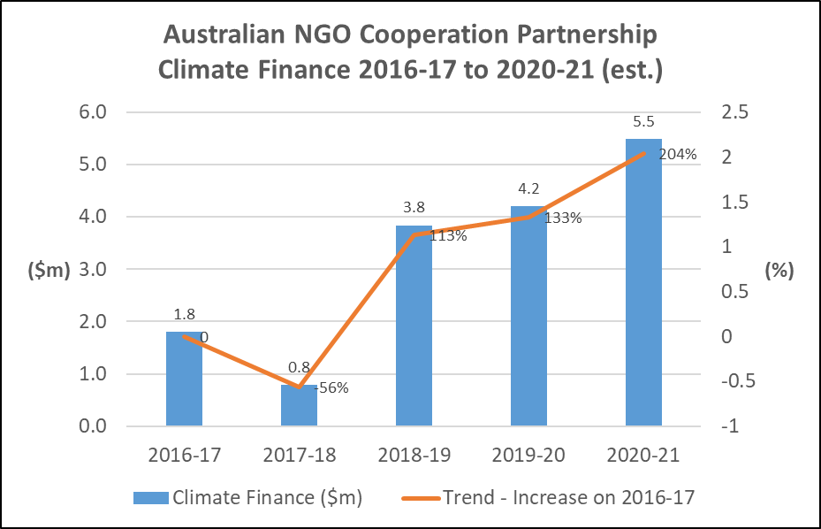

1. The data provided in the Annual Snapshot is drawn from annual progress reporting by ANCP NGOs. The ANCP captures both quantitative and qualitative data in its annual progress reporting. Quantitative data is reported under 42 program indicators, six of which are Tier 2 indicators under *Partnerships for Recovery*. An additional six Tier 2 indicators were available to voluntary report against in 2020-21 under ANCP arrangements.