**AIP-RURAL**

**Strategic Review Panel**

Independent Review of the Australia Indonesia Partnership

for Rural Economic Development (AIP-Rural) Program

**A: BACKGROUND**

1. The Strategic Review Panel (SRP) is an independent advisory group comprising two senior experts in the fields of market systems development, rural development, agriculture, and performance management. Its function is to provide strategic advice to the program on how to maximise impact. The SRP is contracted by the Department of Foreign Affairs and Trade (DFAT), now reports to the Counsellor Disaster, Environment and Sustainable Development, meets face-to-face twice a year and also provides remote inputs, as required.
2. The SRP made inputs to AIP-Rural in March and September 2014, March and September 2015, March 2016, February and September 2017, and May 2018. The SRP contributed to the mid-term review of AIP-Rural in September 2016 and an analysis of Proof of Concept during July 2017. The SRP also contributed to the investment design document for the Australia Indonesia Partnership for Promoting Rural Income through Support for Markets in Agriculture Phase II (PRISMA-2).
3. This aide memoire covers the ninth and final SRP input during November 4-14, 2018. It took place in the context of the transition between completion of AIP-Rural and inception of PRISMA-2. SRP-9 assessed:

* PRISMA progress towards achieving end of program outcomes and identifying lessons learned
* Proof of Concept for the other three programs within the AIP Rural portfolio
  + Tertiary Irrigation Technical Assistance (TIRTA)
  + Strengthening Agriculture Finance in Rural Areas (SAFIRA)
  + Applied Research and Innovation Systems in Agriculture (ARISA)
* Progress against the transition plan and in planning for inception of PRISMA-2
* Response to SRP-8 recommendations
* Management response and next steps with DFAT management.

1. SRP-9 included two days in East Java for site visits to eight interventions and field interviews with men and women farmers, Intermediary Service Providers (ISPs) and partners as well as project field teams. This required planning and support from AIP-Rural, DFAT and program partners. The SRP acknowledges the work involved and thanks the AIP-Rural team, DFAT Rural Development Unit, and program partners, ISPs and farming households.

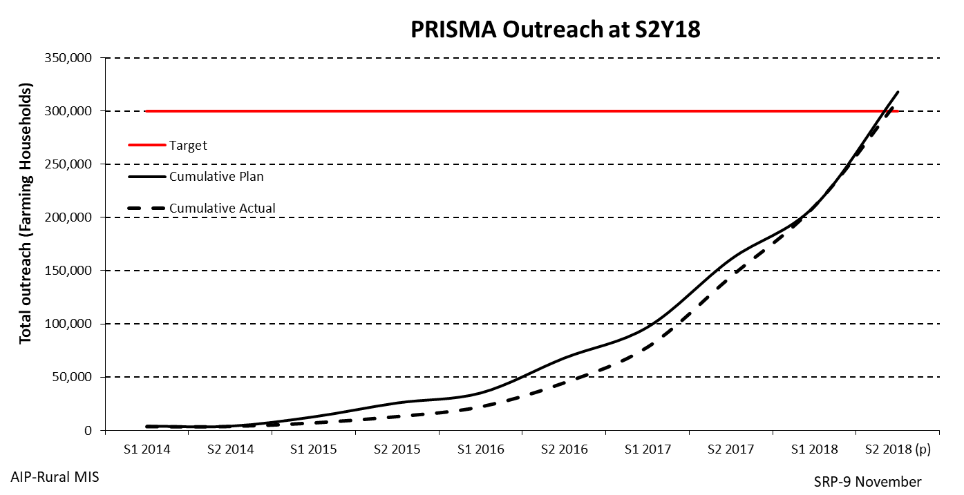**B: ADEQUACY OF PROGRESS**

1. The SRP assesses the adequacy of progress in implementing AIP-Rural against its designed target of 300,000 smallholder households with a 30% or more increase in income. AIP-Rural is generally on track, with Key Performance Indicators (KPIs) on plan or ahead of plan for PRISMA and ARISA. The program will meet key performance targets at the end of 2018 and exceed some with additional, attributable, results counted for two years after interventions end (as per Donor Committee for Enterprise Development (DCED) Results Measurement Standard).
2. At end of June 2018 ***overall progress*** was as planned: ***781,707 households had access*** to new inputs, services and/or technologies; more than ***350,000 households used*** those improvements; and a ***net attributable income change was measured in 234,812 households*** (at June 2018). 66% of benefiting households live on less than USD2.50 per day at PPP. Impact assessments completed this semester lift the outreach to ***291,382 households*** (at October 2018).

|  |  |
| --- | --- |
|  |  |

1. The average increase in income varies across project interventions – an average of 327% for PRISMA, 186% for ARISA and 101% for TIRTA, with all greater than the designed targets. The turnover of 5089 intermediary service providers (ISP) engaged across the program has increased by almost AUD42m to date. These ISP and private sector partner businesses have co-invested almost AUD10m (around 83% of direct intervention costs) and beneficiary farming households have co-invested more than AUD20m in cash so far. That means that together, ***private sector partners and beneficiary farming households have co-invested more than the DFAT investment in direct intervention costs*** across the portfolio, and almost one third of the total program cost. These results are consistent with the market systems development approach.

**C: ACTION POINTS FROM SRP-8**

|  |  |  |  |  |  |
| --- | --- | --- | --- | --- | --- |
| **Proposed action** | | **Justification** | **Person responsible** | | **Status** |
| 1 | Refine transition plan for PRISMA and reflect commitments in contract amendments and/or OPA criteria for S1Y18 and S2Y18 | The draft transition plan prepared by Palladium for PRISMA, TIRTA and SAFIRA is a good start. Clear closure plans for the three programs are needed. Specify ***who*** will do ***what,*** ***when*** for each task in the transition plan. | | Palladium Contract Rep. | Completed and submitted to DFAT |
| 2 | Prepare closure plans for ARISA | Because ARISA will close early 2019, a detailed closure plan should be presented to DFAT. | | CSIRO Team Leader | Completed and submitted to DFAT |
| 3 | Prepare a transition plan for DFAT program oversight and management | There are several changes to DFAT personnel during the transition period. DFAT also needs to prepare a detailed plan for transition of DFAT program oversight and management. | | DFAT Rural Dev Unit Manager and team | Completed |
| 4 | Review and refine PRISMA interventions in Papuan provinces | Field work in Papuan provinces identified opportunities for adding more value to intervention partners and targeted farming households. Refined PRISMA interventions in Papuan provinces will improve results. | | Lead Head of Portfolio (HoP) for Papuan provinces | Completed and now being incorporated into PRISMA-2 strategy and working group analyses |
| 5 | Review SAFIRA’s VCF portfolio, to better understand areas of underperformance, risks, means of mitigation and lessons for Phase 2. Communicate this to DFAT. | The SAFIRA portfolio is encountering problems that SAFIRA has begun to investigate, which should be investigated further by the management team. | | Chief Executive Officer (CEO) PRISMA with support from SAFIRA | Completed and now being incorporated into PRISMA-2 strategy and working group analyses |
| 6 | Maintain resources and focus for MRM team to ensure effective delivery of the many planned impact studies in 2018. Keep VfM and partner change innovations simple, focused and useful. | The tool developed for a structured approach to partner assessment is useful and could be refined and applied. It is not clear how the VfM regression tool will add value or benchmark to portfolio management. Consider using simple frequency distributions such as those developed by SRP-8 (para 18 above) for comparative analysis of Papuan interventions. | | Monitoring and Results Management (MRM) team | 42 of the 62 impact assessments completed, and on-going work scheduled for S1Y19 |
| 7 | Use the innovation systems theory of change to develop 2-3 indicators for each end-of-program outcome, and report against these in 2018 PRIPs to demonstrate progress against this project outcome area. | The revised ARISA Innovation Systems logic model is fit for purpose. SRP 7 also asked for indicators that could be used to demonstrate progress against plan and towards end-of-program outcomes for this outcome area. | | CSIRO Team Leader | Completed and included in final PRIP submitted to DFAT |

**D: FINDINGS FROM THIS SRP INPUT**

1. 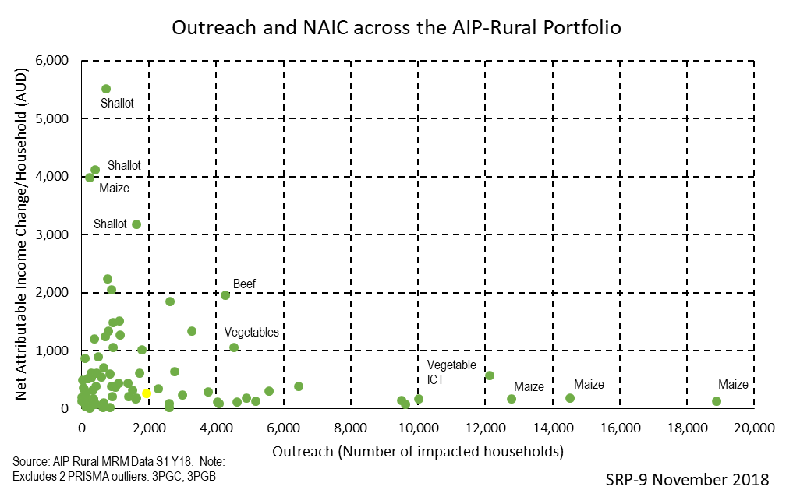**PRISMA** is on track to meet or exceed the designed KPIs and value for money indicators. At completion, more than 300,000 farming households, of which two thirds live below the USD2.50 purchasing power parity (PPP) poverty line, will have benefited. As expected, almost one-third of the final outreach is from systemic change (other private sector businesses and farming households copying from those involved in PRISMA interventions). The average increase in income across these households is 278% (on average AUD480 per household). These farming households co-invested AUD65m towards these results and the 101 private sector partners and 5154 ISPs co-invested AUD7.9m. Average total intervention costs amounted to AUD149 per benefiting household. On several measures PRISMA demonstrates both value for money and effectiveness for the AUD77 million investment. The averages summarised here and in the Progress Report and Implementation Plan (PRIP) and Activity Completion Report (ACR) mask a wide range of performance – with interventions in the pig, maize and vegetable markets particularly benefiting large numbers of households. For example, more than 80,000 households adopting maize innovations increased income by at least 50% over the life of PRISMA; and 82% of cumulative ISP increased turnover was attributable to new activities in the pig market system.
2. The team is now preparing for implementation of PRISMA-2, building on lessons and successes of PRISMA and other projects as well as exploring opportunities to deliver new results in new ways. The forward-looking presentations made to SRP-9 by the team maintain the MSD approach, retain the effective partnerships and systems from PRISMA, integrate those lessons and relationships from pilot projects that complement PRISMA-2, and respond to the changing Indonesian context. The team’s thinking about working with partners in a more strategic manner, working in supporting systems and developing new intervention approaches to drive systemic change is encouraging. The approach being developed to measure systemic change in a rigorous way over time appears promising. As required under the DCED Results Measurement Standard, direct and systemic outreach from all AIP-Rural interventions should be measured and counted for 2 years after their completion. This will contribute to early PRISMA-2 outreach and may mitigate the short-term impact of any loss of momentum resulting from budget constraints in Semester 1 2019.
3. ***TIRTA proof of concept***. At mid-term the SRP identified that TIRTA would demonstrate proof of concept with successful private investment stimulated in tertiary irrigation (leverage); changes in access to and use of irrigated land; and net attributable income change (income outreach); as well as evidence of current partners committing to invest again, or other investors copying the approach. On these measures, evidence in the TIRTA PRIP and recent impact assessments demonstrate proof of concept. TIRTA has relatively high leverage (0.46 of total intervention costs compared with 0.14 for PRISMA) and private sector partners invested more (114%) than their partnership agreement commitments and almost half of the private sector investors have made repeat or expanded investments. Nett Attributable Income Change (NAIC) from irrigation interventions is high (>150% or AUD660/household/year).
4. TheTIRTA team developed, implemented and finalised several successful tertiary irrigation interventions during 2018. This confirms the potential for private sector investors to be engaged, motivated and committed for fast planning and delivery of tertiary irrigation interventions. This builds on all the experience gained during implementation of TIRTA and leverages the technical services offered by MESINDO and experience of investors in earlier interventions. Despite the clear progress and great efforts from the team and their private sector partners, results remain modest – cumulative outreach from irrigation investments at the end of Semester 1-2018 is 1,719 households, with an average NAIC of 155%. Impact assessments conducted after the dry season harvest in Semester 2-2018 are projected to lift the cumulative outreach from irrigation investments to 5079 households, with an additional 5667 households projected to benefit from productivity enhancing good practice interventions, although these have much lower NAIC (11% in Semester-2018).
5. These results demonstrate that a MSD approach can address systemic constraints to tertiary irrigation performance – with private sector technical service providers proving particularly effective at motivating private sector investment and improving irrigation efficiency. Value for money – especially investment/ household and social return on investment – remains challenging. TIRTA has the highest investment per household and lowest Social Return on Investment (SROI) of all AIP-Rural projects. Early signs of localised sustainability emerged in 2018 – for example, several investors paid for technical services and extended their irrigation investment beyond what was agreed in the intervention plans.
6. Lessons from TIRTA include the complexity of tertiary irrigation, the thin market system it operates in, comparatively high levels of investment that benefit relatively few households, as well as limited opportunities to scale-up individual interventions. Sustainable availability of river water for expanded irrigation systems remains a concern. However, given the potential for dry-season irrigation to significantly increase household income and local economic performance, it makes sense to consider tertiary irrigation interventions for inclusion in PRISMA-2. To be included, such interventions would need a scale agent (*e.g*. a technical service provider like MESINDO); be integrated with resource-use innovations (*e.g*. dry-season irrigated vegetables or melons) to increase factor productivity; and an enabling business environment (*e.g*. an operational irrigation associations (HIPPA) or local permission for farmers to work independently with a private investor as well as clarity about access to the industrial electricity tariff for tertiary irrigation service providers). TIRTA and PRISMA-2 are not designed to build capacity of local public sector organisations such as HIPPA or BUMDes (village owned enterprises).
7. ***SAFIRA proof of concept***. At mid-term the SRP identified that SAFIRA would demonstrate proof of concept with successful private investment stimulated in value chain financing (VCF) (leverage); household access to finance and use of loans; and net attributable income change (income outreach); as well as evidence of partner financial service providers (FSP) buy-in; adapting or expanding products; other FSPs copying the approach; and possibly service providers responding to serve supported FSPs. On these measures, SAFIRA has gone some way to proving the concept. SAFIRA’s leverage remains low (0.07 of total intervention costs compared with 0.14 for PRISMA), although this is projected to increase significantly in S2Y18 as final impact assessments are completed (the value of loans made by FSPs should not be included as private sector co-investment leveraged). Conversion from access to use (30%), and average NAIC (93%) is the lowest of all AIP-Rural projects (*e.g*. 46% and 278% respectively for PRISMA). However, there is evidence of FSPs buying into VCF, dedicating resources, adapting products and extending it to other agricultural commodities or geographic areas beyond their partnerships with SAFIRA. For example, BISI will extend its YARO (down payment system – bayar separo) scheme to maize and paddy farmers across Indonesia, based on high repayment rates experienced in the Lombok pilot. EWINDO and DuPont have approached Bank Rakyat Indonesia (BRI) to develop VCF schemes. The credit union apex body, Puskopdit, plans to promote VCF across its 43 credit union members.
8. SAFIRA partnerships with FSPs have yielded 9 commercial VCF products and resulted in 18,582 loans, exceeding a target of 12,000 users, and benefitted 8735 HH, exceeding a target of 6000 HH. 60% of HHs reached are below the USD2.5PPP income line. Bad debt problems have been experienced, but these represent a small proportion of SAFIRA’s portfolio, and the causes are now understood. The portfolio is skewed to state-owned banks and is reliant on three FSPs for the bulk of outreach: BRI (3000 or 34% of outreach households); Bank NTT (23%); BISI YARO model (20%). Approximately 70% of the portfolio value is based on KUR lending (BRI, BNI), which is discussed in paragraph 17.
9. Providing formal financial services to farming enterprises means dealing with a lack of collateral, unpredictable or ‘lumpy’ cash flows, and high transaction costs associated with understanding, identifying and reaching diffuse rural enterprises, and monitoring and collecting loan repayments from them. These obstacles make lending money to farmers risky and expensive. Some FSPs are more adept at penetrating rural areas because they have built up extensive infrastructure and experience over decades, often through government and donor support (*e.g*. BRI), or because they are localised with proximity to their clients (*e.g*. Bank Perkreditan Rakyat (BPRs)/Credit banks, Credit Unions (CUs)). For FSPs that lack these advantages, there are two other ways of overcoming these obstacles: using technology or relying on third parties. VCF is an example of the latter. SAFIRA VCF interventions have demonstrated the validity of the premise. FSPs have been able to make loans and secure reasonable repayment rates in the majority of cases. For example, CUs report that their Portfolio At Risk (PAR) is substantially lower on VCF lending (0%) than for their conventional lending (in excess of 16%) – based on a limited, anecdotal sample.
10. ***Kredit Usaha Rakyat (KUR)/ subsidised micro loan program credit guarantee***. One major challenge faced by SAFIRA and its FSP partners is the Government of Indonesia (GOI) interest rate subsidy and credit guarantee scheme, KUR. Intended to make credit cheaper (7% interest, compared to the 1-month JIBOR (Jakarta Interbank Offered Rate) interbank lending rate of approximately 5-7% in 2018), it squeezes banks’ interest rate spread to almost zero. The only way most banks can make money on KUR lending is by slashing their operational expenditure. In practice this means cutting back on the people, processes and infrastructure needed to undertake due diligence, repayment monitoring and collection. This results in higher loan losses, which banks are prepared to tolerate because they receive a guarantee from GOI. KUR encourages banks to use weak lending practices to reach rural areas (in contrast to the microfinance experience, for example). BRI is able to take advantage of KUR because it has an established, low-cost network in place to operate within these artificially low margins. There is anecdotal evidence that BRI is taking customers away from BPRs and CUs, who have higher operating costs and cost of capital. The prospects of PRISMA-2 influencing KUR policy to be more market supportive rather than distortive appear slight, so it would be prudent to avoid overreliance on KUR-based lending as a foundation for new interventions including rural finance market innovations.
11. Several lessons from SAFIRA inform how PRISMA-2 might approach finance: VCF works best in tightly-defined value chains (*e.g*. those with lower prospects of side-selling); with a strong, motivated third party (*e.g*. an input provider or off-taker); helped by a degree of homogeneity (*e.g*. to understand characteristics that borrowers have in common and design products accordingly); with carefully thought through moral hazard and adverse selection risks; and adoption of ‘do no harm’ safeguards to avoid excessive indebtedness or credit blacklisting for borrowing households.
12. For PRISMA-2, it is valid to continue to focus on rural finance innovations. The extent to which access to finance is a problem in rural areas is debatable: farmers have access to money lenders, supplier and buyer credit, family and friends, etc. The problem tends to be one of cost and appropriateness. Therefore, focusing on innovative ways to improve the terms of the deal for farmers, through VCF or use of technology (*e.g*. digital payment platforms) makes sense in principle, especially when it supports other sector innovations and interventions. The lens through which PRISMA-2 considers intervention in finance should be the same as for the rest of the portfolio: the potential of a sector, the identification of critical constraints and new business models that can unlock a sector’s potential and inclusiveness, the likely scale and sustainability achieved through a partnership, and its relative value for money. The potential of SAFIRA’s current partnerships to contribute to this should be assessed on this basis.
13. ***ARISA proof of concept***. At mid-term the SRP identified that ARISA would demonstrate proof of concept with successful private and public investment stimulated in research collaboration (leverage); household access to and use of innovations; and net attributable income change (income outreach) as well as evidence of private and public partners expanding their collaboration, initiating new research collaborations – or applying innovations from collaboration more widely. On these measures, evidence in the ARISA PRIP and recent impact assessments demonstrate proof of concept. ARISA has relatively high performance and value-for-money results from a small portfolio of seven, purposefully selected, interventions – in many ways a premium selection of PRISMA interventions. Partnership with both research institutions and private sector partners results in high leverage (0.83 compared with 0.14 for PRISMA) and SROI (5.61 compared with 3.6 for PRISMA). Outreach (5967 households at S1Y18 and projected to be 9924 at completion) is close to plan.
14. Lessons from ARISA relevant to PRISMA-2 include the complementarity of research institutes (RI) to some interventions. This is particularly through local credibility and technical support to local adaptation and adoption provided by universities (*e.g*. University of Jember (UNEJ) and University of Mataram (UNRAM). There is no compelling evidence that ARISA has influenced or contributed to change in the Indonesian innovation system. Influencing knowledge sector policy is complex and slow, but early results from support to Ministry of Research, Technology, and Higher Education (Kemenristekdikti) and partner universities to plan and implement Intermediation Units has yielded some change. Overall lessons confirm the research and innovation system in Indonesia is driven by public sector characteristics that make systemic engagement with the private sector difficult and costly for both RI and businesses.
15. Existing relationships with UNEJ, UNRAM and some other local universities as well as relationships with partners such as Nestlé, PT BCM, ISRI, PT GMM and PT Sierad should be handed over to the PRISMA-2 team along with all ARISA intervention data, relationships ad records as well as performance information to ensure relevant lessons and opportunities are included in the portfolio-building process. Performance of dairy interventions suggest further exploration of fodder, including silage, and concentrated feed for dairy enterprises is warranted. The program has the partnerships in place to exploit this. The wider dairy sector also looks promising, with the arrival of new market entrants such as Arla. PRISMA-2 should re-assess demand trends, the competitiveness of local supply, and the needs and plans of large processors to gauge whether there are opportunities to intervene further.
16. ***Progress against the transition plan*** ***and in planning for inception of PRISMA-2***. DFAT and the team engaged to manage delivery of PRISMA-2 prepared fit-for-purpose transition plans that are now under implementation. Progress against the transition plans is adequate. DFAT budget constraints create new risks to maintaining momentum and staff retention, which are being actively managed by DFAT and the Managing Contractor. The staff and management organisation proposed for PRISMA-2 is carefully considered and is a reasonable starting point. The treatment of financial and information technology sectors should be consistent with other sectors, and could be reviewed to reduce the span of control for the Chief Executive Officer (CEO) and to make best use of resources in the Mentoring Hub.
17. ***Working with GOI partners***. AIP-Rural designed dedicated activities with local governments to build their capacity for implementing market-oriented activities. These distilled MSD into a simple curriculum and trained 160 officials. Feedback from participants was positive, but their ability to apply their new knowledge was constrained by the government working environment. A more detailed assessment of these GOI interventions was conducted in 2018. It found organisational features that enabled AIP-Rural to implement MSD successfully are rarely found in GOI. There are key practices involved in the approach that have proved useful for government to improve the delivery of public functions (*e.g*. better diagnosis, working with others, and tighter objective setting and measurement), but willingness and ability to adopt them is often limited. It can take two or more years for government to plan and implement a new activity. Government is fragmented and compartmentalised. Political imperatives and bureaucratic inertia predominate. Results have therefore been variable. Where AIP-Rural has engaged with government successfully (*e.g*. maize in Sumenap) it was as part of a wider program sector strategy, where it has conducted its routine analysis and established partnerships with the private sector. In these cases a clear opportunity was identified for government to play a defined, business enabling, role to make a specific system work better. Such cases were opportunistic, limited, and relied on finding the right officials as entry points. A more structured approach has not proved possible. The training curriculum developed by AIP-Rural should be made available to other initiatives that are better positioned to work with government (*e.g*. governance for growth programs such as KOMPAK).
18. ***Gender and social inclusion***. AIP-Rural evolved from a do no harm to a gender aware approach to gender, social inclusion and women’s economic empowerment. Proposals for PRISMA-2, particularly the focus on assessing and understanding the behaviour and consumer decision journey of women and men farmers – which integrates analysis on how men and women process information differently, and plans to provide inclusive market insights to businesses, are innovative and useful. Early indications, such as mung bean consumer behaviour research, Du Pont Women Front-liners, PT BISI YARO Female Agents, and PT Nasa and Google Womenwill Collaboration, are promising. The target of fully mainstreamed gender and social inclusion in PRISMA-2 by the end of 2020 is appropriate.
19. ***Monitoring, results measurement and learning***. The MRM systems and MIS, as well as the systematic use of data across AIP-Rural continues to be good practice. The number of impact assessments successfully completed and used in 2018 is an impressive record for a DFAT investment. The AIP-Rural dataset offers many lessons for anyone with the time and interest to explore it further. Proposed refinements to KPI, Value for Money (VfM) indicators and the Quality Monitoring Tool (QMT) process for PRISMA-2 are good practice. The mid-2019 QMT is especially important, as it will identify new interventions and those with existing partners and sectors to scale, continue or replicate in PRISMA-2. There could be benefit to PRISMA-2 having access to research capability that can contribute technical skills and knowledge to evaluative studies and longitudinal investigations of thematic or contextual change (*e.g*. understanding adoption [access-use-benefit], farming systems, labour and multiplier effects, impact on nutrition, and environmental risk). PRISMA has lessons that are of international and national importance that should be shared with other development practitioners, donors and private sector business partners during the next 2 years.
20. ***PRISMA-2 SRP***. DFAT intends to retain a Strategic Review Panel (SRP) to support and independently verify PRISMA-2 performance. The first input from this SRP is proposed for **March 10 – 20, 2019**. Contributions during PRISMA-2 inception and early implementation could include:

* Monitoring adequacy of progress and momentum during the transition from AIP-Rural to PRISMA-2
* Tracking trends in conversion (access-use-benefit), portfolio benchmarking, the shift to systemic change, and longitudinal change in selected sectors, regions and households
* Reviewing effectiveness and efficiency of new team functions and organisation with a particular focus on collaboration between portfolios and sectors, innovation and efficiency
* Supporting DFAT to negotiate indicators for Outcome Performance Assessment/Partner Performance Assessment (OPA/PPA) and independently verification of results where required by DFAT
* Ensuring the principles of a MSD approach, proven effective during AIP-Rural, continue to be used as a foundation for all PRISMA-2 activities and relationships
* Supporting DFAT to communicate lessons from AIP-Rural across the Indonesian program and the DFAT agriculture, food security and private sector engagement/economic growth portfolio
* Contributing to proof-of-implementation analyses for new sectors and approaches (e.g. rice, fertiliser, government-led interventions)
* Providing the new DFAT team supervising implementation of PRISMA-2 with technical assistance and advisory support in market systems development, performance assessment and other topics as requested by DFAT.

**E: ACTION POINTS FROM SRP 9 November 2018**

|  |  |  |  |  |
| --- | --- | --- | --- | --- |
| **Proposed action** | | **Justification** | **Person responsible** | **Deadline** |
| 1 | Select and peer review criteria for selection and prioritisation of initial PRISMA-2 portfolio of interventions; and include no-go lessons from Phase 1 (*e.g*. no organisational change [banks, HIPPAs, BUMDes, agriculture extension workers (PPL)] and no co-facilitators or GoI-led interventions). | Once working groups have prepared their ideas for PRISMA-2 there needs to be a rigorous and transparent process of filtering them to select the initial interventions. The criteria used for the filtering should be developed as early as possible and peer reviewed with DFAT and SRP, and shared with the team before finalising. | CEO, Chief Quality Officer (CQO) and Head of Portfolios (HoPs) | January 25, 2019 |
| 2 | Review functions and organisation to include financial, Information Communication Technology (ICT) and irrigation innovations in the PRISMA-2 portfolio so that they are treated consistently with other sectors and best use is made of resources in the Mentoring Hub. | The treatment of financial and information technology sectors should be consistent with other sectors, and could be reviewed to reduce the span of control for the CEO and to make best use of resources in the Mentoring Hub. | CEO and Contractor Representative | January 25, 2019 |
| 3 | Capture and communicate final AIP-Rural resources (*e.g*. the MSD training curriculum developed for government partners), as well as lessons from case studies, MIS and completion report. | AIP-Rural invested heavily in development of resources and tools; as well as performance assessment, evaluative studies and capturing lessons. These are relevant to other DFAT programs in Indonesia (*e.g*. KOMPAK) and other MSD and rural programs in ASEAN and the Pacific Region (*e.g*. Aus4Women, Market Development Facility (MDF), Pacific Horticultural and Agricultural Market (PHAMA). | PRISMA-2 Head of Communications and DFAT Team | End March 2019 |
| 4 | Manage risk of loss of momentum – partners, staff, interventions, including maintaining the HOP capacity and an active Mentoring Hub. | Changes in DFAT resources for PRISMA-2 inception and staff deployment changes increase the risk of losing momentum during transition from AIP-Rural. | CEO and Contractor Representative | End March 2019 |
| 5 | Manage new budget constraint context with better financial planning, forecasting and reporting. | Changes in the DFAT budget context and resources available for a scaled-up PRISMA-2 mean less flexibility and a need for more budget discipline and portfolio management to ensure efficiency and effectiveness. | CEO, Chief Operations Officer (COO) and Contractor Representative | End March 2019 |
| 6 | Measure outreach from all AIP-Rural interventions (direct and systemic) for 2 years from their completion. | As required under the DCED Results Measurement Standard, direct and systemic outreach from all AIP-Rural interventions should be measured and counted for 2 years after their completion. This will contribute to early PRISMA-2 outreach and may mitigate the short-term impact of any loss of momentum resulting from budget constraints in Semester 1-2019. | CQO | End S1Y19 |