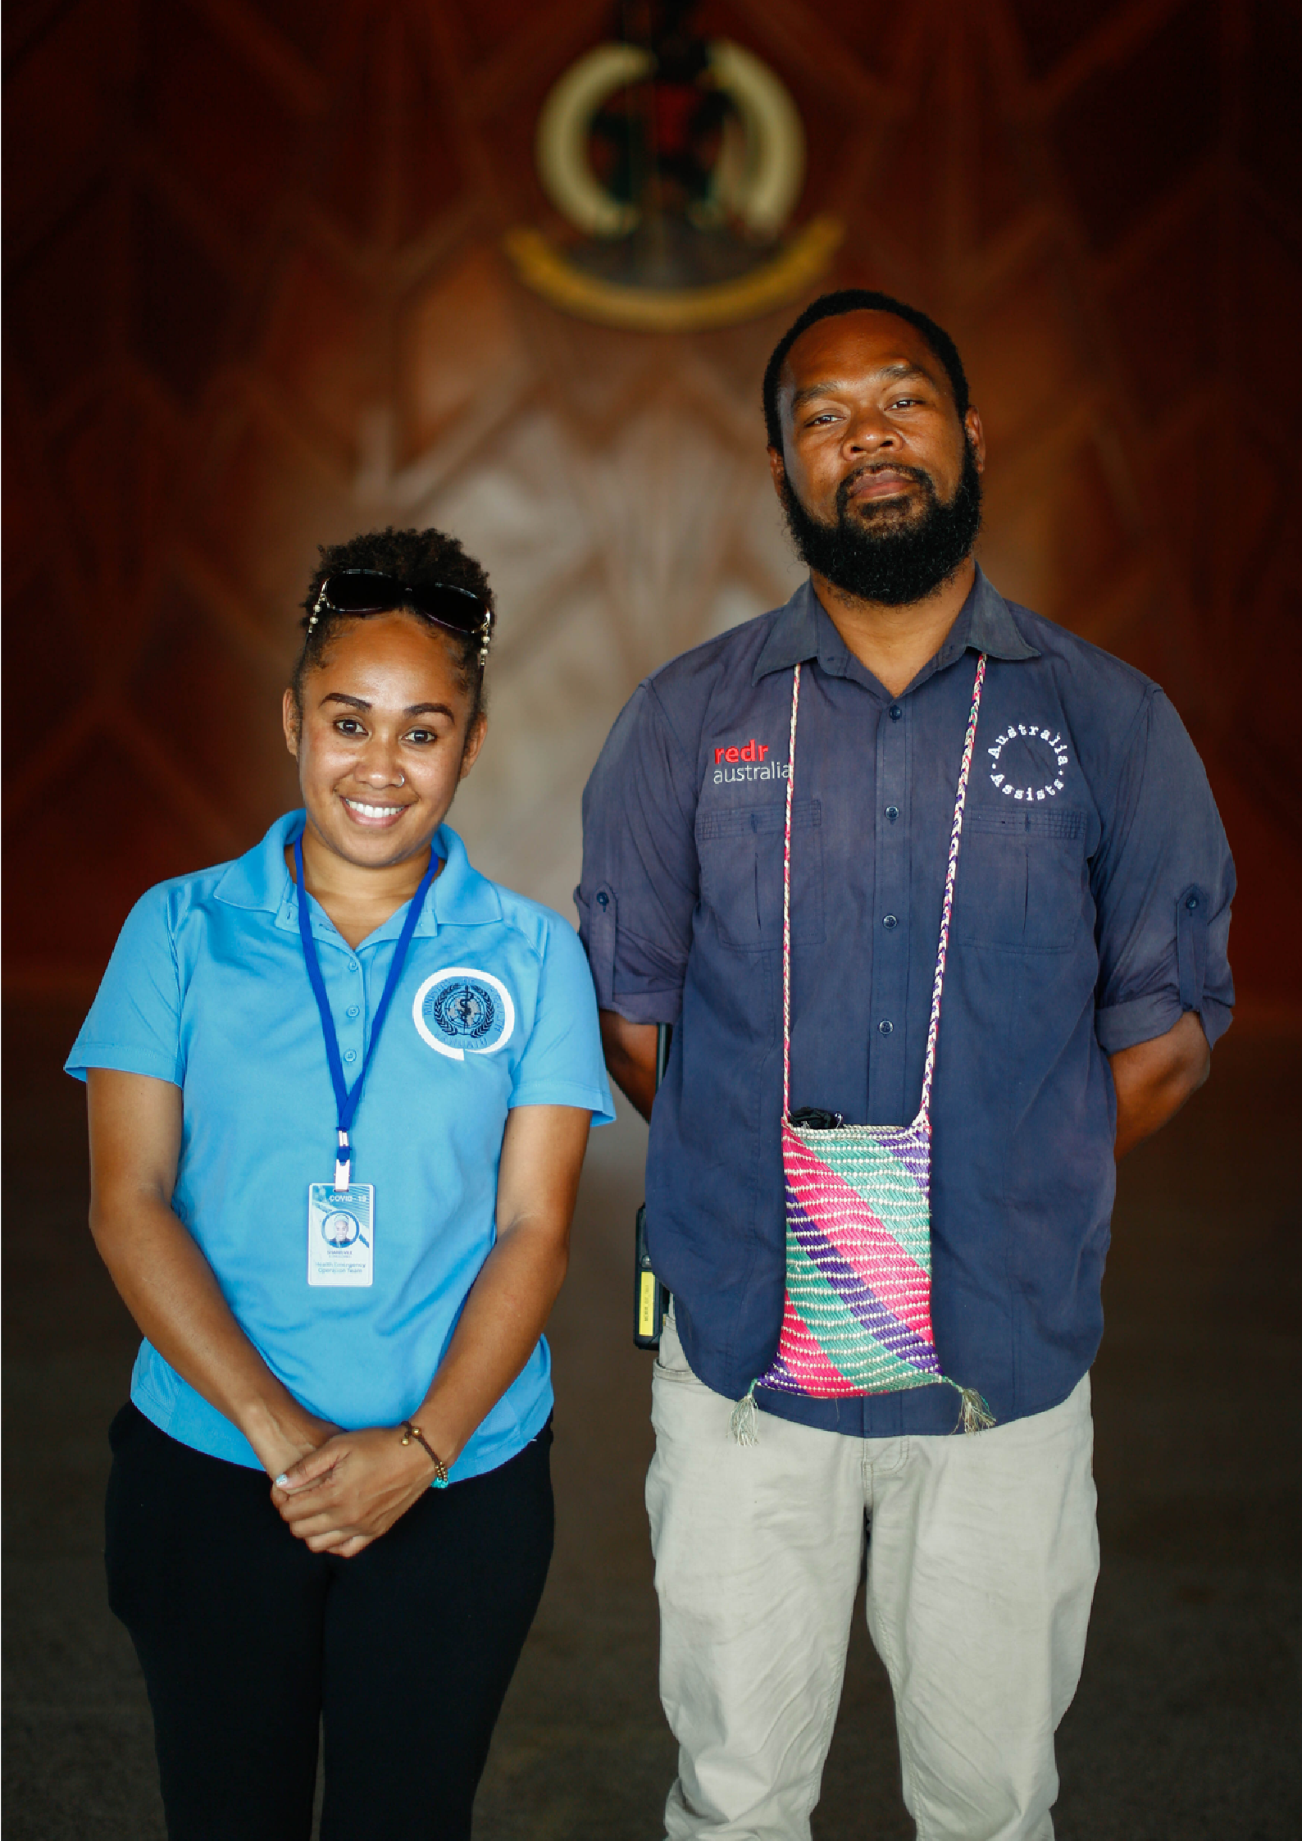


Australia Assists
Annual Report FY21



Table of Contents
Message from RedR Australia’s Chief Executive Officer, Kirsten Sayers 6
Australia Assists at a Glance 7
Program statistics 7
Program milestones 7
Program impact 8
Global Snapshot 12
Program Snapshots 14
Partnerships for Recovery 14
Disaster Risk Reduction and Climate Change Adaptation 17
Peace and Stability 21
Gender Equality 23
Disability Inclusion 27
Localisation 30
Pacific 33
Asia 36
Myanmar and Bangladesh 38
Middle East 40
Africa 42
Program Management 43
Roster Management 44
Training and Capability 45
Program Visibility and Engagement 46
Monitoring, Evaluation, Accountability and Learning (MEAL) 47
Strategic Partnerships 50
Financial Management 51
Risk, Safety and Security 52
Acronyms 54
Annexes FY21 Deployment Data 55
FY21 Financial Acquittal 60

Message from RedR Australia’s Chief Executive Officer, Kirsten Sayers

This year, climate change, COVID-19 and shifting geopolitical dynamics have continued to create unprecedented challenges for individuals, communities and partners. Through RedR Australia and the Australia Assists Program, the Australian Government has stayed and delivered in the face of increased humanitarian need.
As communities around the world struggle, learn and find new ways to adapt to the dynamic nature of the COVID-19 pandemic, the program’s disaster risk management expertise has never been more in demand. The program rapidly began delivering on Australia’s Partnerships for Recovery Strategy, demonstrating the need to manage consecutive and compounding natural hazards while simultaneously mitigating and responding to the global pandemic.
While the world watched in shock as the 1 February military coup in Myanmar escalated and widened an unfolding humanitarian crisis, the program was already positioned to support affected populations, building on 60 deployments over four years in Myanmar and neighbouring Bangladesh, to save lives and protect the most vulnerable.
Together with the Australian Government, RedR Australia is proud to be delivering on a long-term mission to invest in and accelerate local humanitarian leadership in nations and communities managing natural hazards, crises and conflict. We have asked the hard questions to determine what more we can do to proactively redress societal power imbalances. Leveraging our gender, disability and localisation action plans, the program is seeing accelerated progress on these shared commitments that ensure the world is a more equal, fair and inclusive place.
The challenges of the past year have been significant. RedR Australia’s agility and extensive partnership architecture continue to enable Australia Assists to support before, during and after crises, conflict and a global pandemic.
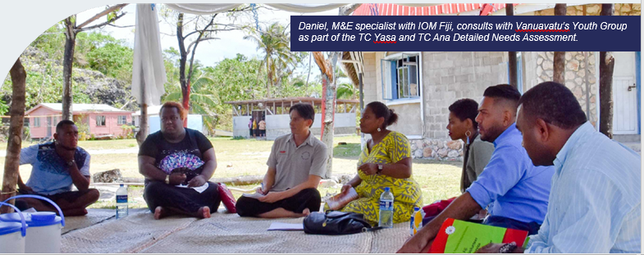Image caption: Daniel, M&E specialist with IOM Fiji, consults with Vanuavatu’s Youth Group as part of the TC Yasa and TC Ana Detailed Needs Assessment.

Australia Assists at a Glance

Program statistics

- 109 specialists deployed to 30 program partners in 26 countries across the Indo-Pacific, Africa and the Middle East.
- Deployments totalled 523 months, against a minimum target of 350, a 15 per cent increase on FY20.
- Females comprised 46 per cent of all deployments, a 2 per cent increase on FY20.
- 20 specialists deployed into targeted gender equality, disability inclusion and protection roles.
- 69 specialists, or 63 per cent, were deployed in-country, while 48 (37 per cent) worked remotely.
- 44 specialists, or 40 per cent of the program, directly supported COVID-19 preparedness and response (61 per cent Pacific, 25 per cent Asia, 14 per cent Middle East, Africa and Europe).
- RedR Australia’s Roster maintains gender parity

In FY21, Australia Assists provided 52 months or the equivalent of 44 consecutive years of technical humanitarian expertise in just one year.

Program milestones
- The program is reinforcing the strengths of our region. Through Australia Assists, RedR delivered its first, fully contextualised Pacific Essentials of Humanitarian Practice training course to augment regional emergency management capacity. Pacific Islander training and subject matter experts co-led the design and delivery.
- The program is becoming more diverse. In line with Australia Assists’ Localisation Action Plan (LAP), the RedR Roster comprises 25 nationalities, and 17 per cent of all deployed personnel had the socio-cultural or linguistic background of the country into which they deployed¹. The program met 40 per cent of LAP targets in the first nine months of implementation.
- The program is delivering on Australian Government gender equality and social inclusion priorities, reaching the highest number of Gender Action Plan targets (25/28 or 89 per cent) and Disability Action Plan targets (21/26 or 81 per cent) to date.
- The program is operationally agile in a COVID-19 environment. A COVID-19 Action Review Report in August 2020 found that RedR had maximised resources to stage an agile and flexible whole-of-organisation response to the pandemic, including accelerating localisation and diversifying the RedR Roster.
- The program is directly supporting national systems. Twelve deployees were embedded in Pacific government ministries and a further seven deployees to UN agencies were seconded to ministries or worked alongside government counterparts.
- Demand for the program is growing. Twenty-four Australian Department of Foreign Affairs and Trade (DFAT) Posts engaged with the program, with RedR responding to new and emerging priorities, including requests from Posts that previously had no or limited engagement with the program. The increasing demand for Australia Assists reflects the quality of deployees and outcomes achieved, coupled with DFAT’s enhanced internal communication.
“The deployment of Australia Assists personnel into Iraq extends the reach of our humanitarian and stabilisation program. It has driven progress on Australian Government priorities, including on disability inclusion, gender equality and post-conflict accountability mechanisms.” — DFAT Post, Iraq.

Program impact
- The Review of Australia Assists’ Support to the Rohingya Crisis 2017-2020 revealed that the program delivered critical impact and value for money. More than 50 deployees since 2017 have provided life-saving assistance, helped protect the most vulnerable, and supported a more targeted, sustainable and accountable response.
- The same review recommended further research into the experiences of Australians working in humanitarian agencies. RedR is finalising this work, with a focus on opportunities to advance the prevention of sexual exploitation, abuse and harassment in the sector.
- The program is facilitating legislative change, with a deployee assisting the Director of NEMO Tonga to prepare the nation for future disasters by drafting a Disaster Risk Management Bill. The Bill, which passed in August 2021, also broadens the NEMO’s scope to include safeguarding, protection and inclusion responsibilities.
- Australia Assists undertook its first clinical deployments in response to COVID-19 with two emergency nurses deployed to an IOM field hospital in Bangladesh, and an Infection, Prevention and Control Technical Adviser deployed to Papua New Guinea.
- RedR Australia operationalized the newly signed bilateral agreement with RedR Indonesia, with the deployment of four Indonesian nationals to support the COVID-19 Response.
- The first jointly recruited specialist with RedR India was deployed as a Capacity Deployment and Deployments Expert, Expert, supporting the broad mandate of the CDRI²

“We will continue to engage with RedR because we believe in their capacity, and most importantly because [the partnership] exemplifies integrity, dedication and commitment to humanitarian values and value-based partnership”.— Deputy Executive Director, ASEAN Coordinating Centre for Humanitarian Assistance.
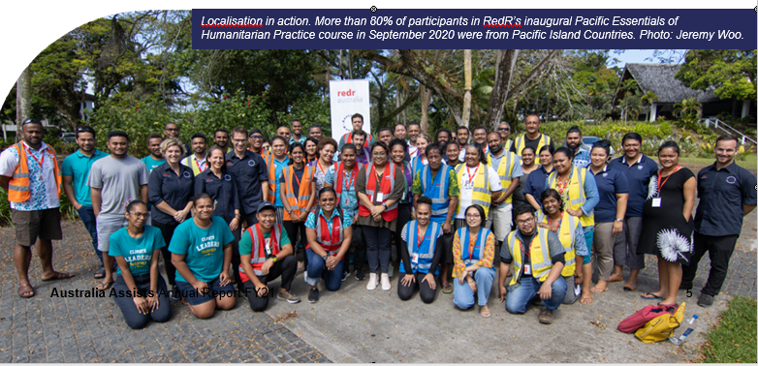
Image caption: Localisation in action. More than 80% of participants in RedR’s inaugural Pacific Essentials of Humanitarian Practice course in September 2020 were from Pacific Island Countries. Photo: Jeremy Woo

- The program’s first Women, Peace and Security (WPS) Specialist was deployed to UN Women Myanmar from July 2020 to June 2021 as conflict and crisis escalated within the country. As the February 2021 coup further destablised peace and security, she worked alongside women in the community to advance local ownership of the WPS agenda.
- Three Civil-Military and access Advisors helped OCHA address significant access constraints that actors face as they try to respond to spiralling humanitarian needs in Myanmar, Jordan and Ethiopia respectively. The work progressed, despite sever restrictions on movement, communications and resources.
- Support to the Humanitarian Partnership Forum’s Localisation Task Team in Jordan resulted in the country’s first jointly agreed gender-responsive Monitoring, Evaluation, Accountability and Learning (MEAL) Framework to push the localization agenda forward.
- Supporting climate change readiness in Timor-Leste, two specialists worked alongside the relevant Ministry’s DRM-Climate Change Adaptation Task Force, resulting in the DRM Strategy for Agriculture and the Multi-Hazard DRM Plan for Agriculture being drafted and implemented.
- FY21 saw the first Australia Assists deployment to UNESCO in Samoa, where a COVID-19 Information and Communications Technology Education Specialist delivered education solutions to enable the Samoan Government to ensure no child is left behind, as the rising sea and climate challenges impede access to physical school infrastructure.
- The program stands in the wake of crises. Following Cyclone Harold (April 2020), Cyclone Yasa (December 2020), and Cyclone Ana (January 2021), 13 deployees assisted in response roles, spanning national emergency operation centre support, crop damage assessments, information management, evacuation, procurement, donor funding and reconstruction.

“A perfect blend of global systems applied locally and regionally in one course.”— Pacific EHP Participant
“RedR Australia has been one of OCHA’s strongest partners in conducting training courses to prepare personnel to deploy to the field. They provide expertise in the realm of training which is scarce, with a strong awareness of and regard to gender sensitivity and disability inclusion.” — United Nations Office of the Assistant Secretary-General for Development Coordination
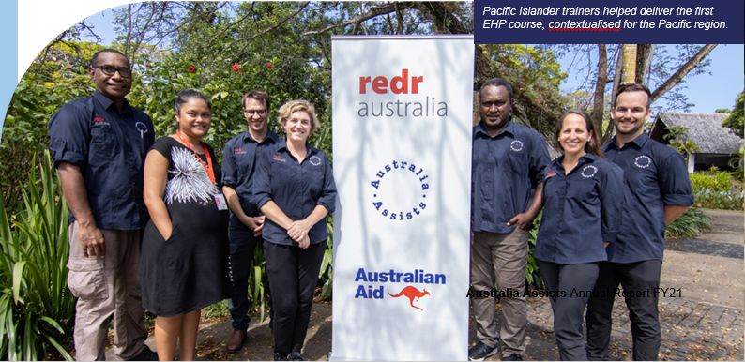
Image caption: Pacific Islander trainers helped deliver the first EHP course, contextualised for the Pacific region.
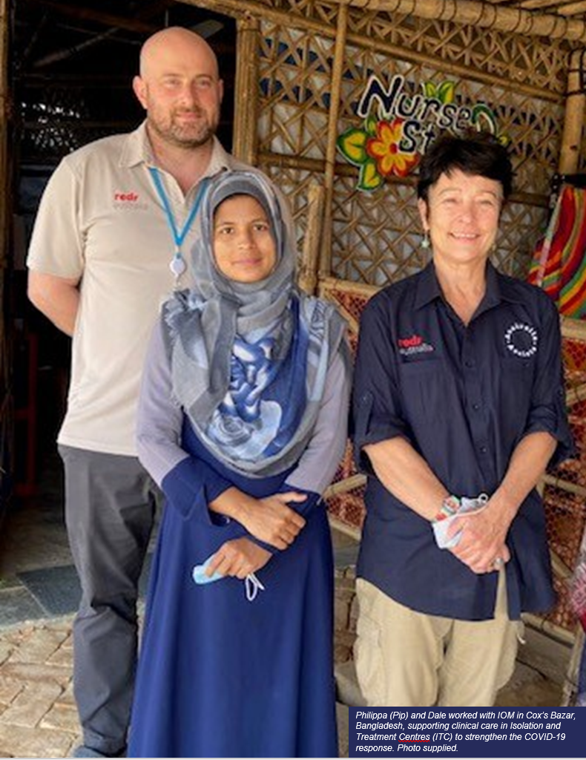
Image caption: Phillipa (Pip) and Dale worked with IOM in Cox’s Bazar, Bangladesh, supporting clinical care in Isolation and Treatment Centres (ITC) to strenghten the COVID-19 response. Photo supplied.

Global Snapshot
Total Deployment | Total Deployment months | Total countries | COVID-19 Deployments
109 | 523 | 26 | 44
14% deployed within their country of origin | Against a minimum target of 350, and a 15% increase on FY 20` | Supporting 30 partner host organisations | Directly supported COVID-19 preparedness and response

Deployments by skill area
Skill area | Total
Response Coordination and Management | 23
Preparedness, Risk Reduction and Resilience | 23
Protection and Legal | 15
Logistics | 10
Information Management | 7
MEAL and Reporting | 7
Communications | 5
Health/Nutrition | 4
Shelter/Engineering | 4
WASH | 4
Education | 4
Stabilisation and Recovery | 2

The top two deployment skill areas (response coordination; preparedness and disaster risk reduction (DRR) reflect the high demand for COVID-19 and climate-related program support.

Deployments by Gender

Gender | Months | Average deployment length
Female 46% | 42% | 4.4 months
Male 54% | 58% | 5.1 months

Deployments by Region

Region | Percentage
Pacific | 52%
Asia | 25%
Middle East | 14%
Africa | 6%
Other (Europe; South America) | 3%

Deployments across the disaster cycle
Australia Assist deployed specialist right across the disaster cycle from Disaster Risk Reduction, to Emergency Management and Response, to Stabilisation and Recovery.
- 25 Nationalities – 17% of all deployees had the socio-cultural or linguistic background of the country of deployment
- 20 targeted deployments – in gender equality, disability and protection roles in line with UN Sustainable Development Goals 5, 10 and 16.
- EPO 1 37 deployments – 34% support before a crisis
- EPO 2 53 deployments – 49% support during a crisis
- EPO 3 19 Deployments – 17% support after a crisis

Deployments by host organisation
- 69% United Nations – FAO, IOM; OCHA; UN Women, UNDP; UNESCO; UNFPA; UNHCR: UNICEF; UNITAD; UNRWA; WFP; WHO.
- 14% Governments - Department of Water Resources Vanuatu; Ministry of Health and Medical Services Solomon Islands; Ministry of Health Vanuatu; Ministry of the Interior Timor-Leste; Ministry of Justice and Community Services; Office of the Bougainville Electoral Commission; Office of the Prime Minister Vanuatu; Office of the President Kiribati; Department of Health PNG; Public Works Department Vanuatu;
- 8% National Disaster Management Authorities – NDMO Samoa; NDMO Vanuatu; NDMO Tonga.
- 6% NGO’s – IPPF; SPC/.
- 4% Regional Organisations AHA Centre; PDF

Program Snapshots

Partnerships for Recovery
(P4R; COVID-19 Preparedness, Response and Recovery)

In FY21, Australia Assists delivered on the Australian Government’s new Partnerships for Recovery development policy. Program outcomes were directly aligned with the Policy’s two areas of Focus and four Actions.

Areas of focus

The Indo-Pacific, particularly the Pacific, Timor-Leste and Southeast Asia.
38 of the 44 COVID-19-focused deployments (86 per cent) were in the Indo-Pacific, with 27 based in the Pacific (Papua New Guinea, Fiji, Kiribati, Solomon Islands, Samoa, Tonga, Vanuatu) and 11 in Southeast Asia (Bangladesh, Laos, Indonesia, Pakistan).

An effective global response and recovery.
Six COVID-19-focused deployments (14 per cent) were in Jordan, the Palestinian Territories, Liberia and Latin America. The remaining two were based in Geneva with a global focus.

Areas of action

Health Security
- Reducing COVID-19 transmissions through public health awareness, clear guidelines and standards and strengthening local capacity with medical training and supply chain logistics
- In Papua New Guinea, Abby drafted national guidelines on Infection, Prevention and Control, and developed and delivered training for medical personnel, including 78 PNG Defence Force Medical Corps officers, 21 nurses and 32 lab technicians. Chiedza concentrated on disease surveillance and control by establishing a national dashboard and an algorithm that helped to identify, determine and provide recommendations to mitigate the risk of importing COVID-19. Shannon assisted the National Department of Health communicate risk and engage the community to help stop the spread of COVID-19. Together these deployments supported a more efficient and effective provincial and national response to COVID-19 to safeguard the health of the population.
- Stephen and Rowan provided supply chain and logistics support to WFP Fiji and the Department of Water Resources in Vanuatu. As nationals of their respective countries, they leveraged and strengthened existing capacities and networks for local and regional procurement. Stephen oversaw the movement of essential goods throughout the pacific and organized a warehouse from which to freight personal protective equipment and relief supplies, while Rowan supported the Department of Water Resources and the Ministry of Health to create a tracking system for medical cargo for distribution to local hospitals.

Stability
- Building social cohesion and stability by investing in national capacity to maintain essential services while developing and implementing effective COVID-19 response and recovery plans.
- Three Indonesian Provincial Officers, jointly recruited by RedR Indonesia, facilitated engagement between provincial and national government actors to support the assessment of humanitarian needs. Together they identified and articulated the serious concerns of more than 1000 individuals relating to food security, health worker availability and medical supplies, which informed the drafting of recovery plans. This directly resulted in provincial hospitals receiving medical consignments, including much needed ventilators, to help save lives but also help maintain critical community trust in provincial and national government COVID-19 responses.
- COVID-19 Management and Coordination Response Advisor, Christine, was embedded in the Solomon Islands Ministry of Health and Medical Services where she advised the Under Secretary of Health on long-term COVID-19 response planning and sustainable resourcing. She identified and prepared public facilities for infection overflow and facilitate partnerships with national UNICEF and Red Cross offices to promote public health.
- Two COVID-19 Information Management Officers, Greg and Rod, created dashboards with real-time updates on COVID-19 responses in more than 30 countries, helping decision-makers and donors to allocate global resources equitably.
- See Regional Program Snapshots for more examples of COVID-19 preparedness and response.

Economic Recovery
- Bridging the humanitarian-development stabilization gap through civilian leaders who are experts in coordinating and facilitating joint programming to keep communities safe and support locally led recovery.
- Five COVID-19 Coordinators worked remotely together in support of the UNDP Resident Coordinator’s Office across the Solomon Islands, Tonga, Federated States of Micronesia, Kiribati and Vanuatu to inform national decision-making on economic recovery.
- One deployee undertook rapid market assessments of sanitation products (hand sanitizer, soap, water trucking and chlorine) to understand their availability and affordability for COVID-19 response throughout 36 Latin America Countries.
- As a Logistic and Supply Chain Consultant, David provided new perspectives for the AHA Centre to find innovative ways to manage ASEAN humanitarian warehouses to prepare and respond to humanitarian crises.

“This deployment has been critical to the COVID-19 response in Papua New Guinea. [Chiedza] has significantly increased the capacity of our organisation in the areas of epidemiology and surveillance.” - WHO Incident Manager, on deployee, Chiedza.
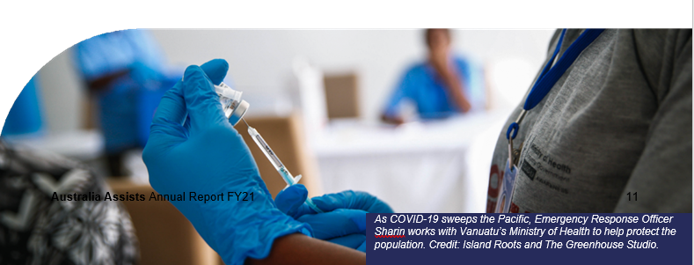
Image caption: As COVID-19 sweeps the Pacific, Emergency Response Officer Sharin works with Vanuatu’s Ministry of Health to help protect the population. Credit: Island Roots and The Greenhouse Studio.

Protecting those most at risk, especially women and girls.
As the effects of the COVID-19 pandemic exacerbated existing inequalities across every sphere -from health and the economy, to security and social protection. Maintaining the wellbeing and resilience of those invulnerable situations, especially women and girls, remains a strategic policy.
Five dedicated Protection and Gender Specialists focused on the Indo-Pacific, and two on the Middle East, to advance, mainstream and safeguard protection and inclusion in their respective host agency programs.
- Jess prepared a Risk Communications and Community Engagement Strategy for the regional Joint Incident Management Team and organised toolkits to guide community workers on COVID-19 related risks, including gender-based violence, wellbeing in isolation and mental health and psychosocial support

[See Gender Equality and Disability Inclusion}]
“One key component of the work was the emergency set-up of facilities around WFP’s COVID-19 response. [Valeri] has been instrumental in ensuring that the new market facilities were created in a practical and fast manner to enable safe markets.” — Deputy Country Director, WFP Uganda, on deployee, Valeri.

Disaster Risk Reduction and Climate Change Adaptation

The COVID-19 pandemic, coupled with compounding global emergencies, including the effects of climate change, has increased both the demand for and the relevance of the Australia Assists program. The program has continued to strengthen disaster risk reduction (DRR) and emergency preparedness through strategically positioned humanitarian expertise.

Supporting National Disaster/Emergency Management Organisations (NDMO’s/NEMOs)

NEMO Tonga
Suresh recommended changing the Emergency Management Act to Disaster Risk Management Act to cover all elements in the identification of risks, relief and recovery processes at the onset of the emergency. This led to the development of the Emergency Road Map which is the first of its kind in the region. The Road Map was endorsed by SPC Fiji and launched in August 2021. Along with Australia Assists colleague Maureen, Suresh also helped re-draft the recently passed DRM Bill, which broadens the NEMO’s scope to include safeguarding, protection and inclusion elements. Maureen also supported policy development, including drafting preparedness and response plans for volcanic eruptions/ash and tropical cyclone risks.
“Last month was a critical time for NEMO as we were at the finalisation stage of our DRM bill of which Suresh is taking the lead on. This is NEMO’s highest priority area now and I’m glad to share with you that the DRM bill was approved by Cabinet yesterday and this is a great milestone for NEMO Tonga. We owe it to you and wish to acknowledge the support from your side through the deployees, malo aupito!”
— NEMO, Tonga.

NDMO Samoa
Ameen tailored an online information management system to help NDMO and the National Emergency Operation Centre with planning and decision making.
Simione worked with strategic DRM leaders (including SPC, OCHA, UNDRR and IFRC) to help redesign a Response Agencies Toolkit. The toolkit provides resources to help regional agencies develop fit-for- purpose but standardised DRM plans that guide future preparedness, response and recovery work

NDMO Vanuatu
Deployees Rowan, Rebecca and Allen supported the NDMO to advance a common operating model of DRM across the Pacific, while achieving fit-for- purpose local emergency response plans that coordinate agencies in times of crisis. In a simulated cyclone exercise, a team of 30 staff from government agencies, non-government organisations and province offices produced a strong situation report to update the Secretary General within five hours.

Climate resilience in Timor-Leste
Kate and Marina deployed consecutively to the FAO, working alongside the DRM-Climate Change Adaptation Task Force in the Ministry of Agriculture and Fisheries. This work resulted in the drafting of a DRM Strategy for Agriculture and the Multi-hazard DRM Plan for Agriculture. The Ministry-endorsed strategy sets out a vision for the management of disaster risks, including pests, disease and climate change, while the plan can be used by practitioners and technical experts. Marina’s work included developing and socialising a Hazard, Vulnerability, Risk Assessment Tool among government counterparts while also supporting the National Disaster Operation Centre with database management and Situation Reports during flash flooding in early 2021.
“The focus of Kate’s assignment was to set the foundation for the institutionalisation of agriculture DRM in Timor-Leste. This is a significant contribution that will, in due time, make a difference for communities vulnerable to the numerous hazards affecting Timor-Leste.”
— Team Leader, FAO Timor-Leste, on deployee, Kate.

Food Security in the Pacific – practical approaches to resilience
Emergency and Resilience Expert, Kara provided assistance to vulnerable populations as the focal point for FAO’s sub-regional Office for the Pacific Islands and the Regional Pacific Food Security Cluster Coordinator. Kara’s role was essential to cyclone affected communities and those bearing the brunt of COVID-19 restrictions as her reports and proposals resulted in increased funding and enhanced humanitarian programming. Working with FAO and the Food Security Cluster, Philippe established the Climate and Disaster Risk and Resilience Unit within Fiji’s Ministry of Agriculture. The foundations he laid were put to the test when Tropical Cyclone Yasa caused significant crop damage in Fiji. Philippe’s well integrated standard operating procedures allowed district level actors to rapidly mobilise and complete a comprehensive damage assessment within days of the disaster. This is testament to the efficacy of preparedness planning that Philippe had fostered to safeguard communities against food shortages.
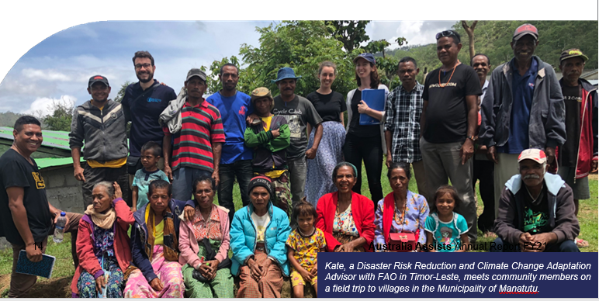
Image caption: Kate, a Disaster Risk Reduction and Climate Change Adaptation Advisor with FAO in Timor-Leste, meets community members on a field trip to villages in the Municipality of Manatutu.

Interoperability across the Pacific
The program’s longest-serving deployee, Gina has worked with SPC since 2018 to enhance interoperability between disaster management agencies.
Specifically, she has:
- Developed the SPC Post Disaster Response Framework and supporting tools that guided SPC’s network of Pacific agencies through TC Harold and COVID-19 responses in its test phase.
- Customised an Incident Management System with online awareness training implemented across 80 organisations within 18 countries. The system strengthens national and regional response capability by instilling common procedures and training standards for emergency services.
- Prepared a Pacific TAFE Certificate IV qualification in DRM Team Leadership, in partnership with the Pacific Resilience Programme and the University of the South Pacific. This is the first of its kind and will significantly increase capability through competency-based training that is accessible across the region.

Pacific DRM analysis
RedR has begun examining the nature and extent of Australia Assists’ contribution to building institutional DRM capability across the Pacific. Research indicates that in its first four years (2017-2021), the program’s relevance, effectiveness, efficiency, impact and sustainability have continuously improved. While there are clear lessons on the importance of building longer-term capability to ensure the sustainability of response deployments, early findings confirm that:
- Australia Assists deployees were of high quality and were able to provide high quality technical assistance which resulted in development or updates
of fit-for-purpose Standard Operating Procedures and legislation, and improved human resource capacities.
- Localisation is a key component in sustaining DRM/DRR institutional development reform efforts. RedR Australia has begun this important action, which should continue to be scaled up.

Through the review, we are learning:
- There is an opportunity to further increase partnerships with the private sector and private non-government organisations, in Australia and the Pacific on disaster preparation and response, fragility and conflict, especially in the food security area.
- A deployment model with a humanitarian/ development lens that incorporates a long-term programmatic approach, rather than a short-term problem-solving approach, would further strengthen Australia Assists’ efforts in reforming institutional development of DRR/DRM.
- Australia Assists deployees to the Pacific would benefit from a regular communications platform (such as a Community of Practice) to share institutional knowledge, experience and networks relating to DRR and management.

“The Government of Kiribati now has a Cabinet-endorsed Disaster Risk Management and Climate Change Act and comprehensive Regulations which will provide guidance and direction to emergency responders. This will enable a much more effective and efficient whole-of- government emergency/disaster response.” — Deputy Secretary, Kiribati Office of the President, on deployee, Christine.

Peace and Stability
Australia Assists continues to improve the ability of priority countries and partner agencies to mitigate, stabilise and recover from conflict. As COVID-19 continues to fray social cohesion and stability, Australia Assists remains focused on the root causes of conflict, mitigating its impact, and building the foundations for peace through RedR Australia’s gender, disability and localisation action plans.

Surge Capacity in peace and stability settings

Humanitarian access
Two OCHA Civil-Military Coordination Officers in Jordan and Ethiopia, Joseph and David, negotiated access and safe passage to enable the most impartial, neutral and independent life-saving access and services to reach populations most affected by the Syrian and Tigray conflicts.

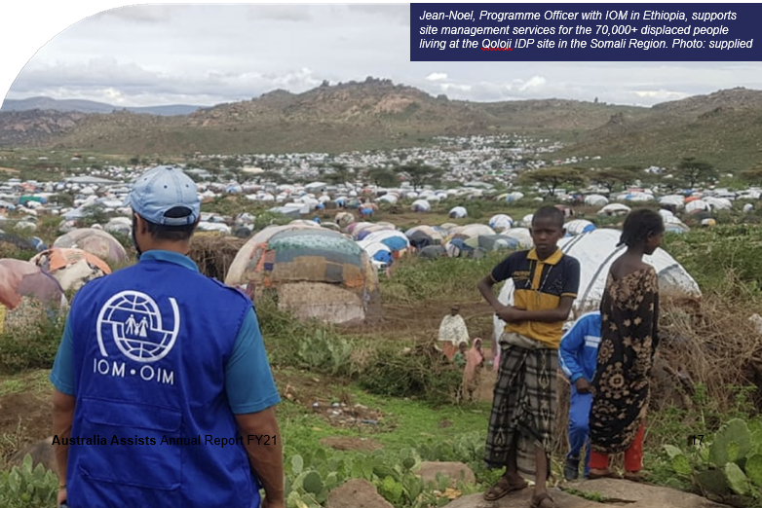
Image caption: Jean-Niel, Programme Officer with IOM in Ethiopia, supports site management services for the 70,000+ displaced people living at the Qoloii IDP site in the Somali Region. Photo: supplied
“The expertise that Australia Assists has provided in Ethiopia has allowed Australia to fill critical technical gaps in the humanitarian sector and provided timely insights in a rapidly-changing context.” — DFAT Post, Ethiopia

Myanmar
The independent Review of Australia Assists’ Support to the Rohingya Crisis 2017-20 confirmed that Australia Assists prioritised providing technical assistance into UN agencies that improved accountability, participatory processes and visibility for vulnerable groups. This included validation that the program helped to raise the voices of refugee women to donors and key agencies, leading to increased funding for prevention of gender-based violence and women’s empowerment programming. The review also confirmed that Australia Assists raised awareness and good practice disability inclusion programming, including training 200 WFP staff. The review confirmed that the collective efforts focused on social inclusion, including the advice Jess shared with UN Women that resulted in the development of a Women, Peace and Security Strategy and Operational Plan, which remains the bedrock of program activity supporting social cohesion. This is a fundamental element required to respond effectively to the priorities of the Australian Government’s Partnerships for Recovery.
“Michelle advocates both from the standpoint of the vulnerable and crisis-affected populations, but also with an eye to balancing very real protection concerns against the pragmatic need to deliver humanitarian assistance.” — Deputy Country Director, WFP Myanmar, on deployee, Michelle.

Bougainville
The program promoted social and political stability by supporting elections in Papua New Guinea for the third time. Elections provide a formal mechanism for improving representative governance, the responsiveness of states to their citizens and the peaceful transfer of power.³ Deploying two election specialists who provided operational and logistics advice to the Office of the Bougainville Electoral Commissioner supported the delivery of a legitimate local election.
“[Barnaby] was able to advise OBEC on factors to consider in logistics planning. This is a good knowledge transfer. Through this deployment, the skills shared with the team are important and timely as OBEC focuses on the planning and delivery of [other] elections in the near future.” — Director Elections, OBEC, on deployee, Barnaby.

Timor-Leste
As a Civil Protection Policy Advisor at the Timor-Leste Ministry of Interior, Sandra provided technical advice for the drafting of the national Civil Protection Strategy written in both English and Portuguese, as well as the Secretary of State Civil Protection Strategic Plan. This legislation provides a legal basis to reinforce civilian, community and protection-led approaches to social inclusion, and helps to ensure a peaceful future.

Gender Equality
In FY21 the program reached its highest number of targets from the Australia Assists Gender Action Plan (GAP) to date (25/28 or 89 per cent). Australia Assists doubled the target of four gender specialists deployed per year, deploying eight targeted specialists, plus five more technical experts deployed to gender-mandated host organisations (IPPF, UN Women and UNFPA).

GAP priorities
- Enhance women’s voices in decision- making, leadership and peace building.
- End violence against women and girls.
- Build organisational capacity including developing improved policies and systems

The program advanced GAP priorities through targeted deployments to multiple host organisations throughout Asia-Pacific and the Middle East including:
  - Gender and Protection Support Advisor, UN Women Vanuatu
  - Protection and AAP Advisor, WFP Myanmar
  - Gender Advisor, WFP Jordan
  - Gender/PSEA Advisor, OCHA Jordan
  - SRH (Sexual and Reproductive Health) and GBV (Gender Based Violence) in Emergencies Programme Specialist, UNFPA Fiji
  - PSEA (Preventing Sexual Exploitation and Assault) Coordinator, UNFPA Fiji
  - Protection Advisor, UN Women Fiji

In addition, Australia Assists deployed other specialists to gender-mandated host organisations including:
  - Two MEAL specialists and a supply chain and logistics specialist to IPPF Fiji
  - MEAL Specialist, UN Women Jordan
  - Women, Peace and Security Advisor, UN Women Jordan.

Driving the protection agenda
Preventing gender-based violence (GBV) and sexual exploitation, abuse, and harassment (PSEAH) remained a program priority, at both an operational and organisational level. The deployment of protection specialists to the Pacific directly contributed to increased local and national capacity to prevent, manage and respond to GBV during emergencies such as COVID-19 and recent tropical cyclones. Deployees worked to integrate the principles of GBV prevention into plans, strategies and procedures of emergency programming. They also took pragmatic action to reduce GBV risks through public information campaigns, including distributing helpline posters in evacuation centres and advocating for female representation in community decision-making roles.

Women, peace and security
Deployed to UN Women Myanmar six months before the February 2021 coup, Women, Peace and Security Specialist (WPS) Jess supported local women to have a greater voice in peace and stability, as violence escalated around the country. She helped contextualise a Training of Trainers handbook, which incorporates international law and WPS information geared to increase women’s participation in peace processes. Her work identified barriers and partnership opportunities to enable local ownership of the WPS agenda.

Impact at a glance
Sixty-eight per cent of completed deployments in FY21 reported on their contribution toward gender equality – 18 per cent higher than the GAP target, and a 10 per cent increase on FY21. This was in part attributable to a stronger emphasis on gender equality in pre- deployment briefings and online training opportunities offered to deployees.
- A UN Women Protection Advisor supported the Pacific regional protection cluster to identify and address protection bottlenecks experienced during disaster response phases and build on lessons learned in preparation for the next cyclone season.
- Two PSEAH specialists to OCHA Jordan and UNFPA Fiji improved organisational accountability on awareness and prevention and strengthened information sharing within their respective regional networks.
- A Gender Advisor developed a Gender Strategy and Action Plan for WFP Jordan and assisted working groups to address the gendered impacts of COVID-19, such as heightened risks of GBV during lockdown.
- A Disaster Risk Management Specialist with FAO Timor-Leste led the integration of gender considerations into COVID-19 food security impact assessments. During field trips, she interviewed women and men separately to ensure open, equitable discussions.
- A UNHCR Turkey Shelter Officer incorporated strategies to reduce the risk of gender-based violence in refugee settlement designs, for example, separating male and female bathrooms by distance, and considering the layout of women- friendly and child-friendly spaces in line with humanitarian Sphere standards.
“She demonstrated respect for diversity and inclusion, and collaborative work ethic, in her manner of engaging with multiple diverse stakeholders and actors.” — Gender and Humanitarian Specialist, UN Women Jordan, on deployee, Kylie.
“Nimarta has assisted us to strengthen our response and recovery to multiple disasters, mainstreaming gender and protection into other sectors. Her technical assistance and support has directly contributed to increased budget and programming for the Justice and Community Services sector.” — Director General, Vanuatu Ministry of Justice and Community Services, on deployee, Nimarta.

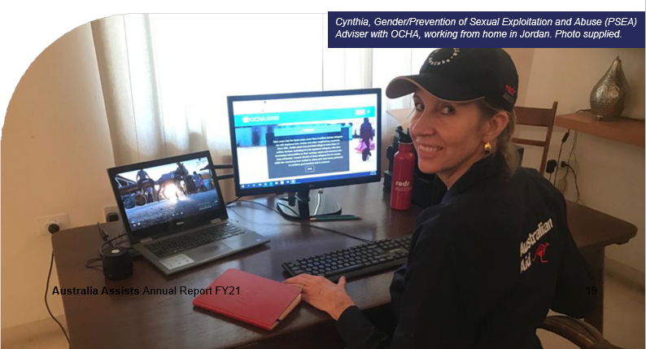
Image caption: Cynthia, Gender/Precention of Sexual Exploitation and Abuse (PSEA) Advisor with OCHA, working from home in Jordan. Photo supplied.

GAP highlights
  - The number of gender specialists on the RedR roster has increased by 59 per cent since the October 2017 baseline, from 56 to 89 specialists.
  - As a direct result of an Australia Assists Rohingya Review finding, RedR commissioned a follow-up project that specifically focused on preventing sexual exploitation, assault and harassment (PSEAH) (see The PSEAH Project box below and Partnerships section). The project sought to capture the experiences of people working in the humanitarian sector in relation to PSEAH, and to provide pathways for improving both practice and policies. The research involved close engagement with sector partners and an internal learning session, held in May 2021.
  - RedR initiated an independent desk-based gender review of a sample of 18 deployments, including a mix of gender specialists and others, which provided examples of gender mainstreaming. The analysis of the GAP’s Priority One (Enhancing women’s voices in decision-making) and Two (Ending violence against women and girls) found that Australia Assists deployments:

» help keep the needs of women and girls on the agendas of host organisations and other humanitarian actors and decision-makers.
» contribute to institutional strengthening of partner agencies and the broader humanitarian sector, through collaboration with local partners and other organisations.
» contribute to the coordination of gender and protection activities during disaster response.
» play a key role in mentoring and advancing the knowledge and skills of humanitarian staff, leaders and decision-makers in government and non-government sectors.
» strengthen gender and social inclusion in humanitarian response through Monitoring, Evaluation and Learning deployments.
» strengthen GBV Clusters and coordination on gender-based violence.
» improve the quality of needs assessment processes and tools.
» contribute to improving GBV standards, policies and guidelines.
- In September 2020, RedR engaged a Gender Specialist from the roster to deliver two professional development online training sessions on GBV awareness, which reached 23 staff, associate trainers and other roster members.

The PSEAH Project
The PSEAH Project examined individual experiences of, and progress within, the Australian humanitarian sector since PSEAH and Whistle-blower policies were developed in 2018. Data collected from May to June 2021 drew on more than 109 confidential survey respondents, half of whom had more than 10 years individual professional sectoral experience, totalling more than 600 years of collective expertise. The final report is scheduled for the 2021-22 financial year but a key message has emerged:
“Sexual exploitation, abuse and harassment is enabled by cultural and societal norms that perpetuate power imbalance and inequality. Tackling sexual exploitation, abuse and harassment for organisations and as a sector should be recognised as a golden opportunity – wherein individuals, teams and leaders are encouraged to reflect on and unlearn traditional ways of working in order to build resilient, inclusive, safe and creative workplaces. The downstream effects of this are not only related to internal efficiency, effectiveness and innovation but ultimately will be felt by affected populations and local partners.”
– PSEAH Project Final Report (RedR Australia and the Australian Red Cross)

What challenges emerged?
- The three annual GAP objectives that RedR did not meet in FY21 relate to the inclusion of gender-specific outputs in deployment Terms of Reference (TOR), the delivery of staff training on the Gender Strategy, and the review of RedR’s GBV Policy. Including gender-specific outputs in deployment Terms of Reference has been challenging in relation to UN deployments, but RedR is addressing this outside the TOR document. Staff training on the Gender Strategy and the review of the GBV Policy are scheduled for FY22, upon completion of the Preventing Sexual Exploitation Assault and Harassment (PSEAH) Project.
- The independent desk-based gender review recommended ‘including sub- questions on community level and host organisation-level impacts of targeted gender deployments in final (deployment) reports’. RedR has addressed this by updating all deployment reporting templates and placing questions regarding gender, disability and protection at the front-end to optimise capture.

“Nimarta has assisted us to strengthen our response and recovery to multiple disasters, mainstreaming gender and protection into other sectors. Her technical assistance and support has directly contributed to increased budget and programming for the Justice and Community Services sector.” — Director General, Vanuatu Ministry of Justice and Community Services, on deployee, Nimarta.
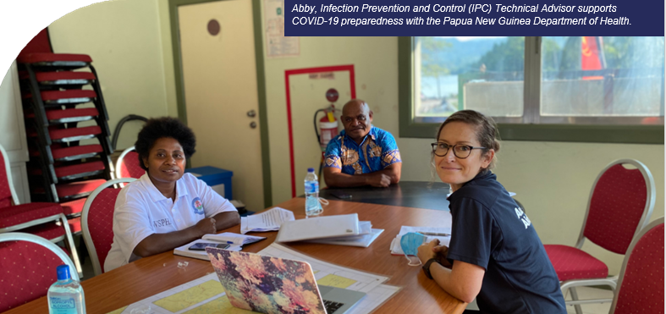
Image caption: Abby, Infection Prevention and Control (IPC) Technical Advisor supports COVID-19 preparedness with the Papua New Guinea Department of Health

Disability Inclusion
Disability Inclusion Action Plan (DAP) targets in FY21 (81 per cent), the highest number to date – four more targets reached than in the previous two years. Six targeted disability inclusion specialists deployed to Fiji, Jordan, Iraq and Somalia, and RedR continued to build the capacity of roster members to be disability champions.

DAP priorities
- Personnel and partners have capacity to practice effective disability inclusion across the humanitarian continuum.
- Contribute learning to advance global policy and practice on disability inclusive humanitarian action.
- Strengthen organisational systems, processes and staff capability to be more disability inclusive

Tools, training and technical guidance
Australia Assists specialists deployed to the Middle East and Africa secured more sustainable and meaningful approaches to disability inclusion within their host organisations by institutionalising new practices and processes.
  - At UNRWA Jordan, Mayada systemised referral pathways and established a psychosocial support group for parents of children with disabilities to provide guidance on at-home support.
  - At IOM Iraq, Tarryn built organisational capacity via regular disability inclusion messages to 250 staff, and developed a dedicated intranet page featuring guidance notes, checklists and relevant resources.
  - At OCHA Somalia, Melissa embedded disability inclusion into the national Humanitarian Response Plan to ensure that humanitarian assistance reaches vulnerable populations.
The program also collectively raised the profile of people with disabilities in emergency preparedness through three deployments to the Pacific Disability Forum, which provided communications, humanitarian training and project coordination expertise.

Disability inclusion mainstreaming
The proportion of Australia Assists deployees who reported disability inclusion outcomes in their final deployment reporting has steadily increased in the past two years, from 39 per cent in FY19 to 58 per cent in FY20, and now 62 per cent in FY21.
Highlights include:
- A COVID-19 ICT in Education Specialist consulted with disability experts to redesign the physical layout of a learning space in Samoa, including entry ramps and fully accessible bathrooms.
- A Disaster Recovery and Risk Reduction Specialist coordinated with the Laos Association for Autism to establish it as the receiving organisation of a UN75 fundraising campaign which generated more than US$2,000. The handover was conducted on the International Day for Persons with Disabilities (3 December), to help consolidate the partnership between the UNRCO and the local organisation.
- A Monitoring and Evaluation Specialist in Fiji ensured that a component of the Washington Group Questions on Disability Statistics was included in IPPF Disaster Needs Assessment to improve data collection for people living with a disability.
- Despite initial resistance, a MEAL Specialist in Jordan ensured that local and national organisations for people with disabilities will be prioritised during implementation of the Humanitarian Action Framework she developed. She advocated for specific targets for organisations for people with disabilities which remain in place, thanks to her counselling and insistence.

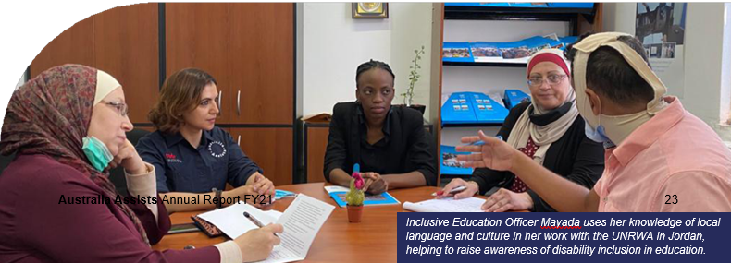
Image caption: Inclusive Education Officer Mayada uses her knowledge of local language and culture in her work with the UNRWA in Jordan, helping raise awareness of disability inclusion in education.

DAP highlights
- RedR and CBM delivered five online introductory disability inclusion training sessions to 141 participants (53 per cent female, 47 per cent male).
  - 14 deployees took part in a mentoring initiative with CBM, which helped them identify opportunities for disability inclusion in their deployments (see below).
  - RedR successfully advocated for disability inclusion indicators with a new five year partnership with the UNOPS.
  - A RedR-CBM partnership health check revealed improved ratings for good disability inclusion practice for 22 of 27 indicators, against the 2017 baseline. RedR held an internal learning session to communicate the health check results and identify areas for priority action.
  - RedR published a case study entitled ‘One Year On: Reflecting on the Deployment of an Australia Assists Disability Inclusion Specialist to the World Food Programme’.

Remote mentoring – Australia Assists deployees and CBM
RedR offered 18 Australia Assists deployees an opportunity to be mentored by an Advisor from CBM. For the pilot program, RedR selected deployments from a wide geographic spread which focused on community engagement, information dissemination, communications or gender.
- 14 deployees took part in the pilot, including six who participated at the same host organisation.
- Sessions involved a 45 to 60 minute call with a CBM Advisor to discuss disability inclusion entry points.
- CBM followed up with an email outlining recommended resources.
- Discussion topics included:
- access to early warning systems and evacuation centres
- establishing and sustaining organisational Disability Task Forces
- creating individual education plans for students with learning difficulties
- barriers to accessing gender-based violence and sexual reproductive health services
- partner surveys to assess disability inclusion capacities

Training in focus
RedR’s Training and Capability team has achieved the following disability inclusion milestones:
- Invited CBM to participate in Essentials of Humanitarian Practice (EHP) and Hostile Environment Awareness Training (HEAT) courses and provide recommendations
- adopted the majority of CBM recommendations and updated monitoring documents accordingly. By May 2021, 39 recommendations had been adopted for EHP (compared to 16 in June 2020), and 42 had been fully adopted for HEAT (compared to 7 in June 2020)
- added voice captioning to more than 18 training videos
- invited two staff from PDF (a Disability Inclusion Advisor and a Preparedness Manager) to participate in the inaugural Pacific EHP course in Fiji
- explored options to recruit Associate Trainers with the requisite experience to ensure disability inclusion can be integrated into regular organisational activities and develop a new course offering

Challenges and focus areas for FY22
- Of the five DAP commitments that were not met in FY21, most relate to strengthening disability inclusion outcomes in new and existing partnerships. This was largely due to the impact of COVID-19 on RedR’s ability to secure new partnerships, which often require face-to-face engagement to bring to life. Discussions are underway regarding opportunities to establish new partnerships with organisations for people with disabilities in Asia and the Middle East.
- A shortage of disability inclusion specialists remains an ongoing challenge, which was compounded by current travel barriers. In an effort to boost disability inclusion expertise on the roster, RedR initiated a new scholarship, offering two individuals who have a disability or disability inclusion expertise to undertake EHP and HEAT courses as a pathway to deployment.
“Tarryn’s work greatly impacted IOM’s understanding of disability inclusion, not only from the way programs are designed and conceptualised, but also implemented, reported and technically measured in terms of impact and lessons learnt. The large number or checklists, tools, templates and guidelines bear witness to her impact and the sustainability of her coaching.” — Programme Coordinator, Community Stabilisation Unit, IOM Iraq
“Melissa played a key role as part of the Humanitarian Program Cycle team for 2021. She reviewed both the Humanitarian Needs Overview and Humanitarian Response Plan to ensure disability and gender inclusion were sufficiently incorporated. Her work and efforts directly contributed to making the Humanitarian Needs Overview and Humanitarian Response Plan more robust documents, and the clusters are better prepared to implement their programs with a more thorough focus on inclusion.” — Deputy Head of Office, OCHA Nairobi

Localisation
While the program has focused on localisation since its inception, FY21 marked a milestone with the development of the Australia Assists Localisation Action Plan (LAP); 2020-2024. In line with relevant global and regional frameworks including the Grand Bargain and Sendai Framework, RedR made significant progress against LAP commitments, reaching 40 per cent (12/30) of targets in the first nine months

LAP priorities:
- New and existing partnerships build on and support the capacity of local and national actors working across the humanitarian continuum.
- Training and the Roster are responsive to, and representative of, the needs and
priorities of local and national humanitarian actors.
- RedR Australia offers an enabling environment that reflects and supports organisational commitments to localisation.

Deploying national experts
The COVID-19 pandemic has provided an opportunity for RedR Australia to accelerate local ownership and leadership of humanitarian action. Recent efforts to export training and bolster partnerships within RedR International has resulted in more local inclusion and leadership in the program than in any previous year. After successfully completing RedR’s Essentials of Humanitarian Practice (EHP) Pilot in the Pacific, three deployees were added to the roster and within months, began long-term deployments assisting the governments of Vanuatu, Fiji and Samoa. Overall, the program deployed 12 specialists from their home countries, and three from neighbouring countries.
“Great opportunity to learn by doing an amazing overview of Pacific disaster and humanitarian settings.”
— Participant, Pacific EHP Pilot
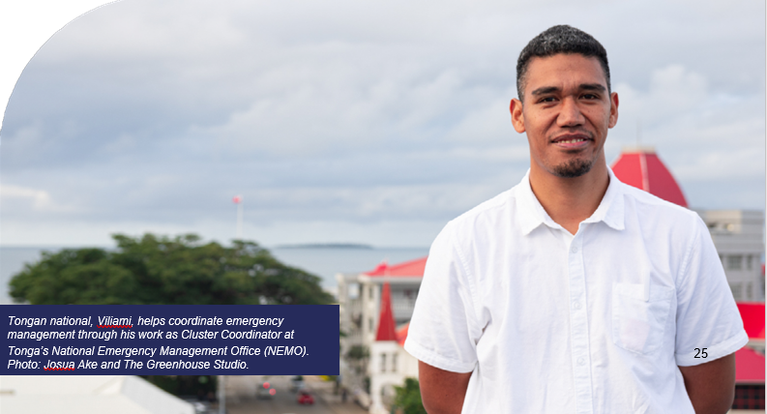
Image caption: Tongan national, Viliami, helps coordinate emergency management through his works as Cluster Coordinator at Tonga’s National Emergency Management Office (NEMO). Photo: Josua Ake and The Greenhouse Studio.

LAP highlights

Priority one - New and existing partnerships
  - Agreements to enable RedR organisations to share roster members have been operationally implemented with RedR Indonesia and RedR India.
  - 22 per cent of deployments across the program directly support partner governments, including both government ministries and national disaster management authorities.
  - A RedR pitch to Rotary International resulted in a commitment to fund two Pacific Islanders to participate in an EHP course in FY22. [See Partnerships].

Priority two - Training and roster
  - RedR contextualised its inaugural EHP training course for Pacific Islanders with leadership qualities for regional emergency management responses. National training experts were involved in designing and delivering the course, including the Course Coordinator and several guest speakers.
  - RedR extended online Disability Inclusion and Child Safeguarding training outside Australia to RedR India and Indonesia staff.
  - the program is planning to align deployee salary scales in a remuneration review to reduce pull factors that can undermine local organisations when staff are lured away by higher salaries. [See Program Management, Leadership and Responsiveness].
  - RedR formalised new agreements with three universities, allowing students to receive course credits for completing RedR training courses. This builds on the Young Humanitarian Professionals initiative that aims to deliver a pipeline of young talent to the roster on an annual basis, ensuring the capability remains fresh and replenished to offset retiring members. [See Training and Capability]

Applying a localisation lens – deployees at work

Partnership
Forging closer connections with RedR International partners, the program has deployed four referrals from RedR Indonesia to assist with COVID-19 response activities, plus the first referral from RedR India to improve capacity in disaster-resilient infrastructure.

Policy
A Monitoring, Evaluation, Accountability and Learning Specialist developed a national level, gender- responsive framework in Jordan that commits national and international humanitarian actors to involve crisis- affected populations in determining what assistance is provided to them, and how.

Participation
Involving affected communities, host organisation colleagues, local leaders and national actors was a core tenant of deployments. Examples include staff training workshops on incident control systems in Vanuatu, simulation exercises with emergency services at Kiribati’s airport, and household consultations on sanitation initiatives planned for 300 Solomon Islands communities.
“RedR Australia roster members consistently rated amongst the highest in performance evaluations, integrating immediately into local cultures, sensitive towards needs by local communities, taking into account modus operandi on the ground while contributing substantively to the humanitarian response operation at hand.” — Office of the Assistant Secretary- General for Development Coordination.

Piloting the Pacific EHP course
RedR delivered its first EHP course in the Pacific (Suva, Fiji) in collaboration with a local network of experts. By contextualising the course, RedR was able to strengthen the capacity of local humanitarian and disaster management specialists, while also sharing a wealth of knowledge and experience on climate crises.
Post-course evaluations revealed strong participant satisfaction with an overall course rating of 92 per cent, while six-month follow- up interviews revealed examples of applied learning and behavioural adjustments.
- “EHP has broadened my skills in negotiating and problem solving to overcome problems at provincial level.”
- “During proposals or talking to partners, I have lately been aware of standards, so I was reviewing through the lens of minimum standards and gave recommendations accordingly. The course reinforced these and showed I can apply them at different levels of response. Credit to the course.”
- “I now have a much better appreciation of the pressures these countries are under, and why, when I reach out to the Director during an emergency, they are often busy!”
Although the second Pacific EHP course was postponed due to COVID-19, RedR expects to deliver further courses in the region in FY22 and beyond.
What challenges emerged?
  - COVID-19 presents both opportunities and challenges. While international travel restrictions have meant that international staff have played a remote support role this has enabled local actors to step up.
  - Although RedR has laid foundations, progressing LAP Priority Three (regarding the enabling environment to support organisational commitments) has yet to be realised. Activities largely rely on the development of an internal communications plan to support the rollout of actions and responsibilities. This is currently in planning.

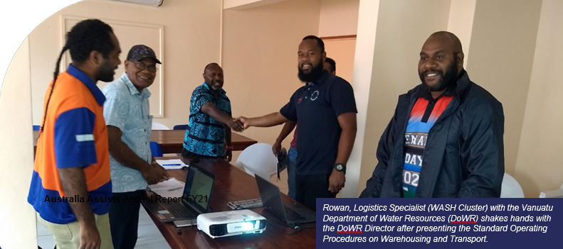
Image caption: Rowan, Logistics Specialist (WASH Cluster) with the Vanuatu Department of Water Resources (DoWR) shakes hands with the DoWR Director after presenting the Standard Operating Procedures on Warehousing and Transport.

Pacific

In support of Australia’s Partnerships for Recovery policy, the program expanded in the Pacific, exceeding the Australia Assists Annual Plan target4 by re-allocating deployment months from other regions. RedR Australia training initiatives such as the inaugural Pacific Essentials of Humanitarian Practice course provided an opportunity to build critical capacity in the region and strengthen existing partnerships with government agencies, the UN, regional organisations (SPC, PDF, IPPF) and the private sector (DT Global).

Pacific pandemic surge
Australia Assists supported 27 deployments to COVID-19 preparedness and response roles across eight Pacific Island countries to support the health security of our near neighbours.

Response
With Fiji and Papua New Guinea hardest hit in the region, the program’s provision of emergency public health, information management, communications and protection personnel filled critical human resource gaps. For example, deployee Gregory improved the efficiency of health coordination systems by working as a critical connector alongside the Papua New Guinea government and WHO Incident Management Team. This enabled key issues to be escalated to relevant ministers and a streamlined flow of information into situation reports. In Fiji, support to COVID-19 outbreaks manifested in mainstreaming protection and gender considerations throughout government toolkits for community workers via COVID-19 Protection Advisor, Jess.

Preparedness
The program bolstered preparedness and contingency planning for several Pacific nations through both in-country and remote deployments. Two Ni-Vanuatu deployees worked together within Vanuatu’s Ministry of Health. Sharin advised the Ministry of Health Emergency Operations Centre on prevention and preparedness measures, such as vaccination rollouts and medical inventory standards. Rowan provided logistics support to ensure those standards were met by undertaking inventory assessments in 42 health centres throughout three provinces and mobilising free public transport from community hubs to vaccination sites.

Australia Assists connects the UN with national systems
Australia Assists played an important role as connector between the UN and national systems, driving collaborative work to achieve mutual humanitarian objectives. In addition to 12 deployments that were directly embedded in Pacific government ministries, eight deployees to UN agencies were also seconded to ministries or worked closely with government counterparts in a capacity building function. Among them:
- Philippe, FAO Fiji Disaster Risk Management Specialist, helped ensure that food security gets the administrative attention it deserves, by establishing a Climate and Disaster Risk Resilience Unit within the Ministry of Agriculture. He developed national tools to assess disaster-related losses in the agriculture sector, which align Fiji with international disaster risk management standards (including the Sendai Framework). Philippe’s work also enhanced coordination between government ministries and humanitarian partners to rebuild capacity in disaster-impacted communities.
- Tim, a UNICEF Fiji Water, Sanitation and Hygiene Specialist, spent 90 per cent of his deployment at the Ministry of Health where he analysed and improved the content, quantity and distribution of water, sanitation and hygiene kits. His information management work also enabled government departments to share information efficiently and accurately, thanks to his direct access to National Disaster Management Office data collection systems.
- Maxwell, a COVID-19 Education Learning Systems Technical Advisor with UNICEF Fiji, increased community awareness about the pandemic through his work with the Ministries of Education in Fiji, Solomon Islands, Tuvalu, Tonga and Samoa. Specifically, he worked with ministry officials, heads of schools, teachers and parents to inform them of COVID-19 precautions, inclusion, welfare and protection measures.

“The government and UN Agencies are able to utilise reliable and accurate data and information on the needs of vulnerable groups conducted by the deployee in the Lau region to assess the impact of TC Yasa and TC Ana.” - Chief of Mission, IOM Fiji,

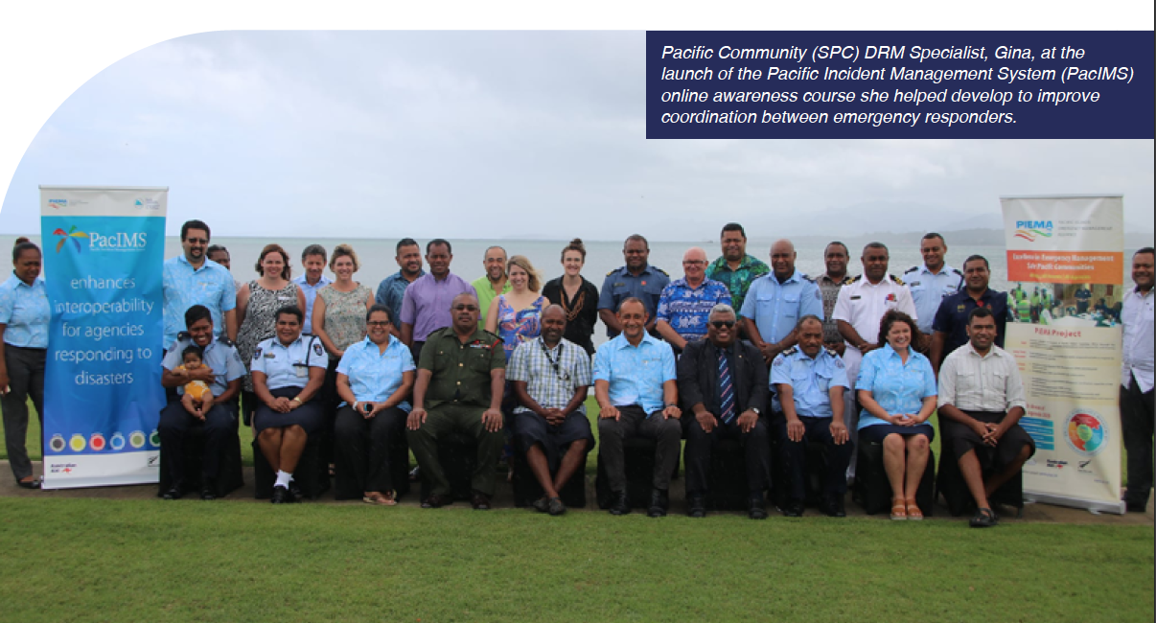
Image caption: Pacific Community (SPC) DRM Specialist, Gina, at the launch of the Pacific Incident Management System (PacIMS) online awareness course she helped develop to improve coordination between emergency responders.

Working in the wake of cyclones
Following Tropical Cyclones Harold (April 2020), Yasa (December 2020), and Ana (January 2021), 13 deployees assisted in response roles spanning national emergency operation centre support, crop damage assessments, information management, evacuation, procurement, donor funding and reconstruction. Daniel, a Monitoring and Evaluation Specialist, represented IOM Fiji on a joint UN-Government mission to seven of Fiji’s most remote islands, which had been devastated by both Tropical Cyclone Harold and Ana. With a focus on vulnerable groups, his consultations with village representatives fed back to the Protection Cluster, ensuring that food security, shelter, and water, sanitation and hygiene were top priorities.

What challenges emerged?
COVID-19 restrictions on travel have made it difficult to conduct in-person risk assessments and due diligence checks on new partners, which has put those emerging partnerships on hold.
Recurring COVID-19 outbreaks have disrupted deployments and forced the postponement of critical training in the region.
“There is no question of Greg’s technical expertise and the efforts he made to go above and beyond the scope of this role in order to contribute to the overall COVID-19 response … He made extensive and thoughtful efforts to build technical capacity in local counterparts.” — Humanitarian Coordination Specialist, UNDP PNG, on deployee, Gregory.

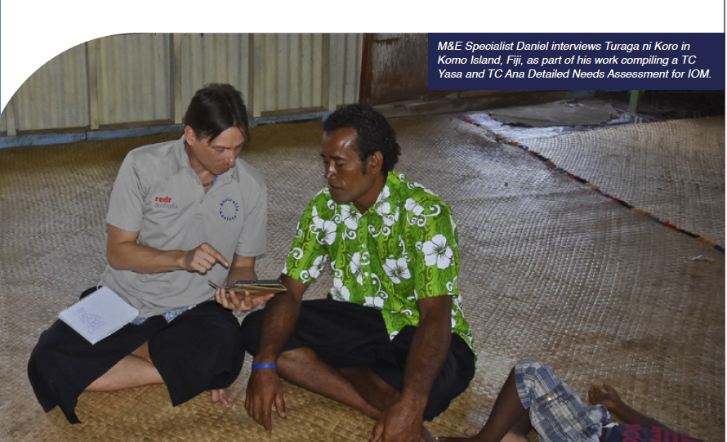
Image caption: M&E Specialist Daniel interviews Turaga ni Koro in Komo Island, Fiji, as part of his work compiling a TC Yasa and TC Ana detailed Needs Assessment for IOM.

Asia
In the most disaster-prone region in the world, Australia Assists continues to deliver on the Australian Government’s commitment to ‘Stand with our region’, building resilience among partners and communities. Sixteen deployments supported requests from host organisations throughout Asia. These deployments were 31 per cent remote-based and 69 per cent field-based across Timor-Leste, Indonesia, Laos, India and Pakistan. The program delivered 25 per cent of total deployment months in Asia, exceeding the Australia Assists Year Four Annual Plan target of 20 per cent.

Climate crises in Timor-Leste
Australia Assists has stood with Timor-Leste’s Ministry of Agriculture and Fisheries, via FAO, and the Ministry of Interior (MOI), to shift a national crisis response approach towards one of proactive planning. Five deployments have contributed across the disaster cycle, implementing multi-hazard risk legislation, coordinating flash flooding response and safeguarding social inclusion, as communities recover from, and build resilience against, future civil unrest.
Carly and Neil worked directly with the MOI Director General to provide flood modelling for the Dili area and reinforce recovery coordination. Initiated by Carly, a logistics agreement between the MOI Civil Protection Directorate and WFP, as well as policy-level engagement with The World Bank and UNDRR, are helping ensure that essential supplies are reaching communities. Neil’s flood mitigation strategies continue to enhance community resilience.

Regional support to ASEAN
Deployments brought logistics and donor financing expertise to the AHA Centre to expand mobilisation capacity. Leigh helped decentralise and localise the Centre’s funding model, which will improve financial sustainability and empower partners within member states. David’s supply-chain feasibility assessment provides technical recommendations for more efficient warehousing to enhance disaster readiness throughout the region.
‘Our triple pioneer’ to the Coalition for Disaster Resilient Infrastructure (CDRI)
Sriraman, a Capacity Development and Deployments Expert, was not only the program’s first deployee to India, he was also the first to be jointly recruited by RedR India, and one of two first deployees at CDRI5. He and Anne, a Projects Expert, are playing key roles in the early design and implementation of projects that will contribute to disaster risk reduction through urban infrastructure and social resilience.
“The contributions of RedR to the AHA Centre not only helped shape ASEAN disaster management tools and mechanisms, the partnership with RedR also contributed immensely to enhance AHA Centre capacities to be the primary coordinating agency of ASEAN.” — Deputy Executive Director, AHA Centre.

Pivots and surge – COVID-19
Across Asia, seven Australia Assists deployees supported COVID-19 preparedness and response, either pivoting from a previous role or surging into a COVID-19 specific role.

Pivot to COVID-19
Jock, a Disaster Recovery and Risk Reduction Specialist with UNDP Laos, pivoted from his original flood recovery role to support the national government response by developing a harmonised multi-sector approach to COVID-19 programming.

Surge for COVID-19
Ivy built on Jock’s work, updating contingency planning as the realities of COVID-19 impacted crisis management and response. This ensures that UN agencies and local partners can maintain operations with minimal disruptions.
In Pakistan, Mahmood applied a COVID-19 lens to his work as a Humanitarian Communications Expert with UNFPA, developing awareness materials related to reproductive health and gender-based violence.
[See Partnerships for Recovery Snapshot].

What challenges emerged?
The absence of a dedicated presence in Asia limits the extent to which the program can broker new and build on existing partnerships. To mitigate this, RedR Australia has begun to leverage deeper engagement with Asian-based RedR organisations such as RedR India and RedR Indonesia, in addition to existing program partners in the region.
“Jock’s strength in sharing his humanitarian background created a platform for the transfer of skills, new initiatives, innovation, and set-up of new systems that supported both programmatic dimensions, operations and duty of care throughout 2020”. - UN Resident Coordinator, on deployee, Jock.

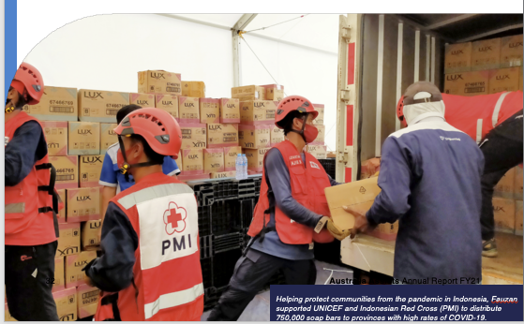

Image caption: Helping protect communities from the pandemic in Indonesia, Fauzan supported UNICEF and Indonesian Red Cross (PMI) to distribute 750,000 soap bars to provinces with high rates of COVID-19.

Myanmar and Bangladesh

The February 2021 military coup in Myanmar heightened vulnerability to human rights risks across the country and for approximately 600,000 Rohingya who live in Myanmar. Since then, unchecked COVID-19 cases and high fatality rates, coupled with widespread violence, have exacerbated a spiralling humanitarian catastrophe. The program has remained steadfast in both Myanmar and Bangladesh, providing life-saving assistance, as well as strategic planning and guidance, both in-country and from afar.

Health security in Cox’s Bazar
In line with Partnerships for Recovery, Australia Assists has prioritised investment in fragile health systems, providing surge support to improve distribution of medical products and bolster infectious disease response in Cox’s Bazar.
Health Migration Nurses Philippa and Dale, worked with IOM in COVID-19 Isolation Treatment Centres, upskilling local staff to bolster treatment, screening and triage standards. This work had far-reaching benefits as trainees shared the knowledge they had gained with other medical facilities in the region.
Navjuvon worked with WHO to source temperature-controlled warehouse space to store a 180m3 consignment of critical medical supplies (weighing 12,600kg). Neil put his structural expertise to use for UNHCR, setting up an Isolation Treatment Centre able to serve 1,444 patients.

Promoting peace in Myanmar
In position prior to the crisis in February 2021, the program was already embedding women, peace and security (WPS) principles with partners in Myanmar, with three female deployees focusing their attention on accountability to affected populations. With UN Women, Jess mapped and analysed key WPS actors in Myanmar to develop a joint WPS strategy and operational plan. Annie progressed OCHA Myanmar’s national dashboard and worked closely with the Prevention of Sexual Exploitation and Abuse Network to help reduce incidences. This work helps fulfil a commitment by UN Women and OCHA to use power responsibly and ensure mechanisms are in place to ensure they can be held to account by the communities they seek to assist.
“Through effective accountability to affected populations initiatives, local voices are better fed into humanitarian programming - and humanitarian action better reflects their needs.” - Australia Assists deployee, Annie.

Partnership management and humanitarian access
Coordinating and negotiating the safe, effective and efficient delivery of humanitarian assistance to Rohingya and host communities remains a program priority. Working with UNHCR Bangladesh, Anita paved the way for positive partnerships with the Office of the RRRC, supporting NGOs with access passes and sharing regular updates on dynamics unfolding within and outside of Cox’s Bazar.
At OCHA Myanmar, Sarah developed a multi-sectoral Operational Access Tracker to help humanitarian actors work together and inform government operations in Rakhine. The tool provides a new, coordinated approach for sectors to monitor, report and analyse programming barriers at the activity level, and work harmoniously toward solutions. The model has since been considered by OCHA Headquarters for wider adoption and implementation in other humanitarian contexts.
“[They] are very good at including the national staff in their work. Probably more so than other deployees. I get the impression that RedR has a particular focus on this. They bring national staff into the work and transfer their knowledge. It’s something we can learn from. It should be the goal for all deployees.” — UNHCR Bangladesh.

Review of Australia Assists’ Support to the Rohingya Crisis; 2017-2020.
The program has provided more support to the Rohingya response than to any other humanitarian crisis, with 60 technical specialists deployed to eight UN agencies and the Inter-Sector Coordination Group since 2017. The Review provides detailed analysis of the program impact to date. It found that the collective impact of the program’s response had been significant, yielding both critical impact and value for money. It confirmed “Australia Assists’ support to the Rohingya crisis, through RedR Australia, was critical.
Between 2017 and 2020, the program provided life-saving assistance, helped protect the most vulnerable, and meaningfully supported more sustainable and targeted responses. Deployees achieved significant outcomes
in extremely testing circumstances. Their accomplishments are a testament to both the quality of individuals deployed and RedR’s operations and work at large.”

Rohingya Review Recommendations – taking action
The Review identified that some deployees who worked with program partners in the field:
“experienced workplace challenges, ranging from poor organisational culture to interpersonal dynamics that impacted deployee wellbeing and stress levels. This affected around 10 percent of deployments, disproportionately impacting women…[and] at least four deployees experienced toxic workplaces where bullying, harassment, sexism and misogyny were commonplace”.
The report recommended that RedR consider conducting research to better understand the experiences of Australian deployees working in UN agencies through the lens of Australia’s commitment to gender equality. This recommendation was not only accepted by RedR Australia and DFAT, but funding was reallocated to conduct joint research with the Australian Red Cross on the issue.

Middle East
Through 15 deployments to five countries in the Middle East, Australia Assists support has complemented other DFAT programs for the Syrian crisis response, Palestine refugees and to support humanitarian and stabilisation activities in Iraq. Host organisations have benefited from coordination expertise, gender and disability advisory services, justice and reconciliation, and technical support to critical infrastructure projects.

Continuing support to the Syria crisis
Social inclusion, access and negotiation for lifesaving supplies and services have been the focus throughout the first four years of the program’s response to the Syrian crisis. This again included providing critical Civil- Military Coordination expertise, this time to the OCHA Whole of Syria office, involving routine engagement with armed actors in north-eastern Syria on matters of access and protection, led by a deployee on behalf of the wider humanitarian community. A deployment to UNHCR Turkey provided expertise and training in site planning for NGOs and partner organisations establishing IDP settlements in north-western Syria, resulting in the implementation of 29 separate sites in line with Sphere Standards. Support to host communities of the Syrian diaspora also continued with deployments to Lebanon and Jordan focusing on maintaining provision of services in the face of COVID-19.

Gender, disability inclusion and prevention of sexual abuse and exploitation
Specialist support to WFP Jordan resulted in development of the first standalone strategy for mainstreaming gender into national operations, while gender was also central to localisation work undertaken with the Jordanian Humanitarian Partnerships Forum in conjunction with UN Women (see below). In Iraq, a deployee assisted IOM’s Community Stabilisation Unit across 12 offices by mainstreaming disability inclusion through a framework, staff training and resources which will continue this work beyond the deployment. Another Disability Inclusion Specialist worked with UNRWA Jordan’s Inclusive Education Team to develop and deliver workshops tailored to teachers, parents and children. Deployment support to OCHA Jordan brought technical guidance to the Prevention of Sexual Exploitation and Abuse Network to implement a Community Based Complaints Mechanism, working with senior national staff on sustainable gender equality and empowerment initiatives.
“ This deployment was very timely and represented an important support to the Department of Planning. The fact that the deployee was already in-country when the pandemic started, allowed us to reinforce the emergency response capacity at headquarters and Nisarg rapidly integrated into the task force. Nisarg and RedR’s ability to extend the deployment beyond the initially planned six months was also much appreciated and contributed to strengthening emergency response.” — Senior Emergency Officer, UNRWA headquarters Amman

Program resilience – COVID-19
Pandemic-related travel restrictions saw 40 per cent of deployments to the Middle East completed entirely remotely in FY21. This demanded adaptability at both the organisation and individual deployee level. The positive feedback that was consistently received from remote-based deployees (some of them working in opposite time zones) is testimony to the creativity and flexibility of program personnel in overcoming operational barriers. For example, site planning support delivered to UNHCR Turkey resulted in creation of 19 instructional videos now available (in English and Arabic) on the Shelter Cluster website, allowing new staff to continue learning into the future. In Lebanon, a deployee led a large-scale UN75 campaign on behalf of the UNRWA Youth Unit, coordinating 13 online events, the highest number of any UN agency in Lebanon, reaching more than 200 young people.

Localisation
Of the deployees who were mobilised internationally, 50 per cent either originated from or were permanently based in the regions into which they deployed. As well as the socio-cultural and linguistic advantages of maintaining a geographically diverse roster, this also demonstrates some of the benefits for operational resilience in the face of COVID-19. Expanding Australia Assists’ regionally based talent pool continues to be a focus of the program. Beyond operational localisation, specific support to the Humanitarian Partnership Forum’s Localisation Task Team in Jordan resulted in the development of the country’s first jointly agreed gender-responsive Monitoring, Evaluation, Accountability and Learning framework and related indicators to push the localisation agenda forward. This significant achievement was delivered while the deployee was working remotely from Australia.
“Most of the organisations working in north-west Syria did not have experience in site planning and/or site establishment because most of the internally displaced persons sites were self-established. David played a key role in the new Shelter/Non Food Items (NFI) Cluster strategy to establish internally displaced persons settlements according to Sphere standards. His support was well appreciated by the partners and the impact visible in the field.” — Senior Shelter/NFI Coordinator, UNHCR Turkey
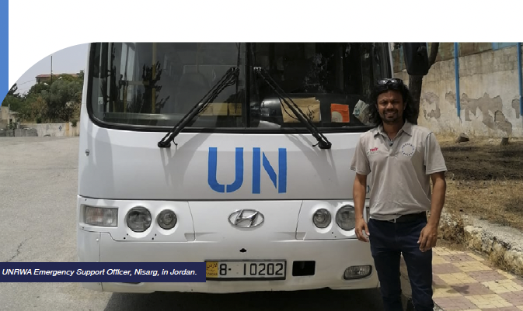
Image caption: UNRWA Emergency Support Officer, Nisarg, in Jordan.

Africa
In a region grappling with emergencies new and old, the program remained responsive to immediate needs as well as gender equality and disability inclusion priorities, while supporting recovery efforts. From western Africa (Liberia) to the Horn of Africa (Somalia) and into Uganda, deployees have worked on initiatives to optimise inclusion. In FY21, six Australia Assists deployments supported humanitarian response within five UN Agencies.

Ethiopia, including Tigray
The eruption of violence in northern Ethiopia’s Tigray state in late 2020 required the program to move rapidly to respond. The results highlight the program’s ability to address both immediate needs as well as longer-term drivers of insecurity – sometimes within the same crisis. Civil-Military Coordination expertise helped OCHA address significant access constraints that actors face as they try to respond to spiralling humanitarian needs. The work progressed, despite severe restrictions on movement, communications and resources. A Programme Officer with IOM Ethiopia worked on a coordination platform to help prevent future intercommunal violence and displacement across Ethiopia.

Leaving no one behind
Australia Assists deployments have responded to overlapping crises in Africa that are both compounding and creating new inequalities. Addressing the needs of marginalised groups has been central to deployment priorities. Melissa worked with OCHA Somalia to develop guidelines, conduct training and ensure gender and disability inclusion in the UN Somalia Humanitarian Needs Overview and Humanitarian Response Plan. In Liberia, Claire implemented best practices for the inclusion of refugee education at a national, district and country level. Meanwhile, in Uganda, engineer Valeri oversaw the construction of Infectious Disease Centres and in doing so, ensured ramps were included to improve physical accessibility.

Program agility – COVID-19
Pandemic-related travel restrictions to Africa meant 33 per cent of deployments were moved to remote roles.
“[Claire] coordinated very well even though she was not physically in-country. She was instrumental in providing a consolidated source of information on education actors at both an operational and national level. The steps taken by [Claire] to implement her duties were remarkable. She was instrumental in convincing the operations team on the importance of continuous education and refugee children having access to learning and instruction materials.” — Head of Field Office, UNHCR Liberia

Program Management

Program Management, Leadership and Responsiveness
FY21 was characterised by a focus on implementing the Australian Government’s Partnerships for Recovery response across the Indo-Pacific, and supporting national commitments to Peace and Stability. In doing so, the program:
- continued to adapt to COVID-19 while delivering a significantly greater volume of deployments, both in-country and working remotely
- continued to embed Australia Assists, implemented by RedR Australia, as the partner of choice for the United Nations in the Indo-Pacific and beyond
- kept an eye to the future by moving forward with recommendations from the Australia Assists 2019 Mid-Term Review, including Project PIVOT, a major IT transformation that positively impacts program delivery.
- continued to further localise and internationalise the roster to ensure the program remains relevant in the absence of global travel and more effective in delivering deployment outcomes.

Program governance
Throughout FY21, engagement between RedR Australia and the Department of Foreign Affairs and Trade (DFAT) Canberra, remained effective in managing both the day-to-day and longer-term interests of the Australia Assists program. A staffing restructure in Canberra led to a change of Assistant Director, (Australia Assists Program Manager), in October 2020. The program managed this transition well with minimal disruption to everyday engagement and program delivery.
The program benefited from DFAT’s regular engagement, including participation in fortnightly meetings with program managers to progress the implementation of the Australia Assists Year Four Annual Plan. In addition, DFAT’s early engagement in the annual planning process for Year Five resulted in the timely approval of the Annual Plan on 1 July 2021. This gave program stakeholders the certainty they needed to facilitate a smooth transition of deployments and other program priorities from Year Four to Year Five.

Stakeholder engagement
The rising profile of the program among DFAT’s internal stakeholders increased the volume and quality of engagement with desks and posts, particularly during the annual planning process. In Year Four the program engaged with 24 posts and multiple desks and branches within DFAT to respond to new and emerging deployment priorities, including requests from posts that previously had no or limited engagement with the program. The increasing visibility of, and demand for, Australia Assists reflects the quality of deployees and outcomes achieved, as well as enhanced internal communication within DFAT

Program personnel
There were two changes to specified personnel during FY21. The Middle East and Africa Regional office saw the resignation of the Regional Manager after two-and-a-half years in the role. In the Pacific, the Regional Manager’s tenure concluded at the end of the financial year, ending three years managing the program across the Pacific. These positions have since been filled. Both Offices spearheaded the localisation of Australia Assists deployments, paving the way for the substantive programmatic response in the form of the Australia Assists Localisation Strategy and Action Plan, as well as the inaugural Pacific Essentials of Humanitarian Practice (EHP) course.

Project PIVOT
Throughout FY21, RedR Australia continued its ambitious IT transformation to gain efficiencies and address operational gaps in the administration of Australia Assists deployments and outcomes. The resulting platform, the RedR Hub, is expected to enable greater speed and volume of roster recruitment to respond to new, emerging and existing deployment requests and profiles; streamlined pre, during, and post deployment administration; a more professional and user-friendly online experience for deployees; and more effective delivery of critical policy and program monitoring documents.

Deployee remuneration review
In 2019, RedR Australia and DFAT commissioned a Mid-Term Review of the Australia Assists program. One of the nine review recommendations related to Australia Assists deployee remuneration, specifically: To ensure the attractiveness of the roster within a crowded market, RedR in consultation with DFAT, should consider restructuring the deployee remuneration package to deliver equity in remuneration. In response, RedR engaged Ernst and Young (EY) in late 2020 to undertake a review of the deployee remuneration structure in an actionable, evidence-based, and pragmatic manner. Undertaken in consultation with DFAT, deployees and RedR, the review was delivered in early 2021. Work has been undertaken in step with DFAT to develop a framework for implementation in Year Five that is simple, transparent, flexible, fair and equitable.

Roster Management
The RedR Australia Roster currently has 804 active members, 49 per cent of whom are female. The median age is 48 years. The roster is becoming increasingly diverse, comprising 25 nationalities. In FY21, 17 per cent of all those deployed via the roster had the socio-cultural or linguistic background of the country of their deployment6.

Roster updates
A 15 per cent increase in deployment months since FY20 required increased output across RedR Australia’s recruitment and deployment functions. In response, the team dedicated significant time and thought to how to most efficiently manage the roster of humanitarian talent, with particular emphasis on systems and processes to attract, engage and deploy roster members. Through this review, RedR determined that a new, best-in-class human resources information system was required. This led to the implementation of the new RedR Hub, an online portal which provides members and staff with a more user-friendly and highly automated experience. By reducing labour-intensive tasks, the system has increased the team’s capacity to carry out more nuanced and direct roster management activities.
Responding to the continuing COVID-19 pandemic, RedR Australia prioritised recruiting public health experts, inducting three new roster members with health-related specialisations. The roster team also renewed the priority status of key skill profiles, including:
- information management
- civil-military coordination
- public health
- humanitarian affairs
- water, sanitation and hygiene
- logistics
- program management
- gender
- protection
- disability inclusion
- disaster risk reduction, disaster risk management
- climate change adaptation.

“RedR Australia has been one of the strongest partner organizations for the United Nations, deploying qualified, skilled and high-performing personnel from its roster to complex emergencies/conflicts and sudden onset disasters across the world. RedR Australia calibrated the profiles on its roster to match the needs of the United Nations.” — Office of the Assistant Secretary-General for Development Coordination.

Training and Capability
RedR Australia’s training team has adapted to the ongoing challenges of COVID-19 with a substantial increase in the number of new online training activities.
Face-to-face training resumed in November 2020 at a new training venue, the Victorian Emergency Management Institute at Mt Macedon. RedR delivered seven core training courses to 183 participants. These comprised three Essentials of Humanitarian Practice (EHP), including one EHP delivered in Suva, Fiji in September 2020; two Hostile Environment Awareness Trainings (HEAT); one Humanitarian Logistics in Emergencies course; and one Child Protection in Humanitarian Action course.
RedR continued to recruit more national Associate Trainers, increasing the pool to 90, and currently has more than 80 Volunteers.
Finally, RedR is well advanced in commissioning a new Learning Management System. This will place the organisation’s training capability in an excellent position for the future as it prepares potential Australia Assists deployees with the foundational knowledge they need to deliver quality program outcomes, safely.

Reinforcing the strengths of our region
Through Australia Assists, RedR delivered its first, fully contextualised Pacific Essentials of Humanitarian Practice training course to augment regional emergency management capacity. Pacific Islander training and subject matter experts co-led course design and delivery.
“A great opportunity to learn about stressful things that you may encounter in a difficult location… it will push you out of your comfort zone and allow you to see how you act under pressure.” — HEAT participant.
“A perfect blend of global systems applied locally and regionally in one course.” — Pacific EHP participant.

Program Visibility and Engagement
COVID-19 logistics and content accessibility constraints presented challenges to RedR Australia’s traditional approach to program visibility. Despite this, increased social media activity and engaging with partners to amplify content helped boost the combined audience for the Australia Assists Twitter and Instagram accounts by 758 (a 91 per cent increase). Engagement rate per impression (measuring the number of times users engaged with a post) was 2.6 per cent, representing a 52 per cent year-on-year increase.

Demonstrating impact
The revised strategy applied by RedR Australia to build and share its content hub gave Department of Foreign Affairs and Trade (DFAT) focal points direct access to content to support the promotion of Australia Assists. DFAT has accessed deployee biographies, images, videos and infographics, including the quarterly dashboard. Among the fresh content available on the hub was a package on the pilot Pacific Essentials of Humanitarian Practice course, including key messages, a media release, infographics, images, video and social posts for DFAT to use in the Pacific. RedR’s digital impact was also enhanced through accessibility updates to the RedR Australia website, including the Australia Assists page, and work began to create the first Australia Assists digital annual report.

Program promotion
RedR increased engagement and visibility by employing a range of traditional, digital and social media channels to share the Australia Assists story with a growing audience. This included securing media opportunities with ABC’s 7:30, SBS News, Engineers Australia’s content channels, the Vanuatu Daily Post, and several specialist journals. RedR also provided content for Australia Assists’ social media channels to support key United Nations days, including World Humanitarian Day and International Day for Disaster Risk Reduction.

Monitoring, Evaluation, Accountability and Learning (MEAL)

COVID-19 and beyond
As the COVID-19 crisis shifted from disruption to regular programming in FY21, RedR Australia’s MEAL capability focused on monitoring and analysis that addressed broader program priorities as well as the pandemic.
COVID-19 saw deployees providing humanitarian assistance remotely for the first time. As such, and in line with the COVID-19 Action Review findings, RedR gathered evidence regarding the remote deployment experience for both deployees and partners. Results conveyed the characteristics required of people, partners and positions that make for more effective remote deployments.

Periodic reporting, enhancing systems
The MEAL team led the preparation of periodic program reporting, including annual, mid-year and calendar year reporting. In addition, the team conducted regular outcomes tracking and training evaluation, provided ad hoc mentoring and resource support (links, tools, guidance notes) to deployees, and chaired the Standby Partnership (SBP) MEAL Working Group, bringing together 19 United Nations and other SBP member agencies.
As part of RedR Australia’s IT transformation project, Project PIVOT, the MEAL team revised deployment reporting templates and processes in readiness for the new system. This will result in better, more automated and more timely deployment and program reporting.

Major MEAL projects in FY21
RedR completed:
1. Localisation Strategy and Action Plan (LAP);
2. COVID-19 Action Review;
3. Review of Australia Assists’ Support to the Rohingya Crisis; 2017-2020;
4. Gender and Protection Outcomes Desk Review (internal).
RedR initiated:
1. Preventing Sexual Exploitation, Abuse and Harassment Project, with Australian sector partners;
2. Pacific Disaster Risk Management Research.
These projects will be completed and disseminated in FY22.
Australia Assists MEAL publications developed and published in FY21 include:
Overview of RedR’s Inaugural Pacific Essentials of Humanitarian Practice Training
Australia Assists’ Support to Pacific Disaster Preparedness; 2017-2020
One Year On: Reflecting on Disability Inclusion Outcomes and Sustainability
Deployee Tip Sheet: Disability Inclusion

Remote work at work:
COVID-19 saw deployees providing humanitarian assistance remotely for the first time. In line with the COVID-19 Action Review findings, RedR systematically gathered evidence of the remote deployment experience for deployees and partners. In summary, this analysis can be conceptualised by asking three questions about remote support:
Q1. Is it the right position?
Can tasks be conducted without direct access to affected populations, host organisation colleagues, or national/local leaders?
Has the deployment Terms of Reference been tailored to accommodate remote work arrangements, rather than using a generic role profile?
Will a dedicated counterpart work directly with the remote deployee?

Q2: Is it the right partner?
Does the organisation regularly - and successfully - work with remote staff?
Does the organisation have adequate internet access and IT capabilities, such as established accounts to use communication platforms such as Zoom?
Will an online document filing system be available to the remote worker?

Q1: Is it the right person?
Will the deployee be working from a similar time-zone (within 5 hours) of the host organisation?
Has the deployee had previous work experience in the country or region of the host organisation?
Has the deployee had previous work experience with the host organisation, either at the same country office or other?

Remote work effectiveness
A comparison of available Performance Evaluation Review (PER) ratings by deployment supervisors from the reporting period revealed similar average scores between in-country deployments (4.31/5 from 43 PERs) and remote deployments (4.28/5 from 26 PERs). Supervisors frequently commended remote deployees’ technical competencies, high quality performance, ability to work independently and provision of proactive support. Aware of the additional constraints posed by remote work, supervisors were, for the most part, praiseworthy of deployees’ instrumental involvement in their respective outputs.

Monitoring Australia Assists’ Action Plans:
Gender Action Plan (GAP):
Highest number of ‘fully met’ commitments in one year for the GAP to date (25/28 or 89 per cent). Doubled the target of four gender specialists deployed per year, with eight targeted specialists.
Disability Action Plan (DAP):
Highest number of DAP targets reached to date, with 21 of 26 (81 per cent) achieved in FY21 – four more targets reached than in the previous two years.

RedR’s MEAL team continues to actively track and report on the small number of GAP and DAP commitments that remain unmet, or are ongoing. Note the LAP commenced in FY21 and monitoring is well underway.
Localisation Action Plan (LAP):
40% of LAP commitments were fully met within the first nine months of implementation.
“During a short period, [Civil- Military Coordinator] Joe was able to establish a good relationship with external partners, including the International Coalition Forces, international non-government organisations and UN agencies. He was a solid source of advice for the leadership and management of teams. He worked independently without having ever met any of the management or stakeholders in person given the remote support due to COVID-19.” — Deputy Head of Office, OCHA Whole of Syria
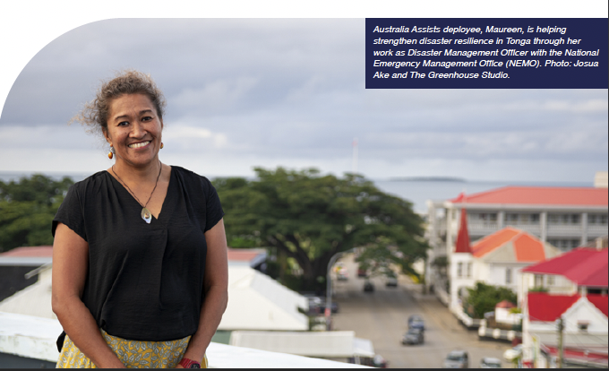
Image caption: Australia Assists deployee, Maureen, is helping strengthen disaster resilience in Tonga through her work as Disaster Management Officer with the National Emergency Management Office (NEMO). Photo: Josua Ake and The Greenhouse Studio.

Strategic Partnerships

Partnership
As a foundation member of the Standby Partnership (SBP) secretariat, RedR Australia continued to bring SBP members, donors and United Nations agencies together to improve collective impact, accountability and coordination for the benefit of the Australia Assists program. This year, RedR managed the SBP Secretariat Pooled Funds, contracting experts responsible for the SBP Secretariat administration. RedR also continued co-chairing the SBP Monitoring, Evaluation, Accountability and Learning (MEAL) Working Group and continued membership of the Steering Committee and Duty of Care Working Group.

RedR International
RedR took important steps in FY21 to strengthen the unity and collaboration within RedR International. In May 2021, RedR Australia’s Chair, Robert Care, was elected Chair of RedR International. Through targeted executive governance coaching and programming support, RedR Indonesia was voted in unanimously as a fully accredited RedR International member.

Partnerships in the Indo-Pacific
Australia Assists deployments supported the foundational work of CDRI in India and the UN Resident Coordinator’s Offices response to COVID-19 in Papua New Guinea, Laos, Federated States of Micronesia, Kiribati, Vanuatu, Tonga, Solomon Islands and Fiji. In FY21, RedR also delivered the first Australia Assists deployment to UNESCO in Samoa, with a COVID-19 Information and Communications Technology Education Specialist. This role leveraged private sector partners to deliver blended (online and physical) education solutions to enable the Samoan Government to ensure no child is left behind, as the rising sea and climate challenges reduce access to physical school infrastructure.

New UN Partnership
In May 2021, RedR Australia entered into its 14th UN partnership, with UNOPS, deepening our potential to work with the private sector to maximise local leadership, peace and security, humanitarian and development outcomes. UNOPS is managed by the same UN Executive Board that oversees our two other major UN partners, UNDP and UNFPA.

Australia Assists partner satisfaction
Of the 69 Performance Evaluation Reviews completed by host organisation supervisors for FY21 deployments:
• The average rating was 4.31/5
• 16 (nearly one quarter) deployments scored 5/5.
• Only 2 deployments scored 3/5, or ‘less than satisfactory’.

Financial Management
RedR Australia continues to deliver value for money through careful attention to financial planning, cost structure and delivering effective deployments.
The program’s budget for FY21 was fully expended in accordance with the Australia Assists Annual Plan. Underspends across Personnel, Personnel Support and Operational Costs were absorbed by deployments, resulting in a 3 per cent increase in Activity Costs expenditure.
Australia Assists’ FY21 Financial Acquittal for the period ending 30 June, 2021, is summarised as follows (a full financial acquittal for the Contract Funding is provided as an Annex):
Costs | Budget | Actual | % Expended
Management Fee | 1,911,000 | 1,911,000 | 100%
Personnel Costs | 2,258,309 | 2,188,623 | 97%
Short-term Personnel Costs | 39,600 | 39,600 | 100%
Personnel Support Costs | 216,146 | 167,876 | 78%
Operational Costs | 247,000 | 117,814 | 48%
Activity Costs | 7,327,944 | 7,575,086 | 103%
Total Contract Funding | 12,000,000 | 12,000,000 | 100%

Post Funding:
Costs | Budget | Actual | % Expended
Samoa Post | 79,915 | 79,915 | 100%
Tonga Post | 17,967 | 17,967 | 100%
Vanuatu Post | 71,136 | 71,136 | 100%
Total Post Funding | 169,018 | 169,018 | 100%
Total Program Funding | 12,169,018 | 12,169,018 | 100%
Management Fee, Personnel Costs and Short-term Personnel costs were expended in line with budgeted forecasts.
Personnel Support Costs and Operational Costs expenditure were less than budget due to prevailing COVID-19 restrictions, timing of events and a commitment to producing ongoing efficiencies.
Activity Costs expenditure exceeded annual budget allocation (accounting for 63 per cent of the Program’s total Year 4 budget) as it absorbed underspending across other budget lines. Activity Costs expenditure relates primarily to:
- training expenses supporting course delivery, including 2 x Hostile Environment Awareness Training, 2 x Essentials of Humanitarian Practice

- (EHP), 1 x Humanitarian Logistics in Emergencies, 1x Child Protection in Humanitarian Action and 1 x Pacific EHP (held in Fiji).
- deployment costs, which accounted for 90 per cent of Activity Costs expenditure across the year, including a large number of deployments responding to the COVID-19 pandemic.

In addition to the Contract budget of $12 million, individual DFAT Posts provided $169,000 deployment funding, for five deployments across three Posts (Vanuatu, Tonga and Samoa).

Risk, Safety and Security
Despite the challenges of maintaining a diffused global workforce during COVID-19, the program continued to deliver safe in-person deployments across a wide range of complex environments.
The program maintained insurance coverage and an evacuation capability through health and security services firm, International SOS, allowing operational independence without the issue of Letters of Assurance. This was achieved through close interaction with insurers and International SOS, and a proactive risk management approach. Careful pre-departure screening was also key and, as the COVID-19 situation developed, RedR was able to retract some of the restrictions initially put in place. Notably, the decision to not deploy experts over the age of 65, which was implemented in FY20, was reversed as vaccinations were rolled out globally and in Australia.
This year also saw the successful deployment of two frontline medical staff to support the Rohingya crisis in Bangladesh. This presented new challenges for RedR and required some changes to standard risk management processes but presented a valuable learning opportunity. A better understanding of exposure to clinical risks and the ability to work on niche insurance solutions, set the foundations for future deployments of this type.
Other risk management improvements included an upgrade in RedR’s staff safety monitoring software and the development of incident reporting guidance and a Risk Management Overview for the Australian Department of Foreign Affairs and Trade Posts.
Although there were five confirmed cases of COVID-19 among deployees across the year, the number of significant safety and security incidents remained low with no medical evacuations required and only one incident (of any severity) reported for every 20 deployment months. The program risk management architecture remains flexible to support our current deployees in the field and adapt to future challenges. 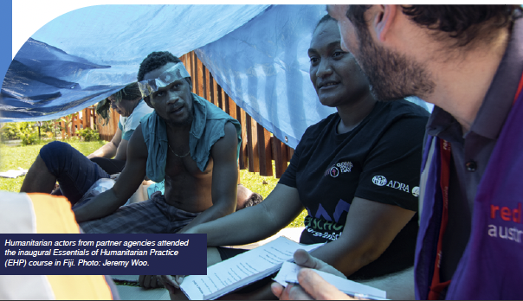
Image caption: Humitarian actors from partner agencies attended the inaugural Essentials of Humitarian Practice (EHP) course in Fihi. Photo: Jeremy Woo.

Acronyms
Acronym | Full name
AAP | Accountability to Affected Populations
AHA Centre | ASEAN Coordinating Centre for Humanitarian Assistance on Disaster Management
ASEAN | Association of Southeast Asian Nations
CADRI | Capacity for Disaster Reduction Initiative
CADRU | Climate and Disaster Risk and Resilience Unit
CDRI | Coalition for Disaster Resilient Infrastructure
CPHA | Child Protection in Humanitarian Action
DAP | Disability Inclusion Action Plan
DFAT | Department of Foreign Affairs and Trade
DRM | Disaster Risk Management
DRR | Disaster Risk Reduction
EHP | Essentials of Humanitarian Practice
EPO | End of Program Outcome
FAO | Food and Agricultural Organization
GBV | Gender-Based Violence
GAP | Gender Equality Strategy and Action Plan
HEAT | Hostile Environment Awareness Training
HLE | Humanitarian Logistics in Emergencies
ICT | Information Communication Technology
IDP | Internally Displaced Persons
IFRC | International Federation of Red Cross and Red Crescent Societies
IOM | International Organization for Migration
IPPF | International Planned Parenthood Federation
LAP | Localisation Strategy and Action Plan
MAF | Ministry of Agriculture and Fisheries (Timor- Leste)
M&E | Monitoring & Evaluation
MEAL | Monitoring, Evaluation, Accountability and Learning
MHPSS | Mental Health and Psychosocial Support
MOI | Ministry of Interior (Timor-Leste)
NDMO | National Disaster Management Office
NEMO | National Emergency Management Office
NGO | Non-Governmental Organisation
OCHA | United Nations Office for the Coordination of Humanitarian Affairs
OPD | Organisations for People with Disabilities
PER | Performance Evaluation Review
PHPC | Pacific Humanitarian Protection Cluster
PNG | Papua New Guinea
PSEAH | Preventing Sexual Exploitation, Abuse and Harassment
RCO | Resident Coordinator’s Office (UN)
RRRC | Office of the Refugee, Relief and Repatriation Commissioner (Bangladesh)
SBP | Standby Partnership
SOP | Standard Operating Procedures
SPC | The Pacific Community
SRH | Sexual and Reproductive Healthcare
TC | Tropical Cyclone
TOR | Terms of Reference
UNDP | United Nations Development Programme
UNDRR | United Nations Office for Disaster Risk Reduction
UNESCO | United Nations Educational, Scientific and Cultural Organization
UNFPA | United Nations Population Fund
UNHCR | United Nations High Commissioner for Refugees
UNICEF | United Nations Children's Emergency Fund
UNITAD | Investigative Team to Promote Accountability for Crimes Committed by Da’esh/ISIL
UNOPS | United Nations Office for Project Services
UNRWA | United Nations Relief and Works Agency for Palestine Refugees in the Near East
WASH | Water, Sanitation and Hygiene
WFP | World Food Programme
WHO | World Health Organization

Annexes FY21 Deployment Data
Position Title | Host  Organisation | Region | Country | FY21  Months | Gender | Australia Assists End of Program Outcome (1-3)
Senior COVID-19 Coordinator | UNDP | Pacific | Federated States of Micronesia | 1.4 | Female | 2 Crisis Preparedness and Response
Emergency and Resilience  Expert | FAO | Pacific | Fiji | 12.0 | Female | 1 Stability, Resilience and Risk Reduction
DRM Specialist | FAO | Pacific | Fiji | 12.0 | Male | 1 Stability, Resilience and Risk Reduction
M&E Specialist | IOM | Pacific | Fiji | 6.0 | Male | 1 Stability, Resilience and Risk Reduction
Supply Chain & Logistics Specialist | IPPF | Pacific | Fiji | 2.1 | Male | 1 Stability, Resilience and Risk Reduction
Monitoring and Evaluation Specialist | IPPF | Pacific | Fiji | 3.4 | Male | 1 Stability, Resilience and Risk Reduction
MEAL & Evaluation Specialist | IPPF | Pacific | Fiji | 2.9 | Male | 1 Stability, Resilience and Risk Reduction
Humanitarian Affairs Officer | OCHA | Pacific | Fiji | 6.0 | Male | 2 Crisis Preparedness and Response
Humanitarian Trainer | Pacific Disability Forum | Pacific | Fiji | 0.7 | Female | 1 Stability, Resilience and Risk Reduction
Communication & Advocacy  Expert | Pacific Disability Forum | Pacific | Fiji | 0.8 | Female | 2 Crisis Preparedness and Response
Humanitarian Project Coordinator | Pacific Disability Forum | Pacific | Fiji | 4.4 | Female | 2 Crisis Preparedness and Response
Regional Disaster Management Specialist | SPC Fiji | Pacific | Fiji | 6.3 | Female | 1 Stability, Resilience and Risk Reduction
Monitoring, Evaluation & Learning Specialist | SPC Fiji | Pacific | Fiji | 12.0 | Male | 1 Stability, Resilience and Risk Reduction
Protection Advisor | UN Women | Pacific | Fiji | 12.0 | Female | 2 Crisis Preparedness and Response
Crisis Communication Specialist | UNDP | Pacific | Fiji | 6.7 | Female | 2 Crisis Preparedness and Response
Senior COVID-19 & TC Harold Coordinator | UNDP | Pacific | Fiji | 2.1 | Female | 2 Crisis Preparedness and Response
Senior Humanitarian/ Humanitarian Development Nexus Advisor | UNDP | Pacific | Fiji | 5.4 | Female | 3 Stabilisation, Recovery and Reconstruction
SRH and GBV in Emergencies Programme Specialist | UNFPA | Pacific | Fiji | 2.0 | Female | 1 Stability, Resilience and Risk Reduction
Prevention of Sexual Exploitation and Abuse Coordinator | UNFPA | Pacific | Fiji | 5.1 | Female | 1 Stability, Resilience and Risk Reduction
DRR in Education Technical Adviser | UNICEF | Pacific | Fiji | 6.0 | Female | 2 Crisis Preparedness and Response
Education Learning Systems Technical Adviser | UNICEF | Pacific | Fiji | 1.9 | Male | 2 Crisis Preparedness and Response
WASH Cluster Coordination Support | UNICEF | Pacific | Fiji | 4.2 | Male | 2 Crisis Preparedness and Response
Senior Shipping Expert | WFP | Pacific | Fiji | 11.0 | Female | 2 Crisis Preparedness and Response
IM Officer (Food Security Cluster) | WFP | Pacific | Fiji | 5.8 | Male | 2 Crisis Preparedness and Response
Logistic Preparedness Officer | WFP | Pacific | Fiji | 3.4 | Male | 2 Crisis Preparedness and Response
Disaster Risk Management Specialist | Office of the President | Pacific | Kiribati | 2.3 | Female | 1 Stability, Resilience and Risk Reduction

Position Title | Host  Organisation | Region | Country | FY21  Months | Gender | Australia Assists End of Program Outcome (1-3)
Coordinator (multi country) | UNDP | Pacific | Kiribati | 3.7 | Female | 2 Crisis Preparedness and Response
Operations and Logistics Advisor | Office of the Bougainville Electoral Commission (OBEC) | Pacific | Papua New Guinea | 2.6 | Female | 1 Stability, Resilience and Risk Reduction
Operations and Logistics Advisor | Office of the Bougainville Electoral Commission (OBEC) | Pacific | Papua New Guinea | 3.0 | Male | 1 Stability, Resilience and Risk Reduction
IPC Technical Adviser | PNG  Department of  Health | Pacific | Papua New Guinea | 4.5 | Female | 2 Crisis Preparedness and Response
Information Management Officer | UNDP | Pacific | Papua New Guinea | 5.7 | Male | 2 Crisis Preparedness and Response
Risk Comms& Community Engagement Technical Officer | WHO | Pacific | Papua New Guinea | 3.1 | Female | 2 Crisis Preparedness and Response
Public Health Specialist | WHO | Pacific | Papua New Guinea | 4.0 | Female | 2 Crisis Preparedness and Response
DRM Senior Information Management Specialist | NDMO  Samoa | Pacific | Samoa | 4.0 | Male | 1 Stability, Resilience and Risk Reduction
Disaster Risk Management Specialist | NDMO  Samoa | Pacific | Samoa | 5.1 | Male | 1 Stability, Resilience and Risk Reduction
ICT in Education Specialist | UNESCO | Pacific | Samoa | 5.0 | Male | 2 Crisis Preparedness and Response
Management and Coord Response Adviser | MHMS  Solomon Islands | Pacific | Solomon Islands | 3.0 | Female | 2 Crisis Preparedness and Response
Senior COVID-19 Coordinator | UNDP | Pacific | Solomon Islands | 0.3 | Male | 2 Crisis Preparedness and Response
CLTS Specialist | UNICEF | Pacific | Solomon Islands | 6.9 | Male | 1 Stability, Resilience and Risk Reduction
Disaster Management Officer | NEMO Tonga | Pacific | Tonga | 5.1 | Female | 1 Stability, Resilience and Risk Reduction
Cluster Coordinator | NEMO Tonga | Pacific | Tonga | 7.2 | Male | 1 Stability, Resilience and Risk Reduction
Senior Specialist (Institutional Capacity & DRM) | NEMO Tonga | Pacific | Tonga | 7.0 | Male | 1 Stability, Resilience and Risk Reduction
Disaster Risk Management Specialist | NEMO Tonga | Pacific | Tonga | 4.9 | Male | 1 Stability, Resilience and Risk Reduction
COVID-19 Coordinator | UNDP | Pacific | Tonga | 0.8 | Male | 2 Crisis Preparedness and Response
Logistics Specialist (WASH Cluster) | Department of Water Resources, Vanuatu | Pacific | Vanuatu | 12.0 | Male | 2 Crisis Preparedness and Response
Project Manager | Department of Water Resources, Vanuatu | Pacific | Vanuatu | 3.0 | Male | 3 Stabilisation, Recovery and Reconstruction
Displacement Technical Advisor | IOM | Pacific | Vanuatu | 3.0 | Male | 1 Stability, Resilience and Risk Reduction
Logistics & Procurement Support Officer | Ministry of Health Vanuatu | Pacific | Vanuatu | 4.8 | Male | 1 Stability, Resilience and Risk Reduction
Communications & Events Specialist | Ministry of Justice and Community Services Vanuatu | Pacific | Vanuatu | 6.0 | Female | 1 Stability, Resilience and Risk Reduction
Emergency Response Officer | MoH Vanuatu | Pacific | Vanuatu | 4.0 | Female | 2 Crisis Preparedness and Response
Disaster Risk Management Specialist | NDMO  Vanuatu | Pacific | Vanuatu | 10.0 | Female | 1 Stability, Resilience and Risk Reduction
Position Title | Host  Organisation | Region | Country | FY21  Months | Gender | Australia Assists End of Program Outcome (1-3)
Disaster Management Support Services Advisor | NDMO  Vanuatu | Pacific | Vanuatu | 1.1 | Male | 1 Stability, Resilience and Risk Reduction
Response and Recovery Advisor | NDMO  Vanuatu | Pacific | Vanuatu | 3.1 | Male | 3 Stabilisation, Recovery and Reconstruction
Recovery Coordination and Implementation Adviser | Office of the Prime Minister Vanuatu | Pacific | Vanuatu | 11.4 | Male | 3 Stabilisation, Recovery and Reconstruction
Project Management Specialist | Public Works Department, Vanuatu | Pacific | Vanuatu | 2.0 | Male | 3 Stabilisation, Recovery and Reconstruction
Gender and Protection Support Advisor | UN Women | Pacific | Vanuatu | 0.8 | Female | 1 Stability, Resilience and Risk Reduction
Logistics Officer | WFP | Pacific | Vanuatu | 0.7 | Male | 2 Crisis Preparedness and Response
Disability Inclusion Expert | IOM | MENA | Iraq | 2.7 | Female | 3 Stabilisation, Recovery and Reconstruction
Joint Operations Expert | UNITAD | MENA | Iraq | 12.0 | Male | 3 Stabilisation, Recovery and Reconstruction
Information Analyst (Political Affairs) | UNITAD | MENA | Iraq | 4.0 | Male | 3 Stabilisation, Recovery and Reconstruction
Gender / PSEA Adviser | OCHA | MENA | Jordan | 3.0 | Female | 3 Stabilisation, Recovery and Reconstruction
Civil-Military Coordination Officer | OCHA | MENA | Jordan | 3.7 | Male | 3 Stabilisation, Recovery and Reconstruction
MEAL Specialist | UN Women | MENA | Jordan | 3.5 | Female | 3 Stabilisation, Recovery and Reconstruction
Emergency Support Officer | UNRWA | MENA | Jordan | 12.0 | Male | 2 Crisis Preparedness and Response
Disability Officer | UNRWA | MENA | Jordan | 7.9 | Female | 3 Stabilisation, Recovery and Reconstruction
Associate Donor Relations and Projects Officer | UNRWA | MENA | Jordan | 3.9 | Male | 3 Stabilisation, Recovery and Reconstruction
Gender Adviser | WFP | MENA | Jordan | 1.2 | Female | 3 Stabilisation, Recovery and Reconstruction
Reports Officer | UNICEF | MENA | Lebanon | 3.0 | Female | 2 Crisis Preparedness and Response
Youth Communication and Reporting Coordinator | UNRWA | MENA | Lebanon | 3.3 | Female | 3 Stabilisation, Recovery and Reconstruction
Junior Operations Officer | FAO | MENA | Palestinian  Territories | 12.0 | Male | 3 Stabilisation, Recovery and Reconstruction
Information/Knowledge Manager | UNRWA | MENA | Palestinian  Territories | 12.0 | Female | 3 Stabilisation, Recovery and Reconstruction
Shelter Officer | UNHCR | MENA | Turkey | 3.1 | Male | 2 Crisis Preparedness and Response
Information Management Officer (Remote) | OCHA | Europe | Global | 3.8 | Male | 2 Crisis Preparedness and Response
Information Management Officer | OCHA | Europe | Global | 0.7 | Male | 2 Crisis Preparedness and Response
Regional WASH Markets Specialist | UNICEF | Caribbean | LAC | 1.1 | Male | 2 Crisis Preparedness and Response
Migration Health Emergencies Nurse | IOM | Asia | Bangladesh | 3.9 | Female | 2 Crisis Preparedness and Response
Migration Health Emergencies Nurse | IOM | Asia | Bangladesh | 4.2 | Male | 2 Crisis Preparedness and Response
Environmental Assessment and Planning Specialist | UNDP | Asia | Bangladesh | 1.0 | Male | 1 Stability, Resilience and Risk Reduction
Liaison Officer | UNHCR | Asia | Bangladesh | 5.9 | Female | 2 Crisis Preparedness and Response
Hydraulic Engineer | UNHCR | Asia | Bangladesh | 5.6 | Male | 2 Crisis Preparedness and Response
Social Protection Specialist | UNICEF | Asia | Bangladesh | 0.3 | Female | 2 Crisis Preparedness and Response
Health Logistics Officer | WHO | Asia | Bangladesh | 2.3 | Male | 2 Crisis Preparedness and Response
Disaster Risk Reduction & Climate Change Adaptation Advisor | FAO | Asia | East Timor | 4.9 | Female | 1 Stability, Resilience and Risk Reduction
Position Title | Host  Organisation | Region | Country | FY21  Months | Gender | Australia Assists End of Program Outcome (1-3)
Disaster Risk Reduction & Climate Change Adaptation Advisor | FAO | Asia | East Timor | 6.0 | Female | 1 Stability, Resilience and Risk Reduction
Civil Protection Policy Advisor | Ministry of the Interior Timor- Leste | Asia | East Timor | 3.0 | Female | 1 Stability, Resilience and Risk Reduction
Interagency Planning and Coordin | MOI - Timor-  Leste | Asia | East Timor | 1.0 | Female | 2 Crisis Preparedness and Response
Civil Engineering Advisor | MOI - Timor-  Leste | Asia | East Timor | 3.3 | Male | 2 Crisis Preparedness and Response
Projects Expert | UNDP | Asia | India | 0.3 | Female | 1 Stability, Resilience and Risk Reduction
Capacity Development and Deployments Expert | UNDP | Asia | India | 2.2 | Male | 1 Stability, Resilience and Risk Reduction
Resource Mobilization and Donor Relations Advisor | ASEAN AHA  Centre | Asia | Indonesia | 8.5 | Male | 1 Stability, Resilience and Risk Reduction
Consultant (Logistics and Supply Chain Expert) | ASEAN AHA  Centre | Asia | Indonesia | 4.5 | Male | 1 Stability, Resilience and Risk Reduction
Provincial Officer | UNDP | Asia | Indonesia | 9.0 | Male | 2 Crisis Preparedness and Response
Provincial Officer | UNDP | Asia | Indonesia | 9.0 | Male | 2 Crisis Preparedness and Response
Provincial Officer | UNDP | Asia | Indonesia | 9.0 | Male | 2 Crisis Preparedness and Response
WASH Global Coordinator Assistant | UNICEF | Asia | Indonesia | 3.8 | Male | 2 Crisis Preparedness and Response
COVID-19 Recovery & Response Spec. | UNDP | Asia | Lao People's Democratic Republic | 9.6 | Female | 2 Crisis Preparedness and Response
Disaster Recovery & Risk Reduction Specialist | UNDP | Asia | Lao People's Democratic Republic | 2.2 | Male | 3 Stabilisation, Recovery and Reconstruction
HAO Access Advisor | OCHA | Asia | Myanmar | 5.7 | Female | 2 Crisis Preparedness and Response
AAP Community Engagement Specialist | OCHA | Asia | Myanmar | 3.3 | Female | 2 Crisis Preparedness and Response
Women, Peace and Security (WPS) Advisor | UN Women | Asia | Myanmar | 10.2 | Female | 1 Stability, Resilience and Risk Reduction
Education Officer | UNICEF | Asia | Myanmar | 2.8 | Female | 2 Crisis Preparedness and Response
Protection and AAP Advisor | WFP | Asia | Myanmar | 0.9 | Female | 2 Crisis Preparedness and Response
Humanitarian Communications  Expert | UNFPA | Asia | Pakistan | 7.6 | Male | 1 Stability, Resilience and Risk Reduction
Emergency Programme Officer (Livelihoods/IDP Response) | FAO | Africa | Ethiopia | 1.4 | Male | 2 Crisis Preparedness and Response
Programme Officer | IOM | Africa | Ethiopia | 3.5 | Male | 2 Crisis Preparedness and Response
Civil Military Coordination Office | OCHA | Africa | Ethiopia | 3.5 | Male | 2 Crisis Preparedness and Response
Humanitarian Affairs Officer - Protection | OCHA | Africa | Kenya | 9.6 | Female | 2 Crisis Preparedness and Response
Associate Education Officer | UNHCR | Africa | Liberia | 3.5 | Female | 3 Stabilisation, Recovery and Reconstruction
Ebola Infrastructure & Camp Services Management Engineer | WFP | Africa | Uganda | 1.4 | Male | 2 Crisis Preparedness and Response

Cost type | Financial year to date | Budget this  financial year | Financial year to date variance | % budget expended | Actual July | Actual August | Actual September | Actual October | Actual  November | Actual December | Actual January | Actual February | Actual March | Actual April | Actual May | Actual June
Management Fee
Milestone 1 … 40% 1/07/20 | 764,400.00 | 764,400.00 | - | 100% |  | 764,400.00
Milestone 2 … 20% 1/10/20 | 324,870.00 | 324,870.00 | - | 100% |  |  |  | 324,870.00
Milestone 3 … 10% 1/11/20 | 181,545.00 | 181,545.00 | - | 100% |  |  |  |  | 181,545.00
Milestone 4 … 10% 1/03/21 | 213,395.00 | 213,395.00 | - | 100% |  |  |  |  |  |  |  |  | 213,395.00
Milestone 5 … 10% 1/05/21 | 213,395.00 | 213,395.00 | - | 100% |  |  |  |  |  |  |  |  |  |  | 213,395.00
Milestone 6 … 10% 1/06/21 | 213,395.00 | 213,395.00 | - | 100% |  |  |  |  |  |  |  |  |  |  |  | 213,395.00
Sub Total | 1,911,000.00 | 1,911,000.00 | 0.00 | 100% | - | 764,400.00 | - | 324,870.00 | 181,545.00 | - | - | - | 213,395.00 | - | 213,395.00 | 213,395.00
Personnel Costs
Specified | 627,769.87 | 613,799.76 | 13,970.11 | 102% | 51,149.98 | 51,149.98 | 51,149.97 | 51,149.97 | 51,149.98 | 51,149.97 | 51,149.96 | 51,149.97 | 53,377.62 | 51,397.49 | 51,397.50 | 62,397.48
Non-Specified | 1,560,853.12 | 1,644,509.67 | (83,656.56) | 95% | 142,658.34 | 141,058.02 | 139,976.35 | 125,846.87 | 129,695.58 | 132,776.53 | 113,127.99 | 109,578.30 | 118,774.55 | 137,175.11 | 136,281.12 | 133,904.37
Total Personnel Costs | 2,188,622.99 | 2,258,309.43 | (69,686.45) | 97% | 193,808.32 | 192,208.00 | 191,126.32 | 176,996.84 | 180,845.56 | 183,926.50 | 164,277.95 | 160,728.27 | 172,152.17 | 188,572.60 | 187,678.62 | 196,301.85
Short-term Personnel Costs
MEAL consultant | 39,600.00 | 39,600.00 | - | 100% | - | - | - | - | - | - | - | - | - | 25,170.00 | 9,397.50 | 5,032.50
Total Short-term Personnel Cost | 39,600.00 | 39,600.00 | - | 100% | - | - | - | - | - | - | - | - | - | 25,170.00 | 9,397.50 | 5,032.50
Personnel Support Costs
Specified personnel support
costs
Travel Overseas | 44,826.34 | 80,945.40 | (36,119.06) | 55% | 9,278.74 | 2,322.09 | 285.62 | 8,435.32 | 7,018.64 | - | 6,826.82 | 5,638.51 | 2,906.33 | - | 114.71 | 1,999.57
Local travel costs (Australia) | 2,174.30 | 1,882.55 | 291.75 | 116% | 1,679.06 | 58.34 | - | - | - | - | 243.26 | - | - | - | 193.64 | -
Regional managers accommodation | 96,000.00 | 96,000.00 | - | 100% | - | - | 12,000.00 | 12,000.00 | - | 12,000.00 | - | 12,000.00 | 12,000.00 | 12,000.00 | - | 24,000.00
Non-specified personnel support
costs
Travel Overseas | 20,057.03 | 35,235.06 | (15,178.03) | 57% | 16,485.06 | 3,542.34 | - | - | - | 6,826.82 | -6,826.82 | - | - | 29.63 | - | -
Local travel costs (Australia) | 4,818.33 | 2,083.33 | 2,735.00 | 231% | - | 441.04 | - | - | - | 301.17 | - | 66.82 | - | 1,828.03 | 2,181.27 | -
Total Personnel Support Costs | 167,876.00 | 216,146.34 | (48,270.34) | 78% | 27,442.85 | 6,363.81 | 12,285.62 | 20,435.32 | 7,018.64 | 19,127.99 | 243.26 | 17,705.33 | 14,906.33 | 13,857.66 | 2,489.62 | 25,999.57
Operational Costs
Office rental | 28,559.44 | 64,700.00 | (36,140.56) | 44% | - | - | - | - | - | - | - | - | - | - | - | 28,559.44
Office stationery supplies | 1,673.09 | 3,468.20 | (1,795.11) | 48% | 14.54 | 240.94 | - | - | - | - | 53.84 | 695.96 | 667.81 | - | - | -
Phone, communications, IT/ internet, printers, photocopier, software | 26,498.09 | 50,771.78 | (24,273.69) | 52% | 1,475.28 | 1,479.65 | 1,377.31 | 1,172.50 | 1,267.04 | 763.67 | 1,140.50 | 4,054.42 | 8,976.60 | 1,933.89 | 610.83 | 2,246.40
Utilities | 2,292.87 | 3,690.74 | (1,397.87) | 62% | 211.20 | 124.55 | 228.84 | 73.82 | 64.51 | 87.48 | 114.87 | 353.85 | 729.33 | 217.90 | 86.52 | -
Office cleaning services costs | 1,980.61 | 1,930.49 | 50.12 | 103% | 161.65 | 120.14 | 119.38 | 119.38 | 122.44 | 141.97 | 112.06 | 239.16 | 468.88 | 151.12 | 112.88 | 111.55
Vehicle operating costs as required by the program | 4,608.47 | 9,318.23 | (4,709.76) | 50% | 505.21 | 246.80 | 380.43 | 352.67 | 1,117.27 | 399.27 | 479.84 | 249.88 | 366.26 | 290.29 | 80.34 | 140.21
Vehicle Lease costs Fiji $30K Jordan $27K | 27,888.30 | 35,000.00 | (7,111.70) | 80% | - | - | - | - | - | - | - | - | - | - | - | 27,888.30
Car insurance | 1,445.67 | 5,858.93 | (4,413.26) | 25% | - | - | - | - | - | 1,445.67 | - | - | - | - | - | -
Office insurance costs (in-  country) | 3,080.47 | 2,106.72 | 973.75 | 146% | - | 1,407.17 | - | - | - | - | - | - | - | - | - | 1,673.30
Office outgoings | 3,046.00 | 10,639.30 | (7,593.30) | 29% | 282.88 | 425.24 | 119.70 | 404.61 | 331.05 | 336.56 | 119.93 | 294.37 | 336.70 | 186.19 | 63.62 | 145.15
Security | 722.59 | 15,722.59 | (15,000.00) | 5% | 722.59 | - | - | - | - | - | - | - | - | - | - | -
In country legal compliance and payroll support | 16,018.40 | 43,793.01 | (27,774.61) | 37% | 2,036.01 | 1,388.34 | 1,905.86 | 1,852.80 | 1,277.22 | 20.00 | 1,257.28 | 1,925.65 | 257.82 | 1,483.03 | 1,328.76 | 1,285.63
Total Operational Costs | 117,814.00 | 247,000.00 | (129,186.00) | 48% | 5,409.36 | 5,432.83 | 4,131.52 | 3,975.78 | 4,179.53 | 3,194.62 | 3,278.32 | 7,813.29 | 11,803.40 | 4,262.42 | 2,282.95 | 62,049.98

FY21 Financial Acquittal
 | Financial year to date | Budget this  financial year | Financial year to date variance | % budget expended | Actual July | Actual August | Actual September | Actual October | Actual  November | Actual December | Actual January | Actual February | Actual March | Actual April | Actual May | Actual June
Activity Costs
Deployee remuneration | 5,749,787.15 | 5,432,193.80 | 317,593.35 | 106% | 675,925.45 | 556,225.60 | 646,625.45 | 495,864.00 | 400,927.25 | 447,046.14 | 435,907.95 | 410,481.70 | 405,792.28 | 366,735.98 | 433,488.34 | 474,767.01
Recruitment, training, mobilisation and retention, CDT, clothing | 1,058,874.54 | 1,009,233.93 | 49,640.60 | 105% | 366,735.22 | 133,225.27 | 44,221.85 | 45,113.74 | 70,092.55 | 51,146.35 | 41,130.80 | 94,223.06 | 66,286.87 | 58,756.47 | 26,079.90 | 61,862.46
Partnerships and Innovation | 30,799.97 | 15,399.98 | 15,399.99 | 200% | 5,133.33 | 5,133.33 | 5,133.33 | - | - | - | 15,399.99 | - | - | - | - | -
Logistical Assistance Fund | 4,495.32 | 7,020.16 | (2,524.84) | 64% | 3,737.18 | - | - | - | - | 758.14 | - | - | - | - | - | -
Communications | 47,336.76 | 89,285.71 | (41,948.95) | 53% | - | - | - | 4,920.00 | - | 1,760.00 | - | 680.00 | 120.00 | - | 6,393.00 | 33,463.76
MEAL Advisor travel | - | - | - | 0% | - | - | - | - | - | - | - | - | - | - | - | -
Training Expenses | 594,130.43 | 659,649.92 | (65,519.48) | 90% | 11,712.88 | 6,882.09 | 23,411.29 | 39,272.39 | 16,610.99 | 52,467.85 | 76,715.50 | 56,589.63 | 30,316.32 | 37,032.46 | 175,071.11 | 68,047.92
Disability Consultant and CBM Partnership | 15,550.00 | 29,415.00 | (13,865.00) | 53% | - | - | - | - | 2,000.00 | 680.00 | - | - | - | - | - | 12,870.00
Gender Consultant and HAG  Partnership | 21,805.00 | 33,240.00 | (11,435.00) | 66% | 2,000.00 | 6,800.00 | - | 10,005.00 | (2,000.00) | - | - | - | - | - | - | 5,000.00
Regional Management Team Monitoring & Security Assesment | 52,306.84 | 52,505.73 | -198.89 | 100% | 2,505.73 | - | - | - | - | - | - | - | 9,301.12 | - | - | 40,499.99
Total Activity Costs | 7,575,086.01 | 7,327,944.23 | 247,141.78 | 103% | 1,067,749.78 | 708,266.28 | 719,391.92 | 595,175.13 | 487,630.79 | 553,858.48 | 569,154.24 | 561,974.39 | 511,816.59 | 462,524.91 | 641,032.35 | 696,511.14
Total | 11,999,998.99 | 12,000,000.00 | (1.01) | 100% | 1,294,410.31 | 1,676,670.92 | 926,935.38 | 1,121,453.07 | 861,219.51 | 760,107.59 | 736,953.77 | 748,221.28 | 924,073.50 | 694,387.60 | 1,056,276.04 | 1,199,290.04

Supplementary links
1. Australia Assists’ Support to Pacific Disaster Preparedness 2017-2020
2. Australia Assists’ Support to Global Disaster Preparedness 2017-2021
3. Pacific Essentials of Humanitarian Practice (EHP) Training Course - Pilot
4. Career Trajectories of RedR Australia Trainees
5. Localisation Action Plan
6. Review of Australia Assists’ Support to the Rohingya Crisis 2017-2020

Footnotes
1 At a regional rather than country level, this number increases to 22 deployments or 20 per cent of the program.
2 CDRI is a multi-stakeholder global partnership of country governments, UN agencies, multilateral banks, the private sector and knowledge institutions that aims to build resilience into infrastructure systems for sustainable development.
3 https://www.dfat.gov.au/sites/default/files/making-it-count-lessons-from-australian-electoral-assistance-2006-16.pdf
4 The Year Four Annual Plan allocation for the Pacific is 50 per cent. This was exceeded by 2 per cent, equalling 57 deployments in total.
5 CDRI is a multi-stakeholder global partnership of country governments, UN agencies, multilateral banks, the private sector and knowledge institutions that aims to build resilience into infrastructure systems for sustainable development.
6 At a regional rather than country level, this increases to 22 deployments or 20 per cent of the program.

