

Australia Assists

End of Program Evaluation

ANNEXES

**December 2022**

**Report prepared by Alinea International**

**Authors:**

**Dr Bernadette Whitelum**

**Christina Northey**

**Dr Prima Romana Wulandari**

**Jo-Hannah Lavey**

**Claire Bowyer**

The authors wish to thank the staff of the Australian Department of Foreign Affairs and Trade, the staff of RedR, Australia Assists deployees, and Australia Assists host organisations, for the generosity of their time and their insights that have contributed to this Independent Evaluation. The views expressed herein are those of the authors and are not necessarily those of the Australian Government.

Alinea International acknowledges that our Australian head office is on the land of the Wurundjeri people of the Kulin Nation and their sovereignty was never ceded. We pay our respects to their elders – past, present and emerging. We acknowledge and seek to champion the continued connection of Aboriginal and Torres Strait Islander people to land, waterways and community, and we pay our respects to all First Nations people whose communities we work in around the world.

Table of Contents

Abbreviations 4

Annex 1: List of documents reviewed 5

Annex 2: List of organisations interviewed 8

Annex 3: Australia Assists Theory of Change 10

Annex 4: Deployee survey responses 13

Annex 5: Progress against mid-term review recommendations 22

Annex 6: Deployment data Sept 2017 – July 2022 26

Annex 7: Deployment mechanisms comparative analysis 30

Annex 8: Evaluation findings summary 35

Annex 9: RedR reported progress against EOPOs 43

Annex 10: Evaluation plan 49

Introduction 49

Background and Overview 49

Purpose and Scope 50

Approach 50

Methods 51

Evaluation team roles and responsibilities 56

Evaluation schedule 58

Evaluation Plan Annex 1: Key evaluation questions and methods 60

Evaluation Plan Annex 2: Document review analysis tools 66

Evaluation Plan Annex 3: Evaluation rubric 69

Evaluation Plan Annex 4: Options for comparitive Analysis between deployment mechanisms: 73

Evaluation Plan Annex 5: Draft interview and discussion guides 73

Evaluation Plan Annex 6: Survey sample questions 78

Evaluation Plan Annex 7: Value for money framework (A) 89

Evaluation Plan Annex 8: List of documentation 91

### List of tables

Table 1: Deployments and Deployment Months by Region 21

Table 2: Number of deployments 21

Table 3: Total Deployment Months by gender 21

Table 4: Deployments by Partner Organisation 22

Table 5: Deployment by Region 22

Table 6: Deployment by EOPO 22

Table 7: Indicators of actions to progress disability inclusion 23

Table 8: UN Standby Partner Deployments 2019 24

Table 9: Comparison of Deployment Type by Deployment Management Organisation 27

Table 10: Breakdown of evaluation team member responsibilities 48

Abbreviations

|  |  |
| --- | --- |
| ACC | Australian Civilian Corps |
| AHPSU | Australian Humanitarian Partnership Support Unit |
| AVP | Australian Volunteer Program |
| DFAT | Department of Foreign Affairs and Trade |
| DRM | Disaster Risk Management |
| DRR | Disaster Risk Reduction |
| EOPO | End of Program Outcome |
| FCDO | Foreign, Commonwealth and Development Office |
| FGD | Focus Group Discussion |
| HPD | Humanitarian Partnerships Division |
| IP | Intellectual Property |
| KEQ | Key Evaluation Question |
| KII | Key Informant Interview |
| MEAL | Monitoring, Evaluation, Adaptation and Learning |
| MoU | Memorandum of Understanding |
| MTR | Mid Term Review |
| NDMO | National Disaster Management Office |
| NEMO | National Emergency Management Office |
| NGO | Non-Government Organisation |
| OCHA | Office for the Coordination of Humanitarian Affairs |
| ODA | Official Development Assistance |
| PER | Performance Evaluation Rating |
| PSEAH | Preventing Sexual Exploitation, Abuse and Harassment |
| ToC | Theory of Change |
| ToR | Terms of Reference |
| UN | United Nations |
| UNSBP | United Nations Standby Partnership |
| VfM | Value for Money |
| WHS | Work Health and Safety |

Annex 1: List of documents reviewed

### Australia Assists Annual, Mid-Year, Calendar Year Reports and Annual Plans

* Australia Assists Annual Plan FY18
* Australia Assists Annual Plan FY19
* Australia Assists Annual Plan FY20
* Australia Assists Annual Plan FY21
* Australia Assists Annual Plan FY22
* Australia Assists Annual Report FY19
* Australia Assists Annual Report FY20
* Australia Assists Annual Report FY21
* Australia Assists Mid-Year Report 2020
* Australia Assists Mid-Year Report 2021

### Australia Assists Investment Monitoring Reports

* Australia Assists Aid Quality Check 2018
* Australia Assists IMR 2019
* Australia Assists IMR 2020
* Australia Assists IMR 2021
* Australia Assists IMR 2022

### Australia Assists and RedR strategies and reviews

* Disability Inclusion Strategy and Action Plan (2018)
* Gender Equality Strategy and Action Plan (2018)
* Localisation Strategy and Action Plan (2020)
* Australia Assist’s Gender Action Plan Review (2020)
* RedR Australia’s Response to COVID-19: Action Review Report (2020)
* Review of Australia Assist’s Support to the Rohingya Crisis 2017-2020 (2020)
* Independent Mid-Term Review of Australia Assists (2019)
* Independent Mid-Term Review of Australia Assists Management Response (2019)

### DFAT frameworks, policies, strategies, designs

* Partnerships for Recovery: Australia’s COVID-19 Development Response (2020)
* Foreign Policy White Paper (2017)
* Defence White Paper (2016)
* AusResponse Design Document 2017-2024 (2017)
* DFAT’s draft Theory of Change for HPD

### Other Australia Assists and RedR internal documents

* RedR’s self-assessment of Organisational Engagement on Disability Inclusion
* RedR Australia Deployee Remuneration Policy (2021)
* Australia Assists Incident Reporting Guidance Note (2022)
* Australia Assists Risk Management Overview (2022)
* Australia Assists Risk Register (2022)
* Incident Reporting Policy (2021)
* RedR Driving Policy (2022)
* RedR Australia Risk Management Policy (2022)
* RedR Australia Deployments Duty Phone System Policy (2021)
* RedR Australia Global Safety & Security Policy (2021)
* RedR Australia Overseas Driving Request Form (2022)
* Australia Assists Periodic Deployee Reports (One month, Six months, Final Report)
* Australia Assists roster deployee data (demographics, deployment records)
* Performance Evaluation Form for Standby Staff (UNSBP)
* Performance Evaluation Report data – 2020-2022
* Steering Committee Meeting Minutes, Quarterly Snapshots, and Reports – 2019 to 2022
* CBM Partnership Health Check Results Presentation (2020)
* Australia Assists Program Logic Diagram (outcome level and intermediate outcome level)
* DFAT-RedR Australia Assists Contract (including contract amendments)
* Australia Assists financial data

Annex 2: List of organisations interviewed

### Organisation

* UN Women
* Centre for Health Security – Health Security Initiative
* RedR Australia
* Australian Department for Foreign Affairs and Trade (DFAT)
* Norwegian Refugee Council
* United Nations Relief and Works Agency for Palestinian Refugees (UNRWA)
* United Nations Office for the Coordination of Humanitarian Affairs (UN OCHA)
* Humanitarian Advisory Group (HAG)
* Australia Assists Deployees (various organisations)
* Australian Volunteers International (AVI)
* United National World Food Programme (UN WFP)
* ODE
* Danish Refugee Council
* Palladium Australia
* National Emergency Management Office Tonga
* United National World Health Organisation (UN WHO)
* Palladium UK

Annex 3: Australia Assists Theory of Change

|  |  |
| --- | --- |
| LONG TERM GOAL | TO SAVE LIVES and alleviate suffering by building resilience and responding to disaaster and conflict. |

| ENd of program outcomes | | intermediate outcomes (First level) | intermediate outcomes (second level) | intermediate outcomes (third level) |
| --- | --- | --- | --- | --- |
| 1 | stability, resilience and risk reduction  Improved ability of Australia and partner countries1 to reduce disaster risk, build resilience, and contribute to conflict mitigation. | 1.1 Resilience and DRR  The Program4 supports partner countries to adopt, lead and implement more effective approaches to resilience and DRR in line with relevant frameworks.5 | 1.2 Resilience and conflict mitigation  The Program strengthens Australia’s and partner country efforts to address fragility, support stability, build societal resilience, particularly in priority countries. | 1.3 conflict and disaster analysis and planning  The Program contributes to improved identification, analysis and planning in relation to conflict and fragility risk, particularly in priority countries. |
| 2 | crisis preparedness and response  Improved ability of Australia and partner countries to prepare for and respond to disaster, fragility and conflict2 | 2.1 response to disaster  The Program strengthens Australia’s and partner country responses to natural disasters, contributing to positive humanitarian and resilience building outcomes. | 2.2 Resilience and DRR  The Program strengthens Australia’s and partner country responses to conflict and insecurity, contributing to positive humanitarian action and stability. | 2.3 crisis response preparedness  The Program contributes to strengthening partner country preparedness to respond to a humanitarian crisis, particularly in priority countries. |
| 3 | Stabilisation, recovery and reconstruction  Improved ability of Australia and partner countries to stabilise, recover3 and rebuild following natural disaster and conflict | 3.1 transition from response  Deployments assist Australian programs and partner governments to accelerate the transition from humanitarian response to recovery and reconstruction and longer-term stability. | 3.2 recovery following disaster  The Program contributes to strengthening partner country stability, recovery and reconstruction following disaster. | 3.3 recovery following conflict  The Program contributes to strengthening partner stabilisation, recovery and reconstruction, physical and institutional, following conflict, particularly in priority countries. |
| 4 | Quality of humanitarian action  Improved influence of Australia’s humanitarian efforts and advancement of humanitarian policy imperatives. | 4.1 Resilience and DRR  The Program contributes to improving Australia’s engagement with regional and global humanitarian actors and advancing Australian Government stabilisation, resilience and response policy objectives. | 4.2 harmonisation of action  The Program contributes to the harmonisation of Australian humanitarian efforts and a more consistent focus on agreed policy imperatives and adherence to agreed humanitarian standards.6 | 4.3 visibility and recognition  The Program improves the visibility and recognition of Australia’s humanitarian contribution and enhances public and international diplomacy. |

| 5 program management outcome | Effective and efficient management by RedR Australia and DFAT7 of an integrated deployable civilian capability that meets Australian humanitarian policy imperatives. | | | | |
| --- | --- | --- | --- | --- | --- |
| 5.1 policy and priority setting  Steering Committee policy and priorities are actioned. | 5.2 partnerships and linkages  Standby Partnership commitments are met, annual plan partnership priorities are delivered, and monitoring reports provide evidence of partnership development and influence. | 5.3 deployment development  Deployment strategies are developed, implemented and reviewed in consultation with partners. | | 5.4 roster managements  The Program roster is developed and utilised to deliver against agreed priorities. | 5.5 deployment cycle management  Recruitment, preparation, mobilisation, in-country support, safety and security and re-entry are all efficiently managed. |
| 5.6 financial and administrative efficiency  All financial and administrative aspects of the program are implemented and deliver value for money. | 5.7 accountability  The Program is accountable to the partner countries and communities it supports, and to the Australian public. | 5.8 Meal  MEAL results in evidence of lessons learning. | | 5.9 risk management  Risk management and compliance is assured, consistent with DFAT policies and relevant legislation. |  |
| 1. The reference to ‘the ability of Australia’ includes acting through partners e.g. through the UN Standby Partnership. ‘Partner countries’ includes governments, national organisations and communities. 2. ‘Disaster’ refers to natural disaster, recognising that this is often a misnomer. 3. ‘Recovery’ refers to medium and longer-term recovery. Early recovery is undertaken during the response. | | | 1. ‘The Program’ throughout this document refers to ‘Australia Assists’, which includes the RedR-DFAT partnership, program partners and deployments. 2. Currently the Sendai Framework for Disaster Risk Reduction 2015-2030 and the Framework for Resilient Development in the Pacific. 3. Including as they relate to protecting the safety, dignity and rights of affected people. 4. DFAT is the Australian Government’s Department of Foreign Affairs and Trade. | | |

Annex 4: Deployee survey responses

Alinea received a very high response rate for the survey, approximately 56% of the total targeted recipients. Several respondents reached out to Alinea and extended their appreciation for allowing RedR deployees to voice their concerns through an independent evaluation. The following are the findings generated from Q1 – Q21 of the survey questionnaire:

1. From 136 responses (from a total 243 targeted recipients of the survey), the survey was completed by 44% female (60 respondents), 54% male (72 respondents) and the other 2% preferred not to respond (3 respondents).
2. There was also a representation of the various age groups among respondents. The majority of respondents fell within the 40-49 age group (51 respondents (23 male, 25 female, 3 preferred not to respond); 38%) and 60 or older (34 respondents; 25%). The other age groups are in the range of 50-59 years of age for 20% (27 respondents), 30-39 years of age 16% (22 respondents) and also on the range of 18 – 29 years of age for 1% (2 respondents).

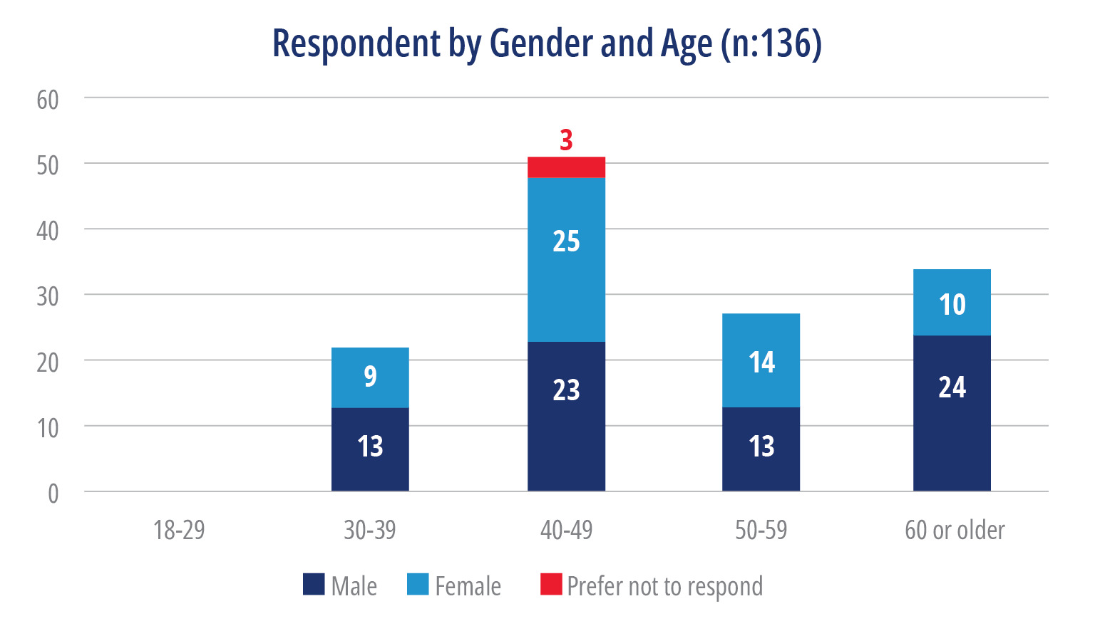

1. 6 respondents (4.4%) reported having difficulty seeing, even if wearing glasses (5 respondents) and difficulty hearing, even if using a hearing aid (1 respondent).
2. With regard to years of experience in the humanitarian sector, the minimum year of experience is one year, while the maximum years of experience is 40. From the total 135 respondents grouped by years of experience:

* 19% (25 respondents) in the range of 1-5 years of experience
* 30% (40 respondents) in the range of 6-10 years
* 20% (26 respondents) in the range of 11-15 years
* 23% (30 respondents) in the range of 16-20
* 11% (14 respondents) in the range of above 20 years.

1. On RedR deployment experience:

* 98% of the respondents have experienced their first deployment with RedR
* 52% second deployment
* 33% third deployment
* 15% fourth deployment
* 8% fifth deployment
* 5% sixth deployment
* 3% seventh deployment
* 1 respondent who reported going on their 10th deployment with this mechanism.

Regions for deployments:

* 84% respondents have been deployed to the Pacific
* 60% to Asia
* 36% to Middle East and North Africa
* 30% to Africa and
* 6% to Europe.

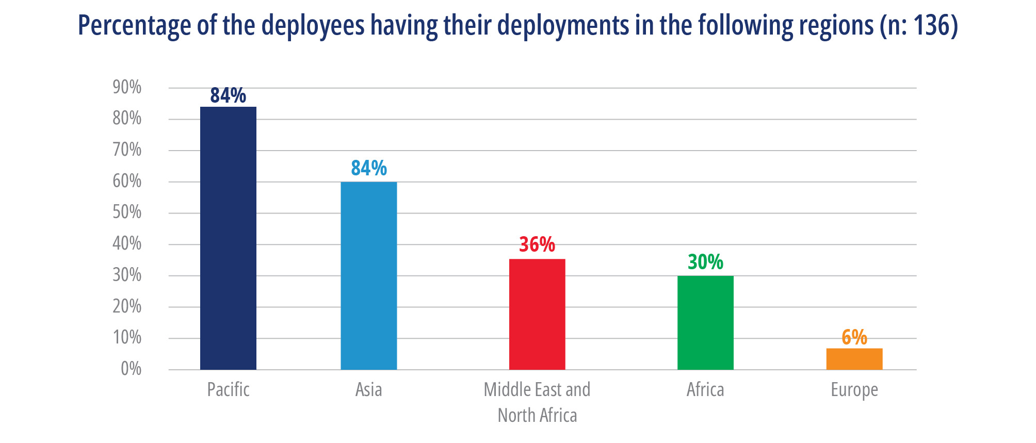

1. The respondents also reported their experience of having deployed with other organizations, ranging from NGOs, bilateral and multilateral programs and agencies.

* 36% of the respondents have been deployed more than 5 times with other organizations.
* 45% of the respondents deployed less than 5 times with other organizations.
* Only 19% of the respondents have never been deployed other than RedR under the Australia Assists program.

1. The respondents reported that their motivation to go for deployments is because it offers career opportunities (48%), gives them a sense of purpose (47%), while also mentioning additional qualitative responses that they are keen to make a contribution to a good cause, expand their skills and experience in the humanitarian sector, widen their network to different regions, support Australian foreign interests, pursue their passions, and look for adventure and experience living in other (“developing”) countries.
2. RedR deployees perceived their deployments made high contributions to the EOPOs.

The qualitative responses of those who perceived they had a high contribution to the EOPOs mentioned the importance of working collaboratively with host governments, local organisations, local staff and other stakeholders.

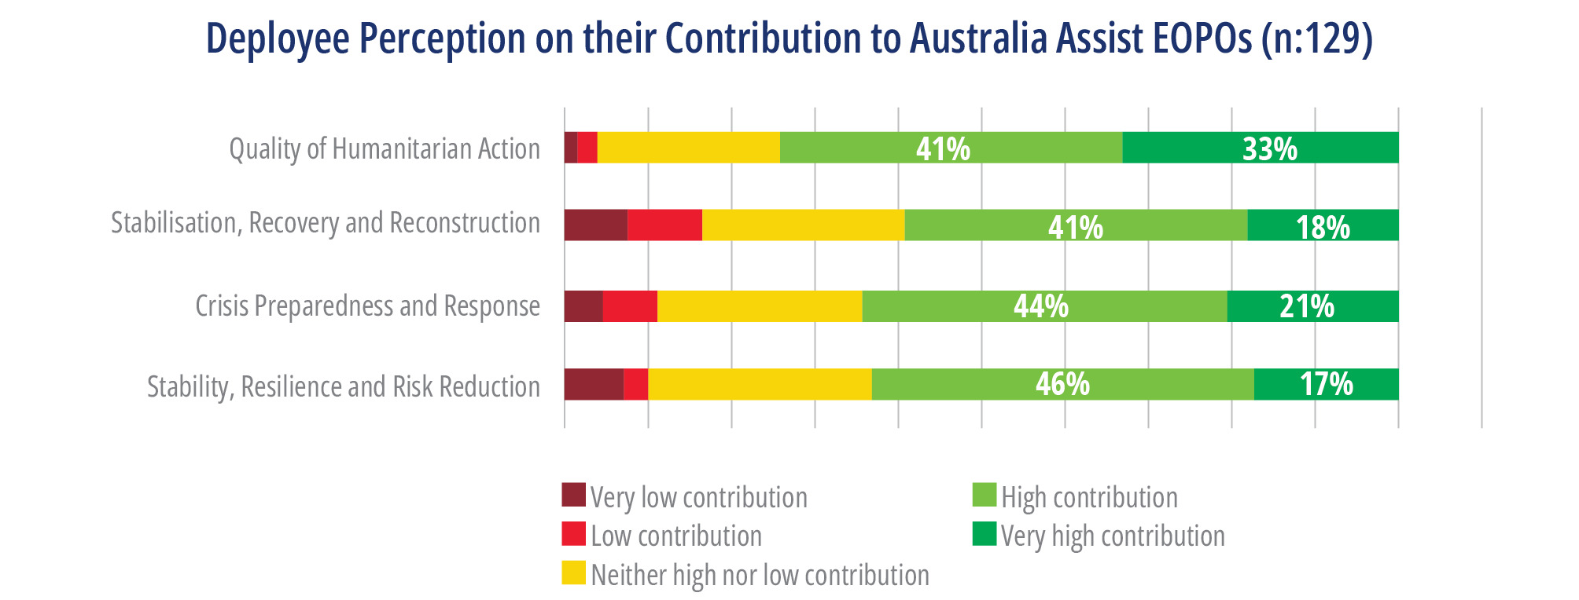

1. The respondents also perceived they made multiple contributions in the multiple thematic areas.

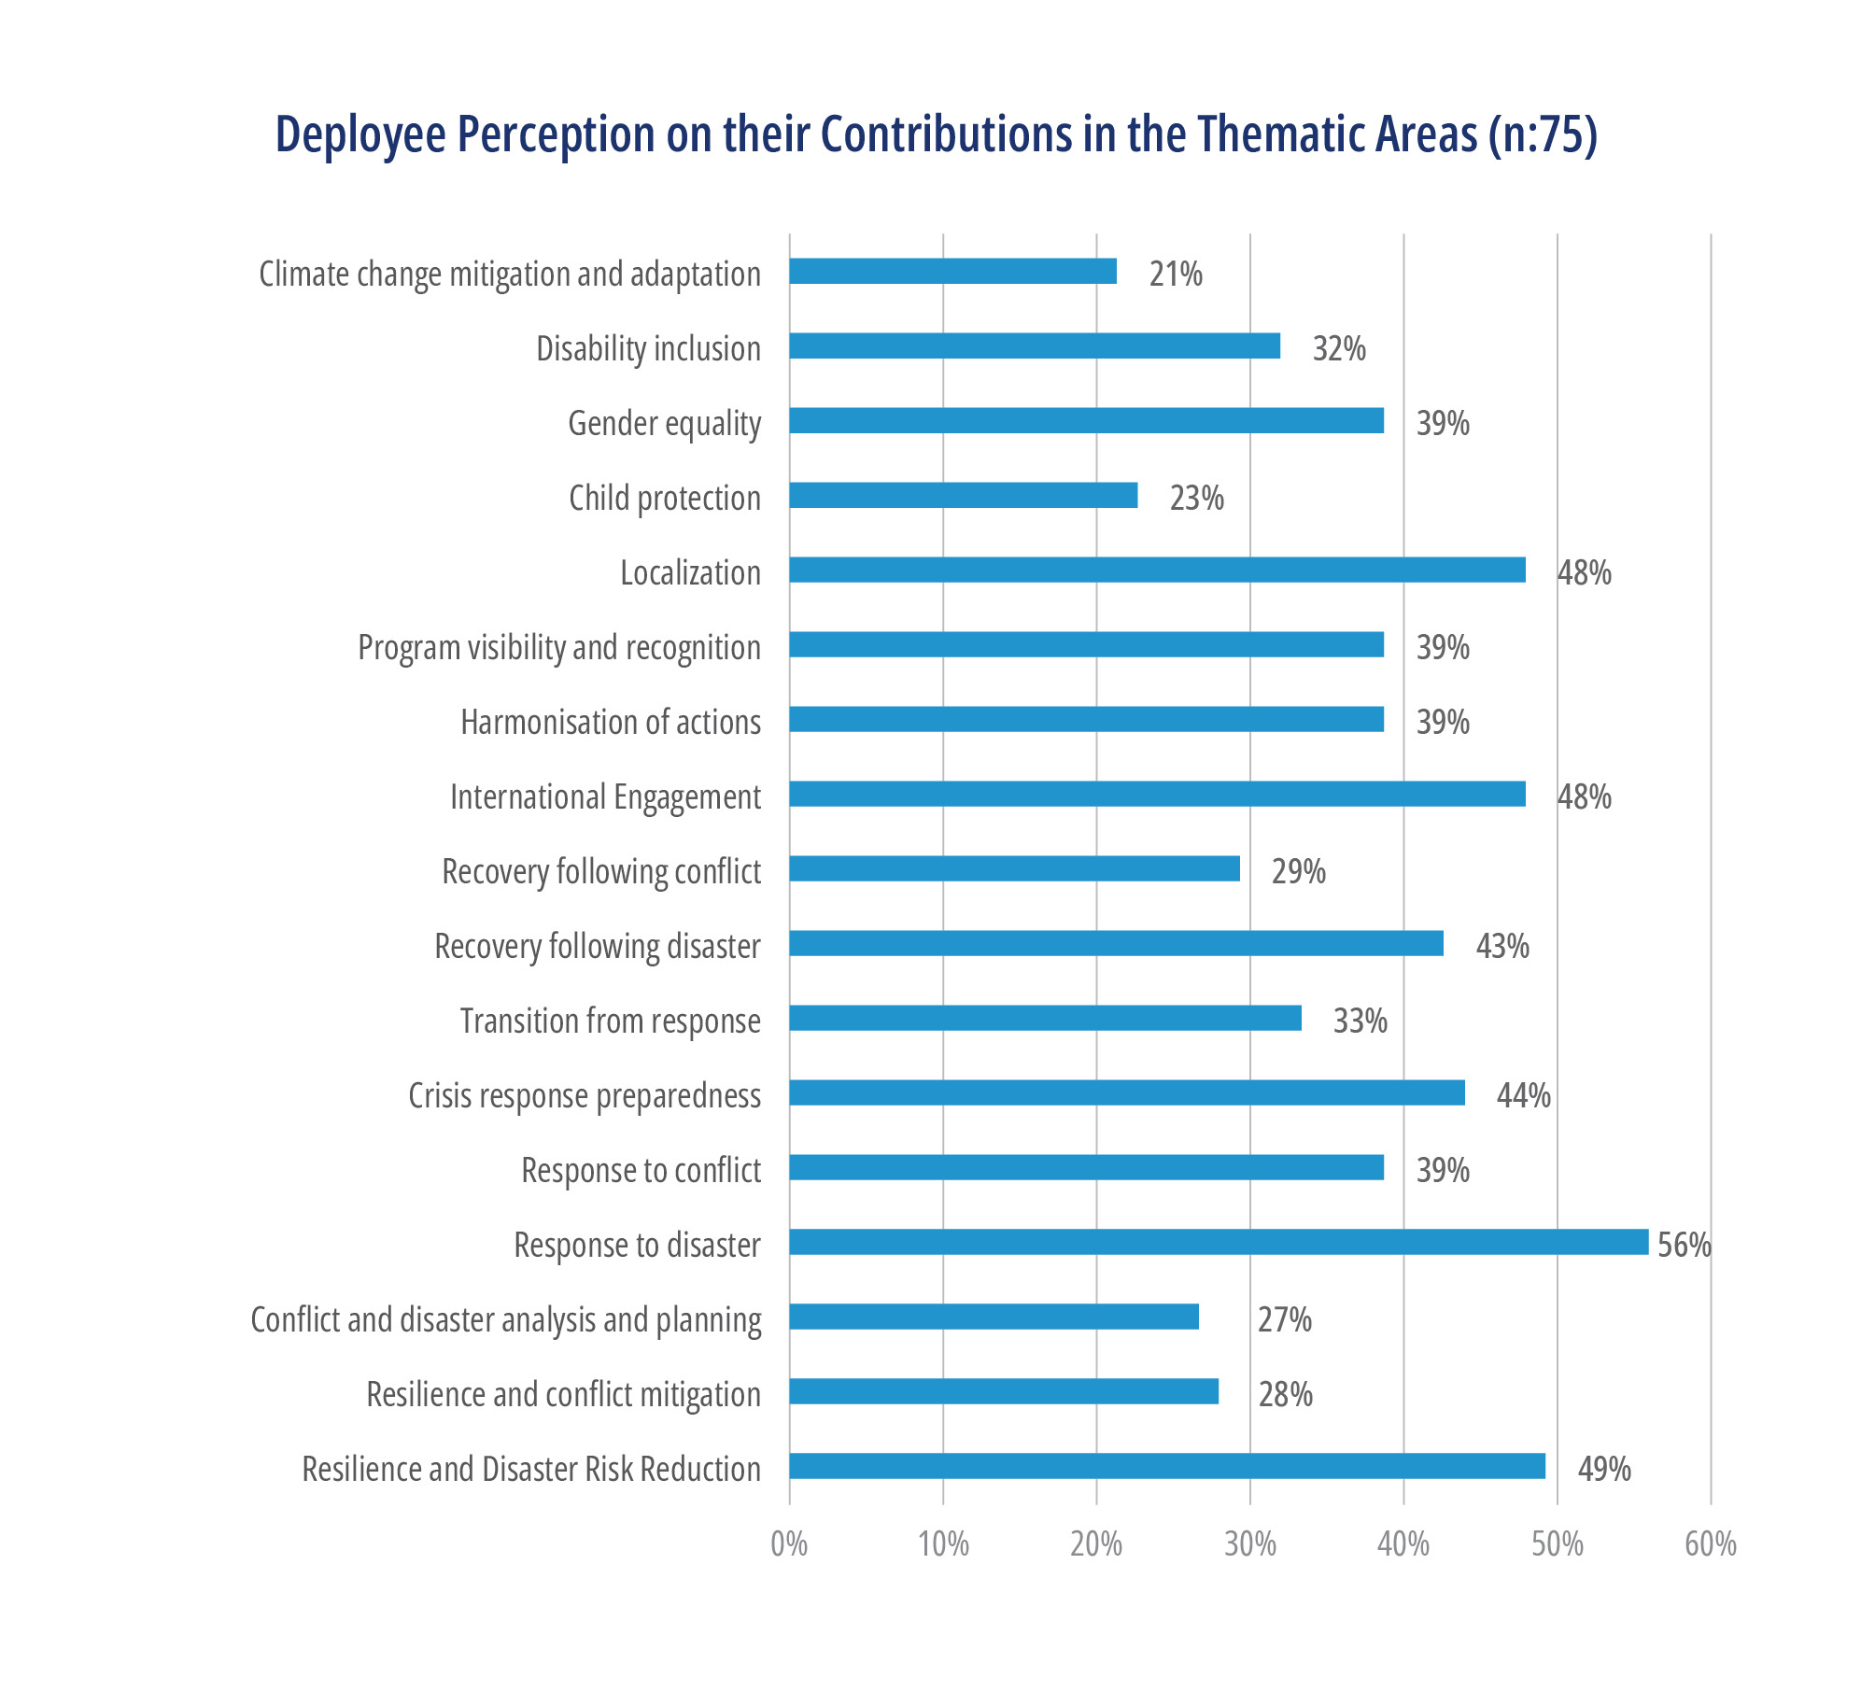

1. When asked about their perceptions of whether their deployment was strategically positioned where they were likely to have the greatest influence:

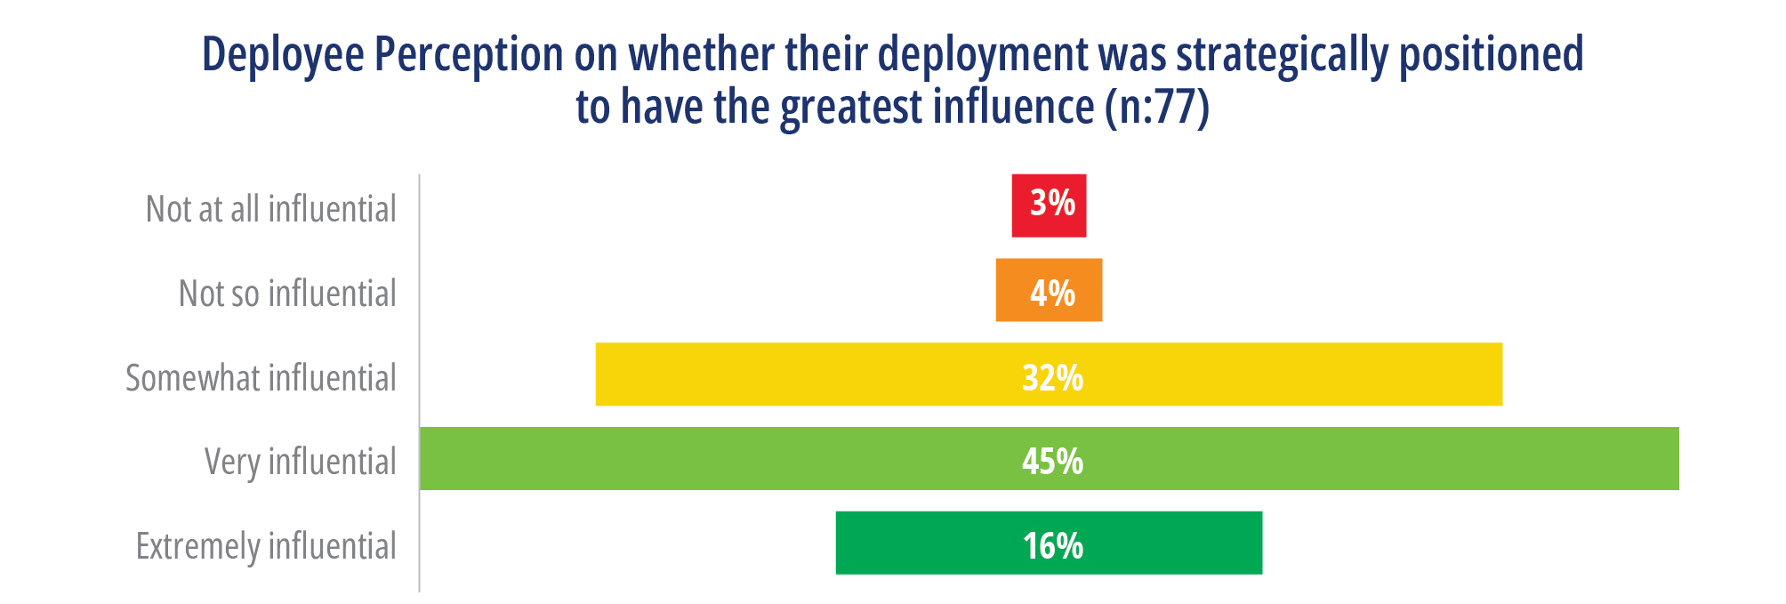

The qualitative responses to this question offer insight into several factors inhibiting them to be influential in their work, such as a mismatch in the knowledge, skills and experience, lack of integration, limited timeframe for deployment, and the nature of remote deployment that inhibit meaningful engagement.

1. The suggestions deployees have on how their deployments could have been better positioned to have a greater impact are grouped per the following:
2. Stronger in-country support, such as logistics transport, communications, as well as clarity of roles between RedR field and Melbourne office, particularly on the duty of care to deployee.
3. Better information management systems are required so the deployee can have access to the information on the type of support provided and lessons learned from the previous deployments in the host organization. This means that post deployment review and feedback loop is connected with new deployments.
4. ToR negotiated between RedR, host organisation and other parties should ensure that the management lines, roles and responsibilities and expected deliverables are clear and aligned with working context and recent progress on project implementation. In addition, the budget to cover the basic needs for work (e.g, travel, per diem, etc) to be clarified as well in the ToR.
5. Closer engagement between deployee and DFAT Posts, as well as allowing a network to build among deployees who work in the same country and region to facilitate knowledge sharing.
6. In 2022, RedR introduced a new remuneration package.

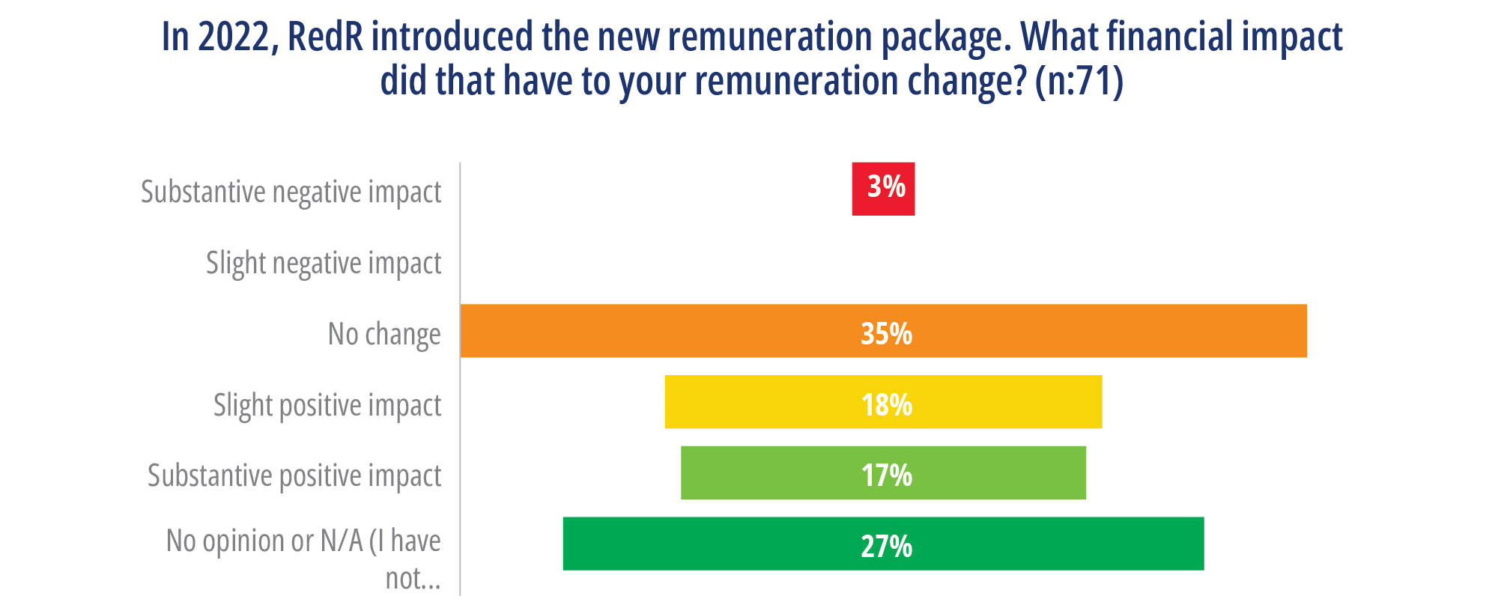

1. The criticisms echoed in the next question on how fair they consider the remuneration package offered for their deployments.

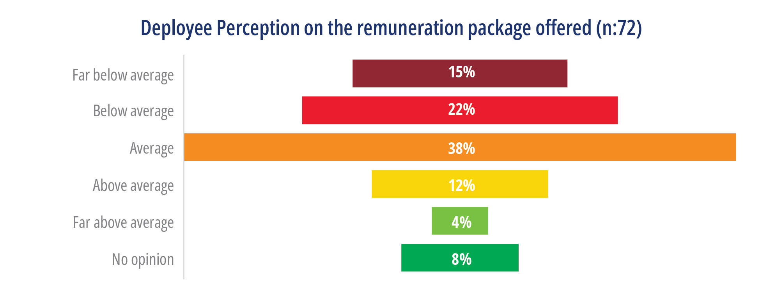

1. The respondents rate the effectiveness of RedR on the following support:

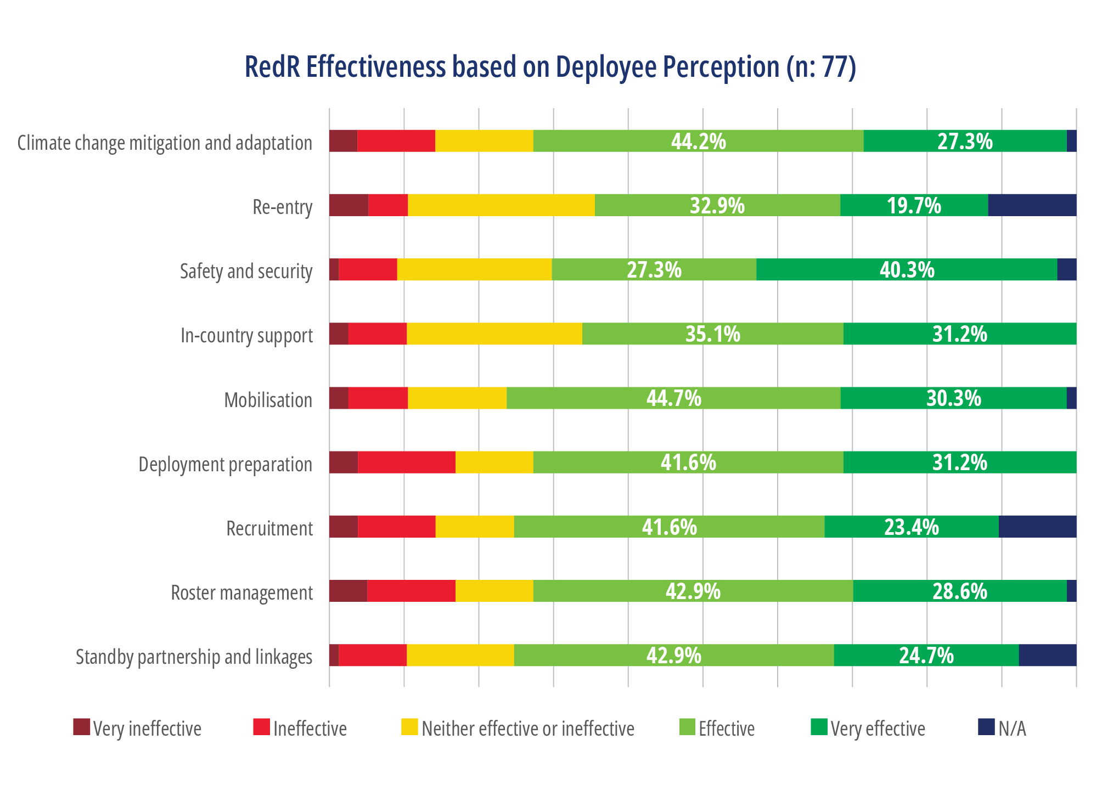

*“RedR is a very professional organization. They provided excellent support from pre-deployment to post deployment”*

Qualitative survey responses recommended improvements to the following RedR processes:

1. A whistleblowing mechanism to report on harassment, bullying, fraud and exploitation cases as deployees are often placed in intense short-term assignments in high security risk contexts. (N.B. the evaluation notes there is a whistleblowing mechanism in place, but these survey responses highlight the need to promote this more extensively through the deployee on-boarding and orientation process.)
2. In the pre-deployment briefings, be more specific to role and country situation, particularly with the in-country safety and security when working either host organisations that do not provide support - aim to be compliant to Minimum Operational Residential Security Standards (MORSS).
3. Better MEAL with information management systems are required so the deployee can have access to information on the type of support provided and lessons learned from the previous deployments in the same host organisation. This means that the post-deployment review and feedback loop is connected to new deployments.
4. Engagement with deployees who have been deployed to the country and/or organisation is considered important as a way of accessing formal and informal information and ways of working. This allows better insights to conditions in the field and the soft skills required to approach the assignments.
5. Stronger relationships between host organisations and DFAT Posts to understand how to better align with Australian humanitarian policy priorities.
6. The recruitment and onboarding process (e.g. ToR, visa, etc) needs to be more efficient as the current process brings uncertainty for the deployee.
7. On the top 3 things that are most helpful in preparing them for their deployments, the responses are:

The responses with ‘other’ 20% mentioned about the HEAT training, speaking with other deployees and other humanitarian actors to the same organization or country, previous in-country experience and contacts, briefing with the host organization, extensive self-research, RedR briefings and backup support from other specialist staff.

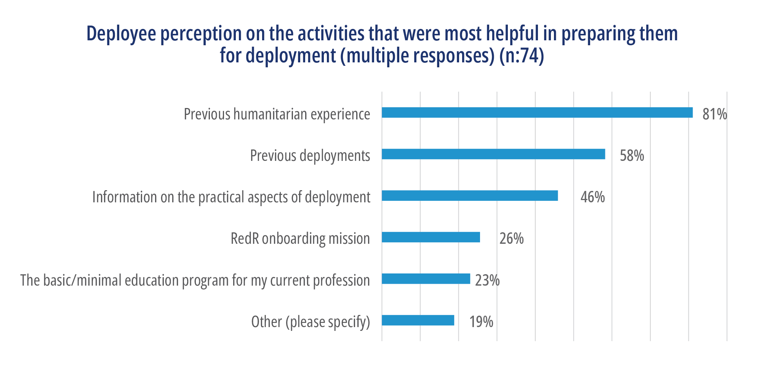

1. Prior to their deployment with RedR, were they adequately informed about:

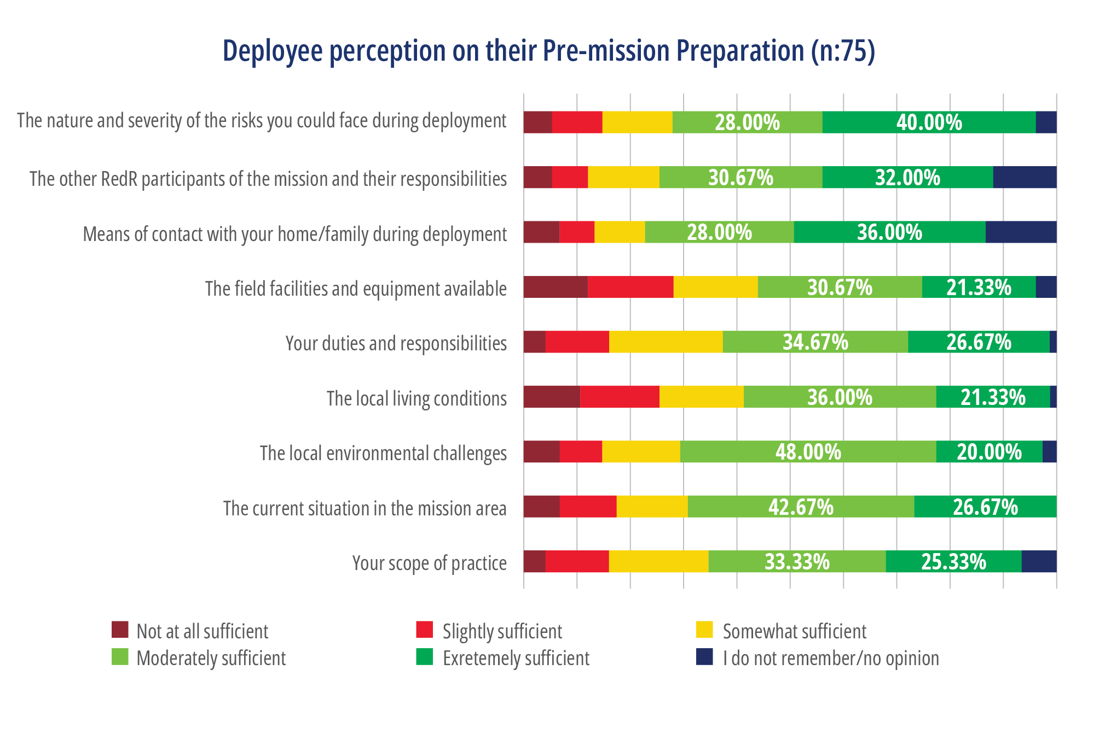

1. On additional training and support needed prior to deployments, the qualitative responses mentioned that training support to enable them to be a high-quality Australian deployee would be appreciated, such as Hostile Environment Awareness training (HEAT), Humanitarian Civil-Military Coordination (CMCoord), program design, management and MEL, humanitarian operation and logistics, GEDSI, particularly in the areas of protection, GBV and disability inclusion, communication and information management, and basic language training (conversational) for relevant place for deployments.

The qualitative responses also mentioned that prior to deployments, they would need the following information:

* Besides the information on Australia Assists program and the long-term goals of the deployment, deployee need to be informed with information on Australian Government priorities and humanitarian strategic framework.
* Current contextual information in relation to the mission itself and inter-agency cohesion and effectiveness, and in particular the reputation of and quality of the agency.
* Contacts with RedR deployee of the same organisation and country to allow insights on formal and informal approaches, including the interpersonal aspects of deployments. In addition, on tips in dealing with stress and endure long periods of inactivity when projects are hindered by climatic or cultural events.
* Timeframes on the onboarding process with certainty on visa processing information.

1. On the question of whether it was clear what they meant to be doing, 60% of the respondents answered ‘yes’, while the remaining 40% answered ‘no’. This indicates that the majority of respondents felt that it was clear what they were meant to be doing on their delployments.
2. On the question of whether the respondents were able to consult more experienced colleagues when needed, the answer is the following:

|  |  |
| --- | --- |
| Yes, on site | 40% |
| Yes, by phone | 34% |
| Yes, by internet | 44% |
| Yes, other (please specify): | 6% |
| No, it was not possible when I needed to | 10% |
| No, it was never possible | 6% |
| I do not remember; N/A | 8% |

The qualitative responses provide suggestions that access to more experienced deployees and networking among RedR deployees could have been useful. Several responses also mentioned the importance of building a network of experienced humanitarian workers through informal channel in country, LinkedIn invitations, internet searches, and Facebook groups. Utilising soft skills and working together with national staff is seen as an important way to navigate finding solutions at work.

1. The effect of last RedR deployment has on personal development:

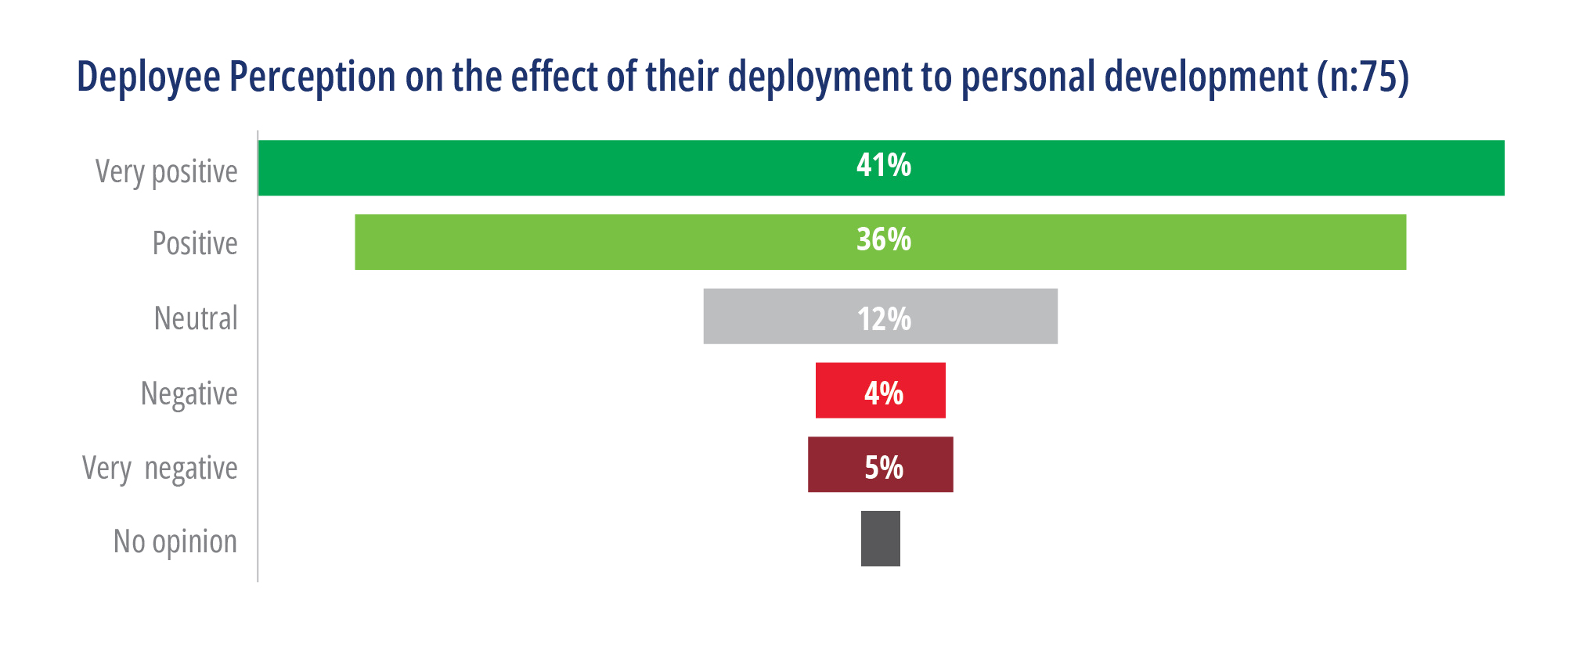

1. To deal with stress during a deployment, the respondents mentioned that the following would be helpful:

Suggestions on regular checks on deployee wellbeing, having specified periodic feedback, a good information management system and whistle-blowing mechanism were mentioned as areas for improvement.

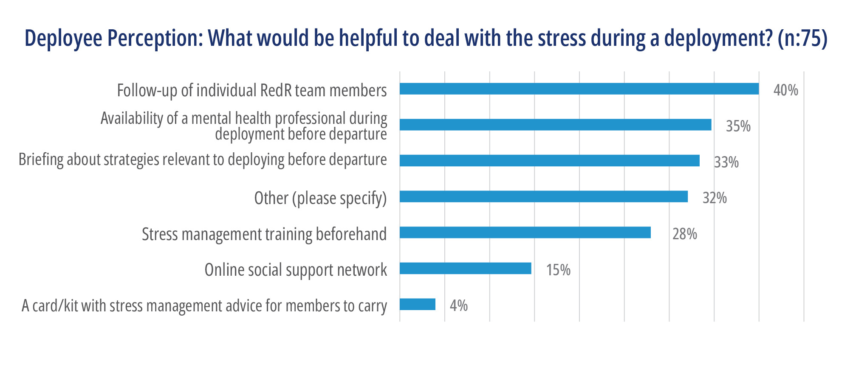

1. Additional inputs from the deployee:
2. The mechanism should consider deploying people who have significant G2G experience, particularly when dealing with government as host agencies as the nature would be different than working with UN or NGOs. In addition, there is an increased focus on the pacific with a higher emphasis from the current Government on Public Diplomacy.
3. Better information management, monitoring and evaluation system should be in place to ensure visibility and continuity in building on the progress made during deployments to each host organisations, DFAT[1] and other shareholders.
4. Learning from other providers and NGOs in the Standby Partnership Network on better internal systems, processes and operating capacity to allow rapid deployment, monitoring and evaluation, a better duty of care and remuneration standard.

Exit strategy should be well thought through by RedR, host organisation and the deployee to ensure continuity and sustainability of contribution made by the deployee. The exit strategy is not only reflected in the ToR but also in structured post deployment briefings between the deployee, RedR and host organisation so the end of assignment report and recommendations could be better utilised.

Annex 5: Progress against mid-term review recommendations

| Recommendation | Action plan | Timeframe | Has this been achieved? |
| --- | --- | --- | --- |
| Recommendation 1:  Developing regional strategies that allow flexible responses to crises, take into account the significant variations between regions and the need to service the Standby Partnership (SBP), and concurrently focus resources on key outcomes would help DFAT and RedR deliver greater sustainability of outcomes moving forward. | DFAT and RedR will include a longer-term regional strategic discussion during the next annual planning process.  As per Recommendation 3 below, DFAT will engage RedR through the forthcoming Pacific humanitarian design process to identify how deployments can be strategically integrated into Australia’s broader programming priorities. | Regional discussions to occur during the 2020-21 Annual Planning Process. | Regional strategies did not proceed because DFAT preferred to shift to greater regional focus in annual plans from 2020-21. It was agreed that the annual plans would serve as the guiding strategic documents. |
| Recommendation 2:  RedR should review Australia Assists management structure to better facilitate cross-departmental management oversight to strengthen partnership and performance management and efficiency in reporting and decision-making. | DFAT will continue regular dialogue with RedR on the program’s management restructure and other administrative arrangements at Steering Committee Meetings and further build on the positive working relationships between RedR and DFAT. | DFAT will seek a final program management structure from RedR by 31 January 2020. | Completed. RedR presented a revised structure which placed Director of Operations (now Programs) being the central conduit for Australia Assists. |
| Recommendation 3:  To support a stronger focus on results as the program matures, a Pacific regional strategy should be developed that has sufficient flexibility to concurrently address long-term support for disaster preparedness and resilience-building while progressing Australia’s objectives vis-à-vis protection, social inclusion and short-term surge capabilities at times of crisis. | DFAT will engage RedR through the Pacific Prepare design process to identify how deployments can be strategically integrated into Australia’s broader programming priorities.  DFAT and RedR will continue to look for opportunities for Australia Assists deployees to support recovery activities following disasters in the Pacific. | Paper to be developed by June 2020 and incorporated into Australia Assists Annual Plan for FY 2020-21. | RedR and DFAT agreed not to pursue a separate Pacific regional strategy, rather that regional strategies would now be part of Annual Planning discussions |
| Recommendation 4:  DFAT can create greater visibility of and alignment to Australia Assists’ contribution to protracted crises by taking steps to integrate Australia Assists within multi-year response frameworks and associated MEAL arrangements for key protracted crises into the future. | DFAT will build on the relationship between RedR and DFAT Posts/geographic desks to better align deployments within the objectives of Australia’s aid investments in the region.  As future protracted crisis packages are developed, DFAT will ensure Australia Assists deployments are factored into DFAT’s wider planning and MEAL for protracted crises and work across the humanitarian-development nexus. | As protracted crisis packages are developed. | Yes partially – Australia Assists has been integrated into packages for Bangladesh. |
| Recommendation 5:  As the program matures, the need to arrive at a more nuanced understanding about what localisation means for a technical deployment mechanism such as Australia Assists will become increasingly evident. As a first step DFAT and RedR should work together to define what localisation means for Australia Assists, systematically explore opportunities and barriers to advancing the localisation agenda and develop an action plan to progress localisation efforts. | DFAT and RedR will prepare a practice note to define what localisation means for Australia Assists. | Practice note and roster to be developed by June 2020 and incorporated into Australia Assists Annual Plan FY 2020-21. | Yes – localisation strategy and action plan developed, referenced in the 2020-21 Annual Plan. |
| Recommendation 6:  There is an ongoing need to recruit specialist disability inclusion expertise into the roster as well as to upskill the capability of the wider roster to mainstream disability inclusion and extend partnerships with Disabled People’s Organisations. This will require persistent efforts to address barriers to deployment of people with disability themselves, including addressing challenges associated with reasonable accommodations, safe workspaces and insurance and the need for adequate resourcing. | DFAT and RedR to identify potential deployments for future disability inclusion positions and seek a wider range of partners to develop this priority.  DFAT and RedR to discuss possible revisions, including refreshing the roster to gain more diversity, at a follow-up Q3 strategic meeting (February 2020). | Approach to be agreed in 2019-20 Q3.  Future disability inclusion positions to be addressed in Annual Plan FY 2020-21. | Annual plan 2020-21 references ‘up to three disability inclusion specialist’ targets and a disability focused partnership with a regional DPO in Southeast Asia. |
| Recommendation 7:  DFAT should pragmatically consider the extent to which pursuit of Australia Assists brand recognition effectively reinforces its wider need to promote Australia as a valuable technical partner. This should include consideration of the relative priority placed on pursuit of this identity in favour of other program management priorities. | Accept that brand recognition is a long term process but continue to monitor through deployees and Posts how well Australia Assists branding is understood by humanitarian partners and host governments.  DFAT will engage in further discussion with RedR and other stakeholders to find ways to optimise the use of the Australia Assists brand. | Approach to be agreed in 2019-20 Q4. | Unknown if acted on by DFAT.  RedR: Communications strategy focused on curated content for DFAT and Posts to use through Brand folder and stronger focus on scheduling social media has brought greater coherence.  Although it has dropped off the SCM action items list, branding issue remains an ‘issue’. Multiple DFAT programs using ‘Australia Assists’. |
| Recommendation 8:  The MEAL framework should be revised to include:   * a narrative explanation of the purpose of the MEAL system, Australia Assists’ approach to MEAL and the descriptors of key terms and what successful outcomes would look like * targets and outcome indicators for training * a consideration of whether or not EOPO 4 (Quality of Humanitarian Action) should be articulated as a goal or remain as a standalone outcome.   Concurrently, DFAT and RedR should re-engage with the Knowledge and Learning Strategy to establish and guide learning priorities and how these will be used. | DFAT and RedR will discuss and agree on a revised MEAL framework for Australia Assists. | Approach to be agreed in 2019-20 Q4. | No – revision to the MEAL framework and program logic began in 2021 but was still not completed by 2022, when the evaluation commenced. DFAT requested that it be put on hold until the evaluation concluded. |
| Recommendation 9:  To ensure attractiveness of the roster within a crowded market; RedR, in consultation with DFAT, should consider restructuring the deployee remuneration package to deliver equity in remuneration.  This could include:   * an increase in the base remuneration package consideration of how best to overcome the costs of training to promote greater diversification and renewal of the roster including, for example, increased funding for training or refunding of the cost of training upon completion of the first successful deployment * a tiered structure that allows additional cost supplementation for high value deployments into multilateral agencies (eg the deployment in Iraq) so that they align with the host agency.   This process could be undertaken within a wider context of considering the utility of the roster as Australia Assists matures, including the implications for localisation and for DFAT resourcing. | DFAT and RedR will further discuss the composition of the Australia Assists budget. Any revisions to the overall budget would form part of a contract amendment. | Approach to be discussed in 2019-20 Q4. | Yes – new remuneration framework released in January 2022. |

Annex 6: Deployment data Sept 2017 – July 2022

Deployment Data from 1 September 2017 – 21 July 2022

Table 1: Deployments and Deployment Months by Region

| Region | No. of deployments | Months deployed |
| --- | --- | --- |
| Pacific | 129 | 1,006 |
| Asia | 109 | 662 |
| Middle East | 59 | 434 |
| Africa | 36 | 190 |
| Europe | 12 | 48 |
| Caribbean | 2 | 10 |
| Total | 347 | 2,351 |

Table 2: Number of deployments[2]

| Year of deployment | Female | Male | Total |
| --- | --- | --- | --- |
| 2016 | 2 | 0 | 2 |
| 2017 | 14 | 11 | 25 |
| 2018 | 59 | 61 | 120 |
| 2019 | 40 | 49 | 89 |
| 2020 | 44 | 63 | 107 |
| 2021 | 40 | 46 | 86 |
| (per July) 2022 | 37 | 47 | 84 |
| Total | 236 | 277 | 513 |

Table 3: Total Deployment Months by gender

|  | No. of deployments | Months deployed |
| --- | --- | --- |
| Female | 158 (45.5%) | 1063 (45.2%) |
| Male | 189 (54.5%) | 1288 (54.8%) |
| Total | 347 | 2351 |

Table 4: Deployments by Partner Organisation

| Type of partner | No. of deployments | Months deployed |
| --- | --- | --- |
| UN Agencies | 254 (73%) | 1,629 (69%) |
| Governments (Departments, Ministries, National Disaster Management Authorities) | 72 (21%) | 551 (23%) |
| Non-governmental Organisations | 13 (4%) | 74 (3%) |
| Intergovernmental Organisations | 5 (2%) | 97 (4%) |
| Total | 347 | 2,351 |

Table 5: Deployment by Region

| Region | No. of deployments | Months deployed |
| --- | --- | --- |
| Pacific | 129 | 1,006 |
| Asia | 109 | 662 |
| Middle East | 59 | 434 |
| Africa | 36 | 190 |
| Europe | 12 | 48 |
| Caribbean | 2 | 10 |
| Total | 347 | 2,350 |

Table 6: Deployment by EOPO

| EOPOs | No. of deployments | Months deployed |
| --- | --- | --- |
| EOPO 1: Stability, Resilience and Risk Reduction | 106 | 808 |
| EOPO 2: Crisis Preparedness and Response | 171 | 959 |
| EOPO 3: Stabilisation, Recovery and Reconstruction | 70 | 584 |
| EOPO 4: Quality of humanitarian action | N/A (integrated with deployments in EOPO 1 – 3) | |
| EOPO 5: Program Management | N/A | |
| Total | 347 | 2351 |

Table 7: Indicators of actions to progress disability inclusion

| Year | % of ToRs with disability inclusion objective | No. of roster members with disability inclusion expertise recruited |
| --- | --- | --- |
| FY17 | NA | 10 |
| FY18 | NA | 4 |
| FY19 | 6% | 3 |
| FY20 | 24% | 2 |
| FY21 | 23% | 1 |
| FY22 | 30% | NA |

Annex 7: Deployment mechanisms comparative analysis

### NGOs as UN Standby Partners

RedR Australia provides many Australia Assists deployments through the UN Standby Partnership mechanism[3], through which independent organisations can deploy experts into UN Agencies. There are around 50 participating Standby Partner organisations[4], with some also deploying to national governments, and others incorporating experts from the Global South in their roster (see for example NORCAP and CANADEM respectively).

The following provides a high-level comparison of RedR Australia to three other standby partners rated highly by at least one UN partner interviewed for this evaluation, and who are also funded by the Foreign, Commonwealth and Development Office (FCDO). Data for the Indo-Pacific is included to demonstrate that other UN Standby Partners (in addition to RedR) provide deployments to the Indo-Pacific region that are similar to that of RedR Australia[5].

Table 8: UN Standby Partner Deployments 2019

| **Location** |  | **RedR** | **NORCAP** | **CANADEM** | **DRC** |
| --- | --- | --- | --- | --- | --- |
| GLOBAL | Roster members | 900 | 1,000+ | 50,149 | 600 |
| Deployments | 54 | 670 | 169 | 66 |
| Countries | 21 | 81 | 40 | 27 |
| INDO PACIFIC | Deployments | 32 |  | 39+ | 15 |
| Deployment months | 253 | 228+ |  |  |
| Countries | 9 | 10 | 6+ | NA |

RedR Australia[6] has more than 700 roster members in the 2019 financial year. It provided 122 deployments to 28 countries, with 38 deployments to eight countries in the Pacific. RedR lists UN partners, host organisations, DFAT and DFID (now FCDO) as donors. It listed 21 skill profiles, and highlighted its contribution to gender, protection, and social inclusion.

The Norwegian Refugee Council operates

RCAP[7]. In 2019 NORCAP deployed 228 person months to Asia and the Pacific: to Bangladesh, Myanmar, Thailand, Indonesia, Papua New Guinea, the Philippines and Fiji. It also deployed 374 person-months to the Middle East and North Africa, which includes Afghanistan and Pakistan.

NORCAP’s top partners included host governments and multilaterals: OSCE, UNHCR, UNICEF, National Governments, the African Union, UNDP, WFP, IOM, FAO and UNFPA. It focused on coordination and leadership, peacebuilding and peacekeeping, protection, climate, energy and resilience, cash and markets, civil affairs and democratization, and camp management. It listed ten donors in 2019 including Norway, ECHO, Sweden, the World Bank, the United States and Switzerland.

CANADEM[8] had 50,149 roster members in 2019, with approximately forty per cent (or 20,456 people) from developing countries. It primarily deployed to UNFPA, UNICEF, WHO and UNHCR, with deployment languages including Spanish, Arabic, Portuguese, and French.

In 2019, CANADEM supported 39 surge missions to 6 countries in South and Southeast Asia, primarily to Bangladesh. 55% of these missions were staffed by women; 86% by experts from developing countries. They also deployed to Myanmar, Pakistan, Papua New Guinea and Samoa. CANADEM lists 3 main donors: DFID (now FCDO), Global Affairs Canada, and UN Agencies. Its largest areas of expertise are protection, gender-based violence, logistics, health, WASH, education, sexual and reproductive health, food security, humanitarian affairs and shelter.

The Danish Refugee Council (DRC) operates the DRC Humanitarian Response Roster, and two rosters specific to UNHCR: the DRC Registration Roster and DRC Resettlement Roster[9]. They currently have 994 active members across the 3 rosters. DRC’s Humanitarian Response Roster has 519 active members with 46% from Europe, 27% from developing countries, and 27% other[10]. It prioritises short-term field-based deployments (gap-filling), including rapid deployments. In 2019, DRC’s Humanitarian Response Roster had 600 roster members and supported 66 UN Standby Partner deployments, including 15 to Asia[11]. They listed 7 donors in 2019, with Danida funding the most deployment months, followed by UNHCR and the EU, then DFID, WFP, UNFPA and IOM.

### Managing contractors and NGOs

DT Global[12] manages deployments to national governments under DFAT’s Centre for Health Security Initiative. Although a much smaller program than RedR and not associated with the UN Standby Partnership mechanism, it is highly responsive to DFAT needs, deploying health experts to operational and strategically important roles including emergency response. Deployments are based on demand identified by DFAT, and arranged through tasking notes. They are able to deploy experts of any nationality, and have deployed Australians, Tongans, Fijians, Americans and Irish experts. Deployees are paid in line with the Australian Remuneration Framework.

Palladium[13] (UK) manages humanitarian surge capacity for FCDO under a project called the Humanitarian, Stabilisation Operation Team (HSOT).[14] It provides surge capacity through several separate mechanisms:

1. A Palladium roster of 300-400 members that the FCDO country office can draw upon to deploy as FCDO humanitarian experts, and
2. Administers FCDO’s contributions to four UN Standby Partners (CANADEM, DRC, NRC and RedR Australia) to deploy to UN Agencies.
3. Palladium deploys its own core staff within 24 hours to support FCDO’s logistics and other emergency needs. These mechanisms allow Palladium to be responsive to both FCDO and UN needs.

**Palladium**[15](Australia) also manages DFAT’s logistics capabilities under a five-year (2018-2023) contract Provision of Humanitarian Logistics Capability Services, which includes the deployment of advisors for the purpose of facilitating logistics. They are capable of deploying within three hours. Palladium is also able to employ staff locally. They do not deploy to the UN or other agencies.

The **Australian Volunteers Program (AVP)**[16] deploys volunteers to partner organisations, including local organisations, UN agencies and host governments, on behalf of DFAT. It is managed by Australian Volunteers International (AVI) in consortium with DT Global and Alinea International. It operates in 26 countries through 22 country offices and provides volunteers training in advance, and on arrival at their placement. Recruitment is usually in collaboration with partner organisations and advertised online and / or through a talent pool (similar to a roster). AVP has also established more direct referral pathways to facilitate strategic placements in unique circumstances. In general, it takes 3-5 months from advertisement to the assignment starting in country, though this varies. AVP places volunteers across a range of disciplines, including humanitarian preparedness and disaster risk reduction. The investment in innovation has provided space for AVP to do interesting work on localisation and to explore and adapt new modalities for volunteering

The history of AVP has similarities to Australia Assists in terms of timing. Financing for Australian volunteers shifted from a grant to several organisations, to a single contract model. A tender process saw AVI installed as the managing contractor of the Australian Volunteers Program in January 2018. This process facilitated a clear delineation from the earlier approach to funding volunteers. Previously, AVI was inseparable from the volunteering program funded by DFAT, with more than 90% of AVI income coming from DFAT. The new contracting model led to a clear separation in branding, website presence and intellectual property. This, in turn, gave DFAT improved opportunity to steer the program and gain recognition for the Australian Government contribution. In addition, the consortia approach provided AVI with access to the systems and processes for delivering large government contracts; enabling them to shift from a grant recipient agency to a managing contractor. The MEL Unit as part of the consortium brought strong MEL technical expertise, as well as ring fencing the MEL staff, providing opportunity for AVP to deliver solid data and reporting to DFAT, as well as investing in research and learning.

### Summary of services able to be provided

This evaluation identified services that are valued by DFAT in terms of surge deployments related to humanitarian crises. It identified both the types of deployment, and host organisations as well as training, risk management and branding. The following section lists which organisations are able to provide each of these services. Please note the following table is based on available information and may be incomplete.

Table 9: Comparison of Deployment Type by Deployment Management Organisation

| **Deployments of Australians and internationals** | **Deployment to UN partner** | **Deployment to host government** | **Deployment to one donor government** |
| --- | --- | --- | --- |
| Preparedness for crises | RedR  Palladium UK  NORCAP  CANADEM  AVP  DRC | RedR  DT Global  NORCAP  AVP | Palladium UK |
| Response to protracted crisis response | RedR  CANADEM  NORCAP  Palladium UK  DRC | RedR  DT Global  NORCAP | Palladium UK |
| Rapid response to sudden-onset crises | RedR  CANADEM  NORCAP  Palladium UK  DRC | RedR  DT Global  NORCAP | Palladium UK |
| Longer-term recovery from crises | RedR  CANADEM  NORCAP  Palladium UK | RedR  DT Global  NORCAP | Palladium UK |
| High-profile deployments, likely to secure positions in responses important to donor | RedR and Palladium UK can do this depending on relationship with UN  AVP | RedR  DT Global  NORCAP  AVP | Palladium UK |
| Longer-term policy and global thought leadership roles incl. reform and GEDSI | RedR  Palladium UK  NORCAP  CANADEM  AVP | RedR  DT Global  NORCAP  AVP | Palladium UK |

### Training

Information on comparative training services was less available. Other Standby Partners may offer similar training, though it is less likely to be offered in the Indo Pacific. NORCAP for example has over 200 experts completing their Hostile Environment Awareness Training each year[17], while DRC occasionally offers HEAT training and other technical training, usually hosted by UN partners[18]. Managing contractors do not report similar training services to RedR Australia.

### Branding

The one UN Standby Partner interviewed has not in the past prioritised branding for themselves or their donor[19]. While noting the potential for confusion if a deployee to a UN agency wears a shirt with roster branding, they recognise branding is becoming more important for some donors. It has become an area of greater focus for the organisation.

Branding can largely be dictated by donors for managing contractors, in line with what is most appropriate. For example, Palladium reported substantive Australian branding on boxes and pallets, but not on vehicles[20]. AVP similarly noted their program has clear AVP and DFAT/Australian Aid branding, marking a shift from earlier branding approaches which had included the brand of implementing partners[21].

Annex 8: Evaluation findings summary

### Performance Rating Key

Performance is good, and no actions required

Performance is reasonable however suggested actions are included to strengthen outcomes either now or in new phase

Performance is less than desirable, and action required within current contract period

| Effectiveness KEQs | Rating | Rationale | Data Sources |
| --- | --- | --- | --- |
| Effectiveness in meeting the intended outcomes and Australia’s Humanitarian strategic objectives. | Rating = Reasonable | * Overall, RedR performed well in meeting the intended outcomes. However, reporting progress against EOPOs are skewed as EOPO 4 is integrated with most deployments. * RedR has managed the roster to better align deployment capability with Australia’s humanitarian priorities. | * Document review * Survey * Interviews with RedR, DFAT, Host organisations * Deployment data * Interviews with deployee * Survey to deployee |
| Strategic Objective 1: Reformed Global Humanitarian System (EOPO 4) | Rating = Reasonable | * Refer to all deployments contributing to global humanitarian action via UN Standby Partners * Survey responses show the percentage of deployee who perceive they have contributed to the following areas: |
| Strategic Objective 2: Reduced Disaster Risk (EOPO 1) | Rating = Reasonable | * Refer to deployments under EOPO 1 (Table 6) – 106 deployments totalling 808 deployee months from 2017 – July 2022. * Survey responses show the percentage of deployee who perceive they have contributed to the following areas:   Resilience and Disaster Risk Reduction 49%  Resilience and conflict mitigation 28%  Conflict and disaster analysis and planning 27% |  |
| Strategic Objective 3: Enhanced Preparedness and Response (EOPO 2) | Rating = Reasonable | * Refer to deployments under EOPO 2 (Table 6) – 171 deployments totalling 959 deployee months from 2017 – July 2022 * Survey responses show the percentage of deployee who perceive they have contributed to the following areas:   Response to disaster 56%  Response to conflict 39%  Crisis response preparedness 44% |
| Strategic Objective 4: Prioritised Early Recovery (EOPO 3) | Rating = Reasonable | * Refer to deployments under EOPO 3 (Table 6) – 70 deployments totalling 584 deployee months from 2017 – July 2022 * Survey responses show the percentage of deployee who perceive they have contributed to the following areas:   Transition from response 33%  Recovery following disaster 43%  Recovery following conflict 29% |
| Branding and Visibility of Australia Assists (EOPO4.3) | Rating: weak | * Australia Assists is more commonly known as RedR, and DFAT branding guidelines are not strictly applied. * Lack of clarity within the contract and DFAT expectations regarding branding. | * Document review: Australia Assists annual reports, MTR, DFAT Branding Guidelines, RedR’s Australia Assists Communications and Branding policy. * KIIs with DFAT and RedR |
| Effectiveness of the Management of Australia Assists (EOPO5) | Rating = Reasonable | * RedR has delivered a rigorous recruitment process that integrates essential humanitarian training, psychological assessment, selection, pre-deployment preparation, mobilisation, in-country management, and re-entry. * Survey on 8 areas of assessments rate RedR sufficiently informed the deployee during the onboarding processes (average 62%) * Survey responses rate RedR of having above 70% effectiveness in providing the supports and services throughout deployment cycle. * Operational management of deployments is well managed. * Lack of breadth of deployment options * Lack of a learning and adaptation cycle * Out-dated contract | * KIIs & FGDs with deployees, RedR, DFAT and host organisations * Survey of deployees * RedR deployee reports * Desk review of key documents |
| Effective deployee recruitment and mobilization | Rating: Good | * RedR has delivered robust deployee recruitment, training, and mobilisation, resulting in generally high-quality deployees. | * Reports   Deployee Survey |
| Effectiveness of the Theory of Change | Rating = Reasonable | * The Theory of Change has a good breadth across the humanitarian continuum but lacks specificity, making outcomes difficult to measures. | * Document review: annual reports, RedR deployee reports * Survey * Interviews with RedR |
| Effectiveness of MEAL system | Rating: weak | * Underdeveloped and unresponsive MEAL system * Salary investment is not enough to attract senior MEAL staff[22] * MEAL has been too closely associated with communications products * Organisational culture needs to embed learning and place emphasis on how MEL could nurture accountability | * Interviews with RedR, DFAT and host organisations * Survey * IMR * RedR deployee report * The 2012 MTR * The 2017 MTR * RedR Contract |

| Effectiveness KEQs | Rating | Rationale | Data Sources |
| --- | --- | --- | --- |
| Progress on the recommendations from the MTR | Rating = Reasonable | * Most recommendations appear to have been addressed * The regional strategies have not yet been developed nor has RedR changed its management approach to incorporate short-term surge capacity (meaning rapid response). * Issues with the MEL system are outstanding * DFAT has not progressed review of AA branding. * DFAT has not progressed on review of AA ? | * Interviews with RedR, DFAT * Australia Assists Mid-term review and management response. * Remuneration policy * Australia Assists annual plans |
| Effectiveness of RedR in managing the thematic priorities:   * Gender Equality * Disability inclusion * Localisation * DRR and Climate Change * Child Protection * PSEAH * Adapting to Covid-19 | Rating = Reasonable | Localisation, gender, child protection, PSEAH and disability inclusion.   * Strong progress against the localisation and gender action plans * Limited disability inclusion expertise on the roster * Limited evidence of people with disabilities engaged on the roster * Interviews and survey results indicate concerns around reporting PSEAH * Survey responses show the percentage of deployee who perceive they have contributed to the following areas:   Localisation 48%  Child protection 23%  Gender equality 39%  Disability inclusion 32% | * Interviews with RedR, DFAT, Host organisations * Survey * IMRs * Deployment data * Australia Assists annual reports * GAP, DAP and LAP? |

| Relevance KEQs | Rating | Rationale | Data Sources |
| --- | --- | --- | --- |
| Alignment with DFAT’s humanitarian requirements and contribution to priorities and response capabilities | Rating: Good | The Australia Assists mechanism demonstrates effective alignment with the Australian government’s humanitarian priorities and is highly relevant to Australia’s strategic policy frameworks.  Data from interviews demonstrates there are multiple and sometimes conflicting expectations of the Australia Assists mechanism from different parts of DFAT, particularly in terms of its flexibility and adaptive capacity.  Australia Assists is well known and respected in the global policy space. | Interviews with DFAT, RedR  IMRs |
| Alignment with Australian Government policies | Rating: Good | Alignment and complementarity of the Australia Assists mechanism has been assessed against three policies: Partnerships for Recovery, Foreign Policy White Paper and Defence White Paper. | Policy analysis  KIIs with DFAT, RedR  Design Document  Annual reports |
| Relevance for Australia’s footprint and influence | Rating: Good | Appreciated by Australia’s multilateral partners, and is important to Australia’s relationships and influence both in country, and at global policy fora  A range of DFAT respondents indicated Australia Assists in important to Australia’s multilateral engagement and contributes to Australia’s credibility internationally. | Interviews with DFAT, multilateral host organisations, RedR  Survey |
| Responsive and strategic use of deployments, including for emerging challenges | Rating = Reasonable | * Perception that the Australia Assists program is not as nimble and fit for purpose in responding to emerging issues * Need to define more clearly what this looks like * Demonstrated ability to shift in COVID-19 but has drawbacks – remote support   COVID-19:   * surge model moving into online delivery:   + Between 1 July 2020 and 30 June 2021, 37 per cent (40 specialists) worked remotely.   + Between 1 July 2021 and 30 June 2022, 11 per cent (11 specialists) worked remotely and 30 per cent (31 specialists) began remotely before moving in-country. * COVID-19 is an opportunity to strengthen localisation agenda   Surges and changes in demand   * Does not respond quickly to surge demands, limited evidence of adaptive capacity * RedR HR and Program Director recognise the skills and experience demanded is changing from more traditional roles to humanitarian coordination, information management   Good feedback from DFAT about responsiveness to their demands | Interviews with RedR, DFAT, Host organisations  RedR COVID-19 After Action Review  Australia Assists annual reports  Deployment data  Interviews with RedR  RedR email exchange  Survey to deployee |
| Fit for Purpose Contract | Rating = Reasonable | * Risk management: there is an effective risk management architecture in place for the Australia Assists mechanism, including a complaint handling mechanism. There is a need to assess the independence of the complaint handling mechanism to ensure stakeholder confidence in reporting and assurance reports will be investigated. | * Document review of risk policies and steering committee meeting minutes. * Interviews with DFAT, RedR, host organisations. * Survey to deployee |
| Fit for Purpose: Capability | Rating = Reasonable | * Australia Assists is seen by Posts and Canberra as providing high-quality deployee and an option to deliver humanitarian responses in high-risk contexts. * The current supply has largely met the demands from UN and partner governments but needs some improvements to meet the demands from DFAT posts. * Partnerships with 15 UN Standby Partners are active. Within the UN SBP seems a wide range of skills, experience etc. is being deployed, noting there may be a mismatch in prioritisation or placement.   Sub-questions:  Does supply meet demand?   * Supply has largely meet demands for UN Standby partner deployments (68%) but need improvement in meeting demands from DFAT Posts.   Appropriate ratio of client types for Australia Assist mechanism   * Taking FCDO model as an example, deployments requested by FCDO has a higher percentage than the UN Standby partnership deployments as the mechanism put the priority to align with the country’s humanitarian response policy and priorities while still contributing to the global humanitarian action via UN agencies. | * Interviews with DFAT, Host organisations * Interviews with UN Standby Partners and other organisations for comparative analysis * Survey * Deployment data |

| Value for Money KEQs | | Rating | | Rationale | | Data Sources | |
| --- | --- | --- | --- | --- | --- | --- | --- |
| Cost consciousness | | Rating: Good | | * RedR has demonstrated cost consciousness in: * Successfully urging the UN to contribute to the cost of deployments, and this contribution funded 63 additional deployment months in 2019. * Drawing income from training fees to support RedR overheads. * Relatively low remuneration to deployees. | | * Document review * Financial analysis * Interviews with DFAT and RedR | |
| Encouraging competition | | Rating = Reasonable | | * RedR demonstrates competition in relation to the recruitment of personnel for deployment. Personnel are selected based upon a competitive selection process. * DFAT has not yet undertaken a competitive tender for the management of the Australia Assists program and therefore the market price for these services has not been tested. | | * Document review * Interviews with DFAT RedR and host organisations | |
| Evidence-based decision making | | Rating: weak | | * The lack of a robust M&E system has resulted in poor quantity and quality of data to form an evidence base upon which to launch organisation learning. | | * Document review * Interviews with DFAT and RedR | |
| Proportionality | | Rating: Good | | * The AUD $12 million per year cost of Australia Assists to DFAT has delivered an average of 516 deployment months per annum and drawn on minimal resourcing available from DFAT to manage the program overall or each deployment. | | * Document review * Interviews with DFAT and RedR | |
| Performance Risk Management | | Rating: Good | | * There is an effective risk management architecture in place for the Australia Assists mechanism. * Performance and risk management are well-managed within the scope of deployment types that Australia Assists currently offers, largely because many of these risks are transferred to host organisations. | | * Document review * Interviews with DFAT and RedR | |
| Results Focused | | Rating: weak | | * A review of Australia Assists reports and reviews demonstrates that the program is more focused on input data and targets for deployments rather than results data. | | * Document review * Interviews with DFAT and RedR | |
| Experimentation and innovation | | Rating: weak | | * RedR has tended to apply a formulaic approach to deployment management, and deployees took a longer than hoped for time to be placed. * The management approach to Australia Assists has not evolved to incorporate an increased demand for different types of deployments such as rapid response and non-hosted deployments. | | * Document review * Interviews with DFAT and RedR | |
| Accountability and Transparency | | Rating: weak | | * Accountability at the input level is strong, however accountability at the outcome level and financial management is hampered by a head contract that does not lend itself to serving these principles. | | * Document review * Interviews with DFAT and RedR | |

Annex 9: RedR reported progress against EOPOs

The following table draws on evidence reported by RedR in annual reports.

### AUSTRALIA ASSISTS OUTCOMES

| OBJECTIVES AND OUTCOMES | EVIDENCE |
| --- | --- |
| Objective 1:  Reformed global humanitarian system  Aligns to Australia Assists EOPO 4: Quality of Humanitarian Action | |
| Humanitarian diplomacy strengthened | Strategic deployment of a Disability Inclusion Expert to World Food Programme (WFP) headquarters for one year, which facilitated disability-sensitive programming at both operational and corporate level |
| Deployment to EU Advisory Mission, Iraq |
| Provision of civil-military and humanitarian affairs expertise to UNDP and OCHA in Amman |
| Digital diplomacy to build public awareness and engagement through strategic digital content |
| Provision of civil-military and humanitarian affairs expertise to UNDP and UNOCHA in Jordan. |
| Australian humanitarian innovation is showcased | Support in application of innovative solar generation in refugee camps in Jordan |
| Transition strategy for emergency WASH infrastructure in Syrian refugee camps |
| Universal quality and accountability standards are applied | RedR’s leadership position among the UN Standby Partnership Network (SBP), including through steering a Joint After Action Review of the SBP Response to Tropical Cyclone Idai |
|  | Implementation of a global pilot to develop monitoring and evaluation protocols to capture and implement best practice for more efficient outcomes in Syrian camps |
|  | Development of tools that give voice to survivors of SGBV, trafficking and forced labour |
|  | Deployment of specialists in preparedness roles within government departments and national disaster management authorities to provide advice to officials on executive level systems and legal frameworks required to meet global DRR standards. |
|  | RedR’s partnership with FAO has resulted in DRR and resilience being incorporated into FAO programming. |
|  | Development of a framework and action plan that has created a three-year pathway for gendered action in collaboration with WFP’s Country Strategic Plan |
|  | Design of a tool to collect real-time data on community needs and satisfaction levels, which was then fed back into recovery planning |
|  | Maximisation of Pacific Incident Management System (PaCIMS) with online awareness training implemented across 80 organisations within 18 countries |
| Humanitarian and development objectives are better aligned | Support in improving regional interoperability of emergency services by supporting the Pacific Islands Emergency Management Alliance (PIEMA) and through the provision of a Regional Disaster Management Specialist with the Secretariat of Pacific Community (SPC) |
| Development of a disaster response framework and a network of DRM responders across the Pacific on Covid-19 response |
| Strategic Objective 2:  Reduced Disaster Risk Aligns to Australia Assists EOPO 1: Stability, Resilience and Risk Reduction | |
| Emergency preparedness | Emergency preparedness support for the Ebola crisis |
| Development partners enabled to meet Sendai commitments | Provision of support to the Government of Bangladesh in developing the 2019 Joint Response Plan |
| Development of an organisation-wide Localisation Strategy and Action Plan (LAP) in line with the Grand Bargain, Sendai and other relevant regional frameworks |
|  | Assistance to the Director of NEMO Tonga to prepare the nation for future disasters by drafting a Disaster Risk Management Bill |
| Australian aid investments are risk-informed | Role of RedR as Contractor |
| Early warning systems effectively alert communities at-risk | Contribution to early warning messaging improved communication of emergency preparedness to the Rohingya population, and promoted cross-organisational sharing of hazard warning information. |
| Strategic Objective 3:  Enhanced Preparedness and Response  Aligns to Australia Assists EOPO 2: Crisis Preparedness and Response | |
| Timely, effective and appropriate emergency response | Deployment of a Gender and Protection Specialist to PNG highlands earthquake response which reached more than 71,000 earthquake survivors |
| Deployment in Bangladesh and Myanmar to support the Rohingya crisis |
|  | Deployment in Vanuatu for the Ambae Volcano emergency |
|  | Provision of support in drafting the National Guidelines on Infection Prevention and Control (IPC), reviewed resources for use in Covid-19 prevention training, develop surveillance updates, and provide technical assistance to contact tracing teams in PNG. |
|  | Increased the number of roster members with expertise in public health and outbreak response in Asia and Pacific |
|  | Deployment in Vanuatu as a response to Cyclone Harold (April 2020), Cyclone Yasa (December 2020), and Cyclone Ana (January 2021) |
|  | Provision of support to United Nations Relief and Works Agency for Palestine Refugees in the Near East (UNRWA) at a critical juncture in realising improved access to quality basic services such as education, health and protection for Palestine refugees |
|  | Rapid education in emergencies and damage assessment support to Mozambique and Malawi, following Tropical Cyclone Idai |
| National capacities for emergency response are strengthened | Deployed a Strategic Coordinator to the Ministry of Agriculture and Livestock (Biosecurity) in response to the Coconut Rhinoceros Beetle (CRB) national emergency in the Solomon Islands |
| Development of two Central Emergency Response Fund proposals for Fiji and Vanuatu and the Pacific Humanitarian Response Plan |
| Support in drafting the national guidelines on Infection Prevention and Control (IPC), and delivering training for medical personnel |
|  | Provision of support to the AHA Centre with specialists in Civil-Military Coordination and Risk, Safety and Security, evaluation of ERAT training, and the design of a new Training of Trainers module. |
|  | Delivery of RedR’s globally recognised training of four Essentials of Humanitarian Practice (EHP) and five Hostile Environment Awareness Training (HEAT) programs |
|  | Implementation of pilot training programs in Year 2 – Active Armed Assailant and Investigating Localisation in Pacific |
|  | Mapping of country-specific legal frameworks and service providers, and delivery of a training package on SGBV fundamentals for regional partners across six Pacific countries |
|  | Deployment of protection specialists with specific skillsets in sexual and gender-based violence prevention and child protection in emergencies |
|  | Targeted deployments to multiple host organisations throughout Asia-Pacific and the Middle East in gender-specific issues such as gender and protection support advisor. |
| Rapid disaster response mechanisms are maintained | Provision of support to the Office of the President Kiribati and NEMO Tonga to develop Kiribati’s National Covid-19 Emergency Response Plan and Tonga’s National Action Plan for Covid-19 |
| Protection and assistance for conflict-affected populations is strengthened | GBV specialists to improve reporting rates, set up survivor referral systems, and mainstream SGBV guidelines across cluster operations in both Myanmar and Bangladesh during Rohingya crisis. |
|  | Revitalisation of the gender and protection sub-clusters during the Ambae volcano response |
|  | Disability inclusion in training |
|  | Partnership with the Pacific Disability Forum through the provision of humanitarian training support and advocacy and communications technical advice. Deployees provided input into the new Gender Guidelines for women and girls with disabilities in the Pacific. |
| Strategic Objective 4:  Prioritised Early Recovery Aligns to Australia Assists EOPO 3: Stabilisation, Recovery and Reconstruction | |
| Rapid resumption of basic services and economic activity | Provision of support to resettlement and recovery in Vanuatu following the Cyclone Pam and the Ambae Volcano emergency |
| Public utilities and basic services are restored | Restoration of basic services including Education in Emergencies and resuscitate markets by supporting infrastructure plans designed to restimulate livelihood opportunities in Rakhine State |
|  | Designed a stable, long-term access to clean water for refugees in northwestern Uganda |
|  | Design and construction of infrastructure projects that aided the scale-up of support to affected populations, including roads, sewerage systems, bridges, shelters and health facilities in Bangladesh and Myanmar during Rohingya crisis |
|  | Engineering of more permanent sanitation infrastructure solutions in hastily constructed refugee settlements in Northern Iraq |
| Markets, livelihoods and private sector are revitalised | Establishment of a specific food security unit within the Ministry of Agriculture to safeguard against future shortages in Fiji |
| Enhancing of the programming of climate change-induced risk reduction in the agriculture sector in collaboration with FAO |
| Building of a stock of seeds for re-cropping and supported local NGOs in distribution |
| Identification of and support to supply chain and logistics, and procurement in the Pacific |
|  | Rapid market assessments of sanitation products (hand sanitiser, soap, water trucking and chlorine) to understand their availability and affordability for COVID-19 response throughout 36 Latin American countries |
| Local actors, including vulnerable groups, are empowered | Mentorship to more than 350 Election Commission staff during the 2019 Solomon Islands Election |
| Delivery of training national trainers in community disaster awareness and assessments to build community resilience ahead of the cyclone and monsoon seasons |
| Communities, systems and governments are better prepared for future crises | Institutionalisation of new systems and standard operating procedures to ensure gender and protection was mainstreamed within PNG’s Department of Women’s Affairs and across clusters. |
| Provision of support to the Bougainville Referendum Commission to support their corporate service, logistics and information technology capabilities |
|  | Support for NEMO Tonga in developing the emergency Road Map which is the first of its kind in the region |
|  | Support in the issuance of DRM Bil in Tonga |
|  | Development of The Pacific Community (SPC)’s Post Disaster Response Framework and supporting tools that guided SPC’s network of Pacific agencies through tropical cyclone Harold and COVID-19 |

Annex 10: Evaluation plan

## Introduction

The Australia Assists program (Australia Assists) is the Australian Government’s humanitarian civilian deployment capability. The program is in year 5 of a 7-year, $84.6 million program, which enables the mobilisation and deployment of specialists into geographic and thematic areas of priority in line with Australia’s humanitarian, development, and foreign policy priorities.

The Australian Department of Foreign Affairs and Trade (DFAT) has commissioned this End of Program Evaluation of the Australia Assistsprogrampursuant to DFAT’s Aid Evaluation Policy and Aid Evaluation Plan. The evaluation will be conducted ahead of the program completion date (30 June 2024) and draw out program achievements, inform decisions on the next phase of the program and confirm what salient features should be included in any new program design. Following successful completion of the evaluation, preparations for a further phase of investment may be progressed.

This evaluation plan sets out the detailed approach to the evaluation, including the method, schedule, and outputs, as well as further defining the scope and the key questions the evaluation will examine. It builds on the final Terms of Reference and provides a more detailed guiding document for the evaluation team.

## Background and Overview

Australia Assists is an Australian Government funded program, implemented by RedR Australia that deploys technical specialists to work with governments, multilateral agencies, and communities to prepare for, respond to, and recover from disasters and conflict. The 7-year, $84.7 million program enables the mobilisation and deployment of specialists into geographic and thematic areas of priority in line with Australia’s humanitarian responsibilities and national interests.

Australia Assists responds to sudden onset and emerging humanitarian needs as they arise, with a focus on the Pacific, Asia, the Middle East and Africa regions. The program deploys technical specialists to Australia’s global partners, including United Nations (UN) organisations, host governments, multilateral organisations, and non-government organisations (NGOs), to help them prepare for, respond to and recover from natural disasters and conflicts. In doing so the program strengthens bilateral and multilateral relationships held by the Australian Government and enhances Australia’s foreign policy and international diplomacy efforts.

The current Australia Assists program was built on the strengths of two previous Australian deployment mechanisms: the Australian Civilian Corps (ACC), and the Australian Government’s partnership with RedR Australia. Through the United Nations (UN) Standby Partnership and in consultation with DFAT stakeholders, the program funds temporary deployments to the UN to help boost their surge capability to respond to a humanitarian event at the national, regional or global level. It draws on expertise from RedR’s stand-by roster of over 750 technical specialists, reflecting the skills and experience required in the multifaceted contexts of humanitarian preparedness, response, and recovery.

The long-term goal of the Australia Assists program is to ‘save lives and alleviate suffering by building resilience and responding to disaster and conflict’. It does this through four end of program outcome areas relating to:

* EPO 1 – Stability, Resilience and Risk Reduction
* EPO 2 - Crisis Preparedness and Response
* EPO 3 - Stabilisation, Recovery and Reconstruction
* EPO 4 - Quality of Humanitarian Action.

A further outcome relating to the effective management of the program is led by RedR as the current contractor. It is understood the end of program outcomes outlined above are currently being updated. However, the team will proceed with the evaluation by assessing against the original outcomes for the period June 2017 – June 2022.

## Purpose and Scope

### Evaluation Purpose

The purpose of the evaluation is to serve DFAT’s dual key purpose, to account for Australia’s investment in responding to sudden onset and emerging humanitarian needs as they arise, and to improve what future investment can achieve. The evaluation will provide DFAT decision-makers with high quality performance information which will be used to inform management decisions, including on any potential future phases of the investment.

### Evaluation Scope

The evaluation will cover five years of the investment’s design and implementation, from June 2017 to June 2022. DFAT commissioned a mid-term review of the program in September 2019 – this evaluation will draw on the findings and recommendations of that report. It will focus on measuring the effectiveness, relevance, and value for money of the program, as well as capturing lessons learnt on both strategic and operational issues and provide options and recommendations for DFAT as future phases of the investment are considered.

The evaluation will separate the performance of the Australia Assists mechanism from the performance of RedR against contracted requirements and stated end of program outcomes as much as possible. This approach aims to provide DFAT with the information to identify whether successes and challenges originate from the mechanism, or its implementation.

The evaluation will take a broad view of outcomes, considering any additional benefits accruing from the provision of funding to RedR. The evaluation will consider progress against both the original end of program outcomes (contained within the design), as well as any revisions to the end of program outcomes where practical and feasible. It will also assess the extent to which the current mechanism and contract meet DFAT’s stated and unstated needs and fit within DFAT’s broader humanitarian response capabilities and the toolkit available to the Australian Government for humanitarian response. The evaluation will consider the training provided by the Australia Assist program to deployees, DFAT officers, partner government officials, and other relevant stakeholders. The evaluation will consider issues of effectiveness, relevance, and value for money (including against the ODA eligibility test), particularly in light of the RedR Localisation Plan.

The evaluation will assess the extent to which the investment is fit for purpose and has been able to innovatively adapt and respond to emerging issues to date and will be able to do so going forward (relevance), meeting the intended outcomes (effectiveness) and meeting the value for money expectations (value for money). Alignment with Australia’s Foreign Policy White Paper, Partnerships for Recovery policy, and Defence White Paper will be considered. The evaluation will also examine alignment with DFAT policies on localisation, gender, disability inclusion, child protection, PSEAH and climate change.

## Approach

### Areas of Enquiry and Key Evaluation Questions

The areas of enquiry proposed draw on the humanitarian application of the most relevant OECD DAC Criteria[23]. The three areas are as follows:

Effectiveness: Effectiveness measures the extent to which an activity achieves its purpose, or whether this can be expected to happen on the basis of the outputs. Implicit within the criterion of effectiveness is timeliness.

Efficiency: Efficiency measures the outputs – qualitative and quantitative – achieved as a result of inputs. This generally requires comparing alternative approaches to achieving an output, to see whether the most efficient approach has been used.

Relevance: Relevance is concerned with assessing whether the project is in line with local needs and priorities (as well as donor policy).

To guide the evaluation, the following high-level key evaluation questions were initially developed for the evaluation to answer:

1. the effectiveness of the investment, including the extent to which the investment has achieved outcomes (both intended and additional).
2. the efficiency of the investment, including the extent to which it has achieved value for money.
3. the relevance of the investment, including: the extent to which the current design is fit for purpose, going forward, including in relation to deployment options and processes, and risk management; and the extent to which the investment has been able to innovatively adapt and respond to emerging issues to date, and will be able to do so going forward, including but not limited to: surges and changes in demand, COVID-19, climate change and disaster risk reduction, humanitarian sector policy issues, broader DFAT humanitarian response arrangements, sudden and slow onset disasters and protracted crises, the decolonisation of aid and localisation.

These have been further developed and expanded into a set of key evaluation questions and sub-questions which can be found in Annex 1.

The Australia Assists End of Program Evaluation will apply the DFAT Monitoring and Evaluation Standards (2017) and the Australian Evaluation Society Code of Ethical Conduct and Guidelines. The features of our approach are:

* Utilisation-focused: Developing evaluation recommendations that meet the needs of key users. This will be based on inception briefings by DFAT and RedR and draw on our team’s understanding of the type of evaluation required. Alinea’s team includes consultants based in our region to ensure our work is informed by local context, culture, and operating realities at all stages of the process.
* Participatory and inclusive: Alinea will seek the availability of age, gender, and disability disaggregated data, and ensure that analysis of it is conducted.
* Learning-oriented: The evaluation will identify achievements and how they were reached to help inform broader learning and support future programming.
* Consent and confidentiality: Alinea will de-identify any data collected to ensure confidentiality. Meaningful consent processes and the principles of “do no harm” will be utilised throughout the evaluation process.

## Methods

The evaluation will use a mixed methods approach, combining stakeholder interviews, document review, focus group discussions (FGDs), and data analysis. Qualitative and quantitative data will be derived from multiple sources (primary and secondary) to provide reliable evidence and findings and will take place in phases as outlined below. During the evaluation, our specialist will be based in Indonesia and available to conduct in-person interviews with stakeholders in Jakarta. Alinea can also draw on staff based in regional offices in the Pacific, namely Fiji, Papua New Guinea and Timor-Leste to conduct in-person interviews if necessary.

### Phase 1: Inception

1. Document review

The document review will entail analysis of the Australia Assists design document and contract; programmatic reports, strategies, and policies; monitoring, evaluation, adaptation and learning (MEAL) framework; and DFAT policy and strategy documents. The team will prioritise the review of material according to the following principles:

* Materiality – documents relevant to the evaluation as provided by RedR and DFAT will be analysed.
* Relevance – documents with content directly related to the key evaluation questions will receive priority attention.

Document review will be captured via coding important extracts against relevant review questions; the analysis tool used for the review is attached in Annex 2. It is also anticipated the document review will assist in tailoring the key informant interview (KII) questions.

Inception meetings and interviews with key stakeholders

A robust inception phase is critical for establishing a strong foundation for this evaluation. Inception meetings have taken place with DFAT and RedR to establish positive collaborative relationships and shared understanding of the scope and expectations for the evaluation. The interviews with key stakeholders have helped Alinea to define the key evaluation questions under the three key areas of enquiry (relevance, effectiveness, and efficiency - value for money).

Methodology workshop

A methodology workshop with DFAT and RedR was conducted on July 6, 2022to provide an early opportunity for consultation on the evaluation approach and data collection methods. During the workshop, consultation on the key evaluation questions, data collection methodologies, including sample size and appropriate sampling strategies, took place.

Interview Guides and Survey

As part of this phase, the evaluation team will develop interview guides to use for the key informant interviews (Annex 5); review survey data that RedR has collected from deployees and potentially conduct an additional survey should the existing information be incomplete for the needs of this evaluation (Annex 6); focus group discussion guides for use in focus group discussions with RedR and DFAT (Annex Seven) and value for money framework applied for the analysis (Annex 8).

### Phase 2: Data collection and analysis

1. **Rubric Development**

A rubric is a learning and evaluation tool that articulates the expectations for assignments and performance tasks by listing criteria, and for each criterion, describing levels of quality. This rubric is key to the evaluation as it will: (i) enable all parties to understand what ‘high/ moderate/low’ looks like; (ii) provide guidance on what additional information should be collected for the evaluation; and (iii) allow data to be analysed against the rubric, and conclusions to be drawn on the key areas of enquiry defined in the rubrics. The potential rubrics discussed during the methodology workshop are set out in Annex 3.

The evaluation team will develop a rubric to define the conditions that equate to high / moderate / low achievement in relation to relevance, effectiveness, and value for money of the program. Alinea proposes to develop evaluation rubrics together with RedR to ensure they reflect collective understanding of the indicators under the key areas of enquiry. This encompasses the extent to which their management of the program aligns with DFAT priorities (rubric on relevance), their understanding of the progress towards EOPOs (rubric on effectiveness) and the value for money (VfM) principles applied and achieved during their work (rubric on VfM).

Sampling

The evaluation will maintain a tight focus on the evaluation questions and methods of enquiry outlined in this plan. A purposive sampling strategy will be used in key informant interviews to maximise the value of information gathered against the time and opportunity cost associated with each interview. Purposive sampling will consider the involvement of DFAT staff, deployees and partners that are broadly representative of the geographic and thematic range of the deployments as suggested in Annex 3. The purposive sampling strategy will ensure diverse representation and local context/views being brought into the evaluation by selecting respondents that have experience in the selected countries of interest in Asia, Pacific, MENA and Africa regions.

The proposed FGDs with DFAT and RedR will involve 5-8 people per group drawn from the key informant list (Annex 4). In disseminating the survey to RedR deployees, voluntary response sampling will be applied. Alinea will aim to receive a high response rate from those deployed in the Pacific and Southeast Asia region, as at least 60% of roles are deployed to the Pacific and 20% to Southeast Asia, given DFAT’s strategic focus on investment delivery to these regions.

Key informant interviews

Semi-structured interviews will be undertaken with DFAT staff, RedR board members and staff, RedR partners, and RedR deployees. Interview guides will be used to facilitate discussions by using similar questions with each of these partners to allow the evaluation team to reliably identify consistent themes or perspectives in their responses.

The KII questions have been coded against the key evaluation questions which will facilitate subsequent analysis of responses and linkages to the document review. Each interview will be attended by at least two evaluation team members, one of whom will take the role of lead interviewer and the other to take notes.

Prior to the commencement of any interview, the team will outline the purpose of the evaluation, how the information will be used, and steps that will be taken to maintain confidentiality of responses (such as non-attribution of quotation). Informants will be made aware that the evaluation’s final report and DFAT’s management response will be published on the DFAT website. The interview guide can be found in Annex 5.

Survey Questionnaire

A survey questionnaire may be distributed to RedR deployees depending upon the breadth and depth of data RedR has already collected. Comprising two sections, the first section of the survey will collect quantitative and categorical data on demographic characteristics such as age, gender, professional background, and international humanitarian deployment experience. The second section will collect more qualitative data on individual perspectives and experience, personal motivations, pre-departure preparation, field and post-field experience, personal impact and reflection on the effectiveness of missions. The sample survey questions can be found in Annex 6.

Focus group discussions

Focus group discussions may be used to discuss preliminary findings from the document review and key informant interviews to further interpret the data and to allow a stronger triangulation approach. The FGDs will help Alinea to make sense, distil and draw a broader and deeper understanding of the data collected.

The FGDs will provide the opportunity to ‘ground-truth’ the assessment, identify any key issues not addressed, clarify any areas of uncertainty, and correct any misinterpretations. Alinea proposes up to two FGDs; one with RedR staff, and a possible second with DFAT staff. Each FGD should consist of no more than 8 participants to allow for a diversity of views and ensure sufficient time for all participants to meaningfully contribute.

Prior to the commencement of any focus group discussion the team will outline the purpose of the review, how the information will be used, and steps that will be taken to maintain confidentiality of responses (such as non-attribution of statements). Where possible, each meeting should be approximately 1.5 hours in duration. We suggest questions for validation FGDs be developed once the document review and key informant interviews are largely complete and there are some emerging findings available from the initial analysis.

Data Analysis

The quantitative and qualitative data will be compiled and cleaned to enable analysis. The univariate analysis will be used to assess results concerning each rubric developed, primarily aiming to understand the trends and variety within responses, using statistical data analysis software. Qualitative data and analysis will provide in-depth information on the extent of relevance, effectiveness and value for money created by the program. A three-step process of content analysis will be used: key themes occurring from survey responses, respondents’ answers and facilitator/interviewer notes will be identified; frequently occurring words or concepts will be analysed; and the findings will be measured against the rubrics developed.

To organise the data collected, Alinea will apply Miles and Huberman’s (1994)[24] suggestions on collecting data, displaying data in different formats, and reducing the data into manageable chunks to draw and verify conclusions. The strategy of coding data allows relationships and patterns to emerge from the data.

### Phase 3: Validating findings and report writing

Reporting

Alinea will develop an Aide Memoire in the DFAT-approved format and facilitate an initial findings verification workshop with DFAT staff to substantiate key findings from the evaluation. The verification workshop will feed into the development of the final evaluation report. Alinea will present information, findings, and in ways that make it easy for DFAT to use, including an infographic containing major findings and recommendations. While there is no one-size-fits-all approach, Alinea’s approach will give insights into the data, facts, and figures to understand the findings from the evaluation.

Triangulation, rigour of evidence and quality assurance

Evidence will be triangulated as much as possible to maximise rigour. This means in practice that emerging themes from interviews will be tested in subsequent interviews and FGDs. Major findings emerging from the document review will have multiple sources, as well as being tested in interviews.

With the input and support of team members, the Evaluation Team Leader will be responsible for writing the Aide Memoire providing initial findings and recommendations and will seek additional verification or input if required. Where evidence for a particular finding or recommendation is relatively weak, this will be clearly articulated in the Aide Memoire and subsequent report. Following feedback on the Aide Memoire and provision of additional information, the evaluation report will be drafted.

### Constraints and Limitations

#### Access

Due to the ongoing COVID-19 pandemic and associated travel restrictions, the evaluation team will not be able to travel to international locations, with the exception of Indonesia, where the Evaluation Specialist is based, and potentially in Suva, Timor Leste and PNG where Alinea has M&E specialists based, if required. As a result, the evaluation will rely significantly on remote interviews and document review to inform findings.

### Availability of evidence

The tools have been designed to capture data across all areas of enquiry. In the event key stakeholders are not able to provide relevant or requested evidence it will limit the ability of the evaluation team to reach definitive findings and recommendations. The team will mitigate this by regularly reviewing the evidence gathered against the areas of enquiry, and if necessary, re-focusing data gathering processes to gather additional or different data in areas with little or weak evidence.

### Ethical considerations

The evaluation will be planned and conducted in accordance with the DFAT Monitoring and Evaluation Standards (2017), DFAT’s Ethical Research and Evaluation Guidance Note, AES Guidelines for the ethical conduct of evaluations (2013) and Alinea policies. This will include considering ethical considerations on:

* Conducting Evaluation.

In this stage, Alinea will:

* + Consider implications of differences and inequalities in the design, the conduct, and the reporting of evaluations
  + Identify ourselves to potential informants or respondents and advise them of the purpose and use of the evaluation and the identity of the commissioners of the evaluation.
  + Ensure that the informed consent of those directly providing information be obtained. All participants in consultations will be provided with a verbal overview of why they are being consulted, how the information will be used and that their participation is voluntary prior to the consultation. Consultations will only be undertaken once verbal consent has been obtained.
  + Ensure that the design, data collection and analysis to the extent required by the intended use of the evaluation be rigorous and adhere to the highest standards of validity and reliability, appropriate to the intended use, to increase the accuracy and credibility of the information produced.
  + Declare our limitations to the commissioner of the evaluation and include a ‘limitations’ section in the report when describing methodology, to make these issues clear to all readers.
  + Maintain privacy and confidentiality. The identity of any program beneficiaries involved in the evaluation will be protected. Key informants in professional roles may be referred to by their position title in the report where explicit consent has been obtained.
* Reporting the results of an evaluation

Before submission to DFAT, Alinea will ensure the final report to be:

* Presented as clearly and simply as accuracy allows so that clients and other stakeholders can easily understand the evaluation process and results.
* Direct, comprehensive, and honest in the disclosure of findings and the limitations of the evaluation.
* Clearly identifying the source of evaluative judgements (whether evaluator or other stakeholder).
* Reflecting fully the findings and conclusions determined by the evaluator, and not amended without the evaluator’s consent.
* Releasing information that does not breach the integrity of the reports

Throughout the evaluation, Alinea will continue to apply 4 principles in DFAT’s Ethical Research and Evaluation Guidance note, namely respect for human beings, beneficence (be of value or for the benefit of others), research merit and integrity, and justice

## Evaluation team roles and responsibilities

The evaluation will be undertaken by a team of five: Dr Bernadette Whitelum (Team Leader); Christina Northey (Humanitarian Specialist); Jo-Hannah Lavey (Humanitarian Technical Advisor); Dr Primatia Wulandari (Evaluation Specialist); and Claire Bowyer (Research Consultant).

Table 10: Breakdown of evaluation team member responsibilities

| Task | Bernadette Whitelum | Christina Northey | Jo-Hannah Lavey | Primatia Wulandri | Claire Bowyer |
| --- | --- | --- | --- | --- | --- |
| Evaluation plan | | | | | |
| Draft evaluation plan including: | lead | review | review | review | review |
| Description of method | review | review | review | lead | review |
| Data gathering tools | review | review | review | lead | review |
| Consultations with DFAT, RedR, deployees, and implementing partners | | | | | |
| Prioritise and arrange interviews and FGDs | - | support | - | - | lead |
| Lead interviewer and note-taker | alternate | alternate | alternate | alternate | alternate |
| Document review, financial analysis and process mapping | | | | | |
| Identify and prioritise key documents | - | support | - | lead | support |
| Undertake financial analysis using VfM framework | lead | review | support | review | - |
| Survey with RedR deployees | | | | | |
| Draft survey | review | review | - | lead | support |
| Identify participants and distribute survey | - | - | - | review | lead |
| Aide memoire | | | | | |
| Arrange initial findings verification workshop with DFAT | - | support | - | - | lead |
| Draft document | lead | support | support | support | support |
| Draft evaluation report | | | | | |
| Arrange recommendations workshop with DFAT | - | support | - | - | lead |
| Draft sections of the report | all | all | all | all | all |
| Consolidate sections into draft | lead | support | review | review | support |
| Final evaluation report | | | | | |
| Consolidate stakeholder comments | support | lead | review | support | support |
| Coordinate input, resolve differences, conduct final edit & submit to client | lead | review | review | review | support |

## Evaluation schedule

The following draft schedule outlines the key activities and outputs to complete the evaluation.

|  |  | | | | | | | | | | | | | | | | | | | |
| --- | --- | --- | --- | --- | --- | --- | --- | --- | --- | --- | --- | --- | --- | --- | --- | --- | --- | --- | --- | --- |
|  | **Week ending** | | | | | | | | | | | | | | | | | | | |
| **Jul-10** | **Jul-17** | **Jul-24** | **Jul-31** | **Aug-07** | **Aug-14** | **Aug-21** | **Aug-28** | **Sep-04** | **Sep-11** | **Sep-18** | **Sep-25** | **Oct-02** | **Oct-09** | **Oct-16** | **Oct-23** | **Oct-30** | **Nov-06** | **Nov-13** | **Nov-21** |
| **Activity** |
| Finalise evaluation plan |  |  |  |  |  |  |  |  |  |  |  |  |  |  |  |  |  |  |  |  |
| **Submit evaluation plan (18 July)** |  |  |  |  |  |  |  |  |  |  |  |  |  |  |  |  |  |  |  |  |
| KIIs with DFAT management |  |  |  |  |  |  |  |  |  |  |  |  |  |  |  |  |  |  |  |  |
| KIIs with DFAT program managers |  |  |  |  |  |  |  |  |  |  |  |  |  |  |  |  |  |  |  |  |
| KIIs with RedR staff |  |  |  |  |  |  |  |  |  |  |  |  |  |  |  |  |  |  |  |  |
| DFAT mid-term stocktake of initial consultations and updated plans |  |  |  |  |  |  |  |  |  |  |  |  |  |  |  |  |  |  |  |  |
| KIIs with RedR partners, central & In-country managers |  |  |  |  |  |  |  |  |  |  |  |  |  |  |  |  |  |  |  |  |
| Survey of RedR deployees |  |  |  |  |  |  |  |  |  |  |  |  |  |  |  |  |  |  |  |  |
| KIIs with RedR deployees |  |  |  |  |  |  |  |  |  |  |  |  |  |  |  |  |  |  |  |  |
| Financial analysis |  |  |  |  |  |  |  |  |  |  |  |  |  |  |  |  |  |  |  |  |
| Initial findings verification workshop with DFAT |  |  |  |  |  |  |  |  |  |  |  |  |  |  |  |  |  |  |  |  |
| Draft Aide Memoire |  |  |  |  |  |  |  |  |  |  |  |  |  |  |  |  |  |  |  |  |
| **Submit Aide Memoire (26 Sept)** |  |  |  |  |  |  |  |  |  |  |  |  |  |  |  |  |  |  |  |  |
| Recommendations workshop |  |  |  |  |  |  |  |  |  |  |  |  |  |  |  |  |  |  |  |  |
| Write evaluation report |  |  |  |  |  |  |  |  |  |  |  |  |  |  |  |  |  |  |  |  |
| **Submit draft report (24 Oct)** |  |  |  |  |  |  |  |  |  |  |  |  |  |  |  |  |  |  |  |  |
| DFAT review draft Report |  |  |  |  |  |  |  |  |  |  |  |  |  |  |  |  |  |  |  |  |
| Update Report based on feedback |  |  |  |  |  |  |  |  |  |  |  |  |  |  |  |  |  |  |  |  |
| **Submit final evaluation report (21 November)** |  |  |  |  |  |  |  |  |  |  |  |  |  |  |  |  |  |  |  |  |

Evaluation Plan Annex 1: Key evaluation questions and methods

| Key Evaluation Questions | Evaluation Methods |
| --- | --- |
| Relevance: To what extent is the current Australia Assists mechanism fit for purpose?  1. What are DFAT’s past, current, and expected needs from the Australia Assists mechanism? 2. To what extent is the Australia Assist Program aligned with the Australian government’s priorities? 3. Where and what are the gaps between what the mechanism is designed to deliver, contracted to deliver, is actually delivering, and what DFAT wants it to deliver? 4. How does the Australia Assists mechanism fit within DFAT’s broader humanitarian response capabilities, i.e., the toolkit available to the Australian Government for humanitarian action?  * The extent to which the mechanism contributes to DFAT’s humanitarian strategic framework? * The humanitarian / development nexus – where Australia Assists is located and should be located?  1. What other deployment mechanisms are available to DFAT (CBR and Post)? 2. To what extent has the Australia Assists mechanism been able to innovatively adapt and respond to emerging issues to date, and will be able to do so going forward, including but not limited to:  * Emerging issues and over-the-horizon challenges * surges and changes in demand * COVID-19 * climate change and disaster risk reduction * humanitarian sector policy issues * DFAT humanitarian response, sudden and slow-onset disasters, protracted crises * Localisation, gender, PSEAH and disability inclusion. | 1. KIIs with DFAT senior management in Canberra and at Post; include current and previous FAS HPD 2. KIIs with DFAT program managers in Canberra and at Post, RedR staff 3. Document review and process mapping. Includes design, all contractual expectations, reporting etc. 4. Mapping across time and identifying changes. 5. Comparative analysis between current scope and DFAT’s needs. 6. FGD with RedR and selected deployees, UN, and partner governments. 7. Document review of other deployment options available to DFAT.  Tools:  * Rubric evaluation on Relevance * KII and FGD questions guide * NVivo qualitative analysis (applies to document reviews, FGDs and KIIs) * Timeline and process maps |
| 1. What capabilities have been useful in the past, and what capabilities are required going forward?   In terms of capability, does supply meet demand (from different perspectives – DFAT, RedR, UN, partner governments)?  What would be the appropriate ratio of client types (UN, partner government, LNGO) for Australia Assist mechanism?   1. Are the governance and management arrangements fit for purpose?   To what extent is the DFAT- RedR Partnership meeting expectations and delivering on needs?  Is the DFAT management of the RedR contract optimum?  Is the RedR management of Australia Assists fit for purpose vis-à-vis the contract and DFAT expectations? |  |

| Key Evaluation Questions | Evaluation Methods |
| --- | --- |
| **Effectiveness: To what extent does the mechanism and its delivery meet the intended outcomes of the program?**  Over time, against the contract requirements, hard and soft requirements, stated and unstated.   1. To what extent is Australia Assists achieving its intended outcomes and is producing worthwhile results?  * The extent to which Australia Assists deliver on its goals and outcomes? * Is the current mechanism and contract fit for purpose, including in relation to:   + Deployment options, processes, and risk management?   + Delivering on DFAT’s stated and unstated objectives? * Are the current outcomes achievable? Does the MEAL deliver evidence against the outcomes? * In what ways has this program extended Australia’s footprint to countries Australia would otherwise have minimal footprint (e.g., African states), and increased our access to (and influence with) UN agencies in ways that enhance our influence, etc. * How has the financing and contracting approach helped and/or hindered the Australia Assists program to deliver DFAT’s objectives? * Does the mechanism and contract allow the investment to adapt and respond to emerging and unforeseen issues?   + Where are the gaps and overlaps?   + How has this evolved over time, since the original design * To what extent are the deployments strategically positioned and effective against i) the position ToRs and ii) DFAT objectives (Post and Canberra). * Do we know if the deployments are effective, individually and in aggregate, immediate and over time? * How does Australia Assists enable RedR to develop and deliver rapid deployment capability? | 1. KIIs with DFAT program managers in Canberra and at Post, RedR staff and implementing partners (central deployee managers and select in-country managers) 2. Document review of design, contractual requirements, mid-term reviews, M&E plans and reports, annual reports. 3. Case Study of sample of deployments. 4. Survey of RedR deployees 5. KIIs with select RedR deployees 6. FGDs with DFAT 7. FGD with RedR and selected deployees 8. Comparative analysis: Australia Assists vis-à-vis examples of deployment capability from other donors and multi-lats.  Tools:  * Rubric evaluation on Effectiveness * Case Studies * Survey * KII and FGD questions guide * Comparative analysis * NVivo qualitative analysis (applies to document reviews, FGDs and KIIs) |
| 1. How effectively has RedR managed the Australia Assists mechanism (cross reference to issues of VfM)?  * How has RedR performed overall? * The extent to which DFAT provides appropriate guidance to RedR? * How does the contract, financing, and mechanism design, support or hinder RedR’s ability to effectively manage Australia Assists and respond to DFAT needs? * What progress has been made on the recommendations from the MTR? * How effectively have key program strategies on gender, disability and protection been implemented? * How effectively is the Australia Assists brand been promoted and received, and is it aligned with DFAT branding guidelines?  1. Is the MEAL framework and MEAL system fit for purpose? |  |
| Value for Money: To what extent does Australia Assists program meet value for money expectations?  1. To what extent does the Australia Assists mechanism represent the best value for money according to Commonwealth Procurement Rules? 2. Did RedR deliver on time and on budget? 3. Throughout implementation, what have been the ongoing efforts to ensure VFM through the program’s budget and program management processes, including completing a VFM assessment? 4. How has the mechanism, design and contract helped or hindered Australia Assists to deliver value for money? What has been the VFM impact of the shift from a grant arrangement with RedR to a contractual one? 5. What is the value-add of RedR as the manager of Australia Assists – over and above what DFAT pays for? 6. Is RedR a unique supplier of these types of services? Does it possess assets, licences, accreditations (especially the UN SBPP mechanism?– 7. How many other suppliers are/could there be providing similar services? 8. How many Australia Assists deployments needed to go through UN SBPP? 9. What is the intellectual property, effective duty of care management expertise, and niche set of skills that does not exist in other suppliers in Australia or elsewhere, and would not be able to be created in other suppliers? 10. To what extent do cost sharing arrangements demonstrate VfM? 11. To what extent is Australia Assists delivering on outcomes through the training programs provided by RedR? 12. To what extent is RedR demonstrating accountability and transparency in its financial governance and dealings? The extent to which RedR and the Australia Assists mechanism deliver fair and equitable deployee remuneration? 13. Is Australia Assists being utilised in ways it is intended to be utilised, why do Posts draw upon Australia Assists? 14. Is the investment into the various aspects of Australia Assists suite of tools (i.e. training / deployment / standby UN Partnership) representative of value for money? | 1. KIIs with DFAT senior management and program managers in Canberra and at Post, includes contract and procurement experts 2. Financial / budget analysis 3. FGDs with DFAT 4. FGD with RedR and selected deployees 5. Document Review: MTR, potential to compare with other deployment mechanisms (logistics contract? UN?); current and past renumeration rates; demographic and skill set of the pool. 6. Comparative analysis on VfM and financing compared to other deployment mechanisms.  Tools:  * Rubric evaluation on Value for Money * KII and FGD questions guide * NVivo qualitative analysis (applies to document reviews, FGDs and KIIs |

Evaluation Plan Annex 2: Document review analysis tools

### Performance against targets

The following draft table will be completed with documented data. Additional key indicators may be added.

| Year | Budget | Deployee months | Deployments | Deployments by gender | Deployments by region | Deployments by host org. | Deployments by EOPO | Deployments by nationality |
| --- | --- | --- | --- | --- | --- | --- | --- | --- |
| 2017/18 | Budget  Expenditure | Target  Actual | Target  Actual | Target  Actual | Target  Actual | Target  Actual | Target  Actual | Target  Actual |
| 2018/19 | Budget  Expenditure | Target  Actual | Target  Actual | Target  Actual | Target  Actual | Target  Actual | Target  Actual | Target  Actual |
| 2019/20 | Budget  Expenditure | Target  Actual | Target  Actual | Target  Actual | Target  Actual | Target  Actual | Target  Actual | Target  Actual |
| 2020/21 | Budget  Expenditure | Target  Actual | Target  Actual | Target  Actual | Target  Actual | Target  Actual | Target  Actual | Target  Actual |
| 2021/22 | Budget  Expenditure | Target  Actual | Target  Actual | Target  Actual | Target  Actual | Target  Actual | Target  Actual | Target  Actual |

### Change mapping

Key contextual and programmatic changes will be mapped across the duration of the program to date:

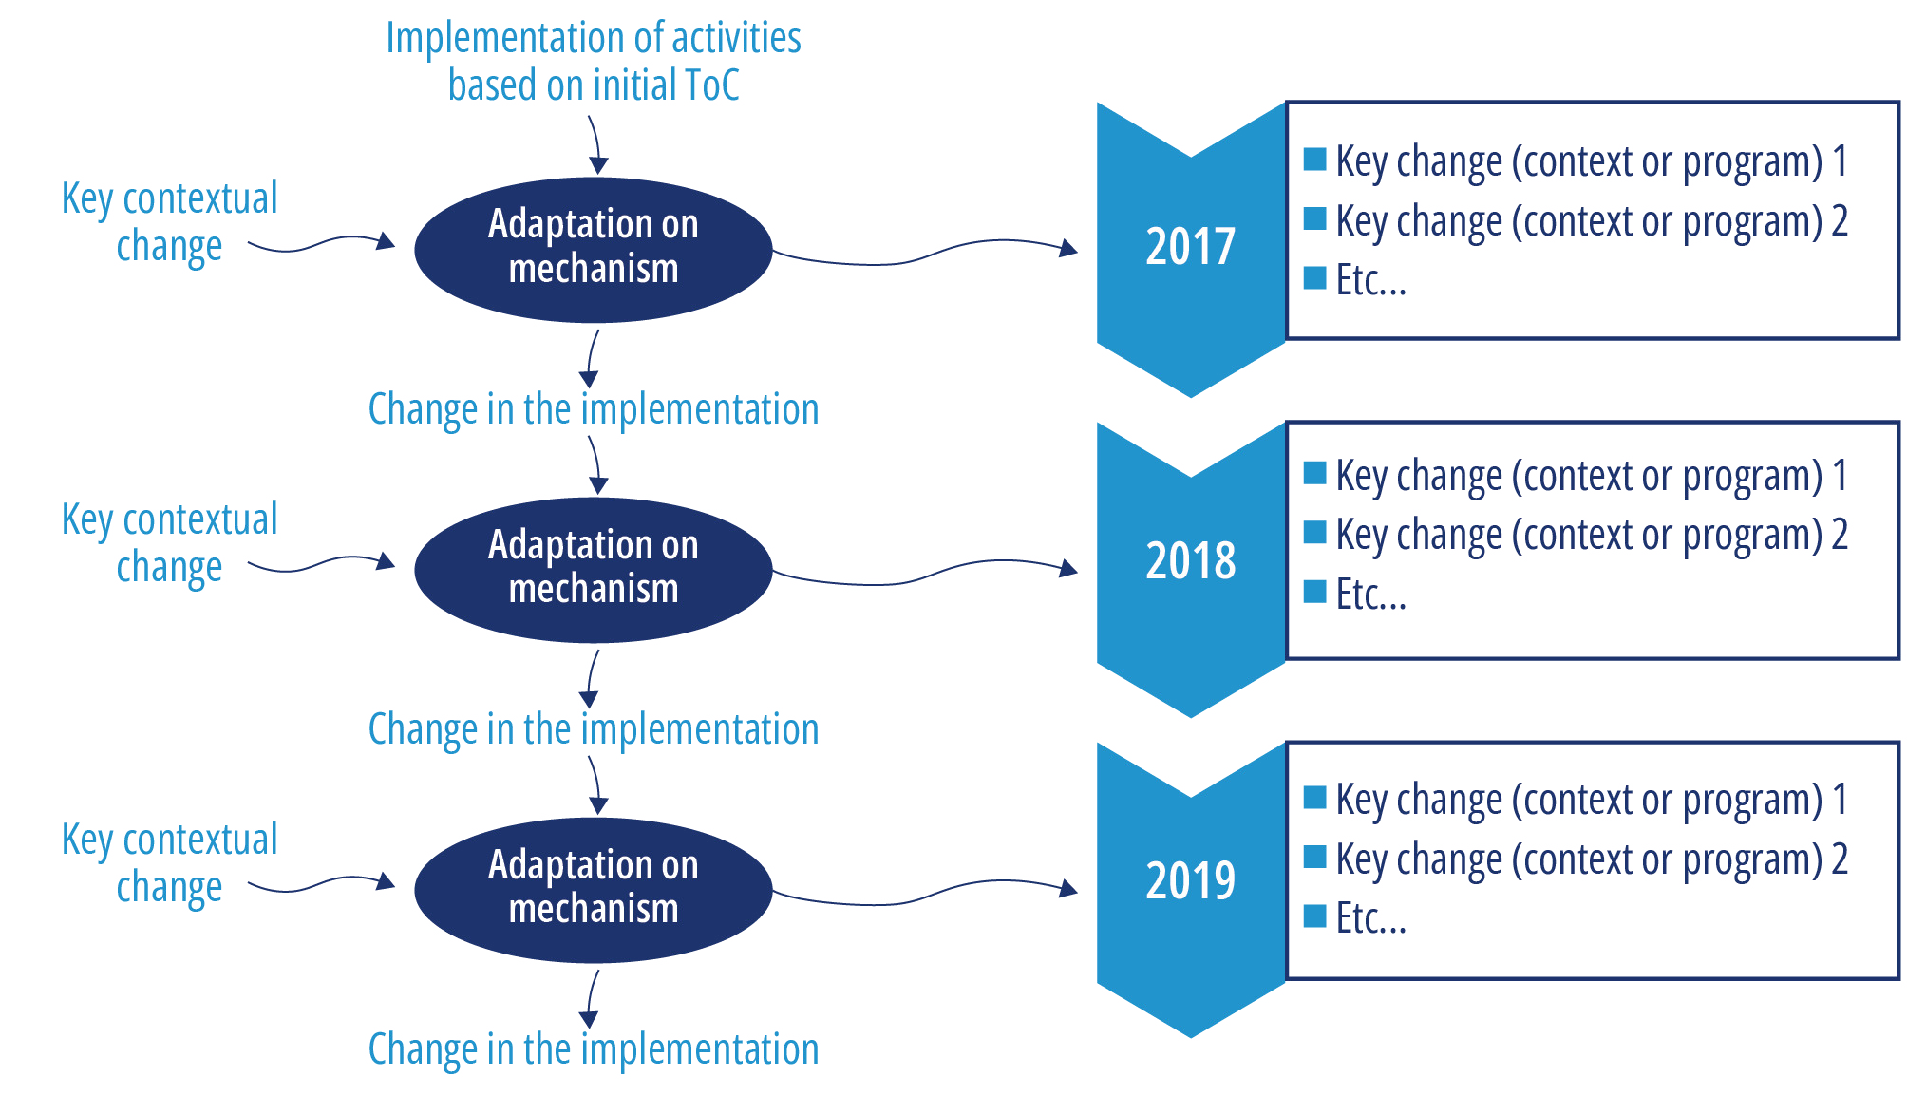

Key contextual events, for example COVID-19, change of government

Key changes to the Australia Assists mechanism e.g. contract amendments, updates to program outcomes

### Performance against end of program outcomes

| **End of program outcome** | **Evidence of performance contributing to End of Program Outcomes 2017-2022** |
| --- | --- |
| EOPO 1 |  |
| EOPO 2 |  |
| EOPO 3 |  |
| EOPO 4 |  |
| Program Management Outcome |  |

### Comparative analysis: contracted vs undocumented expectations of the Australia Assists mechanism

| **Contracted requirements and agreed outcomes** | **Undocumented expectations** | **Other services available to the Australian Government e.g. AusMAT, DART** | **Gaps** |
| --- | --- | --- | --- |
|  |  |  |  |

Evaluation Plan Annex 3: Evaluation rubric

| Evaluation rubric for Relevance The following rubrics will be completed using data from the evaluation and validated with DFAT staff prior to ranking. | | | |
| --- | --- | --- | --- |
| Fit for Purpose | What are the qualitative and quantitative indicators that measure how high/ moderate/ low is Australia Assists mechanism fit within DFAT’s broader humanitarian response capabilities, i.e., the toolkit available to the Australian Government for humanitarian action? | | |
| High | Moderate | Low |
|  |  |  |
| What are the qualitative and quantitative indicators that measure how high/ moderate/ low the governance and management arrangements fit for purpose? | | |
| High | Moderate | Low |
|  |  |  |
| Adaptation and innovation in responding to emerging issues | What are the qualitative and quantitative indicators that measure how high/ moderate/ low has the Australia Assists mechanism been able to innovatively adapt and respond to emerging issues to date and will be able to do so going forward:  Emerging issues and over-the-horizon challenges  surges and changes in demand  COVID-19  climate change and disaster risk reduction  humanitarian sector policy issues  DFAT humanitarian response, sudden and slow-onset disasters, protracted crises  Localisation, gender, and disability inclusion | | |
| High | Moderate | Low |
|  |  |  |
| What are the qualitative and quantitative indicators that measure how high/ moderate/ low is the program positioned to understand and respond to emerging and over-the-horizon issues? (program capabilities to adapt and innovate) | | |
| High | Moderate | Low |
|  |  |  |

| Evaluation rubric for Effectiveness | | | |
| --- | --- | --- | --- |
| The effectiveness of the Australia Assists program achieving its intended outcomes | What are the qualitative and quantitative indicators that measure how high/ moderate/ low is the Australia Assists program achieving its intended outcomes and is producing worthwhile results? | | |
| High | Moderate | Low |
|  |  |  |
| The effectiveness of RedR in managing the Australia Assists mechanism | What are the qualitative and quantitative indicators that measure how high/ moderate/ low is the performance of RedR in managing the Australia Assists mechanism? | | |
| High | Moderate | Low |
|  |  |  |

| Evaluation rubric for Value for Money | | | |
| --- | --- | --- | --- |
| Effectiveness  Performance and Risk Management  Results Focus  Experimentation and innovation | What are the qualitative and quantitative indicators that measure how high/ moderate/ low has the mechanism, design and contract helped (or hindered) Australia Assists to deliver value for money? | | |
| High | Moderate | Low |
|  |  |  |
| Efficiency  Evidence based decision making  Proportionality | What are the qualitative and quantitative indicators that measure how high/ moderate/ low is the investment into the various aspects of Australia Assists suite of tools (i.e., training / deployment / standby UN Partnership) representative of value for money? Also, the extent Australia Assists being utilised in ways it is intended to be utilised. | | |
| High | Moderate | Low |
|  |  |  |
| Economy  Cost consciousness  Encouraging competition | What are the qualitative and quantitative indicators that measure how high/ moderate/ low is the value-add of RedR as the manager of Australia Assists – over and above what DFAT pays for? Did RedR deliver on time and on budget? | | |
| High | Moderate | Low |
|  |  |  |
| Ethics  Accountability and transparency | What are the qualitative and quantitative indicators that measure how high/ moderate/ low is RedR demonstrating the accountability and transparency in its financial governance and dealings? | | |
| High | Moderate | Low |
|  |  |  |
| Equity  GEDSI | What are the qualitative and quantitative indicators that measure how high/ moderate/ low is RedR and the Australia Assists mechanism deliver fair and equitable deployee remuneration? | | |
| High | Moderate | Low |
|  |  |  |

Evaluation Plan Annex 4: Options for comparitive Analysis between deployment mechanisms:

| Organisation |
| --- |
| Palladium |
| Australian Volunteers International |
| DART and Australia’s implementing partners e.g. FRNSW |
| Other UN Standby Partners (TBD) |
| Other deployment options for Post |
| IASC Protection Standby Capacity Project (ProCap) |
| Gender Standby Capacity Project (GenCap) |

Evaluation Plan Annex 5: Draft interview and discussion guides

### Introduction and Informed Consent

The Australian Department of Foreign Affairs and Trade (DFAT) has commissioned an independent evaluation of the Australia Assists program. The purpose of the evaluation is to serve DFAT’s dual key purpose, to account for Australia’s investment, and to improve what future investments can achieve. The evaluation will provide DFAT decision-makers with high quality performance information which will be used to inform management decisions, including on any potential future phases of the investment.

The evaluation will be undertaken by a team of five consultants from Alinea International, including: Dr Bernadette Whitelum (Team Leader); Christina Northey (Humanitarian Specialist); Jo-Hannah Lavey (Humanitarian Technical Advisor); Dr Primatia Wulandari (Evaluation Specialist); and Claire Bowyer (Research Consultant).

The evaluation will seek to answer three key evaluation questions:

1. To what extent is the current Australia Assists mechanism fit for purpose?
2. To what extent does the mechanism and its delivery meet the intended outcomes of the program?
3. To what extent does Australia Assists program meet value for money expectations?

The evaluation will provide forward looking recommendations, including areas of improvement.

You have been contacted to take part in an interview that will generate data for the review. The following provides information about your participation so you can make an informed decision about whether you wish to participate.

1. Your participation is voluntary. You do not need to answer anything you do not feel comfortable with.
2. Notes will be written during the interview to ensure we record your opinions accurately.
3. We will not attribute any comments or findings to you personally or to your organisation, however as the number of people we are speaking to is relatively small, it may be possible for a reader of the final report to attribute back comments. If there is something you do not want recorded, please let us know.
4. The interview findings will contribute to a public review report. If your organisation is explicitly associated with a particular finding we will check it with you first, otherwise there will not be an opportunity to comment on the draft.
5. If you have any questions about the evaluation, please get in touch with Christina Northey (christina.northey@alineainternational.com).

Please let the review team know if you have any concerns or questions prior to taking part in an interview or focus group discussion, otherwise the team will seek your informed consent to proceed at the time of interview or focus group discussion.

### Interview Guide: DFAT staff

1. Please briefly describe your engagement with the design and/or implementation of the Australia Assists program.
2. What have been the key successes of DFAT’s Australia Assists program? What were less successful aspects?
3. What does DFAT need from the Australia Assists mechanism and implementation?
4. How does the Australia Assists mechanism fit within DFAT’s broader humanitarian response capabilities / the toolkit available to the Australian Government? Where are the gaps and overlaps?
5. Do you think the standby partnership (long-term deployment) and rapid response models had positive impacts and answered DFAT needs? If yes, please explain how. If not, please explain why.
6. Is the current mechanism and contract fit for purpose, including in relation to deployment options and processes, and risk management?
7. How has the financing and contracting approach helped or hindered the Australia Assists program deliver DFAT’s objectives?
8. Does the mechanism and contract allow the investment to adapt and respond to emerging and unforeseen issues? How has this evolved over time since the original design?
9. How effectively has RedR delivered the contracted and stated outcomes of the Australia Assists mechanism?
10. What progress has been made on the recommendations from the last mid-term review?
11. What are the outstanding concerns regarding Australia Assists mechanism and implementation, and how can these be resolved?
12. Are you aware of the extent to which thematic priorities (localisation, gender equality, child protection and climate change) have been mainstreamed or targeted?
13. Do you think the investments are cost effective in meeting the EOPOs?
14. What improvements would you recommend DFAT make in the final two years of the program?
15. What improvements should DFAT make for any potential investments in future programs?

### Interview Guide: RedR board members and staff

1. Please briefly describe your role within the Australia Assists program.
2. Can you please describe what you see as the key successes or strengths of the Australian Government’s humanitarian assistance through Australia Assists program, and areas where it could be improved?
3. In your opinion, does Australian humanitarian support align with the priority needs RedR has identified (sector and location, scale, duration and financing)? Are there ways it could better align? Do you have any suggestions for any efficiencies or cost savings in delivering future/similar programs?
4. What progress has been made with the recommendations from the mid-term review? What are the challenging areas? (Probe MEAL Framework)
5. How appropriate and effective has the relationship with DFAT been? What improvements are needed to create a more effective governance mechanism?
6. Are RedR partners in the Australia Assists program sufficiently linking activities to recovery, resilience and long-term development?
7. How has the Australia Assists program impacted on principled humanitarian action? (Positive and negative impacts.)
8. Has DFAT’s partnership and policy engagement helped to improve humanitarian assistance overall? If so, in what ways?
9. Could Australia’s assistance better complement that of other DFAT program and donors, in countries and regions where Australia Assists is deployed? If yes, what mechanism need to be in place to ensure this?
10. Do you think Australia and its partners have strengthened national and local actors (government, civil society and national organisations)? Can you give specific examples? Are there ways this can be improved?
11. How have you ensured that the program is cost-effective? Do you have specific examples/ evidence of good use of time and resources?
12. How do you envision RedR and the Australia Assists program after 2024? Would it look exactly the same or would it be different? If different, could you please describe how/why?

### Interview Guide: RedR Deployees

1. We are interested in whether your deployment experience through the Australia Assist program has positioned you to make greatest impact and had any longer-term impact for you. People have lots of different reasons for doing this work. Why did you go? Would you say the deployment has had any effect on your career prospects?
2. Before you were deployed to X, had you ever done any crisis or overseas work? What was it? (Probe for crisis response, even if in Australia). Did that experience help you or hinder you?
3. You must have had expectations of what things would be like before you went. Did your experiences match your expectations?
4. How long were you deployed for? Was that what you expected? If no: What did you think about that?
5. And how much notice did you get before you deployed? Was that enough? (Probe for timeline in recruitment, pre-deployment preparation and deployment to understand mechanism for rapid deployment.)
6. Did you have any specific training or preparation before you were deployed? Can you tell me what you had? In retrospect, how helpful was it? Is there anything that should be done to make it better?
7. How well do you think things were organised by RedR? Was there any aspect of the way work was run that made things difficult or stressful for you? Or that made life easier or more positive for you? (Probe for the deployment experience and support.)
8. In terms of the resources or planning or infrastructure that you had available, do think there was anything there that made life especially difficult or easier for you? (Probe for training and equipment to do job safely and also effectively. Also probe for remuneration package/living conditions/benefits.)
9. How did things go in terms of communication with RedR?
10. Overall, do you think the response by RedR and the host organisation through the Australia Assist program has helped crisis-affected people? How about your team? And what about you personally—do you feel YOU helped? Why/why not? Did it feel like you were helping at the time? (Probe for their role in promoting localisation, gender equality, child protection and climate adaptation during their work.)
11. Are you aware of the objectives of Australia Assists program and how your deployment contributed to its objectives?
12. How do you consider your deployment(s) or other deployments contributing to building resilience and providing emergency relief – before, during and after humanitarian crises?
13. Do you have any suggestions on how your deployment could have been better positioned to have the greatest impact?
14. Are you aware of being an Australian Government funded deployee through the Australia Assist Program?
15. Anything else you want to share about your deployment or related issue?

### Interview Guide: RedR Partners

1. Please briefly describe your partnership with RedR within the Australia Assists Program.
2. What do you consider to be the key successes of the partnership that have been supported by Australia? Please provide specific examples where possible.
3. What are the main areas for improvement? How could Australia support this? (Ask any specific questions resulting from the document review relating to meeting targets partners have set for themselves.)
4. What have you put in place to ensure that program outcomes link to recovery, resilience and development?
5. How has the program supported national leadership and local ownership (government authorities, civil society and national organisations)? Can you give specific examples? Are there ways this can be improved?
6. What do you see as the successes or strengths of Australia’s support and engagement, both with you directly and in the crisis overall? Can you suggest ways that this could be improved?
7. For deployments to the UN: What benefits has the standby partnership and Australia’s regional approach to its strategy had for your organisation and programs? For your partner organisations? For the community? For the response as a whole? Any specific examples?
8. Could Australia’s assistance, particularly in the deployment mechanism, better complement that of other donors, in [country] and regionally?
9. Are there any examples where Australia Assists contributions have been particularly important or influential? Ineffective? Are there any issues that you feel Australia would be particularly well placed and effective to advocate for?

### Interview Guide: Host Governments

1. Please briefly describe your engagement with the Australia Assists program.
2. How effective do you think the support provided by Australia Assists program has been in providing humanitarian expertise to support national response systems? Have they coordinated well with yourself and other actors? What ways could the improve?
3. Can you please describe what you see as the key successes or strengths of the Australia Assists program, and areas where it could be improved.
4. In your opinion, does Australia Assists program and the presence of humanitarian expertise align with the government priority needs you have identified? Are there ways it could better align?
5. On COVID-19: With regards to COVID-19, do you think Australia Assists program and the presence of their deployees have been able to support the national government response to COVID-19 programming? If so, in what ways?
6. On localisation: Do you think the Australia Assists program and its deployees have strengthened national and local actors (government, civil society and national organisations)? Do you also think the Australia Assists program and the presence of their deployees have promoted more local inclusion and leadership in the program? If so, in what ways?
7. On DFAT humanitarian response to sudden and slow-onset disasters, protracted crises: Could Australia’s assistance through deploying humanitarian expertise from Australia better complement that of other donors, in [country] and regionally to respond to sudden and slow-onset disasters, protracted crises?
8. On other cross-cutting issues: Can you give some examples where such deployments have succeeded in promoting gender equality, disability inclusion, child protection and climate change adaptation in their work?
9. Do you have any suggestions for any improvements or efficiencies in the deployment process that could strategically position humanitarian expertise from Australia?

### Interview Guide: Others for Comparison

1. In what way has your organisation provided humanitarian assistance in response to rapid onset, protracted, and complex emergencies?
2. From the lessons learned from program implementation, in what way can international crisis responses be better coordinated, responsive to donor government (DFAT, FCDO) and have maximum impact?
3. Can you provide examples of deployment mechanisms that facilitate timely, effective, inclusive humanitarian assistance?
4. In what way can surge capacity be improved, particularly on the ability to draw on broader resources for rapid deployment?
5. How do you ensure that the deployees have sufficiently broad and relevant skills and experience?
6. Can you please elaborate on the governance and management arrangements your organisation has with DFAT/other government client?

* What aspects of the governance and management arrangements work well to guide decision-making in program adaptation, funding mechanisms and resource allocation?
* Did the governance arrangement allow stronger relationships to be built with governments and regional organisations in [country/region important to government client]?

1. What are DFAT/government client’s value for money expectations from your program?
2. As we are conducting Value for Money analysis for Australia Assist program, would you mind sharing the information of the cost of output value, for example remuneration framework for the deployees?

Evaluation Plan Annex 6: Survey sample questions

Part One

### General information

1. Gender
2. Male
3. Female
4. Transgender
5. Non-binary/ non conforming
6. Prefer not to respond
7. Age (years):
8. Do you have any of these conditions?
9. difficulty seeing, even if wearing glasses
10. difficulty hearing, even if using a hearing aid
11. difficulty walking or climbing steps
12. difficulty remembering or concentrating
13. difficulty (with self-care such as) washing all over or dressing
14. difficulty communicating, for example understanding or being understood
15. Professional background:
16. International humanitarian deployment experience:
17. Country: ______________ Period: DD/YY – DD/YY
18. Country: ______________ Period: DD/YY – DD/YY
19. Country: ______________ Period: DD/YY – DD/YY
20. Country: ______________ Period: DD/YY – DD/YY
21. Country: ______________ Period: DD/YY – DD/YY
22. (drop down list until 10)
23. How many deployments have you done with the RedR?
24. No deployments yet
25. 1
26. 2
27. 3
28. 4
29. 5 +
30. How many deployments have you done with other organisations?
31. 0
32. 1
33. 2
34. 3
35. 4
36. 5+

Optional: Which organisation(s) deployed you: .................................

### Personal motivations

1. What is your motivation to work as RedR deployee for the Australia Assists Program? (Multiple answers possible)
2. Career opportunities
3. I was looking for volunteering experience
4. I was looking for an adventure
5. It gives me a sense of purpose
6. …
7. ...
8. Other (please specify):

Part Two

### Pre-deployment preparations

1. What individual preparations did you undertake before your deployment? (Multiple answers possible)
2. Medical/health-related preparation
3. Training/Courses
4. Preparations within life/work/home
5. Reading/Research about the project/placement
6. Organisation of project logistics
7. Psychological preparation
8. No preparation possible
9. What do you value most about your RedR deployment preparations? (Please enter your top 3):
10. The basic/minimal education program for my current profession
11. Previous humanitarian experience
12. Previous deployments
13. RedR onboarding mission
14. Information on the practical aspects of deployment
15. Other (please specify):

Explanation:

1. Please mention the topic(s) in which you would like to receive additional training prior to deployment, and please specify the reason why. You are allowed to fill multiple topics:
2. ……….
3. Why do you feel the need for additional training on this topic?
   1. Because I do not feel optimally prepared for this topic on deployment
   2. I do feel prepared for this topic on deployment, but I would find it an interesting topic for additional training
   3. Other:
4. ……….
5. Why do you feel the need for additional training on this topic?
6. Because I do not feel optimally prepared for this topic on deployment
7. I do feel prepared for this topic on deployment, but I would find it an interesting topic for additional training
8. Other
9. ………. (drop down list the same as above)
10. ……….
11. ……….
12. Prior to your deployment with the RedR, were you adequately informed about:
13. Your scope of practice
14. Not at all sufficient
15. Not very sufficient
16. Neutral
17. Somewhat sufficient
18. Very sufficient
19. I do not remember/No opinion:
20. The current situation in the mission area
21. Not at all sufficient
22. Not very sufficient
23. Neutral
24. Somewhat sufficient
25. Very sufficient
26. I do not remember/No opinion:
27. The local environmental challenges
28. Not at all sufficient
29. Not very sufficient
30. Neutral
31. Somewhat sufficient
32. Very sufficient
33. I do not remember/No opinion
34. The local living conditions
35. Not at all sufficient
36. Not very sufficient
37. Neutral
38. Somewhat sufficient
39. Very sufficient
40. I do not remember/No opinion
41. Your duties and responsibilities
42. Not at all sufficient
43. Not very sufficient
44. Neutral
45. Somewhat sufficient
46. Very sufficient
47. I do not remember/No opinion
48. The field facilities and equipment available
49. Not at all sufficient
50. Not very sufficient
51. Neutral
52. Somewhat sufficient
53. Very sufficient
54. I do not remember/No opinion
55. Means of contact with your home/family during deployment
56. Not at all sufficient
57. Not very sufficient
58. Neutral
59. Somewhat sufficient
60. Very sufficient
61. I do not remember/No opinion
62. The other RedR participants of the mission and their responsibilities
63. Not at all sufficient
64. Not very sufficient
65. Neutral
66. Somewhat sufficient
67. Very sufficient
68. I do not remember/No opinion
69. The nature and severity of the risks you could face during deployment
70. Not at all sufficient
71. Not very sufficient
72. Neutral
73. Somewhat sufficient
74. Very sufficient
75. I do not remember/No opinion

Explanation:

### Field Experiences

The following questions refer to your last deployment with the RedR.

1. How much time, on average, did you spend on work in one day?
2. Less than 8 hours
3. 8 to 10 hours
4. 10 to 12 hours
5. 12 to 14 hours
6. More than 14 hours
7. Constant (24 hours a day, 7 days a week)
8. I do not remember

Explanation:

1. How many days, on average, did you spend on work in one week?
2. Less than 5 days
3. 5 days
4. 6 days
5. 7 days
6. I do not remember

Explanation:

1. Were your pre-deployment training, knowledge and skills sufficient to help you decide about what to do and how to do it during your last RedR deployment?
2. Not at all sufficient
3. Slightly sufficient
4. Somewhat sufficient
5. Moderately sufficient
6. Very sufficient
7. I do not remember/No opinion

Explanation:

1. In general, how do you consider the knowledge and skills of your colleagues during your last RedR deployment?
2. Very poor
3. Poor
4. Average
5. Good
6. Excellent
7. I do not remember/No opinion

Explanation:

1. Were you able to consult more experienced colleagues when needed? (Multiple answers possible)
2. Yes, on site
3. Yes, by phone
4. Yes, by internet
5. Yes, other (please specify):
6. No, it was not possible when I needed to
7. No, it was never possible
8. I do not remember; N/A

Explanation:

1. Would it be beneficial to have an online community forum to seek advice and share lessons learned among deployees?
2. Yes
3. No

Explanation and ideas you may have:

1. Was it always clear what you were meant to be doing?
2. Yes
3. No. If not how was the uncertainty dealt with:

Explanation:

1. In hindsight, how would you rate your team dynamics during deployment?
2. Very poor
3. Poor
4. Average
5. Good
6. Excellent
7. I do not remember/No opinion

Explanation:

### Personal impact

The following questions refer to your last deployment with the RedR.

1. Were you adequately informed about who to contact for professional psychological help, should you require it:
2. Not at all sufficient
3. Slightly sufficient
4. Somewhat sufficient
5. Moderately sufficient
6. Very sufficient
7. I do not remember/No opinion

Explanation:

1. What would be helpful to deal with the stress during a deployment? (Multiple answers possible)
2. Stress management training beforehand
3. A card/kit with stress management advice for members to carry
4. Availability of a mental health professional during deployment
5. Briefing about strategies relevant to deployment before departure
6. Follow-up of individual RedR team members
7. Online social support network
8. Other (please specify):

Explanation:

1. Did you value the formal debriefing with RedR after deployment?
2. Not important at all
3. Low important
4. – (Neutral)
5. Important
6. Very important
7. No opinion

Explanation:

1. Did you value informal debriefing after deployment (with colleagues, friends or family)?
2. Not important at all
3. Low important
4. – (Neutral)
5. Important
6. Very important
7. No opinion

Explanation:

1. What effect did your last RedR deployment have on your personal development?
2. Major negative effect
3. Somewhat negative effect
4. – (Neutral)
5. Somewhat positive effect
6. Major positive effect
7. No opinion

Explanation:

1. Regarding preparation (e.g., courses or training), what would you especially recommend for colleagues preparing for a mission in a protracted crisis and conflict zone?
2. Answer:
3. N/A

### Reflections on the effectiveness of mission

1. What impact did your last RedR deployment have on your skills in your primary specialism (in the non-deployed setting)? Your skills:
2. Much deteriorated
3. Somewhat deteriorated
4. Did not change
5. Somewhat improved
6. Much improved
7. No opinion

Explanation:

1. Based on your role during your deployment(s) with RedR, what aspects do you see your deployment contributing to? (Multiple answers possible)
2. Resilience and Disaster Risk Reduction
3. Resilience and conflict mitigation
4. Conflict and disaster analysis and planning
5. Response to disaster
6. Response to conflict
7. Crisis response preparedness
8. Transition from response
9. Recovery following disaster
10. Recovery following conflict
11. International Engagement
12. Harmonisation of actions
13. Program visibility and recognition
14. Localization
15. Child protection
16. Gender equality
17. Disability inclusion
18. Climate change mitigation and adaptation

Explanation:

1. How did you see your deployment contributing to : (Multiple answers possible)
2. Stability, Resilience and Risk Reduction:_____________
3. Crisis preparedness and response:_____________
4. Stabilisation, recovery and reconstruction:_____________
5. Quality of humanitarian action:_____________
6. In your opinion, was your deployment strategically positioned where you were likely to have the greatest influence?
7. No influence
8. Limited influence
9. Moderate influence
10. Important influence
11. Very important influence

Explanation:

1. Do you have any suggestions on how your deployment could have been better positioned to have a greater impact?
2. No
3. Yes: (your suggestion) ______________________________________________________________
4. How fair do you consider the remuneration package offered for your deployment?
5. Very Poor
6. Below Average
7. Average
8. Above Average
9. Excellent

Explanation:

1. How do you rate the effectiveness of RedR regarding the following:

* Standby partnership and linkages
  + Very ineffective
  + Ineffective
  + Neither effective nor ineffective
  + Effective
  + Very effective

Area for improvement:

* Roster management
  + Very ineffective
  + Ineffective
  + Neither effective nor ineffective
  + Effective
  + Very effective

Area for improvement: ________________

* Recruitment
  + Very ineffective
  + Ineffective
  + Neither effective nor ineffective
  + Effective
  + Very effective

Area for improvement: ________________

* Preparation
  + Very ineffective
  + Ineffective
  + Neither effective nor ineffective
  + Effective
  + Very effective

Area for improvement: ________________

* Mobilisation
  + Very ineffective
  + Ineffective
  + Neither effective nor ineffective
  + Effective
  + Very effective

Area for improvement: ________________

* In-country support
  + Very ineffective
  + Ineffective
  + Neither effective nor ineffective
  + Effective
  + Very effective

Area for improvement: ________________

* Safety and security
  + Very ineffective
  + Ineffective
  + Neither effective nor ineffective
  + Effective
  + Very effective

Area for improvement: ________________

* Re-entry
  + Very ineffective
  + Ineffective
  + Neither effective nor ineffective
  + Effective
  + Very effective

Area for improvement: ________________

* Finance and administration
  + Very ineffective
  + Ineffective
  + Neither effective nor ineffective
  + Effective
  + Very effective

Area for improvement: ________________

* Other:
  + Very ineffective
  + Ineffective
  + Neither effective nor ineffective
  + Effective
  + Very effective

Area for improvement: _______________

1. Any final comments or suggestions regarding your deployment experience with RedR under Australia Assists Program?
2. No
3. Yes: (your comment/ suggestion) ______________________________________________________________

Thank you.

Evaluation Plan Annex 7: Value for money framework (A)

The following draft framework will be used to identify organisations that can deliver comparable services and value expected from the Australia Assists mechanism. This analysis will inform financial comparison pending availability of financial data.

| Deployments | Deployment of Australians or internationals to UN partner | Deployment of Australians or internationals to partner government | Deployment of Australians or internationals to / with Australian government team *(not as gov official)* |
| --- | --- | --- | --- |
| Preparedness for crises |  |  |  |
| Response to protracted crisis response |  |  |  |
| Rapid response to sudden-onset crises |  |  |  |
| Longer-term recovery from crises |  |  |  |
| High-profile deployments, winning UN positions in responses important to Australia |  |  |  |
| Longer-term policy and global thought leadership roles incl. reform and GEDSI  [to other agencies?] |  |  |  |
| Training  *\*to confirm priority for Australia Assists* | Australian Assist deployees in Australia | DFAT staff in Australia | Other humanitarians in the region, and training in the region |
| General humanitarian response and security training (EHP training and HEAT) |  |  |  |
| Specialist training e.g. WASH, logistics, protection |  |  |  |
| Risk Management |  |  |  |
| Health, safety and security of deployees (v DFAT responsibility) |  |  |  |
| Reputational risk, including quality of deployees |  |  |  |
| Ability to manage risk of operational service delivery (financial and operational management, audits etc) |  |  |  |
| **Branding** |  |  |  |
| Ability to brand as Australian Government |  |  |  |

Evaluation Plan Annex 8: List of documentation

### Project Documents:

* Investment Monitoring Report FY 2018; 2019; 2020; 2021
* Annual Report FY 2018 – 2019; 2019 – 2020; 2020 – 2021
* Mid Year Report FY 2020; 2021
* Mid-Term Review 2019
* Mid-Term Review 2019 Management Response
* Australia Assist Overview (outcome level)
* Australia Assist Overview (intermediate outcome level)
* Deployee Remuneration Policy
* Gender Equality Strategy and Action Plan
* Disability Inclusion Strategy and Action Plan
* Localisation Strategy and Action Plan
* MEL impact and learning reports and resources
* Scope report on establishing a rapid deployable capability
* Deployment data
* Communications social media channels:
  + Twitter
  + Instagram
* RedR Australia’s Response to COVID-19: Action Review Report (August 2020)
* Review of Australia Assist’s Support to the Rohingya Crisis 2017-2020 (September 2020)
* RedR survey data
* RedR deployee demographic data
* RedR contract

### Australia Government Documentation

* 2016 Defence White Paper
* 2017 Foreign Policy White Paper
* Partnerships for recovery: Australia’s COVID-19 Development Response

### Evaluation documents:

* Key informant interview notes
* Survey Questionnaire
* FGD note



1. A respondent mentions that a direct (and unofficial) link was established to the Australian Embassy at the beginning of his deployment to allow embassy staff to obtain up-to-date situational awareness, clarification/triangulation of information, and analysis when other channels were unavailable.
2. These figures include deployments that have continued from previous years of the Australia Assists program in addition to new deployments
3. https://www.standbypartnership.org/about
4. https://www.standbypartnership.org/partners
5. The comparison is based on data publicly available in 2019 annual reports (financial year 2018-19 for RedR), to reflect operations prior to the pandemic. Data for DRC is drawn from its 2019 Stand-by Roster Deployments infographic.
6. https://redr.org.au/media/dcglgceo/fy19-annual-report.pdf
7. https://www.nrc.no/globalassets/pdf/annual-reports/2019/norcap-annual-report-2019/norcap-2019-report.pdf
8. https://www.canadem.ca/_files/ugd/08a38a_de1f6d712c714722ac09459f814dc9b0.pdf
9. https://drc.ngo/our-work/what-we-do/the-humanitarian-strategic-surge-capacity-division/about-the-drc-standby-roster/
10. Email correspondence Romana Dyhr Zangenberg 27.10.22
11. DRC 2019 Standby Roster Deployments Infographic in email correspondence Romana Dyhr Zangenberg 27.10.22
12. KII 37
13. KII 38
14. https://www.standbypartnership.org/partners/fcdo
15. KII 34
16. KII 39
17. https://www.nrc.no/heat-training/
18. KII 40
19. KII 40
20. KII 34
21. KII 39
22. As a guide, a senior M&E officer would normally earn between AUD 13 and 15,000 per month according to the latest update of DFAT’s Adviser Renumeration Framework.
23. ALNAP (2006) Evaluating Humanitarian Action Using the OECD DAC Criteria p20-21.
24. Miles, M. B., & Huberman, A. M. (1994). (2nd ed.). Sage Publications, Inc.