**End of Program Evaluation of Australia Assists**

**Purpose: To understand the effectiveness, relevance, and value for money of the Australia Assists Program, with a view to building on successes and informing the next iteration of Australia’s humanitarian deployment mechanism.**

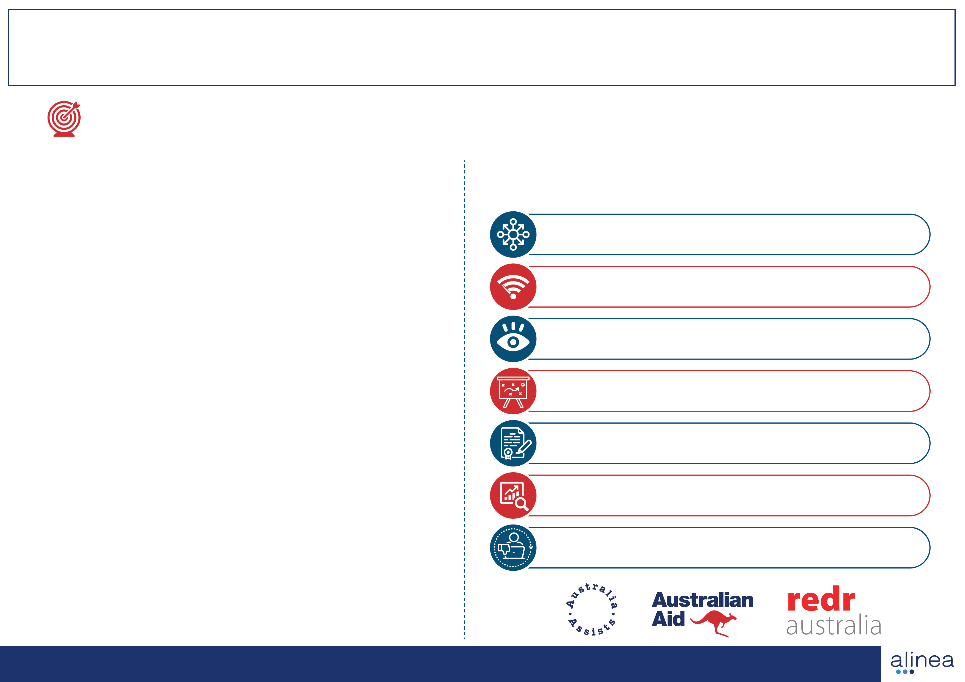**The Evaluation found many successes.   
Australia Assists is…**

* A highly valued and important component of Australia’s humanitarian toolkit
* Reducing disaster risks and building resilience across the Indo-Pacific region
* Effectively managing the deployment life cycle
* A trusted partner to the UN in some of the most challenging places in the world
* Positively influencing the global humanitarian architecture
* Paying attention to gender equality and disability inclusion
* Helping countries prepare for and respond to disasters
* Building a cadre of local humanitarian officers in partner countries
* Training hundreds of Australians to be effective in conflict, disasters, and other humanitarian settings
* Supplying a value for money deployment model to the Australian Government development program

## **We recommend…**

## **New deployment types and more rapid response options**

## **Enhanced bandwidth within DFAT to strategically engage**

## **More visibility of the Australia Assists brand**

## **A new Theory of Change and MEAL system**

## **Strengthening clarity in the contract**

## **Increasing outcome data**

## **Strengthened complaints handling**