

Australia Awards

Global Tracer Facility

Tracer Survey

Year

3

201

8

-

1

9

Ethiopia

Country Report

Alumni of

2011

to

2016

Tracer Survey

# Outcomes Summary: Ethiopia

This country report details the responses of alumni from **Ethiopia** to the Australia

Awards Global Tracer Facility **Tracer Survey** carried out in 2018-19. The Tracer Survey was conducted between November 2018 and February 2019 and targeted **alumni who completed their award between 2011 and 2016**.

Alumni were asked a range of questions via an online survey, focussed on exploring the long-term outcomes of the Australia Awards. In total 3,768 alumni in this cohort from more than 123 different countries participated in the survey. A 26 per cent response rate of the target cohort was achieved globally. This report focuses on the response data of alumni from Ethiopia.

For Ethiopia, there were 87 alumni included in the target population. Responses were received from 10, a **response rate of 11** **per cent**. Among these respondents, six were scholarship alumni and four were fellowship alumni.

The survey data provide a valuable quantitative insight into alumni use of knowledge and skills, development of networks and contribution to cooperation with Australia. The responses also offer rich examples from alumni of the types of contributions they are making, the way in which they are using their award, and the things that help and hinder them in reaching their potential.

The data detailed here are reported based on the four long-term outcomes of the Australia Awards as articulated in the *Australia Awards Global Strategy: Investing in the next generation of global leaders for development 2016-2018* and the Australia Awards Global Monitoring and Evaluation Framework. In terms of responding to the **long-term outcomes** of the Australia Awards, the following summary offers findings based on the responses of alumni from Ethiopia. Further outcomes are included in the infographic following this summary.

**Outcome 1:** *Alumni are using their skills, knowledge and networks to contribute to sustainable development.*

* Most alumni from Ethiopia (90 per cent) indicated they have passed on their skills and knowledge to others in their country on return from their award.
* 80 per cent of alumni indicated they had introduced improved practices and innovations in their work on return from their award.

/ 1

**Outcome 2:** *Alumni are contributing to cooperation between Australia and partner countries.*

* 20 per cent of alumni from Ethiopia have maintained frequent contact with fellow alumni, while 20 per cent have frequent contact with friends in Australia and 20 per cent with Australian students/alumni.
* In terms of frequent contact with Australian organisations, 20 per cent of alumni have frequent contact with Australian institutions and 20 per cent of alumni have frequent contact with Australian businesses.

**Outcome 3:** *Effective, mutually advantageous partnerships between institutions and businesses in Australia and partner countries.*

* 40 per cent of alumni from Ethiopia indicated having had a professional link with an Australian organisation at some time following award.
* These links were with Australian universities, the government sector, nongovernment organisations and the Australian High Commission or Consulate.

**Outcome 4:** *Alumni view Australia, Australians and Australian expertise positively.*

* All alumni from Ethiopia indicated their experience in Australia positively influenced their perception of Australia.
* All alumni have provided advice to people in Ethiopia about pursuing opportunities in Australia.

The Tracer Survey represented the views of a range of alumni from Ethiopia. Of those who responded, **40 per cent were women and 90** **per cent came from an urban location**. The largest age group represented were alumni 30 to 39 years. Among all alumni, 80 per cent were employed full-time. Of those alumni employed, **75 per cent** indicatedthat they hold a **formal leadership role**.

In addition to this Outcomes Summary, this report includes an infographic as well as data tables including the detail of respondents from Ethiopia to the Tracer Survey. The data tables correspond to each of the Australia Awards long-term outcomes and include benchmark data from the entire survey response population.

For further information about the Australia Awards Global Tracer Facility please visit the website: [www.australiaawardstracerfacility.org](http://www.australiaawardstracerfacility.org/)

/ 2

|  |
| --- |
| *Upon completion I returned to my role in the section which follows the African Union. New exposure and skills did improve my negotiating skills at the committee meeting level at the African Union Commission. Since lobbying was part of the job my level of communication after the training improved.* |

|  |
| --- |
| *I have used my skills for short term training, which is the main task of my directorate, through teaching and structural change of the regional institution, research and conducting public opinion surveys.* |

|  |
| --- |
| *I have built networks with most of the participants from DFAT and remain in contact to date. I believe that I have been able to influence and inform Australian participants as to what the AU does and the importance of the Union for the continent as well as for my country.* |

|  |
| --- |
| *I was the first from my country to take part in the program. This allowed for a continued participation of my colleagues in the program. I have also been able to pass newly acquired writing, speaking and negotiating skills to colleagues.* |

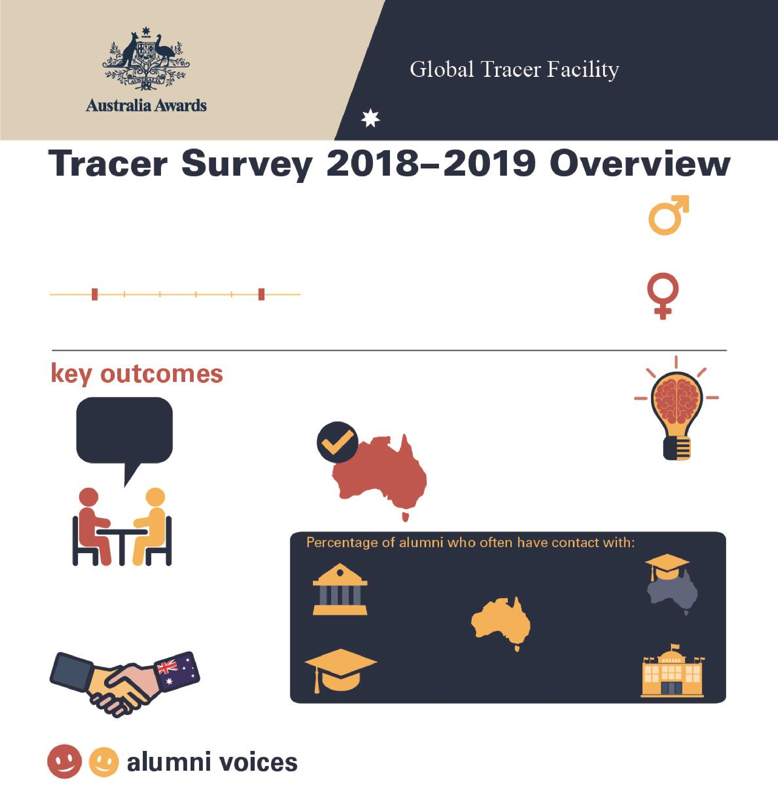

**Tracer Survey 2018**

**–**

**2019**

**Ethiopia**

**Overview**

**10**

**Alumni from**

**Ethiopia**

Alumni who completed a scholarship or

fellowship between

2011

and 20

16

**2011**

**2016**

**Men**

**%**

**60**

**W**

**omen**

**%**

**40**

**90**

**%**

**of alumni**

Passed on skills

and knowledge

to others

**80**

**%**

**of alumni**

Introduced improved

practices and

innovations at work

**%**

**40**

**of alumni**

Developed professional

links with Australia

**%**

**100**

**of alumni**

Say their awards experience

positively influenced perception

of Australian skills and expertise

Host

institution

**%**

**20**

Other scholarship

alumni

**20**

**%**

Friends in

Australia

**20**

**%**

Australian

alumni

**%**

**20**

Australian

Embassy or

High Commission

**0**

**%**

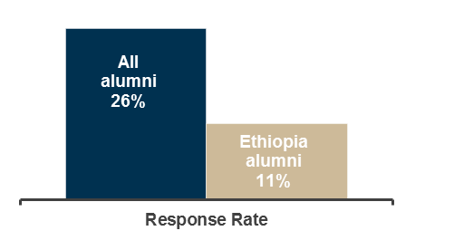

**Table 1: Tracer Survey Data for 2011 to 2016 alumni from Ethiopia and All alumni - Respondent characteristics**

|  |  |  |  |  |  |  |  |  |  |
| --- | --- | --- | --- | --- | --- | --- | --- | --- | --- |
|  |  | Alumni from Ethiopia | | | |  |  |  | |
| Scholarships | | Fellowships | | Alumni from Ethiopia | | All Alumni | |
| Count | Column N % | Count | Column N % | Count | Column N % | Count | Column N % |
| Age at time of survey | Under 20 years | - | - | - | - | - | - | - | - |
| 20 to 29 years | - | - | - | - | - | - | 111 | 3.0% |
| 30 to 39 years | 5 | 83.3% | 3 | 75.0% | 8 | 80.0% | 2134 | 56.8% |
| 40 to 49 years | 1 | 16.7% | - | - | 1 | 10.0% | 1144 | 30.4% |
| 50 to 59 years | - | - | 1 | 25.0% | 1 | 10.0% | 310 | 8.3% |
| 60 to 69 years | - | - | - | - | - | - | 52 | 1.4% |
| 70 and older | - | - | - | - | - | - | 6 | 0.2% |
| Year of graduation from award | 2011 | - | - | - | - | - | - | 382 | 10.1% |
| 2012 | 1 | 16.7% | - | - | 1 | 10.0% | 546 | 14.5% |
| 2013 | 1 | 16.7% | 2 | 50.0% | 3 | 30.0% | 631 | 16.7% |
| 2014 | - | - | 1 | 25.0% | 1 | 10.0% | 657 | 17.4% |
| 2015 | 3 | 50.0% | 1 | 25.0% | 4 | 40.0% | 881 | 23.4% |
| 2016 | 1 | 16.7% | - | - | 1 | 10.0% | 671 | 17.8% |
| Have you received any other awards? | Yes | - | - | - | - | - | - | 956 | 25.4% |
| No | 6 | 100.0% | 4 | 100.0% | 10 | 100.0% | 2779 | 73.9% |
| Don't know | - | - | - | - | - | - | 27 | 0.7% |
| What is your current employment status? | Employed full-time | 4 | 66.7% | 4 | 100.0% | 8 | 80.0% | 3297 | 87.7% |
| Employed part-time | - | - | - | - | - | - | 155 | 4.1% |
| Not employed | 2 | 33.3% | - | - | 2 | 20.0% | 113 | 3.0% |
| Retired | - | - | - | - | - | - | 15 | 0.4% |
| Studying | - | - | - | - | - | - | 135 | 3.6% |
| Other (specify) | - | - | - | - | - | - | 46 | 1.2% |
| Level of leadership in relation to current job | Formal leadership role | 2 | 50.0% | 4 | 100.0% | 6 | 75.0% | 2080 | 61.9% |
| Informal leadership role | 2 | 50.0% | - | - | 2 | 25.0% | 1019 | 30.3% |
| Do not have a leadership role | - | - | - | - | - | - | 203 | 6.0% |
| Don't know/prefer not to say | - | - | - | - | - | - | 56 | 1.7% |

**Table 2: Tracer Survey Data for 2011 to 2016 alumni from Ethiopia and All alumni - Outcome 1**

|  |  |  |  |  |  |  |  |  |  |
| --- | --- | --- | --- | --- | --- | --- | --- | --- | --- |
|  |  | Alumni from Ethiopia | | | |  |  |  | |
| **Q**: To what extent do you agree with each of these statements:  I have… | | Scholarships | | Fellowships | | Alumni from Ethiopia | | All Alumni | |
| Count | Column N % | Count | Column N % | Count | Column N % | Count | Column N % |
| Passed on new skills and knowledge to others | Strongly agree | 2 | 33.3% | 1 | 25.0% | 3 | 30.0% | 2298 | 61.1% |
| Agree | 3 | 50.0% | 3 | 75.0% | 6 | 60.0% | 1367 | 36.4% |
| Disagree | - | - | - | - | - | - | 44 | 1.2% |
| Strongly disagree | - | - | - | - | - | - | 13 | 0.3% |
| Don't Know | 1 | 16.7% | - | - | 1 | 10.0% | 38 | 1.0% |
| Introduced improved practices and innovations through my work | Strongly agree | 1 | 16.7% | 3 | 75.0% | 4 | 40.0% | 2023 | 53.9% |
| Agree | 3 | 50.0% | 1 | 25.0% | 4 | 40.0% | 1571 | 41.8% |
| Disagree | 1 | 16.7% | - | - | 1 | 10.0% | 69 | 1.8% |
| Strongly disagree | - | - | - | - | - | - | 12 | 0.3% |
| Don't Know | 1 | 16.7% | - | - | 1 | 10.0% | 81 | 2.2% |
| Built networks with Australians or Australian organisations | Strongly agree | 1 | 16.7% | 2 | 50.0% | 3 | 30.0% | 848 | 22.6% |
| Agree | 1 | 16.7% | 2 | 50.0% | 3 | 30.0% | 1892 | 50.4% |
| Disagree | 4 | 66.7% | - | - | 4 | 40.0% | 719 | 19.2% |
| Strongly disagree | - | - | - | - | - | - | 68 | 1.8% |
| Don't know | - | - | - | - | - | - | 226 | 6.0% |
| Built networks with other awardees | Strongly agree | 1 | 16.7% | 3 | 75.0% | 4 | 40.0% | 1683 | 44.9% |
| Agree | 3 | 50.0% | 1 | 25.0% | 4 | 40.0% | 1730 | 46.1% |
| Disagree | 2 | 33.3% | - | - | 2 | 20.0% | 251 | 6.7% |
| Strongly disagree | - | - | - | - | - | - | 21 | 0.6% |
| Don't know | - | - | - | - | - | - | 66 | 1.8% |

**Table 3: Tracer Survey Data for 2011 to 2016 alumni from Ethiopia and All alumni - Outcome 2**

|  |  |  |  |  |  |  |  |  |  |
| --- | --- | --- | --- | --- | --- | --- | --- | --- | --- |
|  |  | Alumni from Ethiopia | | | |  |  |  | |
| **Q**: How frequently are you in contact with the following groups: | | Scholarships | | Fellowships | | Alumni from Ethiopia | | All Alumni | |
| Count | Column N % | Count | Column N % | Count | Column N % | Count | Column N % |
| Host Institution | Always | - | - | 1 | 25.0% | 1 | 10.0% | 168 | 5.0% |
| Often | - | - | 1 | 25.0% | 1 | 10.0% | 568 | 16.8% |
| Sometimes | 3 | 50.0% | - | - | 3 | 30.0% | 1279 | 37.8% |
| Rarely | 2 | 33.3% | 2 | 50.0% | 4 | 40.0% | 973 | 28.7% |
| Never | 1 | 16.7% | - | - | 1 | 10.0% | 364 | 10.8% |
| Don’t know | - | - | - | - | - | - | 34 | 1.0% |
| Fellow Australian Students | Always | - | - | - | - | - | - | 278 | 8.2% |
| Often | 1 | 16.7% | 1 | 25.0% | 2 | 20.0% | 850 | 25.1% |
| Sometimes | - | - | 3 | 75.0% | 3 | 30.0% | 1270 | 37.6% |
| Rarely | 3 | 50.0% | - | - | 3 | 30.0% | 611 | 18.1% |
| Never | 2 | 33.3% | - | - | 2 | 20.0% | 341 | 10.1% |
| Don’t know | - | - | - | - | - | - | 32 | 0.9% |
| Fellow Award recipients | Always | - | - | - | - | - | - | 488 | 14.4% |
| Often | 1 | 16.7% | 1 | 25.0% | 2 | 20.0% | 1219 | 36.1% |
| Sometimes | 2 | 33.3% | 3 | 75.0% | 5 | 50.0% | 1151 | 34.1% |
| Rarely | 2 | 33.3% | - | - | 2 | 20.0% | 389 | 11.5% |
| Never | 1 | 16.7% | - | - | 1 | 10.0% | 115 | 3.4% |
| Don’t know | - | - | - | - | - | - | 17 | 0.5% |
| Professional associations or  Australian businesses operating in  Australia/your home country | Always | - | - | - | - | - | - | 104 | 3.1% |
| Often | 2 | 33.3% | - | - | 2 | 20.0% | 359 | 10.6% |
| Sometimes | - | - | 1 | 25.0% | 1 | 10.0% | 834 | 24.7% |
| Rarely | - | - | 1 | 25.0% | 1 | 10.0% | 989 | 29.3% |
| Never | 4 | 66.7% | 2 | 50.0% | 6 | 60.0% | 984 | 29.2% |
| Don’t know | - | - | - | - | - | - | 105 | 3.1% |
| Australian Embassy, High Commission or Consulate | Always | - | - | - | - | - | - | 85 | 2.5% |
| Often | - | - | - | - | - | - | 251 | 7.4% |
| Sometimes | - | - | 1 | 25.0% | 1 | 10.0% | 775 | 23.0% |
| Rarely | 4 | 66.7% | 3 | 75.0% | 7 | 70.0% | 1119 | 33.2% |
| Never | 2 | 33.3% | - | - | 2 | 20.0% | 1092 | 32.4% |
| Don’t know | - | - | - | - | - | - | 50 | 1.5% |
| Friends in Australia | Always | 1 | 16.7% | - | - | 1 | 10.0% | 426 | 12.6% |
| Often | - | - | 1 | 25.0% | 1 | 10.0% | 921 | 27.3% |
| Sometimes | 3 | 50.0% | 2 | 50.0% | 5 | 50.0% | 1232 | 36.6% |
| Rarely | 1 | 16.7% | 1 | 25.0% | 2 | 20.0% | 551 | 16.4% |
| Never | 1 | 16.7% | - | - | 1 | 10.0% | 219 | 6.5% |
| Don’t know | - | - | - | - | - | - | 21 | 0.6% |

**Table 4: Tracer Survey Data for 2011 to 2016 alumni from Ethiopia and All alumni - Outcome 3**

|  |  |  |  |  |  |  |  |  |  |
| --- | --- | --- | --- | --- | --- | --- | --- | --- | --- |
| **Q**: As a result of your Australia Award, have you developed professional links with Australian organisations? | | Scholarships  Count Column N % | | Alumni from Ethiopia  Fellowships  Count Column N % | | Alumni from Ethiopia  Count Column N % | | All Alumni  Count Column N % | |
| Professional links | Developed professional links | 2 | 33.3% | 2 | 50.0% | 4 | 40.0% | 1513 | 44.2% |
| Did not develop professional links | 4 | 66.7% | 2 | 50.0% | 6 | 60.0% | 1583 | 46.2% |
| Don't Know | - | - | - | - | - | - | 330 | 9.6% |
| Types of professional links with Australian organisations* | Public sector | - | - | 1 | 50.0% | 1 | 25.0% | 336 | 22.4% |
| Private Sector | - | - | - | - | - | - | 150 | 10.0% |
| Universities | 1 | 50.0% | - | - | 1 | 25.0% | 740 | 49.3% |
| Non-Government Organisations | 1 | 50.0% | - | - | 1 | 25.0% | 137 | 9.1% |
| Australian High Commission or Consulates | - | - | 1 | 50.0% | 1 | 25.0% | 30 | 2.0% |
| Other or don't know | - | - | - | - | - | - | 108 | 7.2% |

*Note these counts and proportions only include alumni who indicated that they had developed a professional link as well as providing information about their current employment in the survey.

**Table 5: Tracer Survey Data for 2011 to 2016 alumni from Ethiopia and All alumni - Outcome 4**

|  |  |  |  |  |  |  |  |  |  |
| --- | --- | --- | --- | --- | --- | --- | --- | --- | --- |
|  |  | Alumni from Ethiopia | | | |  |  |  | |
| **Q**: To what extent did your experience during your award influence your perception of the following: | | Scholarships | | Fellowships | | Alumni from Ethiopia | | All Alumni | |
| Count | Column N % | Count | Column N % | Count | Column N % | Count | Column N % |
| Australia as a country | Much more positive | 6 | 100.0% | 4 | 100.0% | 10 | 100.0% | 2825 | 84.6% |
| Slightly more positive | - | - | - | - | - | - | 406 | 12.2% |
| No change | - | - | - | - | - | - | 84 | 2.5% |
| Slightly more negative | - | - | - | - | - | - | 13 | 0.4% |
| Much more negative | - | - | - | - | - | - | - | - |
| Don't know | - | - | - | - | - | - | 13 | 0.4% |
| Australian people | Much more positive | 5 | 83.3% | 4 | 100.0% | 9 | 90.0% | 2497 | 74.8% |
| Slightly more positive | 1 | 16.7% | - | - | 1 | 10.0% | 626 | 18.7% |
| No change | - | - | - | - | - | - | 152 | 4.6% |
| Slightly more negative | - | - | - | - | - | - | 37 | 1.1% |
| Much more negative | - | - | - | - | - | - | 1 | 0.0% |
| Don't know | - | - | - | - | - | - | 26 | 0.8% |
| The knowledge skills and expertise of Australians | Much more positive | 3 | 50.0% | 4 | 100.0% | 7 | 70.0% | 2532 | 75.9% |
| Slightly more positive | 3 | 50.0% | - | - | 3 | 30.0% | 642 | 19.2% |
| No change | - | - | - | - | - | - | 118 | 3.5% |
| Slightly more negative | - | - | - | - | - | - | 19 | 0.6% |
| Much more negative | - | - | - | - | - | - | 2 | 0.1% |
| Don't know | - | - | - | - | - | - | 24 | 0.7% |
| Have provided advice to people from home country in relation to pursuing opportunities in Australia | Yes | 6 | 100.0% | 4 | 100.0% | 10 | 100.0% | 3245 | 97.3% |
| No | - | - | - | - | - | - | 74 | 2.2% |
| Don't know | - | - | - | - | - | - | 17 | 0.5% |

