

Australia Awards

Global Tracer Facility

Tracer Survey

Year

3

201

8

-

1

9

Liberia

Country Report

Alumni of

2011

to

2016

Tracer Survey

# Outcomes Summary: Liberia

This country report details the responses of alumni from **Liberia** to the Australia

Awards Global Tracer Facility **Tracer Survey** carried out in 2018-19. The Tracer Survey was conducted between November 2018 and February 2019 and targeted **alumni who completed their award between 2011 and 2016**.

Alumni were asked a range of questions via an online survey, focussed on exploring the long-term outcomes of the Australia Awards. In total 3,768 alumni in this cohort from more than 123 different countries participated in the survey. A 26 per cent response rate of the target cohort was achieved globally. This report focuses on the response data of alumni from Liberia.

For Liberia, there were 52 alumni included in the target population. Responses were received from 15, a **response rate of 29** **per cent**. Among these respondents, 15 were scholarship alumni and 0 were fellowship alumni.

The survey data provide a valuable quantitative insight into alumni use of knowledge and skills, development of networks and contribution to cooperation with Australia. The responses also offer rich examples from alumni of the types of contributions they are making, the way in which they are using their award, and the things that help and hinder them in reaching their potential.

The data detailed here are reported based on the four long-term outcomes of the Australia Awards as articulated in the *Australia Awards Global Strategy: Investing in the next generation of global leaders for development 2016-2018* and the Australia Awards Global Monitoring and Evaluation Framework. In terms of responding to the **long-term outcomes** of the Australia Awards, the following summary offers findings based on the responses of alumni from Liberia. Further outcomes are included in the infographic following this summary.

**Outcome 1:** *Alumni are using their skills, knowledge and networks to contribute to sustainable development.*

* All alumni from Liberia indicated they have passed on their skills and knowledge to others in their country on return from their award.
* All alumni indicated they had introduced improved practices and innovations in their work on return from their award.

/ 1

**Outcome 2:** *Alumni are contributing to cooperation between Australia and partner countries.*

* 75 per cent of alumni from Liberia have maintained frequent contact with fellow alumni, while 75 per cent have frequent contact with friends in Australia and 58 per cent with Australian students/alumni.
* In terms of frequent contact with Australian organisations, 67 per cent of alumni have frequent contact with Australian institutions, 8 per cent of alumni have frequent contact with Australian businesses and 25 per cent with Australian Embassies, High Commissions or Consulates.

**Outcome 3:** *Effective, mutually advantageous partnerships between institutions and businesses in Australia and partner countries.*

* 38 per cent of alumni from Liberia indicated having had a professional link with an Australian organisation at some time following award.
* These links were with Australian universities, the government sector and the private sector.

**Outcome 4:** *Alumni view Australia, Australians and Australian expertise positively.*

* All alumni from Liberia indicated their experience in Australia positively influenced their perception of Australia.
* All alumni have provided advice to people in Liberia about pursuing opportunities in Australia.

The Tracer Survey represented the views of a range of alumni from Liberia. Of those who responded, **33 per cent were women and all came from an urban location**. The largest age group represented were alumni 40 to 49 years. Among all alumni, 80 per cent were employed full-time. Of those alumni employed, **79 per cent** indicatedthat they hold a **formal leadership role**.

In addition to this Outcomes Summary, this report includes an infographic as well as data tables including the detail of respondents from Liberia to the Tracer Survey. The data tables correspond to each of the Australia Awards long-term outcomes and include benchmark data from the entire survey response population.

For further information about the Australia Awards Global Tracer Facility please visit the website: [www.australiaawardstracerfacility.org](http://www.australiaawardstracerfacility.org/)

/ 2

|  |
| --- |
| *My work involves integrating mental health into mass immunisation campaigns by assigning vaccination teams to disadvantaged communities around Monrovia.* |

|  |
| --- |
| *I passed on skills of quality and safety in health to others through infection prevention and control training for the burial teams for the Ebola response. I also wrote concept papers for the Liberian Board for Nursing and*  *Midwifery on Continuing Professional Development as a requirement for relicensure for nurses and midwives to improve the quality of service they provide in country.* |

|  |
| --- |
| *I have been in contact with Australian institutions and organizations that I came across during my study in Australia. We have a civil society organization that has applied for Australian development grants. I serve as Board Chair for this organization. Australian aid presently has a project for the empowerment of over 500 women from our institution.* |

|  |
| --- |
| *I have built links through Alumni programs as well as activities I participated in while studying in Australia. My work with World Vision Australia was a great connection.* |

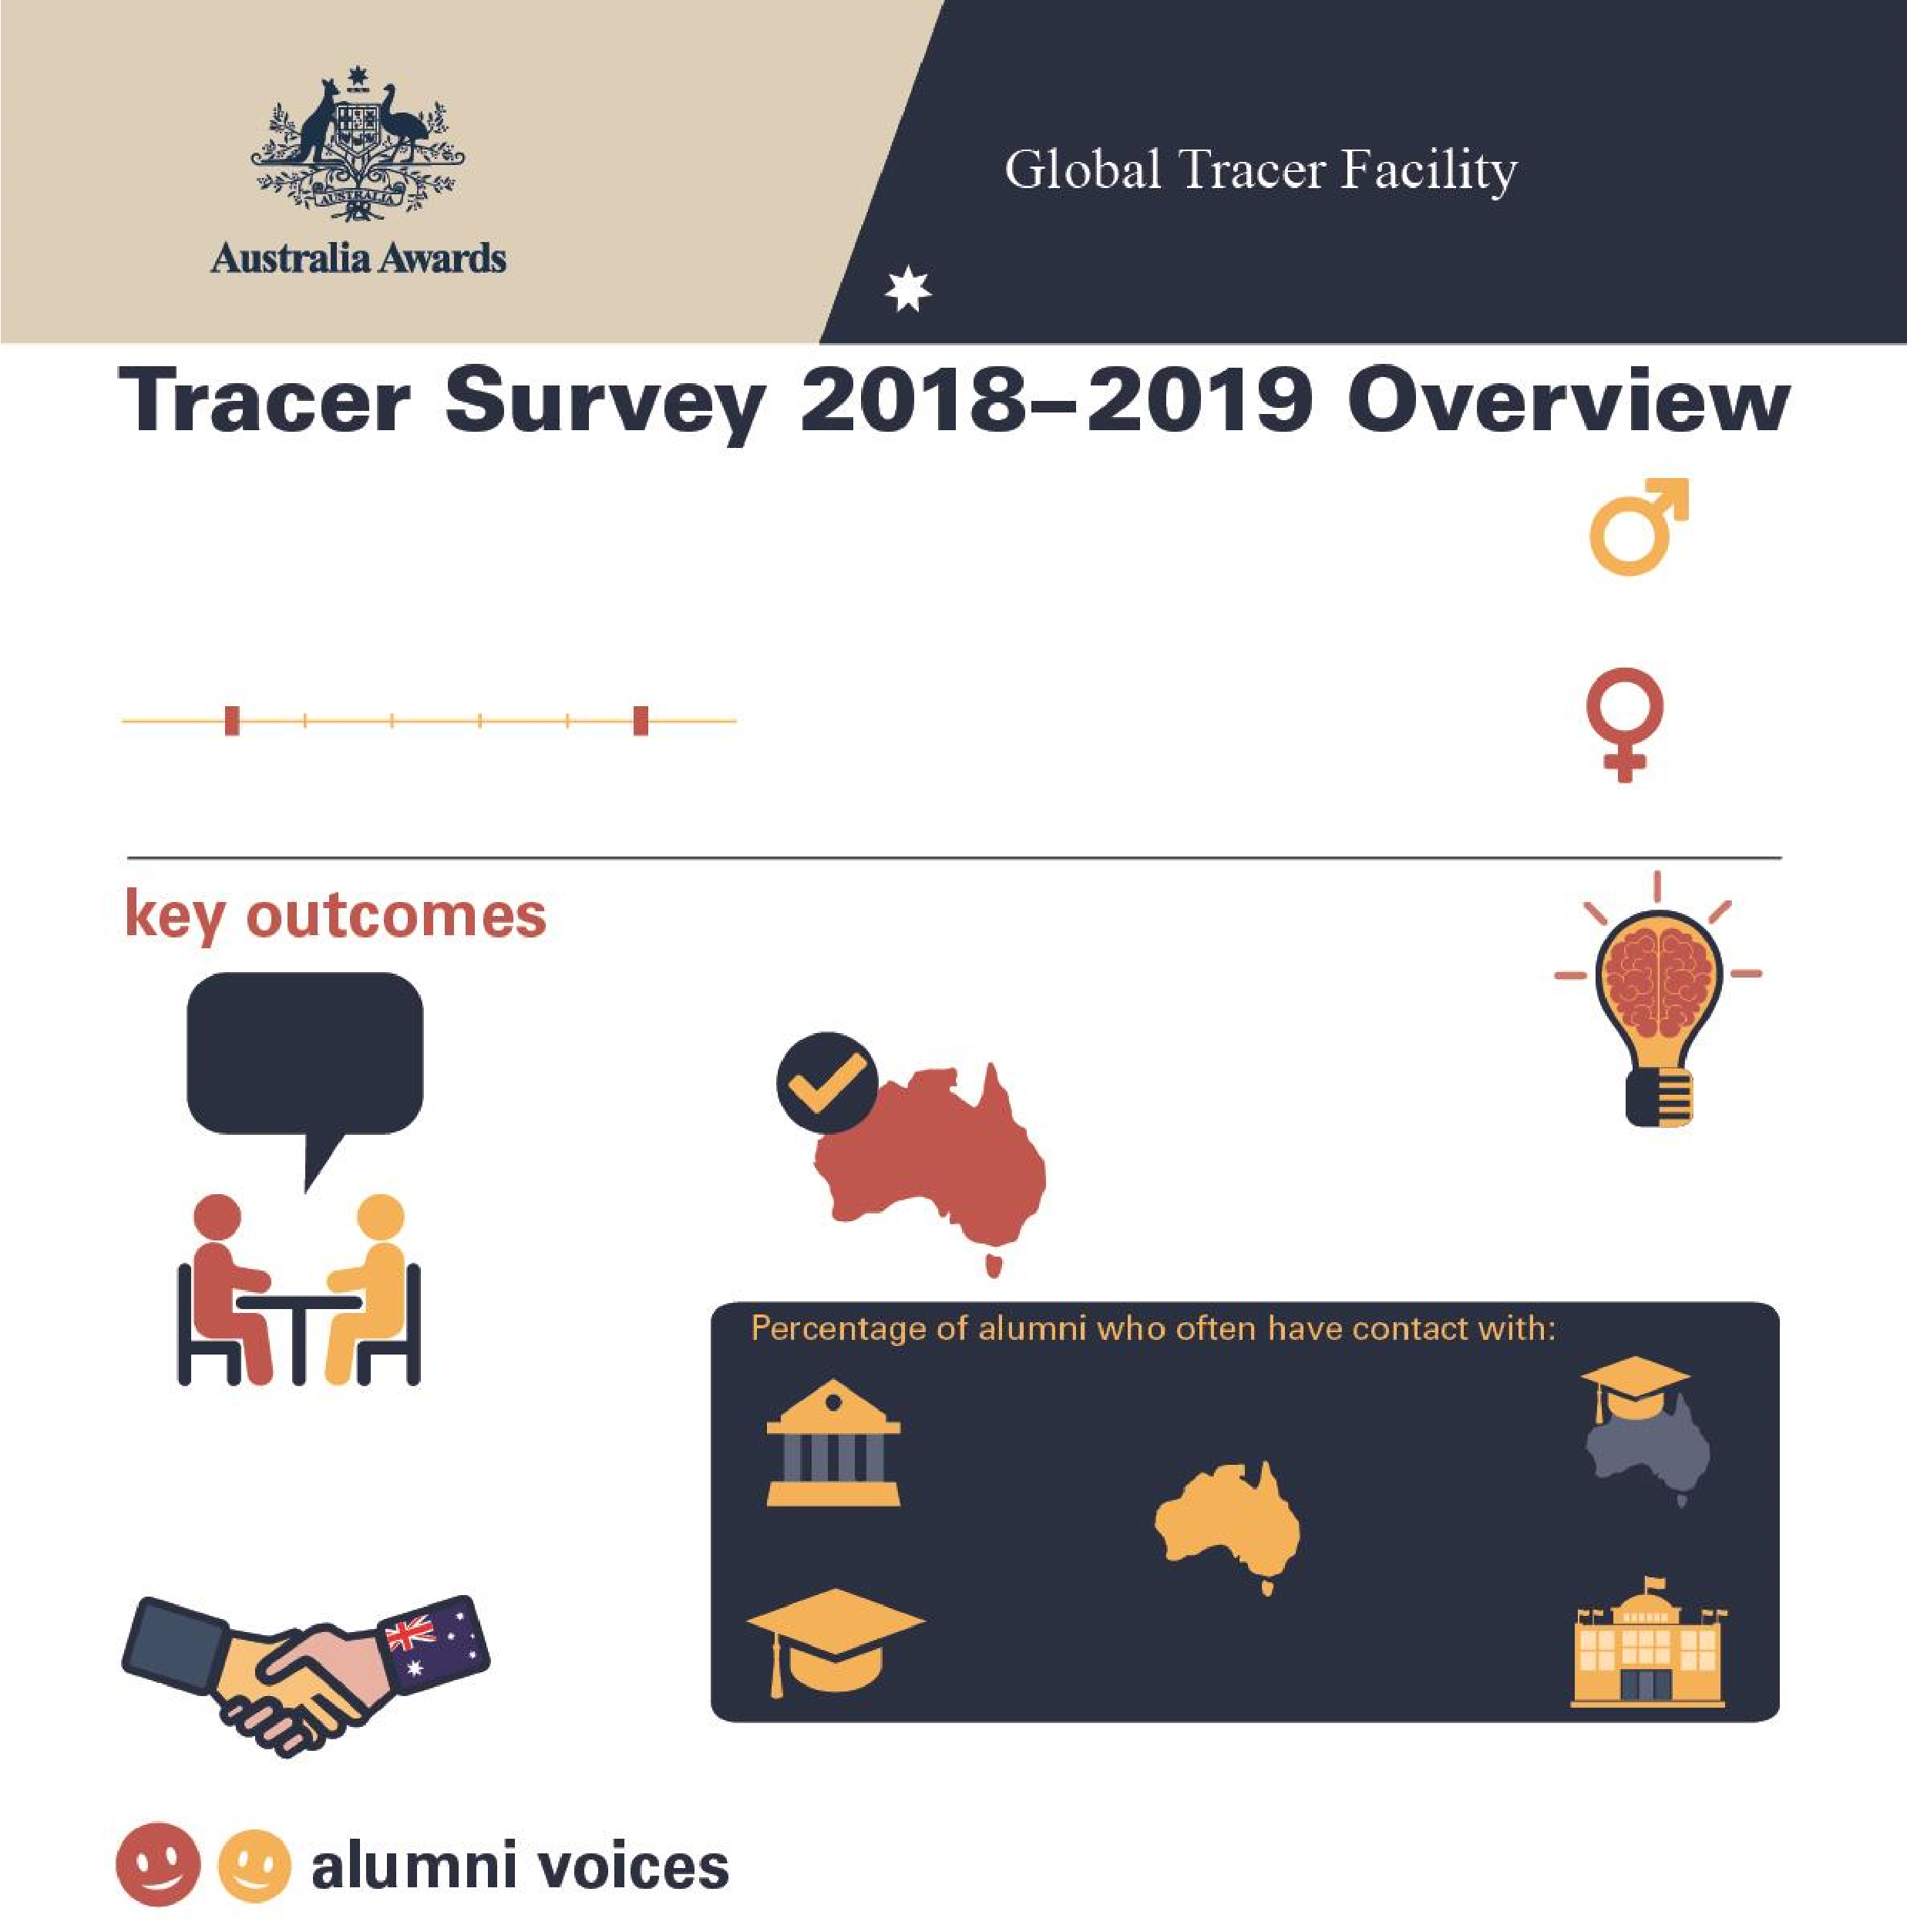

**Tracer Survey 2018**

**–**

**2019**

**Liberia**

**Overview**

**15**

**Alumni from**

**Liberia**

Alumni who completed a scholarship or

fellowship between

2011

and 20

16

**2011**

**2016**

**Men**

**67**

**%**

**W**

**omen**

**33**

**%**

**100**

**%**

**of alumni**

Passed on skills

and knowledge

to others

**%**

**100**

**of alumni**

Introduced improved

practices and

innovations at work

**%**

**38**

**of alumni**

Develope

d professional

links with Australia

**100**

**%**

**of alumni**

Say their awards experience

positively influenced perception

of Australian skills and expertise

Host

institution

**67**

**%**

Other scholarship

alumni

**75**

**%**

Friends in

Australia

**75**

**%**

Australian

alumni

**%**

**58**

Aus

tralian

Embassy or

High Commission

**25**

**%**

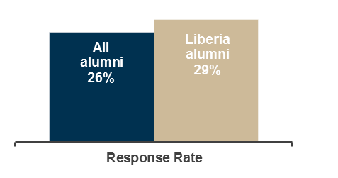

**Table 1: Tracer Survey Data for 2011 to 2016 alumni from Liberia and All alumni - Respondent characteristics**

|  |  |  |  |  |  |  |  |  |  |
| --- | --- | --- | --- | --- | --- | --- | --- | --- | --- |
|  |  | Alumni from Liberia | | | |  |  |  | |
| Scholarships | | Fellowships | | Alumni from Liberia | | All Alumni | |
| Count | Column N % | Count | Column N % | Count | Column N % | Count | Column N % |
| Age at time of survey | Under 20 years | - | - | - | - | - | - | - | - |
| 20 to 29 years | - | - | - | - | - | - | 111 | 3.0% |
| 30 to 39 years | 5 | 33.3% | - | - | 5 | 33.3% | 2134 | 56.8% |
| 40 to 49 years | 6 | 40.0% | - | - | 6 | 40.0% | 1144 | 30.4% |
| 50 to 59 years | 4 | 26.7% | - | - | 4 | 26.7% | 310 | 8.3% |
| 60 to 69 years | - | - | - | - | - | - | 52 | 1.4% |
| 70 and older | - | - | - | - | - | - | 6 | 0.2% |
| Year of graduation from award | 2011 | - | - | - | - | - | - | 382 | 10.1% |
| 2012 | 5 | 33.3% | - | - | 5 | 33.3% | 546 | 14.5% |
| 2013 | 3 | 20.0% | - | - | 3 | 20.0% | 631 | 16.7% |
| 2014 | 6 | 40.0% | - | - | 6 | 40.0% | 657 | 17.4% |
| 2015 | 1 | 6.7% | - | - | 1 | 6.7% | 881 | 23.4% |
| 2016 | - | - | - | - | - | - | 671 | 17.8% |
| Have you received any other awards? | Yes | 4 | 26.7% | - | - | 4 | 26.7% | 956 | 25.4% |
| No | 11 | 73.3% | - | - | 11 | 73.3% | 2779 | 73.9% |
| Don't know | - | - | - | - | - | - | 27 | 0.7% |
| What is your current employment status? | Employed full-time | 12 | 80.0% | - | - | 12 | 80.0% | 3297 | 87.7% |
| Employed part-time | 2 | 13.3% | - | - | 2 | 13.3% | 155 | 4.1% |
| Not employed | 1 | 6.7% | - | - | 1 | 6.7% | 113 | 3.0% |
| Retired | - | - | - | - | - | - | 15 | 0.4% |
| Studying | - | - | - | - | - | - | 135 | 3.6% |
| Other (specify) | - | - | - | - | - | - | 46 | 1.2% |
| Level of leadership in relation to current job | Formal leadership role | 11 | 78.6% | - | - | 11 | 78.6% | 2080 | 61.9% |
| Informal leadership role | 2 | 14.3% | - | - | 2 | 14.3% | 1019 | 30.3% |
| Do not have a leadership role | 1 | 7.1% | - | - | 1 | 7.1% | 203 | 6.0% |
| Don't know/prefer not to say | - | - | - | - | - | - | 56 | 1.7% |

**Table 2: Tracer Survey Data for 2011 to 2016 alumni from Liberia and All alumni - Outcome 1**

|  |  |  |  |  |  |  |  |  |  |
| --- | --- | --- | --- | --- | --- | --- | --- | --- | --- |
|  |  | Alumni from Liberia | | | |  |  |  | |
| **Q**: To what extent do you agree with each of these statements:  I have… | | Scholarships | | Fellowships | | Alumni from Liberia | | All Alumni | |
| Count | Column N % | Count | Column N % | Count | Column N % | Count | Column N % |
| Passed on new skills and knowledge to others | Strongly agree | 13 | 86.7% | - | - | 13 | 86.7% | 2298 | 61.1% |
| Agree | 2 | 13.3% | - | - | 2 | 13.3% | 1367 | 36.4% |
| Disagree | - | - | - | - | - | - | 44 | 1.2% |
| Strongly disagree | - | - | - | - | - | - | 13 | 0.3% |
| Don't Know | - | - | - | - | - | - | 38 | 1.0% |
| Introduced improved practices and innovations through my work | Strongly agree | 10 | 66.7% | - | - | 10 | 66.7% | 2023 | 53.9% |
| Agree | 5 | 33.3% | - | - | 5 | 33.3% | 1571 | 41.8% |
| Disagree | - | - | - | - | - | - | 69 | 1.8% |
| Strongly disagree | - | - | - | - | - | - | 12 | 0.3% |
| Don't Know | - | - | - | - | - | - | 81 | 2.2% |
| Built networks with Australians or Australian organisations | Strongly agree | 4 | 26.7% | - | - | 4 | 26.7% | 848 | 22.6% |
| Agree | 7 | 46.7% | - | - | 7 | 46.7% | 1892 | 50.4% |
| Disagree | 2 | 13.3% | - | - | 2 | 13.3% | 719 | 19.2% |
| Strongly disagree | 1 | 6.7% | - | - | 1 | 6.7% | 68 | 1.8% |
| Don't know | 1 | 6.7% | - | - | 1 | 6.7% | 226 | 6.0% |
| Built networks with other awardees | Strongly agree | 7 | 46.7% | - | - | 7 | 46.7% | 1683 | 44.9% |
| Agree | 8 | 53.3% | - | - | 8 | 53.3% | 1730 | 46.1% |
| Disagree | - | - | - | - | - | - | 251 | 6.7% |
| Strongly disagree | - | - | - | - | - | - | 21 | 0.6% |
| Don't know | - | - | - | - | - | - | 66 | 1.8% |

**Table 3: Tracer Survey Data for 2011 to 2016 alumni from Liberia and All alumni - Outcome 2**

|  |  |  |  |  |  |  |  |  |  |
| --- | --- | --- | --- | --- | --- | --- | --- | --- | --- |
|  |  | Alumni from Liberia | | | |  |  |  | |
| **Q**: How frequently are you in contact with the following groups: | | Scholarships | | Fellowships | | Alumni from Liberia | | All Alumni | |
| Count | Column N % | Count | Column N % | Count | Column N % | Count | Column N % |
| Host Institution | Always | - | - | - | - | - | - | 168 | 5.0% |
| Often | 8 | 66.7% | - | - | 8 | 66.7% | 568 | 16.8% |
| Sometimes | 4 | 33.3% | - | - | 4 | 33.3% | 1279 | 37.8% |
| Rarely | - | - | - | - | - | - | 973 | 28.7% |
| Never | - | - | - | - | - | - | 364 | 10.8% |
| Don’t know | - | - | - | - | - | - | 34 | 1.0% |
| Fellow Australian Students | Always | 1 | 8.3% | - | - | 1 | 8.3% | 278 | 8.2% |
| Often | 6 | 50.0% | - | - | 6 | 50.0% | 850 | 25.1% |
| Sometimes | 4 | 33.3% | - | - | 4 | 33.3% | 1270 | 37.6% |
| Rarely | 1 | 8.3% | - | - | 1 | 8.3% | 611 | 18.1% |
| Never | - | - | - | - | - | - | 341 | 10.1% |
| Don’t know | - | - | - | - | - | - | 32 | 0.9% |
| Fellow Award recipients | Always | 3 | 25.0% | - | - | 3 | 25.0% | 488 | 14.4% |
| Often | 6 | 50.0% | - | - | 6 | 50.0% | 1219 | 36.1% |
| Sometimes | 3 | 25.0% | - | - | 3 | 25.0% | 1151 | 34.1% |
| Rarely | - | - | - | - | - | - | 389 | 11.5% |
| Never | - | - | - | - | - | - | 115 | 3.4% |
| Don’t know | - | - | - | - | - | - | 17 | 0.5% |
| Professional associations or  Australian businesses operating in  Australia/your home country | Always | - | - | - | - | - | - | 104 | 3.1% |
| Often | 1 | 8.3% | - | - | 1 | 8.3% | 359 | 10.6% |
| Sometimes | 5 | 41.7% | - | - | 5 | 41.7% | 834 | 24.7% |
| Rarely | 4 | 33.3% | - | - | 4 | 33.3% | 989 | 29.3% |
| Never | 1 | 8.3% | - | - | 1 | 8.3% | 984 | 29.2% |
| Don’t know | 1 | 8.3% | - | - | 1 | 8.3% | 105 | 3.1% |
| Australian Embassy, High Commission or Consulate | Always | 1 | 8.3% | - | - | 1 | 8.3% | 85 | 2.5% |
| Often | 2 | 16.7% | - | - | 2 | 16.7% | 251 | 7.4% |
| Sometimes | 3 | 25.0% | - | - | 3 | 25.0% | 775 | 23.0% |
| Rarely | 4 | 33.3% | - | - | 4 | 33.3% | 1119 | 33.2% |
| Never | 2 | 16.7% | - | - | 2 | 16.7% | 1092 | 32.4% |
| Don’t know | - | - | - | - | - | - | 50 | 1.5% |
| Friends in Australia | Always | 5 | 41.7% | - | - | 5 | 41.7% | 426 | 12.6% |
| Often | 4 | 33.3% | - | - | 4 | 33.3% | 921 | 27.3% |
| Sometimes | 3 | 25.0% | - | - | 3 | 25.0% | 1232 | 36.6% |
| Rarely | - | - | - | - | - | - | 551 | 16.4% |
| Never | - | - | - | - | - | - | 219 | 6.5% |
| Don’t know | - | - | - | - | - | - | 21 | 0.6% |

**Table 4: Tracer Survey Data for 2011 to 2016 alumni from Liberia and All alumni - Outcome 3**

|  |  |  |  |  |  |  |  |  |  |
| --- | --- | --- | --- | --- | --- | --- | --- | --- | --- |
| **Q**: As a result of your Australia Award, have you developed professional links with Australian organisations? | | Scholarships  Count Column N % | | Alumni from Liberia  Fellowships  Count Column N % | | Alumni from Liberia  Count Column N % | | All Alumni  Count Column N % | |
| Professional links | Developed professional links | 5 | 38.5% | - | - | 5 | 38.5% | 1513 | 44.2% |
| Did not develop professional links | 8 | 61.5% | - | - | 8 | 61.5% | 1583 | 46.2% |
| Don't Know | - | - | - | - | - | - | 330 | 9.6% |
| Types of professional links with Australian organisations* | Public sector | 1 | 20.0% | - | - | 1 | 20.0% | 336 | 22.4% |
| Private Sector | 1 | 20.0% | - | - | 1 | 20.0% | 150 | 10.0% |
| Universities | 2 | 40.0% | - | - | 2 | 40.0% | 740 | 49.3% |
| Non-Government Organisations | - | - | - | - | - | - | 137 | 9.1% |
| Australian High Commission or Consulates | - | - | - | - | - | - | 30 | 2.0% |
| Other or don't know | 1 | 20.0% | - | - | 1 | 20.0% | 108 | 7.2% |

*Note these counts and proportions only include alumni who indicated that they had developed a professional link as well as providing information about their current employment in the survey.

**Table 5: Tracer Survey Data for 2011 to 2016 alumni from Liberia and All alumni - Outcome 4**

|  |  |  |  |  |  |  |  |  |  |
| --- | --- | --- | --- | --- | --- | --- | --- | --- | --- |
|  |  | Alumni from Liberia | | | |  |  |  | |
| **Q**: To what extent did your experience during your award influence your perception of the following: | | Scholarships | | Fellowships | | Alumni from Liberia | | All Alumni | |
| Count | Column N % | Count | Column N % | Count | Column N % | Count | Column N % |
| Australia as a country | Much more positive | 9 | 81.8% | - | - | 9 | 81.8% | 2825 | 84.6% |
| Slightly more positive | 2 | 18.2% | - | - | 2 | 18.2% | 406 | 12.2% |
| No change | - | - | - | - | - | - | 84 | 2.5% |
| Slightly more negative | - | - | - | - | - | - | 13 | 0.4% |
| Much more negative | - | - | - | - | - | - | - | - |
| Don't know | - | - | - | - | - | - | 13 | 0.4% |
| Australian people | Much more positive | 7 | 63.6% | - | - | 7 | 63.6% | 2497 | 74.8% |
| Slightly more positive | 4 | 36.4% | - | - | 4 | 36.4% | 626 | 18.7% |
| No change | - | - | - | - | - | - | 152 | 4.6% |
| Slightly more negative | - | - | - | - | - | - | 37 | 1.1% |
| Much more negative | - | - | - | - | - | - | 1 | 0.0% |
| Don't know | - | - | - | - | - | - | 26 | 0.8% |
| The knowledge skills and expertise of Australians | Much more positive | 9 | 81.8% | - | - | 9 | 81.8% | 2532 | 75.9% |
| Slightly more positive | 2 | 18.2% | - | - | 2 | 18.2% | 642 | 19.2% |
| No change | - | - | - | - | - | - | 118 | 3.5% |
| Slightly more negative | - | - | - | - | - | - | 19 | 0.6% |
| Much more negative | - | - | - | - | - | - | 2 | 0.1% |
| Don't know | - | - | - | - | - | - | 24 | 0.7% |
| Have provided advice to people from home country in relation to pursuing opportunities in Australia | Yes | 11 | 100.0% | - | - | 11 | 100.0% | 3245 | 97.3% |
| No | - | - | - | - | - | - | 74 | 2.2% |
| Don't know | - | - | - | - | - | - | 17 | 0.5% |

