

Australia Awards

Global Tracer Facility

Tracer Survey

Year

3

201

8

-

1

9

United Republic

of

Tanzania

Country Report

Alumni of

2011

to

2016

Tracer Survey Outcomes Summary: United Republic of Tanzania

This country report details the responses of alumni from the **United Republic of Tanzania** to the Australia Awards Global Tracer Facility **Tracer Survey** carried out in 2018-19. The Tracer Survey was conducted between November 2018 and February 2019 and targeted **alumni who completed their award between 2011 and 2016**.

Alumni were asked a range of questions via an online survey, focussed on exploring the long-term outcomes of the Australia Awards. In total 3,768 alumni in this cohort from more than 123 different countries participated in the survey. A 26 per cent response rate of the target cohort was achieved globally. This report focuses on the response data of alumni from the United Republic of Tanzania.

For the United Republic of Tanzania, there were 228 alumni included in the target population. Responses were received from 45, a **response rate of 20** **per cent**. Among these respondents, 27 were scholarship alumni and 18 were fellowship alumni.

The survey data provide a valuable quantitative insight into alumni use of knowledge and skills, development of networks and contribution to cooperation with Australia. The responses also offer rich examples from alumni of the types of contributions they are making, the way in which they are using their award, and the things that help and hinder them in reaching their potential.

The data detailed here are reported based on the four long-term outcomes of the Australia Awards as articulated in the *Australia Awards Global Strategy: Investing in the next generation of global leaders for development 2016-2018* and the Australia Awards Global Monitoring and Evaluation Framework. In terms of responding to the **long-term outcomes** of the Australia Awards, the following summary offers findings based on the responses of alumni from the United Republic of Tanzania. Further outcomes are included in the infographic following this summary.

**Outcome 1:** *Alumni are using their skills, knowledge and networks to contribute to sustainable development.*

* Most alumni from the United Republic of Tanzania (98 per cent) indicated they have passed on their skills and knowledge to others in their country on return from their award.
* 98 per cent of alumni indicated they had introduced improved practices and innovations in their work on return from their award.

/ 1

**Outcome 2:** *Alumni are contributing to cooperation between Australia and partner countries.*

* 71 per cent of alumni from the United Republic of Tanzania have maintained frequent contact with fellow alumni, while 48 per cent have frequent contact with friends in Australia and 55 per cent with Australian students/alumni.
* In terms of frequent contact with Australian organisations, 29 per cent of alumni have frequent contact with Australian institutions, 21 per cent of alumni have frequent contact with Australian businesses and 7 per cent with Australian Embassies, High Commissions or Consulates.

**Outcome 3:** *Effective, mutually advantageous partnerships between institutions and businesses in Australia and partner countries.*

* 60 per cent of alumni from the United Republic of Tanzania indicated having had a professional link with an Australian organisation at some time following award.
* These links were with Australian universities, the government sector, the private sector and non-government organisations.

**Outcome 4:** *Alumni view Australia, Australians and Australian expertise positively.*

* All alumni from the United Republic of Tanzania indicated their experience in Australia positively influenced their perception of Australia.
* All alumni have provided advice to people in the United Republic of Tanzania about pursuing opportunities in Australia.

The Tracer Survey represented the views of a range of alumni from the United

Republic of Tanzania. Of those who responded, **33 per cent were women and 91 per cent came from an urban location**. The largest age group represented were alumni 40 to 49 years. Among all alumni, 89 per cent were employed fulltime. Of those alumni employed, **72 per cent** indicatedthat they hold a **formal leadership role**.

In addition to this Outcomes Summary, this report includes an infographic as well as data tables including the detail of respondents from the United Republic of Tanzania to the Tracer Survey. The data tables correspond to each of the Australia Awards long-term outcomes and include benchmark data from the entire survey response population.

For further infor[mation about the Australia Awards Glob](http://www.australiaawardstracerfacility.org/)al Tracer Facility please visit the website: [www.australiaawardstracerfacility.org](http://www.australiaawardstracerfacility.org/)

/ 2

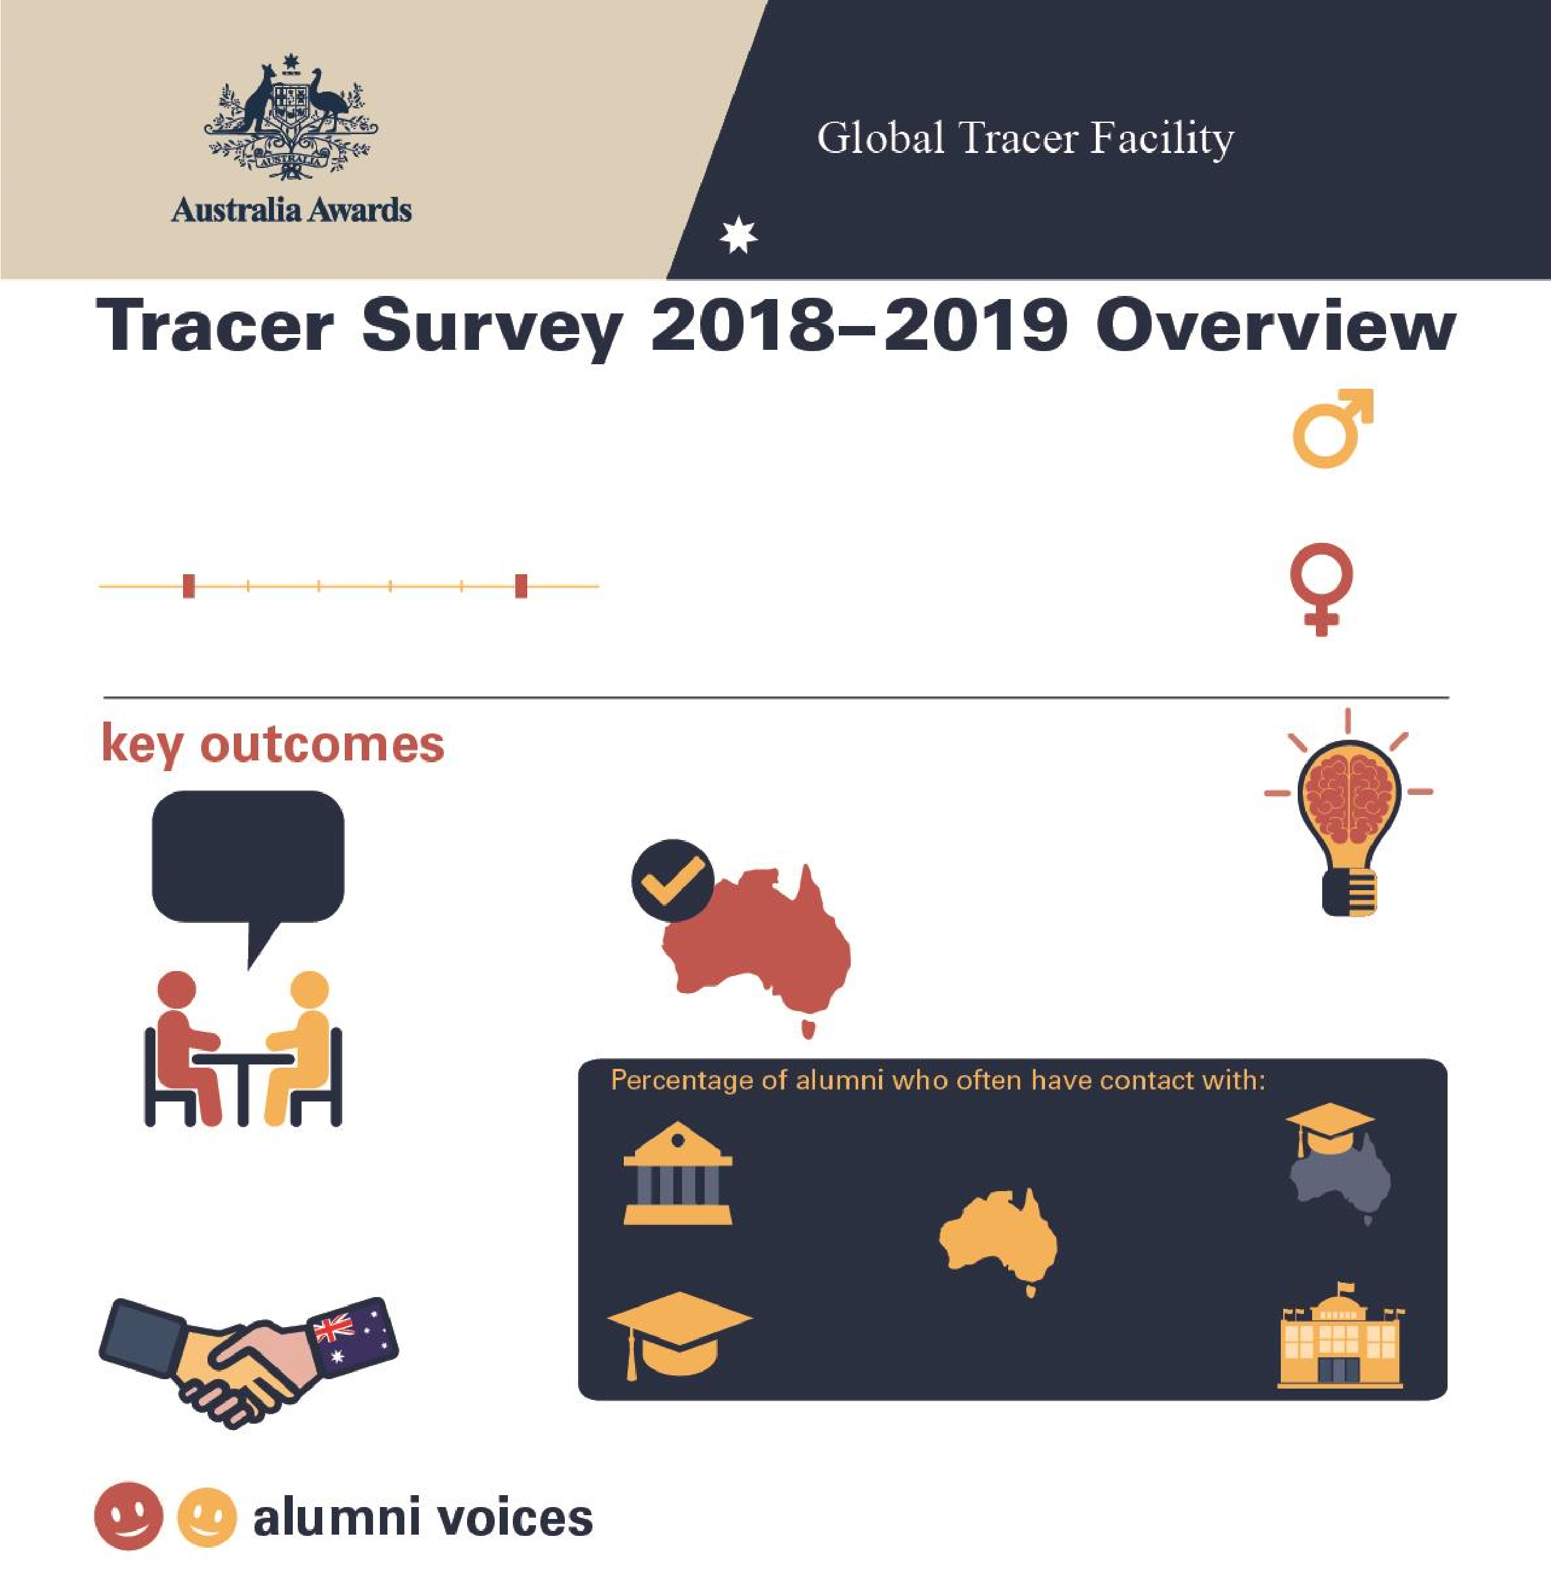

**Tracer Survey 2018**

**–**

**2019**

**Tanzania**

**Overview**

**45**

**Alumni from**

**the**

**United Republic of**

**Tanzan**

**ia**

Alumni who completed a scholarsh

ip or

fellowship between

2011

and 20

16

**2011**

**2016**

**Men**

**67**

**%**

**W**

**omen**

**33**

**%**

**%**

**98**

**of alumni**

Passed on skills

and knowledge

to others

**%**

**98**

**of alumni**

Introduced improved

practices and

innovations at work

**%**

**60**

**of alumni**

Developed professional

links with Australia

**100**

**%**

**of alum**

**ni**

Say their awards experience

positively influenced perception

of Australian skills and expertise

Host

institution

**29**

**%**

Other scholarship

alumni

**71**

**%**

Friends in

Australia

**48**

**%**

Australian

alumni

**55**

**%**

Australian

Embassy or

High Commission

**7**

**%**

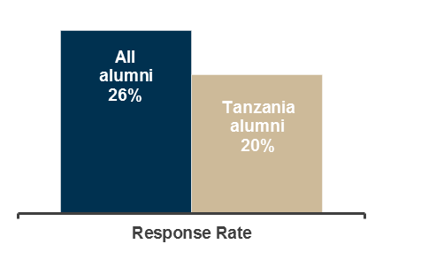

|  |  |  |  |  |
| --- | --- | --- | --- | --- |
| |  | | --- | | *During the review of feasibility studies reports for PPP projects, I developed a guideline for evaluation of proposals and shared this with my staff members. The guidelines cover the materials received from Australia. Now, the guidelines are used in my organisation.* | | |  | | --- | | *As one of the management team member I have contributed in the reformation of a new structure of our Agency to increase its effectiveness. I have introduced a new motivation strategy to our staff that based on the performance. Initially we did not have a formal motivation strategy.* | | |
| |  | | --- | | *Through my work as a television presenter I have been airing programmes that are to eradicate gender based violence towards women and children.* | | | |  | | --- | | *I have established useful contacts with alumni who are Australians and we have shared some experiences*  *in handling consulting engagements.* | |

# Table 1: Tracer Survey Data for 2011 to 2016 alumni from Tanzania and All alumni - Respondent characteristics

|  |  |  |  |  |  |  |  |  |  |
| --- | --- | --- | --- | --- | --- | --- | --- | --- | --- |
|  |  | Alumni from Tanzania | | | |  |  |  | |
| Scholarships | | Fellowships | | Alumni from Tanzania | | All Alumni | |
| Count | Column N % | Count | Column N % | Count | Column N % | Count | Column N % |
| Age at time of survey | Under 20 years | - | - | - | - | - | - | - | - |
| 20 to 29 years | - | - | - | - | - | - | 111 | 3.0% |
| 30 to 39 years | 17 | 63.0% | 2 | 11.1% | 19 | 42.2% | 2134 | 56.8% |
| 40 to 49 years | 10 | 37.0% | 10 | 55.6% | 20 | 44.4% | 1144 | 30.4% |
| 50 to 59 years | - | - | 5 | 27.8% | 5 | 11.1% | 310 | 8.3% |
| 60 to 69 years | - | - | 1 | 5.6% | 1 | 2.2% | 52 | 1.4% |
| 70 and older | - | - | - | - | - | - | 6 | 0.2% |
| Year of graduation from award | 2011 | 1 | 3.7% | - | - | 1 | 2.2% | 382 | 10.1% |
| 2012 | 5 | 18.5% | 5 | 27.8% | 10 | 22.2% | 546 | 14.5% |
| 2013 | 6 | 22.2% | 2 | 11.1% | 8 | 17.8% | 631 | 16.7% |
| 2014 | 4 | 14.8% | 8 | 44.4% | 12 | 26.7% | 657 | 17.4% |
| 2015 | 7 | 25.9% | 3 | 16.7% | 10 | 22.2% | 881 | 23.4% |
| 2016 | 4 | 14.8% | - | - | 4 | 8.9% | 671 | 17.8% |
| Have you received any other awards? | Yes | 6 | 22.2% | 8 | 47.1% | 14 | 31.8% | 956 | 25.4% |
| No | 21 | 77.8% | 9 | 52.9% | 30 | 68.2% | 2779 | 73.9% |
| Don't know | - | - | - | - | - | - | 27 | 0.7% |
| What is your current employment status? | Employed full-time | 24 | 88.9% | 15 | 88.2% | 39 | 88.6% | 3297 | 87.7% |
| Employed part-time | - | - | 2 | 11.8% | 2 | 4.5% | 155 | 4.1% |
| Not employed | 3 | 11.1% | - | - | 3 | 6.8% | 113 | 3.0% |
| Retired | - | - | - | - | - | - | 15 | 0.4% |
| Studying | - | - | - | - | - | - | 135 | 3.6% |
| Other (specify) | - | - | - | - | - | - | 46 | 1.2% |
| Level of leadership in relation to current job | Formal leadership role | 15 | 68.2% | 13 | 76.5% | 28 | 71.8% | 2080 | 61.9% |
| Informal leadership role | 7 | 31.8% | 3 | 17.6% | 10 | 25.6% | 1019 | 30.3% |
| Do not have a leadership role | - | - | 1 | 5.9% | 1 | 2.6% | 203 | 6.0% |
| Don't know/prefer not to say | - | - | - | - | - | - | 56 | 1.7% |

# Table 2: Tracer Survey Data for 2011 to 2016 alumni from Tanzania and All alumni - Outcome 1

|  |  |  |  |  |  |  |  |  |  |
| --- | --- | --- | --- | --- | --- | --- | --- | --- | --- |
|  |  | Alumni from Tanzania | | | |  |  |  | |
| **Q**: To what extent do you agree with each of these statements:  I have… | | Scholarships | | Fellowships | | Alumni from Tanzania | | All Alumni | |
| Count | Column N % | Count | Column N % | Count | Column N % | Count | Column N % |
| Passed on new skills and knowledge to others | Strongly agree | 21 | 77.8% | 11 | 64.7% | 32 | 72.7% | 2298 | 61.1% |
| Agree | 5 | 18.5% | 6 | 35.3% | 11 | 25.0% | 1367 | 36.4% |
| Disagree | 1 | 3.7% | - | - | 1 | 2.3% | 44 | 1.2% |
| Strongly disagree | - | - | - | - | - | - | 13 | 0.3% |
| Don't Know | - | - | - | - | - | - | 38 | 1.0% |
| Introduced improved practices and innovations through my work | Strongly agree | 17 | 63.0% | 12 | 70.6% | 29 | 65.9% | 2023 | 53.9% |
| Agree | 10 | 37.0% | 4 | 23.5% | 14 | 31.8% | 1571 | 41.8% |
| Disagree | - | - | 1 | 5.9% | 1 | 2.3% | 69 | 1.8% |
| Strongly disagree | - | - | - | - | - | - | 12 | 0.3% |
| Don't Know | - | - | - | - | - | - | 81 | 2.2% |
| Built networks with Australians or Australian organisations | Strongly agree | 9 | 33.3% | 2 | 11.8% | 11 | 25.0% | 848 | 22.6% |
| Agree | 15 | 55.6% | 10 | 58.8% | 25 | 56.8% | 1892 | 50.4% |
| Disagree | 2 | 7.4% | 4 | 23.5% | 6 | 13.6% | 719 | 19.2% |
| Strongly disagree | - | - | - | - | - | - | 68 | 1.8% |
| Don't know | 1 | 3.7% | 1 | 5.9% | 2 | 4.5% | 226 | 6.0% |
| Built networks with other awardees | Strongly agree | 22 | 81.5% | 8 | 47.1% | 30 | 68.2% | 1683 | 44.9% |
| Agree | 5 | 18.5% | 7 | 41.2% | 12 | 27.3% | 1730 | 46.1% |
| Disagree | - | - | 1 | 5.9% | 1 | 2.3% | 251 | 6.7% |
| Strongly disagree | - | - | - | - | - | - | 21 | 0.6% |
| Don't know | - | - | 1 | 5.9% | 1 | 2.3% | 66 | 1.8% |

# Table 3: Tracer Survey Data for 2011 to 2016 alumni from Tanzania and All alumni - Outcome 2

|  |  |  |  |  |  |  |  |  |  |
| --- | --- | --- | --- | --- | --- | --- | --- | --- | --- |
|  |  | Alumni from Tanzania | | | |  |  |  | |
| **Q**: How frequently are you in contact with the following groups: | | Scholarships | | Fellowships | | Alumni from Tanzania | | All Alumni | |
| Count | Column N % | Count | Column N % | Count | Column N % | Count | Column N % |
| Host Institution | Always | 3 | 11.5% | - | - | 3 | 7.1% | 168 | 5.0% |
| Often | 5 | 19.2% | 4 | 25.0% | 9 | 21.4% | 568 | 16.8% |
| Sometimes | 14 | 53.8% | 8 | 50.0% | 22 | 52.4% | 1279 | 37.8% |
| Rarely | 2 | 7.7% | 2 | 12.5% | 4 | 9.5% | 973 | 28.7% |
| Never | 2 | 7.7% | 2 | 12.5% | 4 | 9.5% | 364 | 10.8% |
| Don’t know | - | - | - | - | - | - | 34 | 1.0% |
| Fellow Australian Students | Always | 8 | 30.8% | 1 | 6.3% | 9 | 21.4% | 278 | 8.2% |
| Often | 9 | 34.6% | 5 | 31.3% | 14 | 33.3% | 850 | 25.1% |
| Sometimes | 5 | 19.2% | 6 | 37.5% | 11 | 26.2% | 1270 | 37.6% |
| Rarely | 3 | 11.5% | 2 | 12.5% | 5 | 11.9% | 611 | 18.1% |
| Never | 1 | 3.8% | 2 | 12.5% | 3 | 7.1% | 341 | 10.1% |
| Don’t know | - | - | - | - | - | - | 32 | 0.9% |
| Fellow Award recipients | Always | 12 | 46.2% | 4 | 25.0% | 16 | 38.1% | 488 | 14.4% |
| Often | 9 | 34.6% | 5 | 31.3% | 14 | 33.3% | 1219 | 36.1% |
| Sometimes | 5 | 19.2% | 5 | 31.3% | 10 | 23.8% | 1151 | 34.1% |
| Rarely | - | - | 2 | 12.5% | 2 | 4.8% | 389 | 11.5% |
| Never | - | - | - | - | - | - | 115 | 3.4% |
| Don’t know | - | - | - | - | - | - | 17 | 0.5% |
| Professional associations or  Australian businesses operating in  Australia/your home country | Always | 1 | 3.8% | - | - | 1 | 2.4% | 104 | 3.1% |
| Often | 4 | 15.4% | 4 | 25.0% | 8 | 19.0% | 359 | 10.6% |
| Sometimes | 7 | 26.9% | - | - | 7 | 16.7% | 834 | 24.7% |
| Rarely | 5 | 19.2% | 1 | 6.3% | 6 | 14.3% | 989 | 29.3% |
| Never | 9 | 34.6% | 9 | 56.3% | 18 | 42.9% | 984 | 29.2% |
| Don’t know | - | - | 2 | 12.5% | 2 | 4.8% | 105 | 3.1% |
| Australian Embassy, High Commission or Consulate | Always | 1 | 3.8% | 1 | 6.3% | 2 | 4.8% | 85 | 2.5% |
| Often | 1 | 3.8% | - | - | 1 | 2.4% | 251 | 7.4% |
| Sometimes | 6 | 23.1% | 1 | 6.3% | 7 | 16.7% | 775 | 23.0% |
| Rarely | 11 | 42.3% | 5 | 31.3% | 16 | 38.1% | 1119 | 33.2% |
| Never | 7 | 26.9% | 9 | 56.3% | 16 | 38.1% | 1092 | 32.4% |
| Don’t know | - | - | - | - | - | - | 50 | 1.5% |
| Friends in Australia | Always | 4 | 15.4% | 2 | 12.5% | 6 | 14.3% | 426 | 12.6% |
| Often | 10 | 38.5% | 4 | 25.0% | 14 | 33.3% | 921 | 27.3% |
| Sometimes | 8 | 30.8% | 4 | 25.0% | 12 | 28.6% | 1232 | 36.6% |
| Rarely | 3 | 11.5% | 3 | 18.8% | 6 | 14.3% | 551 | 16.4% |
| Never | 1 | 3.8% | 3 | 18.8% | 4 | 9.5% | 219 | 6.5% |
| Don’t know | - | - | - | - | - | - | 21 | 0.6% |

# Table 4: Tracer Survey Data for 2011 to 2016 alumni from Tanzania and All alumni - Outcome 3

|  |  |  |  |  |  |  |  |  |  |
| --- | --- | --- | --- | --- | --- | --- | --- | --- | --- |
| **Q**: As a result of your Australia Award, have you developed professional links with Australian organisations? | | Scholarships  Count Column N % | | Alumni from Tanzania  Fellowships  Count Column N % | | Alumni from Tanzania  Count Column N % | | All Alumni  Count Column N % | |
| Professional links | Developed professional links | 18 | 69.2% | 7 | 43.8% | 25 | 59.5% | 1513 | 44.2% |
| Did not develop professional links | 7 | 26.9% | 9 | 56.3% | 16 | 38.1% | 1583 | 46.2% |
| Don't Know | 1 | 3.8% | - | - | 1 | 2.4% | 330 | 9.6% |
| Types of professional links with Australian organisations* | Public sector | 2 | 11.1% | 3 | 42.9% | 5 | 20.0% | 336 | 22.4% |
| Private Sector | 3 | 16.7% | 1 | 14.3% | 4 | 16.0% | 150 | 10.0% |
| Universities | 9 | 50.0% | 3 | 42.9% | 12 | 48.0% | 740 | 49.3% |
| Non-Government Organisations | 2 | 11.1% | - | - | 2 | 8.0% | 137 | 9.1% |
| Australian High Commission or Consulates | - | - | - | - | - | - | 30 | 2.0% |
| Other or don't know | 2 | 11.1% | - | - | 2 | 8.0% | 108 | 7.2% |

*Note these counts and proportions only include alumni who indicated that they had developed a professional link as well as providing information about their current employment in the survey.

# Table 5: Tracer Survey Data for 2011 to 2016 alumni from Tanzania and All alumni - Outcome 4

|  |  |  |  |  |  |  |  |  |  |
| --- | --- | --- | --- | --- | --- | --- | --- | --- | --- |
|  |  | Alumni from Tanzania | | | |  |  |  | |
| **Q**: To what extent did your experience during your award influence your perception of the following: | | Scholarships | | Fellowships | | Alumni from Tanzania | | All Alumni | |
| Count | Column N % | Count | Column N % | Count | Column N % | Count | Column N % |
| Australia as a country | Much more positive | 23 | 88.5% | 15 | 93.8% | 38 | 90.5% | 2825 | 84.6% |
| Slightly more positive | 3 | 11.5% | 1 | 6.3% | 4 | 9.5% | 406 | 12.2% |
| No change | - | - | - | - | - | - | 84 | 2.5% |
| Slightly more negative | - | - | - | - | - | - | 13 | 0.4% |
| Much more negative | - | - | - | - | - | - | - | - |
| Don't know | - | - | - | - | - | - | 13 | 0.4% |
| Australian people | Much more positive | 21 | 80.8% | 13 | 81.3% | 34 | 81.0% | 2497 | 74.8% |
| Slightly more positive | 4 | 15.4% | 3 | 18.8% | 7 | 16.7% | 626 | 18.7% |
| No change | 1 | 3.8% | - | - | 1 | 2.4% | 152 | 4.6% |
| Slightly more negative | - | - | - | - | - | - | 37 | 1.1% |
| Much more negative | - | - | - | - | - | - | 1 | 0.0% |
| Don't know | - | - | - | - | - | - | 26 | 0.8% |
| The knowledge skills and expertise of Australians | Much more positive | 24 | 92.3% | 14 | 87.5% | 38 | 90.5% | 2532 | 75.9% |
| Slightly more positive | 2 | 7.7% | 2 | 12.5% | 4 | 9.5% | 642 | 19.2% |
| No change | - | - | - | - | - | - | 118 | 3.5% |
| Slightly more negative | - | - | - | - | - | - | 19 | 0.6% |
| Much more negative | - | - | - | - | - | - | 2 | 0.1% |
| Don't know | - | - | - | - | - | - | 24 | 0.7% |
| Have provided advice to people from home country in relation to pursuing opportunities in Australia | Yes | 26 | 100.0% | 16 | 100.0% | 42 | 100.0% | 3245 | 97.3% |
| No | - | - | - | - | - | - | 74 | 2.2% |
| Don't know | - | - | - | - | - | - | 17 | 0.5% |

