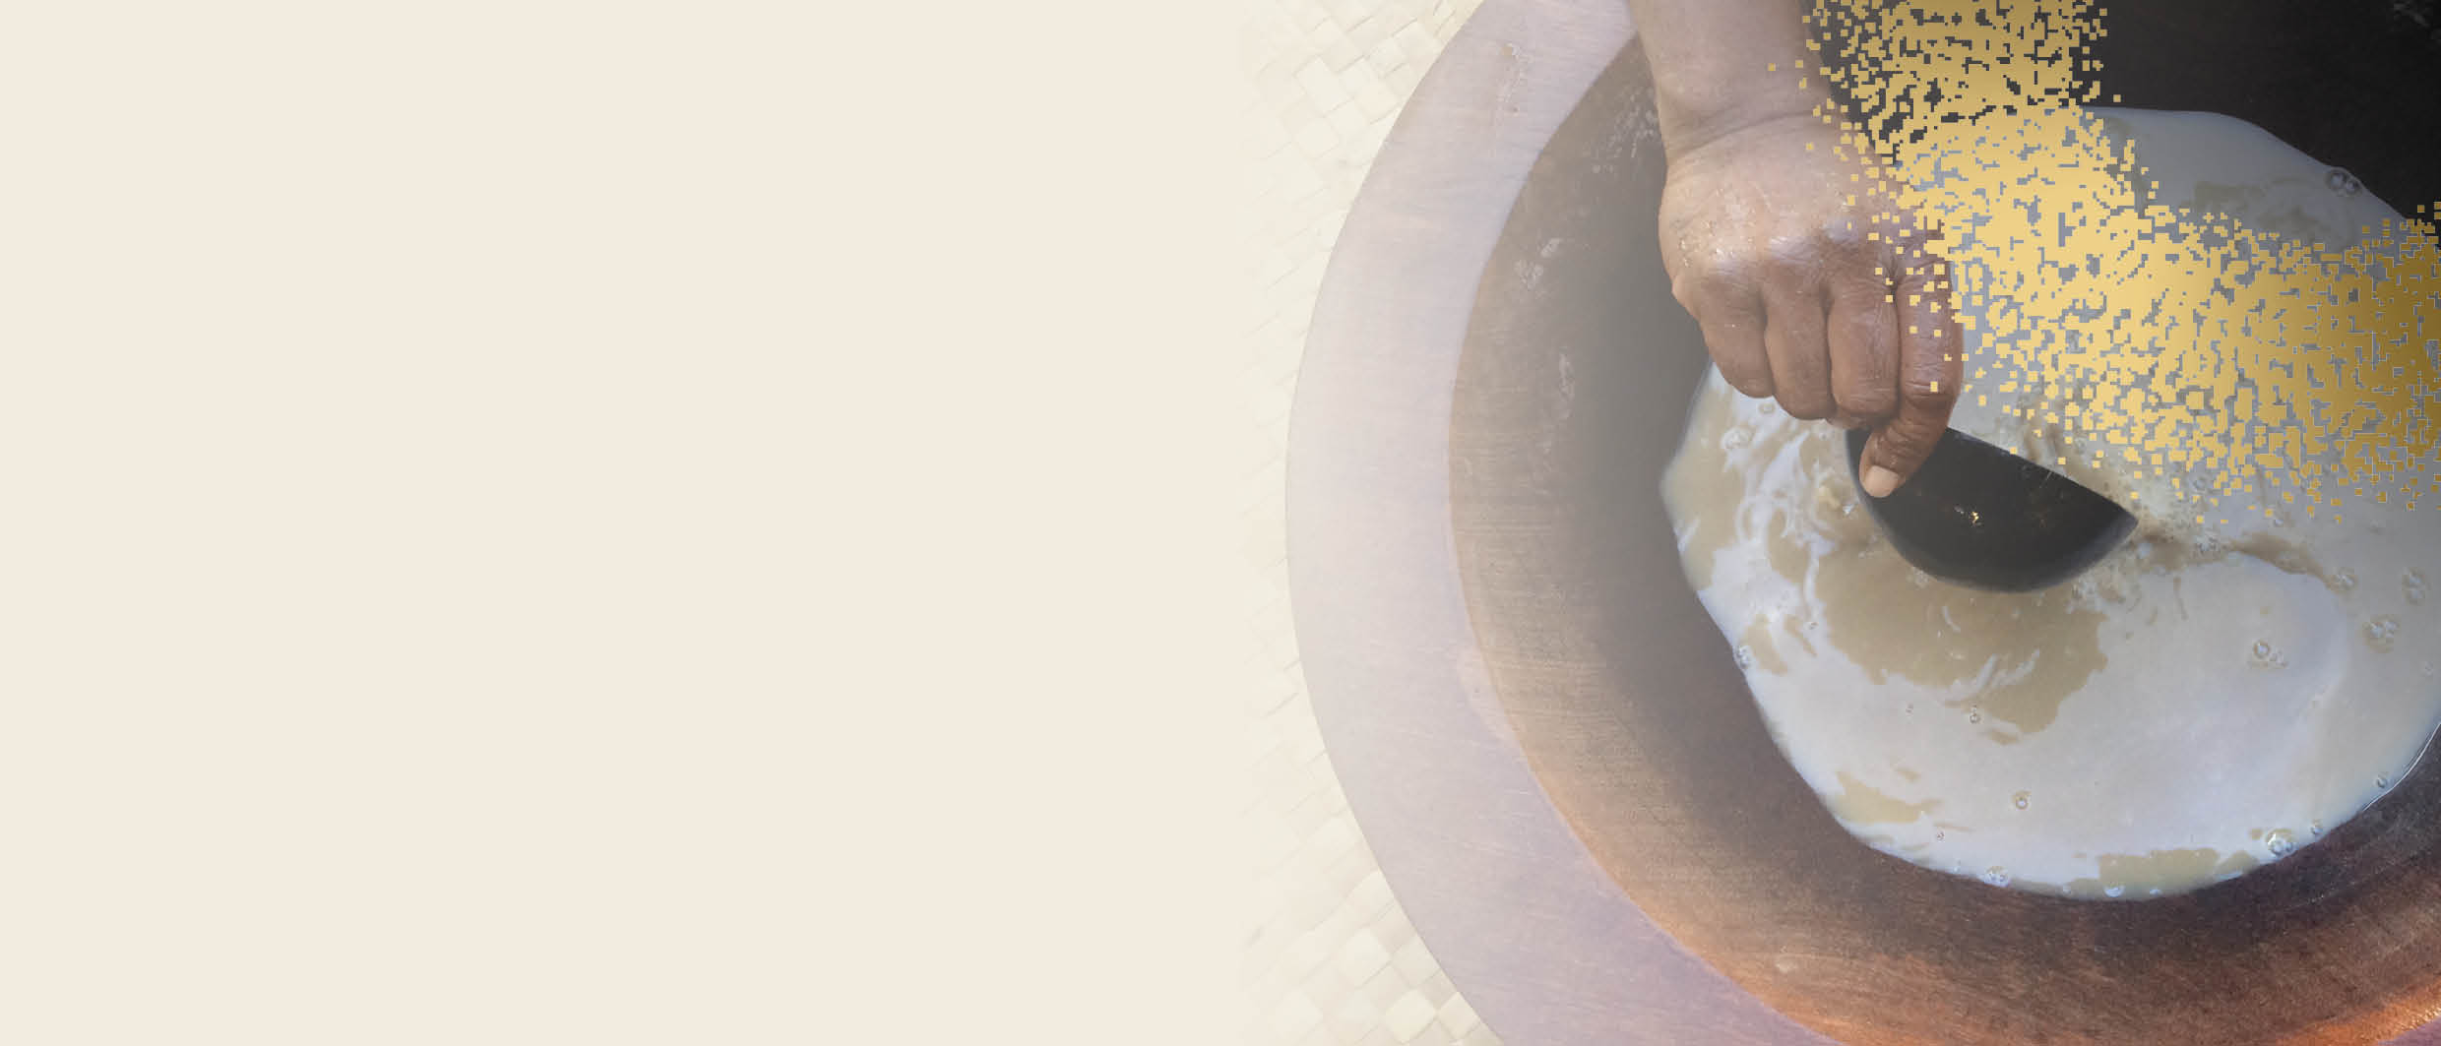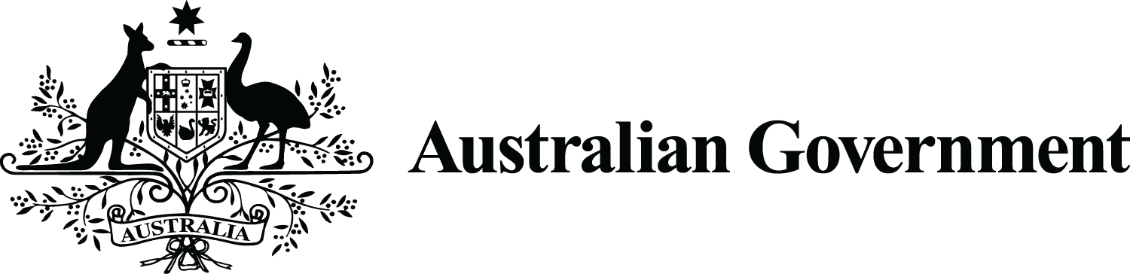

**Food import   
Requirements**

australia’s Commercial kavA Pilot

Importers are responsible for ensuring the quality and safety of the food they import. All food imported into Australia must be safe and comply with Australian food standards. This includes compliance with the [Australia and New Zealand Food Standards Code](http://www.foodstandards.gov.au/code/Pages/default.aspx) (the Code) and [country of origin food labelling requirements](https://www.accc.gov.au/publications/country-of-origin-food-labelling).

The Department of Agriculture, Water and the Environment (DAWE) checks imported food is safe and compliant at the Australian border through the [Imported Food Inspection Scheme (IFIS)](https://www.awe.gov.au/biosecurity-trade/import/goods/food/inspection-testing/ifis).

# How to comply with food import requirements

Kava products permitted by [Standard 2.6.3](https://www.legislation.gov.au/Series/F2015L00466) of the Code are either:

* a beverage obtained by the aqueous suspension of kava (*Piper methysticum*) root using cold water only, and not using any organic solvent
* dried or raw kava (*Piper methysticum*) root*, including kava root chips, kava root powder and whole kava root

**and must**

* not contain as an ingredient or a component any substance used as either a food additive or a processing aid
* be derived from the peeled root or peeled rootstock of a Noble variety of kava, no other forms of kava are permitted as food for sale

***\* kava root*** means the peeled root or peeled rootstock of kava

**Note:** All biosecurity import conditions must be met before food safety requirements apply. Under current biosecurity import conditions, kava powder, kava beverages (using cold water only), frozen raw kava root and rhizomes (whole or sliced), and dried kava root and rhizomes (whole or sliced) are permitted for commercial importation. See the [Biosecurity requirements factsheet](https://www.dfat.gov.au/sites/default/files/australia-commercial-kava-pilot-biosecurity-requirements.pdf) for further information.

Kava products will also need to meet requirements in Chapter 1 and Chapter 2 of the Code. For example, kava product labels must include the warning statements:

* ‘Use in moderation’
* ‘May cause drowsiness’.

For more information, see [Kava - DAWE](https://www.awe.gov.au/biosecurity-trade/import/goods/food/type/kava) and also the [Kava import labelling requirements fact sheet](https://www.awe.gov.au/sites/default/files/documents/kava-factsheet-april-2022.pdf).

Importers may wish to engage a food technologist or consultant, obtain legal advice or seek advice from a relevant industry association to ensure the food complies with the Australian food standards.

 **At-border inspection of kava food products**

Under the Imported Food Inspection Scheme (IFIS), kava food products are classified as risk food. This is based on [advice from FSANZ](https://www.foodstandards.gov.au/consumer/importedfoods/Pages/FSANZ-advice-on-imported-food.aspx) that the food poses a medium or high risk to public health.

All consignments of risk food are referred to DAWE. The rate of inspection of new imports from an overseas producer will commence at 100% but decline once compliance is demonstrated. When referred for inspection, consignments of kava products will be subject to a visual and label inspection to verify compliance. If food fails inspection, it cannot be released. The importer will need to either relabel the imports if labelling issues were found or destroy or re-export the food under the supervision of an authorised officer.

# Post border requirements for kava

State and territory food authorities have responsibility for monitoring all food, including imported food, that is available for sale. Each food authority has its own food legislation. It is important for importers to be aware of relevant [state and territory requirements for kava](https://www.foodstandards.gov.au/about/foodlawandtreaties/pages/default.aspx).