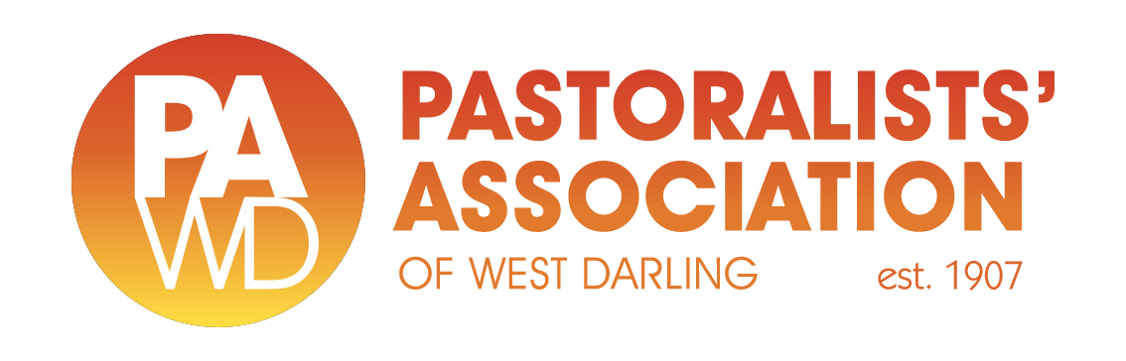

The Coordinator  
Australia-India Comprehensive Economic Cooperation Agreement  
Free Trade Agreements Division  
Department of Foreign Affairs and Trade  
RG Casey Building  
John McEwen Crescent  
Barton ACT 0221

e: [indiafta@dfat.gov.au](mailto:indiafta@dfat.gov.au)

Dear Sir/Madam,

The Pastoralists’ Association of West Darling (PAWD) represents the interests of pastoralists in far west NSW. Our members are cattle, sheep, wool and rangeland goat producers.

Australia is the largest goat meat exporter in the world. The United States is our largest market; however China and South Korea have emerged as significant buyers of Australian goat meat in response to [carcase values](https://www.mla.com.au/prices-markets/oth/) falling by 80% since June 2022, driven by increased production.

PAWD is aware that a Free Trade Agreement between Australia and India ([ECTA](https://www.dfat.gov.au/trade/agreements/in-force/australia-india-ecta)) came into force on 29 December 2022. We understand that goat meat was excluded from the ECTA.

PAWD also understands that both countries are committed to building on ECTA by negotiating the Australia-India Comprehensive Economic Cooperation Agreement ([CECA](https://www.dfat.gov.au/trade/agreements/negotiations/aifta/australia-india-comprehensive-economic-cooperation-agreement)). Securing improved market access for agricultural commodities that have been excluded from ECTA (such as goat meat) is a key focus of CECA negotiations.

Increased production of goat meat in Australia and the associated fall in value presents a very significant opportunity for India to source Australian goat meat at an attractive price point. Equally, lower values for other products from our region (beef, sheep meat and wool) also present opportunities for India to achieve value-for-money trading outcomes in these commodities.

Any positive outcomes that can be achieved in terms of developing markets for Australian goat meat in India will be warmly welcomed by PAWD and goat producers across Australia.

Yours sincerely,

Lachlan Gall.

Councillor.