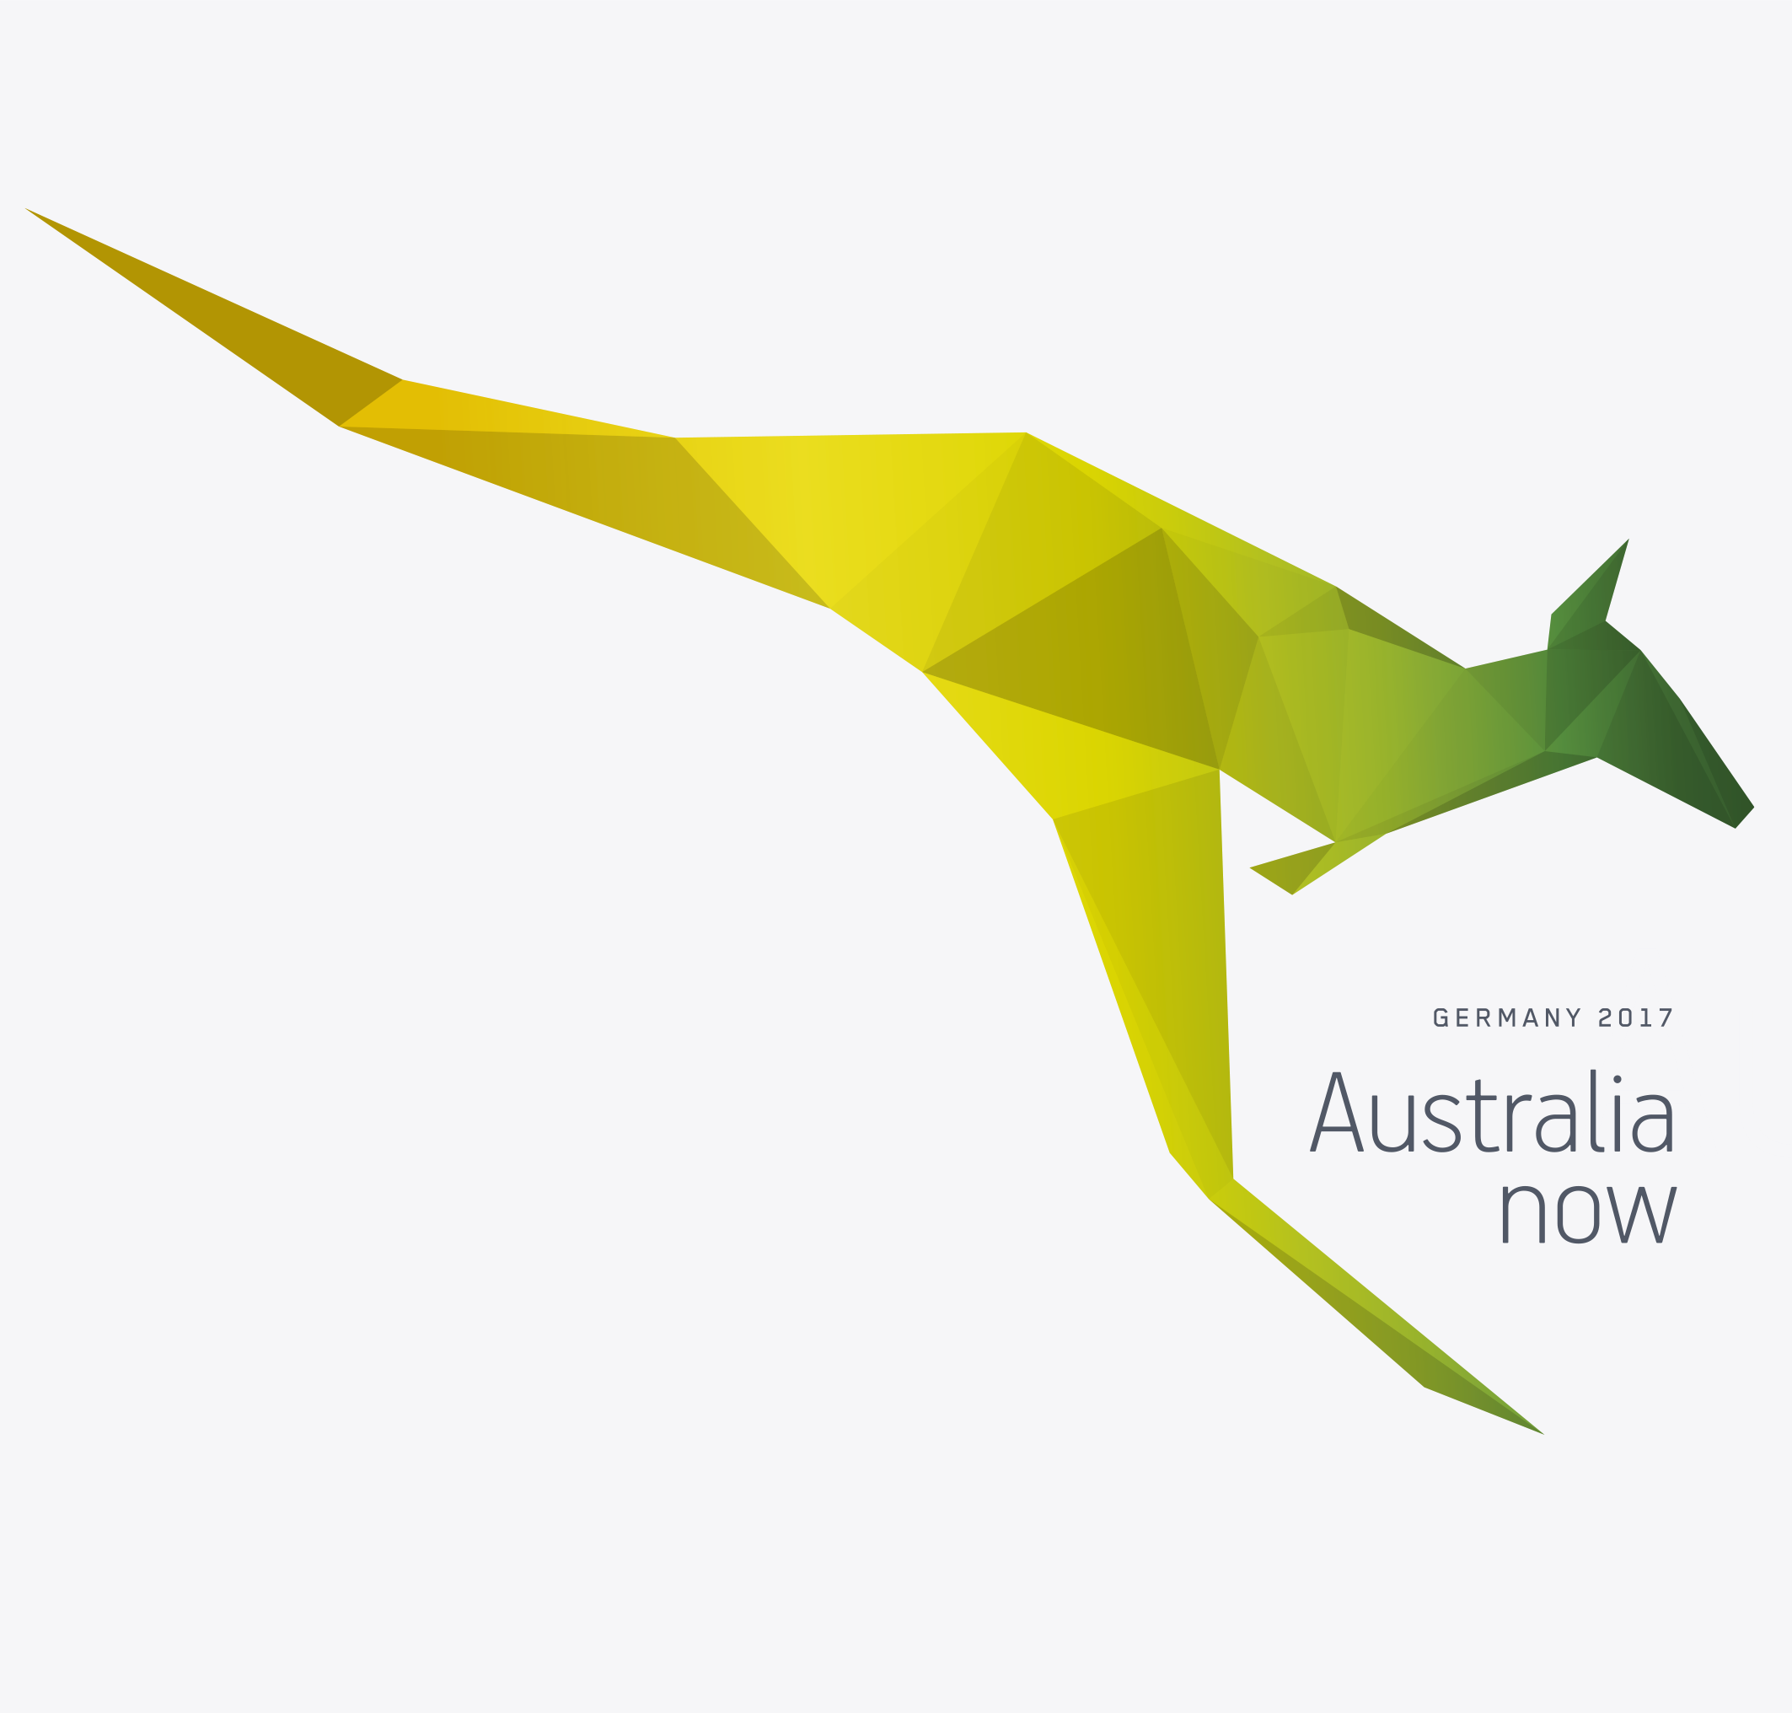

We invite you to come to Germany with us

Australia now is a celebration of Australian culture in Germany from February – November 2017. Recognising the strong ties between Australia and Germany, Australia now will promote Australia’s creative excellence, diversity, and innovation and strengthen networks and collaboration.

It’s all about building relationships for the future.

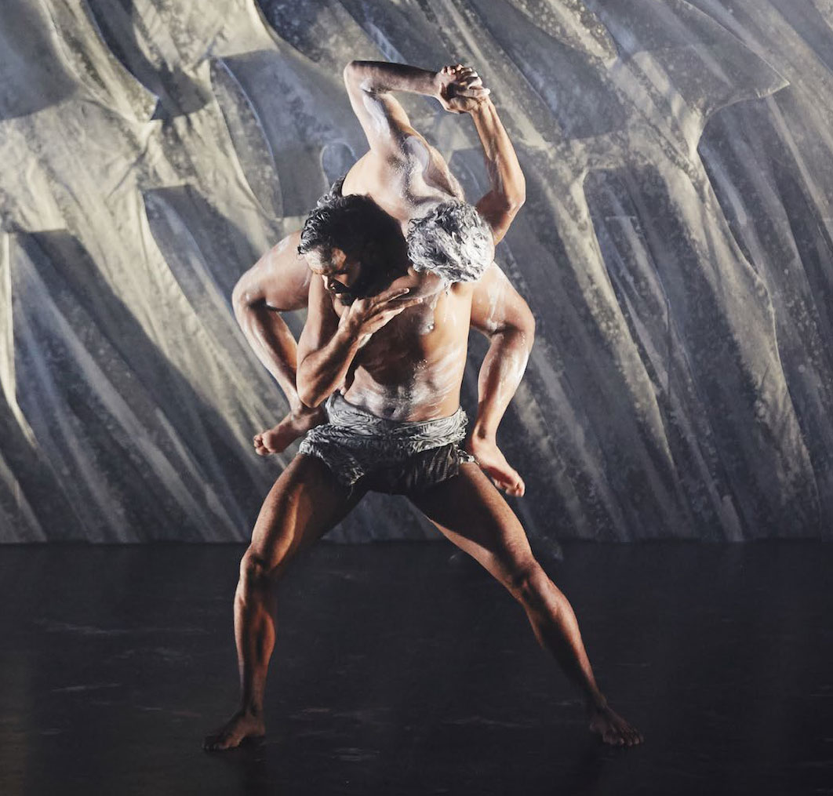

Luke Currie Richardson & Beau Dean Riley Smith Nyapanyapa, OUR land people stories Bangarra Photo by Edward Mulvihill

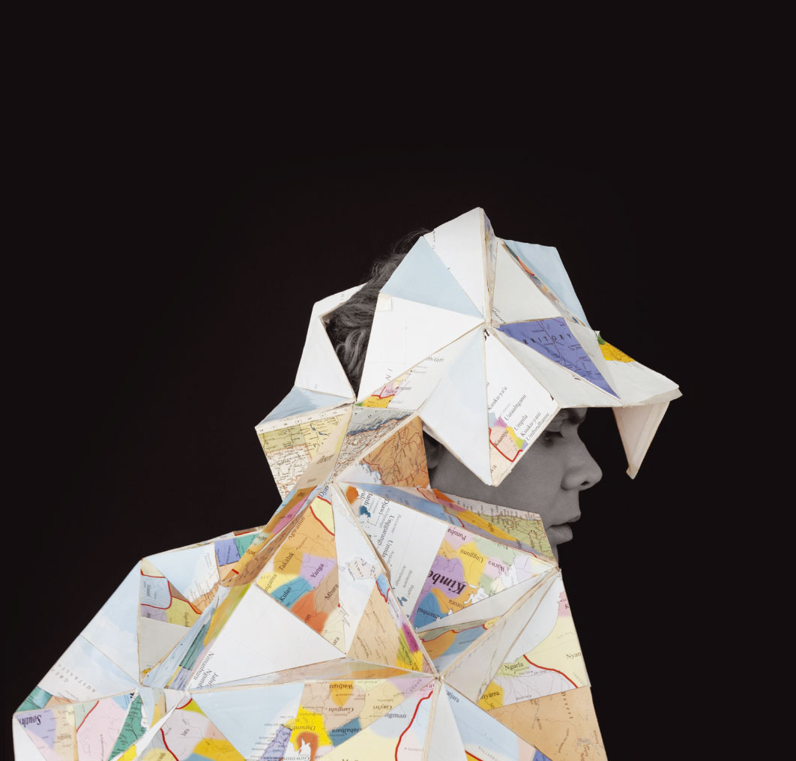

“The Australian Government is placing our creative and innovative industries at the heart of our international engagement by promoting Australian entrepreneurs and businesses overseas.”

The Hon Julie Bishop MP Minister for Foreign Affairs

Gods and Kings, 2015, Christian Thompson

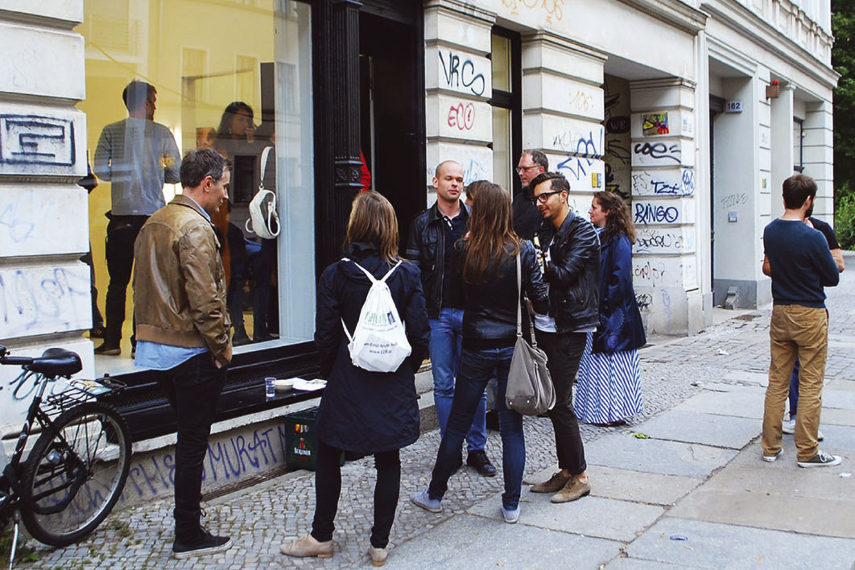

# The moment is right for Australia to engage more deeply with Germany.

## Germany is one of Australia’s largest trade partners and investment destinations. Germany is also renowned as a leader in technology, innovation and science. Germany has a rich and sophisticated arts and cultural market demonstrating innovative connections between arts and society.

### Australia now will strengthen Australian – German relations and promote Australia as a key destination for German students, tourists, innovators, researchers and investors.

Australia now:

* Raising Australia’s profile as an innovative, contemporary and creative nation
* Celebrating the cultural richness and diversity of Australia
* Promoting Australia as an attractive and safe place for Germans of all ages to explore, study, invest, conduct business and live

Australia now will offer an opportunity to explore issues of international significance about how we live and ways to deepen the connections between our communities.

Image courtesy of Michael Reid Gallery, Berlin

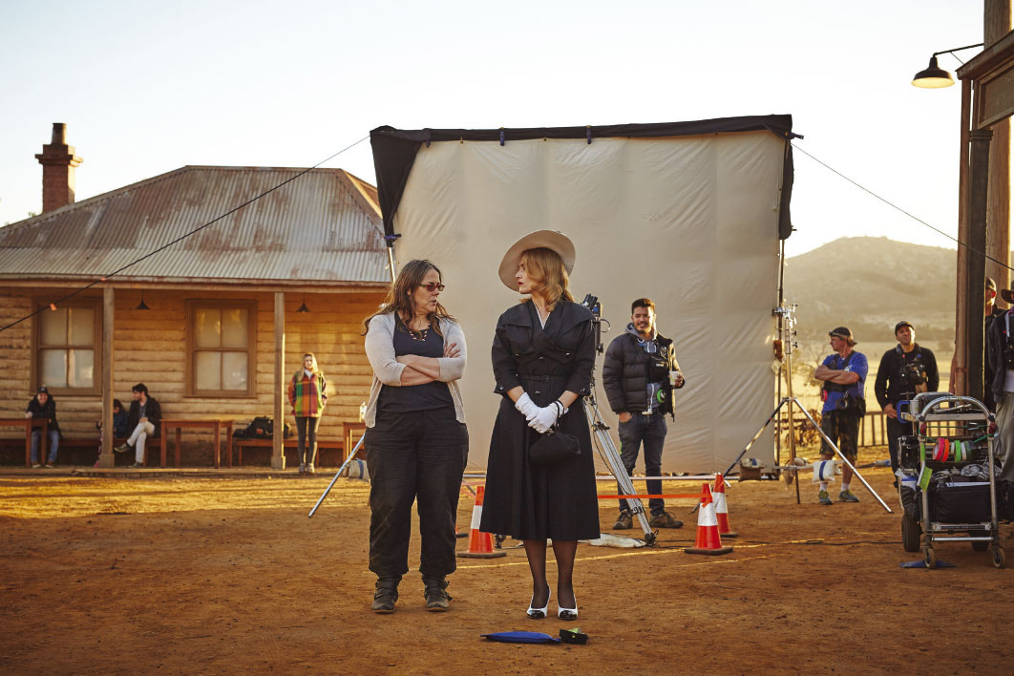

# Australia now – building relationships for the future.

Building relationships for the future:

* Reaching out to young and influential Germans
* Highlighting Australia’s world class arts, business, science, research and education sectors
* Promoting Australia as an attractive investment and tourism destination
* Demonstrating Australia’s capabilities in innovation, science, research and technology
* Illustrating Australia’s culturally rich and diverse background, unique Indigenous history and vibrant art, architecture and design practice
* Featuring Australian expertise and capability in sport and sport integrity

Partners from government, business, cultural, education, science and research institutions will join us to build these relationships.

The success of our cultural diplomacy will depend on the degree to which we tap into the relationships between people and culture.

The Dressmaker Director Jocelyn Moorhouse, Actress Kate Winslet, courtesy of Screen Australia

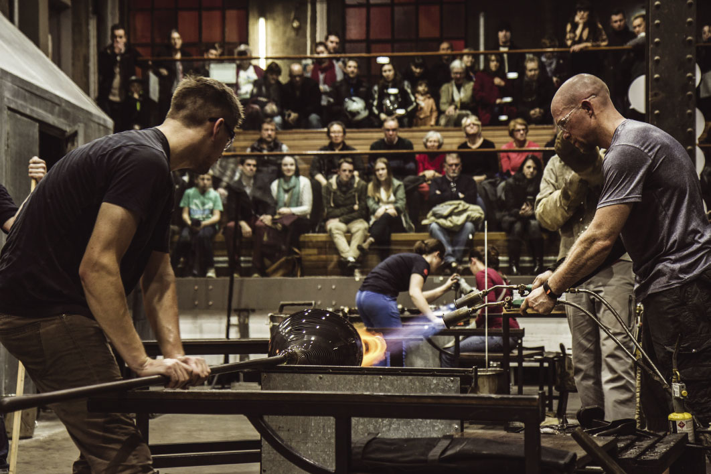

# Australia now will promote cultural exchange and cooperation across a variety of fields.

## We will join with some of Germany’s best cultural fairs, festivals and venues to stage headline events in Berlin, Munich, Frankfurt and Hamburg, along with smaller scale partnership projects and collaborations in key locations across Germany.

### Inspiring audiences through contemporary music and the performing arts, visual arts, literature, film, science and innovation, dialogue, architecture and urban design, sporting and culinary events.

Australia now will engage German society through three themes:

* Creativity: Arts and culture
* Innovation: Innovation and science
* Dialogue: Discussion, exchange and collaboration

Winter Glass Market, photo Wendy Dawes

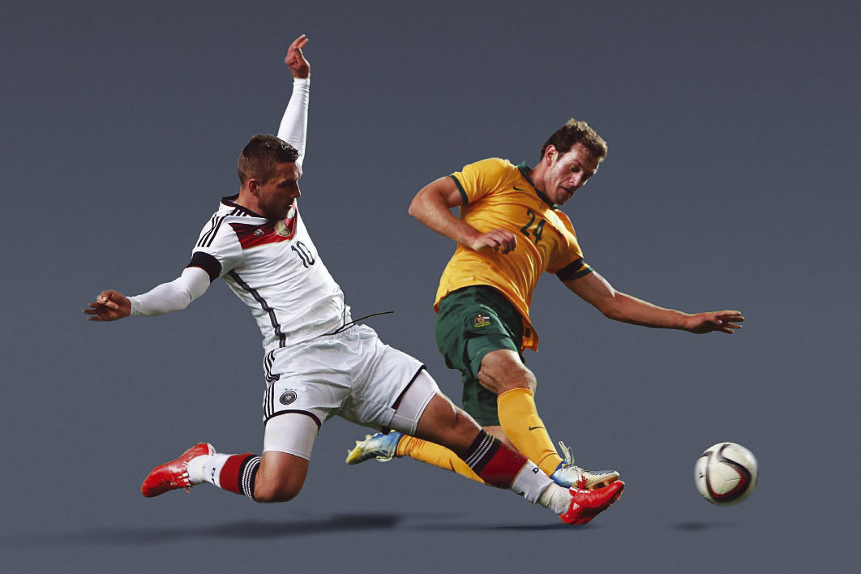

# Australia and Germany share a love of sport and rich sporting tradition. Australia now will extend sporting cooperation beyond the playing field.

## Partners of Australia now will support the Australian Government to deliver a dynamic festival that will engage German audiences, reach valued stakeholders and develop future networks.

### Australia now partners will enjoy:

* Association with this major festival of Australian culture in Germany
* Partnership recognition on Australia now marketing collateral (including printed program information, website and advertising campaign)
* Increased brand exposure to existing and new international stakeholders
* On-site branding through signage and displays at Australia now events and recognition in media kits, releases and interviews
* Networking opportunities with government and business leaders, creative industry specialists, science and technology experts, leading architects, urban designers, innovators, sporting identities and culinary products from Australia and Germany
* Invitation packages to the Australia now launch, official opening events and ticketed program events

Germany v Australia International Friendly, photo Alex Grimm

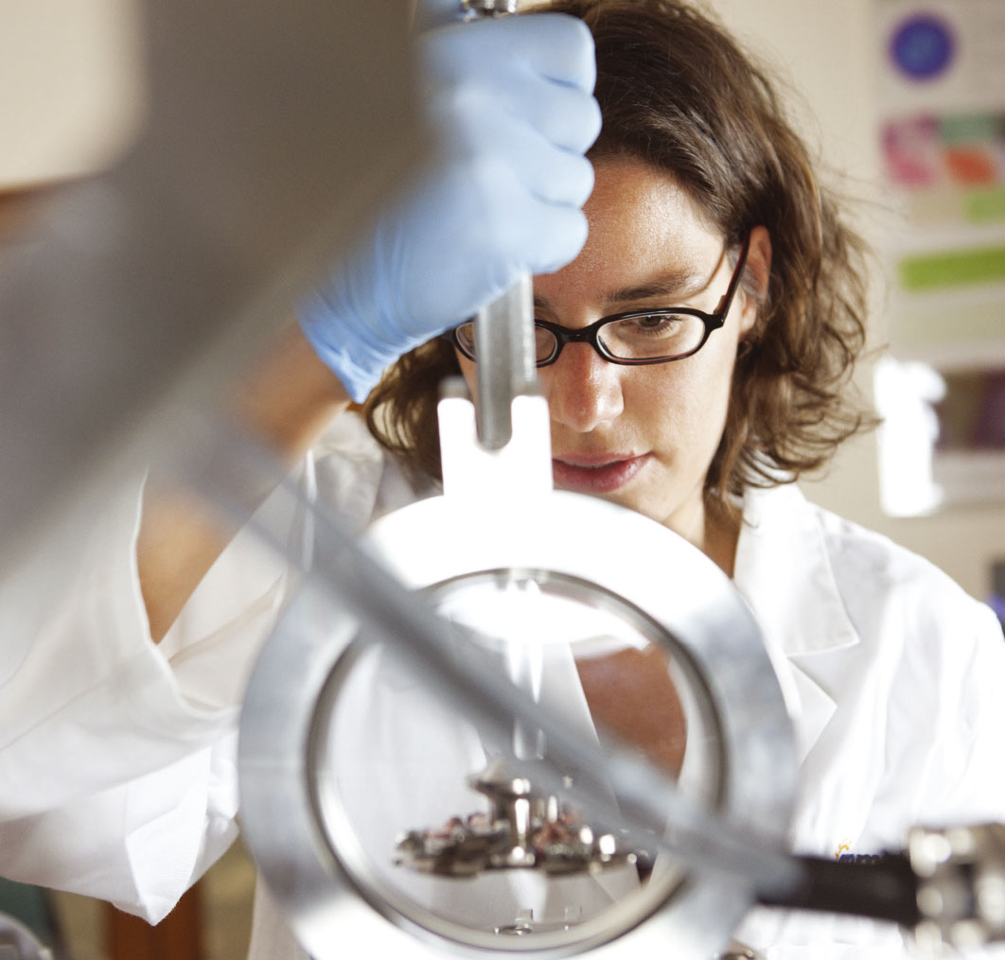

# Partner benefits and opportunities

## Australia now offers a wide range of sponsorship opportunities.

Cameca Local Electrode Atom Probe, University of Sydney

### This table indicates some of the benefits available at various sponsorship levels.

**We will work with** Australia now **sponsors to match sponsorship offerings to sponsors’ interests and requirements and welcome offers outside of these suggested amounts — from AUD5K.**

|  | Platinum | Gold | Silver | Bronze |
| --- | --- | --- | --- | --- |
| Amount (cash or in-kind) | AUD100K+ | AUD50K+ | AUD25K+ | AUD10K+ |
| **Branding Acknowledgement** |  |  |  |  |
| Sponsor logo on Australia now advertising and collateral (Australia now website, digital media and on-line platforms, program and promotional material) (tiered subject to sponsorship level) | **Platinum** | **Gold** | **Silver** | **Bronze** |
| Sponsor logo and on-site branding at specific Australia now program events | **Platinum** | **Gold** |  |  |
| Sponsor logo on featured Australia now product (e.g. tote bag) | **Platinum** | **Gold** |  |  |
| Targeted marketing opportunities to promote sponsor’s business or product and alignment with Australia now | **Platinum** |  |  |  |
| Merchandising rights, including a sponsor-specific promotional stand at particular events or signage for a stage, cinema screen or venue entrance (as agreed) | **Platinum** |  |  |  |
| Acknowledgement in selected speeches | **Platinum** | **Gold** | **Silver – as appropriate** | **Bronze – as appropriate** |
| **Events** |  |  |  |  |
| Invitations to the official Australia now launch | **Platinum – 20** | **Gold – 15** | **Silver – 10** | **Bronze – 5** |
| Invitations to official Australia now opening events | **Platinum – 20** | **Gold – 15** | **Silver – 10** | **Bronze – 5** |
| VIP tickets to featured program events | **Platinum – 20** | **Gold – 15** | **Silver – 10** | **Bronze – 5** |
| Dinner hosted by the Australian Ambassador to Germany for the sponsor and guests | **Platinum – 20** | **Gold – 8** |  |  |
| Opportunity for an exclusive tailored event with program artists | **Platinum** |  |  |  |
| A preview tour of the Australia now featured exhibition | **Platinum** | **Gold** | **Silver** |  |
| Backstage passes to selected events | **Platinum** | **Gold** |  |  |
| Speaking opportunity at a specific program or associated synchronised event | **Platinum** | **Gold** | **Silver – as appropriate** | **Bronze – as appropriate** |

We look forward to tailoring packages to your needs or facilitating sponsorship of a particular Australia now event. To discuss sponsorship options for your company or organisation, please contact:

Juliette Brassington  
Director Cultural Diplomacy  
Department of Foreign Affairs and Trade, Canberra

P: +61 2 62612909  
E: juliette.brassington@dfat.gov.au

Sinje Steinmann  
Program Manager  
Australian Embassy Berlin

P: +49 30 88 00 88 201  
E: sinje.steinmann@dfat.gov.au

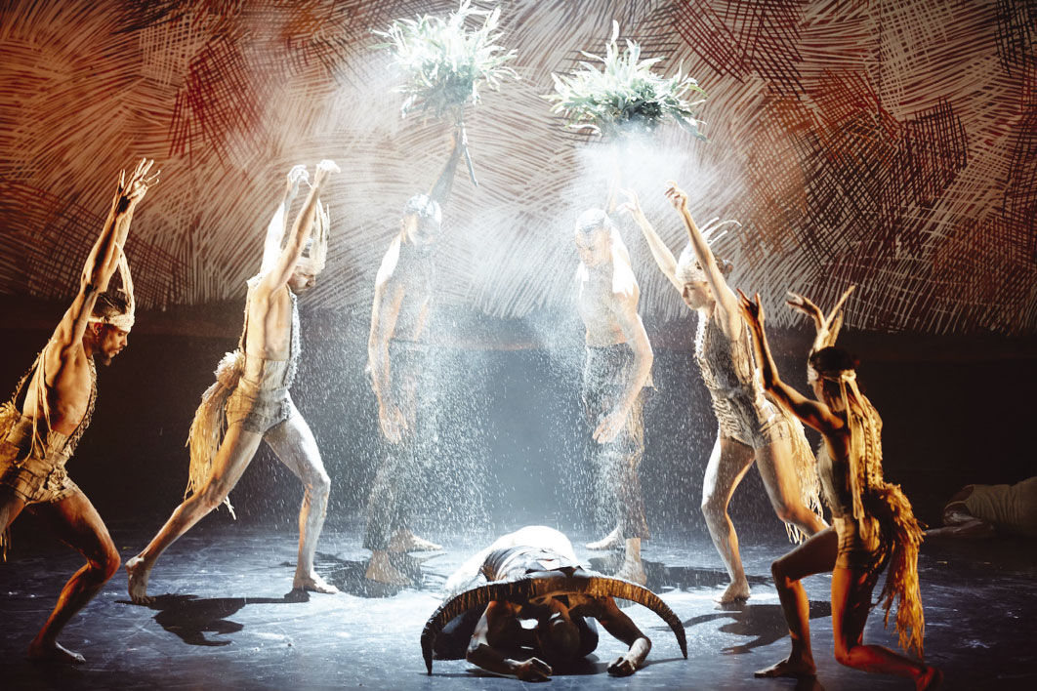

“We are thrilled to be involved with Australia now and look forward to strengthening Australia’s cultural links with Germany in 2017. As Australia’s cultural carrier, the promotion of intercultural dialogue and exchange is crucial for Bangarra.”

Philippe Magid, Executive Director, Bangarra Dance Theatre

Bangarra Dance Ensemble Nyapanyapa, OUR land people stories Photo by Edward Mulvihill

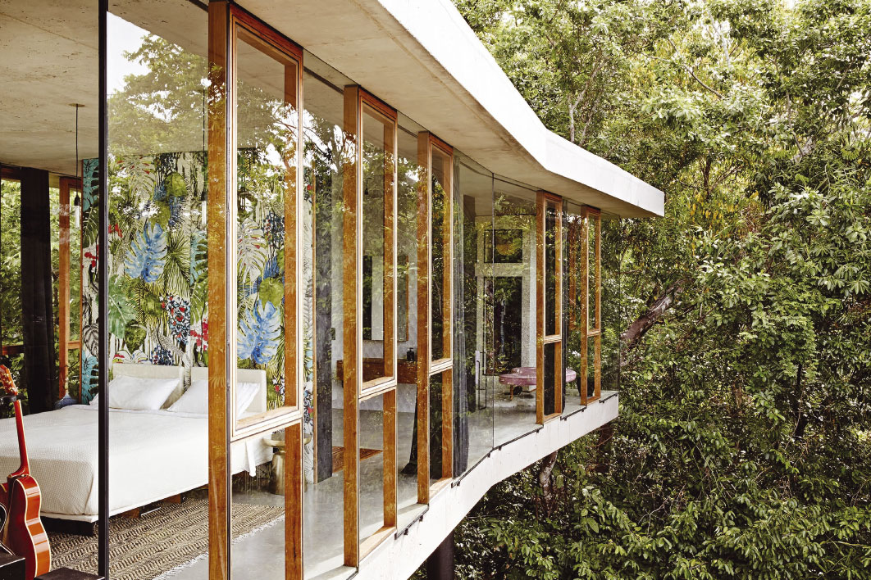

# Australia now program

## Offering exchange and engagement through inspired events, an array of specially curated programs and dialogue to elevate interest and bring our respective communities together.

### Program highlights include:

* Performances by Australia’s leading Aboriginal and Torres Strait Islander performing arts company – Bangarra Dance Theatre
* Australian films and producers featuring at the Berlin International Film Festival (Berlinale)
* Outstanding exhibitions and access to some of the world’s most prestigious contemporary art events
* Artist-in-residence programs
* Contemporary and classical music events
* Performances by prominent Australian performing arts organisations
* Dialogue and debates about issues confronting urban designers, communities and societies around the world
* Presentations and panel discussions by leading thinkers and industry experts on topics including visual arts, literature, science, innovation, urban renewal, contemporary design, sport and development
* Sporting events including football friendship matches
* Innovation and science elements through dialogue, illustrating the scope of Australian - German collaboration in science, research and education

And there are more surprises to come…

Follow us over the coming months for Australia now announcements and the full Australia now program

Jesse Bennett Architect / Builder Project Planchonella House, Photo by Sean Fennessy

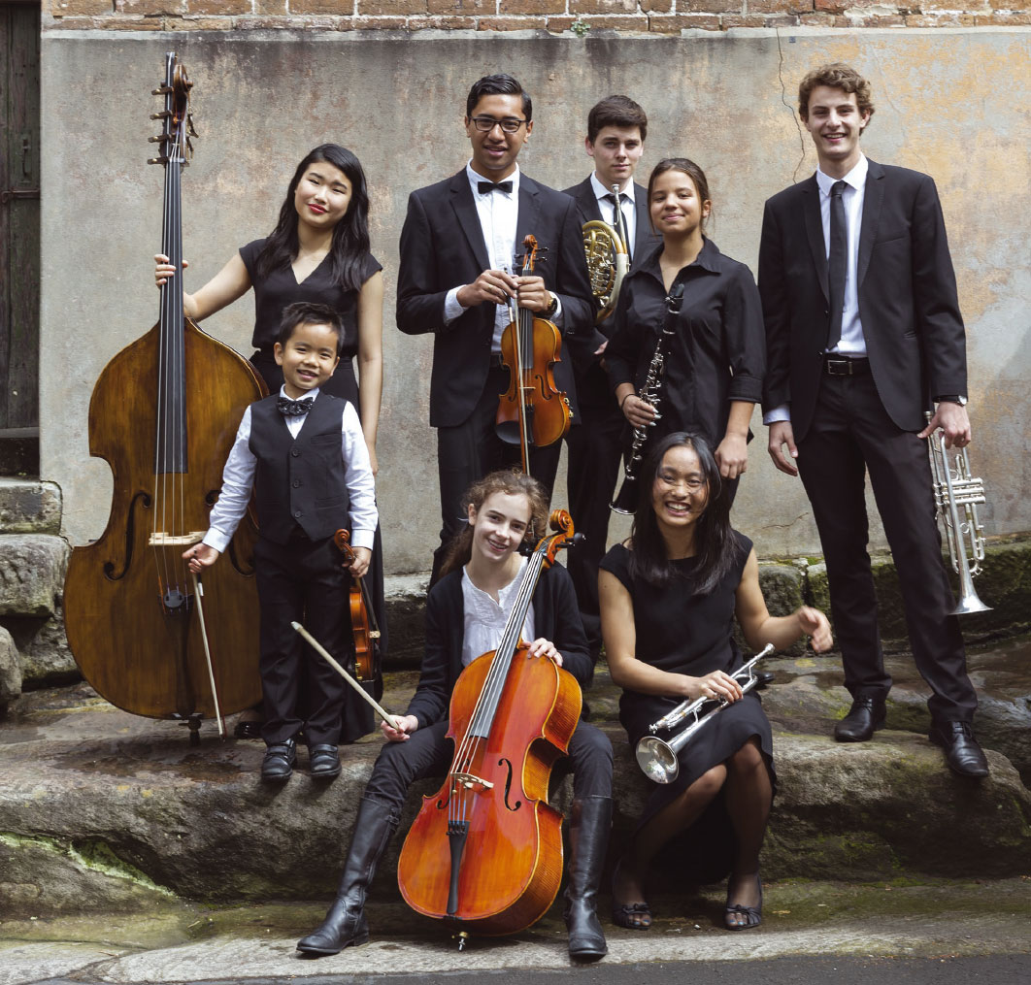

## Australia now – providing a unique opportunity to impress, connect and engage.

Sydney Youth Orchestras, Photo by Craig Proudfoot

# Join the celebration in Germany

## As an Australia now sponsor you will have an unrivalled opportunity to join leading Australian thinkers, innovators, entrepreneurs and artists to promote your business on a highly visible international platform in one of the world’s most exciting settings.

Emily Kam Kngwarray, Yam awely, 1995
synthetic polymer paint on canvas, 150 x 491 cm
National Gallery of Australia, Canberra
Gift of the Delmore Collection, Donald and Janet Holt 1995
© Emily Kam Kngwarray. Licensed by Viscopy 2016

“The German-Australian bilateral relationship has been significantly strengthened over the last few years. However, as Chairman of the Board of the German-Australian Chamber of Industry and Commerce I can see further potential for deeper economic and cultural collaboration and the Australia now program in 2017 will support this deeper engagement.”

Ron Koehler, CEO of DB Schenker Australia and Chairman of the German-Australian Chamber of Industry and Commerce

Your logo on Australia now material and programed events will speak to business leaders and audiences throughout Germany – one of the most populous and innovative countries in Europe.

Above all, you’ll have helped to celebrate Australia, its diversity and creativity.

Emily Kam Kngwarray, Yam awely, 1995  
synthetic polymer paint on canvas, 150 x 491 cm  
National Gallery of Australia, Canberra  
Gift of the Delmore Collection, Donald and Janet Holt 1995  
© Emily Kam Kngwarray. Licensed by Viscopy 2016

