VERSION 3.1

Australian Humanitarian Partnership Mid Term Evaluation

2020

Linda Kelly & Anna Roche

# Acknowledgements

The Evaluation Team would like to thank all those who generously contributed their time, reflections and ideas to this evaluation. This includes – Australian Government Department of Foreign Affairs and Trade (DFAT) staff in the Humanitarian, Non-Governmental Organisations (NGOs) and Partnership Division who guided the overall focus and context of the evaluation together with DFAT staff at the Timor Leste, Fiji, and Papua New Guinea Posts who informed the understanding of the context for the Australian Humanitarian Partnership (AHP) Disaster READY program in those countries; AHP partners and their consortium partners in Australia and in-country who provided extensive information about their programs and their visions for AHP’s future; AHP Support Unit staff who supported the evaluation with documents, information, introductions, reflections, feedback and ideas; Government officials, the staff of in-country Civil Society Organisations (CSOs) and community members who took the time to explain how they have worked with AHP, what has jointly been achieved and how it could develop in the future; and those other organisations and individuals took the time to reflect on and provide assessment about AHP, its work and how it position within into the broader humanitarian sector.

The Evaluation Team would like to also thank Guilhermina de Araujo, Eddy Pinto, Marica Tabualevu and Peta Turnbull who undertook the in-country data collection for the evaluation in Timor-Leste, Fiji and Vanuatu. Their local experience and insight contributed greatly to accurate and in-depth assessment of AHP outcomes and impact in those locations.

Linda Kelly & Anna Roche

# Executive Summary

## Introduction

The Australian Humanitarian Partnership (AHP) is a five year (2017-2022) partnership between the Australian Government (Department of Foreign Affairs and Trade, DFAT) and Australian Non-Governmental Organisations (ANGOs). This mid-term evaluation was designed to provide evidence-based assessment of the progress of AHP and recommendations for future planning.

AHP continues the support provided by DFAT to Australian NGOs to deliver effective humanitarian assistance and to provide support for communities to take a leadership role in preparedness, response, early recovery, risk reduction and resilience efforts. AHP is delivered through a partnership between DFAT and six Australian NGOs. AHP is managed by DFAT and the Australian NGOs with the assistance of a Support Unit (AHPSU).

AHP has two major areas of work. The first revolves around response to protracted and rapid onset disasters, which continues the utilisation of Australian NGO expertise in Australia’s disaster responses. The second program component is Disaster READY, a sub program that focuses on disaster risk reduction in Timor-Leste, Fiji, Papua New Guinea (PNG), Solomon Islands and Vanuatu.

In 2020, with COVID-19 closing international borders, the Disaster READY program was utilised by DFAT to respond to disasters (including Tropical Cyclone Harold) and floods in Timor-Leste), and as one of the channels of support to countries in their response to COVID-19.

## Overall findings

In the area of rapid and slow onset disasters, the program provides an effective way for DFAT to utilise Australian organisations to contribute to response and recovery. There are some possible areas for improvement in the activation mechanisms.

Disaster READY has been the major focus of this evaluation. This program has five end of program outcomes and there is evidence of progress against all five.

The current program modality, a partnership between DFAT and six accredited Australian NGOs supported by an administrative and contracting mechanism, has provided for efficient and timely use of Australian funds.

## Specific findings and related recommendations

| **Evaluation questions** | **Finding** | **Recommendations** |
| --- | --- | --- |
| 1. To what extent has AHP enabled Australia to address the needs of affected populations in rapid and slow onset disasters? | **AHP has been a highly effective mechanism to enable Australia to address the needs of affected populations in rapid and slow onset disasters.** | **Recommendation One**  **DFAT, supported by AHPSU, increase or include criteria around participation and localisation in assessments for both rapid onset and protracted activations.** **Recommendation Two**  **DFAT, supported by AHPSU, make transparent the steps in its decision-making process for both rapid onset and protracted activations**. |
| 1. What progress has Disaster READY made towards increasing the capacity of Pacific communities and their representative organisations to prepare for and respond to disasters? | **Disaster READY has made a demonstrable contribution towards increasing the capacity of Pacific communities and governments to prepare for and respond to disasters.**  However, the complexity of the program, together with its utilisation for disaster response as well as disaster preparedness, and its varied implementation in different country contexts, makes it difficult to provide a simple assessment across all of its intended outcomes.  On the other hand, the diverse experience and experimentation of Disaster READY, provides considerable learning for any possible future programs of support. | ***Recommendation Three***  **The AHPSU explore and identify how the Disaster READY in-country committees can be more effectively resourced to enhance collaboration within Disaster READY and across other DFAT programs and development actors.**  ***Recommendation Four***  **AHP partners design and implement mechanisms, relevant to their consortia arrangements, to provide communities, in-country partners and local government representatives the opportunity to provide feedback and commentary on the value and quality of disaster ready activities.** |
| 1. To what extent is the overall modality of AHP including the Support Unit, the partnership arrangements and the respective roles played by NGOs, the local partners and DFAT, fit for purpose? | **The Disaster READY modality has met the needs of DFAT and AHP partners and has largely been fit for purpose.**  There is opportunity for further development of the modality in future phases of the program | ***Recommendation Five***  **Review and update the Terms of Reference for the AHPSU to match the current services provided, noting adjustments since the commencement of the AHP**  ***Recommendation Six***  **Adjust the Monitoring Evaluation and Learning Framework (MELF) and reporting requirements for Disaster READY, to require AHP partners to provide evidence-based reporting on progress against outcomes.** |
| 1. To what extent have the activities of AHP supported and advanced the localisation of Australia’s humanitarian response? | **Some AHP activities have supported good practice in localisation at community level. However, Disaster READY shows very slow progress in shifting decision making and resources to local organisations** | ***Recommendation Seven***  **Require all AHP partners to report on progress towards localisation against an agreed set of program wide indicators.** |
| 1. To what extent have the activities of AHP supported and advanced leadership and participation of women, people with disability and other marginalised people in disaster preparation and disaster response? | **AHP results show that the program has worked to include women and people with disability. Results show that overall, gender inclusion has been more effective than inclusion of people with disability** | ***Recommendation Eight***  **AHP partners to identify and implement a strategy to increase inclusion of people with disability in program decision-making and program implementation, utilising the guidance and ideas from country Disabled People’s Organisations.**  ***Recommendation Nine***  **AHP partners and their consortia members to ensure that at least 15% of Disaster READY program beneficiaries are people living with disability.** |
| 1. To what extent have AHP activities and approaches contributed to learning and improvements in the humanitarian sector, DFAT humanitarian programming and that of the NGO community? | **AHP has good information for wider sector learning but there are currently limited opportunities to share this learning** | ***Recommendation Ten***  **The AHPSU to identify a process to capture relevant program learning and together with AHP partners, ensure this is communicated regularly through the existing program and other learning forums.** |

## Future considerations beyond AHP

### AHP as a whole

* In any future phase of AHP, consider the inclusion of a mechanism that regularly reviews program innovations and relevant new policy or practice ideas, and identifies the implications for the program, as part of ongoing program adaptation and improvement.

### Disaster READY specific

* Any future phases of Disaster READY should limit the number of program objectives in order to ensure one clear overall purpose for the program.
* Sustainability, specifically including pathways towards localisation, ought to be a major consideration for any future phases of Disaster READY.
* Activities under any future phase of Disaster READY ought to be framed within an understanding of resilience relevant to the country and regional context.
* Any future phase of Disaster READY, should shift to a country focus, while retaining opportunity for regional exchange, learning and cooperation. That is, the program should become a *multi country program.*
* In line with the current Disaster READY rationale, any future phase of the program should consider expansion to countries in the Pacific and beyond that are highly disaster prone. In the Pacific this would likely include Tonga (the remaining Pacific country among the world's most 15 disaster prone countries) and the small island states of Kiribati, Tuvalu and Nauru (all countries at particular risk of impact by disasters due to the growing influence of climate change).
* Any future phase of Disaster READY should consider inclusion of monitoring systems that provide information about the value of different consortium models in relation to program implementation and outcomes
* Any future phases of Disaster READY should require a costed and time bound plan for achieving localisation as part of the selection criteria for participating Australian NGOs. The new phase should require that the selected NGOs to report against this plan throughout the life of the program.

Table of Contents

Acknowledgements 1

Executive Summary 2

Introduction 2

Overall findings 2

Specific findings and related recommendations 2

Future considerations beyond AHP 4

AHP as a whole 4

Disaster READY specific 4

Acronyms 7

1. Introduction 8

2. Evaluation Approach 8

3. The Australian Humanitarian Partnership 9

4. Findings 10

4.1 To what extent has AHP enabled Australia to address the needs of affected populations in rapid and slow onset disasters? 10

4.1.1 Program overview 10

4.1.2 To what extent has AHP achieved effective outcomes and/or impact in its response funding? 12

4.1.3 Selection processes and parameters 16

4.2 What progress has Disaster READY made towards increasing the capacity of Pacific communities and their representative organisations to prepare for and respond to disasters? 18

4.2.1 Program description 18

4.2.2 What progress has been made towards the intended outcomes of Disaster READY? 21

4.2.3 What changes are evident at community and government level as a result of Disaster READY activities? 28

4.2.4 How could the current funding, decision-making and governance arrangements be further improved to meet the purpose of Disaster READY? 30

4.2.5 Is there scope for expansion of Disaster READY either within the existing countries or beyond? 33

4.3 To what extent is the overall modality of AHP including the Support Unit, the partnership arrangements and the respective roles played by NGOs, the local partners and DFAT, fit for purpose? 33

4.3.1 What are the benefits and constraints in utilising AHPSU as a mechanism? 34

4.3.2 Partnerships, collaboration and consortia 34

4.3.3 What are the implications for contracting, operational systems and processes for program management and implementation going forward? 35

4.4 To what extent have the activities of AHP supported and advanced the localisation of Australia’s humanitarian response? 37

4.4.1 How have initiatives supported local communities to anticipate, prepare for and reduce risks from natural hazards? 38

4.4.2 How have initiatives supported local authorities to implement inclusive DR and resilience activities? 38

4.4.3 To what extent did approaches support local leadership and not undermine local efforts? 39

4.5 To what extent have the activities of AHP supported and advanced leadership and participation of women, people with disability and other marginalised people in disaster preparation and disaster response? 43

4.5.1 Are women and people with disabilities benefiting equitably from initiatives? 43

4.5.2 How well have partners supported the inclusion and leadership of women and people with disabilities in their own staffing, volunteer and community structures that support DRR/resilience initiatives? 45

What evidence is there that women and people with disabilities are leading initiatives and playing key operational, management and decision-making roles in initiatives? 45

4.5.3 To what extent did women, men, children and people with disabilities participate in and lead decision making? 46

4.5.4 Did different groups have access to safe and responsive mechanisms to handle complaints? 47

4.6 To what extent have AHP activities and approaches contributed to learning and improvements in the humanitarian sector, DFAT humanitarian programming and that of the NGO community? 48

5. Conclusions 49

5.1 AHP overall 49

5.2 Support for rapid and slow onset disasters 49

5.3 Disaster READY 49

5.4 Beyond AHP 50

Annex One - Evaluation Plan 51

Annex Two – List of people consulted for the evaluation 66

Annex Three – Documents reviewed 70

Annex Four – Summary of Evaluation Findings 72

Annex Five - AHP rapid and protracted humanitarian responses 2017 – 2019 78

Annex Six - Disaster Ready Country Reports 81

# Acronyms

| **Acronym** | **Meaning** |
| --- | --- |
| ACFID | Australian Council for International Development |
| AHP | Australian Humanitarian Partnership |
| AHPSU | Australian Humanitarian Partnership Support Unit |
| ANCP | Australian NGO Cooperation Program |
| ANGO | Australian Non-Governmental Organisation |
| ARC | Australian Red Cross |
| AVI | Australian Volunteers International |
| CANDO | Church Agencies Network Disaster Operations |
| CDCCC | Community Disaster and Climate Change Committees |
| CHS | Core Humanitarian Standards |
| CPP | Church Partnership Program |
| CSO | Civil Society Organisation |
| CVTL | Cruz Vemelha Timor Leste |
| DFAT | Department of Foreign Affairs and Trade |
| DPO | Disabled People’s Organisation |
| ERP | Emergency Response Proposal |
| FCOSS | Fiji Council of Social Services |
| FDPF | Fiji Disabled Peoples’ Federation |
| GESI | Gender Equality and Social Inclusion |
| HAG | Humanitarian Advisory Group |
| HRG | Humanitarian Reference Group |
| LGBTQI | Lesbian, Gay, Bisexual, Transexual, Queer and Intersex |
| M&E | Monitoring and Evaluation |
| MELF | Monitoring, Evaluation and Learning Framework |
| NDMO | National Disaster Management Office |
| NGO | Non-Governmental Organisation |
| PDF | Pacific Disability Forum |
| PIANGO | Pacific Islands Association of Non-Government Organisations |
| PNG | Papua New Guinea |
| PPF | Performance and Partnership Fund |
| RHTO | Ra’es Hadomi Timor-Oan |
| SOP | Standard Operation Procedure |
| SU | Support Unit |
| TCH | Tropical Cyclone Harold |
| UASC | Unaccompanied and Separated Children |
| UN | United Nations |
| UNICEF | United Nations Children’s Fund |
| WASH | Water, Sanitation and Hygiene |

# Introduction

The Australian Humanitarian Partnership (AHP) is a five year (2017-2022) partnership between the Australian Government (Department of Foreign Affairs and Trade, DFAT) and Australian NGOs. Through AHP, DFAT and Australian NGOs coordinate and collaborate to deliver humanitarian assistance in protracted and rapid onset disasters. AHP also implements Disaster READY - an initiative in Timor-Leste and four Pacific countries that aims to strengthen community-based preparedness in cooperation with local organisations. AHP is supported by a standalone Support Unit.

The current five year phase of AHP will expire in mid-2022. This evaluation is designed to provide evidence-based assessment of the progress of AHP to date, against its intended outcomes. A major purpose of the evaluation is to provide guidance for future planning.

# Evaluation Approach

The purpose of the AHP mid-term evaluation is to *provide an evidence based assessment of AHP performance, in order to inform DFAT’s humanitarian program going forward.*

Three core evaluation questions were addressed by this review:

1. To what extent has AHP enabled Australia to address the needs of affected populations in rapid and slow onset disasters?
2. What progress has Disaster READY made towards increasing the capacity of Pacific communities and their representative organisations to prepare and respond to disasters?
3. To what extent is the overall modality of AHP including the Support Unit, the partnership arrangements and the respective roles played by NGOs, the local partners and DFAT, fit for purpose?

Alongside these questions the evaluation gave attention to three cross cutting considerations:

1. To what extent have the activities of AHP supported and advanced the localisation of Australia’s humanitarian response?
2. To what extent have the activities of AHP supported and advanced leadership and participation of women, people with disability and other marginalised people in disaster preparation and disaster response?
3. To what extent and in what ways have AHP activities and approaches contributed to learning and improvements in the international humanitarian sector, DFAT humanitarian programming and that of the NGO community?

In the approach to the evaluation the evaluation team was directed to focus in particular on assessment of Disaster READY. The evaluation was also directed towards providing DFAT with information to inform future planning and decision-making for AHP beyond the current program life. A detailed plan for the evaluation was developed in March 2020, reflecting these directions. The impact of COVID-19 led to a reshaping of this plan and an extended timeframe for its completion, adding opportunity for more in-depth data collection.[1] See Annex One for the finalised evaluation plan.

The evaluation has some limitations. In particular, the context for this evaluation has been very dynamic, leading to changes in AHP programming during, and subsequent to, the data collection process. While the evaluation has sought to accompany and understand some of these shifts, the program continues to evolve and therefore the assessment and interpretation provided in this evaluation is a time specific assessment, which does not include more recent program changes.

The travel restrictions imposed on the evaluation team required use of local researchers for data collection in three countries. There were advantages to this. The researchers brought good understanding of local context, and they were able to undertake informed consultation, particularly with communities and government in the respective countries. However, having several team members added additional layers in the data collection and interpretation process. There is some risk that details are incomplete or misinterpreted. Country and stakeholder feedback sessions were conducted to address this concern; however, this report needs to be read with this limitation in mind.

# The Australian Humanitarian Partnership

AHP has three intended outcomes:

1. Target populations receive timely and high-quality humanitarian assistance appropriate to the context; and are well supported in early recovery.
2. There is stronger local humanitarian capability and preparedness in the Pacific and Timor-Leste so that communities are better able to respond to, and recover from, rapid- and slow-onset disasters.
3. There is an ongoing contribution to sector-wide learning, policy, coordination and practice improvement through sector coordination bodies including the Humanitarian Reference Group (HRG), global, regional and country-based mechanisms.

AHP continues the support provided by DFAT to Australian NGOs[2] to deliver effective humanitarian assistance and to provide support for communities to take a leadership role in preparedness, response, early recovery, risk reduction and resilience efforts. It is aligned to DFAT policy, in particular the DFAT Humanitarian Strategy[3], and the Australian Government commitment to effective disaster risk reduction[4].

AHP is delivered through a partnership between DFAT and six Australian NGOs, who in turn work in consortium with additional Australian organisations and Non-Governmental Organisations (NGOs), and NGOs, Civil Society Organisations (CSOs) and governments in countries, to deliver both humanitarian response and disaster risk reduction (see Table 1).

##### Table 1. AHP Australian NGO Partners and consortiums

| Lead NGO | Consortium NGO members |
| --- | --- |
| **CARE Australia** | * Live & Learn |
| **Caritas Australia / CAN DO (Church Agencies Network - Disaster Operation)** | * Act for Peace * Adventist Development and Relief Agency * Anglican Board of Mission * Anglican Overseas Aid * Australian Lutheran World Service * Caritas Australia * Transform Aid International * Uniting World |
| **Oxfam Australia** | * ABC International Development * CBM Australia * Habitat for Humanity Australia |
| **Plan International Australia** | * ActionAid Australia * Australian Volunteers International * CBM Australia * ChildFund Australia * International Medical Corps UK |
| **Save the Children** |  |
| **World Vision Australia** | * Australian Bureau of Meteorology * CBM Australia * Field Ready * Habitat for Humanity Australia |

AHP has two major areas of work. The first revolves around response to protracted and rapid onset disasters, which utilises Australian NGO expertise in Australia’s disaster responses. The second program component is Disaster READY, a sub program that focuses on disaster risk reduction in Timor-Leste, Fiji, PNG, Solomon Islands and Vanuatu.

AHP is managed by DFAT and the Australian NGOs with the assistance of a Support Unit (AHPSU). The AHPSU provides grant management and administration support to the partnership and holds head agreements with each of the preselected AHP Australian NGO partners. This innovation was designed to support DFAT manage program administration, and to increase the flexibility and responsiveness of program management.

# Findings[5]

## To what extent has AHP enabled Australia to address the needs of affected populations in rapid and slow onset disasters?

**Overall finding - AHP has been a highly effective mechanism to enable Australia to address the needs of affected populations in rapid and slow onset disasters.**

### Program overview

**From its inception until the end of 2019 the AHP has responded to 18 humanitarian responses reaching just over one million people**. More than A$73million has been channelled through the AHP mechanism.[6] Of the 1.1million recorded beneficiaries to the end of 2019, 55% were women and girls, 6% people with disabilities and 47% children (see Annex Five).

Responses have been a mix of rapid responses (between 2 and 12 months) and longer-term initiatives (protracted responses) designed and delivered with multi-year funding. There were eight rapid responses during this period utilising A$10.5million (see Fig 1.).

##### Fig 1. AHP: value of rapid responses active in 2018 and 2019

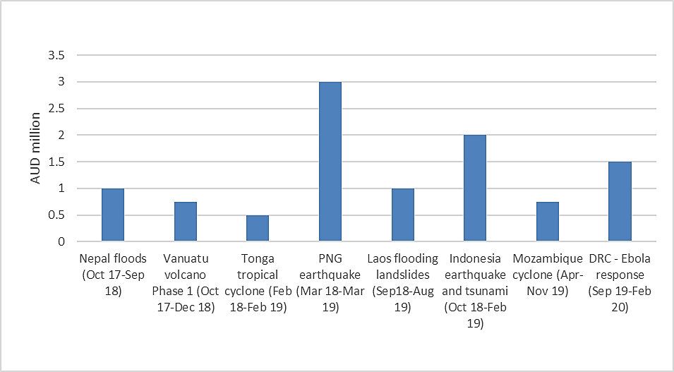

Since 2017 there have been 10 protracted responses at a cost of A$63milliion (see Fig 2.).

##### Fig 2. AHP: value of protracted responses active in 2018 and 2019

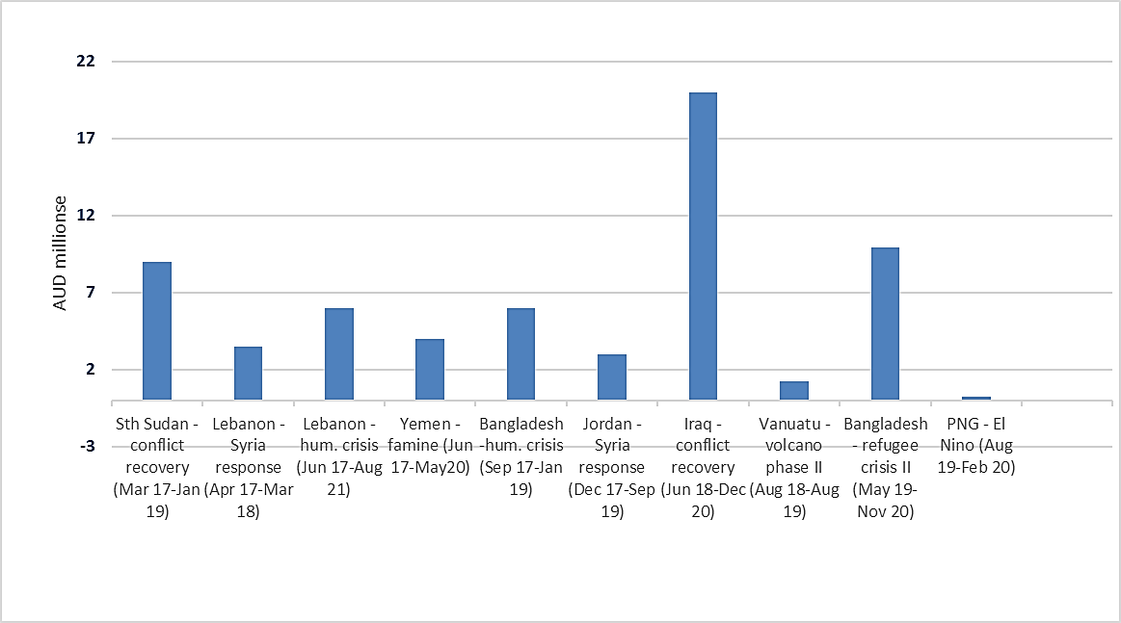

**Responses have included activity in a range of sectors**, including protection (11), Water, Sanitation and Hygiene (WASH) (13), education (7), early recovery (5), health (6), food security (7), nutrition (7), shelter and non-food items (4). See Annex Five for further details.

**In 2020 DFAT utilised AHP, through Disaster READY, to support partners response to the COVID-19 pandemic** in Fiji, PNG, Solomon Islands, Vanuatu and Timor Leste, and to other disasters (flooding in Timor Leste and Tropical Cyclone Harold (TCH) in Fiji, Solomon Islands and Vanuatu.)

### To what extent has AHP achieved effective outcomes and/or impact in its response funding?[7]

#### **Finding - AHP has made relevant and effective use of Australian funding for rapid and protracted disaster response. Responses have largely been efficient. Results for inclusion, promotion of local leadership and accountability to affected communities are more mixed.**

#### Appropriate and relevant

**The responses by AHP partners and consortia took account of and responded to assessed needs.** For instance, the evaluation of the response to the Rohingya humanitarian crisis found that both the AHP funded programs – led by Oxfam (in partnership with CARE) and Save the Children (in partnership with CBM) – were closely aligned with the urgent priorities that had been identified by the UNHCR and IOM rapid assessments of refugee needs. The evaluation also reported that affected communities viewed AHP-supported activities as relevant to their personal priority needs and that there was a common view in communities that the AHP programming was of a higher quality than those offered by other providers in their camp context.

**The AHP responses have been well aligned with wider coordination mechanisms**, including in situations where there were complex and multi-faceted needs, such as the response to the Rohingya refugee crisis. This strong connection to systems and interaction with other responders has added value. For example, the evaluation of the Yemen response led by Save the Children Australia with its local affiliate, reported that sustained engagement and interactions at the regional level between key AHP member representatives had created unusually strong lines of communications between the wider set of responders where learning, intelligence and support were more frequently and easily shared. There was a consistent view that this had had a positive, if intangible, influence on outcomes.

**The AHP responses have built on partners’ previous experience and relationships to develop appropriate and relevant implementation plans**, that have reduced overlap or duplication where more than one partner was selected for a response. For instance, the review of the South Sudan response, led by Oxfam and World Vision, reported that each partner participated in the country-wide response system, contributing and leveraging data to inform planning and implementation, and that plans reflected extensive local knowledge of context and existing relationships with key stakeholders.

**In some cases, there was scope for more collaboration between AHP responses**; for instance, the evaluation of the South Sudan response found that the two AHP funded programs (led by Oxfam and World Vision) operated as independent programs and that there might have been opportunities for more collaboration.

#### Largely effective

**Independent evaluations of the AHP responses shows all but one response as fully effective.** This conclusion was supported through review of additional external evaluations[8] and assessment by non-AHP responders.

**Outputs and outcomes were clear and largely met,** **with appropriate adjustments to activities**. AHP responses were both flexible and adaptive in response to changing needs on the ground, feedback from communities, changing in-country government requirements, changing security contexts, and so on. For example, DFAT’s early commitment to flexible unearmarked longer term funding was seen as key to the success of the Rohingya activation. It allowed applicants to tailor their submissions to the initial United Nations (UN) needs assessments and play to their organisational strengths and previous relationships. It also allowed the agencies to build momentum and leverage additional funding based on AHP funding.

At the response level, CARE was able to change its programming to provide incentives to female doctors and midwives to staff the delivery wards in the health centres it was rehabilitating. In Bangladesh, a key strength was Oxfam’s ability to adapt its WASH approaches to changing circumstances such as the very heavy monsoonal rains and the number of donors present in the WASH sector. In addition, there is some evidence that agencies adapted programs in response to local feedback.

##### Box 1. Good practice example -Bangladesh Rohingya refugee response – integration of programming across sectors

Save the Children is implementing an integrated program in the Cox’s Bazaar camp for Rohingya refugees in order to benefit from synergies between sectors. Its nine Health Posts are the centre point for program, working across the community to provide culturally appropriate health support options and to identify emerging issues in the community including child protection issues, vulnerable children and unaccompanied and separated children (UASC). Nutrition Centres are stand alone in their management but are located very close to Health Centres. They provide basic supplementary feeding programs and also specific services related to infant and young child feeding in emergencies and treatment of malnutrition. WASH programming is integrated with WASH messaging provided to people while they wait to attend Health Posts or Nutrition Centres, which allows multiple people to be engaged easily, supports peer to peer education and also helps pinpoint specific issues and locations around water borne disease.

**The consortium model contributed to the high-quality outcomes and effectiveness.**  For example, in the Iraq response the consortium model was said to have played a significant role in its success, as it allowed partners to learn from each other and strategically use the knowledge and experience of the other partners to improve the overall quality of the program. It was also noted that AHP partners contributed to improving the effectiveness and quality of other non-AHP responses through their specialist skills and modelling in areas such as disability inclusion.

**Despite AHP’s support for adaptive and flexible programming, there were some practical constraints.** It was noted in the Yemen evaluation for instance, that the cumulative delay caused by a many tiered approval process (field, local authority, country, international, donor) was challenging to rapid and flexible implementation responses.

#### Mostly efficient

**The AHP responses were well managed, largely cost-effective and implemented within budget and within agreed timelines**. The one identified exception was the Church Agencies Network Disaster Operations (CANDO) PNG earthquake response, which was beset by significant delays with key activities incomplete at the time of the evaluation.

**Overall, the program offered value for money**, despite the inevitable difficulties and risks of working in the context of a disaster. The AHP approach appears to have contributed to these assessments. For example, AHP activities are often complementary to, or coordinated with, other efforts (by other agencies or by the AHP partner funds from other donors) which reduces duplication, has a positive effect on relationships and increases efficiency, and the possibilities of leveraging funding.

#### Mixed progress on inclusion

**AHP includes gender and protection as central to its approaches and strategies.** Independent evaluation of both rapid and protracted responses noted that the response activities aligned with Australia’s humanitarian strategy in their focus on gender and women’s empowerment, protection and disability inclusion. This has been supported in action in the AHP responses with good attention to gender inclusion reported in all AHP response evaluations.

##### Box 2. Good practice example - Indonesian Sulawesi earthquake and tsunami response.

During the Indonesian Sulawesi earthquake and tsunami response, post-disaster assessments identified adolescent girls, pregnant mothers and mothers of young children as high risk, particularly in relation to health and nutrition. Response activities were focused accordingly. Save the Children developed a nutrition project that promoted women and girls’ participation through the distribution of dignity kits, menstrual hygiene education and the establishment of infant and young child feeding centres. As part of is exit strategy, Save the Children handed infant and young child feeding services over to the Provincial Government and, through partnership with Indonesian NGO Sentra Laktasi, trained health workers from 12 local health clinics in two districts and provided additional training to village health cadres.

*From: AHP Humanitarian Response Annual Progress Update 2019*

**Gender relevant approaches have been culturally appropriate**. For example, the Rohingya evaluation found that they were “*sophisticated, well-resourced and relevant to context and outcomes proposed.*” Across the responses, the evaluations found that there have been positive signs of cultural shifts in the acceptance of women’s presence and activity in civil society. This has included men speaking about their support of women.

**AHP partner NGOs report that attention has been paid to disability inclusion, but with limited success in reaching people with disabilities**. This assessment is supported by the findings of the independent evaluations. Across all of the humanitarian responses only 6% of beneficiaries identified as people with disabilities. [9] The challenges in this area of inclusion include what the Rohingya evaluation called “an intersection of issues”. These include: difficulties in identifying people with disabilities, cultural attitudes, high demand and limited resources, overcrowding and space issues within camps, and difficult terrain.

**There have been some good initiatives to improve disability inclusion.** In the PNG earthquake response, CARE worked with local disability organisations to conduct a disability needs assessment and involved these organisations in responding to the identified needs. The consortium working on conflict recovery in the Iraq response included Handicap International, who ensured there was a focus on disability inclusion. Consortium partners reported that the involvement of Handicap International as a partner enabled them to significantly improve their understanding of tools and methodologies around disability inclusion and also reported that there was a ripple effect beyond the AHP consortium partners with other responders gaining understanding and improving their approaches.

#### Some progress on local leadership

**Localisation is a focus of large-scale rapid and slow onset responses in AHP[10];** however, the results so far have been mixed**.**

**AHP partners have tried to work in coordination and alignment with local mechanisms**. For example, in PNG these relationships were essential to acceptance into the communities. There was also evidence in most responses that NGO work with local partners and governments had strengthened the organisational capacity and improved communication between those local partners. However, AHP partners reported difficulty in finding appropriate and available local organisations to partner with and challenges around integrating them into wider coordination mechanisms.

#### Progress towards accountability to affected populations

**The AHP responses have made efforts to be transparent and accountable to affected populations in line with Core Humanitarian Standards(CRS).**[11] AHP partners have implemented mechanisms for transparency and accountability in both rapid and protracted responses. These were varied and included both formal and informal mechanisms. Some responses invested in multiple mechanisms to help ensure accountability to affected people. Examples include formal post-activity monitoring, regular planned meetings with community groups, and systematic inclusion of feedback mechanisms within post distribution monitoring, a free local hotline to record complaints, and permanently staffed desks at food distribution points and primary health care centres (Save the Children in Yemen).

**Attention was paid to inclusion** with examples such as holding feedback sessions in women-friendly spaces, working with organisations such as Translators without Borders to allow complaints to be registered (CARE, Rohingya response), setting up ‘listening groups’ of key cohorts – women, men, girls, boys and traditional birth attendants - whose inputs guided meetings with local authorities (Oxfam, Rohingya response). In the first systematic attempt by any agency in a response context, Save the Children in the Rohingya response, having recognised that very small numbers of children were accessing existing mechanisms, is also piloting a child friendly feedback system.

**Despite the efforts, it was reported that achieving accountability was difficult for a number of reasons**. These included cultural norms that restrict women’s voice and mobility, literacy levels of respondents, the difficulty of engaging face-to-face with community members to encourage feedback, language issues, especially for women, and inconsistent accountability pathways through local hierarchies, such as churches.

**Some positive outcomes were reported where programs were adapted or changed as a result of feedback.** For instance, in the Yemen response, the local community used a free hotline to petition for a water point which was subsequently installed by Save the Children. CARE acting in the PNG earthquake response, kept a record of community feedback and its response to it, including for instance replacing axe heads which were reported to be sub-standard.

### Selection processes and parameters

**Finding- the current selection processes for both rapid and protracted responses serve DFAT’s interests and through ongoing improvement are largely fit for purpose.**

#### In what ways do the current processes for the response mechanism support selection of the best placed organisation to respond?

**The AHP Support Unit has developed clear Standard Operating Procedures (SOP)** for both rapid and protracted crises activations including templates for proposals (see Box 3).

**Review of the procedures for rapid activations indicated a good degree of confidence that the best proposal was funded**.Where the full process, including peer scoring of proposals, was followed, the scoring tended to indicate a clear ’winner’, suggesting consensus on the merit of individual proposals.

**Protracted and slow onset activation processes are determined directly by a DFAT Assessment Committee,** most often together with an independent humanitarian specialist. In these situations, proposals are scored against criteria based on the specific context of the crisis, enabling DFAT to select the most suitable organisation or consortium of organisations for the response.

##### Box 3. SOP for rapid and protracted crisis activations

For rapid responses, the selection process involves an assessment of Emergency Response Proposals (ERPs) submitted by AHP partners in response to an activation request from DFAT. Parameters for activations, including priority sectors and geographic areas, funding amounts and the number of proposals to be funded are set by DFAT, with provision for input by AHP partners in a pre-activation teleconference.

Protracted and slow onset activation processes follow a similar process path with some modifications.

#### In what way do the selection criteria and parameters facilitate best response outcomes?

**Reviews of the rapid response activation mechanisms have found these to be fit for purpose, effective and flexible**. The AHPSU activation reviews have found that the process has worked largely as planned and have enabled DFAT to respond quickly to crises, make timely funding decisions and dispersing funds efficiently via the Support Unit.

**The activation process has been regularly updated and improved** as a result of these reviews and other feedback. This has included adapting the process so that DFAT engages earlier in the process with AHP partners around shaping the parameters of the activation and providing clear communication around requirements.

**AHP partners noted a shift within the process to AHP NGOs increasingly collaborating** to develop joint proposals, including with other consortia partners. This is to ensure that the best positioned, technically able and complementary combination of NGO strengths is available to respond. Over the period from the start of the AHP, 30% of ERPs received for both rapid and protracted activations were from consortia of AHP partners. Notably, and as discussed later in this report, the in-country Disaster READY committees have submitted single country proposals for responses to the recent COVID-19 pandemic, TCH and Timor Leste flooding.

The Bangladesh (Rohingya) Phase III response is a recent innovation, involving a joint all-partner design process intended to increase effectiveness and efficiency by coordinating and aligning the responses of the NGOs to individual agencies’ sectoral strengths and existing in-country partnerships and relationships. It was consistently identified by respondents as a possible model for future activations.

#### In what ways could these parameters be further strengthened?

**There were some concerns expressed around the activation process, mostly to do with the transparency of decision-making**. For example, there was a view expressed by a small number of respondents that some AHP partners negotiate outside the formal process, undermining the impartiality of the scoring and also the trust between AHP partners. A further view was expressed that Australian NGOs who work closely with local partners to develop their proposals have tended to lose out to more ‘polished’ submissions, wholly constructed by Australian NGOs’, thus limiting local voice in the process and undermining localisation efforts.

#### **Recommendation One**

**DFAT, supported by AHPSU, increase or include criteria around participation and localisation in assessments for both rapid onset and protracted activations.**

**There were also comments that there was insufficient clarity around decision-making in DFAT,** such as the process for deciding whether an activation was through the rapid or protracted process; the role of Posts in the process; and utilisation, or not, of technical expertise when DFAT is assessing proposals on technical merit.

#### **Recommendation Two**

**DFAT, supported by AHPSU, make transparent the steps in its decision-making process for both rapid onset and protracted activations**.

## What progress has Disaster READY made towards increasing the capacity of Pacific communities and their representative organisations to prepare for and respond to disasters?

**Overall finding - Disaster READY has made a demonstrable contribution towards increasing the capacity of Pacific communities and governments to prepare for and respond to disasters.**

However, the complexity of the program, together with its utilisation for disaster response as well as disaster preparedness, and its varied implementation in different country contexts, makes it difficult to provide a simple assessment across all of its intended outcomes.

On the other hand, the diverse experience and experimentation of Disaster READY, provides considerable learning for any possible future programs of support.

### Program description

**Disaster READY was designed to prioritise collaborative efforts for disaster preparedness, complementing other work focused on resilience**. Its purpose is to s*trengthen local humanitarian capability and preparedness in the Pacific and Timor-Leste so that communities are better able to respond to and recover from rapid and slow onset disasters.* It envisaged strong coordination between disaster risk reduction and other NGO programs focused on community building such as ANCP. Recognising the considerable overlap with climate change risk reduction, the design proposed close collaboration with DFAT Pacific climate change programs.

**The AHP design proposed an emphasis on NGOs as innovators, able to create new ways of working and new approaches to building disaster resilience** in the Pacific and elsewhere. The focus and requirements of this innovation were not specified, although a fund to support innovation was included as part of the program design.

**Disaster READY has a complex implementation model** (see Box 4). The program is implemented in five countries, identified as some of the most disaster-prone countries in the world.[12] Across those five locations, it has 4.5 years to achieve five substantial end-of-investment outcomes.[13]

##### Box 4. Disaster READY implementation processes

The program is contracted through the six Australian NGOs who in turn each subcontract a consortium of partners that include Australian NGOs and other organisations. Program implementation is undertaken by a mixture of direct implementation by Australian NGOs and their consortia, work by the local country branch of the Australian NGO or the consortium partner, and /or through local organisations and local government partners.

Each country has an in-country committee comprised of different combinations of representatives from Australian NGO local branches and /or local partners (in Fiji local partners make up the majority of the in-country committee, in contrast to other locations). These in-country committees also have a place reserved for representation by the local Disabled People’s Organisation (DPO). They are each supported by a shared services function, funded through Disaster READY, which assists with a focus on gender and social inclusion, child protection and overall collaboration

Until recently in-country committees were responsible for oversight of program implementation and worked to ensure collaboration and coordination between the respective Australian NGO funded programs operating in that country. The responsibilities of these committees has broadened with recent disaster response funding allocations.

**Disaster READY has multiple funding streams**. It commenced with multi-year funding for each of the six Australian NGOs (A$5 million each), plus funding for shared services (A$2.4 million, directed at support for increased gender and social inclusion and support for in-country coordination). These funds are allocated against annual work plans, based on country designs overseen by the Australian NGOs. The initial design also included a Performance and Partnership Fund (PPF) of A$8.5 million, able to be accessed by competitive grants which were open to all of the AHP consortia and designed to assist them scale up successful collaborations and innovations.

**The resourcing available to achieve end of program outcomes in each location shows considerable variation**, not proportionate to population**.** Up until the recent additional funding for disaster response and support for COVID-19 response, resources have beenallocated by AHP partners based on their program and country focus. This has led to some sharp variations in available resourcing (see Fig 3 & 4).[14] This wide variation makes it difficult to simply assess the overall value for money of the Disaster READY inputs.

##### Fig 3. Total Disaster READY funding Yrs 1 – 3 by country including PPF1 funds

##### Figure 3 is a bar graph displaying the Disaster READY funding allocated to each Disaster READY country across the program's first three years. The amounts include the Performance and Partnership Fund. The graph shows Vanuatu has received the most funding, followed by Timor-Leste, Solomon Islands and Fiji. Papua New Guinea has received the least. Information regarding specific amounts can be obtained by contacting the AHPSU on supportunit@ahpsu.com

##### Fig 4. Disaster READY funding including PPF1 funds Yrs 1 – 3 by Australian Non-Governmental Organisation (ANGO) and country

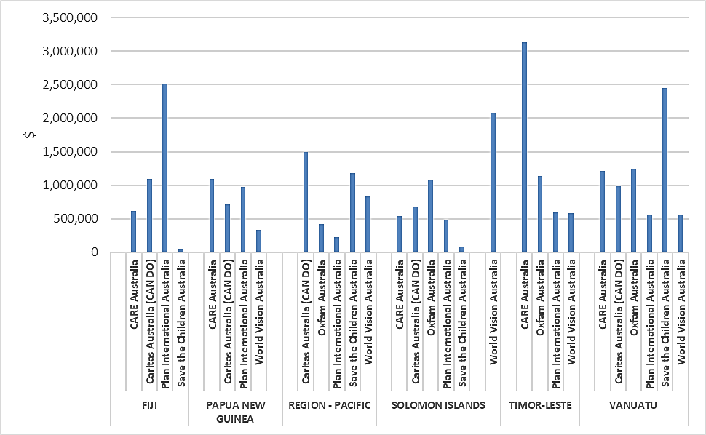

**In 2020, with COVID-19 closing international borders and limiting international travel, the Disaster READY preparedness program was utilised by DFAT to respond to disasters** (including Tropical Cyclone Harold (TCH) and floods in Timor-Leste), and as one of the channels of support to countries in their response to COVID-19 (see Fig 5). As discussed later in this report, this has led to rapid and considerable adaptation by Disaster READY, providing good outcomes but also stretching existing systems and staff capacity.

**In contrast to the original Disaster READY processes, this additional funding was managed directly by the in-country committees,** changing program responsibility and accountability arrangements. The additional funds were channelled through Australian NGOs, but proposals were designed and managed by the in-country committees, changing the original purpose and mandate of those groups.

##### Fig 5. COVID funding allocated through Disaster READY[15]

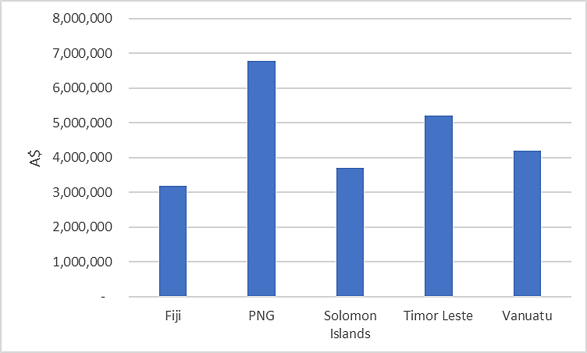

### What progress has been made towards the intended outcomes of Disaster READY?

**Finding - Disaster READY has made progress against all of its intended outcomes although progress has varied between countries and against each outcome.**

The most significant progress has been in preparedness, coordination with country systems and collaboration between AHP partners. Mixed progress has been achieved in inclusion and strengthening the role of local actors and organisations**.**

The AHPSU collate reporting from across Disaster READY every six months to make a judgement about progress against the program intended outcomes. The most recent summary of that judgement shows the variation by country and by outcome (see Table 2).

##### Table 2. Disaster READY summary of progress against outcomes by country Jan-Dec 2019[16]

| **Country** | **Preparedness** | **Inclusion and protection** | **Coordination within-country systems** | **Strengthening the role of organisations** | **Collaboration** |
| --- | --- | --- | --- | --- | --- |
| **Fiji** | Progress | Progress | Progress | Progress | Significant progress |
| **Papua New Guinea** | Minor Progress | Minor Progress | Progress | Minor Progress | Minor Progress |
| **Solomon Islands** | Progress | Minor Progress | Minor Progress | Progress | Progress |
| **Timor Leste** | Progress | Significant Progress | Progress | Progress | Progress |
| **Vanuatu** | Progress | Progress | Progress | Minor Progress | Progress |

Additional assessment and detail for each outcome area, drawing on the information collected though this evaluation[17], is provided in the following sections. Detailed findings from three of the five countries are included at Annex Six.

#### Communities are better prepared for rapid and slow onset disasters

**In the first two years of implementation (2017-19), Disaster READY assisted 50,555 people directly,** (49.5% women and 50.5% men, and 1.8% of people who identified as having a disability). Progress against targets has tended to be more significant in Fiji and Vanuatu overall (see Fig 6.)

##### Fig 6. Percentage achievement against targets for key indicators of **Preparedness -** by country, cumulative to December 2019[18]

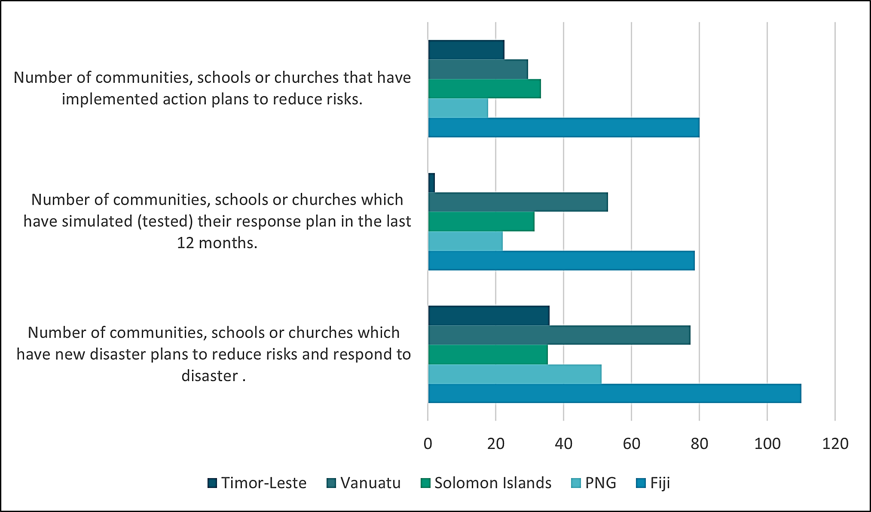

**In most locations the preparedness work has provided people with the knowledge and/or the local systems and structures to act to support themselves and others in response to disasters**. For example, in Fiji women reported that with the approach of TCH, they were able to recall information provided in training and knew how to organise themselves, their families and other community members through the disaster and during immediate recovery. This included giving attention to vulnerable groups and ensuring safety and organisation in evacuation centres. In Vanuatu, the local government representatives reported that in areas where community disaster committees had been supported by Disaster READY, these were seen to be actively supporting the distribution of food and other items in the aftermath of TCH. This ensured more timely delivery of essential supplies and fair and equitable distribution, in strong contrast to community activity in other locations.

#### The rights and needs of vulnerable groups are being met in disaster preparedness and response at all levels

**Disaster READY gives particular attention to promoting inclusion of vulnerable groups** within its preparedness work and the work it promotes with partners, including Governments. Attention to inclusion in program work plans and Disaster READY activities, up until the end of 2019, shows that all countries are making progress in their inclusion work (see Fig 7), with more being achieved by Timor Leste and Vanuatu overall.

##### Fig 7. Percentage achievement against targets for indicators of **Gender and Social Inclusion -** by country, cumulative to Dec 2019

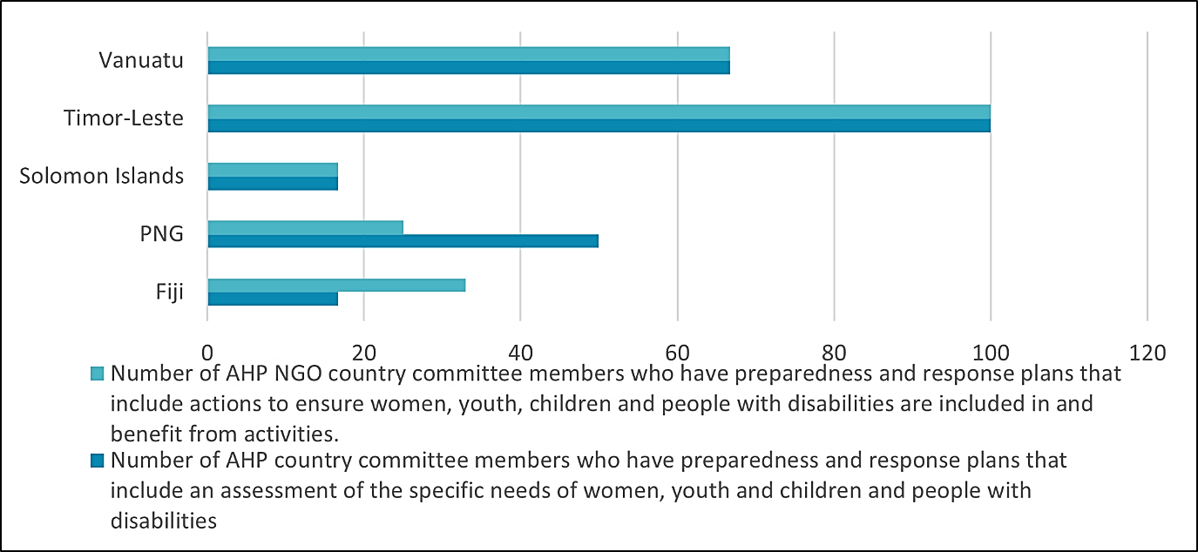

**Where Disaster READY is seeking to influence the work of others, there is good progress towards increased gender inclusion**. For example, in Vanuatu, the Department of Women’s Affairs pointed to the significant support by Disaster READY for the Gender and Protection cluster. The Disaster READY NGOs had also supported attention to humanitarian response in the national gender and equality policy. At the community level in Vanuatu, people talked about the different roles able to be played by men and women in the response to TCH. They commented on the different knowledge and contributions of men and women and how these were important in an effective disaster response. Fiji National Government staff spoke about how their community preparedness training now has a Gender Equality and Social Inclusion (GESI) lens, which has lifted the quality of the training and led to communities being much better prepared. In Timor-Leste, the many local leaders who provided feedback consistently pointed to the benefits of having women involved in both preparation and response. External respondents in Timor Leste also pointed to the impact of the program in changing inclusion of women at local government levels.

**In contrast, Disaster READY appears to have had less influence on the inclusion of people with a disability**. Notably in the first two years of Disaster READY implementation, only 1.8% of beneficiaries were identified as people living with a disability. The field research undertaken for the evaluation observed at community level in some countries, that people with disabilities were actively discriminated against and excluded from community level meetings and discussions. In community discussions in other locations, people pointed to the need to help women and elderly people but largely ignored the possible additional needs of people with disability. This likely puts people with disability at much greater risk in situations of disaster.

There are some positive examples. In Timor-Leste, for example, particular attention was given to influencing government systems and guidelines around humanitarian response to ensure greater attention to the diverse needs of people with disability. Across most of the countries, local government counterparts who responded to the evaluation pointed to the importance of disability inclusion and have clearly been well-informed about the Disaster READY focus on disability inclusion. Translation from information into action appears to be the ongoing challenge.

**Consultation with DPOs suggest that they have been increasingly engaged in and supported by Disaster READY.** The program architecture requires the participation of the DPO in in-country committees. DPOs reported that they had been utilised to support training for partners and as part of in-country assessment work during the recent responses.

**Including DPOs in training is not sufficient to support the active engagement of DPOs in Disaster READY implementation and decision-making** nor in in-country committee discussions and processes. The DPOs report that this is in some part, because reasonable accommodation has not been provided for their participation. In addition, DPOs and the Pacific Disability Forum (PDF) suggest that while there has been progress around awareness and knowledge about disability inclusion in Disaster READY, NGOs are still not being held fully accountable to ensure that disability inclusion is mainstreamed into decision-making, leadership, implementation and assessment systems. This is an area for further development in the program going forward.

**There is some indication that in Fiji there is increased inclusion of other vulnerable groups including people from the Lesbian. Gay, Bisexual, Transexual, Queer, and Intersex (LGBTQI) community**. This is reportedly possible because of the wide number of local partners participating in the Fiji Disaster READY program, where the emphasis is upon introducing good-quality development organisations (including those concerned with LGBTQI inclusion) into the humanitarian space.

#### Government, NGOs and the private sector and community coordinate more effectively

**Disaster READY is building positive relationships with both national and subnational governments and supporting development of country humanitarian systems**. In most locations there is good progress towards the targets established for this outcome (see Fig 8.). In the feedback received for the evaluation. there was strong support for the collaborative approach introduced by Disaster READY and the willingness of the in-country committees and in-country partners to work within and alongside government systems and in line with government guidelines and regulations.

##### Fig 8. Percentage achievement against target for indicators of **sector coordination**- by country, cumulative to December 2019

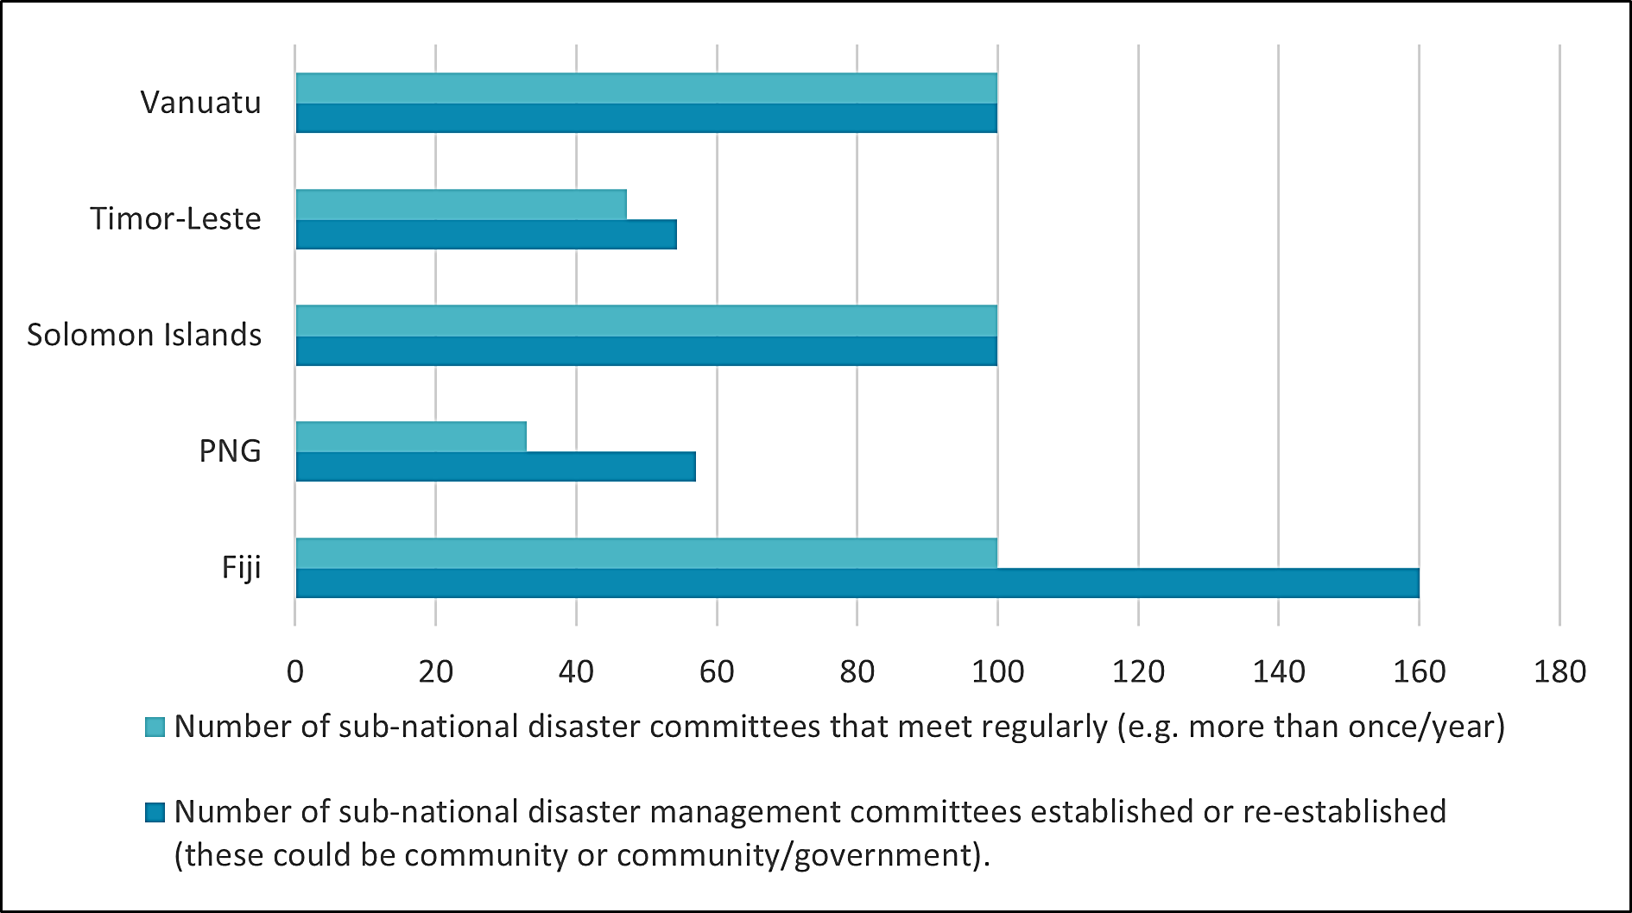

**Examples of progress highlight the different contexts in which Disaster READY is being implemented,** including the existing relationships between civil society and government in those contexts. For example, in Timor-Leste, national government representatives pointed to the willingness of the Disaster READY NGOs to work together with government systems, as something that distinguished the program from the work of other NGOs.

In Fiji, both the government and wider civil society strongly supported the collective approach demonstrated by Disaster READY. The program focus on coordination appears to have increased the legitimacy and value of Disaster READY and influenced greater collaboration among other civil society organisations in the country. National and subnational governments reported that they saw Disaster READY as a positive and significant support for the national humanitarian system. As discussed later in this report, it appears that the greater collaboration with government and other NGOs able to be mobilised in Timor-Leste and Fiji has provided the most promising basis for more progress towards localisation.

Program reporting in the Solomon Islands shows that as the national government mobilised its response to COVID-19, Disaster READY was well-positioned to demonstrate a cooperative and effective approach to working with government and other systems, supporting a more effective sector overall.

**The focus on sector coordination has been more difficult to demonstrate in some locations.** In PNG where Disaster READY partners are each working in different provinces (apart from Bougainville) there has been limited opportunity to demonstrate a collaborative approach. While there has been some good collaboration with provincial level governments, there is limited evidence that Disaster READY is influencing others to work together for humanitarian response in this location.

In Vanuatu, feedback from national and subnational government representatives indicated positive regard for the work of Disaster READY NGOs and partners, but also a consistent message that the work needed to be more connected to government and in-country systems. Local governments reported good cooperation among Disaster READY NGOs in the response to TCH, and identified the support provided by Disaster READY partners to the UN cluster system, but were concerned that this would not be maintained following the response.

#### National NGOs and faith-based organisations have more influence and capacity in the country humanitarian system.

**The evaluation identified mixed progress on local organisational strengthening across the different contexts** (see Fig 9). It is a core assumption of the Disaster READY program that in order to work for sustainability, local actors will be strengthened and will over time be able to respond in humanitarian crises, support preparedness work and represent the views and needs of people in communities into the future.

##### Fig 9. Percentage achievement against targets for indicators of **local organisational strengthening** - by country, cumulative to December 2019

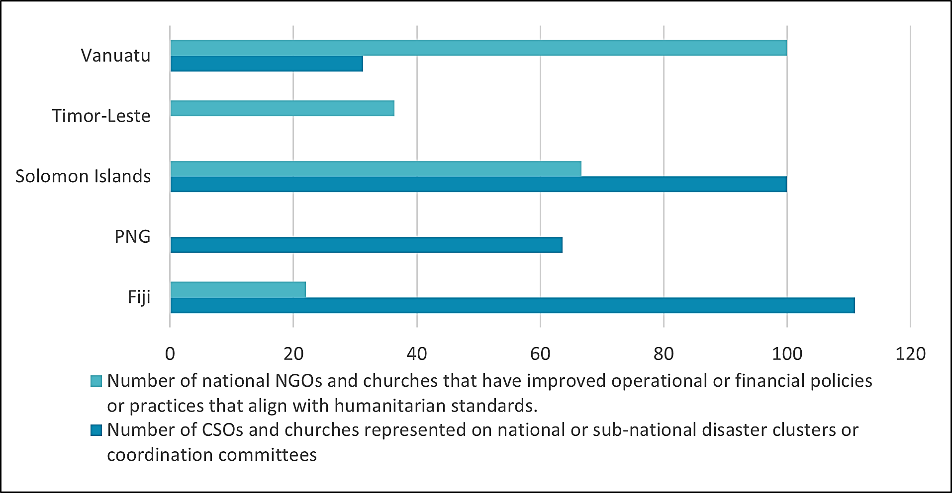

**The most substantial progress against this outcome area was demonstrated in in Fiji,** where the Disaster READY program is largely implemented by local NGOs and CSOs. For several of these organisations, the program has been an important conduit into the humanitarian system and has enabled them to bring their diverse expertise to both government and communities. For example, communities in Fiji reported on the value of the psychosocial support made available through local partners with expertise in counselling and trauma working as part of the Disaster READY consortium. This embeddedness with local CSOs was identified by others as contributing to the legitimacy and influence of Disaster READY in Fiji. Significantly, an innovation in this location has been to support capacity development of local partners through the inclusion of Australian Volunteers International (AVI) in the Plan Australia consortia, specifically to utilise their technical experience in civil society organisational capacity development.

**Through the CANDO network, Disaster READY has been influential in drawing faith-based organisations to government and formal humanitarian systems**. For example, in the Solomon Islands 10 faith-based organisations worked together in 2018 to establish a national level disaster working group. In the flood emergency in January 2019, these organisations were able to share information and resources and provide contacts between church communities, the National Disaster Office and other AHP partners. In PNG, Disaster READY is implemented through the existing Churches Partnership Program (CPP) and has been able to both utilise the wide reach and spread of that program as well as influence the humanitarian and disaster understanding of churches involved in the extensive CPP network. This is an important contribution given that CPP has representation on the National Disaster Management Team in PNG.

**In other locations, while AHP NGOs work through a range of local partners, there is less direct engagement of those local organisations in the planning, management and assessment of Disaster READY activities.** Consistent feedback from local organisations to the evaluation team was their interest in greater opportunity to shape the activities and directions of Disaster READY going forward. Many partner in the respective countries reported that there are limited opportunities in the current consortia arrangements for them to contribute to program assessment and improvement.

#### AHP NGOs work effectively together and with other relevant stakeholders

**A core assumption of AHP is that collaboration between Australian NGOs and their partners will increase the quality, value and impact of their interventions.** Disaster READY is provided with additional supports to facilitate this collaboration including support for shared services in areas such as gender and disability inclusion and monitoring and evaluation, as well as in-country coordination between partners. There are no specific measures to track either the process or outcomes of collaboration as part of Disaster READY. This evaluation therefore gave considerable attention to the views of respondents to this issue.

**Disaster READY in Timor-Leste has demonstrated a strong commitment to a collaborative approach** built on a thorough understanding of the strengths of each Disaster READY member and commitment to utilise those strengths towards the most effective outcomes for work in the country. This has been demonstrated through recent funding proposals where individual organisations have forgone funding to support the work of other more relevant partners. This strong commitment to collaboration has served as an example to other organisations in the country, and as noted previously, served to increase the influence of the program with the Timor-Leste government. It has provided the basis for the Disaster READY in-country committee to leverage additional funds outside of Australian government support, in collaboration with other civil society actors in the country.

**In Fiji, the collaboration demonstrated by Disaster READY has inspired more collaborative effort by others**, in strong contrast to what is described as the more usual ‘*competitive and siloed’* approach of many civil society actors in that country. Some respondents in that country suggested that the Disaster READY collaboration was as important to improving country systems as the direct assistance provided for humanitarian preparedness. The Fiji National Government representatives identified the collaborative approach of Disaster READY as fundamental to its legitimacy and valued contribution to the humanitarian space in the country.

In contrast, in PNG as noted above, it has been more difficult for the Disaster READY partners to collaborate, given their relative spread across the country. Similarly, in Vanuatu, government and respondents reported good collaboration with the individual Disaster READY partners but found it difficult to see a strong sense of collaboration between the program as a whole.

**Effective in-country collaboration requires time and resources.** With the additional responsibilities for in-country proposal development and local management of disaster responses, instigated by DFAT in 2020, the existing systems for collaboration have required further development. In some cases, AHP NGOs report that previous working relationships in the in-country committees have been strained by these additional responsibilities, and negotiation around differences in control over and access to resourcing have had to be addressed. Consistent feedback was received around the need for clearer guidelines and some additional resources if in-country committees were expected to shift towards management of programs on an ongoing basis.

A further issue that was identified by some in-country committees was the potential tension between in-country collaboration, particular where resources were distributed on the basis of organisational strengths and location, and the interests and mandates of their Australian-based partners. This issue is explored later in the report.

**There are fewer examples of Disaster READY collaboration with other DFAT programs or those of other international organisations**. While there are some good examples of cross program collaboration, for example in the Solomon Islands Disaster READY worked with the Red Cross, UNWomen and the National Disaster Office to review government guidelines for community-based disaster risk management, to ensure good gender integration into the guidelines. In several locations Disaster READY also collaborates with the UN cluster system. Notably in Vanuatu Disaster READY representatives act as deputy chairs across several of the clusters. In other locations relevant DFAT and Australian programs reported that they found it difficult to actively collaborate with Disaster READY, largely because the program was so busy with existing work plans and predetermined activities. There was also less evidence of Disaster READY collaboration with other Australian NGO development programs, including those funded under the Australian NGO Cooperation Program (ANCP).

### What changes are evident at community and government level as a result of Disaster READY activities?

**Finding – Disaster READY has contributed to increased resilience and preparedness in communities in most locations.**

It has created working relationship with different levels of Government and has started to positively influence the standards, approaches and depth of national Government disaster response.

There is support for expansion and extension of Disaster READY.

**Outcome level information about impacts in communities and with governments is not routinely collected in Disaster READY monitoring and reporting**. Assessment against this evaluation question draws almost entirely from the evaluation in-country field research (see detailed country level reports at Annex Six), with a focus upon the experience in Timor-Leste, Fiji and Vanuatu.

**Communities report tangible change as a result of the support received from Disaster READY**. In particular people pointed to increased information about disasters and how to prepare for and mitigate the potential risk of likely disasters.

*My community is ready to response to disaster through reforestation. We get training about disaster from World Vision. I also attended the training about disaster (Chef de Suco, Timor-Leste)*

People also spoke about the value of having committee and other community systems in place to respond following disasters.

*My community is ready to response to the disaster and COVID-19.*

*The community is now aware of the disaster because they got training from agencies. Example - they already plant trees and they do not build their house near the rivers. (Community member Timor-Leste)*

Community feedback in Fiji indicated that people know more about how best to help themselves and other vulnerable groups in an emergency.

*I remember the training we got. I know what to do now to look after myself and other women* *(Community member, Fiji)*

People in communities talked about being individually more prepared to respond in disaster events. People also reported that as a result of the Disaster READY strategy in Fiji to work with a broad range of local civil society actors, in the recent TCH response they had been able to access a range of services relevant to their needs, including psychosocial support.

In Vanuatu, communities reported that the long-term and ongoing relationship with AHP partners means that they know and trust those organisations.

*Save the Children have been working in East Malo for approximately 2 years. Their communication and engagement with community is good and communities speak very highly of Save (Local community leader, Vanuatu)*

The value of the preparedness work and relationships with communities has recently been demonstrated particularly in the Vanuatu response to TCH. Communities and local government reported that due to the preparedness work undertaken by AHP partners, there was timely delivery of supplies to remote areas, notwithstanding the difficulties of emergency relief being able to enter the country due to COVID restrictions. In the locations where Disaster READY had provided training and supported the formation of local committee structures, communities were better able to manage the responses to the cyclone and demonstrated increased resilience and recovery.

**There was consistent feedback that Disaster READY has become a valued contributor to national government systems for disaster preparedness and response.** In Timor-Leste, the program has carefully worked to align with government systems and is understood to support government leadership and further capacity development. In turn this has provided opportunity for Disaster READY to influence government standards in disaster preparedness and response. As a result, the revised government guidelines now reflect increased attention to inclusion and standards for child protection.

In Fiji, Disaster READY is understood to be respectful of the role of the National Disaster Management Office (NDMO). They are valued by the NDMO for the technical expertise the program brings, particularly to support capacity development at the divisional level in the government system.

*NDMO appreciates AHP because they align and support the vision, mission and goals of NDMO i.e. national priorities, instead of going off to do work in the spaces on their own (NMDO representative)*

As a result of the positive engagement through Disaster READY, several CSO are cooperating for the first time with the Fiji national government in disaster preparedness and response.

In Vanuatu, there has been good cooperation reported between AHP partners and provincial level government. National government representatives report their appreciation of the value of Disaster READY, although they also reported some concerns that the work of AHP NGOs and others is not always in line with national government leadership and directions.

*On a general level the NGO’s have engaged well with government. …….The main weakness is that NGO’s need to focus their planning and implementation on what government want. (National government representative)*

**Notwithstanding the wide range of positive outcomes from this work, the evaluation also identified some areas further improvement.** Feedback from communities in Timor-Leste indicated some dissatisfaction with the quality and scope of the assistance and the limited opportunity to voice their views with AHP NGOs. This aligned with a wider concern raised in more than one location, about insufficient attention to community voice and feedback in Disaster READY implementation mechanisms (this issue is revisited in Section 4.4.3).

**A broader concern was identified about the technical quality of the preparedness information provided at community level**. Utilising community knowledge and wisdom was seen as a positive part of the Disaster READY approach. However, external respondents with specialist resilience knowledge, were concerned about the quality of some information being provided to communities. In particular if communities were receiving current and complete information about the likely changing nature and impact of disasters due to climate change.

**In several countries, there was concern about the scale and reach of Disaster READY activities**. In Vanuatu and Fiji, local and national government wanted to see an extended program reach to more remote communities. There was also considerable discussion in these locations and Timor Leste about the sustainability of the work at community level, recognising that any training or information needed to be repeated regularly and updated over time.

### How could the current funding, decision-making and governance arrangements be further improved to meet the purpose of Disaster READY?

**Finding – DFAT has added additional work areas and considerable additional funding to what was already an ambitious program, stretching the current resources and capacities.**

In the short term there are some additional management and resourcing supports which would support this expansion. More substantial changes should be considered for any extension of Disaster READY.

#### Current program

**Throughout 2020, Disaster READY shifted from a focus solely on disaster preparedness and resilience to also include responsibility for disaster response and recovery**. In-country budgets expanded from approximately AU$1 million per annum to several million. Responsibility for proposal design and oversight shifted from AHP NGOs in Australia to AHP partners working as part of in-country committees in the five Disaster READY countries.

**The additional work and responsibilities have clearly stretched the in-country partners well beyond the original program intent**. The additional resources and responsibilities were clearly of value in order to support disaster responses, the initial response to the COVID-19 impact and the longer term challenges related to health and economic security in the respective countries. However, this additional work, in large part because of the restricted travel arrangements (and therefore limited opportunity for additional technical personnel or other support to be provided from Australia) has fallen to local staff. In many situations the same people were trying to undertake disaster response at the same time as preparing new proposals and also adjusting and maintaining existing programmed work. At the time of the evaluation, several concerns were raised by Disaster READY in-country committees. These included:

* Staff exhaustion, and for those locations experiencing significant disasters, staff trauma and dislocation.
* Relationships between in-country committee members and the risk that these would be undermined by, or be inadequate to address, the additional in-country responsibilities.
* Partner capacity and the risk that additional work for disaster response and recovery could distract partners from their core focus or create expectations beyond their current capacity.
* How to balance completion of existing work plans alongside these additional responsibilities.

**In the short term, in-country committees reported the need for additional help to establish appropriate working systems** between themselves and in some cases with other partners. They also sought more assistance for the additional monitoring, evaluation and reporting requirements associated with the additional funding, looking to both streamline these and ensure some consistency and clarity around these requirements. Particular suggestions included the opportunity for in-country committees and NGO partners to receive direct assistance from the AHPSU, as well as having the opportunity to recruit additional technical assistance as required.

**Recommendation Three**

**The AHPSU explore and identify how the Disaster READY in-country committees can be more effectively resourced to enhance collaboration within Disaster READY and across other DFAT programs and development actors.**

**Adaptive implementation** - The recent challenges of COVID-19 and response to other local disasters, have stimulated considerable discussion in the in-country committees about Disaster READY’s ways of working. There is strong interest in further innovation, particularly to adapt ongoing disaster preparedness work based on this response experience. The barrier identified by in-country committees together with other stakeholders, is that the tightly planned and predetermined approach of Disaster READY and the top-down management arrangements, mitigate against program innovation. A common concern raised by local country partners and others in-country was the difficulty in communicating feedback, new ideas and opportunities for change and adaptation through the current Disaster READY implementation system. Ideally the program should grow to become a more adaptable mechanism able to respond flexibly to opportunities and the priorities of local stakeholders. A starting point would be to increase the opportunity for in-country stakeholders, including community members, to provide feedback to the program.

**Recommendation Four**

**AHP partners design and implement mechanisms, relevant to their consortia arrangements, to provide communities, in-country partners and local government representatives opportunities to provide feedback and commentary on the value and quality of Disaster READY activities.**

#### Future considerations

**Disaster READY is now being asked to work across several domains and the program priorities are unclear.** Beyond the complexity identified earlier - multiple end of program outcomes, complex implementation arrangements and changing lines of accountability and responsibility - additional areas for clarification of program intent were identified through the evaluation.

**Sustainability**- The need to focus on sustainability of program outcomes was identified by various in-country respondents. People recognised that while communities had benefited from training and other preparatory work, in order for it to have sustained impact, it needed to be extended, particularly to the more remote and disaster prone areas. It also required regular repeat delivery and updating, in order for it to be relevant to the ongoing needs of those communities.

Work with governments was seen as an important contribution to sustainability, but government respondents pointed to their limited resourcing and questioned the longer term intention of the program and its capacity to commit to ongoing government systems development. Supporting local CSO engagement in the humanitarian system was seen as a further possible path to more sustainable outcomes for the program, but it was less clear to respondents how this was being pursued consistently across all Disaster READY locations. In particular, it was not clear how attention to this outcome was being balanced against the other priorities of Disaster READY.

**Localisation** - Several respondents raised issues about how far localisation had progressed under Disaster READY. In-country respondents, particularly local partners, identified the need for more discussion around the respective roles of in-country NGOs and the contribution being made by Australian NGOs and their in-country organisational arms. As discussed later in this report, there was a strong interest in the degree to which Disaster READY would be a pathway towards localisation of humanitarian response in the Pacific.

**Resilience** - Respondents within the Pacific and in Australia pointed to the changing nature of disasters in the Pacific and Timor-Leste, with the growing impact of climate change and the recent challenges to livelihoods and economic development introduced by the COVID-19 pandemic. Within this dynamic the contribution by one program focused only on disaster preparedness was thought to be insufficient to the challenge and out of touch with the reality of people’s experience.

*More needs to be done to ensure that disaster management in Fiji shifts away from a reactive approach to a more proactive one, which focuses upon prevention and risk reduction, builds on strengths and capabilities, reduces vulnerabilities, and addresses the effects of natural disasters coupled with the impacts of climate change, and meeting the needs of marginalised groups. (Fiji workshop with local NGO partners, 2019)*

There was some suggestion that Disaster READY needs to be reframed as a resilience program with more attention to cooperation with other Australian programs of support.

**Future considerations**

**Any future phases of Disaster READY should limit the number of program objectives in order to ensure one clear overall purpose for the program.**

**Sustainability, specifically including pathways towards localisation, should be a major consideration for any future phases of Disaster READY.**

**Activities under any future phase of Disaster READY should be framed within an understanding of resilience, relevant to the country and regional context.**

### Is there scope for expansion of Disaster READY either within the existing countries or beyond?

**Finding - Disaster READY has the potential to be extended to other countries in the Pacific, but this will require country specific adaptation and implementation.**

**Disaster READY has been able to achieve progress towards its various outcomes to different degrees in each country context.** For example, in Fiji, a very mature and developed CSO sector, together with functional government systems, have supported Disaster READY to make good progress in its work through local organisations and in complementing and extending the work of government. In Vanuatu, the ongoing challenge of regular disasters leading to a rolling situation of response and recovery, means that governments and local systems are stretched, with possibly less attention for disaster preparedness. In Timor Leste, where there is widespread development need, it appears that it is difficult for community and local leaders to separate their needs into disaster preparedness and other areas of development. Future work by Disaster READY in this context will likely require increased cooperation between development and humanitarian sectors, possibly around a shared resilience focus.

**Ongoing attention to the opportunities and challenges in the various country contexts is required** for Disaster READY to effectively achieve its outcomes in the current countries and any additional locations.

**Future considerations**

**Any future phase of Disaster READY, should shift to a country focus, while retaining opportunities for regional exchange, learning and cooperation. That is, the program should become a *multi country program.***

**In line with the current Disaster READY rationale, any future phase of the program should consider expansion to countries in the Pacific and beyond that are highly disaster prone. In the Pacific this would likely include Tonga (the remaining Pacific country among the world's most 15 disaster prone countries) and the small island states of Kiribati, Tuvalu and Nauru (all countries at particular risk of impact by disasters due to the growing influence of climate change).**

## To what extent is the overall modality of AHP including the Support Unit, the partnership arrangements and the respective roles played by NGOs, the local partners and DFAT, fit for purpose?

**Overall Finding - the Disaster READY modality has met the needs of DFAT and AHP partners and has largely been fit for purpose.**

There is opportunity for further development of the modality in future phases of the program**.**

**There was very positive feedback from DFAT in Canberra and at Posts about the operation of AHP as a modality.** The current arrangement, a partnership between DFAT and six accredited Australian NGOs supported by an administrative and contracting mechanism, has provided for efficient and timely use of Australian funds. The modality is understood within DFAT to be an effective way to provide support for the humanitarian sector, in line with DFAT policy[19].

**Australian NGOs and their partners report that the mechanism is growing in maturity**. Under the arrangements instigated in the AHP design, Australian NGOs report that it is increasing collaboration and improving relationships between the Australian NGOs and DFAT.

### What are the benefits and constraints in utilising AHPSU as a mechanism?

**Finding - the AHPSU has evolved into an effective mechanism, however its role has been extended beyond its original terms of reference.**

**DFAT reports that the AHPSU has considerably assisted their management of AHP**, enabling them to utilise funds flexibility and to manage the large-scale administration required by an NGO funding program.

**Australian NGOs consider that the role of the AHPSU has evolved in effective ways**. The mechanism was seen as valuable and helpful in areas such as monitoring, evaluation and learning and communications.

**The AHPSU is currently working beyond its contracted role, stretching its available resources**. There appears to be some need to clarify the role of the AHPSU, and possibly extend that role with suitable resourcing. There were several different views about further development of the AHPSU, including:

* Some respondents particularly those in-country, requested that the AHPSU provide more technical expertise and support. Other respondents suggested that this ought to be provided by the Australian NGOs as part of their contribution to AHP and should not be the role of the AHPSU.
* Respondents in both Australia and in-country suggested that the AHPSU ought to provide more leadership and direction, particularly in processes around activations and funding arrangements. Other respondents had strong views that the program was under the leadership of DFAT and that the AHPSU should not substitute for clear policy direction and leadership by DFAT.
* There was support among several respondents for increased AHPSU responsiveness and proactivity, particularly in identifying issues for program improvement and systems development. This contrasted with those who were concerned about the SU creating distance between DFAT and Australian NGOs, particularly in areas of humanitarian policy and program development.
* Finally, in-country committees identified the importance of the AHPSU and sought to have greater access to this resource directed to them.

### Partnerships, collaboration and consortia

**Finding - the collaboration in AHP particularly through the consortia approach within countries, has added value to the disaster response and preparedness work.**

**AHP focus on collaboration, particularly at the field level, has increased efficiency and the overall value for money for DFAT investments**. This is in line with previous DFAT research and assessment[20] Australian NGOs see the requirement under AHP for them to cooperate together and manage through consortia and local partners as a significant improvement upon the more competitive arrangements under previous programs. In both humanitarian response as well as in Disaster READY, the arrangement has pushed organisations to focus on finding solutions and working arrangements that will allow them to bring the best capacity to the humanitarian situation. Australian NGOs report that it has allowed them to focus more on the strengths of respective agencies, and significantly has allowed the participation of smaller, more niche organisations, bringing a greater range of capabilities and competencies to the program. This has included organisations with less humanitarian experience but wide reach into community areas such as church agencies

**The partnership arrangement and consortia arrangement in-country has added value through learning, but has been time and resource intensive,. R**espondents reported that the focus on partnership had improved coordination between organisations and the opportunities for joint learning. In particular, Disaster READY partners pointed to the learning events managed at both country and regional level and the considerable value generated through these events. Finally, people identified the opportunity for more collective monitoring, evaluation and learning and joint communications as being a strength of the AHP model. However, people stressed that for these arrangements to work, sufficient resourcing was required at the country level.

**There is great diversity between the partnership and consortia arrangements** from one AHP partner to the other. It was not possible for this evaluation to assess comparative value of the different types of consortia. There is no specific reporting nor assessment required to understand this the added value of these various different arrangements.

**Future considerations**

**Any future phase of Disaster READY should consider inclusion of monitoring systems that provide information about the value of different consortium models in relation to program implementation and outcomes.**

### What are the implications for contracting, operational systems and processes for program management and implementation going forward?

**Finding - there are areas for improvement in the current systems.**

These require some changes in the role of AHPSU as well as a redirection of resources and program focus.

#### Accountability

**In the current program management arrangements, there are insufficient systems to hold AHP partners to account for continual improvement**. For example, regular reports under both AHP and Disaster READY indicate challenges with disability inclusion, but it was not clear to the evaluation team who has responsibility to direct NGOs and their partners to increase attention to this area. Also, while the various evaluations of large-scale humanitarian responses are in general excellent documents for outlining strengths and challenges, and their recommendations are monitored by the AHPSU, it was not clear to the evaluation team who ensured the subsequent compliance and change in organisational practices recommended through these evaluations. While the evaluation has found that in general AHP is a good quality program demonstrating adherence to humanitarian standards and quality practice, it would be further improved through AHP partners and their consortia being held accountable for ongoing quality development.

#### Operational guidelines

**Updated operational guidelines and some increased resources for in-country consortia** **to manage effectively** are required, given the new challenges introduced in Disaster READY countries through in-country committees taking responsibility for proposals and management of responses. People suggested that any new guidelines ought to include ways to hold each other accountable at country level.

#### Practice development

**Good practice in humanitarian preparedness, response and recovery is evolving**, particularly with the new challenges introduced by climate change but also alongside the development of more sophisticated policy positions supporting localisation and a nexus between development and humanitarian programming. The experience of COVID-19 impacting borders and economic conditions in countries had caused people to question traditional disaster preparedness training, suggesting that the pace and nature of disasters is changing and preparation needed to be more of an active process. Respondents in Fiji identified the intersecting but also different threats from various types of disasters, such as climate change, the economic and livelihood insecurity brought about by the pandemic and the challenges related to cyclones and other ‘traditional’ disasters. In Vanuatu, several respondents identified the blurring between disaster response and recovery and the need for ongoing preparation in that location. Respondents were looking to Disaster READY to engage in the policy discussion and program adaptation potentially required by this evolving situation.

All of these issues are being discussed regularly by AHP implementing partners and other stakeholders, however there is no system in the AHP mechanism to ensure emerging ideas are converted to new and improved practices. A mechanism to review current practice challenges and adapt, as appropriate, AHP practice, would ensure that the program represents the best possible practice and aligns with emerging DFAT policy.

**Recommendation Five**

**Review and update the Terms of Reference for the AHPSU to match the current services provided, noting adjustments since the commencement of the AHP.**

**Future considerations**

**In any future phase of AHP, consider the inclusion of a mechanism that regularly reviews program innovations and relevant new policy or practice ideas, and identifies the implications for the program, as part of ongoing program adaptation and improvement.**

#### Monitoring and Evaluation

**There was strong support for the focus on evaluations of large-scale activations**, recognising that this supported improved program quality and accountability. There was also strong appreciation of the learning focus introduced by the monitoring and evaluation under Disaster READY and the opportunity for this to happen systematically through regular learning events.

**Concerns were raised around the detailed activity reporting required by Disaster READY** and the many changes that have been introduced throughout this process (notwithstanding the fact that many of these changes were response to NGO suggestions). There was considerable discussion and debate about the capacity for in-country partners in the Disaster READY program to meet monitoring, evaluation and reporting requirements. It was the observation of the evaluation team that this seems to be a gap in the support provided by Australian NGOs to their local partners.

**Disaster READY gives insufficient attention to outcome monitoring**. The strong focus on detailed activity planning which characterises much of the Disaster READY work, largely assessed through low-level indicators, has contributed to a lack of attention on outcome monitoring by AHP partners, and limited opportunities for the utilisation of community and local partner feedback. For AHP to evolve and adapt, particularly in response to changing humanitarian policy and the challenges of different country contexts, there needs to be an increased focus on outcomes and greater attention to program impact within each context. This would be in line with the emerging views about monitoring, evaluation and reporting for humanitarian work.[21] It could also be expected to lead to more streamlined and focused reporting, with greater emphasis on discussion of change and impact, versus inputs and activities.

**Recommendation Six**

**Adjust the Monitoring Evaluation and Learning Framework (MELF) and reporting requirements for Disaster READY, to require AHP partners to provide evidence-based reporting on progress against outcomes.**

## To what extent have the activities of AHP supported and advanced the localisation of Australia’s humanitarian response?

**Overall Finding – Some AHP activities have supported good practice in localisation at community level. However, Disaster READY shows very slow progress in shifting decision making and resources to local organisations.**

**AHP was designed to achieve a shift to more locally based humanitarian response that better leveraged local capacities**. In particular it proposed that support for disaster risk reduction in the Pacific, through the work of Disaster READY, would be framed by localisation, building disaster management capacity and coordination in Pacific countries and strengthening the disaster resilience of Pacific communities.[22] This is in line with DFAT policy, which strongly supports localisation as both accountability to affected populations and increased local leadership and decision making.[23]

### How have initiatives supported local communities to anticipate, prepare for and reduce risks from natural hazards?

**Finding - Disaster READY has provided relevant disaster preparedness for communities in all countries, including those in remote areas.**

**As discussed,** **Disaster READY has contributed to increased resilience and preparedness in communities** (see sections 4.2.2 and 4.2.3 and Annex Six). This support has been valued, and demonstrated to contribute to communities’ ability to respond to and recover from disasters.

### How have initiatives supported local authorities to implement inclusive DR and resilience activities?

**Finding - Disaster READY has worked closely with national and local government in all locations.**

Effective working relationships with government systems supports sustainability but it can slow delivery of services.

**Disaster READY has worked hard to build relationships with government, for example, at national level in Fiji and Timor-Leste and with provincial and local authorities in Vanuatu**. Program reporting indicates that in PNG and Solomon Islands, the program has sought to work with provincial level governments alongside local leadership.

**The focus of this work has generally been to support capacity and reach of local governments** and influence the quality and standards of national level disaster preparedness and disaster response systems. At the national level in Timor-Leste and Vanuatu, there are good examples of Disaster READY contributing to policy and guidelines which support inclusion. In Fiji, as discussed, the cooperation between Disaster READY partners and the NDMO has facilitated improved working relationships between civil society and government for disaster response.

**National and local government representatives responding to this evaluation all supported the value of AHP contribution to disaster response** in the respective countries. In most locations the program clearly supplements government services, extending the reach of preparedness work and more recently disaster response, beyond that able to be served by government systems. While this is very valued, local and national government respondents raised questions about the sustainability of the support.

**Throughout the recent disaster responses in Vanuatu, Fiji and Timor-Leste, Disaster READY partners have cooperated with government both at national and local level**, adhering to government restrictions in relation to COVID-19, and as far as possible, supporting government leadership. In several situations it is reported that working with and through government processes has increased the legitimacy of the Disaster READY as a valued actor but frequently has slowed the delivery of supplies and support, particularly to remote areas.

##### Box 5. Good practice example - TC Gita response in Tonga

During the Tropical Cyclone Gita response in Tonga, CARE Australia’s response was wholly implemented by MORDI, a local Tongan NGO. CARE and MORDI took joint decisions on the design of the response with MORDI making the final decision on field operations. CARE primarily played a support role, deploying key technical personnel, based on needs identified by MORDI to assist with coordination and building the technical capacity of MORDI’s implementing staff. Employing an entirely localised approach significantly increased the efficiency of the response as it utilised MORDI’s contextual knowledge and existing community and Government networks. For example, MORDI was able to reduce supplier and distribution costs by accessing existing local networks and relationships that international actors could not. As a result of the partnership, the post-project evaluation found that MORDI’s capacity to lead and deliver in a future humanitarian response had been greatly increased.

*From: AHP Humanitarian Response Annual Progress Update 2019*

### To what extent did approaches support local leadership and not undermine local efforts?

**Finding - support for local leadership in AHP has not progressed in line with the original program design aspirations**.

There are some specific examples of localisation practice in Disaster READY which offer potential pathways towards improved practice.

**Independent assessment of localisation in a selection of AHP protracted and rapid disaster responses indicates that there has been progress in supporting local leadership** (see Table 3). However, the more detailed findings from these evaluations indicate there have been some challenges, in part due to contextual constraints and also because of difficulties with finding local partners with suitable capacity.

##### Table 3. Summary of findings from independent evaluations of AHP disaster responses

| **Event and Country** | Evaluation of ***Support for local leadership*** |
| --- | --- |
| **Protracted responses** |  |
| Conflict recovery - South Sudan | Good |
| Famine - Yemen | Achieved with constraints |
| Rohingya response - Bangladesh | Needs improvement |
| Conflict recovery - Iraq | Good |
| **Rapid responses** |  |
| Earthquake - PNG | Good |

##### Box 6. Good practice example - South Sudan Response

World Vision partnered with UNIDO, a South Sudan based humanitarian NGO who had been active in the area since 2004, to deliver humanitarian assistance in Unity State. UNIDO successfully managed the technical delivery of planned nutrition, WASH and protection activities and its extensive relationships with state, County and community group leaders allowed rapid initiation and scale-up of activities. World Vision supported these activities mainly through procurement and logistics and with technical assistance when needed.

*From: South Sudan evaluation plus AHP 2018 Annual Progress update*

**For Disaster READY, the progress towards support for local leadership particularly through local organisations, remains slow, notwithstanding the strong focus on this area in the original program design.** Disaster READY partners with a wide range of local organisations and utilises extensive contacts across civil society in all of the countries where it is implemented. However, the evidence from program reporting, feedback received for this evaluation and wider research[24], suggests that core areas such as resources and decision-making related to program intent and focus, are still largely controlled by AHP partners.

**Disaster READY partners show mixed results in ceding control over resources to local CSO partners.** The recent DFAT decision to task in-country committees with decision-making around design and implementation of responses for disasters and the support for COVID-19 was an opportunity to shift resourcing and control in those locations. However, reports indicate that in the initial activations, in all locations, at least 50 % of resources were still directed through either an Australian NGO or their in-country branch (see Figure 10).

##### Fig 10. COVID 2 activation: funding split by organisation type

##### Figure 10 is a bar chat displaying the split of Covid-19 activation 2 funding by organisation type for each of the Disaster READY countries: Fiji, PNG, Solomon Islands, Timor-Leste, and Vanuatu. The organisation types include ANGO in Australia; ANGO in-country branch; local partners, and disabled people's organisations (DPOs). ANGO in-country branches received the most funding in all countries except Fiji, where local partners received the most. DPOs received the least funding in each country compared to other types of organisations, and received the greatest amount of funding in Fiji followed by PNG.

**Two of the Australian NGO consortiums have worked to increase localised control of resources.** These include the CANDO consortium and the group of organisations brought together by Plan Australia. (see Fig 11), suggesting that alternative arrangements are possible.

##### Fig 11. COVID 2 activation AHP partner funding split by organisation type

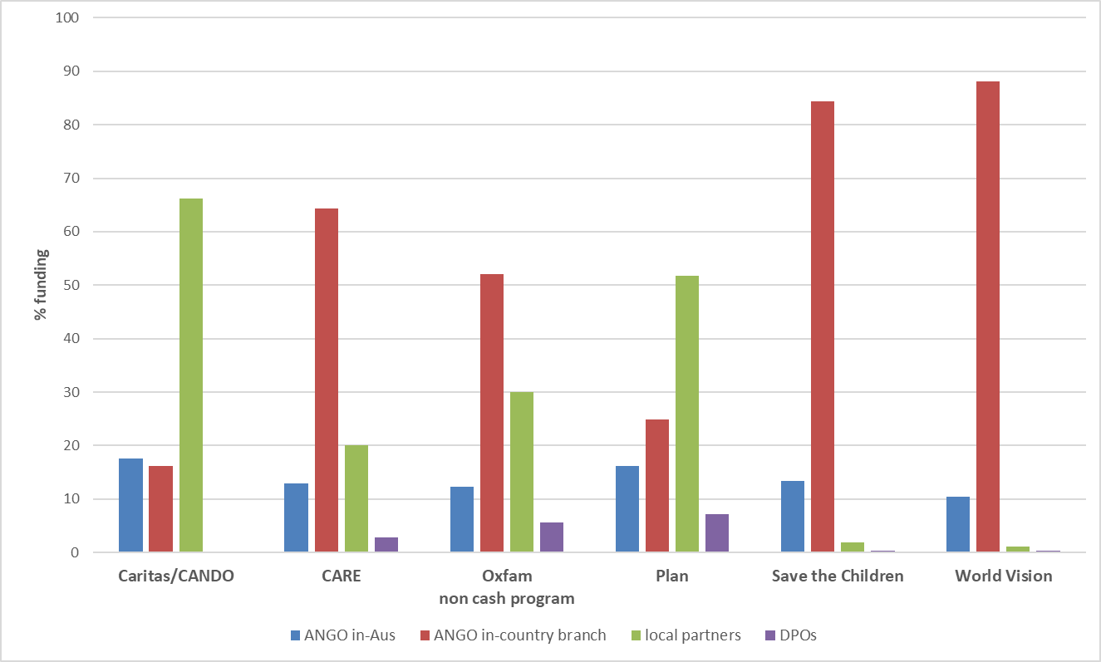

**Consistent feedback was received from local organisations which indicated dissatisfaction with their opportunity to influence and engage with AHP** in the Pacific and Timor-Leste. While there was strong support for Disaster READY in most areas of its operation, there was a consistent view by local organisations that they lacked power within the program structure to influence work plans and program direction. There was also a view across countries, that the contribution by local partners was not visible in Disaster READY reporting and that local organisations and communities did not have voice within the program.

**As discussed, (see Section 2.2), there are some good localisation practices which could serve to demonstrate the possible improvements for the program more widely.** The Disaster READY program in Fiji has demonstrated the greatest commitment to local agency decision-making and control, with its in-country committee comprising mainly local partners and a strong emphasis on a diversified partnership mix. This is complemented by capacity development support for those local organisations by AVI.[25] A further example which was highlighted by several respondents, is the collaboration between CBM Australia and the Pacific Disability Forum (PDF) to support capacity building and activity by country based Disabled Peoples Organisations (DPO). This arrangement was identified by in-country DPOs as of considerable value in supporting their participation in Disaster READY. It was seen as a flexible and responsive arrangement relevant to the changing role of DPOs in the respective countries.

**A core issue raised by the Fiji Disaster READY in-country committee and respondents in Timor-Leste, is how to change the relationship between Australian NGOs and their local partners**. Strong feedback was provided around the desire to retain Australian expertise, particularly in relation to core issues such as gender and social inclusion, humanitarian technical expertise and assistance with financial and administrative accountability. However local organisations were interested in how such support could be reconfigured for increased local organisation leadership and control.

##### Box 7. Good practice example – Fiji partner audit

In Fiji was an audit undertaken by Save the Children on the quality of child protection policies developed by eight churches. This arrangement demonstrated the shift in attitude by the faith-based organisations to recognise the importance of consistent standards in their humanitarian and development work and it also demonstrated the way in which the technical expertise of an Australian NGO could be tasked to improve specific areas of quality in the country humanitarian response.

*Annual Progress Update 2019*

**Recommendation Seven**

**Require all AHP partners to report on progress towards localisation against an agreed set of program-wide indicators.**

**Future considerations**

**Any future phases of Disaster READY should require a costed and time bound plan for achieving localisation as part of the selection criteria for participating Australian NGOs. Require that the selected NGOs to report against this plan throughout the life of any future program.**

## To what extent have the activities of AHP supported and advanced leadership and participation of women, people with disability and other marginalised people in disaster preparation and disaster response?

**Overall Finding – AHP results show that the program has worked to include women and people with disability. Results show that overall, gender inclusion has been more effective than inclusion of people with disability.**

### Are women and people with disabilities benefiting equitably from initiatives?

**In both protracted and rapid disaster response AHP has given good attention to the needs of women and girls,** and in most responses directed services to children. However, the figures (see Fig. 12 & 13) indicate that apart from some exceptions, such as the rapid earthquake response in PNG, the protracted conflict recovery response in Iraq and the Rohingya response in Bangladesh, **people with disability have been considerably underrepresented as beneficiaries from AHP activities**.[26]

**Finding – across AHP women are benefiting equitably from initiatives. People with disability are not benefitting equitably in most AHP activities.**

##### Fig 12. AHP Rapid Responses 2017-19, Percentage of beneficiaries who are women and girls, children and people living with disability.

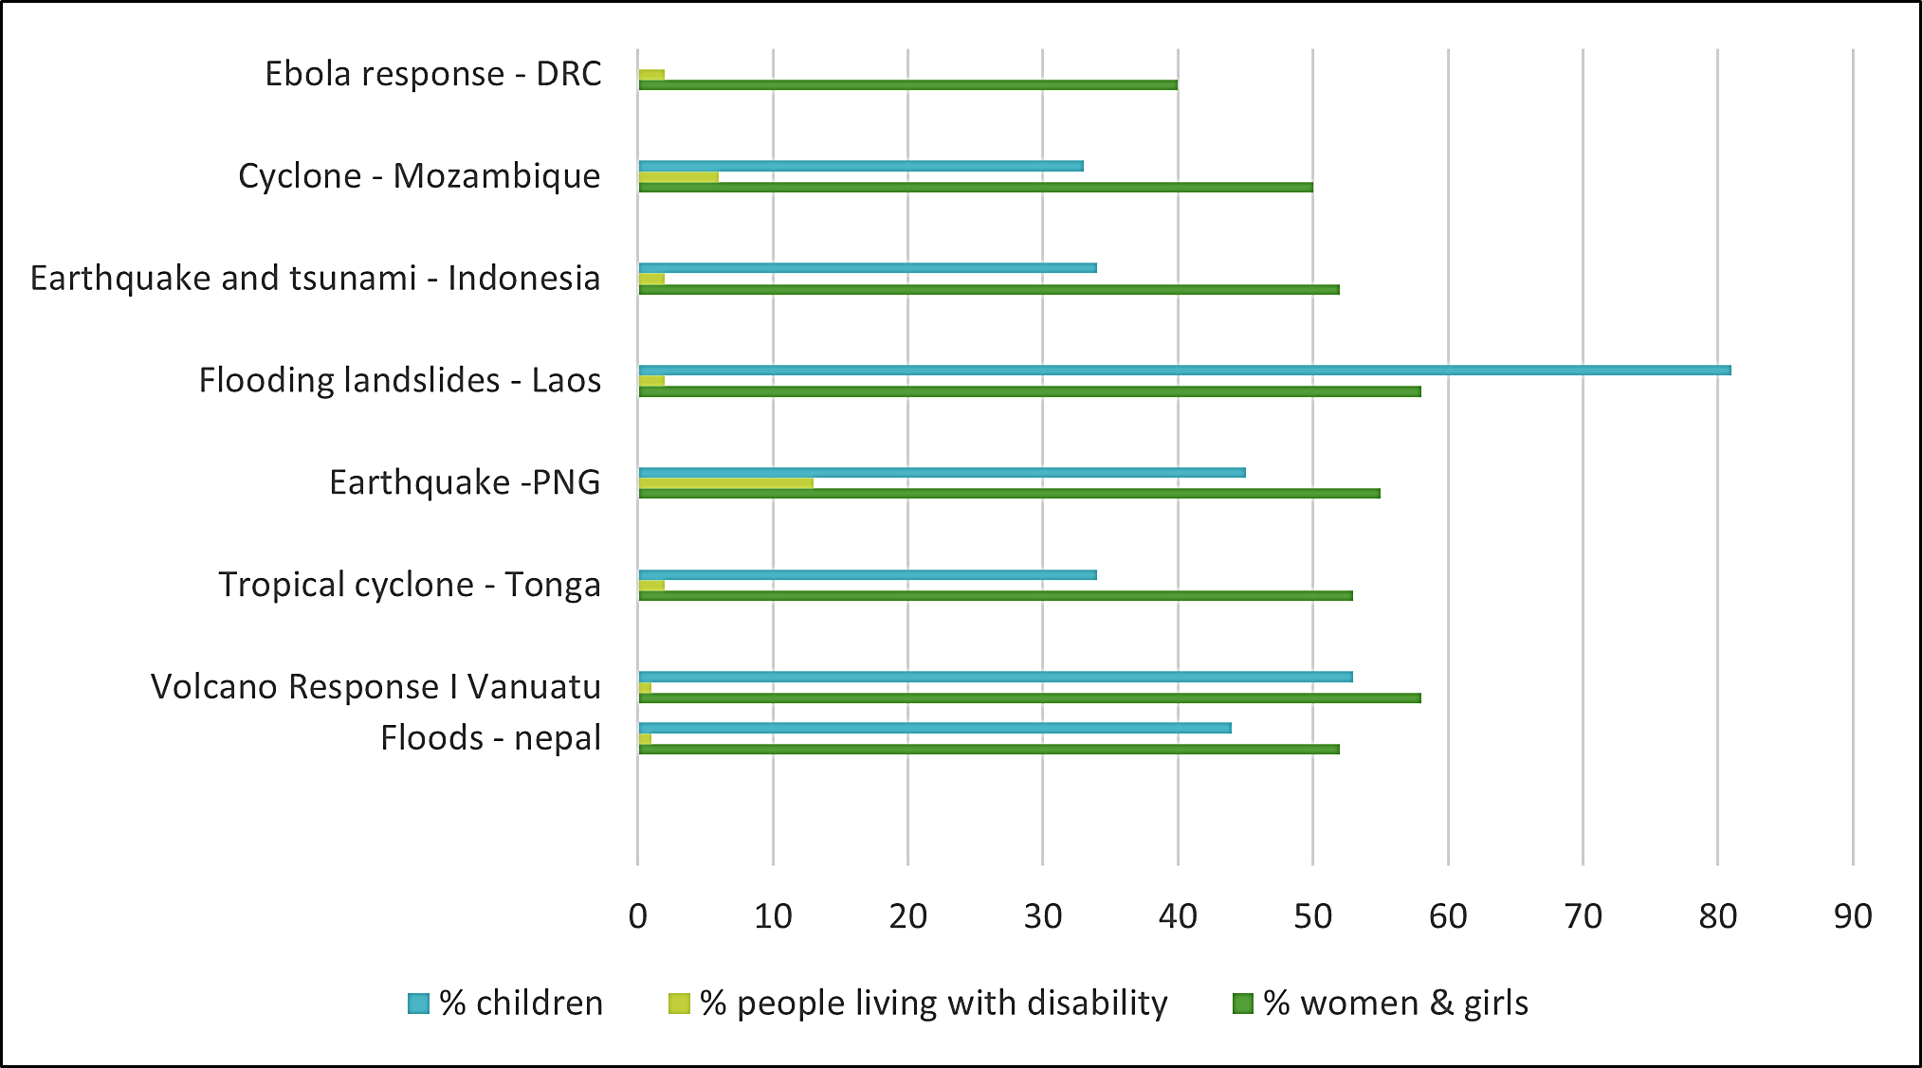

##### Fig 13. AHP Protracted Responses 2017-19, Percentage of beneficiaries who are women and girls, children and people living with disability

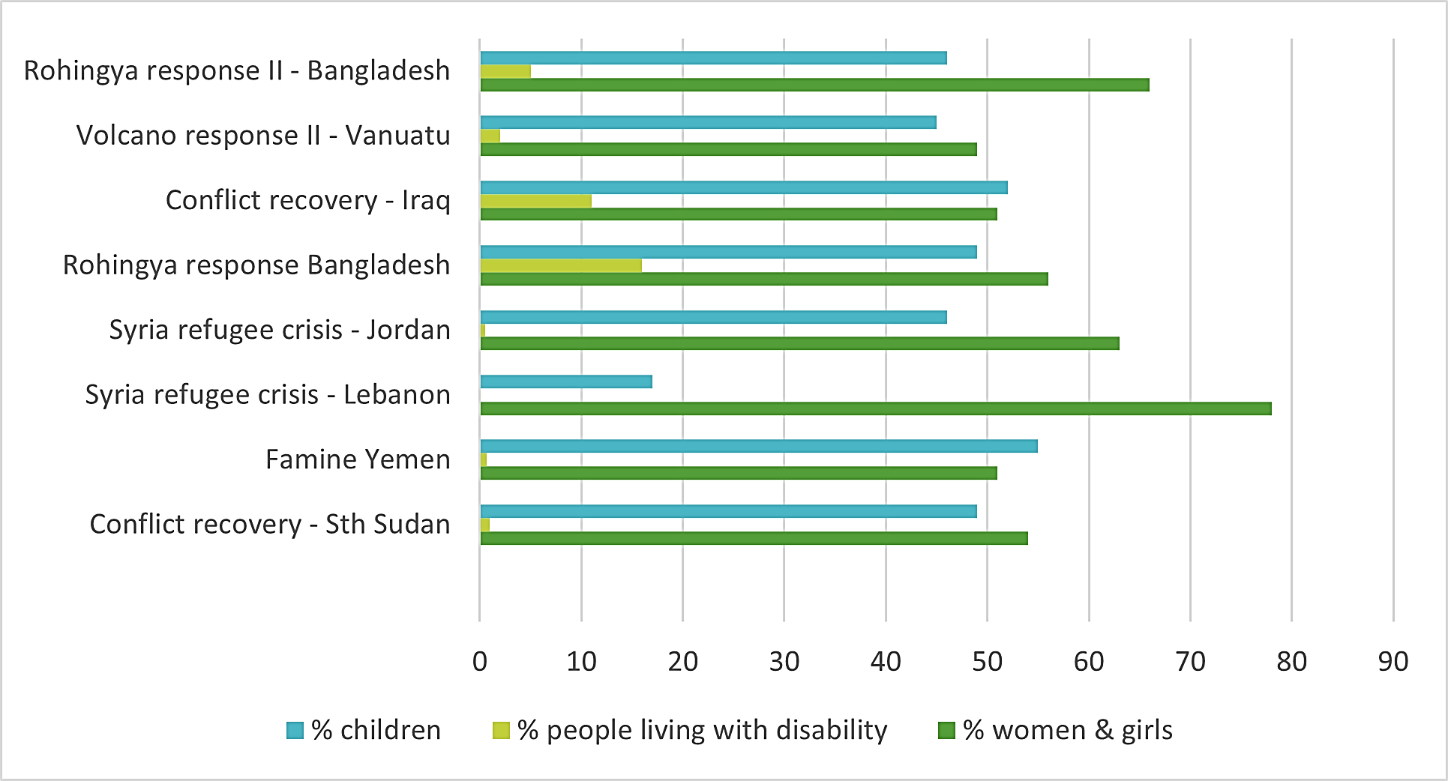

##### Box 8. Good practice example -Bangladesh Rohingya response

In Bangladesh, CARE in partnership with Oxfam needed to find ways to address cultural barriers that were deterring or preventing women and girls from accessing women friendly spaces where they could receive counselling and health-related support. Women and girls faced extremely limited mobility and the support of the male members of their families was needed for them to be able to access these women-friendly spaces but these spaces were treated with suspicion in the camp, particularly among men and boys. CARE addressed these issues by engaging with influential male community members, such as religious and community leaders, socialising the benefits of the women friendly spaces and gradually earning the trust of the broader community through house-to-house visits. By the end of the project there was increased acceptance of the women friendly spaces which became known and ‘*Shantikana’* or ‘*house of peace’*.

*Adapted from AHP Humanitarian Response Annual Progress Update 2018*

As noted, in the first two years (2017-19) of implementation for Disaster READY, the figures show that 49.5% of beneficiaries were women, but only 1.8% of the people assisted by the program were people who identified as having a disability.

##### Box 9. Good practice example - PNG Earthquake response

In its PNG earthquake response CARE made a particular effort to identify and support people with a disability; for example, 402 people in the target areas underwent disability inclusive training and 174 people with a disability received livelihood kits. CARE worked with disability groups including the PNG Assembly of Disabled Persons and the Prosthetics Division of the Ministry of Health to undertake a disability assessment in CARE’s target areas. CARE convened workshops with DPOs at both national and provincial levels resulting in the setting up of small provincial DPOs in Southern Highlands and Western Highlands Provinces. As a result, a range of support was provided to people in the target areas including disabled toilets, raised garden beds, prosthetic limbs and other assistive devices. The DPOs involved in these initiatives were uniformly positive about CARE’S collaboration. This successful collaboration has strengthened PNGADP’s existing work with the Disaster READY program and it is hoped to build on this in the future.



### How well have partners supported the inclusion and leadership of women and people with disabilities in their own staffing, volunteer and community structures that support DRR/resilience initiatives?

### What evidence is there that women and people with disabilities are leading initiatives and playing key operational, management and decision-making roles in initiatives?

**Finding – there is evidence that Disaster READY has worked to support DPOs and their inclusion in disaster planning and response**

**As discussed (section 4.2.2), Disaster READY has a particular focus on inclusion of DPO in-country committees.** DPOs report they have been increasingly engaged and supported by the program; however, they also report this is not translated to their active engagement in program decision-making. Disaster READY is presently trialling a tool to assist AHP partners self-assess their support for effective disability inclusion in all aspects of their work. This tool has significant potential for ongoing assessment and program improvement.

##### Box 10. Good practice example - Cyclone Idai response, Mozambique

During the Cyclone Idai response in Mozambique World Vision found a number of challenges in assisting children with disabilities, including the accessibility of services and negative community attitudes and stigma around disability which resulted in many families hiding children with disabilities in the home. World Vision adopted a range of approaches to address these issues. They held discussions with parents and volunteers about the importance of ensuring children with disabilities accessed child friendly temporary learning spaces and ran sensitisation campaigns and training on psychosocial support and child rights to help parents understand that children with disabilities were facing discrimination. Referrals to the relevant Mozambique health and social action services helped build community trust in World Vision’s support and resulted in an increase in the number of children with disabilities assisted. In the resettlement camps volunteers and parents in the resettlement camps participated in training on how to care for children with disabilities and disability-inclusive toilets were built.

There is no quantitative program evidence to indicate the number of women included as staff or volunteers in AHP partners or their consortia members, nor the number of women who are leading initiatives.

### To what extent did women, men, children and people with disabilities participate in and lead decision making?

**Finding – there is some evidence that women and people with disabilities are participating in initiatives.**

**Disaster READY reporting indicates that there is some active participation of women and people with disability** in disaster plan preparation across all locations, with more modest results in PNG and Timor-Leste (see Fig 14).

**As reported earlier, field research indicates good inclusion of women in community planning and disaster resilience committees at community level**. However, there was very limited evidence of inclusion of people with disability at community level activity. In some situations, such as communities in Timor-Leste, active resistance to inclusion of people with disability was observed.

##### Box 11. Good practice example - South Sudan Humanitarian response – improving livelihoods and status of women

Oxfam and World Vision EFSVL (Emergency Food Security and Vulnerable Livelihoods) activities provided agricultural tools, seeds, and training in improved practices which enabled families to supplement their diets with growing vegetables. Women in one area reported that the garden cooperative had trained them on the production of vegetables using improved farming techniques such as irrigation, pest control and organic fertilising and that their families were benefitting and they were also able to assist other vulnerable women attending the health and nutrition centre nearby. Yields were increased sufficiently that they were able to sell their surplus in the market which stimulated the fledgling local markets. It was also reported that seeing women working and managing their profitable vegetable gardens, increased their status in communities, with women reporting increasing participation in community activities, including the local judiciary, over time.

##### Fig 14. Percentage achievement against targets for indicators of **Gender and Social Inclusion in community planning -** by country, cumulative to Dec 2019

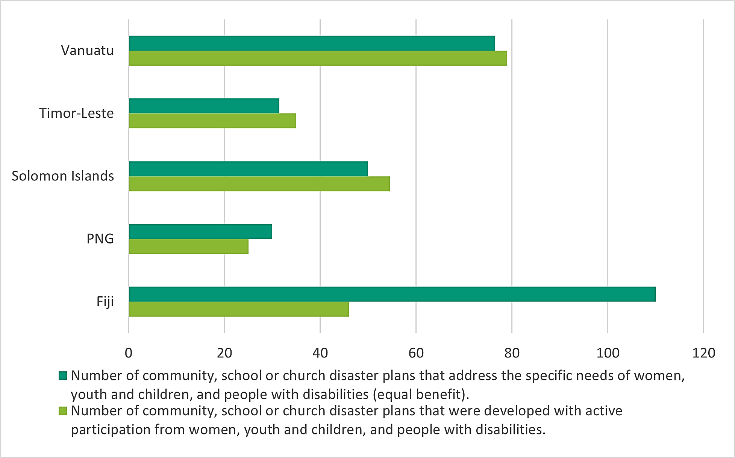

**Recommendation Eight**

**AHP partners to identify and implement a strategy to increase inclusion of people with disability in program decision-making and program implementation, utilising the guidance and ideas from country DPOs.**

**Recommendation Nine**

**AHP partners and their consortia members to ensure that at least 15% of Disaster READY program beneficiaries are people living with disability.**

### Did different groups have access to safe and responsive mechanisms to handle complaints?

**Finding – AHP rapid and protracted responses have evidence of mechanisms to handle complaints from affected communities. Disaster READY does not report on how complaints from affected communities are managed.**

**As discussed (see section 4.1.1), AHP partners have largely given appropriate attention to protection issues and provided accountability systems to affected populations** in protracted and rapid onset disasters.

**Disaster READY NGOs and their partners have strict requirements in place to address issues of child protection and prevention of sexual and other exploitation.** These commitments are regularly monitored to ensure compliance.

**There is limited attention to complaints from affected populations in Disaster READY monitoring and reporting**. As discussed, respondents to this evaluation at community level identified their concern about the lack of opportunity or process to provide feedback about the services they had received. This finding aligns with evidence from a recent evaluation commissioned by DFAT that identified protection concerns related to humanitarian responses in the Pacific in areas such as distributions, temporary shelter and displacement, mental health and psychosocial support and increases in pre-existing and new vulnerabilities related to sexual and gender-based violence, child protection, disability and exclusion of people from the lesbian gay bisexual transgender and intersex community. Of particular significance to Disaster READY, the evaluation also found that in practice protection clusters are not meeting regularly or undertaking necessary advocacy to influence other actors and decision-makers with the exception of Vanuatu.[27] Other research undertaken in Vanuatu, Tonga and Solomon Islands, found that humanitarian actors are not consistently recognising and respecting each other’s roles which is undermining the complementarity and protection outcomes for communities.[28]

**The Disaster READY NGOs clearly take responsibility to represent the views of communities and their representatives in their interactions with government** and are actively seeking to ensure attention to inclusion and protection within government guidelines and those of partner organisations including churches. However, in light of the broader research, some increased transparency around accountability to affected populations and how this is maintained and addressed throughout Disaster READY systems, would strengthen understanding of the quality and impact that the program has brought about**. *Refer Recommendation Four.***

## To what extent have AHP activities and approaches contributed to learning and improvements in the humanitarian sector, DFAT humanitarian programming and that of the NGO community?

**Overall finding – AHP has good information for wider sector learning but there are currently limited opportunities to share this learning.**

**Australian NGOs and representatives of other relevant humanitarian organisations noted that learning and improvements in the humanitarian sector are currently mostly pursued in other locations**, including through the International structures of NGOs and established humanitarian fora.

**There is strong acknowledgement in the humanitarian sector about the good-quality evaluations being produced by AHP and the visibility and accountability these evaluations provide**. There has also been strong affirmation of the internal learning opportunities in AHP, particularly those conducted under Disaster READY with in-country partners. For actors within the Pacific these have been effective ways to identify learning from the program and how it relates to their ongoing work.

**Respondents suggested that there are several areas where AHP can contribute learning and experience to the humanitarian sector in Australia and beyond**. For example, the Bangladesh Phase III response utilised a collaborative design process involving all AHP partners, with attention to specific organisational strengths in order to maximise outcomes. Respondents expect that outcomes from this response and its approach will likely be significant for AHP learning and the sector more widely.

**The AHPSU manages a comprehensive website with considerable information about the program providing opportunity for widespread communication and sharing of information**. This is an important mechanism for program transparency and likely to contribute to shared program learning. It is anticipated that as the results from some of the projects funded under PPF come to conclusion, good-quality learnings will emerge relevant to AHP and broader stakeholders and ideally these will be featured on the website and in other forums. DFAT report that they have been able to make use of learning from the approach and outcomes of AHP within internal systems. Overall, therefore there is both content and opportunity to make further progress under this program outcome.

**Recommendation Ten**

**The AHPSU to identify a process to capture relevant program learning and together with AHP partners, ensure this is communicated regularly through existing program and other learning forums.**

# Conclusions



## AHP overall

This mid-term evaluation of AHP has found that the program is largely effective and meets the DFAT policy intention of utilising Australian NGOs’ skills and experience as part of its work in disaster response and preparedness. There is considerable evidence in the program reporting, program commissioned evaluations and the evidence collected for this review, that Australia is achieving strong outcomes in the response and preparedness work supported by Australian NGOs.

The support for Australian NGOs to work with partners is a strength of the program. Under this phase of DFAT and Australian NGO cooperation, the emphasis on utilisation of additional partners and increased collaboration has supported increased value, particularly in the implementation of Disaster READY.

## Support for rapid and slow onset disasters

The AHP response to rapid and slow onset disasters is largely of good quality and demonstrates strong outcomes. Some weaknesses were identified in the negotiations around activations for different responses. Disability inclusion is an additional area for further improvement.

## Disaster READY

The evaluation has found that Disaster READY is a complex program which has been further stretched by its recent extension into disaster response. While there is progress against all outcomes appropriate to the mid-term point in the program, the different contexts for implementation, together with the large ambition articulated by five outcomes and additional recent demands, are leading to varied results.

The program benefits from its wide range of partners . The program has demonstrated considerable achievements in its support for communities and governments in recent disaster responses, but questions are also being raised about how the work and outcomes of the program will be sustained into the future and retain relevance as the nature of disasters increases in complexity. Disaster READY has good systems for internal learning and is generating considerable in-country discussion, but it is difficult for external stakeholders to access these discussions and contribute to further program development.

Significantly, Disaster READY has demonstrated the value of collaboration in disaster preparedness and response and is receiving strong support in most locations for this approach. At the same time, in-country committees have identified the need for support and additional guidelines to maintain and build effective working relationships. There is a tension between the work required to maintain effective collaboration and the demands upon the program to achieve against original work plans and the expanded activities introduced by recent activations.

Disaster READY has demonstrated some innovation, both in program implementation and the PPF projects, which has the potential to provide important learning and development in the wider humanitarian sector. However, the current program implementation, working through predetermined work plans with a strong focus on activity completion, mitigates against larger scale innovation. Partners and others describe the program as difficult to influence and giving inadequate attention to feedback from communities, partners and other local actors. The program structure reinforces the role of Australian NGOs as management mechanisms rather than enabling and learning organisations. There is little incentive for Australian NGOs to creatively utilise the cooperative or partnership approach between themselves. There appear to be few incentives for them to actively collaborate with their development counterparts in Pacific countries and Timor-Leste or relevant stakeholders in related DFAT programs.

Disaster READY has considerable potential to progress several important DFAT policy positions. There is good learning emerging around pathways to localisation in different contexts. The program is demonstrating the value of utilising development NGOs within humanitarian preparedness and response. Disaster READY is also closely aligned to Australia’s most recent aid policy as it demonstrates how to combine Australian technical expertise with locally based implementation.[29]

The challenge for Disaster READY in its remaining life is to establish functional implementation systems focused on feasible work plans, while also exploring its many areas of learning and emerging directions and the potential of these for future program development.

## Beyond AHP

Looking beyond the current program there is considerable potential for further cooperation between DFAT and Australian NGOs, and local NGOs and partners, to deliver effective disaster response and preparedness.

DFAT has committed to several significant policy directions for its humanitarian support. These should frame its future support for protracted and sudden onset disaster response. These include the commitments made by DFAT to localisation in humanitarian action, to protection for affected communities and to humanitarian action that bridges the development /humanitarian nexus, in the Pacific in particular. It also includes support for disaster response and preparedness that is informed by current and relevant information about the impacts of climate change.[30] Any future phases of AHP ought to reflect these policy commitments as program priorities.

# Annex One - Evaluation Plan

June 2019

## Introduction

The Australian Humanitarian Partnership (AHP) is a five year (2017 – 2022) partnership between the Australian Government (Department of Foreign Affairs and Trade, DFAT) and Australian NGOs. Through AHP, DFAT and Australian NGOs coordinate and collaborate to deliver humanitarian assistance. AHP also implements Disaster READY - an initiative across five countries that aims to strengthen community-based preparedness in cooperation with local organisations. AHP is supported by a standalone Support Unit.

The goal of Australia’s humanitarian action is *to save lives, alleviate suffering and enhance human dignity during and in the aftermath of conflict, disasters and other humanitarian crises, as well as to strengthen capacity to prepare for, and recover from, these events.*

AHP contributes to this goal through three intended outcomes:

1. Target populations receive timely and high-quality humanitarian assistance appropriate to the context; and are well supported in early recovery.
2. There is stronger local humanitarian capability and preparedness in the Pacific and Timor-Leste so that communities are better able to respond to, and recover from, rapid- and slow-onset disasters.
3. There is an ongoing contribution to sector-wide learning, policy, coordination and practice improvement through sector coordination bodies including the Humanitarian Reference Group (HRG), global, regional and country-based mechanisms.

The current five year phase of the AHP is due to expire in mid-2022 and this review comes at its mid-term. The mid-term evaluation will provide evidence-based assessment of the progress against outcomes of AHP to date. It will also provide recommendations for future planning.

This document outlines the revised plan for the evaluation. It details the approach and methodology including specific areas of data collection and analysis. It outlines proposed timelines and reporting processes. In light of the current and likely long-term restrictions on international travel, it proposes various options for overall management of this evaluation.

## Background

The Australian Humanitarian Partnership was established in 2017 and replaced its predecessor, the DFAT-NGO Humanitarian Partnership Agreement (HPA) which expired in the same year. The partnership serves to strengthen collaboration and innovation between DFAT and humanitarian NGOs to deliver effective humanitarian assistance and support local communities to take a leadership role in preparedness, response, early recovery, risk reduction and resilience efforts.

## Emergency response

Up to December 2019 AHP had supported the Australian response to 18 humanitarian situations across 14 countries. More than AU$75 million has been allocated through this mechanism to those responses. Significant to this evaluation, evaluations have been completed for five of these responses, and an additional four process reviews have been undertaken around the activation processes. Alongside this specific information some additional independent evaluations, relevant to these responses, are also available from other sources.

## Disaster READY

Disaster READY is implemented in four Pacific countries (Fiji, Vanuatu, Solomon Islands, Papua New Guinea) and Timor-Leste. The program focuses on four areas: community preparedness, inclusion and protection, coordination within-country systems and strengthening the role of national organisations. The program is funded for AU$50 million from January 2018 to June 2022.

## Modality

The program modality has several important characteristics.

**Partnership -** the program is characterised by a focus on partnership and various networks of actors. There are six lead Australian NGOs who in turn work with consortia of other NGO. In emergency responses the lead Australian NGOs work with a wide range of local partners, as required, within-country. For Disaster READY, the lead NGOs and their consortia have established in-country relationships in the five countries where they are working.

**Support unit -** the modality includes a Support Unit, which is intended to promote efficiency in humanitarian response and streamlined administration for the program as a whole. It is also intended to facilitate information sharing, innovation, program level monitoring and evaluation and effective communications.

**Stakeholder engagement -** alongside the need NGOs the program provides for wider stakeholder engagement. This includes a partner relationship with Pacific Disaster Management stakeholders including the Australian Pacific Climate Partnership, Australian Volunteers Program, and Australian Red Cross (ARC).

**Priorities –** AHP has established a set of priorities that define the aspirations of the program (see Annex One). All parties to the partnership including the NGOs, DFAT and the Support Unit have agreed to operate in the spirit of these priorities.

## Evaluation scope and purpose

The focus for this evaluation includes the two AHP work areas of emergency response and Disaster READY, as well as the program modality including the Support Unit. The evaluation is intended to cover all aspects of the AHP, giving particular attention to progress against the three program outcomes.

Given the unique modality of AHP, and the way in which this modality has evolved since the program beginning, the evaluation will also consider the fit between the management and implementation arrangements and the overall intentions of the program.

The purpose of the AHP mid-term evaluation is:

**To provide an evidence based assessment of AHP performance, in order to inform DFAT’s humanitarian program going forward.**

The evaluation will assess progress to date and identify lessons and areas for further development in order to inform any future phase of the partnership. In addition, the evaluation will inform other DFAT humanitarian initiatives including new programs being designed to support increased resilience in the Pacific.

There are three core evaluation questions:

1. To what extent has AHP enabled Australia to address the needs of affected populations in rapid and slow onset disasters?
2. What progress has Disaster READY made towards increasing the capacity of Pacific of communities and their representative organisations to prepare and respond to disasters?
3. To what extent is the overall modality of AHP including the Support Unit, the partnership arrangements and the respective roles played by NGOs, the local partners and DFAT, fit for purpose?

Alongside these questions there are three cross cutting evaluation questions:

1. To what extent have the activities of AHP supported and advanced the localisation of Australia’s humanitarian response?
2. To what extent have the activities of AHP supported and advanced leadership and participation of women, people with disability and other marginalised people in disaster preparation and disaster response?
3. To what extent and in what ways have AHP activities and approaches contributed to learning and improvements in the international humanitarian sector, DFAT humanitarian programming and that of the NGO community?

Additional sub questions are outlined in Table One.

## Evaluation Methodology

### Approach and Principles

The overall approach for this evaluation will be shaped by a critical epistemology[31]. That is understanding and answering the following questions:

* What is happening now?
* What has occurred in the past, in this context, to bring about this current situation?
* Based on this understanding, what should be further developed and improved?

A critical approach to evaluation supports the use of a mixed methodology drawing on a wide range of data sources to understand change over time.

Given the priorities within which AHP operates the following principles will underpin the overall approach to this evaluation:

1. Maximise the voice and participation of affected communities with particular attention to the experience of women and people living with disability.
2. Identify significant positive outcomes, both intended and unintended, that can inform ongoing and future humanitarian and resilience programs.
3. Provide opportunity to build local capacity in line with AHP intentions.
4. Maximise the space for shared analysis to support mutual learning.
5. Ensure all conclusions and recommendations are evidence-based.

### Data collection

A detailed data collection plan against each of the key evaluation questions and sub- questions is outlined in Tables One to Six.

##### Table One: Data collection for Evaluation Question 1

| **Evaluation question** | **Data collection process** |
| --- | --- |
| 1. To what extent has AHP enabled Australia to address the needs of affected populations in rapid and slow onset disasters? | Data collection process by sub-question. |
| * 1. To what extent has AHP achieved effective outcomes and /or impact in its response funding? | Document review of completed evaluations and other relevant material |
| * 1. What way do the current processes for the response mechanism support selection of the best placed organisation to respond? | Document review of process evaluations and interviews with selected stakeholders |
| * 1. In what way do the selection criteria and parameters established by DFAT facilitate best response outcomes, including when additional response funds become available after the initial NGO program selection? | Based on document review and interview information, summarise evidence about this area and test/ analyse with relevant stakeholders. |
| * 1. In what ways could these parameters be further strengthened? | Based on document review and interview information, summarise evidence about this area and test/ analyse with relevant stakeholders. |

##### Table Two: Data collection for Evaluation Question 2

| **Evaluation question** | **Data collection process** |
| --- | --- |
| 1. What progress has Disaster READY made towards increasing the capacity of Pacific communities and their representative organisations to prepare for and respond to disasters? | Data collection process by sub-question. |
| * 1. What progress has been made towards the intended outcomes of Disaster READY? | Document review of program reports  Light touch assessment of COVID 19 and other current disaster response mechanisms  In-country data collection |
| * 1. What changes are evident at community and government level as a result Disaster READY activities? | In-country data collection |
| * 1. How could the current funding, decision-making and governance arrangements be further improved to meet the purpose of Disaster READY? | Interviews with relevant stakeholders including stakeholders in-country. |
| * 1. Is there scope for expansion of Disaster READY either within the existing countries or beyond? | Interviews with relevant stakeholders, particularly DFAT and partner governments.  Light touch assessment of COVID 19 and other current disaster response outcomes. |

##### Table Three: Data collection for Evaluation Question 3

| **Evaluation question** | **Data collection process** |
| --- | --- |
| 1. To what extent is the overall modality of AHP including the Support Unit, the partnership arrangements and the respective roles played by NGOs, the local partners and DFAT, fit for purpose? | Data collection process by sub-question. |
| * 1. What are the benefits and constraints in utilising AHPSU as a mechanism? | Stakeholder interviews |
| * 1. Is the consortium approach (both vertical and horizontal) effective and fit for purpose? | Stakeholder interviews in both Australia and in-country |
| * 1. What are the strengths and weaknesses of collaboration through AHP? | Stakeholder interviews in both Australia and in-country.  Light touch assessment of COVID 19 and other current disaster response mechanisms |
| * 1. To what extent is the partnership approach utilised in this program contributing to outcomes in each of the three outcome areas? | Based on program reporting, hypothesise the relationship between the approach and outcomes and test/ analyse this with relevant stakeholders in-country.  Light touch assessment of COVID 19 and other current disaster response outcomes. |
| * 1. What are the implications for contracting, operational systems and processes for program management and implementation going forward? | Based on the findings above, explore this area with relevant stakeholders. |

##### Table Four: Data collection for Evaluation Question 4

| **Evaluation question** | **Data collection process** |
| --- | --- |
| 1. To what extent have the activities of AHP supported and advanced the localisation of Australia’s humanitarian response? | Data collection process by sub-question. |
| * 1. How have initiatives supported local communities to anticipate, prepare for and reduce risks from natural hazards? (knowledge, skills, connections and structures) | Document review  In-country data collection  Light touch assessment of COVID 19 and other current disaster response outcomes. |
| * 1. How have initiatives supported local authorities to implement inclusive DRR and resilience activities? (knowledge, skills, connections and structures) | Interviews with local authorities plus relevant documentation review |
| * 1. To what extent did approaches support local leadership and not undermine local efforts? | Document review  Interviews with relevant in-country stakeholders. |

##### Table Five: Data collection for Evaluation Question 5

| **Evaluation question** | **Data collection process** |
| --- | --- |
| 1. To what extent have the activities of AHP supported and advanced leadership and participation of women, people with disability and other marginalised people in disaster preparation and disaster response? | Data collection process by sub-question. |
| * 1. How well have partners supported the inclusion and leadership of women and people with disabilities in their own staffing, volunteer and community structures that support DRR/resilience initiatives? | In-country data collection with particular focus on the views and experience of women and people with disability |
| * 1. What evidence is there that women and people with disabilities are leading initiatives and playing key operational, management and decision-making roles in initiatives? | Document review  Program reporting  In-country data collection with particular focus on the views and experience of women and people with disability |
| * 1. Are women and people with disabilities benefiting equitably from initiatives? | Document review  Program reporting  In-country data collection with particular focus on the views and experience of women and people with disability |
| * 1. To what extent did women, men, children and people with disabilities participate in and lead decision making? (Core Humanitarian Standard (CHS) 4) | Document review  Program reporting  In-country data collection with particular focus on the views and experience of women and people with disability |
| * 1. Did different groups have access to safe and responsive mechanisms to handle complaints? | Document review  Program reporting  In-country data collection with particular focus on the views and experience of women and people with disability |

##### Table Six: Data collection for Evaluation Question 6

| **Evaluation question** | **Data collection process** |
| --- | --- |
| 1. What extent have AHP activities and approaches contributed to learning and improvements in the humanitarian sector, DFAT humanitarian programming and that of the NGO community? | Stakeholder interviews in particular with NGOs, partners and DFAT. |

**Document review** will be the primary data collection process for evaluation question one. Primary documents will include independent evaluations of those undertaken by the program and other relevant additional evaluations with these are available. Information from these independent evaluations will be understood to be independently verified and will be directly utilised as findings in this evaluation. Other program documentation and reporting will be utilised primarily to establish the proposed outcomes and progress in the various program areas and to identify the questions and areas for verification to be explored through stakeholder interview or more detailed in-country data collection.

**Stakeholder interviews** willbe shaped by the document review and the specific evaluation question under examination. Stakeholder interviews will be utilised for all three core evaluation questions but are likely to focus on evaluation questions two and three in particular. Interviews will be targeted to relevant stakeholders, drawing together the areas of enquiry and the propositions identified through review of program documents. It is expected that this will include interviews with NGOs, including consortium members and in-country partners (noting that this would be limited to a relevant sample as required); Pacific disaster stakeholder organisations; DFAT representatives in-country and Canberra; Pacific governments; and relevant in-country organisations including Women’s Organisations and Disabled People’s Organisations. As required, and in response to the current situation, some interviews will be undertaken virtually; others will be undertaken in-country by local consultants as described below.

**Light touch assessment** of the current COVID 19 and other current disaster responses, is an opportunity for real time evaluation. DFAT is presently utilising Disaster READY as part of its support for the COVID-19 response in the Pacific, alongside response to Tropical Cyclone Harold and floods in Timor Leste. This is an opportunity to test in real-time, a number of aspects of the program including the preparedness of local organisations and communities, the capacity of local organisations to collaborate and the degree to which humanitarian support has been localised within countries. It would also possibly provide real-time information around AHP systems and their fit for new situations. To this end a light touch accompaniment process which tracks both process and outcomes will provide another source relevant and current data. In line with a critical approach to evaluation it will also possibly provide real-time information to support further improvement of the current response.

This process will include at least regular review with relevant stakeholders including DFAT and the Support Unit, and regular check in with in-country partners.

**Stakeholder discussions** will possibly be utilised to obtain responses to, and further verification of, propositions developed through the light touch assessment of the COVID 19 and other current disaster responses> Discussions will be undertaken virtually.

**In-country consultation** will be primary methodology for evaluating the progress of Disaster READY (evaluation question two). This will also build on and further explore the issues and findings raised during the light touch assessment. It is proposed that three of the five Disaster READY countries will be subject to detailed review. Ideally, the in-country consultation in each of the three countries will be shaped in line with the intentions of Disaster READY in that country and the particular humanitarian challenges and opportunities in the context. As far as possible in line with the AHP priorities and Australian principles for this evaluation the in-country consultations should utilise local capacity for data collection. The current travel restrictions mean that the Australian evaluation team is unable to travel for data collection in the Disaster READY countries. It is therefore proposed that the in-country data collection is carried out by local consultants, under the supervision of the Australian team. To this end it is proposed that:

* Building on the light touch review, further areas for in-country consultation will be identified with in-country committees and other stakeholders.
* Making use of evidence collected during the light touch review and in the document review, the evaluation team will work with in-country committees and local Pacific consultants to establish the best data collection and analysis process in that country.
* In-country review will proceed with relevant stakeholders, facilitated by the local consultants with virtual support by the Australian MTR team.

### Analysis

In line with the intentions of AHP, the analysis process will aim to maximise opportunities for learning and further program improvement.

It is proposed that interim findings will be shared at various points to invite clarification and promote dialogue This includes feedback meetings in-country, stakeholder discussion groups to explore propositions from the document review and other analyses as they become available. This will support the process of sense making of the findings and enable stakeholders to engage in considering how to further improve AHP. In particular it is proposed to hold virtual feedback sessions with the in-country Disaster READY committees and possibly other appropriate stakeholders that will provide an opportunity to:

* Ensure the accuracy and value of the information collected.
* Validate interim findings
* Create a space for reflection and learning from the COVID 19 light touch assessment.

For the evaluation as a whole, the Australian based evaluation team will be responsible for managing the local consultants and the approach to locally based data collection, and for the collation and analysis of all inputs, working to ensure findings are evidence-based and clearly articulated. It will also be the responsibility of the Australian based evaluation team to manage the ongoing stakeholder analysis opportunities and ensure that this additional information is reflected in the final report. A draft report will be presented to DFAT and other stakeholders providing the opportunity for additional commentary and analysis. The finalised report will reflect all of these inputs.

### Other tasks

This evaluation is taking place at the same time as a separate review of disability inclusion in AHP commissioned by the AHP Support Unit. The evaluation team will coordinate with the consultant carrying out the disability review to ensure that resources (including consultant and in-country time) are used efficiently; for instance by including the consultant carrying out the disability review in the discussions with Disaster READY in-country committees for the ‘light touch assessment’ of the COVID-19 activation as appropriate.

### Budget

The costs of the local Pacific consultants will be met by repurposing the travel budget for travel to the Disaster READY countries for the Australian evaluation team.

### Limitations

This mid-term evaluation will have the opportunity to draw from a range of data sources however no primary data collection will be undertaken around the AHP support for Australian responses to rapid and slow onset disasters. While the evaluation team will have access to some independent evaluations, not all of the 18 responses have been independently evaluated and therefore there are limits to the information and verification able to be made for this area. Conclusions and recommendations will be provided with due reference to this limitation.

The proposed use of local consultants for data collection for Disaster READY will be subject to decisions determined by opportunity, capacity and restrictions on travel within each country. The Australian evaluation team will work with the local consultants and the Disaster READY in-country committees to develop the methodology and questions for the in-country consultations and data analysis and manage the quality of outputs. However, there may be some limitations around the breadth and depth of this data and its analysis, given restrictions in countries in regard to access and travel. This will be identified and reported in the final report.

Finally, the program modality will be explored through the experience of stakeholders and evidence of outcomes to date. There is neither the time nor the resources to undertake a full systems review for this modality. The conclusions and recommendations about the modality need to be considered with this limitation in mind.

## Evaluation management

### Reference group

The mid-term evaluation has been commissioned by DFAT and DFAT are responsible for the overall management of the evaluation.

At the same time AHP is a complex modality with several stakeholders and partners. It is also working in a specialised areas and several further subspecialties across responses and within its focus areas in different countries. For this reason, it is proposed that a reference group is established to advise the evaluation team and DFAT particularly around the evaluation scope, focus and methodology.

It is recommended that this advisory group should be comprised of people able to bring additional skill and insight to the evaluation process and be confined to no more than 5 people. Ideally the group should involve representation from the DFAT Humanitarian Section, the Office of Development Effectiveness in DFAT, a representative from the Pacific humanitarian sector and a representative from the Australian non-government humanitarian sector.

This advisory group be expected to meet virtually at key points in the evaluation process including for the purposes of review of this evaluation plan, review of in-country data collection plans, review of draft report and contribution to final report.

### Management Plan and timelines

As noted, the most likely risk identified for this evaluation has been realised, with international travel now stopped due to the impact of COVID -19. It is proposed that the current response provides a significant opportunity for a real-time evaluation of the Disaster READY program. This might also include particular learning around disability inclusion, complementing the current in-depth review of disability including also being undertaken.

Final data collection in-country will be carried out in July and August by the local Pacific consultants.

Table Seven outlines the proposed management and revised timing for the evaluation.

Table Eight lists the days required for the identified tasks.

##### Table Seven: Revised Evaluation timeline

| **Evaluation focus** | **March** | **April** | **May** | **June** | **July** | **August** | **September** | **October** | **November** |
| --- | --- | --- | --- | --- | --- | --- | --- | --- | --- |
| **Evaluation questions 1 and 3 with reference to cross cutting issues** | **Document review** | **Document review** Completed April 30 | No activity | No activity | **Key stakeholder interviews** Commence week 27 July | **Key stakeholder interviews** Completed 31 August | **Feedback and learning meetings** Early September | **Draft report** Early October 2020 | **Final Evaluation Report** early Nov 2020 |
| **Evaluation question 2 with reference to cross cutting issues** | **Document review** | **Document review** Completed April 30 | **Local data collection relevant to current response**  First zoom meeting with in-country committees’ week of April 20 | **Local data collection relevant to current response** | **Local data collection relevant to current response**  **In Australia stakeholder interviews**  **In-country data collection and analysis** Commence week 27 July | **Local data collection relevant to current response**  Meetings completed 31 August  **In Australia stakeholder interviews**  Completed 31 August  **In-country data collection and analysis** Completed 31 August | **Feedback and learning meetings** Early September | **Draft report** Early October 2020 | **Final Evaluation Report** early Nov 2020 |

##### Table Eight: Evaluation Plan

| Phase | Timing | Description | Deliverable |
| --- | --- | --- | --- |
| Finalise TORs | Mid-February | Assist DFAT in finalising TORs to identify priorities for the evaluation | Final TORs |
| Evaluation Briefing and Planning | End of March 2020 | The evaluation team will be briefed by DFAT and other key stakeholders before developing an Evaluation Plan that provides details and approach, methodology, deliverables, etc. | Evaluation Plan |
| Literature and secondary source review | March/April 2020 | Evaluation team provided with documents. Identify evidence from existing documents.  Collaborate with disability review to ensure minimum disruption to partners and maximise opportunities for in-depth learning.  Identify areas for further inquiry with stakeholders and for in-country examination | Document Review |
| Light touch review of current response in Pacific and Timor | April 2020 | Evaluation team will establish a regular (every 3-4 weeks) check in with in-country committees, supported by the SU, to identify lessons learned, best practices and challenges.  Evaluation team will check in with SU and DFAT every 3-4 weeks to identify emerging issues, best practices and lessons.  Evaluation team will collaborate with disability review to ensure complementary inquiry and minimise demands on all stakeholders.  Evaluation team will document and share from each round of inquiry | Regular response updates |
| In-country data collection (Disaster READY countries) | July – August 20 | In-country data collection that complements the data collection to date and supports local organisations and partners to review the most current response and the implications for the program going forward. Data collection undertaken by local consultants, recruitment, supervision/mentoring and data analysis across countries. | Aide Memoires |
| Stakeholder interviews | August 2020 | Interviews with relevant stakeholders to test the emerging findings from the desk review and shape any further inquiry . | Interviews with DFAT, Support Unit and ANGOs |
| Feedback meetings in-country (virtual) | Early September 2020 | Virtual feedback sessions with the in-country Disaster READY committees and possibly other appropriate stakeholders that will provide an opportunity to: ensure the accuracy and value of information collected; Validate interim findings; create a space for reflection and learning from the COVID 19 light touch assessment. | Virtual meetings |
| Data Analysis and report writing | September 2020 | During this time, the evaluation team will undertake its data analysis and write-up. | Draft Evaluation Report |
| Draft report | Early October 2020 | Draft report | draft report |
| Feedback | mid October, 2020 | DFAT will provide consolidated feedback for consideration of the evaluation team. | Consolidated Feedback document (from DFAT) |
| Final Evaluation Report | end October 2020 | Evaluation team to finalise the report, taking account of feedback and providing recommendations on Phase 2 of the AHP and Disaster READY programs | Final evaluation report |
| Total days |  |  |  |

### Risks

As noted, the most likely risk to this evaluation has been realised. Management of this situation has been proposed through various options as discussed above.

There are additional risks including the possible risk that any country data collection will be time-consuming for local partners and governance and depending upon the timing may overwhelm current capacity. To address this risk the in-country data collection process is proposed to be participatory and appropriate to the context in order to minimise the resources required. It will be an opportunity to build local leadership and leadership of disaster preparedness in line with the priorities of AHP and thus not presented to participants as work that is outside of the current responsibilities.

There is a risk that is the participatory nature of the overall evaluation, inviting ongoing analysis and engagement by partners could lead to confusion about interim and proposed findings. The evaluation team will ensure that each step of the process is fully explained and the status of any information is fully outlined to the relevant stakeholders and audiences. The evaluation team will seek the guidance of the advisory group around any likely sensitive areas.

## Annex One: AHP priorities

* **Emergency capacity**: rapid mobilisation of Australian assistance and effective coordination of responses to crises when it is needed to augment local efforts.
* **Early recovery**: response efforts include support for early recovery and the transition from humanitarian relief to longer-term recovery and development.
* **Localisation**: support local actors to become robust organisations in support of nationally led responses to crises.
* **Protection and inclusion**: those in situations of vulnerability, including women, children and people with disabilities, are supported to live safer and more dignified lives and protection mechanisms strengthened, particularly from sexual and gender-based violence.
* **Leadership by women and people with disabilities**: the role of women and people with disabilities in decision making is elevated. The partnership will support full participation and recognise women’s and people with disabilities’ capacity as leaders and participants.
* **Innovation and learning**: innovation in response and community resilience initiatives is supported; the private sector is engaged appropriately and sector-wide learning to improve project design and delivery is ensured.
* **Public awareness**: utilising each other’s networks to effectively communicate the impact of Australia’s response to the Australian public and other key stakeholders are leveraged.
* **Relationships**: investing in relationships with local communities, humanitarian agencies and national governments.
* **Resilience and risk reduction in the Pacific**: communities and local governments have been supported through the AHP Disaster READY program to prepare for and anticipate disasters and crises and have taken practical steps to protect their own lives, livelihoods and economies.

# Annex Two – List of people consulted for the evaluation

##### Table One: DFAT

| **Name** | **Organisation** |
| --- | --- |
| Jason Andean | DFAT Canberra |
| Gus Overall | DFAT Canberra |
| Jenna Young | DFAT Canberra |
| Dylan Jones-Virma | DFAT Canberra |
| Clemency Oliphant | DFAT Canberra |
| Stephanie Werner | DFAT Canberra |
| Helen Corrigan | DFAT Vanuatu Post |
| Susan Ryle | DFAT Vanuatu Post |
| Dora Wilson | DFAT Vanuatu Post |
| Erin Magee | DFAT Fiji Post |
| Kenneth Cokanasiga | DFAT Fiji Post |
| Troy Skaleskog | DFAT Timor Leste Post |
| Ovania Mendonca | DFAT Timor Leste Post |
| Carly Shillito | DFAT Timor Leste Post |

##### Table Two: AHP Support Unit

| **Name** | **Organisation** |
| --- | --- |
| Jason Brown | AHP Support Unit |
| Jess Kenway | AHP Support Unit |
| Liam Sharp | AHP Support Unit |
| Lisa Ritchie | AHP Support Unit |
| Bernadette Whitelum | Whitelum Group |

##### Table Three: AHP Partners and Consortia members

| **Name** | **Organisation** |
| --- | --- |
| Charlie Damon | CARE Australia |
| Emma Barker-Perez | CARE Australia |
| Geoff Shepherd | Caritas Australia/CANDO |
| Andre Breitenstein | Caritas Australia/CANDO |
| Madeline Baker | Caritas Australia/CANDO |
| Grace Asten | Caritas Australia/CANDO |
| Aletia Dundas | Caritas Australia/CANDO |
| Alexandra Eaves | Caritas Australia/CANDO |
| Tim Hartley | Anglican Overseas Aid/CANDO |
| Sarah Doyle | ACT for Peace/CANDO |
| Murray Millar | ADRA/CANDO |
| Bronwyn Spencer | Uniting World Australia/CANDO |
| Joshua Hallwright | Oxfam Australia |
| Anna Pelkonen | Oxfam Australia |
| Elsa Carnaby | Oxfam Australia |
| Berhe Tewoldeberhan | Plan International Australia |
| Tukatara Tangi | Plan International Australia |
| Archie Law | Save the Children Australia |
| Imogen Westfield | Save the Children Australia |
| Graham Tardiff | World Vision Australia |
| Cedric Hoebreck | World Vision Australia |
| Junus David | World Vision Australia |
| Ipsita Wright | Australian Volunteers  International |
| Emma Hess | Australian Volunteers International |
| Liz Morgan | CBM |
| Simione Bula | Pacific Disability Forum |

##### Table Four: Other Australian stakeholders

| **Name** | **Organisation** |
| --- | --- |
| Fiona Tarpey | Australian Red Cross |
| Katy Southall | Australian Red Cross |
| Sophie Ford | Australian Red Cross |
| Louise McCosker | Australian Red Cross |
| Martyn Hazlewood | Geoscience Australia |
| Beth Eggleston | Humanitarian Advisory Group |
| Jeong Park | Australia Pacific Climate Partnership |
| Kate Duggan | Australia Pacific Climate Partnership |
| Rhonda Chapman | Co-Impact Consulting |

##### Table Five: Fiji stakeholders

| **Name** | **Organisation** |
| --- | --- |
| Josefa Lalabalavu | Plan International, Fiji |
| Ana Alburqueque | ADRA, Fiji |
| Doris Susau | Live and Learn, Fiji |
| Christine Lemau | ADRA, Fiji |
| Mike McDonnell | Child Fund |
| Masi Latianara | Habitat for Humanity, Fiji |
| Dorine Narayan | Habitat for Humanity, Fiji |
| Kolosa Matebalavu | Live and Learn Fiji |
| Meranda Emose | Empower Pacific Fiji |
| Patrick Morgam | Empower Pacific Fiji |
| Venjaleen Sharma | Empower Pacific Fiji |
| Ateca Ravai | Empower Pacific Fiji |
| Mereisi Tavaiqia | Empower Pacific Fiji |
| Meretino Tuinbuna | Empower Pacific Fiji |
| Lagi Seru | Rainbow Pride Foundation, Fiji |
| Ilisapeci Rokotunidau | Fiji Red Cross |
| Nete Logavatu | Fiji Red Cross |
| Maciu Nokelevu | Fiji Red Cross |
| Robert Misau | Fiji Red Cross |
| Leon Fajardo | UNICEF, Fiji |
| Vani Catanasiga | Fiji Council of Social Services, Fiji |
| Mosese Baseisei | Fiji Council of Social Services, Fiji |
| Laisiasa Corerega | Fiji Disabled People’s Federation, Fiji |
| Lanieta Tuimabu | Fiji Disabled People’s Federation, Fiji |
| Vasiti Soko | National Disaster Management Office, Fiji |
| Prishika Nadan | National Disaster Management Office, Fiji |
| Mitieli Ratinaisiwa | National Disaster Management Office, Fiji |
| Ruth Atumurirava | Provincial Administrator Nadroga/Navosa, Fiji |
| Mereisi Rukulawe | District Administration Nadroga/Navosa, Fiji |
| Naomi Kasainasera | Tailevu South Disabled People’s Organisation, Fiji |
| Jiuta Ralubu | Naitasiri Disability Association, Fiji |
| Nakaitaci Soqone | Naitasiri Disability Association, Fiji |
| Sainimere Ralubu | Naitasiri Disability Association, Fiji |
| Avisalome Damuyawa | Naitasiri Disability Association, Fiji |

##### Table Six: Timor-Leste stakeholders

| **Name** | **Organisation** |
| --- | --- |
| Maqsood Kabir | CARE International, Timor Leste |
| Peter Goodfellow | CARE International, Timor Leste |
| Kathy Richards | Oxfam, Timor Leste |
| Annie Sloman | Oxfam, Timor Leste |
| Jaozito dos Santos | Ra’es Hadomi Timor Oan (RHTO), Timor Leste |
| Dillyana Ximenes | Plan International, Timor Leste |
| Yane Pinto | Mercy Corps, Timor Leste |
| Cristen Mandela | Mercy Corps, Timor Leste |
| Luis Pedro Pinto | International Organization for Migration, Timor Leste |
| Pe Adriano | Caritas, Timor Leste |
| Quang | Plan International, Timor Leste |
| Fernando Pires | Caritas, Timor Leste |
| Simon Mugabi | Child Fund, Timor Leste |
| Jose | Care Timor Leste |
| Consolee | Care Timor Leste |
| Ermelinda Belo | Cruz Vermelha de Timor Leste (CVTL), Timor Leste |
| Ismail Babo | Director General, Civil Protection, Timor Leste |
| Sergio Goncalves | Administrator, Balibo, Timor Leste |
| Marcus Pereira | Disaster Management Committee, Balibo, Timor Leste |
| Paulino | Disaster Management Committee, Balibo, Timor Leste |
| Evaristo Carvalho | Disaster Management Committee, Balibo, Timor Leste |
| Juliana da Silva | Disaster Management Committee, Balibo, Timor Leste |
| Marino Bareto Nunes | Chefe Aldeia Faloai, Leohito village, Balibo, Timor Leste |
| Jeferino de Araujo | Cowa Village, Balibo, Timor Leste |
| Belasio do Nacimento | Chefe Aldeia Futatas Cowa village, Balibo, Timor Leste |
| Benzamin Maia | Chefe suco, Leohito, Balibo, Timor Leste |
| Caitano dos Santos Ribeiro | Administrator, Zumalai, Timor Leste |
| Domingos Braganza | Planning and Development, Zumalai, Covalima, Timor Leste |
| Carlos Correia | Oxfam, Zumalai, Timor Leste |
| Afonso Nogeira Nahak | Administrator, Covalima Municipality, Timor Leste |
| Juliao | Community Centre Covalima, Timor Leste |
| Vitorino Lopes | MDMC, Maliana Municipality |
| Sandra Maria Correia | MDMC, Maliana Municipality |
| Francisco Amaral | Caritas, Maliana, Timor Leste |
| Zitu Afranio Soares | World Vision, Maliana, Timor Leste |
| Remigo Gomes | Lalawa Village, Suai, Timor Leste |

##### Table Seven: Vanuatu stakeholders

| **Name** | **Organisation** |
| --- | --- |
| Annie Obed | Save the Children, Vanuatu |
| Annie Benau | Save the Children Vanuatu |
| Lisa Cuatt | Save the Children Vanuatu |
| Mitch | Save the Children, Vanuatu |
| Shantony | Save the Children, Vanuatu |
| Anne Pakoa | Action Aid, Vanuatu |
| Julia | World Vision, Vanuatu |
| Rucinta Vora | Anglican Church, Vanuatu |
| Nelly Caleb | Disability Promotion and Advocacy, Vanuatu |
| Alice Natu | National Disaster Management Office, Vanuatu |
| Director Leith | Ministry of Internal Affairs, Department of Local Authorities, Vanuatu |
| Celine | Department of Women’s Affairs, Fiji |
| Community representatives | Alowaro village Malo |
| Area Administrator and other representatives | East Malo |
| Vice Chairman, Chief and community representatives | Danmial Community |
| Job | Vanuatu Council of Churches |
| Nelly | Vanuatu DSP |
| Kensley | Provincial Disaster Management Officer, Samna |
| Allan | RedR Technical Advisor, Samna |

##### Table Eight: PNG stakeholders

| **Name** | **Organisation** |
| --- | --- |
| Sally Jerome | Care International, PNG |
| Julius Nohu | Caritas PNG |

##### Table Nine: Solomon Islands stakeholders

| **Name** | **Organisation** |
| --- | --- |
| Lorima Tuke | Oxfam, Solomon Islands |
| Nicholas Suava | Oxfam Solomon Islands |
| Vatina Devesi | World Vision Solomon Islands |

# Annex Three – Documents reviewed

* AHP Design
* AHP Monitoring, Evaluation & Learning Framework
* AHPSU Strategic Framework 2017 - 2022
* Australian Humanitarian Partnership Annual Progress Update January - December 2018
* Australian Humanitarian Partnership Annual Progress Update January - December 2019
* AHPSU 2017 Workplan Achievements
* AHPSU Workplan 2018
* AHPSU Workplan 2018: Annual Achievements
* AHPSU Workplan 2019
* AHPSU Workplan 2019: Six-month Achievements
* AHPSU Workplan 2019: Annual Achievements
* AHPSU Workplan 2020
* HPA Partnership Review – 6 years
* AHP Standard Operating Procedures
* AHP Response Committee Guidelines
* AHP Activation Templates
* South Sudan Evaluation 2018
* Rohingya/Bangladesh Evaluation 2019
* North Yemen Evaluation 2019
* PNG Evaluation 2018
* PNG Evaluation – Management Response
* Iraq Evaluation 2020
* South Sudan Activation – Internal Process Review 2017
* Nepal Activation – Internal Process Review 2017
* PNG Activation – Internal Process Review 2018
* DRC Ebola Activation – Independent Process Review 2019
* AHP Report Tracker
* COVID-19 Activation 1 Proposals
* COVID-19 Activation 2 Proposals
* Disaster READY Design
* Disaster READY Reporting Templates
* Disaster READY Country Plan - Vanuatu
* Disaster READY Country Plan - PNG
* Disaster READY Country Plan – Solomon Islands
* Disaster READY Country Plan - Fiji
* Disaster READY Country Plan – Timor-Leste
* Disaster READY Progress Update - 2018
* Disaster READY Progress Update - 2019
* Review Learning Planning Forums: 2018 Reflections and Planning for 2019
* 2019 Review, Learning & Planning workshop reports
* 2019 Field Monitoring Report - Vanuatu
* 2019 Field Monitoring Report – Solomon Islands
* 2019 Field Monitoring Report - Fiji
* 2019 Field Monitoring Report – Timor-Leste
* 2018 Funding Justification Report
* 2019 Funding Justification Report
* Disaster READY Partnership & Performance Fund Guidelines: Assessment Process & Criteria
* PPF1 Proposals
* PPF2 Proposals
* Fiji, Timor-Leste, Vanuatu Activity Plans 2020
* Disaster READY Activities Overview and 2020 NGO Workplans
* AHP Communications Strategy
* AHP-HRG 'Responding for Impact' Seminar Paper
* AHP Field Story Guidelines - Activations
* AHP Field Story Guidelines – Disaster READY
* AHP Record of Partnership Arrangements
* 2018 Partnership Health Check
* 2019 Partnership Health Check
* AHP Pacific Pooled Fund concept

# Annex Four – Summary of Evaluation Findings

| **Evaluation question** | **Core Finding** | **Related recommendations** |
| --- | --- | --- |
| 1. **To what extent has AHP enabled Australia to address the needs of affected populations in rapid and slow onset disasters?** | **AHP has been a highly effective mechanism to enable Australia to address the needs of affected populations in rapid and slow onset disasters.** | **Recommendation One**  **DFAT, supported by AHPSU, increase or include criteria around participation and localisation in assessments for both rapid onset and protracted activations.** **Recommendation Two**  **DFAT, supported by AHPSU, make transparent the steps in its decision-making process for both rapid onset and protracted activations**. |
| 1. **What progress has Disaster READY made towards increasing the capacity of Pacific communities and their representative organisations to prepare for and respond to disasters?** | **Disaster READY has made a demonstrable contribution towards increasing the capacity of Pacific communities and governments to prepare for and respond to disasters.**  However, the complexity of the program, together with its utilisation for disaster response as well as disaster preparedness, and its varied implementation in different country contexts, makes it difficult to provide a simple assessment across all of its intended outcomes.  On the other hand, the diverse experience and experimentation of Disaster READY, provides considerable learning for any possible future programs of support. | ***Recommendation Three***  **The AHPSU explore and identify how the Disaster READY in-country committees can be more effectively resourced to enhance collaboration within Disaster READY and across other DFAT programs and development actors.**  ***Recommendation Four***  **AHP partners design and implement mechanisms, relevant to their consortia arrangements, to provide communities, in-country partners and local government representatives the opportunity to provide feedback and commentary on the value and quality of disaster ready activities.** |
| 1. **To what extent is the overall modality of AHP including the Support Unit, the partnership arrangements and the respective roles played by NGOs, the local partners and DFAT, fit for purpose?** | **The Disaster READY modality has met the needs of DFAT and AHP partners and has largely been fit for purpose.**  There is opportunity for further development of the modality in future phases of the program. | ***Recommendation Five***  **Review and update the Terms of Reference for the AHPSU to match the current services provided, noting adjustments since the commencement of the AHP**  ***Recommendation Six***  **Adjust the Monitoring Evaluation and Learning Framework (MELF) and reporting requirements for Disaster READY, to require AHP partners to provide evidence-based reporting on progress against outcomes.** |
| 1. **To what extent have the activities of AHP supported and advanced the localisation of Australia’s humanitarian response?** | **Some AHP activities have supported good practice in localisation at community level. However, Disaster READY shows very slow progress in shifting decision making and resources to local organisations.** | ***Recommendation Seven***  **Require all AHP partners to report on progress towards localisation against an agreed set of program wide indicators.** |
| 1. **To what extent have the activities of AHP supported and advanced leadership and participation of women, people with disability and other marginalised people in disaster preparation and disaster response?** | **AHP results show that the program has worked to include women and people with disability. Results show that overall, gender inclusion has been more effective than inclusion of people with disability.** | ***Recommendation Eight***  **AHP partners to identify and implement a strategy to increase inclusion of people with disability in program decision-making and program implementation, utilising the guidance and ideas from country DPO.**  ***Recommendation Nine***  **AHP partners and their consortia members to ensure that at least 15% of Disaster READY program beneficiaries are people living with disability.** |
| 1. **What extent have AHP activities and approaches contributed to learning and improvements in the humanitarian sector, DFAT humanitarian programming and that of the NGO community?** | **AHP has good information for wider sector learning but there are currently limited opportunities to share this learning.** | ***Recommendation Ten***  **The AHPSU to identify a process to capture relevant program learning and together with AHP partners, ensure this is communicated regularly through the existing program and other learning forums.** |

# Annex Five - AHP rapid and protracted humanitarian responses 2017 – 2019

##### Table One: Rapid responses

| Event | Country | AUD  million | AHP partners | Sectors | Time-frame Start | Time-frame End | Beneficiaries to end Dec 19 | % women & girls | % people living with disability | % children |
| --- | --- | --- | --- | --- | --- | --- | --- | --- | --- | --- |
| Floods | Nepal | 1 | Oxfam Australia, Plan International Australia, World Vision Australia | WASH, education, protection, nutrition | Oct 2017 | Sep 2018 | 67,855 | 52 | 1 | 44 |
| Volcano Response I | Vanuatu | 0.75 | Save the Children Australia, CARE Australia, Caritas Australia | WASH protection, nutrition, coordination | Oct 2017 | Dec 2018 | 4,910 | 58 | 1 | 53 |
| Tropical cyclone | Tonga | 0.5 | CARE Australia | Food security, WASH, shelter, early recovery | Feb 2018 | Feb 2019 | 10,570 | 53 | 2 | 34 |
| Earthquake | PNG | 3 | CARE Australia, CANDO | Food security, WASH, protection, early recovery | Mar 2018 | Mar 2019 | 83,198 | 55 | 13 | 45 |
| Flooding landslides | Laos | 1 | CARE Australia, Plan International Australia, Save the Children Australia | Food security, education, protection, nutrition, early recovery | Sep 2018 | Aug 2019 | 3,650 | 58 | 2 | 81 |
| Earthquake and tsunami | Indonesia | 2 | All AHP partners | WASH, shelter, non-food items, health, nutrition, early recover | Oct 2018 | Feb 2019 | 87,238 | 52 | 2 | 34 |
| Cyclone | Mozambique | 0.75 | World Vision | WASH, shelter, health, nutrition, early recover | Apr 2019 | Nov 2019 | 27,311 | 50 | 6 | 33 |
| Ebola response | DRC | 1.5 | Caritas Australia | Health, WASH | Sep 2019 | Feb 2020 | 283 | 40 | 2 | 0 |

##### Table Two: Protracted responses

| Event | Country | AUD  million | AHP partners | Sectors | Time-frame Start | Time-frame End | Beneficiaries to end Dec 19 | % women & girls | % people living with disability | % children |
| --- | --- | --- | --- | --- | --- | --- | --- | --- | --- | --- |
| Conflict recovery | South Sudan | 9 | Oxfam Australia, World Vision Australia | WASH, food security, protection, nutrition | Mar 2017 | Jan 2019 | 279,901 | 54 | 1 | 49 |
| Famine | Yemen | 4 | Save the Children Australia | WASH, food security and livelihoods, health and nutrition | Jun 2017 | Dec 2018 | 79,681 | 51 | 0.7 | 55 |
| Syria refugee crisis | Lebanon | 9.22 | Caritas Australia, Plan International Australia, Oxfam Australia, CARE Australia | Protection | Jun 2017 | Aug 2021 | 7,520 | 78 | 0.1 | 17 |
| Syria refugee crisis | Jordan | 3 | Caritas Australia, Oxfam Australia | Education, livelihoods | Dec 2017 | Sep 2019 | 4,101 | 63 | 0.5 | 46 |
| Rohingya response | Bangladesh | 6 | Save the Children Australia, Oxfam Australia, Care Australia | WASH, protection, education, nutrition, shelter, health | Sep 2017 | Jan 2019 | 286,056 | 56 | 16 | 49 |
| Conflict recovery | Iraq | 20 | Save the Children Australia, CARE Australia | Health, WASH, camp coordination and management, protection, early recovery | June 2018 | Dec 2020 | 73,750 | 51 | 11 | 52 |
| Volcano response II | Vanuatu | 1.25 | Save the Children Australia, CARE Australia, World Vision Australia | Food security, WASH, education, protection, shelter, coordination | Aug 2018 | Aug 2019 | 7,473 | 49 | 2 | 45 |
| Rohingya response II | Bangladesh | 9.9 | World Vision Australia, Save the Children Australia, Plan International Australia, CARE Australia, Oxfam Australia | Health, WASH, Education, protection | May 2019 | Nov 2020 | 78,585 | 66 | 5 | 46 |

# Annex Six - Disaster Ready Country Reports

## Timor-Leste

### Overview

Disaster READY in Timor-Leste is implemented by Oxfam Australia, Plan International Australia, World Vision Australia and Care International, together with their partners including Child Fund, Red Cross Timor-Leste, Ra’es Hadomi Timor Oan (RHTO), and various national, municipal and local level NGOs (see Table 1).

##### Table 1. Australian NGOs (ANGOs) managing Disaster READY in Timor-Leste and their 2019 partners

| ANGO | 2019 partners |
| --- | --- |
| * **Oxfam Australia** * **World Vision Australia** * **Plan International Australia** * **CARE Australia** | * Asosiasaun Futuru Foins Sa’e Oecusse Sustentavel (AFFOS) * Binibu Faef Nome (BIFAN)) * Centru Comunidade Covalima (CCC) * Cruz Vermelha de Timor Leste (CVTL) * Mata Dalan Institute (MDI) * Kdadalak Sulimutuk Institute (KSI) * Perma culutura Timor Leste (PERMATIL) * Redi Feto; Rai Hadomi Timor-Oan (RHTO) * Caritas Diocese de Dili * Caritas Diocese de Baucau * Caritas Diocese de Maliana * Bale Alekot New oe-Cusse (BAN)) * Fundasaun Luta Ba Futur (F-LBF) * Child Fund Timor * Fraterna * Tafon Green |

The program is implemented across Timor, as outlined in Fig 1.

##### Fig 1. Disaster READY activity location in Timor Leste

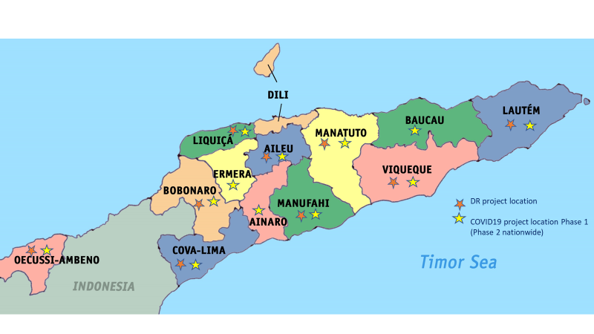

Prior to the responses activated for COVID-19 and the floods in Dili, the total budget for the first three years of the program was A$5.45m For the first two years of the program, total expenditure was A$1.56m.

##### Table 2: Timor Leste Disaster READY funding including COVID 2 funding (AUD)*

| **AHP Partner** | **Year 1** | **Year 2** | **Year 3** | **COVID** |
| --- | --- | --- | --- | --- |
| **CARE** | 372,778 | 1,391,019 | 1,366,417 | 1,200,000 |
| **Caritas (CAN DO)\*** | 0 | 0 | 0 | 500,000 |
| **Oxfam** | 263,900 | 305,555 | 570,611 | 1,100,000 |
| **Plan** | 193,026 | 214,311 | 182,624 | 1,100,000 |
| **World Vision** | 207,017 | 170,266 | 208,173 | 1,100,000 |
| **Total** | **1,036,721** | **2,081,152** | **2,327,825** | **5,000,000** |

*Caritas joined the Timor Leste partnership in 2019, but to date has been directly funded only for the COVID activation.

The data collection in Timor-Leste included review of reports and other documentation, several interviews and discussions with country committee representatives, field-based research which sought the views of community, government and partners, and discussions with DFAT and Australian NGOs. An initial set of findings were presented to DFAT in Timor-Leste together with the Disaster READY country committee partners, in order to check the validity of those findings and engage the various organisations in initial analysis and sense making. This country summary draws from all these data sources.

### Findings

Disaster READY in Timor-Leste has made progress against all of the five program outcomes.

1. ***Communities are better prepared for rapid- and slow-onset disasters***

Community representatives including local leaders and community members report that they have benefited from the Disaster READY activities. In particular that they are more informed about disasters and more prepared to act to protect themselves. In particular where there have been longer term relationships with NGOs or local organisations, the community value this commitment and relationship and the impact in terms of changed community understanding and preparedness is more evident.

There were a range of reports from some communities and some local leaders who are unhappy with the quality or the scope of the Disaster READY activities in their location. In the recent responses, for example the Dili flood response, some support had been quite delayed leading to people without adequate shelter for several months. The core difficulty appears to be a breakdown in communication between community level and high level NGO management. Implementing through local partners provides the NGOs with access to rural and remote communities, but there are not necessarily sufficient resources to oversee the quality and delivery of this local level work in all situations.

Communities reported that they generally did not understand who is responsible for the projects in their location or how this work necessarily contributes to their overall development priorities. Feedback from community people and local leaders suggested that they would like more say and more opportunity to provide feedback about the quality of activities and to influence planning and delivery of these activities. It was noted that many NGOs both local and international work in different locations in Timor-Leste and that it is probably difficult for people in communities and local leaders to distinguish between specific Disaster READY activities and support for local disaster response from broader development interventions and indeed overall development aspirations.

1. ***The rights and needs of women, people with disabilities, youth and children are being met in disaster preparedness and response at all levels.***

Program reporting and observations at community level indicate that there has been good progress in gender inclusion in Disaster READY activities. Men and women are working together and there have been clear shifts in more women being included in discussions and some decision-making. Stakeholders external to Disaster READY including those from other organisations, report that Disaster READY has been a significant contributor to supporting gender inclusion in Timor-Leste.

In regard to inclusion of people with disability, the local partners and local leaders were aware of this area of work and knowledgeable about the importance of increased inclusion for people of all abilities. There has also been work to influence government around disability inclusion with support through the program for RHT0 to assist with assessments alongside government. RHTO also provides training to increase awareness among in-country NGOs. However, disability inclusion is still to move from awareness and understanding into changed practice. Observations at community level indicate there is continued exclusion and discrimination against people with disability which puts them at greater risk from disasters due to exclusion from preparation activities and means they are not necessarily benefiting from disaster response. This is an area where the program needs to place more attention particularly in understanding how plans and activities are being implemented at community and local government level. RHTO is making good use of Disaster READY support to engage in preparation and response activities, but cannot by itself meet all requests to raise awareness and represent the needs of people with disability.

1. ***Government, NGOs, the private sector and communities coordinate more effectively for inclusive disaster preparedness and response.***

Disaster READY in Timor-Leste has worked effectively to coordinate with government, in particular at the national level. National level government departments provided very positive feedback about the high-quality coordination with the program and their view is that this coordination has supported improvements in-country wide systems for disaster preparation. They pointed to the utilisation of standard government approaches as being critical to ensuring sustainability of outcomes beyond the life of this program.

Working with government has provided Disaster READY NGOs with the opportunity to influence and seek to further improve government standards and approaches. This has included attention to disability inclusion and a focus on gender and child protection. While advocacy around these areas has not always been easy, recently revised government guidelines now reflect increased attention to inclusion and child protection.

Working through and with government has its challenges. The government response to disasters implemented through several levels of government has been slow, which in turn limits what Disaster READY is able to achieve. Several respondents also noted that while the cooperation with government had been positive, Disaster READY is not in itself big enough to address all of the capacity needs in national, municipal and local governments around disaster preparation and response, and there needs to be a much wider cooperation between government and all players including other NGOs, UN agencies and private sector, in order for there to be a comprehensive capacity in country to both prepare for and respond to disasters.

1. ***National NGOs and faith-based organisations have more influence and capacity in the country humanitarian system.***

Local NGOs and local leaders have identified that Disaster READY has provided support and increased their capacity to work in disaster preparation. At the municipal level in particular, leaders know about the program and are appreciative of the support. The program reports that as a result of its focus on cooperation with local partners, local NGOs now have a stronger voice in the UN cluster system in Timor-Leste. Disaster READY has allowed smaller and specialist NGOs, such as RHT0, to participate in the humanitarian system.

Conversely the program is working across several locations with many local partners who are utilising different activities and ways of bringing about change. It is difficult for the in-country NGOs at the country committee level to necessarily oversee and ensure the quality of all of this work. There seems to be some tension between working with local NGOs in order to utilise community knowledge and engage with communities around traditional resilience methods, versus ensuring that projects are well-informed with current understanding of climate change and disaster risks. Further work to bring the best of these together is required.

A further challenge for working through national NGOs and faith-based organisations, are the several levels of reporting and monitoring in Disaster READY in Timor-Leste. Presently the program is planned in a very detailed way with the emphasis on reporting against agreed detailed work plans and established outputs and outcomes. According to local partners this provides limited opportunity for new ideas and innovation to influence upwards. It also seems to limit identification of the work and contribution of local actors with some views that local voice and local experience is not well captured in the reporting eventually provided to DFAT.

As noted there appears to be limited opportunity for communities to provide feedback about the quality of activities and limited opportunity for communities and vulnerable people within those communities to influence program implementation.

1. ***AHP NGOs work effectively together and with other relevant stakeholders.***

There was very strong feedback from government and other organisations in Timor-Leste that the Disaster READY program is very progressive in its approach to cooperation. Respondents noted that it provides increased value to the country because it lessens duplication and promotes sharing and joint activity. Government respondents and others also reported that the ways in which the Disaster READY country committee and partners work are respectful of Timor-Leste government leadership.

Respondents from organisations outside of Disaster READY reported that the active cooperation between Disaster READY agencies has encouraged them to work more cooperatively. The in-country committee identified that cooperation has enabled them to cover a wider area and to utilise the unique technical and other abilities of each agency. Altogether this has led to a wider range of expertise being available for the disaster preparation and response work in Timor-Leste.

The Disaster READY in-country committee has placed significant emphasis on learning how to work cooperatively since the commencement of the program. Its success is evident in the additional funding it is now leveraging outside of Australian government support.

The program now provides a combined report in order to present a more comprehensive and integrated overview of the Disaster READY work. The recent responses to COVID -19 and the floods in Dili provided very clear examples of the ways in which the in-country committee is able to manage available resources based on the expertise and location of organisations, avoiding the competition between NGOs which is more common in disaster response situations.

### Additional findings

With the response activations undertaken in 2020, alongside the existing work plan, Disaster READY in Timor-Leste has been very stretched. While individual agencies and the in-country committee have worked very hard to manage all requirements it is clear that the many additional tasks, largely undertaken without external supports, have exhausted staff and partners. The need for in-country committees to develop proposals and make decisions around resource allocation has challenged the typical roles vis-à-vis in-country versus international NGOs. It has also interrupted much of the intended work plan for 2020.

The recent response activations have highlighted the way in which, for a country like Timor-Leste, disaster preparation and response and ongoing development work overlap, particularly at community level. The Disaster READY partners seem to be addressing needs which are a mixture of both DRR and development.

Disaster READY in Timor-Leste has a wide range of accountabilities. These include accountability to DFAT and to other donors, accountabilities to the Timor-Leste government at national and local levels and accountabilities to people in communities. These are alongside individual agency mandates and the direct accountability between country committee NGOs and their international NGO organisation.

### Conclusions

Overall, the program in Timor-Leste has demonstrated progress against its outcomes. Its focus on cooperation between agencies and with government, has been particularly influential. This is expected to contribute to sustainability of outcomes beyond the life of the program and likely lays important groundwork for increased localisation of humanitarian response. The program would be improved by more attention to the quality of work in communities, building mechanisms for accountability and increased engagement with community members and leaders.

The program is stretched in several directions with many ambitions and accountabilities. Further development of the program should focus around clarifying its overall intention and end goal and directing resources more clearly towards support for this goal.

## Fiji

### Overview

Disaster Ready in Fiji is implemented by five Australian NGOs and their partners, which include a mixture of government organisations and local NGOs in Fiji as well as additional Australian and International organisations, as outlined in Table 3.

##### Table 3. ANGOs managing Disaster READY in Fiji and their 2019 partners

| ANGO | 2019 partners |
| --- | --- |
| * **CAN DO** * **CARE Australia** * **Plan International Australia** * **Save the Children Australia** * **World Vision Australia** | * ChildFund Australia * CBM Australia * Plan International Australia in Fiji * Live and Learn Fiji * Habitat for Humanity Fiji * Field Ready * CAN DO Fiji (Anglican, Catholic, Methodist, Seventh-day Adventist, ADRA, Salvation Army, Baptist Convention, Fiji Council of Churches, Olafou, Fiji Community Churches for Christ, ECREA) * Save the Children Fiji * Partners in Community Development Fiji * Fiji Disabled Peoples Federation * Fiji Council of Social Services * Empower Pacific * Rainbow Pride Foundation * Department of Social Welfare * Pacific Disability Forum |

The program is implemented across Fiji, as outlined in Fig 2.

##### Fig 2. Disaster Ready activity location in Fiji

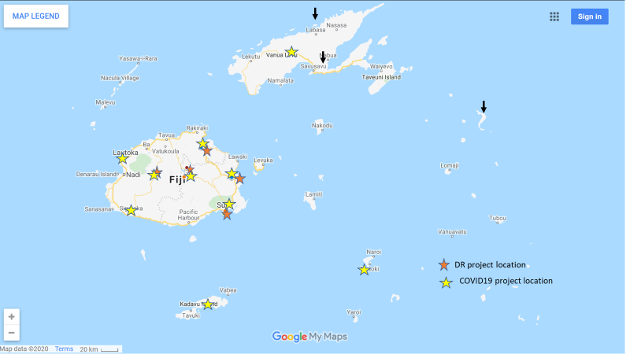

Prior to the responses activated for COVID-19 and TCH, the total budget for the first three years of the program was A$4.28m For the first two years of the program, total expenditure was A$1.72m.

##### Table 4: Fiji Disaster READY funding including COVID 2 funding (AUD)*

| **AHP Partner** | **Year 1** | **Year 2** | **Year 3** | **COVID** |
| --- | --- | --- | --- | --- |
| **CARE** | 199,722 | 224,139 | 198,121 | 499,500 |
| **Caritas (CAN DO)** | 354,389 | 367,410 | 367,988 | 632,700 |
| **Oxfam** | 0 | 0 | 0 | 416,250 |
| **Plan** | 365,087 | 1,299,296 | 848,212 | 815,850 |
| **Save the Children** | 17,499 | 17,500 | 15,899 | 632,700 |
| **Total** | **936,697** | **1,908,345** | **1,430,220** | **3,000,000** |

*As shown in the table, some ANGOs are working with Disaster READY partners in this country for the COVID response only.

Data collection in Fiji included review of reports and other documentation, several interviews and discussions with country committee representatives, field-based research which sought the views of community, government and partners, and discussions with DFAT and Australian NGOs. An initial set of findings were presented to DFAT in Fiji together with the Disaster READY country committee partners, in order to check the validity of those findings and engage the various organisations in initial analysis and sense making. This country summary draws from all these data sources.

### Findings

Fiji is a very mature development location with a well-developed civil society sector and strong government systems. Disaster READY implementation in Fiji has made good progress against outcomes. Implementation has clearly been shaped by the country context.

1. ***Communities are better prepared for rapid- and slow-onset disasters***

At community level people report that they see the value of the training provided through Disaster READY activities in preparing them for disasters. Community members consulted for this review who had undergone training reported that they had been able to respond more effectively in the most recent emergency related to TC Harold.

The range of local NGOs and partners involved in this program has ensured there is a good range of different services brought together at the community level including attention to psychosocial support. This has been of particular value to community people and one that was highlighted to the evaluation team.

Community members and local leaders report that training and other disaster preparation has increased the focus on how to help marginalised groups such as people with disability and older people in disaster and emergency situations.

A suggested improvement from local organisations and some community leaders was the opportunity for more feedback and ideas from community level up through the planning and decision-making in Disaster READY. Other respondents suggested that there needed to be more focus on overall outcomes and more room within the program to work adaptively to address emerging needs particularly as these are shifting after the economic and other challenges introduced in 2020 because of COVID-19.

1. ***The rights and needs of women, people with disabilities, youth and children are being met in disaster preparedness and response at all levels.***

The program appears to give good attention to gender inclusion and has made effective use of local organisations to support women’s active engagement in disaster preparedness.

Disability inclusion has shifted from collecting data about people with disability to building more awareness about the need to actively include people and there is evidence from the responses particularly from community and local leaders that people are gaining some new perspectives around disability inclusion. Significantly both DPO and LGTBI groups identified that working with Disaster READY has given them a way into humanitarian work and an effective conduit to working with communities. In turn, other respondents noted that having these groups included in community level work has helped to broaden the discussions and promote more inclusive disaster response practice.

There is need for ongoing work around disability inclusion. Results at community level and reports from partner NGOs suggest that the ambitions around disability inclusion are still not matched by results on the ground. There needs to be further work around improving communication with DPOs and increasing the opportunity for people with disability and their organisations to actively contribute to planning, implementation and assessment of programs managed by Disaster READY.

Fiji Disabled People’s Federation (FDPF) was identified as an effective organisation, which has been supported through Disaster READY to provide capacity to other DPOs and CSOs in-country. Respondents suggested that it has worked well in this role but is not necessarily able, by itself, to address all the changes required to ensure disability-inclusive practice in Disaster READY.

1. ***Government, NGOs, the private sector and communities coordinate more effectively for inclusive disaster preparedness and response.***

The Disaster READY program is recognised and valued by the NMDO. In the recent responses to TC Harold and COVID-19, Disaster READY partners were invited to work with Divisional governments in Fiji, acknowledging their relevance and expertise. Respondents to the review suggested that strength of the program was its ability bring together relationships with communities and CSOs and interaction with local government around disaster preparation and response.

1. ***National NGOs and faith-based organisations have more influence and capacity in the country humanitarian system.***

As noted, Fiji is a mature development location. The National Disaster Management Act mandates civil society leadership and coordination for disaster preparedness and response through the Fiji Council of Social Services (FCOSS). The NMDO has responsibility under the Act to coordinate government response. Disaster READY was identified as a legitimate and valuable local player particularly because it works through local NGOs. It is seen as respectful of the designated roles of FCOSS and NMDO, and supportive of increased national government leadership in disaster response. The technical expertise it brings from its partnership with Australian NGOs was identified by the government and others as a significant contribution.

Fiji has several experienced and capable people working in disaster response and preparation. While there are many ongoing needs, including resourcing for FCOSS (in order that it is able to fully implement its coordination and leadership role), and ongoing technical inputs to develop the quality of disaster preparation and response, local partners of Disaster READY had several views about how a more locally managed program could be developed.

Specifically, local partners were keen to retain access to the technical expertise available in Australian NGOs but did not necessarily want to respond to the mandates of multiple Australian organisations. There were suggestions around ways in which this might be streamlined, including having one Australian NGO responsible for coordinating any technical and other inputs provided to in-country partners. Concern was also raised about the funding directed to Australian NGOs and how the proportion for Australian-based overhead costs could be reduced in order to maximise funding for partner organisations in Fiji.

There was some concern about the work of local NGOs not being sufficiently recognised in the program reporting for Disaster READY and AHP. This corresponded to another view that the program was not utilising the voices and experiences of community, local CSO and NGO partners in supporting its adaptation and further development. Local partners suggested there needed to be far more flexibility in the program planning and approach in order to respond to the emerging priorities of government (expected to be developed further under a new 10 year plan for the NMDO) and the likely emerging challenges due to the impacts of COVID-19.

1. ***AHP NGOs work effectively together and with other relevant stakeholders.***

Disaster READY partners report that the coordination between them has been good and is improving. They are keen to do more to improve their cooperation particularly to ensure the best quality activities unavailable at community level. The response required for COVID-19, having them coordinate a shared country proposal with attention to balancing both need and partner capacity was seen as a good learning experience.

Organisations and respondents outside of the Disaster READY program in Fiji noted that many Fiji NGOs and organisations tend to work in silos and that the Disaster READY program has offered a different and influential approach which is appreciated across the civil society community. Other organisations have been challenged to increase their interaction and cooperation. The coordination and cooperation approach was seen by external respondents as being efficient and effective. In particular respondents noted that it brings together a wide range of organisational skills and specialties, increasing the value of the activities in each location.

### Other findings

Program partners raised some concerns around the monitoring and evaluation for Disaster READY. Notwithstanding the support that has been provided for coordination of monitoring and evaluation, people have found it difficult to respond to changing requests and variation in indicators and measures of change. There was also a view that different organisations and partners had a wide variety of needs related to monitoring and evaluation and that more attention might need to be given to supporting different systems tailored to both country and agency needs.

Alongside this there was a very strong view that there is insufficient communication about the work of local organisations in the program reporting. Further that there is insufficient voice from community local CSO and local partners in the program planning and design. It was suggested that the program ought to work further to promote accountability to affected populations both to ensure the continuity and quality of the work at community level.

Program partners in-country identified the ongoing changes being imposed upon the program and the difficulty in maintaining attention to planned work while also managing response and recovery activities. As noted there were a range of concerns around how the program could be adapted going forward in order to reflect both the learning developed to date and to respond to the emerging needs in countries.

Respondents raised issues around sustainability of program outcomes. It was suggested that there needs to be more systematic and regular training at district and local levels in order to update and embed disaster preparation and response in local government and community systems. Respondents also recommended that the work ought to be expanded beyond the current Disaster READY locations to meet the needs of more remote communities. It is recognised that Fiji will experience ongoing disasters and any future work will need to include a mixture of disaster preparedness and response. Ongoing work to address the impact of COVID-19 will also consume CSO and government resources.

Disaster READY partners identified that they had a contribution to make across all of these areas, but that a comprehensive response also required further cooperative work with government and civil society organisations in Fiji. It also requires clarity from donors about their priorities (in-country partners were keen to know what the likely DFAT policy priorities would be and how these would align with Fiji national development priorities going forward). Finally, in-country partners need to develop the skills and capacities to work across these various areas and need to be supported by adequate resourcing.

Some additional issues were raised around how to better integrate climate change information into disaster preparedness. A small number of respondents raised concerns about the need for a focus on resilience, bringing together the development expertise of in-country NGOs with a focus on climate informed disaster preparation.

### Conclusions

In Fiji, the program has demonstrated the value of a cooperative approach, positioning it as a legitimate and valuable contributor in the humanitarian space and influencing other organisations to work in more cooperative ways. Respondents suggested that this is an important area to is retain into the future.

The program is part of a maturing humanitarian sector and is valued for the comprehensive technical and other expertise it introduces from Australia. It has also been valued for its attention to issues around diversity and inclusion. The program has worked effectively through local partners. Notwithstanding the need to further support the systems and capacities of those partners, the opportunities for increased localisation appear to be strong in this location.

## Vanuatu

Disaster Ready in Vanuatu is implemented by six Australian NGOs and their partners, which include a mixture of government organisations and some local NGOs, as outlined in Table 5.

##### Table 5. ANGOs managing Disaster READY in Vanuatu and their 2019 partners

| **ANGO** | **2019 Partners** |
| --- | --- |
| * **CAN DO** * **CARE Australia** * **Oxfam Australia** * **Plan International Australia** * **Save the Children Australia** * **World Vision Australia** | * National Disaster Management Office * Action Aid Australia * Action Aid Vanuatu * World Vision Vanuatu * Save the Children Vanuatu * Act for Peace * Oxfam Vanuatu * Wan Smolbag * Vanuatu Disability Promotion and Advocacy * Vanuatu Christian Council * Women I Tok Tugetha Forum * Pacific Disability Forum * CBM Australia * Ministry of Education and Training * Sanma Disaster Management Office * Sanma Provincial authorities including Area Councils * Habitat for Humanity |

The program is implemented across Vanuatu, as outlined in Fig 3.

##### Fig 3. Disaster READY activity location in Vanuatu

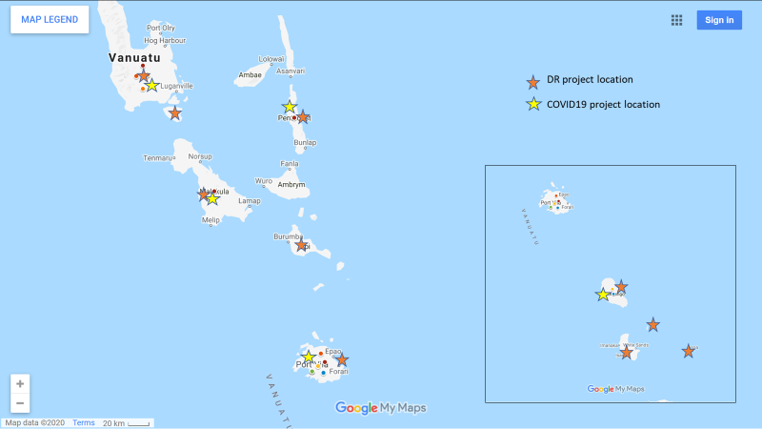Prior to the responses activated for COVID-19 and TCH the total budget for the first three years of the program was A$7.02mm For the first two years of the program, total expenditure was A$4.37m.

##### Table 6: Vanuatu Disaster READY funding including COVID 2 funding (AUD)

| **AHP Partner** | **Year 1** | **Year 2** | **Year 3** | **COVID** |
| --- | --- | --- | --- | --- |
| **CARE** | 398,091 | 400,522 | 412,727 | 765,000 |
| **Caritas (CANDO)** | 238,389 | 395,280 | 353339 | 765,000 |
| **Oxfam (non-cash)** | 515,011 | 222,879 | 511,005 |  |
| **Plan** | 164,815 | 256,625 | 145,968 | 550,000 |
| **Save the Children** | 680,856 | 857,253 | 910,732 | 1,065,000 |
| **World Vision** | 224,669 | 154,768 | 179,412 | 855,000 |
| **Total** | **2,221,830** | **2,287,328** | **2,513,183** | **4,000,000** |

Data collection in Vanuatu included review of reports and other documentation, some interviews and discussions with country committee representatives, field-based research which sought the views of community, government and partners, and discussions with DFAT and Australian NGOs. This country summary draws from all these data sources.

### Findings

Vanuatu is a challenging context within which to focus on disaster preparedness. It was described by several respondents to this evaluation as having been in a continuous state of disaster, particularly since tropical cyclone Pam in 2015. Nevertheless, there has been progress in program implementation against most of Disaster READY outcomes.

1. ***Communities are better prepared for rapid- and slow-onset disasters***

Progress against this objective is strong in Vanuatu. The recent TCH response has clearly demonstrated the value of preparedness work with communities. It has also demonstrated the value of the Community Disaster and Climate Change Committees (CDCCC) model in drawing communities together to both prepare for and then work to respond to major disasters. Communities themselves, local government and national government all identified the significant contribution made by Disaster READY NGOs to community disaster preparation and the value of this preparation in the face of recent disasters. Acknowledging that there was limited opportunity for international support in response to TCH, communities and government identified that those communities where NGOs had been active in training and capacity development had managed much better quality responses compared to other locations.

Communities themselves expressed their appreciation for the support from Disaster READY NGOs. In particular where there are long-term relationships with some of the NGOs, communities have come to know staff and trust them and report that have worked well with those staff in disaster preparedness.

It was noted by both communities and local government that with the recent cyclones and other local disasters people are still experiencing trauma and that communities, local governments and others are exhausted by the ongoing demands of recovery and response.

There was a small amount of concern expressed in some communities that decisions around appropriate preparation and response tended to be made through NGOs planning with provincial government and that insufficient attention was played to community based assessment and ideas. This was not expressed by all communities.

Several respondents to this evaluation identified the need for greater reach to more remote communities particularly for disaster preparation. They also noted the changing nature of disasters in Vanuatu with increased severity of cyclones and increased number of disasters, suggesting that preparedness with communities needed to be regularly updated and extended across the country.

1. ***The rights and needs of women, people with disabilities, youth and children are being met in disaster preparedness and response at all levels.***

Program monitoring together with observations for this evaluation indicates that gender inclusion in disaster preparedness and response is improving, in part through the support and focus of Disaster READY. At the community level people reported on the value of women’s active inclusion in the CDCCCs. Examples were given around women’s effective leadership in the disaster committees.

Previous program monitoring had identified that the Women I Tok Tugeta program, a Disaster READY program that supports women to plan for their own needs and advocate for women participating in CDCCCs, has had significant impact in changing dynamics at community level. At the same time monitoring for this evaluation identified that this program has been controversial in some locations with insufficient understanding by some community members and local leaders about the focus and rationale for this work. This appears to be a program where Disaster READY NGOs could do further work to explain its value and its contribution to the wider Disaster READY approach.

Beyond this at national level, government respondents identified that Disaster READY had provided excellent support for the gender and protection cluster. And overall that the Disaster READY focus on gender has been positive and in line with government policy.

The work to support disability inclusion has improved the focus and attention to disability, particularly during the recent TCH response. The national DPO reported that there is increased focus on inclusion and that the support received through Disaster READY has been significant in building their opportunity to participate and to build their own internal capacity. National government through the NDMO reports that the focus on inclusion has increased throughout disaster preparation and response. External respondents report that the disability sub cluster was strong and active in the TCH response.

At the same time, there are areas for further improvement. Program monitoring suggests that the focus has tended to be on inclusion of people with physical disabilities such as people with mobility issues, with less attention to both psychosocial and less visible disabilities such as people who are blind or deaf. Church representatives suggested that more work was required on disability inclusion particularly reaching down to understanding at community level.

Significantly, the national DPO appreciated the support it is receiving through Disaster READY but was not clear why the Disaster READY disability inclusion officer was not collocated in their office, building their capacity to represent disability issues directly. They were also concerned about the limited cooperation and collaboration between some Disaster READY NGOs and the way in which this undermined a shared and cohesive approach to disability inclusion.

1. ***Government, NGOs, the private sector and communities coordinate more effectively for inclusive disaster preparedness and response.***

Some respondents noted that coordination between different levels of government in both disaster preparation and disaster response is still developing in Vanuatu and creates some challenges across the sector. The experience for NGOs is that at provincial level it has been easier to engage with government and to work more directly particularly during disaster response. Working through national systems is described by NGOs as more difficult and likely to slow the opportunity to move swiftly particularly during disaster response.

There was discussion around the NGO work at community level. Overall government respondents at both provincial and national level saw the value in this work and saw the value in the development of local disaster committees in communities. However, while these local committees are an important part of disaster response and are identified in the government system, national government respondents were concerned about their sustainability. In practice they are usually created or revived by various NGOs, including those who are part of Disaster READY, then at the end of programs are handed back to government. However, without the capacity or resources within the government system there is no ongoing process to support and update these committees going forward. National government respondents suggested that in order for this NGO work at community level to be more sustainable there needed to be much increased collaboration between NGOs and government and considerably more attention to capacity development within government systems.

A further concern was expressed about the general exhaustion across the humanitarian sector in Vanuatu and the lack of capacity to focus on preparedness in the face of ongoing response.

The churches reported good cooperation between themselves and government and good potential for this cooperation to be further developed.

1. ***National NGOs and faith-based organisations have more influence and capacity in the country humanitarian system.***

It was difficult to understand how Disaster READY work in Vanuatu has contributed in a significant way to the development of national NGOs and their participation in the humanitarian sector. While some Disaster READY NGOs do work with local partners and see some value in extending and expanding this work, this does not seem to be a strong focus compared to Disaster READY in other locations. Feedback from some Disaster READY NGOs suggested very mixed views about the road to humanitarian localisation in this country

Feedback from the churches is that Disaster READY has been useful for increasing their capacity. They report good relationships with government through their well-established programs. Given their spread across Vanuatu they are well placed to play a significant role in preparation and response. They report that the Disaster READY support has been important for their development although they would like to see increased coordination and collaboration between Disaster READY NGOs in order to maximise the outcomes able to be achieved.

1. ***AHP NGOs work effectively together and with other relevant stakeholders.***

Government respondents and others report that Disaster READY NGOs worked together well during the recent emergency responses. There are a range of good examples of specific collaboration especially to reach more remote communities and to ensure timely delivery of supplies. Government respondents particularly at provincial level, expressed their appreciation for the NGO work throughout the responses and the value of this work in preparing communities, increasing inclusion and supporting provincial disaster systems.

At the same time, government at national, provincial and local level all expressed concern about the limited collaboration between NGOs and government at other times. There was a strong view that NGOs including those in Disaster READY, needed to make more effort to work within government systems and government guidelines.

Disaster READY NGOs report that the recent responses have been important to demonstrate the value of their shared cooperation. Overall, they report that their ability to coordinate together has improved over time but have identified that this is an area for further development. The recent requirement for in-country committees to develop and manage activations directly has been difficult because of the lack of formal guidelines round cooperating together. They report that this has been challenging and an area where more assistance is required. At this time Disaster READY NGOs are utilising assistance to both develop their partnership arrangement and the accompanying structures.

More generally, communities and government respondents tended to see Disaster READY as a group of NGOs with whom they had various individual relationships. In those situations where staff had been retained over time, there was greater opportunity to build good working relationships. However, government and communities did not see Disaster READY as a coordinated program. Others, such as churches and DPO, suggested that the limited cooperation and information sharing at times undermined the effectiveness of the program. Internally it was difficult to get one cohesive voice from Disaster READY NGOs for this evaluation.

### Other findings

As noted above, the plan for sustainability of Disaster READY program outcomes in Vanuatu is not clear. It was difficult to generate discussion about sustainability among Disaster READY respondents. Overall people were still focused on finalising the response and recovery work from the recent disasters and managing the activations being made available by DFAT. This seems to have been limited space at the country level for program staff to input their ideas and strategies into Disaster READY directions.

Government and others noted that discussing sustainability in community preparation is challenging in a location such as Vanuatu where disasters are ongoing and appear to be increasing in severity. There appears to be the need for further discussion around the vision for resilience in this country, particularly with attention to climate change. Accompanying that would be further exploration of the respective roles of government, civil society and international supports.

Disaster READY NGOs reported that the program administration has at times been quite burdensome. They noted that reporting is often time-consuming with many versions being required and up to 6 months taken to finalise individual reports. They also raise concerns about monitoring and evaluation systems and difficulties created by changing requirements.

Program monitoring does report that there has been some good work undertaken on integration with other DFAT programs such as the Australian NGO Cooperation Program (ANCP). It would be useful to have more visibility around this integration particular for wider learning across Disaster READY.

### Conclusions

Vanuatu is a challenging context for Disaster READY implementation. There has been good progress in work with communities and some promising work through churches. However, the path towards sustainable program outcomes and sufficient government capacity is still being developed in this location.

## Papua New Guinea

Disaster READY in PNG is implemented by four Australian NGOs and their partners, which include a mixture of government organisations and some local NGOs, as outlined in Table 7.

##### Table 7. ANGOs managing Disaster READY in PNG and their 2019 partners

| **ANGO** | **2019 Partners** |
| --- | --- |
| * **Caritas Australia** * **CARE Australia** * **Plan International Australia** * **World Vision Australia** | * Anglicare * ADRA PNG * Baptist Union * Evangelical Lutheran Church * Salvation Army * United Church * ChildFund PNG * Plan International Australia in Bougainville * National Agricultural Research Institute * Department of Agriculture and Livelihood * Climate Change and Development Authority in PNG * Autonomous Region of Bougainville Red Cross * Autonomous Region of Bougainville Directorate for Disasters and Emergencies * Madang Provincial Disaster Management Office * Madang Provincial Department of Education * Eastern Highlands Province Disaster Office * Self Help Creative Centre (Disability Centre) * PNG Assembly for Disabled Persons |

##### Fig 4. Disaster READY activity location in PNG

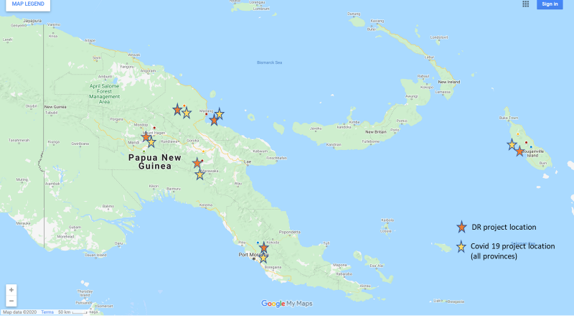

Prior to the responses activated for COVID-19, the total budget for the first three years of the program was A$3.12m For the first two years of the program, total expenditure was A$1.91m.

##### Table 8: PNG Disaster READY funding including COVID 2 funding (AUD)*

| **AHP Partner** | **Year 1** | **Year 2** | **Year 3** | **COVID** |
| --- | --- | --- | --- | --- |
| **CARE** | 344,268 | 364,463 | 388,241 | 1,656,481 |
| **Caritas (CAN DO)** | 218,611 | 271,906 | 222,391 | 986,481 |
| **Oxfam** | 0 | 0 | 0 | 877,968 |
| **Plan** | 294,338 | 369,644 | 306,760 | 986,481 |
| **Save the Children** | 0 | 0 | 0 | 1,097,593 |
| **World Vision** | 0 | 155,304 | 182,815 | 986,481 |
| **Total** | **857,217** | **1,161,317** | **1,100,207** | **6,591,485** |

*As shown in the table, some ANGOs are working with Disaster READY partners in this country for the COVID response only.

## Solomon Islands

Disaster READY in Solomon Islands is implemented by six Australian NGOs and their partners, which include a mixture of government organisations and some local NGOs, as outlined in Table 9.

##### Table 9. ANGOs managing Disaster READY in Solomon Islands and their 2019 partners

| **ANGO** | **2019 Partners** |
| --- | --- |
| * **CAN DO** * **CARE Australia** * **Oxfam Australia** * **Plan International Australia** * **Save the Children Australia** * **World Vision Australia** | * Anglican Church of Melanesia * ADRA Solomon Islands * Caritas Australia (Solomon Islands Office * South Seas Evangelical Church * United Church of Solomon Islands * Solomon Islands Christian Association * People with Disability Solomon Islands * Provincial Disaster Management Office and committees * Plan International Australia in Solomon Islands * Australian Volunteers International (AVI) in Solomon Islands * Solomon Islands Development Trust * Australian Bureau of Meteorology * National Disaster Management Office * Provincial Disaster Management Office * Solomon Islands Meteorological Services |

##### Fig 5: Disaster READY activity location in Solomon Islands

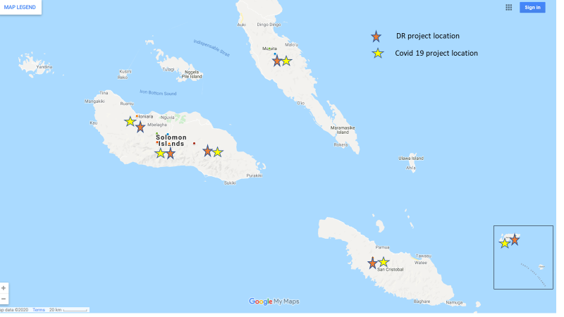

Prior to the responses activated for COVID-19, the total budget for the first three years of the program was A$4.96m For the first two years of the program, total expenditure was A$2.31m.

##### Table 10: Solomon Islands Disaster READY funding including COVID 2 funding (AUD)

| **AHP Partner** | **Year 1** | **Year 2** | **Year 3** | **COVID** |
| --- | --- | --- | --- | --- |
| **CARE** | 182,222 | 176,638 | 182,222 | 513,000 |
| **Caritas (CAN DO)** | 218,056 | 185,965 | 276,944 | 817,000 |
| **Oxfam** | 318,979 | 281,374 | 486,106 | 707,000 |
| **Plan** | 197,026 | 152,736 | 136,746 | 475,000 |
| **Save the Children** | 23,153 | 61,007 | 0 | 513,000 |
| **World Vision** | 543,966 | 1,183,369 | 357,205 | 475,000 |
| **Total** | **1,483,402** | **2,041,088** | **1,439,223** | **3,500,000** |

1. These included the opportunity to observe the practice of AHP in the Pacific and Timor-Leste as it implemented aspects of DFATs response to the pandemic. It also provided the opportunity to make use of locally based researchers to undertake fieldwork in three of the five Disaster READY countries (see Annex Two for a full list of the stakeholders consulted and Annex Six for detailed country reports). Finally, it provided the opportunity to have locally based NGOs and their partners reflect on their experience in real time and explore the emerging lessons and implications of these for future programming work. These and other features supported more in-depth data collection and increased collective sense making or analysis about progress towards program outcomes.
2. AHP builds on a predecessor program, the DFAT-NGO Humanitarian Partnership Agreement which operated for six years.
3. *DFAT Humanitarian Strategy 2016, May 2016*.
4. In 2015, DFAT endorsed the *Sendai Framework for Disaster Risk Reduction, 2015-2030*.
5. A summary of major findings against evaluation question, together with relevant recommendations is at Annex Four.
6. AHP Humanitarian Response Annual Progress Update January – December 2019
7. The data for assessment of the AHP response to rapid and slow onset disasters was drawn mainly from AHP monitoring and evaluation reports, and independent evaluations. To date, there has been one independent evaluation of a rapid response (PNG Earthquake Response) and four of protracted responses: South Sudan; Bangladesh (Rohingya Humanitarian Crisis); Yemen; and Iraq.

   This information was triangulated as far as possible with other data sources including interviews with the Australian NGOs and DFAT and interviews with informed Australian and other stakeholders (see Annex Two), alongside review of other relevant reports (for example, the *Independent Evaluation of the Syria Crisis Humanitarian and Resilience Package,* DFAT, May, 2019).
8. For example, the *Independent Evaluation of the Syria Crisis Humanitarian and Resilience Package*, DFAT, May 2019
9. AHP 2019 Annual Progress report
10. Templates for proposals for both rapid and protracted activations require a paragraph detailing the approach to ‘sustainability, connectedness and localisation’ and the approach to enhancing and building longer term local capacity and support for local leadership and decision making , and to coordination.
11. Standard Five requires that communities and people affected by crises have access to safe and responsive mechanisms to handle complaints *(Core Humanitarian Standard on Quality and Accountability*, Sphere Project 2014).
12. In 2019, Vanuatu was ranked as the country in the world most at risk from disasters. Solomon Islands was ranked number four, PNG number six, Fiji number 12 and Timor-Leste number 15 out of 180 countries (*The World Risk Report, 2019*, Bündnis Entwicklung Hilft and Ruhr University Bochum – Institute for International Law of Peace and Armed Conflict (IFHV))
13. The five end of program outcomes include:

    * Communities are better prepared for rapid- and slow-onset disasters.
    * The rights and needs of women, people with disabilities, youth and children are being met in disaster preparedness and response at all levels.
    * Government, NGOs, the private sector and communities coordinate more effectively for inclusive disaster preparedness and response. National NGOs and faith-based organizations have more influence and capacity in the country humanitarian system.
    * AHP NGOs work effectively together and with other relevant stakeholders.

   
14. The significantly greater funding directed to Vanuatu appears to be due to 2 factors. The first was the continued work being undertaken here by several NGOs to complete the recovery work from Tropical Cyclone Pam. The second reason is illustrated in Figure 4, which shows that one of the Australian NGOs, Save the Children, chose to direct the bulk of its funding to Vanuatu in contrast to other consortia.
15. Note that some additional funding for COVID-19 was made available to other Pacific countries through Disaster READY partners and the mechanism of AHPSU, a further expanding of the program scope and focus.
16. Disaster READY Annual Progress update, January -December 2019.
17. This evaluation has drawn from multiple sources of evidence to assess its progress against its original outcomes and additional evaluation questions. This includes review of program reporting; interviews with representatives of all of the Australian NGOs and representatives of a range of other organisations who have participated in or collaborated with AHP and Disaster READY (see Annex Two); and independent data collection in Fiji, Timor-Leste and Vanuatu. In addition, a real-time reflection process was undertaken throughout the initial response to COVID-19, designed to explore the challenges and strengths experienced in the country committee’s direct management of these responses. Interviews were also undertaken with DFAT in Vanuatu , Timor-Leste and Fiji.
18. The chart shows percentage of progress against life of program targets. Note that each country (and each NGO within that country) sets its own targets. In some situations, such as the outcome for Fiji against the third indictor, the target has been exceeded before the end of the program, showing achievement of greater than 100% of the target.
19. DFAT Humanitarian Strategy 2016, May 2016.
20. See for example – The HPA Mid-Term Review, June 2013 and DFAT (2016) *The Australia Africa Community Engagement Scheme. Effective Partnerships for Sustainable Development. Program Review 2011 – 2016*.
21. See for example the discussion in, Dillon, N. (2019) Breaking the Mould, Alternative Approaches to Monitoring and Evaluation, ALNAP Paper. The paper suggest that the common practice of humanitarian assessment systems, which is to focus on simple quantitative assessments and accountability for activity completion, have undermined the more adaptive and learning orientated processes now required for complex humanitarian response
22. AHP Investment Design Document, 2016, pg. 11.
23. DFAT Localisation Of Humanitarian Action, 2019
24. Wider research indicates that progress towards localisation in countries in the Pacific is still under-developed **(**Australian Red Cross (2017), *Going Local – Achieving a more appropriate and fit for purpose humanitarian ecosystem in the Pacific,* October).

    In particular recent research in Vanuatu, Tonga, Solomon Islands and Fiji has identified that there has been insufficient action in areas such as equal working partnerships between national and local actors, sufficient community participation in humanitarian response and preparation and insufficient localised funding. Significantly this research shows that Vanuatu, one of the most disaster-prone countries in the world, has shown the least progress among these four countries towards localisation (FCOSS, PIANGO, Humanitarian Advisory Group, September 2019. Localisation in Fiji: demonstrating change. CSFT, PIANGO, Humanitarian Advisory Group, June 2019, Localisation in Tonga: demonstrating change. VANGO, PIANGO, Humanitarian Advisory Group, January 2019, Localisation in Vanuatu: demonstrating change. Development Services Exchange, PIANGO, Humanitarian Advisory Group. November 2019. Localisation in the Solomon Islands: demonstrating change)
25. AVI develops and supports capacity building plans with local Fiji civil society organisations. The plans are time-limited and designed to target specific organisational development which will enhance its capacity to operate independent of external actors. This approach was described as a support towards localisation for the Fiji CSOs working in humanitarian response.
26. It is assumed that people with disability make up at least 15% of any population (WHO (2011) World Report on Disability). Persons with disabilities are among the most vulnerable to natural and human-made hazards and are disproportionately represented among victims of disasters (Global Report on Human Settlements 2007, Enhancing Urban Safety and Security (published by Earthscan in the UK and US, 2007), United Nations Human Settlements Program (UN-HABITAT), p 181. Available at: <Http://www.preventionweb.net/files/2585_2432alt1.pdf>)
27. DFAT, February 2019, Evaluation of protection in Australia’s disaster responses in the Pacific.
28. Australian Red Cross, Humanitarian Advisory Group, Humanitarian Policy Group, March 2019, Protecting people in locally led disaster response
29. The Australian government policy as outlined in *Partnerships for Recovery: Australia's COVID-19 development response, 2020,* focuses on localisation of Australian assistance through partner government systems and local organisations, supported by Australian organisations including NGOs and faith-based organisations that are able to reflect Australian values and build enduring ties with institutions in other countries.
30. As outlined in the Pacific Framework for Resilient Development.
31. Cornwell 2014