APO regulator performance

– self-assessment report

December 2018

Introduction

The Australian Passport Office (APO) of the Department of Foreign Affairs and Trade (DFAT) issues Australian travel documents under a framework of legislation, policy and administration. Consistent with the requirements of the Australian Government’s *Regulator Performance Framework[1]*, this report sets out the results of the APO’s self-assessment of its performance during the 2017-18 financial year (Review Period).

The Framework includes six Key Performance Indicators (KPIs) against which all regulators must assess their performance. For each of these KPIs, APO has assessed its performance by reference to one or two metrics.

KPI 1: REGULATORS DO NOT UNNECESSARILY IMPEDE THE EFFICIENT OPERATION OF REGULATED ENTITIES

*Metric: Measures taken to improve and refine the APO’s regulatory footprint.*

The APO is continuously striving to strengthen passport systems and enhance client service. We released a new Online Application Form for adult applicants that has streamlined and simplified the application process. This new platform has facilitated the import of cleaner data into our systems, which has reduced the need for rework and reduced the need to seek further information from our clients post application lodgement.

*Metric: APO performance in meeting targets for processing passport applications once all required information has been submitted (10-day turnaround for ordinary applications and 2-day turnaround for priority-processed passport applications) to ensure clients receive their passports in a timely and reliable manner.*

The Passport Issuance and Control System (PICS) records all data on Australian travel documents issued by the APO. PICS data as at 30 June 2018 shows 97.6% of all applications received in 2017-18 were processed within 10 days, and 98.4% of applications where a priority processing fee was paid were completed within 48 hours.

KPI 2: COMMUNICATION WITH REGULATED ENTITIES IS CLEAR, TARGETED AND EFFECTIVE

KPI 5: REGULATORS ARE OPEN AND TRANSPARENT IN THEIR DEALINGS WITH REGULATED ENTITIES

*Metric: APO public communications material is clear, current and responsive to client needs.*

The APO launched a campaign to encourage passport applicants to start their applications online, which resulted in a decrease in the use of hardcopy forms. 74.3% of applicants completed their forms online in 2017-18, a 17.2% increase on the previous year. Online forms significantly reduce errors through the import of cleaner data, reducing the need to reconfirm information with clients.

We also continue to review and make improvements on our communication products through our website materials, brochures, posters and social media content. We released information to the public on the discontinuance of frequent traveller passports in January 2018. In February 2018 the APO advised the public that callers to the Australian Passport Information Service (APIS) could expect call wait time delays, and in May 2018 we notified Australians that glasses will not be allowed in new passport photos taken from 1 July 2018, which received extensive coverage in domestic media and the Australian travel sector’s communication channels[2].

*Metric: Client feedback, as measured by the APIS Call Centre Feedback Management Survey and the Australian Passport Office Client Satisfaction Survey, shows a satisfactory experience with communication from the APO and its agents.*

The APO did not conduct its annual APIS Call Centre Feedback Management Survey, nor the APO Client Satisfaction Survey in 2017-18. The APO held an open tender for these services and will resume survey activities in the 2018-19 financial year. From 2018-19 the APO will also increase the frequency of these surveys from an annual activity to quarterly.

The APO has noted, however, that client complaints with our APIS call centre had increased in 2017-18. This is due to the unforeseen change in the nature of client calls to APIS following the release of our online adult application form. Historically calls to APIS were to clarify APO policy in regards to the submission of a paper application form. Calls to APIS following the release of our online application form are now of a more technical nature, with people calling to seek advice on online account creation, password resets, online form navigation or error message resolution. These more technical calls are taking much longer to resolve, extending the waiting time for clients seeking assistance from APIS as demonstrated by the following graphs.

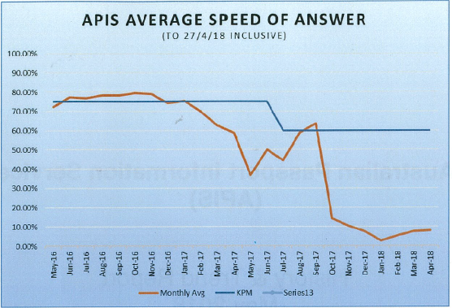

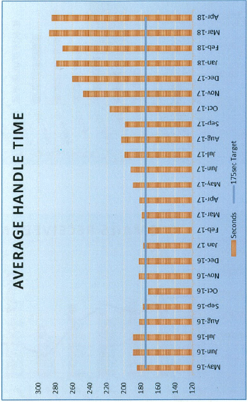

The APO is making changes to its online form to simplify the language, and remove steps that are duplicative or unnecessary, particularly for clients who have previously held an Australian travel document and already have existing data and documentation within our systems. We are also making changes to provide clearer advice on how to navigate the form and create new accounts. These steps should reduce the number of calls made to APIS as well as the length and complexity of calls.

KPI 3: ACTIONS UNDERTAKEN BY REGULATORS ARE PROPORTIONATE TO THE REGULATORY RISK BEING MANAGED

*Metric: Measures/assessments the APO has undertaken to identify and reduce unnecessary requirements for Australian travel document applicants while maintaining the security, integrity and efficiency of the Australian passports system.*

The APO is constantly looking at reducing unnecessary requirements on the client whilst maintaining the integrity of our decisions. We are currently undergoing a modernisation program; shifting focus from IT development to an organisation with a greater focus on improved integrity of our decision-making processes and a better client experience. Working with key partners such as Australia Post, we will examine opportunities presented by our new IT services to develop new products and services that better meet the needs of our clients. The APO has restructured to manage this transformational business change, creating a Future Directions Group, led by the Assistant Secretary, Passports Client Services Branch.

KPI 4: COMPLIANCE AND MONITORING APPROACHES ARE STREAMLINED AND COORDINATED

*Metric: The extent that APO’s compliance and monitoring activities are streamlined and coordinated.*

The APO finalised its Data Warehouse project in June 2018 with daily data feeds from the Passport Issuance and Control System (PICS) and the publication of monthly data science bulletins. The Data Warehouse continues to develop advanced analytics and improved business intelligence functionality for better evidence-based decision-making. The project also assists with fraud detection and management through the application of large scale data manipulation, advanced statistical algorithms and machine learning techniques.

Our continued participation in international standards bodies helped drive best practice in passport security and interoperability. We continued to lead the way in inter-agency data sharing initiatives. We work closely with the Attorney-General’s Department, the Department of Home Affairs, and the Digital Transformation Agency to develop further capacity for the Facial Verification Service and contribute to the development of initiatives such as GovPass.

We worked closely with intelligence and law enforcement partners to detect passport misuse and take the necessary actions. In response to competent authority requests, the Foreign Minister cancelled 56 passports, refused three and suspended two on national security or law enforcement grounds.

KPI 6: REGULATORS ACTIVELY CONTRIBUTE TO THE CONTINUOUS IMPROVEMENT OF REGULATORY FRAMEWORKS

*Metric: Measures/assessments the APO has undertaken to identify and reduce unnecessary requirements for travel document applicants while maintaining the security, integrity and efficiency of the Australian passports system.*

As noted above, the APO is making improvements to its online application, particularly for clients who have previously held an Australian travel document and already have existing data and documentation within our database. We are aiming to ask future applicants for copies of documentation only where we do not already have a copy, or where client information has changed and supporting documentation for those changes is required.

We are also working closely with other agencies, both Federal and State/Territory, to contribute to the continuous improvement of regulatory frameworks across government, mostly notably through our contribution to the development of the GovPass program managed by the Digital Transformation Authority.

1. Accessible at www.cuttingredtape.gov.au
2. For examples refer to: [www.news.com.au](http://www.news.com.au); [www.australianfrequentflyer.com.au](http://www.australianfrequentflyer.com.au); [www.traveller.com.au](http://www.traveller.com.au); [www.ausbt.com.au](http://www.ausbt.com.au); au.news.yahoo.com.