

Country Case Study

SOLOMON ISLANDS

April 2021

Table of contents

1 The country program 1

1.1 Program description 1

1.2 Program performance: January 2018 to December 2020 1

1.2.1 Supporting our partners 2

1.2.2 Supporting our volunteers 4

2 Stakeholder perceptions 8

2.1 Program staff 8

2.2 DFAT 8

2.3 Government Staff 9

2.4 Partner organisations 10

3 Case studies of partner organisations 11

3.1 Bethesda Disability Training and Support Center 11

3.1.1 Relevance of the program’s support 11

3.1.2 Impact on organisational capacity 11

3.1.3 Benefits to volunteers 11

3.1.4 Diplomatic benefit to Australia 11

3.1.5 Future directions of the program 11

3.2 Ministry of Health and Medical Services 12

3.2.1 Relevance of the program’s support 12

3.2.2 Benefits to volunteers 12

3.2.3 Diplomatic benefit to Australia 12

3.2.4 Future directions of the program 12

4 Conclusion 13

Acronyms

| Acronym | Definition |
| --- | --- |
| AADs | Approved accompanying dependents |
| ACEM | Australian College of Emergency Medicine |
| AIP | Australia Investment Plan |
| AVI | Australian Volunteers International |
| COVID-19 | Novel coronavirus |
| DFAT | Department of Foreign Affairs and Trade |
| HR | Human resources |
| MEL | Monitoring, evaluation, and learning |
| MHMS | Ministry of Health and Medical Services |
| MTC | Medical Training Committee |
| NGO | Non-governmental organisation |
| NRH | National Referral Hospital |
| SDGs | Sustainable Development Goals |
| SIGISSP | Solomon Islands Graduate Internship Supervision and Support Program |
| SIMPLER | Solomon Islands Medical Partnership for Learning, Education, and Research |

# The country program

## Program description

The Australian Volunteers Program in Solomon Islands partnered with 41 organisations and supported 94 volunteers to deliver 106 assignments over three years (2018-2020). The program successfully contributed to development in health, education, economic growth, good governance, security and stability, disaster resilience and climate change in Solomon Islands. The program has expanded into new locations outside of Honiara and has successfully developed long term partnership plans with partner organisations.

In 2019-2020 the program delivered partnership workshops and partnerships planning support in Tulagi, Gizo, Munda, and Auki. In August 2019, the in-country team successfully hosted the 2019 Pacific Regional Reflection and Learning event in Honiara, with 50 participants including program staff from Melbourne, the Department of Foreign Affairs and Trade (DFAT) Canberra and local Posts from across the Pacific.

A key project supported by the program, DFAT and Australian partner organisations in the Solomon Islands is the Solomon Islands Medical Partnership for Learning, Education, and Research (SIMPLER), formerly known as Solomon Islands Graduate Internship Supervision and Support project (SIGISSP). This project supports positive outcomes for the Ministry of Health and Medical Services (MHMS) in progressing its goal of universal healthcare. Through this project, the skills of medical professionals have been enhanced and significant improvements have been made in the management of the Solomon Islands medical workforce. In 2020, with COVID-19, the National Referral Hospital (NRH) Medical Training committee has shown commitment to the long-term delivery of the internship and post-graduate programs with the support of volunteers.

Over 2018-2020 the program faced significant challenges including: supporting the volunteers and partners over the vast geographical spread of current and possible assignment locations; managing the limited and costly travel options; poor internet and phone connectivity; national COVID-19 restrictions and natural disasters. In responding to these challenges, the program organised multiple internal capacity building events to help the in-country team provide more efficient volunteer management and upskilling of the staff for better programming.

As part of the program’s response to COVID-19, twenty-two volunteers and four approved accompanying dependents were safely and successfully repatriated with support from the in-country team in March 2020. The program continued to build and maintain relationships with partner organisations throughout this period. As part of the program’s rapid response to COVID-19, the in-country team provided support to partner organisations to access volunteers who continued their assignments through remote volunteering. Partner organisations were also given access to and supported to apply for Impact Funding.

## Program performance: January 2018 to December 2020

The data presented here is based on a reporting period encompassing the first three years of the program, covering assignments that were active between 1st January 2018 and 31st December 2020. This timeframe falls outside the program’s normal annual data cleaning and reporting cycle, so some inconsistencies may exist with data as previously reported in Annual Reports.

### Supporting our partners

The program worked with 41 partner organisations across Solomon Islands in 2018-2020. Most of the partner organisations are located in Honiara.

Partner organisations were asked to assess the extent to which volunteers achieved the assignment objectives mutually agreed to in their assignment plan. Ninety-one per cent of partner organisations stated progress on objectives was good or excellent.

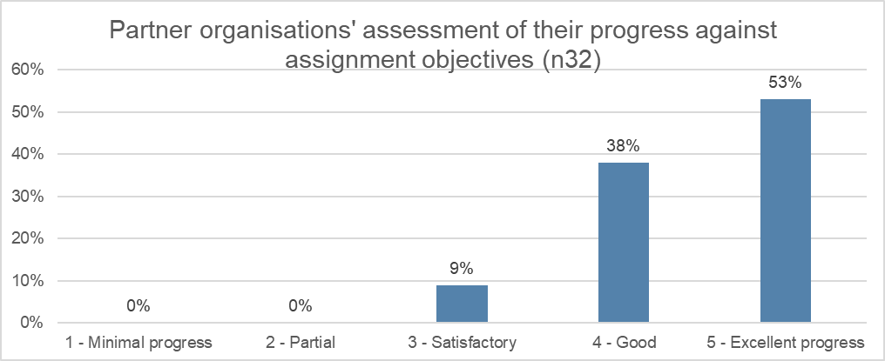

The graph below shows the most common development sectors that volunteer assignments contributed to were government and civil society (37%), education (17%), health (7%) and industry, mining, construction & environmental protection (2%).

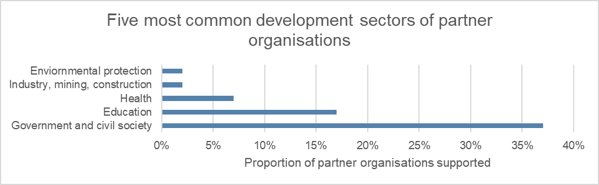

The following graph shows the most common types of partner organisation which were government (local and national) (54%), followed by non-governmental organisations (NGOs) (local and national) (20%), international NGOs (5%), academic/research/educational institutions (5%) and private sector (2%).

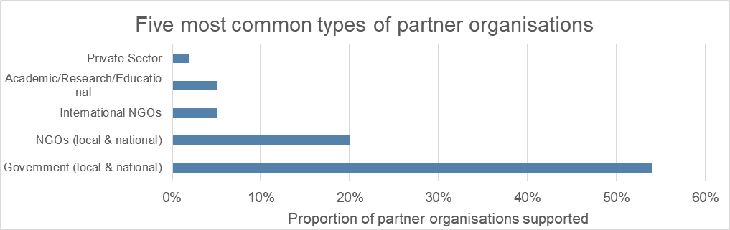

The following graph illustrates the most common Sustainable Development Goals (SDGs) partner organisations contributed to. These were well-being (30%), followed by quality education (25%) and peace & justice strong institutions (25%), with a low proportion of contributions towards gender equality (10%) and reduced inequality (10%).

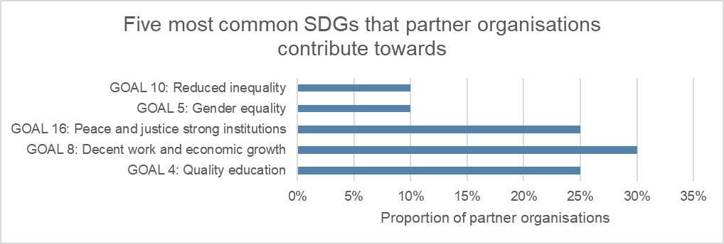

The following graph provides an overview of the impact areas that partner organisations contribute towards. These were inclusive economic growth (42%) followed by human rights (38%) and climate change, disaster resilience, food security (21%).

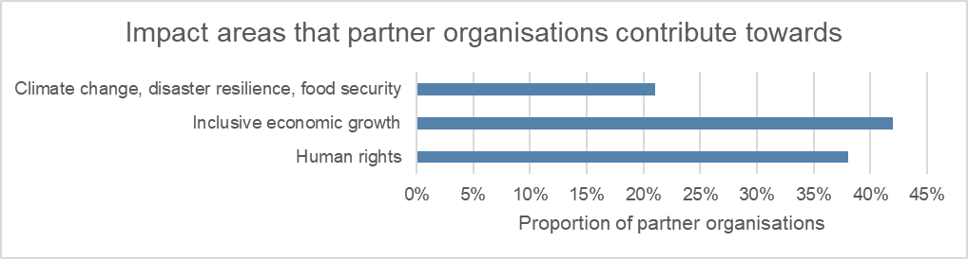

The following graph shows the most common cross cutting themes addressed by partner organisations were child protection and gender. Of the 19 organisations, eight address child protection (42%) and five address gender (26%).

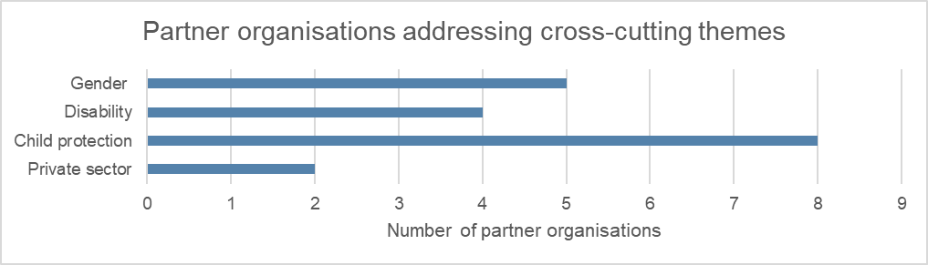

Eighty-eight per cent of volunteers reported strengthening capacity at the organisational level, 78% of volunteers reported strengthening capacity at the individual level and 46% of volunteers reported strengthening capacity at the systemic level.

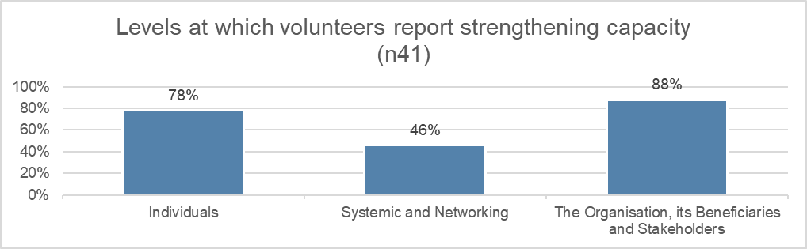

Ninety-one per cent of partner organisations reported they were overall ‘very satisfied’ with the assignment, 95% reported they were ‘very satisfied’ with the volunteer and 70% reported they were ‘very satisfied’ with the program’s in-country management.

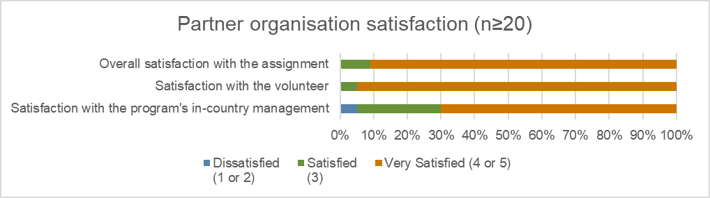

### Supporting our volunteers

Over the first three years, the program supported 92 volunteers with 10 approved accompanying dependents to deliver 106 assignments. Sixty-two volunteers were female, and thirty volunteers were male. The majority of volunteers were 30-39 years old, followed by the 60+ age group and fewer volunteers in the age group from 40-59 years old.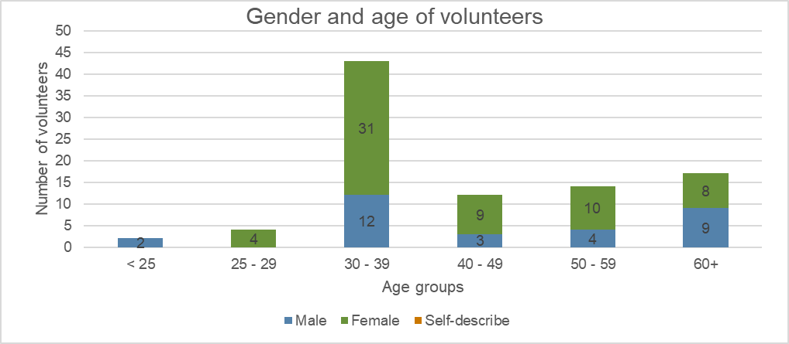

The following graph illustrates the duration of assignments. It shows most assignments are for 7-12 months (51%), followed by 0-6 months (42%) and over 12 months (7%).

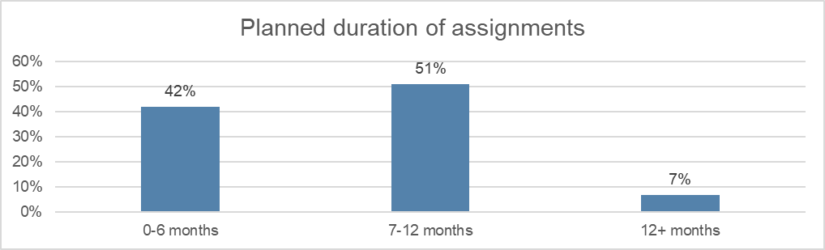

Three per cent of volunteers returned home early as shown in the graph below. The reasons for early returns included pursuing other international employment opportunities, dissatisfaction with a lack of engagement from a partner organisation, and workplace bullying. Ten per cent of volunteers had their assignments extended.

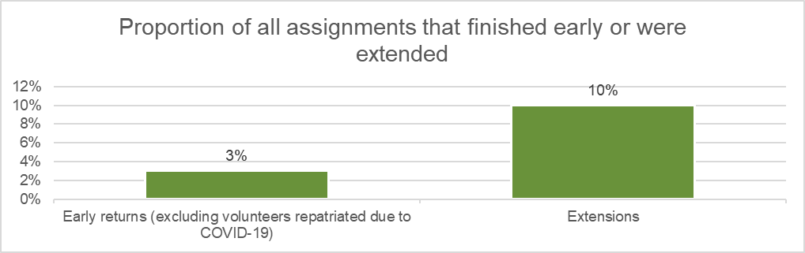

The majority of assignments were in Honiara (81%) with the remainder of assignments distributed across Auki (4%), Tulagi (3%) and Gizo (2%), and the lowest number of assignments in Munda and Taro (1% each). Eight per cent of assignments were delivered remotely.

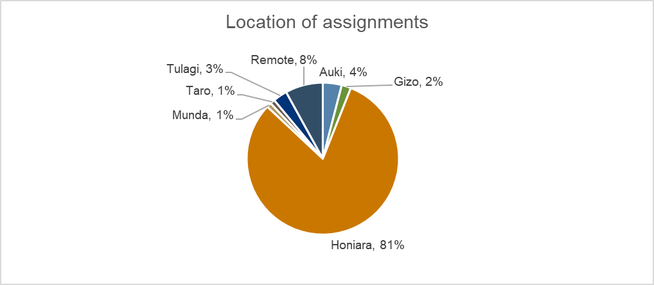

The following graph shows the five most common professions of volunteers, which were health care and medical (25%), followed by business, finance & human resources (HR) (20%), education (17%), community development and social development (13%) and legal (12%)

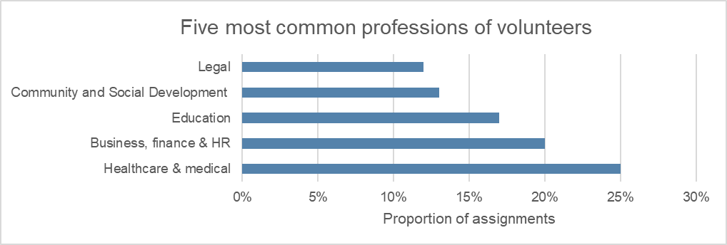

The following graph illustrates the number of assignments delivered through alternative volunteering modalities and partnership assignments. Most assignments (16) were delivered through SIMPLER, followed by remote volunteering (9) and COVID-19 response assignments (7).

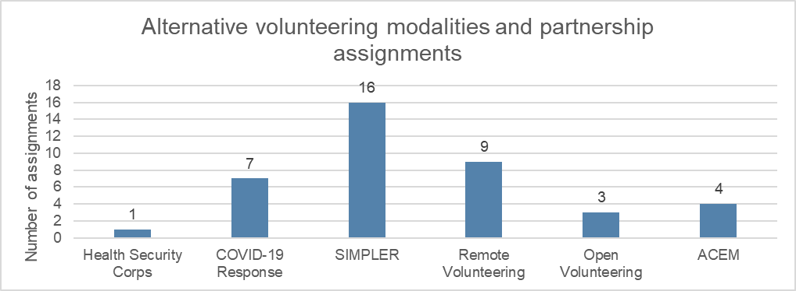

Eighty per cent (80%) of volunteers rated their progress on their assignment as good or excellent as shown in the graph below. Fifteen per cent rated their progress as ‘satisfactory’ and six per cent rated as partially progressing on their assignment.

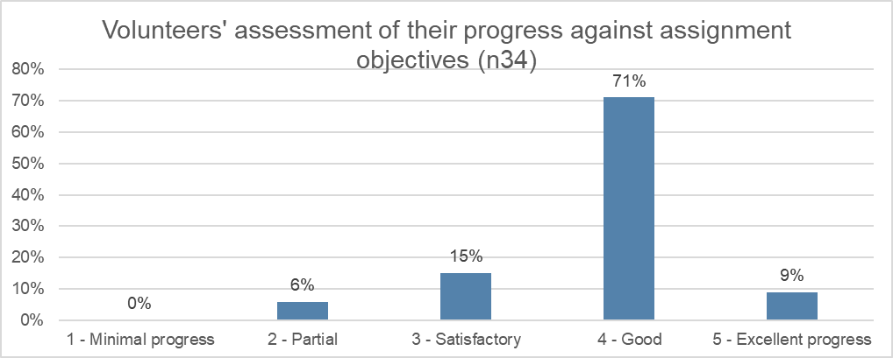

The majority of volunteers (71%) reported they were ‘very satisfied’ with the overall program. Sixty-two per cent of volunteers reported being ‘very satisfied’ with both the in-country management and the safety and security management.

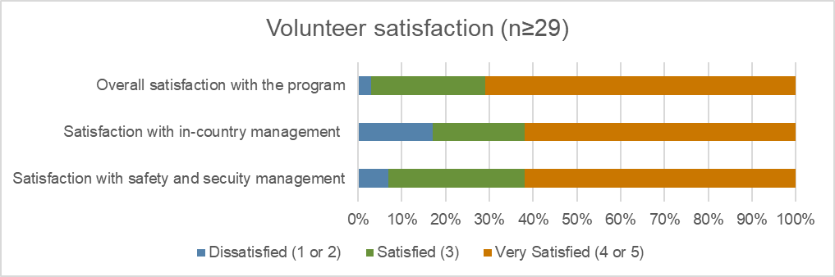

As shown by the graph below a total of twenty-two volunteers and four approved accompanying dependents (AADs) were safely and successfully repatriated as part of the program’s response to COVID-19. One volunteer remained in country on a COVID-19 response assignment.

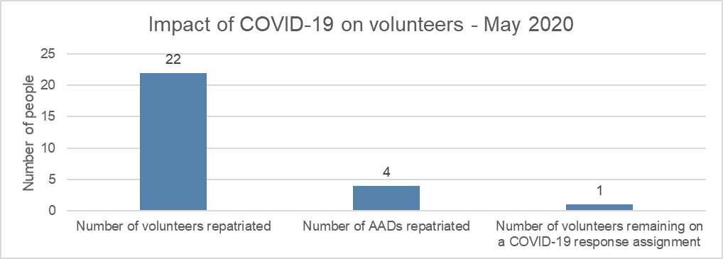

# Stakeholder perceptions

## Program staff

**Program activities and outcomes are aligned with the needs and priorities of partner organisations**. Program staff highlighted that program activities are designed in accordance with partner organisations’ needs. It is the partner organisations' needs that drives the assignment for the volunteers. Program activities and plans are developed collaboratively with partner organisations.

**The program’s activities are aligned to the program logic**. Program staff mentioned that the logic provides guidance on the expected outcomes of the program and how to carry out work effectively. The program staff also said that the tools developed through the monitoring, evaluation, and learning (MEL) unit supports the program to ensure quality data is collected from assignments and feedback is used to inform management of the program’s progress. The MEL framework, Global strategy 2018-2022 and Annual Plan support the program to be accountable and successful.

**The program positively impacts on the capacity of partner organisations**. Program staff affirmed that the program positively impacts the capacities of partner organisations. Mutual relationships and partnerships are established through the development of partnership plans. Collaborative work and learning have helped build the capacity of partner organisations' staff. Overall, the program helps partner organisations to address their priority needs through this collaborative approach, learning, and partnership.

**The program has contributed to Australia's 'soft power' and diplomatic relations with Solomon Islands.** Program staff believe the program helps build a sustainable partnership, and one that is based on mutual support and respect. It fulfills the needs of the program and partner organisations, which helps to achieve the global and bilateral strategy of Australia's soft power and diplomatic ties with Solomon Islands. Australia is one of Solomon Islands’ main aid donors. The program reflects Australia's soft power and influence in the region.

**The program represents value for money.** Program staff stated that having more local staff at the country level reduces the operational costs for the program. There is capacity building for the national staff on program management, building partnerships and networking with the partner organisations. The program activities, through volunteers, also bring in specialised skills and experiences to fill in the technical gaps and build the capacity of the partner organisations which can be very costly. The services and support reflect value for money.

**Corporate governance arrangements are inclusive and support efficient decision-making and program management.** Program staff said that they are informed of structural changes in the program through ongoing learning, reflections, and communications from managers at the regional and global levels. There are clear lines of communication and established procedures that support efficient decision-making, program management and implementation. Program staff affirmed that corporate governance arrangements and senior program managers at the regional and head office level are very supportive and inclusive.

## DFAT

**The program design may require adjustment to remain relevant to the aid investment plan of Australia and to Solomon Islands government priorities.** DFAT staff noted that, when the program was designed, it aligned to Post’s aid priorities in the Solomon Islands. The design was ‘fit for purpose’ however, when the bilateral program changed, the program on the ground didn’t adapt quickly to accommodate new priorities

**The Australian public awareness of the program could be improved**. DFAT Post staff believe that the program has had great outcomes in respect of Australia’s aid investment in Solomon Islands. There are great stories to share with the Australian public and inspire others to join the program in the future. However, only a small proportion of the Australian public who have encountered the volunteers are aware of the program.

**The new branding is a good start.** DFAT post staff said that it is still a challenge to get the public and partner organisations to recognise the new branding. There is a need to develop strategies around public awareness of the new brand.

**The program strengthens the partnership between Australia and the Solomon Islands.** DFAT Post noted the positive relationship building and networking that occurs through the program in Solomon Islands. This includes volunteers representing Australia at a personal level in their partner organisations and local communities. The program values partner organisations and volunteers and this brings out mutual respect to Australia’s influence in the Solomon Islands.

**COVID-19 remains the key challenge for the future.** DFAT post staff believe that the repatriation of the volunteers has left a huge gap for partner organisations and that this in turn, has had a significant, negative impacts on program outcomes.

**Several strategies were suggested to improve the sustainability of the program in the future.**

* Expand opportunities for group volunteering. Over a short period, the program can increase the number of volunteers to work with a partner organisation to increase organisational capacity on shorter term assignments.
* Continuing dialogue with partner organisations for better understanding of the work of volunteers and the program. This is to reduce the risks on volunteers of potential perceptions that the volunteers are taking local jobs away from unemployed Solomon Islanders.
* Work more closely with other volunteer agencies in the country to expand program activities in other locations and fields not currently covered that are relevant to the program strategy and priority areas.
* Make the program a focal point for groups in Australia wanting to support sectors in Solomon Islands.

## Government Staff

**The program's activities and outcomes are aligned with the needs and priorities of Solomon Islands** **government.** The government perspective is that the program has been very successful in meeting needs in a range of sectors, notably rural development, justice and legal services, health and education services and the economics and resources sectors. Volunteers assignments with partner organisations and government ministries are aligned to the priorities of the country as stated in the National Development Strategy.

**The program has strengthened the capacity of Solomon Islanders**. The government view is that the capacity of Solomon Islanders has been enhanced and developed through the program. This was noted as particularly so in policy formulation, budgeting, and development planning. The government acknowledges the priority need for technical support and capacity building to effectively manage development programs and approaches in Solomon Islands and sees the program as contributing to addressing this priority.

**The program has strengthened Australia's diplomatic relations and soft power with Solomon Islands**. Australia is the Solomon Islands’ main donor partner. Australia, through the program, has provided development support in the form of financial, human, and material in the different sectors or areas for the development of the country. Australia's friendship and relationship with Solomon Islands is built on mutual respect and trust for each other to advance the different development agendas of the two countries. The government representative interviewed acknowledged that Australia has helped the Solomon Islands to move from being a failed state to nation building and bringing back good governance.

**Ongoing dialogue and collaboration build strong partnerships for the program.** The government staff stated that it is important for the program to continue to disseminate information on program progress in the country and changes to its partners and stakeholders. Staff suggested facilitating events for more collaboration with partner organisations to share learnings and improve on weak areas for better programming.

**Dialogue between the program, DFAT and government is needed to explore strategies to strengthen the program’s resilience and sustainability**. The government view is that ongoing dialogue helps maintain program integrity within the country from the design phase through to program implementation. This is considered important in ensuring program goals are aligned with DFAT priorities and Solomon Islands national development goals. It was noted that the government lacks a body to coordinate volunteering programs in the country. This is seen as a gap that needs to be addressed to help support the sustainability of such programs in Solomon Islands.

## Partner organisations

**Program activities and outcomes meet the needs and priorities of partner organisations.** Partner organisations make requests for volunteers based on their organisation’s priority needs. In most cases, partner organisations require people with high technical skills to lead change in addressing organisational gaps. However, getting the right volunteer and assignment matching to partner organisation’s need is a challenge because the real needs or priority of the partner organisations are not identified in the partnership plans. At times the volunteer’s behaviour makes it difficult to progress on the assignment.

**The program has strengthened partner organisations' capacity through volunteer assignments and other trainings provided to the organisation staff by volunteers.** One of thepartner organisations’ representatives stated thatthe volunteer supported them in developing landscape designs to support local tourism operators on Guadalcanal. Another representative said the volunteer supported enhancement of the online business portal for the business and cooperatives sector for the Ministry of Commerce. However, the repatriation of volunteers has left many gaps with the partner organisations.

**Volunteers benefit professionally and personally**. Partner organisations believe that volunteers benefit from being involved in the program and working with partner organisations. They learn about the government system, local organisations, the private sector work culture, and local customs. Through collaborative work and learning with local staff, volunteers build their own capacity professionally and personally.

**The program is a flagship program for the Australian government in the Solomon Islands.** Partner organisations acknowledge that the program operates at all levels and is influential at the government level and in the private sector. The program is also reaching partner organisations at the community development level. Volunteers are culturally imbedded into local communities and the program promotes mutual understanding of people and the work they do. The partner organisations acknowledge Australia as Solomon Islands’ major donor partner for many years, resulting in a good relationship between the two countries.

**Program implementation and management in country has been significantly affected by the COVID-19 pandemic**.Partner organisations would like more information and communication about the status and future of the program in Solomon Islands. They noted that most volunteer assignments have been suspended and volunteers have returned home prior to completing assignments. They find remote mentoring challenging. Challenges expressed were the cost and poor quality of internet connectivity and challenges in absorbing technical information through remote mentoring.

**Partner organisations would like to see improved and ongoing communications with the in-country program management office.** They believe that effective communications are the foundation of a sustainable partnership with the program.

**Diversity in the program is important for the future development of the program.** Partner organisations would like to see indigenous Australians encouraged to apply for any assignment in the Solomon Islands. They believe having Aboriginal volunteers in country would bring more diversity into the program in the Solomon Islands, strengthen relationships and provide an opportunity to share collective experience and learning with the locals and partner organisations. However, the program needs to provide information on how to access Aboriginal volunteers and design a project around sharing collective experience and learning.

**Remote volunteering is not suitable for some partner organisations in Solomon Islands**. As the program response to COVID-19, all volunteers were repatriated and the program modality changed. Some organisations find it challenging to use remote volunteering as the logistics for the approach is very costly for them and there is lack of experience on how to use the online platform. However, the program supported some organisations to use the online platform and successfully complete the remote volunteer assignments.

# Case studies of partner organisations

## Bethesda Disability Training and Support Center

### Relevance of the program’s support

The program meets the needs and priorities of the centre. Bethesda is an organisation that provides education and training opportunities for people with a disability or special needs. They believe that the volunteers’ assignments are aligned to the needs and priorities of the centre. Volunteers have provided technical support and training, including in financial management skills for the finance staff, and life skills for the women at the centre.

### Impact on organisational capacity

The program sustainably strengthened the capacity of the centre. Feedback from the centre indicated that the system of financial management introduced by the volunteers helped build confidence in themselves. For example, the finance staff know how to use the system to carry out tasks effectively and support the daily operations of the centre. One volunteer provided sewing training to women at the centre. This has built the capacity of the women and today they continue to sew and are inspired to train others as well.

### Benefits to volunteers

Volunteers gained professionally and personally through collaborative and shared learning experiences in country. Volunteers established relationships with the people and were embedded in the local culture and organisational norms. They also developed confidence in dealing with people with disabilities and special needs.

### Diplomatic benefit to Australia

Australia is a key donor for Solomon Islands. There is already an understanding between Solomon Islands and Australia in terms of bilateral ties and mutual relationships. The program is seen as a part of Australia's development assistance to the Solomon Islands.

### Future directions of the program

The COVID-19 pandemic has impacted access to experts and professionals. The restrictions imposed because of the COVID-19 pandemic makes it difficult for the centre, other partner organisations and government to access people with specialised skills, qualifications and experience and bring them to the Solomon Islands.

An ability to adapt to change in the future is a key challenge. Bethesda staff acknowledge that changes in the program due to external causes may necessitate a shift in the program approach. How well the program is prepared to accommodate and adjust to future changes remains important.

Strengthening the program’s resilience and sustainability for the future will require an ability to be innovative and creative. Bethesda staff believe that new, strategic ways to deliver support in the future should be explored and that ongoing dialogue is important for any future project development.

## Ministry of Health and Medical Services

### Relevance of the program’s support

The program's activities and outcomes are aligned with the needs and priorities of the MHMS-NRH. The SIGISSP or SIMPLER as it is now called is a partnership with the program and the Australian College of Emergency Medicine (ACEM) collaborating to assist and support in the supervision and training of large numbers of returned foreign-trained local medical graduates to Solomon Islands.

SIMPLER provides continuous medical education opportunities for the graduates. The program has been ongoing for over three years. MHMS through the Medical Training Committee (MTC) noted that through SIMPLER, local medical graduate interns are being trained and equipped with technical skills that prepare them to enter the medical workforce in the capital and the provinces.

The program has strengthened the capacity of MHMS-NRH through the graduate intern program training and clinical services provided by the volunteers. The volunteers are medical practitioners from Australia who join SIMPLER to provide trainings for the medical interns and the local medical staff. While providing training they also provide clinical services and transfer knowledge to the locals.

Volunteers assisted the development of guidelines and protocols for MHMS-NRH over several years. For example, a volunteer developed the prevention and management of COVID-19 guideline to support NRH’s response to COVID-19 and the gynaecology standard treatment manual to support health workers working in the healthcare for women. The staff stated that through SIMPLER the MTC can train more graduates than they had in the past. MTC are also carrying out intern exams in-country during the COVID-19 pandemic. Local graduate interns have close supervision before they go out to the rural health centres.

### Benefits to volunteers

Volunteers have gained professionally and personally through experience of the local context. From their Solomon Islands experience, Australian volunteers learn much about emergency medicine in a resource-poor environment. In hospitals in the Solomon Islands they are exposed to high patient volume, and complex and serious emergency care situations. These are situations that they would not usually be challenged by in Australian, high-resource hospital emergency settings. Volunteers not only gain new emergency medicine expertise from their local counterparts but develop new personal resilience and coping skills.

### Diplomatic benefit to Australia

The program helps strengthen bilateral relationships between Australia and Solomon Islands. Dedication of the staff and funding from the Australian government is also seen through this program from both countries. There is more interaction with staff at a personal level leading to building confidence and a good relationship with the MHMS. The connection or networking continuing beyond the volunteer assignments showed positive outcomes for the presence of Australia in Solomon Islands

### Future directions of the program

The COVID-19 pandemic has caused major interruptions to SIMPLER. The MHMS noted that volunteers have been repatriated to Australia and that this has led to incomplete assignments. It was also noted however, that with the introduction of remote mentoring, assignments are again slowly progressing.

The program seems to easily adapt to the changing external environment. The program has demonstrated its capacity to adapt to changed environments and future challenges. The introduction of remote mentoring in response to the COVID-19 pandemic restrictions is an example of this.

The MHMS would like to see the SIMPLER continue to build the capacity of local emergency medicine staff. They see their partnership with the program and ACEM as important for the future sustainability of the MHMS and Solomon Islands as a country.

# Conclusion

In the Solomon Islands, the program has achieved good progress towards outcomes in the first three years of implementation. The program has achieved outcomes in the fields of health, education, child protection and gender equality. Through the program, partner organisations contributed to the SDGs and Solomon Islands development priorities in the areas of inclusive economic growth, human rights, climate change, disaster resilience and food security.

The program has established sound relationships with partner organisations and government that support achievement of program outcomes and completion of long-term partnership plans. While partner organisations believe that the program design remains relevant to their needs and priorities, DFAT Post and government stakeholders are interested in exploring changes to the design to align more closely with DFAT country program priorities and national development plans.

In rapidly repatriating volunteers from the Solomon Islands, the program responded effectively to the changing external environment brought about by the COVID-19 pandemic. Program implementation in the Solomon Islands has however, been significantly affected. Partner organisations are experiencing challenges in adapting to the remote volunteering model and for some sectors, remote volunteering is unsuitable.

All stakeholders agree that the program has strengthened the capacity of partner organisations. This been achieved at several levels including organisational capacity development, skills transfer (and exchange) for individuals, systems development and professional practice, and increased networking opportunities with Australian organisations.

SIMPLER is perceived as a key strategic partnership. It has become an exemplary model for other Pacific countries to adapt in their own health sectors.

The program is perceived by all stakeholders as providing opportunities for volunteers to gain personally and professionally. Volunteers are seen as bringing expertise to the aid program. They build strong relationships with Solomon Islanders and share success stories with the Australian public.

The program is perceived as positively enhancing Australia’s soft power and diplomatic influence in the Solomon Islands.