Australia’s Official
Development Assistance

STATISTICAL SUMMARY 2022–23

Australia’s Official Development Assistance: Statistical Summary 2022–23
ISSN 2652-0451 (Print)
ISSN 2652-0435 (Online)

Creative Commons
With the exception of the Commonwealth Coat of Arms and where otherwise noted all material presented in this document is provided under a Creative Commons Attribution 3.0 Australia (creativecommons.org/licenses/by/3.0/au/) licence. The details of the relevant licence conditions are available on the Creative Commons website (accessible using the links provided) as is the full legal code for the CC BY 3.0 AU licence (http://creativecommons.org/licenses/by/3.0/au/legalcode).
The document should be attributed as: Commonwealth of Australia, DFAT, Australia’s Official Development Assistance, Statistical Summary, 2022–23.

Contact
Inquiries about this document should be directed to:
Department of Foreign Affairs and Trade
RG Casey Building, John McEwen Crescent,
Barton ACT 2600 Australia
+61 2 6261 1111 (Phone)
aidstatsinquiries@dfat.gov.au (Email)

Table of Contents
Introduction 4
Reporting Against International Guidelines 6
1 2030 Agenda: Sustainable Development Goals, Primary Intent 8
2 Development Assistance Committee Sector 10
Overview Tables 13
3 Sector Group 13
4 Sector Group by Type of Partner 17
5 Region of Benefit by Sector Group 19
6 Partner Country by Sector Group 25
7 Government Departments and Agencies 27
8 Loan Disbursements 29
9 Partnerships for Recovery Pillars 30
Type of Assistance by Region and Benefit Tables 31
10 Climate Finance 31
11 Gender Equality 33
12 Disability Inclusion 35
13 Education 37
14 Health 39
15 Maternal and Child Health 41
16 Family Planning 43
17 Nutrition 44
18 Water, Sanitation and Hygiene 46
19 Government and Civil Society 47
20 Humanitarian and Disaster Response 48
21 Economic Growth 49
22 Aid for Trade 51
23 Private Sector Development 53
24 Research 55
25 Amounts Mobilised from the Private Sector 57
People to People Link Tables 58
26 Long-term Australia Awards by Field of Study 58
27 Long-term and Short-term Australia Awards by Partner Country 60
28 Volunteers Program 62
Appendices 64
Appendix 1: Explanatory Notes 64
Appendix 2: Concepts and Definitions 65
Appendix 3: Abbreviations and Symbols 73
Appendix 4: DAC List of Aid Recipients 75

Introduction

Australian development assistance
This report, Australia’s Official Development Assistance: Statistical Summary, 2022–23, presents statistical details of Australia’s development cooperation and reflects government priorities for 2022–23 with partner countries, multilateral and bilateral development agencies, civil society organisations and the private sector. It provides a range of information at the aggregate level of where Australia’s development program was delivered and the type of official development assistance (ODA) that was delivered. The Statistical Summary represents a point in time summary using the best available data at the time of publication.
This report details ODA expenditure and complements other reporting of the Australian development program. Users may wish to refer to the following publications, which can be downloaded from the Department of Foreign Affairs and Trade (DFAT) website:
- Foreign Affairs and Trade Portfolio Budget Statements.
- Australian Aid Budget Summary.
- Annual Report: Department of Foreign Affairs and Trade.
This publication includes ODA reporting against Partnerships for Recovery: Australia’s COVID-19 Development Response, which was released by the Government in May 2020. In August 2023, the Government published Australia’s International Development Policy, which sets the long-term direction for Australia’s international development engagement. This publication marks the final instance of ODA reporting against Partnerships for Recovery.

Concepts and definitions
The ODA concepts and definitions used in Australia’s Official Development Assistance: Statistical Summary, 2022–23 are consistent with the Organisation for Economic Co-operation and Development (OECD) Development Assistance Committee’s (DAC) Statistical Reporting Directives. Refer to Appendix 2: Concepts and Definitions for further details.

Comparability with other donor countries
To facilitate comparability between donor countries, Australia annually reports its development assistance to the OECD DAC, in United States dollars (USD) and on a calendar year basis. Statistical information is provided at the investment level.
This information can be accessed through the OECD DAC’s web site at http://www.oecd.org/dac.
Statistics in this publication are stated in Australian dollars (AUD) and reported on an Australian financial year basis, unless otherwise specified. This may restrict, in some instances, a direct comparison between Australia’s development cooperation and that of other donor countries.

Figure 1. Total Australian Official Development Assistance by Region of Benefit, 2022–23

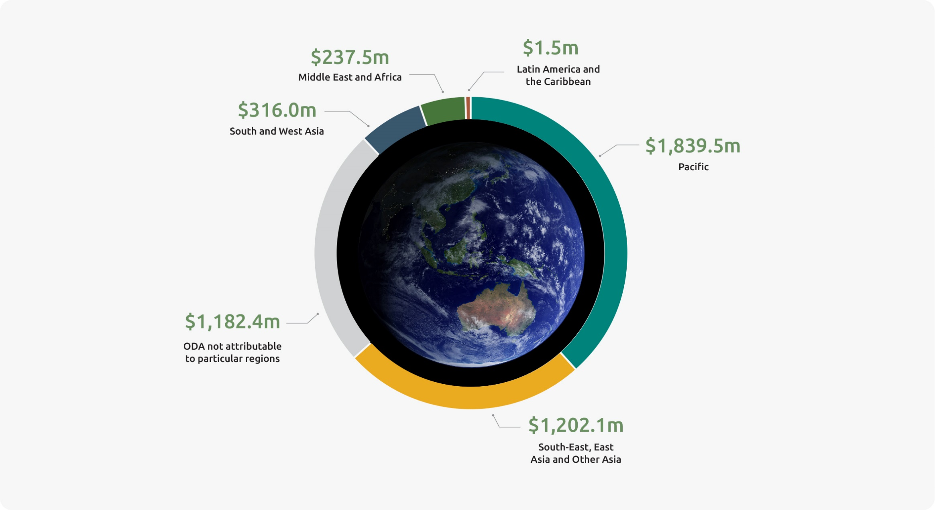

Reporting Against International Guidelines

Figure 2. Australian Official Development Assistance 2030 Agenda: Sustainable Development Goals, Primary Intent, 2022–23^{(a)}

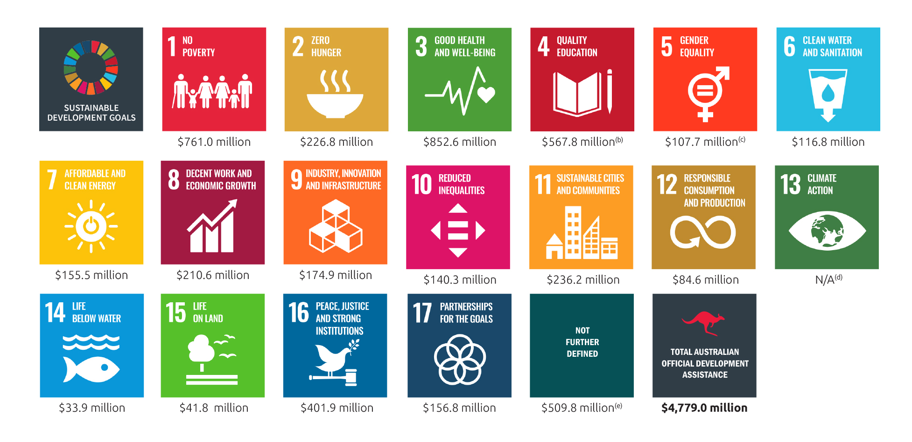

“-” denotes nil or rounded to zero (including null cells).
Due to rounding, discrepancies may occur between sums of the component items and totals.
- The Sustainable Development Goals (SDGs) are a United Nations initiative, officially known as Transforming our world: the 2030 Agenda for Sustainable Development,(https://www.un.org/sustainabledevelopment/sustainable-development-goals/). For further information about the Sustainable Development Goals refer to paragraphs 54 to 56 of Appendix 2: Concepts and Definitions.
- Includes scholarships.
- Data presented for SDG5 reflects only those aid investments with a primary goal of Support for Women’s Equality Organisations and Institutions (DAC purpose code 15170) or Ending Violence Against Women and Girls (DAC purpose code 15180),and is not reflective of Australia’s total ODA contribution to gender equality which cuts across all SDGs. See Table 11 for Australia’s expenditure contributing to gender equality. As per Table 11, Australia’s total gender equality assistance for 2022–23 is $1,756 million.
- Not reported as there is no dedicated DAC sector code for climate change. Instead, the OECD DAC uses Rio Markers to promote mainstreaming of climate considerations in all sectors. In line with this, climate change is integrated across the breadth of Australia’s development assistance. A more comprehensive picture of Australia’s climate change assistance is presented in Table 10 based on Rio Marker reporting methods. As per Table 10, Australia’s total climate change assistance for 2022–23 is $571 million.
- Includes regional and global programs (including payments to multilateral organisations), departmental and other administrative expenses that cannot be attributed to a Sustainable Development Goal.

1 Australian Official Development Assistance, 2030 Agenda: Sustainable Development Goals, Primary Intent,
2022–23^{(a)}
Sustainable Development Goal | 2021–22  $’000 | 2022–23  $’000
1 No poverty | 658,353 | 760,956
2 Zero hunger | 223,687 | 226,799
3 Good health and well-being | 958,656 | 852,580
4 Quality education ^{(b)} | 478,754 | 567,822
5 Gender equality ^{(c)} | 84,714 | 107,685
6 Clean water and sanitation | 118,600 | 116,802
7 Affordable and clean energy | 61,763 | 155,548
8 Decent work and economic growth | 271,476 | 210,640
9 Industry, innovation and infrastructure | 137,892 | 174,891
10 Reduce inequalities | 117,239 | 140,266
11 Sustainable cities and communities | 202,927 | 236,182
12 Responsible consumption and production | 87,973 | 84,616
13 Climate action ^{(d)} | n.a. | n.a.
14 Life below water | 14,254 | 33,899
15 Life on land | 14,066 | 41,847
16 Peace, justice and strong institutions | 410,269 | 401,934
17 Partnerships for the goals | 147,998 | 156,799
Not further defined ^{(e)} | 429,860 | 509,764
Total Australian Official Development Assistance | 4,418,481 | 4,779,031

“-” denotes nil or rounded to zero (including null cells).
Due to rounding, discrepancies may occur between sums of the component items and totals.
- Sustainable Development Goals (SDGs) can cut across multiple goals and are not mutually exclusive. Data presented in this table reflects the aid investments’ primary goal intent and is not reflective of Australia’s total ODA contribution to sustainable development. For further information about the Sustainable Development Goals refer to paragraphs 54 to 56 of Appendix 2: Concepts and Definitions.
- Includes scholarships.
- Data presented for SDG5 reflects only those aid investments with a primary goal of Support for Women’s Equality Organisations and Institutions (DAC purpose code 15170) or Ending Violence Against Women and Girls (DAC purpose code 15180), and is not reflective of Australia’s total ODA contribution to gender equality which cuts across all SDGs. As per Table 11, Australia’s total gender equality assistance for 2022–23 is $1,756 million.
- Not reported as there is no dedicated DAC sector code for climate change. Instead, the OECD DAC uses Rio Markers to promote mainstreaming of climate considerations in all sectors. In line with this, climate change is integrated across the breadth of Australia’s development assistance. A more comprehensive picture of Australia’s climate change assistance is presented in Table 10 based on Rio Marker reporting methods. As per Table 10, Australia’s total climate change assistance for 2022–23 is $571 million.
- Includes regional and global programs (including payments to multilateral organisations), departmental and other administrative expenses that cannot be attributed to a Sustainable Development Goal.

2 Australian Development Assistance by Development Assistance Committee Sector, 2022–23^{(a)}
DAC sector | 2021–22  $’000 | 2022–23  $’000
Social infrastructure and services
Education
Primary and early childhood | 128,189 | 102,759
Secondary education | 35,979 | 35,961
Post-secondary education | 32,988 | 66,547
Education policy administration, training and research | 130,864 | 131,471
Scholarships | 150,733 | 231,084
Total education | 478,754 | 567,822
Health
Leadership and capacity building health service delivery | 193,216 | 237,172
Disease control and preventable impairments | 672,146 | 542,184
Total health | 865,361 | 779,357
Family planning and reproductive health ^{(b)} | 96,342 | 73,493
Improving water supply and sanitation | 118,600 | 116,802
Government and civil society
Conflict prevention and resolution, peace and security | 62,544 | 68,865
Government and civil society general | 609,407 | 628,620
Total government and civil society | 671,951 | 697,485
Other social infrastructure and services | 152,642 | 214,831
Total social infrastructure and services | 2,383,650 | 2,449,789
Economic infrastructure and services
Transport and storage | 207,936 | 278,977
Communications | 30,221 | 30,176
Energy generation and supply | 61,763 | 155,548
Banking and financial services | 46,234 | 44,007
Business and other services | 94,491 | 45,615
Total economic infrastructure and services | 440,645 | 554,323
Production sectors
Agriculture, forestry and fishing
Agriculture | 215,580 | 208,099
Forestry | 2,616 | 15,661
Fishing | 14,254 | 33,899
Total agriculture, forestry and fishing | 232,451 | 257,659
Industry, mining and construction
Industry | 32,792 | 24,819
Mineral resources and mining | 2,282 | 2,436
Construction | 3,867 | 702
Total industry, mining and construction | 38,941 | 27,956
Trade and tourism
Trade | 53,777 | 47,246
Tourism | 7,435 | 8,841
Total trade and tourism | 61,212 | 56,088
Total production sectors | 332,604 | 341,702
Multisector
General environment protection | 104,016 | 114,316
General budget support | 92,153 | 121,626
Other multisector | 210,862 | 309,625
Total multisector | 407,030 | 545,566
Commodity aid and general program assistance
Development food aid and food security assistance | 7,190 | 8,649
Other general program and commodity assistance | - | -
Total commodity aid and general program assistance | 7,190 | 8,649
Humanitarian assistance
Emergency response | 492,126 | 508,369
Reconstruction relief and rehabilitation | 15,445 | 27,375
Disaster prevention and preparedness | 38,245 | 27,764
Total humanitarian assistance | 545,816 | 563,508
Action relating to debt | 210 | 286
Administrative costs of donors | 300,030 | 312,804
Refugees in donor countries | - | -
Promotion of development awareness | 1,306 | 2,404
Total Australian Official Development Assistance | 4,418,481 | 4,779,031

“ - “ denotes nil or rounded to zero (including null cells).
Due to rounding, discrepancies may occur between sums of the component items and totals.
- Presents Australia’s expenditure on the basis of purpose codes which list codes, names and descriptions used to identify the sector of destination of a contribution. This purpose code classification is maintained by the OECD and used by donors to report on their aid flows to the Development Assistance Committee (DAC) databases. Further information on OECD DAC sectors area available from http://www.oecd.org/dac/financing-sustainable-development/development-finance-standards/dacandcrscodelists.htm
- Includes social mitigation of HIV/AIDS.

Overview Tables

3 Australian Official Development Assistance by Sector Group, 2022–23^{(a)}
Sectors | 2021–22  $’000 | 2022–23  $’000
Economic Infrastructure and services
Banking and financial services | 46,234 | 44,007
Energy | 61,763 | 155,548
Large water infrastructure | 39,310 | 35,980
Transport and storage (b) | 207,936 | 278,977
Communications | 30,221 | 30,176
Other economic infrastructure and services (c) | 107,588 | 70,362
Total economic infrastructure and services | 493,051 | 615,050
Agriculture, trade and other production services
Agriculture, fisheries and forestry | 232,451 | 257,659
Trade policy | 53,777 | 47,246
Industry | 32,792 | 24,819
Mining and mineral resources | 2,282 | 2,436
Other agriculture, trade and other production sectors | 35,740 | 45,116
Total agriculture, trade and other production services | 357,041 | 377,276
Governance
Governance, general | 708,041 | 765,818
Other social infrastructure and services | 158,445 | 231,032
Total governance | 866,486 | 996,850
Education
Scholarships | 150,733 | 231,084
Education, general | 328,020 | 336,738
Total education | 478,754 | 567,822
Health
Health, general | 964,007 | 855,349
Basic water and sanitation | 56,354 | 52,675
Total health | 1,020,361 | 908,024
Humanitarian
Emergency response | 491,209 | 498,317
Disaster prevention and preparedness | 63,338 | 101,773
Other humanitarian | 102,106 | 82,039
Total Humanitarian | 656,653 | 682,128
Multisector and general support
General environment protection | 104,016 | 114,316
Action relating to debt | 210 | 286
Other multisector ^{(d)} | 441,909 | 517,279
Total multisector and general support | 546,135 | 631,881
Total Australian Official Development Assistance | 4,418,481 | 4,779,031

“-” denotes nil or rounded to zero (including null cells).
Due to rounding, discrepancies may occur between sums of the component items and totals.
- Sector group based on broad level OECD DAC Sectors. See Appendix 2, paragraph 52 for further information.
- Includes transport policy, planning and management, systems and all transport infrastructure.
- Includes business support, urban development support and industry support.
- Includes administrative costs, research and scientific institutions and other multisector not further defined.

Figure 3. Australian Official Development Assistance by Sector Group, 2022–23

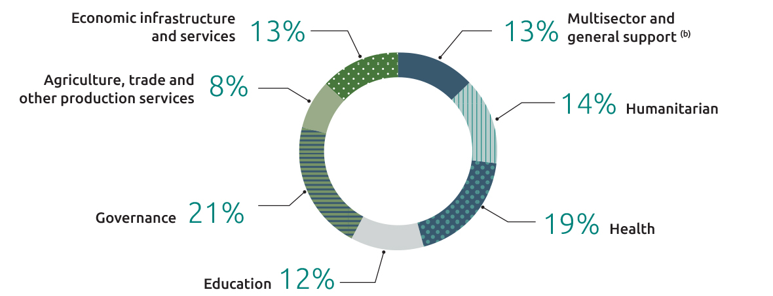

Figure 4. Australian Official Development Assistance by Sector Group, 2021–22 to 2022–23 ^{(a)}

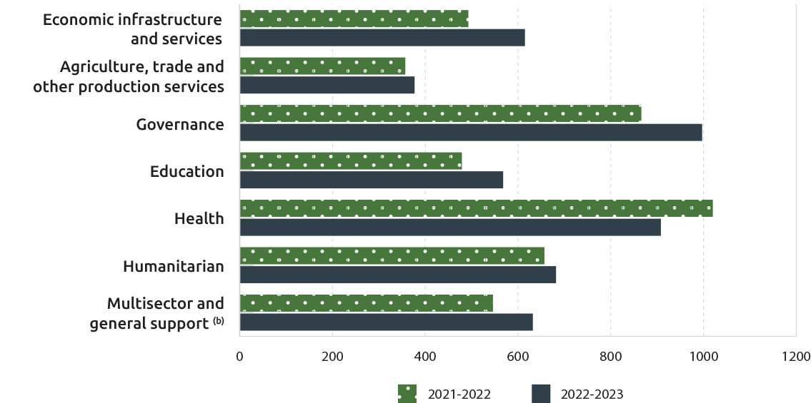

Due to rounding, discrepancies may occur between sums of the component items and totals.
- For further details on how sector groups are compiled, refer to Appendix 2: Concepts and Definitions, paragraph 52.
- Includes action relating to debt, administration costs, research and scientific institutions and other multisectors not further defined.

4 Australian Official Development Assistance, Sector Group by Type of Partner, 2022–23^{(a)}
Sectors | Multilateral Organisation  $’000 | Commercial Supplier  $’000 | Non-Government Organisations  $’000 | Universities and Academic Institutions  $’000 | Developing Country Governments  $’000 | Australian Public Sector Organisations  $’000 | Other Partners  $’000 | Total  $’000
Economic Infrastructure and Services | 182,310 | 247,325 | 18,835 | 1,964 | 148,792 | 10,164 | 5,661 | 615,050
Agriculture, Trade and other Production Sectors | 141,743 | 96,471 | 30,550 | 2,661 | 9,469 | 16,995 | 79,386 | 377,276
Governance | 261,804 | 298,349 | 127,314 | 4,236 | 159,467 | 126,483 | 19,197 | 996,850
Education | 109,146 | 183,497 | 47,904 | 167,390 | 45,208 | 3,934 | 10,743 | 567,822
Health | 468,599 | 180,796 | 83,899 | 9,498 | 55,873 | 85,838 | 23,521 | 908,024
Humanitarian | 429,403 | 67,240 | 149,078 | 979 | 21,605 | 10,182 | 3,641 | 682,128
Multisector and General Development Support (b) | 244,751 | 69,332 | 13,281 | 5,337 | 4,135 | 255,175 | 39,870 | 631,881
Total Australian Official Development Assistance | 1,837,756 | 1,143,011 | 470,860 | 192,064 | 444,548 | 508,771 | 182,020 | 4,779,031

“ - ” denotes nil or rounded to zero (including null cells).
Due to rounding, discrepancies may occur between sums of the component items and totals.
- Sector Group based on broad level OECD DAC sectors. See Appendix 2, paragraph 52 for further information.
- Includes administrative costs, research and scientific institutions and other multisector not further defined.

Figure 5. Australia Official Development Assistance by Type of Partner, 2022–23

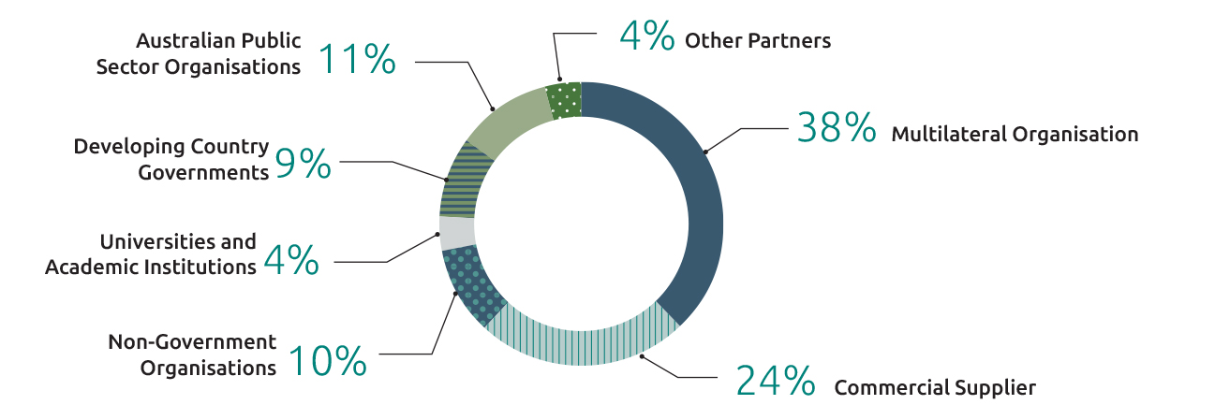

Figure 6. Australia Official Development Assistance by Type of Partner, 2011–12 to 2022–23
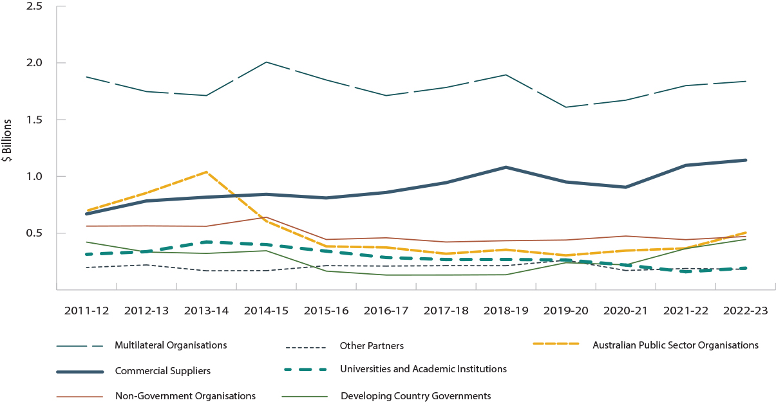

5 Australian Official Development Assistance, Region of Benefit by Sector Group^{(a)}
Region of benefit | 2021–22  $’000 | 2022–23  $’000
Pacific
Economic Infrastructure and Services | 264,427 | 315,689
Agriculture, Trade and other Production Sectors | 79,277 | 103,043
Governance | 425,293 | 515,461
Education | 247,519 | 280,786
Health | 345,148 | 291,501
Humanitarian | 88,593 | 80,693
Multisector and General Development Support ^{(b)} | 211,659 | 252,304
Total Papua New Guinea and Pacific Island Countries | 1,661,917 | 1,839,476
Southeast and East Asia ^{(c)}
Economic Infrastructure and Services | 101,259 | 155,599
Agriculture, Trade and other Production Sectors | 115,561 | 110,792
Governance | 241,244 | 315,457
Education | 153,808 | 192,369
Health | 321,192 | 140,462
Humanitarian | 85,285 | 102,470
Multisector and General Development Support ^{(b)} | 128,287 | 129,920
Total Southeast and East Asia | 1,146,635 | 1,147,070
South and West Asia
Economic Infrastructure and Services | 12,248 | 18,383
Agriculture, Trade and other Production Sectors | 17,188 | 11,618
Governance | 50,838 | 31,910
Education | 34,081 | 48,260
Health | 35,066 | 18,716
Humanitarian | 171,616 | 162,047
Multisector and General Development Support ^{(b)} | 26,099 | 25,043
Total South and West Asia | 347,136 | 315,978
Other Asia ^{(d)}
Economic Infrastructure and Services | 12,782 | 18,407
Agriculture, Trade and other Production Sectors | 5,417 | 10,348
Governance | 7,054 | 6,259
Education | 278 | 80
Health | 22,986 | 9,813
Humanitarian | 10,880 | 3,776
Multisector and General Development Support ^{(b)} | 31,077 | 6,320
Total Other Asia | 90,475 | 55,005
Sub-Saharan Africa ^{(d)}
Economic Infrastructure and Services | 1,698 | 1,668
Agriculture, Trade and other Production Sectors | 16,595 | 20,937
Governance | 6,887 | 11,761
Education | 8,294 | 7,791
Health | 14,063 | 15,051
Humanitarian | 32,513 | 80,365
Multisector and General Development Support ^{(b)} | 8,754 | 10,618
Total Sub-Saharan Africa | 88,805 | 148,191
Middle East and North Africa
Economic Infrastructure and Services | 635 | 157
Agriculture, Trade and other Production Sectors | 613 | 869
Governance | 718 | 877
Education | 1,505 | 1,457
Health | 2,662 | 3,862
Humanitarian | 69,066 | 75,995
Multisector and General Development Support ^{(b)} | 5,731 | 6,106
Total Middle East and North Africa | 80,930 | 89,324
Latin America and the Caribbean
Economic Infrastructure and Services | 93 | 2
Agriculture, Trade and other Production Sectors | 323 | 409
Governance | 718 | 877
Education | 1,505 | 1,457
Health | 2,662 | 3,862
Humanitarian | 69,066 | 75,995
Multisector and General Development Support ^{(b)} | 5,731 | 6,106
Total Middle East and North Africa | 80,930 | 89,324
Latin America and the Caribbean
Economic Infrastructure and Services | 93 | 2
Agriculture, Trade and other Production Sectors | 323 | 409
Governance | 292 | 207
Education | 461 | 497
Health | 245 | 245
Humanitarian | 70 | 2
Multisector and General Development Support ^{(b)} | 194 | 103
Total Latin American and the Caribbean | 1,677 | 1,465
Other ^{(e)}
Economic Infrastructure and Services | 99,910 | 105,142
Agriculture, Trade and other Production Sectors | 122,067 | 119,261
Governance | 134,161 | 114,917
Education | 32,808 | 36,581
Health | 278,998 | 428,374
Humanitarian | 198,630 | 176,780
Multisector and General Development Support ^{(b)} | 134,332 | 201,467
Total Other | 1,000,906 | 1,182,522
Total Australian Official Development Assistance | 4,418,481 | 4,779,031
“ - ” denotes nil or rounded to zero (including null cells).
Due to rounding, discrepancies may occur between sums of the component items and totals.
- Sector Group based on broad level OECD DAC sectors. See Appendix 2, paragraph 52 for further information.
- Includes administrative costs, research and scientific institutions and other multisector not further defined.
- Includes Timor-Leste.
- Includes regional programs that cannot be disaggregated to a lower geographic level.
- Includes global programs that cannot be disaggregated to a lower geographic level.

Figure 7. Pacific

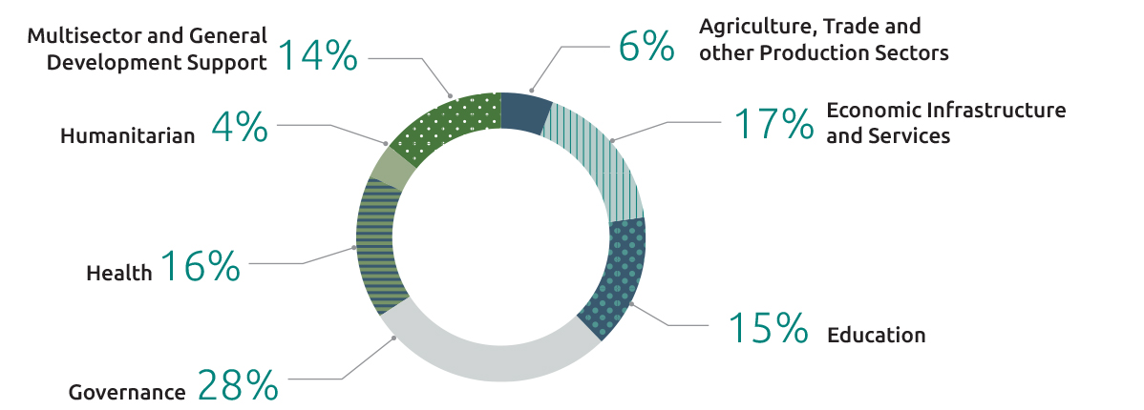

Figure 8. Southeast and East Asia

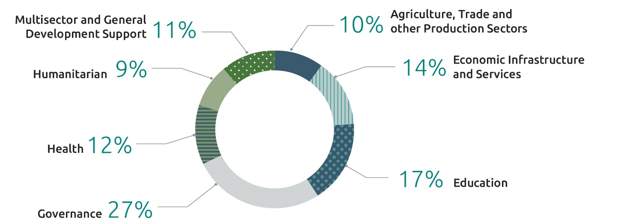

Figure 9. South and West Asia

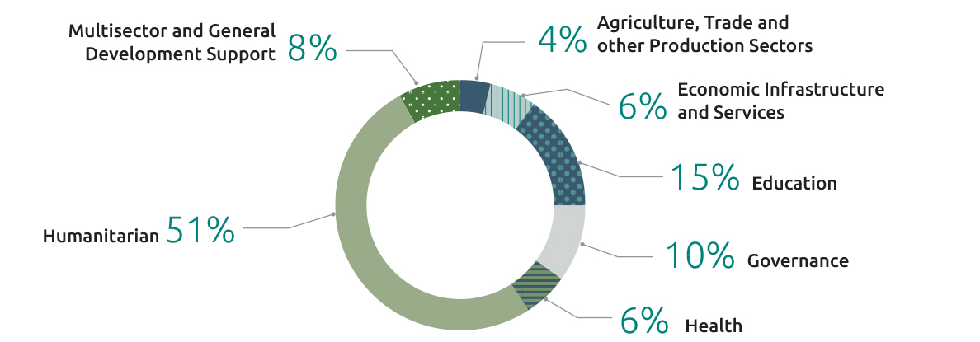

Figure 10. Sub-Saharan Africa

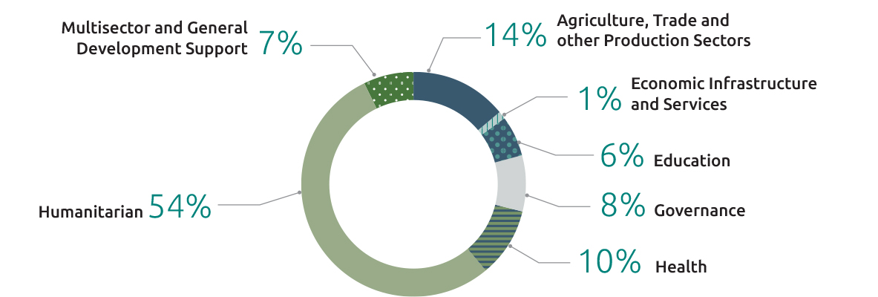

Figure 11. Middle East and North Africa

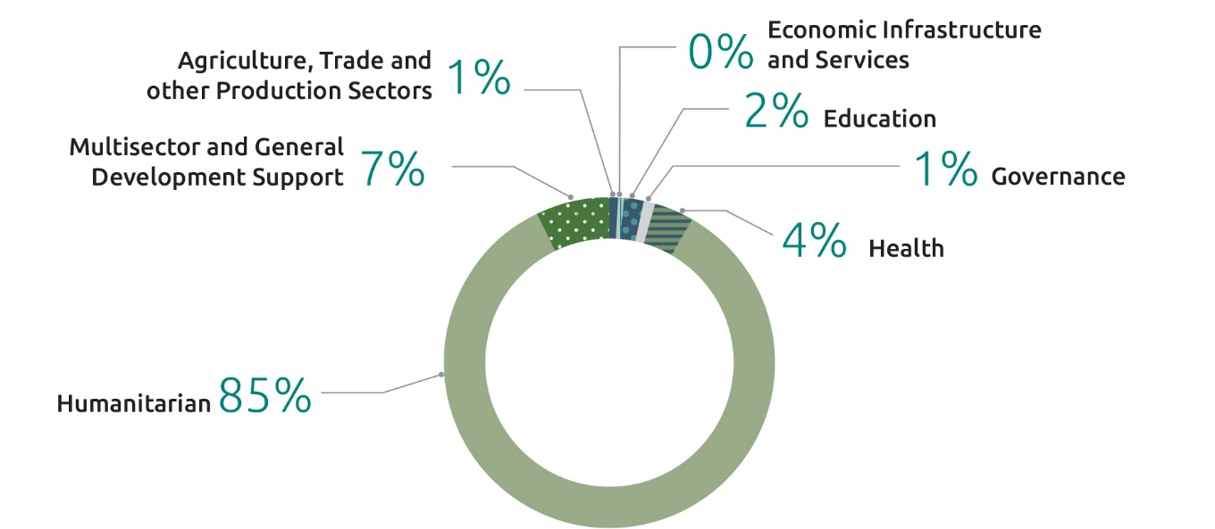

6 Australian Official Development Assistance, Partner Country by Sector Group, 2022–23^{(a)}
Partner Country | Economic Infrastructure and Services  $’000 | Agriculture, Trade and other Production Sectors  $’000 | Governance  $’000 | Education  $’000 | Health  $’000 | Humanitarian  $’000 | Multisector and General Development Support  $’000 | Total  $’000
Pacific
Fiji | 13,082 | 8,695 | 58,691 | 25,720 | 15,567 | 18,947 | 8,554 | 149,256
Kiribati | 4,661 | 996 | 15,762 | 11,824 | 2,937 | 5,470 | 949 | 42,599
Nauru | 4,927 | 3 | 5,616 | 5,114 | 7,377 | 2,673 | 6,243 | 31,953
Niue and Tokelau | - | 17 | 2,180 | 110 | - | - | 400 | 2,706
Papua New Guinea | 198,366 | 20,531 | 148,446 | 89,336 | 132,233 | 19,054 | 35,961 | 643,926
Samoa | 2,997 | 2,634 | 31,858 | 13,056 | 6,360 | 1,591 | 1,809 | 60,305
Solomon Islands | 27,029 | 11,760 | 66,995 | 29,165 | 28,268 | 2,219 | 9,708 | 175,145
Tonga | 6,384 | 2,361 | 20,189 | 5,948 | 36,374 | 3,122 | 423 | 74,801
Tuvalu | 290 | 3 | 16,038 | 2,428 | 1,362 | 1,096 | 181 | 21,398
Vanuatu | 15,612 | 10,907 | 35,503 | 27,013 | 12,009 | 8,047 | 3,421 | 112,511
North Pacific ^{(b)} | 26,041 | 81 | 1,453 | 2,340 | 3,805 | 1,350 | 309 | 35,379
Regional Pacific Island countries ^{(c)} | 16,300 | 45,054 | 112,731 | 68,732 | 45,209 | 17,123 | 184,347 | 489,496
Total Pacific | 315,689 | 103,043 | 515,461 | 280,786 | 291,501 | 80,693 | 252,304 | 1,839,476
Southeast and East Asia
Cambodia | 13,335 | 17,305 | 19,570 | 14,898 | 22,389 | 376 | 7,561 | 95,434
Indonesia | 45,370 | 39,765 | 105,179 | 62,884 | 37,314 | 6,479 | 9,785 | 306,775
Laos | 6,328 | 1,681 | 7,696 | 23,345 | 6,816 | 373 | 4,718 | 50,956
Mongolia | - | 1,085 | 1,163 | 5,548 | 249 | 400 | 109 | 8,553
Myanmar | 896 | 8,237 | 25,138 | 13,435 | 21,335 | 69,887 | 3,791 | 142,720
Philippines | 5,657 | 6,950 | 31,427 | 19,518 | 16,181 | 16,371 | 4,741 | 100,845
Timor-Leste | 19,466 | 7,672 | 81,130 | 9,047 | 13,452 | 2,843 | 3,962 | 137,572
Vietnam | 33,975 | 8,704 | 13,001 | 19,534 | 9,766 | 276 | 10,006 | 95,262
Regional East Asia ^{(c)} | 30,573 | 19,394 | 31,153 | 24,159 | 12,960 | 5,467 | 85,247 | 208,953
Total Southeast and East Asia | 155,599 | 110,792 | 315,457 | 192,369 | 140,462 | 102,470 | 129,920 | 1,147,070
South and West Asia
Afghanistan | - | - | 400 | 4,000 | - | 45,685 | - | 50,085
Bangladesh | 1,196 | 3,382 | 10,295 | 23,416 | 3,515 | 72,850 | 1,026 | 115,681
Bhutan | 102 | 5 | 68 | 2,642 | 1,116 | - | - | 3,934
Maldives | - | - | 553 | 1,997 | - | - | - | 2,549
Nepal | 762 | 2,995 | 7,276 | 5,071 | 4,282 | 1,545 | 2,181 | 24,112
Pakistan | 876 | 2,686 | 378 | 3,249 | 1,440 | 10,291 | 177 | 19,096
Sri Lanka | 5,507 | 920 | 10,195 | 5,841 | 163 | 31,067 | 372 | 54,064
Regional South and West Asia ^{(c)} | 9,940 | 1,630 | 2,746 | 2,044 | 8,201 | 609 | 21,288 | 46,457
Total South and West Asia | 18,383 | 11,618 | 31,910 | 48,260 | 18,716 | 162,047 | 25,043 | 315,978
Other Asian Countries ^{(c)} | 18,407 | 10,348 | 6,259 | 80 | 9,813 | 3,776 | 6,320 | 55,005
Sub-Saharan Africa | 1,668 | 20,937 | 11,761 | 7,791 | 15,051 | 80,365 | 10,618 | 148,191
Middle East and North Africa ^{(d)} | 157 | 869 | 877 | 1,457 | 3,862 | 75,995 | 6,106 | 89,324
Latin America and the Caribbean | 2 | 409 | 207 | 497 | 245 | 2 | 103 | 1,465
Other ^{(e)} | 105,142 | 119,261 | 114,917 | 36,581 | 428,374 | 176,780 | 201,467 | 1,182,522
Total Official Development Assistance | 615,050 | 377,276 | 996,850 | 567,822 | 908,024 | 682,128 | 631,881 | 4,779,031

“-” denotes nil or rounded to zero (including null cells).
Due to rounding, discrepancies may occur between sums of the component items and totals.
- Sector Group based on broad level OECD DAC sectors. See Appendix 2, paragraph 52 for further information.
- Includes Micronesia, Marshall Islands and Palau.
- Includes regional programs that cannot be disaggregated to the lower geographic level.
- Includes the Occupied Palestinian Territories, Iraq, Syria and other flows to the region.
- Includes global programs that cannot be disaggregated to a lower geographic level.

7 Australian Official Development Assistance, Government Departments and Agencies, 2022–23^{(a) (b)}
Government Departments and Agencies | 2021–22  $’000 | 2022–23  $’000
Agriculture, Fisheries and Forestry | - | 15,939
Agriculture, Water and the Environment and Bureau of Meteorology | 15,893 | -
Attorney-General’s
Attorney-General’s | 8,771 | 2,095
Australian Federal Police ^{(c)} | 49,185 | 54,039
Climate Change, Energy, the Environment and Water | - | 1,961
Defence | 16,066 | 279
Education | - | 30
Education, Skills and Employment | 30 | -
Employment and Workplace Relations | - | 33,760
Finance | - | -
Foreign Affairs and Trade
Foreign Affairs and Trade | 4,090,919 | 4,389,679
Australian Centre for International Agricultural Research | 101,077 | 102,002
Export Finance Australia | 45,910 | 16,732
Health | 23,503 | 89,662
Home Affairs | - | 2,395
Infrastructure, Transport, Regional Development, Communications and the Arts ^{(d)} | 50 | 200
Treasury | 61,699 | 65,484
State and Territory Governments | 5,379 | 4,775
Total Official Development Assistance | 4,418,481 | 4,779,031

“-” denotes nil or rounded to zero (including null cells).
Due to rounding, discrepancies may occur between sums of the component items and totals.
- Figures are grouped at the portfolio level and will include relevant Commonwealth entities and companies within the portfolio unless a separate breakdown is provided.
- Further information on donated vaccines is available at https://indopacifichealthsecurity.dfat.gov.au/covid-19-vaccine-access. These donated vaccines are not included in ODA figures.
- AFP is represented under its current portfolio, Attorney-Generals. In 2021–22 it was within the Home Affairs portfolio but figures are presented here for comparability purposes.
- Infrastructure, Transport, Regional Development, Communications and the Arts is represented with its current portfolio name, noting in 2021–22 its portfolio name was Infrastructure, Transport, Regional Development and Communications.

8 Australian Official Development Assistance, Loan Disbursements, 2022–23^{(a) (b)}
Sector/Program | Country | 2021–22  $’000 | 2022–23  $’000
Australia Infrastructure Financing Facility for the Pacific
Papua New Guinea Ports Infrastructure Investment Program | Papua New Guinea | 531 | -
Palau Solar Plant Investment ^{(c)} | Palau | - | 13,514
Papua New Guinea Road Wau and Sepik Highways | Papua New Guinea | 2,687 | -
Total ODA loan disbursement |  | 3,218 | 13,514

“ - ” denotes nil or rounded to zero (including null cells).
Due to rounding, discrepancies may occur between sums of the component items and totals.
- For further information about ODA grant equivalent of loans refer to Appendix 2: Concepts and Definitions, paragraph 27.
- Further detailed information is available on the Australian Infrastructure Financing Facility for the Pacific at: https://www.aiffp.gov.au.
- The treatment under the statistical directives for loans to the private sector was on the cash flow basis for loans disbursed up to 31 December 2022. For loans from 1 January 2023 these will be accounted for under the grant equivalent method.

9 Australian Official Support by Partnerships for Recovery Pillars^{(a)}
Pillars | 2021–22  $’000 | 2022–23  $’000
Health Security | 1,167,664 | 1,080,451
Stability | 1,790,527 | 1,872,845
Economic Recovery | 1,460,291 | 1,825,735
Total Official Development Assistance | 4,418,481 | 4,779,031

Figure 12. Australian Official Development Assistance, Partnerships for Recovery, 2022–23

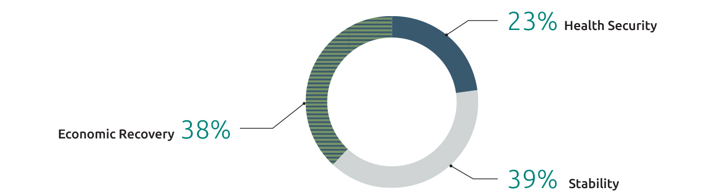

“-” denotes nil or rounded to zero (including null cells).
Due to rounding, discrepancies may occur between sums of the component items and totals.
- The three Partnerships for Recovery pillars are sector based. See Appendix 2, paragraph 49 for further information.

Type of Assistance by Region and Benefit Tables

10 Australian Official Development Assistance, Climate Finance, Type of Assistance by Region of Benefit, 2022–23^{(a) (b) (c)}
Type of assistance | Pacific  $’000 | Southeast and East Asia  $’000 | South and West Asia  $’000 | Other Asia ^{(d)}  $’000 | Sub-Saharan Africa ^{(d)}  $’000 | Middle East and North Africa  $’000 | Latin America and the Caribbean  $’000 | Other ^{(e) (f)}  $’000 | Total  $’000
Environmental protection
Environmental policy and administrative management | 29,474 | 4,390 | 1,457 | - | 237 | 29 | - | 34,566 | 70,152
Environmental research | - | 240 | - | - | - | - | - | 9 | 249
Bio-diversity ^{(g)} | 3,180 | 240 | 200 | 1,950 | 26 | - | - | 86 | 5,682
Other environmental protection | - | - | - | - | - | - | - | 97 | 97
Total environmental protection | 32,654 | 4,870 | 1,657 | 1,950 | 263 | 29 | - | 34,757 | 76,179
Economic infrastructure and services
Transport and storage | 36,545 | 17,427 | 3,000 | - | - | - | - | 3,729 | 60,701
Communications | 1,378 | 1,274 | - | - | 3 | 5 | - | 838 | 3,498
Energy generation and supply | 30,165 | 24,482 | 772 | - | 24 | - | - | 7,598 | 63,041
Business, banking and financial services | 6,147 | 3,290 | 1,333 | 6,453 | 255 | 30 | - | 2,085 | 19,592
Total economic infrastructure and services | 74,235 | 46,472 | 5,105 | 6,453 | 282 | 35 | - | 14,249 | 146,832
Production sectors
Agriculture | 11,268 | 15,871 | 3,421 | 328 | 7,282 | 149 | 53 | 8,628 | 47,001
Forestry and fishing | 17,029 | 14,340 | 6 | - | 88 | 10 | - | 507 | 31,980
Industry | 1,237 | 129 | 42 | 5 | 60 | 3 | 5 | 784 | 2,265
Mining & mineral resources | - | - | - | - | - | - | - | 199 | 199
Other production sectors | 2,071 | 4 | - | - | 4 | - | - | 1,927 | 4,007
Total production sectors | 31,605 | 30,344 | 3,470 | 333 | 7,434 | 162 | 58 | 12,046 | 85,452
Humanitarian assistance
Disaster prevention and preparedness | 9,935 | 11,361 | 1,313 | 432 | 449 | 294 | - | 12,275 | 36,059
Reconstruction relief and rehabilitation | 15,538 | 540 | 123 | - | - | - | - | 509 | 16,710
Other humanitarian assistance | 3,471 | 2,367 | 1,798 | - | 8 | 1 | - | 12,218 | 19,863
Total humanitarian assistance | 28,944 | 14,269 | 3,233 | 432 | 457 | 295 | - | 25,001 | 72,631
Education | 21,913 | 565 | 201 | - | 623 | 75 | 30 | 5,365 | 28,773
Water and Sanitation | 13,499 | 14,620 | 5,807 | 820 | 393 | 41 | 6 | 7,367 | 42,553
Other sectors ^{(h)} | 63,029 | 21,268 | 1,841 | 9 | 2,311 | 276 | 47 | 29,876 | 118,658
Total Australian Climate Finance ODA | 265,880 | 132,408 | 21,315 | 9,997 | 11,763 | 913 | 141 | 128,661 | 571,079

“ - ” denotes nil or rounded to zero (including null cells).
Due to rounding, discrepancies may occur between sums of the component items and totals.
- Type of assistance based on OECD DAC Sectors.
- For further details on Climate Finance methodology and compilation refer to Appendix 2: Concepts and Definitions - paragraphs 8 to 11.
- Figures in this table represent the climate-related component of the expenditure under each sector. Total Australian climate finance equals Official Development Assistance (ODA) climate finance grants and loans (this table) plus the climate finance portion of: Non-ODA grants and loans, and amounts mobilised from the private sector by Australian Official Development Finance investments. For further detail on total climate finance support by Australia and tracking against the Australian Government’s climate finance commitment over the period 2020–2025, refer to the DFAT website (https://www.dfat.gov.au/international-relations/themes/climate-change/supporting-indo-pacific-tackle-climate-change/delivering-our-climate-commitments).
- Includes regional programs that cannot be disaggregated to a lower geographic level.
- Includes the climate finance portion of core contributions to multilateral organisations, based on OECD DAC imputed shares (https://www.oecd.org/development/financing-sustainable-development/development-finance-topics/climate-change.htm); sectoral breakdown follows the OECD DAC’s reporting standard, which applies the same sectoral split as for the entire core contribution.
- Includes global programs that cannot be disaggregated to a lower geographic level.
- Biodiversity here reflects the climate finance portion of investments that have selected the OECD DAC Biodiversity Sector. This is not equal to the total value of Australia’s biodiversity-related expenditure.
- Includes government and civil society, health, public finance and other aspects of climate finance.

11 Australian Official Development Assistance, Gender Equality, Type of Assistance by Region of Benefit, 2022–23^{(a) (b)}
Type of assistance | Pacific  $’000 | Southeast and East Asia  $’000 | South and West Asia  $’000 | Other Asia  $’000 | Sub-Saharan Africa ^{(c)}  $’000 | Middle East and North Africa  $’000 | Latin America and the Caribbean  $’000 | Other ^{(d)}  $’000 | Total  $’000
Social infrastructure and services
Education | 144,133 | 111,055 | 20,418 | - | 2,750 | 269 | 149 | 1,898 | 280,672
Health | 92,395 | 24,780 | 4,164 | 1 | 9,721 | 3,142 | - | 4,003 | 138,207
Family planning and reproductive health | 17,324 | 3,938 | 352 | 2,478 | 287 | 27 | - | 8,271 | 32,677
Water supply and sanitation | 19,609 | 33,269 | 8,574 | - | 1,872 | 162 | - | 4,314 | 67,799
Government and civil society | 211,428 | 164,857 | 19,916 | 5,212 | 5,895 | 672 | - | 20,695 | 428,675
Other social infrastructure and services | 18,912 | 54,909 | 9,422 | 111 | 895 | 35 | - | 619 | 84,903
Total social infrastructure and services | 503,800 | 392,809 | 62,846 | 7,803 | 21,420 | 4,307 | 149 | 39,799 | 1,032,933
Economic infrastructure and services
Transport and storage | 7,647 | 44,267 | 6,000 | - | - | - | - | - | 57,913
Communications | 3,007 | 2,400 | 4 | - | 22 | - | - | - | 5,433
Energy generation and supply | 1,058 | 19,919 | 1,600 | - | 30 | - | - | - | 22,607
Banking and financial services | 9,336 | 1,463 | 4,300 | 2,163 | 1,092 | 116 | - | - | 18,472
Business and other services | 5,749 | 11,358 | 1,266 | 2,000 | 93 | 7 | - | 2,447 | 22,920
Total economic infrastructure and services | 26,797 | 79,407 | 13,168 | 4,163 | 1,238 | 123 | - | 2,447 | 127,344
Production sectors
Agriculture, forestry and fishing | 19,285 | 41,769 | 2,441 | - | 6,452 | 673 | - | - | 70,620
Industry, mining and construction | 3,923 | 7,761 | 172 | 3,145 | 200 | 13 | 33 | 1 | 15,249
Trade and tourism | 405 | 8,817 | 57 | - | 65 | - | - | 1,990 | 11,335
Total production sectors | 23,612 | 58,347 | 2,669 | 3,145 | 6,718 | 686 | 33 | 1,992 | 97,204
Humanitarian assistance | 31,427 | 85,664 | 134,551 | 3,339 | 35,030 | 53,363 | - | 33,320 | 376,694
Other sectors ^{(e)} | 74,604 | 38,998 | 3,443 | - | 2,410 | 127 | - | 2,684 | 122,267
Total Australian Gender Equality ODA | 660,241 | 655,224 | 216,679 | 18,450 | 66,816 | 58,606 | 182 | 80,242 | 1,756,442

“-” denotes nil or rounded to zero (including null cells).
Due to rounding, discrepancies may occur between sums of the component items and totals.
- For further details on Gender Equality methodology and compilation refer to Appendix 2: Concepts and Definitions - paragraphs 23 to 25.
- Type of assistance based on OECD DAC sectors.
- Includes regional programs that cannot be disaggregated to the lower geographic level.
- Includes global programs that cannot be disaggregated to a lower geographic level.
- Includes multisector education and training, urban and rural development projects and other multisector not further defined.

12 Australian Official Development Assistance, Disability Inclusion, Type of Assistance by Region of Benefit, 2022–23^{(a) (b)}
Type of assistance | Pacific  $’000 | Southeast and East Asia  $’000 | South and West Asia  $’000 | Other Asia  $’000 | Sub-Saharan Africa ^{(c)}  $’000 | Middle East and North Africa  $’000 | Latin America and the Caribbean  $’000 | Other ^{(d)}  $’000 | Total  $’000
Social infrastructure and services
Education | 6,717 | 3,208 | 644 | - | 307 | 27 | - | - | 10,902
Health | 4,821 | 4,416 | 612 | 53 | 1,131 | 516 | - | 434 | 11,982
Family planning and reproductive health | 698 | 284 | 122 | 124 | 48 | 3 | - | 284 | 1,563
Water supply and sanitation | 919 | 1,719 | 366 | - | 175 | 16 | - | - | 3,196
Government and civil society | 8,337 | 26,494 | 1,217 | - | 647 | 92 | - | 10,160 | 46,948
Other social infrastructure and services | 1,269 | 3,487 | 272 | 11 | 136 | 3 | - | 68 | 5,246
Total social infrastructure and services | 22,760 | 39,608 | 3,233 | 189 | 2,443 | 657 | - | 10,946 | 79,837
Economic infrastructure and services
Transport and storage | 1,475 | 849 | - | - | - | - | - | - | 2,324
Communications | 186 | 6 | - | - | - | - | - | - | 192
Energy generation and supply | 1,756 | 36 | 10 | - | 3 | - | - | - | 1,805
Banking and financial services | 67 | 198 | 51 | - | 106 | 12 | - | - | 434
Business and other services | 53 | 189 | 70 | 100 | 8 | 1 | - | - | 421
Total economic infrastructure and services | 3,537 | 1,279 | 132 | 100 | 117 | 13 | - | - | 5,177
Production sectors
Agriculture, forestry and fishing | 412 | 596 | 235 | - | 596 | 68 | - | - | 1,908
Industry, mining and construction | 35 | 69 | 15 | - | 17 | 1 | - | - | 137
Trade and tourism | 40 | 18 | - | - | - | - | - | - | 58
Total production sectors | 488 | 683 | 251 | - | 612 | 69 | - | - | 2,103
Humanitarian assistance | 712 | 5,182 | 7,045 | 2 | 2,182 | 2,737 | - | 3,074 | 20,935
Other sectors ^{(e)} | 3,618 | 2,919 | 674 | 19 | 327 | 37 | - | 207 | 7,801
Total Australian Disability Inclusion ODA | 31,116 | 49,671 | 11,335 | 310 | 5,681 | 3,513 | - | 14,227 | 115,854

“-” denotes nil or rounded to zero (including null cells).
Due to rounding, discrepancies may occur between sums of the component items and totals.
- Disability inclusion refers to assistance provided to persons with a disability. Estimates in this table reflect the value of all activities that provide some level of assistance to disabled persons. The level of assistance varies across all activities with some activities providing principal or significant focus and other activities moderate or minor focus. For further details on how disability inclusion data are compiled refer to Appendix 2: Concepts and Definitions - paragraphs 17 to 20.
- Type of assistance based on OECD DAC sectors.
- Includes regional programs that cannot be disaggregated to the lower geographic level.
- Includes global programs that cannot be disaggregated to a lower geographic level.
- Includes multisector education and training, seminars and other multisector not further defined.

13 Australian Official Development Assistance, Education, Type of Assistance by Region of Benefit, 2022–23^{(a)}
Type of assistance | Pacific  $’000 | Southeast and East Asia  $’000 | South and West Asia  $’000 | Other Asia  $’000 | Sub-Saharan Africa ^{(b)}  $’000 | Middle East and North Africa  $’000 | Latin America and the Caribbean  $’000 | Other ^{(c)}  $’000 | Total  $’000
Basic education
Primary education | 16,582 | 50,627 | 9,357 | - | 1,519 | 160 | 49 | 6,803 | 85,098
Early childhood education | 1,949 | 1,286 | 219 | - | 274 | 114 | 16 | 2,985 | 6,843
Basic life skills for youth and adults | 4,723 | 1,898 | 2,570 | - | 542 | 79 | - | 1,005 | 10,818
Total basic education | 23,255 | 53,812 | 12,146 | - | 2,335 | 354 | 65 | 10,792 | 102,759
Secondary education
Secondary education | 3,873 | 73 | 14 | - | 11 | 3 | 11 | 5,451 | 9,437
Vocational education | 13,958 | 413 | 7,442 | - | 512 | 74 | 163 | 3,961 | 26,524
Total secondary education | 17,831 | 486 | 7,457 | - | 523 | 77 | 174 | 9,412 | 35,961
Post-secondary education
Higher education | 22,025 | 666 | 204 | - | 159 | 147 | 103 | 3,104 | 26,408
Advanced technical and managerial training | 26,709 | 11,253 | 28 | - | 58 | - | - | 2,090 | 40,139
Total post-secondary education | 48,735 | 11,920 | 232 | - | 217 | 147 | 103 | 5,194 | 66,547
Other education
Education policy and administrative management | 54,479 | 5,866 | 190 | 30 | 267 | 33 | - | 6,671 | 67,537
Education facilities and training | 40,350 | 1,935 | 465 | 50 | 1,622 | 90 | 114 | 2,182 | 46,806
Teacher training | 11,552 | 2,139 | 265 | - | 164 | 6 | 41 | 1,515 | 15,683
Education research | - | 764 | 1 | - | 71 | - | - | 609 | 1,444
Total other education | 106,381 | 10,703 | 921 | 80 | 2,124 | 130 | 155 | 10,976 | 131,471
Multisector education and training ^{(d)} | 84,583 | 115,449 | 27,505 | - | 2,591 | 749 | - | 206 | 231,084
Total Australian Education ODA | 280,786 | 192,369 | 48,260 | 80 | 7,791 | 1,457 | 497 | 36,581 | 567,822

“-” denotes nil or rounded to zero (including null cells).
Due to rounding, discrepancies may occur between sums of the component items and totals.
- Sector groups based on broad level OECD DAC Sectors.
- Includes regional programs that cannot be disaggregated to the lower geographic level.
- Includes global programs that cannot be disaggregated to a lower geographic level.
- Includes scholarships.

14 Australian Official Development Assistance, Health, Type of Assistance by Region of Benefit, 2022–23^{(a)}
Type of assistance | Pacific  $’000 | Southeast and East Asia  $’000 | South and West Asia  $’000 | Other Asia  $’000 | Sub-Saharan Africa ^{(b)}  $’000 | Middle East and North Africa  $’000 | Latin America and the Caribbean  $’000 | Other ^{(c)}  $’000 | Total  $’000
Leadership and capacity building in health service delivery
Medical education and training | 998 | 240 | 44 | - | 26 | 3 | - | 185 | 1,497
Medical research | - | - | - | - | - | - | - | 25,713 | 25,713
Medical services | 32,988 | 352 | 293 | - | 424 | 2,091 | 14 | 5,000 | 41,161
Health policy and management | 91,643 | 20,637 | 931 | 1,651 | 1,625 | 232 | - | 45,319 | 162,038
Total leadership and capacity building in health service delivery | 125,629 | 21,229 | 1,268 | 1,651 | 2,076 | 2,325 | 14 | 76,216 | 230,408
Disease control and preventable impairments
Primary health care | 34,515 | 33,976 | 7,775 | 1,869 | 4,057 | 572 | 38 | 120,088 | 202,889
Health infrastructure | 27,454 | 3,861 | 603 | 31 | 1,713 | 239 | 37 | 1,255 | 35,192
Nutrition | 2,103 | 3,879 | 361 | - | 1,558 | 162 | - | 4,349 | 12,413
Infectious disease control | 31,636 | 47,210 | 544 | 2,104 | 1,003 | 80 | 1 | 134,943 | 217,520
Malaria control | 1,414 | 3,600 | - | 1,680 | 8 | - | - | 17,501 | 24,204
Tuberculosis control | 1,509 | 4,520 | - | - | - | - | - | 17,004 | 23,033
Public health education programs | 14,803 | 3,183 | 1,094 | - | 638 | 116 | 77 | 1,092 | 21,003
Other basic health | 9,041 | 1,359 | 529 | - | 989 | 101 | - | 676 | 12,696
Total disease control and preventable impairments | 122,476 | 101,588 | 10,907 | 5,684 | 9,966 | 1,269 | 152 | 296,907 | 548,949
Family planning and reproductive health programs ^{(d)}
Reproductive health care | 8,210 | 1,314 | 505 | 743 | 359 | 21 | 18 | 12,188 | 23,357
Family planning | 8,255 | 2,674 | 416 | 991 | 32 | 6 | - | 10,204 | 22,579
Sexually transmitted disease control | 1,708 | 4,068 | 49 | 743 | 14 | - | - | 22,476 | 29,059
Other population and health programs | 250 | 115 | 212 | - | 61 | - | 20 | 340 | 998
Total family planning and reproductive health programs | 18,422 | 8,172 | 1,182 | 2,478 | 467 | 27 | 38 | 45,207 | 75,993
Total Australian Health ODA | 266,527 | 130,988 | 13,357 | 9,813 | 12,509 | 3,621 | 204 | 418,331 | 855,349

“-” denotes nil or rounded to zero (including null cells).
Due to rounding, discrepancies may occur between sums of the component items and totals.
- Sector groups based on broad level OECD DAC Sectors.
- Includes regional programs that cannot be disaggregated to the lower geographic level.
- Includes global programs that cannot be disaggregated to a lower geographic level.
- Family planning and reproductive health data presented in this table has been compiled using DAC sectors, which differs from the methodology agreed at the 2012 London Family Planning Summit for tracking family planning expenditure. Data compiled using the Summit methodology is presented in Table 16.

15 Australian Official Development Assistance, Maternal and Child Health, Type of Assistance by Region of Benefit, 2022–23^{(a) (b)}
Type of assistance | Pacific  $’000 | Southeast and East Asia  $’000 | South and West Asia  $’000 | Other Asia  $’000 | Sub-Saharan Africa ^{(c)}  $’000 | Middle East and North Africa  $’000 | Latin America and the Caribbean  $’000 | Other ^{(d)}  $’000 | Total  $’000
Leadership and capacity building in health service delivery
Medical education and training | 1,791 | 381 | 167 | - | 340 | 42 | - | 223 | 2,943
Medical research | - | - | - | - | - | - | - | - | -
Medical services | 13,195 | 141 | 117 | - | 170 | 836 | 5 | 2,000 | 16,464
Health policy and management | 36,342 | 8,080 | 371 | 660 | 649 | 93 | - | 18,128 | 64,323
Total leadership and capacity building in health service delivery | 51,328 | 8,601 | 655 | 660 | 1,159 | 970 | 5 | 20,350 | 83,730
Disease control and preventable impairments
Primary health care | 7,983 | 10,269 | 6,199 | 472 | 1,621 | 229 | 15 | 8,876 | 35,663
Health infrastructure | 10,978 | 1,531 | 240 | 12 | 685 | 96 | 15 | 502 | 14,059
Nutrition | 2,068 | 3,740 | 350 | - | 1,554 | 162 | - | 2,454 | 10,327
Infectious disease control ^{(e)} | 12,604 | 18,811 | 217 | 836 | 401 | 32 | - | 108,856 | 141,756
Public health education programs | 5,921 | 1,272 | 438 | - | 255 | 46 | 31 | 437 | 8,400
Water supply and sanitation | 3,621 | 1,324 | 771 | - | 379 | 36 | 6 | 1,332 | 7,469
Other basic health | - | - | - | - | - | - | - | - | -
Total disease control and preventable impairments | 43,175 | 36,947 | 8,215 | 1,320 | 4,894 | 600 | 67 | 122,455 | 217,674
Family planning and reproductive health programs ^{(f)}
Reproductive health care | 4,691 | 1,314 | 505 | 743 | 359 | 21 | 18 | 9,765 | 17,415
Family planning | 4,651 | 2,674 | 416 | 991 | 32 | 6 | - | 5,767 | 14,538
Sexually transmitted disease control | 45 | - | - | - | - | - | - | - | 45
Other population and health programs | 250 | 115 | 212 | - | 61 | - | 20 | 178 | 836
Total family planning and reproductive health programs | 9,636 | 4,103 | 1,133 | 1,735 | 453 | 27 | 38 | 15,710 | 32,834
Humanitarian and food aid | 1,192 | 6,095 | 16,289 | 4 | 1,231 | 7,157 | - | 5,300 | 37,267
Other ^{(g)} | 315 | 3,933 | 286 | - | 10 | - | - | 1,969 | 6,513
Total Australian Maternal and Child Health ODA | 105,646 | 59,680 | 26,577 | 3,719 | 7,747 | 8,754 | 111 | 165,784 | 378,018

“ - “ denotes nil or rounded to zero (including null cells).
Due to rounding, discrepancies may occur between sums of the component items and totals.
- Maternal and child health (MCH) data has been compiled using a maternal, neonatal and child health methodology “Muskoka 2”. For further information on how data is compiled please refer to Appendix 2 Concepts and Definitions - paragraphs 28 to 31.
- Sector groups based on broad level OECD DAC Sectors.
- Includes regional programs that cannot be disaggregated to a lower geographic level.
- Includes global programs that cannot be disaggregated to a lower geographic level.
- Includes Tuberculosis and Malaria Control.
- Family planning and reproductive health data presented in this table reflects investments presented in table 14 and 16 that specifically target maternal and child health.
- Includes education, governance, social infrastructure and other multisector not further defined or captured as part of the three Muskoka 2 partners.

16 Supplementary Table: Australian Official Development Assistance in Family Planning based on the methodology agreed at the 2012 London Family Planning Summit, by Region, 2022–23^{(a) (b)}
Type of assistance | Pacific  $’000 | Southeast and East Asia  $’000 | South and West Asia  $’000 | Other Asia  $’000 | Sub-Saharan Africa ^{(c)}  $’000 | Middle East and North Africa  $’000 | Latin America and the Caribbean  $’000 | Other ^{(d)}  $’000 | Total  $’000
Government Departments and Agencies
Health policy and administrative management | 4,582 | 1,032 | 47 | 83 | 81 | 12 | - | 2,266 | 8,102
Medical education/training | 50 | 12 | 2 | - | 1 | - | - | 9 | 75
Medical services | 1,649 | 18 | 15 | - | 21 | 105 | 1 | 250 | 2,058
Basic health care | 598 | 354 | 84 | - | 203 | 29 | 2 | 353 | 1,623
Basic health infrastructure | 1,373 | 193 | 30 | 2 | 86 | 12 | 2 | 63 | 1,760
Health education | 740 | 159 | 55 | - | 32 | 6 | 4 | 55 | 1,050
Health personnel development | 175 | 38 | 19 | - | 41 | 5 | - | 19 | 297
Population policy and administrative management | - | - | - | - | - | - | - | 13 | 13
Reproductive health care | 1,642 | 263 | 101 | 149 | 72 | 4 | 4 | 2,438 | 4,671
Family planning | 8,255 | 2,674 | 416 | 991 | 32 | 6 | - | 10,204 | 22,579
STD control including HIV/AIDS | 85 | 203 | 2 | 37 | 1 | - | - | 999 | 1,328
Personnel development for population and reproductive health | 12 | 6 | 11 | - | 3 | - | 1 | 3 | 36
General budget support | 473 | 135 | - | - | - | - | - | - | 608
Total Australian Family Planning ODA | 19,634 | 5,088 | 781 | 1,261 | 573 | 178 | 13 | 16,672 | 44,200
“ - ” denotes nil or rounded to zero (including null cells).
Due to rounding, discrepancies may occur between sums of the component items and totals.
- Family Planning data are presented in this table using the methodology agreed at the 2012 London Family Planning Summit. This narrower targeted focus differs from the standard reporting approach for presenting family and reproductive health program data using OECD DAC sectors presented in Table 14. For further details on the methodology refer to Appendix 2: Concepts and Definitions - paragraph 22.
- Sector groups based on broad level OECD DAC Sectors.
- Includes regional programs that cannot be disaggregated to a lower geographic level.
- Includes global programs that cannot be disaggregated to a lower geographic level.

17 Australian Official Development Assistance, Nutrition, Type of Assistance by Region of Benefit, 2022–23^{(a) (b) (c)}
Type of assistance | Pacific  $’000 | Southeast and East Asia  $’000 | South and West Asia  $’000 | Other Asia  $’000 | Sub-Saharan Africa ^{(d)}  $’000 | Middle East and North Africa  $’000 | Latin America and the Caribbean  $’000 | Other ^{(e)}  $’000 | Total  $’000
Leadership and capacity building in health service delivery
Medical education and training | 127 | - | - | - | - | - | - | - | 127
Health policy and management | 3,597 | 897 | - | - | - | - | - | 178 | 4,672
Total leadership and capacity building in health service delivery | 3,724 | 897 | - | - | - | - | - | 178 | 4,799
Disease control and preventable impairments
Primary health care | 1,180 | 5,017 | - | - | - | - | - | 557 | 6,754
Nutrition ^{(f)} | 2,103 | 2,204 | 361 | - | 1,558 | 162 | - | 558 | 6,946
Public health education programs | - | 341 | - | - | - | - | - | - | 341
Reproductive health care | 338 | 294 | - | - | - | - | - | 1,000 | 1,632
Total other health | 3,621 | 7,857 | 361 | - | 1,558 | 162 | - | 2,115 | 15,673
Social infrastructure and services
Education | 281 | - | - | - | - | - | - | 1,298 | 1,579
Water supply and sanitation | 3,727 | 1,525 | 970 | - | - | - | - | 1,503 | 7,726
Social and welfare services | 1,841 | - | - | - | - | - | - | 627 | 2,468
Total social infrastructure and services | 5,849 | 1,525 | 970 | - | - | - | - | 3,428 | 11,773
Humanitarian Assistance
Emergency food aid | - | 5,500 | - | - | 17,500 | 14,000 | - | 34,500 | 71,500
Other humanitarian assistance | - | 235 | 21,023 | - | - | 7,875 | - | - | 29,133
Total humanitarian assistance | - | 5,735 | 21,023 | - | 17,500 | 21,875 | - | 34,500 | 100,633
Agriculture, forestry and fishing | 1,061 | - | - | - | - | - | - | 12,972 | 14,033
Food aid and food security | - | 6,080 | - | - | - | - | - | - | 6,080
Other ^{(g)} | 2,626 | 1,520 | - | - | - | - | - | 1,285 | 5,431
Total Australian Nutrition Official Development Assistance | 16,881 | 23,614 | 22,354 | - | 19,058 | 22,037 | - | 54,478 | 158,422

“ - ” denotes nil or rounded to zero (including null cells).
Due to rounding, discrepancies may occur between sums of the component items and totals.
- Nutrition expenditure presented in this table reflects investments identified as ‘nutrition specific’ or ‘nutrition sensitive’ based on the Scaling Up Nutrition (SUN) methodology.
- Sector groups based on broad level OECD DAC Sectors.
- For further details on how nutrition data presented in this publication has been compiled refer to Appendix 2: Concepts and Definitions - paragraphs 39 and 40.
- Includes regional programs that cannot be disaggregated to a lower geographic level.
- Includes global programs that cannot be disaggregated to a lower geographic level.
- These investments relate to direct nutrition specific feeding programmes for maternal feeding, breastfeeding and weaning foods, child feeding and school feeding.
- Other includes rural development, women’s organisations and other multisector aid not further defined.

18 Australian Official Development Assistance, Water, Sanitation and Hygiene, Type of Assistance by Region of Benefit, 2022–23^{(a)}
Type of assistance | Pacific  $’000 | Southeast and East Asia  $’000 | South and West Asia  $’000 | Other Asia  $’000 | Sub-Saharan Africa ^{(b)}  $’000 | Middle East and North Africa  $’000 | Latin America and the Caribbean  $’000 | Other ^{(c)}  $’000 | Total  $’000
Water resources policy and management
Water sector policy and administrative management | 5,293 | 8,228 | 428 | 2,732 | - | - | - | 6,032 | 22,713
Water resources conservation (including data collection) | 263 | 1,383 | 61 | - | 122 | 3 | - | 3,603 | 5,434
Total water resources policy and management | 5,556 | 9,611 | 489 | 2,732 | 122 | 3 | - | 9,634 | 28,147
Water supply and sanitation systems, urban | - | 23,083 | 3,154 | - | - | - | - | 6,654 | 32,890
Water supply and sanitation systems, rural | 24,111 | 8,779 | 5,141 | - | 2,527 | 241 | 41 | 9,172 | 50,013
Other water supply and sanitation
River basins' development | - | 1,186 | - | - | - | - | - | 509 | 1,696
Waste management/disposal | - | 3 | 2 | - | 111 | - | - | 1,278 | 1,394
Education and training in water supply and sanitation | 863 | 694 | 219 | - | 15 | - | - | 871 | 2,662
Total other water supply and sanitation | 863 | 1,884 | 220 | - | 126 | - | - | 2,658 | 5,752
Total Australian Water, Sanitation and Hygiene ODA | 30,530 | 43,357 | 9,004 | 2,732 | 2,775 | 244 | 41 | 28,118 | 116,802

“ - ” denotes nil or rounded to zero (including null cells).
Due to rounding, discrepancies may occur between sums of the component items and totals.
- Sector groups based on broad level OECD DAC Sectors.
- Includes regional programs that cannot be disaggregated to the lower geographic level.
- Includes global programs that cannot be disaggregated to a lower geographic level.

19 Australian Official Development Assistance, Government and Civil Society, Type of Assistance by Region of Benefit, 2022–23^{(a)}
Type of assistance | Pacific  $’000 | Southeast and East Asia  $’000 | South and West Asia  $’000 | Other Asia  $’000 | Sub-Saharan Africa ^{(b)}  $’000 | Middle East and North Africa  $’000 | Latin America and the Caribbean  $’000 | Other ^{(c)}  $’000 | Total  $’000
Government and civil society, general
Public sector policy and administrative management | 64,080 | 91,406 | 2,172 | 535 | 226 | - | - | 14,971 | 173,390
Public finance management | 24,795 | 13,317 | 133 | - | - | - | - | 11,151 | 49,395
Domestic revenue mobilisation | 6,861 | 5,945 | - | - | - | - | - | 2,755 | 15,561
Election management | 28,496 | 5 | - | - | - | 2 | - | 484 | 28,987
Legal and judicial development | 89,158 | 27,135 | 1 | 4,085 | 56 | - | - | 592 | 121,028
Democratic participation and civil society | 33,087 | 5,311 | 12,641 | 400 | 464 | 28 | 19 | 44 | 51,995
Human rights | 9,762 | 11,253 | 2,194 | 607 | 3,170 | 356 | 115 | 20,425 | 47,881
Women's equality organisations and institutions | 20,714 | 7,099 | 1,185 | 261 | 1,008 | 285 | 30 | 11,799 | 42,380
Ending violence against women and girls | 37,312 | 19,832 | 2,505 | 260 | 1,690 | 102 | - | 3,603 | 65,305
Other government and civil society, general (d) | 21,255 | 1,397 | 1,018 | - | 119 | 6 | 22 | 4,485 | 28,301
Total government and civil society, general | 335,519 | 182,700 | 21,848 | 6,148 | 6,733 | 779 | 186 | 70,310 | 624,223
Conflict prevention and resolution, peace and security | 4,571 | 23,917 | 1,860 | 806 | 24,653 | 2,761 | - | 10,296 | 68,865
Other government and civil society ^{(e)} | 76,626 | 81,136 | 9,809 | 111 | 1,536 | 92 | 21 | 45,500 | 214,831
Total Australian Government and Civil Society ODA | 416,716 | 287,754 | 33,517 | 7,066 | 32,922 | 3,632 | 207 | 126,105 | 907,920
“-” denotes nil or rounded to zero (including null cells).
Due to rounding, discrepancies may occur between sums of the component items and totals.
- Type of assistance based on OECD DAC Sectors.
- Includes regional programs that cannot be disaggregated to the lower geographic level.
- Includes global programs that cannot be disaggregated to a lower geographic level.
- Includes media and free flow of information, legislatures and political parties and decentralisation and support to subnational government.
- Includes other basic social and welfare services, institution capacity building, special programmes and other multisector not further defined.
This table incorporates data previously reported in the Australian Official Development Assistance, Law and Justice table in prior years’ statistical summaries.

20 Australian Official Development Assistance, Humanitarian and Disaster Response, Type of Assistance by Region of Benefit, 2022–23^{(a)}
Type of assistance | Pacific  $’000 | Southeast and East Asia  $’000 | South and West Asia  $’000 | Other Asia  $’000 | Sub-Saharan Africa ^{(b)}  $’000 | Middle East and North Africa  $’000 | Latin America and the Caribbean  $’000 | Other ^{(c)}  $’000 | Total  $’000
Emergency response
Material relief assistance | 19,417 | 50,155 | 92,474 | 85 | 10,461 | 55,101 | 1 | 79,589 | 307,284
Emergency food aid | (22) | 14,670 | - | - | 40,000 | 14,000 | - | 34,575 | 103,223
Relief co-ordination and support services | 1,365 | 6,937 | 56,828 | - | 539 | 2,312 | - | 19,829 | 87,810
Total emergency response | 20,759 | 71,762 | 149,303 | 85 | 51,000 | 71,413 | 1 | 133,993 | 498,317
Other humanitarian assistance
Reconstruction relief and rehabilitation | 16,507 | 1,800 | 6,990 | - | - | - | - | 2,078 | 27,375
Disaster prevention and preparedness | 41,578 | 17,720 | 3,894 | 2,884 | 4,712 | 1,821 | - | 30,413 | 103,023
Refugees in donor countries | - | - | - | - | - | - | - | - | -
Land mine clearance | 1,377 | 113 | 1,000 | - | - | - | - | 1,414 | 3,904
Civilian peace-building, conflict prevention and resolution | 472 | 10,623 | 860 | 806 | 482 | 38 | - | 8,112 | 21,392
Participation in international peacekeeping operations | - | - | - | - | 24,171 | 2,723 | - | 237 | 27,132
Reintegration and Small Arms Light Weapons control | - | 452 | - | - | - | - | - | 529 | 981
Child soldiers prevention and demobilisation | - | - | - | - | - | - | - | 4 | 4
Total other humanitarian assistance | 59,933 | 30,708 | 12,744 | 3,691 | 29,365 | 4,582 | - | 42,787 | 183,811
Total Australian Humanitarian and Disaster Response ODA | 80,693 | 102,470 | 162,047 | 3,776 | 80,365 | 75,995 | 2 | 176,780 | 682,128

“ - ” denotes nil or rounded to zero (including null cells).
Due to rounding, discrepancies may occur between sums of the component items and totals.
- Sector groups based on broad level OECD DAC Sectors.
- Includes regional programs that cannot be disaggregated to the lower geographic level.
- Includes global programs that cannot be disaggregated to a lower geographic level.

21 Australian Official Development Assistance, Economic Growth, Type of Assistance by Region of Benefit, 2022–23^{(a)}
Type of assistance | Pacific  $’000 | Southeast and East Asia  $’000 | South and West Asia  $’000 | Other Asia  $’000 | Sub-Saharan Africa ^{(b)}  $’000 | Middle East and North Africa  $’000 | Latin America and the Caribbean  $’000 | Other ^{(c)}  $’000 | Total  $’000
Economic infrastructure and services
Transport and storage | 201,341 | 49,837 | 6,000 | - | - | - | - | 21,799 | 278,977
Communications | 20,055 | 6,364 | 4 | - | 32 | 34 | - | 3,687 | 30,176
Energy generation and supply | 64,872 | 44,678 | 1,600 | - | 116 | - | 2 | 44,279 | 155,548
Banking and financial services | 13,928 | 2,102 | 4,772 | 3,663 | 1,278 | 116 | - | 18,148 | 44,007
Business and other services | 14,194 | 18,663 | 2,793 | 8,299 | 105 | 7 | - | 1,554 | 45,615
Total economic infrastructure and services | 314,390 | 121,644 | 15,168 | 11,962 | 1,531 | 157 | 2 | 89,468 | 554,323
Production sectors
Agriculture | 42,175 | 56,516 | 9,833 | 38 | 17,766 | 758 | 228 | 80,784 | 208,099
Forestry | 184 | 13,420 | 23 | - | 911 | 40 | - | 1,081 | 15,661
Fishing | 28,281 | 2,454 | 3 | - | 16 | - | 1 | 3,144 | 33,899
Industry | 4,971 | 8,235 | 205 | 7,577 | 303 | 13 | 63 | 3,451 | 24,819
Mineral resources and mining | - | 1,085 | - | - | 535 | - | - | 816 | 2,436
Construction | 677 | - | - | - | - | - | - | 25 | 702
Trade and tourism | 20,255 | 17,733 | 57 | - | 69 | - | - | 17,974 | 56,088
Total production sectors | 96,543 | 99,444 | 10,121 | 7,615 | 19,600 | 812 | 292 | 107,275 | 341,702
Other sectors
Other social and infrastructure services | 46,824 | 66,771 | 9,484 | 111 | 991 | 20 | - | 34,952 | 159,154
Environmental policy and governance | 43,955 | 17,411 | 1,888 | 1,978 | 2,102 | 129 | 2 | 46,851 | 114,316
Urban and rural development | 2,243 | 10,661 | 1,068 | 6,446 | 1,241 | 54 | 117 | 9,585 | 31,414
Food aid and food security programs ^{(d)} | - | 5,288 | 50 | - | 3,239 | - | - | 72 | 8,649
Total other sectors | 93,022 | 100,131 | 12,490 | 8,535 | 7,573 | 203 | 120 | 91,459 | 313,532
Total Australian Economic Growth ODA | 503,955 | 321,218 | 37,779 | 28,112 | 28,705 | 1,173 | 414 | 288,202 | 1,209,557

“-” denotes nil or rounded to zero (including null cells).
Due to rounding, discrepancies may occur between sums of the component items and totals.
- Type of assistance based on OECD DAC Sectors.
- Includes regional programs that cannot be disaggregated to the lower geographic level.
- Includes global programs that cannot be disaggregated to a lower geographic level.
- Food aid and food security programs exclude food aid delivered under humanitarian aid.

22 Australian Official Development Assistance, Aid for Trade, Type of Assistance by Region of Benefit, 2022–23^{(a)}
Type of assistance | Pacific  $’000 | Southeast and East Asia  $’000 | South and West Asia  $’000 | Other Asia  $’000 | Sub-Saharan Africa ^{(b)}  $’000 | Middle East and North Africa  $’000 | Latin America and the Caribbean  $’000 | Other ^{(c)}  $’000 | Total  $’000
Trade policy, regulations and trade adjustment
Trade policy and administrative management | 3,929 | 2,270 | 19 | - | 1 | - | - | 4,340 | 10,559
Trade facilitation | 9,930 | 50 | 29 | - | 3 | - | - | 5,868 | 15,879
Regional trade agreements | - | 13,997 | - | - | - | - | - | 12 | 14,010
Multilateral trade negotiations | 150 | - | - | - | - | - | - | 6,311 | 6,462
Trade education, training and trade adjustment | 300 | - | - | - | - | - | - | 36 | 336
Total trade policy, regulations and trade adjustment | 14,309 | 16,318 | 48 | - | 4 | - | - | 16,568 | 47,246
Economic infrastructure
Transport and storage | 201,341 | 49,837 | 6,000 | - | - | - | - | 21,799 | 278,977
Communications | 20,055 | 6,364 | 4 | - | 32 | 34 | - | 3,687 | 30,176
Energy supply and generation | 64,872 | 44,678 | 1,600 | - | 116 | - | 2 | 44,279 | 155,548
Total economic infrastructure | 286,268 | 100,879 | 7,603 | - | 149 | 34 | 2 | 69,766 | 464,701
Building productive capacity
Business and other services | 14,194 | 18,663 | 2,793 | 8,299 | 105 | 7 | - | 1,554 | 45,615
Banking and financial services | 13,928 | 2,102 | 4,772 | 3,663 | 1,278 | 116 | - | 18,148 | 44,007
Agriculture | 42,175 | 56,516 | 9,833 | 38 | 17,766 | 758 | 228 | 80,784 | 208,099
Forestry | 184 | 13,420 | 23 | - | 911 | 40 | - | 1,081 | 15,661
Fishing | 28,281 | 2,454 | 3 | - | 16 | - | 1 | 3,144 | 33,899
Industry | 4,971 | 8,235 | 205 | 7,577 | 303 | 13 | 63 | 3,451 | 24,819
Mineral resources and mining | - | 1,085 | - | - | 535 | - | - | 816 | 2,436
Tourism | 5,946 | 1,415 | 9 | - | 65 | - | - | 1,406 | 8,841
Total building productive capacity | 109,679 | 103,891 | 17,638 | 19,577 | 20,979 | 935 | 292 | 110,385 | 383,376
Total Australian Aid for Trade ODA | 410,257 | 221,087 | 25,289 | 19,577 | 21,132 | 969 | 294 | 196,718 | 895,324

“-” denotes nil or rounded to zero (including null cells).
Due to rounding, discrepancies may occur between sums of the component items and totals.
- Type of assistance based on OECD DAC Sectors.
- Includes regional programs that cannot be disaggregated to the lower geographic level.
- Includes global programs that cannot be disaggregated to a lower geographic level.

23 Australian Official Development Assistance, Private Sector Development, Type of Assistance by Region of Benefit, 2022–23^{(a)}
Type of assistance | Pacific  $’000 | Southeast and East Asia  $’000 | South and West Asia  $’000 | Other Asia  $’000 | Sub-Saharan Africa ^{(b)}  $’000 | Middle East and North Africa  $’000 | Latin America and the Caribbean  $’000 | Other ^{(c)}  $’000 | Total  $’000
Social infrastructure and services
Education | 40,667 | 11,666 | 7,470 | - | 571 | 74 | 164 | 6,051 | 66,663
Health | - | - | - | - | - | - | - | - | -
Government and civil society | 196,184 | 133,136 | 3,323 | 4,621 | 336 | - | - | 31,198 | 368,799
Other social infrastructure and services | 37,849 | 2,231 | 1,747 | - | 120 | 19 | - | 1,304 | 43,270
Total social infrastructure and services | 274,700 | 147,033 | 12,540 | 4,621 | 1,027 | 93 | 164 | 38,553 | 478,731
Economic infrastructure and services
Transport and storage | 201,341 | 49,837 | 6,000 | - | - | - | - | 21,799 | 278,977
Communications | 20,055 | 6,364 | 4 | - | 32 | 34 | - | 3,687 | 30,176
Energy generation and supply | 64,872 | 44,678 | 1,600 | - | 116 | - | 2 | 44,279 | 155,548
Banking and financial services | 13,928 | 2,102 | 4,772 | 3,663 | 1,278 | 116 | - | 18,148 | 44,007
Business and other services | 14,194 | 18,663 | 2,793 | 8,299 | 105 | 7 | - | 1,554 | 45,615
Total economic infrastructure and services | 314,390 | 121,644 | 15,168 | 11,962 | 1,531 | 157 | 2 | 89,468 | 554,323
Production sectors
Agriculture, forestry and fishing | 54,106 | 49,584 | 2,338 | 38 | 10,708 | 751 | 203 | 28,531 | 146,260
Industry, mining and construction | 4,971 | 9,320 | 205 | 7,577 | 839 | 13 | 63 | 4,267 | 27,255
Trade and tourism | 20,255 | 17,733 | 57 | - | 69 | - | - | 17,974 | 56,088
Total production sectors | 79,333 | 76,637 | 2,600 | 7,615 | 11,615 | 764 | 265 | 50,772 | 229,602
Other sectors ^{(d)} | 32,346 | 15,436 | 1,526 | - | 113 | - | 1 | 35,194 | 84,616
Total Australian Private Sector Development ODA | 700,769 | 360,750 | 31,835 | 24,198 | 14,287 | 1,015 | 433 | 213,986 | 1,347,272

“-” denotes nil or rounded to zero (including null cells).
Due to rounding, discrepancies may occur between sums of the component items and totals.
- Type of assistance based on OECD DAC Sectors.
- Includes regional programs that cannot be disaggregated to the lower geographic level.
- Includes global programs that cannot be disaggregated to a lower geographic level.
- Includes Environmental policy and administrative management.

24 Australian Official Development Assistance, Research, Type of Assistance by Region of Benefit, 2022–23^{(a)}
Type of assistance | Pacific  $’000 | Southeast and East Asia  $’000 | South and West Asia  $’000 | Other Asia  $’000 | Sub-Saharan Africa ^{(b)}  $’000 | Middle East and North Africa  $’000 | Latin America and the Caribbean  $’000 | Other ^{(c)}  $’000 | Total  $’000
Social infrastructure and services
Education | 78 | 858 | 1 | - | 71 | - | - | 1,309 | 2,316
Health | 4,285 | 1,588 | - | - | - | - | - | 25,713 | 31,586
Family planning and reproductive health care | 162 | 499 | - | - | - | - | - | - | 661
Water supply and sanitation | 60 | - | 520 | - | - | - | - | - | 580
Government and civil society | 985 | 119 | - | 120 | - | - | - | - | 1,224
Conflict prevention and resolution | - | 79 | - | - | - | - | - | 384 | 463
Other social infrastructure and services | 814 | 10 | - | - | - | - | - | - | 824
Total social infrastructure and services | 6,383 | 3,153 | 521 | 120 | 71 | - | - | 27,406 | 37,653
Economic infrastructure and services
Transport and Storage | 69 | - | - | - | - | - | - | - | 69
Communications | 103 | - | - | - | - | - | - | - | 103
Energy generation and supply | 36 | 1,581 | 24 | - | - | - | - | - | 1,641
Business, banking and financial services | - | - | - | - | - | - | - | - | -
Total economic infrastructure and services | 208 | 1,581 | 24 | - | - | - | - | - | 1,813
Production sectors
Agriculture | 18,027 | 15,975 | 7,289 | - | 9,882 | - | - | 48,440 | 99,613
Forestry and fishing | 19,500 | 300 | - | - | - | - | - | 16 | 19,816
Industry | 1,666 | 2,285 | - | - | - | - | - | 23 | 3,973
Mining and construction | - | - | - | - | - | - | - | - | -
Trade and tourism | 151 | 12 | - | - | - | - | - | 500 | 663
Total production sectors | 39,344 | 18,572 | 7,289 | - | 9,882 | - | - | 48,979 | 124,066
Environmental protection | 45 | 1,450 | - | 28 | 535 | - | - | 535 | 2,592
Humanitarian assistance | - | - | - | - | - | - | - | - | -
Other sectors ^{(d)} | 7,054 | 6,894 | 746 | 639 | 250 | 4 | - | 7,241 | 22,829
Total Australian Research ODA | 53,034 | 31,650 | 8,580 | 786 | 10,738 | 4 | - | 84,161 | 188,953

“-” denotes nil or rounded to zero (including null cells).
Due to rounding, discrepancies may occur between sums of the component items and totals.
- Type of assistance based on OECD DAC Sectors.
- Includes regional programs that cannot be disaggregated to the lower geographic level.
- Includes global programs that cannot be disaggregated to a lower geographic level.
- Includes multisector research, rural development and other multisector not further defined.

25 Amounts Mobilised from the Private Sector by Australian Official Development Finance Investments, 2022–23^{(a) (b) (c)}
Sector/Program | Country | Total amount invested by Australia  $’000 | Total amount of private finance mobilised from Australian official effort  $’000
Small and medium-sized enterprises (SME) development
Australian Development Investments | South East Asia Region | 6,000 | 22,488
Total Small and medium-sized enterprises (SME) development |  | 6,000 | 22,488
Project finance
Australian Climate Finance Partnership | South East Asia Region | 30,019 | 2,175
Private Infrastructure Development Group (PIDG) | South East Asia Region | 2,000 | 5,600
Total Project finance |  | 32,019 | 7,775
Total Amounts Mobilised from the Private Sector by Australian Official Development Finance Investments |  | 38,019 | 30,263

“ - ” denotes nil or rounded to zero (including null cells).
Due to rounding, discrepancies may occur between sums of the component items and totals.
- Includes only programs with a primary focus on private finance mobilised.
- Amounts are calculated using agreed OECD private finance mobilised methodologies.
- For further information about Private Finance Mobilised by Official Development Finance Investments refer to paragraphs 44–45 of Appendix 2: Concepts and Definitions.

People to People Link Tables

26 Long-term Australia Awards Official Development Assistance, Field of Study by Region of Benefit, Number of Students by Gender, 2022–23^{(a) (b)}
Field of study | Pacific ^{(c)}  $’000 | Southeast and East Asia  $’000 | South and West Asia  $’000 | Other Asia  $’000 | Sub-Saharan Africa  $’000 | Middle East and North Africa  $’000 | Latin America and the Caribbean  $’000 | Other  $’000 | Total  $’000
Female students
Natural and physical sciences | 38 | 24 | 3 | - | 2 | 2 | - | - | 69
Information technology | 16 | 10 | 5 | - | - | - | - | - | 31
Engineering and related technologies | 41 | 10 | 5 | - | 1 | - | - | - | 57
Architecture and building | 3 | 13 | 4 | - | - | - | - | - | 20
Agriculture and environmental studies | 19 | 40 | 21 | - | 1 | - | - | - | 81
Health | 280 | 66 | 16 | - | 7 | 1 | - | - | 370
Education | 116 | 50 | 9 | - | - | - | - | - | 175
Management and commerce | 51 | 127 | 25 | - | 3 | 1 | - | - | 207
Society and culture | 106 | 195 | 36 | - | 7 | 5 | - | - | 349
Other field of study (d) | 6 | 27 | 5 | - | - | 1 | - | - | 39
Total female students | 676 | 562 | 129 | - | 21 | 10 | - | - | 1,398
Male students
Natural and physical sciences | 25 | 27 | 6 | - | 5 | - | - | - | 63
Information technology | 18 | 27 | 13 | - | - | - | - | - | 58
Engineering and related technologies | 47 | 33 | 10 | - | 2 | 1 | - | - | 93
Architecture and building | 8 | 5 | 2 | - | - | - | - | - | 15
Agriculture and environmental studies | 16 | 27 | 9 | - | 4 | - | - | - | 56
Health | 107 | 37 | 8 | - | 3 | - | - | - | 155
Education | 94 | 21 | 7 | - | - | - | - | - | 122
Management and commerce | 39 | 63 | 20 | - | 3 | 3 | - | - | 128
Society and culture | 60 | 133 | 38 | - | 7 | 2 | - | - | 240
Other field of study ^{(d)} | 11 | 27 | 4 | - | - | - | - | - | 42
Total male students | 425 | 400 | 117 | - | 24 | 6 | - | - | 972
Gender not specified
Management and commerce | - | 4 | - | - | - | - | - | - | 4
Health | - | 1 | - | - | - | - | - | - | 1
Society and culture | - | 2 | - | - | - | - | - | - | 2
Other field of study ^{(d)} | - | 1 | - | - | - | - | - | - | 1
Total students
Natural and physical sciences | 63 | 51 | 9 | - | 7 | 2 | - | - | 132
Information technology | 34 | 37 | 18 | - | - | - | - | - | 89
Engineering and related technologies | 88 | 43 | 15 | - | 3 | 1 | - | - | 150
Architecture and building | 11 | 18 | 6 | - | - | - | - | - | 35
Agriculture and environmental studies | 35 | 67 | 30 | - | 5 | - | - | - | 137
Health | 387 | 104 | 24 | - | 10 | 1 | - | - | 526
Education | 210 | 71 | 16 | - | - | - | - | - | 297
Management and commerce | 90 | 194 | 45 | - | 6 | 4 | - | - | 339
Society and culture | 166 | 330 | 74 | - | 14 | 7 | - | - | 591
Other field of study ^{(d)} | 17 | 55 | 9 | - | - | 1 | - | - | 82
Total Long-term Australia Awards Official Development Assistance | 1,101 | 970 | 246 | - | 45 | 16 | - | - | 2,378

“ - ” denotes nil or rounded to zero (including null cells).
- Partner region determined by citizenship of student.
- Include scholar data from multiple intakes who were on scholarship in Australia during financial year 2022–23.
- Includes DFAT managed Australia Awards Scholarships (AAS scheme-in Australia) and Australia Awards Pacific Scholarships (AAPS scheme-in Pacific).
- Other field of study include creative arts (communications, journalism, media studies and designs), tourism and hospitality and mixed field programmes.

27 Long-term and Short-term Australia Awards Official Development Assistance, Partner Country by Number of Students, 2023^{(a) (b)}
Pillars | 2021–22  $’000 | 2022–23  $’000
Pacific
Federated States of Micronesia | 9 | 1
Fiji | 17 | 25
Kiribati | 12 | 6
Marshall Islands | - | 1
Nauru | 9 | -
Niue | 3 | -
Palau | 2 | -
Papua New Guinea | 312 | 130
Samoa | 28 | 46
Solomon Islands | 26 | 33
Tokelau | - | -
Tonga | 35 | 4
Tuvalu | 9 | 1
Vanuatu | 10 | 5
Wallis and Futuna | - | -
Total Pacific | 472 | 252
Southeast and East Asia
Cambodia | 47 | 33
China | - | -
Indonesia | 237 | 375
Laos | 36 | 121
Malaysia | 10 | 33
Mongolia | 10 | 72
Myanmar | 27 | 12
Philippines | 29 | 339
Thailand | 10 | 9
Timor-Leste | 10 | 140
Vietnam | 60 | 546
Total Southeast and East Asia | 476 | 1,680
South and West Asia
Afghanistan | - | -
Bangladesh | 40 | 192
Bhutan | 7 | 14
India | - | 87
Maldives | 8 | 8
Nepal | 8 | 74
Pakistan | 8 | 30
Sri Lanka | 16 | 95
Total South and West Asia | 87 | 500
Sub-Saharan Africa | - | 112
Middle East and North Africa ^{(c)} | 14 | 13
Latin America and the Caribbean | - | -
Other | - | 7
Total Number of Long-term and Short-term Australia Awards Official Development Assistance | 1,049 | 2,564

“ - ” denotes nil or rounded to zero (including null cells).
- Partner region determined by citizenship of student.
- Refers to long-term scholarships offered in Calendar Year 2022 for 2023 commencement. Short-term refer to number of participants (including Fellows) in Calendar Year 2023.
- Includes Palestinian Territories, Morocco and Tunisia.

28 Australian Official Development Assistance, Volunteers Program, Partner Country by Number of Volunteers, 2022–23^{(a)}
Partner Country | 2021–22  In-country | 2021–22  Remote | 2021–22  Total | 2022–23  In-country | 2022–23  Remote | 2022–23  Hybrid ^{(b)} | 2022–23  Total
Pacific
Federated States of Micronesia | - | 13 | 13 | 4 | 5 | - | 9
Fiji | - | 28 | 28 | 10 | 8 | - | 18
Kiribati | - | 18 | 18 | 4 | 5 | 2 | 11
Marshall Islands | - | 2 | 2 | 1 | 2 | - | 3
Palau | 3 | 1 | 4 | 3 | - | - | 3
Papua New Guinea | 14 | 19 | 33 | 22 | 10 | - | 32
Samoa | 1 | 10 | 11 | 4 | 3 | - | 7
Solomon Islands | 7 | 17 | 24 | 27 | 11 | 3 | 41
Tonga | 1 | 13 | 14 | 10 | 3 | - | 13
Tuvalu | - | 3 | 3 | - | 1 | - | 1
Vanuatu | 20 | 7 | 27 | 38 | 4 | - | 42
Total Pacific | 46 | 131 | 177 | 123 | 52 | 5 | 180
Southeast and East Asia
Cambodia | 7 | 23 | 30 | 20 | 9 | - | 29
Indonesia | - | 55 | 55 | 6 | 18 | - | 24
Laos | 2 | 11 | 13 | 6 | 6 | 1 | 13
Mongolia | 2 | 17 | 19 | 3 | 7 | 2 | 12
Myanmar | - | 9 | 9 | - | 7 | - | 7
Philippines | - | 23 | 23 | - | 7 | - | 7
Thailand | - | - | - | - | - | - | -
Timor-Leste | 2 | 36 | 38 | 35 | 11 | 1 | 47
Vietnam | 6 | 41 | 47 | 7 | 16 | 6 | 29
Total Southeast and East Asia | 19 | 215 | 234 | 77 | 81 | 10 | 168
South and West Asia
Bangladesh | - | - | - | - | - | - | -
Bhutan | - | 9 | 9 | 1 | 4 | - | 5
Maldives | - | - | - | - | - | - | -
Nepal | - | 14 | 14 | - | 9 | - | 9
Sri Lanka | - | 16 | 16 | - | 10 | 1 | 11
Total South and West Asia | - | 39 | 39 | 1 | 23 | 1 | 25
Sub-Saharan Africa
Botswana | - | - | - | - | - | - | -
Eswatini | - | 2 | 2 | 1 | 3 | - | 4
Ethiopia | - | - | - | - | - | - | -
Ghana | - | - | - | - | - | - | -
Kenya | - | - | - | - | - | - | -
Lesotho | - | 10 | 10 | - | 7 | - | 7
Malawi | - | - | - | - | - | - | -
Namibia | - | - | - | - | - | - | -
South Africa | - | 43 | 43 | 1 | 17 | - | 18
Tanzania | - | 9 | 9 | 3 | 12 | - | 15
Uganda | - | - | - | - | - | - | -
Zambia | - | - | - | - | - | - | -
Total Sub-Saharan Africa | - | 64 | 64 | 5 | 39 | - | 44
Middle East and North Africa | - | - | - | - | - |  | -
Latin America and the Caribbean | - | - | - | - | - |  | -
Total Australian Official Development Assistance, Volunteers Program | 65 | 449 | 514 | 206 | 195 | 16 | 417
“ - ” denotes nil or rounded to zero (including null cells).
- Includes both new assignments, and assignments carried over from the previous year.
- Hybrid volunteering assignments include both in-country and remote components.

Appendices

Appendix 1: Explanatory Notes

Australia’s Official Support to Developing Countries
- Australia’s Official Development Assistance: Statistical Summary, 2022–23, incorporates total Official Development Assistance (ODA) across the Australian public sector.
This report presents statistical details of Australia’s development cooperation with partner countries, multilateral and bilateral development agencies, civil society organisations and the private sector. It provides a range of information at the aggregate level on where Australia’s development program was delivered, and the type of development activity delivered.
- The statistical data in this publication is based on data extracted in November 2023.

Official Development Assistance (ODA)
- Australia’s Official Development Assistance: Statistical Summary, 2022–23, complies with official development assistance as defined by the Organisation for Economic Co-operation and Development — Development Assistance Committee (OECD DAC). Refer to Official Development Assistance in Appendix 2: Concepts and definitions for further details.

Development Assistance Committee (DAC), Primary Purpose Classification
- Australia’s development program has been classified according to the DAC Primary Purpose classification. As stated by the DAC this classification has been ‘specifically developed to track aid flows and to permit measuring the share of each sector (e.g., health, education) or other purpose category “non-sector allocable aid” (e.g., general budget support, multisector) in total aid.’ The sector of destination is assigned by answering the question:
“Which specific area of the recipient’s economic and social structure is the transfer intended to foster?”

Accrual accounting in the development program
- All Australian Government expenditure, in accordance with the accrual accounting framework, is calculated on an expense basis for internal government budgeting and expenditure purposes.
- Refer to Accrual accounting in Appendix 2: Concepts and definitions for further details.

Rounding
- Discrepancies may occur between totals in this publication, the same totals in other sources and the sum of component items due to rounding.

Further information
- Further information about these and related statistics, including time series data, are available from the DFAT website (www.dfat.gov.au).

Appendix 2: Concepts and Definitions

Accrual accounting
- Accrual accounting refers to an accounting method that records financial transactions when they are incurred regardless of when cash is exchanged, that is, it records flows at the time the economic value is created, transformed, exchanged, transferred, or extinguished.
- Following accrual accounting principles:
- Flows involving change of ownership are recorded when ownership changes;
- Services are recorded when provided; and
- Distributive transactions are recorded as amounts payable accumulate.
- Accrual recording ensures that activities are recorded consistently and without distortion from leads and lags in accompanying cash flows. The Australian Government moved to an accrual accounting framework in 1999–2000.
NOTE: ODA is reported on a cash basis. DFAT applies an adjustment to these transactions to report transactions when they occurred. An exception is made for core payments to multilateral organisations which are recorded at the time the payment is made by DFAT to the multilateral organisation.

Australian development programs
- The Australian development program is delivered through a number of programs, which are the major managerial, administrative and accounting frameworks within which these Australian Government development funds are deployed. There are three main types of development delivery programs: Country Programs, Regional Programs and Global Programs.

Cash payments
- ODA is measured in terms of cash payments in a given time period, rather than expenses incurred over that period. Thus, for ODA statistics, some expenditure data needs to be adjusted from the expense basis used in Australian Government financial records to a cash basis.
- In particular, adjustments from expenses to cash are required in relation to expenditure to meet major multi-year liabilities such as commitments to the Asian Development Fund (ADF) and International Development Association (IDA). For each financial year, these adjustments exclude the expenses recorded in relation to those commitments, but include the cash paid under those commitments in that year.
- Adjustments are also made for such items as movements in creditors and depreciation.

Climate Finance
- Climate finance is the financial assistance provided to developing countries in support of climate change adaptation and mitigation.
- Australia’s climate finance is estimated by assessing each development activity to determine if it has an explicit climate change objective that promotes the objectives of the United Nations Framework Convention on Climate Change (UNFCCC). This is done in accordance with OECD DAC guidelines for use of the Rio Markers on climate change adaptation and mitigation. Refer to Counting Australia’s Climate Finance, DFAT, 2022 at: Supporting the Indo-Pacific to tackle climate change | Australian Government Department of Foreign Affairs and Trade (https://www.dfat.gov.au/international-relations/themes/climate-change/supporting-indo-pacific-tackle-climate-change)
- Where climate change is the principal/primary objective – i.e., the activity would not have been funded but for that objective – 100 per cent of the activity value is counted as climate finance. Where climate change is a significant/secondary objective – i.e., it has other prime objectives but has been formulated or adjusted to help meet climate concerns – an estimate is made of the amount spent on delivering climate results.
- For further details refer to OECD DAC Rio Markers for Climate Handbook, Paris: OECD, 2016 at: https://www.oecd.org/dac/environment-development/Revised%20climate%20marker%20handbook_FINAL.pdf

Co-financing
- An arrangement under which a development activity is funded jointly by the Australian Government and a development organisation outside Australia, such as the World Bank (WB), the Asian Development Bank (ADB) or the United Nations Development Programme (UNDP).

Core payments
- The provision of donor funds to a development organisation without specific conditions as to the use of those funds, allowing the organisation to use them for any development purpose within their mandate. The funds become part of the general financial reserves of the organisation. See also Non-core payments.

Country programs
- The Australian development program has a separate country program for each major partner country, which is planned and implemented jointly with the partner government. Each country program consists of an integrated package of mutually agreed activities, developed and implemented under an agreed country strategy.

Departmental expenditure
- For any Australian Government department or agency, departmental expenditure refers to the costs of operating the organisation concerned. Departmental expenditure in the Australian development program includes such costs as salaries, equipment costs, rent and other running expenses of the government agency responsible for administering international development cooperation. In this publication, ODA eligible departmental costs are attributed to geographic regions, in the same proportion as the amount of total ODA expensed in those regions.

Development Assistance Committee (DAC)
- The main committee of the OECD on development matters, and a key forum of major bilateral donors. The key functions of the DAC are to:
- Adopt authoritative policy guidance for DAC members;
- Conduct periodic reviews of its members’ development cooperation programs;
- Provide a forum for dialogue, exchange and the building of international consensus on development-related policy and management issues of interest to members; and
- Publish statistics and reports on development and other resource flows to developing countries and related matters, based principally on reporting by members.

Disability inclusion
- Disability inclusion refers to Australian development activities that provides support to people with disability to improve the quality of their lives by promoting and improving access to the same opportunities for participation, contribution, decision making, and social and economic well-being as others. The Australian Government is preparing a new Disability Equity and Rights Strategy. It will be published in 2024. The strategy will be underpinned by a core principle of supporting an active and central role for persons with disabilities in society.
- Disability inclusion data published uses both the OECD DAC Disability Inclusion marker and a DFAT developed disability inclusion marker. There is no internationally agreed methodology for assessing the exact share of development activity expenditure that contributes to disability inclusion.
- Figures published in Table 12 exclude core payments to multilateral organisations, departmental costs of running the development funding program and the Australian ODA delivered by other government agencies. Programs delivered for reducing preventable impairments target the wider population and are therefore excluded from disability inclusion as they are not delivered specifically to persons with a disability.
- The level of specific disability inclusion expenditure varies across all development activities, with some activities providing mainstreamed disability inclusion support and others providing targeted supported. Due to this variation, including year to year, caution should be exercised when interpreting disability inclusion financial data. This more detailed approach to data by DFAT allows for an approximate qualification of specific development flows.

Expenses
- See Cash payments.

Family Planning
- The 2012 London Family Planning Summit methodology was adopted by participants at the Summit implementing a common, internationally agreed basis for reporting family planning expenditure. The methodology calculates a percentage of thirteen DAC codes that have relevance to the provision of family planning services (for example, capturing percentage of health staff and health facilities relevant to the delivery of family planning services). It can include: stand-alone family planning projects; family planning-specific contributions to multilateral organisations (e.g. contributions to United Nations Population Fund (UNFPA) supplies); and, in some cases, projects that include family planning within broader reproductive health activities. This methodology also includes some funding designated for other health sectors, including HIV, reproductive health (RH), maternal health, and other areas, as well as a percentage of a donor’s core contributions to several multilateral organisations, including UNFPA, the World Bank, World Health Organization (WHO), and the Global Fund to Fight AIDS, Tuberculosis and Malaria.

Gender equality
- Data on gender equality in Australian development activity is based on the OECD gender marker whereby activities are screened and marked as either:
- Targeting gender equality as the ‘principal’ objective or a ‘significant’ objective; or
- Not targeting gender equality as a policy objective.
- The gender equality marker indicates policy objectives in relation to each development investment. A principal objective score means that gender equality is the main objective of the project or programme and is fundamental to its design and expected results. The project or programme would not have been undertaken without this objective. The classification ‘significant objective’ means that gender equality is an important and deliberate objective, but not the principal reason for undertaking the project or program.
- Gender equality data has been adjusted due to introduction of the 2016 OECD-DAC Minimum Requirements for the gender policy marker and is not comparable with figures reported in earlier years. Figures in Table 11 exclude core payments to multilateral organisations, departmental costs of running the development funding program and the Australian ODA delivered by other government agencies. The data generated by the marker provides an “upper bound” estimate of DAC members’ development funding in support of gender equality rather than an exact quantification. The new methodology requires investments to be designed to make a difference for gender equality and women’s empowerment, whereas the earlier method included investments where gender equality was merely considered in the design, thus technically overstating expected gender impact.

Global programs
- Global programs are specialised DFAT programs which deliver other development assistance and/or multi-country development benefits across the developing world. They include contributions to international organisations; emergency, humanitarian, and refugee programs; contributions to NGOs and volunteer programs; development education and public information and development research.

Grant equivalent of loans
- The OECD DAC Statistical Reporting Directives details the method for the calculation of the grant equivalent for loans. For the grant equivalent to be counted as ODA, the loans must be concessional and are therefore dependent on the grant element. Please refer to paragraph 41 for further details on the thresholds. The method for calculating the ODA grant equivalent has so far been defined for bilateral loans to the official sector and for loans to multilaterals. From 1 January 2023, disbursements for loans to the private sector will be accounted for under the grant equivalent method.

Maternal and Child Health
- Maternal and Child Health reports expenditure based on the “Muskoka2 method”. Muskoka2 is an agreed standard used by donors to report on their spending for Reproductive, Maternal, Newborn and Child Health (RMNCH). The development of Muskoka2 has been guided by a group of key stakeholders, who have participated in the Joint Countdown to 2030/PMNCH Financing Working Group.
- The Muskoka2 methodology assigns a pre-determined percentage of funding to the set of agreed DAC sector purpose codes deemed to benefit RMNCH.
- Muskoka2 excludes attributions for core payments to GAVI, UNFPA and UNICEF as these institutions apply a fixed percentage of all their disbursements to RMNCH. These derived percentages are applied to their estimates included in this publication.
- Further detailed information is available through the OECD at: http://www.oecd.org/officialdocuments/publicdisplaydocumentpdf/?cote=DCD/DAC/ STAT/RD(2018)3/RD2&docLanguage=en

Multilateral flows
- Resources channelled through international organisations active in development such as the World Bank (WB), the Asian Development Bank (ADB), the United Nations Population Fund (UNFPA), and the World Food Programme (WFP) include core and non-core payments. Payments made to third parties for administrative purposes are channelled through multilateral and regional organisations, are also reported as multilateral flows.

Negative flows
- Development funding expenditure is usually presented as a positive cash flow to a developing country. In some situations, a negative flow may be reported. Valid negative cash flows from a developing country include:
- Official equity investments acquired for ODA development intentions and subsequently sold, that is the proceeds from the sale are reported as a negative flow; and
- Reimbursements from partners for unexpended resources.
- Negative flows presented in this publication do not necessarily reflect an outward flow of cash being returned to Australia from a developing country. In some instances, these flows may also reflect an accounting adjustment.

Negative values
- See Negative flows.

Net bilateral costs
- Additional costs of providing resources to a recipient country, for example the extra cost of assigning personnel to development activities, net of the costs of stationing them at home, and any compensation received from other parties for their relocation.

Non-core payments
- Payments to a development organisation made with specific conditions, that is where the donor specifies any aspect of how the funds are to be used. These payments are often referred to as ‘earmarked’. See Core payments.

Non-government organisations (NGOs)
- NGOs are legally constituted organisations that operate independently from any government.

Nutrition
- Although there is a DAC sector code for reporting activities aimed at direct nutrition interventions, there is no common, agreed approach to track resources for “nutrition-sensitive” development assistance. These outcomes are drawn from the nutritional conceptual framework (UNICEF 1990), the reference document Addressing Undernutrition in External Assistance (EC2011) and the SUN Movement Strategy 2012–2015.
- The various health data tables presented in this publication reflect differing methodologies and, as such, health data should not be compared from one table to another.
- Table 3, Australian Official Development Assistance by Sector Groups, presents health-specific DAC sector codes plus additional health-related DAC sector codes, specifically four additional water and sanitation codes;
- Table 14, Health by Type of Assistance, presents direct nutrition interventions data only (DAC sector code 12240) in the nutrition line of the table;
- Table 15, Maternal Child Health by Type of Assistance, presents data using a maternal child health marker and direct nutrition interventions data only (DAC sector code 12240) in the nutrition line of the table; and
- Table 17, Nutrition by Type of Assistance, presents nutrition investments identified as ‘nutrition specific’ or ‘nutrition sensitive’ defined using the Scaling Up Nutrition (SUN) methodology. The Nutrition line in this table refers to direct nutrition interventions data only (DAC sector code 12240), or ‘nutrition specific’. These investments relate to direct feeding programs for maternal feeding, breastfeeding and weaning foods, child feeding and school feeding.

Official development assistance (ODA)
- ODA, as defined by the DAC, consists of flows to countries and territories on the List of ODA Recipients, and to multilateral development institutions, which are provided by official agencies, including state and local government, or by their executive agencies, and:
- Are administered with the promotion of the economic development and welfare of developing countries as its main objective; and
- Are concessional in character and conveys a grant element of at least 25 per cent. In the case of non-grants finance:
- 45 per cent in the case of bilateral loans to the official sector of Least Developed Countries and other Low-Income Countries (calculated at a rate of discount of 9 per cent);
- 15 per cent in the case of bilateral loans to the official sector of Lower Middle Income Countries (calculated at a rate of discount of 7 per cent);
- 10 per cent in the case of bilateral loans to the official sector of Upper Middle Income Countries (calculated at a rate of discount of 6 per cent); and
- 10 per cent in the case of loans to multilateral institutions (calculated at a rate of discount of 5 per cent for global institutions and multilateral development).
- To ensure consistency in the application of ODA eligibility, the DAC has further delineated the boundaries of ODA in many areas, for instance:
- Peace and Security: The DAC has issued revised guidelines on peace and security assistance (2016). The reporting of peace and security-related activities is guided by the general principle that the main objective is the promotion of the economic development and welfare of developing countries.
Financing of military equipment or services is generally excluded from ODA reporting, the exception covering human rights, humanitarian law, disaster response, anti-corruption, and improved civilian oversight.
- Anti-Terrorism: Activities combatting terrorism are not reportable as ODA, as they generally target perceived threats to donor, as much as to recipient countries, rather than focusing on the economic and social development of the recipient;
- Peacekeeping: Most peacekeeping expenditures are excluded in line with the exclusion of military costs. However, the net bilateral cost of some closely defined development activities within United Nations (UN) administered or approved peacekeeping operations are included, such as: human rights; election monitoring; rehabilitation of demobilised soldiers and of national infrastructure; advice on economic stabilisation; monitoring and training of administrators; and weapons and mine removal for development purposes only;
- Social and cultural programs: Expenditure on the promotion of museums, libraries, art and music schools, and sport training facilities and venues that builds developing countries capacity are reported as ODA. One-off interventions such as sponsoring concert tours or athletes’ travel costs are not ODA eligible. Cultural programs in developing countries whose main purpose is to promote the culture and values of the donor are not reportable as ODA;
- Assistance to refugees: Assistance to refugees in developing countries is reportable as ODA. Temporary assistance to refugees from developing countries arriving in donor countries is also reportable as ODA during the first twelve months of stay, and all costs associated with voluntary repatriation to the developing country of origin are also ODA;
- Civil police work: Expenditure on some police training is reportable as ODA, unless the training relates to para-military functions or is tactical in nature. The supply of donor’s police services to control civil disobedience is not ODA eligible;
- Nuclear energy: Nuclear energy provided for developing country civilian purposes is reportable as ODA. Military applications of nuclear energy and nuclear non-proliferation activities are not ODA eligible; and
- Research: Research directly and primarily relevant to the problems of developing countries is ODA eligible.

Other government departments (OGD)
- Australia’s development program includes development activities delivered by Australian government departments other than DFAT. These organisations participate in the delivery of development activities that can be either funded by their own appropriations and/or through the Australian development program.

Private Finance Mobilised by Official Development Finance Interventions
- As part of the Transforming our World: the 2030 Agenda for Sustainable Development the DAC has been working to establish an international standard for measuring the volume of private finance mobilised by official development finance interventions. In April 2021 the OECD DAC agreed methodologies for calculating amounts mobilised from the private sector through guarantees, syndicated loans, shares in collective investment vehicles (CIVs), direct investment in companies (DICs) / special purpose vehicles (SPVs), credit lines, simple co-financing arrangements and project finance schemes extended for development purposes.
- Details on Australia’s reporting on amounts mobilised from the private sector using these methodologies are presented in Table 25. As this measure includes private funds it is not included in ODA but reported as a separate and additional measure.

Partial ODA
- Some core payments to multilateral organisations are only partially reportable as ODA. The percentages can be periodically updated as the proportion of the organisation’s work which benefits developing countries change over time.
- For a complete list refer to the Development Assistance Committee Reporting Directives, List of ODA-eligible organisations (http://www.oecd.org/dac/financingsustainable-development/development-finance-standards/annex2.htm)

Partner country
- Countries that Australia collaborates with in the delivery of development assistance to achieve mutually agreed objectives. Australia collaborates with the partner country to develop a country program for each major country partner. See also Country programs.

Partnerships for Recovery Pillars
- ODA expenditure has been aggregated against the three pillars of Partnerships for Recovery: Australia’s COVID-19 Development Response, which was released by the Government in May 2020. The three pillars are:
- Health Security: Investments in emergency health assistance and maintaining key health services. Includes health policy; basic health, non-communicable diseases; population policies and reproductive health; social mitigation of HIV/AIDS; basic water supply and sanitation.
- Stability: Investments that protect established norms, effective regional and international institutions, and support partners’ independence and sovereignty, awareness of risks, and ability to make well-informed policy decisions. Includes basic education; government and civil society; conflict, peace and security; other social infrastructure and services; environment protection; humanitarian and emergency response.
- Economic Recovery: Investments that support partner governments to manage economic slowdown and reduce the impact of the economic crisis on the most vulnerable. Includes secondary education; transport and storage; energy; communications; banking and financial services; business services; agriculture, forestry, fishing; trade; industry; mining; and action relating to debt.

Programs
- See Australian development programs.

Regional programs
- Regional programs are specialised development delivery programs, which deliver an integrated program of Australian government activities across a region (or regions) of interest to Australia. Activities are usually planned and delivered under a single regional program strategy, and usually benefit more than one country. For development statistics, expenditure is allocated between countries of benefit whenever identifiable.

Sectors
- From 2020–21, sectors have replaced investment priorities as the basis for aggregated ODA reporting in Tables 3–6. The attribution of DAC codes to sectors for reporting in this publication has been defined by DFAT, based on sector reporting approaches used by other donors and the OECD. The sectors are:
- Economic Infrastructure and Services: Assistance for networks, utilities and services that facilitate economic activity. Includes: production and distribution of energy; equipment or infrastructure for road, rail, water, and air transport; banking and financial services; and business and other services.
- Agriculture, Trade and other Production Sectors: Contributions to all directly productive sectors. Includes support to: agriculture, fishing and forestry; extractive and manufacturing industries; processing of food and other agricultural products; cottage industry and handicrafts; and trade and tourism.
- Governance: Investments supporting the stronger operation of the public sector and civil society. Includes public sector policy and management; public financial management; domestic revenue mobilisation; legal and judicial development; elections; media and free flow of information; human rights; ending violence against women and girls; social protection; employment creation; and housing policy, culture and recreation.
- Education: Reporting against this sector is unchanged from previous reporting against education as an investment priority. Includes basic education; secondary education; post-secondary education; and scholarships. Specialised education in particular fields, such as agriculture or energy, is reported against the sector concerned.
- Health: Reporting against this sector is unchanged from previous reporting against health as an investment priority. Includes investments in health policy; basic health, non-communicable diseases; population policies and reproductive health; mitigation of HIV/AIDS; and basic water supply and sanitation.
- Humanitarian: Investments providing humanitarian assistance in response to emergencies. Includes emergency and distress relief; emergency response; relief food aid; short-term reconstruction relief and rehabilitation; and disaster prevention and preparedness.
- Multisector and General Support: Support for projects which cut across sectors, including general environment protection. Also includes administrative costs not attributed to another sector, debt relief and research.
- Historical ODA reporting is available at:
https://www.dfat.gov.au/aboutus/publications/statistical-summaries-australias-international-developmentcooperation

Sustainable development goals (SDGs)
- The SDGs are a United Nations initiative, officially known as Transforming our World: the 2030 Agenda for Sustainable Development. They comprise 17 global goals with 169 targets. The SDGs are the blueprint to achieve a better and more sustainable future for all. They address the global challenges we face, including those related to poverty, inequality, climate, environmental degradation, prosperity, and peace and justice. The Goals interconnect and in order to leave no one behind, it is important that we achieve each Goal and target by 2030. For more information visit https://www.un.org/sustainabledevelopment/sustainable-development-goals/
- The 17 global goals are:
- No Poverty: End poverty in all its forms everywhere;
- Zero Hunger: End hunger, achieve food security and improved nutrition and promote sustainable agriculture;
- Good Health and Well-being: Ensure healthy lives and promote well-being for all at all ages;
- Quality Education: Ensure inclusive and equitable quality education and promote lifelong learning opportunities for all;
- Gender Equality: Achieve gender equality and empower all women and girls;
- Clean Water and Sanitation: Ensure availability and sustainable management of water and sanitation for all;
- Affordable and Clean Energy: Ensure access to affordable, reliable, sustainable and modern energy for all;
- Decent Work and Economic Growth: Promote sustained, inclusive and sustainable economic growth, full and productive employment and decent work for all;
- Industry, Innovation and Infrastructure: Build resilient infrastructure, promote inclusive and sustainable industrialisation and foster innovation;
- Reduce Inequalities: Reduce inequality within and among countries;
- Sustainable Cities and Communities: Make cities and human settlement inclusive, safe, resilient and sustainable;
- Responsible Consumption and Production: Ensure sustainable consumption and production patterns;
- Climate Action: Take urgent action to combat climate change and its impacts;
- Life Below Water: Conserve and sustainably use the oceans, seas and marine resources for sustainable development;
- Life on Land: Protect, restore and promote sustainable use of terrestrial ecosystems;
- Peace, Justice and Strong Institutions: Promote peaceful and inclusive societies for sustainable development; and
- Partnerships for the Goals: Strengthen the means of implementation and revitalize the Global Partnership for Sustainable Development.
- SDG data has been adjusted to reflect new methodology for monitoring resource flows that support sustainable development, specifically the mapping of OECD DAC purpose codes and policy markers against SDG targets. The work reflects the DAC’s efforts to map SDGs.

Technical assistance
- Technical assistance is classified into two categories:
- Free-standing technical assistance, comprises activities financed by a donor country whose primary purpose is to augment the level of knowledge, skills, technical know-how or productive aptitudes of the population of developing countries that is increasing their stock of human intellectual capital, and/or their capacity for more effective use of their available factor endowments; and
- Investment-related technical assistance, is defined as the financing of services by a donor country with the primary purpose of contributing to the design and/or implementation of a project or program aiming to increase the physical capital stock of a developing country. These services include consulting services, technical support, the provision of know-how linked to the execution of an investment project, and the contribution of the donor’s own personnel (managers, technicians, skilled labour etc) to the actual implementation of the project.

Technical cooperation
- See Technical assistance.

Appendix 3: Abbreviations and Symbols

Abbreviations
Abbreviation | Definition
AAPS | Australia Awards Pacific Scholarships
AAS | Australia Awards Scholarships
ACIAR | Australian Centre for International Agricultural Research
ADB | Asian Development Bank
ADF | Asian Development Fund
AIIB | Asian Infrastructure Investment Bank
AFP | Australian Federal Police
ANCP | Australian Non-Government Organisation Cooperation Program
DAC | Development Assistance Committee
FAO | Food and Agricultural Organisation
GAVI | Global Alliance for Vaccines and Immunizations
GEF | Global Environment Facility
GNI | Gross National Income
IDA | International Development Association
ILO | International Labour Organisation
ILO-RBSA | International Labour Organisation-Regular Budget Supplementary Account
ISSS | International Seminar Support Scheme
LDC | Least Developed Countries
MCH | Maternal and Child Health
NGO | Non-Government Organisation
ODA | Official Development Assistance
OECD | Organisation for Economic Co-operation and Development
OFDC | Official Resource Flows to Developing Countries
OGD | Other Government Departments
OOF | Other Official Flows
RH | Reproductive Health
RMNCH | Reproductive, Maternal, Newborn and Child Health
SDG | Sustainable Development Goals
SME | Small and medium-sized enterprises
SUN | Scaling Up Nutrition
TOSSD | Total Official Support for Sustainable Development
TTS | Temporary, Targeted and Supplementary
UN | United Nations
UNDP | United Nations Development Programme
UNESCO | United Nations Educational, Scientific and Cultural Organisation
UNFCCC | United Nations Framework Convention on Climate Change
UNHCR | United Nations High Commissioner for Refugees
UNICEF | United Nations International Children’s Emergency Fund
UNFPA | United Nations Population Fund
USD | United States Dollar
WB | World Bank
WFP | World Food Programme
WHO | World Health Organization
WHO-CVCA | World Health Organization-Core Voluntary Contributions Account

Symbols
Symbol | Definition
$m | Millions (dollars)
$’000 | Thousands (dollars)
- | nil or rounded to zero (including null cells) n.a. not available

Appendix 4: DAC List of Aid Recipients^{(a)}
Economies are divided according to Gross National Income (GNI) per capita, calculated using the World Bank Atlas method. The groups set in 2020 are: low-income, less than USD1,045; lower-middle income, USD1,046 – USD4,095; upper-middle income, USD4,096 – USD12,695; and high income, USD12,696 or more. The Least Developed Countries (LDCs) are defined by the United Nations.
Low-income and middle-income economies are referred to as developing economies. The use of the term is not intended to imply that all economies in the group are experiencing similar development or that other economies have reached a preferred or final stage of development. Classification by income does not necessarily reflect development status.

Least Developed Countries

- Afghanistan
- Angola
- Bangladesh
- Benin
- Bhutan
- Burkina Faso
- Burundi
- Cambodia
- Central African Republic
- Chad
- Comoros
- Democratic Republic of the Congo
- Djibouti
- Eritrea
- Ethiopia
- Gambia
- Guinea
- Guinea-Bissau
- Haiti
- Kiribati
- Lao People’s Democratic Republic
- Lesotho
- Liberia
- Madagascar
- Malawi
- Mali
- Mauritania
- Mozambique
- Myanmar
- Nepal
- Niger
- Rwanda
- Sao Tome and Principe
- Senegal
- Sierra Leone
- Solomon Islands
- Somalia
- South Sudan
- Sudan
- Tanzania
- Timor-Leste
- Togo
- Tuvalu
- Uganda
- Yemen
- Zambia

(a) Effective for reporting on aid in 2022 and 2023

Other Low-income countries (per capita GNI <=USD1,045 in 2020)
- Democratic People’s Republic of Korea
- Syrian Arab Republic

Lower middle income countries and territories (per capita GNI USD1,046 – USD4,095 in 2020)

- Algeria
- Belize
- Bolivia
- Cabo Verde
- Cameroon
- Congo
- Cote d’Ivoire
- Egypt
- El Salvador
- Eswatini
- Ghana
- Honduras
- India
- Indonesia
- Iran
- Kenya
- Kyrgyzstan
- Micronesia
- Mongolia
- Morocco
- Nicaragua
- Nigeria
- Pakistan
- Papua New Guinea
- Philippines
- Samoa
- Sri Lanka
- Tajikistan
- Tokelau
- Tunisia
- Ukraine
- Uzbekistan
- Vanuatu
- Vietnam
- West Bank and Gaza Strip
- Zimbabwe

Upper middle income countries and territories (per capita GNI USD4,096 - USD12,695 in 2020)

- Albania
- Argentina
- Armenia
- Azerbaijan
- Belarus
- Bosnia and Herzegovina
- Botswana
- Brazil
- China (People’s Republic of)
- Colombia
- Costa Rica
- Cuba
- Dominica
- Dominican Republic
- Ecuador
- Equatorial Guinea
- Fiji
- Gabon
- Georgia
- Grenada
- Guatemala
- Guyana
- Iraq
- Jamaica
- Jordon
- Kazakhstan
- Kosovo
- Lebanon
- Libya
- Malaysia
- Maldives
- Marshall Islands
- Mauritius
- Mexico
- Moldova
- Montenegro
- Montserrat
- Namibia
- Nauru
- Niue
- North Macedonia
- Palau
- Panama
- Paraguay
- Peru
- Saint Helena
- Saint Lucia
- Saint Vincent and Grenadines
- Serbia
- South Africa
- Suriname
- Thailand
- Tonga
- Turkey
- Turkmenistan
- Venezuela
- Wallis and Futuna

OECD DAC, Purpose Codes: Sector Classification (www.oecd.org)

