# **background document: global value chains and the trans-pacific Partnership agreement**

## Introduction to global value chains

## Global Value Chains (GVCs) are transforming international trade and investment. The Trans-Pacific Partnership Agreement (TPP) will assist Australian businesses, exporters and consumers benefit from this dynamic development.

## A GVC is a network of interlinked stages of production for the manufacture of goods and services that straddles international borders. Typically, a GVC involves combining imported intermediate goods and domestic goods and services into products that are then exported for use as intermediates in the subsequent stage of production.

GVCs are becoming an increasingly important feature of international trade and investment, particularly in Asia. The benefits to industry, business, exporters and consumers from participation in GVCs are manifold. GVCs provide scope for firms to enter markets by specialising in niche intermediate activities within a chain and allow suppliers to upgrade production into higher-value segments of their industries. GVCs also allow business to learn new processes, meet standards that enhance their access to new markets, facilitate exports and imports in intra-firm trade, encourage the utilisation of network technology, and tap into new sources of capital. At the national level, GVCs enable countries to specialise in areas of comparative advantage, thus enhancing productivity growth and supporting wages and incomes.

## The TPP

In addition to providing new market access opportunities, the TPP will establish a common set of rules between the 12 TPP countries and any other Asia-Pacific economies that join the TPP. This includes one set of rules of origin and one standard set of documentation required to claim preferential tariff treatment on goods exported from Australia. Common rules contribute to the functioning of GVCs by reducing the number of different regulatory settings businesses must navigate when they trade with multiple TPP countries. The TPP is the most significant harmonisation of trade rules since the WTO Uruguay Round was concluded over 20 years ago.

As a regional free trade agreement, the TPP will create additional and longer term integration benefits for Australian businesses, exporters and consumers - beyond those that can be achieved in a bilateral free trade agreement (FTA). Under the TPP, businesses and exporters will be able to count inputs sourced from any of the TPP countries when calculating if a good can be traded under the TPP preferential trading arrangements. This means lower tariff rates on inputs as well as the final product.

In sum, the combined effect of new market access opportunities and common rules will make it easier for Australian businesses, exporters and consumers to participate in and benefit from GVCs.

The following examples demonstrate the benefits for Australian businesses and consumers of increased participation in GVCs as a result of the TPP.

### Example 1: Increased sugar exports to New Zealand

Australian agricultural producers and exporters will benefit from increased participation in GVCs because the TPP will drive demand for ingredients from the most efficient agricultural suppliers. Tariffs on ice-cream imported into Japan, for example, will be more than halved to a tariff of less than 10 per cent under the TPP, increasing the demand for ice-cream originating from TPP countries. New Zealand has been the largest exporter of ice-cream to Japan. The TPP will allow increased Australian sugar exports to be mixed with New Zealand dairy products and Malaysian cocoa, to produce ice-cream in New Zealand that can be exported to Japan under new tariff preferences.

New Zealand doesn’t impose duties on Australian sugar or Malaysian cocoa, but the elimination of tariffs faced by New Zealand ice cream manufacturers exporting to Japan results in increased demand for Australian sugar exports.

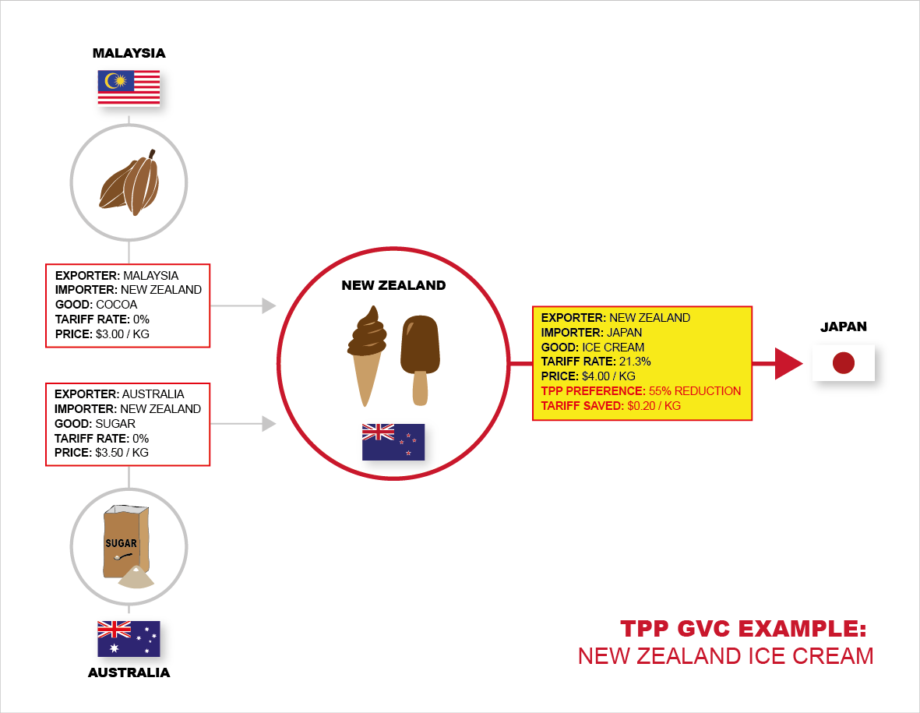

### Example 2: Increased exports of Australian manufactured products

The TPP will make it easier for businesses to source inputs from efficient producers in other TPP countries, manufacture a product in Australia, and then export the product under preferential tariffs to TPP countries. A mining technology business in Queensland, for example, that designs and produces drilling machinery could import vehicles from Japan and engines from the United States. The Australian business could then combine the imported inputs with parts supplied domestically to produce a drilling rig for export.

While Australia’s 5% tariffs on imported materials will have already been eliminated under existing FTAs, the TPP will allow the Australian business to use the imported inputs and treat them as if they were made locally in claiming TPP preferential treatment when exporting drilling equipment to a TPP country.

The ability to gain preferential TPP treatment in this way significantly improves the competitiveness of the Australian business when exporting mining equipment overseas. For example, for drilling equipment sold for $150,000, the elimination of a 15% tariff faced in Mexico or a 6% tariff faced in Chile saves the Australian company $22,500 and $9,000 respectively.

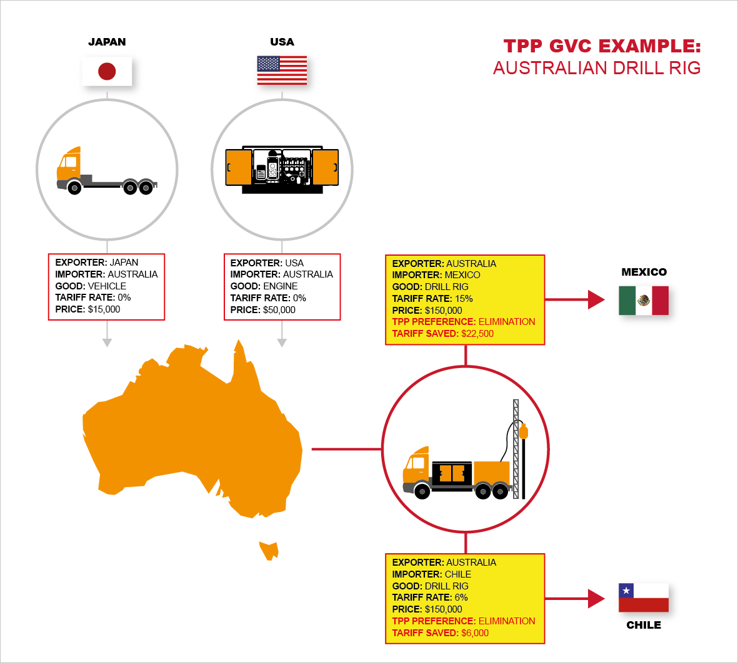

### Example 3: Increased benefits for consumers

The following example of a GVC for a lounge made and sold with inputs from TPP countries demonstrates the benefits of the TPP for Australian consumers.

In the absence of the TPP, a lounge could be made of: wood from Malaysia at a cost of $US75 and tariff of $US15; fabric from Singapore at a cost of $US50 and tariff of $US6; foam from Japan at a cost of $75 and tariff of $7.50; screws and bolts from Singapore at a cost of $US25 and tariff of $US1.25; and chemicals from the United States at a cost of $US25 and tariff of $US1.25. Once manufactured in Vietnam and exported to Australia the lounge would be subject to an additional tariff of $18.75. Under this scenario, the tariffs all add $51 to the cost of the lounge sold to the Australian consumer.

Under the TPP there would be no tariffs adding to the cost of the inputs or the final product, so the lounge would be $51 or 10 % cheaper at the point of sale for the Australian consumer.

|  |
| --- |
| Description: Description: C:\Users\mdean\AppData\Local\Microsoft\Windows\Temporary Internet Files\Content.Outlook\I1PMEJ7M\TPP-GVC-infographic-FINAL-01 (2).png |