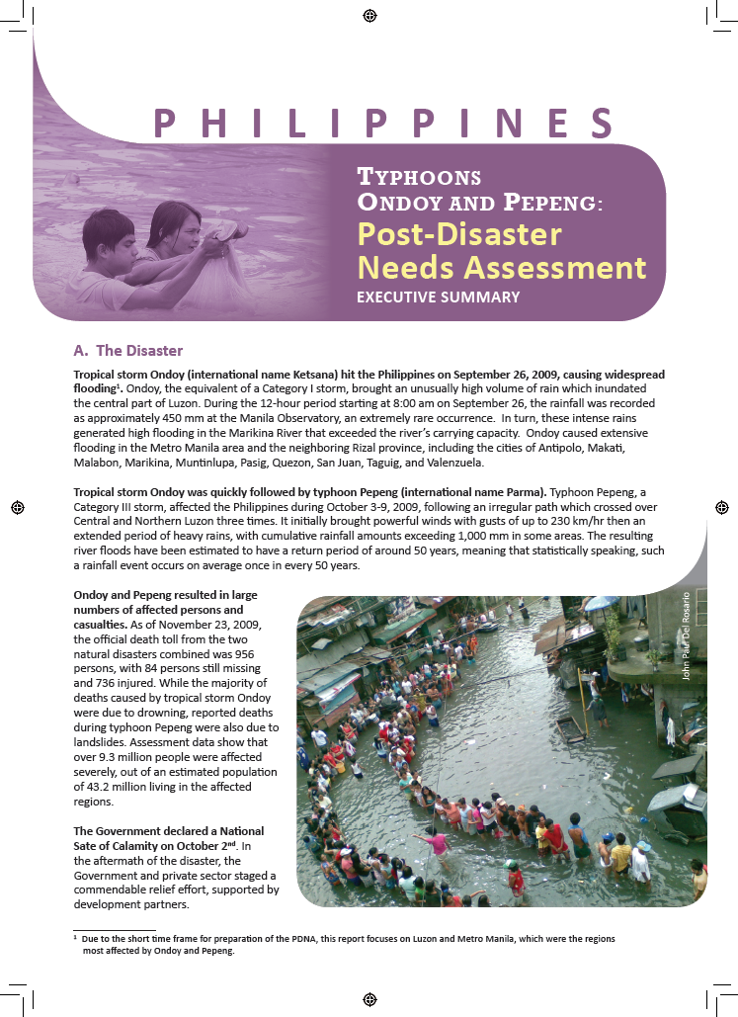
ANNEX 1

SUMMARY OF THE POST-DISASTER NEEDS ASSESSMENT

