Australia-Indonesia BRIDGE Project 2008—2011
Leongatha Primary School, Victoria and SDN Pondok Labu (2010) incorporate Skype sessions to support student language learning and development of intercultural understanding. ‘Skype enables the children to have authentic, real-time, face-to-face conversation. We try to speak Indonesian at our end and they speak English,’ says Irene Beasley.
A number of face-to-face visits have occurred to Leongatha and Jakarta since this BRIDGE partnership was established in 2010. Leongatha PS has committed to funding visits for seven teachers from their partner school to visit Australia over a three-year period. This provides ongoing support and demonstrates a strong commitment to their participation in BRIDGE and an acknowledgement of the project’s outcomes to the school and broader community.
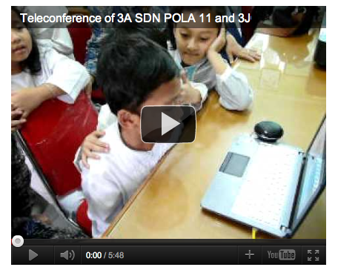

Beverage Primary School, Victoria (2011) selected grade six students to be BRIDGE Ambassadors. Through leadership roles BRIDGE Ambassadors facilitate group discussions with students in the early and middle years on issues such as intercultural and interfaith engagement. Video clips have been created featuring Ambassadors discussing the BRIDGE partnership, and why intercultural understanding is important, plus facilitating discussion with students from grades three and four.

Marlborough Primary School, Victoria and MIN Cempaka Putih (2011) have incorporated a range of learning and teaching activities to engage students with learning about Indonesia and contemporary Islam across learning areas.
Students have participated in synchronous and asynchronous learning such as Skype sessions and wiki activities, which have provided the opportunity for students to engage across cultures. Students have also exchanged letters and e-cards. Students and the school community at Marlborough were engaged in learning about Islam in Indonesia during the program and have continued to explore through related activities such as sending Ramadan cards. As a result of participation in the program Marlborough Primary has connected with the Indonesian Consulate in Melbourne and were invited to celebrate Independence Day with the Consulate.
Partnership teachers maintain regular communication through Facebook. Marlborough PS teachers and the Principal will be participating in a study program and school visit in January 2012 to further build the partnership and plan for ongoing curriculum exchange.
Marlborough PS is also part of the Leading 21st Century Schools Program.

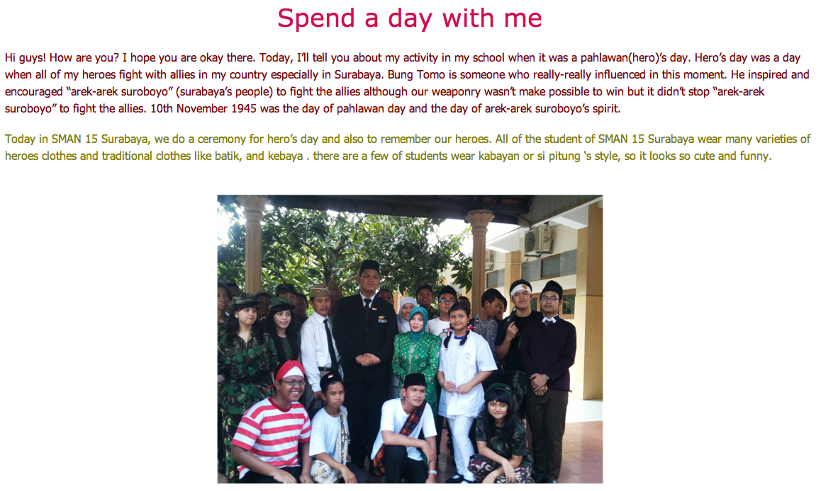
Kormilda College, Northern Territory (2010) hosted a visit from their Indonesian partner school SMAN 15 Surabaya (25 students and 3 teachers) in late October 2011 as part of the BRIDGE Project.
During their stay, the SMAN 15 Surabaya students were billeted with Kormilda College families, and attended classes each day with the host students. The visit has furthered the College’s engagement with their partner school both professionally and personally.
Kormilda College students involved in the visit had an exceptional opportunity to increase their knowledge and understanding of Indonesia, strengthen Indonesian language skills, and develop friendships with the Indonesian students.
Likewise the Indonesian students embraced Australian culture and seized every opportunity to improve their English language skills, as well as make new friends.
The partnership wiki has been used for students to engage in a range of collaborative learning tasks since their partnership commenced in 2010.

Scotts Head Public School, New South Wales (2010) became one of only four schools in their state to be funded to deliver a bilingual curriculum program. The principal has noted that she believed the school’s involvement in BRIDGE was a significant factor in their success.

Since 2010 the school has been teaching Indonesian to junior and middle primary students. The role of the bilingual program is to increase the number of students who will become fluent in Asian languages. Scotts Head Public School joined the BRIDGE Project to develop close ties with an Indonesian sister school to enable our students to gain a deep understanding of Indonesian culture and language.
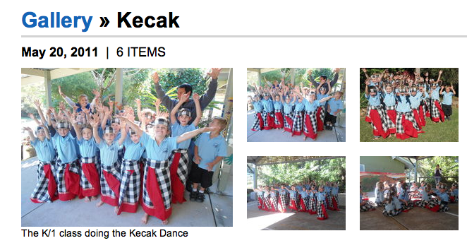

Mullumbimby High School, New South Wales and SMAN 5 Mataram, Lombok (2010) facilitated a Skype session involving the Australian Ambassador to Indonesia. The purpose was to prepare the five students and one teacher from Indonesia to visit their BRIDGE partner school. The discussion feature of the partnership wiki has been used to facilitate student communication. Teachers from both schools indicated that participation in BRIDGE has led to improved Indonesian language enrolment at Mullumbimby HS and excellent final English exam results among the Mataram students, with one student receiving a scholarship to study in the United States. Plans are underway for a second visit from SMAN 5 Mataram to Mullumbimby HS in early 2012.

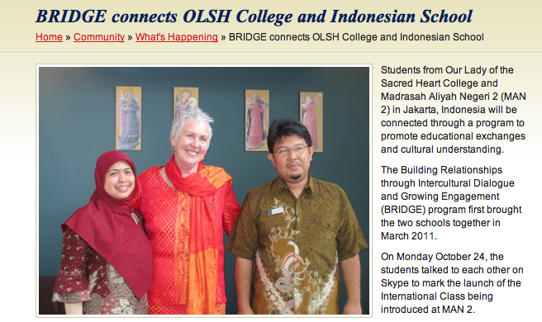
Our Lady of the Sacred Heart College Adelaide and Madrasah Aliyah Negeri 2 (MAN 2) (2011) are collaborating to connect students through video conference technology. The Indonesian partner school has recently established an International Class whereby students will have the opportunity to join the Australian class to learn English, Mathematics and Science. As part of the BRIDGE program, two teachers from MAN 2 spent two weeks at the Australian school in March 2011. After their visit the schools established a sister school agreement and the relationship has since flourished.

Victor Harbor High School, South Australia (2009) has participated in a number of reciprocal exchanges with their partner school SMA Katolik Kesuma Mataram, Lombok. Visits have included teachers from Victor Harbor and teachers and groups of students from Lombok visiting their partner school and staying with host families. Victor Harbor HS has strongly supported the exchanges and has committed to receiving biennial visits by Indonesian students.
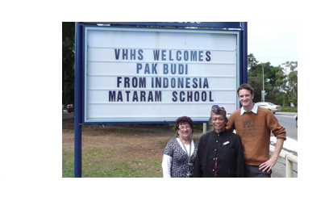
The schools’ partnership has strengthened the teaching of Indonesian at Victor Harbor and students collaborate with their Indonesian peers in a creative media class producing work utilising digital media, which is showcased on the partnership wiki.
The development of the relationship between the schools, teachers and students has had broad-reaching effects throughout the two communities and in their classrooms.

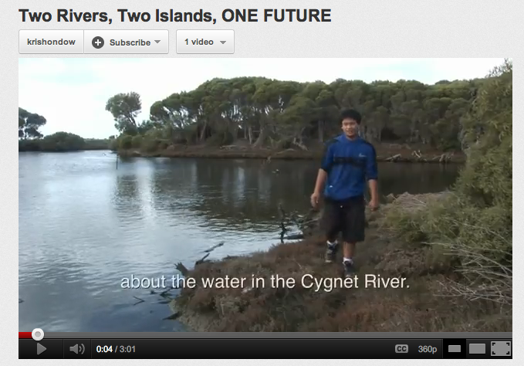
Kangaroo Island Community Education Kangaroo Island, South Australia and SMA Negeri Sumatera Selatan (2010) collaborated on a curriculum unit titled Working to Save Our River. This provided the opportunity for students to explore issues relating to the Musi River (Indonesia) and the Cygnet River (Australia). The end product of this unit was a movie on environmental issues. The movie Two Rivers, To Islands, One Future was produced bilingually: in English and Indonesian. Wikispace and Moodle have been used as the online platforms for digital content and student collaboration.

Tranby College, Western Australia and SMAN 5 Surabaya (2009) have established strong curriculum connections and student engagement to support language learning and intercultural understanding as part of their BRIDGE partnership.
Since 2010, 60 Indonesian students and seven teachers from SMAN 5 have visited Tranby, living with host families and participating in school experiences paving the way for the exchange of cultural experiences, the strengthening of language skills and the establishment of friendships that have been sustained through Facebook and Skype.
Over 2010 and 2011, 29 students and six teachers from Tranby have participated in two reciprocal visits to SMAN 5 Surabaya and participated in a range of school and cultural activities.
Following participation in a school visit to Indonesia, three students decided to return to their partner school after the completion of year 12 to volunteer to teach English. These students stayed from one to six months and not only strengthened their own Indonesian skills but supported students in Surabaya with their English language.
Significant benefits continue to include communication between students, collaborative learning projects, cultural and language exchange and the development of intercultural understanding.
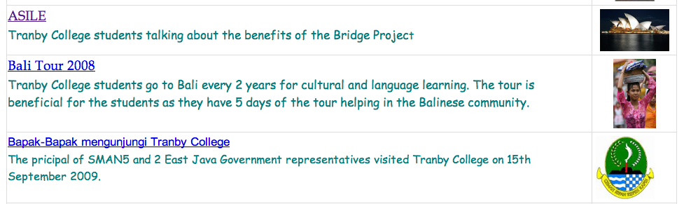

Luther College, Victoria and SMP Negeri 9 Palembang (2011) partner teachers are in contact through email, Skype and Facebook. A range of collaborative activities have been developed that engage Australian and Indonesian students across many learning areas including art, religion, language (English and Indonesian), biology, environment, geography and history. At the VCE level students exchange ideas about religious experiences, beliefs and identity. Plans are under way for a visit to their Indonesian partner school. An extensive array of materials and planning are housed on their wiki.

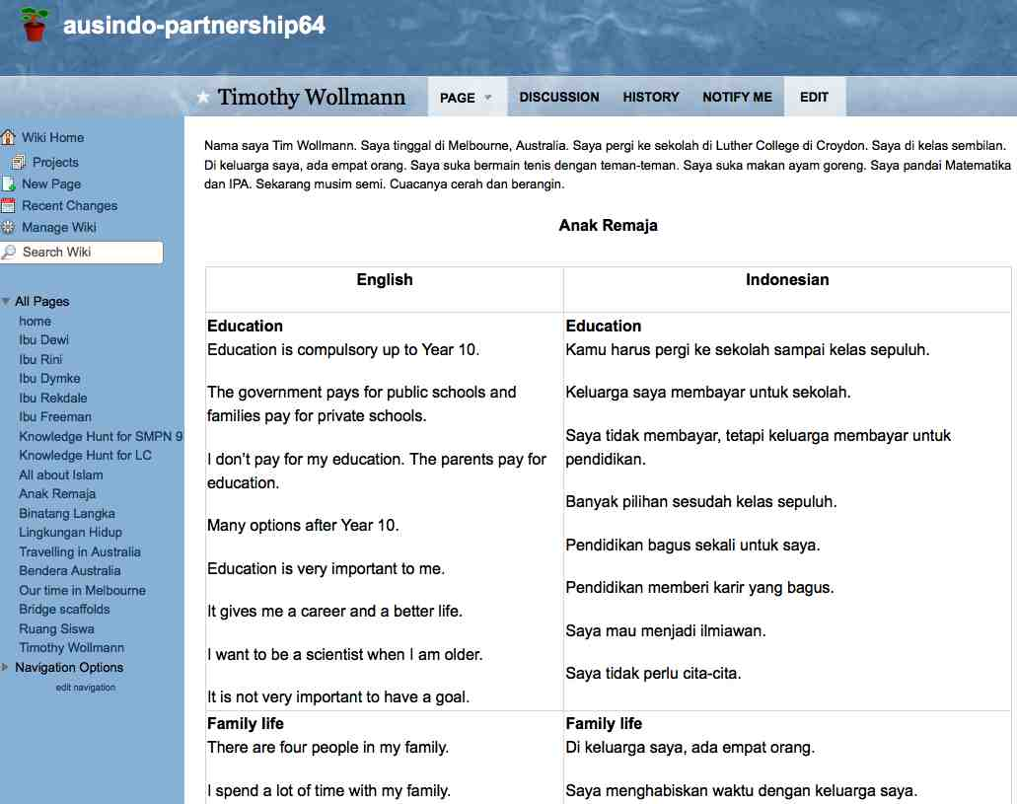

“We’ve moved from being an isolated school to being part of the wider global community and that’s really important in the 21st century”.
Irene Beasley, Leongatha PS.

