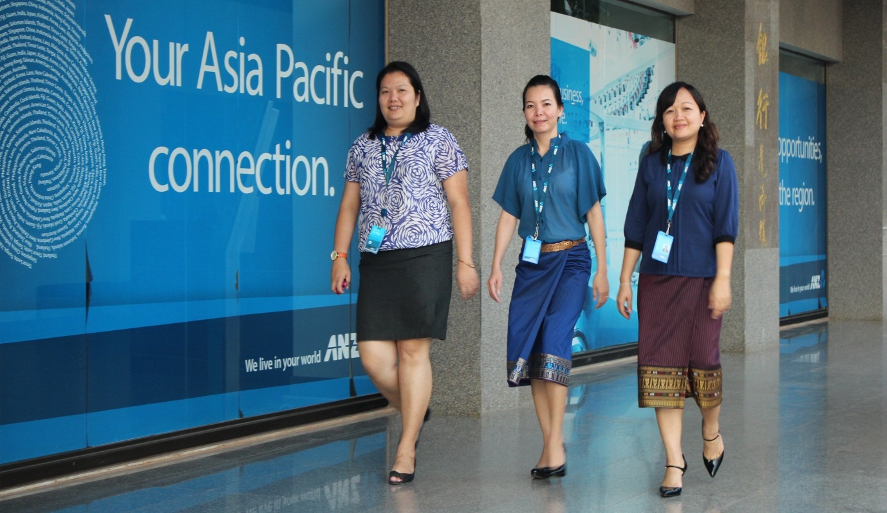Building Women’s Leadership: the Contribution of Australia Awards Scholarships

Office of Development Effectiveness

December 2015

# Foreword

Australian scholarships have been a major element of Australia’s aid program for over 50 years. The international development landscape, aid priorities and the practice of diplomacy have changed considerably over this time, and in recent times. This evaluation is timely given these changes, a more focused aid budget in which supporting women’s leadership is prioritised and the recent integration of development assistance into the Department of Foreign Affairs and Trade.

This evaluation has confirmed that scholarships can indeed be an effective tool for promoting women’s leadership. However, the full potential of scholarships has yet to be realised. The evaluation has identified a number of actions to ensure that gender issues are more effectively addressed in the scholarship program. The recommendation that women’s leadership should be an explicit goal of scholarships is both sensible and necessary. The recommendation that in each country at least half of scholarships should be awarded to women is also highly relevant. This requirement should be applied consistently as there will inevitably be arguments mounted to justify the status quo.

It is also clear that there has to be a much more disciplined, systematic approach to analysis of the impact of scholarships on individuals and their country more broadly. The information collected needs to be directly related to the stated goal of scholarships to build influential leaders. Moreover, this needs to be long term as what is important is how the returnees do over a full career. Women’s leadership outcomes may be more impressive in the longer term but only good data can support or reject this assumption.



Jim Adams   
Chair, Independent Evaluation Committee

**Front cover:** Australia Awards Scholarship alumnae who are on the executive committee of ANZ Vientiane. From left to right: Mukdalay Xayarath, Head of Human Resources, Souphachanh Khansyla, Head of International Banking and Somvone Siaphay, Head of Compliance.   
Photo: Anne Lockley

**Office of Development Effectiveness**

The Office of Development Effectiveness (ODE) is an independent branch within the Australian Government Department of Foreign Affairs and Trade (DFAT). ODE monitors the Australian aid program’s performance, evaluates its impact, and contributes to international evidence and debate about aid and development effectiveness. ODE’s work is overseen by the Independent Evaluation Committee (IEC), an advisory body that provides independent expert advice on ODE’s evaluation strategy, work plan, analysis and reports.

[www.ode.dfat.gov.au](http://www.ode.dfat.gov.au)

# Acknowledgements

This evaluation was managed by the Office of Development Effectiveness (ODE) at the Australian Government Department of Foreign Affairs and Trade (DFAT).

The evaluation was undertaken by Anne Lockley (team leader, gender and evaluation specialist), Dr Ritesh Shah (education and evaluation specialist) and Dr Karen Ovington (ODE). The consolidation of tracer study data was done by Stacey Tennant. Anne, Ritesh and Stacey were contracted through Kurrajong Hill, with Fiona Kotvojs having contractual oversight and providing quality control.

Robert Brink, Director of the Evaluation Section of ODE, and Dereck Rooken-Smith, head of ODE, provided input and advice. DFAT’s Independent Evaluation Committee was responsible for ensuring independence, rigour and a quality process.

The evaluation team and ODE would like to thank the alumni and DFAT staff at posts in Apia, Jakarta and Vientiane for their collaboration and cooperation throughout the evaluation process. The evaluation team is very appreciative of the extensive assistance and insights provided by staff of Australia Awards in Laos and Australia Awards in Indonesia. DFAT staff previously and currently working in the Scholarships and Alumni Branch in Canberra supplied documentation and data as well as valuable inputs.

Contents

Foreword ii

Acknowledgements iii

Contents iv

Executive summary 1

Management response 6

1 Women’s leadership: a development priority 9

1.1 Why prioritise building women’s leadership? 9

1.2 Using scholarships to build leadership 9

1.3 Australia Awards and leadership 10

2 An overview of this evaluation 11

2.1 Focus on long-term scholarships 11

2.2 Evaluation purpose and questions 11

2.3 Methodology 11

2.4 Terminology 12

3 Scholarships build careers and leaders 13

3.1 A step up on the career ladder 13

3.2 Developing a leader identity 18

3.3 Developing a vision for change 22

3.4 Men supporting women’s leadership 23

4 Barriers to women’s leadership 25

4.1 Sociocultural factors 26

4.2 Workplace structures and practices 27

4.3 Professional relationships and networks 29

5 Improving women’s leadership outcomes from scholarships 30

5.1 Selecting scholars 30

5.2 Allocating scholarships to targeted categories 32

5.3 Institutional targeting and increasing the visibility of women 34

5.4 Innovative partnerships 36

5.5 Strategic use of different types of Australia Awards 37

5.6 Supplementary leadership training 40

5.7 Workplace reintegration planning 42

5.8 Alumni associations 42

5.9 Assessing and learning from experience 45

5.10 Making women’s leadership an explicit aim 46

Appendix A Scholarship Courses 48

Appendix B Types of Australia Awards 49

Appendix C Detailed methodology 50

Appendix D Global tracer study data 56

Appendix E Country scholarship allocations 61

Abbreviations 64

References 65

© Commonwealth of Australia 2015 **ISBN** 978-0-9944202-1-3

Published by the Department of Foreign Affairs and Trade, Canberra, 2015.

**Disclaimer:** The views contained in this report do not necessarily represent those of the Australian Government.

With the exception of the Commonwealth Coat of Arms and where otherwise noted all material presented in this document is provided under a Creative Commons Attribution 3.0 Australia (<http://creativecommons.org/licenses/by/3.0/au/>) licence. The details of the relevant licence conditions are available on the Creative Commons website (accessible using the links provided) as is the full legal code for the CC BY 3.0 AU licence (<http://creativecommons.org/licenses/by/3.0/au/legalcode>). The document must be attributed as Office of Development Effectiveness (2015). *Building Women’s Leadership: the Contribution of Australia Awards Scholarships*, ODE, Australian Government Department of Foreign Affairs and Trade, Canberra.

# 

# Executive summary

Gender equality and empowerment of women and girls is one of the six investment areas outlined in Australia’s development policy, with women’s leadership identified as an area for *‘strong investment’*.[1] Since the 1950s, Australia has provided scholarships for women and men from developing countries to undertake overseas tertiary study to *‘develop leadership potential’.* While supporting Australia’s economic diplomacy objectives,scholarships are also expected to enable recipients to *‘make a significant contribution to their home countries as leaders in their field’* and build an *‘engaged and influential global network of leaders, advocates and change-makers’*.[2] As such, scholarships provide a key mechanism for achieving the Australian aid program’s gender objectives.

Overview of the evaluation

The purpose of this evaluation is to assess the contribution of Australia Awards Scholarships to women’s leadership, and identify how this contribution could be increased. The definition of women’s leadership used in the evaluation is *a process of women mobilising people and resources in pursuit of shared and negotiated goals within government, private sector and civil society*.

The evaluation addressed four key questions:

1. Do scholarships increase women’s professional advancement and leadership?
2. How do scholarships impact on women’s professional advancement and leadership?
3. What barriers are there to women achieving leadership?
4. How could scholarships better contribute to women’s leadership?

Methodology

The evaluation used qualitative and quantitative techniques, and evidence from the various sources was mapped against the key evaluation questions. Data collection processes included (1) review of relevant literature and Australia Awards documentation; (2) three in-country field studies (Indonesia, Lao People’s Democratic Republic [PDR], Samoa); (3) telephone interviews with returned scholars and representatives of Australia Awards in Africa; (4) formal and informal consultations with individuals involved in the design, delivery or evaluation of Australia Awards; and (5) compilation and analysis of data form the most recent tracer study[3] for each country.

Scholarships build careers and leaders

Australia Awards Scholarships contribute strongly to women’s professional advancement. Women felt that the prestige and recognised value of overseas tertiary qualifications, combined in many cases with proficiency in English, gave them an advantage over other job applicants, or helped them skip rungs on the professional ladder. Further, analysis of the consolidated tracer study data found that a large proportion of alumnae[4] report positive professional outcomes, including high rates of employment, promotion and increased responsibility. Women working in the private sector or civil society were more likely to report professional advancement than women working in the public sector.

The scholarship experience of living in Australia for an extended period of time (one year or more) was frequently cited as catalysing development of personal skills and attributes—such as confidence, self-belief and open-mindedness—that are critical aspects of a leader identity. The experience of studying overseas is particularly transformational for early-career women, or women from countries or provincial settings where women are under-represented in leadership, have very limited opportunities for tertiary education, and experience restrictive social and cultural norms.

For women and men who have lived their whole lives in resource-poor settings, studying in a developed country provides an opportunity to see how systems can work. Many alumnae noted that leaders need to have a vision of a better society, and living overseas helped them develop their vision. Alumnae also reported having learnt to work in more effective ways. This includes using research and evidence as a basis for decision-making. Many alumnae felt the scholarship experience made them more of an equal with decision-makers and empowered them as leaders. Notably, there were also some examples of changed self-reported attitudes and observed behaviours among male alumni around women’s leadership and workplace roles.

The evaluation found that alumnae are exercising leadership in many ways, in different settings and at various levels. Scholarships assist women to become leaders who supervise and mentor others. More than half of alumnae reported that they are supervising more staff which they considered was largely due to their scholarship. During field studies many alumnae reported being leaders by mentoring and coaching others. Analysis of tracer study data found that about half of alumnae are sharing the skills gained in Australia. Alumnae working in civil society were the most likely to transfer skills to others.

Barriers to women’s leadership

The proportions of women who reported positive outcomes for a range of indicators of professional advancement and leadership were consistently slightly lower than those for men. The barriers to leadership identified by alumnae were similar to those faced by women in other settings, including in developed countries. These barriers can be loosely grouped into sociocultural factors, including family responsibilities; workplace structures and practices; and professional relationships and networks.

Strengthening women’s leadership outcomes

Selecting scholars

Concerted, well considered efforts have been made to increase the number of women receiving scholarships. Women received more than half of the total number of scholarships awarded in 2013–14. However, in some countries with large annual allocations, women received less than half of the scholarships awarded. The proportion of scholarships awarded to women was as low as 30 per cent in a number of countries. This evaluation contends that in all countries where there are 10 or more scholarships allocated annually, at least half should be allocated to women. To do otherwise may entrench gender inequality making it more difficult for women to become leaders.

As scholarships are large investments in individuals, selecting the ‘best’ individuals is critical. Women’s leadership outcomes could be improved by refining selection processes to facilitate selection of women most likely to be influential leaders in their countries. Leadership potential is already a selection criterion but it needs to be given more weight. Leadership exhibited to date should be a heavily weighted selection criterion.

**Recommendation 1** DFAT posts should be required to revise selection criteria and processes for Australia Awards Scholarships to improve women’s leadership outcomes.

› In all countries where there are 10 or more scholarships awarded annually, at least 50 per cent should be awarded to women. If it is not possible to identify sufficient suitable women to meet this requirement, the number of men awarded scholarships should be reduced until a gender balance is achieved.

› Selection criteria should be revised to enable women most likely to be influential leaders to be selected.

Allocating scholarships to targeted categories

Scholarships are often targeted to certain categories to help support development priorities. In some countries, targeting results in high allocations to the public sector, while most women applying for scholarships come from other sectors. This evaluation has found that the categories targeted are often those in which it is harder for women to become leaders.

The proportion of awards that are not targeted should be increased by decreasing awards allocated to the public sector. This is likely to help ensure that the ‘best’ women, working in areas where they can become influential leaders or catalyse developmental change, can secure awards. Additionally, it may be beneficial to create a category specifically focused on women’s leadership, to improve accessibility of scholarships for women (and men) in progressive civil society, the private sector, the media, academia and gender equality-focused organisations.

**Recommendation 2** DFAT posts should be required to revise targeting strategies to improve women’s leadership outcomes.

› At least half of scholarships should be open to all candidates.

› Consideration should be given to allocating a small proportion of scholarships to a women’s leadership category.

Institutional targeting

In some counties, scholarships are targeted to particular institutions or skill areas with the intention of developing a critical mass of awardees sufficient to create an environment open to change. However, institutional targeting on its own was found to be insufficient to build a supportive environment for women’s leadership. When management is unsupportive of women, opportunities for women are limited regardless of the number of alumni. Workplaces and organisations should only be prioritised if they have management with a proven record of supporting women. If management is not supportive of women, the priority status of those organisations should be cancelled.

Innovative partnerships

The context in which Australia provides scholarships has changed considerably since scholarships were first offered. Some partner countries have increased economic prosperity and developed their tertiary education sectors. Many more scholarships provided by a broad range of organisations are now available. In a less expansive aid budget, less funding may be available for scholarships. Australia Awards need to adapt to these changes. Innovative modes of scholarship delivery are needed to maximise the number of scholarships for women without increasing overall expenditure. Options for partnering with other organisations to provide scholarships for more women to study in Australia should be explored.

Strategic use of different types of awards

In some countries there has been a gradual shift in Australia Awards investments from scholarships to short-term training (short course awards and fellowships). While this transition may be appropriate in some partner countries given the changes outlined above, it appears to be detrimental to women’s leadership. If funding is used for short courses, less will be available for scholarships. Furthermore, most short courses have not been designed or delivered with a gender equality objective and most of the participants have been men.

Different award types need to be used more strategically to build women’s leadership and strengthen outcomes from scholarships. For example, short course awards could be used to build coalitions of female and male leaders across and between government agencies, civil society and the private sector. Short courses could also be used strategically to support and engage alumnae, particularly those in senior leadership roles, at critical junctures in their careers. During the evaluation, several alumnae suggested that distance learning or split-site awards could increase accessibility of awards, particularly for women at middle or senior career levels.

It is important to note that the different types of awards are not proposed as a substitute for a focus on scholarships. There is evidence that scholarships build women’s leadership, but comparable evidence is not available for other forms of awards. Different types of awards are an option for some locations, for some women, and in the context of budgetary constraints.

**Recommendation 3** DFAT should use different types of Australia Awards in addition to scholarships to build women’s leadership.

› All types of awards should be held to the same gender equality targets as scholarships and the performance framework for the Australian aid program.

Leadership development post award

There was broad support among alumnae interviewed for post-scholarship leadership development for women in their home environment. A number of alumnae in Samoa who participated in leadership development activities implemented through other programs spoke very highly of the skills and networks gained through these activities.

Within Australia Awards there has been some innovation in post-award leadership training. The recently launched Mongolia initiative is promising, as it aims to address country-specific barriers to women’s leadership, works with both women and men, and is relatively inexpensive. Post-scholarship leadership courses delivered in country for both women and men as part of alumni engagement could be a cost-effective way to strengthen women’s leadership outcomes from scholarships.

**Recommendation 4** DFAT should explore options for post-scholarship leadership development for women, and to build male supporters of, and advocates for, women leaders.

Workplace reintegration planning

In many countries, some alumni—particularly those in the public sector—have formal workplace reintegration plans developed in consultation with their employers. Alumnae felt the plans were not very useful because employers did not engage with them, many different changes made them irrelevant, and promotion opportunities did not typically stem from formal processes and measures. Such findings suggest investing time and resources into developing and monitoring reintegration plans in the current form is not an effective way to build women’s leadership.

Alumni associations

Australia Awards alumni associations have been established in many countries to maintain engagement with scholars. Most alumni associations have not been used effectively to support women’s leadership. Rates of participation in alumni events have been low, especially for women. Alumnae felt that events were primarily social, usually too large for effective networking and not relevant to their own professional interests. As women are often time-poor, the general sentiment expressed was that engagement in alumni associations as they are at present was not worthwhile.

The evaluation also identified that some alumni associations have not been adequately resourced and lacked a clear purpose. Alumni have been expected to maintain databases with little support and often without a financial contribution from the program. Such an expectation is unrealistic and possibly also inappropriate if the association is seen as having diplomatic functions.

Nevertheless, many alumnae interviewed felt that alumni associations could effectively support women’s leadership. Alumnae suggested that sectoral, technical or leadership workshops would be useful alumni activities that would help them advance in their careers. Many alumnae expressed a desire to ‘give back’ and thought re-entry workshops could be used to establish mentoring relationships. Re-entry workshops involving alumnae already in leadership positions could be a valuable opportunity to discuss how alumnae might try to overcome the barriers they are likely to face.

The recently established Africa Women in Leadership Network provides a good model of how alumni associations can be used to support women’s leadership. The online platform component of the network appears to be a cost-effective way to support alumnae as they move into leadership positions. The usefulness of establishing similar women’s leadership networks in the Pacific and other priority regions or countries with large scholarship allocations should be explored.

Assessing and learning from experience

Existing tracer studies provide useful information about alumni and development impacts, but are not as useful as they could be for assessing leadership outcomes. Standardised tracer studies need to be designed to provide data about leadership and used at regular intervals to provide longitudinal quantitative data to assess leadership outcomes for both men and women.

Devolved management and implementation of scholarships has provided the flexibility to respond to country contexts, but it has also meant that lessons learned are not adequately shared.

**Recommendation 5** The DFAT Scholarships and Alumni Branch should revise existing monitoring and evaluation to include a specific focus on leadership outcomes, and establish processes to share knowledge between country posts.

Improving women’s leadership should be an explicit aim of scholarships

Australia Awards Scholarships make a clear contribution to women’s professional advancement and leadership. Scholarships are particularly transformative for women from less economically advanced countries where there is high gender inequality and limited opportunities for tertiary study. In such contexts, Australia Awards investments should strongly focus on scholarships in preference to other types of awards and supplementary activities. For scholarships, and Australia Awards as a whole, a more explicit focus on women’s leadership would yield better results.

**Recommendation 6** DFAT should continue to invest in scholarships and make building women’s leadership an explicit goal of scholarships.

It is important to note that providing Australia Awards Scholarships is one strategy for building women’s leadership. While certainly this evaluation recommends greater, more specific and structured attention to promoting women’s leadership through Australia Awards, it must be considered as one modality that complements other, potentially more effective, tools that directly focus beyond the individual, to address supporting or constraining structural conditions.

# Management response

The Department of Foreign Affairs and Trade (DFAT) welcomes the Office of Development Effectiveness evaluation “Building Women’s Leadership: the contribution of Australia Awards Scholarships.

DFAT notes the evaluation’s conclusion that Australia Awards Scholarships contribute strongly to women’s professional development and leadership. We note the Australia Awards has historically performed strongly on gender parity - from 2012 to 2014, 54% (or 4,113 people) of our awardees were women and 46% (or 3,454 people) were men.

The evaluation is a timely contribution to consideration of future directions for the Australia Awards program and will directly inform DFAT’s development of a new Australia Awards Global Strategy. The Australia Awards program has not previously been underpinned by a whole-of-program strategy or performance framework. Through this new strategy, DFAT will commit to a target of at least equal numbers of Awards for women as men at the global level. Country and regional programs will be supported to implement appropriate strategies to achieve gender equity.

In addition, the new strategy, informed by ODE’s evaluation and recommendations will take steps to further strengthen the contribution of the Australia Awards to women’s leadership.

In future, DFAT will require Australia Awards investments to have an explicit objective of empowering women and will address gender issues by broadening the targeting of sectors from which candidates are drawn; prioritising awards for gender equality and women’s empowerment; continuing work with alumni and their employers on building the capacity and contribution of women and to provide further opportunities for women through fellowship and short course programs to enhance their professional and leadership capabilities.

Importantly, the evaluation of the Australia Awards program as a modality must be seen within the context of (and as one element of) country program strategies and the strategic investments made in priority areas for the country or region including gender. As noted in the evaluation, many country programs are already ensuring that Australia Awards investments promote women’s leadership, and DFAT intends to learn from and build on these efforts. As such, DFAT will report on the overall performance of Australia Awards through the Aid Program Performance Report. This report will also be supplemented by a comprehensive Global Tracer Study Facility designed to evaluate the long term impacts of the Australia Awards Program. Through these performance reporting arrangements, the contribution of Australia Awards to women’s empowerment and leadership will be reviewed on an annual basis.

Management responses to recommendations

|  |  |  |
| --- | --- | --- |
| Recommendation 1 DFAT posts should be required to revise selection criteria and processes for Australia Awards Scholarships to improve women’s leadership outcomes.  1(a) In all countries where there are 10 or more scholarships awarded annually, at least 50 per cent should be awarded to women. If it is not possible to identify sufficient suitable women to meet this requirement, the number of men awarded scholarships should be reduced until a gender balance is achieved.  1(b) Selection criteria should be revised to enable women most likely to be influential leaders to be selected. | Agree in part | 1(a) The new Australia Awards Global Strategy, to be approved later in 2015, will commit to a target, rather than a quota, of at least 50 per cent of Australia Award scholarships across all country cohorts, and at a global level.  In many country cohorts, women already comprise at least 50 per cent of awardees, and DFAT recognises this can assist in redressing historic imbalances. There are some countries where women remain poorly represented, and in those cases, DFAT will undertake a range of measures to increase gender equity, including trialling the introduction of quotas of at least 50 per cent of scholarships awarded to women. This will be supported by a monitoring and evaluation strategy that is focused on academic outcomes.  1(b) Australia Awards promotion and selection processes are designed to attract and select candidates, including women that are best placed succeed in their studies and contribute as leaders to development in their countries.  DFAT will trial strategies to counter unconscious bias in selection processes and remove from selection criteria extraneous considerations (such as requirements for particular experience that women may be less likely to have). |
| Recommendation 2 DFAT posts should be required to revise targeting strategies to improve women’s leadership outcomes.  2(a) At least half of scholarships should be open to all candidates.  2(b) Consideration should be given to allocating a small proportion of scholarships to a women’s leadership category. | Agree in part | 2(a) Agree in part. The new global strategy will propose that Australia Awards eligibility be further broadened to private and community sector applications as well as government with a view to increasing the proportion of applications from qualified women.  2(b) Agree. The new global strategy will propose that all Australia Award investments are required to provide awards for study and training that specifically target gender equality and women’s empowerment issues. |

|  |  |  |
| --- | --- | --- |
| Recommendation 3 DFAT should use different types of Australia Awards in addition to scholarships to build women’s leadership.  All types of awards should be held to the same gender equality targets as scholarships and the performance framework for the Australian aid program. | Agree | All Australia Awards modalities are currently subject to the same gender equality targets as long-term scholarships, however as noted in the evaluation opportunities exist to broaden the scope of these modalities to be more flexible and responsive to gender equality and women’s empowerment issues. |
| Recommendation 4 DFAT should explore options for post-scholarship leadership development for women, and to build male supporters of, and advocates for, women leaders. | Agree | Through Fellowships, short courses and the new Australian Global Alumni Strategy, DFAT provides options for post-award leadership development for women and opportunities to build male supporters and advocates for women leaders. |
| Recommendation 5 The DFAT Scholarships and Alumni Branch should revise existing monitoring and evaluation to include a specific focus on leadership outcomes, and establish processes to share knowledge between country posts. | Agree | The current evaluation framework will be revised to align with the new global strategy and with the new DFAT Gender Equality and Women’s Empowerment Strategy, which will make specific reference to gender equality and women’s empowerment as a priority for Australia Awards. The revisions will account for how information and knowledge will be shared across posts. |
| Recommendation 6 DFAT should continue to invest in scholarships and make building women’s leadership an explicit goal of scholarships. | Agree | DFAT recognises that Australia Awards, including scholarships, are a valued component of nearly all of Australia’s bilateral relationships. The new global strategy will propose all Australia Awards investments have an objective of empowering women and addressing gender issues. |

1 Women’s leadership: a development priority

## Why prioritise building women’s leadership?

Globally, women’s formal participation in leadership lags well behind that of men in political, economic and community spheres. Only 22 per cent of all national parliamentarians and 17 per cent of government ministers are women.[5] Only 18 per cent of more than 130,000 firms in 135 countries have a female top manager.[6] Comprehensive data are not available for the community sector.

There are three main arguments for increasing the number of women in leadership positions. These are based on **rights**—women have equal human rights to men and therefore should have equal opportunities in social, political and professional life; **effectiveness**—the issues facing today’s society are complex and require a diverse range of inputs for effective solutions; and **representation**—women are more likely to consider the broad range of needs and interests present in all societies.

From a rights perspective, women’s leadership and balancing the numbers of men and women in senior roles is an end in itself. The effectiveness argument has, in recent years, become the focus of increased debate. Many studies have found that having more women in leadership positions in the private sector can improve economic performance. Recent examples include research on startup ventures in the United States, discussion of women on corporate boards in the United Kingdom, and a study of Luxembourg banks. Consequently, the economy as a whole benefits when women are able to develop their full potential.

Greater participation by women in the workforce in general and as leaders can trigger a virtuous cycle. When women have higher earnings they typically allocate more money to the education of children, particularly of girls. Women in leadership positions influence the aspirations of subsequent generations. Increasing the number of women in senior or visible roles is, therefore, a viable longer-term strategy for exponential change.

A range of studies support the assertion that women leaders are more likely to represent and prioritise the needs of other women, children, families and marginalised groups. For example, a study in India found that women elected into village councils *‘added the gender-perspective to previously male-dominated norms and values in local governance’* and *‘used their representative authority to organise collective action, for example against corruptive practices, discrimination, and violence’*.[7]

## Using scholarships to build leadership

Scholarship schemes provide individuals from developing countries with educational opportunities they may not otherwise have access to. Higher education is seen to be a key component of development, as strengthening a nation’s human capital generates economic and social capital which drives growth and prosperity. Investments in higher education for key individuals help them build technical skills and expertise, which benefits society as a whole. It is expected that when individuals return home, they will become leaders who drive change and contribute to their country’s development.

## Australia Awards and leadership

Investment in scholarships has been, and continues to be, a significant component of Australia’s official development assistance (ODA). Since the Colombo Plan was launched in 1951, Australia has provided scholarships to enable citizens from developing countries to undertake long-term tertiary study at Australian educational institutions. More recently, Australia has also provided scholarships for people from Pacific countries to study at regional tertiary institutions. Most scholarships support study for Masters degrees by coursework, doctoral degrees and undergraduate degrees, but scholars undertake a broad range of courses (Appendix A).

A recent innovation has been provision of short-term professional development training through short courses and fellowships. ‘Australia Awards’ is the umbrella title currently used to cover the suite of short courses, fellowships and scholarships provided by the Department of Foreign Affairs and Trade (DFAT), Australian Centre for International Agricultural Research, and Department of Education.[8] Different types of Australia Awards are described in Appendix B. In 2013–14, $310 million or six per cent of Australia’s estimated $5,032 million ODA was allocated to Australia Awards.[9]

Australia Awards *‘support emerging leaders from developing countries to study in Australia or within their region, build people-to-people links and return home to contribute to economic and social development’.*[10] The awards are intended to *‘develop leadership potential’,* so that recipients *‘make a significant contribution to their home countries as leaders in their field’* and become part of an *‘engaged and influential global network of leaders, advocates and change-makers’*.[11]

The implementation of Australia Awards needs to align with the Australian Government’s priorities for the aid program. Gender equality and empowerment of women and girls is one of the six investment areas outlined in Australia’s development policy, with enhancing women’s voice in decision-making and women’s leadership identified as areas for strong investment. While in recent years approximately half of Australia Awards Scholarships have been awarded to women, attempts to improve the capacity of scholarships to build women’s leadership potential have been limited.

Australian ODA is currently in a period of change, with the contraction of levels of investment following a period in which investments were rapidly and considerably increased. Although Australia Awards represent a significant investment, they have not been subjected to the same level of scrutiny as many other types of investments. The Office of Development Effectiveness carried out this strategic evaluation to determine if Australia Awards could be used more effectively to build women’s leadership. The evaluation is based on an analysis of if, where and how Australia Awards have supported women’s leadership.

2 An overview of this evaluation

## Focus on long-term scholarships

This evaluation focuses on Australia Awards Scholarships, as they specifically *‘aim to develop capacity and leadership skills’*.[12] Leadership develops over many years. Since scholarships have been a component of Australia’s official development assistance for many years, it is possible to explore long-term leadership outcomes. Sufficient evaluative material was available for scholarships, but little was available for the other types of awards.

## Evaluation purpose and questions

The purpose of this evaluation is to identify how the design and implementation of Australia Awards Scholarships could be modified to improve women’s leadership outcomes. The definition of women’s leadership used in the evaluation is *‘A process of women mobilising people and resources in pursuit of shared and negotiated goals within government, private sector and civil society’.*

The evaluation addressed four key questions:

1. Do scholarships increase women’s professional advancement and leadership?
2. How do scholarships impact on women’s professional advancement and leadership?
3. What barriers are there to women achieving leadership?
4. How could scholarships better contribute to women’s leadership?

## Methodology

A detailed methodology is at Appendix C. This section summarises the main features.

Data collection included five main processes:

1. A document review, encompassing both general literature and documents specifically related to implementation of and outcomes from Australia Awards Scholarships.
2. Three in-country field studies (Indonesia, Lao People’s Democratic Republic [PDR], Samoa), which included interviews with male and female alumni, workplace colleagues and supervisors of alumnae, Department of Foreign Affairs (DFAT) staff and Australia Awards management personnel.
3. Telephone interviews with East Africa alumnae and Australia Awards management personnel.
4. Formal and informal consultations with individuals who have been involved in the design, delivery or evaluation of Australia Awards. This includes staff currently or previously in the DFAT Scholarships and Alumni Branch, other DFAT staff, and staff of managing contractors.
5. Compilation and analysis of most recent tracer study data from all countries. Tracer studies survey alumni to seek information about their experiences and outcomes after completion of their award. They have been undertaken inconsistently and have used a diverse range of methods. Recent efforts to develop a common tracer study method have sufficiently standardised questions so that data from different countries can be consolidated. The document review identified that limited and inconsistent analysis of tracer study data had been undertaken on the basis of gender or time since completion. Therefore, such disaggregation was the focus of this analysis.

Qualitative data was explored through content analysis, first according to the key evaluation questions, and then by sub-themes. Quantitative analysis of the tracer study data first produced disaggregated cross-tabulations, and then identified areas of statistically significant difference, particularly between male and female respondents. Different values are statistically different at a *p* value of 0.05 or less.

The evaluation also reviewed strategies implemented in conjunction with Australia Awards that could impact on outcomes from scholarships. These included reintegration planning, supporting alumni networks, targeting institutions to develop a critical mass of alumni and supplementary leadership training.

There are several limitations of this evaluation. Firstly, it explores leadership from the entry point of women who are Australia Awards Scholarship alumnae, rather than starting from observed leadership and working back to see if education or scholarships were a feature. Secondly, it largely focuses on self-reported changes and results. Thirdly, the selection of interviewees was limited to those who were able to be contacted either because they had registered their details with DFAT or had a public profile that facilitated their identification. The combination of these factors suggests a positive bias is possible. However, as the evaluation seeks to learn from positive examples, the implications of such a bias are considered to be minimal.

## Terminology

The following terms are used for recipients of Australia Awards Scholarships:

Alumnus Male singular—one male returned Australia Awardee

Alumni Group of male and female returned Australia Awardees (for a male-only group, ‘male alumni’ is used)

Alumna Female singular—one female returned Australia Awardee

Alumnae Female plural—a female-only group of returned Australia Awardees.

3 Scholarships build careers and leaders

I couldn’t have imagined how I would advance my career if it hadn’t been for the Australia Award.

High-profile alumna, public sector, Indonesia

## A step up on the career ladder

Australia Awards Scholarships make a clear contribution to women’s professional advancement.

Employment, promotion and remuneration

In developing countries, international qualifications—particularly those from Australia—are well regarded and bring prestige. Alumnae reported that this gave them an advantage over other job applicants, particularly in the earlier stages of their career, and also increased their likelihood of promotion.

The first [step] was actually receiving the Australian Scholarship because for many of us in the country without a western education, the starting point in your career would be considerably lower. So with the Australian education or qualification you already start at a level above the majority in the country … We acknowledge that the Australian education was really the foundation for our professional status at the moment. And many of us are now the Director General of different departments in the ministry, Department of Law, of economics, media trade, et cetera. And for me it is the same, the opportunity that I got from Australia gave me that starting point.

Australian Leadership Awards Scholarship (ALAS) alumna, private sector, Lao

**Finding employment.** Alumnae who did not return to a job succeeded in finding employment soon after return. Women and men reported similar timeframes for finding employment after completing their studies. Within three months, 61 per cent of female tracer study respondents had secured employment; within six months, 85 per cent had. For almost all countries these figures exceed national employment rates for both men and women.

**Promotion on return to a workplace**. Overall, about one-third of alumnae who returned to their previous employer reported returning to a higher position (Figure 1). Alumnae who returned to private sector or civil society positions were twice as likely to have been promoted as those in the public sector. Women were slightly but consistently less likely to be promoted than men in all workplaces.

**Exploiting new opportunities.** Alumnae who returned to a new workplace were more likely to move into a higher position than those who returned to their previous workplace.Within three years of return,58 per cent of alumnae were in a higher position than before their scholarship. The likelihood of professional advancement varied according to the type of employer, much as it did for alumnae returning to the same workplace. Alumnae employed in the private sector were more likely to report receiving a promotion or being in a higher position on return (77 per cent) than alumnae who found employment in the public sector (64 per cent). The percentages of women reporting advancement in global analysis of tracer study data were consistently around two per cent lower than those for men. Although these differences are small they are statistically significant.

Figure 1 Proportions of alumni who report being in a higher position after return from their scholarship to the same employer, by type of employer

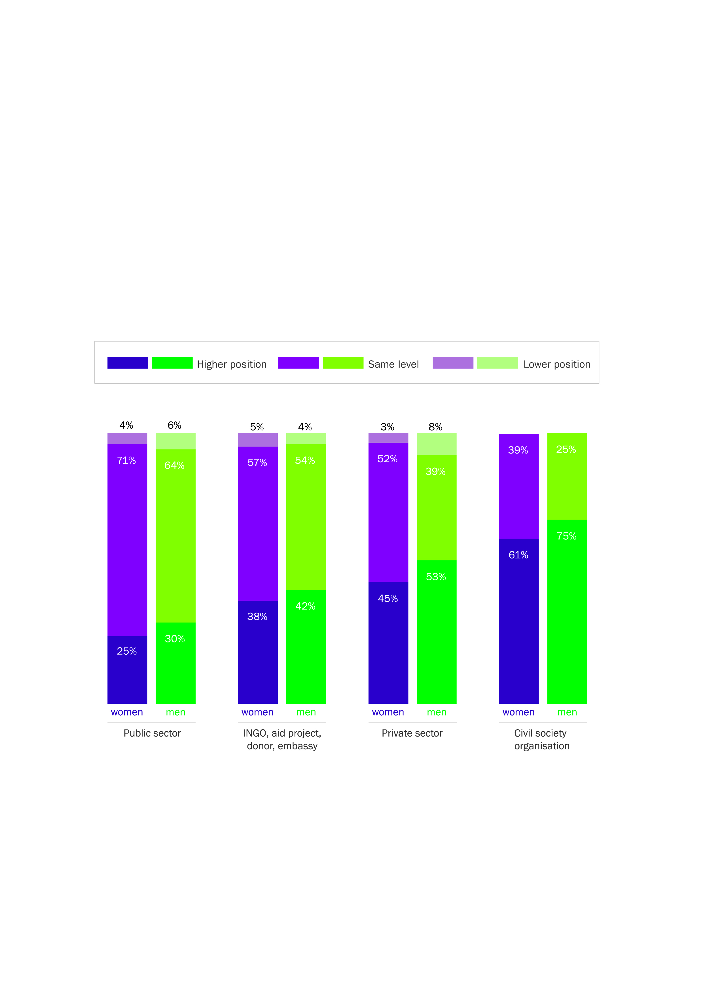

Source:Secondary analysis of consolidated tracer study data(female, n=855; male, n=752).

Figure 2 Proportions of alumni who are in a higher position on return from their scholarship, by region

In South Asia and Pacific countries other than those in Melanesia, a higher percentage of women than men report being in a higher position after return from their scholarship, with 82 per of women and 76 per cent of men in South Asia, and 78 per cent of women and 68 per cent of men in Pacific countries other than those in Melanesia. 
In Melanesia, 79 per cent of women and 86 per cent of men report being in a higher position; in the Mekong, it’s 64 per cent of women and 71 per cent of men; and in Southeast Asia, 58 per cent of women and 61 per cent of men are in a higher position. Source: Secondary analysis of consolidated tracer study data. For data table, see Appendix D.

**Regional differences**. There are regional differences in rates of promotion post award (Figure 2). In the Mekong region proportionally fewer women than men reported professional advancement*.* In contrast, outcomes for women from South Asia and the Pacific are better than those for men. Of relevance to this evaluation are the high proportions of women reporting promotion from Melanesia and the Pacific, areas prioritised for Australia’s official development assistance.

Increased operational, technical and financial responsibility

Professional advancement usually entails greater responsibility.Within the first three years after return, most alumnae (78 per cent) reported having greater operational or technical responsibility (Figure 3). This proportion increased only slightly over time since completion, suggesting a scholarship has an immediate effect which plateaus over time. Increases in technical responsibility are independent of the type of employer. Overall, women are less likely than men to report having increased technical or operational responsibility.

When I went for my [awards] interview a prominent government officer said ‘why do you want to do this; you’ve got an assistant CEO [chief executive officer] position … you are going to lose your position when you go’, and I said ‘yeah I am going to lose my position when I go but I’m thinking about when I get my post grad degree I am going to come back, I am going to be a better person, I am going to be enriched academically and I believe I will get a much better job’.

High-profile ALAS alumna, private sector, Samoa

Around half of alumnae (53 per cent) reported having greater financial responsibility within the first three years of return, and this proportion increases the longer they are home. The proportion of alumnae who reported increased financial responsibility varied considerably according to types of employer: 90 per cent for self-employed; 76 per cent for international non-government organisations (NGOs), donor programs and diplomatic missions; 69 per cent for civil society organisations; 67 per cent for private sector; and 52 per cent for public sector. Women were less likely than men to report increased financial responsibility in both the private and public sectors.

Box 1 Increased technical skills and new opportunities

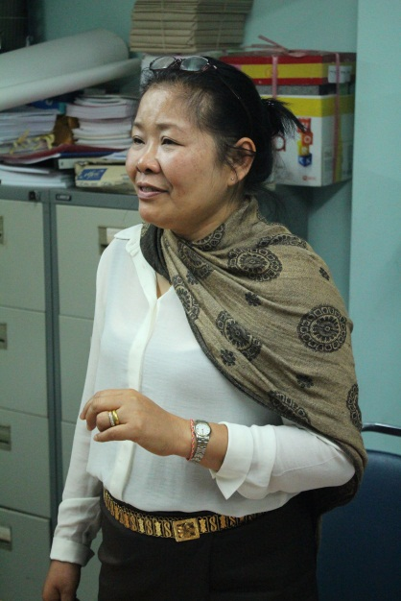Madam Khampaseuth Kitighavong is now the deputy director general of the Ministry of Education and Sport, Lao PDR. She first received an Australian scholarship for a technical and further education (TAFE) diploma in 1993. Her motivation was to improve her English. She already held a Masters in linguistics from Russia. She initially stayed in Canberra for three years:

I came back with the full knowledge of administrative management even though my background was not in finance or admin. [Improving my] English enabled me to change my career. I became the accounting division head. Because I now had English I was promoted to be deputy head of division. For the next step I looked at the Ministry of Education. I had one small boy, 2 or 3 years old. I decided to take another scholarship and in 2002 applied for a Masters in financial management, but then changed my subject to project management because the ministry needs this. I finished my Masters in project management at University of Technology Sydney, in the faculty of engineering. I left my son with my parents and husband, and had two years in Australia. After finishing, the vice minister proposed for me to work in the area of my subject that I finished.

It is not easy working with the 19 poorest districts and the six poorest provinces. We manage $65 million in projects, including $21.1 million from Australia. It was difficult for me; you have to devote yourself to your work. I was promoted to deputy head in 1999, and then in 2005 to head of division, then in 2008 to deputy director general of the planning department. Photo: Anne Lockley

Figure 3 Proportions of alumni reporting having increased responsibility following completion of a scholarship

Increased financial responsibility on return from scholarship was reported by 59 per cent of women, including 53 per cent within 3 years after return, and 67 per cent of men, including 59 per cent within 3 years after return. 
Increased technical or operational responsibility was reported by 78 per cent of women and 86 per cent of men, within 3 years after return. The percentage of women and men who had increased technical or operational responsibility did not increase further the longer they were home.Source: Secondary analysis of consolidated tracer study data. Note that not all country data included time-based disaggregation; therefore, ‘All respondents’ represents the full data set, including those who had returned within the previous three years. For data table, see Appendix D.

Improved remuneration

Salary reflects positional levels within workplaces. In tracer studies, alumni are asked whether they have had a salary increase or are satisfied with their salary. After returning from their scholarship about half of alumnae reported positive salary outcomes, with this proportion increasing with time post return. Interestingly remuneration is one indicator of professional advancement for which outcomes for women were not worse than those for men. It should be noted that this may reflect gender-based expectations and the wording of questions rather than actual salary levels. Salary satisfaction and salary increases are grouped in the same question and the number or size of salary increases are not determined.

Attributing professional advancement to scholarships

… if you have the same qualification here competing with a man who has the same qualification from within the country then I would say the man would have got the job. It sets you apart regardless of your ethnic background or gender … Now to progress into leadership roles in the government it is almost required that you have that international qualification.

ALAS alumna, private sector, Lao PDR

It is difficult to assess the extent to which completing a scholarship contributes to the professional advancement of alumnae. Analyses comparing women of a similar background and profession who have not completed an award to those who have do not exist. In the absence of such a comparison, the views of alumnae and workplace supervisors on the contribution that scholarships make were considered.

Alumnae typically felt their scholarship facilitated their professional advancement. Most female tracer study respondents employed in civil society organisations (86 per cent), the private sector (81 per cent) and the public sector (69 per cent) considered that their promotion was due to their scholarship ‘to a great or medium extent’. In interviews, alumnae consistently stated that qualifications gained through their scholarship opened career opportunities or helped them skip one or two rungs on the professional ladder. The prestige and recognised technical value of an Australian qualification, combined in many cases with higher English language proficiency, were identified as key factors.

Supervisors in workplaces were interviewed to obtain a more independent assessment of the extent to which scholarships contribute to professional advancement. Overseas tertiary study was seen by all supervisors to be a key contributor to women’s professional advancement: *‘The ones who have done the [Australia Awards], if I compare them to the education level of others they are just miles ahead. I hope that will continue as these women have definitely benefited from it’* (supervisor of alumnae, private sector, Lao PDR).

## Developing a leader identity

There is a difference for women who study in [their home] country. They are less outspoken and less confident and don’t feel fully confident to express their opinion. Women who have studied overseas are very confident … they are independent.

Supervisor of alumnae, public sector, Lao PDR

Australia Awards Scholarships and also Australia Awards Pacific Scholarships have made a clear contribution to women’s leadership by enabling alumnae to see themselves as leaders. Particularly for women from more limiting social and cultural contexts, the experience of being away from support networks, families, and the routine of life for a long period is transformational. The more restrictive the environment from which a woman comes, the more pronounced this transformation is. Developing a ‘leader identity’ is cited in much of the leadership literature as being a critical first step towards leadership. Seeing oneself as a leader enhances motivation to lead and engagement in the leadership process, and also promotes the seeking out of leadership responsibilities and opportunities to develop leadership skills.[13]

Before I left Samoa my life was the same – it was home, to school – you get picked up, dropped off. There is no in-between. I didn’t even go to a movie in my final year. I never went anywhere. Also, for me when I went to Australia I went straight into uni, and I had never even slept over at anyone’s house before I left Samoa. Not even my Auntie’s or anyone like that … it was the first time I had been by myself.

Alumna, public sector, Samoa

After studying and living overseas, alumnae reported having greater interpersonal skills, confidence, independence, open-mindedness, self-reliance and self-belief. During the field studies, most alumnae reported that their scholarship experience had made them more likely to speak out; others had become *‘very confident in terms of decision-making or sharing ideas’* (alumna, NGO sector, Lao PDR), and *‘very confident to whatever challenge or issue that needs to be raised’* (Australian Leadership Awards Scholarship [ALAS] alumna, NGO sector, Samoa). Several tracer studies also included stories in which scholarships gave alumnae the necessary confidence to address challenges to their leadership within the workplace and work to address them, rather than shy away from them.[14]

Supervising and mentoring others

Scholarships help women move into supervisory roles where they have the opportunity to mobilise and guide others. In tracer studies, just over half of alumnae (57 per cent) reported supervising more staff within three years of return, with this proportion increasing with time since completion (to 62 per cent overall). Alumnae working in the private and public sectors were more likely than those working in civil society organisations to have increased supervisory responsibilities (Figure 4). Three-quarters of alumnae attribute their increased supervisory responsibilities to their scholarship ‘to a great or medium extent’. Women were less likely than men (59 per cent) to report supervising more staff within the first three years after completing their scholarship.

Figure 4 Proportion of alumnae who report supervising more staff after return from their scholarship, by employer type

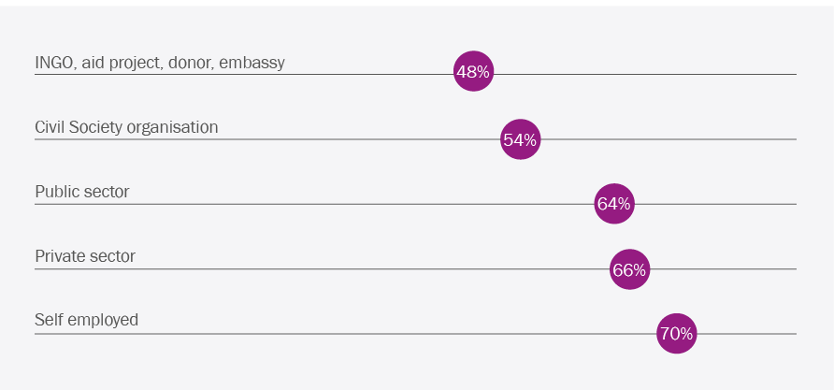Source: Consolidated analysis of tracer study data (n=1313).

During field studies many alumnae reported being leaders by mentoring and coaching others. Analysis of tracer study data found that about half of alumnae are sharing a broad range of skills gained in Australia (Figure 5). Women were less likely than men to transfer most types of skills, either formally or informally (see Appendix D, Table D.4).

Box 2 Women’s leadership raising the voices of people with disabilities

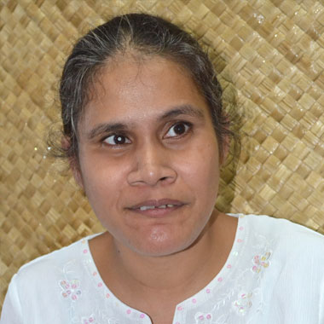Faaolo Utumapu received an Australian Leadership Awards Scholarship in 2008 to study for a Masters in media and communication at Monash University. In 2001, Faaolo was part of a small group that founded *Nuanua o le Alofa*, the only organisation in Samoa that is managed and led by people with disabilities. Faaolo herself is blind. The organisation has now been recognised nationally as the voice of people with disabilities, and Faaolo is the secretary of the board. Faaolo and her organisation led the advocacy encouraging the Samoan Government to sign the Convention on the Rights of Persons with Disabilities—which occurred in September 2014. Of her award experience, Faaolo said:

It was very important in terms of boosting my independence, in terms of decision-making on my own and having to face the consequences of decisions that I made while I was away on my own. The other thing that I found very interesting was that as part of the ALAS we were required to be involved in leadership programs and workshops … People that were sponsored under that program were from all over the Pacific and especially from Asia. You get to mix with people from a lot of different backgrounds, values, priorities, and you have to learn to adapt to working with different people, and I think this has contributed to my own personal development. Because even though it was in Australia, when you come back home you encounter the same issue. You work with people, that even though they are Samoan, they have different values, different priorities and commitments, and you have to learn to adapt and learn to come to a compromise ...

… at the moment I would like to think that I am very confident to whatever challenge or issue that needs to be raised. I am not afraid to voice it if I have all the facts … one thing that I gained in Australia is the fact that you need to do your research, before you make any changes or voice your opinion about anything. I probably wouldn’t be so confident to advocate for rights of people with disabilities. Photo: Senese Inclusive Education

Figure 5 Proportions of alumnae who reported transferring particular skills and knowledge

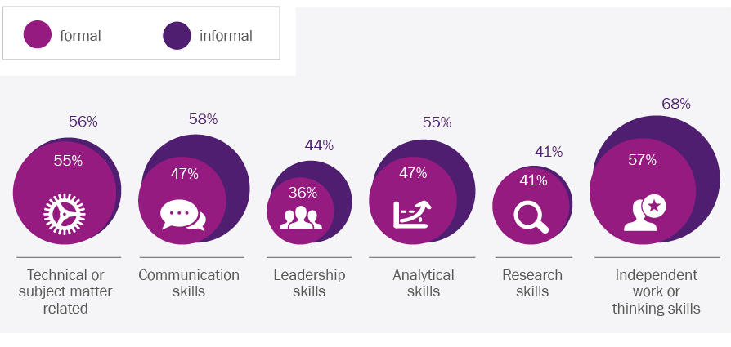Source: Secondary analysis of consolidated tracer study data. For data table, see Appendix D.

Previous studies have found alumnae in private sector or civil society positions are more likely to report sharing skills and knowledge after their return, more than those in the public sector.[15] The secondary analysis of tracer study data found alumnae working in local civil society were the most likely to report both formal and informal skills transfer (70 per cent and 83 per cent respectively), but contrary to previous findings, skills transfer in both the public sector and civil society was better than in the private sector (Figure 6).

Figure 6 Proportions of alumnae who reported transferring skills and knowledge

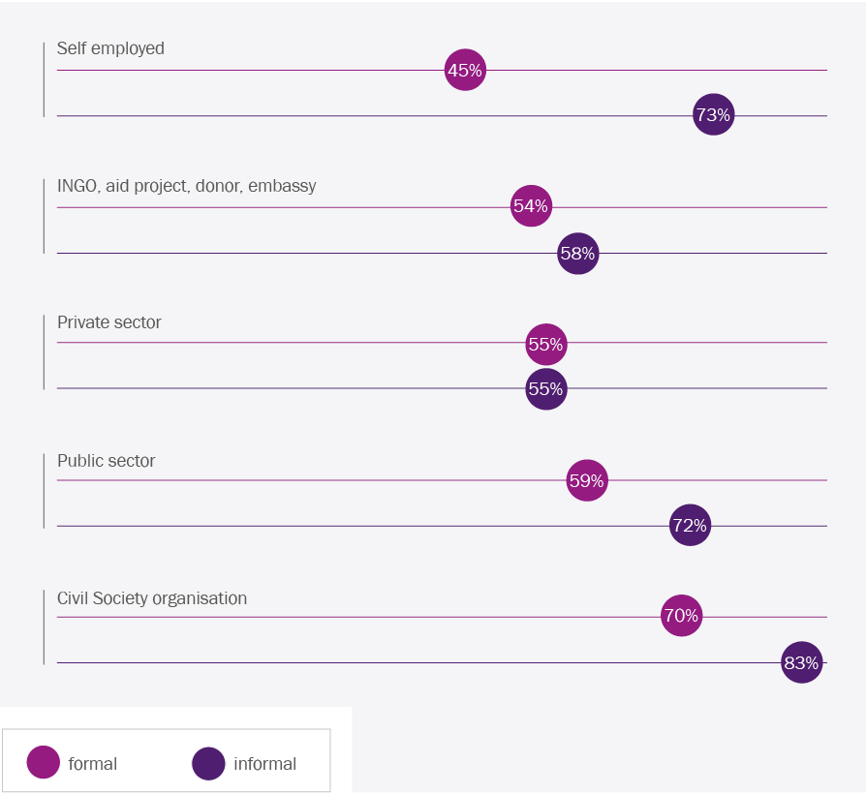

Source: Secondary analysis of consolidated tracer study data. For data table, see Appendix D.

Box 3 Building confidence, expanding horizons

Butet Manurung completed a Masters degree in applied anthropology and participatory development in 2011 from the Australian National University. Butet was already a leader with a vision long before she went to Australia. She had led educational programming for indigenous communities living in the jungles of Sumatra, and eventually this evolved into her co-founding an NGO, SOKOLA. This NGO provides educational opportunities for marginalised people and indigenous communities across Indonesia. Through SOKOLA, more than 10,000 children and adults have benefited from the organisation’s literacy programming.

Despite this success, Butet felt that she lacked the confidence and knowledge to speak with policy makers and international actors about her organisation’s work. At that time, she recalled, *‘I had so many ideas in my head, but it was hard to advance them further.’* She felt that by going to Australia she would *‘be able to understand the work I had undertaken in a more holistic way. I wanted to be an expert of my own work and look at my experience in a more intensive way.’* She wanted to return to Indonesia with the ability to *‘talk to academics and policy makers about my work’,* but to do so she needed to *‘have really* *good arguments’* of how her organisation’s approach to education was more effective for Indonesia’s indigenous communities.

On return to Indonesia, she felt that *‘I came back on an equal level to those that I need to communicate with’* as a result of improved English as well as having a Masters degree. This allowed her to better advocate for the rights of indigenous communities in Indonesia. Her improved English skills have been critical to finding new sources of funding for her NGO to expand, as *‘I found the right words to use when communicating with them’.* Through connections and networks built in Australia, Butet was also able to have a book *(Sokola Rimba)* she had originally written in Bahasa Indonesia, about her experiences as a teacher in the jungle, translated into English and published as *The Jungle School*. More recently, the book has been turned into a movie in Indonesia.

Reflecting back, Butet feels that *‘I am now part of a more important circle of decision-makers … I am no longer just head of an NGO but now I have a Masters degree and can influence others at a national and international level’.* Butet’s leadership has been recognised internationally a number of times since she completed her Australia Award. In 2012, Butet participated in a leadership and public policy program at Harvard University, and in 2014 she was awarded the prestigious Ramon Magsaysay Award. This award honours ‘outstanding individuals and organisations working in Asia who manifest greatness of spirit in service to the people of Asia’. Butet gave her acceptance speech and was interviewed by various members of the international media in English—she recalled how before her Australia Award she *‘would have been terrified to speak in front of an international audience’*. Butet says her award experience gave her *‘the confidence of how to speak, how to express myself* *better’.*

Photo: Butet Manurung

Leadership extending beyond the workplaces

Half (51 per cent) of female tracer study respondents reported sharing their skills and knowledge in local or provincial government or local councils; 45 per cent in community organisations or NGOs; and 24 per cent in religious organisations. The stories of Nana (Box 4) and Ane Moananu (Box 5) are good examples of leadership outside of these women’s main workplace.

Box 4 Developing local enterprises

Souphaphone Souannavong (Nana) completed a Bachelor of Business, majoring in Banking and Finance, at Monash University in 2005. When studying in Australia, Nana dreamed of embarking on a career with the state-owned Bank of Lao PDR. Within a week of returning she had secured an internship with the bank, and remembers being fortunate to be allocated a number of assignments directly supporting the senior bank officials. However, Nana’s experience away had led to her wanting more from her career, and sooner. After six months, she moved to the private sector, starting a range of small business ventures. Later, Nana was awarded a Fulbright scholarship and completed a Masters degree in the United States.

Recently, Nana joined a Malaysian bank operating in Lao PDR and is now the Head of Business Development and Marketing, and one of a six-person senior management team. Nana’s leadership reach, however, extends beyond this high-pressure professional role into a range of other entrepreneurial activities. Nana credits her Australian education with her realising the importance of coaching and encouragement of others as part of leadership. In March 2014, she started *Toh Lao*, a co-working space in the centre of Vientiane where *‘like-minded people come to work, to collaborate, to grow their businesses’*. *Toh Lao* provides low-cost office space, runs professional development seminars, and hosts networking events. In May 2014, *Toh Lao* held the first ‘Startup Weekend’[16] in Lao, and the second was held in March 2015.

For [the first Startup Weekend] we got about 60 or 70 people who joined. At first I only thought that 9 or 10 people would come … So from that point I see that ‘oh wow so this country still has hope!’ But it is then the matter of how we are going to train them for ideation. Through the next two days we work on making their project to be more practical. We feel really proud of what we did.

During the Startup Weekend, participants need to validate their business ideas, build the startup by doing market research, talk to customers and suppliers, and develop the product or services to be as practical as possible. A team of coaches, some of them identified through Nana’s alumni networks, was on hand to help develop the ideas. At the end of the weekend a winning startup idea was selected by a panel of judges, and then supported into development through *Toh Lao*. In 2015, there were again around 60 participants, with seven groups building their startups over the weekend.

Photo: Anne Lockley

## Developing a vision for change

Just over two-thirds of female tracer study respondents reported having an increased role in policy development after their studies. This proportion was consistent across public and private sectors, and for women in international NGOs, donors or embassy workplaces. Knowledge of how systems can work supports policy development. For women and men who have lived their whole lives in resource-poor settings, studying in a developed country provides an opportunity to see functioning systems. Alumnae identified many areas in which they had gained new ideas.

Education methodology:

We are used to being taught and learning in a totally different style … you have to use your brain. Before you just memorise what is written in the book and then write it down exactly. [My] whole thinking process has changed. Alumna, private sector, Lao PDR

The relationship between the government and the people:

There was a sense of a grievance mechanism for citizens when they were unhappy with government actions. This was really inspirational. It entitles [citizens] to change something, to feel outraged and to do something about it in response. It made me realise that there are ways of creating activism, in any context, and getting the cause heard. ALAS alumna, private sector, Indonesia

Women leaders:

The experience in Australia gave me a better understanding of leaders … like women professors at Crawford and the Australian National University. I saw a lot of skilled and assertive women during my time in Australia. They performed really well … they spoke out well and were decisive. They became role models to me. I hadn’t really seen that in Indonesia because we didn’t have a lot of women professors. It inspired me to be like them, and now I am one of them. High-profile alumna, Indonesia

Services:

[I saw] how well arranged the infrastructure in Australia was in terms of public transportation, water systems, and roads. It gave me ideas of how to design urban settlements, and how to make the proper plans to manage infrastructure. High-profile alumna, public sector, Indonesia

I was curious to know what services they offer for people who are blind, what is out there for blind people in Australia that I could bring back here. ALAS alumna, NGO sector, Samoa

## Men supporting women’s leadership

Previous tracer studies included some examples of men and women returning from the scholarship with a new perspective on the possible roles of women, and then advocating for greater gender equality within their organisations. One Bangladeshi alumnus described how he had developed strategies to sensitise managers and trainers in his public sector agency to gender issues, and ensured that training workshops were gender equitable.[17] Another alumnus from Nepal described how he was attempting to ensure equal female participation in his organisation’s workshops, and had worked with colleagues to develop an internal gender policy.[18]

Male alumni interviewed in Lao PDR also mentioned some changes in terms of their attitudes and, in some cases, behaviours related to the gendered perceptions of acceptable male and female roles. Such reports were also confirmed by female alumnae on the basis of observations of their male peers, friends and colleagues who have studied in Australia.

Examples included changes in the home:

I feel like my friends changed, I mean the males who were educated overseas, including Australia. They take more responsibility for the household work. They help out with women’s work at home. They give you the time to do what you want; you don’t need to worry about work at home ... They basically give you the equality, the same as the male. ALAS alumna, private sector, Lao PDR

Examples also included changes in the workplace:

If men have completed overseas study they are more respectful of females. If they have just been working here it is quite difficult to delegate. Alumna, public sector, Lao PDR

It is unlikely, however, that small numbers of male alumni are going to change the prevailing social norms around women in the workplace. Male alumni interviewed described difficulties in maintaining more progressive attitudes and behaviours to support women after they returned home. As one alumna noted:

… three years, four years, is not going to change the attitude that much. Males need to treat women equally not just those with scholarships from Australia. Alumna, private sector, Lao PDR

Box 5 Supporting women entrepreneurs

Ane Moananu completed a Masters in business administration in December 2011 at the University of Newcastle. As a recipient of an Australian Leadership Awards Scholarship she also participated in other activities including conferences, interstate study visits, mentoring and coaching. She found the supplementary program to be:

*really impressive ... a lot of people came together to share their experience. We got to talk to different students from different parts of the world. It was an eye-opening experience.*

Ane is now the CEO of the Samoa Chamber of Commerce, a position she thinks she would not hold if it weren’t for the leadership award:

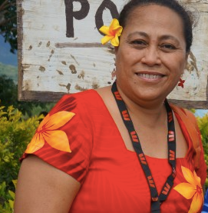… coming back and looking for a job I would have gone back to the government. But I would have been doing the same thing. Then I saw the ad in the paper—I thought I hadn’t worked in the private sector … so I applied and I got the job. And for me the satisfaction that I have working here is great. I can use the networks that I have gained through my time working with the government and through my previous work experience.

As an example of the role women leaders play in representing the needs and interests of other women, Ane tells of being invited to a Women in Business conference, hosted by the Pacific Islands Private Sector Organisation and funded by DFAT and Westpac, in November 2014. Moved by the testimony of women at the conference, Ane and 12 of her colleagues from the Samoan delegation agreed to form the Women Entrepreneurs Network of Samoa. Ane facilitated the preparatory steps, including securing the support of the Ministry of Women, Community and Social Development, applying for funding, and negotiating with successful businesswomen to act as mentors in the program. The network was launched as part of the International Women’s Day program in 2015, and aims to bring *‘assistance to the women in the different rural areas of Samoa, women who are under the radar, those who are struggling with everyday life, who don't have hopes’*. Photo: Pacific Women Shaping Pacific Development

4 Barriers to women’s leadership

This evaluation found that leadership outcomes for women on return from Australia Awards Scholarships are consistently not as good as those for men. The proportions of women reporting positive outcomes for a range of indicators of professional advancement and leadership were slightly lower than that of men, which cumulatively is likely to be significant (Figure 7). The main barriers that make it more difficult for women to become leaders were identified through interviews with recently returned alumnae, and also alumnae who had well established careers and significant leadership positions. The barriers identified are similar to those experienced by women worldwide. These barriers can be loosely grouped into sociocultural factors, including family responsibilities; workplace structures and practices; and professional relationships and networks.

Figure 7 The cumulative impact of many factors makes it difficult for women to become leaders.

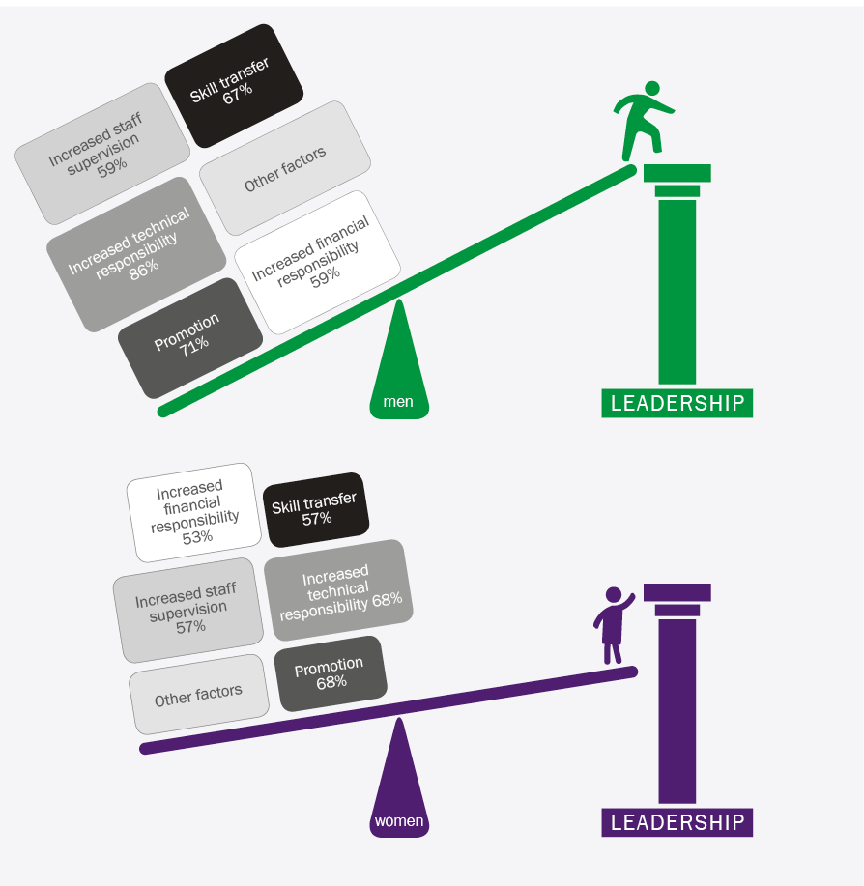

The proportion of women who reported positive outcomes for a broad range of measures of professional advancement in the tracer studies was consistently lower than that for men (shown on the boxes). It is likely that similar differences also apply to many other measures of professional advancement that are not quantified in the tracer studies (represented by other factors boxes). While outcomes for women for each measure may be only slightly poorer than those for men their cumulative effect is likely to be significant and make it harder for women to advance into leadership positions.

## Sociocultural factors

Family responsibilities

Family and sociocultural expectations that women should focus on child bearing and caring for their families was identified as a barrier to women’s leadership. Many alumnae felt the pressure of showing to their colleagues that they were a good wife and mother, despite their professional achievements: *‘I am judged first by how I am taking care of my family by my colleagues … if I work too hard and am seen to be neglecting my family they will say I am not a good woman’* (alumna, public sector, Indonesia). In Lao, alumnae recognised the challenge of managing evolving multiple roles and expectations: *‘in Lao women work hard … now we have the “sam dii”—the “three goods”—women have to work well in the workplace, work at home, and be a good wife and mother’* (high-profile alumna, public sector, Lao PDR).

It is a little difficult to pinpoint barriers in Lao … In politics, women are welcomed; in management women are welcomed; in technical fields women are welcomed. But the expectations of women at home are not lessened just because they are welcomed in politics, technical or management work. We are taught from a young age to be responsible for families, for ourselves, for children, for parents. So it is the struggle to balance our career aspirations and family responsibilities.

ALAS alumna, private sector, Lao PDR

Interestingly, the evaluation found that the recent ending of financial support for family members to accompany the scholarship holder does not appear to have prevented women from completing or applying for scholarships. Alumnae consistently felt funds should be used to provide scholarships rather than increasing the stipend for scholars accompanied by family. Several of those interviewed had made the decision to leave their spouses and children behind to focus on their studies, even though the funding for accompanying family was available at that time. The support network at home that enabled this is perhaps an indicator that on return, women will have the personal support required to pursue their leadership ambitions.

Contradictory expectations: A ‘good’ woman, wife, mother, versus ‘a leader’

It can also be difficult for women to be leaders when the attributes and behaviours expected of leaders are distinct from those considered appropriate to a ‘good’ woman. Many Indonesian alumnae interviewed felt that being authoritative or directive were typically viewed as masculine traits and ones that either did not come naturally to women, or were seen as undesirable for women to exhibit. Some were cognisant that *‘Women in Indonesia need to make sure they don’t come across too assertive to get their causes advanced’* (ALAS alumna, private sector, Indonesia) and that *‘While women do a lot in Indonesia, we still have to act that we are not better than the men we are leading. You still have to be subordinate in front of men, even now’* (ALAS alumna, private sector, Indonesia).

Likewise in Lao, alumnae referred to the need to just *‘smile and agree’* with males under their supervision (alumna, private sector, Lao PDR) because *‘for some male colleagues it is difficult to accept the female to lead them’* (alumna, public sector, Lao PDR). In Samoa, a very senior female government official commented on being careful *‘not to ruffle the feathers of a male who is my boss—because there is a way of doing things’.* That ‘way’ is *‘to be a Samoan lady; to play the Samoan woman role. You don’t go demanding things. You have got to do it the Samoan feminine way’* (alumni, public sector, Samoa).

Alumnae recognise that it is pragmatic to exhibit leadership styles that are currently acceptable and effective, while the broader workplace culture slowly becomes more accommodating. This is an area where support and advice from the experienced and skilled women leaders would be beneficial.

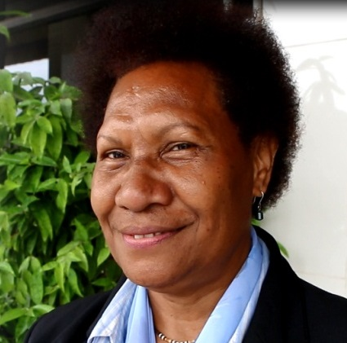Box 6 Working to improve gender equality

Senior public servant, Ida Yuki, is working to advance gender equality and social inclusion across the public sector in Papua New Guinea. Ida studied at the Australian National University as an undergraduate in the early 1990s, before joining the Department of Personnel Management (DPM) in Papua New Guinea in 2000. A second stint at the Australian National University on an Australia Awards Scholarship enabled Ida to complete a Masters degree in public administration.

In her current role at DPM as acting executive manager for public service policy and performance, she has oversight of gender equality and social inclusion policies within the department. This work involves close liaison with advisers from the Economic and Public Sector Program supported by Australia’s official development assistance. Ida says:

For women to break through [in] male-dominated areas, in terms of management, you need to have the qualifications … coming back with a Masters has actually given me a base where I could express myself as a leader. It gave me the opportunity to be considered for senior management positions.

Ida also describes how her work practices were developed from her scholarship experience:

You exercise a lot of independence because you have to do all that work yourself. Coming back here I’ve tried to apply that. When I task my officers, I just give them guidelines and tell them to go out and get results and to not come back with excuses. Photo: Felicity Spurrett

## Workplace structures and practices

The cumulative effect of decades of (albeit sometimes minimal) attention to gender equality and women’s participation is gradually helping to lower some of the barriers facing women in the workplace (Box 7). The three field study countries, along with 186 other countries, are parties to the Convention on the Elimination of All Forms of Discrimination Against Women (CEDAW). In all interviews in Lao, the government’s stated commitment to promoting greater gender equality was mentioned; many Indonesian interviews referred to the Presidential Instruction requiring gender mainstreaming that was signed in 2000; and there was much discussion in Samoa of the parliament’s passing of the 2013 constitutional amendment to reserve five seats (10 per cent) for women electoral candidates.

My perspective is that there is nothing stopping women in Samoa moving up into leadership positions. It is based on merit, except for parliament where there are a lot of factors involved—matai title, family, wealth, contribution to the village.

High-profile alumna, public sector, Samoa

While the implementation of measures to support gender equality is patchy, alumnae clearly felt that formal commitments are making a difference:

I think it is the global issues and the conventions that we are a party to, such as CEDAW. Now women have equal access to education and so are starting to realise that they have this right to do this and to excel in the future. Alumna, Samoan Attorney General’s Department

We are now moving towards a movement in Indonesia where women are being supported to be leaders in government … All ministries have to implement the [gender mainstreaming policy] … We need to have a certain percentage of women in positions of leadership. We can see this even having an effect in the leadership structures at the village level. Alumna, public sector, Indonesia

Some alumni interviewed believe that formal commitments to gender equality have helped to dismantle barriers to women’s advancement and ensure that promotion is merit based:

Everything [in our organisation] is equal … they don’t care about our gender. It is all about if you qualify for the training by your position level, amount of time in the ministry, and area of expertise. Alumna, public sector, Indonesia

There is equality in gender in Lao … In the Lao context we don’t have difference with gender at the high level … discrimination about women becoming leaders in management level now has changed, a lot of [directors general] are women, and higher ranking also. Alumnus, public sector, Lao

The myth of meritocracy

The analysis of consolidated tracer study data found that for many measures of professional advancement, post-award outcomes for women were slightly but consistently worse than those for men. The cumulative impact of the small differences observed in multiple measures of women’s professional advancement is likely to be significant. Judgments about merit are influenced by unconscious bias so that real meritocracy may well be a myth. This has two dimensions. Firstly, those assessing ‘merit’ are shaped by their experiences and values, which are influenced by gender. Secondly, women being assessed can be held back by self-doubt and having had limited opportunities—both of which are highly gendered.

Promotion practices

In tracer studies and interviews alumnae identified some of the promotion practices that make it hard for women to advance as fast and as far as men. Time-in-service or serving in remote or rural locations is often a precondition for promotion in the public sector. Alumnae recognised that for women, time in a position may be truncated by taking leave to care for family and as a result of mandated earlier retirement ages. The inability of women to move location for work because of family responsibilities and sociocultural factors was also recognised.

Areas of expertise and the value placed on these can be heavily influenced by gender—while *‘visible, heroic work, more often the purview of men, is recognised and rewarded … equally vital, behind-the-scenes work, more characteristic of women, tends to be overlooked’.*[19] For example, a male supervisor in a government ministry in Lao PDR said *‘There are a lot of outstanding women who should be promoted to get position but they are in competition with men … In the perception of the people you need someone who is a leader to be very strong and sometimes women do not show this ability to the people’.*

Many alumnae felt there was a ‘glass ceiling’, particularly within the public sector, for women seeking senior positions.[20] Subsequently, women are assuming senior leadership roles more rapidly within non-government sectors (either civil society or the private sector) and this was given as a reason why women are found working in these sectors in disproportionate numbers post award.[21] The glass ceiling effect in the public sector was commonly seen as resulting from the granting of promotions to senior ranks being linked to patronage or political processes, or to a lack of support from senior or line managers. For example, in Lao, both women and men stated freely that moving beyond the deputy director general level was difficult without the right family or political connections. In Indonesia, alumni working within the academic sector in Aceh observed that the prevalence of an ‘old boys’ network and patronage politics at the highest level of the university precluded women from taking up leadership positions.

Glass ceilings and sticky floors make it very hard for women to move up.

High-profile alumna, public sector, Lao PDR

Being noticed, proving yourself

In all field sites, the need for women to prove themselves and be noticed before being given opportunities and gaining leader status was widely recognised—and this was believed to often be harder for women than men. In Lao PDR, women felt that the cultural bias against women leaders meant that they had to earn acceptance from men, rather than have it automatically come with a position of seniority: *‘I wouldn't say that female leadership or male leadership are different. But we have to prove to other colleagues that we can lead. Females have to work harder to get to the same point’* (alumna, public sector, Lao PDR). In Samoa, the bestowal of a *matai* title for most women required their being recognised for considerable efforts and commitment to their family and community, whereas *‘For a man to be bestowed a title …* [said with a laugh] *they have to be born’* (technical specialist, Samoa).

## Professional relationships and networks

Leadership literature highlights the value of good mentoring, particularly for early-career professionals. Having a sponsor, someone of high status and influence who puts others forward for leadership opportunities, has been shown to help individuals get ahead. In each field study location there were numerous examples of the usefulness of sponsorship and supportive managers or supervisors: *‘*… *of course you need authority, you need to be qualified, next the seniority, number of years, and then someone to support you. It is really important’* (alumna, private sector, Lao PDR). In male-dominated workplaces, the best sponsor is likely to be a man. However, the tendency to gravitate to people like oneself can mean that men are more likely to advocate for other men, and thus gender bias occurs.[22] Also, it can be difficult for women to develop relationships with senior men, particularly when to do so involves out-of-work socialising, which for women can be culturally inappropriate or not possible due to other responsibilities.

The tracer study analysis found that less than half of alumnae felt that they received strong support for applying their knowledge and skills gained from the Australia Awards (Figure 8). The level of support was consistently lower for women in the private sector compared to the public sector. The differences between male and female responses are not statistically significant, although it is noted that perceptions of support are influenced by individual expectations—which are highly gendered.

Figure 8 Proportion of alumnae working in the public and private sectors who perceive that they receive support ‘to a great extent’ from various sources after return from their scholarship

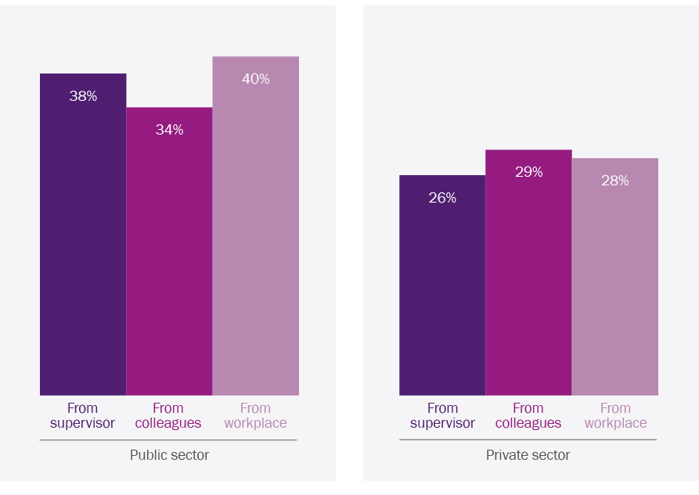

Source: Secondary analysis of consolidated tracer study data. For data table, see Appendix D.

5 Improving women’s leadership outcomes from scholarships

This chapter discusses how the delivery and management of Australia Awards could be modified to improve women’s leadership outcomes.

## Selecting scholars

As scholarships are large investments in individuals, selecting the ‘best’ individuals is critical. Rigorous processes are used in an attempt to select individuals with the dedication and commitment to succeed and contribute to development. Women’s leadership outcomes could be improved by refining selection processes.

Women received 55 per cent of the total number of Australia Awards Scholarships in 2013–14. The proportion of scholarships awarded to women varies greatly at the country level (Appendix D). The proportion of scholarships allocated to women exceeds 60 per cent in some countries, including Mongolia, Papua New Guinea, Philippines, Samoa and Tonga, which have large scholarship allocations (more than 50 scholarships in 2013–14). In some countries, less than half of scholarships were awarded to women (Figure 9). Of the 26 countries with large annual scholarship allocations, eight had less than half allocated to women, with some falling well short of gender parity. Of the 12 countries with between 20 and 50 scholarships, seven had less than half allocated to women, and for some countries it was only 30 per cent.

Figure 9 Countries that allocated 20 or more Australia Awards Scholarships in total for 2013 and 2014, but less than half to women

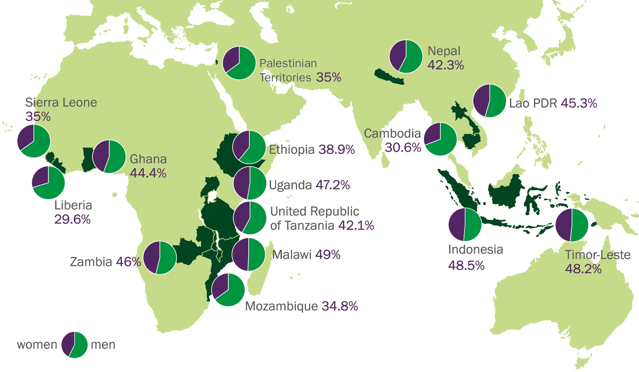

Well considered and concerted efforts have enabled many countries to reach the 50 per cent target for women even in some of the most difficult contexts (Table 5.1). Australia Awards Pakistan is a good model of how the number of awards to women can be increased. In some countries, such as Cambodia, attempts to increase the number of successful female applicants have been less successful. If women receive less than half of scholarships, Australia Awards may be further entrenching existing gender inequalities making it more difficult for women to become leaders. This evaluation therefore contends that in all countries where there are 10 or more scholarships allocated annually, at least half should be allocated to women. A likely contraction in the number of Australia Awards Scholarships due to recent reductions in the Australia Awards budget should make this easier to achieve. Nevertheless, if a country post proposes allocating less than half of scholarships to women, an appropriate response may be to reduce the total number of scholarships to achieve parity. Resultant savings could be used to fund strategies to build future cohorts of women applying for scholarships. Such a response may only be needed once.

Table 5.1 Strategies employed by country programs to increase the number of women who apply for and win an Australia Award

| Country/region | Strategy |
| --- | --- |
| Afghanistan | Positive discrimination practices in shortlisting and selection processes for women.[23] |
| Africa | Positive discrimination practices in shortlisting and selection processes for women, engaging female alumnae (through the Africa Women in Leadership Network) to provide peer support to potential female applicants to the Australia Awards in Africa program, establishment of a Gender and Equality Access Fund to support female applicants facing financial constraints that might preclude them from applying.[24] |
| Bangladesh | Reducing the International English Language Testing System (IELTS) threshold for women to increase pool of eligible female candidates, outreach to women’s organisations and non-government organisations (NGOs) working on gender to publicise awards and encourage female applicants from these organisations to apply.[25] |
| Cambodia | Targeted English language support for women working within government to support their subsequent later application to the scholarship scheme, increasing open category scholarships, reducing the IELTS threshold for female candidates applying under open category scholarships.[26] |
| Fiji | Positive discrimination practices in shortlisting and selection processes for women.[27] |
| Nepal | Positive discrimination practices in shortlisting by affording women 12 extra ‘points’.[28] |
| Pakistan | Reducing IELTS threshold for women to increase pool of eligible female candidates, outreach to women’s organisations and NGOs working on gender to publicise awards and encourage female applicants from these organisations to apply.[29] |
| Papua New Guinea | Planning foundation courses to increase the representation of women and provincial candidates in the program.[30] |
| Vietnam | Outreach to women’s organisations and NGOs working on gender to publicise awards and encourage female applicants from these organisations to apply.[31] |

In some countries where gender inequality is pronounced and opportunities for tertiary education are limited, it may be appropriate to allocate more than half of Australia Awards Scholarships to women. Increasing the proportion of women allocated Australia Awards Scholarships in such contexts will need increased outreach to women from local civil society and the private sector, as well as strategic engagement with public sector organisations.

Revision of selection criteria is needed to increase the proportion of scholarships allocated to women and also to focus selection on women most likely to be influential leaders in their countries. Leadership potential is already a criterion but it needs to be given more weight. Leadership exhibited to date should be a heavily weighted selection criterion. For example, Butet Manurung (Box 3) was repeatedly unsuccessful in securing a scholarship despite having already established a well-respected Indonesian NGO, and receiving international accolades including the United Nations Educational, Scientific and Cultural Organization (UNESCO) Man and Biosphere Award, Time Magazine’s Heroes of Asia, and the Asia Young Leader Award. Butet was only successful after being nominated by Jakarta Post as a priority development sector applicant.

**Recommendation 1**

DFAT posts should be required to revise selection criteria and processes for Australia Awards Scholarships to improve women’s leadership outcomes.

› In all countries where there are 10 or more scholarships awarded annually, at least 50 per cent should be awarded to women. If it is not possible to identify sufficient suitable women to meet this requirement, the number of men awarded scholarships should be reduced until a gender balance is achieved.

› Selection criteria should be revised to enable women most likely to be influential leaders to be selected.

## Allocating scholarships to targeted categories

Scholarships are often targeted to certain categories to help support development priorities and possibly also public diplomacy aims. Targeting often involves splitting award allocations between priority development sectors, the public sector, priority organisations within the public sector and geographic focus areas. In many countries, targeting results in high allocations to the public sector, while most women applying for scholarships come from other sectors.

Analysis of the complicated targeting of Australia Awards in Indonesia illustrates how current targeting disadvantages many women (Table 5.2). In 2014, 76 per cent of the annual Australia Awards Scholarship allocation was split between three targeted categories, leaving only 24 per cent open to any applicant. The open category receives the largest number of applications annually and has the highest number and proportion of female applicants, especially for non-public sector applicants. This makes it particularly difficult for women from outside of government to secure an award. For example, only two per cent of male and female applicants from outside the public sector succeeded in gaining an open category award. Women from priority organisations and priority development sectors had a much greater chance of being successful (28 per cent and 21 per cent respectively) owing to fewer female candidates applying in this category, and attempts to achieve gender equality within each pool of applicants.[32]

Alumnae interviewed in Indonesia readily recognised how difficult it was to be successful in the open category, as one now high-profile alumna in the private sector remembered:

I was lucky to be accepted the first time, it wasn’t easy for me to get the scholarship. I had to fight with another 6000 applicants.

Another also now high-profile private sector alumna described being unsuccessful twice as an open category applicant, then deciding to join the public sector in hopes of being successful:

I was told I was not successful each time because I was a private applicant rather than being part of the priority government institution. So in the end, I made a decision to leave the private sector and start work in a state-owned enterprise. It was only then that I was successful.

Table 5.2 Breakdown of the allocation of awards and success rates for Australia Awards in Indonesia in 2014

|  |  |  |  |  |  |  |  |  |  |
| --- | --- | --- | --- | --- | --- | --- | --- | --- | --- |
| Targeting | Category | Number of awards in 2014 | Percentage of awards in 2014 | Number of applicants | | Number successful | | Percentage successful | |
|  |  |  |  | **Male** | **Female** | **Male** | **Female** | **Male** | **Female** |
| *Targeted* | Priority organisationa | 101 | 31% | 243 | 169 | 53 | 48 | 22% | 28% |
| *Targeted* | Geographic focus areab | 80 | 25% | 267 | 286 | 39 | 41 | 15% | 14% |
| *Targeted* | Priority development sectorc | 65 | 20% | 194 | 164 | 31 | 34 | 16% | 21% |
| *Total targeted* | | *246* | *76%* | *704* | *619* | *123* | *123* | *17%* | *20%* |
| *Open* | Public sector | 32 | 10% | 336 | 369 | 12 | 20 | 4% | 5% |
| *Open* | Non-public sector | 44 | 14% | 735 | 1141 | 17 | 27 | 2% | 2% |
| *Total open* | | *76* | *24%* | *1,071* | *1,510* | *29* | *47* | *3%* | *3%* |
| *Total all* | | 322 | 100% | 1,775 | 2,129 | 152 | 170 | 9% | 8% |

a There are currently 12 priority organisations (see <http://www.australiaawardsindonesia.org/index.php/en/targeted/the-key-agencies>). To date, all have been entire government ministries or units within particular ministries. The Australia Awards in Indonesia design document states that there is scope to also include private sector and civil society organisations in the future.

b Five provinces that are seen as areas of focus for the Australian aid program: Aceh, East Nusa Tenggara, West Nusa Tenggara, Papua, West Papua.

c These are the four sectors that are part of the Australia–Indonesia Partnership and individuals are typically nominated from the Australian aid program.

Source: Data from Australia Awards in Indonesia.

The categories targeted are often those in which it is harder for women to become leaders. This includes provincial areas remote from capital cities, the public sector and priority development sectors. Opportunities for women to become leaders were found to be more constrained in provincial areas in both Lao PDR and Indonesia. Alumnae were more likely to advance in their careers and work in leadership roles in the private sector and local civil society than in the public sector. In Indonesia, the evaluation team spoke to three Australian Leadership Awards Scholarship alumnae who all chose to leave the public service soon after returning for this reason. Alumnae spoke of observing leaders outside of the public sector who *‘have the confidence to say what they want … the motivation to do something’* (high-profile alumna, private sector, Indonesia). In some countries, priority development sectors can be very male dominated. The extractive industries in Africa are an example of this.

If we really want to support women’s leadership, then the Australia Awards program would focus on what is happening for women in the African context, rather than what interests Australia about Africa. We would have to look at directing awards at political parties, civil society and the private sector, and targeting women’s leadership organisations.

DFAT official, Africa

To better support women’s leadership, scholarships need to be allocated more broadly and creatively than in the past. The proportion of awards that are not targeted should be increased by decreasing the number of awards allocated to the public sector. This is likely to help to ensure that the ‘best’ individuals, working in areas where they can become influential leaders or catalyse developmental change, can secure awards. Additionally, it may be beneficial to create a category specifically focused on women’s leadership, to improve accessibility of scholarships for women (and men) in progressive civil society, the private sector, the media, academia and gender-focused organisations. With such a category, Australia Awards could target outstanding individuals who are likely to build women’s leadership but unlikely to be supported by domestic scholarship schemes.

**Recommendation 2**

DFAT posts should be required to revise targeting strategies to improve women’s leadership outcomes.

› At least half of scholarships should be open to all candidates.

› Consideration should be given to allocating a small proportion of scholarships to a women’s leadership category.

## Institutional targeting and increasing the visibility of women

Greater participation by women in the workforce in general and as leaders will normalise these roles for women, and theoretically make it easier for future cohorts of women. In most countries where there are large numbers of Australia Awards Scholarships, there is some targeting of particular institutions or skill areas—with the explicit or implicit intention of influencing workplace cultures through developing a critical mass of awardees that creates an environment open to change. As currently implemented, institutional targeting does not have an objective to increase the visibility or critical mass of women.

Big changes in Indonesia are happening now outside of official government channels and the work of civil servants. It is happening within grassroots movements and those from non-traditional backgrounds. Change is more organic now, and when the government is changing it is not people within that are changing it, but rather people on the outside.

ALAS alumna, private sector, Indonesia

The experience of Samoa shows that building a critical mass of alumnae can transform workplace cultures. Over the past decade, women’s workplace leadership in Samoa has increased exponentially, at certain levels surpassing that of men. Many of the female leaders are Australia Awards Scholarship alumnae:[33] *‘It has become like a naturalisation process over time … women are now given more of a say, and are recognised in terms of the value they add’* (high-profile alumna, public sector, Samoa).

Box 7 Changing the culture of a non-traditional workplace: Samoa Water Authority

At the Samoa Water Authority, the CEO and assistant CEO and five other women are Australia Awards Scholarship alumnae and engineering graduates. The CEO, Seugamalii Jammie Saena, an engineering graduate of University of Technology Sydney, is an advocate for hiring women engineers *‘as they are the ones graduating’*. Drawing on her own experience, she encourages them to go out and get their hands dirty and show that they can do the work. She said *‘definitely I encourage women more than my male peers’*. The large number of overseas graduates has changed the Authority, though in subtle ways. Where there is lingering resistance to change, Jammie draws on the enthusiasm and skills of the graduates to move things along, thus also providing them with valuable opportunities for their own career development.

Workplaces in which a critical mass of alumni can have transformative effects are those that have senior leadership that is supportive of women (Box 8). In contrast, when management is unsupportive of women, opportunities for women are limited regardless of the number of alumni. For example, in some of the priority organisations targeted in Jakarta, there are many Australia Awards Scholarship alumni but very few alumnae in leadership positions. Similarly in targeted provincial locations, the large numbers of alumni in some organisations have not brought about workplace change needed to create opportunities for women. The Aceh university sector has many alumnae but their opportunities are very limited. A senior manager of one university acknowledged that institutional structures and culture made it very difficult for alumnae to rise through the ranks. Similarly, in organisations in provincial Lao PDR that have many alumni, alumnae reported being in the same position for years, watching less experienced male colleagues with limited qualifications being given opportunities and promotions.

Box 8 A critical mass of alumni in institutions helps to build women leaders, but supportive leadership is essential

Samoa legal sector

In Samoa, the head of the Law Reform Commission, a human rights lawyer, assistant chief executive officer (CEO) and six other Attorney General’s staff are Australia Awards Scholarship alumnae. The strength of this critical mass was acknowledged as being important in enabling women to be leaders:

It has I think had a positive impact on this office being all female and that knew each other way before we came … I think it helps in that we all have the same vision … because we have this background together we manage to communicate better between us … We have the same respect for each other and the same vision to build up the office, and we help each other whenever anyone is having any problem or would like some tips on how to deal with certain issues. I am not saying that the boys didn’t do that but this is my experience. High-profile alumna, public sector, Samoa

There have been a number of recent developments in the Samoa legal sector, such as passage of the *Family Safety Act (2013)* and the establishment of a victim’s support group, which according to alumnae interviewed partly result from the prominence of women in leadership positions.

Ministry of Industry and Commerce, Lao PDR

The minister is a woman, the vice minister is a man, at director general level there is one woman (me). At deputy director general level it is increasing—there are three or four … I think it does help women to progress [working in a ministry where there are other women]. We can help each other and discuss. Sometimes it is not that easy to change the thinking of men. High-profile alumna, public sector, Lao PDR

Bank of Lao PDR (Central Bank)

A supervisor interviewed estimated that approximately 40 per cent of staff are Australia Awards Scholarship alumni, working across 13 departments. The bank also has women in senior positions, and structures in place to support women:

The National Committee for the Advancement of Women and Children belongs to the government office and supervises the (bank) committee for promoting progress for women and children ... We have a division as well that looks after gender equality ... We are pleased to tell we have one female deputy governor since last year, and also a party member, so this one is really high ranking within our organisation. They try to increase the number of women. And we have many female leaders with management roles, the division role and also the director general role. In 2015 it is over 40 per cent [women]. Alumna, public sector, Lao PDR

A representative from the managing contractor for Australia Awards in Indonesia (Coffey International) acknowledged that organisational targeting on its own was insufficient to build a supportive environment for women’s leadership, and noted that *‘We are still trying to work through how we engage with the key agencies. We have seen little evidence of a supportive environment in partner agencies in terms of human resources policies that consider women’s needs more explicitly’.* Workplaces and organisations prioritised should only include those that have management with a proven record of supporting women. If organisations that are already prioritised are unsupportive of women, allocations of awards should be reduced.

There was some consensus that high visibility of women in the private sector can influence the government; likewise, the prominence of women in donor funded programs and diplomatic missions, as well as Australia’s previous female prime ministership were mentioned as positive features: *‘I am very happy that Australia has women leaders. Project directors in the Ministry of Education are female—for the ADB [Asian Development Bank], World Bank …’* (high-profile alumna, public sector, Lao PDR). Taking this further, an alumna in Lao PDR proposed that Australian diplomatic personnel use their status to ensure that women, and particularly high-profile alumnae, are represented at meetings and events and on conference panels.[34]

Box 9 Achieving potential: the benefits of a progressive workplace

The ANZ bank in Lao PDR specifically encourages Australia Awards alumni to apply during its recruitment rounds, considering them to be ‘just miles ahead’ of others. Overall, ANZ’s human resources manager, herself an alumna, estimated around 10 per cent of ANZ Lao staff are Australia Awards alumni.

At a corporate level, ANZ also has a strong commitment to promoting women’s leadership. The ANZ group chief executive officer (CEO) is a member of the ‘Male Champions of Change’ program[35][36] and chairs the internal Corporate Sustainability and Diversity Committee. This high-level commitment is accompanied by a range of policies on maternity and paternity leave, flexible work arrangements, and human resource management practices designed to mitigate conscious and unconscious bias against female executives. Within this environment, Australia Awards alumnae have been able to flourish. The three alumnae interviewed spoke highly of the supportive work environment, the opportunities they have, and their leadership roles. Eight of the 12 members of the executive committee in Vientiane are women. All of the Lao women on the committee are Australian alumnae. The alumnae interviewed felt that the increased visibility of women in the private sector does have a broader influence.

We have daily contact with the government and with the Bank of Lao … I attend on behalf of the [ANZ] bank … we assist not only the regulators but also the local banks. We provide training in areas they are not aware of, or are unfamiliar with … the message that we are trying to say is equality. Because when we have the discussion with the regulator, in the communication we are showing that here is the international bank and we will not discriminate between men or women and we will have equality and now we have the team leaders who are women, they are capable. Private sector alumna, Lao PDR

## Innovative partnerships

The recent contraction of the Australian aid budget is likely to reduce funding available for scholarships. Innovative modes of delivery are needed to maximise the number of scholarships awarded to women without increasing overall expenditure.

The context in which Australia provides scholarships has also changed over time. Some middle-income countries now have their own scholarship schemes that support large numbers of their citizens to study overseas. For example, the Indonesian Government sends 800 students to foreign universities annually through its higher education scholarship scheme.[37] New government schemes will soon add substantially to these numbers, and provincial governments provide additional scholarships. Consequently, many of those receiving an Australia Award are also successful in being awarded home country scholarships. In 2014, 36 per cent of Indonesians selected for an Australia Award had applied for an Indonesian scholarship in the previous two years, and 46 per cent of these applications were successful.[38]

Innovative options for partnering with other organisations and governments to provide scholarships for study in Australia should be explored. For example, Australia could cover tuition fees while a partner organisation could cover living costs. Such arrangements would provide an incentive for other organisations providing scholarships to increase the number of students coming to Australia. The potential for such partnerships was identified through discussions with the Aceh provincial government’s Institute for Human Resource Development (*Lembaga Peningkatan Sumber Daya Manusia* or LPSDM). In 2014, only three per cent of students with provincial government scholarships for overseas study were sent to Australia, compared to 18 per cent from 2008 to 2011. This was due to the relatively high cost of tertiary education in Australia, rather than student preference. LPSDM reported being unable to negotiate reduced tuition fees for Australian universities, so they sent students to other countries including Germany, Middle East, Netherlands, New Zealand, Taiwan and United States, where negotiation was possible and tuition costs were less. For example, LPSDM negotiated a 50 per cent reduction in tuition fees for students to study at the University of Hawaii. LPSDM is entering into cost-sharing arrangements with other providers, including DAAD (German Academic Exchange Service) in Germany and Fulbright in the United States, for tuition fees and living costs.

Officials from LPSDM believe there is scope to partner with Australia in identification, selection and placement of candidates in Australian universities. Such partnerships with Australia Awards could involve cost sharing and enable Australia to leverage better outcomes for women. LPSDM maintained that they are completely gender blind in their selection of candidates, but about 70 per cent of the students awarded scholarships for overseas study under their scheme are men.

## Strategic use of different types of Australia Awards

In recent years, some country posts have reduced the level of investment in scholarships and increased investment in short course awards and fellowships. To date, different types of Australia Awards do not appear to have been designed or delivered with gender equality and social inclusion objectives, but rather for cost savings or to make the Australia Awards program more flexible and responsive to partner government needs. Current innovations in award design and delivery do, however, have the potential to address barriers that may preclude current and potential female leaders from either qualifying for or accepting long-term scholarships.

Short course awards

Although scholarships are the focus of this evaluation, some consideration is given to short course awards, as they may impact on scholarship funding and women’s leadership. A shift of investments from scholarships to short course awards may be appropriate in more economically advanced countries that have well-developed tertiary education sectors of their own or well-resourced domestic scholarship schemes for overseas study.

As they are currently being delivered, however, short course awards could have a negative impact on women’s leadership outcomes. Budgetary constraints inevitably mean that as more funding is used for short courses less will be available for scholarships. The costs of short course awards vary according to country of origin, course length and course content. While less costly than scholarships, they remain a significant financial investment (Table 5.3).

Table 5.3 Average costs per student of Australia Awards

| Level of study | Australia Awards Scholarships  (study at Australian institution) | Australia Awards Pacific Scholarships (study at Pacific institution) |
| --- | --- | --- |
| Bachelor degree | $209,000 | $71,000 |
| Certificate IV | $56,000 | $34,000 |
| Diploma | $84,000 | $50,000 |
| Doctoral degree | $274,000 | $48,000 |
| Graduate diploma | $74,000 | $25,000 |
| Masters degree (coursework) | $123,000 | $49,000 |
| Masters degree (research) | $149,000 | $55,000 |
| Masters degree (distance learning, Samoa) | $41,123 | – |
| Short course (average cost, various sites) | $5000 per person per week, $14,000 to $50,000/course/person | |

Note: Costs covered by the awards are described in Appendix B.

Short course awards are unlikely to have the transformative, leadership-building effect of scholarships as they are short-term, structured group training typically organised in response to requests from partner governments. Furthermore, to date, most participants have been men. A review of a pilot of 11 short courses supported by the DFAT Scholarships and Alumni Branch revealed that only 35 per cent of the participants have been women.[39] Short course awards in both Africa and Indonesia had similarly low levels of female participation: 40 per cent and 36 per cent[40] respectively. With less than half of awards going to women, short courses may be entrenching gender inequality.

Short courses are also unlikely to have supported women’s leadership as they have not met requirements to include gender equality principles and practices in course design and delivery. A 2013 review of the Africa Fellowships Awards identified that *‘there was insufficient evidence in provider reports to conclude that all courses had responded effectively to [these] requirements’*. A review of short course award documentation for Indonesia found that content on gender awareness and inclusion was superficial and ad hoc, with little contextualisation to the challenges and issues women face. Additionally, while leadership was to be a cross-cutting issue in all short courses, the review noted that *‘whether this occurs or not is more an artefact of the development of skills, knowledge and attitudes through the range of activities experienced rather than through a focus on developing leadership per se*’.[41]

Nevertheless, there is potential to use short courses to address some of the barriers to women’s leadership. Courses could help to build coalitions and networks of female and male leaders across and between government agencies, civil society and the private sector. They could also be designed to support and engage alumnae, particularly those in leadership roles and at critical junctures in their careers. Alumnae interviewed in all fieldwork countries felt that short courses five to ten years after returning from scholarship would be valuable. Another possibility is to use short course awards to develop female leaders in civil society or in other development initiatives. The recent short course that supports women’s leadership, run as part of the Empowering Indonesian Women for Poverty Reduction Program (MAMPU) in Indonesia, is a good example of this (Box 10). Short courses could also be used to build men’s leadership in support of women.

Box 10 Strengthening civil society women’s leadership through short courses

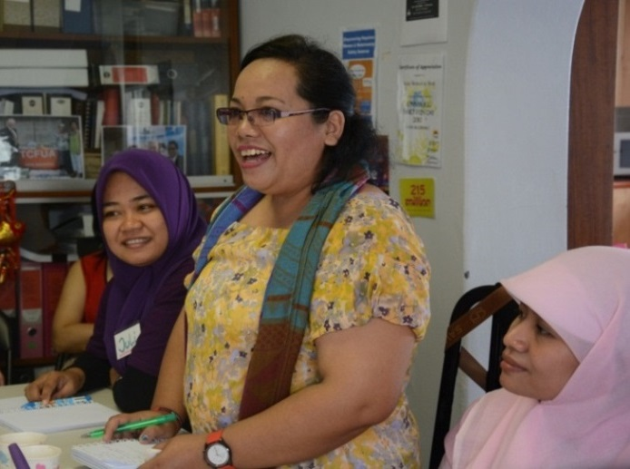A short course award was recently delivered to 25 women leaders working in women or gender-focused Indonesian civil society organisations as part of the Empowering Indonesian Women for Poverty Reduction Program. The short course—Organisational Leadership and Management Practice for Non-Government Organisations Empowering Women—responded to the need for organisations to strengthen their networks, distribute leadership responsibilities, engage with government agencies more effectively, and respond to changes in their external environment. The course also explored women’s leadership in the context of evidence-based advocacy, human resource strategies, organisational governance structures, and monitoring and evaluation of gender equality targets.

Berliana Purba, sharing her experiences and discussing how best to engage community and develop different types of activities, on a site visit to Asian Women at Work. Photo: University of Sydney

The course, designed and delivered by the University of Sydney, began with pre-departure needs assessment conducted in Indonesia. This was followed by two weeks in Australia with experts running sessions on topics including addressing barriers to women’s leadership; building staff capacity; the project management cycle through a gender lens; and stakeholder analysis and collaboration. Participants visited an Australian NGO—Asian Women at Work—which has a similar mandate, to initiate longer-term links between the organisations. All participants were expected to develop and refine a workplace reintegration plan while in Australia. Two months after the course, a three-day post-course workshop was held in Indonesia to follow up on progress, further develop networks and coalitions between participants, and cement knowledge and skills acquired. Ongoing communication and collaboration between participants and their Australian mentors is facilitated for six months after the in-Australia component of the award. While yet to be formally evaluated, one DFAT official in Jakarta noted:

*The course has proven to be really useful for these women and the development program. It is a really targeted course that has been tailored to their needs, and is embedded within the supportive structures of MAMPU. While the women participating are already very conscious of gender issues, the course provides them with knowledge, skills and networks that will hopefully make them less disenfranchised when they come across barriers as female leaders.*

Distance learning and split-site models

The experience of being in Australia is very important; if just online learning then you don't get that independence.

Alumna, private sector, Lao PDR

Family and professional responsibilities can make it difficult for some women to live overseas for the full time required for an Australia Awards Scholarship. Several alumnae suggested women’s access to Australia Awards could be improved by introducing distance learning or split-site models,[42] particularly for mid or senior career women for whom the experience of living overseas is likely to be less transformative. Such models are also lower cost (Table 5.3).

Distance education for both women and men has been trialled in Samoa. Support for distance education recently ceased due to concerns about low completion rates and, more significantly, high administrative demands for DFAT, which manages the awards directly.However, a review of findings of the Samoa trial and interviews suggest that Australia Awards should further explore opportunities to use distance learning to support women at middle or senior career levels. The Samoa review found completion rates for Masters level awards by distance education (77 per cent) were lower than those for students studying in Australia (90 per cent), and University of the South Pacific (84 per cent). However, degrees completed by distance learning cost significantly less and deliver good outcomes. Following completion of their distance education degrees, almost all alumni (87 to 93 per cent) reported supervising more staff, a greater role in policy making, more responsibility and increased leadership. All recipients were employed, with many in senior positions. The review found that the distance education awards delivered high-priority training for potentially influential individuals without negatively impacting on family or workplace employment.[43] The DFAT Scholarships and Alumni Branch should explore how the administrative demands of managing distance education could be reduced to make distance education a viable option for posts that directly manage Australia Awards.

I did a Masters in business administration with the University of New England by distance—it was enjoyable. It was good as I had the work experience that I could feed into the theoretical learning. [I chose distance] because it won’t displace me from the job that I am doing at that time. It was good for me because I was relating the learning and vice versa to the experience that I was having.

High-profile alumna, public sector, Samoa

It is important to note that the different types of award models are not proposed as a substitute for scholarships. There is evidence that scholarships have transformative, leadership-building effects on many women, but comparable evidence is not available for other types of Australia Awards. Different award types are an option for some partner countries, for some women, and in the context of a less expansive aid budget. The appropriateness and resource requirements for different types of Australia Awards should be part of the country-level analysis and will require close evaluation of possible impacts on women’s leadership.

**Recommendation 3**

DFAT should use different types of Australia Awards in addition to scholarships to build women’s leadership.

› All types of awards should be held to the same gender equality targets as scholarships and the performance framework for the Australian aid program.

## Supplementary leadership training

Leadership development programs designed specifically for women can be very effective through facilitating insights into the complexities involved in navigating gender in all aspects of life. These programs can also build leadership skills, including those needed to support others and develop an awareness of one’s own leadership style.[44] Networks established during women-only leadership development activities provide ongoing peer support.[45] Specific initiatives to build men’s support and advocacy for women leaders can also be effective and are becoming more prominent.[46]

Different leadership programs have had mixed outcomes. For example, the now discontinued Australian Leadership Awards Scholarships were explicitly intended to develop the leadership capabilities of a select group of ‘outstanding Australia Awards Scholarship recipients’. Selected scholars participated in leadership training and development discussions, and were given opportunities to connect with other awardees and key people from government, the private sector and civil society.

Analysis of the few tracer studies that have disaggregated data for leadership awardees found leadership outcomes were not significantly better in the Australian Leadership Awards Scholarship (ALAS) cohort.[47] Consistent with this finding, alumnae interviewed in both Indonesia and Lao PDR did not find the leadership program useful. An alumna in Indonesia’s private sector described how *‘There was not sufficient nuance. Things were described in pretty much black and white ways, when the context we work in is very much in shades of grey.’* Another alumna in Lao PDR described the program’s content as *‘rather generic’* and suggested that something more tailored to the different levels of experience was needed. Others noted that the types of messages promoted were pitched to them at the wrong time, when they were students and early career, rather than professionals needing to reflect and test things out in their workplace. However, both of the ALAS alumnae interviewed in Samoa thought the additional leadership focused activities were beneficial (Boxes 5 and 6).

In contrast, the alumnae interviewed consistently supported post-scholarship leadership development for women in their home environment. A number of alumnae in Samoa have participated in leadership development activities implemented through programs such as the Pacific Leadership Program and United Nations Development Programme. All spoke very highly of the skills and networks gained through these activities. One alumna, now in a very senior government position, advised that members of her cohort from an executive leadership program, funded by the Australian aid program, continue to meet and support each other almost a decade later:

There are a lot of them now in CEO positions [and we can call on them for] peer support. And in fact it really facilitates how we operate. Some people might say ‘oh you are playing favouritism’. But it is the understanding that is reached in the program … We have always maintained that CEOs of the time should have also gone through this. A lot of them come to the forums we have had and they say ‘oh we just don’t have what you have’.

Within Australia Awards there is some innovation in post-award training. The recently launched Mongolia initiative (Box 11) is particularly promising as it addresses country-specific barriers that most limit leadership opportunities for alumnae. It works with both women and men to further women’s leadership. In comparison with the cost of scholarships and short course awards the budget for the in-country training is modest.

This evaluation contends that post-award leadership courses delivered in country for both women and men are likely to be a cost-effective way to improve women’s leadership outcomes from scholarships. Courses could be delivered as part of alumni engagement, and would be much less costly than short course awards.

**Recommendation 4**

DFAT should explore options for post-scholarship leadership development for women, and to build male supporters of, and advocates for, women leaders.

Box 11 Combining in-country leadership development with short course awards: working with women and men in Mongolia

Although more women than men complete tertiary education in Mongolia, there are few women in senior leadership positions both in general, and relative to the numbers of women in the workforce. This occurs despite what appears to be an enabling environment for women. A law promoting gender equality developed in 2011 includes quotas to promote women’s leadership in government agencies and in the political sphere. It also includes provisions designed to reduce sexual harassment and gender-based discrimination in the workplace.

Women receive approximately 70 per cent of Australia Awards in Mongolia, but face significant challenges in using their skills, knowledge and confidence on return. Tracer study data show that alumnae are much less likely to rise into leadership positions compared to their male peers. Australia Awards in Mongolia has subsequently launched a women’s leadership program, to be delivered to three different cohorts of women in the coming years.[48] The initiative is aiming for annual cohorts of approximately 25 individuals with a 70:30 female to male split, mirroring the composition of the Australia Awards Scholarships. The in-country component extends over eight months and includes sessions with prominent business, community and government leaders, networking events, gender training, coaching and mentoring, and discussion of development issues in Mongolia and ways alumni can affect change. Groups of participants will be supported to initiate gender-focused projects. This will be followed by an in-Australia short course award component that will be offered to participants selected by a competitive application process. This part of the program will link alumni with relevant leaders and organisations in Australia.

## Workplace reintegration planning

Reintegration planning is being increasingly used in an attempt to address difficulties faced by alumni returning to workplaces, particularly in the public sector. Before or during the award period, awardees and their supervisors, or human resource departments, formalise a workplace reintegration plan, which is revisited upon return. About two-thirds of both women and men reported having a reintegration plan. Overall, women were slightly less likely than men to have a reintegration plan, reflecting the lower proportion of women returning to work in the public sector. In some countries women in the public sector were more likely than men to have a reintegration plan, but in other countries the situation was reversed (see Appendix D, Table D.7). The proportion of alumnae returning to the public sector who had reintegration plans varied greatly between countries, from a low of 14 per cent in Nepal to 100 per cent in Sri Lanka.

In interviews, alumnae reported a range of factors that they felt limited the usefulness of reintegration plans. Indonesian alumnae described a lack of employer or supervisor engagement around the plan on return, and said that promotion and leadership opportunities resulted from ‘being in the right place at the right time’ rather than from formal processes and measures. African alumnae cited supervisor changes, the alumna being transferred or leaving their job, and unpredictable events and crises within their organisations as limiting factors.

## Alumni associations

We have to sort of pave the way, and then the others will come through. But we have to be more strategic. While the doors are not quite open we need to cut through windows, and put windows in where there are walls.

Technical specialist, Samoa

Australia Awards Scholarship alumni associations have been established in many countries to maintain engagement with scholars. The stated purposes of this engagement are enhancing the Australia Awards reputation and identity; ensuring that alumni from developing countries have increased opportunities for contributions to development and research; providing increased opportunity for collaboration among alumni to achieve common goals; and increasing contributions by alumni network members to the successful delivery of the Australia Awards.[49] An electronic database is used to keep track of alumni and invite them to functions, including annual networking events and a small number of professional development activities.

Alumni associations have the potential to build women’s leadership outcomes from scholarships, and help address some of the barriers facing women, by facilitating the following:

*Building peer support.* An Indonesian alumna spoke of her experience of being continually denied promotion by a male CEO, leading her to connect with another alumna, saying:

We are ADS [Australian Development Scholarship] scholars … we need to advance ourselves no matter what. [In the years following] we became best friends. We supported each other to stay in the organisation when things were tough. Now like me, she has been promoted as well. High-profile alumna, private sector, Indonesia

*Establishing mentoring relationships,* connecting junior and senior alumnae within particular workplaces, or fostering a desire for senior alumnae to give back to other women in the workplace:

I encourage my women colleagues, especially if we have meetings … to be confident. High-profile alumna, public sector, Lao PDR

I am happy to share my experiences of studying in Australia with them in hope that they will also seek this opportunity. I try to provide a mentorship and support role to them. High-profile alumna, public sector, Indonesia

*Broadening networks*, connecting alumnae with possible mentors and sponsors working in the same area but from outside their own direct supervisory line.

This evaluation found that, to date, most alumni associations have not been used effectively to support women’s leadership. The rates of participation in alumni events have been low especially for women.[50] In interviews in both Indonesia and Lao PDR, most alumnae were members of the associations but had minor involvement. Alumnae felt that events were primarily social, usually too large for effective networking and not relevant to their own professional interests. As women are often time-poor, the general sentiment expressed was that engagement in alumni associations as they are at present was not worthwhile. Alumnae were consistently unable to identify any benefits they had derived from alumni associations.

Another problem identified was that some alumni associations have not been adequately resourced, and at the country level lacked a clear purpose. Alumni have been expected to maintain databases with little support and often without a financial contribution from the program. It is unrealistic to expect alumni to undertake the burdensome task of maintaining a large database. The level of funding provided for events and activities has also been relatively small. Some of the alumni interviewed who had energetically engaged with alumni associations appeared to be disillusioned.

Nevertheless, many alumnae interviewed enthusiastically supported using alumni associations to support women’s leadership. Alumnae in Indonesia and Lao PDR suggested that sectoral, technical or leadership workshops could help support women’s leadership. In Vietnam, women have recently been found to be just as likely as men to actively participate in the alumni professional development events. One high-profile Indonesian alumna felt that it was critical that *‘the sisterhood, a circle or reference group of support like this is quite significant for women to give them strength and support in challenging the structural as well as cultural barriers for their leadership pathways*.*’* Many alumnae are keen to ‘give back’ and expressed a willingness to support other alumnae by helping them reintegrate into work or being mentors.

Alumnae in all field study locations expressed interest in greater support on re-entry through workshops held for scholars returning home from study in Australia (or abroad), particularly if these could be used to establish connections with past alumnae. This is in part to prepare them for the ‘reverse culture shock’ often faced on return, but also as a forum to discuss how they might try to overcome the barriers they are likely to face. Re-entry workshops could be used to establish mentoring relationships and peer support networks.

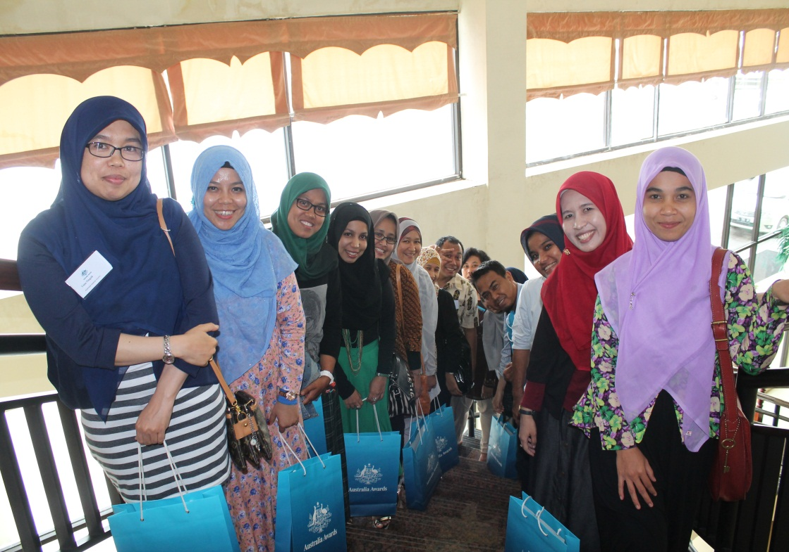

Australia Awards Scholarship alumni at a re-entry workshop in Aceh, Indonesia. Photo: Andi Azka, Australia Awards in Indonesia (Coffey International)

The Africa Women in Leadership Network, which was established in 2013, provides a good model of how alumni associations can be used to support women’s leadership (Box 12). This network has several objectives, including promoting Australia Awards to, and thus increasing applications from, eligible female candidates. Members are encouraged to engage in and provide leadership for gender and development initiatives in their home country. Currently, the network has been well received, having 235 members across 39 African countries. While it is too soon to assess outcomes from the network, early results are promising. The usefulness of establishing similar women’s leadership networks in the Pacific and other priority regions or countries with large scholarship allocations should be explored. The online platform component of the Africa Women in Leadership Network appears to be a cost-effective way to support alumnae as they move into leadership positions. If alumni associations are to be used to build women’s leadership, they need to be adequately resourced and work strategically.

Box 12 Engaging women alumnae: the Africa Women in Leadership Network

The Africa Women in Leadership Network, launched in March 2013, is an important resource for prospective, current and past Australia Award recipients in Africa to connect with and support each other as current and future female leaders. In a recent survey, almost all network members felt that it assists women in the transition to life in Australia, helps to forge relationships between African women, and builds confidence among and support for alumnae.[51]

There have been two network events: a ‘women in leadership’ forum and an ‘empowering women in Africa’ meeting. These events brought together alumnae from across Africa to discuss leadership in the African context and articulate some of the challenges they face. Together these events cost about $100,000. In interviews, alumnae reported that these events were beneficial because they built new professional relationships and coalitions of support. They spoke of being *‘exposed to female colleagues, in similar situations to yourself who are contributing a lot despite circumstances that are even more difficult than your own … this keeps you motivated to keep at your goals’* (alumna, public sector, Kenya), and being inspired to *‘do something yourself’* (alumna, public sector, Uganda). Documentation from the events facilitation team suggests the events have enabled alumnae to collectively brainstorm ways of overcoming leadership struggles and consider how they might jointly advance gender and development initiatives.

Members communicate using Africa Connect, Australia Awards in Africa’s social media platform. The online platform is routinely moderated by staff and regularly used by 75 per cent of network members. The costs of maintaining the network are relatively small, being about $5000 annually.

Alumnae reported that the online platform was useful for keeping in touch with members in other countries, and as a critical mechanism of support for professional and personal challenges faced on return: *‘Through Africa Connect you can articulate your own challenges and contribute solutions to the problems other women are facing. We work collectively to solve each other’s problems’* (alumna, private sector, Uganda). Another alumna reported that through her interactions on Africa Connect, she had gained important insights on how best to further her career within the public sector from other women who had faced similar challenges (alumna, public sector, Kenya).

The survey of network members also found that 43 per cent of respondents had become more engaged with and were providing leadership on gender equality and social inclusion initiatives in their workplace and countries since joining the network. Examples ranged from working on policy issues around gender awareness and social inclusion to supporting program development and implementation from a gender equality standpoint,[52] and establishing credit or microfinance groups for women to assist female widows, and starting or expanding small enterprises.

In general, the Africa Women in Leadership Network was seen as a way of ensuring women maintain their sense of agency and vision for change on return from Australia. One alumna in the public sector in Kenya noted: *‘We need the constant encouragement of other women to keep pursuing our goals, particularly when we return to settings where we often face challenges to make impact. The network ensures that we don’t give up on our dreams.’*

## Assessing and learning from experience

Measuring women’s leadership outcomes

Tracer studies involving questionnaires for returned alumni, sometimes combined with additional qualitative or case study methods, are a key part of the monitoring and evaluation of scholarships. Considerable efforts have been made to standardise tracer studies and ensure they are regularly used so that they become useful tools for longitudinal tracking of outcomes. The DFAT Scholarships and Alumni Branch is continuing work towards establishing a Global Tracer Facility so that tracer studies are used consistently and regularly, to build a strong body of evidence to demonstrate the development contributions and public or economic diplomacy outcomes of Australia’s investment in Australia Awards.

Tracer studies provide useful information about alumni and development impacts, but are not as useful as they could be for assessing leadership outcomes. As improving leadership is a goal of the awards, and enhancing women’s voice in decision-making and women’s leadership have been identified as areas for *‘strong investment’*,[53] tracer studies need to be designed to provide quantitative and qualitative data to assess leadership outcomes for both men and women.

The following steps are needed to ensure the common tracer study protocol can be used to assess leadership outcomes. The first step is to develop a results chain that links inputs (the awards and supplementary programs) to leadership outcomes. . Tracer study questionnaires then need to be aligned with intended outcomes and streamlined. At present, neither the Australia Awards Global Monitoring and Evaluation Framework, nor the Australia Awards Global Program Logic, specifically refer to leadership development objectives The current questionnaire is too lengthy to maximise compliance and becomes less relevant as time since return passes. Modifications to tracer studies should include:

* shortening the questionnaire by removing less useful questions and employing a panel structure whereby alumni only complete sections relevant to their time since completion. This should increase the number of tracer study respondents
* asking specific leadership-focused questions
* asking questions that look at leadership outside the workplace
* ensuring questions are experience based rather than perception based to limit gender bias[54]
* standardising questions to enable disaggregated analysis of consolidated data
* requiring all analyses of tracer data to be gender disaggregated.

Processes for maintaining contact with alumni should also be revised to improve compliance rates. Tracer studies could also include more reflective monitoring and evaluation, drawing on case studies, in-depth alumni and third-party interviews, and secondary data sources such as media reports. Such processes could explore both the contribution of Australia Awards to women’s leadership, and contribute to greater understanding of what works.

As discussed in the methodology section (Section 2.3), a limitation of this evaluation is that the data are likely to have a positive bias. The proportion of alumnae who gained limited benefit from their scholarship is likely to be higher for those who could not be contacted or non-respondents. Much could be learned from analysis of the experiences of less successful alumnae. The DFAT Scholarships and Alumni Branch should identify countries that have larger scholarship allocations and low compliance rates for tracer studies, especially for women, and trial approaches to follow up on a sample of non-respondents.

Facilitating innovation by sharing experience

Devolving the management and implementation of scholarships to posts has provided the flexibility to ensure awards are responsive to country contexts. However, this has also meant that lessons are not adequately shared. For example, posts were generally unaware that Apia Post (Samoa) had trialled and evaluated scholarships for distance education. The managing contractors responsible for more than one Australia Awards program share best-practice knowledge between the contractor’s teams, rather than through posts or DFAT. The DFAT Scholarships and Alumni Branch should actively collate information from posts and managing contractors and ensue it is stored so that it is accessible by all country programs. This could be managed through online communication channels, as well as through inclusion of good practice examples in the Australia Awards design toolbox.

**Recommendation 5**

The DFAT Scholarships and Alumni Branch should revise existing monitoring and evaluation to include a specific focus on leadership outcomes, and establish processes to share knowledge between country posts.

## Making women’s leadership an explicit aim

This evaluation has found that Australia Awards Scholarships make a clear contribution to women’s professional advancement and leadership. Scholarships are particularly transformative for women from less economically advanced countries where there is pronounced gender inequality and limited opportunities for tertiary study. In such contexts, Australia Awards investments should strongly focus on scholarships in preference to other types of awards and supplementary activities. For scholarships, a more explicit focus on women’s leadership would yield better results. An explicit women’s leadership aim is in accordance with Australian aid program and performance framework priorities.

**Recommendation 6**

DFAT should continue to invest in scholarships and make building women’s leadership an explicit goal of scholarships.

Country-level analysis and planning should identify how the awards modality can be best used to complement other Australia aid program initiatives to build women’s leadership. Guidance for such analysis should be incorporated in the Australia Awards design toolbox (managed by the DFAT Scholarships and Alumni Branch). In summary, the analysis should include:

* assessment of women’s leadership gaps (e.g. in the public or private sector, in particular fields, in informal versus formal settings)—asking *‘where do opportunities for women to have a more equal footing with men need to be opened up or strengthened?’*
* areas of inequality or development priorities where strengthened women’s leadership may be of influence—asking *‘where can women leaders play a stronger role representing the needs and interests of others; where is more diversity needed?’*
* change processes relevant to those gaps and areas of inequality or development priorities—such as the importance of the role of national women’s institutions, civil society, social movements, traditional leadership structures, academia, the private sector and the media—asking *‘where is there momentum to overcome barriers or promote enabling factors?’*

Box 13 ‘The best way to promote a woman, is to promote a woman’[55]

Australia Awards in Vietnam has the explicit objective that *‘Women and men have equal opportunity of obtaining Masters and PhD scholarships in order to develop and utilise new skills and contribute to development in the priority development areas and to gender equality in Vietnam’*. The program has been successful in increasing the number and success rate of scholarship applications from women. Many alumnae have senior professional roles and are influential figures in the public and private sectors. However, tracer studies have found a persistent pronounced gender gap in leadership opportunities and outcomes upon return to Vietnam. In light of this, DFAT commissioned a number of preparatory studies to inform the design of the next phase of awards[56]. The study aims to understand the factors that explain alumnae’s lower access to promotion and senior roles, and to suggest strategies for supporting women interested in leadership pathways.

Twelve options have been proposed for the new human resource development program to work to specifically improve women’s leadership outcomes for alumnae. Findings from this evaluation suggest that some of these may be effective. One promising option is to host events, including an ‘inspirational women series’ for outbound and returned alumnae, networking events between junior and senior women, and a networking event with successful Australian women in equivalent institutions (in coordination with Austrade and Australian Education International). Another option is to hold a series of skill-building events, open to all alumni but responsive to issues raised by women.

Study participants were invited to prioritise the 12 options proposed. For alumnae, the overwhelming first priority was short courses on leadership skills (e.g. public speaking, strategic thinking), and for male alumni, to ‘engage leaders within organisations in supporting women’s career development planning’. This was the second choice for alumnae.

Appendix A Scholarship Courses

Table A.1 Courses undertaken by recipients of Australia Awards Scholarships in 2014

| Course | Number of Australia Awards Scholarships |
| --- | --- |
| Masters degree (coursework) | 1,653 |
| Doctoral degree | 195 |
| Bachelor degree | 118 |
| Masters degree (research) | 32 |
| Graduate diploma | 14 |
| Diploma | 11 |
| Advanced diploma | 4 |
| Associate degree | 2 |
| Certificate IV | 1 |
| Total | 2,030 |

Note: Excludes Australia Awards Pacific Scholarships and Australian Centre for International Agricultural Research scholarships.

Table A.2 Courses undertaken by recipients of Australia Awards Pacific Scholarships in 2014

| Course | Number of Australia Awards Pacific Scholarships |
| --- | --- |
| Bachelor degree | 242 |
| Certificate | 187 |
| Diploma | 132 |
| Masters degree (coursework) | 9 |
| Postgraduate diploma | 9 |
| Graduate diploma | 2 |
| Doctoral degree | 1 |
| Graduate certificate | 1 |
| Masters degree (research) | 1 |
| Total | 584 |

Appendix B Types of Australia Awards

There are currently four main types of Australia Awards:

**Australia Awards Scholarships** are prestigious grants to individuals selected from large numbers of applicants by rigorous processes. They provide a range of benefits to individuals from more than 30 eligible countries to enable them to complete long-term (1–4 year) academic programs, at Australian higher education institutions. Australia Awards Scholarships are the most common type of award and represent the largest investment. In the 2015 intake, the largest recipient countries/regions are Indonesia (515), Papua New Guinea (185), Vietnam (185), Pacific excluding Papua New Guinea (138) and Philippines (110).[57] Scholarship benefits include tuition fees for Australian tertiary institutions, return airfare, living expenses, overseas student health cover, and preparatory programs—including an introductory academic program covering information on life and study in Australia, and English language training.

**Australia Awards Pacific Scholarships** are offered to people from Pacific countries to study at tertiary institutions in other Pacific countries. Scholarships are provided for study in Fiji, New Caledonia, Papua New Guinea, Samoa, Solomon Islands and Vanuatu. Scholarship entitlements vary between countries and institution of enrolment but typically cover tuition and other compulsory fees, return airfare, living expenses, an establishment allowance and a living allowance paid fortnightly. In some countries the living allowance may be paid at a higher rate when the student is joined long term by one or more family members. The number of scholarships and fields of study are determined annually as part of Australia's bilateral development assistance program with the particular country.

**Australia Awards short courses** are based on proposals developed by Department of Foreign Affairs and Trade (DFAT) posts. The courses were introduced in 2011 as a response to partner governments’ demand for short-term, targeted training to fill skill gaps. The topics of the courses are linked to development priorities. Higher education providers and training organisations express interest in running courses and, if selected, submit tenders. The courses are flexible in both structure and length. Short courses may involve academic study, placements, site visits and opportunities to network, with components in Australia and home countries. The length of courses varies from two weeks to several months. There is typically an introductory component in the home country, a series of organised classes and visits in Australia, and a concluding session on return home. Awards cover the cost of training as well as airfares, accommodation and living expenses for participants.

**Australia Awards Fellowships** are initiated by Australian organisations that have links with counterpart organisations in approved countries in any sector to *‘deepen and broaden their links with leaders and professionals in developing countries’.*[58] Fellowships are for short-term, non-degree based study and professional development in Australia, and are targeted at *‘current and future leaders and mid-career professionals, who will be in a position to advance priority foreign affairs and development issue*s’.[59] Fellowships cover airfares, accommodation and living expenses for participants and also costs for Australian organisations.

Appendix C Detailed methodology

Approach

As Australia Awards Scholarships were not designed to specifically develop women’s leadership, the evaluation explored promising practices and results, rather than evaluating against a fixed model or theory of change. The methodology aimed to be sensitive to context, and sufficiently flexible to enable investigation of the different strategies and approaches being implemented in different countries.

Preparation

Early in the process two short discussion papers were produced, one proposing an overall approach to the evaluation, and one outlining issues and an approach related to selection of field study locations. These were used to guide initial consultations held with DFAT staff in Canberra, and later with selected field study sites. Following this, an evaluation plan was produced and reviewed by a number of personnel from the DFAT Scholarships and Alumni Branch, as well as gender technical advisers, ODE staff, and DFAT’s Independent Evaluation Committee.

The initial discussion paper and evaluation plan identified and included a number of additional activities or strategies that were hypothesised to potentially contribute to women’s leadership:

* networking activities, particularly through alumni groups and associations
* targeting particular institutions and building a critical mass of alumni or alumnae
* workplace reintegration strategies, including work with the institutions to which alumni return
* supplementary leadership development programs integrated with scholarship provision, including the Australian Leadership Awards Scholarships.

Data collection

For rigour and to allow for cross-checking of findings, the evaluation employed five main processes: document review; field studies; telephone interviews; quantitative global analysis of existing tracer study data; and formal and informal consultations.

The **document review** encompassed both a general literature search and a structured analysis of documents specifically related to implementation of and outcomes from Australia Awards.

The general literature search was conducted using the Educational Resources Information Centre (ERIC) to identify contemporary literature. This used various search string combinations of gender/women, leadership, scholarship/fellowship, and international development. The search identified minimal academic literature on the relationship between scholarships and leadership, and even less on women’s leadership or promotion of gender equality. Therefore, to capture ‘grey’ literature, additional searches were conducted using Google. Finally, manual searches were conducted of a small selection of websites of the following:

* donors with scholarship programs—United States Agency for International Development, Department for International Development (United Kingdom), Norwegian Agency for Development Cooperation, Danish International Development Agency, New Zealand Ministry of Foreign Affairs and Trade, Japan International Cooperation Agency, Canadian International Development Agency
* multilateral development agencies—Asian Development Bank, World Bank, Organisation for Economic Co-operation and Development–Development Assistance Committee, European Union
* gender or leadership focused institutional websites—Pacific Leadership Program, Developmental Leadership Program, Association for Women’s Rights in Development, International Knowledge Centre of Women in Politics, and the International Center for Research on Women.

Documents provided to ODE included tracer study report and data files for most of the larger scholarship recipient countries, available evaluations and reviews prepared by managing contractors, and a selection of DFAT policy, strategy and design documents.

The review of general literature was used to identify key factors associated with women’s leadership development. This provided the framework for analysis of the tracer studies and other internal documents.

**Field studies** were conducted in Lao PDR (Vientiane, 2–10 February 2015; Luang Prabang, 11–12 February); Indonesia (Jakarta, 16–20 February; Banda Aceh, 21–25 February 2015); and Samoa (Apia, 2–6 March 2015). Lao People’s Democratic Republic (PDR) and Samoa field studies were undertaken by Karen Ovington and Anne Lockley, and the Indonesia field study by Karen Ovington and Ritesh Shah. An additional cluster of telephone interviews was completed by Ritesh Shah with East Africa alumnae and Australia Awards management personnel based in Nairobi and Pretoria.

The field study locations were chosen to cover different settings: large and small awards programs; large and small countries; programs that had or did not have a managing contractor; different political, cultural and gender equality contexts; and different Australian aid program portfolios. Country selection also considered the willingness and capacity of Australia Awards management (DFAT and managing contractors) to support the logistics of the field study visits, as well as whether the locations were already or had recently been the subject of other ODE or awards-focused evaluations. The desire to explore the range of components of the Australia Awards program also influenced choice of field study locations. The regional Africa interviews were arranged specifically to develop a case study of the Africa Women in Leadership Network. This network was considered highly relevant and was the only initiative of its type identified through the document review.

Due to privacy considerations, it was necessary for the initial invitation to participate in the evaluation to be forwarded by DFAT or the Australia Awards managing contractor in each country. The sampling frame included alumnae who had completed their awards five or more years ago, high-profile individuals and women in leadership positions. In addition, the team aimed to interview a minimum of five alumnae in each location who had participated in each of the supplementary award activities. In reality, many alumnae had participated in multiple activities and so the sample per supplementary activity was much larger than five.

**Telephone interviews**. In East Africa, the alumnae interviewed were active members of the Africa Women in Leadership Network who had participated in the ‘women in leadership’ forum. Through the managing contractor, a de-identified list of individuals who met these criteria was provided to the evaluation team, and interviewees were purposively selected based on their stated development and leadership contributions (included on their application form to the network or to one of the forums), as well as their sectors of employment. Eight of 13 individuals contacted by email by the managing contractor were interviewed by telephone.

In each field study location saturation was reached through the interviews, in that findings were largely consistent and no new information was forthcoming in the later stages.

A small number of male alumni were interviewed to explore male experiences of personal change brought about by studying in Australia, as well as their perceptions of barriers and enablers for women’s leadership. Finally, a selection of private and public sector workplace supervisors of alumnae, DFAT and managing contractor staff, and other technical specialists were interviewed to provide additional reference points for the analysis. Detailed notes or full transcripts were prepared from the interviews.

Table C.1 Breakdown of interviews in each field study location

| Interview group | Samoa | Lao PDR | Indonesia | Africa |
| --- | --- | --- | --- | --- |
| DFAT | 3 | 3 | 2 | 1 |
| Managing contractor | NA | 7 (includes 4 alumnae) | 4 | 7 (Nairobi and Pretoria) |
| Other programs | 1 | 1 |  |  |
| Supervisors, colleagues | Alumnae only | 6 | 10 |  |
| Alumnae |  |  |  |  |
| Alumnae in public sector | 10 | 11 | 19 | 5 |
| Alumnae in private sector (includes civil society) | 3 | 10 (+4 alumnae who work for managing contractor)* | 8 | 3 |
| Total alumnae interviewed | 13 | 21+4 | 27 | 8 |
| Alumni in public sector/targeted agencies | 1 | 6 | 8 |  |
| Alumni in private sector (includes civil society) |  | 3 |  |  |
| **Total** | **18** | **46** | **51** | **24** |
| Included in the above |  |  |  |  |
| Australian Leadership Awardees | 2F | 3F, 1M | 5F |  |
| High-profile alumnae | 6 | 5 | 12 |  |
| Geographic focus area/non-capital city alumnae | NA | 2 | 10 |  |

* These are listed separately, as this group were involved in a consultation meeting with the managing contractor, rather than a structured interview.

The field studies and regional Africa case study employed a semi-structured interview format. Interviewees who were awards alumni had been provided with a brief of the project that emphasised the focus on leadership, but not the direct consideration of scholarships. Alumnae interviews started with broad questions about the meaning of leadership in that context, and the interviewee’s leadership development pathway. The aim was to enable alumnae to make their own connection between their leadership and the contribution of the scholarship to their own development (if applicable), rather than directly prompting for that connection to be made.

**Quantitative global analysis of existing tracer study data** was undertaken. This was done to assess the results achieved from scholarships overall and because the document review identified that most analyses of tracer study data had not been disaggregated on the basis of gender or time since completion. Data sets from tracer studies of Australia Awards Scholarship alumni from different countries were merged into one file to enable secondary analysis. This created a large data set which enabled analyses not possible with single country data sets with small sample sizes. In total, 14 data sets (Table C.2) were combined, matching as many variables as possible. While most tracer studies reported that the sample of respondents was similar to the characteristics of the overall alumni population, the samples alone or as a whole cannot be considered representative. Further, inconsistent inclusion of key variables means that multiple disaggregation (e.g. such as by region and type of employer) has resulted in sometimes small numbers of complete cases. Data tables are included in Appendix D.

Table C.2 Tracer study data sets included in the secondary analysis

| Country | Survey year |  | Country | Survey year |
| --- | --- | --- | --- | --- |
| Cambodia | 2014 |  | Philippines | 2014 |
| Fiji | 2011 |  | Prime Minister’s Pacific Program | 2014 |
| Indonesia | 2012 |  | Solomon Islands | 2013 |
| Kiribati, Tuvalu and Nauru (combined tracer study) | 2013 |  | South Asia combined tracer study:  Bangladesh, Bhutan, India, Maldives, Nepal, Sri Lanka | 2012 |
| Lao PDR | 2009–10 |  | Timor-Leste | 2013 |
| Pakistan | 2011 |  | Tonga | 2014 |
| Papua New Guinea | 2013 |  | Vietnam | 2011 |

The following steps were undertaken to merge the data sets:

* DFAT provided depersonalised data sets, in the form of excel spreadsheets. Initial data cleaning was undertaken and gaps identified.
* Variables from all the tracer studies that relate to evaluation question one (e.g. promotion, position, changes in income, organisational/institutional roles, skills use) were mapped to determine levels of consistency among the questions. Also mapped were other variables that were routinely used and considered potentially useful for DFAT in future examination of the consolidated data set. In total, 130 variables (excluding identifiers) are included in the consolidated data set. Tracer study identifiers have been included in the consolidated data set to enable individual cases to be traced to their original tracer study data set.
* All variables were checked for consistent wording and scaling. A small number of questions had different wording but appeared to have the same intent and were thus combined. For the most part, scaled responses were consistent across the tracer study data sets. Two 4-point scales were converted to yes/no responses.
* Data was recoded to make the files importable to the software package Statistical Package for the Social Sciences (SPSS) for analysis.

**Formal and informal consultations** with individuals who have been involved in the design, delivery or evaluation of Australia Awards were carried out throughout the evaluation. This included staff currently or previously in the DFAT Scholarships and Alumni Branch, other DFAT staff in Canberra and at some country posts, and staff of managing contractors.

Data analysis

Qualitative analysis

The field notes and interview transcripts were first sorted into themes by country. These were presented as country data reports for sharing back with the Australia Awards staff as well as to facilitate cross case analysis. The sorting was in two stages: (1) against the key evaluation questions, and (2) into sub-themes based on content. The first field study (Lao) was used as a model for sub-themes, but others were added as relevant for Indonesia and Samoa. At the end of the three field studies the evaluation team met to discuss preliminary findings and emerging recommendations.

Cross case analysis was firstly based on the four key evaluation questions. The evidence gathered from the various sources was first mapped against the questions, and cases that either supported or did not support the hypotheses were identified. This gave attention to consistent and differential findings between field study sites as well as with the findings of the document review.

Quantitative analysis of tracer study data

The first stage of the analysis involved cross-tabulations to display the frequency distribution of the variables using different disaggregation: male/female (always); time since completion; general scholarship or Australian Leadership Awards Scholarship; and country of citizenship. To ascertain whether statistically significant differences were present in variables indicating professional advancement and leadership between men and women, chi-square statistical analyses were conducted. A 95 per cent confidence interval, that is *p≤*0.05, was used as the cut-off for statistical significance.

Chi-square tests are appropriate when variables are categorical and when the sample size is sufficient to meet the minimum sample size per cell. Where the minimum sample size per cell was not met, the likelihood ratio was used to determine the *p* value. Chi-square procedures tell if a relationship exists, but not the size of its effect.Cramer’s V was calculated to determine the effect size as per the guidelines set out below.[60]

Table C.3 Effect sizes for Cramer’s V

|  |  |  |  |
| --- | --- | --- | --- |
| Degrees of freedom | Small | Medium | Large |
| 1 | 0.10 | 0.30 | 0.50 |
| 2 | 0.07 | 0.21 | 0.35 |
| 3 | 0.06 | 0.17 | 0.29 |

These statistical analyses were used to determine if a relationship exists between certain variables, and how strong that relationship is. However, these statistical analyses do not allow for judgments regarding *causality*—that is, whether one variable has had an impact upon another.

Data compilation

Analysis in relation to the first evaluation question *‘Do scholarships increase women’s professional advancement and leadership?’* combined and compared the reported examples provided in the interviews with the original analysis of the tracer studies. This analysis further compared these findings with the results of the secondary quantitative analysis of the consolidated tracer study data undertaken as part of this evaluation.

To analyse data for the evaluation questions *‘How do scholarships impact on women’s professional advancement and leadership?’ and ‘How could scholarships better contribute to women’s leadership?’,* the data was structured according to the different activities or strategies linked to Australia Awards, as well as completion of study in Australia in and of itself. This analysis focused on *‘what appears to work for whom in what context?’*

Analysis of the question *‘What barriers are there to women achieving leadership?’* compared responses to specific questioning on this, with analysis from the general literature. A matrix was used to identify barriers and enablers active in each field study site. A small number of relevant variables were also explored in the analysis of the consolidated tracer study data. This primarily explored differences between male and female tracer study respondents’ self-reported experiences of being able to apply their skills after return.

The evaluation team met at the completion of the field studies to develop preliminary recommendations. Recommendations from field study participants and previous scholarship studies and reviews were analysed with consideration of lessons identified in the general literature, particularly related to women’s leadership development models.

Limitations

It is important to note that this evaluation is focused on self-reported changes and results. Some effort was made to provide different perspectives through interviews with supervisors, awards program management, and other technical experts. Alumni (male and female) interviews also included a level of reflection on peers who had or had not had the experience of an international education. But in general, where interviewees reported particular contributions to development or results from their leadership, these have not been independently verified.

It was not possible to visit a larger sample of awards countries within the time and resources available. While country selection endeavoured to ensure a cross-section of different contexts, the findings cannot be assumed to be representative across all Australia Awards locations. We also made considerable effort to draw on available documentation from a wider range of awards locations.

The selection of interviewees was limited to those that DFAT or the managing contractors responsible for in-country implementation of Australia Awards were able to contact or knew to be Australia Awards Scholarship alumni. While a sampling frame was employed, and initial selection of individuals to be interviewed was often made by a member of the evaluation team, individuals selected were not always available and DFAT or the managing contractor often provided alternatives. It is reasonable to assume that the identification and selection of individuals by posts or the managing contractor has meant that a more successful pool of participants was identified than may be the average. Given the topic of the evaluation and the approach to seek good examples, this is not seen to be a particular problem.

The tracer studies, which were a substantial component of the document review and the basis of additional quantitative analysis, are limited to self-reported outcomes. It is also important to note that the analysis is limited by the completeness and accuracy of the contributing individual tracer study data sets. While some of these tracer studies reported high response rates for those who were able to be contacted, the data cannot be assumed to be representative of the experiences and views of all alumni, either in each country or as a whole.

A number of issues were encountered when merging the data sets. Of particular note are the following:

* All cases from Vietnam (n=785) and Cambodia (n=220) and a further 39 cases from other countries are missing year of scholarship completion (in total, 29.7 per cent of the data set). Therefore, these were not included in the time-based cohort analyses.
* There is an inverse relationship between the numbers of responses to tracer survey questionnaires and the time since completion (see Table D.1). Therefore, particular care should be taken when comparing time-based cohorts. Time-based analysis is most useful for the newer returned cohorts.

Appendix D Global tracer study data

Table D.1 Nationality and time since completion, tracer study respondents in global data set*

*Note that time since completion was not included in the data files for Cambodia and Vietnam. This table does not include missing values, and so there may be some variation between total numbers and the sum of the time-based cohorts.

|  | **Total numbers** | | | **Less than 3 years post completion** | | | **3–5 years post completion** | | | **6–8 years post completion** | | | **9 or more years post completion** | | |
| --- | --- | --- | --- | --- | --- | --- | --- | --- | --- | --- | --- | --- | --- | --- | --- |
| **Women (W)** | **Men (M)** | **Total (T)** | **W** | **M** | **T** | **W** | **M** | **T** | **W** | **M** | **T** | **W** | **M** | **T** |
| ***South Asia*** | | | | | | | | | | | | | | | |
| Bangladesh | 75 | 80 | 155 | 14 | 19 | 33 | 30 | 37 | 67 | 14 | 14 | 28 | 17 | 9 | 26 |
| Bhutan | 45 | 81 | 126 | 10 | 16 | 26 | 17 | 36 | 53 | 12 | 15 | 27 | 6 | 14 | 20 |
| India | 1 | 2 | 3 | 1 | 1 | 2 |  |  |  | 0 | 1 | 1 |  |  |  |
| Maldives | 47 | 21 | 68 | 4 | 5 | 9 | 21 | 9 | 30 | 12 | 6 | 18 | 10 | 1 | 11 |
| Nepal | 45 | 40 | 85 | 6 | 2 | 8 | 9 | 7 | 16 | 16 | 18 | 34 | 14 | 13 | 27 |
| Pakistan | 65 | 95 | 160 | 31 | 48 | 79 | 19 | 32 | 51 | 5 | 3 | 8 | 3 | 2 | 5 |
| Sri Lanka | 28 | 32 | 60 | 6 | 8 | 14 | 12 | 11 | 23 | 7 | 7 | 14 | 3 | 6 | 9 |
| ***Mekong*** | | | | | | | | | | | | | | | |
| Cambodia | 64 | 156 | 220 |  |  |  |  |  |  |  |  |  |  |  |  |
| Lao PDR | 159 | 194 | 353 | 36 | 34 | 70 | 34 | 30 | 64 | 28 | 38 | 66 | 61 | 92 | 153 |
| Vietnam | 460 | 325 | 785 |  |  |  |  |  |  |  |  |  |  |  |  |
| ***Melanesia*** | | | | | | | | | | | | | | | |
| Fiji | 44 | 33 | 77 | 12 | 8 | 20 | 19 | 16 | 35 | 6 | 6 | 12 | 7 | 2 | 9 |
| Nauru | 18 | 13 | 31 | 9 | 3 | 12 | 9 | 10 | 19 |  |  |  |  |  |  |
| Papua New Guinea | 146 | 129 | 275 | 4 | 3 | 7 | 92 | 81 | 173 | 47 | 45 | 92 |  |  |  |
| Solomon Islands | 54 | 67 | 121 | 12 | 16 | 28 | 38 | 47 | 85 | 4 | 2 | 6 |  |  |  |
| Vanuatu | 3 | 1 | 4 | 1 | 0 | 1 | 2 | 1 | 3 |  |  |  |  |  |  |
| ***Pacific excluding Melanesia*** | | | | | | | | | | | | | | | |
| Kiribati | 33 | 26 | 59 | 16 | 10 | 26 | 17 | 16 | 33 |  |  |  |  |  |  |
| Samoa | 1 | 2 | 3 | 1 | 1 | 2 | 0 | 1 | 1 |  |  |  |  |  |  |
| Tonga | 38 | 33 | 71 | 14 | 7 | 21 | 20 | 21 | 41 | 4 | 5 | 9 |  |  |  |
| Tuvalu | 23 | 17 | 40 | 11 | 7 | 18 | 12 | 10 | 22 |  |  |  |  |  |  |
| ***Southeast Asia*** | | | | | | | | | | | | | | | |
| Indonesia | 112 | 107 | 219 | 112 | 106 | 218 | 0 | 1 | 1 |  |  |  |  |  |  |
| Philippines | 331 | 207 | 538 | 153 | 86 | 239 | 109 | 67 | 176 | 51 | 43 | 94 | 7 | 3 | 10 |
| Timor-Leste | 25 | 43 | 68 | 11 | 21 | 32 | 5 | 10 | 15 | 7 | 7 | 14 | 2 | 5 | 7 |
| ***Total*** | *1,817* | *1,704* | *3,521* | *464* | *401* | *865* | *465* | *443* | *908* | *213* | *210* | *423* | *130* | *147* | *277* |

Table D.2 Position ranked higher or received a promotion on return, all tracer study respondents, by region

|  |  |  |  |  |  |  |
| --- | --- | --- | --- | --- | --- | --- |
|  | **Women** | | | **Men** | | |
| **Region** | **Number with higher position** | **Number of respondents** | **Proportion in higher position** | **Number with higher position** | **Number of respondents** | **Proportion in higher position** |
| South Asia | 217 | 264 | 82% | 247 | 323 | 76% |
| Southeast Asia excluding Mekong countries | 268 | 465 | 58% | 217 | 356 | 61% |
| Mekong | 363 | 570 | 64% | 406 | 568 | 71% |
| Melanesia | 148 | 188 | 79% | 140 | 163 | 86% |
| Pacific excluding Melanesia | 62 | 79 | 78% | 44 | 65 | 68% |
| Total | 1,058 | 1,566 | 68% | 1,054 | 1,475 | 71% |

Table D.3 Increased responsibilities on return, all tracer study respondents, by region

|  | **Women** | | | | | | **Men** | | | | | |
| --- | --- | --- | --- | --- | --- | --- | --- | --- | --- | --- | --- | --- |
|  | **Count (yes)** | | **Total** | | **Proportion (yes)** | | **Count (yes)** | | **Total** | | **Proportion (yes)** | |
| ***Increased financial responsibility*** | | | | | | | | | | | | |
| Less than 3 years post completion | | 195 | | 365 | | 53% | | 166 | | 298 | | 56% |
| Total all | | 802 | | 1,370 | | 59% | | 806 | | 1,210 | | 67% |
| ***Increased operational and technical responsibility*** | | | | | | | | | | | | |
| Less than 3 years post completion | | 284 | | 365 | | 78% | | 254 | | 296 | | 86% |
| Total all | | 1,104 | | 1,378 | | 80% | | 1,063 | | 1,226 | | 87% |

Table D.4 Reported skills transfer through formal and informal means by Awards alumni

|  |  | Through formal means | | | Through informal means | | | *Statistical significance |
| --- | --- | --- | --- | --- | --- | --- | --- | --- |
|  |  | **Count (yes)** | **Total** | **Proportion (yes)** | **Count (yes)** | **Total** | **Proportion (yes)** |  |
| ***Technical/ subject matter related to course content*** | Women | 771 | 1,411 | 55% | 745 | 1,323 | 56% | (F) p<0.001, (I) p=0.008 |
| Men | 808 | 1,268 | 64% | 697 | 1,131 | 62% |
| ***English language skills*** | Women | 567 | 1,410 | 40% | 618 | 1,323 | 47% | (F) p=0.001 |
| Men | 588 | 1,266 | 46% | 521 | 1,131 | 46% |
| ***Communication skills*** | Women | 664 | 1,411 | 47% | 763 | 1,323 | 58% | (F) p=0.015 |
| Men | 656 | 1,267 | 52% | 645 | 1,131 | 57% |
| ***Leadership skills*** | Women | 513 | 1,411 | 36% | 577 | 1,323 | 44% | (F) p<0.001 |
| Men | 549 | 1,265 | 43% | 531 | 1,131 | 47% |
| ***Analytical skills*** | Women | 657 | 1,412 | 47% | 727 | 1,323 | 55% | (F) p<0.001 (I) p=0.036 |
| Men | 698 | 1,267 | 55% | 669 | 1,131 | 59% |
| ***Research skills*** | Women | 393 | 952 | 41% | 353 | 863 | 41% |  |
| Men | 426 | 940 | 45% | 343 | 806 | 43% |
| ***Computer skills*** | Women | 320 | 952 | 34% | 330 | 863 | 38% | (F) p=0.001 |
| Men | 384 | 941 | 41% | 326 | 806 | 40% |
| ***Independent work/thinking skills*** | Women | 641 | 1,122 | 57% | 733 | 1,084 | 68% | (I) p=0.013 |
| Men | 648 | 1,095 | 59% | 609 | 976 | 62% |

\**p* values only included when statistically significant. (F) = through formal transfer, (I) = through informal transfer

Table D.5 Number and proportion of female and male tracer study respondents who report transferring skills on return ‘to a great or medium extent’, by employer type

|  |  |  |  |  |  |  |  |  |  |
| --- | --- | --- | --- | --- | --- | --- | --- | --- | --- |
|  |  | **Through formal means** | | | | **Through informal means** | | | |
|  |  | **Women** | | **Men** | | **Women** | | **Men** | |
| ***Public sector*** | Count | 511 | 59% | 484 | 61% | 561 | 72% | 535 | 74% |
| Total | 871 |  | 790 |  | 784 |  | 726 |  |
| ***Private sector*** | Count | 146 | 55% | 101 | 52% | 170 | 64% | 123 | 64% |
| Total | 265 |  | 195 |  | 264 |  | 192 |  |
| ***Civil society organisations*** | Count | 35 | 70% | 19 | 59% | 33 | 83% | 26 | 96% |
| Total | 50 |  | 32 |  | 40 |  | 27 |  |
| ***International NGO, aid project, donor, embassy*** | Count | 79 | 54% | 54 | 65% | 82 | 58% | 52 | 68% |
| Total | 147 |  | 83 |  | 142 |  | 76 |  |
| ***Self-employed*** | Count | 5 | 45% | 4 | 44% | 8 | 73% | 7 | 78% |
| Total | 11 |  | 9 |  | 11 |  | 9 |  |
| ***Missing*** | Count | 16 | 19% | 13 | 10% | 19 | 22% | 16 | 13% |
| Total | 85 |  | 124 |  | 85 |  | 125 |  |
| ***Total*** | Count | 813 | 57% | 692 | 56% | 894 | 67% | 770 | 67% |
| Total | 1,429 |  | 1233 |  | 1,326 |  | 1155 |  |

Table D.6 Perceptions of support received from various sources in applying new skills on return

|  | From supervisor | | From colleagues | | From workplace | |
| --- | --- | --- | --- | --- | --- | --- |
|  | ***Women*** | ***Men*** | ***Women*** | ***Men*** | ***Women*** | ***Men*** |
| ***Public sector*** |  |  |  |  |  |  |
| None at all | 30 | 24 | 17 | 15 | 4 | 6 |
| A small extent | 94 | 96 | 136 | 116 | 26 | 11 |
| A medium extent | 246 | 206 | 310 | 264 | 48 | 58 |
| A great extent | 224 | 197 | 235 | 218 | 52 | 51 |
| Total | 594 | 523 | 698 | 613 | 130 | 126 |
| ***Private sector*** |  |  |  |  |  |  |
| None at all | 14 | 10 | 12 | 8 | 2 | 1 |
| A small extent | 28 | 22 | 36 | 29 | 12 | 5 |
| A medium extent | 68 | 35 | 74 | 51 | 22 | 20 |
| A great extent | 39 | 42 | 51 | 38 | 14 | 12 |
| Total | 149 | 109 | 173 | 126 | 50 | 38 |

Table D.7 Alumni who reported having a formal workplace reintegration plan, by country

|  | Women | | | |  | | Men | | | |  |
| --- | --- | --- | --- | --- | --- | --- | --- | --- | --- | --- | --- |
|  | ***Number with plan*** | ***Total number*** | ***% with plan*** | ***% in public sector with plan*** | | ***Number with plan*** | | ***Total number*** | ***% with plan*** | ***% in public sector with plan*** | |
| Bangladesh | 53 | 75 | 71% | 70% | | 67 | | 79 | 85% | 64% | |
| Bhutan | 22 | 45 | 49% | 74% | | 46 | | 81 | 57% | 91% | |
| Maldives | 34 | 47 | 72% | 83% | | 14 | | 21 | 67% | 83% | |
| Nepal | 27 | 45 | 60% | 14% | | 34 | | 40 | 85% | 20% | |
| Philippines | 214 | 331 | 65% | 71% | | 142 | | 207 | 69% | 67% | |
| Sri Lanka | 21 | 28 | 75% | 100% | | 27 | | 32 | 84% | 80% | |
| Timor-Leste | 16 | 23 | 70% | 29% | | 32 | | 40 | 80% | 25% | |
| Vietnam | 251 | 390 | 64% | 39% | | 185 | | 267 | 69% | 46% | |
| Total | 639 | 985 | 65% | 56% | | 547 | | 769 | 71% | 61% | |

Appendix E Country scholarship allocations

Table E.1 Gender breakdown of scholarships awarded in each country

| Countrya | Number of scholarships awarded | | | Percentage awarded to women |
| --- | --- | --- | --- | --- |
| Men | Women | Total |
| Papua New Guinea | 454 | 768 | 1,222 | 62.8 |
| Indonesia | 467 | 440 | 907 | 48.5 |
| Vietnam | 219 | 256 | 475 | 53.9 |
| Philippines | 78 | 153 | 231 | 66.2 |
| Bangladesh | 57 | 69 | 126 | 54.8 |
| Pakistan | 59 | 58 | 117 | 49.6 |
| Solomon Islands | 52 | 63 | 115 | 54.8 |
| Cambodia | 75 | 33 | 108 | 30.6 |
| Fiji | 50 | 54 | 104 | 51.9 |
| Bhutan | 46 | 46 | 92 | 50.0 |
| Mongolia | 27 | 64 | 91 | 70.3 |
| Vanuatu | 45 | 45 | 90 | 50.0 |
| Samoa | 33 | 54 | 87 | 62.1 |
| Tonga | 29 | 56 | 85 | 65.9 |
| Nepal | 41 | 30 | 71 | 42.3 |
| Myanmar | 29 | 38 | 67 | 56.7 |
| Maldives | 27 | 39 | 66 | 59.1 |
| Lao PDR | 35 | 29 | 64 | 45.3 |
| Kenya | 29 | 33 | 62 | 53.2 |
| Sri Lanka | 25 | 34 | 59 | 57.6 |
| Kiribati | 28 | 29 | 57 | 50.9 |
| Tanzania, United Republic of | 33 | 24 | 57 | 42.1 |
| Timor-Leste | 29 | 27 | 56 | 48.2 |
| Uganda | 28 | 25 | 53 | 47.2 |
| Malawi | 26 | 25 | 51 | 49.0 |
| Nigeria | 20 | 31 | 51 | 60.8 |
| Zambia | 27 | 23 | 50 | 46.0 |
| Ethiopia | 22 | 14 | 36 | 38.9 |
| Ghana | 20 | 16 | 36 | 44.4 |
| Tuvalu | 14 | 22 | 36 | 61.1 |
| Botswana | 11 | 16 | 27 | 59.3 |
| Liberia | 19 | 8 | 27 | 29.6 |
| Costa Rica | 10 | 16 | 26 | 61.5 |
| Swaziland | 7 | 19 | 26 | 73.1 |
| Mozambique | 15 | 8 | 23 | 34.8 |
| Nauru | 7 | 13 | 20 | 65.0 |
| Palestinian Territories | 13 | 7 | 20 | 35.0 |
| Sierra Leone | 13 | 7 | 20 | 35.0 |
| Guatemala | 8 | 11 | 19 | 57.9 |
| Lesotho | 2 | 17 | 19 | 89.5 |
| Mauritius | 12 | 7 | 19 | 36.8 |
| Micronesia, Federated States of | 5 | 14 | 19 | 73.7 |
| Cameroon | 10 | 8 | 18 | 44.4 |
| Rwanda | 11 | 6 | 17 | 35.3 |
| Seychelles | 4 | 12 | 16 | 75.0 |
| Honduras | 6 | 9 | 15 | 60.0 |
| South Africa | 6 | 9 | 15 | 60.0 |
| El Salvador | 8 | 6 | 14 | 42.9 |
| Guyana | 7 | 6 | 13 | 46.2 |
| Jamaica | 2 | 11 | 13 | 84.6 |
| Colombia | 6 | 5 | 11 | 45.5 |
| Gambia | 6 | 5 | 11 | 45.5 |
| New Caledonia | 6 | 5 | 11 | 45.5 |
| Nicaragua | 3 | 8 | 11 | 72.7 |
| Ecuador | 4 | 6 | 10 | 60.0 |
| Mexico | 2 | 8 | 10 | 80.0 |
| Namibia | 4 | 6 | 10 | 60.0 |
| Peru | 5 | 5 | 10 | 50.0 |
| Saint Lucia | 5 | 5 | 10 | 50.0 |

a Data only shown for countries which awarded 10 or more scholarships in total for 2013 and 2014  
b Numbers of scholarships are the total number awarded in 2013 and 2014

# Abbreviations

ADS Australian Development Scholarship

ALAS Australian Leadership Awards Scholarship

AusAID Australia Agency for International Development

CEDAW Convention on the Elimination of All Forms of Discrimination Against Women

CEO chief executive officer

DFAT Department of Foreign Affairs and Trade

DPM Department of Personnel Management

IELTS International English Language Testing System

MAMPU Empowering Indonesian Women for Poverty Reduction Program

NGO non-government organisation

ODA official development assistance

ODE Office of Development Effectiveness

UN United Nations

# References

1. Commonwealth of Australia (2014). *Australian aid: Promoting prosperity, reducing poverty, enhancing stability*. Canberra: Australian Government Department of Foreign Affairs and Trade (DFAT), page 25.
2. DFAT (2014). *About the Australia Awards*. <http://www.australiaawards.gov.au/Pages/about.aspx> (retrieved 20 April 2015).
3. In tracer studies alumni are asked to complete surveys about their experiences and outcomes after completion of their scholarship.
4. Throughout this report, the following terms are used: alumnus=one male awardee; alumni=group of male and female awardees (for a male-only group ‘male alumni’ is used); alumna=one female awardee; alumnae=group of female awardees.
5. UN Women (2015). *Facts and figures: Leadership and political participation*. <http://www.unwomen.org/en/what-we-do/leadership-and-political-participation/facts-and-figures> (retrieved 19 April 2015).
6. Enterprise surveys (2014). *Gender*. The World Bank Group Enterprise Surveys. <http://www.enterprisesurveys.org/Data/ExploreTopics/gender> (retrieved 20 April 2015).
7. D. Wagner and M. Panda (2012). *Strengthening the leadership of women in local democracy – Gram Panchayats (Village Councils in India)*. Rajasthan: United Nations Democracy Fund (UNDEF).
8. Since scholarships were first provided they have had a number of different titles. For consistency, this report uses the current Australia Awards terminology for scholarships regardless of the title used at the time they were awarded.
9. Commonwealth of Australia (2014). *The 2014–15 development assistance budget: A summary*. <http://dfat.gov.au/aid/aid-budgets-statistics/Pages/default.aspx> (retrieved 31 May 2015).
10. DFAT (2015). Australia Awards Program Logic. February 2015.
11. DFAT (2014). *About the Australia Awards*. <http://www.australiaawards.gov.au/Pages/about.aspx> (retrieved 20 April 2015).
12. DFAT (2015). Australia Awards Program Logic. February 2015.
13. DeRue, D., and Ashford, S. (2010). Who will lead and who will follow? A social process of leadership identity construction in organizations. Academy of Management Review, 35 (4), 627–647.
14. Impact study of the Australian Development Scholarships (ADS) and pre-ADS programs in Lao PDR (2010), Australian aid program’s Australia Awards in Papua New Guinea, Gender study report of Australia Awards in Africa (2013), South Asia program tracer study (2012), Fiji ADS/Australian Regional Development Scholarships (ARDS) impact study (2011) and ADS Pakistan tracer study (2011).
15. See, for example, S. Webb (2009). *Australian Scholarships in Cambodia*. Phnom Penh: DFAT.
16. Startup Weekend is a global initiative originating in Seattle, United States. Startup Weekends are ‘weekend-long, hands-on experiences where entrepreneurs and aspiring entrepreneurs can find out if startup ideas are viable’: http://startupweekend.org/
17. South Asia program tracer study (2012), p.22.
18. Ibid. p.32.
19. R. J. Ely, H. Ibarra and D. Kolb (2011). *Taking gender into account: Theory and design for women’s leadership development programs*. Boston: INSEAD, pp. 9–11.
20. See Australian Scholarships for Development in Vietnam Tracer Study (2012), Solomon Islands Tracer Study (2013), Australian Scholarships in Cambodia Tracer Study and Evaluation (2009).
21. See ADS Pakistan Tracer Study (2011), Australian Scholarships for Development in Vietnam Tracer Study (2012), Australian Aid Program’s Australia Awards in Papua New Guinea: Scholarships Tracer Study (2014), Study of AusAID’s Australia Awards in Tuvalu, Nauru, and Kiribati: Final Report (2013).
22. R. J. Ely, H. Ibarra and D. Kolb (2011). *Taking gender into account: Theory and design for women’s leadership development programs*. Boston: INSEAD, p. 4.
23. GRM (2009). *Australian Development Scholarships (ADS) Afghanistan: Draft review report.* Brisbane: GRM.
24. F. Pakoa and N. Biwott (May 2014). Levelling the playing field: Social inclusion in Australia Awards. *Australia Awards Alumni News Africa Newsletter*, *17*, pp. 1–2; and GRM (2012). *Australia Awards in Africa gender study report.* Brisbane: GRM International.
25. M. Jago-Bassingthwaighte and K. Nethercott (2012). *Scholarships thematic report: A thematic review of six Coffey-managed AusAID scholarships programs.* Adelaide: Coffey International.
26. S. Webb (2009). *Australian Scholarships in Cambodia*. Phnom Penh: DFAT.
27. AusAID (2011). *Fiji ADS/ARDS [Australian Development Scholarships/Australian Regional Development Scholarships] Impact Study.* Canberra: AusAID.
28. M. Jago-Bassingthwaighte and K. Nethercott (2012). *Scholarships thematic report: A thematic review of six Coffey-managed AusAID scholarships programs.* Adelaide: Coffey International.
29. Ibid.
30. Australian National Audit Office (ANAO) (2011). *AusAID's management of tertiary training assistance*. Canberra: Commonwealth of Australia, p. 61.
31. M. Jago-Bassingthwaighte and K. Nethercott (2012). *Scholarships thematic report: A thematic review of six Coffey-managed AusAID scholarships programs.* Adelaide: Coffey International.
32. Some of this variance in success rates may be due to some open category applicants not meeting the minimum eligibility requirements. Typically, such candidates would be excluded from shortlisting. In priority organisations, a process of pre-vetting of applications against these minimum requirements occurs, ensuring that applicants are more able to be shortlisted and potentially selected.
33. Unpublished data from the Samoa Public Service Commission from 2000 puts between 32 and 41 per cent of positions in the highest three salary bands as being held by women, and notes that women were less present in ‘technical areas’ and more present in more traditional fields such as health and education (Fairbairn-Dunlop, 2000, p. 60). A decade later, 2012–2013 data provided by the Samoa Public Service Commission for 20 ministries shows that 6 of 20 heads of departments or chief executive officers were female—and in a wide range of sectors. At the level below, 84 out of 141 (60 per cent) were female. Women are also reportedly prominent in the private sector, although comprehensive data are not available.
34. This suggestion is consistent with the actions taken by various organisations and campaigns around the world, including Australia’s Male Champions of Change initiative (see footnote * at Section 5.6); the Gendered Conference Campaign; the ‘I will not be part of male-only panels’ pledge, signed by a wide range of high-profile male speakers; and BBC television’s pledge to no longer have panel shows with no women, in the United Kingdom.
35. This program, established in 2010 by the Australian Sex Discrimination Commissioner, Elizabeth Broderick, encourages and supports high-profile male business leaders to ‘use their individual and collective leadership to elevate gender equality as an issue of social and economic importance’ (Australian Human Rights Commission, 2013). <http://malechampionsofchange.com>
36. This program encourages and supports high-profile male business leaders to ‘use their individual and collective leadership to elevate gender equality as an issue of social and economic importance’. Australian Human Rights Commission (AHRC) (2013). *Accelerating the advancement of women in leadership: Listening, learning, leading*. Sydney: AHRC.
37. Proportions and study destinations for these scholarships include 33 per cent to Asia (Japan, Korea, Malaysia, Taiwan and Thailand); 26 per cent to Australia and New Zealand; 25 per cent to Europe (Germany, France, Netherlands and United Kingdom) and 4 per cent to North America.
38. DFAT (2015). Online statistics, April 2015.
39. S. Miller (2013). *Progress report and assessment of Australia Awards fellowships and short course awards*. Scholarships Branch. Canberra: AusAID.
40. This figure excludes a recently run short course award titled Organisational Leadership and Management Practice for Non-Government Organisations Empowering Women which, unlike the other short courses, was run as part of a DFAT sectoral program (Empowering Indonesian Women for Poverty Reduction Program—MAMPU) and included only women.
41. Ibid, p. 22.
42. Such models may involve a distance learning component being ‘sandwiched’ between in-Australia components, or study being completed through a combination of units in Australia and at other locations.
43. C. Bryant (2013). *AusAID Samoa Distance Education Scholarships, Independent Progress Review, Final Report.*
44. C. Brungardt (1996). The making of leaders: A review of the research in leadership development and education. *Journal of Leadership & Organizational Studies*, 3 (3), 81–95; and M. Kets de Vries and K. Korotov (2010). *Developing leaders and leadership development*. Fontainebleau: INSEAD.
45. G. Debebe (2011). Creating a safe environment for women's leadership transformation. *Journal of Management Education*, 35 (5), 679–712.
46. For example, Australia’s Male Champions of Change initiative (http://malechampionsofchange.com); and the ‘He for She’ movement, initiated by UN Women, encouraging all men to become gender equality advocates (http://www.heforshe.org).
47. The consolidated data set identifies only 24 female and 44 male recipients of Australian Leadership Awards Scholarships. Some tracer studies appear to have matched tracer study responses with master data sources (e.g. OASIS) for core variables such as completion year and type of award, but this information is not retained in the tracer study data file.
48. Australia Awards in Mongolia (2014). *Women's leadership program design document.* Canberra: DFAT.
49. AusAID (2013). *Annual report 2012–2013*. Canberra: Australian Government.
50. Commonwealth of Australia*. Australia Awards in Tuvalu, Nauru, and Kiribati: final report (2013)*, *Solomon Islands tracer study (2013)*, *South Asia program tracer study (2012)* and *Fiji ADS/ARDS impact study (2011).*
51. GRM (2014). *Australia Awards in Africa gender study report.* Brisbane: GRM International.
52. Ibid.
53. Commonwealth of Australia (2014). *Australian aid: promoting prosperity, reducing poverty, enhancing stability*. Canberra: DFAT, p. 25.
54. As noted throughout this report, many questions require self-assessment that is influenced by personal expectations and experience, both of which are highly gendered. An alternative is to ask about actual behaviour rather than perceptions. For example, rather than asking ‘How would you describe the level of support from your supervisor in applying skills and knowledge gained in Australia’, respondents could be asked to indicate how often their supervisor proactively gives them opportunity to demonstrate their skills.
55. Quote from alumna interviewed for the Vietnam study, November 2014.
56. M. Urbano (2015). *Strategies for promoting leadership pathways for female Australia Awards alumni in Vietnam. Preparatory design study for human resource development program in Vietnam (2016–20).* Canberra: DFAT.
57. Australia Awards in South and West Asia (2014). *Investment design document 2015–2020*. Canberra: Scholarships Branch, DFAT.
58. Australia Awards (2014). *Australia Awards Fellowships*. <http://dfat.gov.au/people-to-people/australia-awards/Pages/australia-awards-fellowships.aspx> (retrieved 13 October 2014).
59. Ibid.
60. J. Cohen (1988). *Statistical power analysis for the behavioural sciences (2nd ed.).* Hillsdale: Lawrence Erlbaum.