B-WTO Program

1st Annual Results Monitoring Report

Prepared by the B-WTO Office of the Steering Committee
March 2011.

Contents
Introduction 2
B-WTO Goals and Results Monitoring 3
Program Level Indicators: Objective and Impact Level 5
Program Level – component and outcome level 5
Component 1: Market economy institutions 5
Component 2: Socio- economic impacts of integration in rural areas 7
Component 3: Capacity building to coordinate and manage integration 9
Component 4: Implementation of provincial action plan activities 10
Component 5: Management of the MDTF 11
Summary and Conclusions 12

Introduction

1 The Beyond WTO (B-WTO) Program was developed in response to a request from the Government of Viet Nam (GOV) for donor support to help with managing economic integration and the transition to a market economy following WTO accession. The first phase of the program - launched in January 2007 - was designed to help the Government (i) to develop a government action plan (GAP) for integration; (ii) develop robust institutional arrangements for coordinating integration and related reforms, and; (iii) to test a nationally managed multi-donor trust fund (MDTF) to provide pooled donor support to the integration process.
2 The second phase of the B-WTO program (from September 2009,) comprises five components.
- Strengthening the institutions of the market economy, addressing issues identified by the Government as priorities for extricating Viet Nam from the Non-Market Economy Status conferred by some WTO members, including support to reform of price policies, interest rate policies, subsidies to state enterprises, state enterprise reform, land policy and management, socialisation of public services and competition policy.
- Addressing social and economic impacts of integration on the rural sector, dealing with challenges created by uneven spatial development and impacts of change on the rural poor — initially supporting programs of policy analysis linked to integration, and agricultural and rural industrialisation and modernisation, including assessment of policy responses to the social and economic changes associated with land policy reforms developed under the first component.
- Supporting capacity for management and coordination of integration, targeting the institutional arrangements that the Government puts in place to oversee and coordinate implementation of the GAP, and supporting, among other things, monitoring and evaluation of GAP implementation, further adaptation of the GAP, assessment of cross-cutting issues and issues falling outside of the mandate of individual ministries, and addressing priority capacity development needs.
- Supporting implementation of provincial action plan activities, helping a subset of provinces to recognize and address integration related challenges and opportunities, and to address these challenges and opportunities by implementing selected activities and incorporating integration issues into their socio-economic planning processes.
- MDTF Management, support for managing the MDTF, including contracting of technical functions (such as financial control, project design and M&E) and higher level support for coordination and appraisal functions through the services of a long term Senior Technical Advisor. This component will also include a contingency for response on an ad-hoc basis to priority requirements for new activities agreed with donors.

B-WTO Goals and Results Monitoring

3 This report summarises key agreed outcomes indicators for B-WTO following the first year of implementation of the second phase of program activities. Details of the B-WTO monitoring and evaluation system cans be found in B-WTO (2010) “Outline framework for Monitoring and Evaluation for the Beyond World Trade Organisation Project”. Targets identified in this report are sourced from that report.
4 The core national outcomes that B-WTO aims to support are reducing poverty and improving living standards. BWTO aims to contribute these outcomes via support efforts to imrpove the enablening envioronent for integration and ensuring equitable linkages to the be benefits of integrations as summarized in the following diagram.

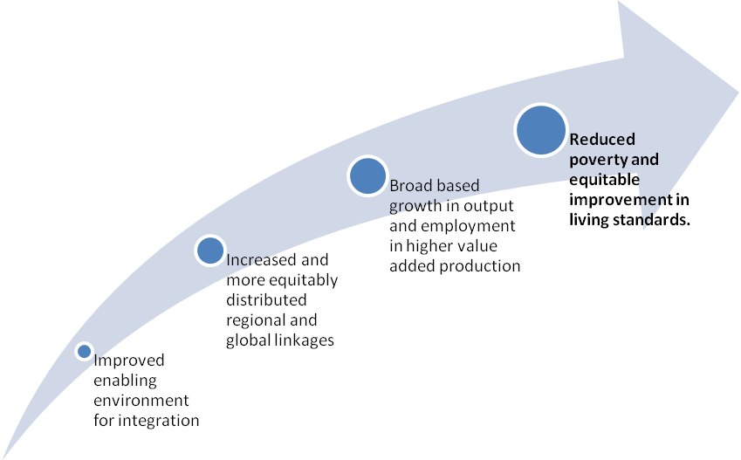
Figure 1: Intended B-WTO Outcomes

5 BWTO components are expected to contribute to the improvements in the enabling environment for integration needed to achieve program goals, via support to (i) build institutional capacity, and (ii) implement studies leading to recommendations on (and implementation of) policy and regulatory reforms (including support to draft policy and regulatory instruments).

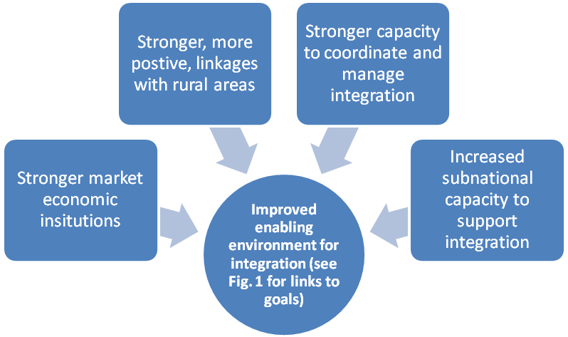
Figure 2: Linkage Between B-WTO Goals and Component Outcomes

6 Key indicators for measuring progress towards achieving these objectives – and the logic for using these indicators are presented in the Outline Framework document noted above. Details are not repeated here, but it is important to note that that the framework does not imply that the BWTO “caused” changes in the indicators. The analysis just aims to show the degree of progress with national program and targets that are being supported by BWTO.
7 Before going to the specific agreed program indicators, it is useful to review the overall progress being made in terms of achieving core Government’s development goals as specified in the SEDP. The following progress indicates sustained progress in reducing poverty via strategies to increase employment via business development and increase linkages with global economy. Trade and FDI to GDP rations remain very high for a country of nearly 90 million people, and is high relative other countries in the region.
Table 1. Key Relevant Macro Indicators
 | 2004 | 2005 | 2006 | 2007 | 2008 | 2009 | 2010*
Poverty Incidence (% of households) | 19.5 |  | 16.0 | 14.8 | 12.1 | 11.2 | 10.0
Employment growth (%) | 2.5 | 2.9 | 2.8 | 2.8 | 2.8 | 2.7 | 2.6
Per/capita income (USD) | 553 | 639 | 724 | 835 | 1,048 | 1,068 | 1,200
Trade/GDP (%) | 139 | 143 | 152 | 170 | 173 | 145 | 170
FDI inflow/GDP) | 3.55 | 3.69 | 3.94 | 9.43 | 10.57 | 8.27 | 8.5
*Preliminary data
Sources: GSO, Party Congress Documents and IMF Reports.

Program Level Indicators: Objective and Impact Level

8 Despite a very challenging external environment in the aftermath of the global financial crisis, sustained progress continues to be made towards realizing planned national outcomes. Sustained progress is being made towards all 4 program level indicators. Most importantly poverty continues to fall throughout the country.
Table 2. Key Program Level Indicators
 | Baseline  2008 | Baseline  2009 | 2010  actual | 2011  Target | 2012  target | 2013  target
Agreed Results Indicators
1. Poverty Incidence (% of households) | 12.1 | 11.2 | 10.0 | 9.0 | 8.0 | 7.0
2. MES* Recognition (Japan, EU, USA) | 0 | 0 | 0 | 1 | 2 | 3
3. Global Competiveness Index | 4.10 | 4.03 | 4.27 | >4 | >4 | >4
4. Enabling Trade Index | 3.42 | 3.54 | 3.96 | >4 | >4 | >4
*Market Economic Status recognized by number of the three countries.
Sources: GSO/MPI (poverty), MOIT (MES), WEF (Global Competitiveness and Enabling Trade Indexes)

Program Level – component and outcome level

Component 1: Market economy institutions

9 The largest share of BWTO resources were allocated in this area under the first Annual Work Plan (2010). Most B-WTO supported projects for this component were implemented in a satisfactory or better manner as indicated in the discussion for component 5. Recognition of Viet Nam as a market economy by Japan, EU and the USA (as reported above) would be the key indicator of success for this component. Other targeted outcomes for this component are:
- Support to: competition policy and enforcement; regulatory and administrative reforms; and related initiatives to make Vietnamese firms more competitive.
- Improved management of State enterprises: corporate governance and implementation of equitization and divestiture processes.
- Support to improve the efficiency and effectiveness of factor markets.
- Financial and foreign exchange markets. Support for studies and actions on financial and foreign exchange markets aimed at facilitating early recognition as market economy.
- Business associations. Strengthen capacity of business associations to facilitate integration.

10 Agreed indicators for the component and progress towards these indicators are summarized in the following table. The indicators suggest that the Government efforts (partly supported by B-WTO) in this area are moving forward in the right direction.

Table 3. Component Level Indicators: Component 1
 | Baseline  2009 | 2010  actual | 2011  target | 2012  target | 2013  target
Agreed Results Indicators
5. Doing Business Rank in Asia (WB) | 13 | 11 | 12 | 11 | 10
6. Key State ownership rights reforms* | plan | plan | action | yes | yes
7. Register property rank in Asia(WB) | 10 | 10 | 9 | 9 | 8
*PRSC condition.
Sources: WB Doing business for indicators 5. and 7. PRSC monitoring for indicator 6. The Register property rank is for number of procedures (aggregate ranking was not available).

11 The specific projects funded under this component and key results achieve under each project are summarized in the following table. The OSC feels that it has generated initial tangible results for most projects, and most have provided good value for money. In some cases (governance of State enterprises), progress was slower (results were less) than envisaged because it took longer than expected to reach agreement on key policy reforms.

Table 4. Component 1: AWP 1 Projects and Key results
Sub-project | Agency | BWTO funding | Internal  Rating (1-5) | Results/Outcomes
1.1 Enhancing capacity for VCAD to reinforce the Market Economy Institution in Vietnam | VCA, MOIT | $ 195 012 | 4 | A report on Viet Nam's efforts to move to a market economy (September 2010) used by Government as input in negotiations with EU on achieving market economy status. Considerable press coverage of report.  Studies of competitiveness -- and factors impeding competitiveness – in insurance, banking, cement, animal feed, oil, milk, aviation, telecommunication, steel, and fertilizers) discussed with business leaders and policy makers. Coverage of studies in national business media.
1.2 Technical Assistance in Drafting Government Decree on State Capital Management and Investment in Enterprises. | CFD, MOF | $149 625 | 2
1.3 Support to the formulation of GOV policy on land valuation in SOE equitization | DSAM, MOF | $150 000 | 2 | New regulations (Decree 120/2010/ND-CP, 30/12/2010) on collection of rents for land rent and water areas to ensure equitable treatment of all investors and to ensure consistency with the Investment and Land Laws. BWTO supported drafting and dialogue with key stakeholders.
1.4 Support to the formulation of the Price Management Law | DPM, MOF | $300 000 | 3 | Facilitated dialogue with business community and initial regulatory impact assessment of draft price law. BWTO support exposed officials to international experiences and emphasised the need to avoid overlap with competition law, and to clearly limit the areas of Government intervention in pricing to cases of market failure.
1.5 Renewing corporate governance in SOEs and supervision of state economic groups in accordance with WTO commitments and market economy practices | CIEM, MPI | $150 000 | 3 | Studies, workshops, and technical support for policies to improve regulatory and institutional environment for SE governance and for equitization process (helped Government in implementing PRSC agreements).
1.6 The improvement of Viet Nam’s Legal System to Implement WTO commitments | ILD, MOJ | $110 000 | 3 | Developed legal reform priorities and action plan as input to National Assembly law drafting agenda.  Draft proposals relating to NA resolution on direct application of WTO commitments were prepared, circulated and widely discussed.
1.7 Survey and evaluation of the current status, identification of the opportunities and challenges, and development of a strategy for environmental service by 2020 and orientation for 2030 | ISPONRE, MONRE | $224 044 | 3 | Initial outline of strategic framework for developing environmental services to 2020, including reports on: 1) the national current status and international experience and 2) studying, evaluating and identifying opportunities and challenges in developing environmental services on entering WTO.
1.8 Formulation of legal policy and mechanism to develop organizations to provide services for the real estate market | GDLM, MONRE | $200 000 | 3 | Initial studies on land law fed into formulation and approval of a national project to revise the current Land Law (tentatively scheduled for National Assembly consideration in 2015).
1.9 Study to Recommend Solutions for Strengthening Production Capacity of SMEs on the Basis of Promoting Their Advantages in the Process of improving the Institutions of Market Economy in Viet Nam | SISME | $189 000 | 3 | Supported SME Assoc. inputs to SME development strategy.
Source: BWTO OSC

Component 2: Socio- economic impacts of integration in rural areas

12 Limited resources were allocated to this component due to the lack of quality project proposals. Efforts under AWP1 focused on developing better proposals for financing in later years. Key targeted outcomes for this component are:
- Build inter-agency capacity to model and assess socio-economic impacts of integration
- Public support to rural areas.
- Addressing structural and spatial impacts of integration.
13 Proposed projects for financing in 2011 and 2012 should lead to concrete recommendations, and adoption of these recommendations as targeted in the B-WTO M&E framework.
No data is available on % of workforce employed in vulnerable jobs, but strong growth in formal employment in manufacturing and service sectors suggests continuing progress.

Table 5. Component Level Indicators: Component 2
 | Baseline  2009 | 2010  actual | 2011  Target | 2012  target | 2013  target
Agreed Results Indicators
8a. Policy recommendations to address socio-economic impact -adopted | No | No | No | Yes | Yes
8b. Policy recommendations to address socio-economic impact –adopted | No | No | No | No | 20%
9a. % of persons employed in vulnerable jobs* –male | 75.3% (2007) | No data | 74% | 74% | 73%
9a. % of persons employed in vulnerable* jobs -female | 78.2% (2007) | No data | 77% | 77% | 76%
* Vulnerable employment is defined as the sum of “own-account and unpaid family labour”
Sources: Program monitoring for indicators 8a and 8. Indicator 9 is from MOLISA/ILO surveys.

14 Relatively few resources meant that there were only limited results under this component. However, an important intangible outcome has been the discussions on the issues and preparations for proposals that are expected to be financed in the remaining years of the program.
Table 6. Component 2: AWP 1 Projects and Key results
Sub-project | Agency | BWTO funding | Internal  Rating (1-5) | Results/Outcomes
2.1 Analysis and evaluation on impact of WTO commitments and regional commitments (impacts on economy, society, rural area, poverty, SME in agriculture) | ICD, MARD | $ 81 000 | 3 | Initial review of impacts at MARD, and formulation of study methodology for implementation in 2011. Consultations have been held to determine priority issues for further study. The CIEM study (component 3) provided an overall assessment of the impact of integration including general impacts on rural economy.
 |  |  |  | Preparatory work for study on migration of rural workers to industrial zones and urban areas.
2.2. Research and Development of database and regulations on Food safety and sanitary and SPS of commercial partners such as EU, Japan, Korea, America, China and ASEAN | ICD, MARD | $31 904 | 4 | A database of regulations on food safety and trade partner of EU, Japan, USA, China, Korea and some ASEAN countries is now available via SPS office website.
Source: BWTO OSC.

Component 3: Capacity building to coordinate and manage integration

15 This component received the 2nd highest allocation of B-WTO resources under AWP 1. Targeted outcomes for this component are:
- Strategic planning capacity to manage integration
- Analytical capacity (integration).
- Models for coordinating integration.

Table 7. Component Level Indicators: Component 3
 | Baseline  2009 | 2010  actual | 2011  target | 2012  target | 2013  target
Agreed Results Indicators
10.Nationally agreed framework for trade negotiations /commitments | No | No | No | No | Yes
11. Diagnosis report on coordination barriers for integration.* | No | No | No | Yes | Yes
* MOIT diagnostic study being implemented in 2010 and 2011 as part of GAP review.
Sources: Program monitoring report.

Table 8. Component 3: AWP 1 Projects and Key results
Sub-project | Agency | BWTO funding | Internal  Rating (1-5) | Results/Outcomes
3.1 Research of functions, tasks organizational structure and capacity improving of the Office of Government staff and civil servants in the context of international economic integration | OOG | $ 110 000 | 2 | Capacity building. Recommendations on restructuring OOG and clarifying roles and responsibilities of different departments.
3.2 Assisting integration coordinating by means of supervision, examination, and assessment mechanisms of the implementation of tasks defined in the Action Plans of Government, Ministries and Agencies and local authorities to realize the Government’s Resolution No 16/2007/NQ-CP | DOP, MOIT | $220 000 | 3
3.3. Impacts of integration on Viet Nam’s economy after three years of joining WTO | CIEM, MPI | $120 000 | 4 | Report on impact of integration following three years of WTO accession widely discussed within Government and in public debate. This helped ensure economic integration issues incorporated in new mainstream planning documents.  Above report led to new (BWTO supported) draft resolution on integration indicates a significant move towards a more strategic and holistic approach to integration compared with the previous GAP on integration.
3.4 Capacity building for the international economic integration focal points | NCIEC | $200 000 | 3 | Capacity building.  Draft studies on indexes of integration to allow international and sub-national comparisons of trends in performance.
3.5 Increasing management capacity to implement WTO commitments for the leaders and managers at Province, commune level at Administration and Politics Institute Area 1 | IOPPA | $130 532 | 3 | Trainers have been trained, and curriculum developed, to sustain training via the National Institute for Public Administration, SME association and some provinces.
 |  |  |  | Under the various projects, workshops on general and specific integration issues have been attended by hundreds (maybe more than 1,000) of representatives from business and business associations throughout the country (domestic and foreign business from all sectors).
Source: BWTO OSC

Component 4: Implementation of provincial action plan activities
16 Key targeted outcomes for this component are:
- Build provincial level capacity
- Provincial cooperation in planning for integration.

Table 9. Component Level Indicators: Component 4
 | Baseline  2009 | 2010  actual | 2011  target | 2012  target | 2013  target
Agreed Results Indicators
12.Diagnosis report on Provincial capacity and coordination barriers # | No | No | No | Yes | Yes
13. Increasing proportion of FDI outside of 5 most urbanized provinces. | 34.2% | 18.7%
13b. Increasing proportion of FDI outside of 5 provinces# receiving the most FDI. | 77.7% | 66.1%
* MOIT diagnostic study being implemented in 2010 and 2011 as part of GAP review.
# Hanoi, HCMC, Da Nang, Dong Nai, Binh Duong. Indicator 13b shows the share of FDI going to the 5 provinces with the most FDI in each year: provinces receiving the most FDI in 2009 were Bà Rịa - Vũng Tàu; Quảng Nam; Bình Dương; Đồng Nai; and TP. Hồ Chí Minh. In 2010: Quảng Nam; Bà Rịa-Vũng Tàu; Quảng Ninh; TP Hồ Chí Minh; and Nghệ An.
Sources: Program monitoring data for Indicator 12. GSO data for indicator 13.

Table 10. Component 4: AWP 1 Projects and Key results
Sub-project | Agency | BWTO funding | Internal  Rating (1-5) | Results/Outcomes
4.1 Establishment of a Centre for WTO Issues in Da Nang City & Development Plan of Wholesale Network and Retail Network in Da Nang City to 2020 | Da Nang PPC | $ 97,031 | 3 | WTO centre (with website) established with interest in their services by business. Initial discussion on extending services to neighbouring provinces. Increased awareness and capacity of private sector and officials in selected provinces to benefit from integration.  Studies on retail distribution issues and strategies in Da Nang completed and discussed with key stakeholders. Strong PPC interest in study recommendations.
4.2 Improving capacity of staff members and farmers in developing rural small enterprises in An Giang, at the stage of 2010-2013. | DOP, MOIT | $220 000 | 2 | Trainers have been retrained and curriculum developed to support farmers to benefit more from integration process
4.3 Increase the capacity of Ho Chi Minh City through global economic integration | HCMC PPC | $190 000 | 4 | WTO centre established, with strong interest in their services by business (and as a vehicle for support activities by other donors, e.g. MUTRAP). Increased awareness and capacity of private sector and officials in selected provinces to benefit from integration.  Initial linkages developed with Le Kuan Yew Institute in Singapore. Some cooperation in training. Plans to extend training and policy research cooperation.
Source: BWTO OSC

Component 5: Management of the MDTF

17 Key targeted outcomes for this component are:
- Increase capacity of PO s to develop quality proposals
- Greater recognition of need to coordinate where relevant
- BWTO effectively supporting its partners in their post WTO integration efforts.

Table 7. Component Level Indicators: Component 1
 | Baseline  2009 | 2010  actual | 2011  target | 2012  target | 2013  target
Agreed Indicators
14.No of projects submitted to MB without ”SMART” M&E^{1/} | none | 50%* | 70% | 80% | 100%
15. Average rating^{2/} | n.a. | 3 | 3 | 4 | 4
16.% of proposals approved with multi-institutional partners/project owners^{3/} | n.a. | 0% | >0% | >10% | >20%
17.% of proposals approved with private sector partners/project owner^{4/} | n.a. | 5% | >0% | >10% | >15%
18 .Other donors join MDTF instead of setting up their own projects^{5/} | n.a. | 0 | 0 | 1 | 2
1/ As assessed during evaluation. * Estimate for 2010 was from M&E report. 2/ Rating (assumed to be on scale of 1-5 at end of year). 3/ % of project with multiple agencies involved in project implementation. 4/% of project with private sector partners involved in project implementation (SME Association in 2010). 5/ The indicator was defined in %. OSC revised to target additional donors supporting MTDF
Sources: B-WTO Program Monitoring Data.

18 More direct outputs from this component include:
- Established office and recruited staff.
- Provided formal and informal training for OSC staff.
- Provided training courses to officials in BWTO supported projects in project management and accounting.
- Developed a draft monitoring and evaluation systems, and organized periodic monitoring of project activities.
- Organized round table meetings and follow-up discussions to establish priorities for 2011 and beyond.
- Organized a review of BWTO institutional arrangements to address perceived short-comings in BWTO responsiveness

Summary and Conclusions

19 The analysis of progress towards targeted results suggests that the Government program on integration being supported by B-WTO is largely on track. The analysis in this report indicates that individual projects supported by B-WTO are generating tangible outcomes that are contributing to the success of the Government program.

