|  |  |  |  |
| --- | --- | --- | --- |
|  | Cambodia Community Justice Assistance Partnership  Department of Foreign Affairs and Trade  23-Jun-2016  Doc No. 001 |  |  |
| Completion Report | | |
|  | | |

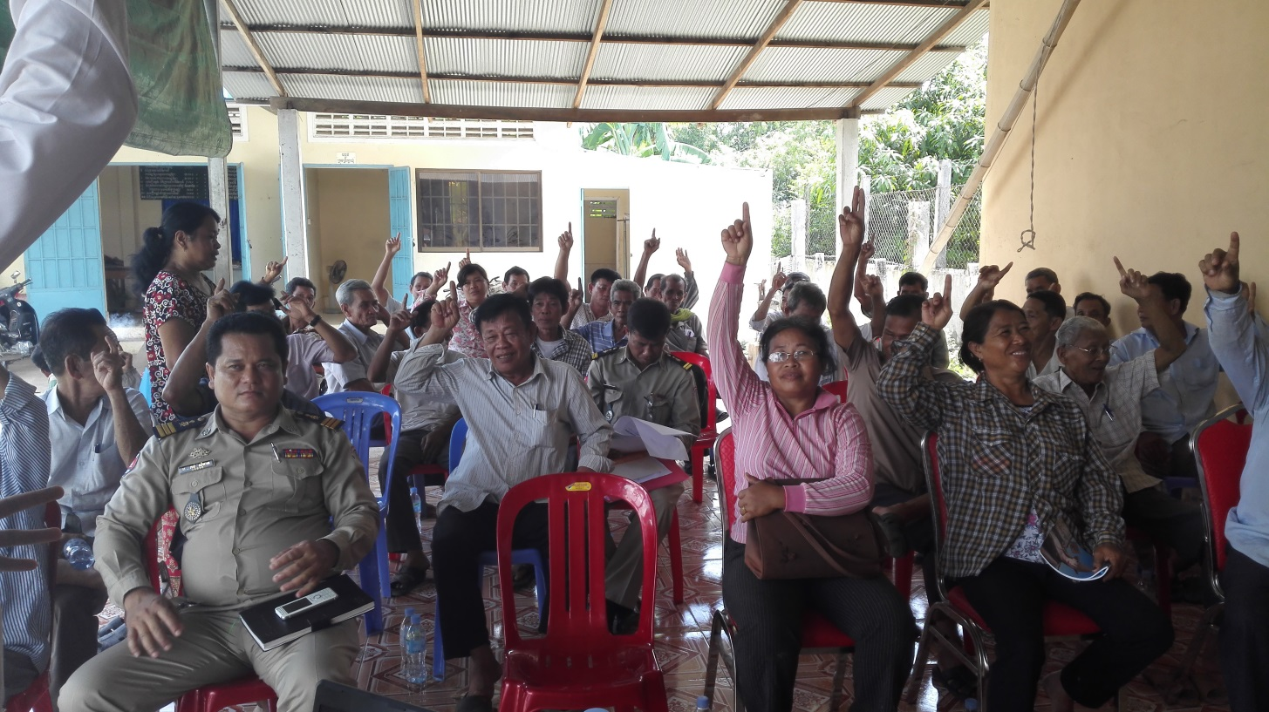

Completion Report

Client: Department of Foreign Affairs and Trade

ABN: 47 065 634 525

Prepared by

**AECOM Services Pty Ltd**

Level 28, 91 King William Street, Adelaide SA 5000, Australia

T +61 8 7223 5400 F +61 8 7223 5499 www.aecom.com

ABN 46 000 691 690

23-Jun-2016

Job No.: 42444174

AECOM in Australia and New Zealand is certified to the latest version of ISO9001, ISO14001, AS/NZS4801 and OHSAS18001.

© AECOM Services Pty Limited. All rights reserved.

No use of the contents, concepts, designs, drawings, specifications, plans etc. included in this report is permitted unless and until they are the subject of a written contract between AECOM Services Pty Limited (AECOM) and the addressee of this report. AECOM accepts no liability of any kind for any unauthorised use of the contents of this report and AECOM reserves the right to seek compensation for any such unauthorised use.

**Document Delivery**

AECOM Services Pty Limited (AECOM) provides this document in either printed format, electronic format or both. AECOM considers the printed version to be binding. The electronic format is provided for the client’s convenience and AECOM requests that the client ensures the integrity of this electronic information is maintained. Storage of this electronic information should at a minimum comply with the requirements of the Electronic Transactions Act 2002.

Quality Information

|  |  |
| --- | --- |
| Document | Completion Report |
| Ref | 42444174 |
| Date | 23-Jun-2016 |
| Prepared by | John Rennie |
| Reviewed by | Geoff Moyle |

Revision History

|  |  |  |  |  |
| --- | --- | --- | --- | --- |
| Revision | Revision Date | Details | Authorised | |
| Name/Position | Signature |
| 1.0 | 15-Jun-2016 | Original | Frank Maiolo  Project Director |  |
| 1.1 | 23-Jun-2016 | Incorporate DFAT comments and contractor responses | Frank Maiolo  Project Director |  |
| 1.2 | 23-Jun-2016 | Revise USD to AUD; minor grammatical edits | Frank Maiolo  Project Director |  |

Table of Contents

Abbreviations ii

General Information iii

Basic Activity Data iv

Executive Summary vi

1.0 Introduction 1

2.0 Activity Implementation Progress 1

2.1 Component 1: The justice system is managed for more effective pre-trial arrangements, use of non-custodial sentencing and improved prisons 1

2.1.1 Alternative Sentencing and Pre-trial Detention 1

2.1.2 Improved Prison Conditions 2

2.2 Component 2: Women, youth and children are safer and communities have less crime 4

2.2.1 Crime Prevention and Community Safety (CPCS) 5

2.2.2 Supporting the Implementation of Community Policing within the CNP 6

2.3 Component 3: Communities, police, courts and prisons use data to support management 6

2.3.1 Data Collection and Management 6

3.0 Performance Against Criteria 7

3.1 Relevance 7

3.2 Effectiveness 8

3.3 Efficiency 8

3.4 Monitoring & Evaluation 8

3.5 Gender Equality and Social Protection Safeguards 9

3.6 Impact and Sustainability 10

3.7 Risk Management 11

4.0 Lessons learned 11

5.0 Program Management Overview 13

6.0 Financial Overview 13

7.0 Conclusion 15

Appendix A

Progress vs. Result Framework A

Appendix B

Additional Progress Indicators against Program Logic B

Appendix C

Implementing Crime Prevention and Community Safety (CPCS) Activities C

Appendix D

Supporting the Development of Community Policing within the Cambodian National Police D

Appendix E

CCJAP Capital Works Projects E

Appendix F

Financial Summary F

**List of Figures**

Figure 1: Number of Convicted Prisoners Receiving Sentence Reduction and Amnesty by Year 3

Figure 2: Percentage of Detainees with Access to Vocational Training by Year 3

**List of Boxes**

Box 1: Benefits of Prison Capital Works 4

Box 2: Supporting CNP to develop and adopt evidence-based policies 7

Abbreviations

|  |  |
| --- | --- |
| **Abbreviation** | **Description** |
| APPA | Administrative Police Post Affairs |
| ASTWG | Alternative Sentencing Technical Working Group |
| AUD | Australian Dollars |
| CC | Correction Centre |
| CCJAP | Cambodia Community Justice Assistance Partnership |
| CIP | Commune Investment Plan |
| CPI | Community Policing Initiative program |
| CNP | Cambodian National Police |
| CPCS | Crime prevention and Community Safety |
| DAPPA | Department of Administrative Police Post Affairs |
| DID | Difference-in-Deference |
| DFAT | Australian Government Department of Foreign Affairs and Trade |
| D&D | National Program on Sub-National Democratic Development |
| GDoP | General Department of Prisons |
| GoA | Government of Australia |
| GBV | Gender Based Violence |
| HE | His/Her Excellency |
| ICT | Information and Communications Technology |
| ICPMC | Inter-Commune Project Management Committee |
| IEC | Information, Education, and Communication |
| ISP | Implementing Service Provider |
| JMIs | Joint Monitoring Indicators |
| L&J | Law and justice |
| LJS | Law Justice Sector |
| MfDR | Managing for Development Results |
| MoI | Ministry of Interior |
| MoJ | Ministry of Justice |
| MOWA | Ministry of Women’s Affairs |
| MOU | Memorandum of Understanding |
| M&E | Monitoring and Evaluation |
| MPA | Minimum Package Activities |
| MSA | Memorandum of Subsidiary Arrangement |
| NCDD | National Council on Democratic Development |
| NGO | Non-government Organisation |
| NMB | National Management Board |
| NP-SNDD | National Program for sub-national democratic development through decentralization and deconcentration |
| PCP | Police-Court-Prisons |
| PDD | Program Design Document |
| RGC | Royal Government of Cambodia |
| SPPCS | Strengthen Police Posts for Community Safety” program |
| USD | United State Dollar |
| VCSP | Village-Commune Safety Policy |
| VIP | Very Important Person |

General Information

**Currency Conversion**

* Currency Unit: USD
* At Project start (April 2013): A$1.00 = USD$ 1.04163 (The exchange rate sources from Oanda on 01 April 2013)
* At Project completion (June 2016): A$1.00 = USD$ 0.74811 cents (The exchange rate source from Oanda on 23 June 2016)

**Contractor Certification**

This Activity Completion Report has been prepared in accordance with the Contract with the Department of Foreign Affairs and Trade.

Basic Activity Data

|  |  |
| --- | --- |
| CCJAP I | April 1997 to April 2000 |
| CCJAP I Extension Phase | April 2000 to June 2001 |
| CCJAP I Transition Phase | July 2001 to October 2001 |
| CCJAP I Transition Extension | November 2001 to March 2002 |
| CCJAP II | April 2002 to February 2007 |
| CCJAP III | 24 February 2007 to 24 January 24 2012 |
| CCJAP III Transition Phase | 25 January 2012 to 31 March 2013 |
| CCJAP IV | 1 April 2013 to 30 June 2016 |

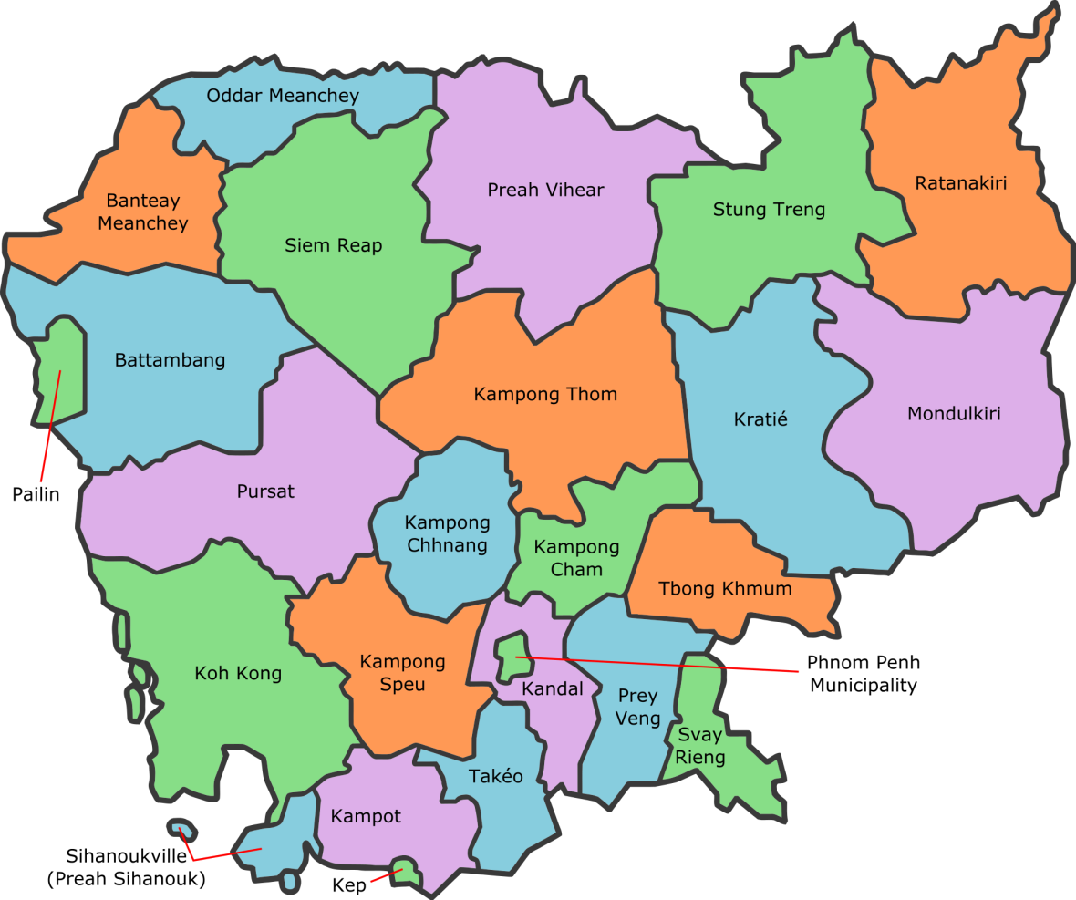

CCJAP Supported Provinces and Target Districts:

Crime Prevention and Community Safety supported provinces – June 2013 to September 2015:

* Battambang, Siem Reap, Kampong Thom, Kratie, Kampong Cham, Kampong Chhnang, Prey Veng, Kandal, and Banteay Meanchey.

Community Policing Pilot provinces – October 2015 –March 2016:

* Prey Veng, Kandal, Kratie, Phnom Penh (2 Sangkats)

|  |  |  |  |
| --- | --- | --- | --- |
| Aid Activity Name | Cambodia Community Justice Assistance Partnership (CCJAP Phase 4) | | |
| AidWorks initiative # | 64318 | | |
| Commencement date | 1 April 2012 | Completion date | 30 June 2016 |
| Total DFAT Funding (AUD) | Up to 10.5 million[1] | | |
| Total other Funding (AUD) | 4 million (Government of Cambodia in-kind contribution) | | |
| Delivery organisation(s) | AECOM (URS) | | |
| Implementing Partner(s) | * Ministry of Interior:   Cambodian National Police.  General Department of Prisons and target Prisons  Provisional Government partners and target Districts:   * + - Kandal Province     - Battambang Province     - Prey Veng Province     - Kampong Cham     - Kampong Thom     - Banteay Meanchey     - Kampong Chhnang     - Siem Reap     - Kratie * Ministry of Justice and Courts in partner Provinces * Ministry of Social Affairs, Vocational Training and Youth Rehabilitation * Ministry of Women’s Affairs * NGOs/IOs. | | |
| Country/Region | Cambodia | | |
| Primary Sector | Law and Justice | | |

**Approved and Actual Cost of the Project**

|  |  |  |
| --- | --- | --- |
| **Partner** | **Activity cost estimates** | **Actual (incl June estimate up until project completion 30 June 2016)** |
| Government of Australia (GoA) | $10.500million[2] | $8.652 million |
| Royal Government of Cambodia (RGC) | $4.013 million - In kind | $4.013 million - In kind |
| Total Funding | $14.513million | $12.665 million |

Executive Summary

The Cambodia Community Justice Assistance Partnership (CCJAP) Completion Report covers the fourth and final phase (April 2013 to June 2016) of Australian support to the Cambodian Law and Justice Sector that first began in 1997. An assessment of progress made towards end of program goals is provided, along with a reflection on lessons learned.

The Program Design Document (PDD) for CCJAP sets out the goal for CCJAP as being, ‘Prosperous, safe and secure communities in Cambodia’, with a purpose of ‘contributing to building safer communities and reducing overcrowding in prisons’. The design provided program logic that was based around three outcome areas, which embraced a changed approach to previous phases with a deeper and narrower focus for delivery of activities;

* Outcome 1: The justice system is managed for more effective pre-trial arrangements, use of non-custodial sentencing and improved prisons
* Outcome 2: Women, youth and children are safer and communities have less crime, and,
* Outcome 3: Communities, police, courts and prisons use data to support management.

**Significant achievements over the life of CCJAP Phase IV**

The CCJAP program has been successful in making progress in some but not all of its outcome areas and has contributed towards progressing the overall program goal in Cambodia. CCJAP has worked in Phnom Penh, in communities across nine provinces, and in selected prisons and police posts across the country. This work has been evaluated and shown to have made a contribution in the following areas:

* CCJAP’s work through its crime prevention and community safety program (CPCS) improved the understanding of people living at the commune level in Cambodia regarding their legal and human rights and fostered improvement in the way in which police and communities identify and respond to crime and safety issues at the commune and village level. During the period of activity CPCS provided 2,060 commune programs that benefited 134,681 people. This investment was evaluated and found to have directly benefited the participants with improved understanding of rights and the law and improved perceptions of safety (Appendix C provides full details of this program and its outcomes).
* CCJAP delivered infrastructure in prisons and police posts that has directly improved the quality of life for prisoners and the publics’ access to police services. CCJAP supported and mentored better collaboration between the General Department of Prisons (GDoP) and the Ministry of Health, which resulted in improvements in the education and certification of prison staff delivering health services in prisons, and an increase in the number of health services being provided in supported prisons. This outcome has been mirrored in the evaluation of CCJAP infrastructure in other prisons with higher levels of health services provided, improved out of cell time, greater access by detainees to legal and family visits, and improved water and sanitation.
* CCJAP Supported the Cambodia National Police (CNP) to design and implement a program of community policing with the goal of improving the quality and effectiveness of police services at the community level. CCJAP developed tools that were pilot tested and subsequently found to be sound and productive and which were then fully adopted and applied by the CNP. The CNP built on the support provided by CCJAP and formally committed to implementing community policing across Cambodia, using the tools and processes developed in conjunction with CCJAP (Appendix D provides full details of this program and its outcomes). [3]
* CCJAP-sponsored a national seminar conducted by the CNP, at which the crime prevention/reduction approach of the CPI was presented to the Commissioner General and senior officers. The Department of Administrative Police Post Affairs (DAPPA) submitted a request to the General Police Commissioner to scale up the CPI pilot exercise from three to twenty-two provinces. The General Police Commissioner, after consulting with Deputy Prime Minister and Minister of Interior, approved the scale-up and the adoption of community policing as a core strategy for the CNP.
* CCJAP supported the strategic decision of the CNP to pilot CPI in the two Phnom Penh Sangkats, which marked the first time in CCJAP support to the CNP that CCJAP worked with the CNP to turn its police and policing attention from rural areas to the rapid urbanization of the country, where the risk of rising crime rates is high. This was identified as a significant outcome by the CCJAP independent review team in May 2016.
* CCJAP supported improvements in the management of data within the CNP and GDoP which supported an increase in the number of amnesties and sentence reductions; provided hardware that protected the data holdings within the CNP, leading to improved use of crime statistics, record keeping and informed planning; and supported the development of an effective national crime records database which was launched on the 16 March 2016.

**Innovative aspects of the CCJAP program**

* The CCJAP management team analysed systems applied during the previous phase for funding of CPCS commune activities, and initiated a revised system that reduced overheads from 42% in the previous phase, to 15% in this phase.
* When it became clear that the goals in Outcome 1 were unachievable, the program worked with DFAT, key counterparts and the NMB to obtain mutual agreement that support to this component would cease in 2015. Resources where then reallocated to other components to drive greater value for money from this investment.
* CCJAP promoted an increased focus on the issues relating to gender based violence (GBV) in Cambodia, and worked with counterparts in the CNP to increase focus on this issue in the delivery of police services and played a key role in the decision by the CNP to create a GBV division within the DAPPA, and to include GBV in their five year strategic plan.

**Constraints**

* The 2013 Cambodian national elections in July 2013 caused significant disruption to the ability of the CCJAP program to engage with many of its key counterparts. In the period immediately after the election and during the following six months, CCJAP was largely unable to access key counterparts and agencies. During the period CCJAP worked to consolidate its strategic direction and established its processes and staff so that by late 2013, counterparts had been re-engaged and activities were under implementation.
* The Change of Government in Australia in 2013 and reductions to the Australian aid budget both had an impact on CCJAP and the partnership. The program absorbed cuts to its budget, which led to changes to activities and the reduction of support to two components had an effect on the partnership and resulted in an increase in tension in some element of CCJAP’s engagement with its counterparts. The program worked collaboratively to largely overcome these constraints and was able to ensure that the program delivered its activities in a timely way and in accordance with the program’s goals. Some partnership tension remained.

# Introduction

The Cambodia Community Justice Assistance Partnership (CCJAP) Phase IV, commenced on 1 April 2013 and concludes on 30 June, 2016. This final phase supported the Cambodian Law and Justice Sector (LJS) through three outcome areas managed under a partnership agreement between the Government of Australia, represented by the Department of Foreign Affairs and Trade (DFAT), and the Royal Government of Cambodia (RGC). The operational management of the CCJAP program was carried out through a National Management Board (NMB) made up of representatives of each government under the details set out in the Memorandum of Subsidiary Arrangement executed between both Governments in March 2013. The program was implemented by an Implementing Service Provider (ISP) AECOM (formerly URS) who provided management services to the program.

CCJAP delivered activities across each outcome area in a manner that responded flexibly to the changing environment and that enabled the partnership to identify and modify program priorities to ensure that the program maintained and met expected value for money principles.

This Completion Report covers the final phase of Australia’s support to the Cambodia LJS and will provide detail of progress, achievements, and lessons learned.

# Activity Implementation Progress

## Component 1: The justice system is managed for more effective pre-trial arrangements, use of non-custodial sentencing and improved prisons

CCJAP supported development in two main areas under this outcome;

* Alternative sentencing and pre-trial detention and,
* Improved prison conditions.

**Summary of Outcomes**

Little progress was made in this component of the CCJAP program and this component was concluded in 2014 by agreement with the NMB.

### Alternative Sentencing and Pre-trial Detention

**Output delivery progress**

CCJAP began its support to the MoJ and the increased use of alternative sentencing by conducting a joint survey in October and November 2013. The survey sought the views of court officials, police and authorities in Battambang, Banteay Meanchey, Siem Reap, Kompong Thom and Kompong Cham to identify the roadblocks perceived by judges, police and commune councils in the implementation of pre-trial arrangements and other non-custodial measures. The survey also sought to identify provincial courts that were willing and committed to implement such measures, and to identify other alternative mechanisms in place for dispute resolution. Roadblocks were identified that included a level of community misperception about alternative sentencing and a lack of effective and efficient coordination among justice agencies, responsible for the implementation of these reforms. Of the court officials interviewed, however, none were willing to enforce alternative sentencing measures unless the MoJ addressed these issues with clear directions.

In January 2014, three circulars governing alternative sentencing on judicial supervision, suspended sentence with probation, and community service were adopted within the MoJ. The adoption of these circulars was seen as a step forward. CCJAP supported the MoJ led Alternative Sentencing Technical Working Group (ASTWG) to organise workshops in March 2014 in Phnom Penh and in August 2014 in Battambang and Banteay Meanchey in order to support the dissemination of the circulars and to provide a venue for the instruction of judges, prosecutors and other key partners about the purpose and intent of the three circulars. In the following year, non-custodial sentencing tasks were integrated into the Joint Monitoring Indicators (JMIs), which represents a national policy document of the RGC. However, no progress could be identified in relation to the implementation of these reforms at the court level.

CCJAP also funded the production of information, education, and communication (IEC) materials for dissemination to communities around the adoption of circulars governing non-custodial sentencing, and supported workshops to inform key stakeholders of the government directives on alternative sentencing.

**Outcome/Impact**

By 2014 no genuine progress could be identified in this area. It had become clear that the implementation of this component no longer represented value for money and that the opportunities identified by the authors of the CCJAP Program Design Document (PDD), could not be advanced.

CCJAP had allocated full time advisory support to this component between April 2013 and November 2014 but by November 2014 it became clear that the advisers were not being utilised and that there had been no direct usage of the resources by the program’s counterparts. CCJAP met with senior counterparts at the MoJ and reached agreements that the CCJAP advisers tasked with supporting alternative sentencing and information management would be re-allocated to work on supporting the development of community policing. An ‘on call’ arrangement was implemented that would allow CCJAP to provide advisory inputs on a request basis which was to be evaluated after six months. Subsequent evaluation revealed that in the following six months, no requests had been made for CCJAP advisor inputs and accordingly, inputs to this component concluded. This decision was later ratified by the NMB at its June 2015 meeting.

CCJAP cannot report any outcomes against this component area.

### Improved Prison Conditions

**Output delivery progress**

CCJAP provided support to improve the conditions of persons in custody in Cambodia through both the construction of more humane prison infrastructure (through its small scale infrastructure and equipment fund) and through work to improve the delivery of health services for persons in custody.

**Outcome/Impact**

The key achievements and associated activities supported by CCJAP included:

* There were an increased number of convicted prisoners who received sentence reduction and amnesty from 2012 to 2015. This achievement could be partly attributed to CCJAP support to the GDoP, which included advisory support and direct support to the organization of a National Workshop on Prisoner Separation and Sentence Reduction in September 2013. In the period following the CCJAP support the number of prisoners who received sentence reduction and amnesty increased from the previous three years, as per Figure 1 below.
* The two CCJAP-financed capital works projects to construct holding cell blocks in the Oddor Meanchey and Pailin prisons also directly contributed to the reduction of prison overcrowding at these facilities. According to the information provided by the prison officers at the two facilities, cell block space for detainees increased after construction completed, with Oddor Meanchey reporting cell block space increased from 1.42 to 2.2 sqm per detainee, whilst in Pailin, space increased from two to three/four sqm per detainee.
* The number of prisoners with access to vocational training increased, see Figure 2. Whilst CCJAP did not directly work in the area of vocational training in prisons, it did support the development of a prison management model policy that included the management of vocational training in prisons and partly financed training on prisoner education and rehabilitation to prison officers. This training provided important impetus to the GDoP’s development of a vocational training program and contributed to the improvement of prison management practices in its ability to better coordinate with non-government actors and to better mobilize training services for prisoners.

Figure 1: Number of Convicted Prisoners Receiving Sentence Reduction and Amnesty by Year

Figure 2: Percentage of Detainees with Access to Vocational Training by Year

* CCJAP supported GDoP to organize a four-day training on the National Guidelines on Minimum Package Activities (MPA) for prison health post officers which was attended by 60 prison health officers (of which 13 were female) from four national correctional centres and 23 provincial prisons. The aim of this training was to enable all prison health officer attendees, to better deliver quality health services to prisoners through applying these guidelines. The Minimum Package Activities guidelines included outpatient services, infection control, referral system management and health post management. CCJAP built the monitoring capacity of GDoP counterparts through direct advisory support and through joint post-training monitoring with GDoP working group counterparts in nine provincial prisons followed by monitoring programs by GDoP counterparts themselves, at the remaining national prisons. CCJAP monitoring identified that the majority of prisons had adopted and complied with the MPA and had introduced these reforms in their prisons. The remaining two or three prisons that had failed to implement the guidelines were identified through this monitoring and were brought into compliance.
* CCJAP funded essential small-scale capital works (please see Appendix E: Capital Works) such as internal prison security fences, prison health posts, and family visit and lawyer rooms in targeted prisons.

Box 1: Benefits of Prison Capital Works

|  |
| --- |
| The GDoP prison health post officer in Ratanakkiri Prison stated that the CCJAP funded prison health post had improved overall health conditions for prisoners and had allowed the prison health officers to provide better health services. He said that during a three month period following the construction of the health post, the number of outpatient consultations increased *from* *five consultations per day prior to the construction of the health post to 150 per day after the opening of the structure*. The officer also said that the new structure had provided space and facilities that had allowed this increase in consultations to occur and had also contributed to the reduction of number of prisoners needing to be referred to hospitals outside the prison. The health post officer in Svay Rieng prison also reported an increase in the number of outpatient consultations from *17 per day prior to the completion of construction to 27 consultations per day after the opening of the structure.*  The prison chief in Battambang claimed that after the construction of an internal prison security fence, he was able to *increase out of cell time for prisoners from 30 minutes/day (before construction) to 45 minutes/day (after construction)*. He reported that the increase of time out of cell for prisoners has also partly contributed to the improvement of health conditions within the prison whilst also providing prison officers and prisoners with greater security and improved peace of mind.  The number of family visits to prisons has also increased after CCJAP-funded construction of family visitation rooms in Preah Vihear and Svay Rieng prisons. According to the Preah Vihear prison records, the number of family visits *increased from 10 per day to 25 per day after the construction of the visitation rooms*. The record of Svay Rieng prison also registered an increase in family visits from 104 to 127 per day after the presence of the structure. The prison officers of both prisons also mentioned other benefits of these family visit rooms. They said that it provides comfortable and clean facilities to sit and talk, wider space for more family members to visit each time, an eased visit schedule and arrangement, and an increased time for each visit as they can visit on weekends and rainy days. |

## Component 2: Women, youth and children are safer and communities have less crime

CCJAP supported development in two main areas under this outcome;

* Crime Prevention and Community Safety (CPCS), and
* Supporting the implementation of community policing within the CNP.

**Summary of Outcomes**

* CCJAP supported commune level activities to support CPCS across nine provinces and 387 target communes. The CPCS activities implemented 2,060 projects that benefited 134,681 people of whom 54% were female, at a total cost of AUD778,548.

Approximately 40% of commune requested CPCS activities related to gender based violence (GBV).

Each activity cost on average AUD378 and benefited approximately 65 commune people. Approximately 85% of the CCJAP funds were spent in direct application of activities with approximately 15% for overhead costs, a reduction from the previous CCJAP phase which had overhead costs of 42% (on average).

CPCS impact was assessed both internally and externally and it was found that:

* + Commune councils began to allocate their own funds to continue the CPCS activities commenced by CCJAP. A CCJAP survey of 30% of the 387 target communes found that 73% of surveyed communes had begun to allocate commune/Sangkat funds to support CPCS activities in 2015 (internal CCJAP evaluation);
  + CCJAP-supported locations experienced a lower rate of crime per person than in non-CCJAP supported locations (control locations) (external independent survey);
  + The level of crime in CCJAP supported locations was lower than in the control locations, 6% of respondents in CCJAP supported locations reported that crime had increased against 12% of respondents in control locations reported crime had increased (external independent survey); and
  + Fear of crime was greater in non-CCJAP supported locations and people surveyed in CCJAP supported locations felt safer than those surveyed in the control group.
* CCJAP supported the CNP Department of Administrative Police Post Affairs (DAPPA) to develop capacity and organisational structures that could implement reforms to police service delivery at the commune level, through the implementation of community policing. Change resulting from CCJAP’s activities in this area include:
  + The DAPPA is providing leadership and capacity development within the CNP for the implementation of community policing at the commune level.
  + The CNP at its senior leadership level formally adopted community policing and committed to increase funding and staffing at communes across the country.
  + The CNP has begun to roll out the model of community policing jointly developed with CCJAP across other provinces beyond the three supported by CCJAP. CCJAP worked to develop and test practical tools that could be easily understood and implemented by the CNP and developed the capacities within DAPPA, to support the implementation of these tools without the need for direct CCJAP support.
  + Communes and police posts in CCJAP-supported areas have reported increases in the cooperation between police and their local authorities; improvements in the engagement by police in appreciating and responding to local crime and safety issues; and an improvement in the capacity of police posts to plan and engage in crime prevention planning.
* CCJAP worked across the 28 communes and 2 Sangkats to support DAPPA as it led the testing of the community policing tools. The CNP has fully endorsed these tools and the approach and has committed to engage with the Australian support to community policing through the agreed Community Policing Initiative (CPI) program, due to commence in June 2016.

Specific analytical tools were developed by CCJAP and adopted by the CNP that provided the CNP with the ability to better understand and respond to crime and safety issues and the causality and contributing factors giving rise to them. These tools have formed the basis for police/community crime prevention plans within the majority of the pilot locations.

CCJAP developed a process of identification and mapping of crime within communes and provided large, accurate wall maps for partnering communes that were used to highlight the location and type of crime and security issues occurring within each commune. The CNP senior leadership strongly endorsed this approach and expanded the allocation of maps to other provinces (with the financial and technical support of CCJAP). These maps will be an important element in improving the knowledge and practices of commune police when engaging with their communities.

CCJAP supported the development of an increased focus on the issue of gender based violence within communes, using its knowledge and the understanding gained through the implementation of the CPCS program and successfully lobbied the CNP to increase its focus on the reduction of GBV as a core platform of its community policing reforms.

The CNP has, without CCJAP support, implemented the CCJAP developed community policing and crime prevention tools across a further 181 non-CCJAP target communes in 25 provinces. This represents a significant ownership of the process by the CNP and their endorsement of the effectiveness of the tools that were developed.

### Crime Prevention and Community Safety (CPCS)

**Output delivery progress**

A detailed summary of the approach and outcomes from this activity area is provided at Appendix C.

**Outcome/Impact**

A detailed summary of the outcomes and impact of this activity area is provided at Appendix C.

### Supporting the Implementation of Community Policing within the CNP

**Output delivery progress**

A detailed analysis of the approach and outcomes from this activity area is provided in Appendix D.

**Outcome/Impact**

A detailed analysis of the outcomes and impact from this activity area is provided at Appendix D.

## Component 3: Communities, police, courts and prisons use data to support management

CCJAP supported development in one main area under this outcome:

* Improved collection and use of data to strengthen management.

**Summary of Outcomes**

* CCJAP worked with each counterpart organisation by supporting the development of technology (dashboards for the more effective management of data within GDoP and CNP) and supported an improved management of data within the CNP implementation of the VCSP.
* CCJAP provided lightning and network security hardware and software, which has provided the CNP with a stable and protected data system that prevents external access by unauthorised persons. This platform has provided the CNP with a nation-wide linked communications system that has significantly improved communications and the flow of strategic data.
* CCJAP supported the development of the CNP crime database in SQL format, (version 3) to a point where the database now provides the CNP Department of Statistics and senior management with a functioning crime recording and reporting database. The eCRIME database was formally launched as the CNP’s official national crime database on 16 March 2016.
* CCJAP developed the capacity of IT specialists from the CNP Department of Administration to be able to administer, maintain and develop the eCRIME database without the need to engage external consultants or experts.
* CCJAP supported the rectification of the Prisoner Database within the Cambodia General Department of Prisons (GDoP), which resulted in improved data management relating to the custody, release dates, granting of amnesty, and the application of sentence reduction entitlements.

### Data Collection and Management

**Output delivery progress**

CCJAP supported the CNP to upgrade its electronic crime database software through direct technical support to their IT directorate to improve the search and retrieval of data from within the system (dashboard) including data on victims and suspects, functions relating to investigations, and functions relating to information on the results of crime reduction initiatives. The CCJAP supported CNP crime database was launched by CNP on 16 March 2016.

CCJAP also provided on-the-job training to four police officers from the CNP IT Office. These officers are responsible for the care and maintenance of the electronic crime database at national level and as a result of the CCJAP training, around 65% of the technical maintenance and system upgrade of the electronic crime database tasks have been successfully managed by those trained officers.

CCJAP also supported the CNP to safeguard its crime data through the installation of network security equipment and lightning protection systems in all 25 provincial police headquarters and two national police headquarters. The safeguard system is now fully operational and is providing security and increased functionality to the CNP and their data systems.

**Outcome/Impact**

CNP senior officials have begun to apply their crime statistics to inform their decision-making by revising the procedure to assess the performance of police in implementing the Village-Commune Safety Policy (VCSP). The procedure (see Box 2below) has been developed with CCJAP technical support and has been approved and applied since 2014.

In providing supporting to CNP in the development of CNP 2nd Strategic Plan 2015-2019, CCJAP also encouraged and advised CNP to use its existing crime and operation data to support the development of its strategies for the plan. The CNP 2nd Strategic Plan 2015-2019 was finalized by CNP and approved by Ministry of Interior (MoI) in 2015.

Box 2: Supporting CNP to develop and adopt evidence-based policies

|  |
| --- |
| Having a long partnership with Australia and existing relationships with key CCJAP advisers, CNP asked for advice on refining the policy relating to the Village-Commune Safety Performance Assessment Contest. The old policy used limited criteria to assess performance, disadvantaging some locations because it only considered the number of reported crimes and the number of crimes solved for the evaluation and assessment of the performance of the province, district and commune in the implementation of the VCSP. More equitable assessment criteria would include population in each location, area covered and efforts in implementing the VCSP.  The CCJAP Advisor worked with the CNP Planning and Statistics Department to produce a new Village-Commune Safety Performance Assessment Contest policy paper with a set of five criteria, new formulas for calculating, scoring systems and scales for ranking. CNP then organised a workshop to present the draft paper to all 25 provincial councils and the national council for comments and feedback. The workshop was led by an MoI Secretary of State. The CCJAP Managing for Development Results (MfDR) Advisor presented the draft paper and answered related questions. Feedback from the workshop was used to finalise the policy. The workshop was financed by RGC resources – CCJAP only contributed the time of the MfDR Adviser and reproduced workshop materials. The final policy was endorsed by MoI on 18 July 2014 for adoption throughout Cambodia followed by a national workshop to disseminate this policy to all 25 provincial and national VCSP performance assessment contest councils with a total of 114 participants (of which three were women). The procedure was applied for the assessment of the VCSP Performance in 2014.  This is a lesson in the advantages of chasing change. CNP drove this change process, enabling CCJAP staff, with existing relationships to support government counterparts to prepare and finalise a new policy that is directly relevant to the outcomes and purpose of CCJAP. |

CCJAP provided the MoJ with advisory support through its Information and Communications Technology (ICT) Database Adviser, for development and expansion of the court register. This adviser also supported the GDoP in the development of its management of prison data and the broader development of data usage to improve policy dialogue and decision-making, and the greater application of data in analysis and research. CCJAP was unable to gain counterpart engagement in these areas, although some progress was made in the use of data within prisons. By the end of 2014, the adviser was not utilised by his counterparts and after discussion within the sector, this area of support was concluded and the resources applied elsewhere in the program.

# Performance Against Criteria

## Relevance

CCJAP implemented its activities in line with its program design and ensured that all of its activities remained relevant to the expectations of both partner Governments. CCJAP identified and applied program resources to each of the outcome areas and managed the quality of inputs; evaluated the relevance of outputs; and sought to consolidate and sustain outcomes from its activities. In components one and three the program had limited success in achieving its end of program outcomes and CCJAP acted flexibly to identify activity areas that had not progressed, and consulted with counterparts to obtain agreement to the early cessation of support to these components and the re-allocation of resources to the remaining outcome areas. In doing so, CCJAP ensured that its activities and the application of its resources aligned directly with the intended purposes set out in the design documents and the agreed outcome goals of the program and maintained the relevance of its focus and activities.

## Effectiveness

This report has in its earlier sections, provided specific details of the outcomes and effectiveness from CCJAP activities. The CCJAP program was effective within the partnership model, adopting a consultative approach that engaged with counterparts to ensure that all CCJAP supported activities had the greatest potential to produce effective change outcomes. CCJAP’s infrastructure program worked with both the GDoP and CNP to identify and support their priority infrastructure needs and delivered appropriate and effective prison and police infrastructure that was evaluated internally as having improved the quality of life for persons in custody, and the improved access to police services by commune and community members. In the area of community safety and crime prevention CCJAP supported the continuation of direct support to communes to allow village and commune members to request and receive activities that addressed their most pressing safety and security concerns. This was an effective approach, which has been evaluated as meeting many of the needs and concerns of attendees and as having a measurable benefit to the quality of their lives.

CCJAP has been effective in its work to support the CNP and its development of an effective community policing approach and worked directly with the DAPPA, as it designed and implemented community policing within pilot provinces. The work of CCJAP has paved the way for the Community Policing Initiative (CPI), Australia’s next program of support in the Cambodia Law and Justice Sector.

CCJAP had limited effectiveness in the areas of reducing prison overcrowding through improved use of alternative sentencing and pre-trial detention options. CCJAP sought to implement activities in this area, however, little progress could be made and support was withdrawn from these activities by November 2014. Similarly, progress in component three was ineffective and CCJAP support to this area was concluded by the end of 2014.

## Efficiency

**Cost Benefit Analysis/Value for Money**

The nature of the development assistance provided by CCJAP makes a traditional cost benefit analysis difficult to conduct; however CCJAP has been able to provide evaluation of impact across most areas of its operations. This evaluation provides either evidence of progress towards outcomes, or anecdotal evidence of cost benefit and value for money. The independent review report completed in May 2016 identified a number of areas where CCJAP had achieved efficiency and value for money. The report identified that in its support to the CNP, for example, CCJAP had achieved a good level of efficiency and value for money.

CCJAP’s investment in CPCS activities provides some additional evidence of value for money. The two independent reviews of the CPCS activities identified positive outcomes from the activities; however, due to the sample sizes and the nature of the surveying, the results were not highly conclusive. The CCJAP evaluation of CPCS recipient communes suggested that the value of the CPCS investment has been recognised by the majority of surveyed commune councils who have begun to fund social and security activities from within their CIP budgets. This had not been the case previously and the evidence that communes are now beginning to commit their own CIP funds to continue CPCS activities is significant. It is difficult to determine; however, if there has been or is likely to be any broader expansion of the lessons learned through the CPCS investment into other non-CCJAP supported provinces. Ultimately, the test of sustainability and value for money in this area will be determined by the extent to which RGC agencies and provincial authorities continue to promote and fund the continuation of these activities in the longer term through their own budgets and leadership.

## Monitoring & Evaluation

CCJAP monitored and evaluated its progress against a number of M&E tools that included the CCJAP results framework and additional indicators identified by CCJAP. The indicators set out in the CCJAP results framework were found to be limited in scope and unable to provide effective monitoring and evaluation data and so CCJAP sought additional M&E indicators and independent research to better support the ongoing management and reporting needs of the program and its partners. This was all discussed and agreed to via the NMB.

CCJAP used the results framework to monitor progress against its activities and sought further evaluation in response to the needs of the partnership. In 2014, CCJAP commissioned a study on the efficacy of police posts that provided the basis upon which the NMB agreed to the construction of police posts under CCJAP’s infrastructure program. CCJAP worked with the CNP to evaluate key issues regarding police post service delivery and supported the DAPPA to develop community-policing strategies, based on this data.

CCJAP adjusted its M&E resources, following the completion of support to components one and three, and reassigned adviser support to the development of the CNP’s community policing strategies and provided capacity development, monitoring and evaluation of programs and issues at the commune level, and support to the CNP leadership team as it consolidated its strategies in this area. CCJAP worked closely with the CNP during the piloting of the community-policing program, to support the capacity development of police officials from the DAPPA, so as to enable them to begin to provide M&E evaluation to the CNP leadership.

Analysis of the CCJAP monitoring and evaluation is provided at Appendices 1 (results framework) and 2 (additional indicators).

## Gender Equality and Social Protection Safeguards

The CCJAP PDD outlined potential opportunities for the strengthening of gender equity within CCJAP activities. CCJAP worked to achieve improvements to gender equity in Cambodia and areas identified and supported by CCJAP achieved the following results:

* CCJAP supported the CNP DAPPA to better understand the significance of GBV within Cambodia and advocated for the establishment of a GBV division within the restructure of the DAPPA. This was accepted and DAPPA formed a GBV team in 2015 and included GBV within the DAPPA five-year strategic plan.
* In the area of disability and women and children accessibility, CCJAP designed its infrastructure to account for persons with disabilities (ramps and appropriate openings to allow wheelchair access); better facilities for women in custody (toilet facilities and improved visitor/family meeting facilities), and improved awareness amongst women of their rights through CPCS activities.
* PDD identified opportunity -Supporting line agencies, justice institutions and civil society to raise women’s legal awareness and providing legal advice –
  + CCJAP supported the strengthening of gender equity in this area during its CPCS work at the commune level. Women made up over 54% of attendees at CPCS activities and 40% of requested activities were GBV prevention related with the majority focused on domestic violence prevention;
* PDD identified opportunity - Inclusion of the Ministry of Women’s Affairs into CCJAP planning, management and decision making, as a member of the NMB –
  + Senior MoWA representatives attended all NMB meetings and provincial and district MoWA officers were included as facilitators or trainers in the delivery of the majority of awareness training for gender based violence prevention and women’s rights at the commune level;
* PDD identified opportunity - Capacity building through activities that train judges, lawyers, police and community members in women’s rights –
  + CCJAP supported the development of community awareness on women’s rights as part of the CPCS activities;
* PDD identified opportunity - Strengthen capacity for planning and budgeting for Commune Committees for Women and Children increasing access to resources –
  + CCJAP surveyed a sample of CPCS supported communes to establish the percentage of councils that had commenced funding of community safety programs. It was found that 73% of surveyed communes had begun to commit commune resources for these programs, including programs that support the reduction of GBV and women’s rights;
* PDD identified opportunity - Supporting agencies to collect data on prevalence and impact of domestic violence and sexual assault against women and girls to help to drive implementation of laws –
  + CCJAP’s work with the CNP to improve data management and the crime database will provide improved statistics relating to crimes against women and girls. CCJAP has also worked with the CNP to implement community policing and developed tools that will improve the combined understanding of causative and contributing factors relating to GBV, and which will facilitate the development of joint CNP/Community plans to address these issues ;
* PDD identified opportunity - Awareness raising on community safety issues, including domestic violence and trafficking, and legal dissemination –
  + CCJAP’s worked through its CPCS program to support the improved understanding and awareness of community safety issues at the commune level. The work done by CCJAP in this area had a direct and positive result in improving the knowledge and awareness of women and identified effective tools that will be used in the forthcoming Community Policing Initiative Program;
* *PDD identified opportunity* -Supporting women to participate in community forums and able to provide feedback to police and authorities on priorities for community safety.
  + CCJAP provide opportunities for the voices of women to be heard through its CPCS activities, through its work to develop and implement community policing, and through its advocacy for improved CNP engagement with communities as part of the development of police/community problem identification and solving.

## Impact and Sustainability

**Component 1**

The impact of CCJAP’s work in this component has been limited. The CCJAP program design was based on an expectation that alternative sentencing and pre-trial detention alternatives were part of an established reform program within the Cambodian law and justice sector. CCJAP sought to implement its activities in line with the design but over time found that it was unable to achieve any impact against this component. There are no significant outcomes or sustainability to report in this area of CCJAP’s operations.

CCJAP completed a range of infrastructure programs that provided buildings that were modern, affordable, and that incorporated design that met the needs of users with disabilities. The designs documents were provided to the CNP and GDoP and can be used by both organisations as templates for future capital works to be funded by the RGC. CCJAP support to improving the delivery of health services within prisons also assisted in the production of operation manuals that will continue to be used after the completion of CCJAP.

**Component 2**

*CPCS -* CCJAP was able to implement its CPCS activities in line with its design objectives and delivered effective and efficient activities across its nine partner provinces. The impact of these activities has been discussed in earlier chapters of this report and an assessment provided.

Anecdotal accounts provided to CCJAP staff suggest that the CPCS program was highly regarded by recipients at the commune and village level and that the knowledge imparted was valuable and appropriate. Whilst the sustainability of the activities is unclear, there is evidence of funding for CPCS activities being taken up by commune councils using their own CIP funds in the majority of evaluated partner communes. Expansion of this commitment to other communes across the country will depend on the extent to which the RGC promotes the benefits identified in the CCJAP supported communes. At the present time there is no evidence of RGC using the lessons learned from the CPCS activities to inform and guide commune leaders in non-CCJAP provinces. The lack of RGC promotion of these lessons learned would suggest that it is unlikely that the impact achieved through CPCS, will be sustained. CCJAP will provide all lessons learned from CPCS to the new CPI program so that the outcomes from this activity can be reinforced by the CPI team as it implements activities with commune, district, and provincial leaders.

*Community policing –* CCJAP provided effective support to the CNP in this area, as has been discussed in previous chapters of this report. The leadership of the CNP has shown strong commitment to implementing community policing and will partner with the CPI program from June 2016 for three years. The impact from the work supported by CCJAP has been adopted by the CNP and there is a high likelihood that this work will be sustained and expanded as part of the CPI program.

**Component 3**

The impact of CCJAP’s work in this component has been limited, as has been described in earlier chapters of this report. CCJAP supported the development of the CNP and court databases and developed reports and dashboards for the retrieval and use of data within these systems. CCJAP provided security protection and lightning protection for CNP data systems that secured sensitive data holdings and expensive IT hardware. .

## Risk Management

CCJAP undertook ongoing risk assessment and management throughout the life of the program. Risks changed as the program was implemented and demanded flexible responses from CCJAP managers as they responded to the changing environment and the needs of the partnership. The 2013 election provided the first major risk to the CCJAP program and this was managed by delaying elements of the CPCS activities until counterparts were able to focus on these activities. The program recognised that the planned activities against components one and three were not progressing and that valuable adviser resources were not being effectively utilised so the risk was managed by obtaining the agreement of counterparts for these resources to be reallocated to component two to ensure effective use of resources. Some risks proved harder to manage, as was the case with the management of risks posed to the effective communication with the NMB. In this area of risk management, a combination of factors not totally within the control of CCJAP, had a negative effect on the partnership relationship but were managed so that the partnership continued to function in accordance with the partnership design.

# Lessons learned

Some of the key overall lessons learned from CCJAP include:

* Development assistance that is implemented within a partnership approach with joint management arrangements requires a higher level of attention to communication if program goals are to be achieved. As the fourth iteration of support to the Cambodian law and justice sector, CCJAP introduced a narrower program with raised value for money imperatives that differed to previous phases. These changes required careful management of the relationship at the DFAT - NMB level.
* The cessation of support to outcome one and three in 2015, was made after the lack of demand by beneficiary counterparts and the under-utilisation of expensive advisory resources within CCJAP had been identified. CCJAP established an agreed program for the cessation of support and maintained resources on an ‘on demand’ basis for a further period of six months, before seeking NMB approval to conclude support to these outcomes and re-allocate these resources within the program. CCJAP carefully managed this withdrawal of support and by communicating all steps in the process; the program was able to maintain support for the CCJAP program after concluding these outcome areas.
* CCJAP carefully maintained relationships with counterparts and was able to implement effective output based contracts and validation systems that have since been replicated by other DFAT programs in Cambodia. CCJAP also was able to access tax-free entitlements on local adviser salaries in accordance with the overarching Cambodia/Australia Memorandum of Understanding (MOU) and CCJAP specific Memorandum of Subsidiary Arrangement (MSA). This was achieved by working closely with officials from the Cambodian taxation department and through the support and leadership of the chair of the NMB.

Lessons learned with regards to component one (alternative sentencing) include:

* The Cambodian judicial system is a complex and layered system that operates within distinct and sometimes poorly coordinated lines of control that can limit opportunities for change. Court management and judicial processes vary greatly across the country, court officials can be resistant to change, and the system itself is often criticised for being open to corruption and mismanagement. Development partners who wish to engage with the Cambodian judicial system should recognise these risks and only engage in development activities that have well-articulated goals, clear leadership support, and agreed go/no go milestones.
* Some encouraging progress has been noted at the policy level with regards to alternative sentencing, in particular the issuing of the three circulars, however, progress was not identified at the court level. Future development support to this area of reform should first carefully determine the nature and extent of MoJ’s timetable for change and the extent of the leadership priority for change to be implemented.

Lessons learned with regards to component one (prison reform and infrastructure) include:

* CCJAP worked closely with other development partners engaged in infrastructure programs in Cambodian prisons. Close liaison was essential to ensure that proper coordination was maintained and to share lessons learned and to identify and work towards common goals. On one occasion this liaison identified that an activity proposed by GDoP for a water system in a provincial prison would be jeopardised by flooding that had been identified by another development partner. CCJAP was able to select an alternative infrastructure program to avoid the risk.
* CCJAP obtained early agreement from GDoP counterparts that prison labour would not be used in construction activities funded by CCJAP. This was a result of information that had been received that programs that had used prison labour in the past had been at a high risk of corruption and the exploitation of prison labour by some prison authorities. Construction in prisons can be completed without the use of prison labour and without jeopardising relationships if development partners are clear and transparent in their early discussions with counterparts.
* CCJAP established joint procurement committees that provided a transparent process for the tendering of projects. This committee process was supported by CCJAP and ensured value for money and reduced the risks of corruption in the tendering process. The use of joint transparent procurement committees can provide an example of good governance and practice for counterpart organisations and may lead to improved practices amongst counterpart organisations.

Lessons learned with regards to component two (investing in crime prevention and community safety) include:

* It is essential that an effective communications strategy is developed and implemented when operating a multi-province program, particularly where funding will be delivered at the commune or village level. This strategy should identify key counterparts, their accountabilities and expectations.
* Where an output based payment strategy is to be implemented it is important to be clear in all contracts how outputs will be identified and activity validated for payment. The management of these payments is a complex issue and are best applied in situations where concrete deliverables are possible, which simplifies the verification process.
* Demand from the commune level provided a very good insight into what issues were most important to village and commune inhabitants. This knowledge was very useful in the later work to support the CNP as it developed its strategies for implementing community policing.
* Local authorities proved to be very cooperative and receptive to the CPCS support. For many communes it was the first funding that had been allocated for social order activities and provided clear evidence of the benefits of this kind of investment. CCJAP was unable to extend this activity beyond its nine target provinces, however, the responsibility for expanding the success in the future, will be the responsibility of the RGC and MoI.

Lessons learned with regards to component two include:

* CCJAP has had a long and successful engagement with the CNP over its 19-year history. The engagement provided a platform of trust and respect between senior CNP leaders and the CCJAP team that allowed open and frank discussions that led to the strategic development of the community policing initiative. CCJAP succeeded because of the existence of these relationships and because of an approach that was sensitive to the culture and practices of the CNP. For external organisations wishing to engage with organisations such as the CNP, it is important to offer inputs that are relevant, practical, based on clear expertise, and part of a sound set of relationships that underpin all engagement. This is not something that can be easily achieved and will depend mostly on the quality and experience of locally recruited program staff, rather than on the skills and qualifications of international technical experts.
* CCJAP accessed data that demonstrated that the commune police had become disengaged with their local communities. CCJAP discussed this disengagement with the CNP and worked sensitively with counterparts to develop a community policing approach and to develop tools that aimed to improve police engagement with their communities. These tools were enthusiastically adopted and implemented by the CNP.
* Commune police have the heavy burden of providing security services for VIPs within many communes, which may impact on police availability for community policing activities. This and other issues surrounding the role and functions of police at the commune level in Cambodia must be taken into consideration when planning and implementing development activities with the police at this level.
* Strong and visionary leadership was identified within the CNP that provided impetus for the program’s success in engaging and supporting the development of community policing programs.

Lessons learned with regards to component three include:

* Progress was minimal in this outcome area. CCJAP attempted to engage in these areas, however, with the exception of the CNP, the lack of counterpart strategic direction and identified objectives prevented meaningful progress being achieved. Organisations that do not have a clear strategic direction are unlikely to be able to implement reforms based on the better use of data to improve management decision-making. Poor data usage is often a symptom of broader systemic weaknesses within organisations and CCJAP found that its work in this area, addressed only a symptom of this organisational weakness and not the substantial causes that were broader and systemic. CCJAP’s experience suggests that any future support to this area of sector operations is unlikely to deliver value for money unless the proposed support is limited and focused only on existing reforms that are part of a clear strategic leadership vision that is resourced and being implemented.

# Program Management Overview

CCJAP phase IV introduced a new managing contractor tasked with implementing a narrower and more focused program with increased emphasis on delivering effective activities that could demonstrate value for money. CCJAP management worked to be responsive to both sides of the partnership whilst implementing activities that were fit for purpose and that met the expectations of the National Management Board.

Key management strategies and innovations included:

* Human resource management - The CCJAP phase 4 program design had proposed that a core team of advisers from the previous interim phase, be novated into the new program to ensure continuity of experience and relationships. CCJAP conducted a full recruitment exercise for all positions, after discussion with and agreement by DFAT and counterparts. By July 2013, the CCJAP team was in place and contracted.
* Financial management – AECOM (URS) adopts a strong commitment to financial integrity in the delivery of its program funding. This commitment was applied within CCJAP’s management strategy, which identified weaknesses in previous fund delivery systems under the Phase 3 CPCS activities. CCJAP management introduced changed systems that significantly reduced overheads and in the case of the CPCS, reduced previous levels of non-activity overheads from 42% under phase III to 15% under this present phase.
* Anti-Corruption - AECOM worked with other partners in Cambodia, including Transparency International (Cambodia) to improve anti-corruption and supported CCJAP’s profile as a deliverer of quality inputs with strong anti-corruption practices and commitment. AECOM partnered with Transparency International to develop anti-corruption training that was linked to programs being implemented by AECOM in other countries. AECOM recognised that program claims for travel allowances and the use of program vehicles was a corruption risk and fitted GPS trackers to its vehicle fleet. Analysis of the records of vehicle usage with adviser claims identified irregularities that led to the resignation of two advisers and the warning of several other team members.
* Resource management – CCJAP supported the Australian Government commitment for value for money in all Australian funded development investment, and worked to ensure that all program activities were transparently implemented in accordance with CCJAP and partner goals and expectations. CCJAP worked closely with counterparts and beneficiaries to ensure that its support was aligned with the strategic goals of the RGC and supported the NMB to manage resources and to monitor outputs and outcomes.

# Financial Overview

Financial management of CCJAP has been accurate and reporting has been timely. Table 1 summarizes budgeted and actual expenditure over the life the current fourth phase of CCJAP, including forecasts for the final month of project implementation up until completion date of 30 June 2016. A summary description of annual progress is presented following that. Appendix F presents a broken down summary by year.

In summary, it can be seen that CCJAP4 spent approximately 72% of budgeted expenditure, predominantly due to Activity costs summing to only 57% of plan. This was an expected consequence of the approved change in focus away from Component 1 alternative sentencing and prison conditions.

Table 1 Total Expenditure to date and forecast to end of Program

|  |  |  |  |  |  |
| --- | --- | --- | --- | --- | --- |
| Activity | Contract Value | Total April 2013 – May 2016 | Forecast to Project Completion | Total Anticipated Invoicing | % Claimed against Total Contract |
| Milestone Claims | $2,089,315 | $1,984,849 | $104,466 | $2,089,315 | 100% |
| Reimbursable Costs |  |  |  |  |  |
| Long-Term Adviser fees | $2,653,534 | $2,392,404 | $48,639 | $2,441,043 | 92% |
| Short-Term Adviser costs | $92,160 | $40,560 | $5,971 | $46,531 | 51% |
| Adviser support costs | $164,588 | $143,752 | $4,000 | $147,752 | 90% |
| Activity costs | $3,477,203[4] | $2,727,592 | $115,054 | $2,842,646 | 82% |
| *Innovation and Technical Assistance Fund (ITAF)* | *$897,000* | *$375,100* |  | *375,100* | *42%* |
| *Community Policing Initiative* | *-* | *$46,029* | *44,773* | *90,802* | *n/a* |
| *Partnership Support Fund* | *$992,200[5]* | *$778,542* |  | *778,542* | *78%* |
| *Small Scale Infrastructure & Equipment Fund* | *$1,588,003* | *$1,527,922* | *70,280* | *1,598,202* | *-1%* |
| Reimbursable set up costs | $566,400 | $370,476 |  | $370,476 | 65% |
| Reimbursable operational costs | $1,456,800 | $696,591 | $17,360 | $713,951 | 49% |
| **TOTAL** | **$10,500,000[6]** | **$8,356,224** | **$295,490** | **$8,651,714** | **72%** |

**Years One and Two**

Expenditure up until March 2014 was under budget, predominantly due to the impact of the 2013 Cambodian elections, which effectively halted counterpart engagement for a period of more than four months. Project implementation re-commenced later in 2013 and expenditure for the latter part of the year was in line with budget estimates. During the period DFAT announced a reduction of $1.5 million to the CCJAP budget which was identified and removed from the existing budget.

**Year Three**

In year three, expenditure came to 19% under plan as the Component refocus and consequent activities came in to effect – 8% underspend in Innovation and Technical Assistance Fund, 22% underspend in Partnership Support Fund and 53% underspend in Small Scale Infrastructure Fund.

The primary reasons for the underspend were due to:

* Reductions in administrative costs on CCJAP activities especially due to per diems and hotel accommodation (following joint donor decisions on per diems).
* CPCS phase out strategy – whereby three provinces were exited every three months from March 2015.
* Small Scale infrastructure fund was underspend 53% due to the late request and finalised location of the new police post to be constructed from CNP until June 2015.

Short Term Adviser Fees were significantly under budget (93%) partly as a result of the Component re-focus but also as a successful cost saving measure.

**Year Four**

In year four, overall underspend was 7%. There was a significant underspend of 97% in Innovation and Technical Assistance Fund and 63% in Partnership Support Fund. The primary reasons for this were:

* Partnership Support Fund was finalised at the end of September 2015, meaning there was no more spending on CPCS.
* CCJAP began to solely focus on Community Policing crime prevention so the CCJAP program dropped two components (component 1 and component 3).

# Conclusion

The CCJAP program supported development activities across a range of justice agencies and their operations and succeeded in making progress in several key areas. Activities were carried out at the commune level in nine provinces to improve crime prevention and community safety and delivered effective awareness raising to over 134,000 Cambodians at the commune and village level. CCJAP supported the Cambodian National Police and their implementation of community policing through direct capacity development within their department of Administrative Police Post Affairs and through the development and trialling of community policing tools and practices across three provinces and two Phnom Penh urban sangkats. This work paved the way for the Community Policing Initiative program to commence in June 2016. CCJAP also provided important infrastructure aligned with RGC priorities that has provided persons in custody with improved living conditions and rural Cambodians with access to police services within modern and well-designed police posts in 16 communes across the country.

CCJAP worked to support reduced prison populations through the greater application of alternative sentencing and alternatives to pre-trial detention. Progress in this area was challenged by limited strategic planning and the absence of clear prioritisation of the issues within the RGC and no meaningful progress was achieved by CCJAP in this area. Other bodies, such as the Technical Working Group on Law and Justice Reform, are working in this area at the policy level and whilst opportunities may arise in the future for support to be attempted at the operational level, at the present time there are no clear opportunities evident to warrant donor support to this area of judicial reform.

Prison overcrowding increased rather than reduced during the life of CCJAP with anecdotal reports suggesting that the increase was a by-product of increased drug offences and collateral criminality. CCJAP work to improve the quality of life of persons in custody provided measurable results in both the way in which health services were improved through workshops and improved liaison with the Ministry of Health, and through the direct construction of facilities. The longer term reduction of the prison population in Cambodia is a complex challenge that will rely on coordinated strategies led by the RGC. At the present time it is difficult to identify any practical and viable opportunities for development support to be applied with any likelihood of reducing the prison population in Cambodia.

CCJAP provided the partnership with effective development activities that were responsive and flexible to a changing environment. Its activities concluded an unbroken era of Australian support to the Cambodian justice sector and provided important development support that worked to achieve the goal of ‘Prosperous, safe and secure communities in Cambodia’.

Appendix A

Progress vs. Result Framework

Appendix A Progress vs. Result Framework

| **Purpose Level Results** | **Achieved vs. Target** | **Actual Baseline** | **Projected Baseline** | **Actual Values** | | | **Differences** | **Explanation** |
| --- | --- | --- | --- | --- | --- | --- | --- | --- |
| **2013** | **2014** | **2015** |
| **CCJAP Purpose:** Contribute to building safer communities and reducing overcrowding in prisons | | | | | | | | |
| **Incidence of violent crime reported to police posts/100,000 population** | **Achieved** | **5.79** |  | **5.34** | **4.73** | **4.88** | **-0.91** | The change in incidence of reported crimes per 100,000 population from 2012 to 2015 in Cambodia has shown a positive result but lower than expected if it is compared between the targeted and achieved indicators (**target -1.20 vs. achievement -0.91**). However, CCJAP is not able to claim that this is due to the intervention of our CPCS projects as decreasing crime incidence may be caused by various factors. The source of this data is from CNP crime annual crime statistics; and the population data is from the commune database managed by Ministry of Planning. CCJAP updated a new baseline by using updated data in 2012 because the originally projected baseline used data from 2011. The purpose of defining this new baseline was to help the project to better re-determine its targeted outcome results. |
| **Target** |  | **6.9** | **6.50** | **6.00** | **5.70** | **-1.20** |
| **Incidence of petty crime (misdemeanours) /100,000 people** | **Achieved** | **12.80** |  | **13.01** | **13.86** | **12.72** | **-0.07** | The change in incidence of reported misdemeanours per 100,000 population from between 2012 to 2015 in Cambodia has shown a positive result but much lower than expected if it is compared to the targeted and achieved indicators (**target -4.40 vs. achievement -0.07**). However, CCJAP is not able to claim that this is due to the intervention of our CPCS projects as decreasing misdemeanours incidence may be caused by various factors. This data is sourced from the CNP annual crime statistics; and the population data is from the commune database managed by the Ministry of Planning. CCJAP updated a new baseline by using updated data in 2012 because the originally projected baseline used data from 2011. The purpose of defining this new baseline was to help the project to better re-determine its targeted outcome results. |
| **Target** |  | **14.4** | **14.00** | **12.50** | **10.00** | **-4.40** |

|  |  |  |  |  |  |  |  |  |
| --- | --- | --- | --- | --- | --- | --- | --- | --- |
| **Ratio number of detainees/prison capacity (GDoP Official Capacity)** | **Achieved** | **161%** |  | **152%** | **158%** | **187%** | **26%** | The outcome result of this area turned out to be negative if compared between target and achievement indicators (**target -25% vs. achievement 26%**). This occurred because of the increase in the number of detainees. The increased number of detainees per prison capacity is beyond CCJAP's control capacity because the increase of prison detainees may have resulted from various reasons such as the government's serious crackdown on; drug usage and trafficking; crime associated with gangs; robbery etc. In addition, CCJAP support for alternative sentencing, which was not utilized by our partners, was meant to be a small part of a much larger strategy intended to reduce prison-overcrowding issues in Cambodia. |
| **Target** |  | **150%** | **150%** | **145%** | **125%** | **-25%** |
| **Incarcerations/100,000 people** | **Achieved** | **106.42** |  | **98.58** | **100.22** | **116.26** | **9.85** | The outcome result of this area turned out to be negative if compared to the target and achievement indicators (**target -18.13 vs. achievement 9.85**). This occurred because of the increase in the number of detainees. The increased number of detainees per prison capacity is beyond CCJAP's control capacity because the increase of prison detainees may have resulted from various reasons such as the government's serious crackdown on; drug usage and trafficking; crime associated with gangs; robbery etc. In addition, CCJAP support for alternative sentencing was not utilized by our partners, which prevented CCJAP from being able to implement alternative sentencing activities. |
| **Target** |  | **98.1** | **98.00** | **95.00** | **80.00** | **-18.13** |
| **% of prison population on pre-trial detention** | **Achieved** | **NA** |  | **62%** | **65%** | **70%** | **8%** | The outcome result of this area turned out to be negative if compared between target and achievement indicators due to a number of factors. (**target -11% vs. achievement 8%**). Firstly, CCJAP support for non-custodial sentencing was not able to be materialized during the project period, secondly, the change in the definition of pre-trial detention also had a role to play in the increased number of pre-trial detainees, and thirdly, under the new prison law, the definition of pre-trial detainees was changed to mean those who have not yet received their final judgments. |
| **Target** |  | **36%** | **36%** | **36%** | **25%** | **-11%** |
| **% petty crime convictions resulting in a non-custodial sentence** |  | **NA** | **0%** | **NA** | **NA** | **NA** |  | CCJAP was unable to access any data from the provincial courts as well as the Ministry of Justice during the project period. Despite the three circulations on (1) Judicial Supervision, (2) Suspended Sentence with Probation and (3) Community Service, the government could not effectively enforce them during this project period. |
| **End-of-program Outcome 1** – The justice system is managed for more effective pre-trial arrangements, use of non-custodial sentencing and improved prisons:  Reduction in pre-trial detention, more effective use of non-custodial sentencing and improved custody for all detainees | | | | | | | | |
| **% of prison population on pre-trial detention** | **Achieved** | **NA** |  | **62%** | **65%** | **70%** | **8%** | The outcome result of this area turned out to be negative if compared between target and achievement indicators (**target -11% vs. achievement 8%**). Firstly, CCJAP support for non-custodial sentencing was not able to be materialized during the project period, secondly, the change in the definition of pre-trial detention also had a role to play in the increased number of pre-trial detainees, and thirdly, under the new prison law, the definition of pre-trial detainees was changed to mean those who have not yet received their final judgments. |
| **Target** |  | **36%** | **36%** | **36%** | **25%** | **-11%** |
| **Average time between accusation and end of trial in provincial court** |  | **NA** | **NA** | **NA** | **NA** | **NA** |  | CCJAP was unable to access any data from the provincial courts as well as the Ministry of Justice. |
| **Incarcerations/100,000 people** | **Achieved** | **106.42** |  | **98.58** | **100.22** | **116.26** | **9.85** | The outcome result of this area turned out to be negative if compared between target and achievement indicators (**target -18.13 vs. achievement 9.85**). This occurred because of the increase in the number of detainees. The increased number of detainees per prison capacity is beyond CCJAP's control capacity because the increase of prison detainees may have resulted from various reasons such as the government's serious crackdown on; drug usage and trafficking; crime associated with gangs; robbery etc. In addition, CCJAP support for alternative sentencing was not utilized by our partners, which prevented CCJAP from being able to implement alternative sentencing activities. |
| **Target** |  | **98.1** | **98.00** | **95.00** | **80.00** | **-18.13** |
| **Incidence of petty crime (misdemeanours) /100,000 people** | **Achieved** | **12.80** |  | **13.01** | **13.86** | **12.72** | **-0.07** | The change in incidence of reported misdemeanours per 100,000 population from between 2012 to 2015 in Cambodia has shown a positive result but much lower than expected if it is compared between the targeted and achieved indicators (**target -4.40 vs. achievement -0.07**). CCJAP, however, cannot claim sole attribution from this change due to the intervention of our CPCS projects as decreasing misdemeanours incidence may be caused by various factors. The source of this data is from CNP annual crime statistics; and the population data is from commune database managed by Ministry of Planning. CCJAP has updated a new baseline by using updated data in 2012 because the originally projected baseline has used data since 2011. The purpose of defining this new baseline is to help the project to better re-determine its targeted outcome results. |
| **Target** |  | **14.4** | **14.00** | **12.50** | **10.00** | **-4.40** |
| **% petty crime convictions resulting in a non-custodial sentence** |  | **NA** | **0%** | **NA** | **NA** | **NA** |  | CCJAP was unable to access any data from the provincial courts as well as the Ministry of Justice during the project period. Despite the three circulations on (1) Judicial Supervision, (2) Suspended Sentence with Probation and (3) Community Service, the government could not effectively enforce them during this project period. |
| **% provinces holding monthly PCP meetings** | **NA** |  | **25%** | **NA** | **NA** | **NA** | **NA** | CCJAP was unable to access any data from the provincial courts as well as the Ministry of Justice. |
| **Ratio number of detainees/prison capacity (GDoP Official Capacity)** | **Achieved** | **161%** |  | **152%** | **158%** | **187%** | **26%** | The outcome result of this area turned out to be negative if compared between target and achievement indicators (**target -25% vs. achievement 26%**). ). This occurred because of the increase in the number of detainees. The increased number of detainees per prison capacity is beyond CCJAP's control capacity because the increase of prison detainees may have resulted from various reasons such as the government's serious crackdown on; drug usage and trafficking; crime associated with gangs; robbery etc. In addition, CCJAP support for alternative sentencing was not utilized by our partners, which prevented CCJAP from being able to implement alternative sentencing activities. |
| **Target** |  | **150%** | **145%** | **125%** | **125%** | **-25%** |
| **Average space per detainee*** (Sq.m/pers.)** | **Achieved** | **1.2** | **1.2** | **NA** | **NA** | **1.10** | **-0.10** | The outcome result of this area turned out to be negative if compared between target and achievement indicators (**target 0.8 vs. achievement -0.10**). This occurred because of the increase in the number of detainees. The increased number of detainees per prison capacity is beyond CCJAP's control capacity because the increase of prison detainees may have resulted from various reasons such as the government's serious crackdown on; drug usage and trafficking; crime associated with gangs; robbery etc. In addition, CCJAP support for alternative sentencing was not utilized by our partners, which prevented CCJAP from being able to implement alternative sentencing activities. The capital works supported by CCJAP has been in a minor infrastructure and was not intended to overcome overcrowding issues, but rather to improve the conditions under which prisoners were detained. As such, CCJAP was not able to directly improve the ability of the General Department of Prisons (GDoP) to cope with this drastic increase of prison detainees. |
| **Target** |  | **1.2** | **1.2** | **1.7** | **2.0** | **0.80** |
| **% detainees with access to vocational training** | **Achieved** | **23%** |  | **25%** | **45%** | **25%** | **1.4%** | Although there has been no target outcome result indicator specified for this area, the achieved figures have shown a stable achievement made for the last 3 years. Whilst CCJAP has not directly conducted activities to support this outcome, CCJAP has supported the development of the prison management model policy. In addition, CCJAP also partly financed the training of prison officers regarding prisoner education and rehabilitation to which may have contributed to the achievement of this outcome results. |
| **Target** |  | **NA** | **NA** | **NA** | **NA** | **NA** |
| **% women separate from men** | **Achieved** | **74%** |  | **100%** | **100%** | **100%** | **26%** | This outcome result has exceeded expectations when comparison is made between target and achievement indicators (**target 14% vs. achievement 26%**). This outcome indicators are calculated from the prison data collected from GDOP. |
| **Target** |  | **86%** | **86%** | **100%** | **100%** | **14%** |
| **Ratio detainees/prison staff** | **Achieved** | **6.60** |  | **5.79** | **6.00** | **7.17** | **0.57** | The outcome result of this area turned out to be negative if comparison is made between target and achievement indicators (**target -1.40 vs. achievement 0.57**). This happened in part, due to the drastic increase of detainees. CCJAP has no influence over the number of prison officers and the ratio deteriorated due to the increase in the number of detainees during this project period. |
| **Target** |  | **9.4** | **9.4** | **9.0** | **8.0** | **-1.40** |
| **End-of-program Outcome 2** – Women, youth and children are safer and communities have less crime:  Community works better together for safety, have improved engagement with police and have greater awareness of the law, their legal rights & responsibilities | | | | | | | | |
| **Incidence of petty crime (misdemeanours) /100,000 people** | **Achieved** | **12.80** |  | **13.01** | **13.86** | **12.72** | **-0.07** | The change in incidence of reported misdemeanours per 100,000 population from between 2012 to 2015 in Cambodia has shown a positive result but much lower than expected if it is compared between the targeted and achieved indicators (**target -4.40 vs. achievement -0.07**). However, CCJAP is not able to claim that this is due solely to the intervention of our CPCS projects as decreasing misdemeanours incidence may be caused by various factors. The source of this data is from CNP annual crime statistics; and the population data is from commune database managed by Ministry of Planning. CCJAP has updated a new baseline by using updated data in 2012 because the originally projected baseline has used data since 2011. The purpose of defining this new baseline is to help the project to better re-determine its targeted outcome results. |
| **Target** |  | **14.4** | **14.00** | **12.50** | **10.00** | **-4.40** |
| **Incidence of violent crime reported to police posts/100,000 population** | **Achieved** | **5.79** |  | **5.34** | **4.73** | **4.88** | **-0.91** | The change in incidence of reported crimes per 100,000 population from 2012 to 2015 in Cambodia has shown a positive result but lower than expected if it is compared between the targeted and achieved indicators (**target -1.20 vs. achievement -0.91**). However, CCJAP is not able to claim that this is due solely to the intervention of our CPCS projects as decreasing crime incidence may be caused various factors. The source of this data is from CNP crime annual crime statistics; and the population data is from commune database managed by Ministry of Planning. CCJAP has updated a new baseline by using updated data in 2012 because the originally projected baseline has used data since 2011. The purpose of defining this new baseline is to help the project to better re-determine its targeted outcome results. |
| **Target** |  | **6.9** | **6.50** | **6.00** | **5.70** | **-1.20** |
| **Incidence of rape reported to police in communes** | **Achieved** | **1.98** |  | **1.50** | **1.53** | **1.67** | **-0.31** | The comparison of the target and achieved outcome result indicators has revealed a positive sign. CCJAP has not directly intervened in crime prevention measure with police to crack down or prevent this crime. However, the project has financed awareness raising sessions at the community level on criminal law, anti-domestic violence law that may somehow contribute to this positive outcome. |
| **Target** |  | **2.1** | **2.0** | **2.0** | **1.8** | **-0.33** |
| **% of commune women and men participating in community forums for CPCS planning** | **Target** |  | **0** | **10%** | **20%** | **30%** | **NA** | CCJAP has not conducted any CPCS planning at the commune leadership level. However, CCJAP has identified and supported discussions regarding commune investment planning in CCJAP targeted communes and supported those relevant needs through CPCS projects. |
| **% CIP budget allocated to commune safety** | **Target** |  | **6.9%** | **7%** | **7.5%** | **8%** | **NA** | CCJAP modelled its programs to demonstrate the benefits for communes from investing in community safety programs. No process was available to accurately monitor percentage of funding allocated through CIP budgets other than through a CCJAP conducted limited survey of CCJAP supported communes.. |
| **Average number of police in commune post** | **Achieved** | **9.93** |  | **9.93** | **9.17** | **9.17** | **-0.76** | The outcome result of this area turned out to be negative if compared between target and achievement indicators (**target 1.0 vs. achievement -0.76**). Although CCJAP has been able to access data related to the number of police officers at commune police post level, the change in this indicator is beyond CCJAP intervention. CCJAP has not so far had any support to the government that contributes to the change in this outcome indicator. |
| **Target** |  | **6.0** | **6.0** | **6.5** | **7.0** | **1.00** |
| **% CNP recurrent budget allocated to commune posts** | **Target** |  | **NA** | **NA** | **NA** | **NA** | **NA** | CCJAP has not been able to access any figures related to CNP recurrent budget allocated to commune posts as this is a very sensitive data of the government agency. |
| **% commune women and men participating in law and justice training** | **Target** |  | **0** | **NA** | **NA** | **NA** | **NA** | There has no such law and justice training for commune men and women during the life the project. Therefore this indicator is no longer relevant. |
| **% judges and court staff participating in law and justice training** | **Target** |  | **0%** | **10%** | **30%** | **50%** | **NA** | CCJAP advisors have not been able to access data related to the total number of judges & court staff so as to calculate the percentage of judges and court staff participating in L&J training. Therefore instead of reporting the percentage, CCJAP has defined a new indicator to report in discrete number. |
| **End-of-program Outcome 3** – Communities, police, courts and prisons use evidence to support management:  Communities, police, courts and prisons use strengthened systems for evidence-based performance management | | | | | | | | |
| **Allocations to CNP, GDoP, MoJ and sub-national VCS as % recurrent budget** | **Target** |  | **NA** | **NA** | **NA** | **NA** | **NA** | CCJAP has not been able to access any data related to budget from those agencies as these figures are quite sensitive. |
| **% districts and provinces providing on-time and on-quality crime data to CNP database** | **Target** | **NA** | **0%** | **NA** | **NA** | **NA** | **NA** | This indicator is not relevant as the crime data is accumulated at provincial level and send to CNP headquarter in Phnom Penh. Therefore CCJAP has re-defined a new indicator to measure this target outcome indicator. |
| **% courts effectively using court register** | **Target** |  | **0%** | **NA** | **NA** | **NA** | **NA** | CCJAP has not been able to access any data with the provincial courts as well as the Ministry of Justice. |
| **% prisons providing on-time and on-quality prison data to GDoP database** | **Achieved** | **NA** | **0%** | **0%** | **7%** | **NA** | **7%** | Although the achievement of the outcome result of this indicator is positive but is still far lower than the original expected target baseline (**target 45% vs. achievement 7%**). CCJAP has found that the original figures of original target baseline are based on estimates made by GDOP without any clear calculation system. After the project commencing in 2013, CCJAP developed a calculation system for this indicator. Therefore it turned out in a much unexpected low level of performance for this outcome indicator. However, if the on-time and on-quality are separated in two individual indicator, the results are far better. |
| **Target** |  | **40%** | **50%** | **60%** | **85%** | **45%** |
| **% CPCS implementation budget sourced from RGC recurrent budget** | **Target** |  | **0** | **NA** | **NA** | **NA** | **NA** | CCJAP has not been able to access any data related to budget with those agencies as these figures are quite sensitive. |

Appendix B

Additional Progress Indicators against Program Logic

Appendix B Additional Progress Indicators against Program Logic

| **Purpose Level Results** | **Baseline** | **Actual Values** | | | **Remarks** |
| --- | --- | --- | --- | --- | --- |
| **2013** | **2014** | **2015** |
| **End-of-program Outcome 1 –** The justice system is managed for more effective pre-trial arrangements, use of non-custodial sentencing and improved prisons:  Reduction in pre-trial detention, more effective use of non-custodial sentencing and improved custody for all detainees | | | | | |
| **Number of convicted prisoners received sentence reduction** | **503** | **704** | **1,275** | **1,692** | Internal M&E |
| **Number of convicted prisoners received amnesty** | **112** | **642** | **186** | **335** | Internal M&E |
| **% of convicted prisoners received amnesty** | **0.9%** | **10.4%** | **3.4%** | **5.9%** | Internal M&E |
| **End-of-program Outcome 2 –** Women, youth and children are safer and communities have less crime:  Community works better together for safety, have improved engagement with police and have greater awareness of the law, their legal rights & responsibilities | | | | | |
| **% of participants claimed they have improved knowledge on CPCS after dissemination** | **NA** | **NA** | **73%** | **90%** | Internal M&E |
| **Average crime per person per year in CCJAP target** | **0.425** | **0.298** | **0.319** | **NA** | Not statistically significant (Report from Angkor Research Co.Ltd) |
| **Average crime per person per year in non-CCJAP target** | **0.532** | **0.476** | **0.536** | **NA** |
| **Level (score 1=Least Fear to 10=Most fear) of being fear of crime in CCJAP target** | **2.84** | **2.56** | **2.35** | **NA** | Not statistically significant (Report from Angkor Research Co.Ltd) |
| **Level (score 1=least fear to 10=most fear) of being fear of crime in non-CCJAP target** | **3.16** | **3.09** | **2.91** | **NA** |
| **% of crime solved in CCJAP target** | **44%** | **53%** | **76%** | **NA** | Not statistically significant (Report from Angkor Research Co.Ltd) |
| **% of crime solved in non-CCJAP target** | **50%** | **50%** | **55%** | **NA** |
| **Mean satisfaction scores (score 1 to 10) over local police in CCJAP target** | **6.85** | **7.06** | **7.39** | **NA** | Not statistically significant (Report from Angkor Research Co.Ltd) |
| **Mean satisfaction scores (score 1 to 10) over local police in non-CCJAP target** | **6.23** | **6.48** | **6.79** | **NA** |
| **End-of-program Outcome 3 –** Communities, police, courts and prisons use evidence to support management:  Communities, police, courts and prisons use strengthened systems for evidence-based performance management | | | | | |
| **% provinces providing on-time crime data to CNP database** | **NA** | **75%** | **87%** | **NA** | Internal M&E |
| **% provinces providing on-quality crime data to CNP database** | **NA** | **73%** | **88%** | **NA** | Internal M&E |
| **% prisons providing on-time prison data to GDoP database** | **100%** | **96%** | **91%** | **NA** | Internal M&E |
| **% prisons providing on-quality prison data to GDoP database** | **0%** | **41%** | **50%** | **NA** | Internal M&E |

Appendix C

Implementing Crime Prevention and Community Safety (CPCS) Activities

Appendix C Implementing Crime Prevention and Community Safety (CPCS) Activities

**BASIC DATA: Scope of CPCS Target Areas and Duration of Implementation**

|  |  |  |
| --- | --- | --- |
| **CCJAP Partner Provinces** | **Number of Target Communes** | **Phased out Strategy (Commenced in Dec 2013)** |
| Kandal | 64 | End of March 2015 |
| Siem Reap | 36 |
| Kratie | 32 |
| Banteay Meanchey | 36 | End of June 2015 |
| Kampong Thom | 48 |
| Kampong Chhnang | 46 |
| Kampong Cham | 35 | End of September 2015 |
| Battambang | 41 |
| Prey Veng | 47 |
| **Total Target Communes** | 385 |  |

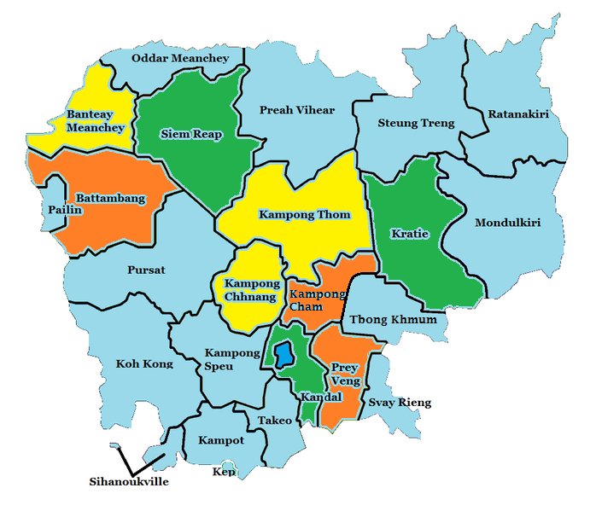

**Cambodia**

**CCJAP CPCS Supported Provinces and Target Communes: Stages of Provincial Phased-out**

|  |  |
| --- | --- |
|  | 1st Stage: December 2013 to March 2015 |
|  | 2nd Stage: December 2013 to March 2015 |
|  | 3rd Stage: December 2013 to March 2015 |
|  | Remaining provinces with no CPCS support from CCJAP |

The CCJAP provided support to the RGC agencies to more effectively implement community safety in action plans for sub-national democratic development, legal and judicial reform and reducing gender-based violence as an integral part of its policy for national program for sub-national democratic development through decentralization and deconcentration (NP-SNDD). The outcome was delivered by providing support of up to $800 per selected partner communes to fund commune requested CPCS initiatives.

The goal of CPCS was to support commune councils in nine CCJAP partner provinces (Kandal, Siem Reap, Kratie, Banteay Meanchey, Kampong Thom, Kampong Chhnang, Kampong Cham, Battambang, and Prey Veng) to strengthen planning and implementation of CPCS activities selected from a menu of options. Activities were to guide commune planning processes to ensure target responses that contribute to the CCJAP program outcomes including the Outcome 2a: “Community works better together to demand and deliver safety” and Outcome 2c: “Cambodian have greater awareness of the law, their legal rights and responsibilities”.

The financial support to implement CPCS activities was based on a mechanism for financing targeted small grants of up to $800 per participating commune per year to support activities prioritized by the commune councils under the CIP. The grants were allocated annually through a competitive planning process aligned to the RGC decentralized processes. CCJAP developed guidelines for project fund management for the Partnership Support Fund (PSF) to manage funds in a transparent and responsible manner. These guidelines were prepared for the Inter-Commune Project Management Committee (ICPMC), Provincial Coordinator, District Focal Point, Project Implementing Agency (PIA), government counterparts, CCJAP staff and other relevant agencies.

The CPCS activities commenced in the partner provinces in December 2013 and concluded on 30 September 2015, responding to the CCJAP Exit and the CPCS phase-out strategies approved by the NMB in December 2014. The phase-out strategy was done in three steps over three months. The CPCS in Kandal, Kratie, and Siem Reap were concluded at the end of March 2015, then Banteay Meanchey, Kampong Thom, and Kampong Chhnang were concluded at the end of June 2015, and finally the last three provinces of Battambang, Prey Veng and Kampong Cham were concluded on 30th September 2015. Ceasing the support on CPCS allowed CCJAP to continue with a focus on supporting community policing within CNP.

At each of the partner provinces, a Deputy Provincial Governor was appointed to be the key government counterpart to support and coordinate CCJAP and CPCS program activities. Under the provincial government umbrella, two to three Provincial Coordinators were appointed to work closely with each CCJAP Senior/Provincial Program Officer to ensure the proper functioning of the CPCS program. A District Focal Point was also selected to support both the provincial CPCS members and the commune councils at each CPCS targeted communes.

A total of 2,060 CPCS activities were implemented attended by 134,681 beneficiaries of which 54% were women and approximately 14.9% were youth.

**DELIVERY/INPUTS**

CCJAP worked to support making communities safer for women, youth, and children and to reduce crime in communities through its investment in commune-level development under the partnership support fund and through capacity development support to the government counterparts. The design of CPCS was based on partnership support at the provincial, district, and commune levels and on a demand-based approach.

CCJAP supported 385 targeted communes in nine provinces to implement CPCS activities. The commune-requested CPCS projects were mainly related to awareness-raising with topics including: law on the prevention of domestic violence; drug abuse; gambling; human trafficking; safe migration; the penal code; the traffic law; education for persons engaged in gang activity; and the VCSP (the Royal Government of Cambodia policy related to community safety). The most frequently requested CPCS project type funded by CCJAP were for activities related to the reduction of domestic violence, followed by VCSP dissemination and drug business/use prevention projects (see Table 1).

Significantly, CCJAP’s work in the area of CPCS achieved measurable results, not only from a quantitative perspective, but also qualitatively (see under the ‘Output and Outcome’ Section). Quantitatively, CCJAP achieved the following outputs:

* **2,060** separate activities were conducted across nine provinces;
* **134,681** persons attended CPCS activities at the commune level;
* **31%** of all commune requested activities related to reducing of gender-based violence (GBV);
* **72,785 (= 54%)** participants were female; and
* **AUD778,548** in program funds were expended in this activity.

**Table 1: CPCS Projects and Beneficiaries**

|  |  |  |  |  |
| --- | --- | --- | --- | --- |
| **CPCS Project Names** | **# of Activities** | **# of Beneficiaries** | | |
| **Male** | **Female** | **Total** |
| Law against domestic violence | 668 | 15,493 | 25,287 | 40,780 |
| Village and commune safety policy | 302 | 11,562 | 11,083 | 22,645 |
| Drug business/use prevention | 287 | 9,370 | 9,327 | 18,697 |
| Traffic law and public order | 227 | 7,434 | 6,697 | 14,131 |
| Public Forum/Community Forum | 122 | 5,146 | 4,592 | 9,738 |
| Law on migration | 101 | 2,701 | 4,109 | 6,810 |
| Law on suppression of women/children trafficking | 104 | 2,733 | 4,017 | 6,750 |
| Education for gangs | 69 | 1,872 | 2,025 | 3,897 |
| Penal and civil law | 56 | 2,085 | 1,475 | 3,560 |
| Law against women and children rape | 32 | 520 | 1,028 | 1,548 |
| Law on suppression of sexual exploitation | 20 | 500 | 769 | 1,269 |
| Civilian protection movement | 15 | 961 | 199 | 1,160 |
| Gambling prevention | 16 | 418 | 570 | 988 |
| Land law | 14 | 459 | 715 | 1,174 |
| Law on marriage and families | 15 | 312 | 458 | 770 |
| Children labour exploitation/prevention | 7 | 136 | 281 | 417 |
| Fishery law | 5 | 194 | 153 | 347 |
|  | **2,060** | **61,896** | **72,785** | **134,681** |

The CPCS projects were selected through a process that involved CCJAP provincial program officers providing support to target commune authorities to assist them to identify, screen, and select CPCS priority project proposals from Commune Investment Programs (the government-led, local participatory planning process applied by all commune councils across the country).

**Figure 1: CPCS Projects Financed from December 2013 to September 2015**

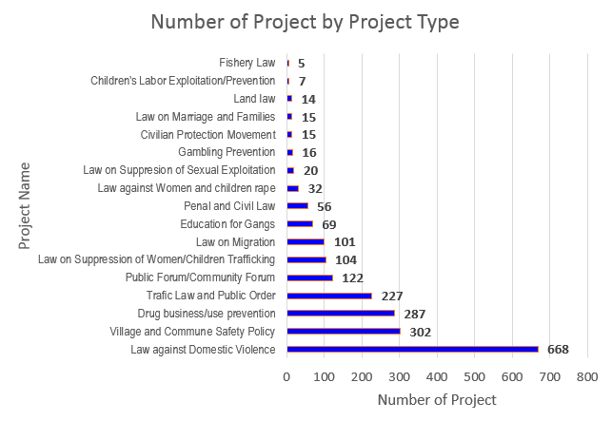

CCJAP delivered its CPCS program by engaging directly with community located agencies and individuals who were contracted locally to provide inputs. The use of these PIAs allowed CCJAP to revise the way in which funds were managed provincially and to reduce previous costs attributed to provincial overheads from 42% under the previous phase to an average of 15% under the current CCJAP. There were nine PIAs involved in delivering CPCS projects to the communities in the CCJAP partner provinces. Police agencies had the highest PIA representation (around 56%) in terms of project value in delivering CPCS projects, with Women’s Affairs Agencies second at around 33%.

**Figure 2: CPCS PIAs during April–September 2015**

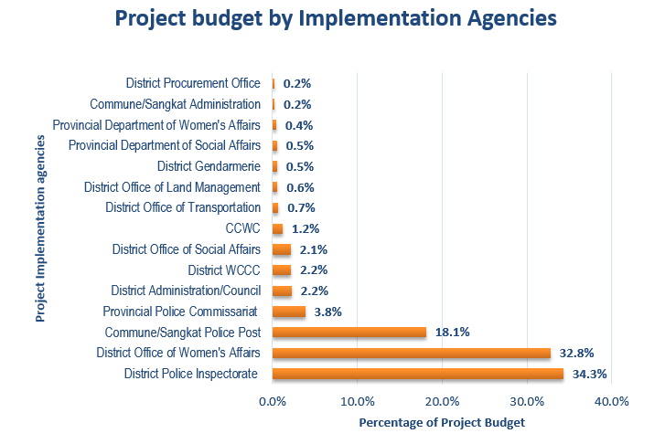

Among the 390 CPCS projects implemented during the period, 57 projects were selected for assessment through CCJAP’s internal monitoring and evaluation system. The assessment results revealed that after having attended a CPCS dissemination meeting, 39% and 61% of respondents[7] rated improvement of their awareness as “**Excellent**” and “**Good**” respectively. Approximately 98% of the respondents expressed that the awareness sessions were “**Important**” and “**Very Important**” (Figure 3).

**Figure 3: Beneficiaries' perception of the CPCS awareness sessions**

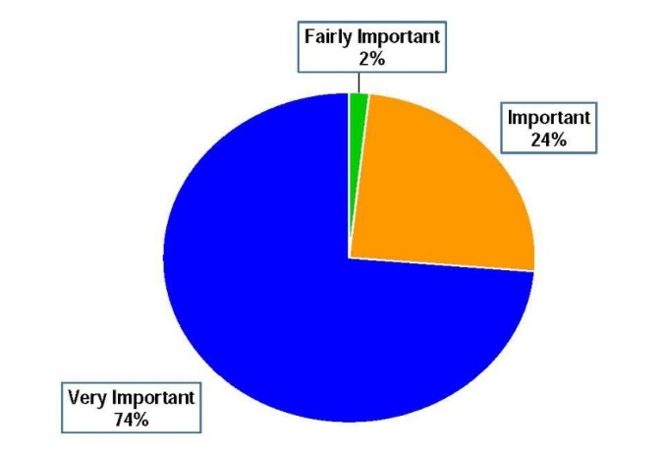

**OUTPUT AND OUTCOME**

CCJAP focused on the monitoring of CPCS project implementation and managed the CPCS end line survey through Angkor Research and Consulting Ltd, a private research company contracted to undertake an independent review of the impact of the CPCS program activities.

The CCJAP’s monitoring and evaluation process included regular tracking of activities and their impact. This monitoring data was also important for supporting and following up the progress of the CPCS project implementation, as well as for monitoring payments made against its schedule of costs.

In terms of monitoring CPCS project progress and performance in the field, all CCJAP provincial officers and their counterparts were directly responsible for monitoring and assessing the CPCS implemented projects through direct observation and interviews with beneficiaries and other project stakeholders. The completed assessment forms were sent to the CCJAP Phnom Penh office, where the assessment data was entered, summarised and analysed and used to support management oversight and feedback to the NMB and counterparts.

During the implementation period, 57 out of 390 CPCS projects implemented were selected for performance assessment through the CCJAP internal monitoring and evaluation system. The assessment results revealed that after having attended the CPCS dissemination meeting, 39% and 61% of surveyed participants from the 57 project sites rated improvement of their awareness as “Excellent” and “Good” respectively (Figure 4).

**Figure 4: Level of CPCS project beneficiaries’ awareness improvement**

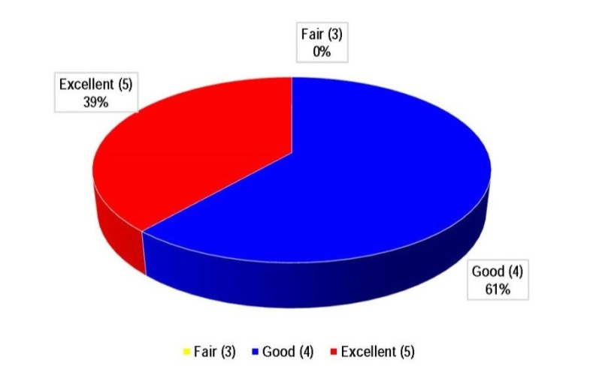

In June 2015, a CCJAP internal ‘rapid assessment’ was conducted of 116 out of 387 CCJAP-targeted communes that had been supported during the period, in order to find out whether any CCJAP targeted communes were using their own commune fund to support CPCS-related projects. This question is highly relevant to understanding if the CPCS-funded activities had established a sustainable platform from which commune leaders would support community safety reform in the future. The key respondents to this assessment were the commune chiefs and commune vice chiefs or clerks who have good knowledge of the use of each assessed commune’s 2015 commune fund. One of the 116 communes was not able to provide a response due to a schedule conflict; however, CCJAP provincial officers were able to interview all other identified respondents. The findings from the assessment include:

* Among 115 communes interviewed, 84% of them had used commune funds to finance social projects in 2015.
* 84 out of 115 communes interviewed (accounting for 73% of the responding communes) used their commune funds to support CPCS-related activities in 2015. The amount of commune funds used to finance CPCS-related activities ranged from USD25 to USD2,375.
* Only 1.2% of the allocated commune funds was used to finance the CPCS-related projects in 2015.
* Upon asking why the communes had not allocated Community Safety funds to finance CPCS-related activities, we received the following responses:
  + 35% said “No idea”
  + 26% said “CCJAP already supported the activities”
  + 19% said “Infrastructure activities are the higher priority”
  + 10% said “No instruction from national level”
  + 10% said “CPCS activities require complicated procurement processes”.

In early 2015, CCJAP engaged Angkor Research and Consulting Ltd. to conduct a study to measure the effectiveness of the CPCS project during the fourth phase of CCJAP in CPCS-targeted communes. The effectiveness of the project was measured in relation to: the safety of women, youth and children; changes in community crime rates; sustainability of the program; and changes in community behaviours. This survey included:

* a cross-sectional, quantitative survey of 756 households in three provinces (504 households in 12 communes that have received CPCS support, along with 252 households in six similar communes without CPCS interventions);
* a qualitative survey of 18 in-depth interviews with relevant local authorities (including commune police and commune council members) and community members (those that have participated in CPCS activities, and/or have the strongest perceptions of safety); and
* three focus group discussions with community members who had completed the quantitative survey already.

Summary of the results of the survey:

* The average rate of crimes per person was lower for the treatment group than the control group. Additionally, a decrease in rate of crime was observed in the treatment group, while the control group remained steady. While this suggests impacts of CPCS, the difference-in-deference (DID) analysis here did not prove this change to be statistically significant.
* There is a noticeable difference in the outcome of reporting, with the treatment group having a larger percentage of crimes solved than the control group. This frequency was also increasing through the timeline surveyed for treatment group, while the control group remained steady.

**Figure 5: Average number of crimes per person per year**

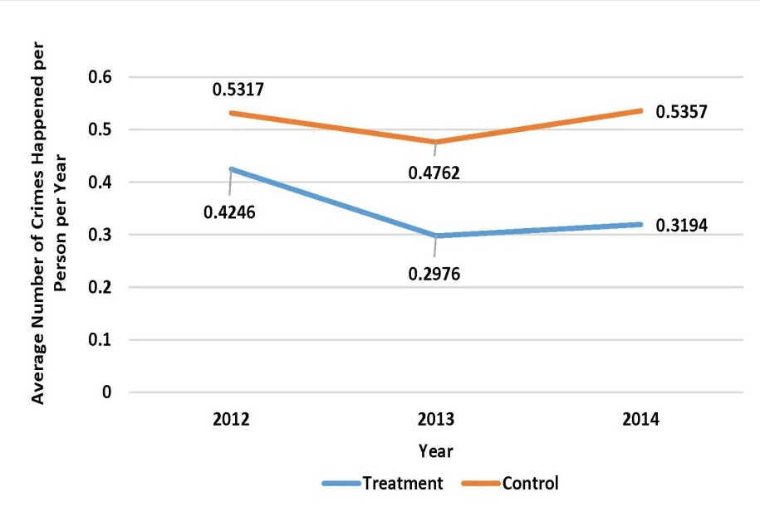

**Figure 6: Outcome of all crimes reported**

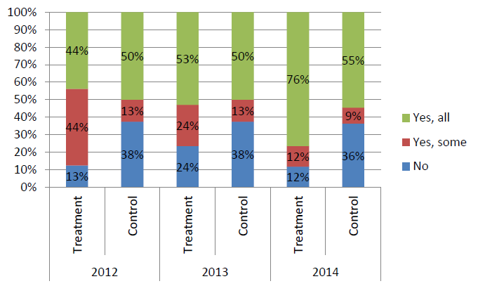

* In relation to how afraid of crimes respondents felt, the treatment group, overall and on specific measures, felt less afraid then the control group. The control group had a higher level of fear of various crime types than CPCS treatment respondents. In both groups, the fear had decreased in the past three years; however, the treatment group was declining at a faster rate than the control group. While these were encouraging for respondents’ perceptions of crime, the DID analysis showed that it cannot be a definitive result of CPCS activities, as a statistical significance was not observed.

**Figure 7: Fear of crime happening in villages**

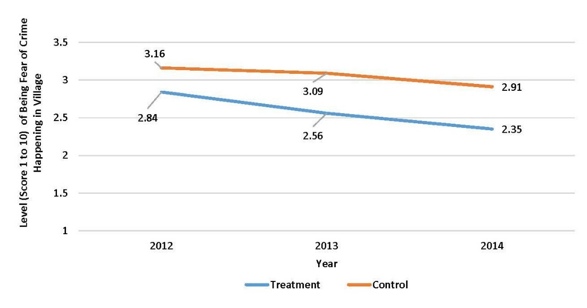

* The treatment group was observed to have higher perceptions of safety than the control group in their homes, villages and various situations in the community. This is also mentioned anecdotally in the qualitative section of the survey at these events.
* For overall satisfaction with local police, the mean satisfaction scores rose throughout the treatment period. This was true for the treatment group and the control group alike. While increasing at a similar rate, the treatment group was higher than the control group; however, because of the similar increase of the control group, the result of the DID analysis was not significant.

**Figure 8: Overall satisfaction with police**

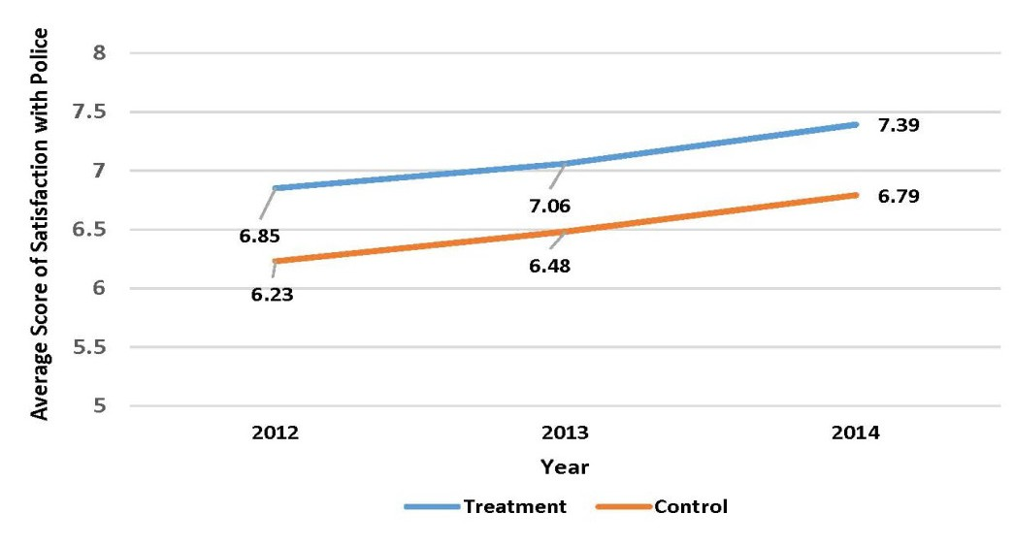

* In regards to specific measure of police behaviour change, the largest change occurred in relation to the accessibility of police; defined as how easy it is to locate and contact police via phone or in person. Here a significantly lower proportion of treatment respondents felt that it had become worse, and a larger percentage had indicated they felt it improved either somewhat or much.

**LESSONS LEARNED**

* While the surveys did not indicate statistical significance of CPCS activities for results observed between the treatment and control groups, the activities were clearly correlated. While this suggests the activities were relevant to the improvements measured in the treatment group, it can only be claimed that they were one of potentially many variables that led to this change. Further study, during the followup CPI project, could potentially take this research further to more accurately identify the level of contribution from CPCS-type activities. The anecdotal evidence (eg. CNP unsupported efforts to extend and expand on some CPCS tools produced) suggests this may be positive.
* The CPCS program provided short-term benefits to local communities with regards to improved understanding and awareness of the law and the rights of community members. More importantly it provided local authority officials at the commune level with clear examples of the benefits of investing in these activities. Subsequent evaluation showed that a majority of commune leaders had begun to use their own funds to continue these activities. A challenge remains about how this understanding can be shared with provinces and communes not supported by CPCS.
* The management of the Partnership Support Fund through which funds were distributed to communes for financing CPCS activities, demanded a flexible approach that worked by funding individual PIAs rather than by paying the funds through provincial treasuries. Past use of provincial treasuries during the previous phase of CCJAP had resulted in the dilution of project funds for ‘overheads’ that on average totalled 42% of all distributed funds. The approach adopted during this phase, using direct funding to PIAs, resulted in an average overhead cost of 15%.
* The investment through the CPCS activity area provided clear evidence of the nature and type of crime and security issues that were of most concern to communes. This knowledge was critical in the later work with the CNP during the development of their community policing strategy and its implementation.

Appendix D

Supporting the Development of Community Policing within the Cambodian National Police

Appendix D Supporting the Development of Community Policing within the Cambodian National Police

CCJAP provided support to Cambodian National Police (CNP) from the commencement of the program in April 2013. In the beginning, CCJAP support focused on CNP requests for assistance to their program to implement their “strengthen police posts for community safety” program (SPPCS). In August 2014 the CNP approached CCJAP for deeper engagement and with a specific request for support that focused on the development of their capacity to effectively enhance the policing services and community safety at the commune level.

CCJAP’s approach was to work directly with the CNP’s Department of Administrative Police Post Affairs (DAPPA), which had been established to support police posts at the commune level, to more effectively deliver policing services to their communities.

The CNP manages its 1,633 police posts in Cambodia through a centralized DAPPA department at the National level, oversighting activities carried out at the Provincial (Office of Administrative Police Post Affairs APPA); District level (Deputy Inspectors for Administrative police posts); and the commune level. DAPPA has a role to work with each layer within the structure to ensure that police posts are properly supported and delivering effective police services.

In November 2014, CCJAP committed to a deeper engagement with the CNP and prioritised support to the development and implementation of community policing within the CNP. This support included a pilot program that took the following form:

An Assessment of the Needs of the CNP and Community

* CCJAP worked closely with the Deputy Commissioner General of National Police (CCJAP’s key senior counterpart) and the head of the DAPPA to develop a community policing initiative proposal for consideration by the CNP. This initiative was approved by the Commissioner General of the CNP and became the template for all subsequent community policing development within the CNP.
* CCJAP supported the CNP to restructure the DAPPA to better align with modern community policing models. The proposed structure was approved by the CNP in early 2015 and established.
* CCJAP supported CNP to conduct workshops on strengthening of police posts for community safety in nine provinces; Kandal, Kratie, Battambang, Kampong Cham, Prey Veng, Kampong Chhnang, Kampong Thom, Siem Reap, and Banteay Meanchey. The purpose of the workshops was a) to inform the important of police posts’ role and responsibilities in terms of working closely with communities and provision of policing services, and b) to collect important information and feedback from the participants about their actual practice, experience, and challenges. A total of 1,338 participants (12 women) attended the workshops commencing from 11 December 2014 to 29 January 2015.

Testing the Logic of the Piloted Activities

* In February 2015, CCJAP and DAPPA jointly conducted an evaluation survey at six communes in Kandal, Kampot, and Kratie provinces. The aim was to evaluate the way in which police services were delivered and to gather further evidence to identify the challenges to inform the way in which CNP would introduce its reform measures. The stakeholders who were involved in the survey interviews included police members at provincial, district, and commune level; chiefs and members of commune councils; chiefs and members of district women and children committee (DWCC); chiefs and members of commune women and children committee ; and the community. The findings from these workshops were used to develop the outline for the subsequent community policing pilot programs across 24 communes and two Sangkats later in 2015.
* In February 2015 CCJAP and DAPPA jointly conducted a GBV evaluation survey in three provinces that examined the way in which GBV cases were being managed and provided the CNP with a better understanding of the impact of GBV within communities. This led to two significant outcomes which are discussed in figure 1 below.

Evaluating the Pilots

* Information and evaluation results from the nine workshops and the survey, followed by a number of discussions within CCJAP and CNP leaderships, were used during a national workshop on strengthening of APPA management mechanism and as an introduction of community policing which was organized in July 2015.
* Police commissioners and deputy police commissioners attended the workshop from 25 provinces, along with 197 district police inspectors, and a number of key senior officers from CNP headquarters. In his closing remarks to the workshop the CNP Commissioner expressed his strong commitment to improve police post services and formally announced the commencement of community policing within CNP.

Outcomes from the Pilots

* The CNP submitted a post workshop report to Deputy Prime Minister and Minister of Interior, who approved its recommendations that community policing be implemented nationally within the CNP.
* The CNP adopted the model of community policing piloted along with the four tools and began to implement them across the country.
* CCJAP responded to requests from the CNP for an expansion of the provision of commune maps and provided maps to a further 180 communes across the country.

**Figure 1:**

The DAPPA used the results of the joint CCJAP/CNP research to gain approval for the establishment of a gender division within their structure that was specifically tasked with supporting improved GBV responses across the country.

For the first time in CNP strategic planning, a section titled, ‘Strategy on GBV’ was included within the DAPPA five year strategic plan (2015-2019) which identified GBV and domestic violence as two of the main challenging issues at the village/commune level that police posts were facing and recognising.

**Piloting Community Policing July 2015 – February 2016**

CCJAP supported the implementation of community policing with the CNP from July 2015 through February 2016 with a series of activities piloted at 24 communes across the three provinces (Kandal, Kratie, and Prey Veng) and two Sangkats (a local term means urban commune) in Phnom Penh. The implementation introduced a four step process that aimed to improve the engagement of commune police with their local communities. The objective of the pilot was to test the four tools; a tool to collate crime and safety data across all local authorities; a tool to map the location of events to identify trends and patterns; a tool to analysis and identify causative and contributing factors; and a tool to coordinate police/community partnership in addressing these causative and contributing factors. The pilot program was implemented through two defined phases of support:

**Phase 1:** Capacity development to members of DAPPA and Offices of APPA in target provinces from July to October 2015

The support in this phase included the establishment of six divisions to improve the functioning of role and responsibilities of the current DAPPA structures, delivery of training on community policing and crime prevention, and development of crime prevention tools that could be used by the police posts at target communes/Sangkats.

**Phase 2:** Implementation of community policing at 26 target communes/Sangkats from October 2015 to the end of February 2016.

In this final phase of CCJAP’s operations, support focused on implementation of community policing program across the 24 communes in three provinces and two Sangkats in Phnom Penh.

The support to CNP and DAPPA within this initiative met the goals set out in CCJAP’s Annual Workplan and included the development of tools for use by the CNP in commune police posts to improve coordination and cooperation between police and their communities. These tools were adapted by the CNP in each of the pilot locations and later expanded across the country to other locations.

**Training**

CCJAP initiated a training program that included mentoring and advising key counterparts; on the job training to members of the DAPPA; workshop programs to introduce the concepts of community policing at the 26 communes and two Sangkats; and broader workshops and conferences at the national and provincial levels focusing on the principles and processes involved in adopting community policing within the CNP. All training programs and engagements were done collaboratively with DAPPA counterparts who quickly took over the lead in subsequent training programs. This approach developed the capacity of DAPPA to train and mentor within the CNP and also ensured that the ownership of the community policing reform rested clearly with the CNP, not CCJAP.

This training took place from October 2015 to February 2016 and DAPPA officers, supported by CCJAP advisors, worked together to organize 14 two-day training sessions on community policing and the development and use of joint police/community crime prevention tools. Attendees numbered 466 participants (37 women), made up of commune police, commune council members, commune citizens, and village chiefs. CCJAP also supported the police posts and commune councils to organize discussion forums as part of the crime prevention planning process at all target communes and Sangkats, which were attended by 1,453 participants (of whom 373 were women).

Feedback from these discussions revealed that the most pressing crime and safety issues facing communes in each of the three provinces and Sangkats were gender based violence issues and the impact of drugs within communities (see Figure 2 below). CCJAP supported the DAPPA as they supported commune police posts to identify crime prevention priorities that would become the basis for joint police/community crime prevention activities in the future.

**Figure 2: Priorities in the Police Posts’ Action Plans**

**Progress Monitoring and Evaluation**

CCJAP support the development of DAPPA’s capacity to monitor and evaluate the implementation of community policing during the pilot period. This built on previous work done with the DAPPA team and involved supported travel to pilot communes and Sangkats to monitor and evaluate the impact and effectiveness of the community policing tools developed by CCJAP/DAPPA. Provincial deputy police inspectors in charge of police posts were included in this fieldwork and were mentored to better manage and oversight the development and implementation of joint crime prevention plans at the commune level.

CCJAP also responded to the Phnom Penh Police’s request to organize the community policing trainings with the use of crime prevention tools to members of police posts and Sangkat councils at eight other Sangkats in addition to the two CCJAP target Sangkats within the same Khan (equivalent to a district in province), Khan Posenchey. The total of 284 (of which 61 are women) attended the training sessions.

**Outputs/Outcomes**

Community policing in Cambodia is understood by all partners as being the delivery of improved police services that are responsive to, and informed by local needs and circumstances. CCJAP supported the CNP to implement community policing from July 2015 through to February 2016. The support was defined in two phases, capacity development within DAPPA and provincial offices of APPA from July to October 2015; and implementation of community policing at target communes/Sangkats from October 2015 to February 2016. Outputs and outcomes from this implementation activity include:

* On the 29 July 2015 Deputy Prime Minister and Minister of Interior approved the results of the community policing conference and directed that the MoI begin cooperation with other relevant agencies.
* The CNP initiated the implementation of the CCJAP-supported community policing and crime prevention tools across a further 181 non-CCJAP target communes in 25 provinces. This represented a significant ownership of the process by the CNP and their endorsement of the effectiveness of the tools that were developed.
* The CNP issued a directive on Further Strengthening of the Effective Functioning of Police Posts No. 003, dated 15 March 2016, which instructed police posts to deliver more effective policing services; to visit and talk to communities; and included an instruction to police posts to undertake community policing within their communes. The directive was a product of the CCJAP/DAPPA collaboration and cooperation and was circulated to all 25 provinces with further instruction to district and commune levels.
* Before CCJAP provided training on community policing tools across the 26 pilot communes, only two out of the 26 (8%) target police posts prepared crime prevention action plans. After the training, all 26 police posts have prepared and completed their three-month crime prevention action plans which are now in place and being used to guide their daily operations.
* After the training, all 26 police posts have involved 1,453 community members (of which 373 are women) in their crime prevention action planning process.
* Following the commencement of the community policing pilot activities the number of police post organizing meetings in relation to community safety issues increased from seven (before) to 16 (after the training on community policing) police posts. (Please see figure 3 below)

**Figure 3: Changes in Police Post Practices before and after Community Policing Training within the 26 Target Police Posts.**

**Lessons Learned**

CCJAP worked closely with the senior executives of CNP at the decision making level in order to keep informing significant message and supporting each other to fulfil the agreed tasks. The decision to implement the reform of police posts to undertake community policing has come from the highest level of the CNP. The genuine commitment is an obvious precursor to undertake the reforms and this has now been firmly established.

The partnership between CCJAP and CNP was a product of mutual trust that was carefully built and developed. Both teams are working closely towards the ultimate goal of contributing to the Cambodian government’s Village and Commune Safety Policy for a safer Cambodia through the implementation of community policing within CNP.

Appendix E

CCJAP Capital Works Projects

Appendix E CCJAP Capital Works Projects



Appendix F

Financial Summary

Appendix F Financial Summary

| ACTIVITY | Contract Value | Total Expenditure  (Apr–Jun 2013) | Total Expenditure  (July 2013–June 2014) | Total Expenditure  (July 2014–June 2015) | Total Expenditure (July 2015-May 2016) | Forecast  June 2016 | Total Anticipated Invoicing | % Claimed against Total Contract |
| --- | --- | --- | --- | --- | --- | --- | --- | --- |
| **MILESTONE CLAIMS** | $2,089,315 | $522,329 | $417,863 | $626,795 | $417,863 | $104,466 | $2,089,315 | 100% |
| **REIMBURSABLE COSTS** |  |  |  |  |  |  |  |  |
| Long-Term Adviser fees | $2,653,534 | $162,562 | $788,697 | $852,701 | $588,443 | $48,639 | $2,441,043 | 92% |
| Short-Term Adviser fees | $92,160 | $10,977 | $15,923 | $2,048 | $11,612 | $5,971 | $46,531 | 51% |
| Adviser support costs | $164,588 | $12,907 | $33,289 | $58,031 | $39,525 | $4,000 | $147,752 | 90% |
| Activity costs | $3,477,203[8] | $0 | $339,522 | $1,319,632 | $1,068,437 | $115,054 | $2,842,646 | 82% |
| Reimbursable set up costs | $566,400 | $143,840 | $221,804 | $4,831 |  | $0 | $370,476 | 65% |
| Reimbursable operational costs | $1,456,800 | $28,683 | $263,237 | $257,248 | $147,424 | $17,360 | $713,951 | 49% |
| **TOTAL** | **$10,500,000[9]** | **$881,298** | **$2,080,335** | **$3,121,287** | **$2,273,304** | **$295,490** | **$8,651,714** | **72%** |

1. This was revised down from $12 million in 2014 following reductions to the Australian Government aid budget.
2. This was revised down from $12 million in 2014 following reductions to the Australian Government aid budget.
3. The CCJAP independent review of 2016 p. found, ‘the transition from CPCS to CPI inspired the CNP to expand the CCJAP pilot and launch its own nationwide community policing initiative. This has been the most concrete result of the program and may prove to have considerable significance’.
4. This figure was revised down from $4,977,203 (reduced by $1.5 million) in 2014 following reductions to the Australian Government aid budget.
5. This figure was revised down from $2,492,200 (reduced by $1.5 million) in 2014 following reductions to the Australian Government aid budget.
6. This figure was revised down from $12 million (reduced by $1.5 million) in 2014 following reductions to the Australian Government aid budget.
7. Of 57 respondents.
8. This figure was revised down from $4,977,203 (reduced by $1.5 million) in 2014 following reductions to the Australian Government aid budget.
9. This figure was reduced down from $12 million (reduced by $1.5 million) in 2014 following reductions to the Australian Government aid budget.