World Health Organisation Cambodia
2015 MID-TERM REPORT
for Human Resource for Health and Collaborative Efforts between MoH, WHO and AUSAID (replaced by DFAT) in Maternal, Newborn & Child Health
01 July 2012 to 31st January 2016

EOL No. 50078/56 WHO Award 59589
30 June 2015

Signed: May 21st 2012
End Date: January 31st 2016
Reporting period: Mid-Term Report 2015

Table of Contents
1. Background 3
2. Health Workforce in Cambodia – Developments and Progress 3
3. Human Resources for Health: Strategic Priorities, Objectives and Activities: Mid-Term Progress Report 5
3a. Strategic Priority One: Supporting and Strengthening of Multisectoral policy dialogue through Increased Capacity of Governance Structures 5
3b. Strategic Priority Two: Improve the Technical skills and Competence of the Health Workforce through Strengthened Pre-service and In-service Training 6
3c. Strategic Priority Three: Strengthen health workforce management: Recruitment, performance management, deployment, retention and compensation 9

Background

Over the past two decades, Cambodia has made significant gains in rebuilding its health system through an extended process of health reform beginning in the 1990s. This has helped the country to make impressive strides in improving health outcomes over the last decade. Between 2000 and 2014, the maternal mortality rate (MMR) dropped from 437 to 170 (per 100,000 live births) and the under-five (U5) mortality rate dropped from 124 to 35 (per 1000 live births). Considerable gains have been achieved in controlling the HIV/AIDS and tuberculosis (TB) epidemics. The HIV/AIDS prevalence has fallen from 3 percent in 1997 to 0.8 percent in 2012.

Yet, in spite of these achievements, several challenges persist and new ones are emerging. Notably, the progress in reducing malnutrition has been slow - stunting showed a modest decline (from 50% in 2000 to 32 percent in 2014), but wasting increased (from 8 percent in 2005 to 10 percent in 2014) and underweight showed no change (28 percent in 2005 and 2014).³ Cambodia’s maternal mortality rate is almost four times higher than the averages for the Asia Pacific region (47 per 100,000 live births).¹ The country is also witnessing an epidemiologic transition; non-communicable diseases and injuries are now amongst the leading cause of DALYs lost per 1,000 population.

A widely acknowledged limitation of the health system is the lack of well-trained, motivated and adequately-compensated staff, providing quality assured services. Although there has been a huge increase in the size of the workforce, health sector analyses in Cambodia point towards the need for improving governance and quality management of the health workforce.

Health Workforce in Cambodia – Developments and Progress

Cambodia still suffers from significant human capacity gaps, a vestige of the years of decimation of the educated population under the Khmer Rouge regime, followed by a decade of instability. Re-building of the skilled workforce, in particular in critical areas such as health, is a national priority and has been outlined in the National Strategic Development Plan 2006-2013 as well as sector-specific plans (First and Second Health Strategic Plans). HSP2 2008-2015 outlines the importance for service delivery of having appropriately skilled health staff who are adequately motivated, proficiently trained and equitably deployed.

To prioritize the rebuilding of the health workforce, the Ministry of Health invested in the Health Workforce Development Plan 1 (1997-2005), which focused on adequate production and equitable distribution of health workforce according to the then newly adopted Health Coverage Plan. Building on the achievements from the first plan, the second Health Workforce Development Plan (2006-2015) aimed to further address the issues of improving the competency and management of the health workforce. The specific focus granted to health workforce under these Plans resulted in impressive gains. For instance, the size of the health workforce increased substantially. The number of doctors increased from fewer than 50 doctors in the early 1990s to a current strength of over 2,500 working in the public sector.
The growth in the workforce was enabled to a large extend by the expansion of the tertiary education sector in the last decade, particularly in the private sector. (Figure 1) Total enrollment in both public and private institutions was little over 20,000 in 2014.

Figure 1. Public and Private Health Training Institutions in Cambodia
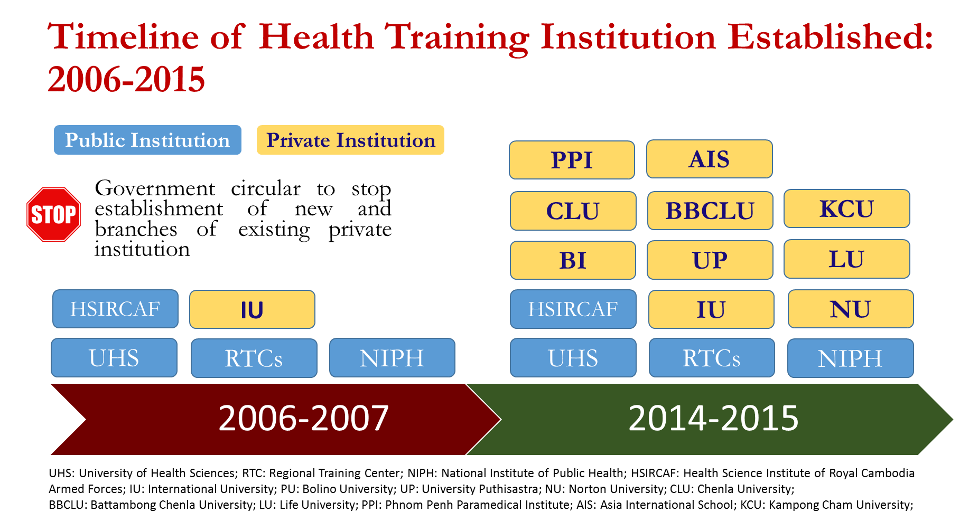
Source: HRRD, MOH

A Mid-Term Review (MTR) of the Health Workforce Development Plan 2006-2015 was conducted in 2011 to review progress and refocus efforts. The MTR identified four strategic priority areas for further investment and action. (See Box 1) The MTR also provided recommendations that centred on these strategic priorities, which were ratified by the Ministry of Health.

Box 1. Overview of the strategic priorities and recommended action
1. Strategic Priority One: Governance, planning and management of Human Resources for Health
1. 1 Human Resource for Health (HRH) Committee
1. 2. Capacity building for strengthening HRH governance at national and subnational levels

2. Strategic Priority Two: Improve the Technical Skills and Competence of the Health Workforce through strengthened pre-service training
2.1. National Licensing and Registration Exam
2.2. National Health Professional Registration Board
2.3. The Centre for Educational Development of Health Professionals (CEDHP)
2.4. The Nurse Bridging programme for Faculty development in Public Schools
2.5. In-service training and continuing education maintains the skills of the health workforce of Cambodia

3. Strategic Priority Three: Health Workforce Management; recruitment, performance management, deployment and retention
3.1. Health Workforce Recruitment, Deployment and Management
3.2. Scholarships

4. Strategic Priority Four: Staff Remuneration, salaries, performance incentives
4.1. Health labour market Analysis
Source: MTR HWDP

Some of the above recommendations are being implemented by the Ministry of Health with technical support from the World Health Organization (WHO) and funding support from the Department of Foreign Affairs and Trade (DFAT) Australia.
This Mid-Term Report 2015 updates on the progress in the past six months (January – June 2015) and builds on the Annual Report 2014 submitted by WHO to DFAT in January 2015.

Human Resources for Health: Strategic Priorities, Objectives and Activities: Mid-Term Progress Report

3a. Strategic Priority One: Supporting and Strengthening of Multisectoral policy dialogue through Increased Capacity of Governance Structures

- Supporting and strengthening multisectoral policy dialogue through the Human Resource for Health (HRH) Committee
The Minister of Health established the Human Resource for Health Oversight Committee (HRH Committee) to monitor and support the implementation of the MTR of the HWDP. Chaired by HE Prof Eng Huot, Secretary of State for Health, the Committee provides an effective platform for dialogue on HRH issues.

Key Achievements:
  - The HRH Oversight Committee met on the 17th of June 2015 to discuss the progress on HRH activities implemented by the two key departments of MOH (Department of Personnel and Human Resource Development). The Committee also discussed and approved the strategic priorities for the next Health Workforce Development Plan.
  - The Secretariat of the HRH Oversight Committee has produced the Annual Health Workforce Report for 2014. The report provides descriptive information on the progress of HRH issues and highlights the achievements, the constraints and the priorities for further action.

Proposed next steps:
  - The HRH Committee will continue to monitor and guide developments in HRH policy, planning and management. It has been decided that the Committee will review the final strategic priorities and activities of the next Health Workforce Development Plan 2016 – 2020 in its next meeting at the end of this year.
  - The HRH Secretariat will continue to provide the required support for the timely and evidence-based response to priority HRH issues.
  - The HRH Oversight Committee TOR is being revisited and there are on-going discussions on broaden the membership of the Committee to ensure adequate representation of key stakeholders and development partners.

3b. Strategic Priority Two: Improve the Technical skills and Competence of the Health Workforce through Strengthened Pre-service and In-service Training

- Strengthening the implementation and quality of the National Exit Examination (NEE)
The National Exit Examination (NEE) has been recognised as an important instrument to test the competencies of recent health graduates, to ensure that they have adequate knowledge and skills for practice. In 2015, two rounds of the NEE were conducted in the months of February and May.

Key Achievements:
  - Continued high-level political commitment for the implementation of the NEE.
  - Review, editing and adaptation of the MCQ Question Bank and OSCE scenarios for the NEE, for each health professional group.
  - Increasing number of students and institutions are now participating in the NEE.
  - Joint Prakas issued by the MOH and MOEYS to extend the NEE to associate degree programs of nursing and midwifery.
  - Eight Working Groups (WGs) were established by the MOH to review exiting MCQ banks: five WGs for Medicine (Basic Sciences, Medicine, Paediatrics, Surgery, and Obstetrics-Gynaecology) and one each for Dentistry, Pharmacy, and Nursing. Each WG had been chaired by a senior MOH official.
  - As of 2014, the NEE MCQ bank for all the four exam disciplines consisted of a total of 7,386 items. After the review, over 400 MCQs were dropped from medicine, dentistry and nursing MCQ banks whereas 85 items were added to the pharmacy MCQ bank.
  - Automated Correction of MCQs using the scanner has been adopted and approved.
  - A procedure for computing students OSCE scores had been developed and tested during the 2015 NEE by using available scanner and Remark Office OMR Software.
  - Students’ guide for the NEE has been developed that takes into consideration the existing exam blueprints and exam rules and regulations stipulated by the NEC, as well as comments from the NEC and WGs leaders and participants.

Figure 2. Number of students taking the NEE – 2013-2015
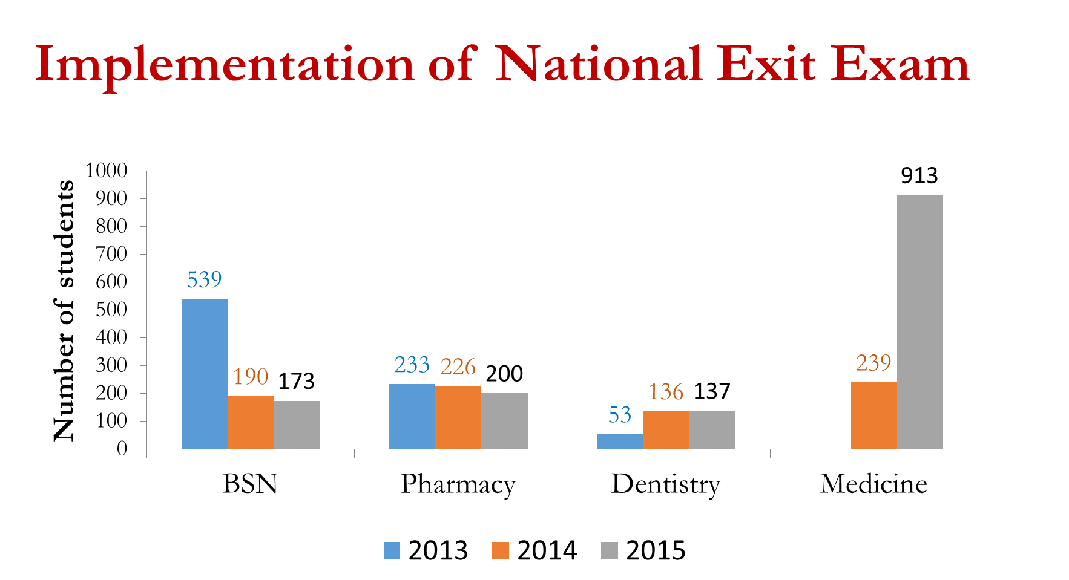

Figure 3. Training Workshop on the Use of Scanner for MCQ Correction

Figure 4. Training of OSCE Examiners

Figure 5. Training of OSCE Standardized Patients

Proposed next steps:
  - Substantially more items need to be added to the existing MCQ banks for each exam discipline, to make the MCQ exam more effective.
  - Similarly, more stations and cases/procedures within each station should be added to the OSCE exam.
  - Automated correction of MCQs is now adopted by the NEC after its successful implementation during the 2015 NEE. This process should continue until a computer-based MCQ exam is developed, tested and accepted by all stakeholders.
  - Automated OSCE scores computing should be administered from 2016 NEE, to render the process more reliable, time saving and cost-effective.
  - The implementation of NEE is labour intensive requiring continuing support from both MOH officials and technical experts. With the anticipated participation of associate degree student in 2016, the number of candidates will increase substantially. The NEC will have to identity an institution that will be handed over the administrative responsibility of conducting the NEE.
  - Given the new focus on competencies and examination of clinical skills, the health professional training institutions will be required to make major reforms to the curriculum and prepare both teachers and students to the new approach.

- Supporting the Health Profession Education Unit (HPEd)
The HPEd Unit is currently an established unit under the Rector of the University of Health Science (UHS). The Unit has developed a short-course on basic pedagogy skills and knowledge. In line with the UHS Strategic Plan 2014-2018, the HPEd Unit will be conducting training for all UHS/TSMC faculties in the short-course.

Key Achievements:
The HPEd Unit conducted the first training workshop for UHS/TSMC faculty on the short-course on basic pedagogical skills on the 15th – 19th of June, 2015.

Proposed next steps:
  - The HPEd Unit will continue to draw on the two cohorts of faculty members who are currently enrolled in the UP Manila MHPEd program, as resource persons to conduct similar training workshops in the short-course.

3c. Strategic Priority Three: Strengthen health workforce management: Recruitment, performance management, deployment, retention and compensation

- Creating a comprehensive HRH Observatory
The Departments of Personnel and Human Resource Development, MOH maintain two separate HRH databases (Data Management Tool (DMT) and Human Resource Development Health Information System (HRD HIS)). While the first database collects information on staff positions at the central level and in the 25 provinces in Cambodia, the second database is specifically for in-service trainings and up-skilling of staff members.
Although these databases have been very helpful to collect, collate and analyze HRH information, there was an immediate need to update the database to align it with the recent changes in the staffing guidelines and staff cadres. There is also an expressed need to include additional features to the database to enhance its utility for workforce planning, especially at the sub-national level.
Key Achievements:
  - A local IT firm has been contracted to create a comprehensive online database (with offline features) to incorporate the new data needs and to develop a collated HRH observatory for health workforce planning.
  - The new database will have additional features and dashboard to assist in easy assimilation and use of HRH data for planning purposes at the sub-national level.

Proposed next steps:
  - Finalize the design, data migration and use of the comprehensive HRH database.
  - Conduct training at the national and sub-national level on the use of the new database.

- Formulation of Health Workforce Development Plan 2016-2020
The MOH has embarked on the process for formulation of the third Health Workforce Development Plan (HWDP 2016-2020). The third HWDP (2016-2020) aims to consolidate the achievements of the previous two Plans, besides providing strategic direction to the future workforce actions. The HWDP will be a “strategic management document” to guide the MOH and health institutions, as well as concerned stakeholders in efficiently utilizing their resources to develop an accessible, acceptable and productive health workforce that will assist in achieving the overarching goals of the health system in Cambodia.

The formulation of the HWDP 2016-2020 is under guidance of the Human Resources for Health (HRH) Oversight Committee and the implementation of the process will be led, managed, coordinated and facilitated by the Departments of Personal and Human Resource Development (HRD). The administrative support for the preparation of the Plan is being provided by the HRH Secretariat.

The MOH has adopted a participatory and consultative approach for the formulation of the next HWDP (2016-2020). The process involves a number of activities, including three national consultative workshops with participants from MOH, Provincial Health Departments, Operational Districts and Health facilities, professional councils, training institutions and Health Partners including NGOs.

Till date MOH has organized two national technical consultation workshops. The objectives of these workshops were:
  - To identify key challenges associated with health workforce planning and performance;
  - To determine strategic objectives to address the prioritized challenges;
  - To determine strategic interventions, inputs, and key stakeholders for the agreed objectives;
  - To identify strategic indicators to monitor the implementation of the Health Workforce Development Plan 2016 - 2020.

Figure 6. National Technical Consultation Workshops for HWDP 2016-2020

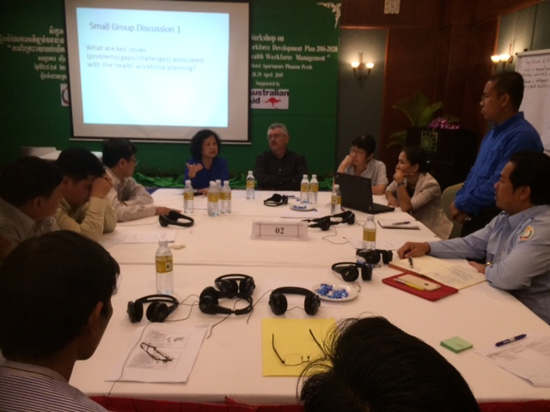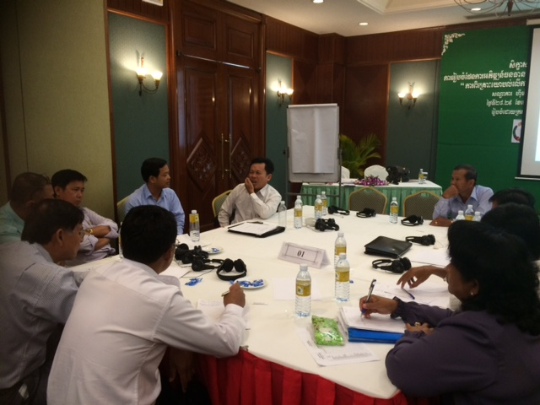
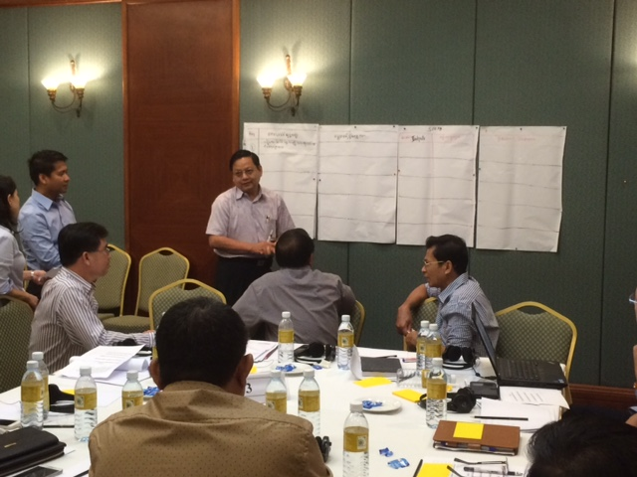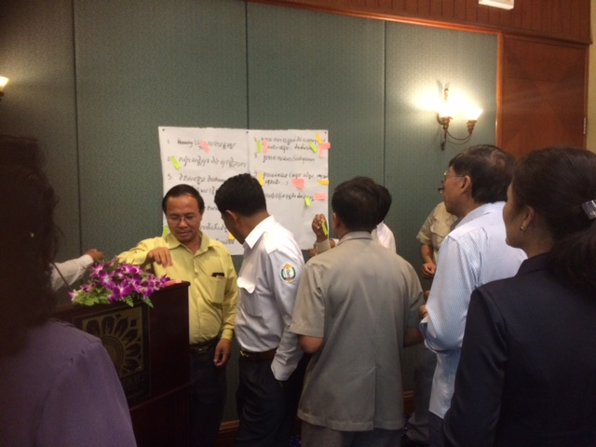

Key Achievements:
  - The first workshop was held on the 28th and 29th of April and focused on HRH planning, recruitment, deployment, retention and work environment.
  - The second workshop was held on the 11th and 12th of May and focussed on HRH production, trainings, accreditation and regulation.
  - Based on the outputs of the two workshops the vision, mission, goal, strategic objectives and priorities for the next HWDP 2016-2020 have been developed. These were presented, discussed and approved during the recent HRH OC meeting.
Proposed Next Steps:
  - The MOH conduct the third Technical Consultation workshop to prioritization of activities – timelines and estimated budget requirements.
  - Activities to develop a ‘ Costed ’ Work Plan for the HWDP 2016-2020
  - Share the full draft the HWDP 2016-2020 with key stakeholders for comments
  - The MOH wishes to disseminate the approved HWDP 2016-2020 during National Health Congress 2016.

Figure 7. HWDP 2016-2020 – Strategic Priorities, Outcomes & Impact



Cambodia Demographic Health Survey, 2005 and 2014
Cambodia Country Profile. UNAIDS 2012
Global Burden of Disease Profile: Cambodia. IHME, 2013

