FINAL PROGRESS REPORT

Support for Reproductive Health Commodities Security in Cambodia

Country: Cambodia

Reporting Period: 01 January 2013 – 31 December 2015

Programme Component: Reproductive Health

Implementing partner: Ministry of Health

- PURPOSE

This report provides a consolidated analysis of implementation and results achieved during the project cycle 01 January 2013 to 31 December 2015 with support from the Australian Government through the Department of Foreign Affairs and Trade (DFAT) for “Support for Reproductive Health Commodities Security in Cambodia 2013 – 2015”. The report reflects the achievements made using funds provided by the Government of Australia through the United Nations Population Fund (UNFPA) to the Royal Government of Cambodia/Ministry of Health, and also progress made in advocacy work in support of the family planning commodity security. This report is submitted as part of the requirements for the final progress and financial report at the end of the project cycle.

Expected Output(s) and Activities:

The support from the Australian Government contributed to improving the reproductive and maternal health of Cambodians and also supported the implementation of the Fast Track Initiative Roadmap for Reducing Maternal and Newborn Mortality (FTIRM) of the MoH. The support ensured and expedited the momentum and achievements made to date in order to meet the targets under Cambodia’s MDG 4: Reducing Child Mortality and MDG 5: Improving Maternal Health.
This Grant covered the procurement of contraceptive commodities for the MoH to supply the public health facilities and to meet the contraceptive needs of the Cambodia population, especially women and girls of reproductive age in need of family planning. The procurement of contraceptive commodities followed the UNFPA Procurement procedure conducted by UNFPA Procurement Service Branch (PSB), based in Copenhagen, Denmark.
- RESULTS
- Overall achievements
All health centres are now providing at least three contraceptive methods. The number of health centres providing IUD insertion and removal services increased from 914 in 2013 to 929 in 2015, representing 84% of all HCs across the country. There are now 44 referral hospitals are providing IUD insertion and removal services. The number of health centres providing Implanon insertion and removal services increased from 448 in 2013 to 663 in 2015, and the number of referral hospitals providing Implanon insertion and removal services increased from 27 in 2013 to 38 in 2015. With the increased service delivery points and secured commodity supply from 2013 to 2015, the Contraceptive Prevalence Rate (CPR) of the country continued to increase from 35% in 2010 to 39% in 2014 with a notable increase in use of Long Term Methods.
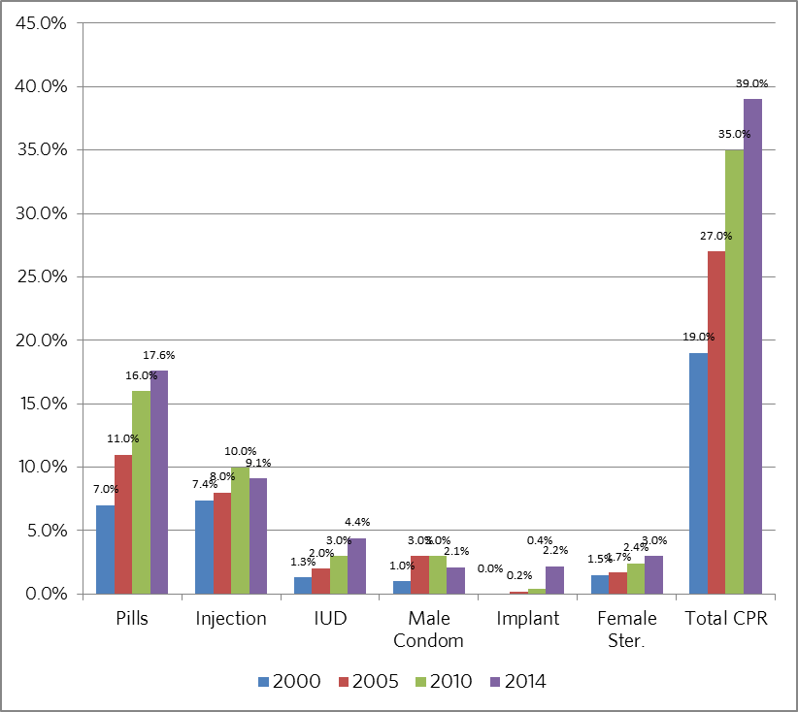
Source: CDHS 2000, 2005, 2010 and 2014
Emergency Contraception (EC) was first introduced in the public sector in 2012 with initial funding from UNFPA core budget. The introduction of this method was a step forward in preventing unwanted pregnancies, including for survivors of sexual violence, and reducing unsafe abortion. In addition, the introduction of EC was also considered as a “gateway” to providing a full range of sexual reproductive health services to women, and in particular a complete range of family planning services. EC is also used and targeted for Entertainment Workers in order to contribute to the reduction of unwanted pregnancies and unsafe abortions among this vulnerable group.
In order to cover the gaps in contraceptive supply in the public sector, with the funding support from DFAT and upon the request from the MoH, the UNFPA Procurement Services Branch based in Copenhagen assisted the MoH and UNFPA Country Office in procuring the following contraceptives:
N | Contraceptive | 2013 | 2014 | 2015 | Total 2013- 2015
1 | Male condom (piece) | 1,728,000 | 2,995,200 | 1,000,080 | 5,723,280
2 | Injectable (vial) |  | 520,000 | 200,000 | 720,000
3 | Combined Oral Contraceptive (CoC) (cycle) |  |  | 2,234,880 | 2,234,880
4 | Progestin Only Pill (PoP) (cycle) | 60,000 | 75,000 | 99,999 | 234,999
5 | Implanon (set) | 23,500 | 20,032 | 5,000 | 48,532
6 | Emergency Contraceptive (pack) | 15,000 | 10,000 |  | 25,000
In addition, UNFPA also used own core resources to procure 87,840 cycles of CoC to fill gaps and 4,000 sets of Implanon NXT. UNFPA successfully negotiated with the Implanon manufacturer (MSD) to provide 4,992 sets of Implanon NXT placebo (Implanon NXT for training practice) free of charge for the training purpose for the public sector.
A remarkable achievement in advocacy was realized in this reporting period. With technical assistance from UNFPA and DFAT, in quarter 3, 2013, an advocacy tool was developed for the National Maternal and Child Health Centre (NMCHC)/Ministry of Health to present to the Ministry of Economy and Finance (MEF) to establish a national budget line to contribute to the contraceptive procurement in 2014. As a result, a national budget line with the amount of around US$100,000 (around 5% of total needs) was created as an initial contribution of the Royal Government of Cambodia to the contraceptive procurement in 2014.
The government then increased the national budget contribution to $200,000 (around 8% of total needs) in 2015 procurement cycle. In quarter 3, 2015, UNFPA provided technical support to the NMCHC/MoH on updating the advocacy tool to be used for the 2016 national budget negotiation with the MEF in August 2015. In September 2015, senior MoH officials reported that the MoH successfully included in the 2016 national budget plan to fully cover contraceptive procurement for 2016, which was fully endorsed by the Ministry of Economy and Finance. The confirmed national budget for the procurement of contraceptives for 2016 is US$ 2,126,000.
In order to strengthen the Contraceptive Security Working Group (CSWG) of the MoH while there was a change in its structure and membership, UNFPA used core fund to hire a national consultant to support the roles and functions of the CSWG from January 2013 to June 2014. The national consultant also worked to support the monitoring of the contraceptive stock status at the national and sub-national levels, and conducted field visits to health facilities to assess the stock status and use of contraceptives.

- Progress of Public Sector
Contraceptive use in the public sector continues to increase steadily with an annual growth between 1 to 1.5 percentage points per year. Recently, the MoH has asked the private sector and NGOs to report their data into the Health Management Information System (HMIS) of the MoH as well. As a result, since 2013, some private facilities and NGOs have reported their achievements into the HMIS and to the NRHP as well. Thus this contributed to a significant increase in the recorded use of contraceptives in 2013, 2014 and it is believed to continue the path in 2015.
Percentage of current users of modern contraceptives
in the public sector 2006 - 2015
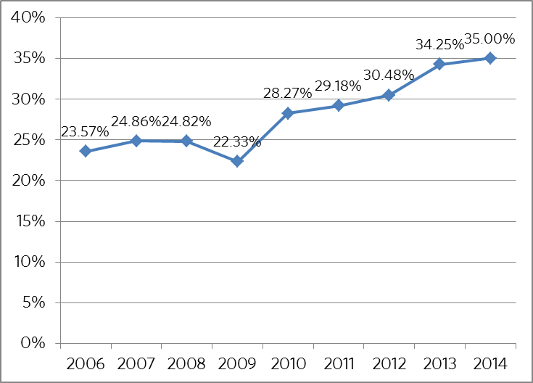

- DFAT/UNFPA Procurement of Contraceptives in 2013 - 2015

Based on the beginning balance of stock, additional USAID supply of oral contraceptives in 2012/13 and the actual needs in 2013, 2014 and 2015, the MoH requested UNFPA to assist in the procurement of contraceptives by using the DFAT grant to the Ministry of Health through UNFPA, the national budget, and UNFPA core fund per below.

Total contraceptive procurement 2013 -2015
N | Commodity | Quantity | Total costs
I | DFAT FUND
1 | Male condom | 5,723,280 pieces | US$1,918,182
2 | Implanon | 48,532 sets | US$1,918,182
3 | Injectable (DMPA) | 720,000 vials | US$1,918,182
4 | Emergency Contraceptives (EC) | 25,000 packs | US$1,918,182
5 | Progestin Only Pill (POP) | 234,999 cycles | US$1,918,182
6 | Combined Oral Contraceptive (CoC) | 2,234,880 cycles | US$1,918,182
 | TOTAL |  | US$1,916,019
II | The MoH Budget
1 | Combined Oral Contraceptives (COC) | 1,045,000 cycles | US$287,642
2 | Intra Uterus Device (IUD) | 45,000 pieces | US$287,642
3 | Handling and management fees and insurance |  | US$14,579
 | TOTAL |  | US$ 302,221
III | UNFPA Core Fund
1 | Combined Oral Contraceptives (COC) | 87,840 cycles | US$ 23,193
2 | Implanon NXT | 5,000 sets | US$ 38,041
3 | Clearance costs |  | US$2,717
 | TOTAL |  | US$ 63,951
 | GRAND TOTAL |  | US$ 2,282,191
- The Contribution of Contraceptive Commodities to Health Impact

With the current investment in contraceptives, from 2013 to 2015, the estimated health impact from the public sector and the support from DFAT through UNFPA can be reliably estimated:

Estimated Health Impacts 2013 – 2015

Estimated health impact  2013 - 2015 | Whole Public Sector | Contribution from DFAT | % of DFAT contribution
Unintended pregnancies averted | 495,379 | 137,122 | 27.68%
Live births averted | 158,824 | 43,963 | 27.68%
Abortions averted | 282,366 | 78,160 | 27.68%
Maternal deaths averted | 366 | 104 | 28.42%
Child deaths averted | 2,907 | 805 | 27.69%
Unsafe abortions averted | 172,524 | 47,755 | 27.68%
Couple Years Protection (CYPs) | 1,805,168 | 514,933 | 28.52%
Estimated direct health costs saved (US$) | 18,592,247 | 5,146,377 | 27.68%

- INDICATIVE PROCUREMENT PLAN IN 2016 BY THE NATIONAL BUDGET
Based on the ending stock balance at the Central Medical Store (CMS) at the end of 2015, the MoH has had an indicative procurement plan in 2016 by using the national budget as per below:

N. | Commodity | Est. Quantity | Estimated Budget (US$)
1 | COC | 4,200,000 cycles | 1,008,000
2 | Injectable | 1,000,000 vials | 890,000
3 | PoP | 99,999 cycles | 30,000
4 | Emergency Contraceptive | 30,000 packs | 19,800
5 | Estimated costs for freights, insurance and clearance |  | 79,825
6 | Estimated management indirect cost |  | 98,581
 | Total Estimated National Budget |  | 2,126,206

It should be also noted that there was a significant increase in use of Implanon (from 14,690 sets distributed in 2013 to 29,924 sets in 2014). In late 2014, Implanon was upgraded to a new version – Implanon NXT, which required refresher training to health care providers across the country on how to insert the new generation of the product. This led to a slowdown of Implanon use in 2015 as only 12,000 sets were distributed. In order to meet the foreseen increase of Implanon NXT use in 2016 and coming years, the MoH has requested KfW to support procurement of 40,000 sets of Implanon NXT, which are being procured using the pooled fund of the second Health Sector Support Programme of the MoH.

- The first National Family Planning Conference
The first ever National Family Planning Conference aimed to increase understanding of the latest development agenda and key strategic directions; learn about successes, challenges, and the way forward for Cambodia; and to revitalize and reaffirm commitments and create partnerships between stakeholders for improving family planning. The atmosphere of the two day conference was vibrant with active involvement of more than two hundreds participants with senior level positions from the Ministry of Health, Provincial Health Departments, Operational Districts, development partners, representatives of civil society organizations, health professionals, representatives of youth organizations, and representatives of private sector companies.

The conference prioritized four key topics which included: 1. The global development agenda and progress in Cambodia in family planning; 2. Sustainable concepts and addressing family planning needs of vulnerable groups; 3. Adolescent/youth sexual reproductive health and rights and private sector engagement in family planning; and 4. Family planning and universal health coverage and next steps.

The conference gathered experts from the region and in-country, from the MoH, Development Partners (DPs), NGOs, and community and youth participants. Speakers, presenters, panellists, performers, and contributors had chances to share their expertise, experiences, good practices, and recommendations to the forum.

At the end of the two day conference, a Joint Commitment was unanimously agreed upon and the commitment will be taken forward into concrete actions to ensure a comprehensive rights-based family planning programme in Cambodia. These actions will be realized through:
  - Creation of an enabling environment for human rights based family planning as an integral part of sexual and reproductive health and rights;
  - Improved availability of good quality, human rights-based, family planning services;
  - Increased demand for family planning according to client’s reproductive health intentions and preferences;
  - Improved availability and reliable supply of quality contraceptives; and
  - Strengthened health management information system (HMIS) and logistics management system pertaining to family planning.

The conference was jointly financed and technically supported by UNFPA, USAID and other DPs and NGOs.

Please refer to the enclose Report of the Conference for more details

- FACILITATING FACTORS AND CONSTRAINTS

Throughout the implementation of the “Support for Reproductive Health Commodities Security in Cambodia” from 2013 to 2015, the main factors facilitating and constraining the implementation were as follows:

Facilitating Factors:
- DFAT support, following the cessation of support by KfW, gave the MoH the time and opportunity to advocate with the Ministry of Economy and Finance to establish a national budget line for contraceptive procurement starting from 2014. This commitment was doubled for 2015, and then fully covered the public sector needs from 2016 onwards.
- Sufficient stock balance from KfW and additional contribution of oral contraceptives from USAID helped ensure commodity security in the country and allowed the DFAT grant to support other family planning commodities as needed by the country.
- The MoH/NMCHC was very active in advocating with the MEF for the establishment of the national budget line for contraceptive procurement, with technical backup from UNFPA and DFAT.

Constraints:
- The interruption of LMIS support continued to hinder timely reporting of Essential Medicines including contraceptive stock status from health facilities, OD and CMS. The development partners including UNFPA continue to look for possibilities to improve this system, giving the sensitive nature of the subject.

- PRELIMINARY FINANCIAL EXPENDITURES:

In respect of financial performance, the preliminarily estimated total expenditure from 2013 to 2015 was US$ 1,916,019.00 out of the total approved budget of US$ 1,919,935.00 for three years (2013 – 2015). The official certified expenditure of 2015 will be submitted by UNFPA Headquarters to the Permanent Mission of the Australian Government to the United Nations, at the end of June 2016.

 | Est. Expenditures
2013 | US$ 320,103
2014 | US$ 802,767
2015 | US$ 793,149
TOTAL | US$ 1,916,019

LIST OF ACRONYMS

ANC Ante-natal care
AOP Annual Operational Plan
BEmONC Basic Emergency Obstetric and Neonatal Care
BS Birth Spacing
CDHS Cambodia Demographic and Health Survey
CEmONC Comprehensive Emergency Obstetric and Neonatal Care
CMS Central Medical Store
CoC Combined Oral Contraceptive Pill
CPR Contraceptive Prevalence Rate
CSWG Contraceptive Security Working Group
DFAT Department of Foreign Affairs and Trade, Australian Government
DP Development Partners
EC Emergency Contraceptive Pill
EmONC Emergency obstetric and neonatal care
FP Family Planning
GBV Gender Based Violence
HC Health Centre
HIS Health Information System
HSP Health Strategic Plan
HSSP Health Sector Support Programme
IUD Intra-Uterus Device
LMIS Logistic Management Information System
LTM Long Term Method
MoH Ministry of Health
MEF Ministry of Economy and Finance
NMCHC National Maternal and Child Health Centre
NRHP National Reproductive Health Programme
OD Operational District
PHD Provincial Health Department
PNC Post-natal care
PoP Progestin/Progestin Only Pill
RH Referral Hospital
RHCS Reproductive Health Commodity Security
RMH Reproductive and Maternal Health
RMNCH Reproductive, Maternal, Newborn and Child Health

CDHS 2010 and 2014
2009 to 2012 HIS reports public sector only. 2013 and 2014 Health Sector Progress Reports, including some private and NGO data. 2015 HIS data is not available yet.
There is no data on public sector for 2015 yet.
Annual Health Progress Report 2014.
The total costs include freight costs, insurance, testing and clearance costs
Using the MSI Impact 2 software (version 2.3.1), Marie Stopes International, February, 2015. http://www.mariestopes.org/impact-2.3
Conversion rate: 1 US$: 0.6852£

