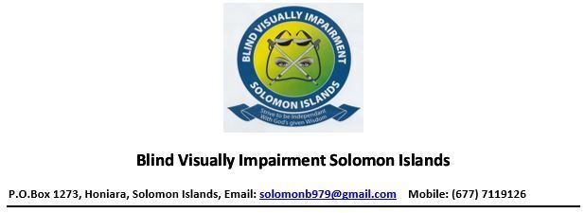

**Disability Equity Rights Questions:**

**Question 1: What are the most important things we should work on for disability equity and rights?**

**With Disability equity and rights, the following are what I think should be prioritized:**

1. Education:

Generally, very few people with disabilities have received formal education. This is because legislation is not in place. Proper school policies are not in place. Teachers are not qualified to assist children with disabilities in the classroom. One example is that teachers do not know how to assist children who are blind. Materials are not in Braille. No Sign language interpreters for deaf children in class.

1. Access to justice: PASI has established a legal clinic in partnership with the Public Solicitor’s office in Honiara, funded by UNDP. With the completion of the contract term between UNDP and the Public Solicitor’s office the legal clinic no longer functions.
2. Employment for people with Disabilities.

**Question 2: What are the best ways we can do this?**

*Train teachers who will be able to assist deaf and blind children in the classroom. In order to enable these teachers to support these children, they need to acquire skills in sign language and Braille.

* We want to be able to advocate through the Ministry of Education so that school policies and guidelines will be reviewed and changed. Better policies and guidelines would enable the education system to enable children with disabilities to attend school and fully participate in the classroom setting.

*Strengthen the legal clinic at PWDSI by revisiting the MOU between DPASI and the Public Solicitor’s office.

* Employ legal staff at the legal clinic who will be able to manage in coming cases.

* Simplify laws in to simple English and Pidgin for people who cannot read. These can also be recorded in to audio format.

* More awareness and sensitization needs to be done in places of employment.

Question 3 Part 1: How can we support people with disabilities to do this work?

*First and foremost, we need support to build the capacity of our office staff, the board members and ordinary members. These are such skills as managerial skills, basic computing skills, members to be trained and qualified to do CRPD training and good governance.

* * We need outside experts to assist us achieve some of what we need to do. A concrete example would be to engage Australian volunteers and some expertise within the region to assist upgrade the skills of teachers who will support children who are mainstreamed in to schools*Funding to carry out the above initiatives.

**Question 3 Part 2: How can we support organizations working with people with disabilities to do this work**?

* *Most importantly, each organization working in partnership with PWDs must have inclusive work policies available. This will assist them to be inclusive in disability matters.

*That each organization working in partnership with PWDs must acquire the knowledge on CRPD.

*Funds must be injected in to those organizations that work in partnership with PWDS.

Question 4 Part 1: What could stop us improving disability equity and rights?

*Non commitment from OPDs, their partners and the government.