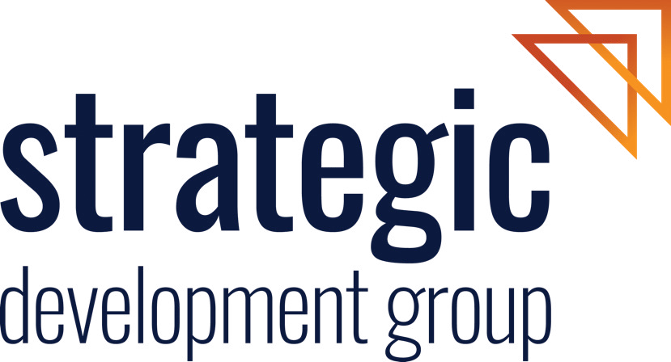

Australia’s new Disability Equity and Rights Strategy

Submission

December 2023

This submission has been prepared by the Strategic Development Group

**strategicdevelopment.com.au**

Australia’s new Disability Equity and Rights Strategy

Strategic Development Group

[Strategic Development Group (*Strategic*)](https://www.strategicdevelopment.com.au/) is an Australian-based consulting group delivering impactful programs for communities in Australia and internationally. We are a company driven by our values of **humility**, **integrity** and **ambition**.

At *Strategic*, we are serious about inclusion, diversity and respect and seek to consistently support collaborative and thoughtful **development** that builds thriving communities in partnership with governments, companies and organisations. We adopt a broad **definition of development** as a process of creating something positive over a period of time. People and communities are central to our understanding of development. Development should enable people to lead lives they have reason to value and for communities to thrive.

*Strategic* was engaged to design and facilitate an inclusive consultation process across Australia and developing countries in our region to deliver the first *Development for All Strategy: towards a disability-inclusive Australian aid program 2009-2014*. At the time, this strategy was heralded for its ground-breaking approach, including by the UN Secretary-General, Ban Ki Moon.

Context

In 2009, Australia set the benchmark by being the first donor country to have a strategy to make development assistance disability-inclusive*.*  The early implementation of this strategy was innovative, and genuinely shifted Australia’s international development assistance towards being more disability inclusive. Australia deservedly earned recognition as a leading and effective global advocate for disability-inclusive development. Evidence-based advocacy, drawing on the experience of Australia and its partners’ innovative practice, has also influenced the policy and practice of other donors and development partners.[1]

The second disability-inclusive strategy (2014-2020) articulated the intent to continue and expand Australia’s commitment. However, in the context of reduced resources, some limitations of technical capability, and inconsistent leadership, Australia’s early momentum in this space has not been maintained.[2]

The Opportunity

We welcome DFAT’s intent to develop a new Disability Equity and Rights strategy. We recognise the potential it offers to take a major step forward in enhancing meaningful and positive change for people with disabilities at an individual and systemic level. The new strategy creates **an opportunity to reignite** Australia’s commitment and influence globally on advancing disability rights.

Australia’s International Development Policy (2023) has given heightened prominence to disability equity and articulates a commitment to enabling the experience and expertise of people with disabilities in the design and delivery of development activities.[3] Critical commitments articulated in the new policy to advance locally-led efforts to drive change, and to provide greater flexibility and adaptable approaches to address marginalisation (including the marginalisation that is reinforced by unequal power systems and structures) offer great potential to deliver positive change on disability inequity.

**We believe that shifting power is the key to changing the status quo**. Recent commentary on participation and power, including by leading advocates like Mr Setareki Macanawai (CEO of the Pacific Disability Forum), provides a clear marker to where the dial needs to move if we are going to shift the power imbalance and enable the full and equal participation and leadership of people with disabilities.[4]

Organisations of Persons with Disabilities (OPDs) provide access to the knowledge and expertise that people with disabilities have on matters that are important to them and impact on them, their families and their communities. These are generally the same issues that matter to us all – health, housing, education, economic, social and personal safety and well-being - and go beyond disability-specific issues. **Removing barriers** (attitudinal, physical, communication and structural) that currently limit the contributions of OPDs and **changing how ‘development is done’** will help to amplify voices that at present are too often not heard in our discourse and have limited influence and agency in delivering inclusive development outcomes.

Recommendations

We congratulate DFAT for **intentionally seeking to move the dial forward**, in a way that builds on progress to date and learns the lessons from what has been achieved and what has yet to be realised.

We recommend that DFAT **be ambitious** in the development of this new strategy.

We encourage DFAT to consider how it puts in place the right drivers – both **enablers and requirements** – and to involve OPDs and commercial suppliers in co-designing and testing new approaches that positively contribute to advancing equity and rights of people with disabilities.

Key drivers that DFAT could put in place to promote change include:

* **Scopes of services** thatclearly articulatethe requirements suppliers must fulfill to deliver equitable and fair practice
* **Selection of suppliers includes an assessment** of the type and quality of their partnership and working arrangements with OPDs
* **Resources are designated** in contract budgets to enable accessible, safe, and equitable practice – this may include allowing more time for certain processes, providing reasonable adjustments, and fair and comparable remuneration for staff of OPDs.

Some of the changes we suggest suppliers can make include:

* **Brokering partnerships and working relationships** with OPDs that are equitable and fair in terms of remuneration and status, and facilitate genuine mutual benefits
* **Investment in enabling and accessible ways of working** that are respectful and create opportunity and space for the diverse breadth of knowledge, experience and expertise of persons with disabilities to inform and influence development discourse and program design, implementation and management
* **Moving out of the way** in situationswhere commercial suppliers do not add real value**,** and instead facilitating and supporting as needed new connections and ways of working between OPDs, DFAT, and their partners.

**END**

1. Office of Development Effectiveness, Development for All: Evaluation of progress made in strengthening disability inclusion in Australian aid, Canberra, 2018.
2. DevPolicy Blog, What Happened to Australia’s Leadership on Disability Inclusion? A Tale of two Summits, Renee Dodds and Kerryn Clarke, 2020.
3. DFAT , Australia’s International Development Policy for a Peaceful, Stable and Prosperous Indo-Pacific, 2023.
4. DevPolicy Blog, Beyond a Seat at the Table: Towards Disability Equity in the Asia-Pacific, Setareki Macanawai and Jane Edge, 2023.