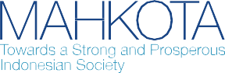**Policy Brief 1**- August 2020



**Economic Impacts and Access to Social Protection during the COVID-19 Crisis:** The Experiences of People with Disabilities in Indonesia

**Findings from a quantitative survey on COVID-19 Impacts on People with Disabilities in Indonesia. Data collection was led by the Disabled People’s Organization (DPO) Network for More Inclusive COVID-19 Response, and analysis jointly conducted with the Australian Government’s development cooperation program working on social protection, MAHKOTA. Written by Sinta Satriana, Social Protection Policy Specialist, MAHKOTA.**

## Background

The COVID-19 pandemic is expected to result in a rapid and significant increase in the prevalence and severity of poverty in Indonesia, as people are unable to work, jobs and income are lost, businesses close and debts accumulate. Under the most recent projection, COVID-19 could push between 1.3 million to 8.5 million people into poverty, significantly increasing the national poverty rate (SMERU, 2020). In regular circumstances, people with disabilities—who comprise approximately 9 per cent of Indonesia’s population—are more likely to be poor, experience high health expenditures, and are more exposed to economic shocks. The COVID-19 pandemic is expected to heighten these inequalities (United Nations, 2020). At the same time, people with disabilities in Indonesia have limited access to social protection programs. Approximately 3 per cent of people with disabilities are benefiting from regular social protection benefits, leaving the vast majority without income protection during this turbulent time. More is needed to offset the economic burden experienced by people with disabilities as well as their carers.

This policy brief analyses how people with disabilities in Indonesia have been impacted by COVID-19, and to what extent they accessed the government’s social protection response programs in the period of 10-24 April 2020. It aims to inform national policy discussions on social protection responses for people with disabilities.

**Methodology**

This assessment analyses data from a quantitative survey conducted in between 10 and 24 April 2020. The survey was organised collectively by DPO Network for More Inclusive COVID-19 Response, with support from Australian Government development cooperation programs working on access to justice (AIPJ2), decentralised governance (KOMPAK), and social inclusion (PEDULI). Data collection was mainly conducted via online survey platforms, plus a small number conducted by phone to accommodate respondents with limited access. Using snowball sampling through contacts from DPOs, the survey received 1,683 responses from all over Indonesia.

## Profile of respondents

Eighty percent of respondents are between the age of 20 and 59 years.1 Types of disability among respondents are summarised in Figure 1.

## Economic impacts of COVID-19 on people with disabilities

The majority of people with disabilities who work are employed in the informal sector, earning low and irregular income, making them susceptible to income shocks in times of crisis. Two-thirds of working respondents are engaged in the informal sector as daily labourers, small

**Figure 1** Types of disabilities among respondents

Mental

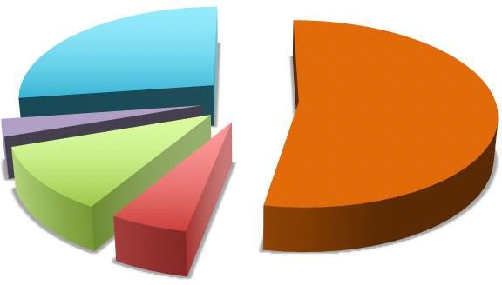

Sensory

**27%**

Physical

**53%**

Intelectual

**11%**

Multiple

**6%**

**3%**

traders, small farmers/fishers, domestic workers and handicraft makers, among others (Figure 2).2 Respondents reported low income overall, with 58 per cent reporting an estimated monthly income of IDR 1 million or less (Figure 3). When asked about the types of income, 60 per cent of these workers reported to have irregular daily/weekly wages (Figure 4).

**Figure 2.** Respondents’ employment sector

**Figure 3.** Respondents’ income level (IDR)

**Figure 4.** Types of respondents’ income

Others

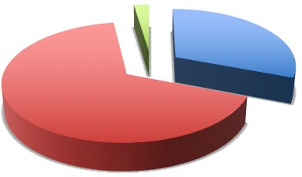

**2%**

Formal

**31%**

Informal

**67%**

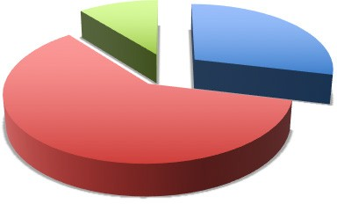

**29%**

Irregular daily/ weekly wage **60%**

Not specified

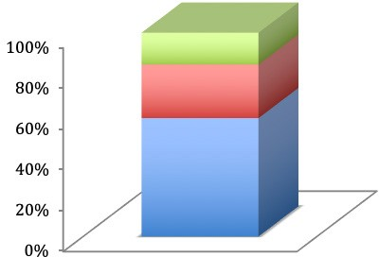

**>2** million

**1 - 2** million

**<1** million

**11%**

Regular monthly/ weekly wage

n=765 n=685 n=765

Note: “Others” include social activist, photographer, writer and athlete

Job loss and unemployment due to the COVID-19 pandemic is expected to be higher for people with disabilities compared to the rest of the population. Thirty eight per cent of working age respondents3 are unemployed (Figure B, Annex 1), which may be an underestimation since the least educated, the most severely disabled and those in very remote areas are less likely to participate in an online survey. Although the extent to which unemployment was caused by the pandemic is unknown4, analyses from a survey conducted by J-PAL (April 2020) showed that 68 per cent of people with disabilities respondents stopped working after the COVID-19 crisis, compared to 55 per cent of respondents in the general population.

Eighty-seven per cent of working respondents experienced income reductions after the COVID-19 crisis. Severe drops in income are more prevalent in urban areas with stricter social distancing regulation (PSBB)5 and “red zone” areas. (Figure C and Figure D, Annex 1).

Expectedly, the occurrence and severity of income reduction is higher among informal workers. Ninety seven per cent of respondents who work in the informal sector experienced income reduction, compared to 67 per cent of those in the formal sector. Informal workers experienced more severe income reductions (51 per cent) as compared to formal workers (23 per cent) (Figure E, Annex 1).

1 This demographic composition may be due to the online survey method, to which people in productive age tend to have more access.

2 Breakdown of respondents’ occupations is presented in Figure A, Annex 1.

3 Represented by people between 20-59 years of age since the questionnaire categorised respondents in 10-year brackets.

4 Analysis on unemployment faces two limitations: (i) the questionnaire did not include questions on the cause and time period of unemployment; and (ii) the question on income reduction does not include more than 80 per cent reduction, thus unable to capture people who lost their jobs or lost their income entirely due to COVID-19. This issue will be explored in subsequent qualitative study.

5 Based on MOH list on areas implementing large-scale social restriction (PSBB) regulations in April 2020.

**Up to 69 per cent of respondents may have become poor or fallen deeper in poverty after the COVID-19 pandemic.** The combination of low baseline income and large income reduction has made 41 per cent of respondents “highly vulnerable” to falling into poverty and another 28 per cent “vulnerable” to falling into poverty **(Table 1 and Table 2).** Using a national poverty line of IDR 454.652 (approx. AUD 44) per person per month, the post-pandemic income of “highly vulnerable” respondents would have certainly put them under the poverty line. The income range of the “vulnerable” group, post-pandemic, would have positioned them under or just above the poverty line. These individuals are most deprived during the crisis and are most in need of government interventions. Their access to assistance during the crisis, consequently, becomes a major concern for this assessment.

**Women faced higher vulnerability, although men experienced slightly higher income reduction during the COVID-19 crisis, because the baseline income of women with disabilities is significantly lower compared to men with disabilities.** In this assessment, 45.1 per cent of female respondents are highly vulnerable compared to 37.8 per cent of men (**Table 2**). This is despite the finding that severe income reduction is slightly higher among men (45.8 per cent) than women (43.9 per cent) (Table B, Annex 1). Lower baseline income among female respondents constitutes the main factor for their higher income vulnerability (Figure G, Annex 1).

**Higher income vulnerability is found among respondents with multiple disabilities (84 per cent), followed by people with mental disability (76 per cent).** More than half of respondents in these two groups are classified as “highly vulnerable” (Figure H, Annex 1).

**Table 1.** Proportion of respondents who reported their income, based on baseline income levels and income change (n=1,415)

## Access to Social Assistance Schemes

### An overwhelming majority of respondents (81 per cent) reported that staple food (*sembako*)

Vulnerable

|  |  |  |  |
| --- | --- | --- | --- |
| **Income change after COVID-19**  **pandemic** | | | |
| **Income before COVID-19**  **Pandemic** | **10-30%**  **reduction** | **30-50%**  **reduction** | **50-80%**  **reduction** |
| >IDR 2 million | 1.6% | 1.6% | 4.2% |
| IDR 1.5 - 2  million | 1.4% | 4.2% | 4.9% |
| IDR 1 - 1.5  million | 1.3% | 1.4% | 4.8% |
| IDR 500,000 –  1 million | 4.0% | 7.3% | 10.9% |
| < IDR 500,000 | 11.0% | 8.1% | 22.0% |

28%

Highly Vulnerable

41%

**has become more difficult to afford due to their reductions in income. As expected, this income effect on staple food is most pronounced among the “highly vulnerable” group.** Staple food far exceeds other expenses such as phone/internet (36 per cent), rent (11 per cent), electricity/water (38 per cent) and credit/debt payment (37 per cent). Difficulties in paying credit or rent are a greater issue for the “non-vulnerable” as these items are more accessible to those who are economically secure (**Figure 5**).

**Table 2.** Income vulnerability by gender

|  |  |  |  |
| --- | --- | --- | --- |
|  | **Not Vulnerable** | **Vulnerable** | **Highly vulnerable** |
| Total | 31.0% | 28.0% | 41.0% |
| Men | 33.0% | 29.2% | 37.8% |
| Women | 28.4% | 26.5% | 45.1% |

**Figure 5**. Items reported more difficult to afford due to income reduction

Staple food

Phone/ Internet

Rent Electricity/ water

Credit payment

High Vulnerable Vulnerable

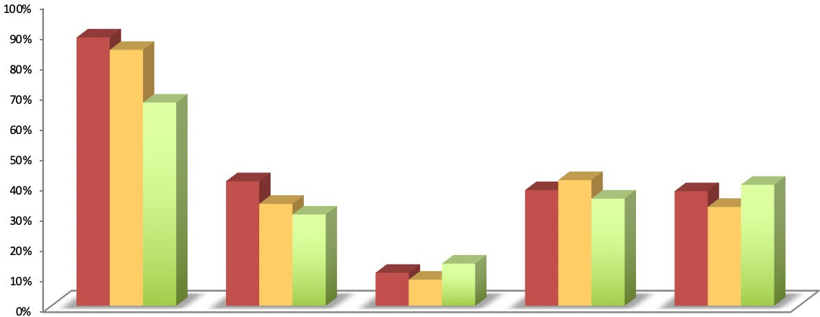Not Vulnerable

**Government of Indonesia’s Social Protection Policies in COVID-19 Crisis**

In response to the crisis, the national government introduced a set of COVID-19 social protection policies consisting of new programs as well as regular social protection programs that have been expanded vertically (with additional new beneficiaries) and horizontally (with top-up benefit amounts) during the COVID-19 crisis. Respondents were asked about their knowledge of, and whether they receive the main social protection programs.

This analysis focuses on electricity subsidy, the Family Hope (PKH) conditional cash transfer program, and the food voucher (Sembako) program. Free and subsidised electricity, available to customers using 450 or 900 volt-ampere (often a proxy for low income), is a program specifically launched as COVID-19 crisis response. PKH and Sembako, on the other hand, are regular programs with vertical and horizontal expansion to reach a greater number of beneficiaries with more regular payment intervals.

Other programs have been launched as part of the COVID-19 response, including unconditional cash transfers, food transfers and modified cash for work programs. However, they have not had significant rollouts by the time the survey was conducted in April 2020. These other programs may be explored in the follow-up qualitative research.

**At 35 per cent coverage, electricity subsidy reached the highest number of respondents while PKH and Sembako have 13 per cent and 12 per cent respectively.** Higher coverage of COVID-19 Social Protection programs coincides with higher respondents’ knowledge about the program (**Figure 6 and Figure 7**).

**Figure 6.** Proportion of respondents who are program beneficiaries

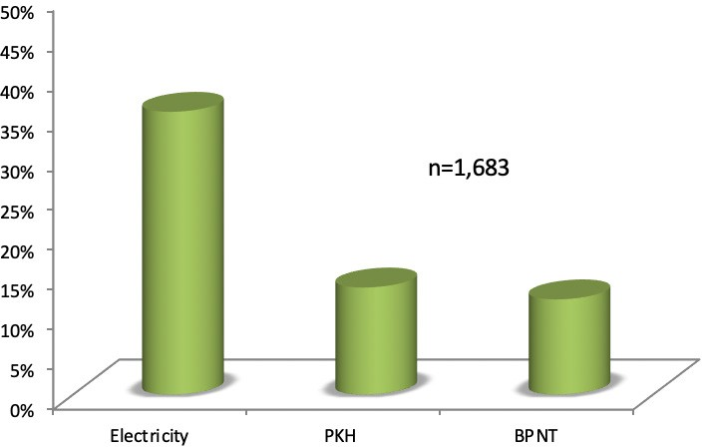

**The government’s COVID-19 social protection programs are generally pro-poor. That is, the coverage and intensity of social protection are higher among highly vulnerable people with disabilities when compared to other groups.** Around 51 per cent of “highly vulnerable” respondents benefited from at least one program, as compared to those classified as “vulnerable” (43 per cent) and “non-vulnerable” (33 per cent). Eleven per cent of “highly vulnerable” respondents also benefited from all three key programs (**Figure 8**).

**Figure 7.** Proportion of respondents who know about COVID-19 social protection programs

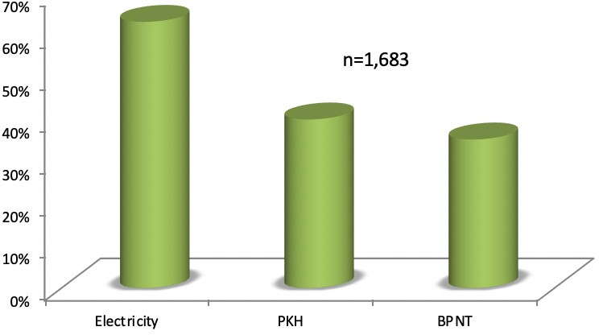

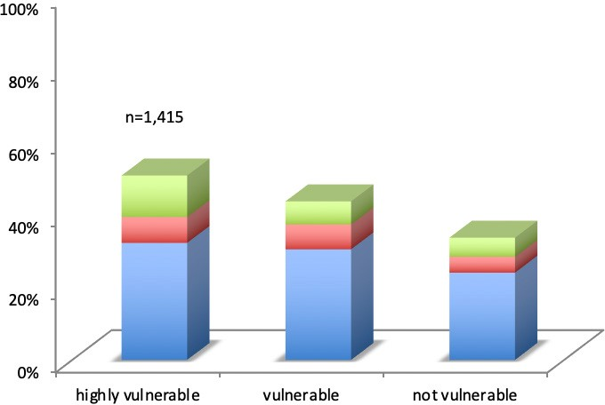**Figure 8.** Proportion of respondents benefiting from main social protection programs

3 programs

2 programs

1 programs

**However, social protection coverage among people with disabilities is significantly below the existing need.** Forty-one per cent of people with disabilities in this survey have access to social protection, with coverage among the “highly vulnerable” amounting to 51 per cent. This means that nearly half of highly vulnerable people with disabilities are not benefiting from social protection in the face of extreme economic shock.

## Way Forward

**Expansion of specific social protection programs for people with disabilities is urgent, both in the COVID-19 crisis response and in long-term social protection policies.** Given their high vulnerability and limited access to social protection, expanding social protection for people with disabilities should be the government’s priority. While existing programs tend to provide benefits to families rather than the people with disabilities, social protection programs for people with disabilities should have adequate coverage and benefits that address the specific vulnerability and poverty profile of people with disabilities (where needs and expenditures may be higher compared to the general population). The gap is found in both regular social protection programs as well as in crisis-response programs.

**There is a need for a social welfare database of people with disabilities beyond those in the poor and near poor category.** As the COVID-19 pandemic has taught us, a crisis of this scale can make fundamental changes to the poverty profile of the country, demonstrating that poverty is very dynamic. It has revealed the challenges in relying on a poverty-targeted database, which presents barriers to providing swift and effective protection to all affected individuals. A comprehensive database of all people with disabilities, integrated with other social welfare databases, would allow for sound provision of regular social protection as well as swift and accurate shock-responsive social protection when the need arises. Such a database will also be useful beyond social assistance, by which employment programs and other relevant policies can be implemented in an integrated manner.

**The design, implementation and monitoring of social protection programs will benefit from more engagement of people with disabilities.** The perspective and specific needs of people with disabilities are often missed from policy making, despite them being a requirement in the implementation of Convention on the Rights of Persons with Disabilities (CRPD). On the other side, people with disabilities often miss out on information of existing programs, as dissemination of information are not always inclusive and government agencies have limited reach. In this case, Disabled People Organisations (DPOs) and grass root organisations can play an important role in providing the bridge between policies and people with disabilities.

# Annex 1

**Figure A**. Respondents’ Occupation

Teacher/lecturer

**6%**

Private sector employee **18%**

Government employee **7%**

Others

**2%**

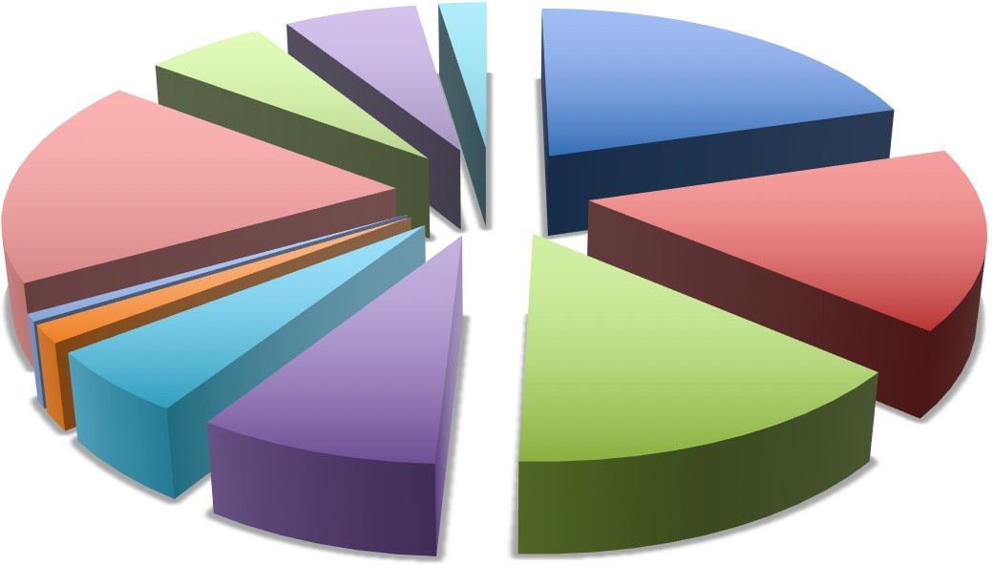

Sevices (massage, hairdressing etc) **20%**

Shop/market/ food stall **16%**

Domestic worker **1%**

Handicraft

**5%**

Farmer/fisher

**8%**

Daily labourer

**15%**

Online Driver **2%**

n=765

Note: “others” include social activist, photographer, writer and athlete

**Figure B.** Employment Status of Respondents aged 20-59 years

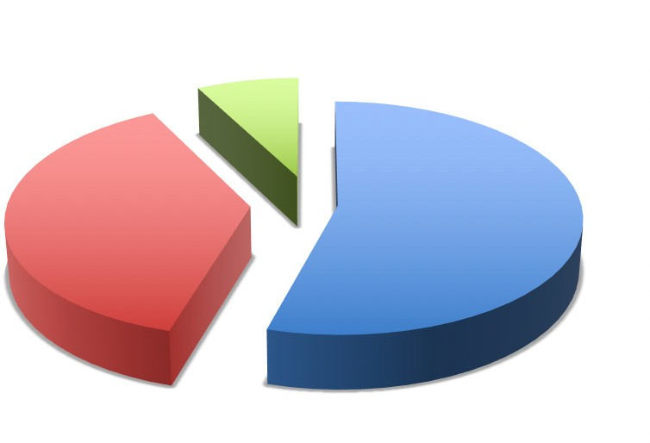

Non-workers

**8%**

Currently not working/unemployed **38%**

Working

**54%**

n=731

Note: Non-workers include students, homemakers and retirees

**Figure C.** Changes in Income of respondents who Work

[increased income]

[did not **1%**

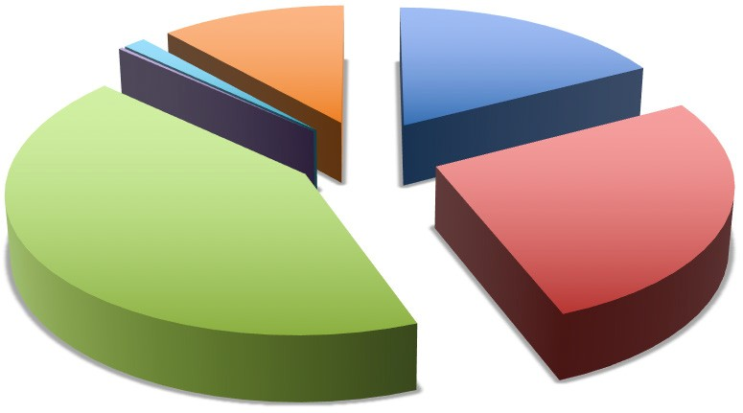

[no reduction]

answer]

**0%**

**12%**

[10-30% reduction]

**17%**

[50-80% reduction]

**43%**

[30-50% reduction]

**27%**

n=765

**Figure D.** Income Reduction based on Area Classification

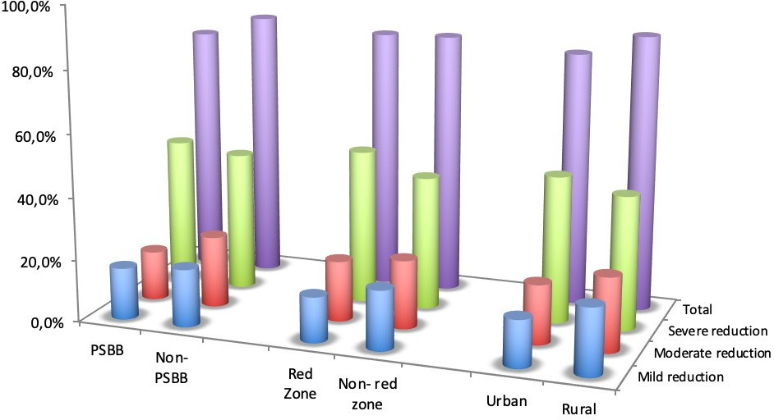

n=1,683

**Table A.** Income Reduction Experienced by Respondents, based on Employment Status (n=1,683)

|  |  |  |  |  |
| --- | --- | --- | --- | --- |
|  | **Income reduction after COVID-19 pandemic** | | | |
| **Employment Status of Respondents** | **10-30%**  **reduction** | **30-50%**  **reduction** | **50-80%**  **reduction** | **Total** |
| Non-workers | 18.2% | 18.2% | 44.2% | 80.5% |
| Working | 17.4% | 26.8% | 42.5% | 86.7% |
| Unemployed | 19.0% | 16.1% | 48.2% | 83.4% |

**Figure E.** Income Reduction among Formal and Informal Workers

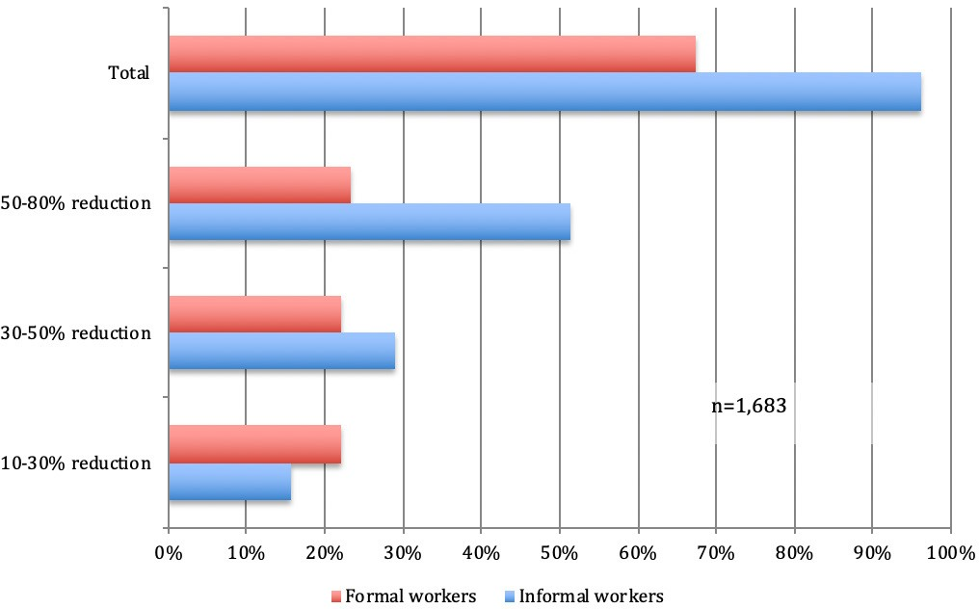

**Figure F.** Number of Respondents who Experienced Income Reduction

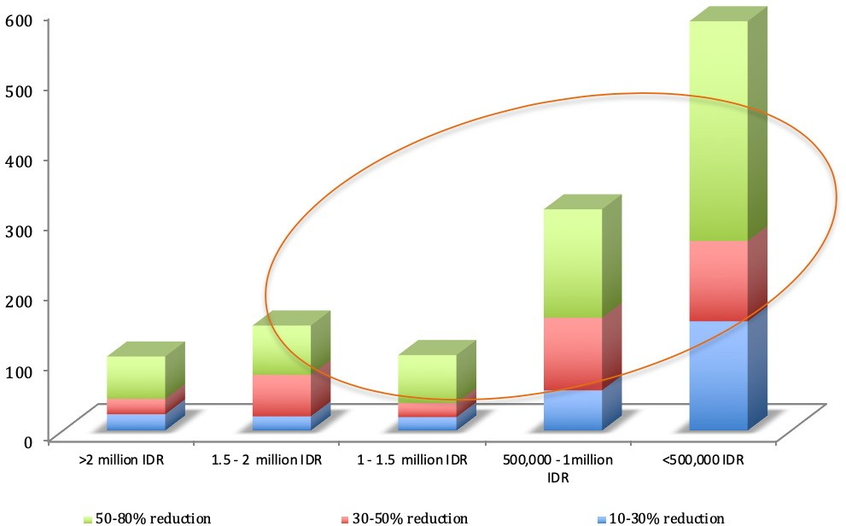

**Table B.** Income reduction among Male and Famale Respondents (n=1,679)

|  |  |  |  |
| --- | --- | --- | --- |
| **Income Reduction** | **Men** | **Women** | **Total** |
| 50 – 80% reduction | 45.8% | 43.9% | 45.0% |
| 30 – 50% reduction | 21.4% | 21.4% | 21.4% |
| 10 – 30% reduction | 18.1% | 18.2% | 18.1% |
| Increased income | 1.0% | 1.6% | 1.3% |
| No reduction | 13.8% | 14.9% | 14.3% |
| Total | 100% | 100% | 100% |

**Figure G.** Respondents’ Baseline Income, by Gender

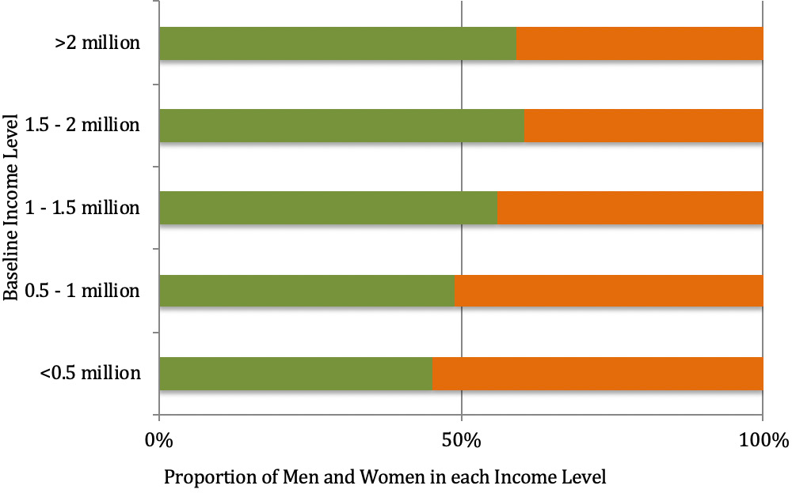

Men Women

**Figure H.** Respondents’s Income Vulnerability based on Types of Disability

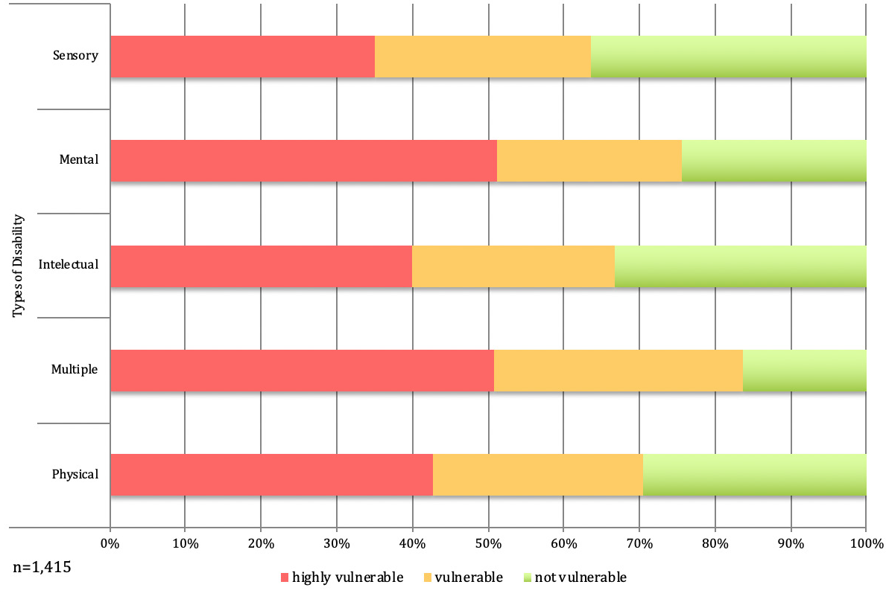

**Table C.** Proportion of Respondents Benefiting from Social Protection, by Program and Respondents’ Vulnerability Level (n=1,415)

|  |  |  |  |
| --- | --- | --- | --- |
|  | **Electricity subsidy** | **PKH** | **BPNT** |
| Highly vulnerable | 43% | 19% | 19% |
| Vulnerable | 39% | 13% | 11% |
| Not vulnerable | 30% | 10% | 8% |
| Total | 35% | 13% | 12% |

# Reference

J-Pal South East Asia. 2020. Online Survey on Economic Impact of COVID-19 in Indonesia: Results for People with Disabilities. PPT presentation.

SMERU. 2020. The Impact of COVID-19 Outbreak on Poverty: An Estimation for Indonesia. SMERU Working Paper April 2020. Jakarta.

United Nations. 2020. Policy Brief: A Disability Inclusive Response to COVID-19. May 2020.

Support for this publication has been provided by the Australian Government through the MAHKOTA Program. The findings, interpretations and conclusions expressed in this work do not necessarily reflect the views of the Government of Indonesia or the Government of Australia. You are free to copy, distribute and transmit this publication for non-commercial purposes.

**MAHKOTA Program**

Level 8, Grand Kebon Sirih, Jalan Kebon Sirih 35 Jakarta Pusat 10110, Indonesia

email: [communications@mahkota.or.id](mailto:communications@mahkota.or.id)