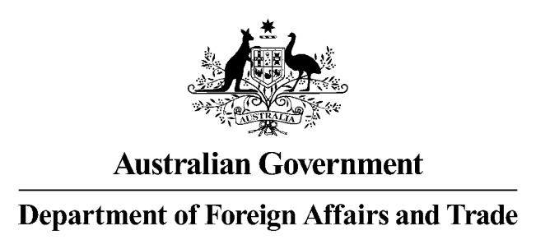

# **Data request form**

Accredited users of the *Data Availability and Transparency Act 2022 (Cth)* (DAT Act) scheme may use this form to request data held by the Department of Foreign Affairs and Trade (DFAT) (in its capacity as a data custodian under that scheme).

The [Register of Accredited Entities](https://www.datacommissioner.gov.au/registers) is available on the Office of the National Data Commissioner (ONDC) website. Contact the ONDC if you require further information regarding the accreditation requirements and process.

The form should be submitted electronically to [data.sharing@dfat.gov.au](mailto:data.sharing@dfat.gov.au).

## Details of accredited user

**Name of accredited user (as entered on the register):**

**Any conditions applied to accreditation (if applicable):**

**Whether the applicant is an intermediary for an accredited user, or whether the accredited user making the application intends to use an intermediary (state conditions for sharing data and with whom):**

**Agency/organisation contact:**

**Position:**

**Address/location:**

**Telephone number:**

**Email address:**

## Details of data sought and other information

**1. Describe in detail the data sought.**

*NB: to respond to this question, we suggest you refer to ONDC guidance:* [*Making and responding to data sharing requests.*](https://www.datacommissioner.gov.au/data-scheme-guidance/responding-to-requests)

**2. Explain in detail how you intend to use the data, including a description of the project you are undertaking and its purpose.**

*NB: to respond to this question, we suggest you refer to ONDC guidance in relation to permitted data sharing purposes (s15 DAT Act) and data sharing principles (s16 DAT Act). DFAT is only authorised to share data under the DAT Act with accredited users for a project that is for one or more of the prescribed data sharing purposes and that meets the data sharing principles.*

**3. Describe who will have access to the data (e.g., internal staff or any contractors or other third parties)?**

**4. Will the data be published, disclosed to any third parties, or otherwise reproduced in part or in full?**

If yes, please provide details.

**5. Have you requested this data before, either from DFAT or any other data custodian under the DAT Act?**

If yes, please provide details.

**6. Provide details of your proposed handling strategy, including how the data/ copies of the data will be stored, accessed, returned, retained and/ or destroyed.**

**7. Will the data include personal information?**

If yes, please provide details and indicate the proposed privacy safeguards.

**8. Provide details of intentions for outputs produced from the requested data.**

## Applicant signature or digital equivalent

**Full name of applicant:**

**Signature of applicant:**

**Date:**

**Name of your authorising officer:**

**Signature of applicant:**

**Date:**

**Privacy and Protective Security Policy Framework notice**: The Department of Foreign Affairs and Trade (DFAT) must comply with the [Australian Privacy Principles (APPs)](https://www.legislation.gov.au/series/c2004a03712) contained in the *Privacy Act 1988* (Cth) Privacy Act and the [Protective Security Policy Framework (PSPF).](https://www.protectivesecurity.gov.au/policies/information-security)  The data DFAT holds are ‘records’ under the *Privacy Act 1988* (Cth) (Privacy Act), for public use. Public sector data means any information (including personal information) obtained, received or held by an agency or body to which the Privacy Act applies, whether or not the agency or body obtained, received or holds that information in connection with the functions of that agency or body.

DFAT collects personal information on this form in order to process the data request detailed above. This personal information will be handled in accordance with the requirements of the Privacy Act and the Information Privacy Principles set out in the Privacy Act. For further information please refer to DFAT’s privacy notice and online privacy notice at [Privacy | Australian Government Department of Foreign Affairs and Trade (dfat.gov.au)](https://www.dfat.gov.au/about-us/corporate/privacy/Pages/privacy)