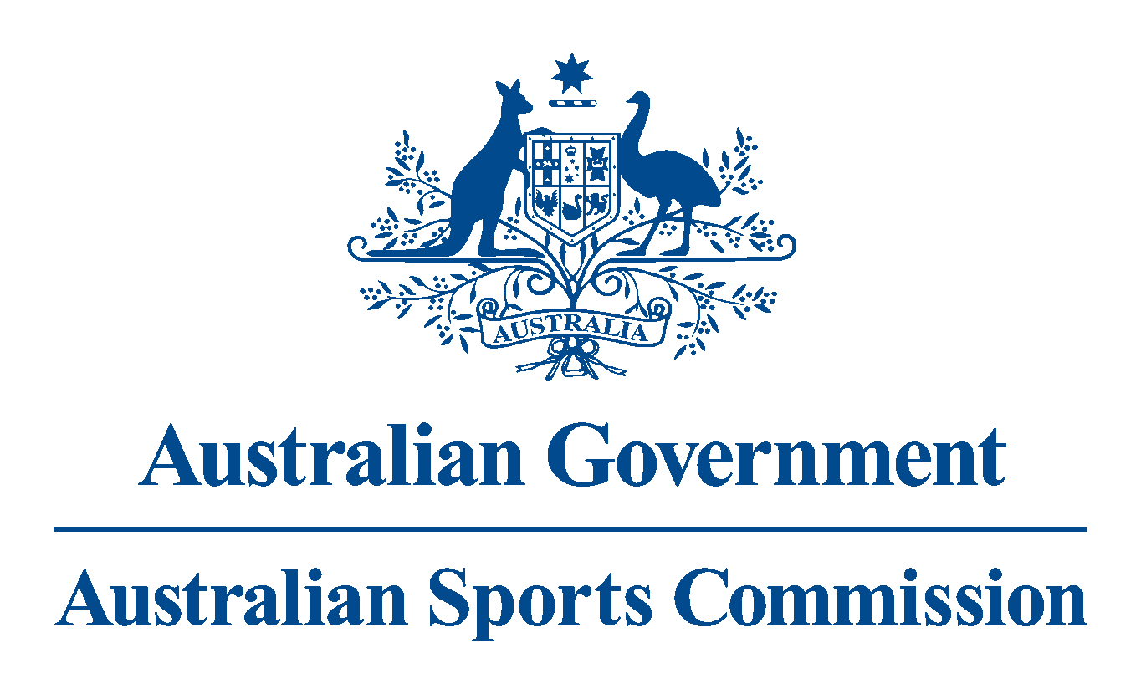

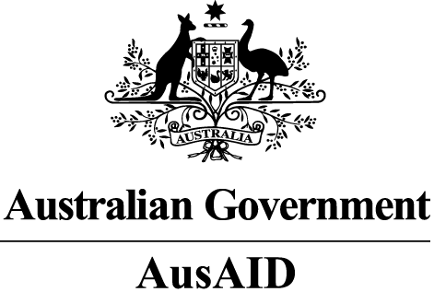

**Development-through-sport**

A joint strategy of the Australian Sports Commission (ASC)   
and the Australian Agency for International Development (AusAID)

2013-2017



Contents

Introduction 3

Context and rationale 3

Relationship to strategic goals 4

Development-through-sport outcomes 6

Outcome 1: Improved health-related behaviours to reduce the risk of non-communicable diseases 6

Rationale 6

How sport can contribute 6

Our approach to reducing the risk of non-communicable diseases 7

Outcome 2: Improved quality of life of people with disability 7

Rationale 7

How sport can contribute 7

Our approach for improving the quality of life of people with disability 8

Cross-cutting outcomes 8

Cross-cutting outcome 1: Improved gender equality and empowerment of women and girls 8

Cross-cutting outcome 2: Improved social cohesion 9

Programs 10

Principles 10

Effective development 10

Quality sport 11

Partners and how we will work together 12

Australian Sports Commission 12

Australian Agency for International Development 12

Roles of the ASC and AusAID 12

Continual improvement 13

# Introduction

Sport has unique attributes that enable it to contribute to development processes. Its popularity, its capacity as a communication platform, its role in reducing the risk of non-communicable diseases and its potential to set the foundation for healthy child development together with its ability to connect people make it a tool that can be used to meet a range of development objectives. When used strategically, sports-based assistance can make a measurable contribution to Australia’s development efforts.

With this strategy, the Australian aid program is implementing an approach it calls ‘development-through-sport[1].’ Development-through-sport identifies development objectives first and then identifies how well planned sport-based activities can contribute to these. It acknowledges that sport is one of a number of approaches that can be used to contribute to development objectives.

This document sets out the joint strategy between the Australian Sports Commission (ASC) and the Australian Agency for International Development (AusAID) to use sport to contribute to Australia’s aid program. The strategy is the result of collaboration between the two agencies and will guide planning and delivery of Australia’s international development-through-sport investments until 2017.

# Context and rationale

Sport can be defined as all forms of physical activity that contribute to physical fitness, mental well-being, and social interaction. This includes play, recreation, organised, casual or competitive sport, and indigenous sports and/or games[2].

Sport’s comparative advantage as an approach to achieve development objectives include:

* Sport has social and cultural value in many societies, and a high level of individual/group interest.
* Sport can be a fun, non-threatening and informal way to bring people together to improve inclusion, improve health-related behaviours and communicate messages.
* Sport can appeal to community members the aid program otherwise may find difficult to reach (eg young men and women, children, people with disability).
* People from different backgrounds (national, religious, cultural, economic) can find common purpose through participating in, or following, sport.
* Sport provides a safe place to talk with peers.
* Sports require participants to adhere to accepted rules and standards of behaviour.

These comparative advantages mean that sport, when used strategically, can:

* address barriers to inclusion
* act as a platform for building knowledge and awareness
* build relationships within and between communities
* foster peer to peer communication that can be crucial in building a bridge between attitude shifts and behaviour change.

AusAID and the ASC recognise that sport is also a ‘natural fit’ for public diplomacy and that public diplomacy benefits will be enhanced when development-through-sport activities contribute effectively to positive social change.

With a reputation as a sporting nation, and with sport playing an important role in Australian communities, Australia is well placed to use sport to contribute to the government’s public diplomacy objectives. Sport:

* assists in building people-to-people links
* promotes a positive image of Australia internationally
* demonstrates Australia’s commitment to and engagement with the region
* provides an opportunity to enrich and enhance relationships with partner governments, other donor governments and international Non-Government Organisations and United Nations agencies that may not usually be involved in particular regions or initiatives.

# Relationship to strategic goals

It is important that development-through-sport contributes to the goals of the Australian aid program. As set out in ‘An effective aid program for Australia: Making a real difference – Delivering real results,[3]’ the fundamental purpose of the Australian aid program is to help people overcome poverty. The Australian aid program is guided by five strategic goals:

* Saving lives
* Promoting opportunities for all
* Sustainable economic development
* Effective governance
* Humanitarian and disaster response

The overall purpose of Australia’s development-through-sport assistance is to ***develop healthier and more inclusive communities through sport***.

To achieve this, development-through-sport will target two of these strategic goals (see figure 1):

1. *Saving lives* – by **improving health-related behaviours to reduce the risk of non-communicable diseases**
2. *Promoting opportunities for all* –by **improving the quality of life of people with disability**.

However, given the characteristics of sport as an inclusive community activity, there are certain cross-cutting outcomes that development-through-sport programs may also contribute to:

1. Improved gender equality and empowerment of women and girls
2. Improved social cohesion.

ASC and AusAID will, through the monitoring and evaluation process and broader research, assess results under these cross-cutting outcomes, and during the strategy’s bi-annual reviews, consider including them as key outcomes in their own right under this development-through-sport strategy.

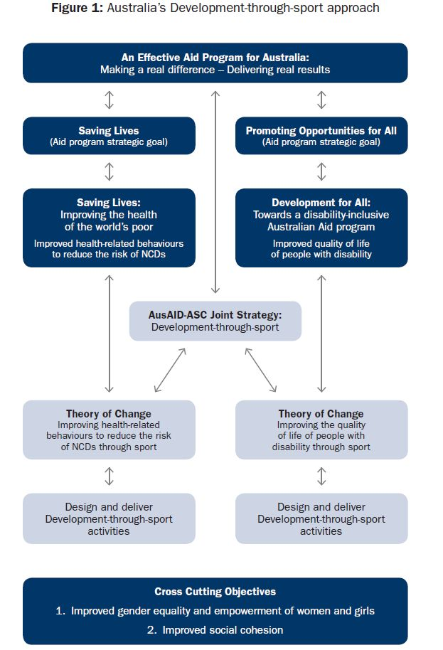

# Development-through-sport outcomes

## Outcome 1: Improved health-related behaviours to reduce the risk of non-communicable diseases

### Rationale

Good health is a fundamental human right[4] and has been recognised in internationally agreed goals, including the Millennium Development Goals. Good health is fundamental to the ability of individuals to realise their full human potential. Low levels of health impede people’s ability to work and earn a living for themselves and their families. When someone becomes ill, an entire family can become trapped in a downward spiral of lost income and high health-care costs. Healthier adults are more able to work and children free of disease are better able to learn at school and gain the skills needed to break out of poverty[5].

The Australian aid program’s health thematic strategy *Saving Lives: Improving the health of the world’s poor* identifies ‘Empowering poor and vulnerable people to improve their health’ and ‘working with other sectors … to address the causes of poor health’ as two of the six pillars of Australia’s health support[6].

Non-communicable diseases (NCDs) such as diabetes, cancer, cardiovascular disease and chronic respiratory diseases are growing rapidly, particularly in low and middle income countries. In 2008, NCDs accounted for an estimated 36 million deaths (or 63 percent) worldwide. In the Pacific, 75 percent of all adult deaths are due to NCDs[7]. NCDs also place an extra burden on health systems that are already struggling to cope.

While NCDs are a global problem, this is a particular issue in our immediate region. At the 42nd Pacific Island Forum in 2011, Pacific Islands leaders stated that NCDs had ‘reached epidemic proportions’ in Pacific island countries and territories[8]. The statement highlighted the huge economic costs of NCDs, and its potential to undermine achievement of the Millennium Development Goals.

### How sport can contribute

Sport is well placed to help combat NCDs. Research shows that to reduce NCDs, it is necessary to reduce population exposure to the four common modifiable behavioural risk factors - unhealthy diets, physical inactivity, tobacco use and harmful use of alcohol[9]. Of these, sport is uniquely positioned to address physical inactivity by getting people more active more often. Sport also provides opportunities to deliver messaging on the three other risk factors (diet, tobacco and alcohol) to large groups of people.

|  |
| --- |
| Reducing obesity on Aniwa Island in Vanuatu |
| Auckland University of Technology research indicated a ‘remarkable’ 50percent reduction in obesity on Aniwa Island in Vanuatu (November 2009 to November 2010)[10]. This was directly attributed to the sports activities coordinated by the Nabanga Sports Committee and supported by the Australian Sports Outreach Program. The program is building on this success by implementing similar programs in the Tafea Province islands of Futuna and Aneythium in partnership with the Vanuatu Ministry for Health. |

### 

### Our approach to reducing the risk of non-communicable diseases

Intermediate outcomes that Australia’s development-through-sport programs will work towards in relation to addressing NCDs are:

1. Improved multi-sectoral action to address NCD risk factors[11]; and
2. Improved health related behaviours among target groups.

The ASC and AusAID are developing a detailed theory of change showing Australia’s approach to improving health-related behaviours to reduce the risk of NCDs.

|  |
| --- |
| Using sport to communicate health messages |
| Under the Pacific Sports Partnerships program, the Vanuatu Cricket Association partnered with World Health Organization and Vanuatu Ministry of Health to conduct a project aimed at teaching middle-aged women (20 – 50 years old) about the importance of physical activity and diet. The 15-week Women’s Island Cricket Project involved games of traditional cricket and workshops on health issues like nutrition. Data collected during the project reported 92 percent of participants recorded a decrease in their waist measurements; 65 percent recorded a decrease in their blood pressure; and 50 percent lost weight. |

## Outcome 2: Improved quality of life of people with disability

### Rationale

The primary objective of the Australian aid program’s disability-inclusive development strategy *Development for All: Towards a disability-inclusive Australian aid program 2009-2014[12]* is improved quality of life for people with disability.

People with disability are among the poorest and most vulnerable in developing countries. They face many barriers preventing them from fully participating in society. People with disability are the most likely to face social exclusion. This includes the inability to access education and health services, and the right to earn a living or participate in decision making like others in their communities. Around 15 percent of the world’s population – about a billion people – live with a disability and about 80 percent live in developing countries.

### How sport can contribute

Research has shown the value of sport in improving the inclusion and well-being of people with disability[13]. Sport works at two distinct, but related levels. At the individual level, sport provides opportunities for social interaction and helps build confidence, self-esteem and a positive self-image. Sport also contributes to physical fitness, strength, range of movement and physical independence. At the community level, sport can be used as an effective platform to deliver messages about inclusion and the rights of people with disability[14]. It also creates opportunities for people without a disability to encounter people with a disability in a positive context[15].

|  |
| --- |
| Encouraging positive attitudes towards people with disability and providing leadership opportunities |
| The Fiji Paralympic Committee has helped encourage positive attitudes towards people with disability with support through the Australian Sports Outreach Program. The Fiji Paralympic Committee has advocated for the inclusion of children with disability in mainstream sport from a young age and organised festivals that bring children with disability and children from mainstream schools together.  In Vanuatu, Sanma Frangipani Association, an Australian Sports Outreach Program partner, advocates for the rights of people with disability. By organising sport events, media, training and community visits, Sanma Frangipani Association has helped people with disability become more confident, take more active volunteer roles within the organisation and take on leadership roles within communities. In 2011/12, 26 volunteers, including 20 with disability, conducted sports activities for over 450 children, of which 90 were children with disability. |

### Our approach for improving the quality of life of people with disability

Intermediate outcomes that Australia’s development-through-sport programs will work towards in relation to disability are:

1. Improvements in how people with disability think and feel about themselves; and
2. Reduced barriers to inclusion, including accessibility, negative attitudes, stigma and discrimination.

The ASC and AusAID are developing a detailed theory of change showing Australia’s approach to improving the quality of life of people with disability.

# Cross-cutting outcomes

### Cross-cutting outcome 1: Improved gender equality and empowerment of women and girls

Gender equality is central to economic and human development. The Australian Government has committed to remaining a firm and persistent advocate of gender equality, and has identified gender equality as a critical cross-cutting theme across the aid program.

A growing body of evidence shows that sport is a viable tool for promoting gender equality and empowering women and girls. Sport can help to enhance girls’ and women’s health and well-being, significantly reducing the risk of osteoporosis, breast cancer, and depression – conditions which disproportionately affect women. It can foster self-esteem and empowerment. Sport can also facilitate social inclusion and integration, challenge gender norms, and provide opportunities for leadership and achievement, with recognition that the additional barriers faced by women and girls, such as the lack of childcare and their household and caring responsibility hinder their participation. Sport can also play a role in empowering women within society and deliver important behavioural messages, on topics such as on sexual and maternal health[16].

Sport can also contribute to increasing women’s voice in decision-making and leadership. Women’s involvement in sport is an entry point to normalise, in the eyes of both women and men, women’s’ participation in decision making. It is also an entry point to women’s participation at higher levels of society and in more formal systems.

|  |
| --- |
| Providing opportunities for girls to participate in sport |
| The Oceania Football Confederation’s Just Play program is providing girls throughout the Pacific with regular opportunities to be involved in safe and healthy physical activity. Supported through the Australian Government’s Pacific Sports Partnerships program, Just Play targets children aged six to twelve -years-old through school and community based football clinics operated by trained coaches and volunteers. In response to previously limited opportunities for young females to participate in sport, Just Play has made strong efforts to target women as part of its training of coaches and volunteers to ensure girls feel comfortable participating, are keen to be involved and to foster positive perceptions of girls’ involvement in sport. More than 45,000 girls have been involved in Just Play clinics, out of the total 106,000 children involved since 2009, a substantial increase since the inception of the program. |

### 

### Cross-cutting outcome 2: Improved social cohesion

One of the focus areas of the Australian Aid program’s *Effective Governance* thematic strategy is ‘safer and more secure communities’.[17]

Well run sport-based activities have been shown to contribute to safer and more secure communities by engaging young men and women in meaningful activities, and diverting them from anti-social behaviour. Sport can also help build a sense of shared identity and fellowship among groups that may otherwise be inclined to treat each other with distrust, hostility or violence. Sport requires participants to adhere to rules regardless of participants social, economic or cultural status.

By establishing community sport organisations and engaging community members and youth as sport volunteers, sport helps promote community leadership, foster greater community involvement in decision-making, and generate social ties and community infrastructure which can contribute to improved peace and community stability[18]. We recognise, for example, the role women’s participation in decision-making has in benefitting the whole community, not only in strengthening women’s leadership but also ensuring that the broader interests of the community are taken into account.

|  |
| --- |
| Breaking down barriers in Solomon Islands |
| In Solomon Islands sport has brought young people from Guadalcanal and Malaita together, enabling them to set aside their differences. Young people who had not interacted with each other due to the tensions reported that the sport activities delivered through the Australian Sports Outreach Program brought them together in a way that was not confrontational and did not focus on the conflict. The activities also helped communities resolve conflicts over water supply. |

# Programs

The ASC is currently responsible for managing three programs under the Australian Sports Outreach Program that will be influenced by this strategy:

1. **ASOP country specific programs:** to build the capacity of local organisations in the Pacific and Caribbean[19] to deliver quality sport-based programs that contribute to locally identified development priorities.
2. **Pacific Sports Partnerships Program:** to promote collaboration between Australian and Pacific sports organisations to strengthen grassroots sports activities in Pacific communities and improve participation pathways for players, administrators, coaches and officials.
3. **Sport Development Grants:** to provide funding assistance to targeted small-medium size community sport development projects which provide benefits to the community through increased community participation in sport and physical activity.

# 

# Principles

These effective development and quality sport principles will guide the design, planning and implementation of the development-through-sport programs.

## Effective development

**Activities will be delivered according to aid effectiveness principles**

Implementation of development-through-sport will be consistent with the Australian Government’s commitment to improving the delivery and quality of aid, as set out in the Australian aid policy, Paris Declaration on Aid Effectiveness,[20] the Accra Agenda for Action[21] and the Busan Partnership for Effective Development.[22]

**Activities will address local priorities and complement development efforts**

Activities in each country will be delivered in a way that targets locally identified development priorities relevant to the key objectives in this strategy and which complement Australia’s overall development assistance in participating countries. Partnerships will be based on shared priorities.

**Capacity development of people and organisations will be a key feature**

Improving the capacity of individuals and organisations is crucial to the sustainability of our programs and for affecting long-term change. Improving capacity will help create local ownership of the activities and mutual accountability for the outcomes and will drive demand in country.

**A strengths-based approach will be applied**

The ASC will continue to use a strengths-based approach to program design, annual planning, capacity development and monitoring and evaluation. This approach is based on recognition that the people and organisations we work with have the knowledge, ideas, energy and existing capacity to do many things well. Increased autonomy, local ownership and sustainability are more likely when local people and organisations understand their individual and collective strengths and resources and are able to harness them for their own individual and collective development.

**Delivery will be underpinned by partnerships across sport, government and civil society**

Recognising that development is relatively new to the sport sector and sport is a recent addition to the development sector, the delivery of activities will be underpinned by extensive consultation across the sport and development sectors. Strategic partnerships will be established between sport bodies (community based, national and regional) and key sectoral actors (including government and civil society). Partners that have shared objectives will be targeted based on their existing strengths and capacity to make a tangible contribution to program delivery.

Sustainability will be enhanced by working with local government agencies and other key stakeholders to embed sport in national development plans and policies and regional development strategies.

**Involving marginalised groups will be a priority**

The involvement of marginalised and underrepresented groups (including children, youth, girls, women and people with disability) will be a priority. Strategies will be implemented to remove the barriers to their participation and increase their involvement in all sport and development activities, provide leadership opportunities and include them in making decisions about how programs are delivered.

**Activities will be guided by comprehensive monitoring and evaluation to inform continuous improvement**

A comprehensive approach to monitoring and evaluation will be implemented to gather the information needed to continuously improve programs, determine the best delivery approaches and maximise the impact of activities. Research will be conducted to assess the contribution of development-through-sport activities to the achievement of strategy objectives and cross-cutting outcomes.

**Behaviour change strategies will be targeted and appropriate for context**

Affecting behaviour change is needed to achieve strategy objectives. Behaviour change is influenced by a range of factors – personal, infrastructure, societal and regulatory. Strategies will be identified to facilitate behaviour change. These strategies will understand the context (including needs, barriers and facilitators of change), address barriers to change (including social norms, roles, traditions and customs), and facilitate communication of the information required to shift attitudes and change behaviour.

## Quality sport

The ASC, through its extensive experience in assisting to develop community level sport in Australia and abroad, has identified the following principles as key for ensuring successful sport engagement:

**Activities will be run by highly skilled and motivated sport leaders**

Local partners will be supported to recruit, train and retain highly skilled and motivated sport leaders (such as coaches, teachers, fitness instructors and community volunteers), officials (referees and umpires) and sport administrators/managers.

**Local sporting organisations will be strengthened to deliver community level sport**

Technical support will be provided to support local sport organisations to develop the necessary skills, resources, systems and networks to strengthen their ability to deliver sport at a community level.

**A positive sport experience will be at the core of all activities**

Activities/approaches will be designed in a way that appeals to target groups. Local partners and participating communities will be supported to run activities that are fun, safe, interesting and non-discriminatory.

**Positive values will be actively promoted as part of sport activities**

Strategies will be developed to promote healthy competition and recognise participants for displaying positive values including fair play, respect (for rules, opponents and officials), teamwork and personal improvement.

**Strategies will be implemented that promote an inclusive philosophy or approach to participation**

Efforts will be made to ensure underrepresented groups have the best possible choice and opportunity to be involved in sport activities.

# Partners and how we will work together

## Australian Sports Commission

The ASC is Australia’s primary national sports administration and advisory agency, and the cornerstone of a wide-ranging sports system. On behalf of the Australian Government, the ASC plays a central leadership role in the development and operation of the Australian sports system, administering and funding innovative sport programs and providing leadership, coordination and support for the sport sector. Internationally, the ASC has been delivering community sport programs in the Pacific, Africa, Caribbean and India for over 15 years, supporting a variety of sport, government, non-government and community-based organisations to develop effective governance and deliver quality, inclusive sport programs for people of all ages and abilities.

## Australian Agency for International Development

AusAID is the agency responsible for managing the Australian Government’s aid program. AusAID provides advice and support to the Minister for Foreign Affairs on development policy, and plans and coordinates poverty reduction activities in partnership with developing countries. AusAID leads and coordinates Australia's responses to humanitarian disasters and represents Australia in international development forums.

### Roles of the ASC and AusAID

AusAID and the ASC will work together to set the strategic direction and design, with the ASC having primary responsibility for managing the development-through-sport activities.

AusAID will:

* provide strategic guidance on development-through-sport and broader aid policy
* provide funding and other support for development-through-sport activities
* provide access to expertise both within AusAID (including expertise on aid effectiveness, health, education, disability, gender, governance and child protection) and externally (such as consultants)
* work with the ASC to promote strategic use of the Australian international volunteer programs.

ASC will:

* improve the effectiveness of activities by promoting innovative approaches and drawing on the skills and experience of the ASC and AusAID
* ensure that development-through-sport activities are delivered efficiently and represent value for money
* reduce risks where possible, and ensure remaining risks are managed effectively, including in relation to child protection, fraud and mismanagement of funding
* continuously improve delivery mechanisms and individual activities through comprehensive monitoring and evaluation and conducting extensive research to ensure development-through-sport is achieving its objectives.

Both parties will:

* broker partnerships between key stakeholders, including sport and development organisations, government and non-government organisations and others
* engage strategically with key regional and international development and sport organisations to establish regional commitment to development-through-sport efforts
* maintain ongoing communication about achievements, challenges and lessons learnt and draw on each agency’s respective strengths in sport and development to guide planning and delivery of development-through-sport activities, and promote successful approaches. The monitoring, evaluation and research undertaken as part of this joint delivery strategy will be particularly crucial in this regard
* continue their shared learning dialogues workshops (at least two per year) involving AusAID and ASC staff on specific topics aimed at either building capacity on those topics, or exploring lessons learned.

### Continual improvement

This joint strategy is a living document. AusAID and the ASC will meet every six months to discuss progress of development-through-sport activities being delivered under the strategy.

The ASC and AusAID recognise that there is evidence that sport may also contribute to a range of other development outcomes (such as education and employment). Evidence of any unintended outcomes will be collected and this evidence put forward for consideration at future reviews of the strategy.

AusAID and the ASC will make changes to the strategy, where required, to address lessons learnt and to take advantage of emerging opportunities.

1. The United Nations defines the intentional use of sport, physical activity and play to attain specific development objectives as sport for development and peace. UNOSDP (2012). *United Nations Office on Sport for Development and Peace website.* [www.un.org/sport](http://www.un.org/sport).
2. UNOSDP (2012). *United Nations Office on Sport for Development and Peace website.* [www.un.org/sport](http://www.un.org/sport)
3. <http://www.ausaid.gov.au/Publications/Documents/AidReview-Response/effective-aid-program-for-australia.pdf>
4. Article 12.1, *International Covenant on Economic, Social and Cultural Rights* (1966).
5. United Nations Sport for Development and Peace International Working Group (2008). *Harnessing the power of sport for development and peace* at <http://www.un.org/FB57F0AE-DECC-4E3F-B85A-09456B871F32/FinalDownload/DownloadId-B0992F52ED17B352634DCD7174FC66F8/FB57F0AE-DECC-4E3F-B85A-09456B871F32/wcm/webdav/site/sport/shared/sport/pdfs/SDP%20IWG/Final%20SDP%20IWG%20Report.pdf>
6. AusAID (2011). *Saving Lives: Improving the health of the world’s poor.*
7. Forum Communique, 42nd Pacific Islands Forum, Auckland, New Zealand, 7-8 September 2011 at <http://www.forumsec.org/pages.cfm/newsroom/press-statements/2011/forum-communique-42nd-pif-auckland-new-zealand.html>
8. ibid.
9. AusAID (2011). *Saving Lives: Improving the health of the world’s poor.*
10. Siefken, K., Schofield, G., Schulenkorf, N., 2010 “NCD elimination in Vanuatu” prepared for WHO Western Pacific Regional Office.
11. The UN High Level Meeting on NCDs in 2011 recognised that effective NCD prevention required leadership on multi-sectoral approaches in health, including whole of government approaches across the health and sports sector.
12. <http://www.ausaid.gov.au/Publications/Documents/dev-for-all.pdf>
13. United Nations Sport for Development and Peace International Working Group (2008). *Harnessing the power of sport for development and peace* at <http://www.un.org/FB57F0AE-DECC-4E3F-B85A-09456B871F32/FinalDownload/DownloadId-B0992F52ED17B352634DCD7174FC66F8/FB57F0AE-DECC-4E3F-B85A-09456B871F32/wcm/webdav/site/sport/shared/sport/pdfs/SDP%20IWG/Final%20SDP%20IWG%20Report.pdf>
14. Ibid.
15. Ibid.
16. Australian Sports Commission (2011). *Sport in the Pacific – Options Paper* at [www.ausport.gov.au](http://www.ausport.gov.au).
17. <http://www.ausaid.gov.au/aidissues/Documents/thematic-strategies/governance-strategy.pdf>
18. United Nations Sport for Development and Peace International Working Group (2008). *Harnessing the power of sport for development and peace*
19. Separate to its work with AusAID, the ASC also manages a program in India under the Australian Spots Outreach Program banner.
20. <http://www.oecd.org/development/aideffectiveness/34428351.pdf>
21. <http://siteresources.worldbank.org/ACCRAEXT/Resources/4700790-1217425866038/AAA-4-SEPTEMBER-FINAL-16h00.pdf>
22. <http://www.dev-practitioners.eu/fileadmin/Redaktion/Documents/Post-Busan_03_2012/Busan_FINAL_EN.pdf?PHPSESSID=676429f1ff11085f8399f01af656fbbc>