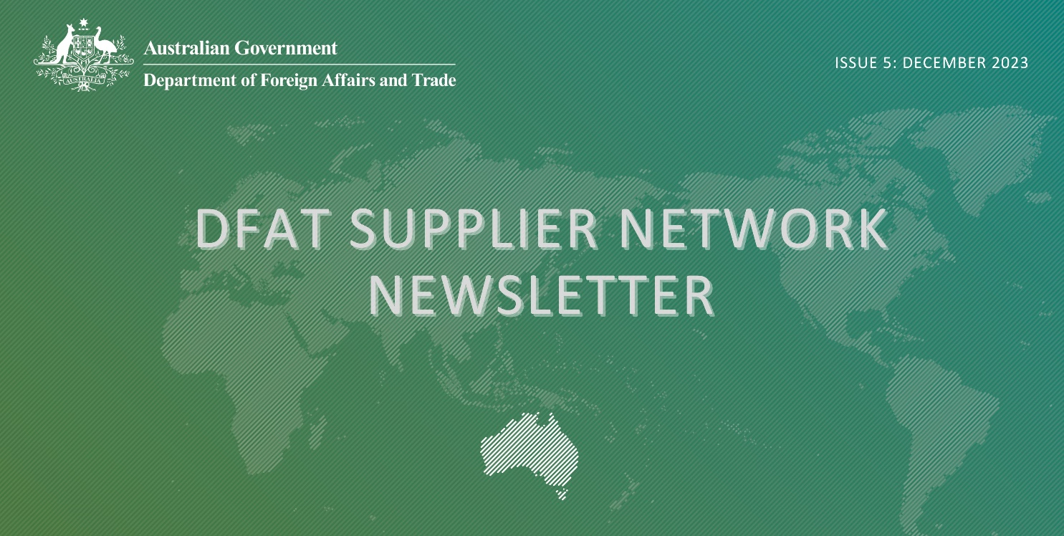Inside This Issue

1. Welcome message from DVB
2. Procurement Messages
3. International Development Policy
4. Regional Big Meets 2023
5. Modern Slavery
6. International Disability Equity and Rights Strategy
7. DFAT Business Envoy
8. Upcoming Events

# Welcome Message from DVB

Welcome to the 5th edition of the Development Procurement, Agreements and Systems Branch (DVB) Newsletter.

DFAT is releasing this newsletter periodically to our current supplier list and interested parties to ensure all partners working on the development program are up to date with policy changes and program opportunities.

Please email us at [supplier.engagement@dfat.gov.au](mailto:supplier.engagement@dfat.gov.au) with any queries you may have regarding any information included in this newsletter or other questions you may have.

# Links

* [Business Notifications](https://www.dfat.gov.au/about-us/business-notifications)
* [Check out the updated pipeline](https://www.dfat.gov.au/about-us/business-opportunities/development-procurement-pipeline)
* [Join DFAT Suppliers Network today](https://www.linkedin.com/%20groups/%2013563309/)

# Travel policy in non-ARF contracts

DVB has recently received a lot of questions on the travel policy for contracted partners. In a non-ARF contract, where the contract does not specify class of travel or travel allowances, DFAT contractor travel rates (including accommodation) are based on the [UN Daily Subsistence Rates](https://aus01.safelinks.protection.outlook.com/?url=https://icsc.un.org/Home/DailySubsistence&data=04%7c01%7cPhilippa.Armstrong%40dfat.gov.au%7c975526c18cb04f92d97808d89caeca9f%7c9b7f23b30e8347a58a40ffa8a6fea536%7c0%7c0%7c637431621834872437%7cUnknown%7cTWFpbGZsb3d8eyJWIjoiMC4wLjAwMDAiLCJQIjoiV2luMzIiLCJBTiI6Ik1haWwiLCJXVCI6Mn0%3D%7c1000&sdata=h01jd7BWAd/irpS0HNUwSY942a5NX9cgphNc%2BSLqs3A%3D&reserved=0). Where individuals might need additional accommodations due to disability for example, contractors are expected to discuss this with their DFAT contact to agree the required support for travel.

# Change in invoicing processes

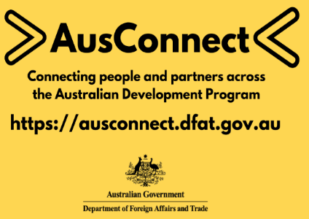

Many contracted partners will already be aware that DFAT will be changing the way claims for reimbursement are processed. DFAT will move to a consistent model across all contracts, requiring sampling of expenditure claimed for reimbursement. An interim process will be in place from 1 February 2024, with a new policy effective from 1 July 2024.

The interim solution will require DFAT agreement managers to check at least 15 transactions per invoice for reimbursement. To facilitate this change, contractors are asked to provide a transaction summary with the invoice, to speed up the sampling process and reduce the risk of late payment of invoices. DFAT encourages contractors to use the transition time from now to work through a new process with your DFAT agreement managers.

# The Fair Work Act

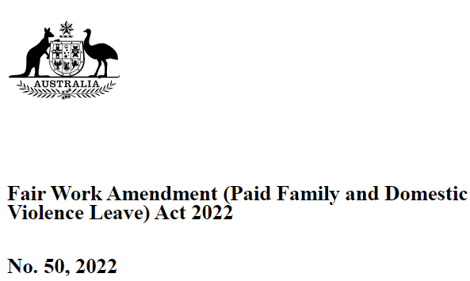

Are you unclear about where domestic and family violence leave or maternity leave is reflected in a contract with DFAT?

DFAT’s standard personnel clauses cover the Fair Work Act entitlements, even if those entitlements are not individually listed in the contract. The Personnel Fees are an all-inclusive fee covering base salary and any entitlements in accordance with local labour laws (including the Fair Work Act), amongst other items.

Contractor personnel can utilise their entitlements under the Fair Work Act without needing an amendment to the contract.

# Procurement over Christmas/New Year

DFAT will not be releasing new complex ODA procurements into the market between Monday 11 December 2023 and Monday 15 January 2024.

# International Development Policy

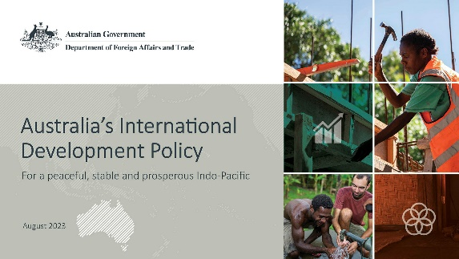

The Government has released its new International Development Policy. Australia’s International Development Policy is centred on listening, respect and genuine partnership. It will guide how Australia’s development program supports a peaceful, stable, and prosperous future for Australia and our region – ensuring it is fit for the challenges and opportunities of our times.

DFAT is now in the process of developing new Development Partnership Plans that will outline the specific application of the new International Development Policy at the country and regional level.

The new International Development Policy can be found on the DFAT internet page:  [Australia’s International Development Policy | Australian Government Department of Foreign Affairs and Trade (dfat.gov.au)](https://www.dfat.gov.au/publications/development/australias-international-development-policy)

# Pacific and PNG Regional Big Meets – Suva, Port Moresby and Lae

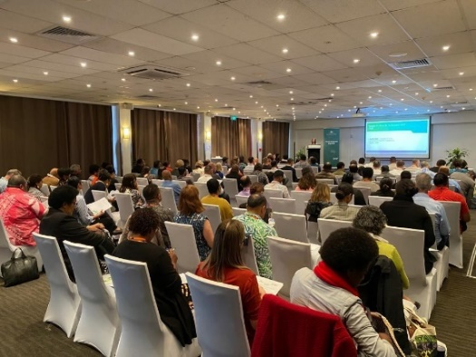 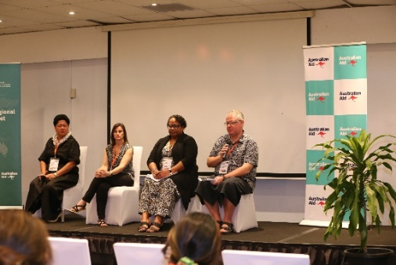 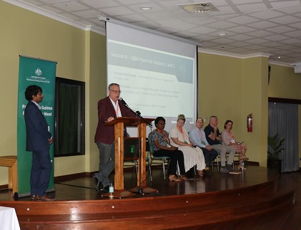

Building on the success of the Southeast Asia Regional Big Meet Jakarta in March 2023, DVB has also held Regional Big Meet events in Fiji and Papua New Guinea.

The Regional Big Meets have been well attended including managing contractors, subcontractors and new local companies interested in getting involved in Australia’s Development Program.

These events were an opportunity for local subcontractors from to discuss collaboration with large suppliers and DFAT. In line with the Australian Government’s objective to champion locally-led development, the events have provided local businesses with an overview of DFAT’s regional development priorities, and key information on how to engage with the Australian Development Program.

The feedback received from these events has been overwhelmingly positive, and participants expressed the value of the event in facilitating networking opportunities within the region and providing new information to a number of attendees. The hope is that with this information, more local companies will seek opportunities to work within Australia’s Development Program and continue to increase diversity in the Program.

# Modern Slavery

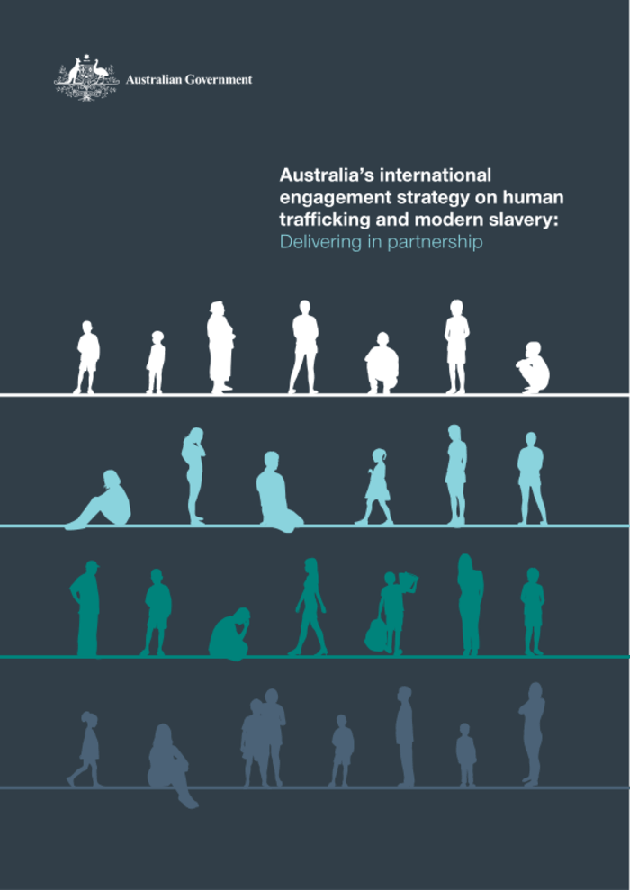

DFAT leads Australia’s whole-of-government international engagement to counter human trafficking and other forms of modern slavery, including forced labour and forced marriage.  The Government has committed to step up its advocacy and action on protecting human rights and countering the scourge of modern slavery through employing a range of measures at our disposal.

On 28 June 2023, the Foreign Minister announced Ms Lynn Bell as Australia’s next Ambassador to Counter Modern Slavery, People Smuggling and Human Trafficking to rally a multilateral response to modern slavery.

The Ambassador plays a leading role in driving international cooperation, including through Australia's work as Co-Chair of the Bali Process, which is crucial to addressing the abhorrent crimes of people smuggling, human trafficking and related transnational crime.

The Australian Government is committed to eradicating all forms of modern slavery. The Ambassador will work with partners in our region to strengthen their responses to modern slavery, and will work closely with the Operation Sovereign Borders Joint Agency Task Force.

DFAT is working closely with the Attorney-General’s Department on the statutory review of the [*Modern Slavery Act 2018*](https://www.legislation.gov.au/Details/C2018A00153).

Under the [National Action Plan to Combat Modern Slavery 2020-2025,](https://www.ag.gov.au/crime/publications/national-action-plan-combat-modern-slavery-2020-25) DFAT developed Australia’s second [International Engagement Strategy on Human Trafficking and Modern Slavery: Delivering in partnership](https://www.dfat.gov.au/publications/international-relations/international-engagement-strategy-human-trafficking-and-modern-slavery-delivering-partnership-2022). The Strategy (launched on 25 March 2022) sets out Australia’s whole-of-government efforts to counter modern slavery.

# New International Disability Equity and Rights Strategy

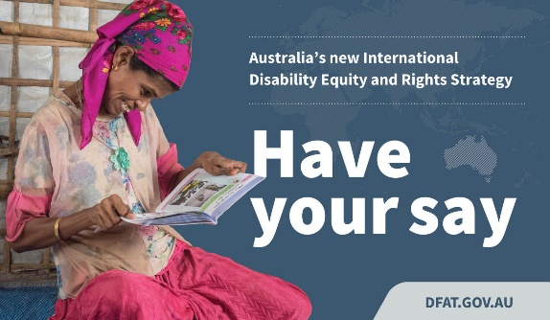

The Australian Government has committed to prioritising disability equity and rights as a core issue for action in the new [International Development Policy](https://www.dfat.gov.au/publications/development/australias-international-development-policy). DFAT is now developing a new [International Disability Equity and Rights Strategy](https://www.dfat.gov.au/international-relations/global-themes/international-relations/disability-equity-and-rights/call-submissions-new-international-disability-equity-and-rights-strategy) (IDEARS) to ensure Australia remains a strong and consistent global leader on disability equity and rights.

A call for public submissions to inform the Strategy is now open. The call will close on **15 December 2023**. For more information, visit the [Call for Submissions](https://www.dfat.gov.au/international-relations/global-themes/international-relations/disability-equity-and-rights/call-submissions-new-international-disability-equity-and-rights-strategy) page.

# DFAT Business Envoy



The September edition of [Business Envoy](https://www.dfat.gov.au/about-us/publications/business-envoy) is now available. Business Envoy is DFAT’s flagship quarterly magazine providing the latest insights into the Australian Government’s open trade and investment agenda, updates on government policy and thinking, industry news, and expert analysis of the latest global market trends and events.

# Upcoming Events



Please keep an eye on our [LinkedIn](https://aus01.safelinks.protection.outlook.com/?url=https%3A%2F%2Fwww.linkedin.com%2Fgroups%2F13563309%2F&data=05%7C01%7CClarinda.MacFarlane%40dfat.gov.au%7C5e02ebf2159b4e0e150408db504cd889%7C9b7f23b30e8347a58a40ffa8a6fea536%7C0%7C0%7C638192063206567883%7CUnknown%7CTWFpbGZsb3d8eyJWIjoiMC4wLjAwMDAiLCJQIjoiV2luMzIiLCJBTiI6Ik1haWwiLCJXVCI6Mn0%3D%7C3000%7C%7C%7C&sdata=UI4%2Fa3%2BN4K0pwvfGwqc0KT9j1sZIxWbQdbbh7x9etxg%3D&reserved=0) and [business opportunities](https://www.dfat.gov.au/about-us/business-opportunities) pages for details on our upcoming events for 2024.

DFAT would like to wish all our suppliers and stakeholders a wonderful and safe Christmas and New Year. We look forward to working with you all again in 2024.

**Contacting DVB:** [**supplier.engagement@dfat.gov.au**](mailto:supplier.engagement@dfat.gov.au)