Disability inclusion in the DFAT development program
  - Good practice note
  - aPRIL 2021

Overview
This good practice note outlines DFAT’s approach to disability-inclusive development and identifies main entry points for disability inclusion within the development program management cycle.
It supports the implementation of Australia’s development strategy, Partnerships for Recovery: Australia’s COVID-19 Development Response which reaffirms Australia’s commitment to those most vulnerable to the impacts of COVID-19 including women and girls, people with disabilities and those living in poverty. It sits beneath, Development for All 2015–2020: Strategy for strengthening disability-inclusive development in Australia’s aid program (extended to 2021) and complements DFAT’s Humanitarian Strategy, which highlights disability inclusion as a thematic priority and commits to ensuring people with disabilities are active participants in the planning, design and implementation of humanitarian assistance.

The importance of disability-inclusive development
To be effective in reducing poverty, development must actively include and benefit people with disabilities. People with disabilities are the largest and most disadvantaged minority in the world. They make up 15 per cent of the global population (about one billion people) and one-in-five of the world’s poorest have a disability.
Disability-inclusive development provides opportunities for people with disabilities to participate on an equal basis with others and realise their full potential. This enables countries to harness the potential contribution of all citizens, maximising opportunities for poverty reduction and sustainable economic growth. Effectively addressing the needs of those who experience greatest vulnerability, including people with disabilities, provides the bedrock for social cohesion and contributes to a resilient and prosperous region.
As a party to the United Nations Convention on the Rights of Persons with Disabilities (CRPD), Australia has committed to supporting other countries implement the CRPD, including through ensuring our development programs and humanitarian efforts are inclusive of and accessible to people with disabilities.

Definition of disability-inclusive development
Disability-inclusive development promotes effective development by recognising that, like all members of a population, people with disabilities are both beneficiaries and agents of development. An inclusive approach seeks to identify and address barriers that prevent people with disabilities from participating in and benefiting from development. The explicit inclusion of people with disabilities as active participants in development processes leads to broader benefits for families and communities, reduces the impacts of poverty, and positively contributes to a country’s economic growth.

DFAT approach to disability-inclusive development
Development for All 2015-2020 reinforces Australia’s focus on participation and leadership of people with disabilities in the development program. This means working towards including people with disability in all our development and humanitarian assistance efforts in a genuine manner.

Twin-track
Australia adopts a twin-track approach to disability-inclusive development which includes a:
- Mainstream approach – including people with disabilities as participants and beneficiaries of general development investments, particularly in sectors identified as key opportunities in Development for All 2015–2020.
- Targeted approach – targeting people with disabilities in development initiatives designed specifically to benefit people with disabilities.
Actively including people with disabilities in mainstream development efforts is necessary to ensure that broader systems, policies and services include and benefit people with disabilities. This cannot be fully realised without complementary targeted efforts to facilitate equality of access and participation for people with disabilities. For example, you can make a school’s infrastructure accessible, and train a teacher on disability inclusion (mainstream approach) but if a child is deaf or has a vision impairment these changes will not lead to equitable access without a sign language interpreter or provision of the necessary assistive technology (e.g. magnifier or screen reader) (targeted approach).

Barriers for people with disabilities
People with disabilities commonly face a range of barriers in participating in society and benefitting from development investments. The types of barriers include:
- Attitudinal and / or societal barriers (such as stigma)
- Communication (such as information not being made available in accessible formats or available in one format only)
- Physical and / or environmental barriers (such as stairs, inaccessible transport) and
- Policy and / or systemic barriers (such as legislation, policies and procedures that explicitly or implicitly discriminate against people with disabilities).

Reasonable accommodation
Reasonable accommodation is the provision of support, modifications, and/or adjustments that meet the individual needs of people with disabilities to enable them to participate in, and benefit from, Australia’s development investments (targeted and mainstreamed). The need for reasonable accommodation is recognised in Development for All 2015–2020 and can include the provision of accessible transportation, sign-language interpreters, support for an individual’s caregiver to attend meetings, and documents being made available in accessible formats as requested by a specific participant. Some adjustments can be implemented at little or no cost, and some can require allocation of a modest budget to facilitate equitable access for people with disabilities.

Development for All 2015–2020 Strategic Framework
This framework underpins Development for All 2015–2020 and outlines Australia’s strategic approach to strengthening disability-inclusive development within the aid program. It identifies opportunities where Australia can make the most difference and operating principles to guide DFAT’s disability-inclusive development efforts.
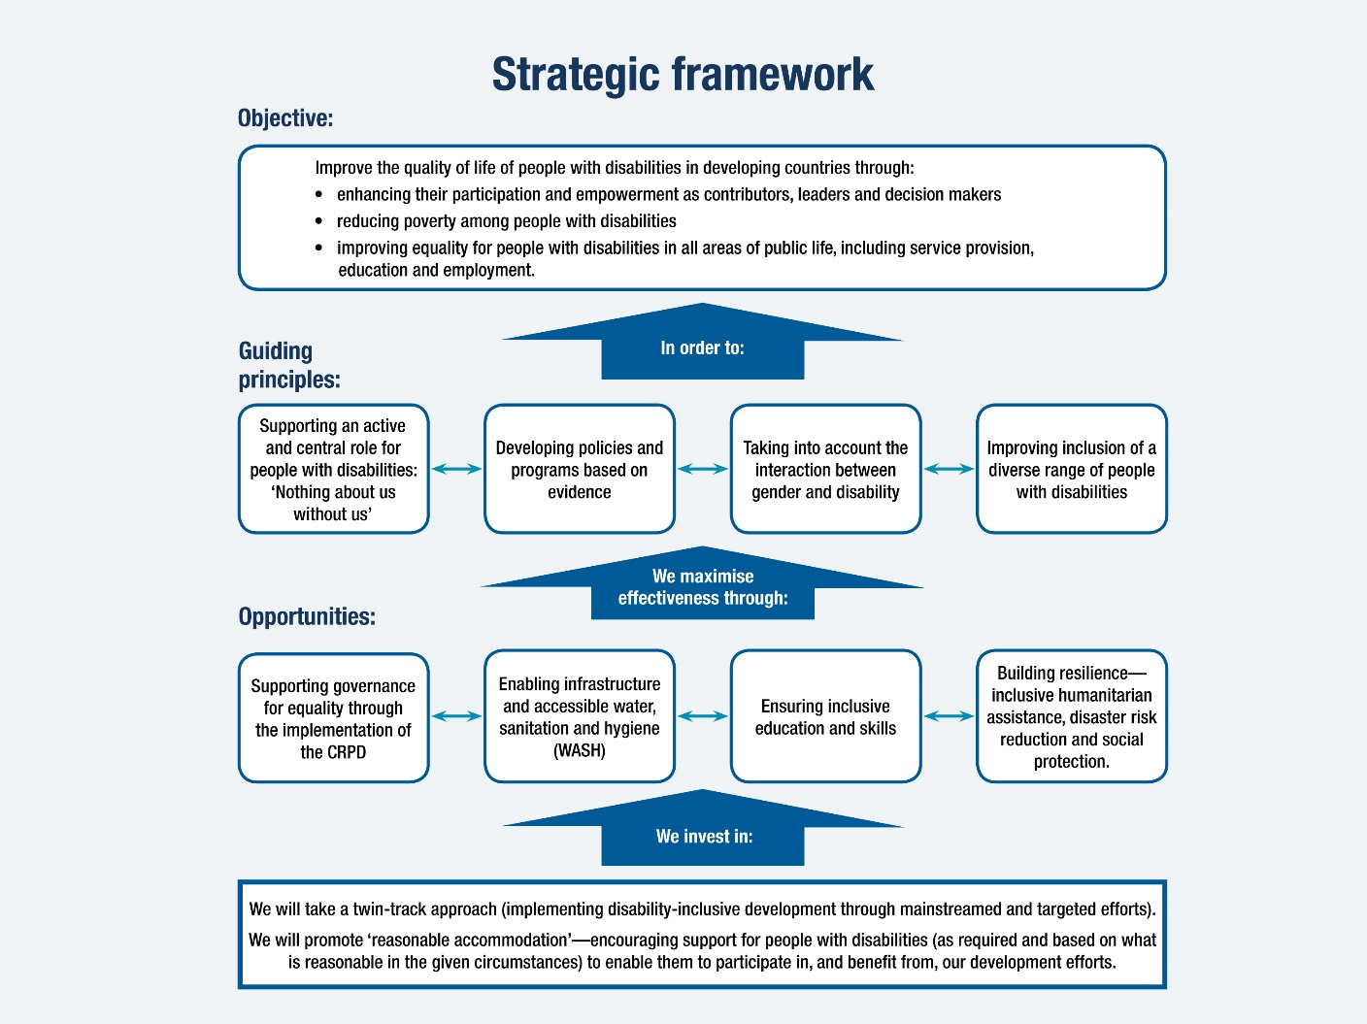

Entry points in development program management
Disability inclusion should be considered at all stages of the development program management cycle – in policy and planning, design and procurement, implementation and performance management, and review and evaluation. There are entry points throughout the development program management cycle to strengthen the disability objectives and outcomes, including:
- Identifying key challenges and barriers to disability inclusion in the country/ region including through consultations with people with disabilities and their representative organisations (known as disabled people’s organisations [DPOs]) or organisations of people with disabilities [OPDs]).
- Identifying opportunities to address these challenges, and the best way to do so, through a targeted and a mainstreamed approach to disability inclusion.
- Making disability inclusion actions clear in all program documentation including designs, risk assessments, analyses, contracts and grant agreements, evaluation frameworks, and in any program reviews and evaluations.
- Ensuring adequate funding has been set aside (approximately 3 to 5 per cent of the budget should be allocated specifically for ensuring the program or strategy development process is inclusive and accessible) to cover potential costs associated with ensuring people with disabilities and their representative organisations can participate in and benefit from the program.
- Building disability inclusion into monitoring and evaluation.
- Finding opportunities to leverage other work and engage in policy dialogue to promote disability inclusion (e.g. using a political economy lens to identify when, where and through whom policy change on disability inclusion might be possible or most effective).
- Supporting people with disabilities and their representative organisations to promote disability inclusion.
- Encouraging partner governments to ascertain disability prevalence by incorporating the Washington Group questions in national censuses and administrative surveys, alongside sex disaggregation.
- Using the Washington Group questions to disaggregate program-level data by disability (and by sex where it is possible) and ensuring there are qualitative data collected which enables processes and outcomes related to disability inclusion to be measured.
It is important to proactively integrate practical actions to address inequalities and promote disability inclusion, be explicit about what we aim to achieve and be clear about implementation. A checklist is included (see page 5) that identifies some key entry points that can be considered by program areas.
For guidance on disability inclusion in humanitarian settings, please refer to the Protection in Humanitarian Action Framework and the Inter-Agency Standing Committee Guidelines, Inclusion of Persons with Disabilities in Humanitarian Action.

Measuring results
- DFAT needs to be able to report on results from development investments, and ensure those results are credible. Investments that are clear about what they want to achieve on disability inclusion are more likely to be effective in implementation and delivery of disability inclusion outcomes, and mitigate the risk of adverse effects on people with disabilities. DFAT will monitor performance on disability inclusion through assessing investment quality and effectiveness. This will include reporting and analysis on the following key evaluative questions through Investment Monitoring Reports:
  - To what extent have investments actively involved people with disabilities and/or disabled people’s organisations in planning, implementing, monitoring and evaluating (recognising this improves participation of people with disabilities and enhances aid effectiveness)?
  - To what extent have investments identified and addressed barriers to inclusion and opportunities for people with disabilities to enable them to benefit equally?

Further support
For further advice on disability-inclusive development, please contact the Disability, Indigenous and Social Inclusion Section (DIS) (Disability.Inclusive.Development@dfat.gov.au). DFAT staff can additionally log a request for technical assistance through a disability inclusion helpdesk available at DID4All.com.au. The DID4all Helpdesk is managed by DIS and DFAT’s technical partner CBM Australia with costs for approved technical support covered by DIS.

check list for disability inclusion within the development program management cycle

Policy and Planning
- Do COVID-19 Development Response Plans include reference to disability and social inclusion? How does the investment align with this reference and to Australia’s focus on those more likely to experience vulnerability, including people with disabilities?
- Do Performance Frameworks and reporting against these frameworks use disability and sex disaggregated data?

Design and procurement
- Has expertise in disability inclusion been sought to inform the investment concept and design? This should include consulting people with disabilities and their representative organisations from the local context. Additionally DFAT staff can contact DIS or submit a request for technical input through the Helpdesk available at www.DID4All.com.au)
- Has disability inclusion been factored into the investment concept and/or design from the outset, particularly for investments in sectors identified as key opportunities in Development for All 2015–2020 (as illustrated in the strategic framework)? Note: it is cheaper to incorporate disability inclusion at the outset rather than retrospectively once a development investment has already been established.
- Has an analysis been undertaken to inform the investment concept and/or design, which identifies (a) relevant existing issues for people with disabilities, (b) potential barriers for people with disabilities in accessing and benefitting from the planned investment and (c) solutions to the identified issues? (Please see Barriers For People with Disabilities above)
- Have the particular needs and interests of the following been factored in to the investment design, recognising the following groups face particular barriers and marginalisation, as well as different needs:
- people with a range of impairment types and severity, including those with psychosocial and intellectual impairments
- women and girls with disabilities
- people of diverse genders and sexualities with disabilities
- children and older people with disabilities.
- Have people with diverse disabilities and their representative organisations (including disabled people’s organisations, and local community groups) been consulted and involved in the design of the investment, in line with the guiding principle of ‘nothing about us without us’ (as seen in Development for All 2015–2020 and outlined in the strategic framework)?
- Has approximately 3 to 5 per cent of the budget been set aside to cover potential costs associated with ensuring people with disabilities and their representative organisations can (a) participate in accessible consultations and provide technical inputs into design, implementation and monitoring and evaluation, and (b) provide technical benefit from the investment, for example through providing reasonable accommodation, such as sign language interpreters and accessible transport?
- Do terms of references require implementing partners to be disability-inclusive, including providing reasonable accommodation?
- Does the investment design ensure any construction is accessible in line with the Accessibility Design Guide?
- Has the design considered the impact (intended and unintended) that the investment could have on people with disabilities and included strategies for avoiding or minimising negative impacts on people with disabilities?
- Have issues and sufficient controls been identified in the risk and safeguards screening tool which reflect the heightened risks faced by people with disabilities - particularly for people with disabilities who also identify as: children, women and girls, indigenous, ethnic or religious minority or at risk of resettlement?
- Are there disability-inclusion deliverables clearly outlined in the Statement of Requirement or agreement, and financed (recommended at 3 to 5 per cent of the budget)? Do they include plans on:
  - how people with disabilities will be included in the development of the investment concept and/or investment design
  - what measures will be taken to ensure people with disabilities will be able to participate in and benefit from the given investment
  - what specific targets will be used to monitor progress towards disability-inclusion and how will data be disaggregated by disability status
  - hiring people with disabilities as implementers, evaluators and researchers (where possible)?

Implementation and performance management
- Has baseline data (quantitative and qualitative) been established from the outset to measure progress on disability-inclusion? (Nonetheless, a lack of data should not prevent action on disability-inclusion, noting that approximately 15 per cent of a given population has a disability, and this is often higher in developing or conflict-affected countries).
- Are both quantitative and qualitative indicators used to track progress on disability-inclusive development outcomes within the M&E framework?
- Is disability disaggregated data being collected and analysed using the Washington Group short set of questions? Is this data also disaggregated by sex and age to assess the impacts on women, men, girls, and boys with disabilities? Are there indicators for disability-inclusion in place for monitoring and evaluation (with sufficient resources allocated)?
- Have systems been established (from the outset) to capture disability information for Investment Monitoring Reports (as required for those over $3 million), particularly on the extent to which:
(a) The investment actively involves people with disabilities and/or disabled people’s organisations in planning, implementation and monitoring and evaluation.
(b) The investment identifies and addresses barriers to inclusion and opportunities for participation for people with disabilities to enable them to benefit equally from the aid investment.
- Is the implementing partner’s performance on addressing disability inclusion being monitored as part of the monitoring and evaluation framework?
- Have people with disability expertise (including people with disabilities and/or their representative organisations) participated in the development of the M&E framework and actively engaged in monitoring and evaluation activities?

Review and Evaluation
- Do terms of references for a program evaluation include performance questions specific to disability inclusion which would enable assessment of disability inclusion (both as a process and an outcome)?
- Does the evaluation and the final investment reporting assess how well the investment performed on disability-inclusion and detail lessons learned?
- Have people with disability expertise (including people with disabilities and/or their representative organisations) actively engaged in and contributed to program evaluation activities?

Additional resources
Performance Assessment Note: Disability-inclusive development: includes detailed guidance and resources for designing disability inclusive monitoring and evaluation (M&E) frameworks for investments (available internally for DFAT staff).
DID4All: Resources for Disability Inclusive Development: includes detailed evidence and guidance on mainstreaming disability-inclusive development in a range of sectors. Requests for technical assistance may be logged through the DID4All disability help desk managed by DIS and partner CBM Australia
Accessibility Design Guide: Universal design principles for Australia’s aid program: provides practical information about how to apply universal design principles to physical infrastructure (such as schools, roads, hospitals and courthouses) to minimise barriers and enable people with disabilities to participate more fully in social and economic life.

World Bank and World Health Organization, World Report on Disability, 2011, p. 261.
World Bank and World Health Organization, World Report on Disability, 2011.
United Nations Convention on the Rights of Persons with Disabilities, Articles 11 and 32.
While prevention of impairments (for example, avoidable blindness and road safety activities) remains an important public health objective, it is outside the scope of disability-inclusive development as set out in this note and recognised in the mid-term review of Development for All 2009-2014: L Kelly and L Wapling, Development for All Mid-Term Review Report, October 2012, p. 31, 65, viewed 23 January 2015, <http://dfat.gov.au/about-us/publications/Pages/development-for-all-strategy-mid-term-review.aspx>.
Documents in accessible formats can include electronic versions that are compatible with screen readers for people with vision impairments, or versions in more simple language and illustrations for people with intellectual impairments.
This guidance document uses the term "Disabled People's Organisations"/"DPOs" as per Development for All 2015-2020: Strategy for strengthening disability inclusive development in Australia's aid program, but notes there is growing use of the term “Organisations of Persons with Disabilities”/”OPDs” globally.
Kelly, L and Wapling, L.; 2012, ‘Mid-term Review of Development for All - Towards a disability-inclusive Australian aid program 2009-2014, p. 42.
The Washington Group’s short set of six questions is recommended by the United Nations for use in all national censuses and household surveys to provide internationally comparable disability data: Washington Group on Disability Statistics, Short Set of Questions on Disability, viewed 3 December 2020, <https://www.washingtongroup-disability.com/question-sets/wg-short-set-on-functioning-wg-ss/>
AusAID, Protection in Humanitarian Action Framework for the Australian aid program 2013, July 2013, PUB9 < https://www.dfat.gov.au/about-us/publications/Pages/protection-in-humanitarian-action-framework>
IASC, IASG Guidelines, Inclusion of Persons with Disabilities in Humanitarian Action, 2019. Viewed 17 December 2020, < https://interagencystandingcommittee.org/iasc-task-team-inclusion-persons-disabilities-humanitarian-action/documents/iasc-guidelines>

