Five year old fights MDR-TB
A case study
October 2012
Duba is a five-year-old boy from Daru Island in Western Province of PNG. He was admitted to the TB ward at Daru Hospital and diagnosed with multi drug resistant tuberculosis (MDR TB).
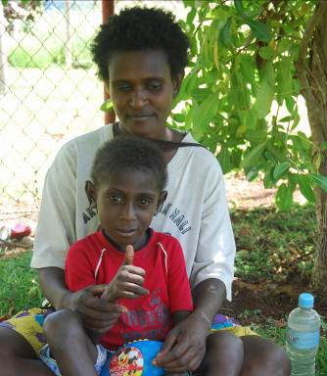
Duba was fortunate that during this time the Provincial and National Governments of PNG, supported by NGO and donor partners including AusAID and World Vision, launched a new program to scale up TB services in Western Province. A particular focus of this program is diagnosing and treating TB including drug resistant strains.
MDR-TB is a form of TB that doesn't respond to the normal six month course of TB drugs. MDR-TB normally occurs when TB patients do not take their daily medication as required. Once this occurs patients must commence a different course of treatment that can last for up to two years.
Just like regular TB it can also be easily spread through the air. This means that MDR-TB is now a major health concern in PNG.
A happy Duba with his mother during one of their trips to the Daru hospital for his daily treatment Photo: AusAID
When Duba was initially admitted to the TB ward, his parents and doctors had very little hope that he was going to survive. Dary Hospital TB expert Dr Rendi Moke said treating TB in children is always a challenge because their diagnosis is more complex.
“When Duba was admitted to hospital he commenced normal medication. However we quickly noticed that he wasn't getting any better so we investigated him for MDR-TB,” Dr Moke said.
His body was extremely frail and he had an enlarged spleen.
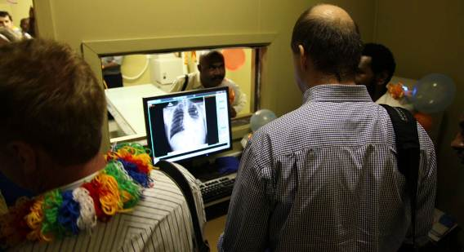
AusAID has upgraded the X-Ray unit at Daru Hospital, which enables patients with TB to be detected and treated more quickly. Photo: AusAID
His mother feared for his life saying: “He didn't even look human when I brought him to the hospital, he was very skinny.”
“After they diagnosed him with MDR-TB and started with this treatment he quickly began to put on weight,” she said.
The new Stop TB in Western Province Program is a partnership with the PNG National Department of Health, the Western Province Government, World Vision and AusAID. The program has already seen significant improvements in Daru Hospital's capacity to diagnose and treat TB and MDR-TB cases.
Through this program Daru Hospital now has the TB diagnostic tool known as the Gene-Xpert, which can detect drug resistant strains of TB in under two hours—a process that would usually take two months or more.
Daru is also benefiting from a specialised TB ward staffed with qualified TB doctors, health workers and outreach staff.
Dr. Moke said patients like Duba are a testimony to the fact that effective investments in human resources, technical capacity and infrastructure have the ability to save lives and in the long term make a real impact on TB.
Duba and his mother still report to Daru hospital every day for his injections and tablets. Duba will continue taking medication until he is cured.
AusAID has upgraded the X-Ray unit at Daru Hospital, which enables patients with TB to be detected and treated more quickly. Photo: AusAID

