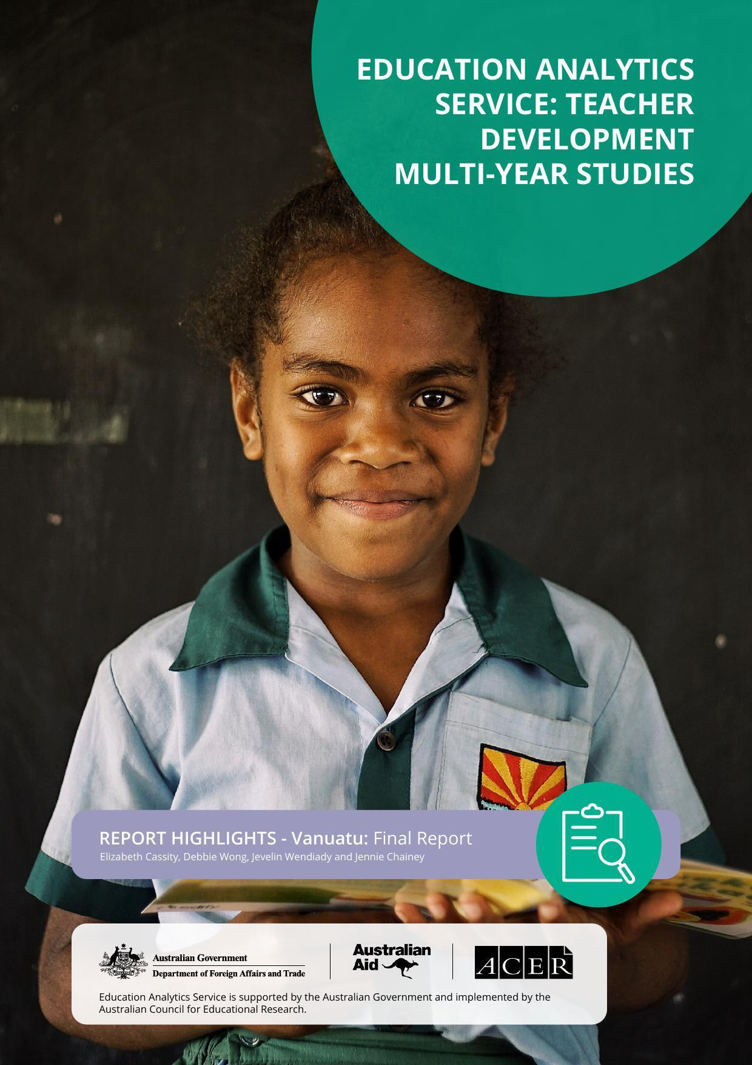

Introduction
The Australian Government is supporting the Government of Vanuatu (GoV) through its Vanuatu Education
Support Program (VESP) to undertake long-term education reforms. A key focus is the rollout of a new national curriculum in conjunction with the National Language Policy (2012), intended to introduce new content and pedagogies, better sequence content, and support the use of Bislama or the vernacular in the early grades. Together, these reforms are intended to improve teaching quality and student learning outcomes.

The multi-year study was commissioned by the Australian Government’s Department of Foreign Affairs and
Trade (DFAT), to investigate teaching and learning development initiatives in 3 countries: Lao PDR, Timor-
Leste and Vanuatu. In Vanuatu, the Education Analytics Service (EAS) is investigating how VESP activities are making a difference to teaching and learning outcomes.

The new primary curriculum has been rolled out to schools by year level, starting with Grade 1 in 2016. It is accompanied by the distribution of teaching and learning materials and training. Pedagogical approaches –
such as student-centred learning, language transition and classroom-based assessment practices – aim to transform teaching and learning.

Methodology
The Teacher Development Multi-Year Study for Vanuatu seeks to answer the question:

To what extent does this aid investment produce improved teaching quality and improved student learning?

The study adopts a mixed methods approach using case study data and student assessment data. Case studies were conducted on islands from 5 of Vanuatu’s 6 provinces – Malekula, Pentecost, Tanna, Efate, Santo and Erromango.

They include interviews with principals, Grade 1 to 6 teachers, national and provincial stakeholders, parents and the community, and classroom observation data of Grade 2 teachers. The study also includes secondary analysis of data from the Vanuatu Standardised Test of Achievement (VANSTA) and the Pacific Islands Literacy and Numeracy Assessment (PILNA).

Summary of findings
VESP has strengthened elements of teaching quality, the implementation of the national curriculum and aspects of student learning.

However, the sustainability of VESP inputs to teaching quality is challenging. Changes to provincial structures previously provided by the Ministry of Education and Training to support teachers and principals have hampered continuity. The absence of an ongoing and continuous program of teacher professional learning means there is no avenue for teachers and leaders to expand upon their improved practice.

‘The main shift regarding the curriculum is that it’s now student-centred, and through the past years, we’ve really seen a change in the way teachers are teaching. They’re teaching with the kids rather than at the kids.’
– National interviewee

VESP has contributed to professional learning opportunities to improve knowledge and practice, particularly student-centred pedagogies. Teachers and principals highly value curriculum support resources. VESP has contributed to MoET outreach programs that support schools and communities to understand the new curriculum and the language policy, although this varies across the country.

Students are more interested and engaged in school as a result of teachers’ use of student-centred practices. However, there is inconclusive evidence that VESP has impacted student learning outcomes.

Wide variations in student achievement across the country and a consistent pattern of boys’ underperformance exist. For example, VANSTA 2021 shows students in Torba and Tafea consistently lag in performance in both literacy and numeracy. Results from PILNA 2021 demonstrate girls are outperforming boys across literacy and numeracy.

Teaching quality
VESP-supported training, curriculum materials and resources, have strengthened the use of new pedagogical methods and improved teacher knowledge of the curriculum.

‘Effective learning and teaching has helped me immensely with my job as a teacher. It helped me to provide good learning to my students in the classroom, the different strategies and ways to provide help to my students to enable them to better understand the coursework.’– Year 2 teacher

However, teachers need more support and time to fully incorporate, and consistently apply new approaches to the curriculum.

The lack of follow-up training or availability of training and support for all teachers and principals is a problem. More comprehensive training, refresher training and ongoing professional learning support is needed.

The current gaps created by the GoV’s dissolution of the in-service teacher training unit and provincial support structures for schools represent significant risks for supporting the professional learning needs of teachers and principals. Any gains made under the VESP towards improving teaching quality and community support for the curriculum are at risk.

Key findings
Key area | Finding 1 | Finding 2 | Finding 3
Knowledge and attitudes | VESP-supported training improved teacher professional knowledge  about content and pedagogies used in the new curriculum, particularly student engagement and lesson planning. | Teachers and principals reported increased confidence and motivation attributed to VESP-supported training,  the teachers’ guide and resource kits, and observations of greater student engagement in learning. | Varied training quality, lack of ongoing support, and uneven training participation have created barriers to improving skills and knowledge.
Teaching practice | VESP-supported training and curriculum resources improved the use of student-centred pedagogies. Although observations indicated variable take-up. Teachers reported using group and pair work, peer-to-peer learning, hands-on activities, supporting a range of ability levels, and making connections to local contexts. | Teachers and principals  reported training and  resources helped them improve lesson planning and to monitor student learning by aligning activities to learning indicators. | Speaking Bislama or vernacular in the classroom was critical for improving teaching practice, especially for  encouraging student engagement in the classroom.
Gender, equality, disability and social inclusion | While there was a positive change in awareness and attitudes towards disability-inclusion, there was not a significant shift in classroom practice. | Teachers and principals who participated in inclusive education courses implemented inclusive practices in their classrooms and schools, but specialist knowledge is not widespread. | Many teachers identified mixed-gender group work as a key strategy to support equal participation of boys and  girls.
Assessment | Teachers and principals reported a clear shift towards more regular classroom-based assessment and using assessment information to monitor student learning and identify supports needed. | Teachers reported using a combination of assessment methods, with student evaluation against learning indicators becoming more prominent. | Some teachers highlighted additional workload associated with the new assessment expectations.
COVID-19 | Home school packages could not reach all students, and teachers could not provide support during COVID-19 disruptions. Many parents could not assist their children due to low  literacy levels and other  priorities. | COVID-19 disruptions affected teacher and principal participation in training. Years 5 and 6 teachers were more affected as the pandemic coincided with this stage of the curriculum rollout. | Many teachers and principals noted a decline in student engagement and learning upon return to face-to-face schooling.  This impacted how teachers prepared and  delivered lessons.

Curriculum implementation
VESP support for teachers and principals through training and resources have contributed to implementation of the new curriculum.

However, ongoing support and feedback is critical for teachers to build on and consolidate their knowledge and practice. Principals and teachers value peer support in planning and discussing pedagogies at the school level, and this has become even more important given the gap in provincial support structures.

‘We work together on planning for the classrooms. We have double streams so we have teachers coming together to plan out how we will go about it…So talk about identifying our slow learners and how we can help them better… I’ve seen a lot of change here…’ – Principal

Capacity and gaps in support from provincial officers to schools presents a risk to long-term uptake of new curriculum content and pedagogies.

‘To expect teachers to do stuff without a management structure is asking a lot.’ – National interviewee

How the language policy is understood and implemented in classrooms is varied across school communities. While some respondents placed high value on access to teachers’ guides and curriculum resources for lesson planning and classroom teaching, instances of limited access were also noted. Questionnaire data also indicate a decline in student and teacher textbook access from 2021.

Key findings

Key area | Finding 1 | Finding 2 | Finding 3
Curriculum resources and materials | Teachers’ guides and curriculum resources provided support for  lesson planning and classroom teaching. | Trend data from the PILNA teacher questionnaires indicated an overall decline  in student access  to textbooks. This is associated with student achievement levels in PILNA. | Teachers reported a lack of access to curriculum resources and resource  gaps, which added to teacher workload.
Teacher support | Teachers valued principal support – such as access to resources, facilitating professional learning opportunities and feedback on teaching practice. But, principals had limited involvement in training and awareness, and  many were not able to  effectively support their teachers. | Principals reported increased capacity and confidence after participating in Instructional Leadership  training, but access was very limited. School leader participation in  in-service curriculum support programs  is associated with higher levels of student  achievement in Year 4  and 6. | Collaboration with teacher colleagues on the new curriculum was valued, but the extent varied.
Language | The language policy  has been unevenly articulated to schools, parents and communities. Training  variations on language  transition resulted in  difficulties for teachers in implementing the policy in classrooms. | Teachers reported that students are more at  ease using Bislama or the vernacular. | Year 3 and 4 teachers said they needed help to  support students to learn English and French. While training provided some support to teachers in language transition, more is needed.

Student learning
The extent to which teacher training and support activities have led to improved learning outcomes
is unclear.

Results from VANSTA and PILNA indicate that there are widespread differences in student achievement between provinces in both literacy and numeracy. There is also evidence of learning loss in literacy and numeracy since 2021. A high proportion of students do not meet the learning outcomes expected at their grade level.
Teacher perceptions on student performance in the new curriculum varied. Some acknowledged the benefit of learning in Bislama or the vernacular on student engagement and interest in lessons.

‘With the new curriculum the students are more comfortable in class and free to voice their opinion and move around.’ – Year 1 teacher

Educational change takes time. Long-term commitment and follow-through to implement large-scale policy changes are needed. This includes more time and support for teachers to understand and fully incorporate new approaches into their teaching practice. Student performance may be related to teacher professional capacity to master the curriculum and apply the necessary pedagogy to facilitate quality learning.

Key findings

Key area | Finding 1 | Finding 2 | Finding 3
Academic outcomes | High proportions of students do not meet the expected learning outcomes at their grade level. Some learning loss from 2021 was possibly related to the impact of  COVID-19 or cyclone- induced school closures. | There are widespread differences in student achievement across provinces in both Years 4 and 6. Girls have consistently outperformed boys at both year levels in literacy and numeracy. Literacy achievement of boys in Year 4 and Year 6 have consistently declined and the gaps between boys’ and girls’ achievements have widened since 2017. | Teacher professional development measures such as attending professional development in the last  3 years, are positively associated with student achievement, especially in Year 4.
Student participation, interest and wellbeing | Case study respondents  observed students as more talkative and expressive in class, and able to speak more coherently and clearly because they were able to use Bislama or the vernacular in their classrooms. | PILNA 2021 Year 4 student reading and writing scores were higher in classrooms where teachers encourage problem-solving and expression of ideas. | Higher levels of student  engagement and interest  in school and supportive  classroom culture, including teacher- student relationships and interactions, contributed to student wellbeing.
Parent and community support | Teachers, principals and national-level respondents reported that parents were encouraged to support their children’s learning.  However, in particular, work commitments  undermine this support. | Many parents reported that they help with children’s homework  and attendance, but some struggle with understanding how to support their children. | N/A

Overall study recommendations
The study recommendations are based on 3 areas of potential policy and program consideration:

Design and implementation
- DFAT to consider the duration and balance of investment needed to support the effective implementation of GoV’s education reform process.
- VESP and DFAT to continue to engage with MoET in policy dialogue and advocacy related to teacher systems.
- MoET and VESP to support communications strategies to enable schools to continue to engage with parents and communities about the curriculum and their children’s learning.
- MoET and VESP to support research to inform how teacher professional learning support can be better targeted and sustained.

Investment in professional learning
- VESP to support MoET to develop a strategy for a sustainable and long-term model for effective and ongoing professional learning.
- VESP to consider more focused support for principals beyond induction programs to ensure school level support for teachers’ professional learning and development.
- MoET and the National University of Vanuatu (NUV) to support alignment in both the areas of preservice and in-service teacher training and support.
- MoET, NUV and VESP to continue to offer opportunities for teachers and principals to develop learning and skills in gender and disability inclusion.

Investment in collecting student learning data
- MoET and VESP to support the interpretation and use of data from PILNA and VANSTA.
- MoET and VESP to support principals and teachers to understand the purposes and uses of VANSTA and PILNA, and how these large-scale assessments can contribute to understanding learning outcomes.

Visit DFAT’s website to read the full report, Vanuatu: Final Report, and to view a list of references.

@2023 The Commonwealth of Australia, represented by the Department of Foreign Affairs and Trade.

Recommended APA citation:
Cassity, E., Wong, D., Wendiady, J., & Chainey, J. (2023). Report Highlights. Vanuatu: Final Report. Australian
Council for Educational Research.

Images supplied by the Vanuatu Education Support Program.

