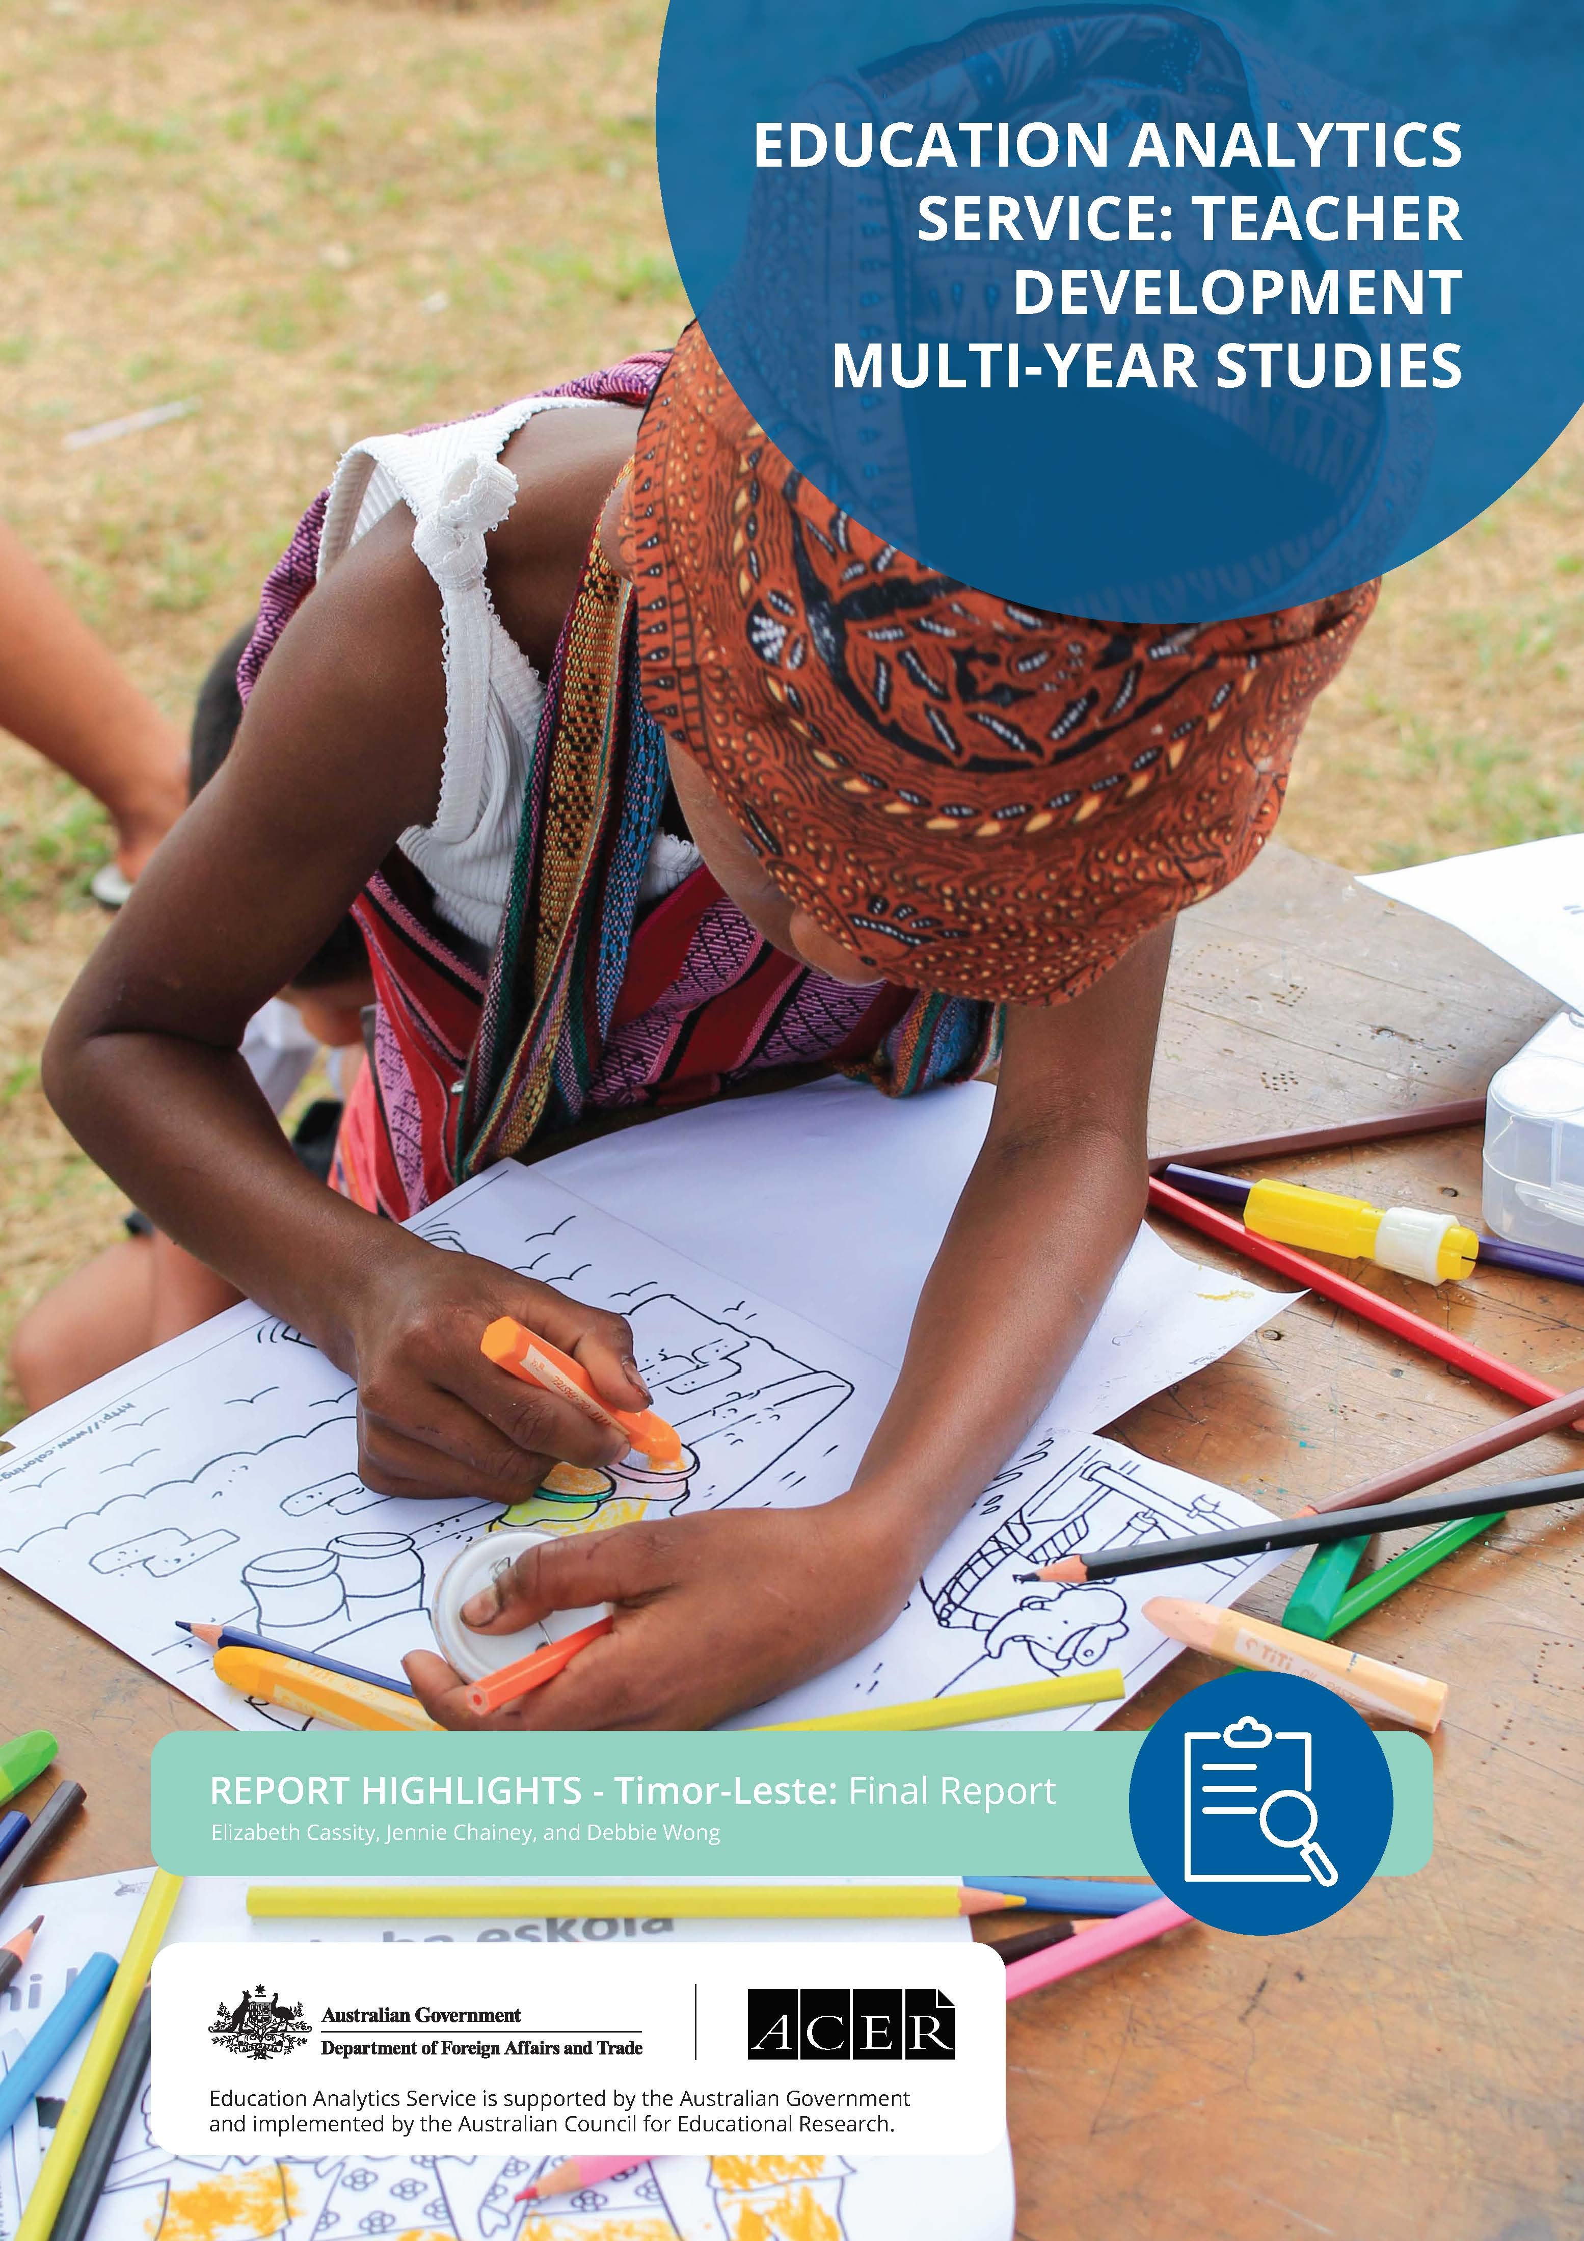

Introduction
The Australian Government is supporting the Government of Timor-Leste to undertake educational reforms through the Partnership for Human Development (PHD) and Apoiu Lideransa liuhosi Mentoria no Apredizajen (ALMA). ALMA enables the Ministry of Education, Youth and Sport (MoEYS) to develop teacher professional learning to support the implementation of its National Basic Education Curriculum.
Under the Teacher Development Multi-Year Study for Timor-Leste, the Education Analytics Service (EAS) is investigating how ALMA is making a difference to teaching and learning outcomes. This research is part of a multi-year study series commissioned by the Australian Government’s Department of Foreign Affairs and Trade (DFAT), to investigate teaching and learning development initiatives in 3 countries: Lao PDR, Timor-Leste and Vanuatu.
The new curriculum was developed in 2013 as a staged approach for pre-school to grade 6, with a focus on improving literacy and numeracy, and reducing student drop out. MoEYS began implementing the new curriculum for grades 1 and 2 in 2015. The goal of ALMA is to facilitate improved teaching and leadership in schools and has been rolled out in 10 of 13 municipalities.

Methodology
The Teacher Development Multi-Year Study for Timor-Leste seeks to answer the question:
To what extent does this aid investment produce improved teaching quality and improved student learning?
The study adopts a mixed methods approach using both qualitative and quantitative data. Case studies include interview data (from school leaders, grade 1 to 4 teachers, ALMA mentors, inspectors, and municipal and national education stakeholders) and classroom observation data.

Summary of findings
The ALMA program has been effective in strengthening elements of teaching quality and curriculum implementation across municipalities.
With a sharp focus on developing the knowledge and skills of school leaders and teachers, ALMA has contributed to changes in the education sector. Importantly, the Leaders of Learning program has directly contributed to an improvement in school leader knowledge, particularly instructional leadership. The establishment of the Grupu Traballu ba Professor (GTP) – teacher peer learning groups in school clusters – provides the potential for a continuous professional development approach.
Peer learning and consistent school leader support has helped align teaching practice with expectations in the curriculum. However, evidence that ALMA has impacted student learning outcomes is inconclusive. While perception data has indicated an increase in student interest in lessons, engagement and well-being, student improvement in literacy and numeracy cannot be adequately reported as there is no regular national assessment of learning outcomes. Teachers are starting to implement a variety of formative assessment activities, but the use of these varies across municipalities.

Teaching quality
To what extent does the ALMA program support improved teaching quality in Timor-Leste?
Grade 1 to 4 teachers are more aware of, and using, student-centred teaching practices in the classroom, to varying extents.

Results from the overall study indicate that ALMA has been effective in establishing and strengthening facets of teaching quality. Critical to ALMA has been the development of leadership capacity of school leaders through the Leaders of Learning program and the support of mentors. GTPs have provided teachers with a forum of peer learning where they can discuss and learn from each other about new pedagogical approaches, as well as practice new skills through lesson simulations.
A key challenge is maintaining ongoing learning for teachers and school leaders after the initial rollout of ALMA, given the scale-down of intensive ALMA support. With a focus on student-centred teaching and learning, ALMA-supported activities have helped teachers use a variety of teaching approaches and resources. This includes student group and pair work, encouraging student interaction and student talk, and making local connections, although consistency across municipalities is uneven.
Stakeholders reported an improvement in teachers’ punctuality and preparation, and all teachers observed had completed lesson plans for every class. The process of observation, feedback, peer learning through GTPs, and general support in terms of preparation and planning for lessons has been reported to contribute to increased teacher confidence and motivation. There is also improved awareness of gender inclusive education and identifying particular student needs. However, teachers are less aware of specific classroom practices to ensure the participation of all students.

Curriculum implementation
To what extent does the ALMA program support the effective implementation of Timor-Leste’s National Basic Education Curriculum?
ALMA has improved access to the curriculum lesson plans and activities on tablets.
The findings indicate that teachers and principals value ALMA support. By improving access to the curriculum and resources, and strengthening teacher support, ALMA is recognised for playing a critical role in supporting the effective implementation of the curriculum.
Teacher support is an important part of ALMA. Peer learning and consistent school leader support has helped align teaching practice with expectations in the curriculum.
School leaders are actively able to monitor and observe teachers and their delivery of lessons against lesson plans using tablets. However, some ongoing technical challenges and difficulties accessing internet in remote areas persist which limit their usability.

Student learning outcomes
To what extent does teacher involvement in the ALMA program lead to improved learning outcomes for Timor-Leste students?
There is indication that student-centred learning approaches have increased student engagement and interest in lessons.
The extent to which ALMA has improved student learning outcomes is inconclusive. Case study data from 2018, 2019 and 2021 indicates that the incorporation of student-centred learning approaches has increased student engagement and interest in lessons, and this was observed by some teachers to improve student academic outcomes.
Evidence about student engagement is an important indicator of student performance and completion. However, as there is no reliable or regular national assessment of learning outcomes, it is not possible to attribute student performance to the curriculum reforms or ALMA program.

Recommendations

Design and implementation
The design and implementation of the ALMA program presents opportunities to learn about the benefits of investing in and supporting a program that has a sharp focus on school leader and teacher professional learning, with a multi-year duration. This approach contrasts with more common sector wide approaches in education, where teacher professional learning is included as part of an overall level of education system support.
The recommendations are to:
- Continue to support and embed a long-term model of professional learning within Timor-Leste schools and government.
- Continue to undertake, develop and embed ALMA monitoring and evaluation (M&E) and research activities.
- Support the interpretation and use of ALMA M&E evidence by government stakeholders (national and municipal level), so they can make informed decisions about where to direct investment or change aspects of interventions and better support schools.
- Support research to inform how teacher professional learning support could be better targeted.

Monitoring student learning
Student learning outcomes data is an important source of evidence for understanding the impact of investments in teacher professional learning. Understanding what students know and can do is also an important source of evidence for teachers and school leaders as they support ongoing student learning. One of the key study challenges in Timor-Leste is that there is very little data on student learning outcomes.
The recommendation is to:
- Develop and expand a regular national assessment to measure and understand student learning outcomes.

Improving sustainability
The ability of schools to sustain inputs is a significant risk to the longevity of ALMA outcomes. Recommendations on sustainability focus on the potential to improve key components of ALMA and to institutionalise interventions through building MoEYS leadership and management of ALMA.
The recommendations are to:
- Continue to support, develop and refine peer professional learning approaches as a high-impact, low-resource intervention.
- Continue to refine the mentor component of ALMA to improve the long-term likelihood of mentoring and sustainability of GTP facilitation.
- Provide ongoing funding and technical support to ensure tablet functionality and useability as this intervention transitions towards MoEYS systems.
- Incorporate leadership change management principles into ALMA Leaders of Learning component.
- Support leaders to expand and retain ALMA knowledge at school level.
- Embed gender and disability inclusive practices within the education system through collaboration between MoEYS and PHD.
- Incorporate pedagogical mentors into the permanent structure of the MoEYS to ensure government ownership.
- Improve the evidence-base behind ALMA and disseminate research to ensure MoEYS’ continued confidence, support and funding of interventions through periods of leadership transition.
- Continue to work on a long-term strategy for system strengthening to integrate core elements of ALMA into national sector plans, strategies and budgets.
To read the full Timor-Leste: final report, please visit the DFAT website.
© The Commonwealth of Australia, represented by the Department of Foreign Affairs and Trade.
Recommended APA citation:
Cassity, E., Chainey, J., & Wong, D. (2023). Teacher development multi-year study series. Report highlights. Timor-Leste: Final Report. Australian Council for Educational Research.
Images supplied by the Australian Government’s Department of Foreign Affairs and Trade.

